**Software & Hardware Requirements Specifications**

**for**

**Roomi**

Prepared by

Denald Demirxhiu

Jacob Ladan

Marko Javorac

Humber College Institute of Technology and Advanced Learning

January 24, 2019

# Table of Contents

Table of Contents 1

List of Illustrations 2

Introduction 5

Project Description 6

Requirements Specification 7

Software 7

Mobile Application 7

Database 8

Firmware 9

Hardware 9

Development Platform 9

Interface boards and sensors 10

Appendix 12

# 

# 

# 

# 

# **List of Illustrations**

#### Figure 1 - Application Flow

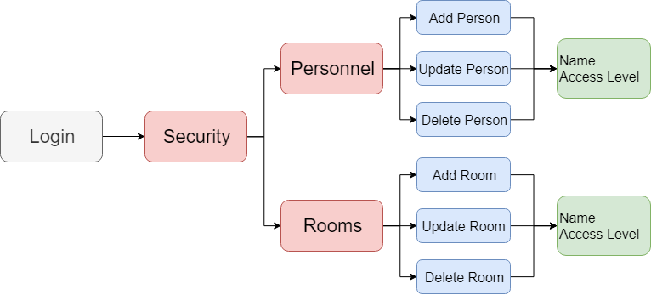

#### 

#### Figure 2 - Database Structure

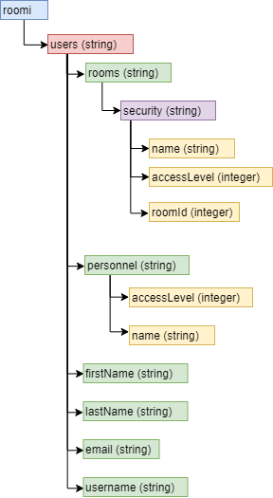

#### 

#### Figure 3 - Access Level

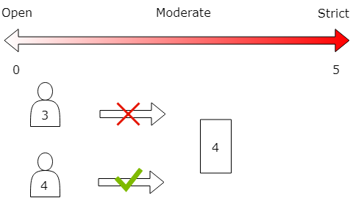

# 

# 

# 

# **Introduction**

Today, many rooms being electronically secured lack the flexibility of information display and mobile user management. The problem herein lies with the decrease in usability, and the sole focus of Roomi is to remedy this. Through the tying together of an LCD screen and existing RFID technology, users will be able to view additional important information about secured rooms, as well as allow administrators to update this information easily and without the need for support from IT.

A 2.4" Digole LCD Display will be used to display relevant information unique to every room. A PN532 NFC/RFID reader will allow individuals access to configured rooms, based on a predefined access level setup through the Android application. A mini push-pull solenoid will be used to demonstrate how the locking mechanism will function.

The mobile application will allow the administration to modify user and room access and display settings in a user-friendly environment. The hardware and application will work in unison with a cloud service hosted on Google's Firebase platform to store relevant information for rooms, user authentication, and personnel registered through the application.

# 

# 

# 

# 

# 

# **Project Description**

As students in the Computer Engineering Technology program, we will be integrating the knowledge and skills we have learned from our program into this Internet of Things themed capstone project. This proposal requests the approval to build the hardware portion that will connect to a database as well as to a mobile device application. The internet connected hardware will include a custom PCB with the following sensors and actuators: 2.4" Serial: UART/I2C/SPI 400x240 TFT with Touchscreen Module DS400240CTFT-61T, Mini Push-Pull Solenoid 5V, PN532 NFC/RFID reader.

The database will store room settings and access levels of registered individuals as well as the administration’s accounts that will be used to configure room settings. The mobile device functionality will allow administrators to modify user and room access and display settings in a user-friendly environment. The application will be further detailed in the mobile application proposal.

We will be collaborating with the following company/departments: Humber College Department of Public Safety and Humber College School of Applied Technology. In the winter semester, we plan to form a group with the following students, who are also building similar hardware this term and working on the mobile application with us. The group members for the fall term will include Marko Javorac, Denald Demirxhiu, and Jacob Ladan. The hardware will be completed in CENG 317 Hardware Production Techniques independently and the application will be completed in CENG 319 Software Project. These will be integrated together in the subsequent term in CENG 355 Computer Systems Project as a member of a 3 student group.

## 

## 

## 

## 

## 

## 

# **Requirements Specification**

## Software

In this section, we will describe the requirements for the application and the database that will work in parallel with the hardware for the capstone project of the Computer Engineering Technology program at Humber College. These requirements will outline the specifications of the Broadcom development platform as well as the three sensors/effectors that will be interfaced.

### Mobile Application

#### Purpose

This application will give administrators the utilities needed to manage room and lab access as well as display relevant information regarding each individual room and lab. A visual representation of the application’s flow can be found in figure 1.

#### Operating Environment

This application will operate on a mobile device running Android OS updated to at least version 5.0 (Lollipop). User settings will be delivered to a cloud service database (Firebase) through which a Raspberry Pi 3B+ will be also communicating. The Raspberry Pi will perform the necessary actions to control room, user, and personnel access/traits.

#### Assumptions and Dependencies

The most significant dependencies of this mobile application include the server-side database (where the data will be stored), the actual hardware it is going to communicate with, and time as the time constraint we have is restricted to 10 weeks. These constraints do affect the development time and the list of features that are going to be implemented, therefore in the final version some of the features might not be fully integrated and compatible, but the functionality will be implemented. There might be feature drop as a result of the time constraint, which can be implemented at a later version of the application.

### 

### Database

#### Purpose

The database will be used to store relevant room information for rooms that have been registered with the application, as well as information about employees/students who have been registered with RFID cards. Additionally, administrators using the application to configure rooms will be required to log in, as a result, account information will be stored.

#### Operating Environment

The database will be hosted on Google’s Firebase cloud service. The information will be stored in JSON format, utilizing RESTful architecture as a NoSQL structure. User authentication information will be stored using Firebase’s authentication database, which allows us to ensure obfuscation of sensitive information such as email and password.

#### Assumptions and Dependencies

Due to the nature of our application and its hardware, the most significant dependency going forward is the requirement of having 100% connectivity to the internet. In order for the hardware, and the application to function accordingly, they will both need to be connected to our cloud service at all times. Additionally, we are utilizing Firebase’s free plan to store data. As such, in order to not incur additional charges or reduce functionality for the user, we will need to limit data rates to the specified plan.

#### Database Structure

At the top level, only one branch is presented, each child holding a unique string value for registered users. Continuing, each user node holds the pertinent information used for authentication as well as two branched nodes; rooms and personnel. The rooms branch holds all the information associated with the user’s rooms that have been set up through the application (access level and name). The personnel branch, similar to the rooms branch, holds all the information associated with the personnel set up by the user through our application (name, access level, and avatar colour). A visual representation of the database’s structure and the functionality of the access level can be found in Figure 2 and 3 respectively.

### 

### Firmware

#### Purpose

The purpose of the firmware will be to provide the software platform of communication between the hardware, database, and mobile application. The firmware will also provide the user interface at the point of contact.

#### Operating Environment

The operating environment is called Raspbian. Raspbian is a free operating system based on Debian GNU/Linux and optimized for the Raspberry Pi hardware.

#### Assumptions and Dependencies

It is critical for Raspbian to receive continual support throughout its planned lifetime. This is important for security and I2C driver compatibility.

## 

## Hardware

In this section, we will describe the hardware specifications for the development of the capstone project. These requirements will outline the specifications of the 3 unique sensors, the Broadcom Development Platform (Raspberry PI 3B+), and system enclosure. The functionalities of all these components will be tightly coupled together to provide seamless communication between the hardware operations and the software aspect of the project.

### Development Platform

#### Purpose

The development platform that is going to be the main focus of the entire project is the Raspberry PI 3B+. It offers a wide variety of features including the ability to communicate with sensors and actuators via I2C, a fast CPU for handling various tasks, 40 general input/output pins that can be used as the main way of communication with external components, and more. The purpose of this device is to process the information retrieved from the RFID sensor mounted on to it and based on the data stored on the database make decisions by triggering the push-pull solenoid to act as a door lock. Additionally, it will display relevant information to the Digole display as a way to communicate with users of the device.

#### Operating Environment

As it was mentioned above, the Raspberry Pi will be used as the central board to connect to and communicate with the respective sensors/actuators. The board will be mounted on the wall where it will provide a way to interact with RFID cards. The cards will be used to grant access to specific rooms whose access level information has been set by the appropriate administrators. With the exception of the mini push-pull solenoid, the RFID sensor and the Digole display will be mounted on the Raspberry PI, which will allow a level of interactivity with the whole system.

#### Assumptions and Dependencies

The major dependency of the hardware will be power, which will be assumed to be supplied at all times. The power to each of the components will be provided by the Raspberry PI itself, however, the power for the Raspberry PI will be supplied by the micro USB charger. The operation of the entire system also depends on a reliable network that ensures communication with the database to make the appropriate decisions at all times.

### Interface boards and sensors

The main sensors/actuators that are going to be used in the making of the entire project include the Digole LCD Display, the PN532 NFC reader/writer, and the mini push-pull solenoid. The purpose of each sensor is described briefly below.

#### Digole LCD touch screen

The purpose of the LCD screen will be to display pertinent information related to the room it is associated with. The information will include the room’s name and access level. Additionally, the LCD screen will display general information such as the date. The LCD will be implemented using a Raspberry Pi 3B+. The Pi will connect to the internet using wifi and communicate directly with the database retrieving and updating any information necessary for display.

#### PN532 NFC reader/writer

The purpose of the NFC reader/writer will be to control access to the room it is associated with. Along with the LCD screen, the NFC will be implemented using a Raspberry Pi 3B+. The Pi will connect to the database using wifi to retrieve the access level associated with the room. Knowing this information the NFC will be able to grant access if the personnel’s access level is equal to or greater than the room’s access level or deny them if it is lower.

#### Mini Push-Pull Solenoid

The purpose of the mini push-pull solenoid will be to demonstrate the mechanism that will deal with locking and unlocking doors.

#### Other Accessories and Enclosure

The development platform will require a power source, display, and a network connection. The enclosure should be designed in CorelDraw and laser cut from acrylic. It may be further improved by 3D printing (responsibility: Mechanical Engineering Technology collaborators).

## 

## 

# **Appendix**

* NFC - Near Field Communications
* RFID - Radio Frequency Identification
* LCD - Liquid Crystal Display
* PCB - Printed Circuit Board
* I2C - I squared C (serial 2 wire communication protocol)
* UART - Universal Asynchronous Receiver/Transmitter
* SPI - Serial Peripheral Interface
* JSON - JavaScript Object Notation
* SQL - Structured Query Language (database language)
* NoSQL - Not Only SQL
* REST - Representational State Transfer
* OS - Operating System
* GNU - GNU not Unix (open source UNIX based OS)
* CPU - Central Processing Unit