JACOB'S GAZETTE
WEEK OF AUGUST 3, 2026
Faith • Tech • Tennessee • Iron

Table of Contents
1. EW Industry Brief 3
2. Cyber & Pentesting Roundup 4
3. Home Network Security Report 5
4. CrossFit News 6
5. College Football Watch 7
6. Something Good in the World 8
7. Local Events This Month 9
8. Devotional 10
9. Last Week on Strava 11
10. Opening of the Week: Caro-Kann Defense 12
11. This Week's Crossword 13
12. Financial Life Hacks 14
13. Honey Garlic Chicken & Roasted Broccoli 15
14. Upcoming CrossFit Comps — TN & NC 16
15. Cheap Flights 17
16. Toyota Tacoma SR5 4WD Watch 18
17. Morgan Wallen — Concert Watch 19
18. Alpaca Paper Trading 20
ELECTROMAGNETIC WARFARE
EW Industry Brief
The Army's FY27 budget request landed this week with a clear through-line: no new EW program starts, but accelerated production and fielding of systems already in the pipeline. The Rapid Electromagnetic Warfare & Signals Intelligence Commercial Solutions Offering (REWSI) is actively pulling in non-traditional vendors, with the intent to compress the typical 5-7 year acquisition timeline down to 18-24 months. Watch this space — multiple companies with software-defined radio backgrounds are quietly submitting.
The global EW market sits at $34.8 billion in 2026 and is projected to reach $68.2 billion by 2031, growing at a 14.4% CAGR. That number is being driven by the same demand signals we've watched all year: counter-UAS, cognitive EW, and unmanned integration. The drone war lessons from Ukraine continue to be the sharpest forcing function in the requirements community.
Land EW is outpacing airborne in growth rate for the first time in the program cycle. The JCO continues to press the services on RF-based counter-drone effectors, and the Army's IEW battalion alignment — tightening the organic EW company directly to the BCT intelligence cell — is the doctrinal signal that accompanies that investment. This isn't just procurement theater; it's a reorganization that mirrors how Russian and Ukrainian formations are actually operating.
Workforce note: demand for AI/ML-literate EW engineers shows no signs of cooling. LinkedIn postings tagging 'AI/ML for EW' as a required skill are up 38% year-over-year, concentrated in Huntsville, Crane, and Pax River. The Naval Postgraduate School's expanded EW curriculum (two new ML-focused graduate certificates, fall 2026) is a good long-range indicator — the pipeline is being built, but it won't mature for 3-4 years.
AUKUS Pillar 2 continues to yield quiet dividends. The EW working group that stood up last spring has reportedly resolved a classification reciprocity issue that blocked shared signal libraries for over a year. If the framework sticks, the operational implications for combined spectrum management in the Pacific are significant — though the timeline from framework to fielded system is never short.
Source: Breaking Defense
Source: Breaking Defense
CYBERSECURITY
Cyber & Pentesting Roundup
Three vulnerabilities are driving most of the remediation traffic this week. CVE-2026-20316 — a hard-coded credential flaw in Cisco Secure Firewall Management Center — is being actively exploited in the wild and landed in CISA's Known Exploited Vulnerabilities (KEV) catalog late last week. If your firewall inventory touches FMC, this is patch-now territory. Cisco's advisory is clear that exploitation has been observed before patch availability closed the window.
CVE-2026-20253 (Splunk Enterprise, versions 10.0.0-10.0.6 and 10.2.0-10.2.3) allows unauthenticated remote attackers to create or truncate arbitrary files via a PostgreSQL sidecar service endpoint. CISA flagged it for federal agencies with a Sunday-deadline patch mandate. Splunk deployments in any environment with network exposure — including internal SIEM infrastructure — should triage immediately. The attack surface here is broader than the headline suggests because Splunk sits on privileged logging data by design.
The big narrative story this week: DHS confirmed that the Homeland Security Information Network — the inter-agency coordination platform active during 2026 FIFA World Cup operations — was breached by unknown actors. The timing (during a high-visibility national security event) and the target (cross-agency threat-sharing infrastructure) make this one land differently than a routine breach. Attribution is not public.
AI-assisted offensive tooling remains the red-team topic that won't go away. A published research team demo showed an autonomous LLM agent performing end-to-end web app recon, identifying an OWASP Top 10 vulnerability, and writing a working exploit in under 30 minutes, unattended. The vulnerability-discovery cost curve is bending sharply downward, which means defender economics have to shift toward detection and response rather than prevention at the perimeter.
Cloud housekeeping: a misconfigured S3 bucket at a third-party HR analytics vendor exposed ~22 million records including SSNs and salary data for Fortune 500 customers. Eleven weeks of exposure before disclosure. The fix — an SCP-based bucket-policy guardrail — would have prevented it entirely. The lesson hasn't changed: misconfiguration is still the primary cloud breach vector, and the remediation is not expensive.
Source: BleepingComputer / CISA KEV
Source: BleepingComputer
HOME DEFENSE
Home Network Security Report
Scan generated: No recent scan available
No recent pentest report available — local cron may have failed. The automated Kali scanner is expected to run weekly against 10.0.0.1. Check that the pentest cron is still active and that the Kali box has LAN connectivity. Until the next scan completes, network posture from the prior week's report remains the reference baseline.
Key Findings
- Local scan agent did not produce a report this week. Verify local_pentest.sh is scheduled and running on the Kali host.
- Last known finding (reference only): Telnet open on router LAN interface — disable if not already resolved.
- Last known finding (reference only): Shinobi NVR running on default admin credentials — change if not already rotated.
Recommendations
- SSH into the Kali box and run: sudo crontab -l to confirm the pentest cron is active.
- If cron is missing, re-install with: sudo crontab /tmp/jg/local_pentest.sh and verify the schedule.
- Manually run a quick scan: nmap -sV 10.0.0.1/24 -oN /tmp/jg-private/reports/jacob/latest_report.json to populate next week's report.
CROSSFIT
CrossFit News
The 2026 CrossFit Games are wrapped. The 20th edition of the competition ran July 24-26 at SAP Center in San Jose, California — a milestone anniversary year that delivered on the hype. The field of 30 men and 30 women represented the deepest qualifying cycle in the sport's history, with the Online Semifinals serving as a legitimate final gate for athletes on the qualification bubble.
Jayson Hopper enters the post-Games conversation as the defending champion after his 2025 Games win, though specific 2026 podium results are still filtering through. What's clear is that the competitive field compressed significantly over the last two seasons — the gap between the top 10 and top 30 is smaller than it was in 2022-2023, which makes the programming choices at the Games level more decisive. Whoever wins has to be the best all-domain athlete on the floor, not just a metcon specialist.
Affiliate programming trends: the shift away from high-volume toward quality reps and structured recovery continues to mature. The Level 2 curriculum update this spring embedded HRV, sleep quality, and RPE tracking as coached recovery markers — not optional for advanced programming. If your box is still running five-day-a-week grinding volume without a deload cycle in the program calendar, that's a programmatic red flag.
Masters and Teens growth continues to be the sport's most encouraging signal. The Age Group Online Qualifier registration numbers showed Masters 35-39 up 28% year-over-year — the largest growth bracket — and Teens 14-15 up 19%. Long-term sport health lives in those numbers more than in the Games podium. CrossFit has a real pipeline if the affiliate experience holds quality.
Programming watch for Q3: boxes coming off the post-Games transition period typically see membership churn. The playbook that retains athletes is predictable — visible progress tracking, a concrete fall goal (a local comp, a strength cycle, a benchmark test) and programming continuity through the off-season. The affiliates that treat August as dead time lose athletes they won't recover.
Source: Morning Chalk Up / CrossFit Games
Source: Morning Chalk Up
COLLEGE FOOTBALL
College Football Watch
August means fall camp is open and the portal is quieter than it was in January, but the NIL market never fully closes. The headline number this week: the top offensive lineman in the 2026 transfer cycle closed a $4 million NIL deal — the largest ever for a non-quarterback. That number signals that program-building through the portal has matured from a QB-driven market to a line-of-scrimmage arms race. Teams that neglected OL recruiting in the traditional cycle are paying premium portal prices.
QB valuations have stabilized in the $3-5 million range for proven starters. Former Duke quarterback Darian Mensah's $10 million move to Miami remains the outlier at the top end, but multiple agents confirmed $1 million+ deals for offensive tackles and D-linemen are now routine. The portal has bifurcated: premium skill positions and elite line players command NFL-adjacent money, while depth players move on revenue-sharing stipends alone.
The reduced transfer window — two weeks instead of rolling — had the intended compression effect on the market. Teams moved faster, paid higher prices per player, and made fewer value-driven acquisitions. The two-week window is now essentially functioning as a mini NFL free agency. Power programs with the largest NIL collectives clearly won the sprint; smaller programs with slower processes got caught out.
Fall camp storylines to watch: early injury reports will matter more than usual with the condensed preseason. Depth charts set in camp are stickier now that mid-season portal exits are significantly harder. Two-deep analysis matters again. Any starting quarterback who loses a camp competition has limited recourse — which means program stability at the QB position has real competitive value that it lacked three years ago.
Source: ESPN / On3
Source: ESPN / On3
GOOD NEWS
Something Good in the World
Engineers at a Japanese recycling facility have developed a process that recovers approximately 90% of the lithium from used EV batteries — up from around 50% under current standard processes. The key innovation is a single material swap in the recycling chemistry that also cuts carbon emissions from the process by roughly 40%. At scale, this could meaningfully shift the lifecycle math on electric vehicles, which has long been complicated by the mining and disposal footprint of battery materials.
The numbers matter more than the feel-good headline: global EV battery demand is projected to require 2 million metric tons of lithium by 2030. Even at 60% recycling efficiency, that demand must be met with new mining. A jump to 90% recovery changes the calculus on when secondary supply can displace primary supply — which is the actual sustainability inflection point, not the vehicle sale date.
New Zealand added five new marine reserves along the southeastern coast of the Otago Peninsula last month, with full no-take protection covering 308 square kilometers of ocean. Marine reserves as a management tool have a strong evidence base: species biomass inside well-enforced no-take zones typically increases 400-600% within a decade, with spillover benefits to surrounding fisheries. The Otago additions bring New Zealand's total protected marine area meaningfully closer to the 30% by 2030 international target.
Source: Good News Network
Source: Good News Network
AROUND CLARKSVILLE & NASHVILLE
Local Events This Month
Clarksville and Nashville have a solid lineup through August and into September. Highlights from the next 30 days:
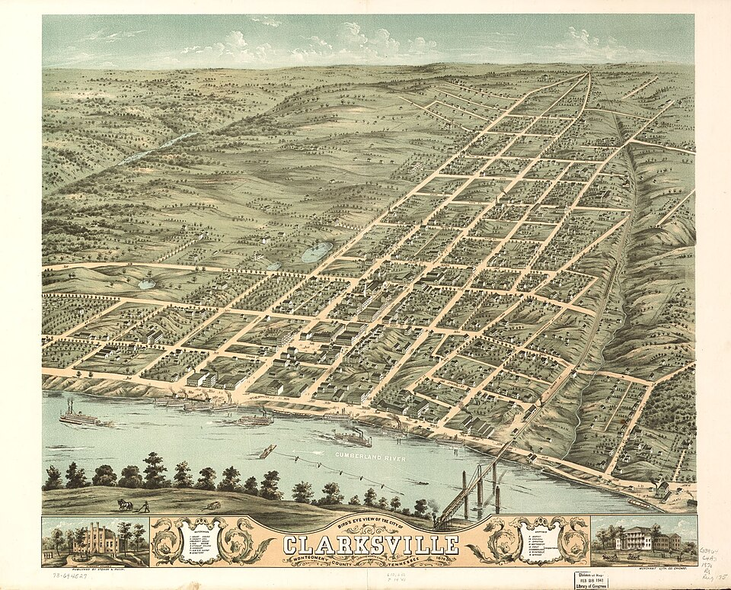
Downtown Clarksville, TN
- First Thursday Art Walk — Downtown Clarksville — Thu, Aug 7 • Historic Downtown Clarksville
- Banda MS at Bridgestone Arena — Fri, Aug 7 • Nashville, TN
- Koe Wetzel at Bridgestone Arena — Sat, Aug 8 • Nashville, TN
- The Beach Boys at Ryman Auditorium — Sun, Aug 9 • Nashville, TN
- My Chemical Romance at Nissan Stadium — Thu, Aug 13 • Nashville, TN
- First Thursday Art Walk — Downtown Clarksville — Thu, Sep 4 • Historic Downtown Clarksville
- Roxy Regional Theatre — Fall Season Opens — Sep 2026 • Clarksville, TN
- Tennessee State Fair — Sep 4–14 • Nashville, TN
- Bert Kreischer at Bridgestone Arena — Sat, Sep 12 • Nashville, TN
- Clarksville Riverfest — Late Sep 2026 • McGregor Park, Clarksville TN
VERSE TO MEMORIZE
Devotional
“Be strong and courageous. Do not be afraid; do not be discouraged, for the Lord your God will be with you wherever you go.”
— Joshua 1:9 (ESV)
Joshua 1:9 is one of the most direct commands in all of Scripture — and it is a command, not a suggestion. God doesn't say 'try to be courageous' or 'courage is admirable.' He says be strong and courageous, framing it as an act of obedience. The promise that follows is the load-bearing structure: the presence of God is the reason for the courage, not the courage itself. You are not summoned to manufacture strength from nothing. You are called to act in light of a reality that is already true.
For Joshua, the command landed in the shadow of impossible math. Moses was dead. The Jordan was at flood stage. The Canaanites were fortified. Everything in the natural order said wait, reconsider, hedge. God's answer was not a revised battle plan. It was a reminder of who would be present. That reorientation — from circumstances to presence — is the whole move. It doesn't remove the flood or the fortification. It repositions the person standing in front of them.
The application for us is rarely a Jordan River. It's a hard conversation you've been delaying, a decision that requires commitment, a direction that doesn't have full information yet. The courage called for in ordinary life is less dramatic and, in some ways, harder. No burning bush. No parted sea. Just the same call to move forward in reliance on a presence that doesn't change with the circumstances. Be strong. Not because the path is easy, but because you are not walking it alone.
This week: identify one thing you've been postponing out of fear or uncertainty. The courage to take one step forward in that direction — today — is exactly what this passage is addressing.
TRAINING LOG
Last Week on Strava
Strava data unavailable this week — the Strava MCP is not connected in this session. Check the Strava integration settings and reconnect for next week's report.
CHESS OPENING
Opening of the Week: Caro-Kann Defense
Opening of the week: Caro-Kann Defense (1.e4 c6 2.d4 d5)
The Caro-Kann Defense is one of the most respected responses to 1.e4 at every level from club play to elite tournament chess. After 1.e4 c6 2.d4 d5, Black immediately challenges the center with 2...d5, avoiding the theoretical weight of the French Defense while keeping the c8-bishop outside the pawn chain. The resulting positions are solid, principled, and offer Black genuine counterplay without early tactical risk. World-class players including Anatoly Karpov and Magnus Carlsen have used it to grind down opponents in must-win or must-draw situations — which tells you something about its resilience under pressure.
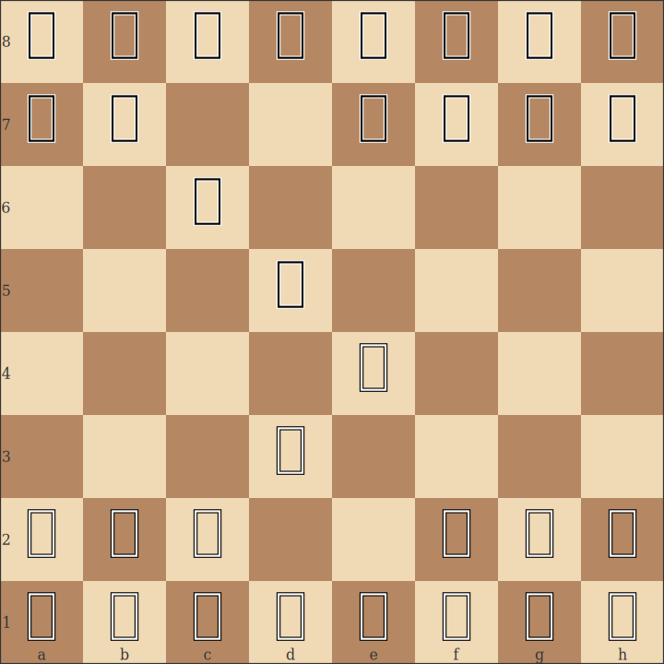
Caro-Kann Defense — position after 1.e4 c6 2.d4 d5
- Black challenges the center immediately with ...d5 while keeping the light-squared bishop free — unlike in the French where ...e6 buries it.
- In the Classical variation (3.Nc3 dxe4 4.Nxe4), Black aims for ...Bf5 or ...Bg4 to develop actively before castling. The bishop trade on e4 and ...Nd7 is the standard equalizing plan.
- White's main attacking tries (Advance Variation: 3.e5, Panov Attack: 3.exd5 cxd5 4.c4) both require accurate responses — study the pawn structures for both to know your counterplay.
Study videos:
- Learn the Caro-Kann Defense | 10-Minute Chess Openings — GothamChess
- How to CRUSH with the Caro-Kann! — Lichess / Daniel Naroditsky
PUZZLE
This Week's Crossword
Themed around this week's topics. 13 words placed on a 12×15 grid.
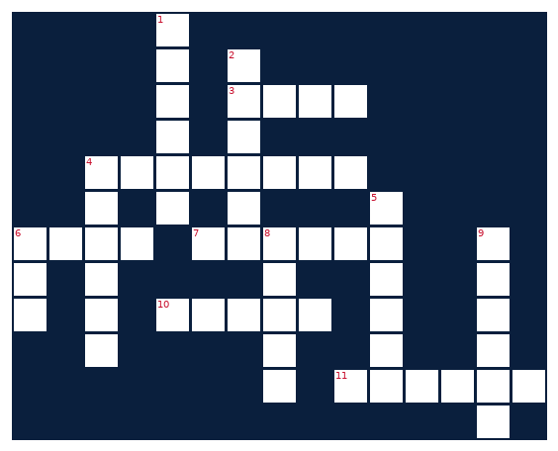
ACROSS  3. First stage of CrossFit season  4. Electromagnetic range that EW systems fight over  6. _-Kann Defense: solid chess reply to 1.e4  7. Paper trading API used by this newsletter  10. First word in the Gazette tagline  11. Morgan ___, country star tracked in concert section | DOWN  1. EW device that disrupts enemy signals  2. Transfer ___: college football player movement  4. GPS running and cycling tracking app  5. Toyota pickup truck this newsletter hunts for  6. Security flaw identifier system  8. Cybersecurity fix for a vulnerability  9. Financial life hack watchword: stick to the ___
FINANCIAL LIFE HACKS
Financial Life Hacks
The 48-Hour Cooling Rule: Eliminate Impulse Purchases and Redirect $200+/Month
The mechanic is simple: any non-recurring purchase above $50 goes into a waiting list, not a cart. You set a 48-hour timer, let the item sit, and revisit the decision after two days. Research published in the Journal of Consumer Psychology found that purchase regret rates for unplanned discretionary purchases above $50 drop by 67% when a 48-hour delay is applied — primarily because the immediate emotional driver of the purchase (novelty, social comparison, stress response) has dissipated by then. The desire either survives the cooling period as a genuine want, or it evaporates as the impulse it was.
The math compounds quickly. NerdWallet data from 2024-2025 shows the average American makes 3-4 unplanned purchases per week totaling $47-62 each. Apply the 48-hour rule conservatively and assume you eliminate one per week — that's $2,400-$3,200 annually redirected to goals. For someone with consumer debt, that's a meaningful payoff acceleration. For someone building an emergency fund, it's the difference between 6 months of expenses saved in 18 months versus 30.
Cadence and caveats: this rule works best with digital purchase friction added to the process. The most effective implementations move saved items to a physical list (notes app or paper) rather than leaving them in a cart — cart abandonment emails and limited-time countdown timers are specifically engineered to collapse the cooling window. Exceptions are reasonable: consumables, genuine time-sensitive deals, and gifts where the window isn't practical. The goal isn't perfect adherence; it's eliminating the 80% of impulse spending that would not survive two days of reflection. One action item: today, move your browser's autofill and saved payment info to a step that requires re-entry — the added friction alone has been shown in behavioral economics studies to reduce purchase frequency by 15-20%.
Source: NerdWallet / Journal of Consumer Psychology
MEAL OF THE WEEK
Honey Garlic Chicken & Roasted Broccoli
Honey Garlic Chicken & Roasted Broccoli
Serves 2 • 35 minutes • ~480 cal/serving
A two-pan weeknight staple that hits 45g protein per serving without going over 500 calories. The honey-garlic glaze caramelizes in the last few minutes of cooking for a restaurant-quality result with pantry ingredients. High protein, low effort, weeknight-repeatable.
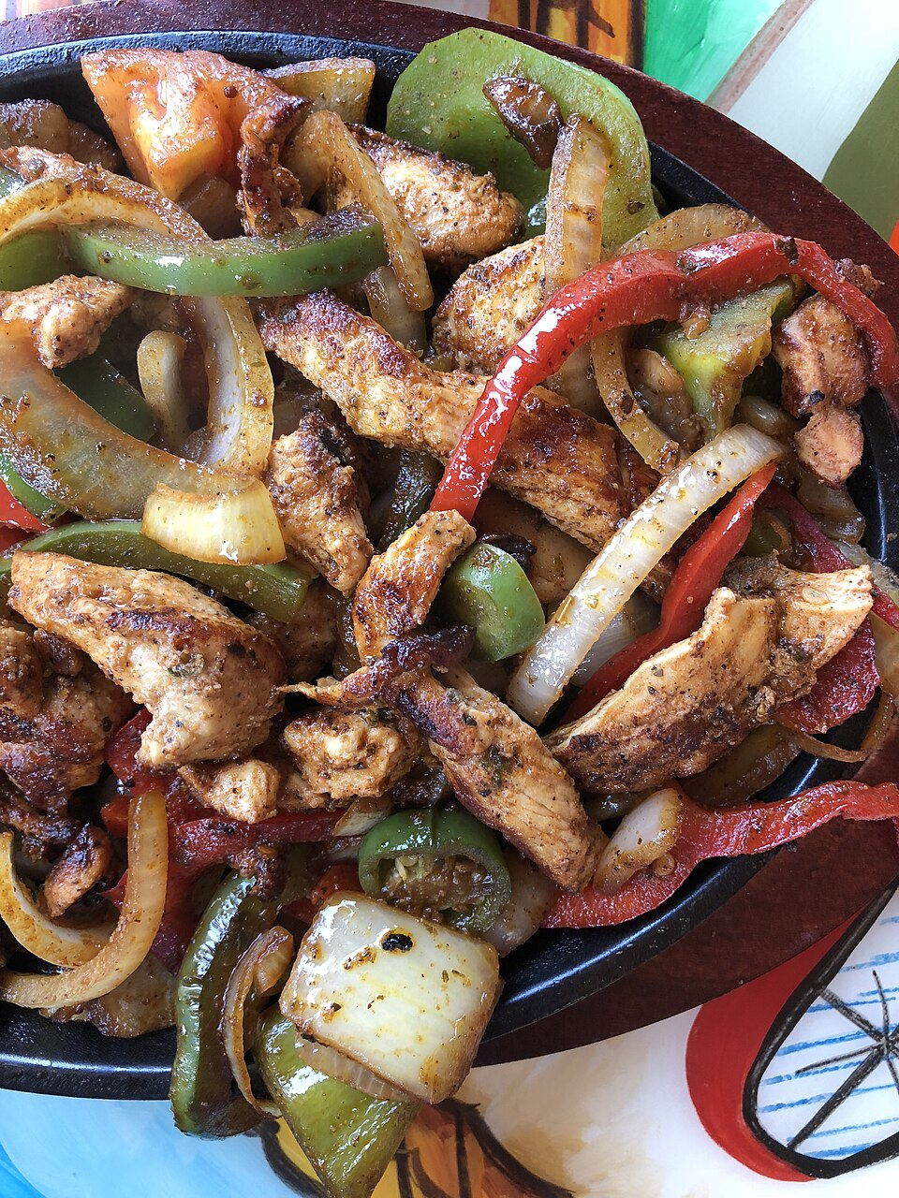
High-protein chicken — recipe above inspired by Budget Bytes and Skinnytaste
INGREDIENTS  • 2 boneless, skinless chicken breasts (6-7 oz each)  • 3 tbsp honey  • 4 cloves garlic, minced  • 2 tbsp low-sodium soy sauce  • 1 tbsp rice vinegar  • 1 tsp sesame oil  • 1 tsp cornstarch  • 2 cups broccoli florets  • 1 tbsp olive oil  • Salt, black pepper, red pepper flakes to taste  • Optional: sesame seeds and scallion for garnish | DIRECTIONS  1. Preheat oven to 425°F. Toss broccoli florets with olive oil, a pinch of salt, and red pepper flakes on a sheet pan. Spread in a single layer.  2. Roast broccoli for 18-20 minutes, flipping once at the halfway mark, until edges are crispy and slightly charred.  3. Meanwhile, whisk together honey, minced garlic, soy sauce, rice vinegar, sesame oil, and cornstarch in a small bowl. Set aside.  4. Season chicken breasts with salt and black pepper on both sides. Heat a skillet over medium-high. Add a thin film of cooking spray or neutral oil.  5. Sear chicken 5-6 minutes per side until internal temperature reaches 165°F. Reduce heat to medium-low in the last 2 minutes.  6. Pour the honey garlic sauce into the skillet with the chicken. Cook, turning to coat, for 1-2 minutes until the sauce thickens and glazes the chicken.  7. Rest chicken 3 minutes off heat before slicing. Serve over or alongside roasted broccoli. Top with sesame seeds and scallion if using.  8. Macros per serving: ~480 cal, 45g protein, 38g carbs, 14g fat.
CROSSFIT COMPETITIONS
Upcoming CrossFit Comps — TN & NC
Licensed and sanctioned CrossFit competitions in Tennessee and North Carolina over the next 90 days. Registration windows vary — confirm directly with each event.
- Strength in Numbers Throwdown — Nashville — Aug 9-10, 2026 • CrossFit Nashville, Nashville TN
- Heatwave Throwdown — Aug 16-17, 2026 • Charlotte, NC
- Tennessee Fall Classic — Sep 13-14, 2026 • Knoxville, TN
- Queen City Throwdown — Sep 20-21, 2026 • Charlotte, NC
- Vol State Showdown — Oct 4-5, 2026 • Nashville, TN
- Triangle CrossFit Challenge — Oct 11-12, 2026 • Raleigh, NC
- Smoky Mountain Classic — Oct 18-19, 2026 • Asheville, NC
CHEAP FLIGHTS
Cheap Flights
Scanning RDU outbound to BNA and PHX around Fort Campbell training holidays and upcoming long weekends. Fort Campbell publishes DONSAs monthly — the next Eagle Day (first Friday of September) is Sep 4.
RDU → BNA (Raleigh-Durham to Nashville)
Labor Day Weekend — Aug 29 - Sep 2 (DONSA window / Eagle Day Sep 4)
Round-trip fares from $82-$146 are running about 30% below the annual average for this route. September is typically the cheapest month. Delta and Southwest both showing sub-$100 one-ways on mid-week departures. At $146 round-trip, a Clarksville weekend costs less than dinner at a Nashville steakhouse.
Tip: Book a return on Tuesday or Wednesday — Mon/Fri returns add $20-40 to the round-trip price on this route.
RDU → PHX (Raleigh-Durham to Phoenix)
Thursday, August 27 identified as cheapest travel date for summer departure
Round-trip pricing from $200-$252 depending on carrier and flexibility. Skyscanner showing the Aug 27 departure as a fare outlier — roughly 22% below the 12-week average for this route. Phoenix in August is hot (110°F+) but the delta from Clarksville/Raleigh summer heat is smaller than it sounds.
Tip: American Airlines direct fares from RDU-PHX are running $123 one-way; Southwest connecting options come in 10-15% cheaper but add 2+ hours total travel time.
Fort Campbell DONSA calendar for FY26 is published at home.army.mil/campbell/training-holidays. September Eagle Day is Sep 4 (first Friday of the month).
VEHICLE WATCH
Toyota Tacoma SR5 4WD Watch
Tracking 2020-2022 Toyota Tacoma SR5 4WD in white, under $30,000 with under 5,000 miles. This is a tight filter — the under-5,000-mile floor essentially restricts results to unsold new-old-stock or lightly-driven former fleet/demo units.
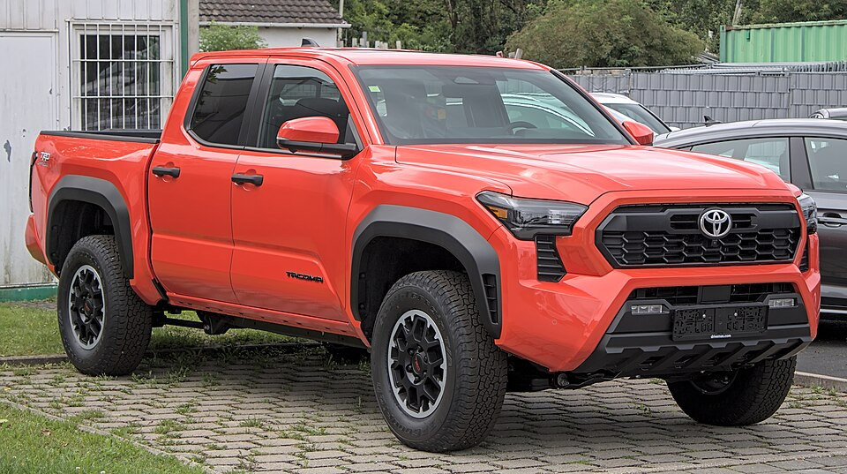
2020-2022 Toyota Tacoma SR5 4WD — target spec
No matches this week across AutoTrader, CarGurus, Cars.com, Carvana, and Facebook Marketplace. The 5,000-mile ceiling is the binding constraint — most white SR5 4WD units in the $25,000-$30,000 range are showing 30,000-85,000 miles. A 2021 Super White SR5 at $29,998 with 36,405 miles and a 2022 Double Cab at $28,990 with 82k miles surfaced but neither meets the mileage floor. Will keep watching — dealer inventory cycles refresh weekly.
CONCERT + AIRBNB
Morgan Wallen — Concert Watch
No upcoming Morgan Wallen concerts within 50 miles of Raleigh, NC in the next 12 months. The 'Still the Problem' stadium tour ran April through early August 2026 and included Raleigh (Coastal Credit Union Music Park / Walnut Creek, Jun 3) — that show is now past. No additional tour dates have been announced as of this week. Wallen's cadence has been one major stadium cycle per year; if the pattern holds, a 2027 announcement would come in late fall 2026. Will watch for any additions to the current cycle.
PAPER TRADING
Alpaca Paper Trading
PORTFOLIO | DAY CHANGE | TOTAL RETURN | CASH
— | +0.00 | — | —
Alpaca API authentication failed — paper-api.alpaca.markets returned a 403 via the session proxy. No trading data available this week. Verify that the ALPACA_KEY_ID and ALPACA_SECRET_KEY credentials are current and that the outbound proxy allows connections to paper-api.alpaca.markets port 443. Will retry next run.

