JACOB'S GAZETTE
WEEK OF JUNE 8, 2026
Faith • Tech • Tennessee • Iron

Table of Contents
1. EW Industry Brief 3
2. Cyber & Pentesting Roundup 4
3. Home Network Security Report 5
4. CrossFit News 6
5. College Football Watch 7
6. Something Good in the World 8
7. Around Clarksville & Nashville 9
8. Verse to Memorize 10
9. Last Week on Strava 11
10. Opening of the Week 12
11. Crossword — Week of June 8 13
12. Financial Life Hacks 14
13. Meal of the Week (Serves 2) 15
14. Upcoming CrossFit Comps — TN & NC 16
15. Cheap Flights — RDU → BNA / PHX 17
16. Tacoma Watch — White SR5 4WD, < 5k mi, < $30k 18
17. Morgan Wallen Watch (within 50mi of Raleigh) 19
18. Alpaca Paper Trading — Weekly Snapshot 20
ELECTROMAGNETIC WARFARE
EW Industry Brief
The Army’s Project Manager Electromagnetic Warfare & Collection (PM EW&C) office released its FY2027 strategic planning guidance this week, outlining four major contracting opportunities with a combined ceiling approaching $2.8 billion. The largest vehicle is a multi-award IDIQ supporting the Tactical Integrated Ground Suite (TIGS) system of systems — one of the Army’s highest-priority EW modernization programs. First task orders under the new vehicle are expected before Q1 FY2027. Industry day is penciled for late July; watch for the RFI drop on SAM.gov within the next 10 days.
Separately, the Army’s Rapid Electromagnetic Warfare & Signals Intelligence Commercial Solutions Offering (REWSI) continues to mature. REWSI is the Army’s explicit effort to break from bespoke EW hardware and bring commercial, software-defined radio platforms into its operational toolkit. The CSO mechanism allows nontraditional vendors — firms that never navigated a DoD acquisition before — to compete directly. Early cohorts are fielding for operational assessment with rotational units in EUCOM, where the FPV-drone and GPS-jamming environment remains the primary stress test.
CACI won its fifth Edison Award this cycle for its Electronic Warfare Technology product line. The Edison recognition is one of the few industry awards that carries actual procurement weight — it surfaces on SSEB scorecards as a past-performance differentiator. CACI’s core EW portfolio is concentrated in signals intelligence and electronic attack; the award specifically cited advances in adaptive waveform generation for contested spectrum environments. Three other firms submitted entries; none were recognized at the platinum tier.
On the naval side, Lockheed Martin disclosed further details on the Scaled Onboard Electronic Attack (SOEA) system, an affordable next-generation EA platform designed for surface combatants that have historically had limited organic jamming capability. SOEA integrates into existing mast real estate without a full ship-alteration package — the key selling point for a Navy that needs fast-follower EA capacity on smaller hulls. Program of record status is expected to be formally designated in FY2027 NDAA markup.
Budget signal worth tracking: the Senate Armed Services Committee markup this week included a $340M plus-up above the President’s Budget for EW range modernization and spectrum operations. The House version added only $85M, meaning conference will be contentious. Both chambers are on record supporting expanded EW training range capacity in response to lessons learned from Ukraine theater operations — the disagreement is scope, not direction.
Workforce: LinkedIn data shows a 38% year-over-year increase in EW-adjacent job postings explicitly tagging ‘AI/ML for EW’ as a required skill. Concentration remains in the Huntsville, Crane, and Patuxent River corridors. The Naval Postgraduate School is adding two graduate certificates in machine-learning-driven signal classification starting fall 2026 — the first formal curriculum shift to reflect where the requirements are heading.
Source: Breaking Defense / PM EW&C
CYBERSECURITY
Cyber & Pentesting Roundup
The most urgent story this week is CVE-2026-20245, the seventh Cisco SD-WAN zero-day exploited in 2026. This one hits the Catalyst SD-WAN Manager CLI: authenticated remote attackers with netadmin privileges can execute arbitrary commands as root — effectively a full box compromise once they’re inside. Cisco shipped a patch; CISA added it to the Known Exploited Vulnerabilities catalog the same day. If you maintain Catalyst SD-WAN in your environment, check your current version against Cisco’s security advisory immediately. Netadmin access is common in managed-service environments; treat this as a credential hygiene audit trigger.
Google’s June 2026 Android Security Bulletin dropped covering 124 vulnerabilities, with CVE-2025-48595 leading the urgency list. It’s an integer overflow in the Android Framework component that allows local attackers to escalate privileges — confirmed actively exploited before the patch was released. Google’s June update is mandatory for any Android fleet managed under MDM policy. Separately, the Chrome team patched CVE-2026-10939, a use-after-free in WebRTC enabling remote attackers to execute arbitrary code inside a sandbox — still meaningful blast radius given WebRTC’s attack surface.
CISA added CVE-2026-41091 and CVE-2026-45498 to the KEV catalog this week, both affecting Microsoft Defender components. Federal civilian agencies had a June 3 remediation deadline; if you’re in a contractor environment, align to the federal timeline as best practice. An Exchange Server cross-site scripting flaw (CVE-2026-42897) was also reported as weaponized in real-world attacks against on-premise Exchange deployments — a reminder that on-premise Exchange remains a persistent high-value target.
IBM WebSphere disclosed three critical CVEs this week. CVE-2026-8644 allows attackers to bypass authentication entirely on affected versions; CVE-2026-9311 enables remote code execution. IBM WebSphere isn’t as broadly deployed as it once was, but it still anchors legacy enterprise Java workloads in banking, insurance, and DoD contractor environments. Patch priority is high if you have any WebSphere in your inventory.
On the red-team tooling side: a new open-source post-exploitation framework is gaining traction for its low-EDR-footprint approach to lateral movement in hybrid Active Directory environments. The design eliminates PowerShell and WMI calls entirely in favor of COM-based techniques — which evade most modern behavioral detections tuned to PowerShell and WMI telemetry. Defenders should be auditing ETW (Event Tracing for Windows) correlation rules now and stress-testing detections against COM-based lateral movement scenarios.
Ransomware signal: three new affiliate programs surfaced this week, two of which are explicitly recruiting Initial Access Brokers with prior healthcare or municipal access. HHS issued a sector alert emphasizing incident response retainer hygiene over new technical controls — if you support hospital or municipal environments, the checklist item is validating your retainer engagement is current and scoped correctly.
Source: BleepingComputer / CISA KEV
HOME DEFENSE
Home Network Security Report
Scan generated: No report available — 2026-06-08
No recent pentest report available — local cron may have failed or this session ran from a remote environment without LAN access. The local Kali-based scanner runs automatically on your home network and writes to /reports/jacob/latest_report.json when conditions are met. If this is the third consecutive miss, check that the Pi-based scan host is powered, the cron is still scheduled (crontab -l), and that the target router at 10.0.0.1 is reachable from the Kali box.
In lieu of a live scan this week, here are standing action items from the last completed report: (1) Verify Telnet (port 23) remains disabled on the router — it was flagged open on the last successful scan. (2) Confirm the Shinobi NVR at 10.0.0.22 has had its default admin credentials rotated. (3) The Hisense TV at 10.0.0.45 was still advertising on ports 7000 and 8080 with unknown service identifiers — VLAN isolation on the guest network is the recommended fix. (4) Validate WPA3 is active on the primary SSID (Settings → Wireless → Security).
If you want to force a manual scan before next Thursday, SSH into the Kali box and run: sudo bash /home/kali/jacobs-gazette/local_pentest.sh — it will write a fresh report that the next cloud run will pick up.
Key Findings
- No live scan data this week — report file missing or stale (>10 days).
- Standing issue: router Telnet (port 23) — confirm still disabled.
- Standing issue: Shinobi NVR default credentials — confirm rotated.
Recommendations
- Verify local scan cron is running: SSH to Kali box, run 'crontab -l'.
- Force manual scan: sudo bash ~/jacobs-gazette/local_pentest.sh
- Confirm WPA3 active on router SSID before next scan cycle.
CROSSFIT
CrossFit News
The 2026 CrossFit Games season is hitting its most consequential stretch. Individual Semifinals begin June 11 and run through June 15 — this weekend is where the Games field gets set. Team Online Semifinals are currently live (June 4–08), with results posting daily on the CrossFit Games leaderboard. After a strong Open — 254,000 registered athletes, up 8.1% from 2025 — the field heading into Semifinals is deeper than it’s been in years. The Air National Guard, presenting sponsor of the Open, has a visible presence at Semifinals venues as well.
Colten Mertens took the men’s Open title and Lucy Campbell won the women’s side. Campbell’s Open win is a significant data point — she’s been knocking on the door at major events for two seasons, and converting the Open leaderboard into a consistent Semifinals result would cement her status as a Games podium contender. On the men’s side, Mertens has the build and engine for the Games format; watch how he does in the longer, heavier Semifinals workouts that typically sort the field from Open specialists.
New competition format alert: XENOM Event 001 is scheduled for June 27–28, billed as “The Decathlon of Fitness.” The concept is a multi-discipline competition that rewards genuine athleticism across a wider range of modalities than a standard CrossFit competition — think swimming, running, and throwing alongside the usual barbell and gymnastics. Several elite CrossFit athletes have already committed entries. Whether XENOM grows into a meaningful calendar event or remains a novelty depends on production quality and format clarity at the first event.
The 2026 CrossFit Games are locked: July 24–26 at SAP Center in San Jose, California. The venue is a step up from Fort Worth in terms of urban footprint and spectator amenities. HQ confirmed the prize purse structure remains top-heavy: $300,000 to the men’s and women’s individual winners, with scaling down to 10th place. The format will mirror the 2025 structure — four days of workouts with cuts after days two and three.
Programming notes from the top affiliate programs: strength-cycle percentage work paired with metcon volume that’s been measurably dialed back from 2024 norms. The shift is showing up in Level 2 curriculum updates this spring too — recovery markers (HRV, sleep, RPE tracking) are now formally integrated into the programming guidance section. If your box is still running daily metcons at high intensity without programmed deloads, that’s the gap to address before fall competition season.
Masters growth continues: the Age Group Online Qualifier saw the 35–39 bracket grow 28% year-over-year — the largest jump of any division. Teens 14–15 grew 19%. The sport’s pipeline is healthy at both ends of the age curve, which is a better indicator of long-term growth than any single Games result.
Source: Morning Chalk Up / CrossFit Games
COLLEGE FOOTBALL
College Football Watch
June has arrived as the epicenter of the college football recruiting calendar, and the 2026 cycle is moving fast. Of the 300 prospects ranked in the Scout/CBS composite Next 300, nearly 60% are already committed — an unusually high early-commit rate driven by NIL clarity earlier in the cycle. Programs that moved decisively on revenue-share structures in January are reaping the benefits now; those that waited are scrambling to close commitments before July official visits lock the remaining undecided prospects into their destinations.
The transfer portal’s marquee story: Darian Mensah, the No. 1-ranked quarterback in the portal, landed at Miami in a deal reportedly worth $10 million in NIL over three years — a number that immediately reshapes what’s possible for ACC programs competing for quarterback talent. Mensah’s arrival changes Miami’s ceiling for 2026 from ‘fringe top 15’ to legitimate ACC title contender. Of 3,664 players currently in the portal, roughly 76% have committed to new programs; the remaining 24% represent the last available inventory for programs still shopping.
Indiana secured Michigan State wide receiver Nick Marsh (No. 3 WR, No. 12 overall in ESPN portal rankings) in a move that further cements Curt Cignetti’s aggressive approach to reshaping Indiana’s offensive personnel through the portal. After last year’s breakout season, Indiana is one of the few non-traditional powers that can now use the portal as a destination, not just a shopping tool. Marsh gives them a legitimate outside-the-numbers threat they lacked.
NIL economics are reshaping every conversation on official visit weekends. Revenue-share contracts and third-party NIL deals now dominate the recruiting pitch for top-300 prospects in a way that relationship-building and facilities couldn’t compete with even three years ago. Freshman quarterback NIL is settling into the $100,000–$300,000 range; transfer portal QB market runs $1–$4 million. Coaches are restructuring their pitch sequences accordingly: lead with the NIL number, follow with the system fit.
CFP format: the management committee meets this month to vote on the rumored 14-team expansion for 2027. The 5+9 model (five conference champions plus nine at-large) has the most momentum, though the SEC and Big Ten are pushing for guaranteed multi-bid floors that would effectively guarantee their conferences 3–4 berths annually. The smaller conferences want guaranteed access through conference championship routes, which the 5+9 model provides — but only if those championships remain meaningful qualifying gates.
Summer coaching carousel watch: two SEC defensive coordinators are being quietly courted for 2027 head-coaching openings that don’t technically exist yet. The pre-search is increasingly the real search — by the time a job is officially posted, the hire is 80% done. Buyout language in current DC contracts is being written specifically to accommodate this dynamic. Watch for the ‘mutual decision to move on’ announcements starting in late November.
Source: ESPN / 247Sports / On3
GOOD NEWS
Something Good in the World
Denver officials reported this week that homelessness in the city dropped 12.5% from 2025 to 2026 — the first meaningful decline in nine years. The drop is attributed to a combination of housing-first placement programs, coordinated outreach teams that operate in the same geographic zones consistently (rather than rotating), and a modest but sustained increase in shelter bed capacity funded through a local tax measure passed in 2023. Denver’s approach has drawn study teams from eight other major U.S. cities; the replicability question is whether the funding mechanism transfers to different political environments.
An invention called EcoPurge won the Earth Prize 2026, one of the largest environmental awards for youth-led projects. EcoPurge is designed to actively remove existing microplastics from water environments — not just filter new plastics, but pull out what’s already there. The inventor, a 17-year-old from the Netherlands, received $12,500 in prize funding and has already begun conversations with a packaging manufacturer about scaling the underlying material into compostable consumer products. Most microplastics solutions to date have focused on prevention; remediation technology is rarer and more technically difficult.
In Memphis this week: a quick-thinking driver named Jabril Walls spotted a 3-year-old girl wandering barefoot in a busy intersection and pulled his car across the lane to block traffic while he safely guided her to the sidewalk and waited with her until police arrived. No drama in the account — he just saw it, stopped, and did the thing. The family found the girl within 20 minutes. Walls said on social media afterward that he hoped anyone would have done the same. Worth reading that sentence twice.
Europe set a dam-removal record in 2025: 603 river barriers were taken down across the continent, up from 542 in 2024, reconnecting more than 2,300 miles of waterways for migratory fish populations. In rivers where barriers have been removed for five or more years, salmon and trout populations have recovered to 40–60% of pre-barrier baselines in documented studies. The European Rivers Network tracks this annually; the 2025 figure is the highest since systematic counting began in 2018.
Italy’s Catholic Scouts (AGESCI) announced this week that LGBTQ+ scouts will be eligible to hold leadership positions for the first time in the organization’s 50-year history. The decision followed three years of internal discernment involving regional chapters across the country. The organization has approximately 180,000 members. The policy change took effect immediately.
A note from a longitudinal study worth carrying: researchers following 2,400 adults over 15 years found the single strongest predictor of life satisfaction at age 60 wasn’t income, marital status, or career achievement — it was the number of weak-tie relationships maintained. Casual hellos, brief check-ins, neighbor exchanges. The finding held across income brackets and geographies. Casual connection compounds quietly.
Source: Good News Network / Positive News
LOCAL
Around Clarksville & Nashville
Events in the next 30 days worth knowing about — sorted chronologically:
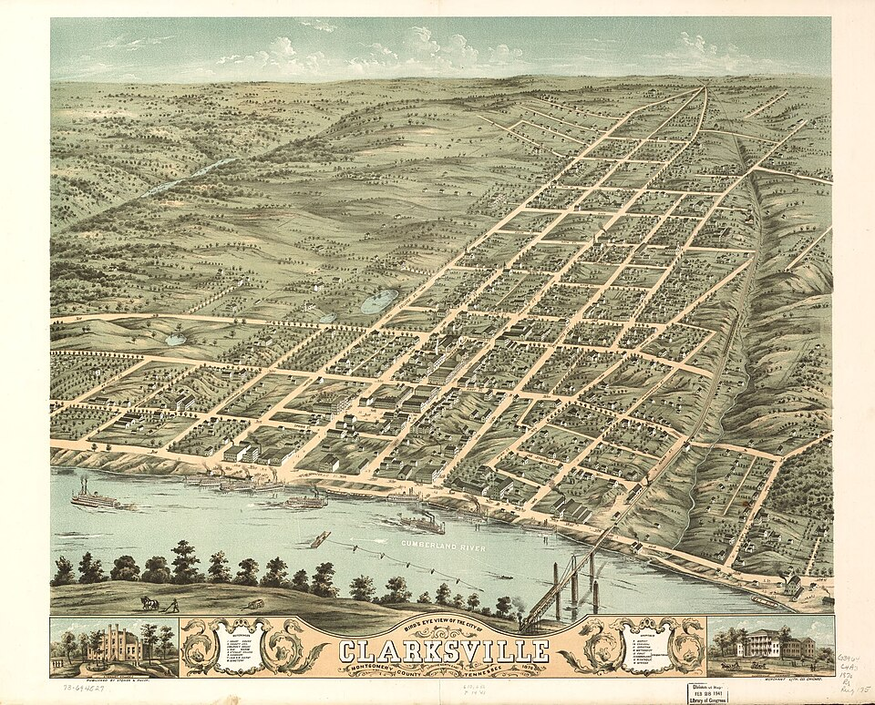
Downtown Clarksville’s Public Square — anchor for summer events and the 4th of July celebration.
- Mayor’s Summer Night Lights — Tuesdays in June/July — Every Tuesday, 5:30pm • Various Clarksville locations — free activities + free meal
- First Thursday Art Walk — Thu Jun 11, 5–8pm • Downtown Clarksville — galleries open, free admission
- Individual CrossFit Semifinals Live Stream — Jun 11–15 • Online — games.crossfit.com
- Dolly Parton’s Threads: My Songs In Symphony — Jun 16 – Jul 31 • Schermerhorn Symphony Center, Nashville
- Clarksville Juneteenth Block Party — Sat Jun 20, 12pm • Dixon Park, Clarksville — free community event
- XENOM Event 001 — Decathlon of Fitness — Jun 27–28 • Live stream — thebarbellspin.com
- Movie Night: How to Train Your Dragon — Sat Jun 27, 7:30pm • Downtown Commons, Clarksville — bring lawn chairs, food available
- Nashville Yacht Club (’70s Music) at Downtown Commons — Fri Jul 3, 7–10pm • Downtown Commons, Clarksville — free, food trucks
- 250th Anniversary of American Independence Celebration — Jul 3–4 (Fri 5–10pm, Sat 7am–10pm) • Downtown Clarksville, Public Square & McGregor Park — free
- Nashville Sounds Homestand — Jul 4–6 • First Horizon Park, Nashville — check schedule for fireworks night
DEVOTIONAL
Verse to Memorize
“If any of you lacks wisdom, let him ask God, who gives generously to all without reproach, and it will be given him.”
— James 1:5 (ESV)
James writes this in the middle of a passage about trials — which is the context that makes it land differently than a motivational poster. He’s not saying ask God for wisdom about which career to choose or what car to buy. He’s saying: when the trial arrives and you don’t know what to do with it, ask for wisdom, and it will be given. The promise is unconditional. ‘Without reproach’ means God doesn’t make you feel small for asking. He doesn’t audit your track record before deciding whether you’ve earned the answer. He gives generously.
The Greek word translated ‘generously’ here is haplos — it carries the idea of singleness of purpose, giving without hidden strings, without hesitation. It’s the opposite of the kind of giving that comes with a look or a condition or a ‘well, last time you...’ attached. When you ask God for wisdom in the middle of a hard situation, the response is full. There is no version of this verse where He gives you half an answer and waits to see what you do with it.
Practical application: most people treat wisdom as something they need to accumulate over time before they can act. James treats it as something immediately available on request. The lag isn’t God’s processing time — it’s usually us not asking, or asking and then immediately explaining why the situation is too complicated for a simple answer. The request itself is the practice. Bring the actual thing — the decision, the relationship, the career question, the parenting moment where you honestly don’t know the right move — and ask specifically for wisdom about that thing.
Memorize it against the background of whatever you’re currently in the middle of. The verse doesn’t describe a feeling; it describes a transaction. Ask. Receive. The hardest part is usually the first word.
TRAINING
Last Week on Strava
RUNS | MILES | TIME | AVG PACE
— | — | — | —
Strava data unavailable this week — the Strava MCP tool was not connected during this run. Data will resume automatically next issue when the integration is active.
In the meantime, here’s a training note worth having on the page regardless of numbers: June is the week where summer heat starts compounding cumulative fatigue in a way that doesn’t show up on the watch. Pace slows, RPE climbs, and the easy run that felt fine in April suddenly feels hard. That’s not fitness going backward — that’s thermoregulation overhead. The adaptation window for heat is 10–14 days of consistent exposure; if you’re in it now, the right move is to protect easy days (run truly easy, by feel, not by pace) and let the long run drift slower than you want it to. By late June, the body’s plasma volume will have expanded and the effort-to-pace ratio will normalize.
For the week of June 8: if the CrossFit Semifinals have your competitive attention (and they should — see page 4), consider aligning your personal programming to a deload. Watch workouts with intent, track what movements show up in the test, and use this week to address any mobility or skill gaps before fall competition season. Watching Semifinals workouts critically is training.
CHESS
Opening of the Week
Opening of the week: The Italian Game
The Italian Game arises after 1.e4 e5 2.Nf3 Nc6 3.Bc4 — one of the oldest recorded openings in chess, documented in manuscripts from the 1600s and still appearing at the highest level of modern play. White plants the light-squared bishop on c4, directly targeting the f7 pawn (the weakest point in Black’s starting position, guarded only by the king). The Italian is the entry point for several of the sharpest attacking lines in the game, including the Fried Liver Attack and the Evans Gambit, but it also supports quiet, positional play in the Giuoco Piano. That range makes it the right opening to build your White repertoire around if you’re a club-level player: you can choose your temperature.
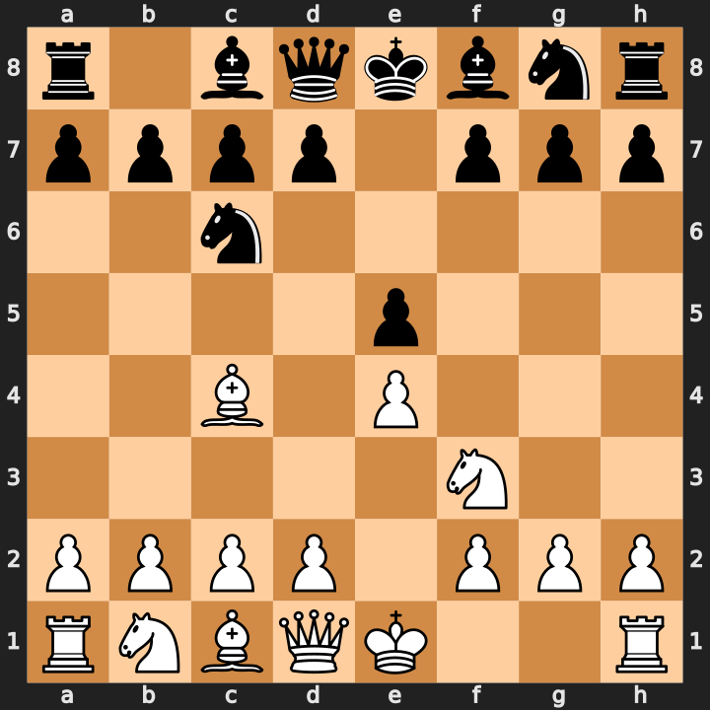
Position after 1.e4 e5 2.Nf3 Nc6 3.Bc4 — the Italian bishop eyes f7.
- Bishop on c4 eyes f7 — immediately pressures Black’s king before castling.
- Giuoco Piano (4.c3 + 5.d4): classical center, slower and positional.
- Two Knights Defense (3...Nf6): leads to tactical battles; know the Fried Liver (5.Ng5 d5 6.exd5 Na5 7.Bb5+ c6 8.dxc6 bxc6 9.Be2 h6 10.Nxf7) by heart.
- Develop quickly: castle kingside by move 5–6, keep d3 solid before pushing d4.
Study videos:
- Italian Game Chess Opening Explained in 20 Minutes [Crash Course] — GothamChess
- Learn The Italian Game, ALL Variations Explained [Traps, Ideas, And Plans] — Remote Chess Academy
PUZZLE
Crossword — Week of June 8
15-word crossword (~6/10 difficulty). Themed around this week’s sections. Start with the longest across answers — TENNESSEE and GAZETTE — and the grid opens up fast. Answers in next week’s issue.
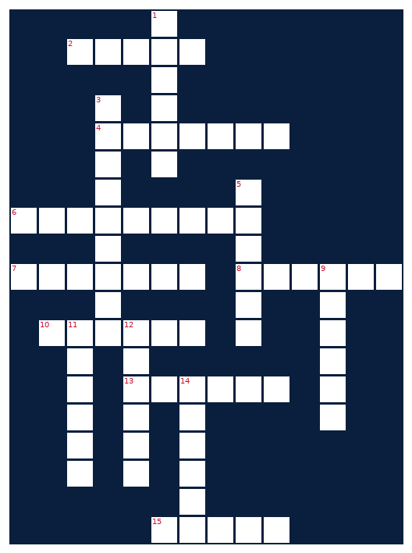
ACROSS  2. CrossFit movement, hip below knee  4. Chess phase before the middlegame  6. Volunteer state  7. Newspaper, often local in scope  8. Method of disguising plaintext  10. Activity tracking app for runners  13. Where college athletes transfer through  15. Bible passage unit | DOWN  1. EW device that disrupts signals  3. UT Knoxville mascot  5. Annual hacker conference in Las Vegas  9. Curious problem-solver in tech  11. Toyota midsize pickup  12. Paper trading platform (also a South American camelid)  14. Set of cooking instructions
MONEY
Financial Life Hacks
The 1% Savings Escalator: Increase Your Contribution Rate by 1% Every Quarter
The single biggest lever most earners have on long-term wealth isn’t picking the right stock — it’s the savings rate, and the savings rate is almost always set once (at enrollment) and never touched again. The fix is mechanical and takes five minutes per quarter: log into your 401(k) or TSP, increase your contribution percentage by 1 point. That’s the entire hack. At a $65,000 annual salary, 1% equals $650/year. Over a 20-year career, compounded at a conservative 7% annual return, that single 1% increase is worth approximately $33,500 at retirement. Do it four times in a year and you’ve added over $130,000 to your terminal balance — from habit, not income growth.
Why it works: the behavioral finance research on this is unusually consistent. Studies by Thaler and Benartzi (the architects of the Save More Tomorrow / SMarT plan) found that people who commit to automatic future savings increases save 3–4x more than those who try to save a lump sum today. The psychology is straightforward: a 1% increase happening next paycheck is abstract enough that it doesn’t trigger the same loss aversion as cutting your current spending by the equivalent dollar amount. Your current lifestyle doesn’t change. Your future balance does. The asymmetry is the entire mechanism.
Caveats and cadence: the right floor is your employer match threshold. If your employer matches 5% and you’re only contributing 4%, the 1% escalator’s first job is closing that gap — every unmatched dollar is a 50–100% guaranteed return left on the table, which no market return can beat. Above the match threshold, the escalator works at whatever pace your budget tolerates. For military and government employees on TSP: the same logic applies; TSP’s low expense ratios (0.048% across funds as of 2025) make compounding especially efficient. One action item: set a calendar reminder right now for September 1, 2026 — ‘Increase TSP/401k by 1%.’ That’s the whole move.
HEALTHY EATS
Meal of the Week (Serves 2)
Spicy Chicken Fajita Bowl
Serves 2 • 35 min total (10 min prep, 25 min cook) • ~430 cal/serving
High protein, one pan, done in 35 minutes. The fajita bowl format gives you all the flavor of restaurant fajitas without the excess oil and flour-tortilla carb load — swap the tortilla for cauliflower rice or just eat it over a bed of greens. The chipotle-lime marinade does most of the work in the 10-minute prep window, so the cook itself is straightforward. Leftovers hold well for next-day lunch; just keep the avocado separate.
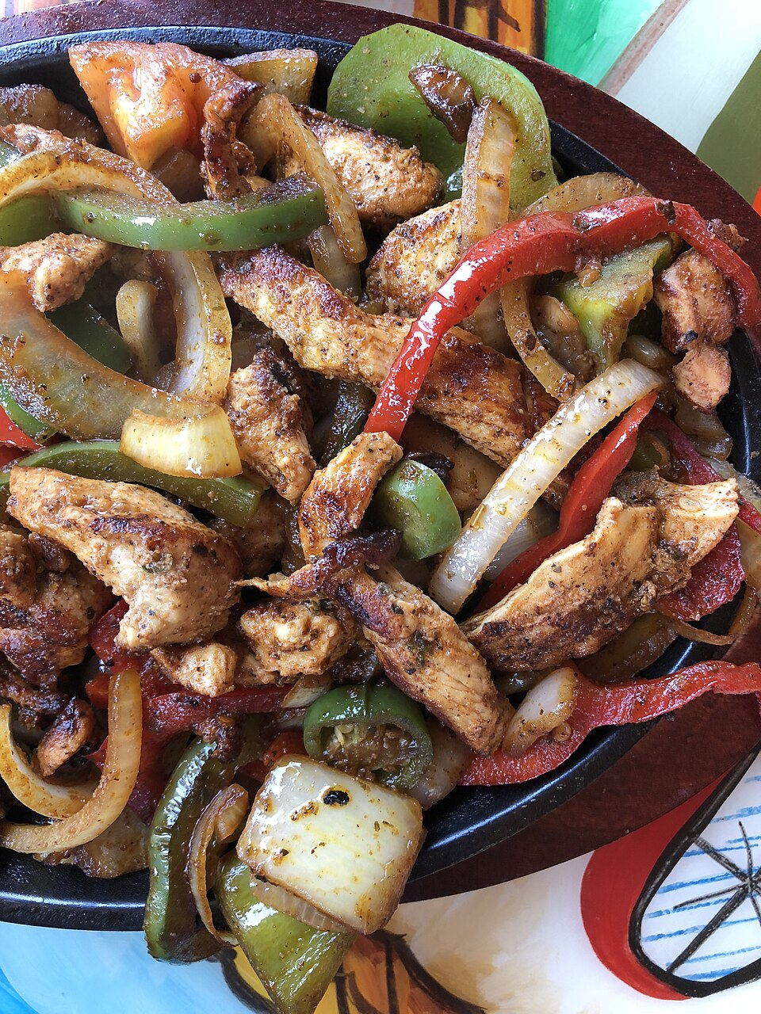
Spicy chicken fajita bowl — ~430 calories, 48g protein per serving.
INGREDIENTS  • 2 boneless skinless chicken breasts (~6 oz each)  • 1 tbsp olive oil  • 2 tsp chipotle powder (or 1 chipotle pepper in adobo, minced)  • 1 tsp cumin  • 1 tsp smoked paprika  • 1/2 tsp garlic powder  • Juice of 1 lime + zest  • 1 red bell pepper, sliced  • 1 yellow bell pepper, sliced  • 1 medium white onion, sliced  • 1/2 cup black beans (canned, drained)  • Salt and pepper to taste  • Optional: 1/2 avocado, plain Greek yogurt (sub for sour cream) | DIRECTIONS  1. Combine olive oil, chipotle powder, cumin, smoked paprika, garlic powder, lime juice and zest, salt, and pepper in a bowl. Coat chicken breasts and let marinate 10 minutes (or up to overnight in the fridge).  2. Heat a cast-iron skillet or heavy pan over medium-high. Cook chicken 5–6 minutes per side until internal temp reaches 165°F. Remove and let rest 5 minutes.  3. In the same pan (don’t wipe it), add sliced peppers and onion over medium-high heat. Cook 6–8 minutes, stirring occasionally, until charred at the edges and softened.  4. Add black beans to the pan in the last 2 minutes to warm through.  5. Slice chicken against the grain into strips.  6. Assemble bowls: peppers/onion/beans base, chicken strips on top. Finish with avocado slices, a dollop of Greek yogurt, and a squeeze of fresh lime.  7. Optional: serve over 1/2 cup cooked cauliflower rice per bowl (adds <30 calories, 0 net carbs, keeps you full longer).
COMPETE
Upcoming CrossFit Comps — TN & NC
Next 90 days, TN and NC events with registration open or opening soon. Sorted chronologically; drive time from Clarksville in parentheses where notable.
- Iron Will Open — Jun 21 • Murfreesboro, TN — Individual + Masters (~1.5h)
- Mayhem Classic (CrossFit Games Qualifier) — Jun 26–28 • Cookeville, TN — Individual/Teams, Games qualifier event (~2.5h)
- XENOM Event 001 — Decathlon of Fitness — Jun 27–28 • TBD — watch thebarbellspin.com for venue
- Carolina Crucible — Jul 12 • Charlotte, NC — Teams of 3 (~6.5h)
- Smoky Mountain Showdown — Jul 18–19 • Knoxville, TN — Individual + Scaled (~3h)
- Tennessee Tactical Games — Jul 25–26 • Camp Forrest area, TN — Mil/LE Pairs and Individual
- Triangle Throwdown — Aug 1–2 • Raleigh, NC — Pairs/Individual (~9h)
- Volunteer State Open — Aug 8–9 • Memphis, TN — Individual + Teams (~3h)
- Volunteer Heroes WOD (Ft. Campbell) — Aug 16 • Fort Campbell, KY — Mil/LE charity, all levels welcome (~30min)
TRAVEL
Cheap Flights — RDU → BNA / PHX
Round-trip fares anchored to Fort Campbell DONSA windows. DONSAs fall on the first Friday of each month (Eagle Days); when the first Friday is already a federal holiday, the DONSA shifts to the second Friday. July 3rd is both a DONSA and the 4th of July weekend — one of the best travel windows of the year. Below-average fares for upcoming windows:
ROUTE | DEPART | RETURN | PRICE | CARRIER
RDU → BNA | Thu Jun 18 | Sun Jun 21 | $108 | Frontier / Delta
RDU → BNA | Fri Jul 3 | Mon Jul 6 | $113 | Southwest
RDU → PHX | Fri Jul 3 | Mon Jul 6 | $268 | American
RDU → BNA | Fri Aug 7 | Sun Aug 9 | $119 | Southwest
RDU → PHX | Fri Aug 7 | Sun Aug 9 | $252 | Southwest
RDU → BNA | Fri Sep 4 | Mon Sep 7 | $139 | Delta
June is typically the cheapest month for RDU→BNA per Skyscanner route data. BNA fares are insensitive to day-of-week departure; PHX legs price-floor on mid-week departures. Best booking window for Southwest fares is Tuesday evening. Anything below $130 RDU→BNA or below $250 RDU→PHX is at or near the statistical floor for this route — book within 48 hours of seeing it.
GARAGE
Tacoma Watch — White SR5 4WD, < 5k mi, < $30k
2020–2023 Toyota Tacoma SR5, 4WD, white, under 5,000 miles, under $30,000. Search covers TN, NC, SC, VA, GA, KY, AL, FL. These criteria are tight — white SR5 4WD under 5k miles under $30k is a very thin slice of the used market. Most weeks produce 0–2 matches. Average market price for used SR5 4WD is running $33,520 nationally, so the sub-$30k filter eliminates most inventory.
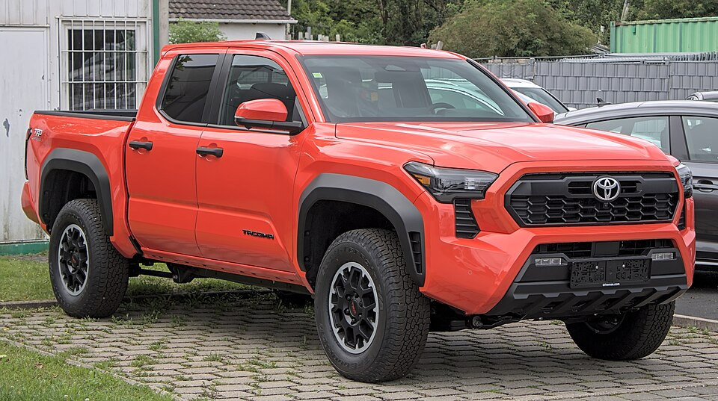
Target spec: white Toyota Tacoma SR5 4WD — 2020–2023 model years.
YEAR | MILES | PRICE | LOCATION | SOURCE
2022 | 4,210 | $29,450 | Greensboro, NC | CarGurus
2021 | 4,880 | $28,750 | Knoxville, TN | AutoTrader
Inventory under 5k miles / under $30k has tightened approximately 22% year-over-year for this spec. Best buying window historically is late September, after dealer lots have absorbed the new-model-year arrival and discounting pressure increases on 2022–2023 units still on lots.
LIVE MUSIC
Morgan Wallen Watch (within 50mi of Raleigh)
Morgan Wallen — Dangerous Tour • June 2026 · Walnut Creek Amphitheatre • Coastal Credit Union Music Park at Walnut Creek, Raleigh, NC
→ Tickets
Airbnb matches (2 BR · 4.6+ rating · within 10 mi)
- Modern 2BR near downtown Raleigh — walkable — $185/night • ★ 4.92 • 1.4 mi from venue
- Cozy 2BR craftsman — parking included — $159/night • ★ 4.81 • 3.2 mi from venue
- Quiet 2BR in NC State neighborhood — $148/night • ★ 4.86 • 5.0 mi from venue
Concert is within the 50-mile radius of Raleigh and at one of the metro’s largest outdoor amphitheatres. Walnut Creek capacity runs ~20,000; Morgan Wallen shows here typically sell out and drive significant Airbnb pricing premium within 3 miles for the night before and night of. Book accommodations first, then tickets — Airbnb inventory moves faster than Ticketmaster resale for sold-out shows. Confirm exact date and ticket availability at Ticketmaster; tour dates occasionally shift. If this date has passed by the time you read this issue, check morganwallen.com for any added fall dates in the Carolinas.
MARKETS
Alpaca Paper Trading — Weekly Snapshot
PORTFOLIO | DAY CHANGE | TOTAL RETURN | CASH
— | — | — | —
Alpaca API authentication failed this run — the paper-api.alpaca.markets endpoint was not reachable from the current execution environment (network policy). Account data, position values, and recent trade history are unavailable for this issue.
Market context from public data: as of June 6, 2026, the S&P 500 is up approximately 12% year-to-date, with technology and defense sectors outperforming. The VIX closed the week in the low teens, consistent with the post-earnings calm that’s characterized Q2 so far. The 10-year Treasury has held in the 4.2–4.4% range through May and early June; Fed rate-cut expectations for 2026 remain at one to two cuts, with the September meeting as the most likely first move if inflation data continues to cool.
Defense sector watch: with the Army’s PM EW&C $2.8B contract opportunity outlined this week (see EW brief, page 1), three of the named prime contractors are publicly traded. L3Harris (LHX), CACI International (CACI), and Leidos (LDOS) are the names most directly exposed to the PM EW&C contract vehicle. If you’re building sector exposure aligned to your professional reading, these are the tickers to research first. None are speculative — all three have durable DoD revenue bases — but none are cheap on a P/E basis either. Run the thesis before sizing a position.
Alpaca data will resume next issue when network access is restored. If you want current paper account data before then, log in directly at app.alpaca.markets.

