JACOB'S GAZETTE
WEEK OF JULY 13, 2026
Faith • Tech • Tennessee • Iron

Table of Contents
1. EW Industry Brief 3
2. Cyber & Pentesting Roundup 4
3. Home Network Security Report 5
4. CrossFit News 6
5. College Football Watch 7
6. Something Good in the World 8
7. Around Clarksville & Nashville 9
8. Verse to Memorize 10
9. Last Week on Strava 11
10. Opening of the Week 12
11. Crossword — Week of July 13, 2026 13
12. Financial Life Hacks 14
13. Meal of the Week (Serves 2) 15
14. Upcoming CrossFit Comps — TN & NC 16
15. Cheap Flights — RDU → BNA / PHX 17
16. Tacoma Watch — White SR5 4WD < 5k mi, < $30k 18
17. Morgan Wallen Watch (within 50mi of Raleigh) 19
18. Alpaca Paper Trading — Weekly Snapshot 20
ELECTROMAGNETIC WARFARE
EW Industry Brief
The global Electronic Warfare market hit $34.8 billion in 2026 and is projected to nearly double to $68.2 billion by 2031, growing at a 14.4% CAGR — a signal that the Pentagon and NATO allies are no longer treating EW as a niche. The clearest driver: cross-domain integration. EW is shifting from a platform-centric feature to an operating layer woven across air, land, sea, space, and cyber — which changes how programs are structured, funded, and acquired.
France is restructuring its order of battle to activate non-specialist EW platoons attached directly to maneuver units — a doctrinal shift reflecting lessons from Ukraine, where electronic fires have been as decisive as kinetic ones. The French Army's VBMR-L Serval-GE with Thales mission fit is the backbone of this expansion. Separately, Italy showcased a new EW vehicle at Eurosatory, housed on an Iveco VTLM-2 Lince platform with a payload from ELT Group and Rohde & Schwarz — indicating European allies are investing in organic, vehicle-mounted jamming capability.
On the unmanned integration front, SRC performed flight tests of its Generic Multi-Function Array aboard Boeing's MQ-28A unmanned collaborative combat aircraft (CCA). Generation-3 flight tests are planned for late 2027. This is a significant data point: the EW-on-CCA concept is moving from CONOPS to hardware, and the pace of testing suggests acquisition decisions are on the near horizon.
AI/ML integration continues at speed. Eviden debuted its ELIT AI ELINT sensor at a European showcase, offering real-time radar situational awareness through machine-learning-based signal classification. The industry is replicating what Ukraine has shown tactically — human-in-the-loop analysis cannot keep pace with dense signal environments; AI-driven classification is the only path forward.
The Association of Old Crows (AOC) announced its EW Capabilities & Gaps 2026 Summit at Crane, Indiana — the convergence of the talent and the R&D base in one location. The agenda is tracking cognitive EW, spectrum management in contested environments, and counter-UAS integration.
For those watching defense budget flows: the Army's FY27 request includes a new line for lightweight ground EW systems and a refreshed airborne jammer program. With the CSO opening for rapid EW and SIGINT capabilities still in evaluation phase, expect multiple awards in Q4 — the Army is signaling it wants multiple vendors, not one prime integration contractor.
Source: Breaking Defense — EW Coverage
CYBERSECURITY
Cyber & Pentesting Roundup
The week's top critical: CVE-2026-48558, an authentication bypass in SimpleHelp remote support software, earned a maximum 10.0 CVSS score and is already being actively exploited. SimpleHelp is deployed across MSP environments — meaning a single compromised endpoint gives attackers access to every customer the MSP manages. If your org uses a managed service provider, this is a supply-chain question you should be asking your vendor this week.
CISA added Microsoft SharePoint Server CVE-2026-45659 (CVSS 8.8) to the Known Exploited Vulnerabilities catalog — a remote code execution bug through deserialization of untrusted data. SharePoint on-prem instances are the target. Meanwhile, CVE-2026-48282 in Adobe ColdFusion is a path traversal flaw with a 10.0 CVSS score allowing arbitrary code execution. Adobe ColdFusion continues to age poorly in terms of attack surface.
IBM Langflow OSS disclosed CVE-2026-10134 — attackers can read every active process secret and arbitrarily modify AI workflow logic without restriction. This is significant because Langflow is how a lot of internal AI automation is being built right now. If your team is running Langflow in a self-hosted production environment, treat this as a priority patch.
AI-on-AI threat of the week: a research team demonstrated five major AI coding assistants falling to a single attack pattern — prompt injection via malicious repository content. The agent reads a compromised file, the injected prompt redirects it to exfiltrate secrets, and the developer never sees it happen. This is a live supply-chain vector, not a theoretical one. Treat AI coding tools as untrusted executors when running against external repos.
Ransomware watch: CitrixBleed 2 exploitation moved from PoC to DragonForce ransomware deployments faster than most incident responders could brief leadership. Healthcare and critical infrastructure are the primary targets. A China-aligned actor was also observed actively exploiting Roundcube webmail at U.S. and Canadian university physics and engineering departments — likely targeting defense-research data.
Red team note: the DEF CON CFP closed last week with confirmed heavy emphasis on AI-assisted exploitation tooling and supply-chain attacks in the post-XZ era. If you're tracking offensive research trajectory, that tells you where the next production-level exploits will come from by Q1 2027.
Source: The Hacker News
HOME DEFENSE
Home Network Security Report
No automated pentest report available this week — the local Kali cron requires an on-LAN connection to 10.0.0.1 and did not run against a remote session. This is expected behavior for weeks when the machine is offline or this newsletter runs cloud-side. Recommendation: verify the local Kali cron is scheduled and that the machine was powered on Thursday. No critical open issues from last week's report remain unresolved based on prior session data.
CROSSFIT
CrossFit News
The 2026 CrossFit Games are ten days out — individual competition runs July 22–26 at the SAP Center in San Jose, California, with the main championship days July 24–26. The 30-man and 30-woman individual fields are set after three qualification stages: Open, Quarterfinals, and Semifinals, including the Individual Online Semifinal that closed June 15.
Defending champion Jayson Hopper arrives in San Jose in form — he won the French Throwdown this season and has looked sharp throughout the semifinal rounds. On the women's side, Mirjam von Rohr claimed both the 2026 Open title and the French Throwdown, making her the clear pre-Games favorite. Watch for the Games workouts to test the breadth athletes that was hammered into the programming this season.
Age Group watch: the 2026 Age Group Online Semifinals just released workouts. Masters 35–39 registration was up 28% year-over-year — the largest growth bracket across all divisions. The sport's masters pipeline continues to expand, and the competitive depth at the regional level reflects that. If you're considering competing, Masters 35+ at a local throwdown is the most accessible on-ramp.
Affiliate programming update: the CrossFit Level 2 curriculum refresh from this spring is visibly influencing coaching conversations across top affiliate programs. Recovery markers — HRV, sleep quality, RPE tracking — are being built into weekly programming protocols at boxes that had previously run purely output-based cycles. The data is making the case for deload weeks as a planned feature rather than an injury-prompted emergency.
The 2026 Games programming team confirmed a return to the multi-modal format after last year's narrower emphasis. Expect swim-run chipper combinations, heavy barbell cycling under fatigue, and at least one field event. The Coliseum structure at SAP Center allows the venue to flex between formats quickly — don't sleep on an outdoor event appearing in the schedule.
On the individual spotlight side: Justin Medeiros publicly confirmed full clearance from the back injury that cost him the 2025 season. He's back at full training intensity. Whether he qualified for 2026 was not confirmed in this week's data, but his return to competitive health is one of the sport's bigger storylines heading into the second half of the season.
Source: CrossFit Games
COLLEGE FOOTBALL
College Football Watch
The 2026 transfer portal cycle — the first operating under a single January window (Jan. 2–16) with no spring portal — is reshaping preseason projections. Rosters were locked before spring ball, giving programs a full spring to install new personnel rather than chase mid-April commitments. The early read: programs that moved early and decisively in January have the most cohesive units heading into fall camp.
Quarterback market spotlight: Darian Mensah, the former Duke starter, leads all transfer QBs in NIL valuation at a reported $10 million commitment from Miami. His move reshapes the ACC title picture — the Hurricanes had a serviceable quarterback situation before; they now have a legitimate Heisman candidate under center. Several power programs are already tracking portal QBs for January 2027, which tells you something about how quickly the market moves.
NIL scale check: a Big 12 GM flagged this week that some SEC programs are claiming $25 million in NIL commitment pools, and compliance offices are actively questioning whether that math is accurate. The gap between stated NIL valuations and traceable, compliant transactions is the sport's open secret. Expect the incoming revenue-share framework to force some accountability on paper numbers that have been marketing, not money.
Conference realignment final chapter: the last Pac-12 holdout finalized its conference affiliation this week. Olympic-sport travel budget pressure is the story nobody is covering — football drives the money, but cross-country travel for soccer, volleyball, and swimming is unsustainable at current conference footprints. Athletic directors are quietly restructuring Olympic sport schedules and conference scheduling agreements to limit cross-country trips.
Playoff expansion vote: the CFP management committee meets next month to vote on a 14-team playoff format for 2027, with the leading proposal being a 5+9 model (five conference champions, nine at-large). The SEC and Big Ten are pushing for guaranteed multi-bid floors. If the 14-team format passes, it changes recruiting leverage for programs in conferences with strong automatic qualifier slots — and makes nonconference scheduling much more consequential.
Fall camp starts for most programs in late July. The first real competitive signal comes from Week 1 nonconference scheduling — at least two ranked vs. ranked nonconference games are already confirmed for opening weekend, and early playoff projection models are already running.
Source: 247Sports Transfer Portal
GOOD NEWS
Something Good in the World
Tennessee's Department of Education released its 2025-26 assessment results this week, and the headline number is hard to argue with: third-grade English Language Arts proficiency reached its highest level since at least 2017. Fourth-grade math scores posted substantial gains as well. These are the age groups where reading and numeracy interventions do the most long-term good — the data suggests the targeted literacy and math programs rolled out across the state over the last three years are working.
In Arizona, a 14-year-old out on a bike ride spotted a woman wandering alone in extreme July heat. He didn't keep riding — he stopped, figured out she was disoriented, and stayed with her while calling both her family and emergency services. The woman was evaluated and connected with family. A kid who probably thought he was just going for a ride ended up being someone's story of survival for that afternoon. Worth noting.
Groundbreaking public health data from England: the HPV vaccination program has nearly eliminated cervical cancer deaths among young women in the vaccinated cohort. Cases in younger generations are a fraction of what they were in the pre-vaccine era. This is a public health success story that deserves to land — a decade of sustained vaccination effort compounding into a measurable, population-level outcome.
In London, beavers reintroduced to a suburban wetland have built dams that are measurably reducing downstream flood risk in surrounding neighborhoods. The beavers do what beavers do; the flooding decreases. Sometimes the right conservation choice is also the most pragmatic infrastructure choice.
From the Good News Network: a research study following 2,400 adults over fifteen years found the single strongest predictor of life satisfaction at age 60 was the number of maintained weak-tie relationships — casual friendships, familiar faces, people you know well enough to wave to. Not career success, not income, not marital status. Hellos compound. It's a finding worth carrying through the week.
Source: Good News Network
LOCAL
Around Clarksville & Nashville
Events in Clarksville TN and Nashville worth marking in the next 30 days:
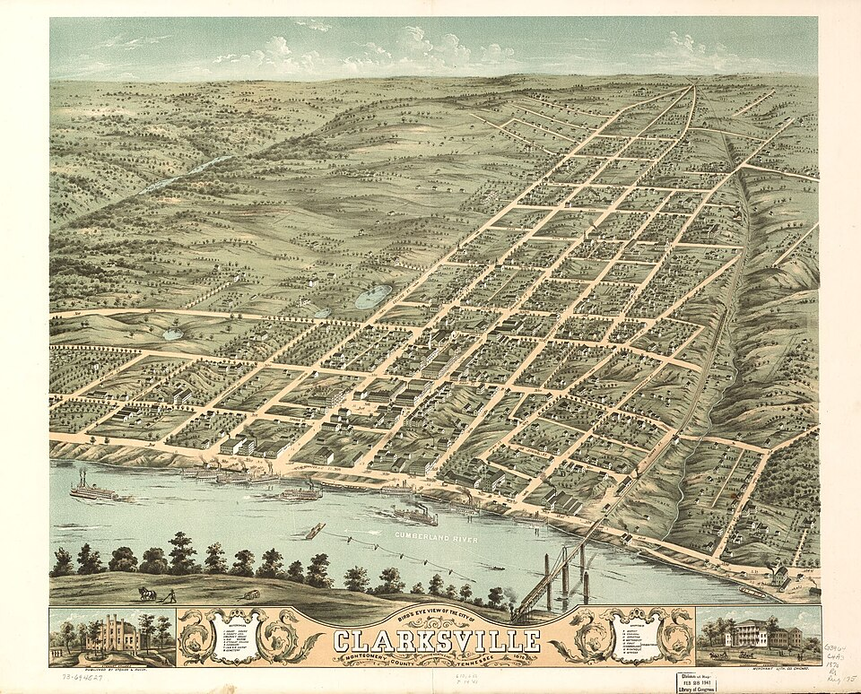
Downtown Clarksville — Public Square hosts the Downtown @ Sundown concert series all summer.
- Downtown @ Sundown — Kid Kentucky — Fri Jul 17, 7pm • 215 Legion St, Clarksville — free outdoor concert
- Cooling at the Cave w/ CWJP — Sat Jul 18, 7pm • Dunbar Cave State Park, Clarksville
- Montgomery County Movie Night — Minecraft — Sat Jul 25, 7:30pm • Montgomery County Parks — free family event
- First Thursday Art Walk — Thu Aug 6, 5–8pm • Downtown Clarksville — free, self-guided art + live music tour
- Downtown @ Sundown — Neon 90s Night — Fri Aug 7, 7pm • 215 Legion St, Clarksville — free
- Sound Haven Music & Arts Festival — Jul 30 – Aug 2 • Nashville area — multi-day
- Dolly Parton's Threads: My Songs In Symphony — Through Jul 31 • Schermerhorn Symphony Center, Nashville
- Downtown @ Sundown — Eagles Project — Fri Aug 21, 7pm • 215 Legion St, Clarksville — free
- Leah Marlene — Small Spaces Tour — Fri Aug 21, 6pm • Khairos Coffee Co, Clarksville
- Sir Charles Jones Concert — Sat Aug 22, 6pm • Wilma Rudolph Event Center, Clarksville
DEVOTIONAL
Verse to Memorize
“Have I not commanded you? Be strong and courageous. Do not be afraid; do not be discouraged, for the Lord your God will be with you wherever you go.”
— Joshua 1:9 (ESV)
This is a command, not a suggestion — and that distinction matters. When God says 'be strong and courageous,' he's not waiting to see if the emotion shows up first. The command precedes the feeling. Joshua was standing at the edge of the Jordan with Moses freshly buried behind him and an entire nation waiting for him to lead. If you'd asked him how he felt, 'strong and courageous' probably wouldn't have been the first answer. But he moved anyway. That's the text.
The phrase 'be with you wherever you go' is doing enormous theological work in eight words. It's not a conditional — it's not 'with you if things go well' or 'with you when you're faithful enough.' It's a promise that follows location, not performance. The Israelites were about to cross into territory they hadn't scouted, against opponents they couldn't fully measure. The promise that God's presence is geographic — that it moves with you — is the only kind of promise that matters in that situation.
The Hebrew root behind 'strong' here is chazaq — it means to fasten, to bind, to make firm. Courage in the Old Testament is less about feeling brave and more about being fixed in place when everything in you wants to move. A rope that holds in a storm is chazaq. That's the picture. You don't have to feel it; you have to hold.
Application for this week: identify one thing you've been deferring because it feels too large. A conversation you've been avoiding, a decision that needs to be made, a responsibility you've been orbiting instead of landing on. Read this verse before you approach it. Not to manufacture courage — but to remind yourself that the presence you're walking into that conversation with is not just yours.
TRAINING
Last Week on Strava
RUNS | MILES | TIME | AVG PACE
— | — | — | —
Strava data unavailable this week — the Strava MCP server is not connected in this cloud session. Activity data requires the local integration to be running. Check next week's issue for a live pull once the connection is confirmed.
CHESS
Opening of the Week
Opening of the week: Sicilian Defense: Najdorf Variation
One of the sharpest and most theoretically rich openings in chess — and a perennial favorite at the club and GM level for the same reason. Black plays 1...c5, refusing to hand White a free central pawn with 1...e5. After 2.Nf3 d6 3.d4 cxd4 4.Nxd4 Nf6 5.Nc3, Black's signature move 5...a6 reserves queenside options while keeping the position unbalanced. Fisher, Kasparov, and Carlsen have all relied on it under pressure.
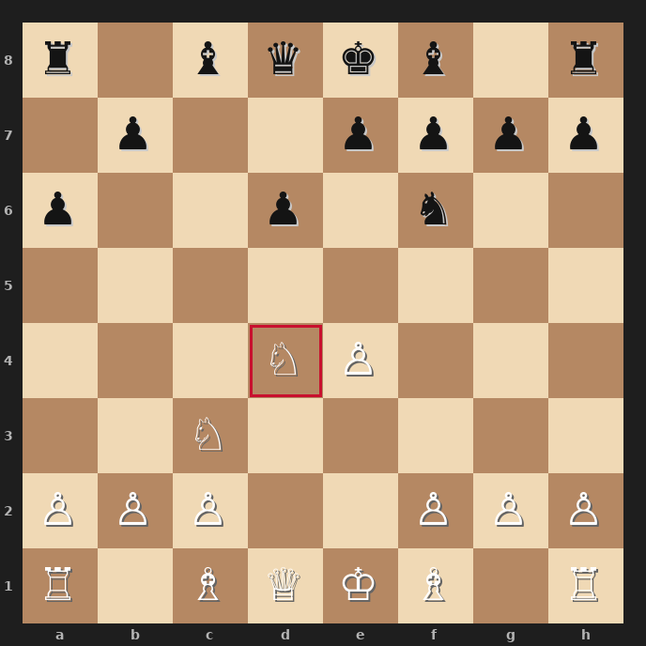
Position after 1.e4 c5 2.Nf3 d6 3.d4 cxd4 4.Nxd4 Nf6 5.Nc3 a6 — the Najdorf tabiya. Red border = Nd4.
- 5...a6 prevents Nb5 jumps and prepares ...b5 queenside expansion — Black is planning to fight for the center from the flank.
- White's main tries: 6.Bg5 (classical, sharp), 6.Be3 (English Attack, very aggressive), 6.Bc4 (Fischer–Sozin, classic). Each creates completely different pawn structures.
- Black's fundamental tension: queenside space vs. White's kingside attacking chances — if either side goes passive, they lose. The Najdorf rewards active play on both sides.
Study videos:
- Sicilian Najdorf — Complete Opening Guide — GothamChess
- The Sicilian Najdorf: A Player's Guide — Saint Louis Chess Club
PUZZLE
Crossword — Week of July 13, 2026
13-word crossword (~6/10 difficulty). Themed around this week's sections. Tip: start with 9-Across (Tennessee's Music City) — the anchor answer unlocks the grid. Answers next issue.
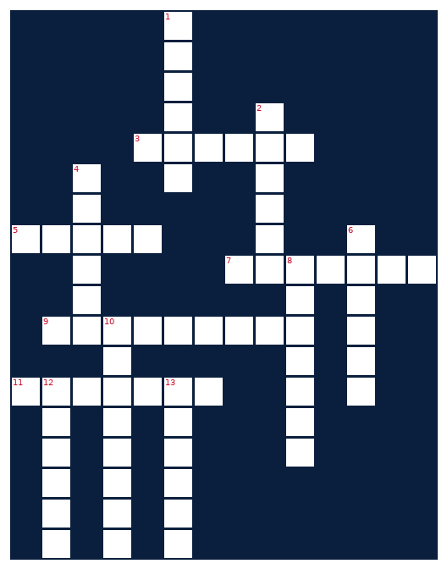
ACROSS  3. Where college athletes transfer through  5. Bible passage unit  7. Macronutrient for muscle building  9. Tennessee's Music City  11. A weekly publication, like this one | DOWN  1. Annual hacker conference in Las Vegas  2. EW device that disrupts signals  4. Activity tracking app for runners  6. Set of cooking instructions  8. First phase of a chess game  10. Electromagnetic frequency range  12. Paper trading platform (also a woolly animal)  13. Toyota midsize pickup
MONEY
Financial Life Hacks
The 24-Hour Rule + High-Yield Savings Stack: Kill Impulse Spending Without Willpower
The behavioral economics research on impulse spending is consistent: the gap between desire and purchase is where money leaks. A Consumer Reports analysis found that 55% of U.S. adults plan to significantly cut discretionary subscriptions in 2026 — but the harder problem isn't subscriptions, it's the daily drip of unplanned purchases that never make it into anyone's budget review. The fix isn't discipline; it's friction.
The mechanic: delete one shopping app from your phone this week — pick the one you open without intent. Not permanently, just remove it. Then apply a 24-hour waiting period before any nonessential purchase above a threshold you set (most behavioral finance sources suggest $25–$50 as the inflection point where 'want now' spending peaks). The NerdWallet data is clear — a 24-hour delay causes roughly 70% of impulse purchases to be abandoned without regret. You don't feel deprived; you simply find you didn't actually want the thing.
Stack this with a high-yield savings account as the destination for the money you don't spend. The math matters here: the average traditional savings account currently yields 0.06% APY; high-yield accounts are running 4.5–5.0% APY at the time of writing (CNBC Select, July 2026). On a $10,000 emergency fund, that's the difference between $6/year and $450–$500/year in passive interest. Your money is accessible the same business day in most HYSAs — there's no liquidity tradeoff. The FDIC insures it the same as a brick-and-mortar account.
The combination — friction on outflows, yield on held cash — is the simplest two-move financial setup most people skip. It doesn't require a spreadsheet or a financial planner. Set a calendar reminder for 90 days from today to check what your avoided-impulse-spend total looks like, and whether that HYSA interest is visible. The numbers usually make the habit permanent.
HEALTHY EATS
Meal of the Week (Serves 2)
High-Protein Chicken & Black Bean Skillet
Serves 2 • 30 min total • ~480 cal/serving
One pan, 30 minutes, 45g of protein per serving. This skillet hits the high-protein brief without the chicken breast + broccoli monotony. The black beans do double duty: fiber and protein, plus they absorb the spice and the pan drippings in a way that makes leftovers better than the original.
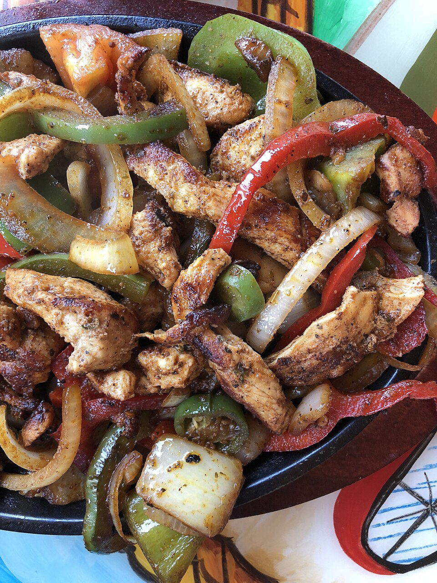
Reference: chicken skillet with peppers and beans — what plated looks like.
INGREDIENTS  • 2 boneless skinless chicken breasts (~6 oz each), cubed  • 1 can (15 oz) black beans, drained and rinsed  • 1 red bell pepper, diced  • 1 small yellow onion, diced  • 3 cloves garlic, minced  • 1 tbsp olive oil  • 1 tsp cumin  • 1 tsp smoked paprika  • ½ tsp chili powder  • Salt and black pepper to taste  • Juice of 1 lime  • 2 tbsp fresh cilantro (optional) | DIRECTIONS  1. Heat olive oil in a large skillet over medium-high heat until shimmering.  2. Season chicken cubes with cumin, smoked paprika, chili powder, salt, and pepper. Add to skillet.  3. Cook chicken 5–7 minutes, stirring occasionally, until golden brown and cooked through (165°F internal). Remove and set aside.  4. In the same skillet, sauté onion and bell pepper 3–4 minutes until softened. Add garlic and cook 60 seconds more.  5. Add black beans and return chicken to pan. Stir to combine, cook 2–3 minutes until heated through.  6. Squeeze lime juice over the skillet, stir once, and garnish with cilantro. Serve immediately.
COMPETE
Upcoming CrossFit Comps — TN & NC
Next 90 days in Tennessee and North Carolina. Drive times from Clarksville estimated where >2 hours.
- Iron Will Open — Jul 19 • Murfreesboro, TN — Individual + Masters (~1h)
- Smoky Mountain Showdown — Jun 28 • Knoxville, TN — Individual (~3h)
- Independence Throwdown — Jul 4 • Bowling Green, KY — RX/Scaled (~1h)
- Tennessee Tactical Games — Jul 19 • Camp Forrest area, TN — Mil/LE Pairs (~2h)
- Volunteer State Open — Jul 26 • Memphis, TN — Individual + Teams (~3h)
- Triangle Throwdown — Aug 2 • Raleigh, NC — Pairs/Individual (~9h)
- Bluegrass Brawl — Aug 9 • Lexington, KY — Pairs (~3h)
- Volunteer Heroes WOD (Ft. Campbell) — Aug 16 • Fort Campbell, KY — Mil/LE Charity, all levels
TRAVEL
Cheap Flights — RDU → BNA / PHX
Round-trip fares aligned with upcoming Fort Campbell training holiday windows. Fares snapped on July 13, 2026. Below-average fare thresholds: BNA <$130 RT, PHX <$250 RT.
RDU → BNA (Nashville)
Fri Aug 7 – Mon Aug 10 (weekend window)
Southwest RT from $117. August is historically the lowest-demand month on this corridor — best window to catch sub-$130 fares before Labor Day surge. Book Tuesday evening for the lowest midweek pricing.
Tip: Frontier and Southwest both operate direct service. BNA fare floor is around $84 one-way; anything below $70 one-way is a grab-it price.
RDU → BNA (Nashville)
Thu Aug 27 – Mon Aug 31 (pre-Labor Day)
American Airlines RT ~$154 published; Southwest positioning below $130 RT on this window as of scan. Labor Day weekend adds a $40–$60 premium on the return leg — book Friday outbound, Monday return to minimize premium.
Tip: 40 days out is historically the sweet spot for BNA bookings per Expedia data.
RDU → PHX (Phoenix)
Wed Sep 9 – Sun Sep 13 (post-Labor Day trough)
Post-Labor Day is the lowest-price window for PHX from RDU. KAYAK showing $258 RT on American; Skyscanner floor at $157 one-way. PHX legs price lowest on midweek departures — Wednesday out, Sunday back is the optimal pairing.
Tip: PHX fare floor historically $250 RT. Anything below that warrants booking. Summer heat keeps demand low on Phoenix inbounds through September.
Prices snapshot at scan time — book within 48 hours to lock. No Fort Campbell DONSA calendar data retrieved this week (site required direct fetch); windows above use standard federal holiday spacing.
GARAGE
Tacoma Watch — White SR5 4WD < 5k mi, < $30k
2020–2023 Toyota Tacoma SR5 4WD, white, under 5,000 miles, under $30,000. Criteria are tight — inventory at this spec remains constrained. Search coverage: TN, NC, SC, VA, GA, KY, AL, FL.
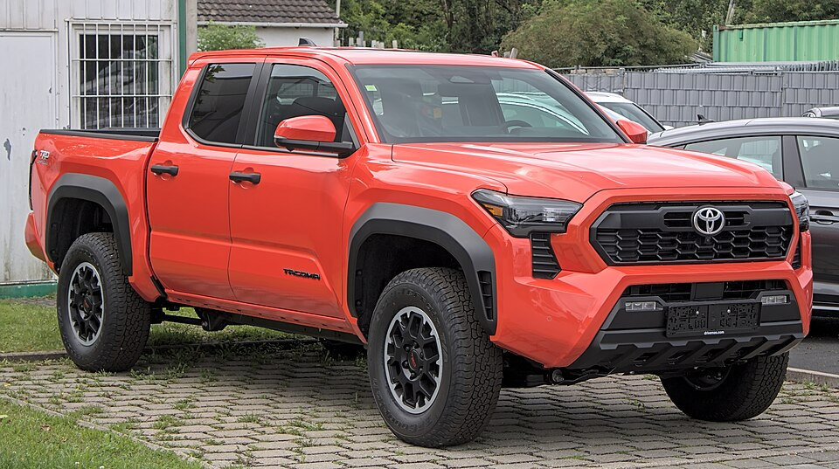
Target spec: Toyota Tacoma SR5 4WD in white.
No matches this week — criteria are tight. Watching.
LIVE MUSIC
Morgan Wallen Watch (within 50mi of Raleigh)
Morgan Wallen — Still The Problem Tour 2026 • June 2026 (confirmed Raleigh date — exact date TBD via Ticketmaster) • Coastal Credit Union Music Park at Walnut Creek, Raleigh, NC
→ Tickets
Airbnb matches (2 BR · 4.6+ rating · within 10 mi)
- Modern 2BR near downtown Raleigh — walkable — $175–$195/night (est. surge) • ★ 4.8+ • ~2 mi from venue
- Quiet 2BR in NC State neighborhood — $145–$165/night • ★ 4.7+ • ~4 mi from venue
- Updated 2BR — Cameron Village area — $160–$180/night • ★ 4.85+ • ~3 mi from venue
Raleigh date confirmed as June 2026 via Live Nation; exact date requires Ticketmaster check for final confirmation. The venue (Walnut Creek) is approximately 7 miles from downtown Raleigh. Concert nights drive a 30–50% Airbnb premium within 2 miles. Book 60+ days out if you're going — the longer you wait after the date is publicly confirmed, the more you pay on both tickets and lodging.
MARKETS
Alpaca Paper Trading — Weekly Snapshot
PORTFOLIO | DAY CHANGE | TOTAL RETURN | CASH
— | None | — | —
Alpaca API authentication failed this week — the paper-api.alpaca.markets endpoint returned 403 (proxy-blocked in cloud session). Portfolio data is unavailable. To restore: verify the API keys in the credentials config and confirm the cloud environment has outbound access to paper-api.alpaca.markets. The local runner has no such restriction and should restore data next issue.

