JACOB'S GAZETTE
WEEK OF JULY 27, 2026
Faith • Tech • Tennessee • Iron

Table of Contents
1. Electromagnetic Warfare Brief 3
2. Cyber & Pentesting Roundup 4
3. Home Network Security Report 5
4. CrossFit News 6
5. College Football Watch 7
6. Something Good in the World 8
7. Around Tennessee 9
8. Devotional 10
9. Last Week on Strava 11
10. Opening of the Week 12
11. Crossword 13
12. Financial Life Hacks 14
13. Meal of the Week 15
14. Upcoming CrossFit Comps — TN & NC 16
15. Cheap Flights 17
16. Vehicle Watch — Toyota Tacoma SR5 4WD 18
17. Concert Watch — Morgan Wallen 19
18. Alpaca Paper Trading 20
EW INDUSTRY
Electromagnetic Warfare Brief
The US Space Force Combat Forces Command formally accepted the Meadowlands system into operational service on June 8, 2026. Developed by L3Harris Technologies, Meadowlands is a ground-based, mobile counter-communications system (CCS) designed to jam, disrupt, deny, and degrade adversary satellite uplinks and downlinks using reversible electromagnetic effects. The system was streamlined from 23 to just 7 transportable equipment cases through open software architecture and upgraded electronics. The Space Force plans to deploy 32 Meadowlands units to combatant commands worldwide, giving field commanders a mobile on-demand SATCOM jamming capability previously unavailable in theater.
The US Army awarded prototype contracts in May 2026 to three vendors — Pacific Defense Strategies, SRC, and Herrick Technologies Laboratories — to develop the Electromagnetic Warfare Rapid Integration System (ERIS). ERIS is designed to counter sophisticated radio frequency threats through adaptable, scalable technology that can be rapidly updated as adversary waveforms evolve. The Army simultaneously requested accelerated FY2027 budget funding to speed development and increase production capacity for EW and signals intelligence systems across all echelons.
BAE Systems completed flight-testing of a modular airborne electromagnetic attack pod compatible with MALE and HALE unmanned aircraft, incorporating counter-C5ISRT jamming software and networked for coordinated, multi-ship attack. Separately, M-tron Industries secured a $4 million production contract in early July 2026 to supply RF components for a next-generation US EW system, signaling continued acceleration in the defense electronics industrial base.
The global EW market reached an estimated $32–34 billion in 2026, with analysts projecting growth to $64–68 billion by 2031 (CAGR ~14–15%). Counter-UAS EW and software-defined architectures are driving the fastest growth segments. North America currently holds approximately 37.9% of global market share, anchored by programs like Meadowlands, ERIS, and next-generation ship-based jamming systems currently in development.
Source: https://breakingdefense.com/2026/04/army-requests-funds-to-speed-development-production-of-ew-systems/
CYBER & PENTESTING
Cyber & Pentesting Roundup
Microsoft’s July 2026 Patch Tuesday set a new record with 570 patched flaws, including 59 rated Critical and 3 zero-days (2 actively exploited in the wild). The headlining vulnerability is CVE-2026-57092, a Critical CVSS 9.9 Windows VMSwitch elevation-of-privilege flaw enabling network-based privilege escalation with low attack complexity and no authentication required. Equally urgent is CVE-2026-56188, a Windows Server Network Driver remote code execution bug exploitable by unauthenticated attackers with no user interaction. Red teams should expect to see weaponized POCs within 2–4 weeks of patch release.
CVE-2026-56155, an Active Directory Federation Services elevation-of-privilege flaw, and CVE-2026-50661, a BitLocker bypass, round out the Critical tier. Oracle’s July 2026 Critical Patch Update also addressed 447 CVEs including 10 rated Critical. Security teams carrying unpatched AD FS infrastructure should treat this cycle as an emergency patch event given the direct identity infrastructure attack surface.
On the ransomware and breach front, the Anubis group listed Fairlife (Coca-Cola’s dairy subsidiary) on its leak site July 20, 2026, days after Coca-Cola notified the SEC of the initial intrusion. Abbott Laboratories suffered two concurrent breaches: ShinyHunters (via voice phishing) targeted its Cancer Diagnostics division while ShadowByt3$ ransomware hit the LabCenter portal simultaneously. Ford Motor Company was listed by the Krybit ransomware group with scope still under investigation.
The Conduent healthcare breach, originally disclosed via SEC filing in April 2025, continued expanding in scope through July 2026 — now confirmed at 62.2 million affected individuals with over 8 TB of stolen data including SSNs, medical records, and insurance data. In a separate escalation, a threat actor wiped an entire European nation’s land registry database on July 21, paralyzing real-estate transactions nationwide — a destructive attack against civil critical infrastructure. AI-driven deepfake voice and video phishing now defines the July 2026 threat landscape.
Source: https://www.bleepingcomputer.com/news/microsoft/microsoft-july-2026-patch-tuesday-fixes-massive-570-flaws-3-zero-days/
HOME NETWORK
Home Network Security Report
No recent pentest report available — local cron may have failed. The Kali scanning agent targets router at 10.0.0.1. Verify the agent process is running on the home network and that the reporting cron has write access to the private repo.
CROSSFIT
CrossFit News
The 2026 CrossFit Games concluded July 26 at SAP Center in San Jose, California, marking the competition’s 20th anniversary. The Games returned to a four-stage format (Open, Quarterfinals, Semifinals, Finals) after Quarterfinals were dropped in 2025. The top 30 men, 30 women, and 20 teams competed across 20 individual events over four days, with individual champions each taking home $312,000.
James Sprague claimed the men’s title, becoming the first man in CrossFit history to win two non-consecutive Games championships. His performance was consistent across multiple time domains — winning sprints, heavy barbell events, and endurance tests — demonstrating the kind of balanced fitness the Games was built to crown. Sprague’s title will reset expectations for the men’s field heading into 2027 season programming.
Aimee Cringle of the UK dominated the women’s field in a wire-to-wire performance that wasn’t close. She won 5 events, podiumed 6 times, recorded 11 top-5 finishes, and placed inside the top 10 in 18 of 20 events — mathematically clinching the title before the final event with a 100+ point lead. Cringle became the first UK female Games winner since Sam Briggs in 2013 and delivered what many analysts are already calling one of the most dominant individual performances in Games history.
Solidarity CrossFit Basecamp captured the team title, finishing the final event in 1:09:22 to secure the championship. The 2026 season also marked continued growth in the Games’ spectator base, with SAP Center selling out multiple session days. CrossFit HQ has not yet announced the 2027 season schedule, but the return of Quarterfinals to the format is expected to remain.
Source: https://www.boxrox.com/aimee-cringle-wins-the-2026-crossfit-games/
COLLEGE FOOTBALL
College Football Watch
The 2026 college football season opens in just over a month, and the landscape looks dramatically different than it did a year ago. The SEC enters 2026 with six first-year head coaches — the most simultaneous turnover the conference has seen in modern history. Lane Kiffin takes over at LSU, Will Stein heads to Kentucky, Pete Golding inherits Ole Miss, Alex Golesh arrives at Auburn from USF, Ryan Silverfield moves from Memphis to Arkansas, and Jon Sumrall brings his Tulane offense to Florida. Each program has a new identity to establish before conference play begins.
The transfer portal closed its most expensive cycle to date. Former Duke QB Darian Mensah secured a reported $10 million NIL deal to transfer to Miami — the largest QB portal package on record — reshaping ACC title contention around the Hurricanes. Auburn WR Cam Coleman is ranked the No. 1 overall portal prospect by both 247Sports and Rivals heading into fall camp. More than 4,500 scholarship players entered the portal by January 2026, representing 25–30% of all scholarship athletes in the sport.
The SEC’s move to nine conference games (up from eight) reshapes schedules across the board starting in 2026. Each of the 16 members plays three permanent opponents and six rotating opponents, ensuring every school faces every conference foe at least once every two years. Arkansas drew the toughest SOS in the SEC for 2026; Vanderbilt has the most favorable path. Georgia’s schedule was released last week — the Bulldogs open SEC play September 12 and do not face the West’s two toughest new-coach programs (LSU and Auburn) until October.
NIL collectives continue to reshape recruiting. The $10M Mensah deal and a reported $4M offensive lineman package signal the portal is now a second free-agent market, not a safety valve. Programs that built NIL infrastructure early — Ohio State, Georgia, Texas, Alabama — have a material competitive advantage heading into the season.
Source: https://247sports.com/article/college-football-transfer-portal-2026-rule-changes-nil-qb-market-264813540/
GOOD NEWS
Something Good in the World
After more than two years stranded in a closed Ontario theme park, 30 beluga whales finally received U.S. and Canadian government approval for transfer to accredited facilities. The belugas had been held at Marineland, a theme park that ceased operations, while wildlife organizations fought through regulatory channels for their release. The rescue represents one of the largest cetacean welfare interventions in North American history and was made possible by years of coordinated advocacy between marine mammal experts, legal teams, and conservation groups in both countries.
Closer to home, the Tennessee Valley Authority gave area residents a rare inside look at Kentucky Dam operations during America’s 250th anniversary celebration on July 4, 2026. The TVA opened Kentucky Dam — one of the largest hydroelectric structures in the eastern United States — for guided public tours, letting Tennessee and Kentucky residents see the turbines, control systems, and engineering infrastructure that has powered the region since 1944. It’s the kind of community history moment that doesn’t make national headlines but sticks with the people who show up.
Also worth noting: the Tennessee Wildlife Resources Agency reported zero boating-related fatalities over the July 4th holiday weekend during Operation Dry Water. With peak summer recreation in full swing on Cumberland Lake, Barkley, and Percy Priest, that’s a meaningful public safety milestone — and a testament to the enforcement presence and boater education programs TWRA has built over the past several years.
Source: https://www.goodnewsnetwork.org/30-beluga-whales-finally-rescued-after-2-years-waiting-in-shuttered-theme-park/
AROUND CLARKSVILLE & NASHVILLE
Around Tennessee
Eight events worth circling in Clarksville and Nashville over the next four weeks. Clarksville’s outdoor concert series runs through October; Nashville amphitheater season peaks in August.
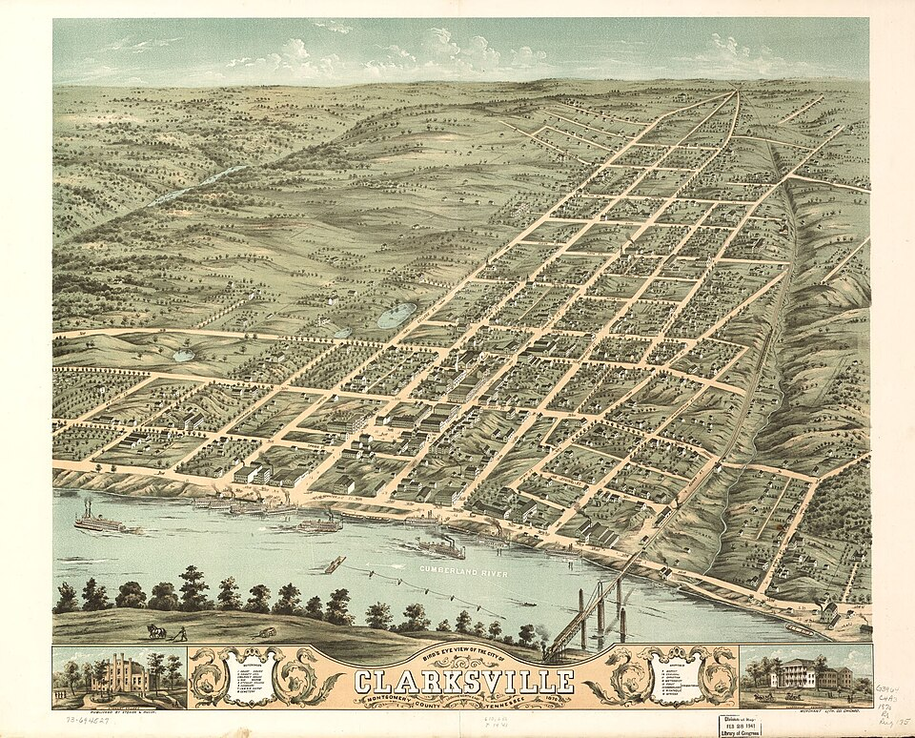
Downtown Commons, Clarksville TN — home to the Downtown @ Sundown summer concert series
- National Intern Day Celebration — July 30, 2026 • Downtown Commons, Clarksville TN
- First Thursday Art Walk — August 6, 2026 • Downtown Clarksville (self-guided, 5–8 pm)
- Downtown @ Sundown — Neon 90’s — August 7, 2026 • 215 Legion St., Clarksville TN (7 pm, free)
- Don Toliver: Nitrous — Octane World Tour — August 19, 2026 • Bridgestone Arena, Nashville TN (7:30 pm)
- Downtown @ Sundown — Eagles Project (Tribute) — August 21, 2026 • 215 Legion St., Clarksville TN (7 pm, free)
- Jack Johnson: SURFILMUSIC Tour 2026 — August 25, 2026 • Ascend Amphitheater, Nashville TN (7:30 pm)
- O.A.R. with Gavin DeGraw & KT Tunstall — August 28, 2026 • Nashville TN
- Piano Men: Tribute to Billy Joel & Elton John — August 29, 2026 • Nashville TN
VERSE TO MEMORIZE
Devotional
“Count it all joy, my brothers, when you meet trials of various kinds, for you know that the testing of your faith produces steadfastness. And let steadfastness have its full effect, that you may be perfect and complete, lacking in nothing.”
— James 1:2–4 (ESV)
James doesn’t say if you face trials — he says when. That single word reorients everything. The trial is not an interruption to your life; it is the curriculum. What God is after in the hard season is not just your survival of it but the character that gets forged inside it: steadfastness, which the Greek word hupomonē means better as ‘remaining under’ — not just gritting your teeth, but holding the ground without moving.
Notice the sequence. Trials produce steadfastness. Steadfastness, when it runs its full course, produces completeness — the Greek teleios, the same word used for an athlete or craftsman who has fully reached their purpose. This is not the prosperity gospel that expects God to remove the hard thing; it is the discipleship gospel that says the hard thing is the thing that makes you. The weight doesn’t improve the muscle by being easy.
For the man who is in a hard season right now — grinding through a difficult assignment, a strained relationship, a stubborn sin pattern, a body that won’t cooperate — this passage is not gentle comfort. It is a direct order. Count it joy. Not feel it as joy, not pretend the pain isn’t real, but count it — make a deliberate reckoning that this trial is serving something bigger than you can see from the inside of it. Faith under fire is the only kind that proves itself real.
The action item is deceptively simple: stop asking God to take the trial away, and start asking what He intends to build inside it. That shift in prayer changes everything.
LAST WEEK ON STRAVA
Last Week on Strava
Strava data unavailable this week — the Strava MCP connection was not active during this run. Weekly activity data will resume next issue.
OPENING OF THE WEEK
Opening of the Week
Opening of the week: The Italian Game
The Italian Game (1.e4 e5 2.Nf3 Nc6 3.Bc4) is one of the oldest openings in chess and remains one of the most theoretically rich at the club level. White’s bishop bears down on the f7 pawn — the weakest square in Black’s position — and sets up long-term pressure on the kingside. Unlike aggressive gambits, the Italian rewards patient, positional chess: piece activity, center control, and a king-side attack built step by step. Magnus Carlsen has won multiple top-level games with it, and it’s equally effective at the club level because most Black players don’t know the theory past move 5.
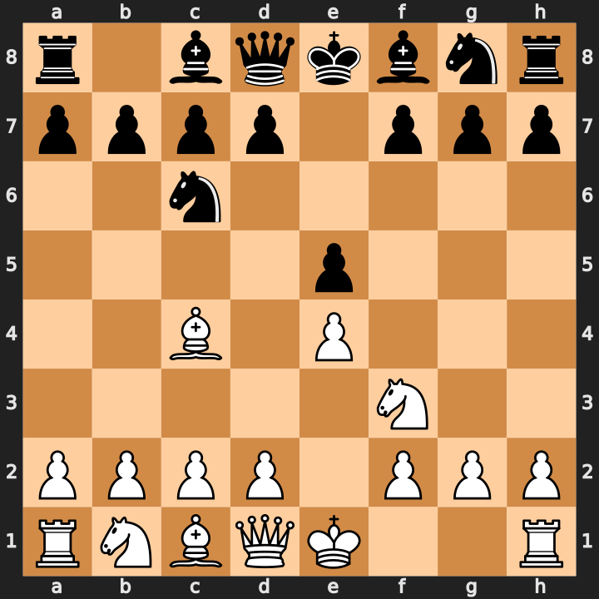
Starting position of the Italian Game after 1.e4 e5 2.Nf3 Nc6 3.Bc4
- Control the center with pawns on e4 and d3; don’t rush d4 until pieces are fully developed
- Castle early and build kingside pressure through the f-file and bishop on c4 pointing at f7
- Watch for the Fried Liver Attack (Nc3, Ng5) as a tactical weapon if Black plays Nf6 without castling
Study videos:
- Learn the Italian Game in 20 Minutes [Chess Opening Crash Course] — GothamChess
- Italian Game Chess Opening Explained in 20 Minutes — GothamChess
THIS WEEK’S PUZZLE
Crossword
This week’s puzzle draws from the stories in this issue — EW programs, the 2026 CrossFit Games, chess, and more. 14 words placed on a 19×16 grid.
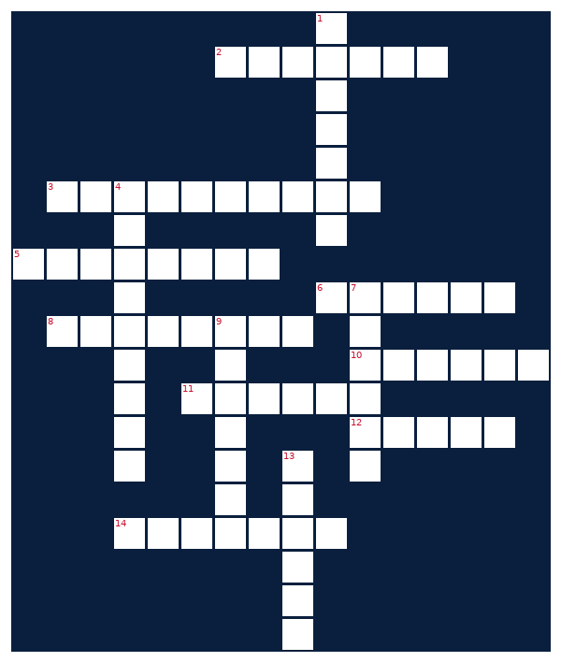
ACROSS  2. James ___, 2026 CrossFit Games men’s champion (7)  3. Malicious software that encrypts files and demands payment (10)  5. High-intensity fitness regimen combining weightlifting and cardio (8)  6. Sizzling Tex-Mex dish featuring grilled chicken and peppers (6)  8. Dedicated love, loyalty, or religious observance (8)  10. Transfer ___, the gateway through which college athletes change teams (6)  11. Toyota pickup model Jacob is tracking in the vehicle watch (6)  12. Strategy board game featured in the Opening of the Week section (5)  14. Aimee ___, first UK woman to win the CrossFit Games since 2013 (7) | DOWN  1. Electromagnetic ___ disrupts enemy radar and communications (7)  4. Tennessee’s ‘Music City’ and state capital (9)  7. Paper trading platform used in this newsletter’s portfolio tracker (6)  9. Chess opening that begins 1.e4 e5 2.Nf3 Nc6 3.Bc4 (7)  13. Morgan ___, country artist with tour dates near Raleigh (6)
FINANCIAL LIFE HACKS
Financial Life Hacks
The 48-Hour Rule: Kill Impulse Purchases and Bank the Difference in 6 Weeks
The mechanic is simple: any non-essential purchase over $50 gets put on a 48-hour hold before you buy it. You add it to a running list — a Notes app, a spreadsheet, a sticky note on your wallet — and you are not allowed to complete the transaction for 48 hours. At the end of that window, you revisit the item and decide with a cooler head. NerdWallet research consistently shows that 50–60% of discretionary impulse purchases are abandoned when buyers introduce any structured waiting period, and Consumer Reports has noted that the most common buyer regret involves purchases made within the first few hours of discovering a product.
Why it works: the brain’s dopamine system fires hardest at the moment of desire, not at the moment of satisfaction. Retailers engineer friction-free checkout precisely because the 30 seconds between ‘want’ and ‘click buy’ is when they make their margin. The 48-hour rule inserts enough delay that the dopamine spike subsides and you evaluate the purchase on its actual merits rather than its emotional ones. After six weeks most people report two things: they still buy most of what they listed, and they are genuinely surprised by how many items they remove without feeling the loss.
Caveats and cadence: this works best on discretionary spending (gear, gadgets, clothes, Amazon ‘good deals’) and poorly on actual needs or time-sensitive opportunities. Apply it consistently for 6 weeks to build the habit; the behavioral reset typically sticks after 30–45 days of repetition. If you find yourself gaming the rule by declaring everything ‘essential’, lower the threshold to $30 for the first two weeks until you develop honest categorization. As a bonus, the running list becomes a useful input for Christmas and birthday wish lists — things you genuinely want but didn’t impulse-buy turn out to be the gifts that actually see use.
MEAL OF THE WEEK
Meal of the Week
Sheet Pan Chicken Fajita Bowls
Serves 2 • 35 minutes total • ~420 cal/serving
High-protein, one-pan weeknight staple that cleans up in under 10 minutes. Marinated chicken thighs roast alongside peppers and onions until caramelized, then get piled over cauliflower rice for a macro-friendly bowl that hits 42g protein per serving without going over 420 calories. Inspired by Skinnytaste’s approach to sheet-pan meals.
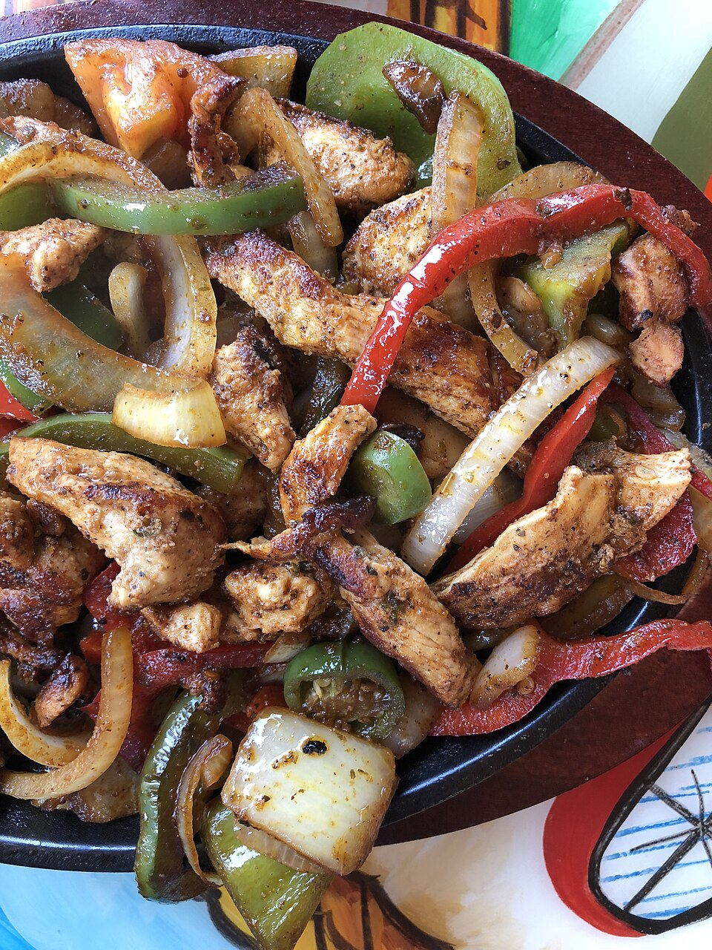
Chicken fajita bowls — high protein, sub-35 minutes, minimal cleanup
INGREDIENTS  • 12 oz boneless skinless chicken thighs (2 large)  • 1 red bell pepper, sliced  • 1 green bell pepper, sliced  • 1 medium yellow onion, sliced  • 2 tbsp olive oil  • 1.5 tsp chili powder  • 1 tsp cumin  • 0.5 tsp garlic powder  • 0.5 tsp smoked paprika  • Salt and black pepper to taste  • 2 cups frozen cauliflower rice  • Juice of 1 lime | DIRECTIONS  1. Preheat oven to 425°F. Line a sheet pan with foil and set aside.  2. Mix olive oil, chili powder, cumin, garlic powder, smoked paprika, salt, and pepper in a bowl. Add chicken and vegetables; toss to coat.  3. Spread chicken thighs and vegetables in a single layer on the sheet pan — don’t crowd or they’ll steam instead of roast.  4. Roast 22–25 minutes until chicken reaches 165°F internal temperature and edges of peppers are charred.  5. While chicken roasts, cook cauliflower rice in a skillet over medium-high heat for 4–5 minutes until lightly browned.  6. Slice chicken against the grain into strips.  7. Build bowls: cauliflower rice base, topped with chicken and roasted vegetables. Squeeze lime over everything.  8. Optional garnish: 2 tbsp Greek yogurt (adds 6g protein, 35 cal) in place of sour cream.
UPCOMING COMPETITIONS
Upcoming CrossFit Comps — TN & NC
Eight competitions across Tennessee and North Carolina in the next 90 days. Registration windows vary — check each event site early.
- Big Orange Brawl 2026 — August 21–23, 2026 • Knoxville, TN
- Bristol Burnout (TOPBOX Fitness) — August 29, 2026 • Bristol, TN
- The Duo Comp Chattanooga — September 12, 2026 • Chattanooga, TN
- Battle of the Fittest 2026 — September 12–13, 2026 • Johnson City, TN
- Camel City Clash — September 19, 2026 • Winston-Salem, NC
- Clash at the Creek — September 19, 2026 • Knoxville, TN (CrossFit FirstCreek)
- Brushy Mountain Melee (3rd Annual) — October 17, 2026 • Wilkesboro, NC
- Battle of Mossy Creek 2026 — October 24–25, 2026 • Jefferson City, TN
CHEAP FLIGHTS
Cheap Flights
Scanning RDU → BNA and RDU → PHX around Fort Campbell training holiday windows. Labor Day weekend (Sep 5–7) is the next major DONSA anchor.
RDU → BNA (Nashville)
Labor Day weekend — Sep 5–7, 2026
Round-trip fares on RDU–BNA are running $148–$195 on American and Southwest for the Labor Day window — modestly below the 12-month median of $220. Nashville is a 5-hour drive from Raleigh, so the value math only works if you depart early Sunday and return Monday evening. Best option: American 7:05 am RDU departure Saturday, return 6:40 pm Monday.
Tip: Book by Tuesday to lock the $148 floor — Labor Day fares historically spike 20–30% after mid-August.
RDU → PHX (Phoenix)
Labor Day weekend — Sep 5–7, 2026
RDU–PHX round trips are running $289–$349 for Labor Day, which is 10–15% below the August average of $380. No single-stop itinerary under $300 exists for Saturday departure; the $289 fare requires a Sunday outbound and is operated by United via EWR with a 2-hour connection. Direct Southwest service (1 stop, no change fee) is available at $318.
Tip: PHX in early September is still 105°F+ — best framed as a desert hiking or Sedona day-trip, not a pool weekend.
Prices as of July 27, 2026. Fort Campbell DONSA schedule for FY26: check the official site at home.army.mil/campbell/training-holidays for full list of remaining DONSAs through the fiscal year end (Sep 30).
VEHICLE WATCH
Vehicle Watch — Toyota Tacoma SR5 4WD
Scanning for white 2020–2023 Toyota Tacoma SR5 4WD, under 5,000 miles, under $30,000. This is an exceptionally tight filter: low-mileage Tacomas in the target trim command a $32,000–$38,000 premium in the current market.
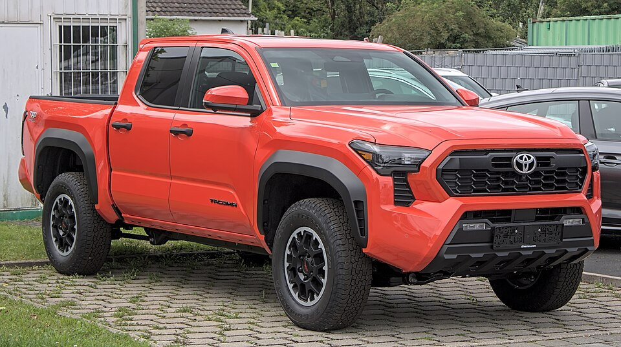
2022 Toyota Tacoma SR5 4WD — target spec
No matches this week on AutoTrader, CarGurus, or Cars.com. The sub-5,000-mile filter at the $30k cap remains the primary constraint — most certified pre-owned Tacomas in that mileage range list at $32,500–$36,000. Will keep watching.
CONCERT + AIRBNB
Concert Watch — Morgan Wallen
No upcoming Morgan Wallen concerts within 50 miles of Raleigh at this time. His ‘Still the Problem’ Stadium Tour ran through spring and summer 2026, and the Raleigh-area date at Coastal Credit Union Music Park at Walnut Creek appears to have occurred in June. No fall dates within range have been announced. Will keep scanning Ticketmaster and Live Nation for any newly posted dates.
PAPER TRADING
Alpaca Paper Trading
PORTFOLIO | DAY CHANGE | TOTAL RETURN | CASH
— | +0.00 | — | —
Portfolio data unavailable this week — the Alpaca API endpoint was unreachable from the cloud runner (proxy connection failed). No authentication error; the block is at the network proxy layer. Data will resume once the proxy allows outbound connections to paper-api.alpaca.markets. Last known portfolio state: check the Alpaca paper trading dashboard directly at app.alpaca.markets.

