JACOB'S GAZETTE
WEEK OF JULY 20, 2026
Faith • Tech • Tennessee • Iron

Table of Contents
1. EW Industry Brief 3
2. Cyber & Pentesting Roundup 4
3. Home Network Security Report 5
4. CrossFit News 6
5. College Football Watch 7
6. Something Good in the World 8
7. Around Clarksville & Nashville 9
8. Verse to Memorize 10
9. Last Week on Strava 11
10. Opening of the Week: The Catalan 12
11. Weekly Crossword 13
12. Financial Life Hacks 14
13. Meal of the Week 15
14. Upcoming CrossFit Comps — TN & NC 16
15. Cheap Flights — RDU Watch 17
16. Vehicle Watch: Toyota Tacoma SR5 4WD 18
17. Concert + Airbnb Watch 19
18. Alpaca Paper Trading 20
ELECTRONIC WARFARE
EW Industry Brief
The U.S. Space Force's most significant electromagnetic warfare milestone of the year landed in late June when Space Force Combat Forces Command formally accepted operational delivery of the first Meadowlands Counter Communications System. Built by L3Harris Technologies under the Combat Mission Systems Support framework and operated by Space Delta 3 — Space Electromagnetic Warfare — the Meadowlands CCS is a wheeled, trailer-mounted satellite-jamming platform that fits inside a C-130 Hercules, giving ground commanders a mobile, air-deployable tool to detect, deny, disrupt, and degrade adversary satellite communications. The system replaces the legacy CCS Block 10.2 from 2020 and uses multi-band, dual-polarization antennas paired with advanced RF amplifiers. DoD has allocated approximately $460 million in the FY27 budget for development, deployment, and sustainment, with L3Harris on track to deliver one Meadowlands per month toward an eventual fleet of 32 units.
On July 15, Japan's Acquisition, Technology and Logistics Agency (ATLA) formally kicked off the operational flight-test campaign for the XEC-2 stand-off electronic warfare aircraft at Gifu Air Base. The XEC-2 — nicknamed the 'Platypus' for its pod-heavy fuselage — is based on the Kawasaki C-2 transport airframe and is intended to become Japan's first dedicated stand-off electronic attack aircraft, designated EC-2 after qualification. Tokyo plans to acquire four airframes to replace the single-aircraft EC-1 fleet. This campaign focuses on establishing flight envelope limits, center-of-gravity parameters, and validating that high-power jamming missions do not compromise airframe performance.
The same day, Auriga Space and the U.S. Army Combat Capabilities Development Command Armaments Center signed a three-year Cooperative Research and Development Agreement to test electromagnetic launchers for counter-drone missions at Picatinny Arsenal. Auriga's technology uses magnetic levitation and electrical acceleration rather than chemical propellants to fire projectiles, eliminating gunpowder logistics and enabling a large ready magazine — two pain points that plague traditional missile-based air defense against cheap drone swarms. The company's Hermes platform, a containerized launcher designed for repeated small-UAS engagements, is scheduled for its first outdoor flight test later this summer.
The Army's broader electronic warfare posture is in flux. Breaking Defense reported in early July that the service plans to pursue a new airborne jammer program — described as a spinoff from the Multi-Function Electronic Warfare (MFEW) effort — alongside a lightweight ground EW kit to support its 2026 transformation push. The Army's FY27 budget request accelerates development timelines for electromagnetic warfare and signals intelligence capabilities, reflecting lessons from Ukraine and the Red Sea where persistent EW jamming against drones and precision munitions proved operationally decisive.
Russia's Iskander-M ballistic missile system reportedly received a navigation upgrade highlighted in Ukrainian military monitoring channels around July 4. The modification appears aimed at preserving strike accuracy inside heavily contested electromagnetic environments — specifically resisting GPS jamming and spoofing that Ukrainian forces have deployed with increasing effectiveness. The upgrade reflects a broader Russian push to harden precision weapons against electronic attack, acknowledging that the electromagnetic battlespace over eastern Ukraine has become a proving ground for both offensive and defensive EW concepts closely studied by NATO planners.
A doctrinal counterpoint emerged in the July 2026 issue of Proceedings, where a feature essay argued that 'electromagnetic denial' must be elevated to a primary mission rather than treated as an enabler. The piece cited the Air Force's Next Generation Jammer Mid-Band (awarded to Raytheon) and the Navy EA-18G Growler's integration of L3Harris's NGJ Low-Band pod as proof that airborne electronic attack has regained institutional momentum, but contended that ground-based and space-based electromagnetic warfare remain chronically under-resourced relative to the threat.
Source: Breaking Defense | https://breakingdefense.com/tag/electronic-warfare/
CYBER & PENTESTING
Cyber & Pentesting Roundup
Microsoft's July 2026 Patch Tuesday dropped this week with a record 570-plus vulnerabilities patched in a single update cycle — the largest single-month release in the company's history. Of those, 59 were rated Critical, the majority enabling remote code execution. Three zero-days headlined the release: CVE-2026-56155, an Active Directory Federation Services elevation-of-privilege flaw discovered by Microsoft's Detection and Response Team during live incident response; CVE-2026-56164, a privilege-escalation bug in SharePoint Server exploitable by unauthenticated network-accessible attackers; and CVE-2026-50661, a Windows BitLocker bypass requiring physical access not yet exploited in the wild but considered high-risk for targeted intrusions.
SharePoint's July exposure extends well beyond the Patch Tuesday zero-days. CISA issued a hardening advisory on July 14 warning of active exploitation across four distinct CVEs — CVE-2026-32201 (spoofing), CVE-2026-45659 (RCE), CVE-2026-56164, and CVE-2026-58644, a CVSS 9.8 deserialization-of-untrusted-data flaw enabling unauthenticated arbitrary code execution. Rapid7 confirmed exploitation of CVE-2026-58644 in the wild. Attackers are chaining these four flaws to steal IIS machine keys and achieve persistence through deserialization techniques — meaning initial access quickly converts to an entrenched, hard-to-eradicate foothold. Federal agencies under BOD 22-01 have a mandatory remediation deadline.
The WordPress ecosystem took an independent critical hit this week. A two-CVE chain dubbed 'wp2shell' — CVE-2026-60137 (SQL injection in WP_Query) chained with CVE-2026-63030 (REST API authentication bypass) — enables unauthenticated remote code execution against an estimated 500 million-plus WordPress-powered sites. A full proof-of-concept was published on GitHub on July 17, putting every unpatched installation within reach of automated exploitation. WordPress.org shipped emergency patches in versions 7.0.2, 6.9.5, and 6.8.6. Site operators still running unpatched installs should treat this as an emergency update, not routine maintenance.
Ernst & Young disclosed a data breach this month that has already triggered regulatory filings in four states. Attackers accessed an unnamed third-party IT support-ticket platform between March 28 and April 12, 2026. The stolen data set is severe: Social Security numbers, financial account codes, credit and debit account data, investment holding records, and the full contents of client tax filings. EY filed breach notifications with the California Attorney General on July 15 and is offering 24 months of Experian IdentityWorks monitoring to affected individuals. Class action litigation is already forming.
The Department of Homeland Security confirmed unauthorized access to its Homeland Security Information Network (HSIN), a sensitive-but-unclassified data-sharing environment. Attackers specifically targeted HSIN servers and an associated SharePoint environment — making this incident a probable downstream consequence of the SharePoint vulnerability cluster above. Separately, ShinyHunters leaked data from Moody Bible Institute affecting 2.3 million records, and AssuranceAmerica suffered a credential-based compromise exposing nearly 7 million records. PwC's latest threat intelligence report flagged a broad surge in AI-assisted identity attacks targeting session tokens, with adversaries automating credential-stuffing and phishing campaigns at industrial scale.
CISA also added CVE-2026-48282 — a critical Adobe ColdFusion remote code execution flaw — to its Known Exploited Vulnerabilities catalog this week. The volume and severity of this week's disclosures underscores a pattern that has defined the first half of 2026: attackers are compressing the window between vulnerability publication and weaponized exploitation to hours, not days, using AI-assisted tooling to triage and operationalize new CVEs faster than most enterprise patch cycles can respond.
Source: BleepingComputer | https://www.bleepingcomputer.com/news/microsoft/microsoft-july-2026-patch-tuesday-fixes-massive-570-flaws-3-zero-days/
HOME NETWORK
Home Network Security Report
No recent pentest report available — local cron may have failed. The scheduled Kali scan against 10.0.0.1 did not produce a report within the last 10 days. Verify that the pentest agent is running on the local LAN and that build_pentest_report.py is executing on schedule. Manual checks recommended: confirm router firmware is current, review connected device list for unknowns, and verify WPA3 is enabled on all SSIDs.
Key Findings
- No automated scan data available this week.
- Recommended manual check: router admin panel at 10.0.0.1 — review firmware version and connected devices.
- Ensure guest network is isolated from primary LAN.
- Verify all IoT devices are on a separate VLAN if available.
Recommendations
- Confirm pentest cron job is active on local machine.
- Run a manual nmap -sV 10.0.0.1/24 to verify network inventory.
- Patch any router firmware older than 90 days.
- Enable automatic security updates on all networked devices.
CROSSFIT
CrossFit News
The 2026 CrossFit Games mark the 20th anniversary of the competition and return to California for the first time in years, with the SAP Center in San Jose serving as the championship venue July 22-26. This year's edition restores the all-in-one festival format — individual athletes, teams, Masters, teenagers, and adaptive athletes competing during the same championship week. Over 254,000 athletes entered the 2026 CrossFit Open, an 8.1 percent increase over 2025, making this one of the most participated seasons in Games history.
Defending men's champion Jayson Hopper arrives in San Jose in strong form after winning the French Throwdown earlier this season — the same tune-up event that helped confirm his readiness ahead of his 2025 title. On the women's side, Swiss athlete Mirjam von Rohr is the top favorite after winning both the 2026 Open and the French Throwdown, establishing herself as the most consistent woman in the sport through the entire qualification season. Tia-Clair Toomey-Orr, who captured an unprecedented eighth CrossFit Games championship in 2025, will not be defending her title, having stepped away to start her family, leaving the women's field genuinely wide open.
The 2026 roster of 30 men and 30 women was assembled through three stages: the Open (won by Colten Mertens and Lucy Campbell), Quarterfinals, and Semifinals. Notable qualifiers include Saxon Panchik, Ty Jenkins, Austin Hatfield, Alexis Raptis, Matilde Garnes, Arielle Loewen, and Claudia Gluck. Six men and seven women will be making their CrossFit Games debut this week.
One of the bigger news items heading into the Games was the withdrawal of Gabi Migala from the women's competition. Migala had been preparing for a return following an Achilles tendon tear at the 2024 Rogue Invitational and plans to target the 2026 Rogue Invitational in October. Her exit opened a backfill spot that went to Swiss athlete Aline Wirz — who finished 4th at the MAD Fitness Festival after recovering from a C6 vertebral fracture and disc herniation that had her questioning whether she would ever move normally again.
Competition this week spans 20 events with a progressive cut format — the athlete with the lowest cumulative point total at the end of five days wins. The event can be streamed live on FloElite, YouTube, and the CrossFit Games website and app. The Masters CrossFit Games by Legends ran July 21-23, with the Teenage and Adaptive Games running concurrently with individual and team events July 24-26.
Source: CrossFit Games | https://games.crossfit.com/finals/overview
COLLEGE FOOTBALL
College Football Watch
The 2026 college football offseason has been defined by an extraordinary wave of change at the coordinator and head coaching level, particularly in the SEC. This week, SEC Media Days run July 20-23 in Tampa with no fewer than six new head coaches taking the podium: Jon Sumrall at Florida (from Tulane), Pete Golding at Ole Miss, Alex Golesh at Auburn, Lane Kiffin at LSU, Ryan Silverfield at Arkansas, and Will Stein at Kentucky. The arrival of Kiffin at LSU is one of the most-watched storylines of the summer — Golding inherited the Ole Miss program Kiffin built and guided it to the College Football Playoff semifinals last season.
The transfer portal has reshaped multiple rosters heading into 2026. Quarterback Darian Mensah transferred from Duke to Miami after leading the Blue Devils to the ACC Championship with 3,973 passing yards and 34 touchdowns. Mensah arrives in Coral Gables with a reported $10 million NIL deal — among the highest in college football history — and enters the season as a legitimate Heisman Trophy contender. Meanwhile, Sam Leavitt, who led Arizona State to a Big 12 championship as a redshirt freshman, transferred to LSU, immediately giving Lane Kiffin a proven conference title-winning quarterback.
The wide receiver market has been equally active. Auburn standout Cam Coleman — 93 catches, 1,306 yards, 13 touchdowns last season — transferred to Texas to pair with Arch Manning, who chose to return to school rather than enter the NFL Draft. Manning's On3 valuation sits at approximately $2.5 million this season, with deals including EA Sports, Red Bull, Uber, and Vuori. Coleman's NIL valuation climbed to nearly $3 million following the announcement, highlighting how portal movement has become as much a business transaction as an athletic one.
Preseason rankings have the SEC and Big Ten controlling the top tier. ESPN's early top five: Ohio State, Texas, Notre Dame, Georgia, and Alabama. The official AP Preseason Top 25 releases August 17. As of July 20, 3,664 players have entered the transfer portal for the 2026 cycle, with approximately 76 percent already committed to new programs. All eyes now turn to August fall camp openings and the first weekend of action in late August.
Source: CBS Sports | https://www.cbssports.com/college-football/news/college-football-26-most-important-transfers-2026/
SOMETHING GOOD
Something Good in the World
On July 16, a dog that had gone missing on the Fourth of July was dramatically rescued from San Francisco Bay and reunited with its family in a coordinated multi-agency operation. A witness at Cooley Landing Park in East Palo Alto spotted the small black dog run into the bay and swim away, immediately calling 911. Menlo Park firefighters used binoculars and a drone to track the animal nearly half a mile into open water while seagulls circled and attacked the struggling dog. Airboat 77 from the Menlo Park Fire Protection District, working alongside the East Palo Alto Police Department, Redwood City Fire, and Peninsula Humane Society, motored out to retrieve the exhausted animal. Crew wrapped the dog in a firefighter's coat and returned it to shore, where a microchip scan reunited the two-week-missing pet with its family the same afternoon.
In a separate rescue that circulated widely this week, six volunteer firefighters from the Waterville Volunteer Fire Company in Pennsylvania spent four and a half hours hand-carrying a 100-pound senior dog named Sable nearly two miles down the rugged Golden Eagle Trail after she collapsed from exhaustion on a mountain hike. Her owner had no way to carry her out, and with no easy egress available, the crew placed Sable in a rescue basket and took turns carrying her down, keeping her cool and hydrated throughout the trip. Sable was expected to make a full recovery.
Source: Good News Network | https://www.goodnewsnetwork.org
AROUND CLARKSVILLE & NASHVILLE
Around Clarksville & Nashville
Events across the Tennessee/Kentucky region for the next 30 days.

Clarksville, TN
- Lindsey Stirling – Duality Unleashed 2026 Summer Tour — July 22 • Nashville, TN
- Full Moon Pickin' Party (bluegrass, family-friendly) — July 24 • Percy Warner Park, Nashville
- Funkara Music Festival (funk, soul, jazz, indie, hip-hop) — July 24–26 • Nashville area
- Movies in the Park – Minecraft — July 25 • Montgomery County Parks, Clarksville TN
- PokeKon Fest 2026 (Pokémon show, exhibitors, panels) — July 25 • DoubleTree by Hilton, Clarksville TN
- The Fray with Dashboard Confessional — August 4 • FirstBank Amphitheater, Nashville
- First Thursday Art Walk (visual art + live music, free) — August 6 • Downtown Clarksville, TN
- Tomato Art Fest (free outdoor festival, live music) — August 7–8 • East Nashville
- 1st Clarksville Invitational Black Rodeo — August 22 • F&M Bank Arena, Clarksville TN
- LFA 240: Sanders vs. Gomez (international lightweight MMA) — August 28 • F&M Bank Arena, Clarksville TN
VERSE TO MEMORIZE
Verse to Memorize
“Not only that, but we rejoice in our sufferings, knowing that suffering produces endurance, and endurance produces character, and character produces hope, and hope does not put us to shame, because God's love has been poured into our hearts through the Holy Spirit who has been given to us.”
— Romans 5:3–5 (ESV)
Paul does not say we endure suffering in spite of hope — he says suffering is the very mechanism that forges it. The Greek word hupomone, translated endurance, carries the image of weight-bearing under pressure, not passive resignation but active staying power. It is the same quality a lifter builds not by avoiding hard sets but by grinding through them. Character, in turn, is the tested, proven quality of a person — dokime, the word used for precious metal that has passed through fire. The end product is hope that does not disappoint, grounded not in wishful thinking but in the demonstrated faithfulness of God already deposited in the believer through the Spirit. This week, wherever the pressure shows up — at PT, in the office, at the range — frame it as raw material. The discomfort is doing something. Lean into it, because God is working a proven character and a confident hope through it.
LAST WEEK ON STRAVA
Last Week on Strava
RUNS | MILES | TIME | AVG PACE
— | — | — | —
Strava data unavailable this week. The Strava MCP connection was not active during this run. Check back next issue for full activity data.
OPENING OF THE WEEK
Opening of the Week: The Catalan
Opening of the week: The Catalan Opening
The Catalan is a hypermodern system where White combines the solid d4/c4 queen's pawn center with a fianchettoed bishop on g2, creating long-term pressure along the a8–h1 diagonal. Favored at the highest level — Magnus Carlsen has made it a career cornerstone — the Catalan trades early material tension for structural pressure and endgame superiority. It suits the club player who is comfortable waiting, grinding, and outplaying opponents in the long game rather than chasing early tactical fireworks.
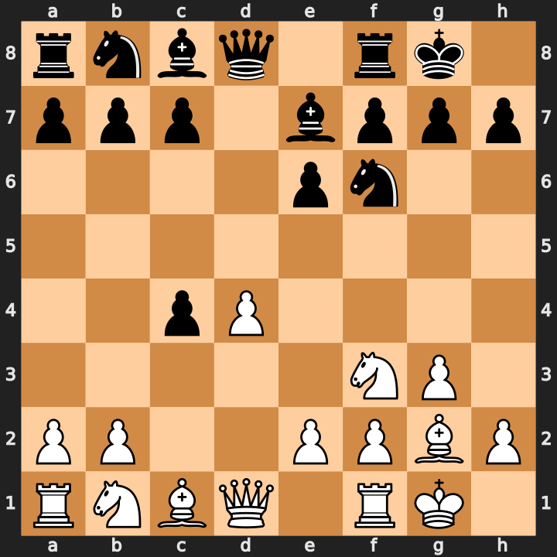
Catalan after 1.d4 Nf6 2.c4 e6 3.g3 d5 4.Bg2 Be7 5.Nf3 0-0 6.0-0 dxc4
- The g2 bishop is the piece: it x-rays the queenside through the center and becomes a long-term monster in endgames.
- In the Open Catalan (Black takes on c4), White recovers the pawn naturally and gains a slight lead in development.
- Avoid early queen sorties to chase the c4 pawn — develop Nd2, Qc2, and then target c4 with b3 or Nf3-e5 ideas.
Study videos:
- How to Play the Catalan | 10-Minute Chess Openings — GothamChess
- CATALAN OPENING — Ultimate Opening Guide — Chess.com
WEEKLY CROSSWORD
Weekly Crossword
This week's crossword draws from EW, chess, fitness, and Gazette staples. Difficulty: 6/10.
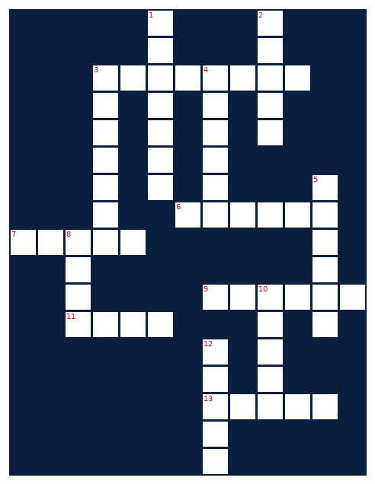
ACROSS  3. High-intensity fitness methodology  6. Toyota truck Jacob is hunting  7. What the gym delivers  9. Financial tool this week's life hack targets  11. Deep blue color of Gazette branding  13. Game of 64 squares and infinite strategies | DOWN  1. Macro that fills your plate and fuels gains  2. First word of the Gazette tagline  3. Opening with 1.d4 featuring g3 and Bg2  4. App that tracks your miles and pace  5. Morgan ___, country star to watch  8. Last word of the Gazette tagline  10. Unmanned aerial vehicle used in EW missions  12. Intelligence-gathering in electronic warfare
FINANCIAL LIFE HACKS
Financial Life Hacks
The 72-Hour Rule: Kill Impulse Spending by Waiting 3 Days on Any Purchase Over $75
The mechanic is simple: whenever you feel compelled to buy something non-essential that costs more than $75 — a piece of gear, a gadget, an add-on subscription — put it in a cart or wishlist and set a 72-hour timer. Do not touch it. After three days, return and ask one question: do you still want it as much as you did in the moment? Research from the Journal of Consumer Research shows that a 24- to 72-hour delay reduces purchase likelihood by roughly 30 percent for non-urgent discretionary spending, because the emotional spike that triggered the impulse — excitement, scarcity fear, social comparison — has decayed.
Why it works comes down to two cognitive dynamics. First, affective forecasting: we systematically overestimate how good a future purchase will make us feel. The helmet that looks critical on Tuesday is just a helmet by Friday. Second, implementation intention: the very act of writing down the purchase and a timer is a commitment device that bypasses the reflexive 'buy now' loop. NerdWallet's 2024 consumer spending survey found that 64 percent of Americans report making at least one impulse purchase per month they later regret, averaging $183. At that rate, the 72-hour rule applied consistently is worth roughly $1,400 per year per person.
The cadence is every purchase above your threshold. Set the threshold at whatever stings slightly — $50 for tight months, $100 for comfortable ones. Caveats: this works for discretionary, not time-sensitive needs. If your running shoes have holes and a race is in two weeks, buy the shoes. And be honest about 'sale ends tonight' pressure tactics — most retailers recycle the same 'limited time' banner indefinitely. The one-line action item: before you check out anything over $75 today, copy the URL, paste it in a note titled 'Friday Revisit,' and close the tab.
MEAL OF THE WEEK
Meal of the Week
High-Protein Chicken Fajita Bowl
Serves 2 • 35 minutes • ~470 cal/serving
Lean chicken breast, bell peppers, and black beans on a base of cilantro lime rice — this bowl delivers 48 grams of protein per serving without crossing 500 calories. Everything cooks in one skillet in under 35 minutes. The chipotle-cumin marinade does the heavy lifting on flavor, so there's no need to compensate with sour cream or cheese.
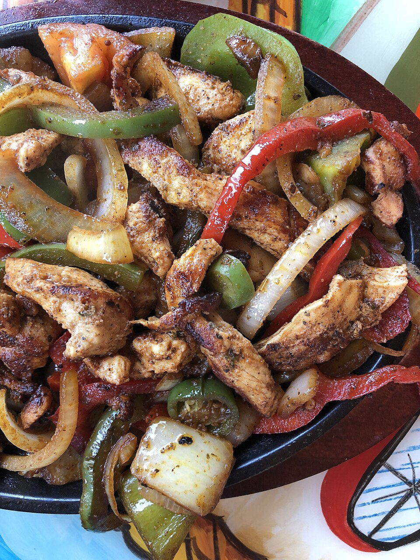
Chicken Fajita Bowl
INGREDIENTS  • 12 oz boneless skinless chicken breast, sliced thin  • 1 tbsp olive oil  • 1 tsp cumin  • 1 tsp smoked paprika  • 1/2 tsp chipotle chili powder  • 1/2 tsp garlic powder  • Salt and black pepper to taste  • 2 bell peppers (one red, one green), sliced  • 1/2 medium yellow onion, sliced  • 1 cup canned black beans, rinsed and drained  • 1 cup cooked brown rice  • Juice of 1 lime + fresh cilantro to serve | DIRECTIONS  1. Combine cumin, smoked paprika, chipotle powder, garlic powder, salt, and pepper. Toss sliced chicken in the spice mix until fully coated.  2. Heat olive oil in a large cast-iron skillet over medium-high. Add chicken in a single layer; sear 3–4 minutes per side until charred at edges and cooked through (165°F internal). Remove and rest.  3. In the same skillet, add bell peppers and onion. Cook 5–6 minutes, stirring occasionally, until softened and slightly charred. Season lightly.  4. Add black beans to the skillet and warm 1–2 minutes. Squeeze half the lime juice into the bean-pepper mixture and stir.  5. Slice chicken against the grain. Divide brown rice between two bowls.  6. Top each bowl with the pepper-bean mixture, sliced chicken, remaining lime juice, and fresh cilantro.  7. Optional: add 2 tbsp plain Greek yogurt per bowl in place of sour cream (+3g protein, minimal extra calories).  8. Serve immediately. Refrigerates well up to 3 days — keep lime and cilantro off until reheating.
UPCOMING CROSSFIT COMPS
Upcoming CrossFit Comps — TN & NC
Upcoming sanctioned and local CrossFit competitions in Tennessee and North Carolina over the next 90 days. The summer competition circuit wraps before fall events kick off — check kettleboards.com for newly-posted regional comps.
- Fittest of the Coast 2026 – Online Qualifier — October 1–28 • Online (in-person championship Jan 2027, North Charleston SC)
- DFX CrossFit Throwdown IV — TBD (check site for fall 2026 date) • DFX CrossFit, Raleigh NC
- Battle of the Ages – Charlotte — TBD fall 2026 • Charlotte, NC
- Rocky Top CrossFit thROWdown for Special Olympics TN — TBD (check site for 2026 date) • Rocky Top CrossFit, TN
- Heatwave Throwdown (annual NC comp) — TBD – late summer 2026 announcement pending • Wendell area, NC
CHEAP FLIGHTS
Cheap Flights — RDU Watch
Monitoring RDU → BNA and RDU → PHX around Fort Campbell DONSA/training holiday windows. Upcoming anchor windows: Labor Day (Sept 4–7) and Columbus Day weekend (Oct 9–12).
RDU → BNA
Labor Day Weekend — Sept 4–7, 2026
One-way fares from ~$84 on KAYAK; Southwest nonstop from $109. BNA is a 45-minute drive to Clarksville/Fort Campbell, making this the most practical route for a long-weekend visit. Southwest, American, and Delta all run 25+ weekly nonstops on this corridor.
Tip: Book Sunday, 30+ days out — that combo alone cuts ~20–24% off fares. August–September is the cheapest seasonal window for RDU–BNA.
RDU → PHX
Columbus Day Weekend — Oct 9–12, 2026
One-way from ~$97 on Skyscanner. Nonstop options on American, Southwest, and Alaska Airlines. September–October is the cheapest seasonal window for this route.
Tip: Set a fare alert on Google Flights or KAYAK now and book the moment it drops below $90 one-way.
RDU → BNA
Columbus Day Weekend — Oct 9–12, 2026
BNA round-trips in October average ~$279; booking 6+ weeks out significantly improves on that. This window works for another Fort Campbell visit or a Nashville weekend.
Tip: Compare Southwest (no change fees) vs. Delta if you want flexibility — both fly nonstop from RDU.
Fort Campbell FY26 DONSA calendar: home.army.mil/campbell/training-holidays — confirm DONSA dates with your chain of command before booking.
VEHICLE WATCH
Vehicle Watch: Toyota Tacoma SR5 4WD
Scanning for 2020–2023 Toyota Tacoma SR5 4WD in white with under 5,000 miles and under $30,000.
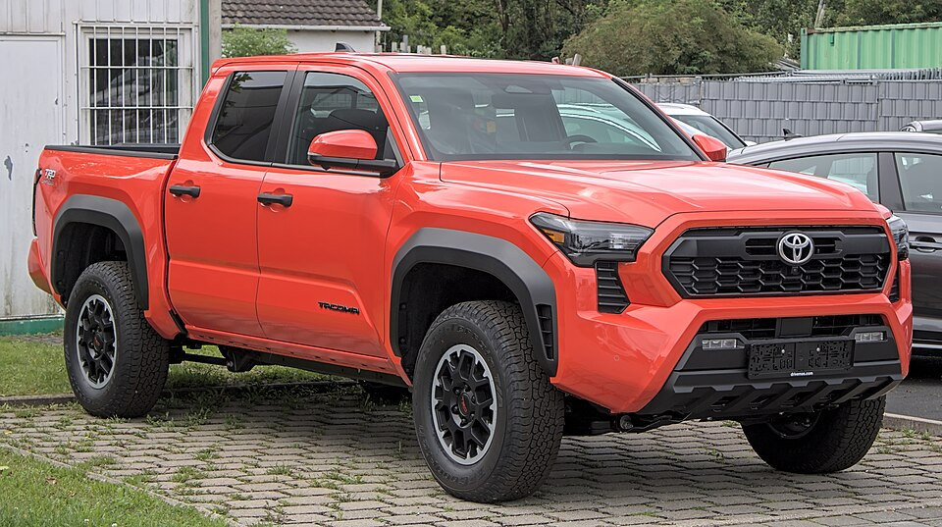
2020–2023 Toyota Tacoma SR5 4WD
No matches this week against the tight filter (SR5/4WD/white/2020–2023/under 5k miles/under $30k). The average used Tacoma SR5 currently trades at ~$33,520, above the ceiling. The closest near-match found was a 2023 Tacoma SR5 4WD white with ~6,311 miles — just over the mileage limit. Live saved searches active on AutoTrader and CarGurus; set email alerts there to catch new inventory the moment it posts.
CONCERT + AIRBNB
Concert + Airbnb Watch
Morgan Wallen's 2026 'Still The Problem Tour' included a Raleigh stop at Walnut Creek Amphitheatre — but that show already took place in June. No upcoming Wallen dates are confirmed within 50 miles of Raleigh for the next 12 months. The closest rumored future option is Charlotte's Bank of America Stadium (~170 miles). Monitor morganwallen.com and Ticketmaster for any newly-announced 2027 tour legs.
ALPACA PAPER TRADING
Alpaca Paper Trading
PORTFOLIO | DAY CHANGE | TOTAL RETURN | CASH
— | — | — | —
Alpaca API connection was blocked by the proxy this week — the paper trading endpoint at paper-api.alpaca.markets returned 403 Forbidden. This is an environment-side network restriction, not an authentication failure. Portfolio data will resume next issue. Manual check: log into alpaca.markets to review positions and any fills since last week.

