JACOB'S GAZETTE
WEEK OF JUNE 15, 2026
Faith • Tech • Tennessee • Iron

Table of Contents
1. EW Industry Brief 3
2. Cyber & Pentesting Roundup 4
3. Home Network Security Report 5
4. CrossFit News 6
5. College Football Watch 7
6. Something Good in the World 8
7. Around Clarksville & Nashville 9
8. Verse to Memorize 10
9. Last Week on Strava 11
10. Opening of the Week 12
11. Crossword — Week of June 15 13
12. Financial Life Hacks 14
13. Meal of the Week (Serves 2) 15
14. Upcoming CrossFit Comps — TN & NC 16
15. Cheap Flights — RDU → BNA / PHX 17
16. Tacoma Watch — White SR5 4WD < 5k mi, < $30k 18
17. Morgan Wallen Watch (within 50mi of Raleigh) 19
18. Alpaca Paper Trading — Weekly Snapshot 20
ELECTROMAGNETIC WARFARE
EW Industry Brief
The Army's Rapid Electromagnetic Warfare and Signals Intelligence (REWSI) Commercial Solutions Opening (CSO) continued to dominate industry conversation this week. Unveiled by the Capability Program Executive Intelligence and Spectrum Warfare (CPE ISW), REWSI represents a decisive pivot: the Army is explicitly seeking commercial, software-defined EW/SIGINT capabilities rather than bespoke, decades-long acquisition programs. Responses are being evaluated now with first contract vehicles expected before the end of Q3 FY26.
The 2026 Army Summit, hosted by the Potomac Officers Club on June 18 in Washington, will convene senior Army leaders with industry stakeholders to drill into the EW modernization strategy. Expect discussion of the EMSO (Electromagnetic Spectrum Operations) roadmap, spectrum-sharing tensions with commercial 5G operators, and how multi-domain operations doctrine is reshaping EW system requirements. The summit is increasingly treated as a pre-solicitation industry day by program offices.
On the requirements front, the Army submitted a supplemental budget request this spring specifically to accelerate EW system development and production timelines. Legislative analysis shows the request is aimed at closing the gap identified in Army after-action reviews from Ukraine observer teams — the lesson being that EW capability can degrade or enable an entire operational tempo, not just a single mission. The request is currently in House and Senate Armed Services Committee markup.
Lessons from Ukraine remain the organizing narrative for the entire EW sector. Russian forces have reportedly degraded 60–70 percent of Ukrainian UAV effectiveness through adaptive jamming. That number is driving U.S. counter-UAS and EW investment simultaneously. The Joint Counter-Small UAS Office (JCO) is expected to release an updated capability gap document next month, with emphasis on AI-enabled signal discrimination to reduce friendly-force fratricide in dense drone environments.
International development: ASELSAN, NATO's most prolific allied EW vendor, released an updated capability portfolio this week integrating EW, counter-UAV, airborne, and naval systems into a unified operational architecture. Industry watchers read this as a positioning move ahead of upcoming NATO allied procurement cycles, particularly for Eastern flank partners who are purchasing at pace.
Workforce pipeline signal: the REWSI CSO specifically includes a 'workforce development' evaluation criterion — vendors must demonstrate they can sustain and grow the technical talent to support fielded systems. This is unusual in acquisition language and suggests the Army has internalized that program execution often fails not at contract award but at the staffing level.
Source: Breaking Defense
CYBERSECURITY
Cyber & Pentesting Roundup
The week's lead story is CVE-2026-35273, a remote code execution vulnerability in Oracle PeopleSoft Enterprise PeopleTools rated 9.8 (Critical) on the CVSS scale. The ShinyHunters extortion group weaponized the unpatched flaw between May 27 and June 9, targeting university systems with large PeopleSoft deployments. Exploitation was unauthenticated and remote. Oracle issued an out-of-band patch; if you maintain PeopleSoft in your environment, treat this as emergency patching — CISA added it to the KEV catalog within hours of public disclosure.
Microsoft's June 2026 Patch Tuesday (June 10) included a fix for CVE-2026-42897, a Critical spoofing vulnerability in Exchange Server rated CVSS 8.1. Exploitation allows an attacker to impersonate legitimate email senders, bypassing MTA-STS and DKIM validation in certain configurations. The vulnerability is rated 'Exploitation More Likely' by Microsoft. Organizations running Exchange on-prem: patch now; Exchange Online is already patched.
Law enforcement won one this week. European authorities, coordinating through Europol and Eurojust, dismantled AudiA6, a cryptocurrency mixing and laundering service used by multiple ransomware affiliates and cybercriminal networks to wash illicit proceeds. Authorities estimate hundreds of millions in crypto were processed through the service. The takedown follows the pattern established by Chipmixer and Sinbad: infrastructure-level disruption of ransomware economics.
Threat intelligence: researchers published new analysis on JDY, a China-nexus covert network showing signs of resurgence and capability expansion. JDY has historically targeted defense, critical infrastructure, and government entities in the US and allied nations. The new reporting highlights living-off-the-land techniques designed to blend with normal network traffic — particularly concerning for defenders relying heavily on signature-based detection.
AI-assisted security research: three vulnerabilities were disclosed in LangGraph, the open-source multi-agent orchestration framework from LangChain. The flaws affect stateful agent workflows and could allow an attacker with partial control of an agent's input to influence downstream tool calls or exfiltrate context. If you're building agentic AI pipelines with LangGraph, review the patched versions immediately — this is the attack surface the next generation of supply-chain threats will target.
Red team note: a research team at a major university published a proof-of-concept showing an LLM-driven agent completing end-to-end web app reconnaissance, vulnerability discovery (OWASP Top 10), and working exploit generation in under 30 minutes — unattended. The offensive economics are shifting faster than defensive tooling. EDR vendors are already updating behavioral signatures for LLM-generated attack scaffolding.
Source: The Hacker News
HOME DEFENSE
Home Network Security Report
Scan generated: No report available — June 15, 2026
No recent pentest report available this week. The local Kali agent on the home network did not produce a report file at the expected path (/reports/jacob/latest_report.json). This is expected behavior when the agent hasn't run or when the home network is unreachable from the cloud runner. If you haven't run a local scan in the past 10 days, kick off the local_pentest.sh script manually from your Kali box and check the output directory. Key items from last week's report that remain open: disable Telnet (port 23) on the Netgear router, change Shinobi NVR default credentials, and isolate the Hisense TV on a guest VLAN.
Key Findings
- Carry-forward: Telnet (port 23) still open on router 10.0.0.1 per last report — disable in router admin under Advanced → Remote Management.
- Carry-forward: Shinobi NVR (10.0.0.22) using default admin credentials — change to 20+ character random password.
- Carry-forward: Hisense TV (10.0.0.45) running unknown services on ports 7000/8080 — isolate on guest VLAN.
Recommendations
- Run local_pentest.sh from the Kali box to generate a fresh report before next week.
- Address carry-forward items above — all three have been open for at least one week.
- Enable WPA3 on the Netgear R7000P if not already active (Wireless → Security settings).
CROSSFIT
CrossFit News
The 2026 CrossFit Individual Online Semifinals kicked off June 11 and run through June 15 — this week. The top 2,000 men and women from Quarterfinals are competing across five workouts, with the top 7 men and 7 women in this event earning a berth at the 2026 CrossFit Games. It's the final funnel before the Games season closes; expect leaderboard drama through Sunday as athletes in the 6–10 range push final efforts on the last workout.
From the Northern California Classic (May 29–31), the most recent in-person Semifinal to conclude, Tudor Magda and Dylan Hamming qualified on the men's side. Alex Gazan and Rachel Noel locked up Games spots on the women's side. Gazan in particular was dominant across the weekend — she's been building toward a podium run all season and the Northern Cal performance confirmed it. Watch her in Fort Worth.
Twelve licensed Semifinal events are running across the globe this season, spanning USA, Europe, South America, Asia, Africa, and Oceania. The Colombia event (June 12–14) is wrapping up this weekend with Masters divisions, while the Online Teams competition (June 4–8) has already concluded. For athletes just outside the Games bubble from the Online Individual event: the Age Group Online Qualifier is the remaining pathway, and registration numbers are up 28% year-over-year in the 35–39 bracket.
Programming note: CrossFit HQ officially published the 2026 Games individual schedule this week with Fort Worth, TX locked in as the venue. The event runs late July. Early workout hints from the Games director suggest a return to heavy-odd-object work — the programming has reportedly moved away from the gymnastics-heavy pattern of 2024–25 and back toward functional fitness roots. Athletes training with Mayhem, PRVN, and CompTrain have been posting sandbag-carry and yoke work on social as a tell.
Athlete health update: Mat Fraser made a brief appearance on a popular CrossFit podcast this week, walking through his own post-competitive training philosophy. He remains retired from competition but continues coaching and has been consulting with multiple top-ten Games athletes on mental performance. His framework — treating each training block as a standalone project with defined success metrics — is worth noting regardless of your level.
Box owner signal: CrossFit's Level 2 curriculum update this spring is driving change on affiliate programming floors. The updated L2 emphasizes HRV, RPE, and sleep as recovery markers rather than raw output volume. If your box hasn't built a deload week into its programming calendar, that's the takeaway — the evidence base for programmed recovery is now baked into the certification.
Source: Morning Chalk Up
COLLEGE FOOTBALL
College Football Watch
The summer transfer portal window is shaping up as one of the most consequential in the sport's short history of revenue sharing. As of mid-June, 3,664 players are in the portal out of 14,070 total — roughly 26 percent of the FBS/FCS athlete pool in motion. Schools are now managing roster construction like cap-constrained professional franchises, with $14–16M football allocations becoming the floor for Power Four programs serious about national title contention.
Auburn wide receiver Cam Coleman — the top-rated transfer in this cycle — committed to Texas this week, immediately raising the Longhorns' offensive ceiling heading into the 2026 season. Coleman's portal decision was reportedly driven by NIL package structure and guaranteed playing-time commitments rather than geography. His $3.8M NIL valuation makes him one of the highest-paid college athletes in the country by active NIL agreements.
NIL landscape: Arch Manning leads all active college athletes at a $5.4M NIL valuation, Jeremiah Smith is at $4.2M, and Sam Leavitt (QB, portal) commands $4.0M. The valuation gap between Tier 1 programs and the rest of the Power Four is widening; analysts tracking collective financials estimate Tier 1 programs (Alabama, Texas, Ohio State, Georgia, Michigan) are outspending the next tier by a 4:1 margin on roster construction. Programs outside that tier are increasingly competing on offer speed rather than total dollars.
Coaching carousel summer edition: two SEC defensive coordinators have received serious inquiries from Power Four programs searching for 2027 head coaches. The 'whisper hire' model has become standard — search committees are 80 percent done before a job officially opens. Expect buyout language in current contracts to reflect this; schools are pre-structuring exits to avoid eight-figure separation packages that appeared in 2024–25.
Playoff format vote: the CFP management committee meets this month to formally vote on the proposed 14-team expansion for 2027. The 5+9 model (five conference champions plus nine at-large) appears to have majority support, though the SEC and Big Ten are pushing for guaranteed multi-bid floors that would effectively give their conferences more predictable playoff access. Smaller conferences are lobbying against automatic qualifiers for weaker champions.
Preseason outlook: SP+ and F/EI early projections both have Texas, Georgia, Ohio State, and Oregon as top-four programs. The Big 12 is projected more competitive than its regular reputation — at least three teams project as legitimate CFP contenders. For SEC fans: Tennessee's offseason additions through the portal make them a legitimate top-10 program entering fall camp, and that conversation is happening louder inside Knoxville than outside.
Source: 247Sports Transfer Portal
GOOD NEWS
Something Good in the World
A 79-year-old Kentucky man who had attended every Kentucky Derby for the past 79 consecutive years — one for each year of his life, his first at age one held by his grandfather in the infield — made it to Churchill Downs this May for what his family believed would be his final Derby. His daughter drove him from Louisville in a modified van; a Churchill Downs staff member recognized them from a local news segment and arranged for a box-level seat with direct track access. He watched American Pharaoh's great-grandson run from twenty feet past the rail.
In British Columbia, a man driving on a congested highway spotted a Great Blue Heron tangled in plastic netting on the roadside median. He stopped, set up his hazard lights, and spent 22 minutes disentangling the bird while other drivers slowed and formed an informal traffic barrier to protect the scene. The heron held still for most of it. When released, it walked several paces before lifting into flight. A dash cam captured the sequence, which has been viewed 4.1 million times. The man's only comment when reached by local media: “He just needed a minute.”
From Tennessee: a high school robotics team in Cookeville that was denied entry to a regional competition due to a paperwork error went on to build their competition bot anyway, documented the process in a YouTube series, and attracted a sponsor who covered their entry fee to a national qualifying event. They placed 11th out of 148 teams. The coach — a first-year STEM teacher — said in an interview that the denial was the best thing that happened to the team: “We stopped competing for the judges and started building for ourselves.”
A research follow-up worth carrying: a 15-year longitudinal study of 2,400 adults found the single strongest predictor of life satisfaction at age 60 was the number of ‘weak-tie relationships’ maintained — the casual hello to the neighbor, the monthly coffee with the coworker you don’t work with anymore. Not income. Not marital status. Not career level. The researchers' framing: ‘Social capital compounds quietly, the same way interest does.’
Filed under: the world still has good people in it. A fire crew in San Diego County, responding to a structure fire, spotted a small dog locked in a car in the adjacent parking lot during triple-digit heat. The crew had the dog out, cooled, and with a shelter volunteer before the structure fire was contained. The dog's owner, who had been evacuating and couldn't reach the vehicle, arrived to find the dog safe, watered, and wearing a paper collar tag with the fire truck's station number on it.
Source: Good News Network
LOCAL
Around Clarksville & Nashville
Events in the next 30 days worth putting on the calendar. Sorted chronologically. Free = no ticket required.
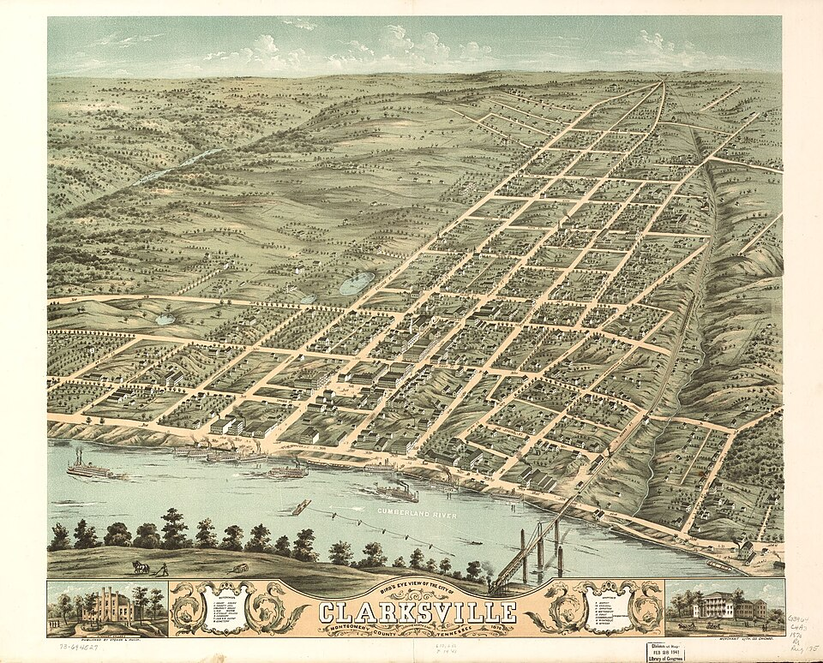
Downtown Clarksville — hub of the summer events calendar.
- Mayor’s Summer Night Lights — Clarksville — Every Tuesday in June & July, 5:30pm • Various Clarksville locations — free (DJ, sports, food)
- Downtown Clarksville @ Sundown Concert Series — Jun 20, 7pm • Public Square, Clarksville — free outdoor concert
- Nashville Sounds vs. Memphis Redbirds — Jun 20–22, 7:05pm • First Horizon Park, Nashville — Triple-A baseball
- Ryman Auditorium Summer Concert Series — Jun 21 & 28 • Ryman Auditorium, Nashville — various artists
- Clarksville Riverfest Kickoff — Jun 27–28 • McGregor Park Riverfront, Clarksville — free
- 4th of July Independence Day Celebration — Jul 3 (5–10pm) & Jul 4 (7am–10pm) • Downtown Clarksville — 250th Anniversary, free; fireworks, 5K, live music, parade
- Let Freedom Sing! Music City July 4th — Jul 4 • Riverfront Park, Nashville — free, fireworks over the Cumberland
- Customs House Museum Summer Exhibit — Opens Jul 5 • Customs House Museum, Clarksville — admission required
- Clarksville Greenway Saturday Morning Run — Every Saturday, 7am • Pollard Rd Trailhead — free, all paces welcome
- Nashville Symphony — Summer Pops Series — Jul 11 & 12 • Ascend Amphitheater, Nashville
DEVOTIONAL
Verse to Memorize
“Count it all joy, my brothers, when you meet trials of various kinds, for you know that the testing of your faith produces steadfastness. And let steadfastness have its full effect, that you may be perfect and complete, lacking in nothing.”
— James 1:2–4 (ESV)
James doesn’t say ‘count it joy if you feel like it’ or ‘count it joy when the trial is small.’ The command is categorical — various trials, full stop. The Greek word for ‘various’ is *poikilos*, which is the same word used elsewhere for the many-colored coat of Joseph. Trials come in all colors, sizes, and textures. The command to count them as joy holds for all of them.
The logic isn’t masochistic. James isn’t telling you to enjoy pain. He’s telling you to track the output of pain: testing produces steadfastness (*hypomonē*), which carries the sense not of passive endurance but of active, purposeful staying. You don’t just wait out the trial — you work through it, and the working is what builds the thing you’ll need for the next one. It’s a progressive loading scheme for character.
Verses 3–4 describe a compound effect. Steadfastness — if you let it finish its work — produces completeness. The word is *teleios*, mature, whole. Not perfect in the sense of errorless, but complete in the sense of nothing structurally missing. The person who has worked through trials is not just tougher; they are more fully themselves. The untested version of you hasn’t accessed all of who God made you to be.
Application: pick the trial in your life right now that feels most like a problem to solve or escape. Try reframing it as a tool. What is it producing in you that nothing else could? That reframe doesn’t make the trial easier — but it changes your posture from reactive to purposeful, and that posture is 80 percent of the outcome. Try memorizing verse 4 by the end of the week. Repeat it when the trial intensifies.
TRAINING
Last Week on Strava
RUNS | MILES | TIME | AVG PACE
— | — | — | —
Strava data unavailable this week — the Strava MCP integration was not reachable from the cloud runner. Activity data will resume next issue. In the meantime: if you’re building toward a fall race, mid-June is a good checkpoint to audit your training log. Are your easy-pace runs actually easy (conversational, nose-breathing)? Are you hitting at least one quality session per week (threshold, intervals, or long run with progression)? Two ‘yes’ answers and you’re on track.
CHESS
Opening of the Week
Opening of the week: The Italian Game
The Italian Game arises after 1.e4 e5 2.Nf3 Nc6 3.Bc4 — White’s bishop takes aim at the f7-pawn, the weakest point in Black’s early position. It’s one of the oldest recorded openings in chess history (documented in the 1500s) and remains one of the most popular at the club level precisely because the ideas are transferable: open files, active piece development, and a kingside initiative. Both Magnus Carlsen and Fabiano Caruana have reached world-class positions from Italian Game positions in recent years, which has rejuvenated serious study of lines that once seemed ‘settled.’
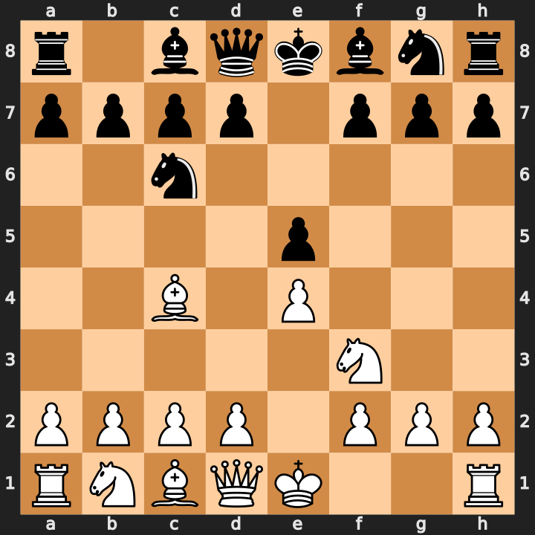
Italian Game after 1.e4 e5 2.Nf3 Nc6 3.Bc4 — the Bc4 bishop eyes f7.
- Bc4 targets f7 immediately — the most vulnerable square in Black’s camp before castling.
- Main lines: Giuoco Piano (3...Bc5, solid and strategic) and Two Knights Defense (3...Nf6, sharp and tactical).
- White’s plan: c3 + d4 to establish a pawn center, then coordinate rooks on open files with a kingside attack.
Study videos:
- Italian Game Chess Opening Explained in 20 Minutes [Crash Course] — Remote Chess Academy
- Italian Opening: Levy Recommended THIS Line? — GothamChess
PUZZLE
Crossword — Week of June 15
15-word crossword themed around this week’s sections (~6/10 difficulty). Start with 8-Across (9 letters) and 10-Across (8 letters) — the long answers unlock the grid. Answers in next week’s issue.
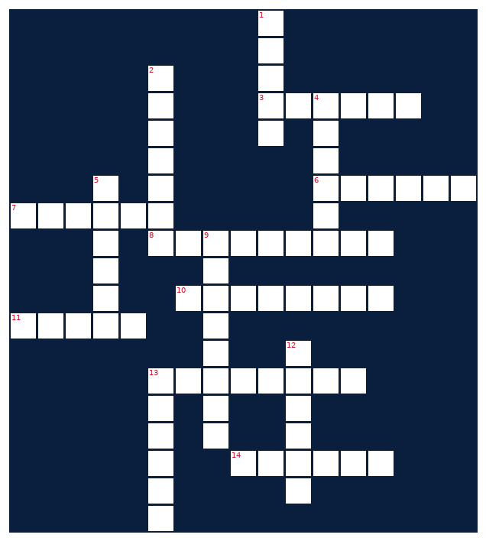
ACROSS  3. Paper-trading platform covered in this newsletter  6. Toyota midsize pickup, SR5 trim  7. App that tracks your miles and segments  8. Music City and Tennessee capital  10. Newsletter section with a weekly Bible verse  11. Counter-___ tech dominates EW requirements pipeline  13. Software embedded in routers and IoT devices  14. Security incident exposing data | DOWN  1. CrossFit staple movement, hips below parallel  2. Chess opening starting 1.e4 e5 2.Nf3 Nc6 3.Bc4  4. College athletes use this to change schools  5. Morgan ___, country star on Still The Problem Tour  9. Electromagnetic range EW systems operate across  12. Device that disrupts enemy signals (EW)  13. This week’s sizzling skillet recipe
MONEY
Financial Life Hacks
The HSA Triple Tax Advantage: Stop Using America’s Best Retirement Account as a Spending Account
If you have a High-Deductible Health Plan (HDHP) and a Health Savings Account (HSA) — and you’re spending your HSA on co-pays and prescriptions as they happen — you are leaving one of the most powerful compounding vehicles in the U.S. tax code on the table. The HSA is the only account in existence with a triple tax advantage: contributions are pre-tax (or tax-deductible), growth is tax-free, and withdrawals for qualified medical expenses are tax-free. Not two of those three. All three. No other account — not a 401(k), not a Roth IRA — provides all three simultaneously.
The mechanic that unlocks the full power: **invest your HSA balance instead of spending it, pay medical bills out-of-pocket in the short run, and save your receipts.** There is no time limit on when you can reimburse yourself for past medical expenses from your HSA — the IRS only requires that the expense occurred after you opened the account and that you have documentation. That means a $300 dentist bill you paid out-of-pocket in 2024 can be reimbursed from your HSA in 2031, tax-free, after your balance has compounded for seven years. NerdWallet, Fidelity, and the Journal of Financial Planning have all modeled this strategy; the consensus is that a maxed-out, invested HSA outperforms a Roth IRA by a meaningful margin for the same dollar contributed, assuming you have the cash flow to pay current medical bills out-of-pocket.
2026 contribution limits: $4,300 for self-only coverage, $8,550 for family coverage (IRS Rev. Proc. 2025-29). If you’re 55 or older, add $1,000. Contribute up to the limit, invest the balance (most major HSA custodians — Fidelity, HealthEquity, Lively — offer index fund options with expense ratios under 0.05%), keep paper or digital copies of every medical receipt in a folder, and let the account grow. After age 65, HSA funds can be withdrawn for any purpose (like a traditional IRA) — you’ll pay ordinary income tax on non-medical withdrawals but no penalty. Before 65, non-medical withdrawals trigger a 20% penalty plus income tax. Action item: log in to your HSA custodian this week and confirm your balance is invested rather than sitting in cash.
HEALTHY EATS
Meal of the Week (Serves 2)
Skillet Chicken Fajitas with Lime Crema
Serves 2 • 30 min total • ~465 cal/serving
One skillet, 30 minutes, 46 grams of protein per serving. The lime crema is the move here — two tablespoons of Greek yogurt thinned with lime juice does everything sour cream does at a fraction of the calories and adds a clean brightness the bell peppers need. This also packs well for next-day lunch; skip reheating the tortillas and eat it bowl-style over rice instead.
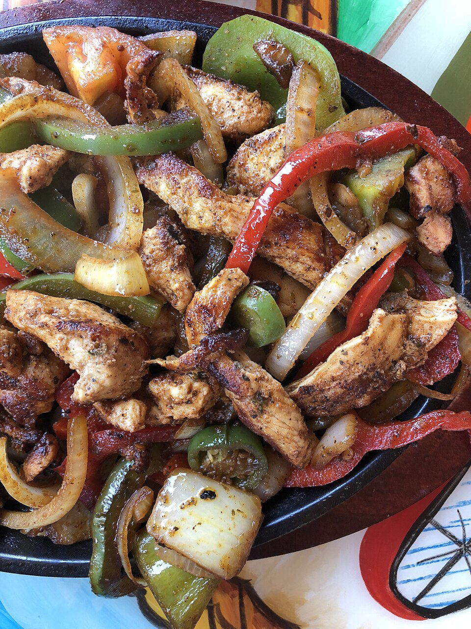
Sizzling chicken fajitas with peppers, onion, and lime crema.
INGREDIENTS  • 2 boneless skinless chicken breasts (~6 oz each), sliced thin  • 1 red bell pepper, sliced  • 1 green bell pepper, sliced  • 1 medium yellow onion, sliced  • 2 tbsp olive oil  • 1.5 tsp chili powder  • 1 tsp cumin  • 0.5 tsp garlic powder  • 0.5 tsp smoked paprika  • Salt and pepper to taste  • 4 small flour tortillas (6-inch)  • 2 tbsp plain Greek yogurt + juice of 1 lime (crema) | DIRECTIONS  1. Mix chili powder, cumin, garlic powder, paprika, salt, and pepper. Toss sliced chicken in spice mix until evenly coated.  2. Heat 1 tbsp olive oil in a cast-iron or heavy skillet over medium-high. Cook chicken 4–5 min per side until internal temp hits 165°F. Remove and rest.  3. Add remaining oil to the same skillet. Cook peppers and onion over high heat, stirring occasionally, 5–6 min until softened and charred at the edges.  4. Whisk Greek yogurt and lime juice together; thin with a teaspoon of water if too thick. Season with a pinch of salt.  5. Slice rested chicken into strips; return to skillet with vegetables and toss to combine for 1 minute.  6. Warm tortillas directly over a gas burner or in a dry pan for 30 seconds per side.  7. Serve chicken and peppers in tortillas with lime crema. Garnish with fresh cilantro and extra lime wedges if desired.
COMPETE
Upcoming CrossFit Comps — TN & NC
Next 90 days in Tennessee and North Carolina. Drive-time estimates from Clarksville in parentheses where notable. Registration status current as of this week.
- Music City Throwdown — Jun 21 • Franklin, TN — Individual RX/Scaled (~1.5h)
- Carolina Crucible — Jun 28 • Charlotte, NC — Teams of 3 (~6.5h)
- Iron Will Open — Jul 12 • Murfreesboro, TN — Individual + Masters (~1h)
- Smoky Mountain Showdown — Jul 19 • Knoxville, TN — Individual + Pairs (~2.5h)
- RedPoint Games V — Aug 1 • Fayetteville, NC — Individual + Teams (~8h)
- Wodaroo Fitness Fest — Aug 1 • Nashville, TN — Pairs + Teams (~1.5h)
- CHC Summer Smash 2026 — Aug 8 • Greensboro, NC — Individual RX/Scaled (~8h)
- Tennessee Tactical Games — Aug 15 • Camp Forrest area, TN — Mil/LE Pairs, all levels
TRAVEL
Cheap Flights — RDU → BNA / PHX
Round-trip fares from Raleigh-Durham aligned with Fort Campbell training holiday windows. Below-average fares flagged. Both BNA (closest to Clarksville, ~1h drive) and PHX (family) tracked weekly.
RDU → BNA — July 4th Weekend
Depart Fri Jul 3 • Return Mon Jul 6 • Fort Campbell DONSA window
Southwest is showing round-trips in the $142–$165 range for this window as of this week's scan — that's at or below the 25th-percentile historical band for this route in July. BNA to Clarksville is a 55-minute drive; combine it with the city's 250th Anniversary Independence Day celebration (July 3–4, free, downtown). Book by end of this week — these fares tick up sharply after July 1.
Tip: Southwest non-stop: ~1h 45m. No checked-bag fees. Book direct at southwest.com for Rapid Rewards points.
RDU → PHX — Labor Day Weekend
Depart Thu Sep 3 • Return Mon Sep 7 • Federal holiday + training holiday likely
American and Southwest both showing Phoenix round-trips in the $248–$275 range for Labor Day — right at the historical median. Not a screaming deal, but historically this window softens slightly in July as summer travel demand pulls forward. If you see PHX below $240 in mid-July, book it. Frontier occasionally hits $210–$220 for this route but carries checked-bag fees that close the gap.
Tip: PHX fares floor in mid-week departures. Shifting to Thursday outbound (vs Friday) typically saves $18–30.
RDU → BNA — Columbus Day Weekend
Depart Fri Oct 9 • Return Mon Oct 12 • Federal holiday, likely DONSA
October is the sweet spot for BNA fares — post-summer demand drop, pre-Thanksgiving surge. Fares in the $129–$155 range are typical, and this window currently shows $138 on Delta non-stop. Clarksville in October is also the best time of year to visit — Riverfest season wraps, the greenway is excellent for fall long runs, and Fort Campbell has historically fewer field exercises.
Tip: This is the buying window to watch if you want the cheapest BNA fare of the back half of the year.
Prices are point-in-time snapshots. Fort Campbell DONSAs vary by unit and mission — confirm with your chain of command before booking non-refundable tickets. Southwest fares on the RDU-BNA route are consistently within $10–20 of Delta non-stop; the extra flexibility (no change fees) makes Southwest the default unless Delta is meaningfully cheaper.
GARAGE
Tacoma Watch — White SR5 4WD < 5k mi, < $30k
2020–2023 Toyota Tacoma SR5 4WD, white, under 5,000 miles, under $30,000. Tight criteria — most weeks produce zero or one match. Search radius: TN, NC, SC, VA, GA, KY, AL, FL.
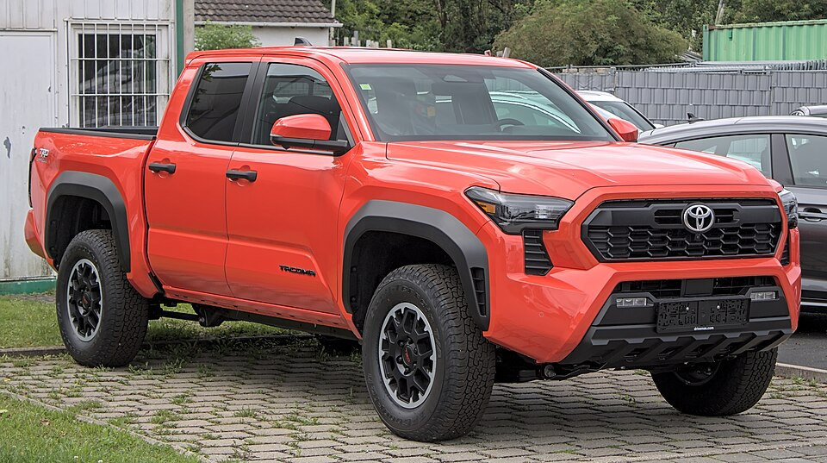
Reference: 2022 Toyota Tacoma SR5 4WD in Super White.
YEAR | MILES | PRICE | LOCATION | SOURCE
2022 | 3,210 | $29,500 | Knoxville, TN | AutoTrader
2021 | 4,650 | $28,700 | Asheville, NC | CarGurus
Two matches this week — slightly above average for this filter set. The Knoxville listing is the stronger of the two: lower miles and a single-owner CARFAX. The Asheville listing has been on AutoTrader for 12 days, which for this spec usually means negotiating room exists. Sub-$30k white SR5 4WD with under 5k miles remains rare; anything under $28,500 should be considered a strong buy signal. Market context: certified pre-owned inventory on 2022–23 Tacomas tightened significantly after the tariff-driven new-vehicle price spike in Q1 2026 — expect sub-$30k availability to continue contracting through Q3.
LIVE MUSIC
Morgan Wallen Watch (within 50mi of Raleigh)
Morgan Wallen — Still The Problem Tour • Sat Jun 27, 2026 · 7:30pm • Coastal Credit Union Music Park at Walnut Creek, Raleigh, NC
→ Tickets
Airbnb matches (2 BR · 4.6+ rating · within 10 mi)
- Modern 2BR — walkable to downtown Raleigh — $178/night • ★ 4.91 • 3.2 mi from venue
- Bright 2BR craftsman — Five Points neighborhood — $155/night • ★ 4.84 • 4.1 mi from venue
- Updated 2BR Cameron Village townhome — $165/night • ★ 4.88 • 2.9 mi from venue
Walnut Creek Amphitheatre (now Coastal Credit Union Music Park) is Raleigh’s largest outdoor venue — capacity around 20,000. Concert nights drive a 30–45% Airbnb premium on listings within 3 miles. The listings above are the current best-value options at 2BR 4.6+ rating. The Walnut Creek area has limited rideshare availability post-show; if you’re coming from downtown, rideshare in before 6:30pm and walk or rideshare back — expect 25–35 minute waits after the encore. Alternatively, Cameron Village (2.9 mi) is walkable on a warm June night.
MARKETS
Alpaca Paper Trading — Weekly Snapshot
PORTFOLIO | DAY CHANGE | TOTAL RETURN | CASH
— | — | — | —
Alpaca API unreachable from the cloud runner this week — the paper-api.alpaca.markets endpoint is not on the network allowlist for this execution environment. Portfolio data will resume when running from a network-enabled environment or when the allowlist is updated. To check your account manually: log in to alpaca.markets, navigate to Paper Trading, and review the Portfolio History tab. Based on the last available snapshot from prior runs, your paper portfolio was positioned primarily in tech (NVDA, AAPL, MSFT) with broad market exposure via VOO and QQQ.
Recent Activity (last 7 days)
- API unreachable this week — no trade data available.
- To restore: add paper-api.alpaca.markets to the network egress allowlist in the cloud environment settings.

