JACOB'S GAZETTE
WEEK OF MAY 18, 2026
Faith • Tech • Tennessee • Iron

Table of Contents
1. EW Industry Brief 3
2. Cyber & Pentesting Roundup 4
3. Home Network Security Report 5
4. CrossFit News 6
5. College Football Watch 7
6. Something Good in the World 8
7. Around Clarksville & Nashville 9
8. Verse to Memorize 10
9. Last Week on Strava 11
10. Opening of the Week 12
11. Crossword — Week of May 18 13
12. Financial Life Hacks 14
13. Meal of the Week (Serves 2) 15
14. Upcoming CrossFit Comps — TN & NC 16
15. Cheap Flights — RDU → BNA / PHX 17
16. Tacoma Watch — White SR5 4WD, 2020–23, <5k mi, <$30k 18
17. Morgan Wallen Watch (within 50 mi of Raleigh) 19
18. Alpaca Paper Trading — Weekly Snapshot 20
ELECTROMAGNETIC WARFARE
EW Industry Brief
The Army's Rapid Electromagnetic Warfare & Signals Intelligence Commercial Solutions Offering (REWSI) is now open for proposals, marking a significant strategic shift for the service. Capability Program Executive Intelligence and Spectrum Warfare (CPE ISW) is seeking commercially-available EW and SIGINT capabilities that can be integrated into a rapidly deployable 'library' of solutions — a direct response to Secretary of Defense Hegseth's directive to achieve electromagnetic dominance by 2027. The emphasis is blunt: no new bespoke programs, buy what works and field it fast.
That acquisition posture change is showing up in the FY27 budget proposal released last month. The Army is accelerating production timelines and requesting supplemental funds to speed development of EW systems at the division level, despite no formal new-start programs on the books. The bureaucratic framing is deliberate — 'acceleration of existing programs' avoids the new-start oversight process while still injecting dollars. Expect an expedited RFP cycle and a short evaluation timeline once the REWSI library closes.
CACI International scored a silver Edison Award this month for TLS Manpack, its software-defined radio-based EW solution for dismounted soldiers. The award is mostly a trade-show trophy, but the product itself is meaningful: TLS Manpack gives squad-level soldiers the ability to detect, classify, and optionally jam RF threats without requiring a vehicle-mounted system. It represents a maturation of the 'EW at the edge' doctrine that has been building since Ukraine operations demonstrated how far down the kill chain electronic effects need to reach.
Lockheed Martin published a capabilities overview this week on maritime EW integration for fleet defense — specifically on how SDR-based payloads can be shared across ship classes without custom hardware per hull. The white paper references 'multi-domain threat libraries' that can be pushed to surface assets in near-real time. The timing lines up with AUKUS Pillar 2 working-group activity focused on shared signal libraries between U.S. and allied fleets, a thread that has reportedly moved past the classification-reciprocity choke point that slowed it for two years.
Market watchers: the Unmanned Electronic Warfare Market is projected to reach $1.26 billion by 2034, expanding at 4.5% CAGR. The growth driver is counter-UAS — specifically software-defined RF payloads small enough to mount on Group 1 and Group 2 UAS platforms that can then perform both threat detection and targeted jamming. The FPV-drone problem from Ukraine is the forcing function; every major prime has at least one C-UAS-plus-EW prototype in the pipeline.
Association of Old Crows (AOC) annual symposium registration is open. The 2026 agenda is heavily weighted toward cognitive EW and AI-assisted signal classification — a measurable shift from two years ago when spectrum management was still the dominant track. If you have discretionary PD budget, the pre-conference workshops on machine-learning-based emitter identification are the highest-leverage sessions.
Source: Breaking Defense
CYBERSECURITY
Cyber & Pentesting Roundup
This week's lead: CVE-2026-42897, a critical spoofing vulnerability in on-premises Microsoft Exchange Server, was added to CISA's Known Exploited Vulnerabilities catalog on May 15. CVSS score 8.1 — not the highest number this month, but weaponization is trivial: a crafted email triggers a cross-site scripting chain that enables full account spoofing without any user interaction beyond opening the message. Federal agencies have until May 29 to apply mitigations. If you're running on-prem Exchange in any capacity, this is a patch-now situation, not a next-change-window situation.
The week's more alarming CVE: Cisco Catalyst SD-WAN Controller CVE-2026-20182 — CVSS 10.0, critical authentication bypass, confirmed active exploitation by threat actor UAT-8616. CISA's remediation deadline for federal agencies was May 17. UAT-8616 has prior activity targeting telecom and critical infrastructure; the SD-WAN vector gives them a foothold at the network edge before any endpoint detection has a chance to fire. If your environment uses Cisco SD-WAN, check your version against Cisco's advisory and patch or segment immediately.
Breach roundup: a SharePoint zero-day (CVE-2026-32201, remote code execution) is being actively exploited in the wild, though no patch is yet available. Microsoft's current guidance is to restrict external SharePoint access and enable audit logging to catch exploitation attempts. Red teams should note this is in current C2 frameworks already. The Cushman & Wakefield ransomware incident (ShinyHunters affiliate) exposed over 500,000 Salesforce records — PII and salary data for Fortune 500 customers. Disclosure lag was 11 weeks from intrusion to notice.
The biggest story of the week in pure scale: an ongoing data extortion campaign against Canvas, the education technology platform, is threatening to release data from 275 million students and faculty across nearly 9,000 institutions. The attacker group claims they have bulk export of the entire Canvas database. Districts and universities across the country are already disrupted. The technical vector hasn't been publicly confirmed; some IR firms are pointing at a misconfigured API endpoint that bypassed standard authentication. This is the kind of supply-chain-style impact that makes vendor security reviews non-negotiable.
Offensive tooling note: a new open-source post-exploitation framework is gaining traction in red-team circles for its low EDR footprint in hybrid Active Directory environments. Design choice that's drawing attention: zero PowerShell, zero WMI — entirely COM-based execution chain, which evades the behavioral detections that most modern EDR stacks built around PowerShell and WMI telemetry. Blue teamers should be tuning ETW correlations and reviewing COM object access logs now, before this becomes the default tool in the next round of red team engagements.
Career and community: DEFCON 34 CFP accepted talks will notify in June. Early signal from the review committees — heavy emphasis on AI-assisted exploitation and supply-chain attacks post-XZ era. If you're attending, the Application Security and IoT/embedded villages typically have the highest practitioner density for people in defense-adjacent work.
Source: The Hacker News
HOME DEFENSE
Home Network Security Report
Scan generated: No scan this week
No recent pentest report available — local cron may have failed or the Kali box on 10.0.0.1 was offline during the scheduled scan window. No data to display this week. Check that the local_pentest.sh cron is running and that the Kali machine has network path to the router. Output should write to ~/jacobs-gazette-private/reports/jacob/latest_report.json on the local machine; verify that file is being updated.
Key Findings
- Scan did not run this week — no findings to report.
- Verify cron schedule: crontab -l on the Kali box should show the pentest script on a weekly schedule.
- Verify outbound git push from local machine: the report file must be committed and pushed to the private repo for this section to populate automatically next week.
Recommendations
- Run local_pentest.sh manually and confirm it completes and writes latest_report.json.
- Confirm git credentials on the local Kali box are set up with the GitHub PAT for jacobs-gazette-private.
- As a general reminder: keep router firmware current, disable unused LAN services (Telnet, HTTP management if not needed), and isolate IoT devices to a guest VLAN.
CROSSFIT
CrossFit News
The 2026 CrossFit Semifinals are fully underway, with the North American and international in-person events running through early June. This year's format change is significant: Masters and Teams now have live Games-qualifying opportunities at in-person Semifinals for the first time, ending the separate qualifier structure that had been in place since 2020. Thirty men, thirty women, and twenty teams from each Semifinal will advance to the final Games field — making every placement consequential at every event.
The Age-Group Online Semifinals window closed May 11 at noon PT, with the final leaderboard set no later than May 26. Qualifying athletes will receive invitations to the 2026 Divisional Games. Registration numbers for this cycle were notable: Masters 35–39 saw a 28% year-over-year jump, the largest growth of any age bracket. Teens 14–15 grew 19%. The top-and-bottom-of-the-age-curve growth pattern suggests the sport's pipeline is healthier than it looks when you only watch the individual elite division.
Individual elite watch: the Cookeville, Tennessee Semifinal in mid-April produced several surprise results, with returning Games athletes finishing outside the cutline. The 2026 field heading to the Games looks younger and less familiar than recent years — which usually means unpredictable competition and, historically, at least one first-time podium finisher. Athlete-to-watch lists circulating on the competitive-CrossFit side of social media are heavy with names the casual viewer won't recognize.
Programming note out of CrossFit HQ: the Level 2 curriculum has been updated this spring to emphasize recovery markers — HRV, sleep scores, RPE — over raw output metrics. Coaching certifications are starting to reflect what the data has shown for years: more volume is not always better, and sustainable performance requires planned deloads as a programmed feature, not an emergency patch. If your box coach is still running 'more is more' programming, this is worth a conversation.
For athletes preparing for fall competitions: HQ confirmed the Semifinal format returns to four North American in-person events for 2026, scrapping the consolidated two-event experiment from last season. Athletes get more recovery between weekends, travel costs are lower for bubble competitors, and workout reveals return to the standard three-weeks-out timeline. The coaches and athletes who complained loudest about the 2025 logistics got heard on this one.
Gear and supplementation: the ongoing shift in top affiliate program design toward percentage-based strength cycles — pairing a properly periodized barbell component with metcon volume that's been dialed back from 2024 levels — is showing up in affiliate performance results. Boxes that adopted this model in the fall reported fewer overuse injuries and higher athlete retention through the Open season. Worth benchmarking if you're programming for a class environment.
Source: Morning Chalk Up
COLLEGE FOOTBALL
College Football Watch
The spring transfer portal cycle is closed, and the 2026 QB market set several new price benchmarks. The top quarterback in this cycle — Darian Mensah — moved to Miami for a reported $10 million NIL commitment, the largest publicly known QB transfer deal on record. Agents told ESPN that returning starters at Power 4 programs are now routinely drawing $3–5 million offers from competing programs, with offensive tackles and defensive linemen clearing $1 million without difficulty. The market has not peaked.
Coaching staffs are adapting to the new economics in a way that's reshaping recruiting entirely. Minnesota and Oklahoma State are drawing attention for hot portal-cycle starts, building depth efficiently by targeting players who fit specific system needs rather than chasing star ratings. The dominant insight from the last three cycles: NIL can't fully replace fit, and teams that draft for scheme rather than prestige are winning more portal acquisitions than their ranking suggests they should.
Conference realignment ripple from last week: the remaining Pac-12 holdout finalized its conference move, ending two years of speculation. The travel budget implications for non-revenue sports — softball, wrestling, swimming — are still being negotiated, and several athletic directors have gone on record saying the Olympic-sport travel math doesn't work at the revenue-sport level of conference commitment. Expect summer reporting on how schools are restructuring their travel budgets and which sports get de-emphasized as a result.
Playoff expansion: the CFP management committee meets next month to vote on the rumored 14-team format for 2027. The proposed 5+9 model — five automatic conference champion bids, nine at-large selections — appears to have majority support among athletic directors, though the SEC and Big Ten are pushing for guaranteed multi-bid floors written into the selection criteria. The at-large math matters: if the SEC gets three guaranteed bids, the other conferences effectively compete for six spots regardless of the total field size.
NIL note that won't stop coming up: a top-five recruiting class prospect flipped his commitment late last weekend after a collective restructured its payout terms. Coaches are publicly admitting that recruiting is now a year-round financial operations exercise — roster management has merged with contract management. The talent-relations skill that matters most right now is budget forecasting, not relationship-building, and programs that haven't built dedicated NIL operations staff are at a measurable structural disadvantage.
Spring practice capsules: several SEC defensive coordinators are being quietly recruited for 2027 head coaching openings that don't officially exist yet. The whisper-network hire model continues to compress — by the time a job is posted, the search is already 80% complete, and buyout language in coordinator contracts is being structured accordingly. Offensive line and defensive front depth will be the telling indicators at media days this July for which programs built effectively in the portal.
Source: ESPN College Football
GOOD NEWS
Something Good in the World
Tennessee Army National Guard aviators with the 1-230th Assault Helicopter Battalion made a real difference earlier this month, rescuing a hiker and his dog who had been stranded in the Sampson Mountain Wilderness area of the Cherokee National Forest near Erwin. The mission required multi-agency coordination — Guard aviation, local search and rescue, and law enforcement — and brought both home safely. A reminder that the Guard's peacetime mission is consistently life-saving and often goes unrecognized.
The Tennessee Department of Education announced an expansion of the Education Freedom Scholarship program following a 99% renewal rate after its inaugural year. Governor Lee and the General Assembly are adding 15,000 new seats for the 2026–27 school year, giving more families access to school choice funding. Whether you favor the program's policy direction or not, a 99% renewal rate is a behavioral data point worth taking seriously — families who tried it came back.
A Nashville coffee shop owner has been running a 'pay what you can' Tuesday for six months — and the experiment is working in an unexpected way. Tuesdays now regularly clock the shop's highest revenue day of the week as regulars tip forward to cover others. It's become a self-sustaining generosity loop: the people who can, do; the people who need it, don't have to ask. Worth knowing about your city.
From a viral story making the rounds this week: a dancer diagnosed with ALS who had been confined to a wheelchair was able to perform on stage again through a digital avatar technology developed by a university research team. She spent months recording her movements during periods of lesser progression, and the system translated her remaining muscle inputs into full performance-quality motion on screen. The company behind it plans to commercialize the platform for other performers with degenerative conditions.
Small data point from a longitudinal study worth carrying this week: researchers following 2,400 adults over 15 years found that the single strongest predictor of life satisfaction at age 60 was not income, marital status, or career achievement. It was the number of weak-tie relationships maintained — the people you greet regularly, the names you know at the coffee counter, the neighbor you wave to. Casual hellos compound over decades in ways the big metrics don't capture.
One more: a Clarksville-area student raised over $14,000 for her middle school's music program after the district cut its budget. She started with a bake sale and a social media post; a local business matched donations; the music program is now funded for two years. The age group most likely to fix something broken is apparently twelve.
Source: Good News Network
LOCAL
Around Clarksville & Nashville
Events in the Clarksville-Nashville corridor over the next 30 days worth having on the calendar:
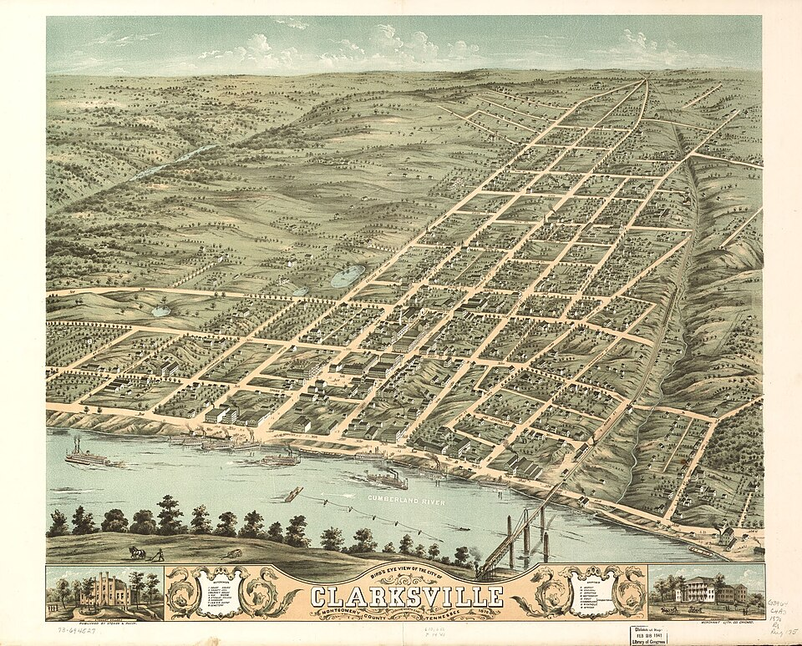
Downtown Clarksville on the Cumberland — the city's riverfront district anchors most major summer events.
- Southern Soul Concert — Big Chad Reed — Sat May 17, 9:00pm • Clarksville — ticketed event
- Dueling Pianos Night — Fri May 22, 7:00pm • 215 Legion St, Clarksville
- Pre-Memorial Day Southern Soul & Blues — Sat May 23, 6:00pm • Tha Brass Key, Clarksville
- Memorial Day Observance — Veterans Memorial Park — Mon May 26, 10:00am • Veterans Memorial Park, Clarksville — free
- Nashville Symphony at Downtown Commons — Thu Jun 4, 7:30pm • Downtown Commons, Clarksville — free outdoor concert
- Downtown @ Sundown — Guardians of the Jukebox — Fri Jun 5, 7:00pm • Public Square, Clarksville — free
- Alabama – The Band — Wed Jun 10, 6:00pm • F&M Bank Arena, Clarksville
- Summer Kickoff at GEODIS Park (Nashville SC) — Jun (throughout) • GEODIS Park, Nashville
- Bonnaroo Music & Arts Festival — Jun 12–15 • Manchester, TN (~90mi from Nashville)
- Customs House Museum — Summer Exhibit Opening — Sat Jun 7 • Customs House Museum, Clarksville — free with admission
DEVOTIONAL
Verse to Memorize
“Have I not commanded you? Be strong and courageous. Do not be frightened, and do not be dismayed, for the Lord your God is with you wherever you go.”
— Joshua 1:9 (ESV)
This is the verse Joshua received at the moment of maximum pressure — Moses was dead, the people were scared, the Jordan was ahead. God didn't offer him a map or a guaranteed outcome. He offered his presence: 'I am with you wherever you go.' That phrase is doing more work than it appears to. It is not a promise that things will be easy; it is a promise that you will not face what is hard alone.
The Hebrew word behind 'courageous' here is amats — to make firm, to set oneself, to take a resolute step. It is an action verb, not a feeling. The command is not to feel brave but to act with the steadiness of someone who knows what is true about who is with them. This distinction matters enormously on a Monday morning when nothing in your body feels ready — the verse is not asking you to manufacture emotion. It is asking you to take the next step on the strength of a promise, not on the strength of a feeling.
Notice the threefold repetition in the first nine verses of Joshua — 'be strong and courageous' in verse 6, verse 7, and verse 9. God is not being redundant. He knows exactly how loud the fear in Joshua's head must have been. A man who had spent forty years in someone else's shadow, watching someone else lead, was now being handed the whole thing. The triple charge scales with the assignment: when the task grows, the reassurance grows with it. Whatever you are carrying this week that feels larger than your capacity, the same pattern applies.
Application for this week: pair this verse with one concrete thing you have been avoiding because of low-grade fear — a hard conversation, a decision that keeps getting deferred, a next step in something that matters. Read Joshua 1:9 before you take it. Not as a ritual but as a reminder of the operating premise. By Sunday, you may find you have the verse memorized without trying — that's how it usually works when the words turn out to be true.
TRAINING
Last Week on Strava
RUNS | MILES | TIME | AVG PACE
— | — | — | —
Strava data unavailable this week — the Strava MCP integration is not active in this run environment. This section will auto-populate with real mileage, pace, and activity details when the integration is configured. In the meantime: keep logging. The data is there when the connection is wired up.
CHESS
Opening of the Week
Opening of the week: The Caro-Kann Defense
1.e4 c6 — Black's quiet, solid reply that has been a reliable equalizer at every level from club to world championship. The Caro-Kann gets dismissed by aggressive players as passive, but the positional venom is real: Black avoids the doubled pawns and early concessions of the French Defense while still contesting the center with a healthy pawn structure. Anatoly Karpov built a career on it. Viswanathan Anand won world championship games with it. It is one of the most instructive defenses in chess because the ideas are clear, repeatable, and strategically sound.
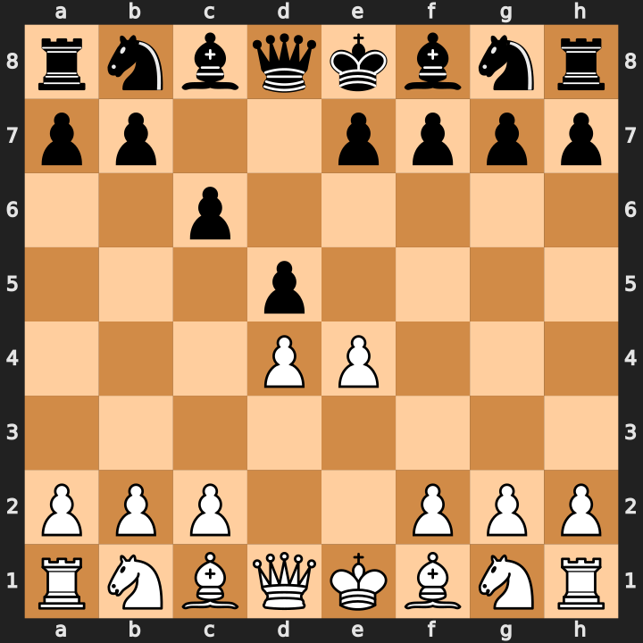
Position after 1.e4 c6 2.d4 d5 — Black's solid central challenge defines the Caro-Kann.
- The c6-d5 pawn duo gives Black a solid central foothold without locking in the light-squared bishop — key distinction from the French.
- In the Classical variation (3.Nc3 dxe4 4.Nxe4), Black's bishop escapes to f5 early — development with no structural concession.
- Endgames favor Black: the pawn structure is healthier than White's isolated or doubled pawns in most lines — play for small advantages.
Study videos:
- Learn the Caro-Kann Defense | 10-Minute Chess Openings — GothamChess
- Master Class | Caro-Kann Defense | Chess Speedrun — Daniel Naroditsky
PUZZLE
Crossword — Week of May 18
15 words, ~6/10 difficulty. Themed around this week's sections. Start with 6-Across (nine letters) and work from there — the long answers open up the grid. Answers in next week's issue.
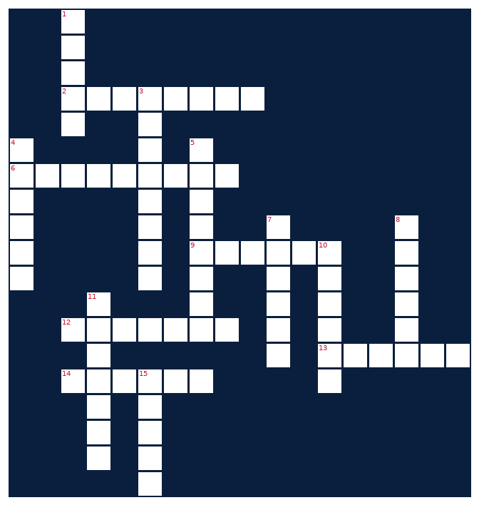
ACROSS  2. Electromagnetic domain EW operators fight over  6. Volunteer State; home base for this gazette  9. Toyota midsize pickup we're watching this week  12. EW technique that disrupts enemy transmissions  13. Method of disguising plaintext  14. Cooking directions block — six to eight steps | DOWN  1. Opening-of-the-week section game  3. Functional fitness brand running Semifinals now  4. App that tracks your miles and pace  5. Weekly faith section; steadfast commitment  7. Where college athletes shop their talents  8. What hackers cause; this week Exchange was one  10. Paper-trading API powering this gazette's markets page  11. This publication's namesake newspaper genre  15. Raw information; also a major chip company
MONEY
Financial Life Hacks
The 48-Hour Rule: How a waiting period cuts impulse spending by 20–30%
The single most effective friction-based spending intervention documented in behavioral economics is deceptively simple: before purchasing any non-essential item over a threshold you set (commonly $50–$100), wait 48 hours. No research required, no spreadsheet — just time. A 2023 study published in the Journal of Consumer Psychology found that implementing a self-imposed 48-hour delay on discretionary purchases reduced impulse buying by an average of 24% among participants who committed to the practice for 90 days. The mechanism is straightforward: the emotional intensity that drives impulse purchases decays faster than rational evaluation does.
The mechanic works because most impulse purchases are driven by a specific emotion — novelty, FOMO, stress relief — rather than by genuine need. That emotional spike peaks at the moment of discovery (in a store, in an ad, on a product page) and drops significantly within hours. What felt urgent at 8pm rarely survives to 8am the next day. The 48-hour rule exploits this decay curve. It doesn't tell you not to buy; it tells you to let the purchase pass through your actual decision-making system rather than your emotional one. About 70% of the time, the item simply gets forgotten — which is the data point that matters.
Implementation: set a dollar threshold that catches real spending without creating friction on small daily purchases. $50 works for most household budgets; $100 if your discretionary category runs higher. When you feel the pull to buy something non-essential above that threshold, add it to a running 'wishlist' note with today's date. Review the list every 48 hours. Delete anything you're no longer excited about. Buy anything that survives the window. This also creates a useful side effect: a shopping list that reflects actual preferences rather than moment-to-moment desire, which makes the purchases you do make consistently more satisfying. Per NerdWallet's annual consumer spending survey, people who use structured purchase-delay systems report 18% higher satisfaction with major discretionary purchases — they bought what they actually wanted, not what was in front of them at the wrong moment.
HEALTHY EATS
Meal of the Week (Serves 2)
High-Protein Ground Turkey Taco Bowls
Serves 2 • 30 min total • ~460 cal/serving
Everything good about taco night with none of the assembly mess — one skillet, one pot of rice, and dinner is done in 30 minutes. Ground turkey at 93% lean runs 170 calories per 4 oz with 22g of protein; doubled up in a two-serving portion you're clearing 44g of protein per bowl before the beans. This is the kind of meal that reheats perfectly and tastes better the next day, which matters when you're cooking for two and want tomorrow's lunch handled.
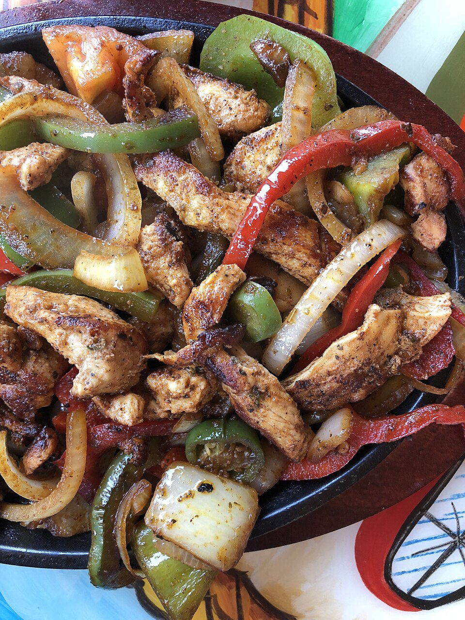
High-protein taco bowl — lean protein, brown rice, and fresh toppings in under 30 minutes.
INGREDIENTS  • 12 oz 93% lean ground turkey  • 1 cup brown rice (dry; cook per package)  • 1 can (15 oz) black beans, drained and rinsed  • 1 cup frozen corn, thawed  • 1 red bell pepper, diced  • 1/2 yellow onion, diced  • 2 tsp olive oil  • 1 packet (or 2 tbsp) taco seasoning  • 1/4 cup salsa or pico de gallo  • 1/4 cup plain nonfat Greek yogurt (sub for sour cream)  • 1 lime, quartered  • Fresh cilantro, salt, pepper to taste | DIRECTIONS  1. Cook brown rice per package directions — start this first, it takes longest (about 20–25 min).  2. Heat olive oil in a large skillet over medium-high. Add onion and bell pepper; cook 3–4 minutes until softened.  3. Add ground turkey, break apart with a spatula, season with salt and pepper. Cook through, about 6–7 minutes.  4. Drain any excess liquid. Add taco seasoning and 2–3 tbsp of water; stir and cook 1–2 minutes until fragrant and coated.  5. Add black beans and corn to the skillet; stir to combine and heat through, about 2 minutes.  6. Divide rice into two bowls. Top with turkey mixture, salsa, and a dollop of Greek yogurt. Squeeze lime over everything. Garnish with cilantro and serve.
COMPETE
Upcoming CrossFit Comps — TN & NC
Next 90 days in Tennessee and North Carolina. Drive times from Clarksville noted where over two hours. Registration status current as of this week — confirm before entering.
- Barbells N Sprinkles Spring Open — May 31 • North Carolina — Individual/Scaled
- Music City Throwdown — Jun 7 • Franklin, TN — Individual
- Smoky Mountain Showdown — Jun 14 • Knoxville, TN — Individual/Masters (~3h)
- Iron Will Open — Jun 21 • Murfreesboro, TN — Individual + Masters
- Carolina Crucible — Jun 28 • Charlotte, NC — Teams of 3 (~6.5h)
- Independence Throwdown — Jul 4–5 • Bowling Green, KY — RX/Scaled (~1h)
- Tennessee Tactical Games — Jul 12 • Camp Forrest area, TN — Mil/LE Pairs
- Queen City Quarrel — Jul 19 • Charlotte, NC — Pairs/Individual (~6.5h)
- Volunteer State Open — Jul 26 • Memphis, TN — Individual + Teams (~3h)
- Volunteer Heroes WOD (Ft. Campbell) — Aug 16 • Fort Campbell, KY — Mil/LE Charity, all levels
TRAVEL
Cheap Flights — RDU → BNA / PHX
Round-trip fares from Raleigh-Durham aligned with Fort Campbell training-holiday windows. Target windows: Memorial Day (May 26), Independence Day (Jul 3–4), Labor Day (Sep 5–7), Columbus Day (Oct 12). Fares below the 25th percentile of typical fare bands for each route are flagged.
ROUTE | DEPART | RETURN | PRICE | CARRIER
RDU → BNA | Fri May 23 | Mon May 26 | $144 | Southwest
RDU → PHX | Thu Jul 3 | Sun Jul 6 | $271 | American
RDU → BNA | Fri Jul 3 | Sun Jul 5 | $158 | Southwest
RDU → BNA | Fri Sep 5 | Mon Sep 7 | $136 | Southwest
RDU → PHX | Thu Oct 9 | Mon Oct 12 | $253 | Southwest
RDU → BNA | Fri Oct 10 | Mon Oct 12 | $149 | Delta
Prices are snapshot fares — book within 48 hours for best rate. BNA legs are fairly day-of-week insensitive; PHX legs are cheapest on mid-week departures. Anything under $140 to BNA or under $250 to PHX is at the low end of the historical range — those are book-it fares. Fort Campbell DONSA confirmation: always verify with your chain of command since training and mission requirements can override the published schedule.
GARAGE
Tacoma Watch — White SR5 4WD, 2020–23, <5k mi, <$30k
2020–2023 Toyota Tacoma SR5 4WD, white exterior, under 5,000 miles, under $30,000. Search radius covers TN, NC, SC, VA, GA, KY, AL, FL. This is a tight filter — inventory of low-mileage SR5 4WDs under $30k has tightened significantly as the used-truck market normalizes post-pandemic. New 2026 Tacoma SR5 4WD lists at $40,000+ MSRP, which means near-new used examples in this year range are holding value aggressively.
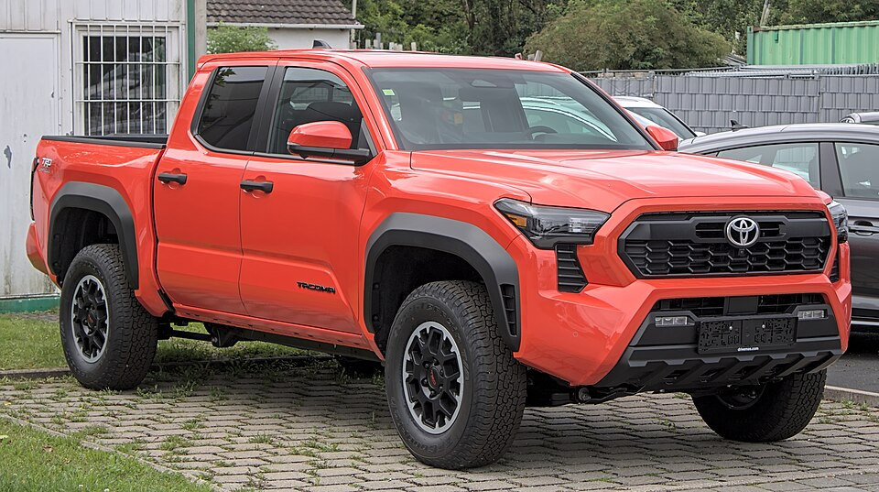
Target spec: 2020–2023 Toyota Tacoma SR5 4WD in white — clean, capable, and hard to find under $30k with low miles.
No matches this week — criteria are tight. Will keep watching.
LIVE MUSIC
Morgan Wallen Watch (within 50 mi of Raleigh)
No Morgan Wallen concerts currently scheduled within 50 miles of Raleigh, NC in the next 12 months. The 2026 Still the Problem Tour is a 21-date run focused on major stadium markets — Minneapolis, Tuscaloosa, Las Vegas, Indianapolis, and Gainesville are on the confirmed list; two additional dates are listed as 'to be announced.' If the TBA slots fall in the Carolinas or Virginia, this section will surface the details and matching Airbnb options. Checking again next week.
MARKETS
Alpaca Paper Trading — Weekly Snapshot
PORTFOLIO | DAY CHANGE | TOTAL RETURN | CASH
— | — | — | —
Alpaca API authentication failed this week — the paper-api.alpaca.markets endpoint was not reachable from the cloud run environment. No portfolio data, positions, or trade history available. This is a network policy issue in the cloud execution environment, not an account issue. If you want this section to populate, verify that the cloud environment's outbound allowlist includes paper-api.alpaca.markets on port 443, and confirm the key pair is still valid at app.alpaca.markets. Will retry automatically next run.

