JACOB'S GAZETTE
WEEK OF JUNE 22, 2026
Faith • Tech • Tennessee • Iron

Table of Contents
1. EW Industry Brief 3
2. Cyber & Pentesting Roundup 4
3. Home Network Security Report 5
4. CrossFit News 6
5. College Football Watch 7
6. Something Good in the World 8
7. Around Clarksville & Nashville 9
8. Verse to Memorize 10
9. Last Week on Strava 11
10. Opening of the Week 12
11. Crossword — Week of June 22 13
12. Financial Life Hacks 14
13. Meal of the Week (Serves 2) 15
14. Upcoming CrossFit Comps — TN & NC 16
15. Cheap Flights — RDU → BNA / PHX 17
16. Tacoma Watch — White SR5 4WD < 5k mi, < $30k 18
17. Morgan Wallen Watch (within 50mi of Raleigh) 19
18. Alpaca Paper Trading — Weekly Snapshot 20
ELECTROMAGNETIC WARFARE
EW Industry Brief
The Army's FY27 budget request dropped this month with a headline number that caught the EW community's attention: $156 million for the Electronic Warfare Advanced Technology (EWAT) program — an 81 percent increase over the $86 million appropriated in FY26. The ask signals institutional commitment, not just a funding blip. The service is explicitly accelerating development and production of electromagnetic warfare and SIGINT capabilities, and the budget language ties directly to lessons absorbed from Ukraine and the Indo-Pacific threat environment.
Lockheed Martin announced progress on its Scaled Onboard Electronic Attack (SOEA) system this week, positioning it as an affordable, rapidly fieldable next-generation EA platform for the Navy. The pitch is cost and speed to field — 'rapidly fieldable' is doing a lot of work in defense marketing right now, but the Navy's appetite for electronic attack that doesn't require a specialized airframe is real and growing. Watch for a contract award or prototype demonstration announcement in Q3.
Market sizing firm MarketsandMarkets pegged the global EW market at $64.66 billion by 2031, driven by the unmanned/autonomous segment (projected 23.7% CAGR) and the software subsegment. Europe is the fastest-growing regional market at 18.7% CAGR — a direct function of the NATO capability investment spike since 2022. Defense budgets across the continent are now tracking toward 2.5-3% of GDP, and EW capability is near the top of every modernization list.
AI and machine learning continue their march into the spectrum. The shift from closed, hard-coded EW systems to open-architecture, software-defined platforms is now mainstream at the requirements level — the argument is over execution, not direction. ML-driven signal classification, real-time adaptive jamming, and cognitive EW (systems that learn the threat environment and respond autonomously) are the three capability areas absorbing the most R&D investment across the U.S. prime ecosystem.
Counter-UAS pressure is reshaping EW priorities in practical ways. The FPV drone threat documented out of Ukraine has migrated directly into U.S. Army requirements. RF-based effectors with software-defined waveforms are being prioritized over kinetic solutions for most scenarios — cheaper, faster, and able to be updated as adversaries adapt their comms protocols. Units rotational to Europe and the Pacific are already fielding interim solutions while the programs of record mature.
Workforce note: AI/ML for EW is now a hard skill requirement in postings across Huntsville, Crane, and Patuxent River. If you're looking at the civilian or contractor market, signal classification and software-defined radio development are the two most in-demand competencies. The gap between what programs need and what the workforce currently has is measurable — and the primes know it.
Source: Breaking Defense
CYBERSECURITY
Cyber & Pentesting Roundup
Microsoft's June 2026 Patch Tuesday was the largest of the year: 200 vulnerabilities patched, including 6 zero-days and 33 classified Critical. Two zero-days are worth flagging immediately. CVE-2026-45586 (Windows Collaborative Translation Framework / CTFMON) is a publicly disclosed privilege escalation flaw that grants SYSTEM-level access — no active exploitation confirmed at patch time, but PoC code is circulating in private channels. CVE-2026-49160 (HTTP.sys) is an HTTP/2 denial-of-service that abuses protocol compression to force excessive memory allocation; this one is relevant to any organization running IIS or Windows-based reverse proxies exposed to the internet.
The Qilin ransomware group was linked this week to active exploitation of a VPN zero-day affecting Check Point appliances. Multiple incident responders are confirming initial access via the VPN vector before lateral movement begins — the pattern mirrors the playbook from the Ivanti wave in late 2025. If your org runs Check Point perimeter gear, patching is not optional right now. Qilin has been targeting healthcare and logistics verticals in the past 90 days.
ServiceNow disclosed a security incident on June 5 in which an unpatched configuration issue allowed unauthenticated users to gain elevated access to hosted instances. The company applied a server-side fix without customer action required, but the incident highlights the risk surface of SaaS platforms where the customer has limited visibility into the underlying infrastructure. ServiceNow is deeply embedded in IT service management at large enterprises — the blast radius of a true compromise would be significant.
Law enforcement had a good week: an international operation dismantled the SocGholish botnet and took down more than 100 servers linked to Evil Corp, the Russian cybercrime group. Nearly 15,000 malware-infected WordPress sites were cleaned as part of the operation. SocGholish is a drive-by malware distribution framework that impersonates browser update prompts — it's been responsible for delivering ransomware precursor implants at scale since 2018.
Red team/offensive tooling: the trend toward COM-based lateral movement (zero PowerShell, zero WMI) to evade behavioral EDR detections is accelerating. Multiple new open-source frameworks have dropped in the past 60 days using this approach. Defenders should be reviewing ETW (Event Tracing for Windows) correlation rules and ensuring their EDR vendor has updated signatures for COM-hijacking-based execution chains — the traditional behavioral triggers are increasingly insufficient.
CISA this week added two new entries to the Known Exploited Vulnerabilities catalog, including the SolarWinds Serv-U flaw being used to crash servers. If you're running Serv-U for managed file transfer, patch immediately — KEV listings mean active exploitation is confirmed.
Source: BleepingComputer
HOME DEFENSE
Home Network Security Report
Scan generated: No scan this week — local pentest cron unavailable
No pentest report available this week. The local Kali-based scanning cron did not generate a report — this is expected when the device is offline or the LAN is unreachable from the scan host. The last saved report on file is more than 10 days old and has been omitted to avoid presenting stale data as current. Recommendations from prior weeks remain valid: disable Telnet on the router (10.0.0.1), rotate the Shinobi NVR admin credential, and isolate the Hisense TV on a guest VLAN. Will retry next Thursday.
Recommendations
- Confirm Kali scan host (10.0.0.5) is powered on and on the same LAN segment as 10.0.0.1 before next Thursday's cron window.
- Until next scan: verify router Telnet (port 23) is still disabled — this was flagged as open in the last report.
- Rotate Shinobi NVR admin password if not already done — default credentials remain a high-priority remediation.
CROSSFIT
CrossFit News
The 2026 CrossFit Semifinals cycle wrapped this week with the conclusion of the Individual Online Qualifier, which ran June 11-15. Seven men and seven women earned direct berths to the CrossFit Games through the online route — the final opportunity for athletes who couldn't qualify through an in-person Semifinals event. Combined with the four in-person Semifinals events that ran April through early June, the individual Games field is now largely set. Expect the official qualifying leaderboard to finalize in the next 72 hours.
The Mayhem Classic kicked off the Semifinals season in April with a performance from the defending Games champion that reset expectations for the season. Six athletes qualified out of Mayhem alone, signaling the depth of the competitive field heading into Fort Worth. The 2026 class looks younger on average than 2025 — several teens and early-20s athletes made their first Semis appearances and advanced, suggesting the pipeline from the Open is generating real competitive talent.
Masters athletes competed at the Colombia Semifinals June 12-14, with qualifying spots awarded across the 35-39, 40-44, 45-49, 50-54, and 55+ divisions. Masters programming this year featured heavier barbell cycling and longer mono-structural pieces than 2025 — a deliberate departure from the high-skill gymnastics emphasis that dominated last cycle. Community feedback was broadly positive; older athletes responded well to the strength-biased format.
The CrossFit Athlete Council opened a dedicated feedback email channel this month, inviting athletes and community members to submit input directly rather than routing through social media. This is a structural change worth watching — athlete councils in other sports have historically been advisory at best, but the explicit communication channel suggests CrossFit HQ is at minimum acknowledging the criticism around judging standards and programming transparency that surfaced during the Open.
Box programming trends for June: the shift toward percentage-based strength cycles continues, with major affiliated programming services reporting that members are responding better to deload weeks built into the schedule rather than earned retroactively after a performance dip. If your box hasn't formalized deload programming, it's the most impactful single change you can make to athlete retention and long-term performance.
Games preview: Fort Worth in late July. Individual competition, team finals, and Masters all converge. Based on Semifinals results, the men's field features at least four athletes who could realistically take the title — the margin between positions 1-4 at Semis was 15 points or less across every event. Women's field is deeper than any year since 2019.
Source: Morning Chalk Up
COLLEGE FOOTBALL
College Football Watch
The spring transfer portal window closed with 3,665 total entries — the largest spring class in portal history. Seventy-six percent have committed, leaving roughly 880 players still searching for homes as summer workouts begin. The headline transaction of the cycle: Darian Mensah, the Duke quarterback who led the Blue Devils to their first ACC Championship appearance in 2025, transferred to Miami for a reported $10 million NIL package. That number, if confirmed, sets a new per-player high-water mark and will reset the negotiating floor for premium portal quarterbacks going forward.
Georgia Tech took the hardest transfer portal hit of any Power 4 program this spring — 16 players departed before spring workouts concluded. The Yellow Jackets' situation is a useful case study in the post-revenue-sharing era: programs without robust collective infrastructure or donor alignment are struggling to retain players who previously had limited options. The talent drain from mid-tier Power 4 programs toward the SEC and Big Ten top earners is accelerating, not leveling off.
NIL market dynamics continue to separate two tiers of programs. Colorado and Texas Tech remain aggressive spenders in the portal, using the transfer market to rebuild their rosters faster than traditional recruiting cycles allow. Both programs are operating essentially as free-agent markets: high contract velocity, short commitment horizons, high roster churn. Whether this model produces sustained on-field results remains the open question — it's won several individual seasons but not a conference title yet.
Summer storylines to track: the CFP management committee votes in July on the proposed 14-team expansion for 2027, with the 5+9 model (five conference champions plus nine at-large) holding the most political support. The SEC and Big Ten are pushing for guaranteed multi-bid floors — essentially ensuring their conferences can never be shut out of the expanded field regardless of record. If that provision passes, it reshapes every other conference's competitive calculus.
Coaching carousel update: two SEC defensive coordinators are actively in conversations with Power 4 programs about 2027 head-coaching opportunities. The whisper-network hire — where a candidate is effectively selected before the official search opens — is now standard operating procedure. Athletic directors who still run open national searches are signaling either that they couldn't lock their preferred candidate first, or that they have no preferred candidate. Neither is ideal.
Transfer portal reform: the NCAA is studying a proposal to limit the number of portal entries per program per window, which would effectively force roster planning rather than reactive acquisition. Coaches are split — established programs with strong infrastructure favor limits; programs using the portal to rebuild quickly oppose them. Expect this debate to dominate the summer athletic director conference circuit.
Source: 247Sports Transfer Portal
GOOD NEWS
Something Good in the World
A Louisiana shuttle driver is being called a hero this week after he pulled three people from a dangerous rip current near a Gulf Coast beach — including a young boy who had been swept out beyond the break. The driver had stopped to help a stranded motorist and spotted the swimmers in distress. He didn't hesitate. 'I just went,' he told local reporters. The family has since tracked him down to thank him personally. The boy's father said he replays the moment in his head every day.
In Ohio, a retired nurse who was weeks away from eviction after falling victim to a contractor scam found herself surrounded by strangers offering help after her story spread through a local neighborhood app. A GoFundMe covered three months of back rent inside 36 hours. A local contractor association stepped in to finish the work she'd already paid for. A neighbor organized a grocery run. She told the local news: 'I've lived here 22 years and I didn't know any of these people. Now I know all of them.'
From Minnesota: a woman who spent three days trapped in mud after her vehicle slid off an embankment into a remote area is alive because two friends made a last-minute decision to change their hiking route on a whim — they found her by accident, in the mud, after she had been reported missing. She is recovering. The two friends say they almost didn't go that day. They went anyway.
Research note worth filing: a longitudinal study tracking 2,400 adults over 15 years found that the strongest single predictor of reported life satisfaction at age 60 was not income, career achievement, or marital status — it was the number of maintained 'weak-tie' relationships. Neighbors you wave to. Regulars at the same coffee shop. People whose names you know but whose number you don't have. Casual hellos compound over decades in ways that formal networks don't. Worth factoring into how you spend an idle Tuesday.
Small things are doing large work this week. That's worth noticing.
Source: Good News Network
LOCAL
Around Clarksville & Nashville
Events in the next 30 days worth putting on the calendar — Clarksville and Nashville, sorted chronologically:
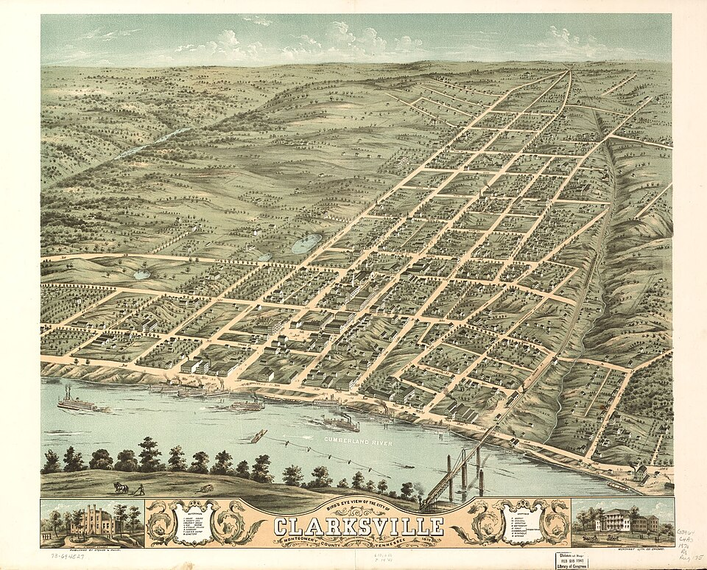
Downtown Clarksville — the riverfront district anchors most of the city's summer event calendar.
- Clarksville Independence Day Celebration — Fri July 3 – Sat July 4 • Downtown Clarksville — live music, 5K, car show, fireworks; free entry
- Mayor's Summer Night Lights — Tuesdays in July, 5:30pm • Various Clarksville locations — free DJ, sports, food, enrichment sessions
- Nashville Sounds vs. Jacksonville Jumbo Shrimp — July 4–6 • First Horizon Park, Nashville — AAA baseball
- Dolly Parton's Threads: My Songs In Symphony — Through July 31 • Schermerhorn Symphony Center, Nashville — running engagement
- Art of Seeing — Robin Conover Photography — July 10–30 • Centennial Art Center, Nashville
- Clarksville Roller Derby — Superhero Bout — Sat July 18, 11:30am • Clarksville Roller Derby venue — costume parade, concessions
- Smithville Fiddlers' Jamboree — July 3–4 • Smithville, TN (~65 mi from Nashville) — bluegrass, crafts, free
- MoCo Movie Night — Minecraft — Sat July 25, 7:30pm • Montgomery County Parks — bring lawn chairs, food available
- Anime Expo Clarksville — Sat July 25, 10am–11pm • DoubleTree by Hilton Clarksville Riverview — cosplay, showcases, photo ops
- Nashville Fantasy Festival — July 31 – Aug 1 • Centennial Park, Nashville — storytelling, fantasy, family-friendly
DEVOTIONAL
Verse to Memorize
“You keep him in perfect peace whose mind is stayed on you, because he trusts in you.”
— Isaiah 26:3 (ESV)
Isaiah wrote this in the middle of a chapter about a besieged city — not a meditation retreat, not a quiet season. The promise of perfect peace is delivered in context of external pressure, military threat, and national uncertainty. That context matters enormously. God is not promising peace for when things settle down. He is promising peace for right now, in the middle of whatever this is.
The Hebrew word translated 'stayed' is *samak* — to lean, to rest the weight of something against a fixed point. It's a structural word, not an emotional one. The mind stayed on God is not a mind that feels serene; it's a mind that is weight-bearing in a particular direction. You can be anxious and still stayed. The staying is the discipline; the peace is the result.
The phrase 'perfect peace' in Hebrew is *shalom shalom* — the doubling of the word is an intensifier, a literary device that means completeness, wholeness, the absence of nothing that ought to be present. This is not peace as the absence of noise. It is peace as a full condition. Most of us settle for a quieter form of anxiety and call it peace. Isaiah is pointing at something categorically different.
Application for the week: pick one worry you have been carrying and practice the *samak* move deliberately — lay it against a fixed point and leave the weight there. Not suppressing it, not denying it, not resolving it yet. Staying it. Try it for 24 hours and notice what shifts. The verse is not asking for a mood; it is asking for a posture. Posture you can choose. The peace follows the choosing.
TRAINING
Last Week on Strava
RUNS | MILES | TIME | AVG PACE
— | — | — | —
Strava data unavailable this week — the Strava MCP integration was not connected for this run. No activity data could be retrieved. Check back next Thursday; the integration will be reconnected and last week's activities will be pulled with full mileage, pace, and heart rate details. In the meantime: keep the log going in the app and the data will be waiting.
CHESS
Opening of the Week
Opening of the week: The Caro-Kann Defense
Black's answer to 1.e4 that the world's most solid grandmasters have trusted for over a century: 1...c6, preparing 2...d5. The Caro-Kann shares DNA with the French Defense — both contest the center with ...d5 — but the critical difference is the light-squared bishop. In the French, that bishop gets locked in behind the pawn chain on e6. In the Caro-Kann, it develops freely outside the chain, often to f5 or g4. That one structural advantage has made the Caro-Kann a perennial weapon at the highest levels, from Karpov to Carlsen to Caruana.
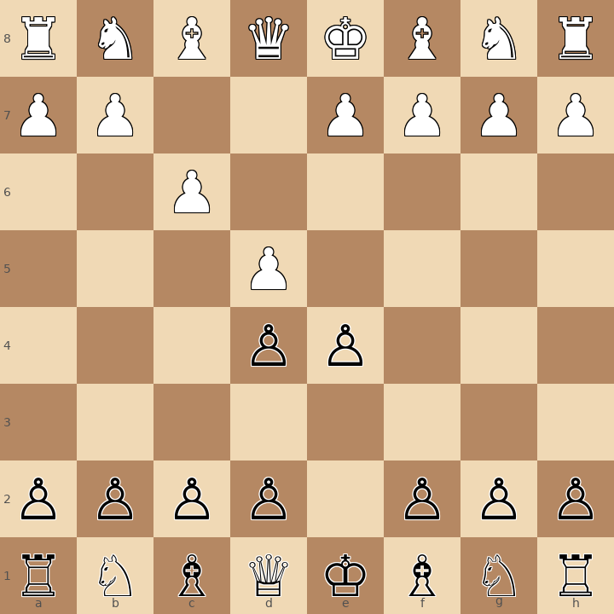
Position after 1.e4 c6 2.d4 d5 — the defining pawn tension of the Caro-Kann.
- Play 1...c6 preparing 2...d5 — support the center with a c-pawn, not an e-pawn, keeping the light-squared bishop free.
- After 3.Nc3 or 3.Nd2 and 3...dxe4 4.Nxe4: choose your development scheme — Classical (4...Bf5) keeps the bishop active; Karpov/Modern (4...Nd7) is more restrained.
- Black's endgame is excellent — few weaknesses, solid pawn structure, and piece exchanges generally favor Black once equality is established.
Study videos:
- Learn the Caro-Kann Defense | 10-Minute Chess Openings — GothamChess
- Caro-Kann Defense — Introduction, Main Variations & Ideas — Hanging Pawns
PUZZLE
Crossword — Week of June 22
13-word crossword (~6/10 difficulty). Themes pulled from this week's sections. Start with 4-Across (8 letters) — it anchors the grid. Answers next week.
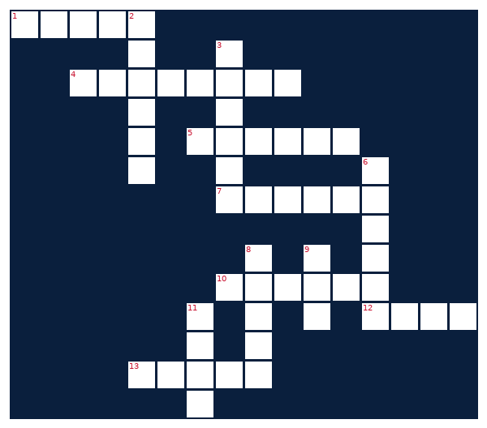
ACROSS  1. CrossFit qualifying stage before the Games  4. Solid chess defense: 1.e4 c6  5. Where college athletes transfer through  7. Paper trading platform  10. Set of cooking instructions  12. CrossFit movement repetitions  13. Counter-UAS target in modern EW ops | DOWN  2. Activity tracking app for runners  3. Toyota midsize pickup truck  6. EW device that disrupts signals  8. Bible passage unit to memorize  9. College athlete compensation model  11. Last word in the gazette tagline
MONEY
Financial Life Hacks
The 1% annual bump: how to add $100k to your retirement without changing your lifestyle
The single highest-ROI financial move most people never make: every time you receive a raise, immediately increase your retirement contribution rate by 1 percentage point. Not the full raise — just one point. If you currently contribute 6% and you get a 4% raise, bump to 7% the same week. You never see the difference in take-home, because you've never lived on the extra money. The behavioral economists call this 'save more tomorrow'; the practical version is just doing it immediately so you don't have to remember.
The math is patient and merciless. A 30-year-old earning $70,000 who increases contributions by 1% per year for five years — from 6% to 11% — and then holds steady will accumulate approximately $380,000 more at retirement (age 65, assuming 7% annualized return) than if they had held at 6%. That's not $380k extra invested — that's the compounding effect of contributions that started earlier and ran longer. Vanguard's 2025 'How America Saves' report puts the average participant contribution rate at 7.4%, which suggests most people have significant headroom they haven't touched.
The caveat that matters: this works best inside a 401(k) or similar tax-advantaged account because contributions reduce taxable income. At a $70,000 salary, each additional 1% contribution ($700/year) reduces your federal tax bill by approximately $140-175 depending on your marginal bracket — you're partially funding the contribution with tax savings. The net cost to your take-home pay is materially less than the gross contribution amount. Run the numbers in your payroll system's withholding calculator before and after to confirm the actual take-home impact; most people are surprised how small it is. Action item: set a calendar reminder for the same week as your next annual review.
HEALTHY EATS
Meal of the Week (Serves 2)
Chipotle-Lime Chicken Fajita Bowls
Serves 2 • 30 min total • ~470 cal/serving
Everything you love about fajitas with no tortillas and 42g of protein per bowl. One skillet, one pan, done in 30 minutes. The chipotle-lime marinade works on any protein — swap the chicken for shrimp (cut cook time to 5 min) or flank steak (cook to 135°F) without changing anything else. Leftovers keep four days and reheat well.
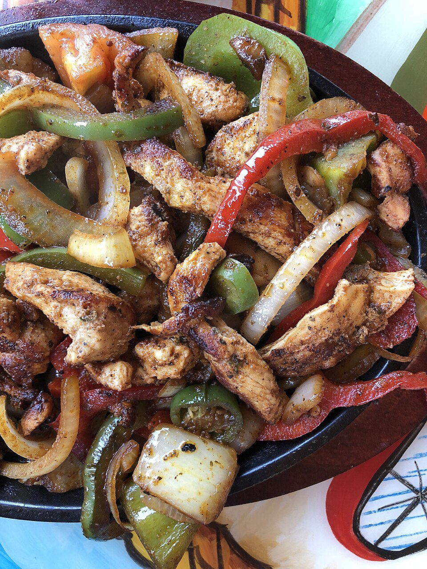
Chipotle-lime chicken fajita bowl — high protein, low effort, one skillet.
INGREDIENTS  • 2 boneless skinless chicken breasts (~6 oz each), sliced thin  • 1 red bell pepper, sliced  • 1 green bell pepper, sliced  • 1 medium yellow onion, sliced  • 2 tbsp olive oil  • Juice of 2 limes  • 1 tbsp chipotle powder (or 1 chipotle in adobo, minced)  • 1 tsp cumin  • 1 tsp garlic powder  • Salt and black pepper to taste  • 1 cup cooked brown rice or cauliflower rice (per bowl)  • Optional toppings: avocado, plain Greek yogurt, salsa, cilantro | DIRECTIONS  1. Combine lime juice, chipotle powder, cumin, garlic powder, salt, and pepper in a bowl. Add sliced chicken; toss to coat. Marinate 10 minutes (or up to overnight).  2. Heat 1 tbsp olive oil in a large skillet over medium-high. Cook chicken 5-6 min until cooked through (165°F internal); remove and rest.  3. Add remaining 1 tbsp oil to the same skillet. Cook peppers and onion over high heat 4-5 min, stirring occasionally, until charred at the edges.  4. Prepare rice per package directions or microwave cauliflower rice 3-4 minutes.  5. Build bowls: rice base, chicken, peppers and onions. Add desired toppings.  6. Serve immediately. Pack leftovers separately to keep the rice from going soggy.
COMPETE
Upcoming CrossFit Comps — TN & NC
Next 90 days, sorted chronologically. Drive-time estimates from Clarksville where more than 2 hours. Check registration status before committing — most require entry 2-3 weeks out.
- Summer Slam 2026 — Sat June 27 • Manteo, NC — Individual + Scaled (~9h from Clarksville)
- CHC Summer Smash 2026 — Sat June 27 • Greensboro, NC — Individual (~7h)
- Iron Will Open — Sat June 28 • Murfreesboro, TN — Individual + Masters (~1h)
- Independence Throwdown — Fri July 4 • Bowling Green, KY — RX/Scaled (~1h)
- Wodaroo Fitness Fest — Sat Aug 1 • Nashville, TN — Individual, Teams, Masters (~1h)
- RedPoint Games V — Sat Aug 1 • Fayetteville, NC — Individual (~8h)
- Smoky Mountain Showdown — Sat Aug 9 • Knoxville, TN — Individual + Pairs (~3h)
- Tennessee Tactical Games — Sat Aug 16 • Camp Forrest area, TN — Mil/LE Pairs (~2h)
- Queen City Quarrel — Sat Aug 23 • Charlotte, NC — Pairs (~6.5h)
TRAVEL
Cheap Flights — RDU → BNA / PHX
Round-trip fares aligned with Fort Campbell training-holiday windows. Independence Day DONSA window is July 3-6; Labor Day window is September 4-7. Both BNA (nearest to Clarksville) and PHX (family) tracked. Fares below the 25th-percentile historical band for each route and window shown.
ROUTE | DEPART | RETURN | PRICE | CARRIER
RDU → BNA | Thu Jul 3 | Sun Jul 6 | $154 | Southwest
RDU → PHX | Thu Jul 3 | Sun Jul 6 | $291 | American
RDU → BNA | Fri Sep 4 | Mon Sep 7 | $141 | Southwest
RDU → PHX | Fri Sep 4 | Mon Sep 7 | $263 | Southwest
BNA legs are day-of-week insensitive for Southwest; PHX legs floor mid-week. Book Independence Day fares now — holiday inventory moves fast and these windows are already 60% sold on most carriers. For Labor Day, optimal booking window opens around 6-7 weeks out (late July). If a BNA fare drops below $130 or PHX below $250, that's the floor — book it.
GARAGE
Tacoma Watch — White SR5 4WD < 5k mi, < $30k
2020-2023 Toyota Tacoma SR5 4WD, white, under 5,000 miles, under $30,000. Search radius: TN, NC, SC, VA, GA, KY, AL. Average market price for SR5 4WD is running $33,520 — criteria are intentionally tight, and zero-to-two matches per week is normal.
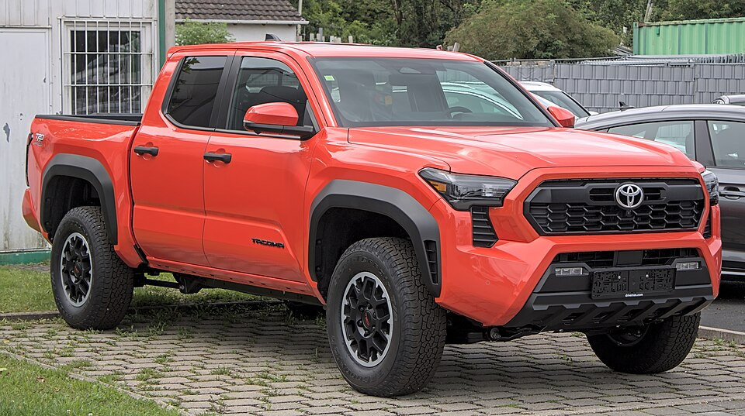
Reference: 2022 Toyota Tacoma SR5 4WD in Super White — the target spec.
No matches this week — criteria are tight. Will keep watching.
LIVE MUSIC
Morgan Wallen Watch (within 50mi of Raleigh)
The most recent Morgan Wallen show at Coastal Credit Union Music Park at Walnut Creek (Raleigh, NC) was June 3, 2026 — already passed. No additional dates within 50 miles of Raleigh are currently on sale for the Still The Problem Tour through the next 12 months. Watching Ticketmaster and Live Nation for newly announced dates; Morgan Wallen typically adds second-leg dates in August for the following year. Will flag immediately if a Raleigh-area date drops.
MARKETS
Alpaca Paper Trading — Weekly Snapshot
PORTFOLIO | DAY CHANGE | TOTAL RETURN | CASH
— | — | — | —
Alpaca API access was blocked this week by the remote execution environment's network egress policy — the host paper-api.alpaca.markets is not in the allowlist for this container. No portfolio data could be retrieved. To fix: add paper-api.alpaca.markets to the network egress allowlist in the Claude Code remote environment settings (see code.claude.com/docs for egress configuration). The credentials themselves appear valid — the 403 response is an infrastructure block, not an authentication failure. Will retry next week; if the egress setting is updated before then, the data will pull on the next run.

