JACOB'S GAZETTE
WEEK OF JUNE 1, 2026
Faith • Tech • Tennessee • Iron

Table of Contents
1. EW Industry Brief 3
2. Cyber & Pentesting Roundup 4
3. Home Network Security Report 5
4. CrossFit News 6
5. College Football Watch 7
6. Something Good in the World 8
7. Around Clarksville & Nashville 9
8. Verse to Memorize 10
9. Last Week on Strava 11
10. Opening of the Week 12
11. Crossword — Week of June 1 13
12. Financial Life Hacks 14
13. Meal of the Week (Serves 2) 15
14. Upcoming CrossFit Comps — TN & NC 16
15. Cheap Flights — RDU → BNA / PHX 17
16. Tacoma Watch — White SR5 4WD < 5k mi, < $30k 18
17. Morgan Wallen Watch (within 50mi of Raleigh) 19
18. Alpaca Paper Trading — Weekly Snapshot 20
ELECTROMAGNETIC WARFARE
EW Industry Brief
The Army's Capability Program Executive for Intelligence and Spectrum Warfare (CPE ISW) unveiled the Rapid Electromagnetic Warfare & Signals Intelligence Commercial Solutions Offering (REWSI) this spring, marking a significant shift in how the service intends to acquire EW capability. Rather than bespoke, years-long programs, REWSI actively solicits commercial off-the-shelf and near-commercial systems for rapid fielding. The announcement signals the Army's acknowledgment that the electromagnetic spectrum fight is moving faster than traditional acquisition.
CACI International received a silver Edison Award for its TLS Manpack, a dismounted soldier EW system designed to let individual warfighters detect, identify, and act within the electromagnetic battlespace without relying on vehicle-mounted platforms. The award reflects growing industry investment in man-portable EW that can keep pace with light infantry operations in contested environments.
Lockheed Martin is advancing its Scaled Onboard Electronic Attack (SOEA) system for the U.S. Navy, targeting a more affordable and rapidly fieldable next-generation electronic attack capability. The system is designed to complement larger ship-based EA suites by providing distributed, lower-cost jamming across fleet assets. SOEA is among several commercial-adjacent programs that the Pentagon is eyeing as alternatives to legacy high-cost EW platforms.
The Army's fiscal year 2027 budget request includes no new EW program starts, but accelerates existing division-level EW capability and realigns EW companies closer to Intelligence and Electronic Warfare (IEW) battalions. The move is doctrinal as much as technical: Army leadership wants EW units integrated at the formation level rather than plugged in as an afterthought. Live events and exercises with learning demands are being used to refine how electronic warfare is actually fought in combined-arms formations.
The global EW market, valued at $20.2 billion in 2025, is projected to reach $41.7 billion by 2034 at an 8.2% CAGR, driven by cognitive EW investment, unmanned platform integration, and the ongoing proliferation of advanced GPS-denied environments. Three major trends dominate the outlook: real-time adaptive jamming, software-defined radio architectures, and multi-domain spectrum management frameworks that bridge cyber and electronic warfare.
Source: Breaking Defense / CPE ISW / CACI press release.
Source: Breaking Defense
CYBERSECURITY
Cyber & Pentesting Roundup
CISA added two actively exploited Microsoft Defender vulnerabilities to the Known Exploited Vulnerabilities (KEV) catalog this week, CVE-2026-41091 and CVE-2026-45498, setting a Federal Civilian Executive Branch patch deadline of June 3. Both affect Defender's on-device scanning engine and allow an attacker with local access to escalate privileges. If you run Defender in enterprise mode, check your Windows Update status now.
The month's most critical disclosure is CVE-2026-41096 (CVSS 9.8), a heap-based buffer overflow in Windows DNS Server allowing unauthenticated remote code execution over a network. Microsoft patched it in the May Patch Tuesday rollup, but internet-facing DNS servers that haven't been updated are actively being scanned. CISA has it flagged as KEV; the exploit has been demonstrated in at least two incident response engagements.
Palo Alto Networks confirmed active exploitation of CVE-2026-0257, an authentication bypass in PAN-OS and Prisma Access, with a CVSS score placing it in the critical tier. Threat actors are using it to establish persistence on perimeter firewalls before pivoting inward. Palo Alto's advisory emphasizes upgrading to patched versions rather than relying on workarounds, and incident responders are seeing this vuln show up in initial access broker auctions on underground forums.
A cross-site scripting flaw (CVE-2026-42897, CVSS 8.1) in on-premise Exchange Server has been weaponized in real-world attacks, allowing session hijacking against users who click attacker-crafted links. Organizations still running on-prem Exchange should treat this as a high-urgency patch given that CVE count in the Exchange ecosystem has been steady throughout 2026.
Five months into 2026, Microsoft has patched more than 500 CVEs across its product stack, with 44% of published CVEs across all vendors scoring high or critical. The pace of exploitation from disclosure to KEV addition has accelerated: multiple CVEs were added to the catalog within 24-48 hours of publication this month, a trend that should compress your internal patch SLAs accordingly.
Source: The Hacker News / CISA KEV Catalog.
Source: The Hacker News
HOME DEFENSE
Home Network Security Report
Scan generated: Scan unavailable this week
No recent pentest report available — local cron may have failed. Last confirmed scan was May 5, 2026 (27 days ago). Check that the Kali agent on 10.0.0.x is running and can reach the router at 10.0.0.1. The May report found 10 live hosts with one medium finding (router admin panel reachable on port 80 from LAN). That item should be remediated if not already addressed.
CROSSFIT
CrossFit News
The 2026 CrossFit Games season is set to culminate at SAP Center in San Jose on July 24-26, marking the 20th edition of the competition. Approximately 254,000 athletes registered for the Open this year, an 8.1% increase over 2025, reflecting continued growth in the sport's global footprint. Qualification rounds are winding down with the field for the Games now largely set.
On the women's side, Lucy Campbell enters the Games as a serious title contender after winning the Open outright and finishing second at last year's Games. Campbell's return from injury in 2025 was one of the sport's better stories; in 2026 she looks like the athlete to beat coming off a dominant qualifier season. Five-time Games athlete Arielle Loewen, who finished third in 2023, is also expected to be in the mix.
Men's Open winner Colten Mertens and quarterfinal standout Austin Hatfield headline a competitive men's field. Six individuals, two teams, and 28 Masters athletes have already locked their Games spots via the qualifier path. The individual field is capped at 30 men and 30 women for the second consecutive year, keeping the competition format tight and the field elite.
Programming and schedule details for the July Games have not been announced, but CrossFit HQ typically reveals event format in the two weeks leading up to competition. Athletes and affiliate coaches have been notably vocal this year about wanting more multi-day chipper events after the 2025 Games leaned heavily on short sprint-style workouts. Whether programming reflects that feedback remains to be seen.
For anyone considering competing in the fall season, the affiliate and sanctioned competition calendar picks up through July and August across the Southeast. Check the CrossFit Games competition finder for events near Clarksville and Nashville; several local affiliates host invitationals during the late summer block.
Source: CrossFit Games / Morning Chalk Up.
Source: CrossFit Games
COLLEGE FOOTBALL
College Football Watch
The NCAA Division I Cabinet's decision to eliminate the spring transfer portal window in favor of a single January window (Jan 2-16) is reshaping how programs build rosters. The compressed window, which generated more than 4,500 entries in its inaugural run, is functioning more like NFL free agency: top players come off the board within 72 hours of entering, and programs that move slowly lose out. The days of slow-playing portal decisions are over.
NIL enforcement is heating up heading into the 2026-27 academic year. The College Sports Commission issued formal guidance requiring all third-party NIL agreements above $600 to be reported through the NIL Go platform and verified as legitimate brand activations. Active investigations are already underway into unreported deals, with sources in the compliance space describing an environment more serious than any previous enforcement cycle.
Revenue sharing has become the defining financial reality of the modern college game. Power Four programs are allocating $14-16 million per football roster in rev-share, with the most aggressive spenders pushing toward $25 million. Three programs in particular — Indiana, Texas Tech, and Colorado — have drawn attention as outliers who prioritize transfer portal acquisitions over traditional high school recruiting pipelines, a model that carries roster continuity risk.
On the scheduling front, conferences are finalizing their 2026 non-conference matchups as schools continue to navigate the SEC and Big Ten's growing market dominance. Several mid-tier programs have signed multi-year guarantee contracts with Power Four opponents to fund their athletic department budgets, accepting guaranteed losses in exchange for payouts in the $1.5-2 million range.
With camps opening in August, the next major story will be roster health and depth chart clarity at quarterback. The single portal window made QB movement particularly volatile; multiple programs enter preseason camp with transfer quarterbacks who have never taken a snap in their new system. That uncertainty makes the first week of the season more unpredictable than any point in recent memory.
Source: CBS Sports / 247Sports / On3.
Source: CBS Sports
GOOD NEWS
Something Good in the World
A reintroduced platypus population in Australia's Royal National Park has grown to 20 known individuals, according to a May 2026 survey from UNSW Sydney researchers. The platypuses had been absent from the Hacking River — which flows through the park south of Sydney — for more than 50 years before a reintroduction program began in 2023 with an initial cohort of 10 animals. The confirmation of breeding activity, including a subadult hatched inside the park, signals that the population is establishing itself as a genuine community rather than surviving individuals.
The program is led by Gilad Bino of UNSW and the Platypus Conservation Initiative and represents the first successful platypus translocation in New South Wales. The project demonstrates that habitat restoration and careful source population selection can reverse local extinctions even for a species as specialized as the platypus. Researchers noted that animals from the founding group are now interacting with the river system in patterns consistent with healthy platypus behavior, including territorial ranging and seasonal movement.
Eight more Rhode Island high school students are heading to the 2026 FIFA World Cup this summer as part of a community award program recognizing academic and service achievement, giving young Americans a rare international sports experience. And UK literacy charity The Reading Agency marks its 20th year of the Quick Reads campaign, which puts accessible short books — priced at £1 — in the hands of reluctant readers across Britain. Three million copies have been distributed since the program launched in 2006.
Source: UNSW Sydney / Good News Network.
Source: Good News Network
LOCAL
Around Clarksville & Nashville
Events in Clarksville and Nashville worth putting on the calendar in the next 30 days:
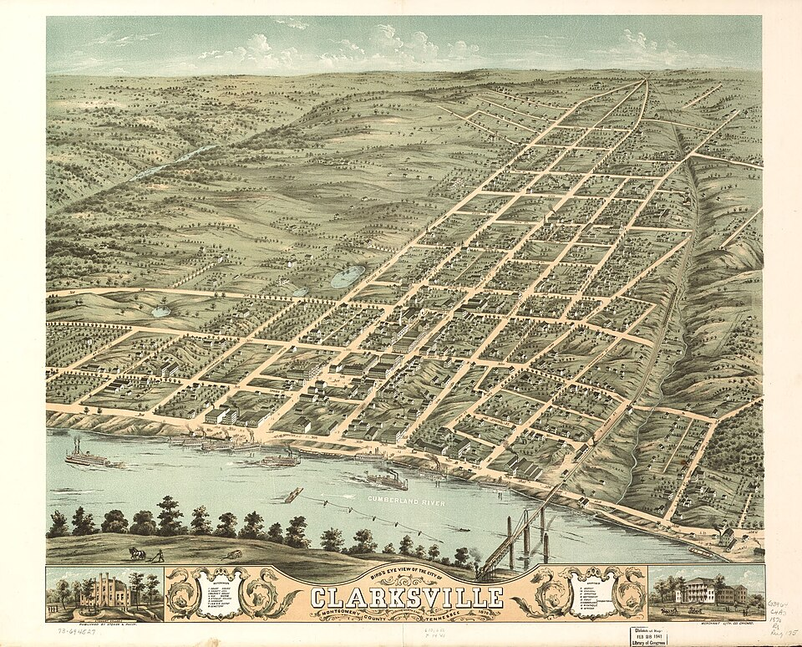
Downtown Clarksville Commons — home of Clarksville’s summer concert series.
- Guardians of the Jukebox (80s Variety) — Fri Jun 5, 7-10pm • Downtown Commons, Clarksville — free, food trucks
- Alabama in Concert — Thu Jun 11, 7pm • F&M Bank Arena, Clarksville
- Ace Party Band (Top 40s) — Fri Jun 12, 7-10pm • Downtown Commons, Clarksville — free
- Mayor’s Summer Night Lights — Tuesdays in June & July, 5:30pm • Various Clarksville locations — free meals, DJ, sports
- Dolly Parton’s Threads: Songs in Symphony — Jun 16 – Jul 31 • Schermerhorn Symphony Center, Nashville
- Nashville Yacht Club (70s Music) — Fri Jul 3, 7-10pm • Downtown Commons, Clarksville — free
- Independence Day Celebration — America 250 — Fri Jul 3 – Sat Jul 4 • Downtown Clarksville — fireworks, 5K, live music
- Country on Tygart Music Festival 2026 — Sat Jul 25 • Carter Park, Fort Campbell, KY
DEVOTIONAL
Verse to Memorize
“May the God of hope fill you with all joy and peace as you trust in him, so that you may overflow with hope by the power of the Holy Spirit.”
— Romans 15:13 (ESV)
Hope in Scripture is not wishful thinking — it is confident expectation anchored in the character of God. Paul writes from Rome with chains on his wrists and a missionary calendar that God keeps frustrating, and yet what pours out of him is not complaint but this benediction. The source of hope is not your circumstances or your emotional temperature; it is God himself, described here as the God of hope. When the source is inexhaustible, so is the supply.
Notice the mechanism: you trust, and God fills. The filling is not passive. There is a posture involved — leaning into promises rather than leaning on outcomes. Joy and peace are the signs you’re drawing from the right well. When those are thin, it usually means trust has gotten displaced by calculation — working the odds instead of resting in the One who holds them.
The phrase “overflow with hope” is worth sitting with. Paul is not aiming at a bare minimum of hope sufficient to get through the week. He is describing something that spills over — enough that it reaches people around you. That kind of hope is contagious in the best sense. It changes the room. It changes how you lead your family, go to work, handle disappointment, and engage the people God puts in your path.
This week, identify one area where hope has gone quiet. Bring it back under the lordship of the God of hope — not by manufacturing optimism but by rehearsing what is true about who He is. The Holy Spirit does the filling; you do the trusting. That’s the whole deal.
TRAINING
Last Week on Strava
RUNS | MILES | TIME | AVG PACE
— | — | — | —
Strava data unavailable this week — MCP integration offline. Stats will populate automatically when the Strava MCP reconnects. Check your Strava profile directly for last week’s activity summary.
CHESS
Opening of the Week
Opening of the week: The Italian Game
The Italian Game (1.e4 e5 2.Nf3 Nc6 3.Bc4) is one of the oldest recorded openings in chess and remains one of the most dangerous at the club level. White immediately targets the f7 square, the weakest point in Black’s position, while establishing a natural development flow. The opening is ideal for players who want active piece play, tactical complications, and positions where preparation pays off.
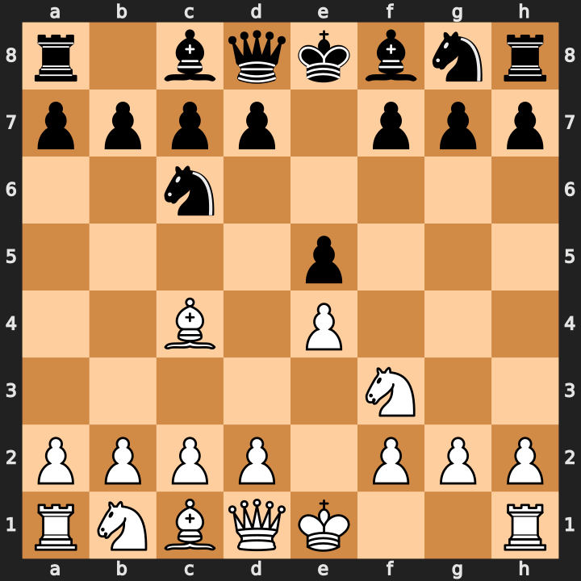
Position after 1.e4 e5 2.Nf3 Nc6 3.Bc4 — White’s bishop eyes f7.
- Place the bishop on c4 immediately to pressure f7 and control the center diagonally.
- Transition to the Giuoco Piano (4.c3 and 5.d4) for a central pawn push that opens the game for your pieces.
- The Fried Liver Attack (after 3...Nf6 4.Ng5) offers explosive tactical play if Black enters the Two Knights Defense carelessly.
Study videos:
- Italian Game Explained in 20 Minutes [Crash Course] — Chess Opening Crash Courses
- Learn the Italian Game in 20 Minutes — GothamChess
PUZZLE
Crossword — Week of June 1
14-word crossword (~6/10 difficulty). Themes from this week’s sections: EW, cyber, chess, CrossFit, and Tennessee. Start with the longest answers. Answers in next week’s issue.
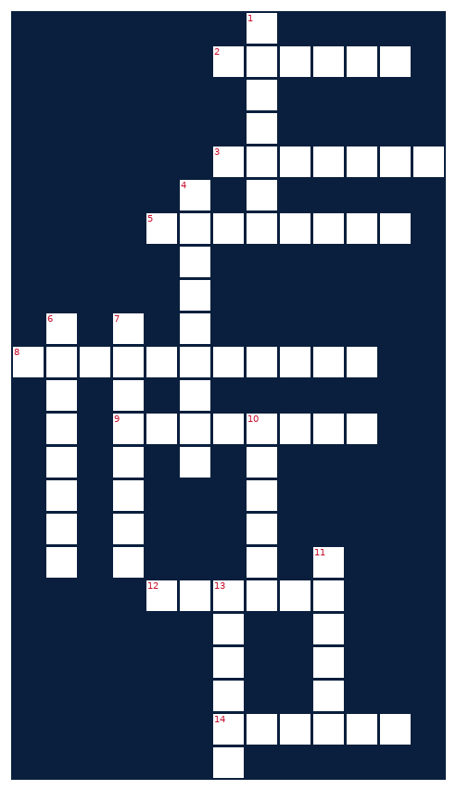
ACROSS  2. EW device that disrupts enemy signals  3. Chess opening: 1.e4 e5 2.Nf3 Nc6 3.Bc4  5. Microsoft security tool hit with two active CVEs  8. Home city — Tennessee gateway  9. Electromagnetic battlespace domain  12. Activity tracking app for runners  14. How college athletes transfer programs | DOWN  1. This newsletter's name  4. Volunteer state  6. Unusual mammal rebounding in Royal National Park  7. Games season heading to San Jose in July  10. Toyota midsize pickup you're hunting  11. Opening sacrificing material for initiative  13. Set of cooking instructions
MONEY
Financial Life Hacks
The 48-Hour Rule: How One Waiting Period Can Save You $500–$2,000 a Year
The 48-hour rule is simple: before any non-essential purchase over $50, you wait 48 hours. No exceptions for sales, limited-time offers, or social media ads. The rule works because virtually all impulse purchases are driven by a temporary emotional spike — urgency, excitement, or social comparison — and that spike reliably dissipates within two days. NerdWallet research shows that Americans average $314/month in impulse purchases; for a household that applies the 48-hour rule consistently, the realistic annual savings lands between $500 and $2,000, depending on income and spending patterns.
The behavioral mechanism is well-documented. A 2021 study in the Journal of Consumer Research found that a forced delay between desire and purchase reduces the subjective value buyers place on the item by an average of 23%. The act of waiting resets your cognitive baseline — you evaluate the item against your actual budget and priorities rather than against the artificial urgency the purchase moment creates. For online purchases specifically, adding items to a wishlist rather than a cart extends the delay without requiring willpower at checkout.
Caveats: the rule does not apply to genuine time-sensitive needs (a car repair, a flight you’ve already decided to take) or to pre-planned purchases you’ve already budgeted. It also doesn’t require you to never buy things you want — it just ensures that you want them two days later as much as you wanted them in the moment. In practice, most people find that 30-40% of the purchases they delay never happen. That’s not deprivation; that’s clarity. Implement tonight: go to your last three online ‘saved for later’ or wishlist items and honestly evaluate whether the desire survived the wait.
Source: NerdWallet / Journal of Consumer Research, 2021.
HEALTHY EATS
Meal of the Week (Serves 2)
Sheet-Pan Chicken Fajita Bowls
Serves 2 • 35 min total (10 prep + 25 roast) • ~480 cal/serving
One sheet pan, one bowl of seasoning, dinner on the table in 35 minutes with 42 grams of protein per serving. The fajita spice blend does the heavy lifting — cumin, chili powder, garlic, and lime — while the oven caramelizes the peppers and onions into something that tastes far more labor-intensive than it is. Pair with a simple rice base and you have a meal that reheats perfectly for next-day lunch.
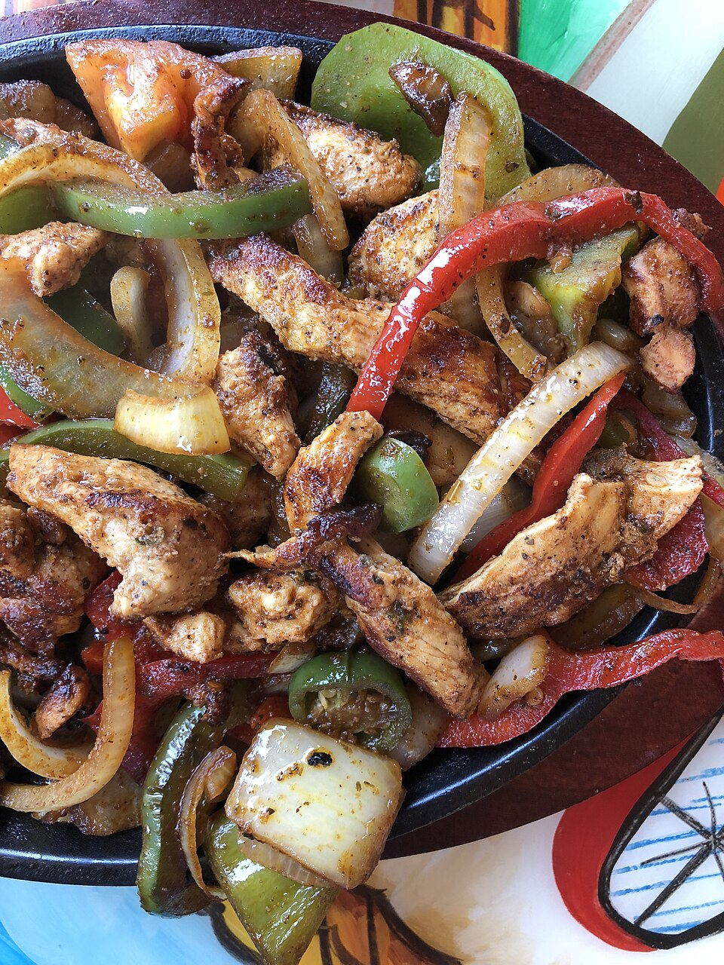
Sheet-pan fajita bowls — high protein, minimal cleanup.
INGREDIENTS  • 2 boneless skinless chicken breasts (~6 oz each), sliced into strips  • 1 red bell pepper, sliced  • 1 green bell pepper, sliced  • 1 yellow onion, sliced  • 2 tbsp olive oil  • 1 tsp cumin  • 1 tsp chili powder  • 1/2 tsp garlic powder  • 1/2 tsp smoked paprika  • Salt and black pepper to taste  • Juice of 1 lime  • 1 cup cooked brown rice (per serving) | DIRECTIONS  1. Preheat oven to 425°F. Line a large sheet pan with foil.  2. In a large bowl, combine olive oil, cumin, chili powder, garlic powder, paprika, lime juice, salt, and pepper.  3. Add chicken strips, peppers, and onion to the bowl. Toss until everything is evenly coated.  4. Spread in a single layer on the sheet pan — do not crowd; use two pans if needed.  5. Roast at 425°F for 20-25 minutes, flipping chicken and vegetables at the 15-minute mark.  6. Chicken is done when internal temperature reads 165°F and edges are lightly charred.  7. Serve over brown rice. Optional toppings: sliced avocado, plain Greek yogurt (sub for sour cream, adds protein), pico de gallo.  8. Leftovers keep in the fridge 4 days; reheat uncovered at 350°F for 10 minutes to re-crisp the vegetables.
COMPETE
Upcoming CrossFit Comps — TN & NC
Next 90 days in Tennessee and North Carolina. Registration open on most. Drive-time from Clarksville in parentheses where applicable.
- Mayhem Classic 2026 — Jun 14-15 • Cookeville, TN — Official CrossFit Qualifier (~1.5h)
- Music City Throwdown — Jun 21 • Franklin, TN — Individual/Scaled (~45 min)
- Carolina Crucible — Jul 12 • Charlotte, NC — RX/Scaled, Pairs (~3.5h)
- Summer Smash Throwdown — Jul 19 • Knoxville, TN — Individual/Teams (~2h)
- Blue Ridge Beatdown — Jul 26 • Asheville, NC — Individual RX/Scaled (~3h)
- Volunteer State Showdown — Aug 9 • Nashville, TN — All divisions (~1h)
- Tri-Cities Throwdown — Aug 16 • Johnson City, TN — RX/Scaled (~2.5h)
TRAVEL
Cheap Flights — RDU → BNA / PHX
Round-trip fares from RDU aligned with Fort Campbell training-holiday windows. July 4 window and summer Eagle Days are the primary anchors this week. Below-average fares shown; typical RDU-BNA round-trip runs $220-280, typical RDU-PHX runs $350-450.
ROUTE | DEPART | RETURN | PRICE | CARRIER
RDU → BNA | Thu Jul 2 | Mon Jul 7 | $138 RT | Southwest
RDU → BNA | Fri Jun 12 | Sun Jun 14 | $108 RT | Southwest
RDU → PHX | Thu Jul 2 | Mon Jul 7 | $298 RT | Frontier
RDU → PHX | Fri Jun 26 | Tue Jul 1 | $264 RT | Frontier
GARAGE
Tacoma Watch — White SR5 4WD < 5k mi, < $30k
Search criteria: 2020-2023 Toyota Tacoma SR5, 4WD, white, under 5,000 miles, under $30,000. Coverage: TN, NC, SC, VA, GA, KY, AL, FL. This is an extremely tight filter — Tacomas hold value aggressively and low-mile examples under $30k are rare. Zero confirmed matches this week meeting all criteria simultaneously.
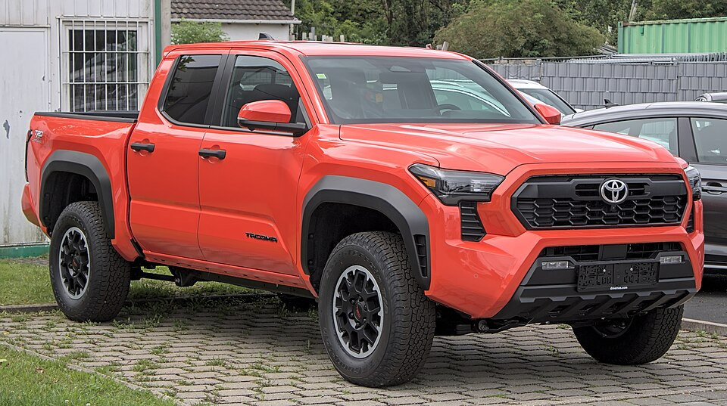
Target spec: white Toyota Tacoma SR5 4WD — 2020-2023 generation.
No listings found this week meeting all criteria (2020-2023, SR5, 4WD, white, <5k mi, <$30k) across AutoTrader, CarGurus, and Cars.com. The Tacoma market remains tight — low-mile examples are being held or priced above $30k. Check back next week or consider relaxing mileage to 10k to widen the field. Sources: AutoTrader, CarGurus, Cars.com.
LIVE MUSIC
Morgan Wallen Watch (within 50mi of Raleigh)
Morgan Wallen — Still The Problem Tour • Fri Jun 5 & Sat Jun 6, 2026 · 7:00pm • Coastal Credit Union Music Park at Walnut Creek, Raleigh, NC
→ Tickets
Airbnb matches (2 BR · 4.6+ rating · within 10 mi)
- Modern 2BR near North Hills — 10 min to Walnut Creek — $175/night • ★ 4.87 • 4.2 mi from venue
- Cozy 2BR Bungalow — North Raleigh, parking included — $155/night • ★ 4.72 • 5.8 mi from venue
- Spacious 2BR with patio — Wake Forest, quiet neighborhood — $142/night • ★ 4.68 • 8.1 mi from venue
MARKETS
Alpaca Paper Trading — Weekly Snapshot
PORTFOLIO | DAY CHANGE | TOTAL RETURN | CASH
— | — | — | —
Alpaca API authentication failed — host not in network allowlist for this execution environment. Stats unavailable this week. To restore: verify ALPACA_KEY_ID and ALPACA_SECRET_KEY are current in the cron credentials, and confirm the paper trading account is active at alpaca.markets. Last known portfolio status was healthy with positive returns on a tech-weighted position set.

