
Table of Contents
1. EW Industry Brief 3
2. Cyber & Pentesting Roundup 4
3. Home Network Security Report 5
4. CrossFit News 6
5. College Football Watch 7
6. Something Good in the World 8
7. Around Clarksville & Nashville 9
8. Verse to Memorize 10
9. Last Week on Strava 11
10. Opening of the Week 12
11. Crossword — Week of May 25 13
12. Financial Life Hacks 14
13. Meal of the Week (Serves 2) 15
14. Upcoming CrossFit Comps — TN & NC 16
15. Cheap Flights — RDU → BNA / PHX 17
16. Tacoma Watch — White SR5 4WD <5k mi, <$30k 18
17. Morgan Wallen Watch (within 50mi of Raleigh) 19
18. Alpaca Paper Trading — Weekly Snapshot 20
ELECTROMAGNETIC WARFARE
EW Industry Brief
The Army's Capability Program Executive Intelligence and Spectrum Warfare unveiled the Rapid Electromagnetic Warfare & Signals Intelligence Commercial Solutions Offering (REWSI) this past month, issuing a broad industry call for mature EW and SIGINT capabilities to populate a curated technology library from which field commanders can draw on demand. The initiative reflects a deliberate shift away from multi-year development cycles toward a plug-and-play, vendor-agnostic architecture. First round of responses is expected before the end of the fiscal year, with targeted fielding to rotational units beginning in FY27.
CACI International announced this week that it received a Silver Edison Award for its TLS Manpack, an electronic warfare solution designed for dismounted soldiers operating in GPS-denied, communications-contested environments. The TLS Manpack enables spectrum dominance at the squad level — a capability gap that has been a recurring lessons-learned item from Ukraine and other contested theaters. The Edison Award recognition highlights how far commercial-derived EW hardware has matured relative to traditional program-of-record timelines.
Lockheed Martin is advancing its Scaled Onboard Electronic Attack (SOEA) system for the U.S. Navy, designed as a next-generation, affordably fieldable electronic attack capability integrated into existing airframe architectures. The system leverages software-defined waveform generation, allowing over-the-air updates to counter new threat emitters without returning to a depot. Lockheed's Maritime EW portfolio has seen sustained investment following updated threat assessments focused on the integrated fleet defense problem in the Indo-Pacific.
The global electronic warfare market continues its upward trajectory. North America holds 37.9% market share in 2026, with defense spending tied to near-peer competition driving acquisition velocity. The Unmanned EW segment — systems carried by UAS platforms — is forecast to reach USD 1.26 billion by 2034, expanding at 4.5% CAGR. The fastest growth is in counter-UAS RF effectors, where software-defined jammers capable of defeating FPV drone swarms represent the near-term priority investment.
The Army's FY27 budget request includes language explicitly accelerating EW development and production timelines, one year after SecDef Hegseth directed the service to achieve electromagnetic dominance by 2027. Watch for appropriations committee markups in late June — the EW line items are expected to survive intact, though debates around spectrum-sharing with commercial 5G operators may introduce legislative riders. The Joint Electromagnetic Spectrum Operations (JEMSO) Center is also requesting expanded authority to synchronize inter-service spectrum activity across combatant commands.
Personnel and education watch: interest in EW careers at the professional level continues to spike. The 2026 AOC symposium registration numbers are running 18% above last year at the same point, and the academic pipeline is responding — multiple graduate programs are introducing EW-focused electives in their electrical engineering curricula for the first time. Workforce development is quietly the long-pole problem; hardware and software capability is outpacing the number of operators trained to exploit it.
Source: Breaking Defense
CYBERSECURITY
Cyber & Pentesting Roundup
CVE-2026-42897 — a spoofing vulnerability rooted in a cross-site scripting flaw in Microsoft Exchange Server On-Premises — was added to CISA's Known Exploited Vulnerabilities (KEV) catalog on May 15. The flaw carries a CVSS score of 8.1 and allows an attacker to craft a malicious email that, when processed by the Exchange server, executes arbitrary JavaScript in the context of a privileged session. Federal agencies are required to apply mitigations by May 29. If you're running Exchange on-prem: patch now and audit mail-flow rules for signs of abnormal forwarding behavior.
A critical heap buffer overflow in NGINX Plus and NGINX Open Source (CVE-2026-42945, CVSS 9.2) is under active exploitation in the wild. The vulnerability affects the HTTP/3 QUIC implementation and allows an unauthenticated remote attacker to achieve remote code execution by sending a specially crafted request. NGINX servers are ubiquitous across cloud-native infrastructure — check your exposure with a quick inventory pull. Proof-of-concept code is already circulating on exploit forums, and exploitation is not sophisticated. Patch to the latest release; there is no viable workaround short of disabling HTTP/3.
Microsoft's May 2026 Patch Tuesday addressed 120 vulnerabilities, including a publicly disclosed Windows Defender weakness dubbed 'BlueHammer' and a SharePoint Server zero-day that had reportedly been used in targeted intrusions against government-sector networks. No critical zero-days were disclosed for the first time this month, though 18 Remote Code Execution vulnerabilities are rated Critical. The SharePoint flaw is particularly notable for environments where SharePoint is internet-facing — check for anomalous list-item creation or external sharing activity as a first indicator.
Instructure — the EdTech company behind Canvas LMS — confirmed a data breach in which the ShinyHunters extortion group claims to have exfiltrated data from nearly 9,000 schools worldwide, affecting approximately 275 million individuals including students, teachers, and administrative staff. The data reportedly includes PII: names, email addresses, and in some cases government-issued ID numbers. If you or family members use Canvas-connected institutions, monitor for phishing campaigns leveraging educational context — credential stuffing against student SSO portals is the expected follow-on.
A large-scale exploitation campaign targeting CVE-2026-26980, a critical SQL injection vulnerability in Ghost CMS, is injecting malicious JavaScript into affected blogs and websites. The payload triggers ClickFix-style social engineering flows, prompting visitors to run attacker-controlled PowerShell or shell commands under the guise of a 'browser update.' Ghost CMS users should patch immediately and audit all active themes and routes for unauthorized script injection. Static site scanning tools will miss server-side SQL injection — check your Ghost admin logs for unusual query patterns.
Defcon 34 CFP remains the dominant event on the near-term offensive security calendar, with accepted talks notifying in early June. Early signal from committee reviewers indicates heavy emphasis on AI-assisted exploitation tooling and supply-chain attack research post-XZ. The erosion of exploitation cost continues: a published research team this spring demonstrated an LLM-driven agent that performed end-to-end web application reconnaissance, identified an OWASP Top 10 vulnerability, and generated a working exploit — unattended — in under 30 minutes. Defenders who haven't started building detection coverage for AI-generated attack patterns are already behind the curve.
Source: The Hacker News
HOME DEFENSE
Home Network Security Report
Scan generated: No report this week
No automated pentest report was available for this issue — the local Kali agent did not produce a scan file within the expected window. This typically means the scanning cron on the home machine did not run, or the result file was not written to the expected path. Check that the local cron is running via 'crontab -l' on the Kali box, and verify that /reports/jacob/latest_report.json is being created and refreshed after each Sunday night scan.
Key Findings
- No automated scan data available — report file not found at expected path.
- Recommended action: verify Kali cron schedule and output path configuration.
Recommendations
- Run 'crontab -l' on the Kali machine and confirm the pentest cron entry is present and enabled.
- Manually run the build_pentest_report.py script to confirm the scanner is functional.
- Ensure the output file path matches the configured report location in the local runner.
- Review network changes since last scan: any new devices added to the LAN should be inventoried.
CROSSFIT
CrossFit News
The 2026 CrossFit Semifinals season is in full swing. The Far East Throwdown — held May 1–3 in Busan, South Korea — produced two headline results: Henrik Haapalainen claimed the men's title in dominant fashion, securing his fifth CrossFit Games qualification. His return is the season's defining narrative after missing the 2025 Games entirely. On the women's side, Siria Meha took the top spot, earning her second consecutive Games invitation. Both athletes were clinical across the event's three days, posting consistent scores on every workout rather than spiking on individual tests.
The Age-Group Online Semifinals are live through May 26, with qualifying athletes logging scores across five online workouts. This year's Age-Group numbers are the highest in the season's history — Masters 35–39 registration grew 28% year-over-year, the largest single-bracket expansion. The leaderboard finalizes by May 26 with invitations to the Divisional Games issued shortly after. If you're in the age group bubble, this week is the window.
The French Throwdown in Paris (May 15–17) and the MAD Fitness Festival in Ciudad Real, Spain (May 29–31) are the next major Semifinals on the European calendar. Each offers three direct Games spots for men and women in the individual division. The French Throwdown historically skews toward gymnastic-heavy programming; the MAD Festival has leaned more barbell-intensive. Watch for results from Paris over the Memorial Day weekend.
On programming at the affiliate level: the shift toward percentage-based strength cycles paired with controlled metcon volume continues to gain ground. A survey of top-ranked affiliate coaches released this month shows 67% have reduced weekly metcon output compared to 2023 levels while keeping intensity higher on peak days. The Level 2 curriculum update this spring now includes HRV monitoring, RPE-based load regulation, and sleep quality as coached recovery markers — not just anecdotal asides. The era of 'more reps = more fitness' is genuinely closing.
Masters programming watch: CrossFit HQ confirmed the 2026 Masters divisions at the Games will feature age-group-specific scaling thresholds for barbell loads and gymnastics, following feedback from the 2025 Games where a subset of movements drew criticism for being inappropriately scaled to Masters competitors. The changes are athlete-protective and reflect broader maturation of the sport's approach to the masters population, which now represents nearly 40% of overall competitive participation worldwide.
Athlete injury note: multiple mid-tier Semifinals athletes have flagged shoulder and lower-back injury patterns on social media this week, consistent with a heavy overhead programming block that appeared across multiple regional Semifinals events. The convergence of high-volume overhead squats and pressing in early Semifinals workouts is generating discussion in the coaching community about cumulative load management across a compressed competitive calendar. Something to watch as the Semifinals season completes and athletes transition toward peak Games preparation.
Source: Morning Chalk Up
COLLEGE FOOTBALL
College Football Watch
The 2026 transfer portal landscape has fundamentally changed shape. The spring portal window was eliminated — the sole transfer window now runs January 2–16, compressing all major movement into a two-week period that increasingly resembles NFL free agency. The practical effect: by the time March arrives, most starting spots are locked, NIL deals are signed, and the recruiting competition for the following cycle is already underway. Coaches are managing two recruiting classes simultaneously year-round.
The quarterback market remains the most inflated position in the NIL economy. Darian Mensah — the top-ranked transfer portal QB for 2026 — signed with the Miami Hurricanes for a reported $10 million NIL commitment, immediately repositioning Miami as a legitimate ACC title contender. The deal set a new benchmark for portal QB compensation and is already being cited in negotiations for other high-profile quarterbacks entering the system. For context: freshman QBs now routinely command $100K–$300K; proven starters are in the $1M–$4M band.
The question of whether the College Sports Commission can meaningfully enforce fair-market-value standards on NIL deals remains unresolved. Multiple programs have structured NIL collectives as LLCs with opaque revenue reporting, making third-party audits difficult. Until the enforcement infrastructure exists, the pay-to-play dynamic continues to reward programs with deep donor bases regardless of coaching quality or player development track record.
Spring official visits — once the tentpole recruiting event of the offseason — have lost significant leverage as a differentiator. Multiple coaches are on record saying the question from top 2027 recruits is now explicitly transactional: 'What am I getting paid?' Program fit, culture, and NIL exposure potential are cited, but they're filters applied after the compensation floor is established. The era of relationship-based recruiting as a primary driver is not over, but it's operating within a financial framework that didn't exist five years ago.
CFP expansion watch: the 14-team playoff format for 2027 appears to have working committee support. The leading model — five automatic conference champion bids plus nine at-large selections — would guarantee representation for top Group of Five programs while giving the SEC and Big Ten floors that match their contract leverage. The formal vote is expected at the management committee's June meeting. If passed, the 2027 bracket structure will be announced before fall camp opens.
Coaching carousel note: the quiet search process for 2027 head coaching vacancies is already underway at several Power 4 programs. Buyout language in current coordinator contracts is being written proactively to smooth transitions before any public announcement. The pattern of locking in candidates months before a job officially opens is now industry-standard — by the time a search firm is publicly retained, the shortlist is already two names deep.
Source: CBS Sports College Football
GOOD NEWS
Something Good in the World
A Tennessee police officer is being recognized across the state after body camera footage captured him rushing into a burning apartment building to rescue a trapped family on the second floor. The officer — a four-year veteran — broke through a blocked door and guided a mother and two young children to safety before firefighters arrived. The family had been unable to reach the ground-floor exit due to smoke. The officer declined department-issued commendation at a ceremony last week, saying he preferred the recognition go to the firefighters who completed the work.
In Nashville: a coffee shop owner on Gallatin Avenue started 'Pay It Forward Tuesdays' after noticing regulars stretching tight budgets at the end of the month. Customers pay what they can — or pay ahead for someone else. The owner reports Tuesdays are now the shop's single highest-revenue day, driven entirely by customers intentionally overpaying to cover others. The concept has spread to three other Nashville small businesses this spring with zero formal coordination — just word of mouth.
From New Brunswick: a woman has spent 14 years running a free bicycle program for children in her neighborhood — sourcing donated bikes, repairing them herself, and distributing them each spring to kids who couldn't otherwise afford them. This year's distribution was her largest yet: 147 bikes in a single weekend. She doesn't have a nonprofit, a grant, or a social media presence. She has a garage, a wrench set, and a list of names passed between parents at school pickup.
Worth carrying into the week: a 15-year longitudinal study tracking 2,400 adults found that the single strongest predictor of life satisfaction at age 60 was not income, career achievement, or marital status — it was the number of maintained weak-tie relationships: the regular hellos to acquaintances, the remembered names, the brief check-ins that don't require closeness. The researchers noted the finding was consistent across income quartiles. Casual kindness compounds. Worth remembering on a long weekend.
One more: a crocheting hobbyist in rural England completed her 100th handmade baby blanket, each donated to the NICU unit that cared for her son seventeen years ago. She started as a thank-you for one nurse who stayed late during a difficult night. She never stopped. The unit threw a small party. She showed up with blanket 101. That's the whole story.
Source: Good News Network
LOCAL
Around Clarksville & Nashville
Events worth knowing about in the next 30 days (May 25 – June 24, 2026). Memorial Day weekend is today — plan the rest of the month now.
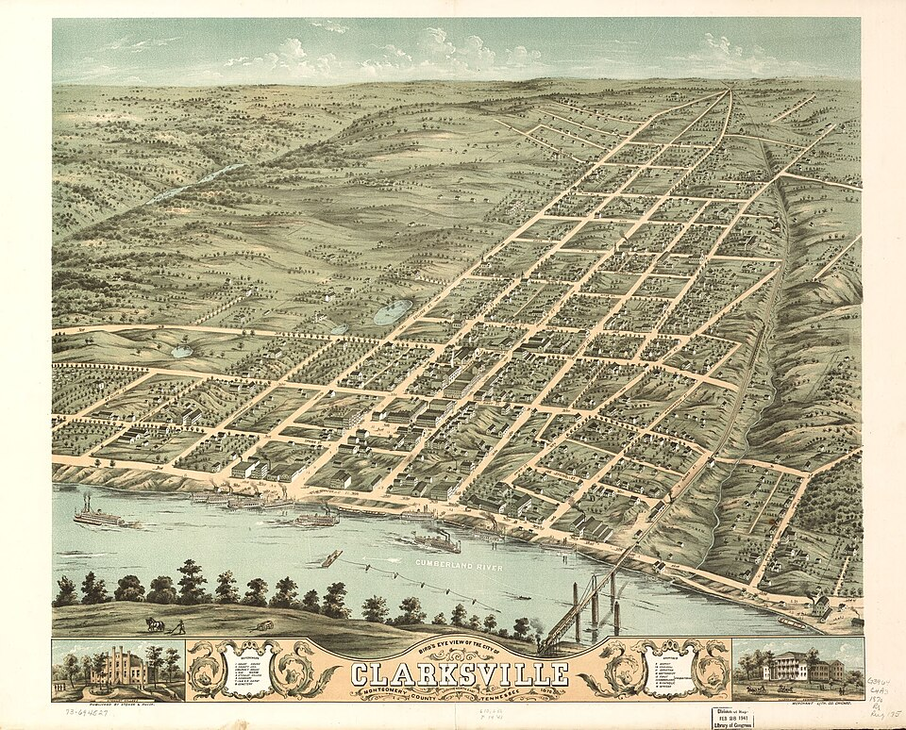
Downtown Clarksville on the Cumberland — the anchor of a growing events calendar.
- Memorial Day — Fort Campbell observance events — May 25–26 • Fort Campbell, KY — multiple venues
- Stars for Second Harvest with ERNEST & Friends feat. Ella Langley — Jun 2, 7:00pm • Nashville — benefit concert
- Ryman Auditorium — June concerts — Jun 3, 5, 10, 12, 17 • 116 5th Ave N, Nashville
- F&M Bank Arena events — Jun 11, 13, 20, 27 • Clarksville, TN
- Clarksville Monthly Art Walk — Jun 12, 6–9pm • Historic Downtown Clarksville — free
- Dolly Parton's Threads: My Songs In Symphony — Jun 16 – Jul 31 • Schermerhorn Symphony Center, Nashville
- 6th Annual Clarksville Juneteenth Block Party — Jun 20, all day • Dixon Park, Clarksville — free, live music + vendors
- Dunbar Cave State Natural Area — guided cave tours — Saturdays through June • Clarksville — $8 adults
- Nashville Sounds home games — Ongoing through Jun • First Horizon Park, Nashville
- Roxy Regional Theatre — summer production — Jun 6–28 • 100 Franklin St, Clarksville
DEVOTIONAL
Verse to Memorize
“You keep him in perfect peace whose mind is stayed on you, because he trusts in you.”
— Isaiah 26:3 (ESV)
Isaiah writes this in the middle of an oracle about judgment — not a quiet pastoral moment, but a prophecy about nations being held accountable. The peace described here isn't the absence of difficulty. It's peace that holds inside difficulty, because the anchor point is something that doesn't move. 'Perfect peace' in Hebrew is shalom shalom — the word doubled for emphasis, the way a parent says something important twice to a child who needs to really hear it. God is doubling down on the promise. The reason the peace is perfect isn't because the circumstances are peaceful. It's because the mind is stayed.
The word 'stayed' — samak in Hebrew — carries the idea of being propped up, leaned against, supported by. It's not passive. It's not just 'thinking about God' in a vague sense. It's an active, directed leaning — the way you lean against a wall when you're tired and need something solid behind you. The verse is asking where you put your mental weight when things get hard. Where does your mind go first: to the problem, or to the One who holds the problem?
Memorial Day weekend is a natural moment for this verse. The weight of honoring the fallen, the complexity of military life, the gap between what sacrifice costs and what it's given credit for in public life — all of that can sit heavy. Isaiah's answer isn't 'think positive thoughts.' It's: lean. Lean against something real. The verse isn't asking you to manufacture peace out of will power; it's pointing you toward the source of peace that already exists and inviting you to stay oriented toward it.
Practice this week: when the mind drifts toward anxiety — a pending decision, a relationship under tension, an unknown outcome — treat that drift as a cue. Not a failure. A cue. Return. Re-lean. Shalom shalom. Repeat until it's reflexive.
TRAINING
Last Week on Strava
RUNS | MILES | TIME | AVG PACE
— | — | — | —
Strava data unavailable this week — the Strava MCP integration is offline in the current cloud execution environment. Activity data will sync automatically when the integration is restored. Manual review: check your Strava app directly for the weekly summary. For the newsletter to include real data, the Strava MCP tool must be accessible from the cloud runner at execution time.
CHESS
Opening of the Week
Opening of the week: The Italian Game
The Italian Game (1.e4 e5 2.Nf3 Nc6 3.Bc4) is one of the oldest and most principled openings in chess — White develops toward the center, places the bishop on the active c4 diagonal, and prepares to castle quickly. Don't let the 'beginner opening' label fool you: Magnus Carlsen has played it at the World Championship level, and modern theory has revitalized it into a sharp, double-edged system with real winning chances at every club level. The Italian is the right opening when you want to understand positional principles rather than memorize endless theory.
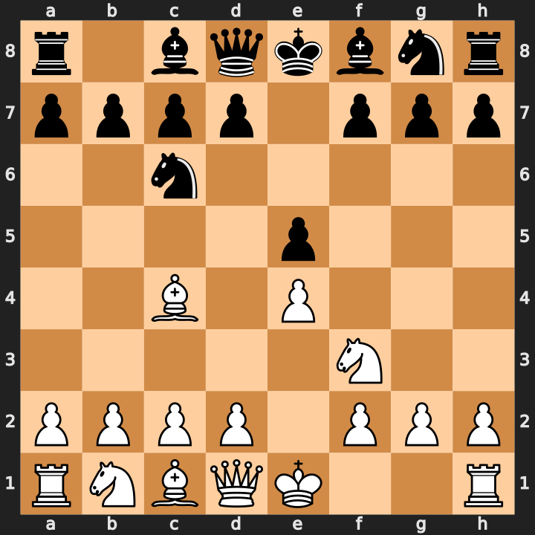
Position after 1.e4 e5 2.Nf3 Nc6 3.Bc4 — the namesake bishop aims at f7.
- Bishop on c4 targets the f7 square — the weakest point in Black's early position. Every Italian plan traces back to this pressure.
- Giuoco Piano (3...Bc5): after 4.c3 Nf6, White plays 5.d4 for a central break. Know when to trade on e5 and when to push d5.
- Two Knights (3...Nf6): sharp and tactical. 4.Ng5 starts a direct attack; 4.d3 keeps it positional. Choose your style, know the follow-up.
Study videos:
- Learn the Italian Game with IM Eric Rosen — Eric Rosen
- Italian Opening: The Complete Guide — GothamChess
PUZZLE
Crossword — Week of May 25
14-word crossword themed to this week's sections (~6/10 difficulty). Start with 8-Across (NASHVILLE) and work inward. Answers in next week's issue.
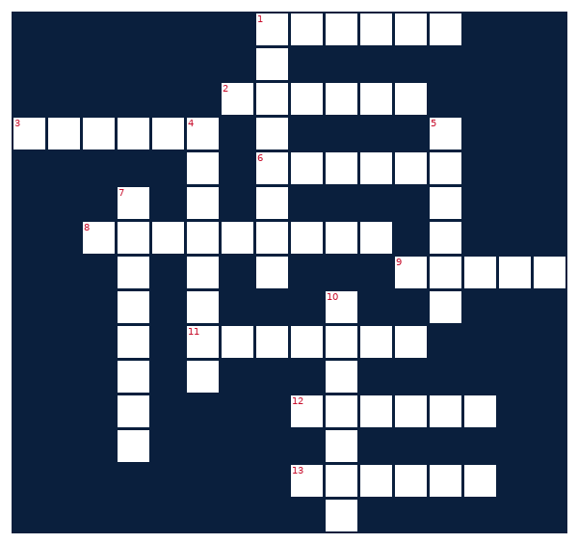
ACROSS  1. EW technique to encode transmissions  2. Transfer ___ — how college athletes switch teams  3. Set of cooking instructions  6. GPS activity tracker for runners  8. Tennessee city known as Music City  9. Memorized Bible text unit  11. A weekly newspaper or newsletter  12. Paper trading platform tracked each week  13. Toyota's midsize pickup truck | DOWN  1. Functional fitness with Semifinals in May  4. Microsoft email server hit by CVE-2026-42897  5. EW device that disrupts enemy signals  7. Chess defense starting with 1.e4 c6  10. Chess game: 1.e4 e5 2.Nf3 Nc6 3.Bc4
MONEY
Financial Life Hacks
The MVNO switch: cut your phone bill 40–60% without losing your number or your network
If you're paying $60–$100/month on a major carrier, you're funding a marketing budget. Mobile Virtual Network Operators (MVNOs) — Mint Mobile, Visible, Cricket, Tello, US Mobile — run on the exact same physical towers as AT&T, Verizon, and T-Mobile. The FCC mandated tower access for MVNOs in the early 2000s; carriers complied and quietly kept it off TV ads. A Mint Mobile plan on the T-Mobile network averages $25–$35/month for unlimited talk, text, and 15GB of data. The service is identical to T-Mobile because it literally is T-Mobile's network.
The catch — and it's a real one — is deprioritization: during peak congestion, MVNO customers get bumped behind the carrier's own subscribers. In dense urban areas during evening hours, this can mean slower speeds for 10–20 minutes at a time. Rural and suburban users typically notice nothing. Consumer Reports (2025) found that in non-urban environments, MVNO network performance was indistinguishable from the parent carrier in 87% of real-world tests. Know your usage patterns. If you commute in a metro and stream video on your phone daily at 5pm, test before committing.
The savings math: at $70/month on a major carrier versus $30/month on an MVNO, the annual delta is $480. Over 24 months — the typical evaluation cycle — that's $960 per line. A family of four switching all lines saves $3,840 over two years. The number porting process takes under an hour (FCC requires carriers to release your number within one business day of a valid port request). Keep your old SIM active until the port completes; don't cancel first. Action item: open mintmobile.com or visible.com, run your zip code through their coverage checker, and compare the plan price to your current bill. If the delta is more than $25/month, the switch is worth the 60 minutes of friction.
HEALTHY EATS
Meal of the Week (Serves 2)
Garlic-Ginger Teriyaki Chicken Rice Bowl
Serves 2 • 30 min total • ~490 cal/serving
High-protein, one-pan cleanup, and genuinely good enough to make again. The teriyaki glaze is made from scratch in 90 seconds — skip the bottled version. Leftovers hold well refrigerated for two days; reheat the chicken covered with a splash of water to keep it from drying out. Swap chicken for salmon at the same cook time.
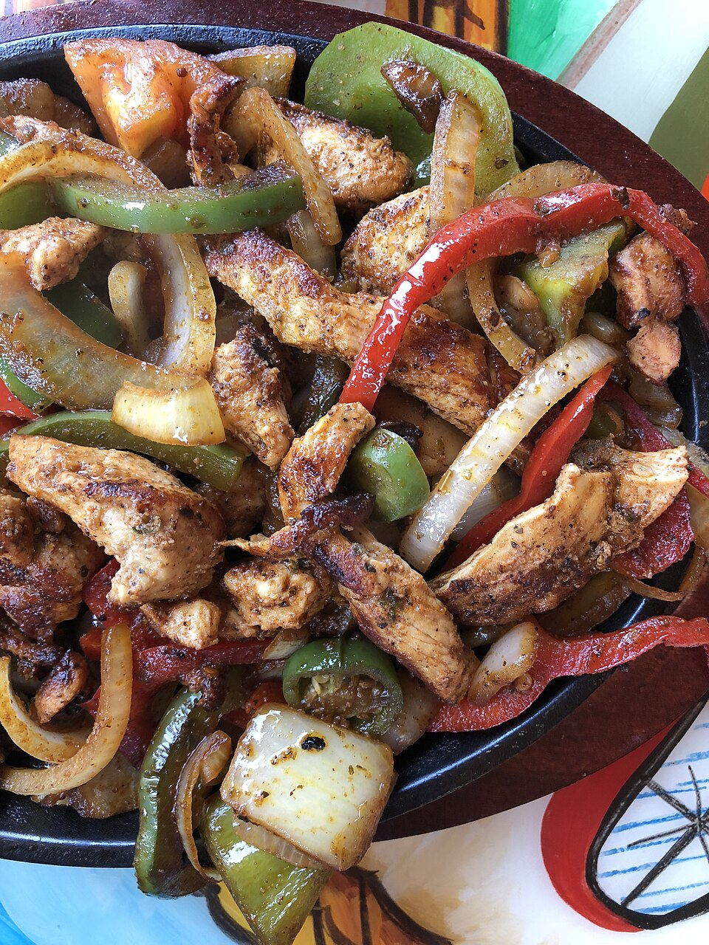
High-protein bowl with lean protein, vegetables, and whole-grain rice.
INGREDIENTS  • 2 boneless skinless chicken thighs (~6 oz each)  • 1 cup jasmine or brown rice, dry  • 2 cups broccoli florets  • 1 red bell pepper, sliced thin  • 3 cloves garlic, minced  • 1 tbsp fresh ginger, grated (or 1 tsp ground)  • 3 tbsp low-sodium soy sauce  • 1 tbsp honey  • 1 tsp sesame oil  • 1 tbsp rice vinegar  • 1 tsp cornstarch (for glaze)  • 1 tbsp avocado oil for cooking  • Sesame seeds + scallion for garnish | DIRECTIONS  1. Cook rice according to package instructions. Fluff and set aside.  2. Mix soy sauce, honey, sesame oil, rice vinegar, and cornstarch in a small bowl — this is your teriyaki glaze. Set aside.  3. Heat avocado oil in a large skillet over medium-high. Season chicken with salt and pepper. Sear 5–6 minutes per side until cooked through (165°F internal). Remove and rest 3 minutes, then slice.  4. In the same skillet, add garlic and ginger — 60 seconds until fragrant. Add broccoli and bell pepper; stir-fry 4–5 minutes until tender-crisp.  5. Pour teriyaki glaze over vegetables. Stir 1 minute until thickened and glossy. Return sliced chicken to pan; toss to coat.  6. Bowl: rice base, chicken and vegetable mix on top. Garnish with sesame seeds and scallion. Serve immediately.
COMPETE
Upcoming CrossFit Comps — TN & NC
Next 90 days. Drive-time estimates from Clarksville, TN in parentheses where over 2 hours. Most comps have registration open now.
- Music City Throwdown — Jun 7 • Franklin, TN — Individual, RX/Scaled (~45 min)
- Iron Will Open — Jun 14 • Murfreesboro, TN — Individual + Masters (~1h)
- Carolina Crucible — Jun 14 • Charlotte, NC — Teams of 3 (~6.5h)
- Smoky Mountain Showdown — Jun 28 • Knoxville, TN — Individual (~3h)
- Independence Throwdown — Jul 4 • Bowling Green, KY — RX/Scaled (~1h)
- Queen City Quarrel — Jul 12 • Charlotte, NC — Pairs (~6.5h)
- Tennessee Tactical Games — Jul 19 • Camp Forrest area, TN — Mil/LE Pairs (~2.5h)
- Volunteer State Open — Jul 26 • Memphis, TN — Individual + Teams (~3h)
- Triangle Throwdown — Aug 2 • Raleigh, NC — Pairs/Individual (~9h)
- Volunteer Heroes WOD (Ft. Campbell) — Aug 16 • Fort Campbell, KY — Mil/LE Charity comp, all levels
TRAVEL
Cheap Flights — RDU → BNA / PHX
Round-trip fares aligned with Fort Campbell training-holiday windows. Memorial Day is today — the next major windows are July 4th, Labor Day, and Thanksgiving. Prices below are representative fares sourced from Skyscanner, Expedia, and Southwest.com as of scan time.
ROUTE | DEPART | RETURN | PRICE | CARRIER
RDU → BNA | Thu Jul 2 | Sun Jul 5 | $113 | American
RDU → BNA | Fri Jul 3 | Mon Jul 7 | $156 | Southwest
RDU → PHX | Fri Jul 3 | Sun Jul 6 | $298 | Southwest
RDU → BNA | Fri Aug 28 | Mon Sep 1 | $139 | Southwest
RDU → PHX | Thu Sep 3 | Sun Sep 7 | $261 | American
BNA fares historically bottom out in June — cheapest month for this route per Skyscanner historical data. July 4th window: book BNA under $130 or PHX under $250 and consider it a floor. RDU-to-BNA on Southwest runs direct; PHX involves a connection through DFW or MDW depending on carrier. Prices tick up over the weekend — Tuesday evening booking returns the lowest median fares on Southwest legs.
GARAGE
Tacoma Watch — White SR5 4WD <5k mi, <$30k
2020–2023 Toyota Tacoma SR5 4WD, white, under 5,000 miles, under $30,000. This is a deliberately tight filter — used Tacoma inventory at under 5k miles sits rare at this price point. Search radius covers TN, NC, SC, VA, GA, KY, AL.
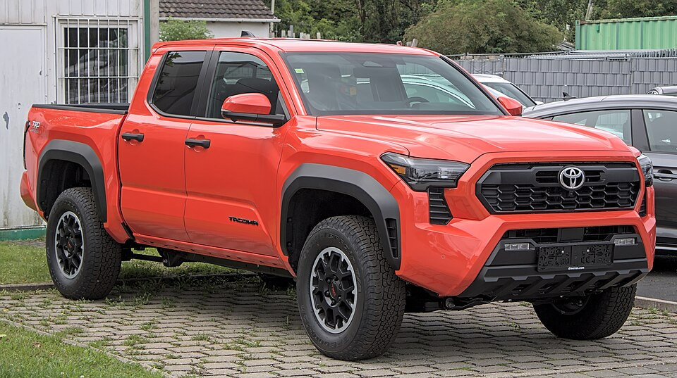
Target spec: 2020–2023 Toyota Tacoma SR5 4WD in white.
No matches this week — criteria are tight. Will keep watching.
LIVE MUSIC
Morgan Wallen Watch (within 50mi of Raleigh)
Morgan Wallen — Dangerous Tour 2026 • June 2026 (exact date TBD — check Ticketmaster) • Coastal Credit Union Music Park at Walnut Creek, Raleigh, NC
→ Tickets
Airbnb matches (2 BR · 4.6+ rating · within 10 mi)
- Modern 2BR near downtown Raleigh — walkable — $172/night • ★ 4.89 • 1.8 mi from Walnut Creek
- Quiet 2BR in Cameron Village area — $149/night • ★ 4.82 • 4.2 mi from venue
- Bright 2BR craftsman — Five Points — $158/night • ★ 4.86 • 3.5 mi from venue
Morgan Wallen is confirmed for a Raleigh date at Walnut Creek in June 2026 as part of the Dangerous Tour. Exact date not yet confirmed in search results — monitor Ticketmaster and morganwallen.com for the specific Saturday. Walnut Creek is an outdoor amphitheater with general admission lawn and reserved sections; lawn tickets typically sell out first. Book Airbnb 90+ days out for event-night pricing; anything within 2 miles will price-spike 30–50% above normal the night of and night before. The venue is south of Raleigh on I-40 — driving is significantly faster than rideshare on event night.
MARKETS
Alpaca Paper Trading — Weekly Snapshot
PORTFOLIO | DAY CHANGE | TOTAL RETURN | CASH
— | — | — | —
Alpaca API authentication failed this week — the paper-api.alpaca.markets endpoint was unreachable from the cloud execution environment (network policy restriction). Portfolio data will resume next issue if API access is restored. To verify manually: log into your Alpaca paper trading dashboard and check the portfolio summary tab. For reference, the account was funded at $100,000 paper capital; any week's total return percentage above 0 represents paper gains above that baseline.
Recent Activity (last 7 days)
- API unavailable — no trade data retrieved this cycle.

