## Website Design

### Architecture

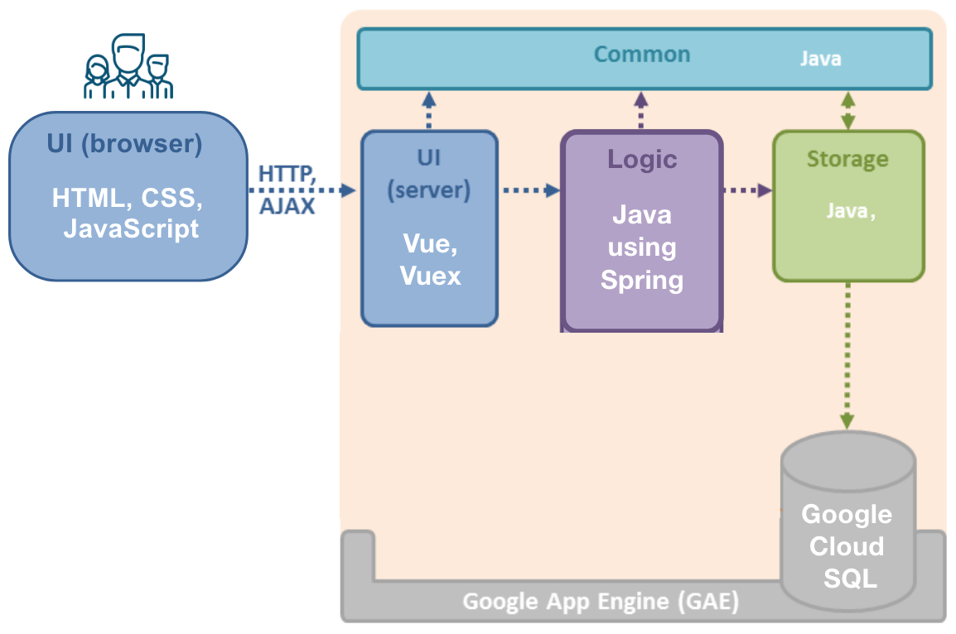

High Level Architecture

Viz is a Web application that runs on Google App Engine (GAE). Given above is an overview of the main components.

* **UI**: The UI seen by users consists of Web pages containing HTML, CSS (for styling) and JavaScript (for client-side interactions). It is generated using Vue through direct rendering of data straight to DOM. Vuex is used as a state management pattern to ensure data can only be mutated in a predictable state.
* **Logic**: The main logic of the application is in Java using the Spring framework.
* **Storage**: The storage layer of the application uses the persistence framework provided by **Google App Engine PaaS**, using Google Cloud SQL, MySQL 5.6.
* **Common**: The Common component contains utility code (data transfer objects, helper classes, etc.) used across the application.

### Typical Sequence Diagram

The diagram below showcases the workflow in the system of a typical request from the user. 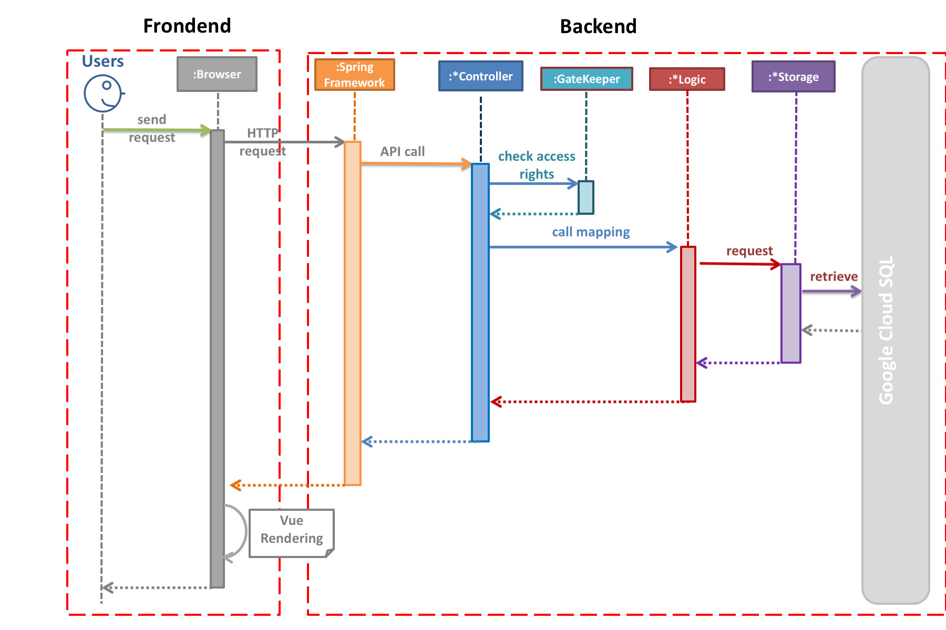

1. Users will send a request to the browser for certain data or visualisation.
2. Browser sends a HTTP request to the backend, specifically Java which uses the Spring framework.
3. *Spring executes an API call to request controller to forward a request.
4. *Controller checks the access rights of the user and executes the call by interacting with the Logic component
5. *Logic requests the data from the storage component.
6. *Storage retrieves the data from Google Cloud SQL.
7. The response will be sent back to the browser where it will use Vue to render the web page.

### Backend Packages

The diagram below showcases the backend package overview of the existing system. 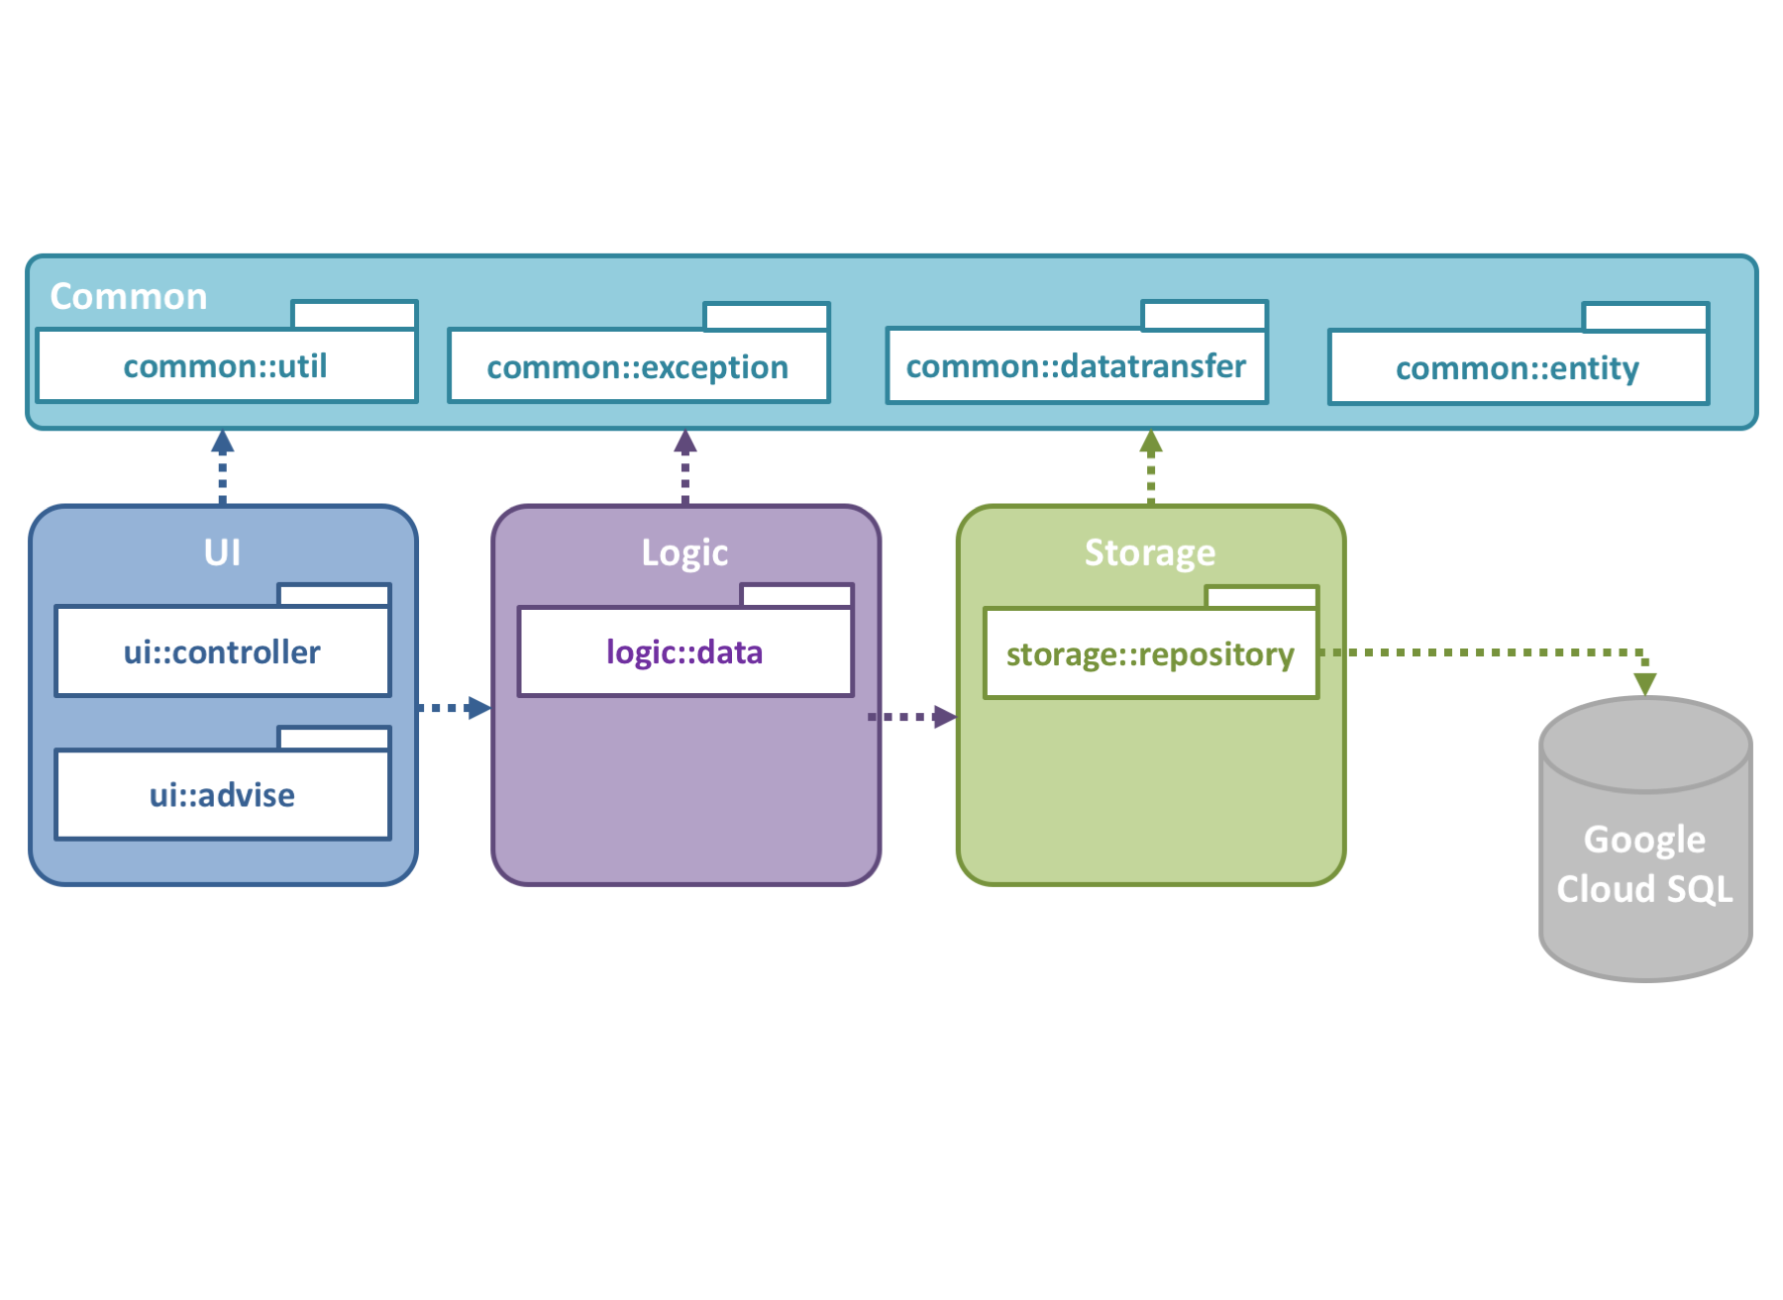

#### UI Component

The UI component is the first stop for all requests received by the web application. Such a request will go through different stages: - **UI.controller.api**: Provide backend API access to the users. - **UI.controller.data**: Helper object to send requests to the server. - **UI.controller.webpage**: Handle static file requests for the users. - **UI.advice**: Handle exception calls by the application.

#### Logic Component

The Logic component handles the business logic. In particular, it is responsible for: - Managing relationships between entities, e.g. cascade logic for create/update/delete. - Providing a mechanism for checking access control rights.

#### Storage Component

The Storage component performs CRUD (Create, Read, Update, Delete) operations on data entities individually. It contains minimal logic beyond what is directly relevant to CRUD operations.

#### Common Component

The Common component basically contains common utilities used across the web application. Package overview: - **common.util**: Contains utility classes. - **common.exceptions**: Contains custom exceptions. - **common.datatransfer**: Contains data transfer objects. - **common.entity**: Contains entity of the user for checking access right.

### Frontend Packages

The diagram below showcases the frontend package overview of the existing system. 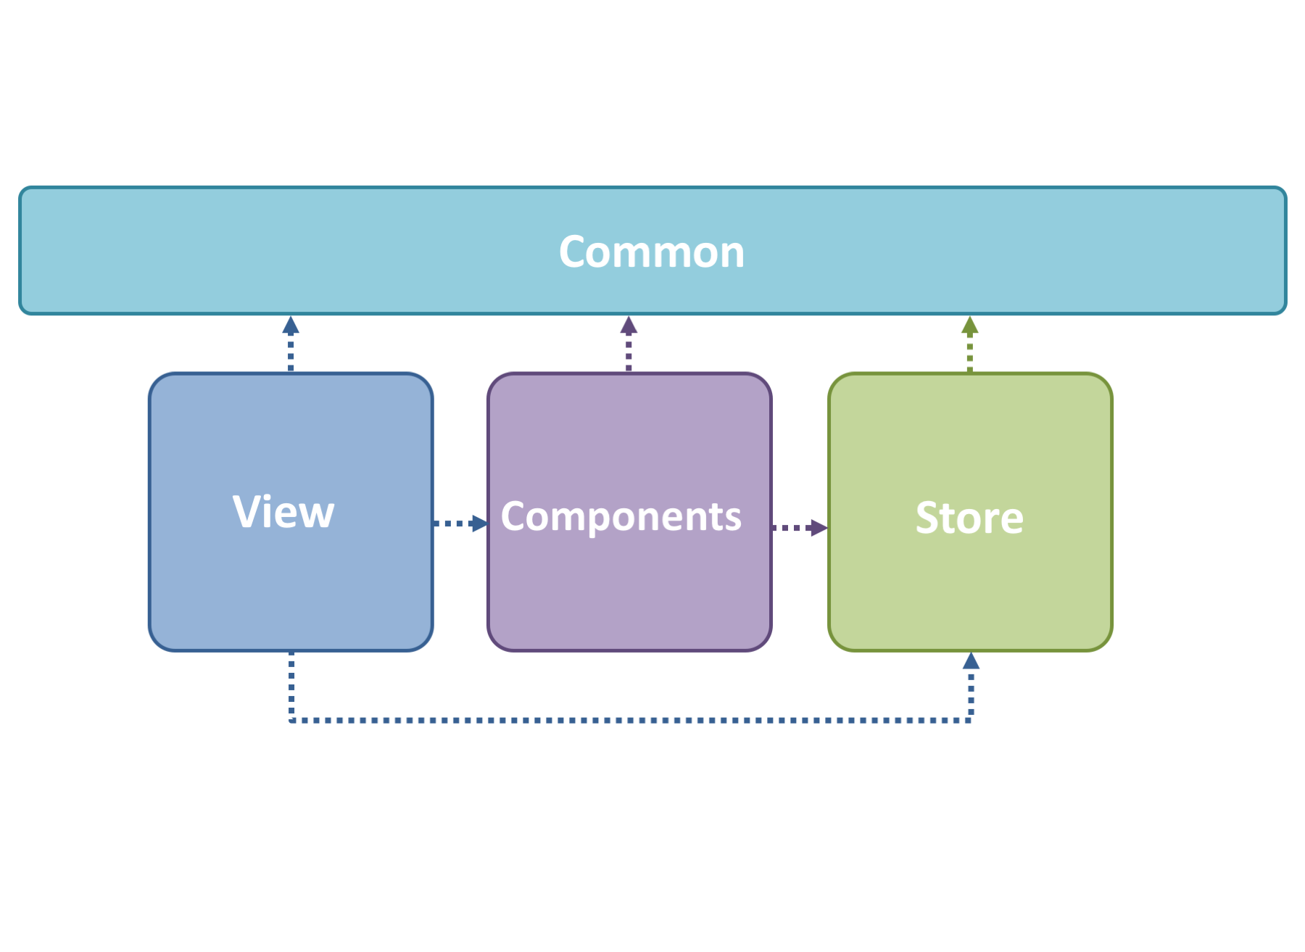

* **view**: The view is mainly in charge of displaying pages of the application.
* **component**: The component contains reusable UI and display logic components which is called by multiple files.
* **store**: The store contains core logic of the application. It shows the state of the application and handles mutation and action to interact within the application.
* **common**: The common is mainly used to provide constants calls by other users.

### Frontend Component Usage

The diagram below showcases an existing usage of the front end packages in the web application. 