**3 Sum**

1. **Screenshot**

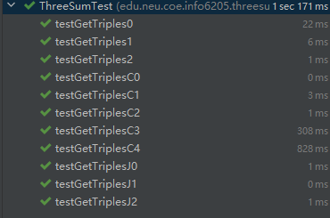

1. **Timing observation**

1. **Explanation**

In the quadratic method, we split the method into two parts. Firstly, we determine a number such as j. The we want to find the other two number to make a[j]+a[i]+a[n]=0. If a[j]+a[i]+a[n]>0, we want a smaller number to replace the a[i](we assume the a[i] is smaller). If a[j]+a[i]+a[n]>0, we want a bigger number to replace the a[j]. If a[j]+a[i]+a[n]=0, we add a[j],a[i],a[n] into the triples list and make j+1 or i-1. Secondly, we make sure that every number of array experiences the first way. Then we get all the 3sum triples.