


A GeoAI-Based Framework For Geospatial Flood Risk Mapping And Short-Term Rainfall Prediction For Urban Waterlogging Prevention
PROJECT REPORT
Submitted by
GOWRI SHANKAR P PRC22CA015 JACOB MATHEW PRC22CA017 SIDDHARTH BIJU PRC22CA026


A GEOAI-BASED FRAMEWORK FOR GEOSPATIAL FLOOD RISK MAPPING AND SHORT-TERM RAINFALL
PREDICTION FOR
URBAN WATERLOGGING PREVENTION
PROJECT REPORT
Submitted By

Gowri Shankar P Jacob Mathew
Siddharth Biju

To

To APJ Abdul Kalam Technological University in partial fulfillment of the requirements for the award of B. Tech Degree in Computer Science with AI and Engineering
Department of Artificial Intelligence and Engineering
Providence College of Engineering,Chengannur


NOVEMBER 2025
DEPARTMENT OF ARTIFICIAL INTELLIGENCE AND
ENGINEERING, PROVIDENCE COLLEGE OF
ENGINEERING, CHENGANNUR
CERTIFICATE
Certified that this report entitled “A GEOAI-BASED FRAMEWORK FOR GEOSPATIAL FLOOD RISK MAPPING AND SHORT-TERM RAINFALL PREDICTION FOR URBAN WATERLOGGING PREVENTION” is the project report completed by the following students during the academic year 2025–26 in partial fulfillment of the requirements for the award of the Degree of Bachelor of Technology in Computer Science and Engineering with Artificial Intelligence.
Gowri Shankar P PRC22CA015 Jacob Mathew PRC22CA017 Siddharth Biju PRC22CA026
Mr. Anoop P.P (Project Supervisor)
Assistant Professor
Department of Artificial Intelligence & Engineering
Dr. Prem Sankar C (Project Coordinator)
Head Of Department
Department Of Artificial Intelligence



DECLARATION
We hereby declare that this project report entitled “A GeoAI-Based Framework for Geospatial Flood Risk Mapping and Short-Term Rainfall Prediction for Urban Waterlogging Prevention”is the bonafide work carried out by us under the supervision of Mr. Anoop P.P., Assistant Professor, Department of Artificial Intelligence. We further declare that, to the best of our knowledge, the work reported herein does not form part of any other project report or dissertation on the basis of which a degree or award has been conferred on an earlier occasion to any other candidate. The content of this report is not being presented by any other student to this or any other University for the award of a degree.
SL NO | NAME OF  STUDENT | ROLL NUMBER | SIGNATURE
1 | GOWRI SHANKAR P | PRC22CA015
2 | JACOB MATHEW | PRC22CA017
3 | SIDDHARTH BIJU | PRC22CA026
Mr. Anoop PP (Project Supervisor)
Associate Professor
Department of Artificial Intelligence & Engineering
Dr. Prem Sankar C
Head of the Department - Artificial Intelligence
Providence College of Engineering
Date: 21/10/2025



ACKNOWLEDGEMENTS
I take this opportunity to express my heartfelt gratitude and sincere thanks to all those who have supported and guided me in successfully completing our presentation.
I express my sincere gratitude to our respected Principal, for providing a supportive academic environment and the necessary facilities to carry out this successfully.
I am deeply indebted to Mr Anoop PP,Assistant Professor for his excellent guidance, constructive criticism, and valuable suggestions throughout the preparation and presentation of this our project.
I would like to extend my sincere thanks to Dr. Prem Sankar C, Associate Professor and Seminar Coordinator, for his overall coordination, timely guidance, and encouragement. I am truly grateful for his continuous support and valuable advice at every stage of this work. I would also like to thank all the faculty members of the Department of Artificial Intelligence for their encouragement, support, and valuable suggestions. Their constant motivation played a vital role in the successful completion of our project.
Finally, I extend my deep gratitude to my parents, family members, and friends for their constant encouragement, support, and inspiration, both directly and indirectly, which greatly contributed to the successful completion of our project.
Gowri Shankar P Jacob Mathew Siddharth Biju Date: 21/10/2025
i


ABSTRACT
The GeoAI-Based Framework For Geospatial Flood Risk Mapping And Short-Term Rainfall Prediction For Urban Waterlogging Prevention integrates Artificial Intelligence (AI) and Geographic Information Systems (GIS) to predict rainfall and identify flood-prone areas with high spatial accuracy. The system utilizes Long Short-Term Memory (LSTM) networks to forecast short-term rainfall patterns and combines these predictions with Digital Elevation Models (DEM) and drainage network data to compute a Flood Risk Index (FRI).
Geospatial processing is carried out using open-source tools such as GDAL, Rasterio, and GeoPandas, ensuring accurate alignment and analysis of environmental datasets. The outputs are visualized through an interactive web dashboard developed with React.js, Leaflet.js, and Plotly.js, supported by a FastAPI backend for real-time data retrieval and alerts.
By integrating AI-driven prediction with spatial analysis, the system enables proactive flood risk management and enhances urban resilience. It demonstrates a scalable, cost-effective, and sustainable approach for early flood warning and disaster preparedness.
Keywords
GeoAI, Flood Risk Mapping, LSTM, Rainfall Forecasting, GIS, DEM, Environmental Monitoring, FastAPI, React.js.
ii


TABLE OF CONTENTS
Contents
ACKNOWLEDGEMENTS ........................................................................................................ i ABSTRACT ............................................................................................................................... ii TABLE OF CONTENTS ......................................................................................................... iii LIST OF FIGURES ................................................................................................................. vii LIST OF TABLES ................................................................................................................. viii LIST OF ABBREVIATIONS ................................................................................................... ix CHAPTER 1 .............................................................................................................................. 1 INTRODUCTION ..................................................................................................................... 1 1.1Background ...................................................................................................................... 1 1.1.1 Need for Disaster Management in Flood-Prone Regions .......................................... 1 1.1.2 Flood Scenario in Kerala ........................................................................................... 1 1.1.3 Limitations of Conventional Flood Modeling Approaches ....................................... 2 1.1.4 Role of Geospatial Technologies in Flood Risk Assessment .................................... 2 1.1.5 Emergence of Geospatial Artificial Intelligence (GeoAI) ......................................... 2 1.2 Problem Definition ........................................................................................................... 3 1.3 Objectives ......................................................................................................................... 3 1.4 Scope of the Project.......................................................................................................... 3 1.5 Methodology Overview ................................................................................................... 4 CHAPTER 2 .............................................................................................................................. 5 LITERATURE REVIEW .......................................................................................................... 5 2.1 Introduction ...................................................................................................................... 5 2.2 Urban Waterlogging Prediction Based on Time-Lag Correlation and Hybrid Deep Learning Models .................................................................................................................... 7 2.3 Remote Sensing and Machine Learning for Multi-Decadal Surface Water Monitoring . 7 2.4 GeoAI-Based Flood Extent Mapping Using Explainable Artificial Intelligence ............ 7 2.5 Deep Learning and Multi-Source Data Fusion for Urban Waterlogging Risk Prediction ................................................................................................................................................ 8 2.7 Artificial Intelligence for Flood Risk Management: A Comprehensive Review ............. 8 2.8 Urban Flood Susceptibility Mapping Using GeoAI and Explainable Deep Learning ..... 8 2.9 GeoAI-Enhanced Hybrid Systems for Urban Flood Risk Management .......................... 9 2.10 Research Gap Identification ........................................................................................... 9 2.11 Relevance of the Proposed Work ................................................................................... 9
iii


CHAPTER 3 ............................................................................................................................ 10 SYSTEM ANALYSIS ............................................................................................................. 10 3.1 Functional Requirements................................................................................................ 10 FR1: Rainfall Data Acquisition ........................................................................................ 10 FR2: AI-Based Rainfall Prediction ................................................................................... 10 FR3: Geospatial Data Processing ..................................................................................... 10 FR4: Flood Risk Index (FRI) Computation ...................................................................... 10 FR5: Visualization of Flood Risk and Rainfall Trends .................................................... 11 FR6: Alert Generation ...................................................................................................... 11 3.2 Non-Functional Requirements ....................................................................................... 11 NFR1: Scalability ............................................................................................................. 11 NFR2: Performance .......................................................................................................... 11 NFR3: Reliability ............................................................................................................. 11 NFR4: Usability ................................................................................................................ 11 NFR5: Maintainability ...................................................................................................... 11 3.3 System Requirements ..................................................................................................... 12 3.3.1 Hardware Requirements .......................................................................................... 12 3.3.2 Software Requirements ............................................................................................ 12 3.3.3 Performance Benchmarks ........................................................................................ 12 3.4 Feasibility Analysis ........................................................................................................ 12 3.4.1 Technical Feasibility ................................................................................................ 12 3.4.2 Operational Feasibility ............................................................................................ 12 3.4.3 Economic Feasibility ............................................................................................... 13 3.5 Project Scheduling.......................................................................................................... 13 CHAPTER 4 ............................................................................................................................ 15 METHODOLOGY .................................................................................................................. 15 4.1 Proposed System ............................................................................................................ 15 4.2 Modular Decomposition ................................................................................................. 15 4.2.1 Data Acquisition Module ......................................................................................... 15 4.2.2 Data Preprocessing Module ..................................................................................... 15 4.2.3 AI-Based Rainfall Prediction Module ..................................................................... 16 4.2.4 GIS-Based Flood Risk Computation Module .......................................................... 16 4.2.5 Visualization and Dashboard Module ..................................................................... 16 4.2.6 Alert and Reporting Module .................................................................................... 17 4.3 Algorithm ....................................................................................................................... 17
iv


4.4 Advantages of the Proposed System .............................................................................. 17 4.5 Technical Components Explained .................................................................................. 18 4.5.1 GeoAI ...................................................................................................................... 18 4.5.2 Long Short-Term Memory (LSTM) ........................................................................ 18 4.5.3 Digital Elevation Model (DEM) .............................................................................. 18 4.5.4 Drainage Density ..................................................................................................... 18 4.5.5 GDAL (Geospatial Data Abstraction Library) ........................................................ 18 4.5.6 Rasterio .................................................................................................................... 19 4.5.7 GeoPandas ............................................................................................................... 19 4.5.8 FastAPI .................................................................................................................... 19 4.5.9 React.js .................................................................................................................... 19 4.5.10 Leaflet.js ................................................................................................................ 19 4.5.11 Plotly.js .................................................................................................................. 19 4.6 System Architecture ....................................................................................................... 19 4.6.1 Architecture Overview ............................................................................................ 20 4.6.2 Data Source Layer ................................................................................................... 20 4.6.3 Preprocessing Layer ................................................................................................ 21 4.6.4 AI Layer (Rainfall Prediction Module) ................................................................... 21 4.6.5 GIS Analysis Layer ................................................................................................. 21 4.6.6 Flood Risk Index (FRI) Engine ............................................................................... 22 4.6.7 Data Storage Layer .................................................................................................. 22 4.6.8 Backend Layer ......................................................................................................... 22 4.6.9 Visualization Layer .................................................................................................. 23 4.7 AI-Based Rainfall Prediction Module ............................................................................ 23 4.7.1 Rationale for Using LSTM in Rainfall Prediction................................................... 23 4.7.2 Overview of LSTM Architecture ............................................................................ 23 4.7.3 Input–Output Configuration of the LSTM Model ................................................... 24 4.7.4 Data Preparation and Feature Engineering .............................................................. 24 4.7.5 Conceptual Working of the LSTM-Based Rainfall Prediction Model .................... 25 4.7.6 Internal Structure of an LSTM Cell ......................................................................... 26 4.7.7 Mathematical Representation of LSTM Operations ................................................ 26 4.7.8 Model Training and Optimization Strategy ............................................................. 27 4.7.9 Advantages of LSTM-Based Rainfall Prediction .................................................... 27 4.8 GIS and Backend Technologies Used ............................................................................ 27 4.8.1 GDAL for Raster Preprocessing and Spatial Standardization ................................. 27
v


4.8.2 Rasterio for Raster-Level Numerical Computation ................................................. 28 4.8.3 GeoPandas for Vector-Based Drainage and Boundary Analysis ............................ 28 4.8.4 Integration of GIS Tools within the GeoAI Workflow ........................................... 29 4.8.5 FastAPI for Backend Services and System Orchestration ....................................... 29 4.8.6 Backend–Frontend Integration ................................................................................ 30 4.4.7 Significance of GIS and Backend Technologies in Flood Risk Assessment .......... 30 CHAPTER 5 ............................................................................................................................ 31 SYSTEM DESIGN .................................................................................................................. 31 5.1 Introduction .................................................................................................................... 31 5.2 Flow Chart ...................................................................................................................... 32 5.3 Activity Diagram ............................................................................................................ 34 5.4 Sequence Diagram.......................................................................................................... 36 CHAPTER 6 ............................................................................................................................ 37 CONCLUSION ........................................................................................................................ 37 CHAPTER 7 ............................................................................................................................ 38 FUTURE SCOPE..................................................................................................................... 38 REFERENCES ........................................................................................................................ 39
vi


LIST OF FIGURES
Figure No. | Figure Name | Page No:
Figure 3.1 | Gantt Chart | 12
Figure 4.1 | System Architecture Diagram | 18
Figure 4.2 | Conceptual Workflow of LSTM-Based Rainfall  Prediction Model | 23
Figure 4.3 | Internal Architecture of LSTM Cell | 24
Figure 5.1 | Flow Chart of the Proposed System | 30
Figure 5.2 | Activity Diagram of the System | 32
Figure 5.3 | Sequence Diagram of the System | 34
vii


LIST OF TABLES
Table No. | Table Name | Page No.
Table 2.1 | Literature Review Survey | 3
Table 3.1 | Project Timeline | 12
viii


LIST OF ABBREVIATIONS
Abbreviation | Expansion
AES | Advanced Encryption Standard
AI | Artificial Intelligence
API | Application Programming Interface
BPTT | Backpropagation Through Time
CPU | Central Processing Unit
CRS | Coordinate Reference System
CSV | Comma Separated Values
DEM | Digital Elevation Model
DL | Deep Learning
FRI | Flood Risk Index
GDAL | Geospatial Data Abstraction Library
GeoAI | Geospatial Artificial Intelligence
GeoJSON | Geographic JavaScript Object Notation
GeoTIFF | Geographic Tagged Image File Format
GIS | Geographic Information System
GPU | Graphics Processing Tool
HTTPS | Hypertext Transfer Protocol Secure
IoT | Internet of Things
LSTM | Long Short Term Memory
LULC | Land Use /Land Cover
MAE | Mean Absolute Error
ML | Machine Learning
MSE | Mean Squared Error
OSM | OpenStreetMap
RAM | Random Access Memory
RMSE | Root Mean Square Error
SRTM | Shuttle Radar Topography Mission
UPS | Uninterruptible Power Supply
XAI | Explainable Artificial Intelligence
ix


CHAPTER 1
INTRODUCTION 1.1Background
Floods occur when the natural or artificial drainage capacity of a region is exceeded due to intense or prolonged rainfall, river overflow, storm surges, or inadequate urban drainage systems. Traditionally, flood assessment and management have relied on historical records, ground-based hydrological observations, and manual surveys. While these methods have been useful, they often fail to capture the spatial complexity and dynamic nature of flood processes, especially in rapidly urbanizing environments.
The increasing availability of geospatial data and advancements in computational technologies have opened new opportunities for improving flood risk analysis. Modern flood management strategies now emphasize early warning, vulnerability mapping, and predictive modeling to reduce disaster impacts before they occur.
1.1.1 Need for Disaster Management in Flood-Prone Regions
Disaster management is essential for minimizing the adverse impacts of floods through systematic planning and preparedness. Effective disaster management involves identifying high-risk zones, assessing vulnerability, and implementing mitigation measures well in advance of flood events. In flood-prone regions like Kerala, disaster management is not only a reactive process but a proactive necessity.
Learning disaster management concepts enables the development of structured frameworks for handling emergencies, improving coordination among agencies, and ensuring community preparedness. Technology-enabled disaster management systems help authorities make timely decisions, issue early warnings, and plan evacuations, thereby significantly reducing loss of life and property.
1.1.2 Flood Scenario in Kerala
Kerala’s unique physiography, characterized by the Western Ghats, midlands, and low-lying coastal plains, makes it highly susceptible to flooding. The state receives heavy monsoon rainfall, and its dense river network often overflows during extreme weather events. Rapid urban expansion, encroachment of wetlands, deforestation, and insufficient drainage infrastructure have further aggravated flood risk.
The devastating floods of 2018 and 2019 exposed serious shortcomings in existing flood forecasting and urban planning systems. These events underscored the need for reliable flood prediction models capable of identifying vulnerable areas and supporting disaster preparedness at regional and local levels.
1


1.1.3 Limitations of Conventional Flood Modeling Approaches
Conventional hydrological and hydraulic models primarily depend on ground-based measurements such as rainfall gauge data and river discharge records. These models often suffer from limited spatial coverage, data gaps, and delays in data processing. Additionally, they require extensive calibration and may not perform well under changing climatic and land-use conditions.
Due to these limitations, traditional models may fail to provide accurate, real-time flood predictions, particularly in urban areas where surface characteristics change rapidly. This has created a need for alternative approaches that can handle large volumes of spatial data and capture complex, non-linear relationships.
1.1.4 Role of Geospatial Technologies in Flood Risk Assessment
Geographic Information Systems (GIS) and Remote Sensing (RS) have become indispensable tools in modern flood risk assessment. GIS enables the integration, analysis, and visualization of spatial datasets, while remote sensing provides continuous observation of the Earth’s surface using satellite imagery.
In flood studies, geospatial technologies are used to analyze terrain characteristics using Digital Elevation Models (DEM), evaluate land use and land cover (LULC) patterns, study drainage networks and drainage density, and assess rainfall distribution. These spatial layers form the foundation for flood susceptibility and risk mapping.
1.1.5 Emergence of Geospatial Artificial Intelligence (GeoAI)
Geospatial Artificial Intelligence (GeoAI) represents the integration of Geographic Information Systems (GIS), remote sensing, and artificial intelligence techniques such as machine learning and deep learning to enable intelligent analysis of spatial data. GeoAI facilitates the processing and interpretation of large volumes of geospatial information derived from satellite imagery, digital elevation models, land use and land cover datasets, drainage networks, and meteorological data. By combining spatial analysis capabilities with advanced computational models, GeoAI supports automated feature extraction, pattern recognition, and spatial prediction.
By learning complex relationships from historical rainfall records, terrain characteristics, hydrological features, and land-use changes, AI-based models can effectively predict flood-prone areas and estimate flood risk under varying rainfall scenarios. These models are capable of capturing non-linear interactions among multiple flood-influencing factors, which are often difficult to represent using conventional hydrological methods. As a result, GeoAI-driven approaches overcome many limitations of traditional flood modeling techniques and provide
2


scalable, data-driven, and adaptive solutions for disaster management, early warning systems, and flood risk mitigation.
1.2 Problem Definition
Despite the availability of modern GIS and remote sensing technologies, many flood prediction and mapping systems in India lack the integration of real-time rainfall forecasting and spatial data fusion. Kerala’s complex topography, dense river networks, and changing climate patterns make flood prediction highly challenging. Existing flood models often fail to dynamically update risk zones or incorporate machine learning-based rainfall prediction, resulting in delayed and inaccurate risk alerts.
Therefore, the main problem addressed in this project is to design a GeoAI-based system that integrates geospatial data with machine learning rainfall forecasting to predict potential floodprone zones and visualize them through an interactive dashboard for better situational awareness and disaster management.
1.3 Objectives
The primary objectives of this project are as follows:
1.To collect, preprocess, and integrate geospatial datasets including DEM, drainage networks, and administrative boundaries of Kerala.
2.To obtain and analyze historical rainfall data and build an LSTM-based rainfall prediction model to forecast upcoming rainfall trends.
3.To generate a flood risk map by combining rainfall predictions with topographical and hydrological features using GIS-based analysis.
4.To identify flood hotspots and water-logging zones using drainage density, elevation, and AI-predicted rainfall risk.
5.To develop an interactive web dashboard that visualizes the flood risk zones, rainfall trends, and AI-based alerts for decision-makers and the public.
1.4 Scope of the Project
The scope of this project encompasses the use of AI and GIS for integrated flood risk prediction and visualization. The project is focused on the state of Kerala, leveraging its high-resolution DEM and hydrological datasets. The system includes both backend data processing and a webbased dashboard interface.
The project scope includes:
3


•Integration of DEM and drainage maps for terrain and hydrological analysis.
•Implementation of Deep Learning (LSTM) models for rainfall forecasting.
•Fusion of AI-based rainfall prediction with GIS layers for flood risk computation.
•The system can be extended in the future to include real-time satellite data, rainfall sensor networks, and IoT-based flood alert mechanisms.
1.5 Methodology Overview
The proposed system architecture involves the following steps:
1.Data Collection and Preprocessing: Datasets are collected from open sources such as OpenStreetMap, Copernicus DEM, and Open-Meteo API. Data is cleaned, reprojected, and clipped to Kerala’s administrative boundary.
2.DEM and Drainage Analysis: GIS-based hydrological analysis is performed to derive elevation gradients, slope, and drainage density for identifying flood-prone basins. 3.Rainfall Forecasting using LSTM: A Long Short-Term Memory (LSTM) neural network is trained on historical rainfall data to predict rainfall intensity for the next seven days. 4.Risk Factor Computation: The predicted rainfall, elevation, and drainage density are combined using weighted indices to calculate a Flood Risk Index (FRI) for each zone. 5.GeoAI Fusion and Visualization: The computed risk factors are merged into GeoJSON maps and visualized using an interactive web dashboard showing hotspots, rainfall trends, and alert levels.
4


CHAPTER 2
LITERATURE REVIEW 2.1 Introduction
Urban flooding and waterlogging have become increasingly frequent due to rapid urbanization, climate change, and inadequate drainage infrastructure. Traditional flood prediction methods, largely based on hydrological and hydraulic models, often suffer from limitations such as high computational cost, dependency on extensive field data, and limited adaptability to dynamic rainfall patterns.
Recent advancements in Artificial Intelligence (AI), Machine Learning (ML), and Geospatial Artificial Intelligence (GeoAI) have opened new possibilities for integrating spatial and temporal data to improve flood risk prediction and mapping. This chapter reviews existing research related to urban waterlogging prediction, flood risk mapping, machine learning and deep learning approaches, and GeoAI-based hybrid systems, with the aim of identifying research gaps that motivate the proposed work.
Paper Title | Methodology Used | Advantages | Disadvantages
Geospatial  Artificial  Intelligence For Satellite-Based Flood Extent  Mapping | •Integrates GeoAI deep-learning  models with SAR/MSI satellite imagery for flood- extent extraction. | •Works in all-  weather conditions  using SAR data  •Handles large-scale  satellite datasets | • SAR has speckle noise Confusion with man-made flat surfaces.  • Requires high-  quality labeled  data .
AI For Predictive Urban Water  Drainage Systems | Reviews ML  techniques supervised, unsupervised, DL, RL, and hybrid methods  for predictive drainage management. | • Improves flood  prediction  • Handles uncertain  rainfall. | • Requires large  datasets.  • Local data often  limited.
Machine Learning and Urban  Drainage Systems: State-of-the-Art  Review | Reviews ML  approaches (ANN,  CNN, RNN, DQN) for operation,  management, and  maintenance of urban drainage. | • Handles high-  dimensional  data  • Enables real-  time prediction. | • Needs large  training data.  • Requires careful  model evaluation.
Artificial  Intelligence for  Flood Risk  Management:  Review & Future Directions | Analyzes hundreds of studies on ML/DL-  based flood prediction, risk mapping, and  management  frameworks. | •Processes multi-source data (satellite, hydro, weather) | • Data bias issues.  • Requires  explainable AI.
5


• | Enables | near-
real-time
forecasting
Urban  Waterlogging Risk Prediction Using  BP Neural  Network +  SWMM | Couples BP neural network with the SWMM numerical model to predict  waterlogging risk rapidly. | • Faster than  physical  simulation  (1000× speed)  •Maintains high  accuracy | • Requires high-  quality SWMM  calibration.  • Needs many  rainfall pattern  samples.
Urban  Waterlogging  Prediction Using Rainfall Time-  Series Features (Shenzhen) | Extracts rainfall-series features and applies  ML to predict  waterlogging depth  using only rainfall  data. | • Very high  accuracy  • Works even  with limited  flood sensors | • Only short-term  prediction.  • Needs high-  resolution rainfall  data.
Remote Sensing + ML for Surface  Water Monitoring (Ethiopia) | Uses Landsat imagery with GTB, RF, and  SVM on Google Earth Engine to map surface water over four  decades. | •High  classification accuracy  •Multi-decadal monitoring | • ML depends on  quality of training  labels.  • JRC benchmark  has gaps.
Smart hotspot  detection using  GeoAI (Portugal) | Applies Random  Forest on DEM, slope, soil, and proximity  data to produce  national-level flood-  hazard hotspot maps. | •High-resolution  hazard maps  •Works at city  and national  scale | •Does not include weather-based  real-time factors.  •Requires  extensive  geospatial  preprocessing
Table 2.1 Literature Review Survey
6


2.2 Urban Waterlogging Prediction Based on Time-Lag Correlation and Hybrid Deep Learning Models
Lei et al. (2023) proposed an advanced urban waterlogging prediction framework by integrating a Poar_LSTM deep learning model with a physically based hydrodynamic component (Poar_DHC) and time-lag correlation analysis (PTLC). The study focused on the city of Fuzhou, China, where complex drainage networks and upstream–downstream interactions significantly influence flood behavior. By explicitly modeling temporal lag relationships between rainfall and water levels across interconnected drainage nodes, the system successfully captured the dynamic response of urban catchments.
The hybrid framework incorporated physical regional mechanisms into the data-driven architecture, enabling the model to reflect real hydrological processes while retaining the learning capability of deep neural networks. Performance evaluation showed Nash–Sutcliffe efficiency coefficients of 0.969 and 0.971, indicating superior predictive accuracy compared to traditional hydrological and purely data-driven models. Despite its strong performance, the approach required extensive calibration and high-quality hydrological inputs, which restricts its applicability in data-scarce urban regions. Nevertheless, the study demonstrated that coupling deep learning with hydrodynamic modeling can significantly enhance urban waterlogging prediction under complex drainage conditions.
2.3 Remote Sensing and Machine Learning for Multi-Decadal Surface Water Monitoring
Tesfaye and Breuer (2025) employed machine learning techniques combined with remote sensing to analyze long-term surface water dynamics across major Ethiopian basins. Using Landsat imagery from 1986 to 2023 within the Google Earth Engine (GEE) platform, the study applied Gradient Tree Boosting (GTB), Random Forest (RF), and Support Vector Machines (SVM) for surface water classification. The models achieved classification accuracies exceeding 90%, with strong agreement against the Joint Research Centre (JRC) global surface water dataset (R² > 0.9).
Among the tested algorithms, GTB demonstrated marginally superior precision and temporal stability compared to RF and SVM. The results revealed a long-term increase in surface water extent accompanied by notable inter-annual variability driven by rainfall fluctuations and land-use changes. While the research validated the effectiveness of cloud-based machine learning for large-scale hydrological monitoring, it primarily addressed long-term surface water trends rather than short-term flood prediction or urban waterlogging scenarios. This limits its direct applicability for real-time urban flood risk assessment.
2.4 GeoAI-Based Flood Extent Mapping Using Explainable Artificial Intelligence
Li and Lee (2024) introduced an explainable GeoAI framework that integrates deep learning with physical flood modeling for satellite-based flood extent mapping. The study embedded domain-specific hydrological and spatial knowledge into neural network architectures to reduce uncertainty and improve interpretability. Sentinel satellite imagery served as the primary data source, enabling flood detection over large spatial extents.
7


To enhance transparency, the framework incorporated explainable AI (XAI) techniques such as SHAP and Grad-CAM, allowing visualization of model decision pathways and contributing factors. Experimental results demonstrated robust flood extent delineation even under extreme rainfall conditions, establishing the framework’s suitability for operational flood monitoring. However, the model relied heavily on satellite imagery and focused on post-event flood extent mapping rather than predictive rainfall modeling or proactive urban waterlogging prevention.
2.5 Deep Learning and Multi-Source Data Fusion for Urban Waterlogging Risk Prediction
Zhang et al. (2023) proposed a deep learning-based urban waterlogging prediction model that integrates multi-source spatial and temporal datasets, including rainfall records, Digital Elevation Models (DEM), drainage network data, and land-use/land-cover information. The model employed a CNN–LSTM architecture to effectively capture spatial heterogeneity and temporal flood dynamics within urban environments.
Validation results showed that the proposed approach outperformed traditional hydrodynamic models in identifying high-risk waterlogging zones, particularly in densely built metropolitan regions. The fusion of terrain, infrastructure, and meteorological data significantly improved prediction accuracy and spatial detail.
2.7 Artificial Intelligence for Flood Risk Management: A Comprehensive Review
Liu and Coleman (2023) conducted an extensive meta-analysis of over 300 studies addressing AI applications in flood risk management. The review categorized existing research into three primary domains: flood forecasting, flood susceptibility mapping, and flood impact assessment. The authors emphasized the rapid advancement of deep learning and hybrid AI–hydrology models, noting their superior performance over traditional statistical approaches.
Despite these advances, the review identified persistent challenges, including data imbalance, limited model explainability, and difficulties in scaling AI solutions for real-world implementation. The study concluded that integrating AI with GIS-based spatial analysis frameworks is critical for achieving transparent, equitable, and effective flood risk management, particularly in developing regions where conventional infrastructure-based solutions may be inadequate.
2.8 Urban Flood Susceptibility Mapping Using GeoAI and Explainable Deep Learning
Li et al. (2024) developed a GeoAI-based flood susceptibility mapping framework using transformer-based deep networks, specifically the SegFormer architecture. The model was trained on multi-modal Sentinel-1 and Sentinel-2 satellite imagery, enabling effective flood boundary delineation even under cloud-covered conditions. The framework incorporated explainable AI visualization techniques to improve interpretability and user trust.
Experimental results demonstrated significant improvements in spatial accuracy and robustness compared to conventional convolutional neural network models. While the approach proved highly
8


effective for large-scale flood susceptibility mapping, it primarily focused on satellite image interpretation and did not explicitly integrate rainfall forecasting or urban drainage characteristics.
2.9 GeoAI-Enhanced Hybrid Systems for Urban Flood Risk Management
A recent study published in IJPREMS (2024) proposed a GeoAI-driven hybrid framework combining geospatial analytics and deep learning to support real-time urban flood risk management. The system integrated topographical, meteorological, and hydrological parameters to compute a Flood Risk Index (FRI), which was visualized through an interactive web-based dashboard.
The framework demonstrated strong potential for early-warning applications and decision support in smart city environments. However, the study did not provide sufficient details regarding lightweight or academic-scale implementations, limiting its reproducibility in low-resource settings
2.10 Research Gap Identification
From the reviewed literature, the following research gaps are identified:
1.Many existing models focus either on rainfall prediction or flood extent mapping, but lack a unified framework that combines short-term rainfall forecasting with terrain-based geospatial risk analysis.
2.Several AI-driven approaches require high computational resources, dense sensor networks, or continuous satellite data, making them less suitable for resource-constrained or academic environments.
3.Limited studies emphasize urban waterlogging prevention, particularly using lightweight GeoAI frameworks that integrate DEM, drainage characteristics, and AI-predicted rainfall. 4.The interpretability and modular integration of AI and GIS components remain limited in many existing systems.
2.11 Relevance of the Proposed Work
The proposed project addresses these gaps by introducing a GeoAI-based framework that integrates:
• Short-term rainfall prediction using LSTM
• Terrain and drainage-based flood risk analysis using GIS
• A weighted Flood Risk Index (FRI) for identifying urban waterlogging-prone zones • A modular and scalable architecture suitable for academic and pilot-scale deployment
By combining AI-driven temporal prediction with geospatial analysis, the system provides a practical, interpretable, and cost-effective solution for urban flood risk mapping and waterlogging prevention, particularly in regions like Kerala.
9


CHAPTER 3
SYSTEM ANALYSIS
This chapter presents the system analysis of the proposed GeoAI-Based Flood Risk Mapping and Predictive Rainfall Analysis System. It defines the functional and non-functional requirements of the system, outlining what the system is expected to perform and the quality constraints under which it must operate. The chapter also discusses the system requirements, feasibility analysis, and cost estimation, ensuring that the proposed solution is technically viable, operationally practical, and economically feasible within an academic and pilot-scale deployment context.
3.1 Functional Requirements
FR1: Rainfall Data Acquisition
Description:
The system shall acquire historical and recent rainfall data from external sources such as Open-Meteo, IMD datasets, or CSV-based archives. This data serves as the primary input for rainfall forecasting.
Input: Rainfall time-series data (CSV / API)
Output: Structured rainfall dataset ready for preprocessing.
FR2: AI-Based Rainfall Prediction
Description:
The system shall use a Long Short-Term Memory (LSTM) deep learning model to predict short-term rainfall trends based on historical rainfall patterns.
Input: Preprocessed rainfall data (previous 60 days)
Output: Predicted rainfall values for the next 7 days
FR3: Geospatial Data Processing
Description:
The system shall process geospatial datasets including Digital Elevation Models (DEM), drainage networks, and administrative boundaries to extract terrain and hydrological features such as slope, flow accumulation, and drainage density.
Input: DEM (GeoTIFF), drainage shapefiles, boundary layers
Output: Processed spatial layers aligned to a common coordinate reference system
FR4: Flood Risk Index (FRI) Computation
Description:
The system shall integrate predicted rainfall risk with terrain elevation and drainage density using a weighted overlay approach to compute a Flood Risk Index (FRI).
10


Input: Rainfall risk score, elevation risk, drainage risk
Output: Flood Risk Index raster representing spatial flood susceptibility
FR5: Visualization of Flood Risk and Rainfall Trends
Description:
The system shall visualize rainfall trends, flood risk zones, and waterlogging-prone areas through an interactive web-based dashboard.
Input: GeoTIFF and GeoJSON outputs
Output: Interactive maps, charts, and spatial layers
FR6: Alert Generation
Description:
The system shall generate alerts when predicted rainfall or flood risk values exceed predefined threshold levels.
Input: Rainfall prediction values, Flood Risk Index
Output: Visual alert notifications on the dashboard
3.2 Non-Functional Requirements
NFR1: Scalability
The system should support expansion to larger geographic regions and additional datasets without requiring significant architectural changes.
NFR2: Performance
Rainfall prediction and flood risk computation should be completed within acceptable time limits (2–5 seconds for standard datasets).
NFR3: Reliability
The system should maintain data integrity and continue functioning reliably under partial failures through its modular design.
NFR4: Usability
The user interface should be intuitive and accessible to non-technical users such as students, planners, and municipal officials.
NFR5: Maintainability
Each module should be independently upgradable, enabling future enhancements without disrupting the overall system.
11


3.3 System Requirements
3.3.1 Hardware Requirements
• Processor: Mid-range multi-core CPU (Intel Core i5 / AMD Ryzen 5 or higher)
• GPU: Optional (NVIDIA GTX 1650 / RTX 2060 recommended for faster AI training)
• Memory: Minimum 8 GB RAM; 16 GB preferred
• Storage: Minimum 512 GB SSD/HDD for datasets and outputs
• Network: Stable broadband connection (≥ 20 Mbps)
• Power Supply: Reliable power source or UPS
3.3.2 Software Requirements
• Operating System: Windows 11 / Ubuntu 22.04 or equivalent
• Programming Language: Python 3.12
• Machine Learning Libraries: TensorFlow, Scikit-learn
• GIS Libraries: GeoPandas, Rasterio, GDAL
• Backend Framework: FastAPI
• Frontend Framework: React.js with Leaflet.js and Plotly.js
• Database: PostgreSQL with PostGIS (optional) or local JSON storage
• Security Protocols: HTTPS and AES-256 encryption
3.3.3 Performance Benchmarks
• Forecast Execution Time: 2–3 seconds for standard datasets
• Dashboard Load Time: Less than 5 seconds
• System Availability: 95–99% uptime
• Data Refresh Interval: Daily rainfall updates and periodic model retraining
3.4 Feasibility Analysis
3.4.1 Technical Feasibility
The system is technically feasible due to the use of well-established open-source tools. TensorFlow
supports efficient LSTM-based rainfall prediction, while GeoPandas and Rasterio enable accurate
geospatial analysis. FastAPI ensures high-performance backend communication, and React.js provides
a responsive visualization layer. GPU acceleration is optional, making the system suitable for academic
environments.
3.4.2 Operational Feasibility
Operationally, the system is designed for ease of use with minimal training requirements. Automated
data acquisition, prediction, and visualization reduce manual intervention. The dashboard is accessible
via standard web browsers, and the modular architecture simplifies maintenance and updates.
12


3.4.3 Economic Feasibility
The project relies entirely on free and open-source software, minimizing development costs. The system can be deployed on existing personal computers or institutional infrastructure.
3.5 Project Scheduling
A well defined project timeline is crucial for monitoring progress and ensuring the project is completed on schedule. The Gantt chart illustrates the overall project schedule,indicating the planned start and and completion dates for each phase of the work.It provides a clear timeline of activities to ensure that all tasks are completed within the designated period.
Task ID | Task Name | Duration (Weeks) | Start Date | End Date | Status
1 | Planning &  Literature Study | 5 | 01-Jul-25 | 04-Aug-25 | Completed
2 | Finalize Problem  Statement & Scope | 1 | 01-Jul-25 | 07-Jul-25 | Completed
3 | Technology Stack Identification | 1 | 08-Jul-25 | 14-Jul-25 | Completed
4 | Literature Survey & Paper Review | 2 | 15-Jul-25 | 28-Jul-25 | Completed
5 | Identify  Research  Gaps &  Objectives | 1 | 29-Jul-25 | 04-Aug-25 | Completed
6 | Requirement Analysis &  Feasibility  Study | 4 | 05-Aug-25 | 01-Sep-25 | Completed
7 | Functional & Non-Functional  Requirements  Drafting | 2 | 05-Aug-25 | 18-Aug-25 | Completed
8 | Feasibility Study (Technical,  Economic,  Operational) | 1 | 19-Aug-25 | 25-Aug-25 | Completed
13


9 | Hardware & Software  Requirement  Finalization | 1 | 26-Aug-25 | 01-Sep-25 | Completed
10 | GeoAI System  Architecture &  Design | 7 | 02-Sep-25 | 23-Oct-25 | Completed
11 | AI & GIS Module Design (LSTM + Terrain Analysis) | 2 | 02-Sep-25 | 15-Sep-25 | Completed
12 | Use Case Diagram Preparation | 2 | 16-Sep-25 | 29-Sep-25 | Completed
13 | Sequence &  Activity Diagram  Preparation | 2 | 30-Sep-25 | 13-Oct-25 | Completed
14 | Consolidation & Documentation of System Design | 1 | 14-Oct-25 | 23-Oct-25 | Completed
Table 3.1 Project timeline
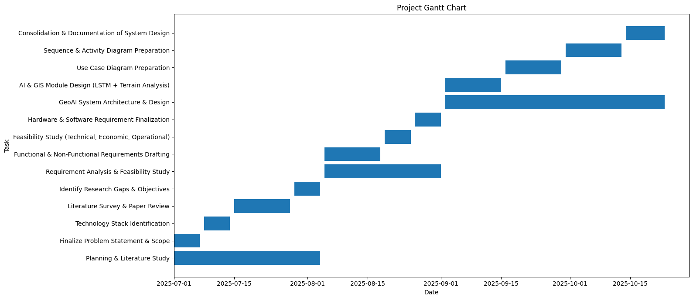
Figure 3.1 Gantt Chart
14


CHAPTER 4
METHODOLOGY 4.1 Proposed System
The proposed GeoAI-Based Flood Risk Mapping and Predictive Rainfall Analysis System is an intelligent framework that integrates Geographic Information Systems (GIS), Artificial Intelligence (AI), and Remote Sensing technologies to analyze and predict potential flood risks across Kerala. The system focuses on combining both spatial intelligence (geographic and topographic features) and temporal intelligence (rainfall prediction over time) to produce an actionable Flood Risk Index (FRI) that enables timely flood management and disaster preparedness.
The architecture operates in a multi-stage pipeline beginning with data acquisition, followed by data preprocessing, AI-driven rainfall forecasting, GIS-based flood modeling, and finally visualization through a dynamic dashboard. It draws on multi-source datasets such as Digital Elevation Models (DEMs) for terrain data, drainage networks for hydrological patterns, and time-series rainfall records for weather analysis. The AI component, powered by Long ShortTerm Memory (LSTM) networks, captures the non-linear temporal dependencies of rainfall data, while the GIS layer integrates these predictions with topographic and hydrological data to generate accurate risk maps.
This integration of deep learning and geospatial analytics ensures that both climatic and environmental factors are equally represented in the model. By embedding AI within a GIS workflow, the system transitions from static flood maps to adaptive, data-driven flood forecasting, offering decision-makers a real-time analytical tool for monitoring high-risk areas. The resulting visual interface provides easy-to-understand outputs, including rainfall trends, predicted waterlogging zones, and spatially ranked flood risk layers.
4.2 Modular Decomposition
The system architecture is modular in nature, ensuring scalability, reusability, and independent functioning of each subsystem. Each module plays a distinct role in achieving end-to-end data processing, prediction, and visualization.
4.2.1 Data Acquisition Module
The Data Acquisition Module is responsible for collecting diverse data inputs from both open and specialized sources. Rainfall data is sourced through APIs such as Open-Meteo or NASA GES DISC, while terrain data is obtained from the Shuttle Radar Topography Mission (SRTM). The drainage networks and river geometries are extracted from OpenStreetMap (OSM). These datasets together capture climatic, hydrological, and topographical aspects necessary for flood risk computation. The collected data, in various formats like CSV, GeoTIFF, and SHP, ensures comprehensive environmental representation.
4.2.2 Data Preprocessing Module
Before modeling, the raw data must undergo transformation to ensure consistency and compatibility. The Data Preprocessing Module handles data cleaning, normalization, and reprojection.
15


For rainfall data, missing entries are interpolated, and values are scaled to a normalized range. For spatial data, GDAL and Rasterio are used to align coordinate reference systems and remove nodata values. The DEM is clipped to Kerala’s administrative boundary using GeoPandas overlays. Additional spatial derivatives such as slope and flow accumulation are computed to enhance hydrological accuracy. This ensures all datasets are topologically aligned and statistically reliable before fusion
4.2.3 AI-Based Rainfall Prediction Module
At the core of the system lies the AI Rainfall Prediction Module, powered by Long Short-Term Memory (LSTM) networks. LSTM, an advanced variant of Recurrent Neural Networks (RNNs), is designed to model long-term dependencies within sequential data. Unlike conventional models that treat each time step independently, LSTM employs memory cells to store relevant information over time, controlled by three gates — input, forget, and output — to manage information flow.
The module takes the last 60 days of rainfall data as input and predicts cumulative rainfall for the next seven days. Training is optimized using the Adam optimizer with Mean Squared Error (MSE) loss function. The output is a Rainfall Risk Score, representing the normalized probability of high-intensity rainfall events. This risk score later influences the flood risk computation phase.
4.2.4 GIS-Based Flood Risk Computation Module
The Flood Risk Computation Module integrates both spatial and predictive data to compute the Flood Risk Index (FRI). The model fuses terrain elevation (from DEM), drainage density (from OSM), and rainfall prediction (from LSTM) using a weighted equation:
FRI=(0.4×Elevation Risk)+(0.3×Drainage Risk)+(0.3×Rainfall Risk)
Low-lying areas, high drainage density, and predicted high rainfall values all contribute to increased flood risk. Using Rasterio, GDAL, and NumPy, these parameters are normalized and merged into a composite raster representing the risk distribution across the region. The result is exported as GeoJSON and GeoTIFF files, forming the analytical basis of the visualization layer.
4.2.5 Visualization and Dashboard Module
The Visualization Module provides a user-centric, web-based interface for interactive analysis. It is built using React.js for front-end logic, Leaflet.js for mapping, and Plotly.js for dynamic charting. Users can explore rainfall trends, view real-time risk zones, and interact with flood maps through zoom, pan, and layer toggling features.
The system’s backend, developed using FastAPI, handles API requests and real-time data streaming. Each visualization — whether it’s a rainfall graph or flood risk layer — is fetched dynamically through endpoints like /api/rainfall, /api/risk-map, and /api/alerts. The dashboard design emphasizes clarity and accessibility, ensuring even non-technical users can interpret data intuitively.
16


4.2.6 Alert and Reporting Module
The Alert Module automatically monitors rainfall and flood risk thresholds. When rainfall risk surpasses 0.75 or when FRI exceeds predefined danger levels, an alert is triggered within the dashboard and logged for reporting.
This system can also generate analytical reports summarizing rainfall trends, drainage vulnerability, and district-wise risk ratings in tabular and visual formats. Future expansions could include integration with IoT-based weather stations for near real-time sensor data.
4.3 Algorithm
The core algorithm of the GeoAI system defines the logical sequence for data flow, AI training, and GIS computation:
1. Initialization: Load configurations, API keys, and dataset paths.
2.Data Collection: Retrieve rainfall CSV, DEM GeoTIFF, and drainage shapefiles.
3.Preprocessing: Normalize rainfall data, reproject spatial layers, and clip DEM to Kerala’s boundary. 4. AI Training: Train the LSTM network using 2000–2025 rainfall data until convergence is achieved. 5.Rainfall Forecasting: Predict rainfall for the next 7 days and normalize it into a Rainfall Risk Score. 6. Hydrological Analysis: Compute drainage density and terrain slope using GDAL and GeoPandas. 7.Flood Risk Computation: Combine rainfall, elevation, and drainage layers into a unified Flood Risk Index (FRI).
8.Visualization: Export results and render them on the web dashboard using Leaflet and Plotly.
9.Alert Generation: Monitor thresholds and trigger warnings when values exceed safe limits. 10.System Update: Store results for time-series tracking and retrain models periodically.
This algorithm ensures seamless synchronization between data science and geospatial computation, making the model adaptive to real-time climatic changes.
4.4 Advantages of the Proposed System
The proposed system presents a significant improvement over conventional flood risk models. Firstly, it leverages AI-driven prediction combined with GIS-based spatial analytics, ensuring both temporal accuracy and spatial precision. Traditional flood risk studies rely on static datasets and manual analysis, while this system automates updates through machine learning and API-based data feeds.
Secondly, its modular architecture enhances flexibility. Each component — from LSTM modeling to mapping visualization — can operate independently or be upgraded without affecting the overall workflow.
Thirdly, the use of open-source libraries such as TensorFlow, GDAL, and React makes the project cost-effective and accessible for academic and government deployment.
Fourthly, the interactive dashboard transforms complex data into intuitive visuals, bridging the gap between data scientists and decision-makers.
17


Finally, the framework is scalable and extensible, capable of incorporating IoT devices, hydrological models, and satellite-derived soil moisture data in future iterations, paving the way for smarter disaster management systems.
4.5 Technical Components Explained
The following technical components are key to the successful operation of the GeoAI system. Each tool or technology contributes uniquely to its analytical and predictive capability.
4.5.1 GeoAI
GeoAI (Geospatial Artificial Intelligence) is the convergence of GIS and AI, combining spatial data with deep learning models to make location-aware predictions. It allows AI algorithms to understand spatial relationships, such as proximity, elevation, and topographic influence. In this project, GeoAI fuses rainfall time-series data with spatial hydrological features to create intelligent flood risk predictions that are geographically accurate.
4.5.2 Long Short-Term Memory (LSTM)
The LSTM model is a deep neural architecture designed to analyze sequential data like rainfall time series. It includes internal memory cells and three regulating gates — input, forget, and output gates — that allow the model to learn long-term dependencies while avoiding data loss. This makes LSTM particularly effective for rainfall forecasting, where past precipitation patterns influence future outcomes.
4.5.3 Digital Elevation Model (DEM)
A Digital Elevation Model is a raster representation of the Earth’s surface where each pixel corresponds to an elevation value. DEMs are critical for hydrological modeling since they help determine flow direction, slope, and accumulation areas. In this project, the DEM identifies low-lying regions that are naturally prone to flooding. The SRTM dataset provides accurate elevation data used for terrain analysis.
4.5.4 Drainage Density
Drainage Density is the measure of total stream length per unit area and reflects how dissected a landscape is by rivers or streams. It is calculated using vector data from OpenStreetMap and analyzed using GeoPandas. High drainage density indicates poor infiltration and higher runoff potential, increasing flood vulnerability.
4.5.5 GDAL (Geospatial Data Abstraction Library)
GDAL is a powerful open-source library for reading, writing, and transforming geospatial data formats. It provides operations such as reprojection, clipping, raster conversion, and coordinate transformation. In this system, GDAL ensures all datasets align spatially, enabling accurate overlay and analysis of DEMs, drainage layers, and administrative boundaries.
18


4.5.6 Rasterio
Rasterio simplifies raster manipulation in Python and integrates seamlessly with NumPy. It is used for reading and writing raster data, masking invalid pixels, and performing array-based elevation analysis. Its compatibility with GDAL ensures fast and efficient raster processing for large datasets.
4.5.7 GeoPandas
GeoPandas extends the popular Pandas library to handle geospatial vector data. It simplifies complex operations such as intersections, overlays, and buffer analysis. In the GeoAI system, it is used for spatial analysis of drainage networks and computation of drainage density and zonal statistics.
4.5.8 FastAPI
FastAPI is a modern, asynchronous Python web framework used to create the backend RESTful API. It connects the AI and GIS computation layer to the frontend dashboard. FastAPI provides endpoints like /api/rainfall and /api/risk-map to deliver real-time results efficiently, ensuring high performance even under heavy computation.
4.5.9 React.js
React.js is a component-based JavaScript library that powers the front-end of the dashboard. It enables real-time rendering and interactive data visualization. Its modularity allows dynamic updates of rainfall graphs, flood maps, and alert panels without page reloads, ensuring an engaging user experience.
4.5.10 Leaflet.js
Leaflet.js is a lightweight, open-source JavaScript library for rendering interactive maps on web applications. It allows the system to visualize spatial data layers like flood zones, drainage networks, and elevation contours. Users can interact with maps through zooming, panning, and layer toggling.
4.5.11 Plotly.js
Plotly.js provides advanced data visualization capabilities through interactive graphs and charts. It is used for displaying rainfall prediction trends, risk comparisons, and AI model outputs in a visually appealing way that supports analytical exploration.
4.6 System Architecture
The system architecture defines the structural and functional organization of the proposed GeoAI-Based Flood Risk Mapping and Predictive Rainfall Analysis System. Since this chapter focuses on explaining how the system works, the architecture is presented here to provide a clear visual and conceptual understanding of the interaction between data sources, artificial intelligence models, geospatial analysis components, backend services, and visualization modules.
The architecture follows a layered and modular design, ensuring scalability, maintainability, and clear separation of responsibilities. Each layer performs a specific function in the overall workflow, while data flows sequentially from raw input sources to final visualization and alert generation.
19


4.6.1 Architecture Overview
The overall architecture of the proposed system is illustrated in Figure 4.1. It represents an end-to-end pipeline starting from data acquisition and ending with decision-support visualization.
The system integrates:
•Temporal intelligence, achieved through AI-based rainfall prediction
•Spatial intelligence, achieved through GIS-based terrain and drainage analysis
These two intelligence streams are combined to compute a Flood Risk Index (FRI), which serves as the primary output of the system.
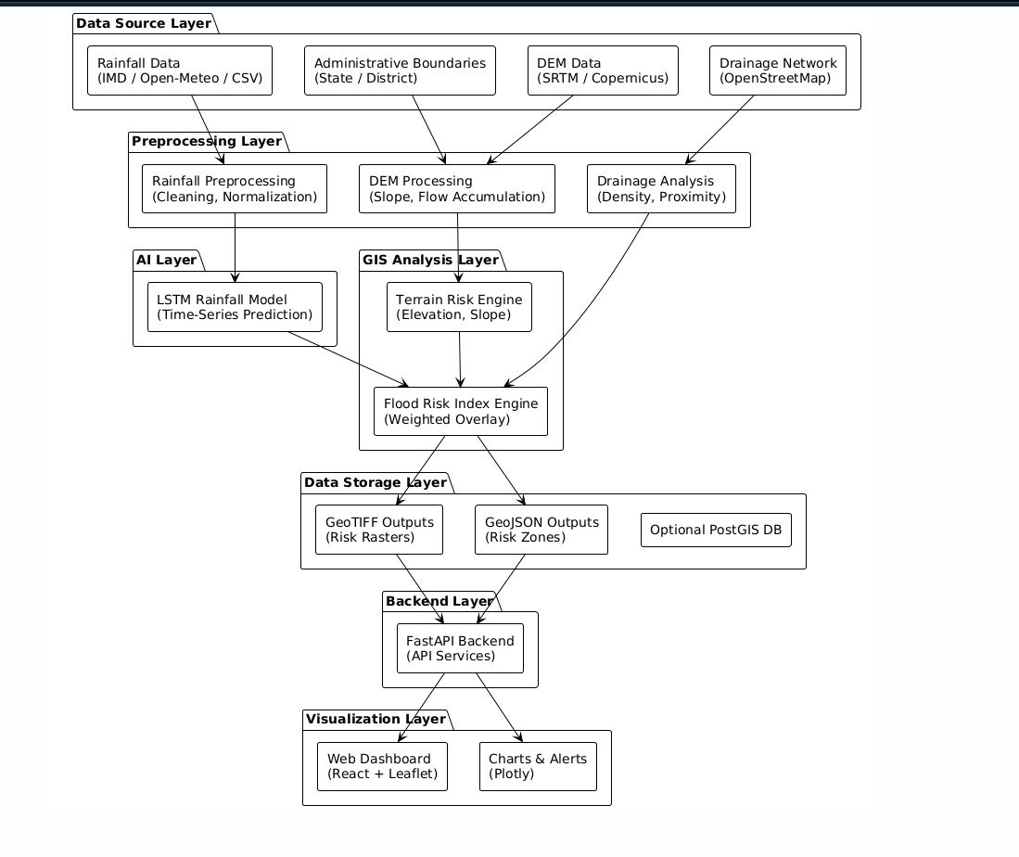
Figure 4.1 Architecture Diagram
4.6.2 Data Source Layer
The Data Source Layer is responsible for providing all raw inputs required for flood risk analysis. It consists of multiple heterogeneous data sources, including:
20


• Rainfall Data: Historical and recent rainfall data obtained from sources such as Open-Meteo APIs, IMD datasets, or CSV-based archives.
• Digital Elevation Model (DEM): Terrain elevation data sourced from SRTM or Copernicus datasets.
• Drainage Network Data: River and drainage geometries extracted from OpenStreetMap (OSM).
•Administrative Boundaries: State and district boundary layers used to define the study area. These datasets collectively represent climatic, hydrological, and topographical characteristics essential for flood risk assessment.
4.6.3 Preprocessing Layer
The Preprocessing Layer ensures that raw datasets are transformed into a standardized and analysis-ready form.
Rainfall data is cleaned to handle missing values and normalized to ensure numerical stability during AI model training. Spatial datasets are reprojected into a common coordinate reference system to ensure accurate spatial alignment.
Key preprocessing operations include:
•Rainfall data cleaning and normalization
•DEM clipping to the study area
•Removal of nodata values
•
Alignment of raster and vector layers This layer ensures data consistency before further analysis.
4.6.4 AI Layer (Rainfall Prediction Module)
The AI Layer provides temporal intelligence to the system. It employs a Long Short-Term Memory (LSTM) deep learning model to predict short-term rainfall trends based on historical rainfall time-series data.
The LSTM model analyzes rainfall sequences from previous days and learns temporal dependencies, seasonal variations, and cumulative rainfall patterns. The output of this layer is a predicted rainfall value for the upcoming period, which is converted into a Rainfall Risk Score.
This predictive capability enables the system to anticipate potential flood-triggering rainfall events rather than relying solely on historical averages.
4.6.5 GIS Analysis Layer
The GIS Analysis Layer is responsible for extracting spatial risk indicators from terrain and drainage data.
21


Using DEM and drainage datasets, this layer computes:
•Elevation-based risk
•Drainage density
•Terrain-related flood susceptibility indicators
Low-lying regions, areas with dense drainage networks, and zones with poor runoff conditions are identified as spatially vulnerable areas. These spatial indicators represent the physical susceptibility of the landscape to flooding.
4.6.6 Flood Risk Index (FRI) Engine
The Flood Risk Index Engine acts as the integration point between AI-based rainfall prediction and GIS-based spatial analysis.
The Rainfall Risk Score generated by the LSTM model is combined with elevation risk and drainage risk using a weighted overlay approach to compute the Flood Risk Index (FRI). This index provides a quantitative representation of flood susceptibility across the study area.
The computed FRI is stored as raster and vector outputs, forming the core analytical result of the system.
4.6.7 Data Storage Layer
The Data Storage Layer stores intermediate and final outputs generated by the system. Flood risk maps are stored as GeoTIFF raster files, while flood-prone zones and risk boundaries are stored as GeoJSON vector files.
An optional spatial database such as PostgreSQL with PostGIS may be used for efficient storage and querying of geospatial data. This layer supports historical analysis and future comparisons.
4.6.8 Backend Layer
The Backend Layer, implemented using FastAPI, manages communication between the analytical components and the visualization interface.
It exposes RESTful API endpoints that:
•Serve rainfall prediction results
•Deliver Flood Risk Index maps
•Provide alert notifications
The backend ensures efficient data exchange, supports concurrent requests, and decouples processing logic from the frontend interface.
22


4.6.9 Visualization Layer
The Visualization Layer provides a user-centric interface for interacting with system outputs. Built using React.js, Leaflet.js, and Plotly.js, this layer enables users to explore flood risk maps, rainfall trends, and alerts interactively.
Users can zoom, pan, toggle layers, and view rainfall predictions and risk classifications. The visualization layer translates complex AI and GIS outputs into intuitive visual insights suitable for planners, researchers, and decision-makers.
4.7 AI-Based Rainfall Prediction Module
The AI-Based Rainfall Prediction Module provides the temporal intelligence required for proactive flood risk assessment. Since rainfall is a primary trigger for urban flooding and waterlogging, accurate short-term rainfall forecasting is essential for predicting flood-prone conditions in advance. This module employs a Long Short-Term Memory (LSTM) deep learning model to analyze historical rainfall time-series data and predict upcoming rainfall patterns.
Unlike static rainfall thresholds or conventional statistical models, the LSTM-based approach enables the system to learn complex temporal dependencies, seasonal variations, and cumulative rainfall effects that significantly influence flood occurrence.
4.7.1 Rationale for Using LSTM in Rainfall Prediction
Rainfall is a non-linear, time-dependent phenomenon influenced by atmospheric dynamics, seasonal cycles, and delayed hydrological effects. Traditional forecasting techniques such as linear regression, moving averages, or ARIMA models often fail to capture long-term temporal dependencies and non-linear rainfall behavior. Similarly, conventional machine learning models treat each data point independently, ignoring sequential continuity.
Long Short-Term Memory (LSTM) networks are specifically designed to handle time-series and sequential data. Unlike standard Recurrent Neural Networks (RNNs), which suffer from the vanishing gradient problem, LSTM networks incorporate memory cells that allow information to persist over long time intervals.
In flood risk assessment, flooding is frequently caused by accumulated rainfall over multiple days rather than a single extreme rainfall event. LSTM models are capable of learning such delayed and cumulative rainfall effects, making them highly suitable for short-term rainfall forecasting within a GeoAI-based flood risk system.
4.7.2 Overview of LSTM Architecture
An LSTM network is a specialized variant of Recurrent Neural Networks that introduces a gated architecture to regulate information flow across time steps. Each LSTM unit consists of:
• A memory cell that stores long-term information
• Three control gates:
23


oInput Gate
oForget Gate
oOutput Gate
These gates determine how much information is added to, retained in, or removed from the memory cell. By selectively controlling information flow, the LSTM model can retain important rainfall patterns while discarding irrelevant short-term fluctuations.
This architecture ensures stable gradient propagation during training and enables the network to learn complex temporal relationships present in rainfall time-series data.
4.7.3 Input–Output Configuration of the LSTM Model
Input Configuration
The LSTM model operates on historical rainfall data collected over multiple years. To structure the data for supervised learning, a sliding window approach is adopted.
• Input window length: 60 consecutive days of rainfall data
• Each input sequence contains daily rainfall values
• Rainfall values are normalized to the range [0, 1] using min–max normalization • Input tensor shape: (samples, time steps, features)
This configuration allows the model to observe short-term rainfall trends, cumulative precipitation buildup, and seasonal patterns.
Output Configuration
• Output: Predicted cumulative rainfall for the next 7 days
• The predicted rainfall value is converted into a Rainfall Risk Score
• The Rainfall Risk Score represents the likelihood of high-intensity rainfall events
This output serves as a dynamic input to the flood risk computation process.
4.7.4 Data Preparation and Feature Engineering
Before training the LSTM model, rainfall data undergoes several preprocessing steps to ensure accuracy and numerical stability:
1.Missing Value Handling:Missing rainfall records are filled using interpolation techniques to preserve temporal continuity.
2.Normalization:Rainfall values are scaled using min–max normalization to prevent extreme values from dominating the training process.
3.Sequence Generation:Time-series data is converted into overlapping input–output pairs using sliding windows.
24


4.Dataset Splitting:The dataset is divided into training and validation sets to evaluate generalization performance.
These steps ensure that the LSTM model receives clean, structured, and consistent input data.
4.7.5 Conceptual Working of the LSTM-Based Rainfall Prediction Model
The conceptual workflow of the LSTM-based rainfall prediction module is illustrated in Figure 4.2.
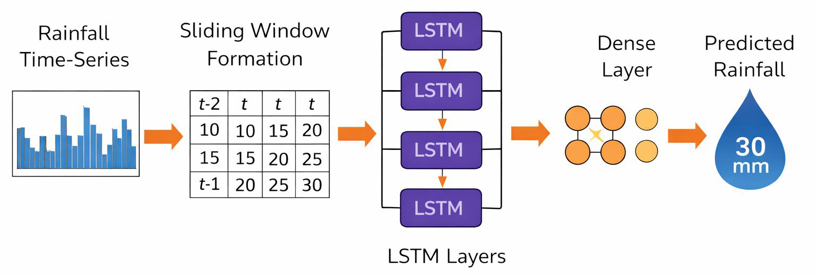
Figure 4.2 Conceptual Workflow of the LSTM-Based Rainfall Prediction Model
The workflow begins with normalized rainfall time-series data, which is segmented into fixed-length sequences. These sequences are processed by stacked LSTM layers that learn temporal dependencies across time steps. The final LSTM output is passed to a dense layer, which generates the rainfall prediction for the future period.
This conceptual representation highlights how historical rainfall patterns influence future rainfall predictions.
25


4.7.6 Internal Structure of an LSTM Cell
The internal structure of an LSTM cell is shown in Figure 4.3.
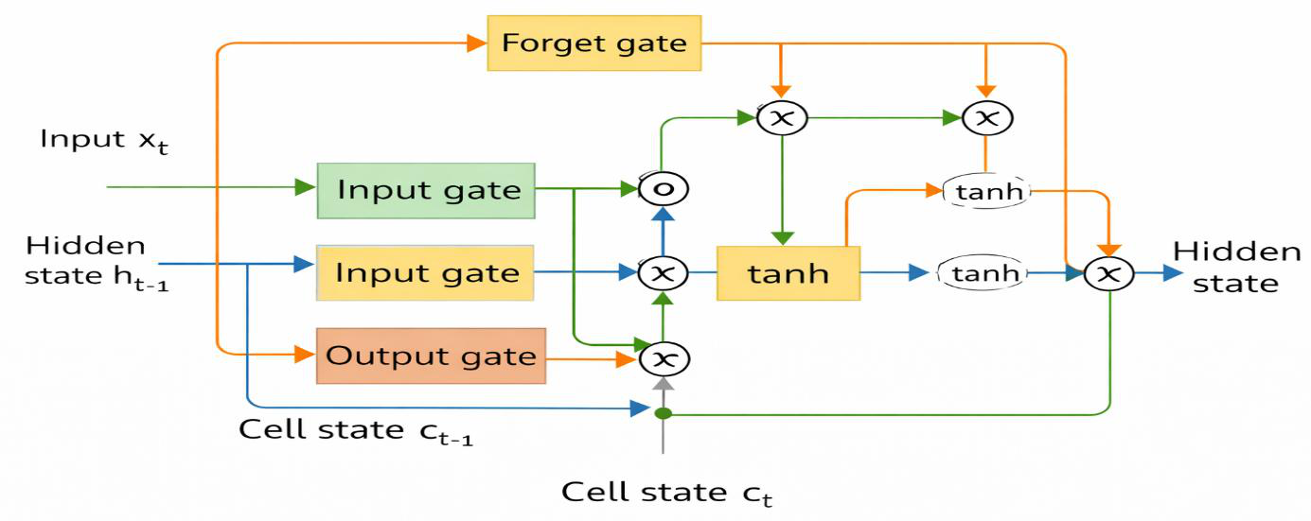
Figure 4.3 Internal Architecture of an LSTM Cell
Gate Operations Explanation
• Forget Gate:Determines which information from the previous cell state should be retained or
discarded.
• Input Gate:Controls how much new rainfall information is added to the memory cell.
• Cell State Update:Combines retained historical information with new candidate values.
• Output Gate:Regulates the information passed to the hidden state and output.
This gating mechanism enables the LSTM to capture cumulative rainfall effects essential for flood
forecasting.
4.7.7 Mathematical Representation of LSTM Operations
A high-level mathematical representation of LSTM operations is provided for conceptual
understanding.
Let:
• 𝑥𝑡 be the rainfall input at time t
• ℎ{𝑡−1} be the previous hidden state
• 𝐶{𝑡−1} be the previous cell state
The LSTM performs the following operations:
• Forget gate:𝑓𝑡= 𝜎(𝑊𝑓[ℎ{𝑡−1}, 𝑥𝑡] + 𝑏𝑓)
• Input gate:𝑖𝑡= 𝜎(𝑊𝑖[ℎ{𝑡−1}, 𝑥𝑡] + 𝑏𝑖)
• Candidate memory:̃ {𝐶}𝑡= \𝑡𝑎𝑛ℎ(𝑊𝑐[ℎ{𝑡−1}, 𝑥𝑡] + 𝑏𝑐)
26


• Cell state update:𝐶𝑡= 𝑓𝑡⋅𝐶{𝑡−1} + 𝑖𝑡⋅̃ {𝐶}𝑡
• Output gate:𝑜𝑡= 𝜎(𝑊𝑜[ℎ{𝑡−1}, 𝑥𝑡] + 𝑏𝑜)
• Hidden state:ℎ𝑡= 𝑜𝑡⋅\𝑡𝑎𝑛ℎ(𝐶𝑡)
This formulation shows how information is selectively retained and propagated across time steps.
4.7.8 Model Training and Optimization Strategy
The LSTM model is trained using historical rainfall data spanning multiple years (e.g., 2000–2025).
The training process follows a supervised learning approach.
• Loss Function: Mean Squared Error (MSE)
• Optimizer: Adam optimizer
• Training Method: Backpropagation Through Time (BPTT)
• Validation Metrics: RMSE and MAE
Early stopping is applied to prevent overfitting and ensure stable generalization performance.
4.7.9 Advantages of LSTM-Based Rainfall Prediction
The LSTM-based rainfall prediction approach offers several advantages:
• Captures both short-term and long-term rainfall patterns
• Handles non-linear and seasonal variations effectively
• Supports proactive flood risk forecasting
• Enhances early warning and preparedness
• Seamlessly integrates with GIS-based spatial analysis
By embedding LSTM within the GeoAI framework, the system achieves a robust combination of
temporal intelligence (AI) and spatial intelligence (GIS), enabling accurate and adaptive flood risk
assessment.
4.8 GIS and Backend Technologies Used
The proposed GeoAI-Based Flood Risk Mapping and Predictive Rainfall Analysis System relies on a
combination of geospatial processing libraries and a high-performance backend framework to ensure
accurate spatial analysis, efficient data handling, and seamless integration between AI computation and
visualization. This section explains the role of each GIS and backend technology used in the system
and how they collectively enable end-to-end flood risk assessment.
4.8.1 GDAL for Raster Preprocessing and Spatial Standardization
The Geospatial Data Abstraction Library (GDAL) is a core open-source library used for reading,
writing, and transforming geospatial raster and vector datasets. In flood risk modeling, raster datasets
such as Digital Elevation Models (DEMs) form the foundation for terrain and hydrological analysis.
27


However, these datasets are often sourced from different platforms and may vary in resolution, coordinate reference systems (CRS), and spatial extent.
In the proposed system, GDAL is used primarily for raster preprocessing and spatial standardization.
Key operations performed using GDAL include:
•Reprojecting DEM datasets into a common CRS
•Clipping raster layers to the Kerala administrative boundary
•Handling nodata values to avoid analytical distortion
•
Converting raster formats for compatibility across processing stages By ensuring that all raster datasets share a uniform spatial reference and extent, GDAL guarantees accurate overlay analysis during flood risk computation. This standardization is critical for correctly combining elevation, drainage, and rainfall-derived raster layers when generating the Flood Risk Index (FRI).
GDAL’s robustness and efficiency make it suitable for handling large geospatial datasets without excessive memory or computational overhead, which is essential for academic and pilot-scale implementations.
4.8.2 Rasterio for Raster-Level Numerical Computation
While GDAL provides low-level geospatial transformations, Rasterio offers a Python-friendly interface that simplifies raster data manipulation and integrates seamlessly with numerical libraries such as NumPy. Rasterio enables raster datasets to be treated as numerical arrays, allowing pixel-level computations required for flood risk analysis.
In this system, Rasterio is used to:
•Read and write GeoTIFF raster files
•Mask invalid or nodata pixels
•Normalize raster values for comparative analysis
•
Perform array-based elevation and risk computations The Flood Risk Index (FRI) computation relies heavily on pixel-wise mathematical operations, where elevation risk, drainage risk, and rainfall risk values are combined using weighted overlays. Rasterio enables these operations efficiently by leveraging NumPy’s optimized numerical processing capabilities.
Thus, Rasterio serves as the computational bridge between geospatial raster data and numerical flood risk modeling.
4.8.3 GeoPandas for Vector-Based Drainage and Boundary Analysis
GeoPandas extends the Pandas data analysis framework to support geospatial vector data, including points, lines, and polygons. Vector datasets play a crucial role in flood risk analysis, particularly for modeling drainage networks, river systems, and administrative boundaries.
28


In the proposed system, GeoPandas is used to:
• Load and manage drainage network shapefiles from OpenStreetMap
• Compute drainage density across different regions
• Perform spatial overlays between drainage networks and administrative boundaries
• Clip vector datasets to the study area
Drainage density is a key hydrological parameter influencing flood susceptibility. Areas with dense
drainage networks and limited infiltration capacity are more prone to waterlogging and flooding.
GeoPandas enables efficient computation of such spatial indicators and ensures accurate spatial
relationships are preserved.
By simplifying complex vector operations into readable Python workflows, GeoPandas enhances
maintainability and transparency of the GeoAI system.
4.8.4 Integration of GIS Tools within the GeoAI Workflow
The combined use of GDAL, Rasterio, and GeoPandas forms a cohesive GIS processing stack, where
each tool addresses a specific aspect of geospatial analysis:
• GDAL handles spatial alignment and raster preprocessing
• Rasterio enables pixel-level numerical computation
• GeoPandas supports vector-based hydrological analysis
This integrated GIS workflow ensures that spatial intelligence is accurately extracted and seamlessly
fused with AI-based rainfall prediction outputs. The result is a reliable spatial–temporal flood risk
modeling framework capable of generating precise and interpretable risk maps.
4.8.5 FastAPI for Backend Services and System Orchestration
The backend of the proposed system is implemented using FastAPI, a modern, asynchronous Python
web framework designed for high-performance API development. FastAPI acts as the central
orchestration layer connecting AI models, GIS processing modules, data storage, and the visualization
interface.
The backend is responsible for:
• Managing rainfall prediction and flood risk computation requests
• Executing AI and GIS processing pipelines
• Serving Flood Risk Index maps and rainfall predictions to the frontend
• Handling alert generation and system responses
FastAPI exposes RESTful endpoints such as:
• /api/rainfall – provides predicted rainfall values
• /api/risk-map – serves Flood Risk Index layers
• /api/alerts – returns flood warning notifications
29


Its asynchronous architecture allows concurrent handling of multiple requests, ensuring responsive dashboard performance even during computationally intensive geospatial operations.
4.8.6 Backend–Frontend Integration
The backend communicates with the frontend visualization layer using structured JSON responses and geospatial formats such as GeoJSON. This separation of concerns ensures that computational logic remains independent of the user interface.
By decoupling AI and GIS computation from visualization, the system achieves:
•Improved scalability
•Easier maintenance
•Support for future extensions such as real-time sensor integration
FastAPI thus enables efficient, secure, and scalable interaction between system components.
4.4.7 Significance of GIS and Backend Technologies in Flood Risk Assessment
The integration of advanced GIS tools with a robust backend framework ensures that the proposed GeoAI system delivers accurate, timely, and interpretable flood risk insights. GIS technologies provide spatial context and hydrological realism, while the backend ensures efficient data flow and real-time accessibility.
Together, these technologies enable the transformation of raw environmental data into actionable flood risk intelligence, supporting informed decision-making and disaster preparedness.
30


CHAPTER 5
SYSTEM DESIGN 5.1 Introduction
The GeoAI-Based Flood Risk Mapping and Predictive Rainfall Analysis system has been conceptualized to bridge the technological gap between artificial intelligence (AI) for rainfall prediction and geospatial information systems (GIS) for terrain-based flood risk evaluation. This chapter outlines the system’s technical framework, workflow, and modular interactions that collectively enable the prediction and visualization of flood-prone regions through the integration of spatial and temporal data intelligence.
The system design phase serves as the technical backbone of the project, transforming theoretical concepts into an operational analytical model. It defines how rainfall and topographical data are collected, preprocessed, analyzed, fused, and visualized for decision support and early warning. The design integrates deep learning models, spatial computation, and interactive web visualization to ensure efficiency, interpretability, and reliability in floodrisk assessment.
At the heart of the system lies a Long Short-Term Memory (LSTM) deep learning network responsible for forecasting short-term rainfall trends using historical data. This is complemented by a GIS-based terrain analysis engine that computes elevation, slope, and drainage density to estimate spatial vulnerability. The two outputs — the predicted rainfall and terrain-based parameters — are fused within the Risk Fusion Engine, which computes the Flood Risk Index (FRI) for each spatial zone.
The architecture follows a modular design with four principal layers:
1.Data Acquisition Layer: for gathering rainfall, DEM, drainage, and boundary data.
2.AI–GIS Processing Layer: for running LSTM-based prediction and spatial computations. 3.Data Storage Layer: for managing results in georeferenced (GeoTIFF/GeoJSON) and relational (PostGIS) formats.
4.User Interface Layer: for interactive visualization and alert generation via the web dashboard.
This layered architecture ensures modularity, scalability, and seamless interoperability between diverse datasets and computation engines. It also enables real-time asynchronous communication between the AI and GIS modules, supporting efficient multi-threaded execution and high-performance analytics.
The system is adaptive by design ,capable of integrating new datasets (updated rainfall or terrain data) without complete model retraining. Built on open-source technologies such as FastAPI, TensorFlow, Rasterio, Geopandas, and React-Leaflet, it offers a cost-effective and extensible framework for research, disaster management, and public policy applications.
31


5.2 Flow Chart
The flowchart in Figure 5.1 illustrates the overall process of converting raw environmental data into predictive and spatially contextualized flood-risk insights. Each stage represents a critical transformation within the GeoAI workflow, combining data science, hydrological modeling, and geospatial intelligence into a single automated system.
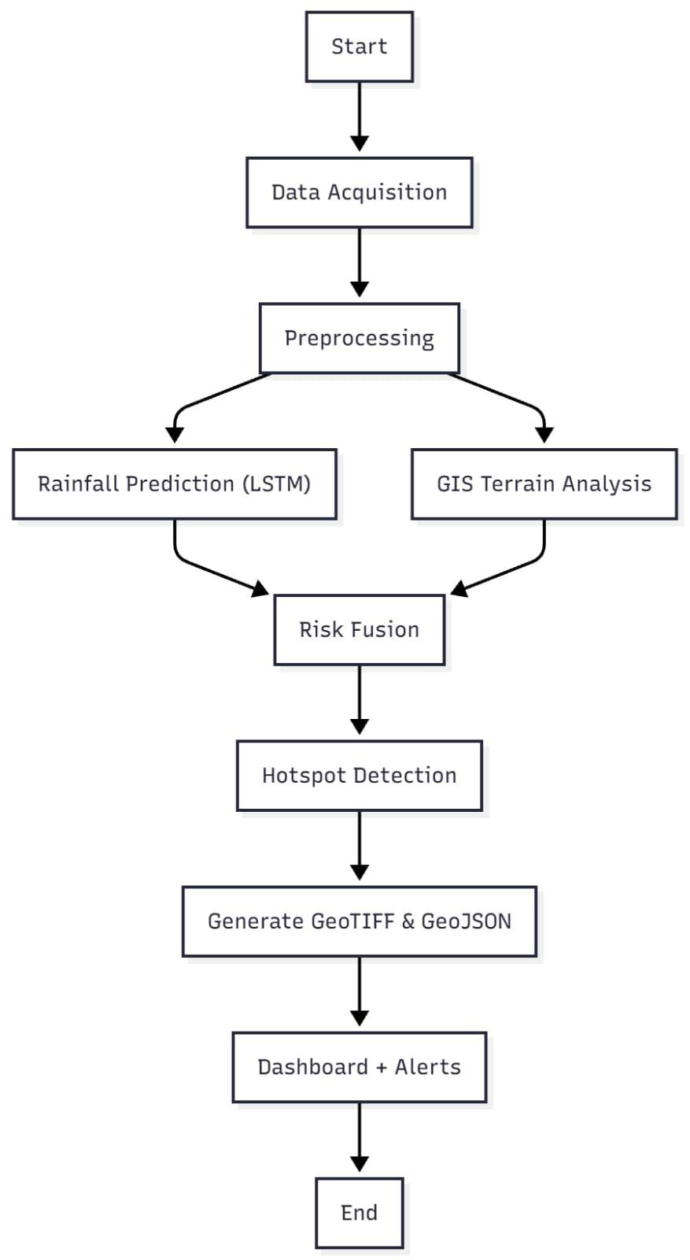
Figure 5.1 -Flowchart
The system begins with data acquisition, where multiple datasets such as rainfall, DEM, and drainage maps are gathered from reliable sources like IMD, OpenStreetMap, or Copernicus. This is followed by preprocessing, where all datasets are cleaned, aligned, and reprojected to a uniform spatial and temporal
32


scale. The rainfall data is normalized and interpolated, while DEMs are clipped and resampled for spatial uniformity.
The LSTM prediction module then processes the temporal rainfall data to forecast rainfall intensity for the next seven days. It outputs both the predicted rainfall values (in mm) and a Rainfall Risk Score (0–1) indicating the probability of heavy rainfall.
Parallelly, the GIS terrain analysis module computes elevation, slope, and drainage density using the DEM and hydrological data layers. These spatial factors determine the land’s runoff potential and accumulation tendencies.
The Risk Fusion module integrates both AI and GIS outputs using a weighted overlay technique to produce the Flood Risk Index (FRI). The FRI quantifies the combined impact of high rainfall and topographic susceptibility on flooding.
Next, the system performs hotspot detection, identifying spatial clusters where FRI values exceed critical thresholds. These high-risk regions are tagged for alert generation and mitigation planning. The results are then exported in GeoTIFF and GeoJSON formats, which can be visualized on GIS platforms or the integrated dashboard.
Finally, the GeoAI Dashboard displays the flood-risk maps interactively, with color-coded regions representing different risk categories. The dashboard also provides rainfall trend graphs and triggers alerts when critical rainfall or FRI values are detected.
This flow ensures that every operation—from data input to actionable insight—is logically sequenced and efficiently executed within the system.
33


5.3 Activity Diagram
The activity diagram in Figure 5.2 illustrates the logical sequence of actions and decision points in the
GeoAI system, representing the real-time behavior and data-driven workflow of the application. It is
divided into three main operational phases.
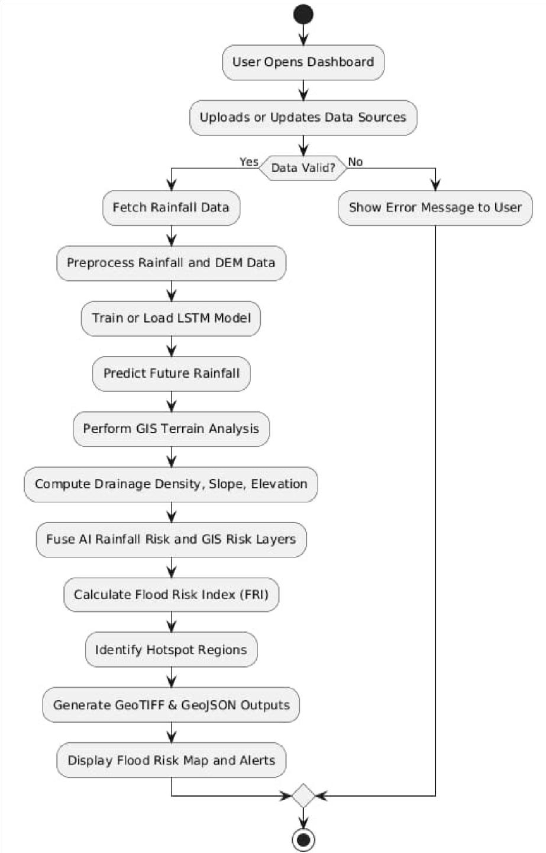
Figure 5.2 – Activity Diagram
34


Phase 1: Data Ingestion and Validation
The process begins when a user accesses the GeoAI dashboard and initiates data ingestion. Users can upload new datasets or select existing ones from repositories. The system then performs validation checks to ensure compatibility, verifying parameters such as coordinate reference system (CRS), completeness of rainfall records, and file integrity. Invalid inputs are flagged for re-upload, ensuring data quality before processing.
Phase 2: AI–GIS Analytical Processing
After validation, the system begins dual-stage analysis:
1.The AI module loads or trains the LSTM model, which forecasts rainfall based on historical sequences. It outputs both daily rainfall predictions and a risk score, providing a temporal perspective of potential flooding.
2.Simultaneously, the GIS engine processes DEM and drainage layers using tools like Rasterio and Geopandas to compute slope, elevation, and drainage density. These spatial variables quantify the land’s flood susceptibility.
The two results — rainfall risk and terrain vulnerability — are then combined within the Risk Fusion Module, which computes the Flood Risk Index (FRI) for each grid cell. The FRI is a normalized value that indicates low, medium, or high flood susceptibility.
Phase 3: Visualization and Alert Generation
The system identifies high-risk regions through spatial clustering and exports the output maps in GeoTIFF (raster) and GeoJSON (vector) formats. These are rendered on the GeoAI dashboard, where users can visualize predicted rainfall patterns, hotspot zones, and flood alerts interactively.
The dashboard dynamically updates whenever new data or model predictions are received, ensuring real-time situational awareness for disaster management and planning
This activity flow effectively captures how GeoAI transitions from user interaction to predictive insight, ensuring data validation, intelligent computation, and informative visualization within a unified process.
35


5.4 Sequence Diagram
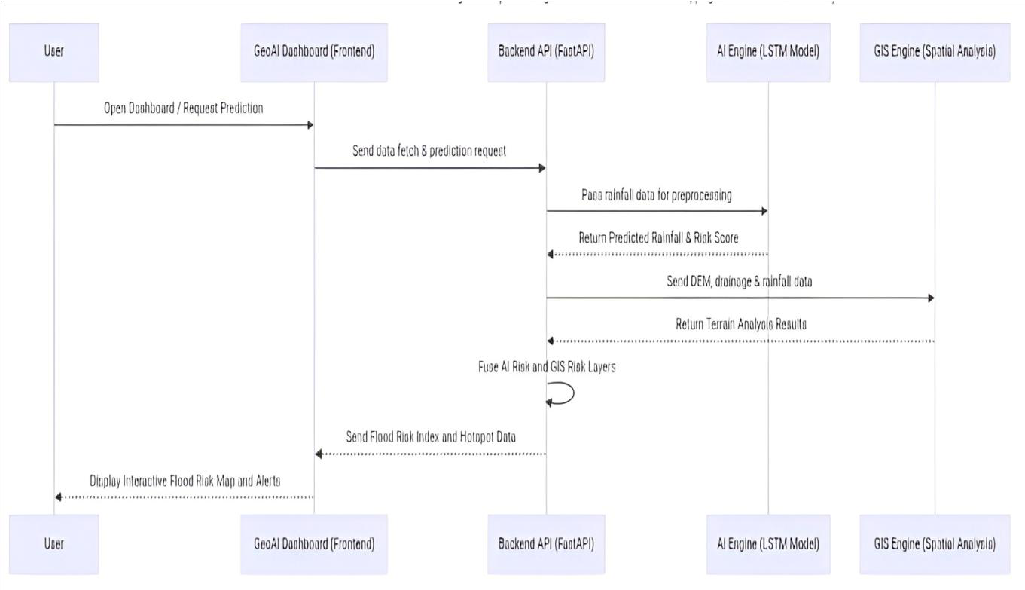
Figure 5.3 – Sequence Diagram
The sequence diagram in Figure 5.3 represents the chronological flow of communication among the system components — the User Interface (Dashboard), Backend (FastAPI), AI Engine (LSTM), and GIS Engine — illustrating how requests are processed and results are delivered.
The interaction begins when the user initiates a flood-risk prediction request through the GeoAI Dashboard. The frontend sends this request to the FastAPI backend, specifying parameters such as geographic extent, rainfall data source, and analysis mode. The FastAPI server, acting as the central orchestrator, processes the request asynchronously to maintain high performance.
The request is first routed to the AI Engine, where the LSTM model analyzes historical rainfall data and forecasts rainfall for the upcoming week. The AI module outputs both numerical rainfall predictions and a rainfall risk probability. These results are temporarily stored and forwarded to the GIS Engine, which performs topographical computations using DEM and drainage datasets
The GIS Engine calculates slope, elevation, and drainage density, which are returned to the FastAPI server. The backend then invokes the Risk Fusion Module, which integrates the AI and GIS outputs into a unified Flood Risk Index (FRI) dataset. The backend then transmits these results to the frontend, formatted as GeoJSON and GeoTIFF files.
Finally, the GeoAI Dashboard visualizes these outputs through interactive maps and graphs, displaying high-risk flood zones, rainfall intensity trends, and early warning alerts.
This sequence ensures efficient modular interaction, enabling simultaneous AI and GIS processing and maintaining rapid response times for end users.
36


CHAPTER 6
CONCLUSION
The proposed project, GeoAI-Based Flood Risk Mapping and Predictive Rainfall Analysis, represents a significant step forward in integrating artificial intelligence and geospatial technologies for real-world environmental resilience. The system successfully combines Long Short-Term Memory (LSTM)-based rainfall forecasting with GIS-based terrain and hydrological analysis, enabling a comprehensive approach to identifying flood-prone regions. By fusing temporal rainfall predictions with spatial risk factors such as elevation, slope, and drainage density, the system provides a data-driven and scalable framework for flood risk management.
A key achievement of this project lies in its fusion of predictive AI models with geospatial intelligence, which allows for both temporal and spatial forecasting of flooding events. Unlike conventional flood monitoring systems that rely solely on static hydrological data, the proposed system continuously adapts to new rainfall and terrain data, making it dynamic and responsive to changing climatic conditions. The integration of FastAPI, TensorFlow, Rasterio, and Geopandas ensures high computational efficiency and seamless automation from data ingestion to risk visualization.
The system’s user-centered design philosophy also enhances its practical value. Through the interactive GeoAI Dashboard, users can visualize predicted rainfall, flood risk maps, and highrisk hotspots in real time. This allows government authorities, disaster management officials, and environmental planners to make informed decisions quickly. The dashboard’s layered visualization and alert mechanisms translate complex analytical outputs into actionable insights, supporting proactive planning and disaster mitigation.
Another notable contribution of this work is its open-source foundation. By leveraging publicly available datasets such as IMD rainfall records, SRTM/DEM data, and OpenStreetMap drainage layers, the project promotes transparency, accessibility, and replicability. This makes the framework adaptable to different geographic regions beyond Kerala and suitable for both academic research and real-world applications in climate risk assessment.
In essence, the GeoAI system demonstrates how the convergence of AI and GIS can revolutionize environmental monitoring and disaster preparedness. It not only improves the accuracy of rainfall forecasting but also contextualizes this data spatially to predict localized flooding risks. The project successfully achieves its objectives of creating a scalable, interpretable, and intelligent flood risk analysis system, setting a foundation for future advancements in smart urban planning and climate resilience.
37


CHAPTER 7
FUTURE SCOPE
While the current system provides a robust framework for flood-risk prediction and visualization, there exist numerous opportunities to expand its capabilities into a more intelligent, autonomous, and large-scale environmental decision-support platform.
One of the primary future enhancements is the integration of real-time data acquisition through satellite-based APIs and IoT sensor networks. The use of weather stations, rainfall gauges, and river flow sensors can facilitate continuous monitoring and live model updates, allowing the system to transition from predictive analysis to real-time flood forecasting. Coupling such live data with LSTM-based models can improve accuracy and ensure timely alert generation during extreme weather events.
Another promising avenue for development lies in model expansion using hybrid deep learning architectures. The combination of Convolutional Neural Networks (CNNs) with LSTM can help capture both spatial and temporal dependencies simultaneously, enhancing the system’s ability to analyze rainfall distribution patterns and topographic features. Moreover, the inclusion of transformer-based AI models could further improve long-range rainfall predictions under changing climatic scenarios.
The GIS component can also be upgraded to include land use/land cover (LULC) analysis and soil permeability mapping, allowing for a more holistic assessment of flood dynamics. By integrating hydrological simulation tools such as HEC-RAS or SWMM, the system can evolve from risk mapping to actual water flow modeling, enabling simulation-based flood management and infrastructure planning.
Another important direction for future research is the incorporation of Explainable AI (XAI) techniques. This would make the model’s decision-making process more transparent, allowing stakeholders to understand which factors contribute most to flood risk in a given area. Such interpretability is essential for building trust among policy-makers and environmental agencies.
The project can also be extended to support automated alert dissemination systems, where early warning notifications are transmitted through SMS, email, or public dashboards in collaboration with disaster management authorities. Additionally, the integration of cloud computing and edge AI frameworks can make the system more scalable and deployable in remote regions, enabling real-time operations even with limited infrastructure.
From an academic and research perspective, the development of a centralized flood-risk data repository can enable long-term tracking of rainfall and flood events. This would provide valuable datasets for future studies in climate change impact assessment, urban flood mitigation, and resilient infrastructure design.
38


REFERENCES
[1]Kumar, V., & Sahu, N. (2023). "AI for Disaster Management: A Review of Techniques andApplications." Artificial Intelligence Review.
[2]Cai, H., et al. (2022). "A Comprehensive Review of Machine Learning for Disaster Response."
[3]Kaggle (2021). "Natural Disaster Predictions Using Machine Learning."
[4]Sharma, A., & Yadav, A. (2020). "The Role of Artificial Intelligence in Disaster Management." International Research Journal.
[5]M. Aboualola, K. Abualsaud, T. Khattab, N. Zorba and H. S. Hassanein, "Edge Technologies for Disaster Management: A Survey of Social Media and Artificial Intelligence
Integration," in | IEEE Access, | vol. | 11, | pp. | 73782-73802, 2023, doi:
10.1109/ACCESS.2023.3293035
[6]S. K. Abid, S. W. Chan, N. Sulaiman, U. Bhatti and U. Nazir, "Present and Future ofArtificial Intelligence in Disaster Management," 2023 International Conference on Engineering Management of Communication and Technology (EMCTECH), Vienna, Austria, 2023, pp.
[7]G. Waghmare, S. Kumar, R. Udhayakumar, B. Raja Mannar, R. Singh and N. Rawat,"Utilizing Social Media Platforms for Artificial Intelligence-Based Detection and Developing Effective Communications in Disaster-Affected Areas," 2023 3rd International Conference on Advance Computing and Innovative Technologies in Engineering (ICACITE), Greater Noida, India, 2023, pp.
[8]Nagarjuna Reddy Aturi, "Cultural Stigmas Surrounding Mental Illness Impacting of Migration and Displacement", International Journal of Science and Research (IJSR), Volume 7 Issue 5, May 2018, pp. 1878-1882, doi:10.21275/SR24914153550
[9]J. Wagner and M. Roopaei, "Edge Based Decision Making In Disaster Response Systems,"2020 10th Annual Computing and Communication Workshop and Conference (CCWC), Las Vegas, NV, USA, 2020, pp. 0469-0473, doi: 10.1109/CCWC47524.2020.9031219.
[10] Jolly, S., Raj, G.S.M. (2020). Artificial Intelligence and the Legal Response Paradigms inDisaster Management. In: Kumar, T.V.V., Sud, K. (eds) AI and Robotics in Disaster Studies. Disaster Research and Management Series on the Global South. Palgrave Macmillan, Singapore.
doi:10.1007/978-981-15-4291-6_10
[11]. Ghadge, A. (2023), "ICT-enabled approach for humanitarian disaster management: a systems perspective", The International Journal of Logistics Management, Vol. 34 No. 6, pp. 1543-1565. doi:10.1108/IJLM-11-2021-0532 34 Providence College of Engineering Changanur [12]. Yu, M.;
39


Yang, C.; Li, Y. Big Data in Natural Disaster Management: A Review. Geosciences 2018, 8, 165. doi:10.3390/geosciences8050165
[13]. Elvas, L.B.; Mataloto, B.M.; Martins, A.L.; Ferreira, J.C. Disaster Management in Smart Cities. Smart Cities 2021, 4, 819-839.doi:10.3390/smartcities4020042 [15]. Acikara, T.; Xia, B.; Yigitcanlar, T.; Hon, C. Contribution of Social Media Analytics to Disaster Response Effectiveness: A Systematic Review of the Literature. Sustainability 2023, 15, 8860.
https://doi.org/10.3390/su15118860
40


41

