**Database**

**Manual**

**For**

**Mountain**

**View**

**Community Hospital**

Developed By:

Jacob McCrae

Manuel Chu

Harwin Jhand

Table of Contents:

Administrator and User Information.............................................................1

Database Information..............................................................................1-3

Developer Notes.........................................................................................4

**1) Introduction**

This database is being designed for a small hospital, Mountain View Community Hospital, which will be designed to provide high-quality, cost-effective health care services for the surrounding community and will help them achieve their day to day goals in a compassionate, caring and personalized manner.

Administrator and User Information

The current database build is designed for a high-level administrator of the database such that they can access all the features of the database as well as assuming they have some knowledge of a database to start the run file as well as understand some SQL data-types such that they can input and edit data correctly to minimize errors.

**2) Database Information**

The database system is design for the Mountain View Community Hospital based on the information specified by the hospital. This hospital has already purchased Oracle DBMS to implement their five major business functions according to the specified information:

1. Patient Care Administration: Patient Information and Registration, Patient Status, Patient Scheduling, Patient Orders

2. Clinical services: Diagnostic Units, Patient Laboratory Results & Vitals

3. Patient Care Services: Patient Care Information

4. Financial Management: Patient Billing, Accounts for Receivables, and Payroll

5. Administrative Services: Purchasing, Inventory Control, Housekeeping and Personnel, Staff Scheduling

i) Universal Commands and Buttons

When users first access the database, they will be prompted with this front page. The database is separated in five major sections, which are indicated by the buttons found on the front page. These buttons would be: **Patient Administration**, **Clinical Services**, **Patient Services, Financial Management**, and **Administrative Services**. Each button allows for the user to access information pertaining to each section. Within each section there are a number of services and other options that, based on the user, will need in the usage of the database. The services for each section can be found in the **Database Information** section.

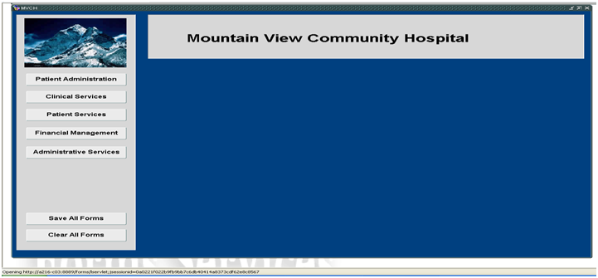

There are also two additional command buttons on the front page. This would be the **Save All Forms** and **Clear All Forms**.

**Save All Forms** -Saves any information inputted into the forms.

**Clear All Forms** -Clears all fields in all the forms and pages.

Both buttons prompt if the user would like to save any data that is inputted into any of the forms before completing the action as a precautionary measure.

In every form there is a **Lookup** button. This button provides the user with a list with the individual records pertaining to the current form. The user can narrow the search by filling the **Find** field.

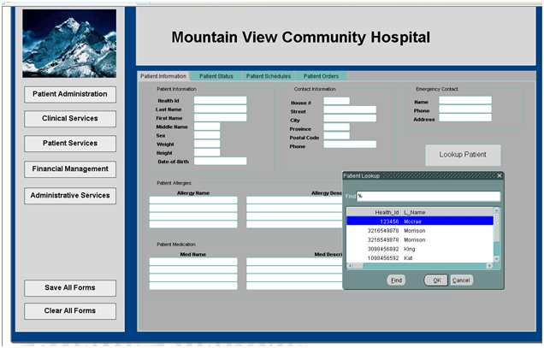

For some of the services within the database, there are specific display buttons. For example this view below has a **Payroll All Staff** button that displays all staff member’s payrolls, as well as a basic **Lookup** button. 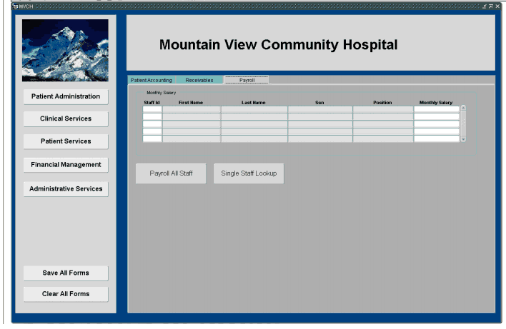  
**3) Developer Notes**

1) The database’s current build is designed for a high-level administrator.

1a) This high-level administrator must know and understand SQL and the Oracle database system such that they may maintain the database correctly.

1b) The high-level administrator must know how to run SQL files possibly through some sort of software like MySQL to run the Install.sql or the individual SQL files announced in the readme.txt file correctly to build the database.

1c) The current data in the database is information that we have inputted as test data; the end-user must give the correct information and data to the high-level administrator such that the database may be filled correctly.

1d) The high-level administrator is prompted to create and manage different users of the database such that they may only observe different views that are particular to their user-type. All the pages and forms have already been correctly created, according to the needs of the end user.

2) There is an issue when launching the database through form builder where the database may freeze or crash due to the use of the third-party program to view the database (Internet Explorer).

3) Some forms require information to be inputted before continuing to another page. Due to this requirement, if a user is to click on an empty form that requires input or has a “not null” condition, the user must promptly input data and save it to the database before continuing on.

4) It is important for the users to remember that the lookup buttons only act as references to the data and there cannot be any updating or changes when looking up information through the lookup button. To insert data, you must have the information already inputted into each form. To perform this action the user may either need to input the data manually into each form or use the execute query button provided by the oracle database toolbar to fill the form. You can then promptly scroll through each relation and make changes or update information.

5) To insert new information with no previous relation, you may just input information into the forms and attempt to save, if there is an error in the information inputted, the database will promptly let the user know.