**Dung Eon : A Dungeon Crawler**

**User Manual**

**COP 4331, Spring, 2016**

Team Name: Bobby Sandwich

Team Members:

* Jacob Crandall
* Robert Bland
* Jacob Jiskoot

Modification history:

|  |  |  |  |
| --- | --- | --- | --- |
| Version | Date | Who | Comment |
| v1.0 | 4/16/2016 | Jacob Crandall | Initial notes added |
| ... |  |  |  |

**Contents of this Document**

System Description

System States

System Functions

Appendix – Acronyms and Abbreviations

**System Description**

We have created a simple game that takes after classic “dungeon-crawler” style games. We did not create an extremely creative, unique or deep gameplay system. The reason for this is that we hope to cater more to ourselves and other developers. We hope to create a skeleton of a game that is easy to add meat to and expand upon. For this reason we’ve added simple enemies, movement, items and interactions. There are either ways to simply implement what a developer may want OR an example of how to implement it in the code that can be replicated. Our current codebase is small and manageable, something that can be appealing when looking to add to and learn from our application.

We hope that we can continue to expand on our project and that other developers will be able to do the same. In this way we can create a community where both the developers and the users can add on to and be a part of this design process. We believe that both the end-user and the developers will be happy if they use our product because it is free, accessible and is open to suggestion and customization. Both users and developers will hopefully find joy in not just playing the products of future collaboration, but also in working together to create a better product.

**System States**

Our system has two major states, the initial menu and the actual gameplay. These states hall behave the same way no matter the circumstances, flipped, upside-down, internet, no-internet, etc. The situation does not change this application.  
  
**Main Menu**  
The main menu has two options, touch the play button to begin a game, or touch the quit button to quit the application altogether. The play button transitions to a gameplay state.

**Gameplay**  
The gameplay state will display a grid of tiles and enemies with which the user can interact.

**System Functions**

**Moving**Each tile will either be walkable or not walkable. Hopefully a user can easily distinguish which tiles are and are not walkable (ie. You cannot walk on water but you can walk on a ground tile). If a tile is walkable it will either contain a character or not contain a character. If a tile is touched and is not walkable, no action will be taken. If a tile is touched and IS walkable and does not contain another character then a “turn” will pass for each tile move that happens. A user will keep on moving until it reaches that touched tile. On each turn all enemies will also move a tile. Many of our actions are a result of, or sub-set of movement.

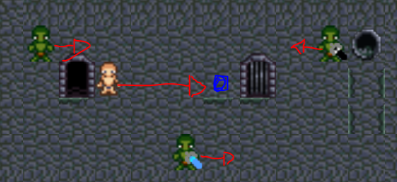Clicking the blue tile will move the user their. It will move the user right 1 tile (one turn), move each enemy on tile, and then repeat the process until the user reaches the blue tile.

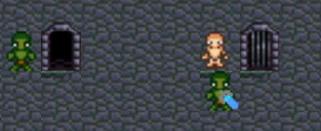  
This is the result of the previous move.

**Attacking**  
If a user is next to (within one tile) of an enemy and taps that enemy a turn will be consumed and that enemy will be attacked and the user itself will be attacked by the enemy. Should a user reach 0 health then the user shall die. On death a user will load a new level with the default items and restart the game as if they hit the button initially. Shall an enemy reach zero health the enemy shall disappear and may drop a weapon.  
  
**Heal**  
On each move or turn consumed the user shall heal a set amount automatically. To heal you simply have to move.

**Weapon pickup**To pick up a weapon you must simply destroy an enemy and weapon pickup will be handled by the system. You will gain the weapon if it is better.

**Exiting the Level**To exit the level the user must defeat all enemies on a level. After this the user may move (by tapping) the exit. The exit is displayed as a gate with bars over it. Exiting a level will load a new level randomly with new characters. The user shall retain their health and weapon.

**Appendix – Acronyms and Abbreviations**

Not applicable.   
Please contact the development team if anything is unclear and we shall expand on our notes and explanations.