DOCTORAL THESIS
A Contribution to the Interoperability of E‑Government Heterogeneous Systems Based on Microservices and Event Driven Architecture
A Case Study
Presented by
NGWABA BIMBALA Joseph
Thesis submitted in fulfilment of the requirements for the Doctoral Degree
2026

DEDICATION
To all those who work towards accessible, equitable public services that serve citizens.
To those who make knowledge a means of collective progress and responsible public-administration modernisation.

ACKNOWLEDGEMENTS
The author thanks the survey participants, public-institution staff and professionals who shared their knowledge of administrative practices, information systems and interoperability challenges in the Democratic Republic of the Congo.
He also thanks the academic experts and government information-technology officials whose assessments contributed to the examination of the proposed framework's relevance, feasibility and implementation conditions.
Finally, he acknowledges the scientific community whose research, cited in this thesis, informed the study of e-government, distributed systems, data governance and Design Science Research.

ABSTRACT
Fragmented public information systems limit integrated service delivery in the Democratic Republic of the Congo (DRC). This research aims to design and evaluate an interoperability framework suited to a decentralized administration characterized by technological heterogeneity and uneven infrastructure capacity.
The study combines Design Science Research, an embedded case study, a questionnaire administered to 34 purposively selected respondents, observation of 24 municipal offices in Kinshasa, interviews, documentary analysis, and expert assessment. The diagnosis shows that 32 respondents report an information system, whereas 6 report intra-institutional integration and 3 report inter-institutional integration. These results describe the study sample and are not statistically representative estimates of the national administration.
The proposed artifact integrates the legal, organizational, semantic, and technical dimensions of interoperability within a municipal, provincial, and national federation. It combines event-driven microservices, governed APIs, registries, trust mechanisms, traceability, and observability while preserving institutional responsibilities and authoritative data within their bounded contexts.
A prototype comprising three domain microservices and one composition service was evaluated in two independent European VPS environments representing Gombe and Lemba. All 218 functional assertions passed. The maximum reported server-side P99 was 34 ms, and the measured maximum throughput reached 132 requests per second under the tested conditions. Delays observed from Kinshasa nevertheless highlight the importance of wide-area delivery conditions.
The research establishes contextual technical feasibility rather than nationwide production certification. It recommends phased implementation supported by enforceable governance, semantic standards, lawful exchange, sustainable infrastructure, and capacity development. Large-scale performance, security, failure recovery, and event convergence require further validation.
Keywords: E-government; interoperability; microservices; event-driven architecture; data governance; Democratic Republic of the Congo.

RÉSUMÉ
La fragmentation des systèmes d'information publics limite la prestation intégrée des services en République démocratique du Congo (RDC). Cette recherche vise à concevoir et à évaluer un cadre d'interopérabilité adapté à une administration décentralisée, caractérisée par l'hétérogénéité technologique et des capacités infrastructurelles inégales.
La démarche mobilise la recherche en science de la conception, une étude de cas enchâssée, un questionnaire administré à 34 répondants sélectionnés de manière raisonnée, l'observation de 24 bureaux municipaux de Kinshasa, des entretiens, une analyse documentaire et une évaluation par les experts. Le diagnostic révèle que 32 répondants déclarent disposer d'un système d'information, contre 6 signalant une intégration intrainstitutionnelle et 3 une intégration interinstitutionnelle. Ces résultats décrivent l'échantillon étudié et ne constituent pas des estimations statistiquement représentatives de l'administration nationale.
L'artefact proposé articule les dimensions juridique, organisationnelle, sémantique et technique de l'interopérabilité au sein d'une architecture fédérée municipale, provinciale et nationale. Il associe microservices orientés événements, API gouvernées, registres, mécanismes de confiance, traçabilité et observabilité, tout en préservant les responsabilités institutionnelles et les données de référence dans leurs contextes délimités.
Un prototype comprenant trois microservices métier et un service de composition a été évalué dans deux environnements VPS européens indépendants représentant Gombe et Lemba. Les 218 assertions fonctionnelles ont été validées. Le P99 maximal rapporté côté serveur était de 34 ms et le débit maximal mesuré atteignait 132 requêtes par seconde dans les conditions testées. Les délais observés depuis Kinshasa soulignent toutefois le poids des conditions d'acheminement sur réseau étendu.
La recherche établit une faisabilité technique contextuelle, et non une certification de production nationale. Elle recommande une mise en œuvre progressive fondée sur une gouvernance contraignante, des normes sémantiques, des échanges licites, des infrastructures durables et le développement des capacités. Les performances à grande échelle, la sécurité, la reprise après défaillance et la convergence événementielle doivent faire l'objet de validations complémentaires.
Mots-clés : Administration électronique ; interopérabilité ; microservices ; architecture orientée événements ; gouvernance des données ; République démocratique du Congo.
TABLE OF CONTENTS
DEDICATION i
ACKNOWLEDGEMENTS ii
ABSTRACT iii
RÉSUMÉ iv
LIST OF ABBREVIATIONS AND ACRONYMS ix
LIST OF FIGURES xii
LIST OF TABLES xiv
GENERAL INTRODUCTION 1
0.1 Background and Context of the Study 1
0.2 Problem Statement and Research Gap 3
0.2.1 Empirical Problem in the Democratic Republic of the Congo 3
0.2.2 Scientific and Design Gap 4
0.3 Rationale, Significance, and Originality 5
0.3.1 Scientific Significance 6
0.3.2 Practical and Policy Significance 6
0.4 Research Aim and Objectives 7
0.4.1 General Objective 7
0.4.2 Specific Objectives 7
0.5 Research Questions 8
0.6 Research Hypotheses 8
0.7 Central Thesis, Conceptual Model, and Expected Contributions 9
0.7.1 Central Thesis 9
0.7.2 Conceptual and Causal Logic 10
0.7.3 Expected Contributions 11
0.8 Research Scope and Methodology 11
0.8.1 Research Design and Strategy 11
0.8.2 Unit of Analysis, Population, and Sampling 12
0.8.3 Data Collection 13
0.8.4 Data Processing and Analysis 13
0.8.5 Artifact Design, Demonstration, and Evaluation 15
0.8.6 Research Quality, Ethics, and Delimitations 15
0.9 Referencing System 16
0.10 Subdivision of the Work 16
CHAPTER 1 CONCEPTUAL AND THEORETICAL FRAMEWORK 17
1.1 Conceptual Framework 18
1.1.1 Public Service 18
1.1.2 E-Government 18
1.1.3 Evolution of Distributed Technologies in E-Government 23
1.1.4 Interoperability 31
1.1.5 Service Level Engineering for E-Government 37
1.1.6 Microservice Transactions and SAGA Models in E-Government 43
1.1.7 Mathematical Formalism of Microservice Granularity in E-Government Systems 51
1.2 Theoretical Framework 60
1.2.1 Domain Driven Design Principles 60
1.2.2 Command Query Responsibility Segregation 61
1.2.3 Event Sourcing 63
1.2.4 Event Driven Service Production and Consumption 64
1.2.5 Information Flow in a Multilevel Environment 66
CHAPTER II. RESEARCH METHODOLOGY 68
2.1 Introduction 68
2.2 Research Paradigm and Overall Design 69
2.2.1 Design Science Research Rationale 69
2.2.2 Embedded Case Study and Multiple Evidence Strategy 69
2.2.3 Artifact Types and Research Outputs 70
2.3 Design Science Research Process 71
2.3.1 Problem Identification and Motivation 72
2.3.2 Definition of Objectives for a Solution 73
2.3.3 Design and Development 73
2.3.4 Demonstration 74
2.3.5 Evaluation 74
2.3.6 Communication 75
2.4 Research Context Unit of Analysis and Case Boundaries 77
2.4.1 Study Context 77
2.4.2 Unit of Analysis 77
2.4.3 Case Boundaries and Evidence Sources 78
2.5 Population Sampling and Respondent Profile 79
2.5.1 Population of Interest 79
2.5.2 Purposive Sampling Technique 79
2.5.3 Inclusion and Exclusion Criteria 79
2.5.4 Institutional Composition of the Sample 80
2.6 Data Collection Methods and Instruments 81
2.6.1 Institutional Diagnostic Questionnaire 81
2.6.2 Semi Structured Interviews 82
2.6.3 Direct Observation and Field Notes 82
2.6.4 Documentary Review 83
2.6.5 Fieldwork Period and Administration 83
2.7 Data Preparation and Analysis 83
2.7.1 Coding Cleaning and Data Management 83
2.7.2 Quantitative Analysis 84
2.7.3 Qualitative Thematic Analysis 84
2.7.4 Triangulation and Evidence Convergence 85
2.7.5 Analytical Tools 85
2.8 Artifact Design Implementation and Experimental Evaluation 86
2.8.1 Artifact Specification and Architecture 86
2.8.2 Prototype Implementation and Deployment 86
2.8.3 Experimental Environment 86
2.8.4 Functional and Interoperability Tests 87
2.8.5 Performance Evaluation Procedure 87
2.8.6 Resilience and Failure Recovery Tests 88
2.9 Expert Evaluation 89
2.9.1 Expert Selection and Profiles 89
2.9.2 Evaluation Criteria and Instrument 89
2.9.3 Feedback Analysis and Artifact Revision 90
2.10 Research Quality Trustworthiness and Reproducibility 90
2.10.1 Quality of Survey and Qualitative Evidence 90
2.10.2 Validity of Artifact Evaluation 91
2.10.3 Reproducibility and Audit Trail 91
2.11 Ethical and Legal Considerations 91
2.12 Research Alignment Matrix 93
2.13 Methodological Limitations 94
*CHAPTER 3 FINDINGS AND RESULTS 95
3.1 Introduction 95
3.2 Findings from the Current State of E-Government Interoperability 95
3.2.1 Existing Information Systems 96
3.2.2 Intra-Institutional Integration 97
3.2.3 Inter-Institutional Integration 97
3.2.4 Existing Data-Exchange Mechanisms 97
3.2.5 API Adoption 97
3.2.6 Cloud and Data-Centre Infrastructure 98
3.2.7 Interoperability Standards and Registries 98
3.3 Findings from the Design Science Artifact 100
3.3.1 Proposed Interoperability Framework 100
3.3.2 Decentralized Administrative Paradigm 103
3.3.3 National Identification Number 108
3.3.4 Integrated Architecture Design 113
3.3.5 Routing Decision Engine 123
3.3.6 API Implementation 124
3.3.7 Request Coordination 127
3.3.8 Message Broker Implementation 127
3.3.9 Network and Hosting Paradigm 139
3.4 Functional and Non-Functional Results 141
3.4.1 Functional Specifications 141
3.4.2 Security and Non-Functional Specifications 143
3.4.3 Performance Strategies 150
3.4.4 Reliability and Recovery 154
3.4.5 Eventual Consistency and Conflict Resolution 162
3.4.6 Scalability 165
3.5 Prototype and Deployment Results 167
3.5.1 Containerization 168
3.5.2 Kubernetes Orchestration 170
3.5.3 Implementation Roadmap and Feasibility 173
3.5.4 E-Government System Prototype Design 180
3.5.5 Microservice Granularity, Cohesion, Coupling, and Architectural Properties 181
3.6 Performance Benchmarking Results 190
3.6.1 Benchmark Scope and Evidence Classification 191
3.6.2 Server-Side Latency and Polyglot Execution Efficiency 193
3.6.3 Scalability, Sustained Throughput, and Fan-Out 195
3.6.4 Provider Comparison and Network Effects 197
3.6.5 Inter-Host Reliability and Network Quality 198
3.6.6 Resource Efficiency, Availability, and Distributed Workflows 199
3.7 Summary of Major Findings 202
CHAPTER 4 EVALUATION DISCUSSION AND RECOMMENDATIONS 203
4.1 Introduction 203
4.2 Evaluation Methodology 203
4.2.1 Expert Review Panel 204
4.2.2 Government IT Officer Panel 204
4.2.3 Evaluation Participation and Evidence Boundary 205
4.3 Evaluation Criteria 206
4.4 Evaluation Findings 207
4.4.1 Assessment of Relevance 207
4.4.2 Assessment of Completeness 207
4.4.3 Assessment of Feasibility 208
4.4.4 Government IT Officer Assessment 208
4.5 Discussion of Findings 209
4.5.1 Interpretive Orientation 209
4.5.2 Current State of E-Government Interoperability 210
4.5.3 Design Science Artifact 212
4.5.4 Prototype and Performance Findings 215
4.5.5 Resilience and Failure Recovery 218
4.5.6 Research Questions and Hypotheses 219
4.5.7 Contributions of the Research 219
4.5.8 Practical and Policy Implications 220
4.5.9 Limitations and Threats to Validity 221
4.6 Recommendations 221
4.6.1 Enabling Conditions for Sustainable Digital Government 222
4.6.2 DRC-Specific Recommendations 224
4.7 Chapter Summary 227
GENERAL CONCLUSION 228
REFERENCES 231
APPENDICES 240
APPENDIX A DATA COLLECTION INSTRUMENTS AND ETHICAL PROVISIONS 241
A.1 Participant Information Sheet 241
A.2 Informed Consent Form 241
A.3 Institutional Diagnostic Questionnaire 241
A.4 Semi Structured Interview Guide 243
A.5 Direct Observation Checklist 244
A.6 Data Coding and Processing Rules 245
APPENDIX B RESPONDENT SAMPLING AND DATA PROCESSING DOCUMENTATION 246
B.1 Evidence Sources and Analytical Roles 246
B.2 Study Population Unit of Analysis and Case Boundary 246
B.3 Sampling Strategy and Participant Selection 247
B.4 Respondent Composition and Institutional Sources 249
B.5 Data Collection Instruments 250
B.6 Fieldwork Period Administration and Ethical Safeguards 251
B.7 Data Preparation Coding and Cleaning 252
APPENDIX C ARTIFACT EVALUATION AND RESEARCH TRACEABILITY 255
C.1 Expert Evaluation Instrument 255
C.2 Government IT Officer Evaluation Instrument 256
C.3 Design Science Research Traceability Matrix 257
APPENDIX D INTERFACE CAPTURE PROTOCOL AND PLACEHOLDER INDEX 258
D.1 Capture Protocol and Index 258

LIST OF ABBREVIATIONS AND ACRONYMS
Abbreviation or acronym | Meaning
ABAC | Attribute-based access control
ACID | Atomicity, consistency, isolation, and durability
AE | Academic expert; evaluator-code prefix
ANCY | Agence Nationale de Cybersécurité
APD | Autorité de Protection des Données
API | Application programming interface
ARPTC | Autorité de Régulation de la Poste et des Télécommunications du Congo; acronym variant used in the manuscript
ARPTIC | Autorité de Régulation de la Poste et des Télécommunications du Congo
AU | African Union
BFF | Backend for Frontend
BPMN | Business Process Model and Notation
CA | Certificate authority
CAP | Consistency, availability, and partition tolerance
CDC | Change data capture
CDN | Content delivery network
CI/CD | Continuous integration and continuous delivery/deployment
CMRAP | Public-administration reform body identified by this acronym in the study
CNN | Conseil National du Numérique
CPU | Central processing unit
CQRS | Command Query Responsibility Segregation
CRDT | Conflict-free replicated data type
DDD | Domain-Driven Design
DDoS | Distributed denial-of-service
DNS | Domain Name System
DRC | Democratic Republic of the Congo
DSR | Design science research
EDA | Event-driven architecture
EGDI | E-Government Development Index
EIF | European Interoperability Framework
EU | European Union
G2B | Government-to-business
G2C | Government-to-citizen
G2G | Government-to-government
GDPR | General Data Protection Regulation
GIS | Geographic information system
GO | Government official; evaluator-code prefix
gRPC | Google Remote Procedure Call
H | Research hypothesis; identifier prefix
HSM | Hardware security module
HTTP | Hypertext Transfer Protocol
HTTPS | Hypertext Transfer Protocol Secure
IAM | Identity and access management
ICT | Information and communication technology
ID | Identifier
IEC | International Electrotechnical Commission
IoT | Internet of Things
ISO | International Organization for Standardization
JSON | JavaScript Object Notation
JWT | JSON Web Token
KPI | Key performance indicator
mTLS | Mutual Transport Layer Security
NIF | National interoperability framework
NIN | National identification number
OAuth | Open Authorization
OCP | Open/Closed Principle
OECD | Organisation for Economic Co-operation and Development
OIDC | OpenID Connect
P50 / P95 / P99 | 50th, 95th and 99th percentiles of a distribution
PKI | Public key infrastructure
PNN2 | Second National Digital Plan (Plan national du numérique)
PPP | Public-private partnership
QoS | Quality of service
R | Statistical computing environment used in the study
RAM | Random-access memory
RBAC | Role-based access control
REST | Representational State Transfer
RPO | Recovery point objective
RQ | Research question; identifier prefix
RTO | Recovery time objective
RTT | Round-trip time
SAGA | Coordination of local transactions through compensating actions
SLA | Service-level agreement
SLEPT | Social, legal, economic, political, and technological
SLI | Service-level indicator
SLO | Service-level objective
SMS | Short Message Service
SO | Specific objective; identifier prefix
SOA | Service-oriented architecture
SQL | Structured Query Language
SRE | Site reliability engineering
SSL | Secure Sockets Layer
SSO | Single sign-on
TELOS | Technical, economic, legal, operational and schedule feasibility
TLS | Transport Layer Security
TOGAF | The Open Group Architecture Framework
UI | User interface
UN | United Nations
UPS | Uninterruptible power supply
URL | Uniform resource locator
USAID | United States Agency for International Development
UUID | Universally unique identifier
VM | Virtual machine
VPN | Virtual private network
VPS | Virtual private server
WACS | West Africa Cable System
XML | Extensible Markup Language

LIST OF FIGURES
Figure 1.1 Conceptual and Causal Logic of the Research 11
Figure 1.1. Stages in the Evolution From Digital Administration to Smart Governance 21
Figure 1.2. Stages of E-Government Maturity 23
Figure 1.3. Comparison of Monolithic and Microservices Architectures 26
Figure 1.4. Evolution From Monolithic to Microservices Architecture 28
Figure 1.5. Evolution of Distributed Technologies in E-Government 30
Figure 1.6. SLI, SLO, and SLA Lifecycle 42
Figure 1.7. Standardized SAGA Transaction Flow and Reverse-Order Compensation 43
Figure 1.8. Generalized Petri Net for the SAGA Pattern with Reverse-Order Compensation 48
Figure 1.9. Reachability-Graph Projection for a Generic SAGA 50
Figure 1.10. Layered CQRS and Event-Sourcing Architecture 62
Figure 1.11. CQRS and Event-Sourcing Data Flow 64
Figure 1.12. Inter-Service Event Production and Consumption Formalism 65
Figure 1.13. Multilevel Information Exchange Network 66
Figure 2.1 Design Science Research Cycle Applied to the Study 72
Figure 2.2 Comprehensive Research Methodology and Case Study Integration 76
Figure 3.1. Reported digital-government and interoperability readiness 99
Figure 3.2. Four-Layer E-Government Interoperability Framework 102
Figure 3.3. Jurisdictional Competence and Exclusive Public Services 103
Figure 3.4. Event-Driven E-Government Service Model 105
Figure 3.5. Data Ownership, Consent, and Access-Control Framework 106
Figure 3.6. National Identification Number as a Foundation for E-Government Services 110
Figure 3.7. Event-Driven Construction and Synchronization of the Federated Citizen Dossier 112
Figure 3.8. Sovereign Multi-Layer Framework 114
Figure 3.9. Business Process Reengineering Lifecycle 116
Figure 3.10. Municipal-Tier Architecture 118
Figure 3.11. Provincial-Tier Architecture 119
Figure 3.12. National-Tier Architecture 120
Figure 3.13. Global Federated E-Government Architecture 122
Figure 3.14. Routing Decision Engine 124
Figure 3.15. Kafka Ecosystem and Core Components 128
Figure 3.16. Three-Tier Kafka Event-Streaming Architecture 129
Figure 3.17. Kafka Consumer Group Processing Sequence 131
Figure 3.18. Kafka Producer and Replication Sequence 131
Figure 3.19. Birth Registration to NIN and Social Services Event Chain 133
Figure 3.20. Death Registration and Service-Closure Event Chain 135
Figure 3.21. Microservice Onboarding Flow and Key Artifacts 136
Figure 3.22. Hybrid Sovereign Hosting and Data-Classification Architecture 140
Figure 3.23. Government PKI Chain of Trust 144
Figure 3.24. E-Government Multi-Zone Security Architecture 145
Figure 3.25. Data Protection in Transit Framework 149
Figure 3.26. Autoscaling and Health-Check Feedback Loop 159
Figure 3.27. Version-Vector Update and Conflict-Resolution Process 162
Figure 3.28. Optimized Versioning Update and Conflict-Resolution Process 164
Figure 3.29. DevOps Container Deployment and Operations Lifecycle 168
Figure 3.30. Containerization Workflow 169
Figure 3.31. Kubernetes Containerization Workflow 171
Figure 3.32. Municipal-Tier Kubernetes Deployment 172
Figure 3.33. Provincial-Tier Kubernetes Deployment 172
Figure 3.34. National-Tier Kubernetes Deployment 173
Figure 3.35. Five-Phase Implementation Roadmap for the Proposed E-Government Architecture 175
Figure 3.36. Measured server-side P50, P95 and P99 latency by endpoint on the Gombe host 193
Figure 3.37. Measured median /health latency for the polyglot microservices on the internal Docker network 194
Figure 3.38. Measured distribution of 50 server-side requests for a three-commune citizen 360° record on Gombe 195
Figure 3.39. Modelled latency-versus-concurrency envelope for the federated 360° record, calibrated to the supplied measurements 196
Figure 3.40. Measured throughput as concurrency increases, showing the single-worker BFF plateau and the observed maximum 197
Figure 3.41. Measured user-observed P50 latency from Kinshasa for Gombe on Hetzner and Lemba on Contabo 198
Figure 3.42. Measured packet loss, inter-host RTT and jitter between the Contabo Lemba node and the Hetzner Gombe node 198
Figure 3.43. Measured CPU utilisation for the 14 containers on the Gombe host on 21 October 2026 199
Figure 3.44. Modelled component availability against 99.90% and 99.95% service-level references 200
Figure 3.45. Modelled P50 and P95 completion times for distributed Saga workflows 201
Figure 3.46. Qualitative comparison of the centralised monolith and the federated microservice architecture on a 1–5 scale 202
Figure 4.1. Enabling Conditions as Moderators of Architectural Impact 223
Figure B.1 Distribution of Questionnaire Respondents by Institutional Group 250
Figure B.2 Survey Data Processing and Reporting Workflow 253

LIST OF TABLES
Table 1.1. Layers of the European Interoperability Framework 32
Table 1.2. Comparison between European, African, and ISO Interoperability Frameworks 34
Table 1.3. Service-Level Indicator Categories, Formulas, and E-Government Examples 37
Table 1.4. Service-Level Objectives and Monthly Error Budgets by Service Criticality 39
Table 1.5. Required Components of E-Government Service-Level Agreements 40
Table 1.6. Severity, Recovery Time, and Recovery Point Classification 41
Table 1.7. Documented E-Government Service Failures and Citizen Harm 41
Table 1.8. Granularity Decision Criteria and Weights 58
Table 1.9. Core Components of Domain-Driven Design 61
Table 2.1 Research Design and Evidence Streams 70
Table 2.2 Design Science Artifacts Produced by the Study 71
Table 2.3 Evidence Sources and Analytical Boundaries 78
Table 2.4 Institutional Composition of Questionnaire Respondents 80
Table 2.5 Questionnaire Items and Diagnostic Indicators 81
Table 2.6 Data Analysis Tools and Outputs 85
Table 2.7 Prototype Evaluation Metrics 88
Table 2.8 Principal Data Quality Controls 90
Table 2.9 Alignment of Research Questions Objectives Hypotheses and Evidence 93
Table 3.1. Current-State E-Government Interoperability Indicators (n = 34) 96
Table 3.1. Current-state interoperability indicators 98
Table 3.2. Actors of Data Ownership and Their Roles (Based on the DRC Digital Code) 107
Table 3.3. OpenAPI Documentation and Developer Portal Tools 126
Table 3.4. Kafka Redundancy Specifications by Governance Tier 132
Table 3.5. Token Storage Classification 149
Table 3.6. Relative Resource Intensity by Phase and PNN2 Funding Line 177
Table 3.7. Risk Assessment Matrix Across TELOS Dimensions 178
Table 3.8. Technology Stack by Architectural Layer 180
Table 3.9. Implemented application-service boundaries evaluated in Section 3.6 182
Table 3.10. Granularity component scores for the evaluated services 183
Table 3.11. Cohesion coupling decision and criticality metrics 183
Table 3.12. Population Service profile 184
Table 3.13. Police Records Service profile 185
Table 3.14. Property Registry Service profile 186
Table 3.15. Dashboard BFF profile 187
Table 3.16. Principal dependencies and coupling controls 188
Table 3.17. Relationship between patterns and the evidence in Section 3.6 189
Table 3.18. Architecture acceptance controls 190
Table 3.19. Monitoring interfaces 190
Table 3.20. Empirical deployment under evaluation 191
Table 3.21. Classification of the evidence presented in Figures 6.5.1–6.5.21 192
Table 4.1. Expert Review Panel Composition 204
Table 4.2. Government IT Officer Panel Composition 204
Table 4.3. Evaluation Participation and Reported Aggregate Scores 205
Table 4.4. Evaluation Criteria and Assessment Methods 206
Table APP.1 Organization and Purpose of the Appendices 240
Table A.1 Informed Consent Form 241
Table A.2 Interoperability and Digital Maturity Questionnaire 241
Table A.3 Interview Guide and Expected Evidence Categories 243
Table A.4 Observation Domains and Indicators 244
Table A.5 Response Coding Rules 245
Table B.1 Evidence Sources and Analytical Roles 246
Table B.2 Participant Inclusion and Exclusion Criteria 247
Table B.3 Institutional Composition of the Questionnaire Sample 249
Table B.4 Structure of the Data Collection Instruments 250
Table B.5 Traceability from Questionnaire Items to Reported Indicators 251
Table B.6 Response Coding Rules 253
Table B.7 Data Analysis Tools and Their Uses 254
Table C.1 Scientific Artifact Evaluation Instrument 255
Table C.2 Practitioner Contextual Evaluation Instrument 256
Table C.3 Alignment of Objectives Evidence and Artifacts 257
Table D.1 Planned Interface Captures 258

GENERAL INTRODUCTION

0.1 Background and Context of the Study
Digital government is no longer defined solely by the presence of computers, institutional websites, or electronic forms. Its maturity depends on the capacity of public institutions to combine authoritative data, administrative responsibilities, and digital capabilities in order to complete services that cross organizational boundaries. Birth registration, passport issuance, taxation, social protection, land administration, public health, business registration, and justice services usually require the participation of several institutions. Their effectiveness therefore depends on the ability of independent systems and organizations to exchange data and use the information exchanged in a lawful, secure, and consistent manner. Interoperability is consequently a foundational capability of digital government rather than an optional technical enhancement (European Commission, 2017; Gottschalk, 2009).
The Democratic Republic of the Congo provides a particularly relevant setting for studying this problem. Public institutions have acquired information systems at different times, through different programmes, suppliers, technologies, and institutional mandates. These systems use heterogeneous databases, programming languages, identifiers, data models, security controls, and administrative procedures. In many cases, the resulting applications reproduce the boundaries of the institutions that commissioned them: each organization captures and stores its own version of citizen or administrative data and has no standardized mechanism for discovering, verifying, or reusing services and records managed elsewhere. The country therefore experiences an electronic form of administrative fragmentation in which data exist but cannot be reliably mobilized for integrated public services.
The national context intensifies this challenge. The DRC covers more than 2.3 million square kilometres, includes 26 provinces, and combines significant geographic, linguistic, economic, and infrastructural diversity. Connectivity, electricity, equipment, and specialist skills remain unevenly distributed. The World Bank's digital-economy diagnostic identified persistent limitations in broadband coverage, affordability, infrastructure, and institutional capacity, while the United Nations E-Government Survey continues to position the DRC among countries requiring substantial progress in online services, telecommunications infrastructure, and human capital (World Bank Group, 2020; United Nations, 2024). These conditions are not peripheral to the architecture: they determine whether a technical solution can be deployed, operated, secured, maintained, and extended beyond the capital.
The constitutional organization of the state introduces an additional requirement. National, provincial, and decentralized territorial entities exercise differentiated responsibilities and varying degrees of administrative autonomy. A solution that transfers every operational record and every decision to one unrestricted national database would create legal, organizational, security, and continuity risks. The research must therefore solve two connected problems: it must preserve legitimate institutional authority over data and services while establishing the common contracts, semantics, trust mechanisms, and accountability arrangements required for cross-tier service delivery.
Microservices and event-driven architecture offer relevant mechanisms for this purpose. A complex governmental capability can be decomposed into independently deployable services aligned with bounded business domains. Services can retain their own logic and data while communicating through versioned APIs and events (Dragoni et al., 2017; Newman, 2021; Richardson, 2018). This modularity supports incremental modernization, selective scaling, fault isolation, technological heterogeneity, and gradual integration of legacy systems. Event-driven communication can further reduce temporal coupling by allowing producers to publish durable facts without requiring every consumer to be simultaneously available.
These benefits are conditional rather than automatic. Microservices multiply interfaces, deployment units, security boundaries, and operational dependencies. They require disciplined service boundaries, automated deployment, observability, contract governance, data-consistency mechanisms, and institutional ownership (Soldani et al., 2018; Taibi & Lenarduzzi, 2018). In a resource-constrained public administration, an architecture that is technically sophisticated but impossible to govern or sustain would not constitute a valid solution. This dissertation therefore develops and evaluates a federated, event-driven, microservices-based interoperability framework designed specifically for the institutional and infrastructural conditions of the DRC.

0.2 Problem Statement and Research Gap

0.2.1 Empirical Problem in the Democratic Republic of the Congo
The empirical problem is the inability of heterogeneous government information systems to exchange and use data seamlessly, securely, reliably, and at the scale required for integrated public services. The diagnostic phase of the research shows that the principal challenge is not the total absence of information systems. Among the 34 purposively selected questionnaire respondents, 94% reported that their institution possessed an operational information system. However, only 18% reported integration within the same ministry or agency and only 9% reported integration across institutions. The DRC has therefore progressed further in digitizing separate administrative functions than in coordinating government as a whole.
The mechanisms required for systematic exchange were also uncommon. Only 15% of respondents reported API-based exchange, 21% reported a recognized data-exchange protocol, 12% reported a common interoperability or design framework, 3% reported an interoperability registry, and none reported a shared registry of web services or APIs. Cloud or GovCloud use was reported by 24%, institutional data-centre or secure-hosting capacity by 35%, and distributed architecture by 12%. In contrast, all respondents considered the interconnection of public systems necessary. These results reveal a clear gap between institutional demand and implementation capability.
Observation of 24 municipal offices in Kinshasa revealed the same structural pattern. Offices operated as isolated information environments with limited built-in data-sharing capability. Information was frequently re-entered, transported on paper or removable media, attached to email, or verified through interpersonal contacts. Such practices may complete individual cases, but they weaken confidentiality, auditability, schema control, recovery, and service predictability. They also transfer the cost of fragmentation to citizens through repeated submission of documents, multiple visits, long delays, inconsistent decisions, and uncertainty regarding the authoritative record.
The consequences extend beyond information technology. Fragmented data constrain evidence-based policy, complicate identity and revenue administration, weaken traceability, create duplicate or contradictory records, and reduce the state's capacity to coordinate services across jurisdictions. The absence of shared identifiers, discoverable services, canonical schemas, explicit ownership, and enforceable data-sharing agreements means that even technically digitized institutions cannot reliably compose end-to-end services. Non-interoperability is therefore simultaneously a technical defect, an administrative inefficiency, a governance risk, and a barrier to public trust.

0.2.2 Scientific and Design Gap
Existing e-government maturity models and interoperability frameworks explain how digital government evolves and identify the legal, organizational, semantic, and technical dimensions that must be coordinated (Layne & Lee, 2001; European Commission, 2017; Janowski, 2015). However, these frameworks generally remain at policy, capability, or governance level. They do not always translate their principles into a deployable architecture that can connect heterogeneous and autonomous public systems under uneven infrastructure conditions.
Conversely, research on microservices, event-driven architecture, distributed data management, and cloud-native infrastructure concentrates primarily on modularity, scalability, availability, performance, and resilience, often in commercial or technologically mature environments. It gives comparatively less attention to constitutional authority, public-data sovereignty, semantic governance, administrative accountability, legal purpose, citizen redress, and the uneven capacity of institutions in developing countries. A technically effective integration pattern may therefore remain institutionally unsuitable if it ignores who is legally authorized to own, publish, correct, or consume a record.
The principal scientific and design gap is the absence of a sufficiently integrated and context-sensitive framework that connects the multidimensional requirements of e-government interoperability with the concrete architectural mechanisms needed to implement them across several levels of government. Limited research explains how event-driven microservices can connect heterogeneous municipal, provincial, and national systems while preserving institutional autonomy, data ownership, semantic consistency, security, traceability, service reliability, and legal compliance. The gap is especially significant in the DRC, where legacy technologies, fragmented systems, uneven connectivity, limited technical capacity, and administrative decentralization make both universal replacement and unrestricted centralization impractical.
This dissertation addresses that gap by treating governance requirements and distributed-system mechanisms as one design problem. The proposed contribution is not simply the adoption of Kafka, containers, APIs, or microservices. It is the design of a governed federation in which legal authority, organizational responsibility, semantic agreement, and technical exchange are expressed through explicit service boundaries, contracts, registries, trust services, observability, and measurable service commitments.

0.3 Rationale, Significance, and Originality
The topic was selected because interoperability is a necessary condition for improving public-service delivery and advancing e-government maturity in the DRC. The country already possesses valuable applications, data, institutions, and emerging digital programmes. A strategy based solely on replacing existing systems would be expensive, slow, and institutionally disruptive. A federated interoperability approach can preserve useful investments while exposing approved capabilities through governed interfaces and events. It can also support progressive implementation, beginning with bounded high-value services before expansion across sectors and provinces.

0.3.1 Scientific Significance
Scientifically, the research connects bodies of knowledge that are often examined separately. It relates e-government maturity and four-dimensional interoperability to domain-driven design, microservice granularity, CQRS, event sourcing, SAGA transactions, message-driven integration, cloud-native deployment, service-level engineering, and formal modelling. It also develops measurable criteria for service boundaries through granularity, cohesion, coupling, decision, and criticality metrics. The research thereby moves from general interoperability principles to an evaluable architectural artifact.
The study further contributes a multilevel interpretation of interoperability. Information does not merely move between applications; it moves upward through aggregation and abstraction, downward through policy interpretation and local adaptation, and laterally through synchronization and institutional learning. This perspective links distributed architecture to the realities of a unitary but decentralized state and provides a basis for analysing similar administrations in other developing-country contexts.

0.3.2 Practical and Policy Significance
Practically, the research proposes a reusable blueprint for connecting ministries, agencies, provinces, municipalities, and decentralized territorial entities without requiring technological uniformity. The framework specifies common trust services, registries, API and event governance, data ownership, security, reliability, scalability, monitoring, and phased onboarding. It can help public institutions reduce duplicate capture, accelerate verification, improve auditability, strengthen data integrity, and provide more coherent citizen services.
At policy level, the contribution clarifies that digital transformation requires more than visible portals and data centres. Shared identifiers, authoritative registries, lawful data-sharing agreements, semantic standards, lifecycle funding, institutional accountability, skills, and recovery capability must evolve together. The research therefore positions interoperability as shared national infrastructure and as a continuing public capability rather than a temporary software project.

0.4 Research Aim and Objectives

0.4.1 General Objective
The general objective is to design, implement, and evaluate a context-appropriate, microservices-based e-government interoperability framework that enables heterogeneous public institutions in the Democratic Republic of the Congo to exchange and use data across municipal, provincial, and national levels while satisfying legal, organizational, semantic, technical, security, reliability, and scalability requirements.

0.4.2 Specific Objectives
SO1. Diagnose the institutional, legal, organizational, semantic, technical, and infrastructural barriers that limit the integration of government information systems in the DRC.
SO2. Derive interoperability requirements from recognized e-government, interoperability, and maturity frameworks and adapt them to the DRC's decentralized and resource-constrained context.
SO3. Design a comprehensive four-layer interoperability framework and a federated three-level architecture for municipal, provincial, and national public services.
SO4. Define an interoperability registry and semantic-governance mechanism for service discovery, API and event contracts, canonical schemas, ownership, classification, versioning, and reuse.
SO5. Specify an integrated model for identity and access management, privacy, security, data integrity, reliability, observability, service levels, distributed transactions, and horizontal scalability.
SO6. Implement and evaluate a heterogeneous prototype in order to assess functional correctness, technological portability, latency, throughput, resource utilization, availability, data integrity, and selected resilience properties under controlled conditions.
SO7. Propose a phased implementation and governance roadmap that identifies institutional responsibilities, legal instruments, capacity requirements, financing conditions, success factors, and lessons transferable to comparable developing-country contexts.

0.5 Research Questions
The research is guided by five questions that connect the diagnosis of the present situation to artifact design, technical evaluation, and sustainable adoption.
RQ1. What institutional, legal, organizational, semantic, technical, and infrastructural challenges currently hamper the integration of government information systems and public services in the DRC?
RQ2. Which technical and non-technical interoperability requirements are identified by recognized interoperability and e-government maturity frameworks, and how should they be customized for the DRC?
RQ3. How can a comprehensive microservices-based interoperability framework, including registries and integrated models for security, reliability, data integrity, and scalability, be designed for the DRC's decentralized e-government ecosystem?
RQ4. To what extent is the proposed approach technically suitable and effective for interconnecting heterogeneous government services under the tested conditions, particularly in terms of latency, throughput, availability, scalability, security readiness, data reliability, integrity, and operational efficiency?
RQ5. How should the framework be implemented and governed in the DRC, which critical success factors determine sustainable adoption, and which lessons are transferable to comparable developing-country contexts?

0.6 Research Hypotheses
The hypotheses translate the central thesis into propositions examined through complementary forms of evidence. Because the institutional questionnaire uses purposive rather than probability sampling, the hypotheses are not treated as national prevalence tests. H1 and H5 are examined mainly through questionnaire, interview, documentary, and observational evidence; H2 and H4 through implementation and technical evaluation; and H3 through the relationship between the designed interoperability capabilities and recognized maturity requirements.
H1. Most government information systems in DRC institutions operate as monolithic or stand-alone silos and lack standardized mechanisms for inter-agency interoperability.
H2. A microservices-based interoperability framework can be implemented under resource-constrained DRC pilot conditions through incremental deployment, open standards, and lightweight cloud-native infrastructure.
H3. Greater microservices-based interoperability capability is positively associated with the technical and organizational enablers required for higher e-government maturity.
H4. Under predefined pilot workloads and service-level criteria, the proposed architecture can achieve acceptable availability, latency, throughput, scalability, data-integrity, and security-control performance without requiring technological uniformity across services.
H5. Lower levels of interoperability are associated with poorer government service quality through duplication, delay, inconsistent records, manual exchange, weak traceability, and limited cross-agency coordination.

0.7 Central Thesis, Conceptual Model, and Expected Contributions

0.7.1 Central Thesis
The thesis maintained in this dissertation is that, in a decentralized and resource-constrained public administration, a federated microservices-based interoperability framework that coordinates legal, organizational, semantic, and technical requirements can improve measurable platform availability, scalability, security readiness, and data reliability while creating the conditions for better public-service quality and higher e-government maturity.
Microservices and event-driven exchange are enabling mechanisms, not sufficient conditions. Positive outcomes also depend on domain-appropriate service boundaries, authoritative data ownership, lawful data sharing, semantic agreement, institutional adoption, operational capacity, sustainable financing, inclusive access, and continuous measurement. The research therefore evaluates both the technical artifact and the socio-institutional conditions of its use.

0.7.2 Conceptual and Causal Logic
The conceptual model begins with the observed DRC problem: siloed systems, fragmented data, technological heterogeneity, and uneven connectivity and institutional capacity. The design intervention combines microservices architecture, four interoperability layers, municipal-provincial-national federation, registries, and common trust services. These components are expected to influence outcomes through explicit API and event contracts, loose coupling, service discovery, shared semantics, durable messaging, identity and access control, auditability, observability, fault isolation, and federated governance.
The principal design variables are microservices capability and interoperability capability. The principal outcome dimensions are service availability, scalability, security readiness, data reliability, public-service quality, and e-government maturity. Legal authority, institutional adoption, skills, infrastructure, financing, and citizen inclusion operate as contextual conditions. They can strengthen, weaken, or prevent the conversion of technical capability into public value. The model therefore avoids claiming that a successful prototype automatically proves nationwide institutional impact.
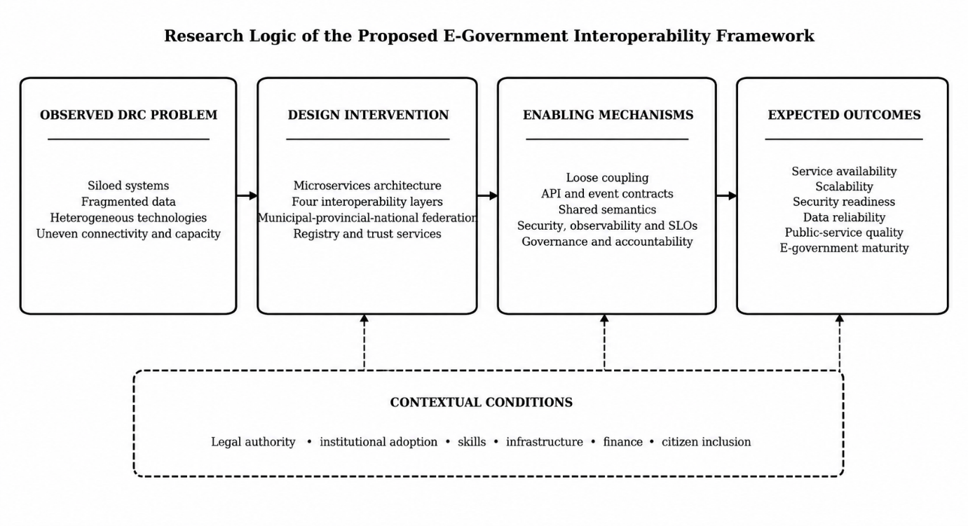
Figure 1.1 Conceptual and Causal Logic of the Research
Source: Author

0.7.3 Expected Contributions
The expected theoretical contribution is a context-sensitive explanation of interoperability as a multilevel governance capability rather than a purely technical connection. The architectural contribution is a federated model combining domain-aligned microservices, API management, event streaming, service discovery, CQRS, SAGA, event sourcing where justified, transactional outbox, idempotency, provenance, identity controls, observability, and a governed registry. The methodological contribution is the integration of field diagnosis, formal service-boundary assessment, heterogeneous implementation, two-provider deployment, and explicit classification of direct, derived, modelled, and qualitative evidence. The practical contribution is a phased path for connecting legacy and new government systems while preserving institutional responsibility and technological choice.

0.8 Research Scope and Methodology

0.8.1 Research Design and Strategy
The study adopts Design Science Research, supported by an embedded case study and multiple forms of evidence. Design Science Research is appropriate because the study creates and evaluates an information-technology artifact for an identified organizational problem. Following Hevner et al. (2004) and Peffers et al. (2007), the research applies six iterative activities: problem identification and motivation, definition of objectives, design and development, demonstration, evaluation, and communication. These activities connect empirical diagnosis to artifact construction and testing.
The research produces the four artifact types identified by March and Smith (1995). Constructs include definitions and metrics for interoperability and microservice granularity. Models include the four-layer framework, the three-level federated architecture, and the SAGA-Petri representation. Methods include microservice onboarding, event governance, API standardization, and distributed-transaction procedures. The instantiation is the working heterogeneous prototype deployed and evaluated under defined conditions.

0.8.2 Unit of Analysis, Population, and Sampling
The primary unit of analysis is the DRC e-government interoperability ecosystem: the institutions, information systems, legal rules, administrative processes, data meanings, infrastructure, and professional roles through which public data are produced and exchanged. The case focuses on Congolese public administration, with particular attention to citizen identity, civil registration, Home Affairs-related functions, and municipal service delivery. National institutions and Kinshasa municipal practice supply the principal field evidence.
The institutional questionnaire covered 34 purposively selected respondents from nine relevant groups: the Ministry of Digital Economy, the Secretariat General for Public Service, the Cabinet of the Minister of Public Service, CMRAP, ARPTC, the Ministry of Foreign Affairs, legal professionals, the Ministry of Interior and Home Affairs, and the National Intelligence Agency. Purposive sampling was used because participants required direct knowledge of public information systems, digital transformation, regulation, security, law, reform, or inter-institutional processes. Observation of 24 municipal offices provided a separate source of contextual evidence and was not added to the questionnaire denominator. The percentages therefore describe the participating institutional sample and are not national prevalence estimates.

0.8.3 Data Collection
Fieldwork was conducted from 15 March to 30 June 2024. Evidence was collected through a standardized institutional diagnostic questionnaire, semi-structured interviews, direct observation, systematic field notes, and documentary analysis. The instruments examined existing systems, intra- and inter-institutional integration, APIs, exchange protocols, cloud and hosting capacity, standards, registries, governance, security, infrastructure, data ownership, semantic ambiguity, skills, and implementation constraints.
Prototype experiments generated a separate technical dataset consisting of HTTP measurements, application and container telemetry, event and workflow evidence, network diagnostics, functional assertions, resource measurements, and model-calibrated planning indicators. The separation between questionnaire responses, municipal observations, interviews, expert assessment, and technical benchmarks preserves the chain of evidence and prevents qualitative or experimental observations from being presented as survey counts.

0.8.4 Data Processing and Analysis
Questionnaire data were assigned pseudonymous respondent codes and transcribed into a respondent-by-item matrix. Binary responses, five-point items, multiple-response variables, missing values, and open responses were coded according to a documented codebook. R was used for validation, frequencies, valid-denominator percentages, distribution summaries, missingness checks, and reproducible outputs. Because the sample was purposive, the quantitative analysis is descriptive rather than inferential.
Interviews, open questionnaire responses, observations, and documents were analysed thematically through familiarization, coding, theme development, review, definition, and reporting, informed by Braun and Clarke (2006). Deductive categories reflected legal, organizational, semantic, and technical interoperability, while inductive themes captured manual exchange, uncertain ownership, connectivity, power interruptions, skills, institutional rivalry, mistrust, and policy discontinuity. An evidence-convergence matrix recorded whether independent sources confirmed, qualified, contradicted, or could not verify each major finding.
Experimental analysis covered functional correctness, latency percentiles, user-observed response time, throughput, resource utilization, availability planning, network behaviour, provenance, and distributed workflow duration. Direct observations were kept separate from values derived from measurements, models calibrated to measurements, and qualitative architectural assessments. This distinction defines the strength of each claim and prevents planning projections from being reported as live production measurements.

0.8.5 Artifact Design, Demonstration, and Evaluation
The artifact translates diagnosed requirements into a four-layer interoperability framework and a municipal-provincial-national federation. Its operational mechanisms include bounded-context microservices, governed APIs and events, service discovery, gateway policy, identity and access management, Kafka-based asynchronous communication, CQRS, selected event sourcing, SAGA coordination, transactional outbox, idempotency, containerization, orchestration, observability, and service-level indicators. Authoritative records remain under the responsibility of the competent service, while approved facts are exposed through purpose-limited and auditable contracts.
The implemented benchmark comprises three authoritative domain services and one composition service. The Population Service uses Java and MySQL; the Police Records Service uses C# and PostgreSQL; the Property Registry Service uses Python and MongoDB; and a Python backend-for-frontend composes municipal and cross-municipal citizen views. Supporting components include Kong, Consul, Redis, Kafka, ZooKeeper, containerized configuration, monitoring, and a national portal. Gombe was deployed on a Hetzner VPS and Lemba on a Contabo VPS, while client-side measurements originated in Kinshasa.
Evaluation combines functional tests, service-boundary assessment, performance measurements, resilience-oriented analysis, requirements traceability, expert review, practitioner assessment, and feasibility analysis. Technical measures include P50, P95, and P99 latency, throughput, availability, CPU, memory, network behaviour, and workflow duration. Security is evaluated through the implemented architecture and control design, but production certification would require penetration testing, privacy impact assessment, key-management exercises, isolation tests, and disaster-recovery drills.

0.8.6 Research Quality, Ethics, and Delimitations
Research quality is supported through source triangulation, explicit case boundaries, consistent coding, requirements traceability, and repeatable deployment and measurement procedures. The audit trail links research questions to objectives, evidence, artifact components, tests, interpretations, and conclusions. Participation was voluntary, identifying information was separated from analytical records, and findings were reported in aggregate or anonymized form. The prototype used no live sensitive citizen records.
The interpretation retains several delimitations. The questionnaire sample is purposive and centred on knowledgeable institutional actors; it does not estimate national prevalence. Municipal field evidence is centred on Kinshasa. The prototype covers a limited service set and two European VPS providers rather than all provinces or sovereign production data centres. Long-duration availability, broker failover, event convergence, adversarial security, and every SAGA compensation path were not directly measured. The research therefore establishes contextual feasibility and architectural coherence within a defined experimental envelope, not nationwide production readiness or completed institutional impact.

0.9 Referencing System
The dissertation applies the American Psychological Association referencing system. In-text citations identify the authors and dates of the sources used, while complete bibliographic information is provided in the consolidated reference list at the end of the dissertation.

0.10 Subdivision of the Work

CHAPTER 1 CONCEPTUAL AND THEORETICAL FRAMEWORK
This chapter establishes the conceptual and theoretical foundations of the research. It is organized into two complementary sections: the conceptual framework defines the principal concepts, models, metrics, and formal constructs used in the study; the theoretical framework explains the design theories that guide the proposed interoperability artifact.

1.1 Conceptual Framework
The conceptual framework clarifies public service, e-government, distributed technologies, interoperability, service-level engineering, SAGA transactions, Petri-net reasoning, and microservice granularity. These concepts provide the vocabulary and analytical structure used throughout the dissertation.

1.1.1 Public Service
A public service is an administrative process or duty delivered by government to citizens, businesses, civil-society organizations, or other public institutions. Many public services depend on contributions from several agencies, whose systems alternately produce and consume data through requests, responses, or events. Tax administrations, for example, require verified business and banking information; judicial services may require criminal-record data; and social services depend on identity verification. Interoperability is therefore a prerequisite for coordinated, efficient, and accountable public-service delivery.

1.1.2 E-Government
The OECD (2010) defines e-government in terms of the use of information and communication technologies, particularly the Internet, to support public-service delivery. This outcome-oriented view shifts attention from technology acquisition to efficiency, user orientation, transparency, and public trust. It also distinguishes digital government transformation from the simple publication of information online.
The United Nations similarly presents e-government as the application of information technologies to public administration in order to streamline workflows, integrate processes, manage data, improve service delivery, and expand channels for citizen engagement. Its perspective is notable because it connects administrative efficiency with participation and empowerment.
The World Bank emphasizes digital interaction between governments, citizens, businesses, and public institutions. This perspective links e-government to accessible service delivery, reduced transaction costs, transparency, institutional coordination, and citizen participation.
The European Union defines e-government as the use of information and communication technologies in public administration to improve public services and democratic processes and to strengthen support for public policies. This definition highlights the organizational change and institutional development that must accompany technological adoption.
Despite their different emphases, the definitions of e-government from the OECD, UN, World Bank, EU converge on several core principles. All agree that ICT is a means to an end serving governance goals rather than an objective in itself, and that e-government is transformative—requiring organizational change and process rethinking rather than mere digitization. Finally, they position citizens not merely as consumers but as participants in governance, with the UN explicitly including "engagement and empowerment," the EU referencing "democratic processes," and the World Bank mentioning "citizen participation." This convergence provides the normative foundation for e-government design, establishing that a comprehensive platform must enable transformation, deliver services efficiently, facilitate multi-stakeholder interaction, empower citizens, and support organizational change through capacity building and institutional reform.
The prefix "e-" is commonly used to denote "electronic"—as in e-commerce, e-learning, e-business, e-health, and e-banking—signifying the digitization of services that were traditionally delivered through physical or paper-based channels. This digital transformation represents a fundamental shift in how governments interact with citizens, businesses, and other government entities, moving from bureaucratic, paper-intensive processes to streamlined, citizen-centric digital services.
The concept of "e-governance" extends beyond service delivery to encompass the broader "ruling" effects produced by the interaction between government, the public service, citizens, and business through ICT (Hinnant & Moon, 2004). E-Governance thus represents a more expansive notion that includes not only the delivery of services but also the transformation of governance processes, citizen participation, and the exercise of public authority. E-Government is accordingly perceived as a subset of e-governance—the service delivery dimension of a broader digital transformation of governance itself.

1.1.2.1 Categories of E-Government

1.1.2.2 Government to Citizens G2C
Government to Citizens (G2C) refers to public services that are accessed by citizens via the internet at any time, from any location (İdikat, 2004). These services are designed to make government more accessible and responsive to individual needs, enabling citizens to conduct transactions without physical visits to government offices. G2C encompasses the full spectrum of citizen-facing government services, ranging from information provision to transactional services such as electronic payment of utility bills, tax filing, application or renewal of licenses, passport issuance, birth registration applications, etc.. Chen et al. (2017) identify G2C as one of the three primary categories of e-government customer interaction, emphasizing the importance of user-centric design and service integration in delivering effective citizen services.

1.1.2.3 Government to Businesses G2B
Government to Businesses (G2B) involves data sharing and service delivery between government agencies and private sector entities, including businesses, NGOs, and other commercial organizations. G2B services are designed to reduce the administrative burden on businesses by providing digital channels for fulfilling government obligations, while also enabling government agencies to collect revenue and enforce regulations more efficiently. Effective G2B services are critical for fostering a favorable business environment, reducing corruption, and enabling economic growth.

1.1.2.4 Government to Government G2G
Government to Government (G2G) enables vertical and horizontal communication and data sharing across and between ministries, departments, and affiliated agencies (Chen et al., 2017). Vertical G2G interactions occur between different levels of government—national, provincial, and municipal—enabling the flow of data, policy guidance, and resources from central to local governments. Horizontal G2G interactions occur between agencies at the same level of government, enabling data sharing for purposes such as criminal record verification, tax collection, social benefits coordination, and statistical aggregation. G2G is the foundational category that enables the integration of government services, as most public services are aggregations of services from multiple agencies.

1.1.2.5 Evolution from Digital Administration to Smart Governance
E-government as a concept has evolved substantially since it first emerged in the 1990s, moving through at least four recognizable stages that reflect not just technological change but a deeper shift in how the state relates to the citizens it serves (Figure 1.1). The earliest stage, e-Administration, was almost entirely internal: government agencies digitized back-office functions — payroll, records, internal correspondence — without necessarily changing how citizens interacted with the state at all. e-Government proper extended this outward, using digital channels to deliver information and services directly to citizens and businesses, typically through agency-specific websites and portals (Scholl & Klischewski, 2007). e-Governance marks a further shift in emphasis, from service delivery toward participation: using digital tools to widen transparency, enable public input into policy, and hold institutions accountable, rather than merely making existing transactions faster. The most recent stage, Smart Governance, treats government itself as a data-driven, adaptive system — using real-time data, predictive analytics, and increasingly automated coordination across agencies to anticipate citizen needs rather than simply respond to them once requested (Gottschalk, 2009).
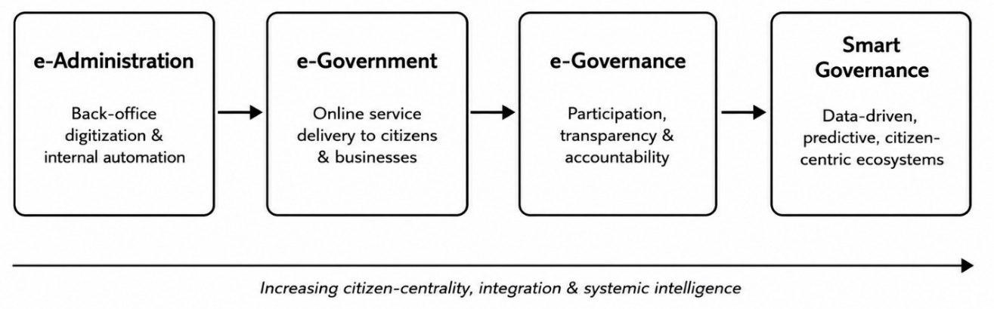
Figure 1.1. Stages in the Evolution From Digital Administration to Smart Governance
Source: Author, adapted from Janowski (2015)
This evolution is cumulative rather than substitutive: a smart-governance system still depends on the back-office digitization established during e-Administration, while mature e-government portals remain a principal channel through which e-governance participation reaches citizens. The DRC case examined in this research shows a country still consolidating internal administrative digitization and citizen-facing portals, with participatory e-governance and smart data integration remaining emerging ambitions. This sequence supports the interoperability-first approach of the dissertation: without cross-agency data exchange, later stages of digital-government maturity cannot be sustained by citizen-facing interfaces alone.

1.1.2.6 Stages of E-Government Maturity

1.1.2.7 Layne and Lee Four Stage Model
Layne and Lee's (2001) four-stage model remains the most widely cited framework for describing e-government maturity precisely because each stage names a genuinely different technical and organizational challenge, not just a deeper level of the same one (Figure 1.2). The Information stage requires only a static, one-way online presence — publishing forms, regulations, and contact details — and was, even at the time Layne and Lee were writing, achievable by almost any agency with a webmaster. The Integration stage is where the real technical difficulty begins, since it requires two or more agencies' backend systems to share data, whether vertically, between national, provincial, and municipal tiers of the same function, or horizontally, across different functions at the same tier. The Transformation stage, finally, is not a technical milestone so much as an organizational one: it is reached only when integration is complete enough that services can be reorganized around citizen life events — a birth, a business registration — rather than around the organizational chart of government itself.
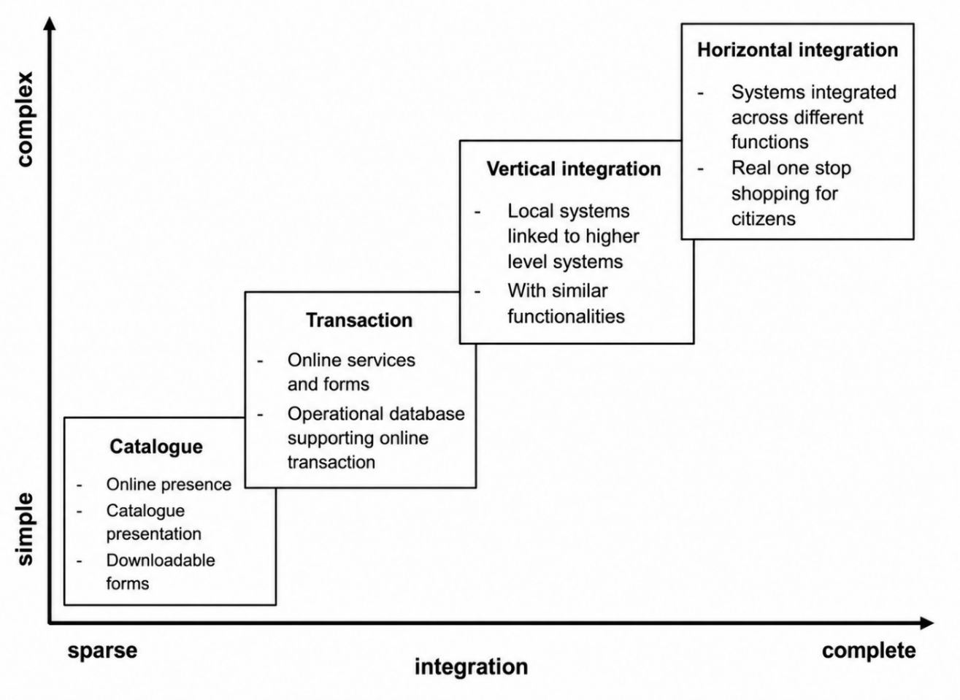
Figure 1.2. Stages of E-Government Maturity
Source: Author, adapted from Layne and Lee (2001) and United Nations (2024)
Layne and Lee's model was quickly adopted well beyond its original public-administration audience: the United Nations built its own cross-country benchmark around a closely related logic, and the European Union, Janowski (2015), and the South Korean e-government literature have each proposed variations that surface a different aspect of what “maturity” actually means.

1.1.3 Evolution of Distributed Technologies in E-Government
Distributed architecture has evolved from platform-dependent object technologies to monolithic systems, Service-Oriented Architecture (SOA), microservices, and Event-Driven Architecture (EDA). This evolution reflects the continuing search for improved interoperability, scalability, agility, and resilience in complex information systems (Papazoglou & van den Heuvel, 2007; van Steen & Tanenbaum, 2017). It also supports Newman’s argument that integration is one of the most important concerns in microservices architecture (Newman, 2015).

1.1.3.1 Early Distributed Technologies
CORBA, Java RMI, and COM/DCOM were among the earliest technologies developed to connect distributed applications. CORBA enabled communication between components written in different programming languages through an Object Request Broker. However, it required specialized middleware, complex configuration, and additional mechanisms to operate effectively across firewalls (Object Management Group, 2021).
Java RMI simplified remote communication between Java applications by allowing objects in different Java Virtual Machines to invoke one another. Nevertheless, its dependence on the Java platform limited interoperability with systems developed using other technologies (Oracle, n.d.). COM/DCOM similarly supported reusable and distributed software components in Microsoft environments but depended heavily on Windows technologies and complex security and network configurations (Microsoft, 2020).
These technologies demonstrated the value of distributed computing, but their platform dependence, synchronous communication, and relatively tight coupling limited their suitability for large heterogeneous environments (Coulouris et al., 2012; van Steen & Tanenbaum, 2017). Their limitations encouraged the adoption of open Internet protocols and standardized web services.

1.1.3.2 From Monoliths to Event Driven Architecture
The transition from monoliths to SOA, microservices, and EDA represents a gradual movement from centralized applications toward autonomous and loosely coupled services. Each paradigm emerged to address limitations in agility, scalability, interoperability, or resilience found in the preceding architectural approach (Dragoni et al., 2017; Papazoglou & van den Heuvel, 2007).
This evolution should not be interpreted as a complete replacement of one architecture by another. Monoliths, SOA, microservices, and EDA may coexist according to organizational requirements, legacy constraints, and operational capacity. The appropriate architectural choice therefore depends on system complexity, institutional maturity, available skills, performance requirements, and governance mechanisms.

1.1.3.3 Monolithic Architecture
A monolithic application combines business logic, data access, user interfaces, and configuration within a single codebase and deployment unit. This design can simplify initial development, testing, deployment, and transaction management. However, the close dependency between modules makes changes increasingly difficult as the system grows. A minor modification may require rebuilding, testing, and redeploying the entire application (Lewis & Fowler, 2014; Newman, 2015).
A shared database may also become a coordination and performance bottleneck. Furthermore, an error in one module can affect the availability of the complete application, while scaling frequently requires replicating the entire system rather than only the resource-intensive component (van Steen & Tanenbaum, 2017).
Many early government tax, identity, civil-registration, and administrative systems followed centralized or institution-specific models. Although such systems could operate effectively within an individual institution, their technological and organizational isolation created difficulties for cross-agency information exchange (European Commission, 2017; Scholl & Klischewski, 2007). Monoliths remain suitable for small, stable, and moderately complex applications, but their limited flexibility makes them less appropriate for continuously evolving national e-government ecosystems.
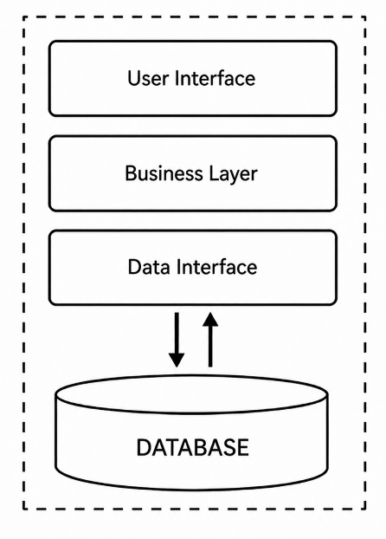
Figure 1.3. Comparison of Monolithic and Microservices Architectures
Source: Author, adapted from Newman (2021)

1.1.3.4 Service Oriented Architecture
SOA decomposes applications into reusable services that communicate through standardized service contracts. Depending on the implementation, communication may use SOAP, XML, WSDL, REST, JSON, or related web-service standards (Fielding, 2000; OASIS, 2006). Service registries support service discovery, while Enterprise Service Buses facilitate routing, protocol transformation, message mediation, and integration between heterogeneous applications (Hohpe & Woolf, 2003).
SOA enabled organizations to reuse shared capabilities such as authentication, identity verification, payment processing, notification, and document management. It was particularly valuable for integrating heterogeneous applications and exposing selected functions of legacy systems without completely replacing them (Papazoglou & van den Heuvel, 2007).
Nevertheless, SOA introduced new challenges. Centralized middleware could become a performance bottleneck and a single point of operational dependency. SOAP messages and extensive XML processing could generate substantial communication overhead, while poorly defined service granularity could create excessive dependencies and coordination costs (Newman, 2015; Papazoglou & van den Heuvel, 2007).
Despite these limitations, SOA established important principles of modularity, service contracts, reuse, loose coupling, and technology-neutral interoperability. These principles subsequently influenced the development of microservices architecture.

1.1.3.5 Microservices
Microservices organize an application into small, autonomous services aligned with clearly defined business capabilities or domains. Each service exposes lightweight APIs or events, controls its business logic and data, and can be developed, tested, deployed, updated, and scaled independently (Dragoni et al., 2017; Lewis & Fowler, 2014; Newman, 2021).
Domain-Driven Design supports the identification of service boundaries through bounded contexts and explicitly defined domain models (Evans, 2003). Microservices are frequently implemented as stateless and independently deployable components, supported by automated testing and CI/CD pipelines. Container orchestration platforms such as Kubernetes provide deployment automation, scaling, load distribution, health checking, and failure recovery (Newman, 2021).
Microservices improve organizational agility, fault isolation, maintainability, and scalability. However, they also introduce the complexity associated with distributed systems. Because services may control independent databases, traditional centralized transactions are no longer always appropriate. Mechanisms such as SAGA transactions, event sourcing, transactional outbox patterns, idempotency, compensating actions, and eventual consistency may therefore be required (Garcia-Molina & Salem, 1987; Kleppmann, 2017; Richardson, 2018; Vogels, 2009).
Every additional service also creates requirements for deployment, monitoring, logging, tracing, access control, version management, and governance. Consequently, microservices are not automatically suitable for every government institution. Their successful adoption depends on technical competence, institutional readiness, DevOps maturity, operational automation, and effective architectural governance (Dragoni et al., 2017; Jamshidi et al., 2018).
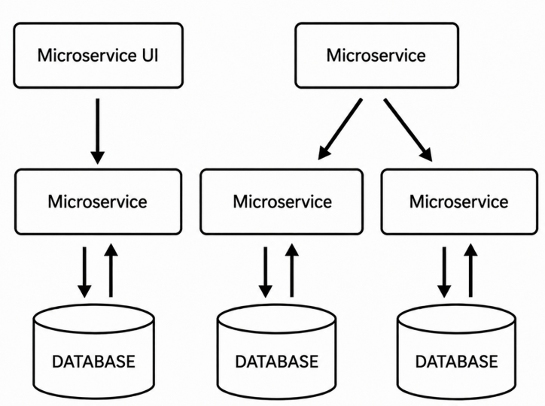
Figure 1.4. Evolution From Monolithic to Microservices Architecture
Source: Author, adapted from Newman (2021)

1.1.3.6 Event Driven Architecture
EDA enables autonomous services to communicate by publishing and consuming events rather than depending exclusively on synchronous request-response interactions. An event represents a meaningful and completed change in the system, such as a citizen registration, payment confirmation, address update, licence issuance, or public-service request (Bellemare, 2020; Hohpe & Woolf, 2003).
Event producers publish events through messaging infrastructure such as Apache Kafka or RabbitMQ, while interested consumers process them independently. For example, after the civil-registration service publishes a CitizenRegistered event, identity, taxation, electoral, health, and social-protection services may consume the event according to their respective responsibilities without requiring the producer to invoke each system directly.
The principal components of an event-driven environment include event producers, brokers, consumers, event stores, stream-processing services, schema registries, and dead-letter queues. Together, these components support reliable event delivery, replay, auditability, recovery, and consistent event structures (Bellemare, 2020; Kleppmann, 2017; Kreps et al., 2011). Event sourcing may additionally preserve an immutable sequence of events from which the current system state can be reconstructed (Kleppmann, 2017; Richardson, 2018).
EDA provides loose coupling, extensibility, independent scalability, resilience, and near-real-time processing. A temporarily unavailable consumer can process retained events after recovering, thereby reducing the probability of cascading failures. New government services can also subscribe to existing events without requiring modifications to the original producer (Bellemare, 2020).
EDA therefore complements microservices by enabling reliable communication and information propagation across autonomous government systems. Its characteristics are consistent with the technical and organizational interoperability objectives promoted by contemporary digital-government frameworks (European Commission, 2017; OECD, 2020; Scholl & Klischewski, 2007). Nevertheless, effective implementation requires strong event-schema governance, security, monitoring, idempotency, privacy protection, and eventual-consistency controls.

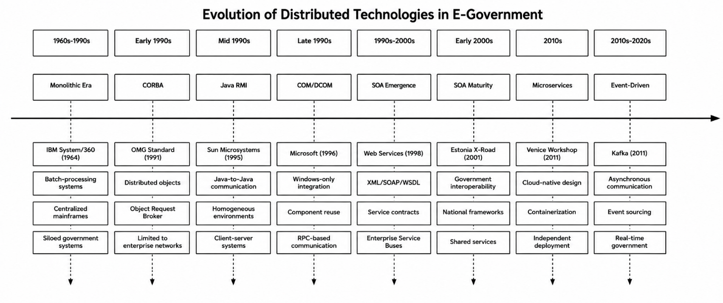
Figure 1.5. Evolution of Distributed Technologies in E-Government
Source: Author, adapted from Dragoni et al. (2017) and Hohpe and Woolf (2003)

The four paradigms trace a single, consistent trajectory: away from tight coupling and centralized control, and toward loose coupling, independent scalability, and increasingly autonomous, real-time behavior.
Extending this trajectory further, the next frontier is the integration of artificial intelligence and predictive analytics into event streams themselves — systems that do not merely react to events but anticipate them, moving from reactive automation toward what might be called event-driven intelligence: architectures capable of autonomous reasoning, dynamic resource allocation, and predictive governance. For e-government specifically, the throughline across all four paradigms is the same: as societies become more digital, government systems must move from being system-centric to being event-driven and citizen-responsive, no longer waiting passively for a request before acting.

1.1.4 Interoperability

1.1.4.1 Definition of Interoperability
"Interoperability" is defined as the capacity for IT systems to integrate and exchange data seamlessly, irrespective of the heterogeneity of their underlying infrastructure—including business rules, database systems, hardware or software architectures, and programming languages (Newman, 2021). It is the antithesis of "legacy," "monolithic," or "siloed" systems, which operate in isolation and resist integration with other systems. Interoperability is the foundational capability that enables e-government to achieve its full potential: the ability to integrate with other government agency systems regardless of infrastructure heterogeneity, creating a unified, citizen-centric digital government that transcends the boundaries of individual agencies and technological stacks.

1.1.4.2 Interoperability Frameworks
Distinct bodies of standards inform how the interoperability framework proposed in this dissertation is designed: a European reference framework with the deepest literature base, emerging African continental frameworks most directly relevant to the DRC's own regional context, and general-purpose international (ISO) standards that operationalize specific layers of either.

1.1.4.3 European Interoperability Framework
The European Interoperability Framework (EIF), revised by the European Commission in 2017, is organized around four layers of interoperability — legal, organisational, semantic, and technical — plus a cross-cutting “integrated public service governance” component spanning all four, and a background “interoperability governance” layer beneath them (European Commission, 2017). Legal interoperability ensures organisations operating under different legal frameworks can still work together; organisational interoperability aligns business processes and service-level responsibilities across those organisations; semantic interoperability ensures the meaning and format of exchanged data survive the exchange itself; and technical interoperability supplies the APIs, specifications, and integration services that make exchange technically possible in the first place.
Table 1.1. Layers of the European Interoperability Framework
Source: Author, adapted from European Commission (2017)
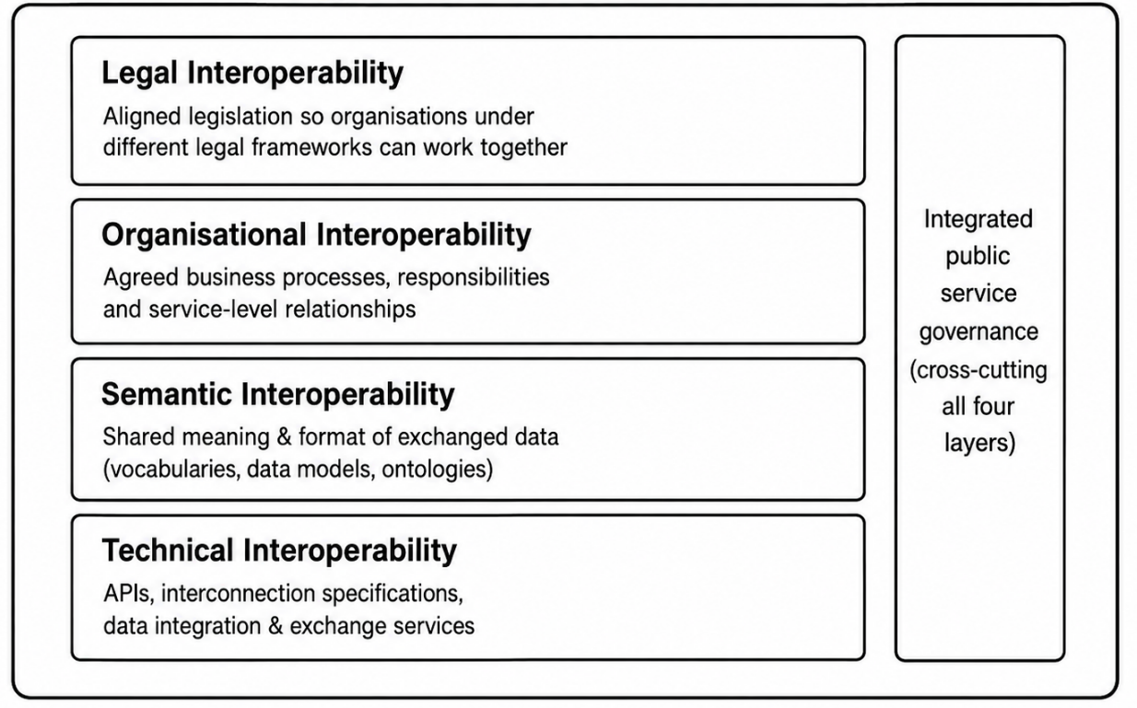

1.1.4.4 African Union Framework
At the continental level, the African Union's Digital Transformation Strategy for Africa 2020–2030 sets the broader policy goal of a continent-wide Digital Single Market by 2030, aligned with the African Continental Free Trade Area, and explicitly calls for open standards and cross-border trust frameworks as a precondition for that market (African Union, 2020). The AU Interoperability Framework for Digital ID (2022) guides member states in building identity systems capable of working across borders while protecting privacy. And the African Union Convention on Cyber Security and Personal Data Protection, the Malabo Convention, supplies the continental legal-interoperability baseline that national data-protection laws, including the DRC's own Digital Code, are increasingly designed to align with.

1.1.4.5 ISO Standards
Finally, general-purpose ISO standards operationalize specific layers of both frameworks above without being e-government-specific themselves. ISO/IEC 11179, the metadata registry standard, defines how data elements are documented and shared so that a term such as “citizen identifier” means the same thing to every system that consumes it — the technical foundation of semantic interoperability. ISO/IEC 19941 defines interoperability and portability for cloud computing specifically, relevant wherever the interoperability framework proposed here draws on cloud or GovCloud infrastructure. Also, ISO/IEC 27001, the information security management standard, underpins the trust guarantees that legal and organisational interoperability both ultimately depend on, since no agency will share data across a boundary it does not trust to be secure. Table 1.1 summarizes how the three frameworks relate.

Table 1.2. Comparison between European, African, and ISO Interoperability Frameworks
Dimension | European Interoperability Framework (EIF) | African Frameworks | ISO Standards
Scope | EU member states and institutions | AU member states (continental) | Global, sector-agnostic
Primary instrument(s) | New EIF (European Commission, 2017) | AU Digital Transformation Strategy 2020–2030; AU Interoperability Framework for Digital ID (2022); Malabo Convention | ISO/IEC 11179 (metadata registries); ISO/IEC 19941 (cloud interoperability); ISO/IEC 27001 (information security)
Structure | 4 layers (legal, organisational, semantic, technical) + governance | Overarching strategy plus sector-specific instruments (digital ID, cybersecurity/data protection) | Standalone technical standards; no unified layer model
Primary use in this dissertation | Structures the phased sequencing of the proposed roadmap | Grounds the DRC's own legal and institutional alignment (Ch. 2; Sec. 3.2) | Supplies concrete technical specifications for the semantic registry and security layers
Source: Author, adapted from European Commission (2017), African Union (2022), and ISO standards

1.1.4.6 Interoperability Requirements for E-Government Platforms
Successful e-government interoperability requires four interconnected dimensions, which are:
- Technical interoperability;
- Semantic interoperability;
- Organizational interoperability; and
- legal interoperability that were — first articulated in the European Interoperability Framework (EIF) and since adopted by national and regional frameworks worldwide. Each addresses a distinct facet of the challenge, and all four must be satisfied simultaneously: neglecting any one can undermine the entire effort, however well the others are implemented.

1.1.4.7 Technical Interoperability
Technical interoperability is the foundational layer upon which all other dimensions of interoperability depend, enabling disparate systems to connect, communicate, and exchange data reliably through standard protocols, interfaces, and infrastructure. The absence of technical interoperability manifests in incompatible protocols, mismatched data formats, and conflicting security mechanisms—problems that must be addressed through open standards, resilient network design, and adaptation layers that enable gradual modernization without wholesale replacement. By establishing this essential foundation, the architecture provides the precondition for semantic, organizational, and legal interoperability to function effectively, enabling the integrated service delivery that is the goal of e-government transformation.

1.1.4.8 Semantic Interoperability
Semantic interoperability ensures exchanged data means the same thing to sender and receiver — technical interoperability moves the bits, semantic interoperability preserves their meaning, which matters acutely where one agency's data drives another's decisions about citizens' rights and entitlements. A shared e-government ontology defines the core concepts of service delivery — services, documents, information systems, administrations, citizens, enterprises, legal-framework elements, life events, technical standards — with the precise semantics and relationships needed for consistent interpretation and for systems to reason over the data automatically. Controlled vocabularies and code lists (country and currency codes, administrative divisions, service and document types) eliminate the ambiguity of multiple representations for one concept, maintained centrally and published through a registry so every system resolves the same referent. That semantic registry itself works as a discovery layer — searchable by domain, publisher, and version, dereferencing to the authoritative source rather than duplicating it — while crosswalk mappings supply the translation rules between national, sectoral, international, and legacy models, applied automatically by transformation engines such as Apache Camel during message processing.

1.1.4.9 Organizational Interoperability
Organizational interoperability aligns business processes, structures, and governance so that technically and semantically interoperable systems actually translate into effective collaboration — without it, misaligned processes, unclear responsibilities, or governance gaps can defeat integration even where the underlying systems work perfectly, a particular risk where agencies hold genuine constitutional or statutory autonomy. Business Process Model and Notation (BPMN) documents cross-agency workflows, decision points, and handoffs, giving orchestration a shared blueprint and defining the process owners and service-level expectations that make accountability possible. A RACI matrix (Responsible, Accountable, Consulted, Informed) clarifies who acts, who decides, who owns data, and who answers for outcomes, alongside escalation paths for exceptions and disputes. Governance operates at strategic, tactical, and operational levels, with representative, transparent decision-making and performance reporting; and change management — stakeholder engagement from the outset, clear communication of rationale and impact, and training in both technical and collaborative skills — builds the trust and culture that structural alignment alone cannot.

1.1.4.10 Legal Interoperability
Legal interoperability ensures organizations operate under compatible legal mandates, so that even properly built, semantically aligned, and well-governed systems are actually permitted to exchange data. Data sharing agreements set out the authority, conditions, purposes, and safeguards for inter-agency exchange, consistent with applicable data protection law and with data ownership and intellectual-property rights respected. Electronic transactions need legal parity with paper — UNCITRAL's Model Law on Electronic Commerce is the reference framework — covering party authentication, transaction integrity, non-repudiation, and admissibility of electronic evidence, underpinned by digital-signature, electronic-archiving, e-procurement, and e-payment laws. Data protection and privacy requirements — lawful basis, purpose limitation, data minimization, and the now-standard data-subject rights of access, rectification, erasure, restriction, portability, and objection — must be designed in from the start, supported by privacy-enhancing techniques (anonymization, pseudonymization, differential privacy) and privacy impact assessments.

1.1.5 Service Level Engineering for E-Government
The digital transformation of public administration has rendered service delivery opaque: citizens interact with an interface while the underlying computation occurs in server infrastructure they cannot inspect, often operated by private contractors in undisclosed data centers.
This section argues that the tripartite construct of Service Level Indicators (SLIs), Service Level Objectives (SLOs), and Service Level Agreements (SLAs) answers the resulting accountability question — how does the State demonstrate it is fulfilling its obligation to deliver service, and how does the citizen prove it has failed? The three constructs form a cascading framework, moving from the empirical (the SLI: what is happening) to the normative (the SLO: is it good enough) to the juridical (the SLA: what happens if it is not). An SLA built without rigorous SLOs and SLIs beneath it is, in the legal sense, an illusory promise — a statement of intent unmoored from verifiable fact.

1.1.5.1 Service Level Indicators
A Service Level Indicator (SLI) is a quantifiable metric derived from system telemetry, selected to represent a dimension of service quality material to the end-user experience. Selecting which SLIs to monitor — and which to exclude — is never a neutral technical act: a portal that tracks only server uptime while ignoring transaction success rate has implicitly defined “service” as “interface availability” rather than “citizen goal achieved.”
Table 1.3. Service-Level Indicator Categories, Formulas, and E-Government Examples
Category | Formula | e-Government Example
Infrastructure Availability | Successful Pings ÷ Total Pings | Data center power and server OS responsive
Application Availability | Valid Responses ÷ Total Probes | Passport portal login page renders fully
Transaction Success Rate | Confirmed Submissions ÷ Total Attempts | Birth certificate issuance confirmed
Latency (Tail) | P95 or P99 of response time | 95% of pension applications load in < 3 sec
Data Freshness | Query Time − Last Update Time | Land registry reflects transactions < 24h old
Data Corectness | Matching Records ÷ Total Records | Tax calculation matches statutory code
Security Posture | Mitigation Time − Compromise Time | Time from intrusion detection to ejection
Source: Author, adapted from Beyer et al. (2016)
Transaction Success Rate, Latency, Application Availability, and Correctness — should be the only SLO-bound indicators; everything else is diagnostic, useful for root-cause analysis but not contractually binding.

1.1.5.2 Service Level Objectives
A Service Level Objective (SLO) is a declared threshold for an SLI, representing the minimum acceptable service quality over a defined window, replacing the diligence standard of traditional administration (“we will process your application promptly”) with a result obligation (“99.5% of applications will be processed within 3 seconds”).
$SLO\left(X,τ\right)≡Pr\left(X≥θ\right)≥α$ (θ = threshold; α = required proportion of window met; τ = measurement window) (1.1)
The error budget — the permissible quantum of failure — follows directly:
A passport portal with a monthly SLO of 99.9% is permitted 43.8 minutes of downtime a month; an emergency dispatch system at 99.999% weekly is permitted roughly six seconds. The budget functions as risk capital — every deployment consumes a portion of it, and once it is exhausted, non-critical changes freeze. What matters operationally is not only the remaining balance but the burn rate: a system with a 43-minute monthly budget that loses 10 minutes in one hour is on track to exhaust the month's budget in nine hours, not thirty days, and monitoring must alert on that velocity, not only on breach.
Systems must be classified into tiers, each calibrated to the social cost of its own failure — a policy decision, not a technical one.
Table 1.4. Service-Level Objectives and Monthly Error Budgets by Service Criticality
Tier | System Type | SLO Target | Error Budget | Societal Cost of Breach
0 | Emergency response, air traffic control, critical health monitoring | 99.999% | 26 seconds | Loss of life; criminal negligence liability
1A | Statutory entitlements: tax filing, passport, social benefits, civil registration | 99.95% | 21.9 minutes | Denial of constitutional right; mass litigation risk
1B | High-volume transactional: licenses, land records, business registration | 99.9% | 43.8 minutes | Economic disruption; reputational damage
2 | Public health information, education portals, municipal services | 99.0–99.5% | 3.6–7.2 hours | Reputational damage; public inconvenience
3 | Internal administrative systems (HR, procurement) | 98.0% | 14.4 hours | Internal inefficiency; no direct citizen impact
Source: Author, adapted from Beyer et al. (2016)
The social cost of failure is not constant over time. A tax portal failing on an ordinary Tuesday is an inconvenience; failing on the statutory filing deadline is a constitutional crisis. Setting the threshold itself is the calibration problem, and no purely technical method resolves it. Historical baseline analysis sets the SLO just above observed performance — empirically grounded but liable to enshrine existing mediocrity.

1.1.5.3 Service Level Agreements
A Service Level Agreement (SLA) is a formal contract, or a binding clause within one, specifying the SLOs a provider is held to, how compliance is measured, the remedies attached to breach, and the force majeure exclusions under which SLOs are suspended — the instrument that renders an abstract constitutional right to public service justiciable.
E-Government SLAs are triadic rather than the bilateral customer-provider relationship of commercial SLAs. The Citizen-State relationship is constitutional, not contractual: no citizen signs an agreement with the passport office, but the State's duty to the citizen forms the normative backdrop against which its vendor contract must be read. The State-Vendor relationship is the procurement contract proper, enforceable through liquidated damages or bank guarantees. The Inter-Agency relationship, often a Memorandum of Understanding, governs shared infrastructure — an authentication API one department provides to others — through service credits or budgetary transfers rather than commercial penalties.
Table 1.5. Required Components of E-Government Service-Level Agreements
Component | Required Specification | Common Failure Mode
SLI Definitions | Measurement methodology, sampling frequency, aggregation algorithm specified | Ambiguous, non-falsifiable definitions
SLO Commitments | Target value, measurement window, statistical aggregation (mean vs. percentile) | Using mean latency rather than p95, masking poor performance for a minority
Measurement & Reporting | Designated measurement authority; dispute resolution for contested readings | Vendor self-reporting with no independent verification
Exclusions & Force Majeure | “Scheduled maintenance” defined with advance notice; cyberattack distinguished from negligence | Broad exclusions that excuse preventable intrusions
Remedies & Penalties | Liquidated damages, service credits, bank guarantee encashment specified | Remedies disproportionate to harm
Governance & Escalation | SLA owners designated; review cadence and escalation path defined | No designated owner; reviewed only at contract renewal
Source: Author
A server can report 99.99% uptime from the data center's perspective while a citizen experiences the service as unavailable. A farmer on a 2G rural connection loading a land-record portal built with a 15-megabyte JavaScript payload waits four minutes and times out; the SLI logs a successful HTTP 200, but the citizen sees a blank screen. This accessibility gap is increasingly closed through Digital Inclusivity SLOs — non-functional requirements embedded in the availability definition itself, such as a contractual requirement that core transactions remain functional on a simulated 2G connection at 400ms latency and 100kbps throughput, forcing vendors toward progressive enhancement rather than client-heavy frameworks.
Operationally, incidents are classified by severity independent of the SLA penalty schedule above, governing response urgency and escalation rather than payment.
Table 1.6. Severity, Recovery Time, and Recovery Point Classification
Criticality | RTO | RPO | Consequence
Tier 0 | < 1 minute | < 1 second | Loss of life
Tier 1 | < 4 hours | < 15 minutes | Financial loss, legal liability
Tier 2 | < 24 hours | < 4 hours | Reputational damage
Tier 3 | < 72 hours | < 24 hours | Operational delay
Source: Author
The stakes behind this framework are not abstract. Eight documented e-government incidents show what happens when SLIs go unmeasured, SLOs go unset, or SLAs go unenforced.
Table 1.7. Documented E-Government Service Failures and Citizen Harm
Incident | Failure Type | Citizen Harm | Resolution & Cost
UK Child Support Agency (2004) | System crash, 5-day outage | Single parents left without maintenance payments | System scrapped (>£1bn wasted); £43m in hardship payments
US Healthcare.gov (2013) | Capacity failure; 5–10 min page loads | Millions unable to enroll before deadline | $2bn emergency rebuild; deadlines extended, no citizen compensation
California Medi-Cal (2013–15) | Stale data; wrongful terminations | 500,000 wrongly stripped of coverage; possible deaths | Emergency manual review; class action settled, no admission of liability
Australia Robodebt (2015–19) | Flawed algorithm; false debt notices | 443,000 false debts; multiple suicides attributed | $1.2bn settlement; debts waived; staff referred for prosecution
UK Post Office Horizon (1999–2015) | Software bugs treated as infallible evidence | 736 wrongful convictions; at least 4 suicides | >£1bn compensation; 2024 Act exonerated all victims
Dutch Childcare Benefits (2013–19) | Ethnic-profiling fraud algorithm | Thousands wrongly denied benefits; children removed | Government resigned (2021); €500m compensation
UK Tax Credits (2003–16) | Data-transform bug; forced repayment | 1.5 million faced £2,000–£5,000 recovery demands | “Maladministration” finding; £43m compensation
Estonia Cyberattack (2007) | 3-week DDoS on national infrastructure | Citizens locked out of banking and government services | NATO Cyber Defence Centre established; no compensation
Source: Author
The three constructs relate through strictly increasing abstraction: an SLI is thresholded into an SLO; an SLO is contractualized into an SLA. No SLA can be enforced without an SLO that renders it quantitatively bounded — an SLA referencing “reasonable efforts” without an SLI threshold behind it is, legally, an illusory promise.

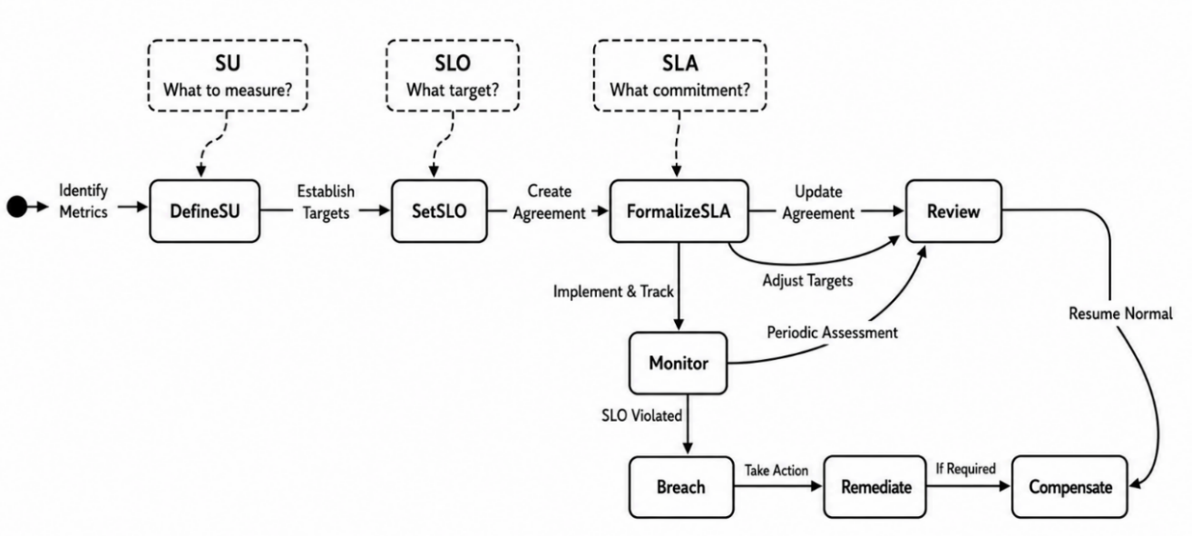
Figure 1.6. SLI, SLO, and SLA Lifecycle
Source: Author, adapted from Beyer et al. (2016)
Service Level Agreements for digital government differ fundamentally from their commercial counterparts. Commercial SLAs mainly address financial loss and customer retention, whereas e-government SLAs must also account for the denial of legal rights, unequal access, public accountability, and political consequences. They therefore require rigorous indicators, measurable objectives, transparent remedies, and coordinated technical, legal, and institutional oversight.

1.1.6 Microservice Transactions and SAGA Models in E-Government
In distributed systems, particularly those underpinning modern e-government platforms, maintaining data consistency across several autonomous services without compromising scalability or availability is a fundamental architectural challenge. Traditional monolithic databases address this problem through ACID transactions (atomicity, consistency, isolation, and durability), which provide strong guarantees within one database but cannot extend across independently deployed services without introducing tight coupling and performance bottlenecks. In the Democratic Republic of the Congo's e-government architecture, where services span municipal, provincial, and national levels, distributed-transaction consistency is essential for processes such as citizen registration, passport issuance, tax declaration, and social-benefit payment. The SAGA model addresses this challenge by managing distributed transactions across microservices while preserving loose coupling and high availability.
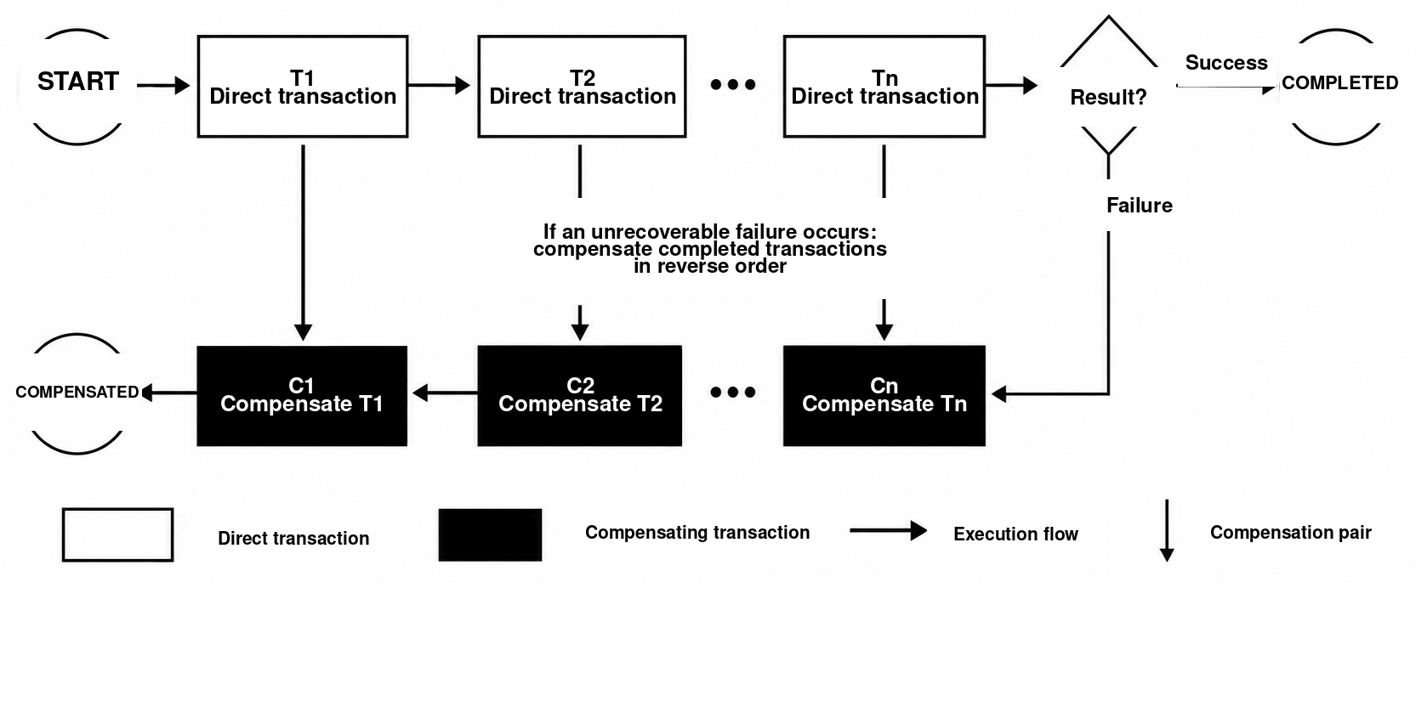
Figure 1.7. Standardized SAGA Transaction Flow and Reverse-Order Compensation
Source: Author, adapted from Garcia-Molina and Salem (1987)
The SAGA model, originally proposed by Garcia-Molina and Salem (1987), provides a framework for managing long-running distributed transactions by decomposing them into a sequence of local ACID transactions, each associated with a compensating transaction. When a failure occurs, the system executes compensating transactions in reverse order to semantically undo the effects of completed transactions, thereby restoring consistency without distributed locking or a two-phase commit protocol. This approach is particularly suitable for e-government applications, in which transactions often cross organizational boundaries, may take considerable time, and must preserve high availability for citizen-facing services.

1.1.6.1 Mathematical Foundations of SAGA Transactions
Let a distributed transaction (saga) be formally defined as a tuple:
where:
T = {t₁, t₂, …, tₙ} is a finite set of direct transactions. C = {c₁, c₂, …, cₙ} is a finite set of compensating transactions. σ₀ ∈ Σ is the saga's initial state, and Σ is the set of all possible saga states. δ: Σ × (T ∪ C) → Σ is the state-transition function. A fundamental SAGA property is the one-to-one correspondence between direct transactions and their compensations: cᵢ semantically reverses tᵢ. Formally, a compensation function associates each direct transaction with one unique compensating transaction and, for every valid state σ, execution of tᵢ followed by cᵢ returns the system to a semantically equivalent state while preserving the audit trail. Each tᵢ, and likewise each cᵢ, is a local ACID transaction executed in one service's database. Function δ models execution and produces the next saga state. | (1.2)

1.1.6.2 Compensation Path Semantics
The compensation path is the mechanism through which a SAGA reverses previously committed transactions when a later step fails. Unlike monolithic ACID transactions, which can roll back all changes through database undo logs, a distributed SAGA must explicitly reverse already committed changes through compensating transactions executed in reverse order.
When transaction T_k cannot be committed successfully, all previously committed transactions T_1, T_2, ..., T_(k-1) must be semantically reversed by executing their compensating transactions C_(k-1), C_(k-2), ..., C_1 in strict reverse order. This reverse execution preserves transaction dependencies and returns the system to a consistent state. A SAGA has two possible execution paths:
Direct path (success): t₁ → t₂ → … → tₙ. Compensation path (failure at step k): t₁ → … → tₖ → cₖ → cₖ₋₁ → … → c₁. Each cᵢ is the compensating transaction for tᵢ, and the final state represents the system after all required compensations have completed. The failure and compensation are recorded in the saga log for audit and recovery. This definition makes the compensation path deterministic for every failure point. | (1.3)

1.1.6.3 Transaction Components

1.1.6.4 Direct Transactions
Direct transactions form the productive core of every compensating-transaction system. A direct transaction is a local ACID transaction, executed within one service, that performs meaningful business work, such as creating records, updating state, processing payments, or generating documents. In the passport-application example, the identity-verification service executes a direct transaction that validates the citizen's documents and creates a verified identity record. The transaction is committed in the service's private database, making it durable and visible within that service's boundary.

1.1.6.5 Compensating Transactions
The SAGA model classifies transactions into four distinct types according to their behavior and capacity for compensation:
Compensable transactions (C) are operations that can be logically reversed through compensating actions if a later saga step fails. Their defining characteristic is reversibility: the system can execute a well-defined compensating transaction that restores a state semantically equivalent to the state preceding the original transaction.
Pivot transactions (P) are critical decision points in the saga. Once a pivot transaction succeeds, the saga must run to completion and can no longer be reversed. Such transactions generally represent irreversible actions, such as sending a confirmation email, notifying an external system, or entering into a binding agreement.
Retrievable transactions (R) are designed to be executed safely again after failure. They are idempotent and produce no side effect that cannot be repeated. They are typically read-only operations or idempotent writes that can be executed several times without changing the final state.
Compensable-pivot transactions combine the characteristics of compensable and pivot transactions. They may be reversed when compensation is required, but once committed they mark a point of no return in the saga.
This classification enables architects to design sagas with failure-handling strategies appropriate to each transaction type, allowing the overall saga to recover from failure without compromising consistency.

1.1.6.6 Coordination Components

1.1.6.7 The SAGA Orchestrator
The SAGA orchestrator is the central nervous system of orchestration-based implementations. This dedicated service manages the entire distributed-transaction lifecycle: it maintains global state, makes progression decisions, and coordinates compensation when failure occurs. The orchestrator is a stateful service that tracks each saga instance and invokes transactions in the appropriate sequence. An orchestrator is formally defined as a tuple:
where:
N is the set of participating services. Q is a finite set of orchestrator states. q₀ is the orchestrator's initial state. F is the set of final (terminal) orchestrator states. | (1.4)
The orchestrator maintains persistent state for every saga instance:
where:
q is the orchestrator's current state. context is a key-value store containing data passed between steps (tokens, identifiers, and related values). step_index records the number of direct steps already committed. | (1.5)
The orchestrator executes a saga according to the following formal semantics:
Initialization. Execute direct steps for i = 1,…,n while status = ACTIVE: tᵢ ← Γ(q); result ← invoke(tᵢ, context). If result = success, extend context with result.data, set step_index ← i, update q ← Δ(q, success_event), and append the success to history. Otherwise set status ← COMPENSATING, update q ← Δ(q, failure_event), append the failure, and begin compensation. Compensation. For i = step_index,…,1 in descending order: cᵢ ← comp(tᵢ); result ← invoke(cᵢ, context). On success, append the result and decrement i. On failure, set status ← FAILED, append the failure, and require human intervention. Completion. If status = ACTIVE and step_index = n, set status ← COMPLETED and append the completion event. These rules make orchestration deterministic and auditable. | (1.6)

1.1.6.8 Detailed Petri Net Modeling of the SAGA Pattern
The Petri net explicitly represents reachable states, direct transitions, failures, and the ordered activation of compensations. It distinguishes state, represented by a marking, from an event, represented by the firing of a transition. Murata (1989, pp. 541-580) summarizes these properties, and Reisig (2013, pp. 13-24) explains their semantics.
The objective is to verify the central property formulated by Garcia-Molina and Salem (1987, pp. 249-259): a long-running transaction is decomposed into local transactions, and every abandoned partial execution is corrected by compensating transactions. The model remains independent of implementation technologies.

1.1.6.9 Formal Definition
Nₛ = (P, T, F, M₀). P = {p₀, p₁, …, pₙ, qₖ, …, q₀, pₛ, p_c}. T = T_d ∪ T_e ∪ T_c, where T_d = {t₁, …, tₙ}, T_e = {f₁, …, fₙ}, and T_c = {c₁, …, cₙ}. M₀(p₀) = 1 and M₀(p) = 0 for every place p ≠ p₀. | (1.7)

P is the set of places, T the set of transitions, F the flow relation, and M_0 the initial marking. Places p_i record commits; q_i records compensation depth; and p_s and p_c are the 'completed' and 'compensated' outputs. T_d, T_e, and T_c denote direct actions, failures, and compensations, respectively.
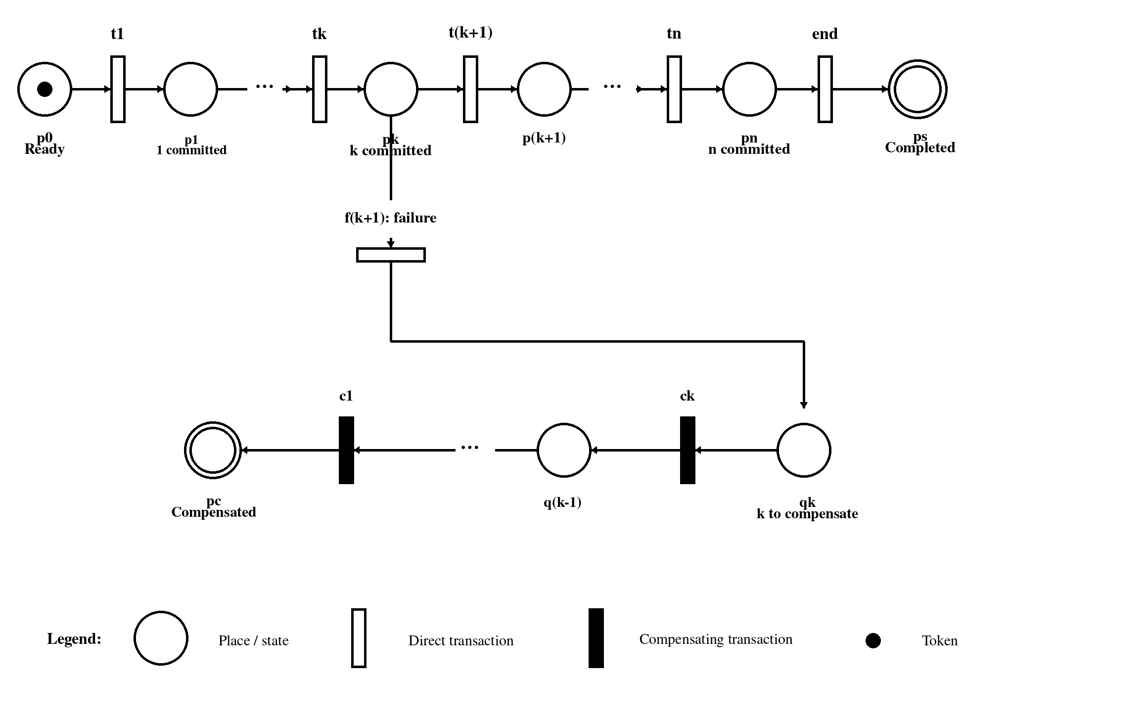
Figure 1.8. Generalized Petri Net for the SAGA Pattern with Reverse-Order Compensation
Source: Author, adapted from Garcia-Molina and Salem (1987) and Murata (1989)
M_0 contains one token in p_0; every committed t_i moves it to the next place. At p_k, t_(k+1) and f_(k+1) are in conflict: firing either disables the other. A failure marks q_k, after which only the chain c_k, ..., c_1 leads to p_c. The structure therefore instantiates the reverse compensation of Garcia-Molina and Salem (1987).
Structural reading of the figure. Nominal path: p₀ → t₁ → … → tₙ → pₛ. Failure path: pₖ → fₖ₊₁ → qₖ. Compensation path: qₖ → cₖ → … → c₁ → p_c. | (1.8)

1.1.6.10 Firing Semantics and Compensation Rules
A marking M: P -> N assigns a number of tokens to every place. A transition t is enabled when its input places contain the required tokens. Firing consumes those tokens and produces tokens in the output places. Peterson (1981) and Murata (1989) therefore distinguish the enabling condition from the effect of a transition.
Transition t is enabled by M ⇔ M(p) ≥ C⁻(p,t) for every place p ∈ P. M′(p) = M(p) − C⁻(p,t) + C⁺(p,t). Compact notation: M [t⟩ M′. | (1.9)
In the nominal branch, t_i is enabled only when p_(i-1) is marked. After it commits, p_i becomes the only marked place and provides abstract proof that transactions t_1, ..., t_i have succeeded. The marking does not claim to contain all business data; it represents only the control state required by the coordination protocol.
From p_k, continuation t_(k+1) and failure f_(k+1) share the same input place. This conflict prevents the nominal path from continuing after compensation begins. A transient error handled by a retry remains internal to t_(k+1); only an error declared unrecoverable fires f_(k+1).

1.1.6.11 Reverse Order Rule
Firing f_(k+1) marks q_k and enables c_k, but not yet c_(k-1). After c_k, the token reaches q_(k-1) and enables c_(k-1). By induction, the structure imposes c_k, c_(k-1), ..., c_1. No compensation is defined for t_(k+1), because it was not committed. The reverse order therefore follows from F.

1.1.6.12 Incidence Matrices State Equation and Invariants
The matrix representation makes the analysis reproducible. C- denotes consumed tokens, C+ denotes produced tokens, and C = C+ - C- assigns one column to each transition and one row to each place. If sigma counts firings, the necessary state equation is written as follows (Murata, 1989; Peterson, 1981):
C = C⁺ − C⁻. M = M₀ + C · σ. σ(t) ∈ ℕ denotes the number of firings of transition t. | (1.10)
The state equation excludes an impossible marking but does not always prove reachability because it does not preserve causal order. It must be complemented by the reachability graph or model checking. Here, the sequential, 1-bounded net has a finite state space that can be explored exhaustively.

1.1.6.13 Token Conservation P Invariant
A P-invariant is a non-zero vector y such that y^T C = 0. It preserves a weighted combination of tokens. Assigning weight 1 to every control place yields conservation of the single token:
yᵀC = 0 ⇒ yᵀM = yᵀM₀. ∑ₚ∈P M(p) = 1. M(pₛ) + M(p_c) ≤ 1. | (1.11)

1.1.6.14 T Invariants and Operational Cycles
A T-invariant is a non-zero vector x such that Cx = 0; the corresponding sequence returns to the same marking. A finite SAGA must contain no uncontrolled cycle. The only permitted repetitions are bounded retries, modeled separately. An unexpected T-invariant indicates a loop that may prevent termination.

1.1.6.15 Reachability Graph and Marking Analysis
The reachability graph links markings reachable through fireable transitions. R(N_s, M_0) is the smallest set containing M_0 and closed under firing. It makes choices, outputs, and deadlocks visible. Jensen and Kristensen (2009, pp. 151-229) describe this state-space analysis in detail.
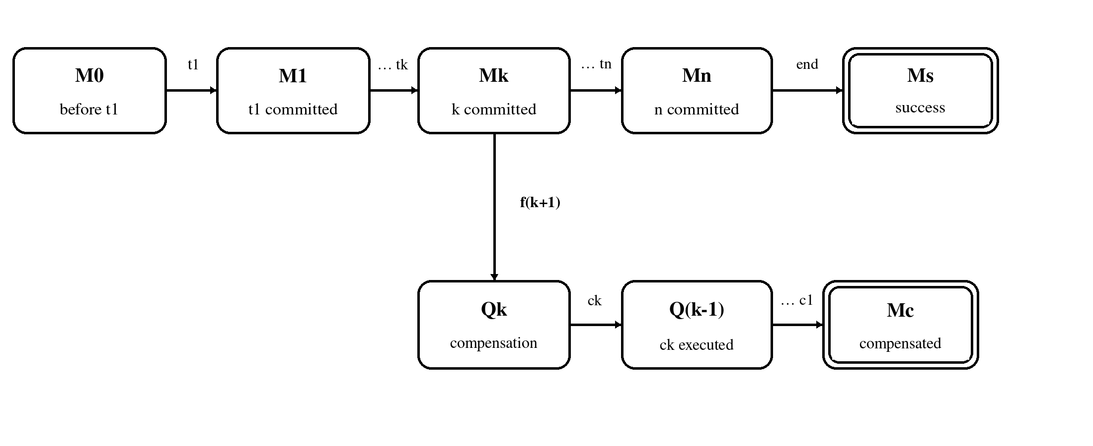
Figure 1.9. Reachability-Graph Projection for a Generic SAGA
Source: Author, adapted from Murata (1989) and Reisig (2013)
The upper path reaches M_s if every transaction succeeds. The lower branch leaves M_k after f_(k+1), then passes through Q_k, Q_(k-1), ..., to M_c. Token conservation makes the outputs mutually exclusive. A branch with no successor before M_s or M_c would constitute an erroneous deadlock.
For n transactions, the sequential model grows linearly. Adding parallelism, choices, and timing constraints can nevertheless cause combinatorial explosion. Property-preserving reductions, partial orders, or a colored net can then group instances without losing their identities (Jensen & Kristensen, 2009).
R = {M | there exists a sequence σ such that M₀ [σ⟩ M}. Termination: for every M in R, M_s or M_c is reachable from M. | (1.12)

1.1.6.16 Correspondence with an Event Driven SAGA Execution
The Petri net is a behavioral model, not an execution engine. A place represents durable coordination state; a direct transition represents a committed business command; a failure transition represents definitive exit from the nominal path; and a compensating transition represents a corrective command. The token identifies the active state of an instance.
Operational correspondence. Place pᵢ ↔ state ‘i direct transactions committed’ in the durable log. Transition tᵢ ↔ local command followed by a success event. Transition fᵢ ↔ unrecoverable-failure event or retry-policy exhaustion. Transition cᵢ ↔ idempotent compensating command followed by a success acknowledgement. | (1.13)
The orchestrator persists the new state together with the event that materializes the firing. An append-only log reconstructs the marking after a failure: Replay(J) = M. Replaying history J must produce the same state as the orchestrator. Reisig (1998) similarly connects concurrency models and distributed algorithms.
With at-least-once delivery, the application transition must be idempotent: repeating a command with the same saga key creates no second effect. Logically, the net fires the transition only once. A transactional outbox, deduplication, and a correlation identifier implement this assumption.
Bounded retries remain distinct from compensation. While an error is transient, the state remains attached to the same action. After the retry threshold is exceeded or an error is declared permanent, f_i fires. If c_i fails, a waiting place q_i and explicit retry or human-intervention transitions must be provided.
In e-government, a case file may cross several autonomous agencies. Each retains its local transaction and database, while the saga log preserves order and evidence. Compensation cancels a reservation, invalidates a provisional number, or creates a corrective entry without erasing the legal record.

1.1.7 Mathematical Formalism of Microservice Granularity in E-Government Systems
Before measuring any property of a microservice, the term must first be defined precisely in mathematical terms. This approach may appear overly abstract, but its purpose is practical: without a formal definition, every discussion of granularity remains subjective. One architect may judge a service 'too large' while another considers it 'appropriately sized,' with no objective means of deciding between them. Defining a service as a mathematical object composed of precise, measurable elements establishes a basis for quantitative analysis. Each of the seven elements in the tuple below captures a different facet of the service's identity: what it does, the data it owns, how it communicates, the team that maintains it, and its degree of internal cohesion or external coupling.
Building on Newman's (2021) foundational work on microservice architecture and related formalization efforts (Bucchiarone et al., 2020), a microservice is defined here as a mathematical object characterized by seven fundamental components. Let microservice S be formally defined as the following 7-tuple:
where:
$F=\{f_{1},f_{2},…,f_{m}\}$ is the set of business functions or capabilities performed by the service (Newman, 2021). Cardinality $\left|F\right|=m$ represents the service's functional scope.
$D=\{d_{1},d_{2},…,d_{n}\}$ is the set of data entities owned exclusively by the service, consistent with Richardson's (2018) database-per-service model. Cardinality $\left|D\right|=n$ indicates the extent of data ownership.
$I=\{i_{1},i_{2},…,i_{p}\}$ is the set of incoming interfaces or API endpoints exposed by the service. Cardinality $\left|I\right|=p$ measures the service's external interaction surface (Fielding, 2000).
$E=\{e_{1},e_{2},…,e_{q}\}$ is the set of outgoing events published to other services, consistent with event-driven architecture principles (Vernon, 2013). Cardinality $\left|E\right|=q$ quantifies the scope of the service's event publication.
$T=\{t_{1},t_{2},…,t_{r}\}$ is the set of members of the team responsible for the service. Cardinality $\left|T\right|=r$ represents team size and implements the‘two-pizza team’ principle commonly associated with Amazon.
$C∈\left[0,1\right]$ is the cohesion score measuring functional relatedness within the service (Yourdon & Constantine, 1979).
$R∈\left[0,1\right]$ is the coupling score measuring dependencies between this service and others (Stevens et al., 1974). (1.14)
This definition extends Dehghani's (2022) work on data-mesh architectures by explicitly incorporating team structure and deployment characteristics as first-order properties in the service formalization.

1.1.7.1 Granularity Cohesion and Coupling Metrics

1.1.7.2 Granularity Score Function
Consistent with the analytical framework proposed by Taibi and Lenarduzzi (2018) for assessing microservice granularity, a composite granularity score is defined by aggregating four distinct dimensions. Let G(S) be the granularity score of service S, defined as follows:
where:
with $T_{opt}=8$ representing the target team size, $d_{max}=10$ representing the maximum weekly deployment frequency (Humble & Farley, 2010), and α, β, γ, δ weights satisfying $α+β+γ+δ=1$. Granularity score $G\left(S\right)∈\left[0,1\right]$, where $G\left(S\right)→0$ indicates a maximally coarse service (a monolith), while $G\left(S\right)→1$ indicates a maximally fine-grained service (a nanoservice). The inverse terms are important: a service with very few functions (small $\left|F\right|$) or very little owned data (small $\left|D\right|$) obtains high g_business or g_data values, correctly moving G(S) toward the nanoservice end of the spectrum. In this proposed decision rule, the target interval for maintainable microservices is $0.3≤G\left(S\right)≤0.7$. (1.15)
This formulation extends work on service granularity by providing a quantifiable metric calculated from observable service characteristics. It addresses a critical gap in applying microservice architecture to e-government systems. Public systems operate at municipal, provincial, and national levels, each with distinct legal mandates, funding models, and operational rhythms. Granularity appropriate for a national identity registry may be too coarse for a municipal permit system. The formalism provides a common language for discussing these differences and makes previously implicit trade-offs explicit. For example, G(S) allows an architect to state: 'This national service has a granularity score of 0.28, below the optimal threshold of 0.3; it may therefore be too coarse and should be considered for decomposition.' Without this quantification, architectural debates remain subjective and often reduce to arguments from authority or anecdotal observation.

1.1.7.3 Cohesion Metric
Determining appropriate microservice granularity requires evaluation of several essential dimensions. First, business-domain boundaries derived from Domain-Driven Design (DDD) are fundamental. Every microservice should correspond to a bounded context: an autonomous domain with clear business meaning. At the national level, this requires defining core domains such as citizen identity, taxation, and registries; at provincial and municipal levels, services extend these domains through contextual logic. A key rule is to avoid splitting one service across several administrative domains, so that every service has a clearly identified and accountable business owner.
Second, granularity must balance autonomy and coordination. Highly autonomous services can evolve independently, but excessive granularity raises coordination costs by proliferating inter-service communication. Coarser services may be preferred at the national level to reduce communication complexity, whereas finer granularity at local levels can support innovation and flexibility. Granularity should therefore increase with the degree of decentralization and autonomy.
Third, event cohesion and data ownership are essential in event-driven architectures. Every microservice should produce meaningful, self-contained events reflecting a coherent business process. If an event depends on data from several domains, the service may be too fine-grained; conversely, overly broad events may reveal excessive granularity. Each service should therefore own a unique and coherent event stream, such as CitizenRegistered, LicenseIssued, or PaymentCompleted, to ensure clarity and interoperability.
The concept of cohesion, introduced by Yourdon and Constantine (1979) for modular software design, is adapted here to assess microservice granularity. Let cohesion(S) measure the degree of functional relatedness within service S, defined as follows:
where $m=\left|F\right|$ is the number of functions, $w_{ij}∈\left[0,1\right]$ is the relationship weight between functions i and j, and $r_{ij}∈\{0,1\}$ is an indicator function such that $r_{ij}=1$ when functions i and j are semantically related, and 0 otherwise. (1.16)
According to the analysis by Bogner et al. (2019), the cohesion metric has the following properties:
• $cohesion\left(S\right)∈\left[0,1\right]$ (1.17)
- Higher values indicate stronger internal functional cohesion.
• Target interval: $0.7≤cohesion\left(S\right)≤0.90$ (1.18)
• If $cohesion\left(S\right)<0.6$: consider splitting the service (Kalske et al., 2018) (1.19)
• If $cohesion\left(S\right)>0.95$: consider merging it with related services (1.20)
This metric operationalizes the principle of high cohesion within services described in microservice architecture literature (Newman, 2021; Richardson, 2018).
One of the most common failures in microservice adoption is the creation of what practitioners call a 'distributed monolith': a system deployed as many separate services that retains all the coupling and coordination costs of a monolith without obtaining its benefits. This antipattern arises when services are divided by technical criteria, such as separating database access from business logic, rather than by business capabilities. The cohesion metric cohesion(S) directly addresses this problem. By measuring how strongly functions belong together, it penalizes decompositions that separate closely related functions. If a citizen-registration process requires the functions validate identity, create record, issue certificate, and send notification, those functions have strong semantic proximity. Distributing them across separate services would create unnecessary network calls and coordination complexity, likely producing low cohesion values that warn architects before implementation. The weighting function w_ij can be calibrated to domain-specific relationships, making the metric adaptable to different public-service contexts.

1.1.7.4 Coupling Metric
Coupling, a fundamental software-engineering concept introduced by Stevens et al. (1974), is adapted here to measure inter-service dependencies. Let coupling(S,T) measure the degree of dependency between services S and T, defined as follows:
where I_S and I_T are the sets of incoming interfaces of services S and T, respectively, and E_S and E_T are their outgoing event sets. The total coupling of service S is defined as follows:
According to Soldani et al. (2018) and Taibi and Lenarduzzi (2018), the coupling metric has the following properties:
• $C\left(S\right)∈\left[0,1\right]$ (1.21)
- Lower values indicate better isolation (Weick, 1976).
• Acceptable value: $C\left(S\right)≤0.3$ (1.22)
• If $C\left(S\right)>0.5$: consider merging it with strongly coupled services (1.23)
• If $C\left(S\right)<0.05$: verify whether the service is excessively isolated (1.24)
This formalization transforms the loose-coupling principle of microservice architecture (Newman, 2021) into a quantifiable metric. Coupling is particularly important in e-government systems spanning several administrative levels. When a municipal service depends on a national registry for identity verification, the coupling is not only technical but also organizational and political. Changes to the national registry API require coordination across levels of government, and failures of the national system may propagate to municipal services. Coupling score C(S) quantifies this vulnerability. A high score for a municipal service indicates excessive dependence on external systems that may violate local-autonomy principles or create unacceptable risk. The formalism therefore suggests designing services to minimize coupling across levels in accordance with subsidiarity, especially where subnational governments possess constitutionally protected autonomy.

1.1.7.5 Decision Score Framework

1.1.7.6 Granularity Decision Score
Consistent with the multicriteria decision-analysis framework developed by Saaty (1980) and adapted to software-architecture evaluation by Kazman et al. (2000), a decision score aggregates several granularity criteria. Let D(S) be the decision score for service S, defined as follows:
Accordingly, the normalized weighted decision score is defined as follows:
Where $d_{i}∈\{0,1\}$ is an indicator variable equal to 1 when criterion i is satisfied and 0 otherwise, and $w_{i}$ is the weight assigned to criterion i (Table 1.8). Consistent with the analytic hierarchy process (Saaty, 1980), the proposed rule adopts a supermajority threshold: (1.25)
Decision score D(S) and its associated criteria serve not only as a design tool but also as a governance mechanism. In large e-government programmes, architectural decisions are often made by distributed teams, increasing the risk of inconsistent design standards. The fifteen explicitly weighted criteria provide a common framework for evaluating proposed service boundaries. The threshold $D\left(S\right)≥0.67$ establishes a clear acceptance rule, reduces ambiguity, and supports objective review. The criteria combine established software-engineering practices—single responsibility, bounded context, and data ownership—with public-administration concerns such as administrative scope and governance accountability. This interdisciplinary foundation makes the framework particularly suitable for e-government contexts, where technical and administrative considerations must be balanced. (1.26)

1.1.7.7 Weighting of Decision Criteria
Following the architecture-evaluation methodology of Cervantes et al. (2016), weights are assigned to fifteen decision criteria according to their relative importance in microservice design. The weighting scheme reflects the foundational importance of Domain-Driven Design principles (criteria 1-4), as established by Evans (2003) and Vernon (2013), while operational considerations (criteria 5-15) receive lower but still significant weights.
Table 1.8. Granularity Decision Criteria and Weights
# | Criterion | Description | Weight
1 | Business capability | Aligns with a clearly defined business domain | 2
2 | Bounded context | Belongs to one DDD bounded context | 2
3 | Single responsibility | Has one reason to change | 2
4 | Data ownership | Uses independent data storage | 2
5 | Dependency analysis | Minimizes calls to other services | 1
6 | Communication cost | Maintains acceptable network latency | 1
7 | Scalability need | Can scale independently | 1
8 | Deployment unit | Can be deployed independently | 1
9 | Failure isolation | Contains the impact of failure | 1
10 | Event cohesion | Produces meaningful business events | 1
11 | Administrative scope | Aligns with municipal, provincial, and national tiers | 1
12 | Governance accountability | Has a clearly identified institutional owner | 1
13 | Operational complexity | Creates an acceptable DevOps burden | 1
14 | Evolution potential | Can evolve independently over time | 1
15 | Final validation | Balances autonomy, performance, and simplicity | 1
 | Total weight |  | 18
Source: Author, adapted from Evans (2003), Saaty (1980), and Vernon (2013)

1.1.7.8 Optimal Granularity Theorem
For every domain D, an optimal service partition exists $S_{1},S_{2},…,S_{k}$ such that the following constraints are satisfied: (1.27)
The existence of an optimal partition follows from the finite nature of function space F. The number of possible partitions of F is bounded by Bell number $B_{\left|F\right|}$, which is finite. Consequently, a finite optimization problem with a well-defined objective function has at least one global optimum (Luenberger & Ye, 2016). (1.28)
The optimal partition $\{S_{1},S_{2},…,S_{k}\}$ minimizes the total-cost function: (1.29)
where α, β, γ, δ are weights satisfying $α+β+γ+δ=1$. This formulation is consistent with the economics of software architecture proposed by Conway (1968) and extended by Baldwin and Clark (2000) in their analysis of modularity in complex systems. (1.30)

1.2 Theoretical Framework
The theoretical framework combines Domain Driven Design, CQRS, event sourcing, event driven interaction, and multilevel information flow. Together, these perspectives explain how service boundaries are defined, how state and auditability are managed, how autonomous services exchange information, and how digital coordination operates across municipal, provincial, and national levels.

1.2.1 Domain Driven Design Principles
The increasing complexity of modern e-government ecosystems demands architectural and methodological approaches that align technology with institutional realities, policy objectives, and citizen needs. Traditional system design often treats software as a purely technical artifact, leading to rigid, fragmented solutions that fail to reflect the nuanced structure of public administration.
Domain Driven Design offers a different starting point. Evans (2003) presents it as a discipline in which a shared domain model guides implementation, design, and team communication. Rather than treating software and the administrative domain as separate concerns to be reconciled later, DDD aligns them from the outset. In e-government, this alignment helps the architecture reflect the legal mandates, responsibilities, language, and processes of public institutions instead of imposing a generic technical model on them.
In e-government, where multiple ministries, agencies, and institutions interact to deliver integrated public services, DDD offers a principled approach to designing systems that are modular, interoperable, and policy-aligned, bridging the gap between digital infrastructure and governance processes. DDD organizes both the strategic structure and the tactical implementation of a system around twelve interdependent concepts, summarized in Table 1.9 with their specific application to the e-government context this dissertation addresses.
Table 1.9. Core Components of Domain-Driven Design
Component | Definition | E-Government Application
Domain | The core area of activity, encapsulating specific rules and workflows, modeled with policy experts. | Taxation, Healthcare, Justice
Subdomain | A smaller segment within a domain, supporting modular development mapped to organizational units. | “Patient Management” within “Health”
Bounded Context | The explicit boundary within which a domain model applies, preventing semantic confusion. | “Citizen” in Taxation differs from “Citizen” in Healthcare
Ubiquitous Language | A shared vocabulary developed by domain experts and developers together. | Standardizes terms like “case” or “filing” across code, policy, and documentation
Entities | Objects with a unique, persistent identity over time. | “Citizen,” “Company,” “Property” — supports “once-only” data collection
Value Objects | Immutable concepts defined by their properties, not an identity. | “Address,” “Date of Birth,” “Tax Rate”
Aggregates | A cluster of entities and value objects treated as one unit; a root entity enforces consistency. | A “Business Entity” with its Owner, Address, and Licenses
Repositories | Mediators providing controlled access to aggregates, abstracting storage operations. | A “CitizenRepository” supporting data sovereignty
Domain Services | Business logic that does not naturally belong to a single entity. | A “TaxComputationService” for cross-cutting rules
Application Services | Coordinates domain objects and external systems, keeping orchestration separate from business logic. | A “CitizenRegistrationService” manages requests and transactions
Domain Events | Significant business occurrences enabling asynchronous, event-driven interoperability. | “ChildBirthRegistered” triggers healthcare and education updates
Context Maps | Visualizations of how bounded contexts relate, using integration patterns. | Shows how Population Registry integrates with Taxation and Healthcare
Source: Author, adapted from Evans (2003)

1.2.2 Command Query Responsibility Segregation
Command Query Responsibility Segregation (CQRS) separates the operations that modify data (commands) from those that retrieve data (queries) into distinct models. The pattern extends “command-query separation,” a principle Bertrand Meyer introduced at the level of a single method in Object-Oriented Software Construction, up to the level of an entire model. Martin Fowler, who did much to popularize the resulting pattern, credits its specific formulation to Greg Young and describes its essence directly: CQRS is “the notion that you can use a different model to update information than the model you use to read information” (Fowler, 2011).
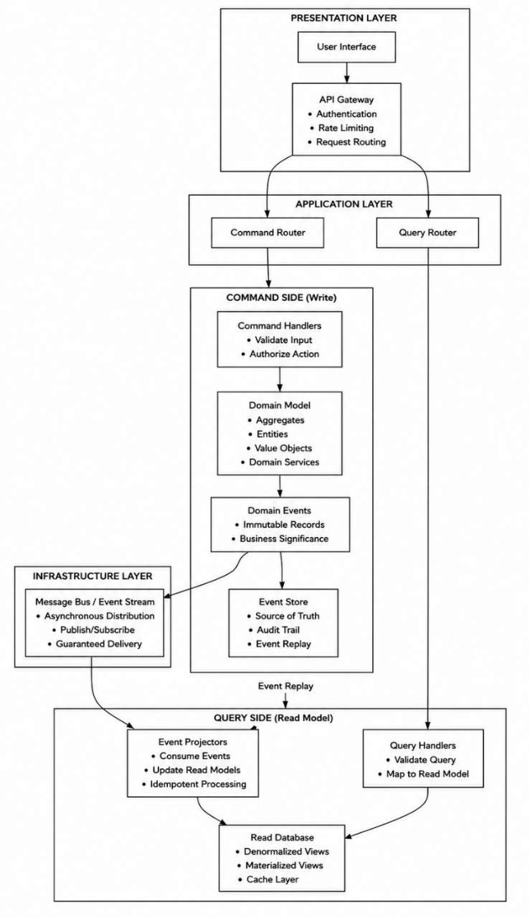
Figure 1.10. Layered CQRS and Event-Sourcing Architecture
Source: Author, adapted from Richardson (2018)
Fowler's own caution about the pattern is worth carrying into this dissertation's design choices directly: CQRS, in his assessment, “adds risky complexity” for most systems and should be applied only “on specific portions of a system” rather than adopted wholesale (Fowler, 2011). This is precisely why the framework proposed later in this dissertation confines CQRS to the specific bounded contexts — civil registration chief among them — where the write/read asymmetry is sharpest, rather than treating it as a default pattern across every government domain.

1.2.3 Event Sourcing
Event sourcing is an architectural pattern that fundamentally reimagines how state is persisted. Rather than overwriting a record with its current values, it stores every change to an application's state as an immutable, append-only sequence of events — captured, in Martin Fowler's now-standard definition, simply as the discipline to “capture all changes to an application state as a sequence of events” (Fowler, n.d.), an idea Fowler traces to the same originator as CQRS, Greg Young. The system's state at any point in time is therefore never stored directly; it is derived by replaying all events that have occurred for a given aggregate, producing a complete and verifiable audit trail of every business action.
When a command is received — registering a citizen, say, or processing a tax payment — the system loads all past events for that aggregate, rebuilds the current state by applying them in order, executes business logic to validate the command against invariants, and then appends one or more new domain events to the event store, each representing an immutable fact of what occurred. This event store serves as the single source of truth, while separate read models are built asynchronously by projectors that consume these events and populate denormalized views optimized for querying. Snapshots of aggregate state can be taken periodically to optimize performance, allowing the system to bypass replaying long event streams during reconstruction.
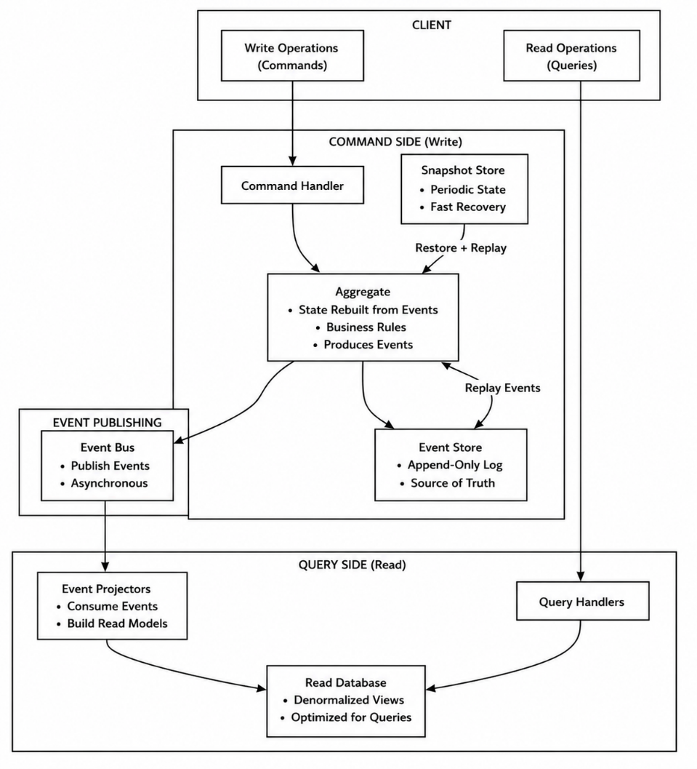
Figure 1.11. CQRS and Event-Sourcing Data Flow
Source: Author, adapted from Richardson (2018)
Event sourcing naturally complements CQRS and DDD, enforcing a clean separation between the write side, where domain logic and consistency boundaries reside within aggregates, and the read side, where events drive projections that keep query models eventually consistent. For e-government systems specifically, this delivers complete auditability for compliance and transparency, the ability to reconstruct system state at any historical point for forensic analysis, the capacity to introduce new read models without modifying the source of truth, and optimistic concurrency control through event versioning.

1.2.4 Event Driven Service Production and Consumption
In the proposed event-driven microservices architecture, each service is modeled as an autonomous producer and/or consumer of events, rather than as a component dependent on direct point-to-point communication with a single predefined service. As illustrated in the figure, a service may consume events generated by one or several other services, while simultaneously publishing its own events for one or several interested services. Consequently, the relationship between services is not restricted to one-to-one communication but supports one-to-many, many-to-one, and many-to-many event interactions. This abstraction is particularly relevant to the heterogeneous information systems of public administration, where the same administrative event may be relevant to several institutions, while a given public service may require information originating from multiple administrative domains.
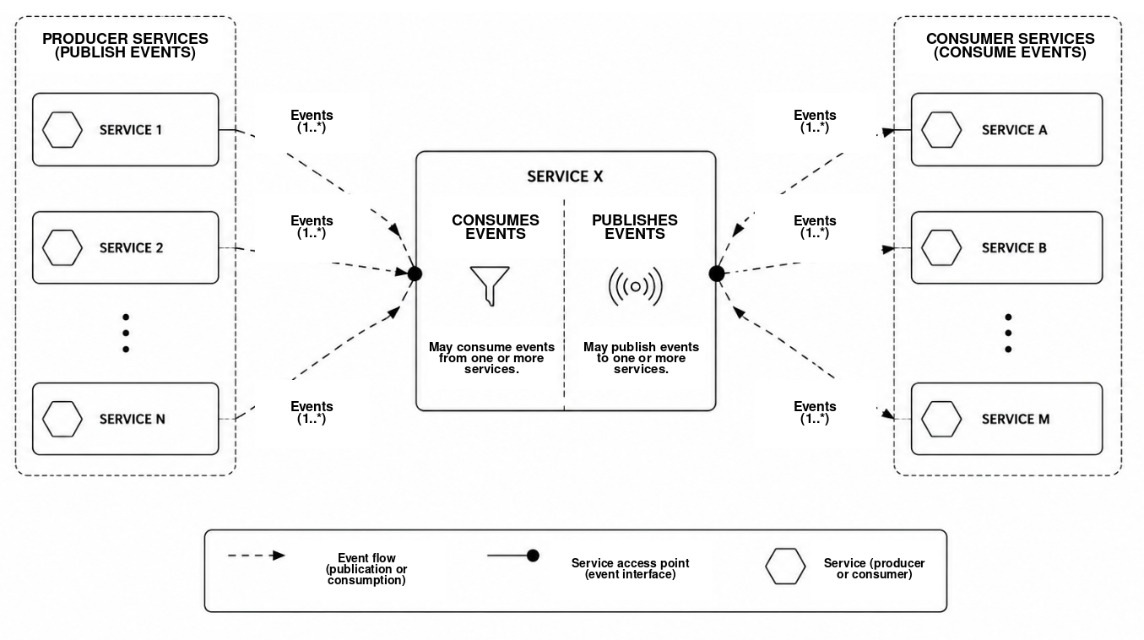
Figure 1.12. Inter-Service Event Production and Consumption Formalism
Source: Author
This formalism contributes to the loose coupling, autonomy, scalability, and interoperability required by the architecture proposed in this thesis. A consuming service does not need to depend on the internal implementation, programming language, database, or technological platform of the producing service; it only needs to understand the agreed event structure and semantics. Likewise, a producer can publish an event without being tightly coupled to the number or identity of the services that may use it.
In public administration, this principle enables heterogeneous municipal, provincial, and national services to exchange information while preserving their operational autonomy. It also facilitates the progressive integration of new services, since additional consumers or producers can participate in the event ecosystem without requiring substantial modification of existing services, provided that they comply with the established event contracts, semantic standards, and interoperability rules.

1.2.5 Information Flow in a Multilevel Environment
The figure illustrates three complementary directions of information and knowledge flow—upward, downward, and lateral—within a multilevel public administration. Rather than treating municipal, provincial, and national administrations as isolated organizational units, the model represents them as interconnected levels in which information is progressively transformed according to the purpose and direction of the exchange. The central principle is that the nature of information changes as it moves through the administrative hierarchy: upward flows tend toward aggregation and abstraction, downward flows toward interpretation and contextual adaptation, while lateral flows emphasize coordination, synchronization, and mutual learning.
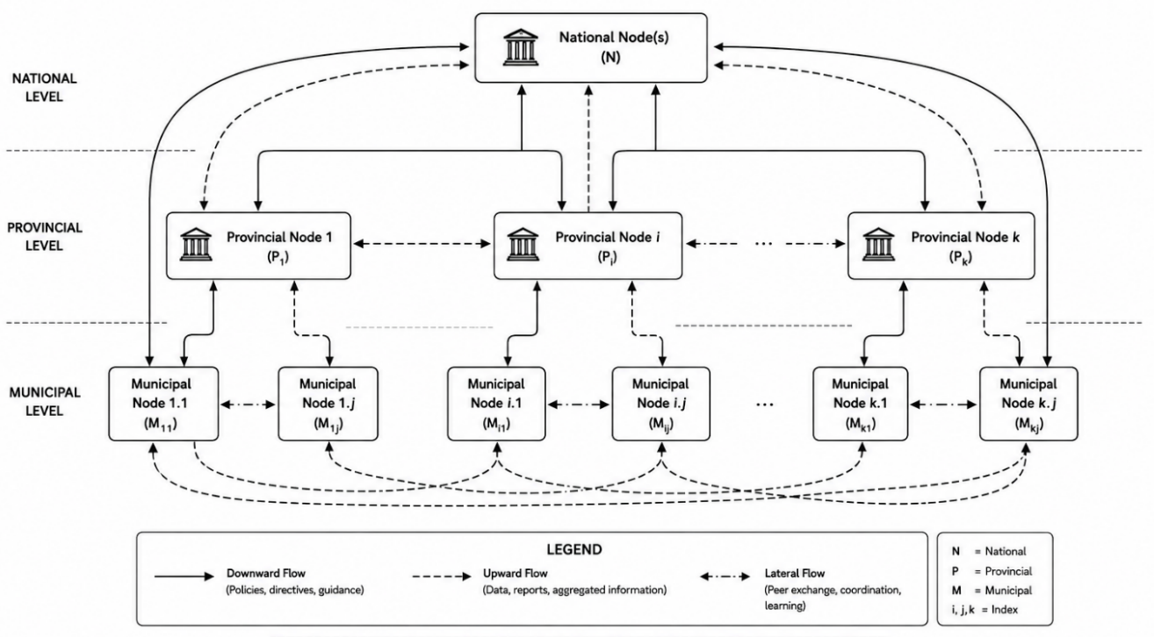

Figure 1.13. Multilevel Information Exchange Network
Source: Author

1.2.5.1 Upward Flow Aggregation and Abstraction
The upward flow transforms detailed municipal data into strategic national information. Municipal transactions and service records are aggregated into provincial indicators and then abstracted into national intelligence. As information moves upward, its volume and operational detail decrease, while its value for policymaking, planning, forecasting, resource allocation, and performance evaluation increases.

1.2.5.2 Downward Flow Interpretation and Adaptation
The downward flow converts national policies, laws, standards, and strategies into locally executable actions. National directives are interpreted as provincial guidelines and adapted to municipal conditions. This process preserves mandatory requirements while accommodating differences in infrastructure, resources, connectivity, geography, population, and institutional capacity.

1.2.5.3 Lateral Flow Synchronization and Learning
The lateral flow enables information exchange among municipalities or provinces operating at comparable levels. Peer administrations share data, innovations, technical solutions, good practices, and lessons learned. This interaction supports synchronization, cooperation, organizational learning, and the reuse of successful approaches, thereby reducing duplication and promoting interoperability across the public administration.

CHAPTER II. RESEARCH METHODOLOGY

2.1 Introduction
This chapter explains how the research problem was investigated, how the proposed interoperability artifact was designed, and how the evidence used in the thesis was produced and evaluated. The study addresses a socio-technical problem in which government information systems, administrative responsibilities, legal rules, data meanings, infrastructure, and professional practices interact. A single descriptive method could identify fragmentation but could not by itself produce and validate an implementable solution. The research therefore uses Design Science Research as the principal paradigm, supported by an embedded DRC case study and several distinct evidence streams.
The methodology separates the architecture from the research method. The event-driven microservices architecture is the principal artifact created by the study; it is not itself the methodology. The methodology comprises the procedures used to diagnose the problem, derive requirements, construct the artifact, demonstrate its operation, assess its technical and institutional suitability, and communicate the resulting knowledge. This distinction makes the chain from research questions to evidence and conclusions explicit.
The chapter is organised in thirteen stages. It presents the research paradigm and Design Science Research process, defines the case and unit of analysis, explains the population and purposive sampling, documents the data-collection instruments and fieldwork period, specifies the quantitative and qualitative analysis procedures, describes prototype and benchmark evaluation, and addresses expert review, research quality, ethics, limitations, and alignment with the research questions. Survey evidence, qualitative evidence, prototype measurements, and expert judgements remain separate datasets and are combined only through documented triangulation.

2.2 Research Paradigm and Overall Design

2.2.1 Design Science Research Rationale
This study adopts the Design Science Research paradigm because it creates and evaluates an information-technology artifact intended to solve an identified organisational problem. Hevner et al. (2004) distinguish design science from behavioural research by its focus on useful constructs, models, methods, and instantiations. March and Smith (1995) similarly treat building and evaluation as complementary activities through which design knowledge is produced. These principles suit a study that must explain the fragmentation of public information systems and also demonstrate a feasible interoperability response.
The selected paradigm combines relevance and rigour. Relevance is established through evidence from DRC institutions, observation of administrative practices, documentary analysis, and the constraints of municipal, provincial, and national governance. Rigour is provided through established theory, explicit requirements, traceable design decisions, repeatable implementation procedures, and systematic evaluation. The resulting contribution is judged both by whether it works under defined conditions and by whether it adds reusable knowledge about e-government interoperability in a developing-country setting.

2.2.2 Embedded Case Study and Multiple Evidence Strategy
Design Science Research is supported by an embedded case study of the DRC e-government interoperability ecosystem. The case is embedded because evidence is collected from several institutions and professional roles within one national administrative context. The approach permits analysis of legal, organisational, semantic, and technical dimensions while retaining the relationships among them. Case-study logic also supports the use of documents, interviews, observations, questionnaire responses, prototype tests, and expert assessment as complementary forms of evidence (Yin, 2018).
The study follows a mixed-evidence strategy rather than treating every source as one statistical sample. The questionnaire provides descriptive indicators for 34 respondents. Interviews and observations explain processes and institutional constraints. Documents establish formal mandates and policy conditions. The Gombe and Lemba deployments produce technical measurements, and expert assessment evaluates relevance, completeness, feasibility, and contextual fit. Table 2.1 states the analytical role and boundary of each stream.
Table 2.1 Research Design and Evidence Streams
Evidence stream | Scope | Analytical role | Boundary
Institutional questionnaire | 34 purposively selected participants | Descriptive diagnosis of systems, integration, exchange, infrastructure, and perceived need | Case sample; not a national probability estimate
Interviews and direct observation | Fieldwork in 24 Kinshasa offices from 15 March to 30 June 2024 | Explanation of processes, authority, constraints, and reported practices | Contextual evidence; not the questionnaire denominator
Documentary evidence | Laws, strategies, standards, institutional and project documents | Formal mandates, policy context, and comparison with reported practice | Documents reflect their issuing institutions and dates
Prototype and benchmarks | Two remote VPS environments representing Gombe and Lemba | Functional, performance, resilience, and interoperability evaluation | Technical dataset separate from the field survey
Expert assessment | Selected public-sector, ICT, legal, governance, and security specialists | Assessment of relevance, completeness, feasibility, and improvements | Judgement evidence analysed separately from benchmark measurements
Source: Author's research design

2.2.3 Artifact Types and Research Outputs
The study produces outputs in the four artifact categories identified by March and Smith (1995). Constructs define the concepts used to describe interoperability and microservice granularity. Models represent the multilevel architecture, event flows, distributed transactions, and maturity states. Methods specify how services are designed, onboarded, governed, secured, and evaluated. The instantiation is the working prototype deployed across two remote environments. Table 2.2 links these artifact types to concrete thesis outputs and their evaluation.
Table 2.2 Design Science Artifacts Produced by the Study
Artifact type | Output in this research | Evaluation basis
Constructs | Interoperability dimensions, event-contract concepts, service granularity, cohesion, coupling, and governance terms | Conceptual consistency, literature grounding, and expert review
Models | Four-layer interoperability framework, municipal-provincial-national architecture, event model, SAGA and Petri-net models, and maturity model | Requirements traceability, scenario walkthroughs, formal analysis, and contextual fit
Methods | Service-boundary decisions, onboarding, event publication, API management, SAGA compensation, CQRS, governance, security, and evaluation procedures | Repeatability, completeness, implementation evidence, and expert assessment
Instantiation | Containerised heterogeneous microservices and supporting infrastructure deployed in Gombe and Lemba environments | Functional tests, benchmarks, failure-recovery tests, and observed resource use
Source: Author, based on March and Smith (1995)

2.3 Design Science Research Process
The research follows the six activities proposed by Peffers et al. (2007): problem identification, definition of objectives, design and development, demonstration, evaluation, and communication. The activities are presented in a logical order, but the work was iterative. Evidence gathered during demonstration or evaluation could expose a missing requirement and return the study to an earlier design activity. Figure 2.1 shows this feedback relationship.
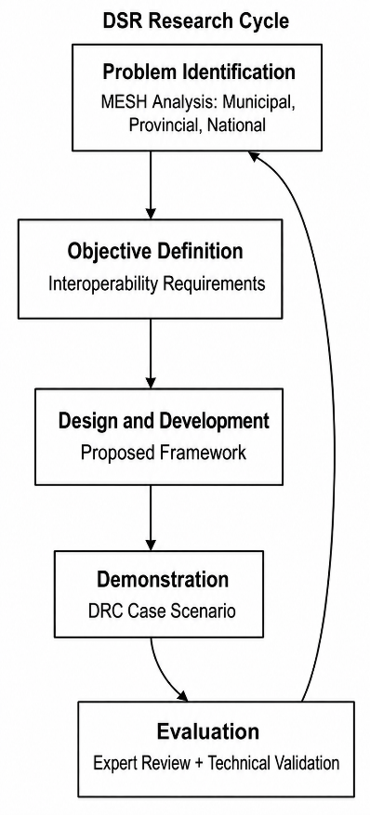
Figure 2.1 Design Science Research Cycle Applied to the Study
Source: Author, based on Peffers et al. (2007)

2.3.1 Problem Identification and Motivation
The first activity defines the practical and scientific problem. The empirical diagnosis examines whether DRC public institutions possess operational systems, whether those systems are integrated within or across institutions, how data are exchanged, and whether APIs, protocols, cloud services, data centres, registries, or common frameworks are available. Interviews, observations, and documents explain why gaps persist and how they affect service delivery, accountability, duplication, and citizens' administrative burden.
The problem statement is not derived from questionnaire percentages alone. The study combines the descriptive indicators with documentary evidence and observed administrative practices. This provides the relevance base for the artifact while keeping claims within the limits of a purposive institutional sample.

2.3.2 Definition of Objectives for a Solution
The second activity converts the diagnosed problem into design objectives and measurable requirements. The artifact must support legal, organisational, semantic, and technical interoperability; preserve the constitutional responsibilities of municipal, provincial, and national administrations; integrate heterogeneous and legacy systems; and support controlled data exchange. Non-functional objectives include security, auditability, availability, scalability, resilience, maintainability, and acceptable performance under remote and constrained network conditions.
Objectives are represented through requirements, service contracts, event schemas, governance rules, and evaluation criteria. Each requirement is linked to one or more research questions and to evidence used later in the evaluation. This traceability prevents the artifact from being assessed against criteria introduced only after implementation.

2.3.3 Design and Development
Design and development produce the event-driven microservices interoperability artifact. Domain-Driven Design defines bounded contexts and service responsibilities. CQRS separates command and query responsibilities where their workloads and consistency needs differ. Event sourcing, the transactional outbox, idempotent consumers, SAGA compensation, service discovery, API management, and security controls address the consequences of distributed state and autonomous services. The architecture also defines municipal, provincial, and national exchange layers and the rules governing upward, downward, and lateral information flows.
Development translates these models into heterogeneous services, independent data stores, containers, deployment descriptors, event contracts, monitoring configuration, and test scenarios. Iterative refinement is recorded through design decisions and versioned implementation artefacts so that architectural claims can be related to executable components.

2.3.4 Demonstration
The demonstration activity shows how the artifact addresses a concrete government-interoperability scenario. A public event such as citizen registration is published by the responsible service and consumed by authorised services that require the information. Synchronous interfaces are used where an immediate answer is necessary, while asynchronous events reduce temporal coupling and allow consumers to recover and continue processing after temporary failure.
The prototype demonstrates service discovery, gateway routing, independent persistence, event publication and consumption, correlation identifiers, idempotency, and distributed-transaction handling. The demonstration establishes technical feasibility under defined laboratory conditions; it does not claim that the prototype is already a production national platform.

2.3.5 Evaluation
Evaluation compares the artifact with the objectives defined earlier. Functional tests verify API behaviour, service registration, event exchange, database interaction, access controls, idempotent processing, and SAGA compensation. Performance tests measure latency percentiles, response time, throughput, availability, scalability, and resource utilisation. Failure tests examine service interruption, timeouts, retries, broker or network disruption, compensation, and recovery toward eventual consistency.
Technical evidence is complemented by expert and stakeholder assessment of relevance, completeness, feasibility, governance, security, and contextual suitability. The evaluation is both formative and summative. Formative findings guide revisions during development; summative results support the conclusions reported in the results and evaluation chapters.

2.3.6 Communication
The final activity communicates the problem, method, artifact, evidence, limitations, and contribution. Outputs include the doctoral thesis, architectural models, implementation guidance, the phased DRC roadmap, technical specifications, and material suitable for academic and practitioner dissemination. Communication also preserves the chain of evidence required for independent review.
Figure 2.2 consolidates the relationship among the research foundation, DRC problem context, DSR cycle, architecture layers, case demonstration, validation artefacts, and final framework output.

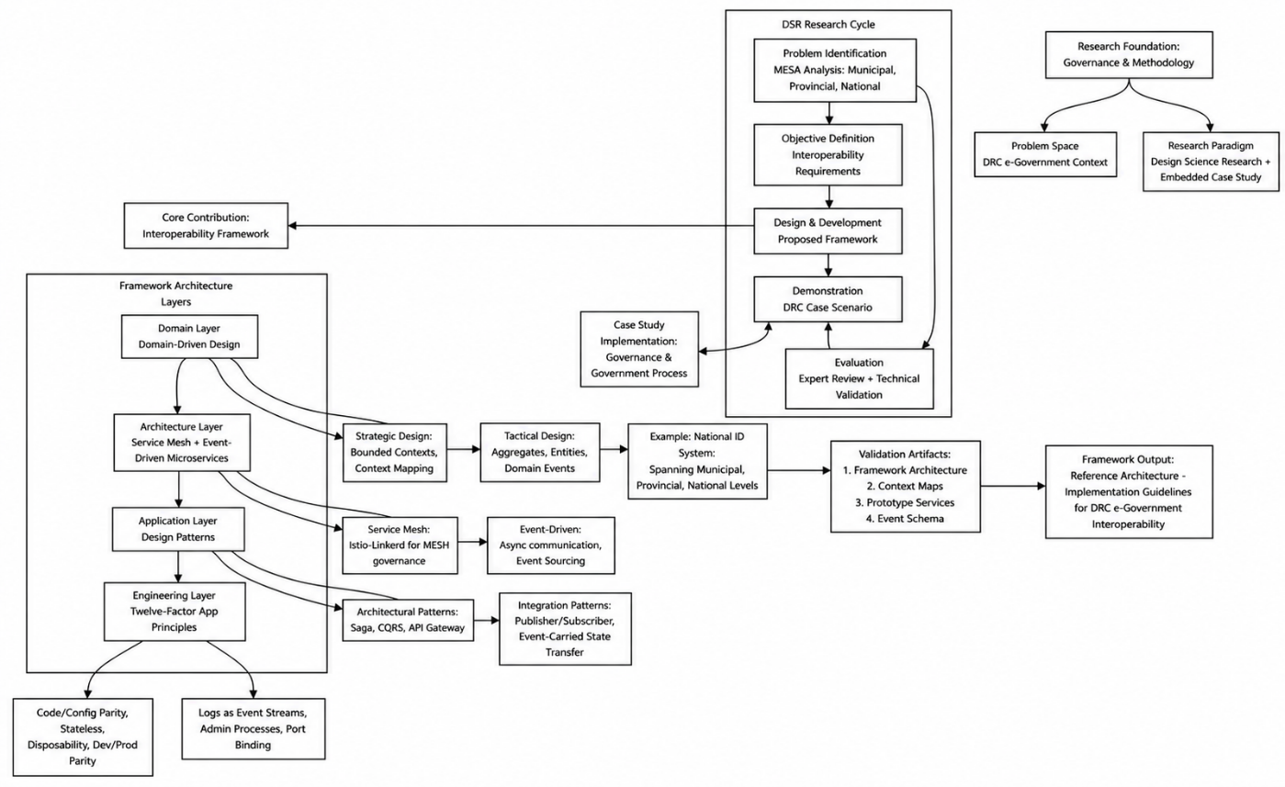
Figure 2.2 Comprehensive Research Methodology and Case Study Integration
Source: Author

2.4 Research Context Unit of Analysis and Case Boundaries

2.4.1 Study Context
The Democratic Republic of the Congo is the institutional setting for the study. Its constitutional decentralisation, 26 provinces, large territory, unequal connectivity, legacy systems, and varying administrative capacity create a demanding environment for interoperability. The study treats these conditions as design constraints rather than as incidental background. The architecture must support national coordination without eliminating the lawful responsibilities and operational autonomy of lower administrative levels.
The case is suitable for Design Science Research because the problem is practically important, theoretically connected to distributed-systems and interoperability research, and accessible through institutional evidence and prototype demonstration. The case also permits analytical transfer to other public administrations with similar fragmentation, while avoiding claims of statistical generalisation beyond the evidence.

2.4.2 Unit of Analysis
The primary unit of analysis is the DRC e-government interoperability ecosystem. It includes public institutions, information systems, administrative processes, legal mandates, data definitions, network and hosting infrastructure, exchange mechanisms, and professional roles involved in producing or using government data. Individual respondents are evidence providers; they are not the ultimate unit of analysis.
The artifact is evaluated as a socio-technical system. Technical success requires more than message transmission. Data must retain meaning, organisations must agree on responsibilities, exchanges must have a lawful purpose, and operations must remain observable and governable. This unit of analysis therefore supports the four interoperability dimensions used throughout the thesis.

2.4.3 Case Boundaries and Evidence Sources
The empirical case covers selected DRC institutions and professional groups with direct knowledge of digital government, public administration, regulation, identity, law, security, or inter-agency exchange. The principal fieldwork period ran from 15 March 2024 to 30 June 2024. Documentary and technical evidence extends beyond that period when required to analyse the artifact or later policy developments, but such evidence is labelled by source and date.
Table 2.3 clarifies which evidence supports each form of analysis. It also prevents the 34-person questionnaire denominator from being incorrectly applied to observations, documents, technical tests, or expert judgements.
Table 2.3 Evidence Sources and Analytical Boundaries
Source | Scope | Use in the research | Boundary
Questionnaire | 34 participants from nine institutional groups | Frequencies and valid-denominator percentages for current-state indicators | Purposive institutional diagnostic
Semi-structured interviews | Fifteen-question guide; usually 60 to 90 minutes | Institutional explanations, constraints, risks, and expected benefits | Anonymised qualitative evidence
Direct observation and notes | 24 offices in Kinshasa | Paper movement, duplicate entry, delays, channels, and operational practice | Observed sites are not a national census
Documents | Legal, policy, strategy, standards, and institutional records | Formal authority, requirements, comparison, and contextual interpretation | Validity depends on issuer, date, and scope
Prototype and logs | Gombe and Lemba remote deployments | Functional, performance, resource, and resilience evidence | Controlled technical environment
Expert instrument | Structured scores and comments | Relevance, completeness, feasibility, and design improvement | Professional judgement rather than benchmark data
Source: Author's evidence inventory

2.5 Population Sampling and Respondent Profile

2.5.1 Population of Interest
The population of interest comprises institutions and professionals involved in DRC digital government, public administration, regulation, public-sector information systems, identity and civil status, inter-agency exchange, law, security, and infrastructure. Eligible participants needed direct knowledge of existing systems, integration practices, policy, governance, or operational constraints. The study did not seek opinions from the general population because the research questions concern institutional interoperability and artifact design.

2.5.2 Purposive Sampling Technique
The study used non-probability purposive sampling. This technique was appropriate because informed evidence required specialised institutional knowledge that could not be assumed in a random population sample (Patton, 2015). Selection aimed to cover policy, administration, reform, regulation, law, security, identity, and external interfaces rather than to reproduce the workforce size of each institution.
The final questionnaire sample contained 34 respondents. The sample size reflects the diagnostic purpose and the diversity of relevant roles; it was not derived from a probability formula. Confidence intervals and national prevalence estimates are therefore inappropriate. Evidential strength comes from informed participation, cross-institutional coverage, and triangulation with interviews, observation, documents, prototype tests, and expert assessment.

2.5.3 Inclusion and Exclusion Criteria
A participant was included when the person belonged to a relevant institution or professional group, had direct knowledge of systems or administrative practice, could address at least one research dimension, and provided voluntary consent. Respondents were excluded from an item-level denominator when they selected do not know, not applicable, or left the item unanswered. Persons without relevant institutional knowledge were not recruited merely to increase the sample size.
Institutional or professional relevance to digital government and public-data exchange
Direct operational, technical, legal, regulatory, policy, or governance knowledge
Capacity to provide informed evidence within the defined case
Voluntary participation and acceptance of the confidentiality arrangements

2.5.4 Institutional Composition of the Sample
The sample deliberately combines several institutional perspectives. Public-service administration provides the largest combined share through the Secretariat General, the Minister's Cabinet, and CMRAP. Digital-economy, regulatory, foreign-affairs, interior, legal, and security participants extend the evidence beyond one ministry. Table 2.4 reports the exact composition.
Table 2.4 Institutional Composition of Questionnaire Respondents
Institution or group | Respondents | Share | Principal relevance
Ministry of Digital Economy | 4 | 11.8% | Digital-government policy
Secretariat General for Public Service | 5 | 14.7% | Administrative systems
Minister's Cabinet for Public Service | 5 | 14.7% | Policy and modernisation
CMRAP | 8 | 23.5% | Reform and implementation
ARPTC | 3 | 8.8% | Regulation and infrastructure
Ministry of Foreign Affairs | 2 | 5.9% | External interfaces
Legal professionals | 2 | 5.9% | Law and accountability
Ministry of Interior and Home Affairs | 3 | 8.8% | Civil status and identity
National Intelligence Agency | 2 | 5.9% | Security and sovereignty
Total | 34 | 100.0% | Analysed purposive sample
Source: Author's field records; n = 34; percentages rounded to one decimal place
The distribution describes the sample and should not be interpreted as the institutional distribution of the entire DRC public service. The table is used to demonstrate source diversity and to support transparent interpretation of the survey results.

2.6 Data Collection Methods and Instruments

2.6.1 Institutional Diagnostic Questionnaire
A standardised 42-item questionnaire supplied comparable institutional indicators. Items 1 to 4 recorded respondent and institutional context. Items 5 to 17 measured current information systems, integration, distributed architecture, APIs, exchange protocols, common frameworks, cloud use, registries, data-centre capability, and perceived need for interconnection. Items 18 to 37 used five-point response scales for barriers, readiness, priorities, and expected benefits. Items 38 to 42 collected open comments and validation information.
Closed items generated frequencies and valid-denominator percentages. Five-point items retained their original direction and were summarised by distribution rather than converted into unsupported interval-scale claims. Open responses were incorporated into the qualitative codebook. The questionnaire was administered directly to selected participants, and the researcher explained the purpose, academic use, voluntary nature, and confidentiality arrangements before acceptance.
Table 2.5 maps the diagnostic items that produce the principal current-state indicators. The table records the analytical procedure, while the results themselves are reported in Chapter 3.
Table 2.5 Questionnaire Items and Diagnostic Indicators
Item or group | Measured indicator | Coding and analytical output
Q5 | Existence of an operational information system | Yes or No frequency and valid-denominator percentage
Q7 and Q8 | Integration within and across institutions | Separate binary distributions for intra-institutional and inter-institutional integration
Q9 | Use of a distributed or microservices architecture | Yes or No frequency and percentage
Q10 and Q11 | Documented APIs and defined exchange protocols | Separate binary distributions; qualitative explanation of alternative exchange mechanisms
Q12 | Existence of a common interoperability framework | Yes or No frequency and percentage
Q13 | Use of cloud services or GovCloud | Yes or No frequency and percentage
Q14 and Q15 | Interoperability metadata registry and API or web-service registry | Separate binary distributions
Q16 | Data-centre or secure-hosting capability | Yes or No frequency and percentage
Q17 | Perceived necessity of institutional interconnection | Yes or No frequency and percentage
Source: Author's institutional diagnostic questionnaire

2.6.2 Semi Structured Interviews
Semi-structured interviews supplied explanations that could not be obtained from closed questionnaire items. A fifteen-question guide addressed institutional history, system ownership, data authority, inter-agency trust, procurement, skills, infrastructure, legal constraints, resistance to change, security, and expected benefits or risks. The guide maintained comparability while allowing follow-up questions when a participant described a relevant practice or contradiction.
Interviews normally lasted 60 to 90 minutes. When separate authorisation was granted, the interview was recorded and transcribed. Otherwise, detailed contemporaneous notes were retained. The confidential field log recorded the participant code, date, duration, consent status, recording status, and transcript or note reference. Interview evidence is interpreted qualitatively and is not converted into percentages; the confidential field log remains the authoritative participation record.

2.6.3 Direct Observation and Field Notes
Direct observation examined how information moved through administrative work. The researcher recorded paper circulation, duplicate data entry, email attachments, removable media, manual verification, waiting periods, and points at which a citizen or agent had to repeat information. Observation covered 24 offices in Kinshasa and was used to confirm, qualify, or contradict reported practices.
Field notes distinguished direct observation from interpretation. Each note identified the site, date, process, actors or roles, observed exchange mechanism, and relevant limitation. No sensitive citizen record was copied into the analytical dataset.

2.6.4 Documentary Review
Documentary analysis covered the DRC constitutional and legal context, digital strategies, institutional mandates, project documents, standards, interoperability frameworks, and comparable international cases. Documents established what institutions were formally authorised or expected to do and allowed comparison between formal rules and reported operational practice.
Each document was recorded with its title, issuing body, date, scope, and analytical relevance. Policy announcements and proposed projects were not treated as proof of operational implementation. This distinction is important when interpreting rapid changes in the DRC digital-government environment.

2.6.5 Fieldwork Period and Administration
The principal fieldwork period ran from 15 March 2024 to 30 June 2024. This inclusive period defines the temporal boundary of the interview and observation evidence used in the institutional diagnosis. The questionnaire was administered during the same empirical stage to selected participants. Later documents are used only when their publication date and relevance are stated.
Accepted questionnaires received pseudonymous identifiers R01 to R34. Names, contact details, signatures, and other direct identifiers were excluded from the analytical matrix. Consent and contact records were stored separately from coded responses, and quotations were anonymised before use in the thesis.

2.7 Data Preparation and Analysis

2.7.1 Coding Cleaning and Data Management
Questionnaires were transcribed into a respondent-by-item matrix readable by R. The respondent code served as the record key. Institutional and role categories were coded without direct identifiers. Binary responses were coded Yes = 1 and No = 0. Do not know, no opinion, not applicable, and missing responses remained distinct. Five-point items retained values from 1 to 5, and multiple-response options were represented by separate binary variables.
Cleaning verified code uniqueness, permissible ranges, missingness, logical consistency, and transcription accuracy. Suspected duplicates or out-of-range values were resolved against the source form rather than inferred. The cleaning log recorded every correction. Item-level denominators were calculated from valid responses, so percentages were not reconstructed from the total sample when an item contained missing or inapplicable responses.

2.7.2 Quantitative Analysis
Quantitative analysis was descriptive because the sample was purposive and the principal variables were categorical. For questionnaire item j and response category k, the percentage was calculated from the observed frequency divided by the non-missing valid denominator for that item. The calculation is shown in Equation 2.1.
Pⱼₖ = (fⱼₖ / nⱼ) × 100 | (2.1)
In the equation, fⱼₖ is the frequency of category k for item j and nⱼ is the number of valid responses to item j. Frequencies, percentages, distribution summaries, and missingness checks were produced in R. Rounded percentages are reported with the denominator or sample note needed for interpretation. Inferential tests were not used to estimate national prevalence.

2.7.3 Qualitative Thematic Analysis
Interview notes or transcripts, open questionnaire responses, observation notes, and relevant documents were analysed using the six-phase thematic procedure described by Braun and Clarke (2006): familiarisation, initial coding, theme construction, theme review, theme definition, and reporting. A documented codebook combined deductive categories from legal, organisational, semantic, and technical interoperability with inductive themes that emerged from the evidence.
Coding preserved the source of each statement. Repeated ideas across different participants were considered stronger when supported by observation or documentary evidence, but frequency alone did not determine importance. Contradictory evidence was retained and examined rather than removed to produce artificial agreement.

2.7.4 Triangulation and Evidence Convergence
Triangulation compared independent evidence streams at the level of a claim or requirement. For example, questionnaire responses about weak integration could be compared with observed paper exchange, interview explanations, and the presence or absence of documented APIs or registries. Convergence strengthened a finding; partial convergence qualified it; contradiction required additional interpretation; and unavailable evidence remained explicitly marked.
The prototype and benchmark data were not used to alter field responses. They address a different question: whether the proposed artifact can operate under defined technical conditions. Expert scores and comments were also analysed separately before being used to revise the design.

2.7.5 Analytical Tools
Table 2.6 identifies the tools and methods used in the study. R supported quantitative validation and descriptive analysis. Qualitative material was coded manually with a documented codebook, and an evidence-convergence matrix supported triangulation. SPSS and NVivo were not used.
Table 2.6 Data Analysis Tools and Outputs
Tool or method | Data | Purpose and output
R | Questionnaire matrix | Validation, frequencies, valid-denominator percentages, distributions, missingness checks, and reproducible outputs
Manual thematic coding | Interviews, open responses, observations, and selected documents | Codebook, theme matrix, source-linked interpretations, and anonymised excerpts
Evidence-convergence matrix | Survey, interviews, observations, documents, prototype, and expert evidence | Classification of confirming, qualifying, contradictory, and unavailable evidence
Source: Author's analytical workflow

2.8 Artifact Design Implementation and Experimental Evaluation

2.8.1 Artifact Specification and Architecture
Artifact design begins with requirements derived from the empirical diagnosis, the literature, legal and policy documents, and comparative interoperability frameworks. The design specifies the four interoperability dimensions, the municipal-provincial-national deployment model, service responsibilities, data ownership, API and event contracts, security controls, registry functions, monitoring, and governance. Requirements are linked to architecture decisions and later tests.
The artifact applies Domain-Driven Design, event-driven microservices, CQRS, SAGA transactions, event sourcing where an immutable audit history is required, the transactional outbox, API gateways, service discovery, and container orchestration. Patterns are selected because they address a documented requirement; they are not treated as universally appropriate for every public-sector application.

2.8.2 Prototype Implementation and Deployment
The prototype uses heterogeneous services and independent data stores to reproduce the diversity of government systems. Services are containerised so that deployments can be repeated and isolated. The supporting platform includes an API gateway, a service registry, an event broker, monitoring, logging, and health checks. Database ownership remains aligned with service boundaries, and inter-service exchange occurs through documented APIs or events.
Deployment evidence includes container state, service-registration records, gateway routes, broker topics, event logs, database operations, and monitoring measurements. Configuration and test scenarios are versioned so that a reported result can be related to the environment in which it was obtained.

2.8.3 Experimental Environment
The experimental environment uses two remote VPS deployments to represent separate administrative sites. The Gombe site is hosted by Hetzner, and the Lemba site is hosted by Contabo. The use of different providers introduces realistic wide-area latency and provider-level variation while remaining controllable enough for repeatable experiments. Each site exposes the e-government portal and supporting interfaces for Consul, Kafka UI, Prometheus, and Kong.
The two-site design supports local and cross-site scenarios. Local tests measure service behaviour within one deployment. Cross-site tests measure synchronous requests, asynchronous event propagation, recovery after interruption, and the effect of network distance. Survey results and prototype measurements remain separate datasets because they have different units, denominators, and validity conditions.

2.8.4 Functional and Interoperability Tests
Functional tests verify service startup, health endpoints, registration and discovery, gateway routing, authentication and authorisation controls, database connectivity, API contracts, event publication, event consumption, schema compatibility, correlation identifiers, and idempotent processing. Multi-service scenarios verify that one administrative event can be used by authorised consumers without direct database sharing.
Distributed-transaction tests inject failure at selected steps and observe retry, timeout, dead-letter, and compensation behaviour. The expected result is defined before execution so that a test is not judged only after its output is known. Test logs record the scenario, request or event identifier, start and completion times, affected services, and final state.

2.8.5 Performance Evaluation Procedure
Performance evaluation measures both central tendency and tail behaviour. Latency is therefore reported with P50, P95, and P99 values rather than with the mean alone. Throughput is measured in completed requests or processed events per second. Response time covers the citizen-facing or workflow-level duration. Resource measurements identify whether observed performance is associated with CPU, memory, network, disk, broker, or database saturation.
Availability is calculated over the defined observation window using Equation 2.2. Scheduled exclusions, failure-injection periods, and the measurement viewpoint are stated with the result because an infrastructure-level health check may not represent citizen-visible availability.
Availability = ((Tₒᵦₛ − Tdown) / Tₒᵦₛ) × 100 | (2.2)
Table 2.7 summarises the evaluation metrics and the interpretation assigned to each. Workload, scenario, concurrency, payload, duration, and warm-up conditions are documented for every benchmark series so that comparisons are made on a like-for-like basis.
Table 2.7 Prototype Evaluation Metrics
Dimension | Metric | Unit or statistic | Interpretation
Latency | Request or event delay | P50, P95, P99 milliseconds | Typical and tail delay under the specified workload
Throughput | Completed operations | Requests or events per second | Processing capacity before saturation
Response time | End-to-end citizen or workflow duration | Milliseconds or seconds | User-visible or business-process completion time
Availability | Successful service time within the window | Percentage | Service continuity from the stated measurement viewpoint
Scalability | Change in capacity and latency as load or instances increase | Relative change and saturation point | Ability to add capacity without unacceptable degradation
Resource use | CPU, memory, disk, and network consumption | Percentage, bytes, and transfer rates | Efficiency and bottleneck identification
Asynchronous propagation | Publish-to-consume completion delay | Milliseconds and backlog depth | Event-processing timeliness and recovery
Failure recovery | Detection, retry, compensation, and restoration time | Seconds or minutes | Resilience and operational recoverability
Source: Author's experimental protocol

2.8.6 Resilience and Failure Recovery Tests
Resilience tests interrupt a service, introduce a timeout, delay a response, make a consumer temporarily unavailable, or disrupt the broker or network path. The evaluation records detection, retry, circuit-breaking or back-off behaviour, message durability, dead-letter handling, and the time required to restore processing. A recovered consumer must process retained events without producing unacceptable duplication.
SAGA tests verify both forward progress and compensation. When a step cannot be completed, previously completed actions are reversed or otherwise corrected according to the defined compensation policy. Eventual consistency is assessed by comparing the intermediate state, convergence period, and final state across participating services.

2.9 Expert Evaluation

2.9.1 Expert Selection and Profiles
Expert evaluation involves participants with relevant experience in digital government, public administration, distributed systems, interoperability, cybersecurity, law, data governance, or public-sector implementation. Selection is purposive because the assessment requires specialised knowledge. Expert profiles are reported in aggregate to protect identity while allowing the reader to judge the relevance of the panel.

2.9.2 Evaluation Criteria and Instrument
The evaluation instrument uses a five-point scale in which 1 indicates insufficient, 2 weak, 3 conditionally acceptable, 4 satisfactory, and 5 excellent. Each score is accompanied by a comment, and a score below 4 requires a recommendation. Criteria cover problem relevance, contextual fit, completeness across the four interoperability dimensions, technical coherence, security, governance, feasibility, scalability, resilience, maintainability, and clarity of implementation guidance.
Quantitative summaries describe the distribution of scores but do not replace expert comments. Comments are coded by criterion and change request. Agreement is interpreted alongside the diversity of expert roles, and dissenting observations are retained when they identify a plausible risk.

2.9.3 Feedback Analysis and Artifact Revision
Expert recommendations are classified as accepted, partially accepted, deferred, or not accepted. The decision and rationale are recorded, and accepted changes are linked to the affected architecture component, requirement, or guidance. This procedure makes expert review part of the design cycle rather than a ceremonial approval after the artifact is complete.

2.10 Research Quality Trustworthiness and Reproducibility

2.10.1 Quality of Survey and Qualitative Evidence
Research quality is addressed through explicit case boundaries, knowledgeable participants, consistent instruments, source separation, question-to-finding traceability, and triangulation. Content validity follows from mapping questionnaire items and interview themes to the research questions and interoperability dimensions. Credibility is strengthened when independent sources converge, while contradictions are reported and investigated.
Table 2.8 states the principal controls used for quantitative, qualitative, and administrative evidence. These controls support defensible case conclusions without converting a purposive sample into a probability survey.
Table 2.8 Principal Data Quality Controls
Quality dimension | Control used in the study
Credibility | Knowledgeable participants, direct observation, documents, and source triangulation
Dependability | Consistent instruments, coding rules, field log, and processing record
Confirmability | Separation of source evidence, interpretation, design decision, and recommendation
Data integrity | Duplicate, range, missingness, denominator, transcription, and total checks
Transferability | Detailed description of the DRC context, case boundaries, and operating constraints
Reproducibility | Anonymised matrix, codebook, scripts, test scenarios, configurations, outputs, and version history
Confidentiality | Pseudonymous identifiers and separate storage of consent and contact records
Source: Author's quality assurance protocol

2.10.2 Validity of Artifact Evaluation
Construct validity is supported by defining each metric and linking it to a requirement. Internal validity for technical tests is improved by documenting the environment, workload, payload, concurrency, and failure condition. Repeated measurements and percentile reporting reduce dependence on isolated observations. External validity remains analytical: the prototype demonstrates feasibility in two remote VPS environments but does not by itself prove performance at nationwide production scale.
Evaluation bias is reduced by defining expected outcomes before execution, preserving raw logs and monitoring data, separating positive findings from limitations, and incorporating expert review. The study reports where a test supports an objective and where further production-scale validation remains necessary.

2.10.3 Reproducibility and Audit Trail
The minimum evidence package contains the questionnaire, sampling record, consent status, anonymised R01 to R34 matrix, codebook, cleaning log, R scripts or commands, item-level outputs, interview and observation registers, documentary inventory, architecture versions, deployment configuration, test scenarios, benchmark outputs, monitoring evidence, and expert-review decision log. Sensitive records may remain access-controlled without breaking the audit trail.
Version identifiers connect results to the instrument, dataset, architecture, and environment used to produce them. This prevents a later revision of a questionnaire, service, event schema, or deployment configuration from silently changing the basis of an earlier result.

2.11 Ethical and Legal Considerations
Participation was voluntary. Participants received an explanation of the study purpose, academic use of the evidence, confidentiality arrangements, and their right to omit a question or withdraw before final anonymisation. Recording required separate authorisation. Findings are reported in aggregate or through anonymised quotations, and direct identifiers are excluded from the analytical dataset.
Data management follows purpose limitation, data minimisation, access control, and separation of identifying records from research data. No live sensitive citizen record was required for the questionnaire or prototype. Synthetic or controlled test data were used for technical scenarios where disclosure of real administrative data would create unnecessary risk.
The proposed artifact is assessed against applicable legal mandates, data-protection principles, institutional responsibilities, and security requirements. A technically possible exchange is not treated as legally authorised merely because systems can connect. Lawful purpose, authority, proportionality, accountability, retention, and audit requirements remain design constraints.

2.12 Research Alignment Matrix
The alignment matrix connects each research question to its specific objective, hypothesis, evidence, and evaluation procedure. It prevents the study from collecting evidence that cannot answer a research question or evaluating the artifact against unrelated criteria. Table 2.9 presents the consolidated alignment.
Table 2.9 Alignment of Research Questions Objectives Hypotheses and Evidence
RQ | Research focus | Objective | Hypothesis | Principal evidence and evaluation
RQ1 | Diagnose barriers to government-system integration in the DRC | SO1 | H1 and H5 | Questionnaire, interviews, documents, observation, descriptive statistics, and thematic analysis
RQ2 | Derive and customise interoperability and maturity requirements | SO2 | H3 | Comparative analysis of frameworks, standards, DRC law and policy, and context-fit assessment
RQ3 | Design the four-layer framework, registry, and security reliability and scalability model | SO3 to SO5 | H2 and H4 | DSR design and development, architecture modelling, traceability, prototype implementation, and expert review
RQ4 | Evaluate technical suitability and operating boundaries | SO6 | H2 to H4 | Functional and performance tests, latency percentiles, throughput, saturation, availability, resource use, workflow duration, and resilience tests
RQ5 | Define implementation governance success factors and transferable lessons | SO7 | H2 H3 and H5 | Case synthesis, stakeholder and expert assessment, comparative cases, feasibility analysis, roadmap, and maturity indicators
Source: Author; RQ = research question; SO = specific objective; H = hypothesis

2.13 Methodological Limitations
Purposive sampling does not provide a national margin of error, and unequal institutional counts prevent population-weighted conclusions. Self-reported evidence may be incomplete or affected by organisational position. Field observation is concentrated in Kinshasa, while the DRC contains substantial provincial and rural variation. Percentages therefore describe the analysed respondents and valid item-level responses rather than the whole public service.
The technical evaluation uses two remote VPS environments and a research prototype. This design is suitable for feasibility, comparative performance, and failure-recovery testing, but it cannot reproduce the full scale, traffic diversity, procurement conditions, security operations, and connectivity variation of a nationwide production platform. Results are interpreted within the documented environment and workload.
Documentary evidence may describe intended policy rather than operational reality, and expert review remains professional judgement. The study addresses these limitations through source separation, transparent denominators, triangulation, repeatable tests, explicit claim boundaries, and recommendations for broader provincial and production-scale validation.

*
CHAPTER 3 FINDINGS AND RESULTS

3.1 Introduction
This chapter presents the findings and results generated by the diagnostic survey, the Design Science artifact, prototype deployment, and performance benchmarking. It distinguishes directly observed measurements from modelled or proposed values and shows how the research converts the diagnosed interoperability problem into an implementable architecture. The formal evaluation and interpretation of these results are presented in Chapter 4.
The empirical basis combines the 34-participant institutional diagnosis, interviews conducted from 15 March to 30 June 2024, documentary and observational evidence, and a two-provider prototype in which Gombe was hosted on Hetzner and Lemba on Contabo. This evidence boundary supports contextual findings for the DRC and technical conclusions within the tested deployment envelope.

3.2 Findings from the Current State of E-Government Interoperability
The diagnostic findings show a clear gap between computerization and interoperability. Ninety-four percent of participants reported that their institution possessed an information system, but the capabilities needed to connect those systems were uncommon. The resulting environment is best characterized as digitized silos: institutions have applications and databases, yet information still crosses organizational boundaries through manual, informal or weakly standardized mechanisms. The unanimous view that interconnection is necessary demonstrates demand for reform, while the low capability indicators show that implementation must begin with governance, standards and shared infrastructure

Table 3.1. Current-State E-Government Interoperability Indicators (n = 34)
Diagnostic item | Yes, n (%) | No, n (%) | Don’t know, n (%) | N/A, n (%) | Missing, n (%)
Institution has an information system | 32 (94%) | 2 (6%) | 0 (0%) | 0 (0%) | 0 (0%)
Systems are integrated within the same ministry | 6 (18%) | 28 (82%) | 0 (0%) | 0 (0%) | 0 (0%)
Systems are integrated across ministries | 3 (9%) | 31 (91%) | 0 (0%) | 0 (0%) | 0 (0%)
Institution uses a distributed architecture | 4 (12%) | 30 (88%) | 0 (0%) | 0 (0%) | 0 (0%)
Institutional data are exchanged through APIs | 5 (15%) | 29 (85%) | 0 (0%) | 0 (0%) | 0 (0%)
A recognized data-exchange protocol exists | 7 (21%) | 27 (79%) | 0 (0%) | 0 (0%) | 0 (0%)
A common interoperability design framework exists | 4 (12%) | 30 (88%) | 0 (0%) | 0 (0%) | 0 (0%)
An interoperability registry exists | 1 (3%) | 33 (97%) | 0 (0%) | 0 (0%) | 0 (0%)
A web-service registry exists | 0 (0%) | 34 (100%) | 0 (0%) | 0 (0%) | 0 (0%)
Institution uses cloud services | 8 (24%) | 26 (76%) | 0 (0%) | 0 (0%) | 0 (0%)
Institution has a data centre | 12 (35%) | 22 (65%) | 0 (0%) | 0 (0%) | 0 (0%)
Interconnection of public information systems is considered necessary | 34 (100%) | 0 (0%) | 0 (0%) | 0 (0%) | 0 (0%)
Source: Author’s field questionnaire, 2024 (n = 34)..

3.2.1 Existing Information Systems
Existing information systems were reported by 94% of respondents, leaving only 6% without an institutional system. This finding rejects the assumption that the DRC interoperability problem results mainly from a complete absence of technology. The more significant problem is that existing systems were acquired or developed around individual mandates, data structures and workflows. They consequently store useful digital records but cannot reliably discover, interpret or consume authoritative records from other institutions.
The result provides a favorable starting point for incremental modernization. Valuable legacy systems can remain in service behind adapters and controlled gateways while new contracts, identifiers and governance rules are introduced. Replacing every system at once would increase cost and institutional resistance without resolving the underlying absence of shared ownership and exchange rules.

3.2.2 Intra-Institutional Integration
Only 18% of respondents reported integration among systems within the same ministry, while 82% reported no such integration. This means that fragmentation occurs before an institution attempts to exchange information with another ministry. Separate departments may maintain overlapping records, repeat validation and rely on staff to move information between applications. The finding supports the use of domain ownership, internal API management and event publication as prerequisites for broader intergovernmental interoperability.

3.2.3 Inter-Institutional Integration
Inter-institutional integration was reported by only 9% of respondents; 91% reported that systems were not integrated across ministries. At the same time, 100% considered interconnection necessary. The contrast establishes both the severity of the current gap and the perceived legitimacy of the research problem. It also shows why a central database alone would be an inadequate response: ministries need governed exchange while retaining statutory authority over their own records.

3.2.4 Existing Data-Exchange Mechanisms
A recognized data-exchange protocol was reported by 21% of respondents, leaving 79% without a common protocol. Field evidence described continued reliance on letters, email attachments, removable media and interpersonal verification. These mechanisms can complete isolated cases, but they provide weak schema control, limited traceability, inconsistent security and little support for automated recovery. They also transfer the cost of non-interoperability to citizens through repeat visits, repeated submission of documents and delayed decisions.

3.2.5 API Adoption
API-based exchange was reported by 15% of participants, while 85% reported no API use for institutional data exchange. The finding indicates that most exchanges lack machine-readable contracts, version control and consistent authorization. It justifies the artifact's contract-first approach, in which every approved service exposes versioned OpenAPI interfaces for bounded synchronous operations and AsyncAPI or equivalent event contracts for durable asynchronous exchange.

3.2.6 Cloud and Data-Centre Infrastructure
Cloud adoption was reported by 24% of respondents and an institutional data centre by 35%. Distributed architecture was reported by only 12%. These values reveal uneven infrastructure maturity rather than total absence. Some institutions have hosting capacity, but it is not yet organized as a shared, resilient and governed national platform. The architecture therefore uses containerization, Kubernetes, logical tenant separation and staged federation so that services can be introduced on modest infrastructure and later transferred to sovereign data centres.

3.2.7 Interoperability Standards and Registries
Only 12% reported a common design framework, 3% an interoperability registry and 0% a web-service registry. This is the most direct evidence of the semantic and governance gap. Without a catalogue of owners, endpoints, event types, schemas, classifications, versions and service expectations, technical connectivity may reproduce inconsistent meanings at greater speed. The proposed registry is therefore a governance mechanism, not merely a developer directory.
Table 3.1. Current-state interoperability indicators
Indicator | Yes n (%) | No n (%) | Finding
Institution has an information system | 32 (94%) | 2 (6%) | Computerization is widespread
Integration within the same ministry | 6 (18%) | 28 (82%) | Internal fragmentation remains dominant
Integration across ministries | 3 (9%) | 31 (91%) | Horizontal government integration is exceptional
Distributed architecture | 4 (12%) | 30 (88%) | Most systems remain centralized or stand-alone
API-based exchange | 5 (15%) | 29 (85%) | Machine-readable exchange is limited
Recognized exchange protocol | 7 (21%) | 27 (79%) | Common transport and governance rules are uncommon
Common design framework | 4 (12%) | 30 (88%) | Architecture decisions are weakly standardized
Interoperability registry | 1 (3%) | 33 (97%) | Service and semantic discovery is almost absent
Web-service registry | 0 (0%) | 34 (100%) | No shared catalogue was reported
Cloud adoption | 8 (24%) | 26 (76%) | Cloud capability is emerging but uneven
Institutional data centre | 12 (35%) | 22 (65%) | Hosting capacity exists in a minority of institutions
Interconnection considered necessary | 34 (100%) | 0 (0%) | The need for integration is unanimously recognized
Source: Author's field questionnaire, n = 34
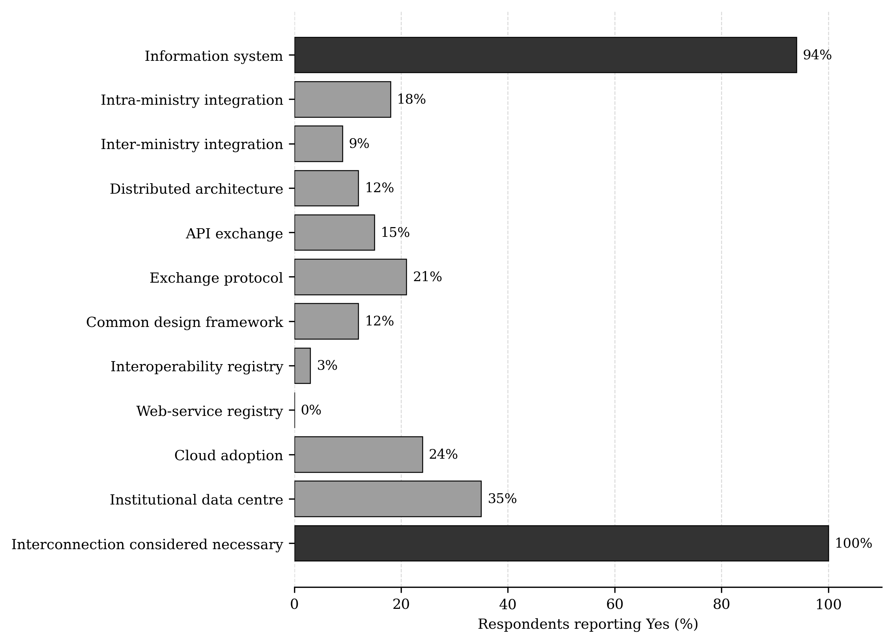
Figure 3.1. Reported digital-government and interoperability readiness
Source: Author's field questionnaire, n = 34; black-and-white rendering
Taken together, the findings validate the problem diagnosis. The DRC does not need an interoperability strategy because institutions lack all information systems; it needs one because existing systems cannot reliably cooperate. This diagnosis directly shaped the artifact: federation instead of forced database centralization, adapters instead of universal replacement, registries instead of undocumented endpoints, and measurable service commitments instead of informal exchange.

3.3 Findings from the Design Science Artifact
The principal Design Science artifact is a context-specific interoperability framework that coordinates legal, organizational, semantic and technical requirements across municipal, provincial and national administration. The artifact translates the diagnostic gaps into operational design rules: authoritative data remain with the competent institution; cross-boundary exchange uses approved contracts; the national level supplies common trust and governance; and performance, security and recovery are measured through service-level indicators.

3.3.1 Proposed Interoperability Framework
The realization of effective decentralized e-governance in the Democratic Republic of the Congo hinges not merely on establishing digital systems at each adminiHstrative tier, but fundamentally on ensuring that these systems can communicate, collaborate, and exchange data seamlessly across the national, provincial, and municipal layers. This capability is encapsulated in the concept of interoperability—the technical and organizational capacity for disparate information systems to work together within and across organizational boundaries. This section examines the four critical levels of interoperability—technical, semantic, organizational, and legal—that together form the foundational framework for a coherent digital governance architecture. Understanding and systematically implementing across these four levels is essential to transform the DRC's constitutional decentralization into a connected government.

3.3.1.1 Technical Interoperability across Governance Tiers
Technical interoperability enables communication among national, provincial, and municipal systems. The national tier defines API, data-format, and security standards and operates the Government Service Bus. Provinces provide regional gateways, while municipalities deploy lightweight endpoints suitable for limited connectivity. Synchronous APIs and asynchronous events support reliable exchange while preserving each tier’s autonomy.

3.3.1.2 Semantic Interoperability in a Diverse Decentralized State
Semantic interoperability ensures that exchanged data retains the same meaning across the DRC’s 26 provinces. National ontologies and controlled vocabularies define concepts such as citizen, property, business, and public service, while allowing provincial and municipal extensions for local administrative needs.

3.3.1.3 Organizational Interoperability
Organizational interoperability aligns cross-tier processes, responsibilities, and governance. Formal agreements establish service levels, accountability, escalation procedures, and performance indicators. The national tier defines common standards, provinces coordinate implementation and capacity building, and municipalities adapt service delivery to local conditions.

3.3.1.4 Legal Interoperability
Legal interoperability requires the Digital Code and data-protection legislation to regulate cross-tier data exchange, digital signatures, institutional responsibilities, and liability. Dispute-resolution procedures and a representative National Digital Governance Council should provide guidance and maintain a registry of applicable digital regulations.
Together, these dimensions allow each governance tier to retain its constitutional autonomy while participating in a nationally coordinated interoperability framework. The DRC's approach to integrated interoperability should be a model where each governance level maintains autonomy within its constitutional sphere while participating in nationally coordinated interoperability frameworks that span across the four dimensions.
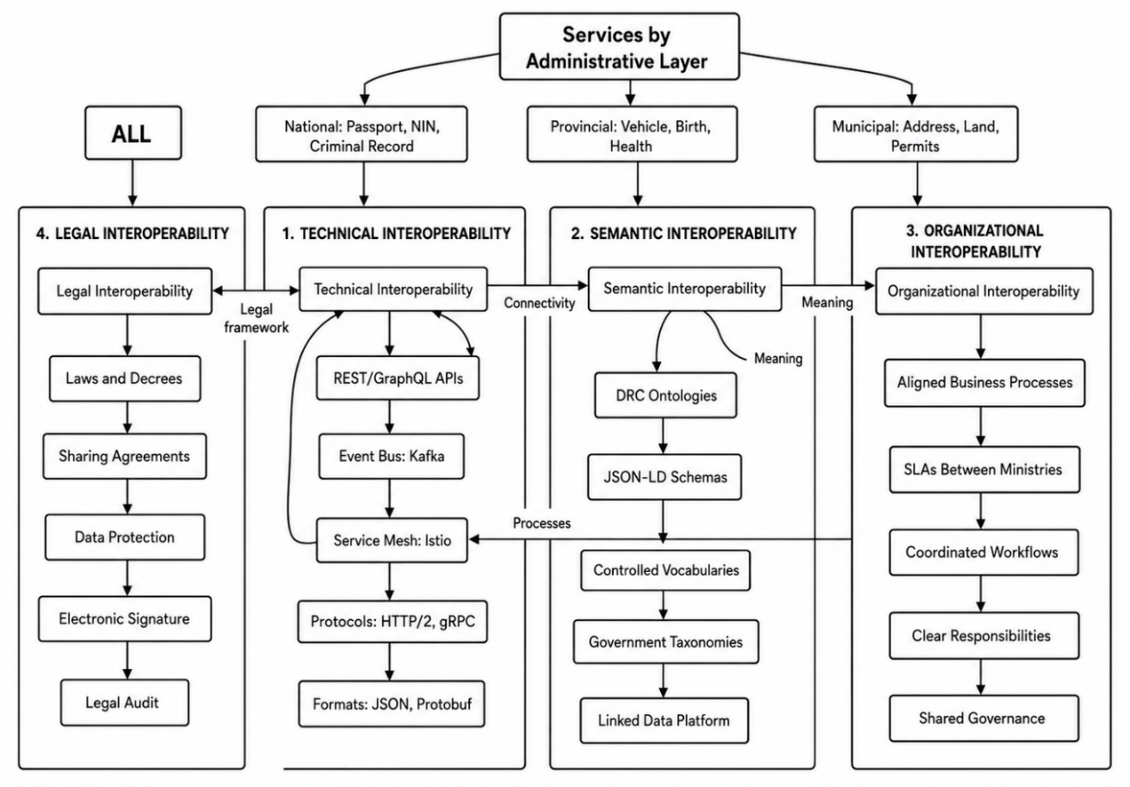
Figure 3.2. Four-Layer E-Government Interoperability Framework
Source: Author

3.3.2 Decentralized Administrative Paradigm

3.3.2.1 Constitutional Foundation of Decentralization in the DRC
Decentralization is established by the 2006 Constitution to improve governance and service delivery across the DRC’s vast and diverse territory. Article 3 recognizes cities, communes, sectors, and chiefdoms as decentralized territorial entities with legal personality and administrative and financial autonomy. Although implementation gaps remain, the Constitution establishes a unitary but decentralized state in which local entities exercise constitutionally assigned powers.

3.3.2.2 Decentralization and Electronic Governance
Electronic governance translates this autonomy into a federated digital architecture in which national, provincial, and municipal systems remain independently managed while interoperating through common standards. The architecture must support vertical coordination between governance tiers and horizontal cooperation among provinces and municipalities. This enables each tier to maintain systems for its exclusive responsibilities while delivering integrated public services to citizens.
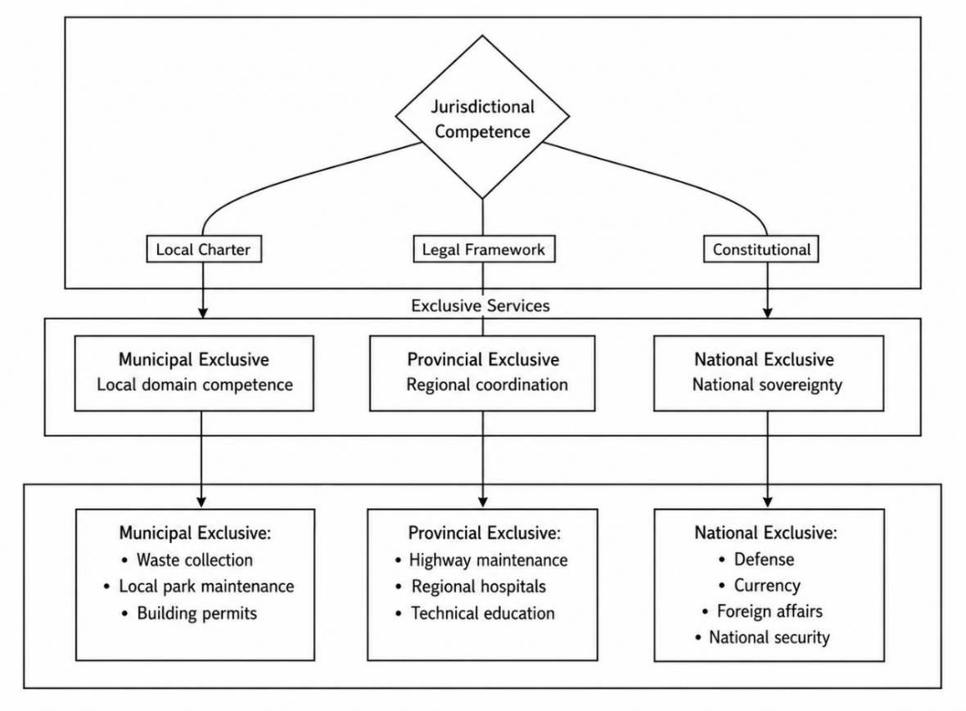
Figure 3.3. Jurisdictional Competence and Exclusive Public Services
Source: Author
The study investigates how event-driven microservices and standardized interoperability protocols can orchestrate complex governance processes across autonomous administrative layers, ensuring that the constitutional principles of subsidiarity and local autonomy are upheld without sacrificing national coherence or citizen-centric service integration. This is particularly salient for the DRC — a vast and diverse nation where governance must simultaneously respect regional specificity, ensure national unity, and deliver efficient digital public services across 26 provinces and hundreds of municipalities.

3.3.2.3 Core Elements of the E-Government Interoperability Framework
The diagram illustrates the foundational ontology for e-government service delivery, mapping the core entities and their interrelationships within the proposed interoperability framework. At the center of the ontology lies the Service, which serves as the primary unit of government function—whether it be citizen registration, tax filing, or passport issuance. Each Service is described by a BPMN Model that defines the workflow, and is associated with one or more Web Services that provide the technical implementation through well-defined APIs. These APIs enable programmatic access to government functionality, allowing citizens, businesses, and other government entities to invoke services without requiring custom integration.
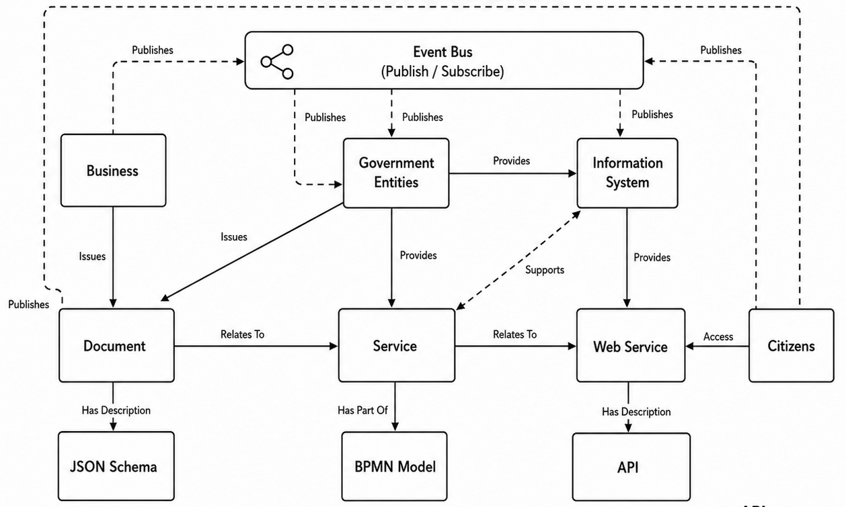
Figure 3.4. Event-Driven E-Government Service Model
Source: Author

3.3.2.4 Data Ownership in Decentralized E-Government Systems
To operationalize data ownership and control, the framework introduces a multi-tier governance structure. A National Data Protection and Governance Council is responsible for defining public data policies, approving technical and legal standards, auditing compliance, and handling complaints of national scope. At the provincial level, governance committees adapt national policies to regional contexts, supervise data quality, manage regional access permissions, and resolve inter-institutional conflicts. Municipal oversight commissions validate local data updates, handle citizen grievances, and report irregularities to higher levels of authority. Its mandate includes verifying access controls, auditing system integrity, evaluating governance effectiveness, and publishing transparency reports. This independent oversight is essential to prevent abuse of decentralized data powers and to maintain public trust.
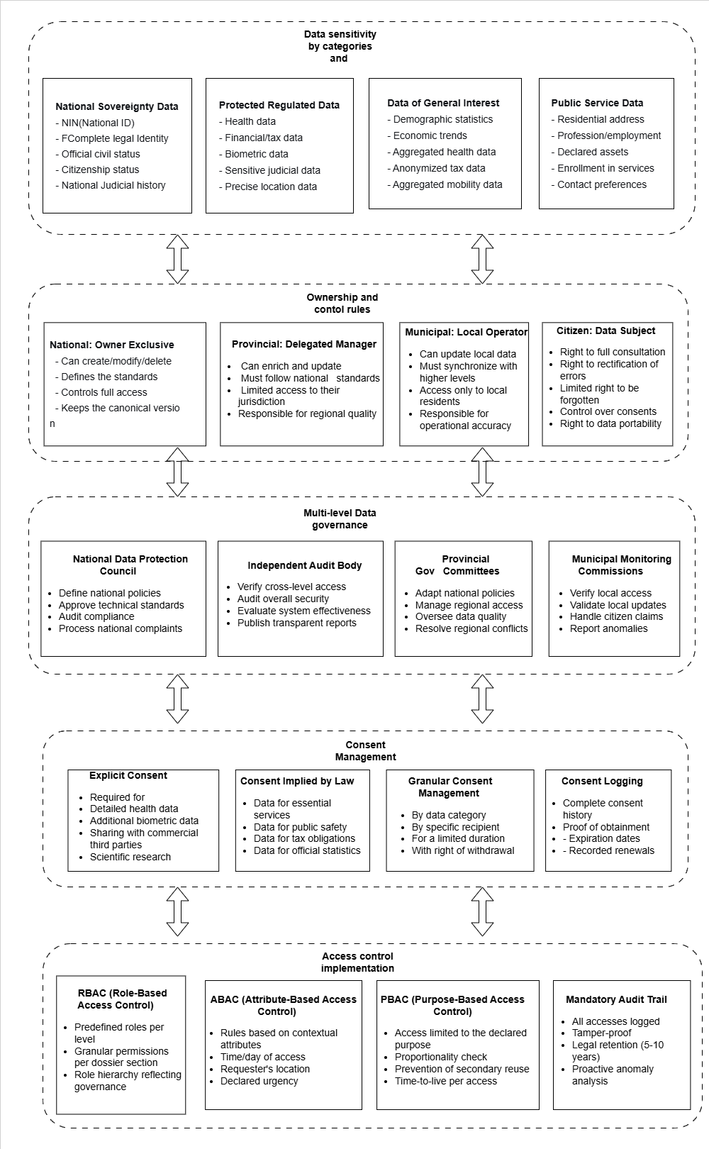
Figure 3.5. Data Ownership, Consent, and Access-Control Framework
Source: Author
The framework incorporates a robust consent management model that differentiates between explicit consent and legally implied consent. Explicit consent is required for high-risk data processing activities, including biometric identification, health data usage, commercial reuse, and scientific research. Legally implied consent applies to essential public services, public security, taxation, and official statistics, where processing is mandated by law. Consent is managed in a granular manner, allowing control by data category, recipient institution, declared purpose, and time limitation. All consent actions are logged, versioned, and time-stamped, enabling traceability, legal accountability, and the enforcement of citizens’ rights to withdraw consent where applicable.
This table defines the roles, responsibilities, and limits of authority for each actor in the e-government data ecosystem. It operationalizes the principle of data sovereignty established in the Digital Code, clarifying that the Central State retains exclusive ownership over sovereign data.
Table 3.2. Actors of Data Ownership and Their Roles (Based on the DRC Digital Code)
Actor | Institutional Level | Ownership Role | Core Responsibilities
Central State | National | Exclusive data owner | Defines standards, maintains canonical data, controls interoperability
Provincial Authority | Provincial | Delegated data steward | Enriches and updates data, ensures quality, enforces standards
Municipal Authority | Local | Operational data manager | Collects and maintains local data, delivers services
Private Business | Cross-level / Sectoral | Licensed Data Processor | Delivers contracted services; processes data for specified purposes; provides feedback/analytics to public sector; ensures commercial data privacy
Independent Audit Body | Cross-level | Oversight authority | Audits access, verifies compliance, publishes reports
Data Protection Authority | National | Regulatory guardian | Policy enforcement, consent oversight, complaint handling
Citizen | Individual | Data subject | Exercises rights (access, rectification, consent, portability)
Source: Author

3.3.3 National Identification Number
The federation of citizen registry systems around the National Identification Number (NIN) stands as a cornerstone imperative for the Democratic Republic of the Congo's digital transformation and the effective functioning of its decentralized governance architecture.
At its most foundational level, politics can be understood as the art and science of managing state affairs. This management, however, is not an abstract exercise but a concrete operation involving two primary categories of objects: “people and their belongings”. In classical political theory, the state’s legitimacy rests on its ability to secure both the individual and their property—whether tangible (land, goods) or intangible (data, intellectual assets). Consequently, political governance necessitates a systematic ordering of these entities, transforming disparate individuals and possessions into legible, governable units. This legibility is achieved through administrative mechanisms that register, categorize, and track relationships between persons and their assets. Without such ordering, the state cannot fulfill its core functions: protection, taxation, dispute resolution, or resource allocation.
A crucial contemporary expression of this ordering is the federation of digital identity systems, particularly a national identification number (NIN). Federating e-government over a NIN means creating an interoperable, secure architecture wherein a single unique identifier serves as the linchpin linking a citizen’s multiple records across different state agencies—land registries, tax databases, social welfare systems, and law enforcement. Far from being a mere technical convenience, this federation is a deeply political act. It reconfigures the relationship between the state and the individual by enabling what I term ontological transparency: the government’s capacity to know, in real time, who does what and what belongs to whom.
In a nation constitutionally committed to decentralization—across 26 provinces and hundreds of municipalities—the absence of a federated identity framework anchored on a unique National Identification Number (NIN) would lead to fragmented, siloed registries at each governance tier. The NIN thus becomes the critical linchpin for transforming a potentially disjointed administrative landscape into a cohesive governance ecosystem, allowing the state to plan national development, track demographics, and serve citizens as they move between provinces or access services at different government levels. at different government levels.

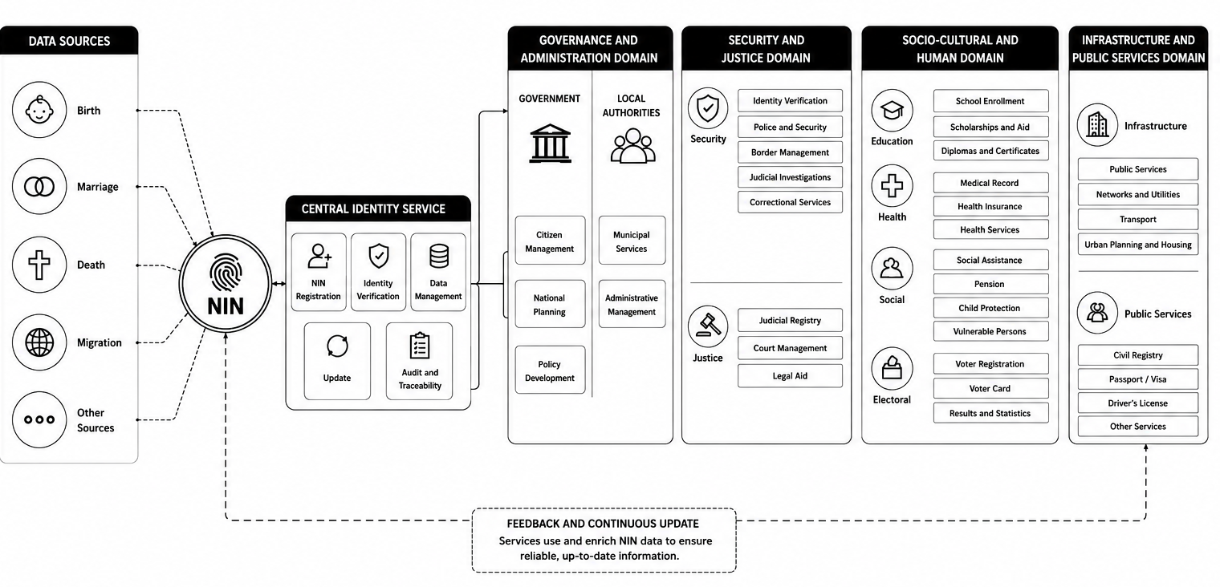
Figure 3.6. National Identification Number as a Foundation for E-Government Services
Source: Author
The federated NIN registry addresses the challenge of establishing a single source of truth while respecting the constitutional autonomy of each tier. In this model, the national tier maintains the core registry with unique identifiers and essential biographical data, while provincial and municipal tiers host federated instances that synchronize with the national registry and add locally relevant attributes and service histories.
The figure illustrates the event-driven construction and synchronization of a federated citizen dossier. Life events such as birth, marriage, change of residence, economic activity, taxation, justice, mobility, health, and voting generate events that are routed through their corresponding data-domain event channels. Specialized updaters then modify only the relevant sections of the citizen dossier according to predefined synchronization rules.
The model also defines multilevel propagation policies, allowing information to move upward from municipal to provincial and national levels, downward from national authorities to lower administrative levels, and laterally between equivalent entities. This approach maintains a consistent and continuously updated citizen dossier while preserving domain separation, administrative autonomy, and controlled information sharing across the public administration.

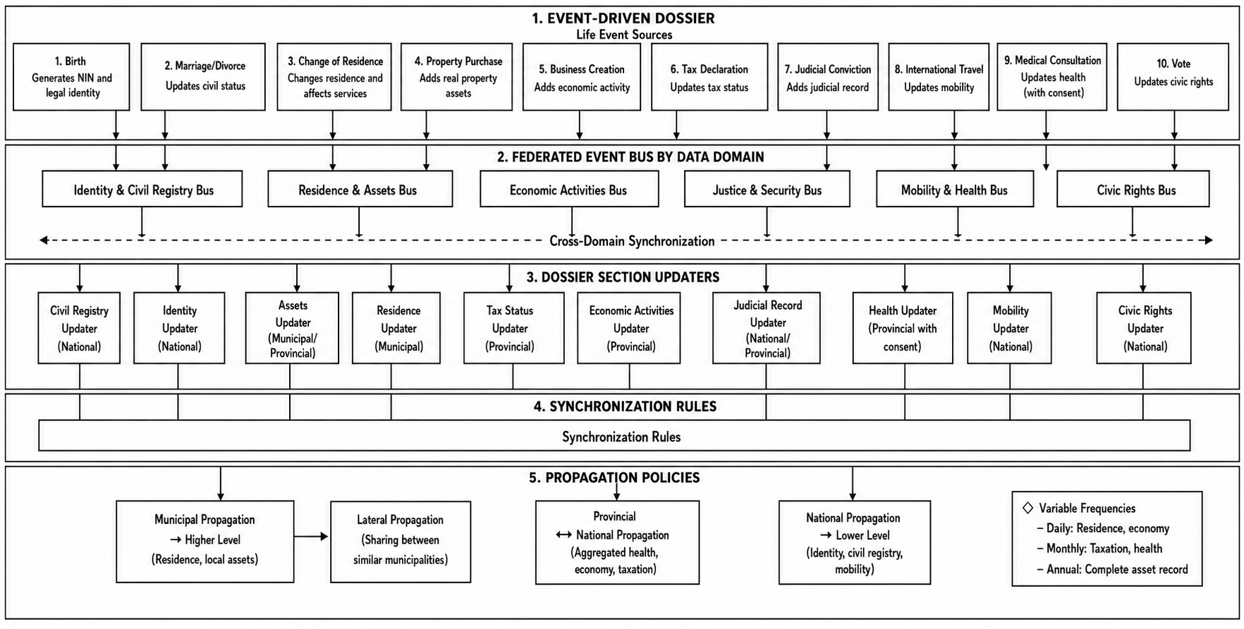
Figure 3.7. Event-Driven Construction and Synchronization of the Federated Citizen Dossier
Source: Author

3.3.4 Integrated Architecture Design

3.3.4.1 Sovereign Multi-Layer Digital Architecture
This e-government architecture is structured as a four-layer stack that progressively transitions from citizen-facing interfaces to sovereign data infrastructure. The User Access Zone serves as the orchestration gateway, consolidating IAM, RBAC/ABAC, session management, and business service orchestration as the “front-office” logic. The Backbone Zone provides the interoperability core through API gateways, service meshes, message brokers, and service discovery, enabling asynchronous communication across central, provincial, and municipal microservices. The innermost Sovereignty Zone integrates security (SSO, PKI, HSM), data (aggregation, CDC, version vectors), and infrastructure (containerization, auto-scaling, monitoring) layers, embedding data ownership and regulatory compliance as foundational design drivers. This layered separation supports federated governance, allows localized policy changes without system-wide redesign, and enables a continuum of trust from anonymous access to audited, cryptographically signed transactions (Cardellini et al., 2002; Cooper et al., 2008; Ferraiolo et al., 2001).

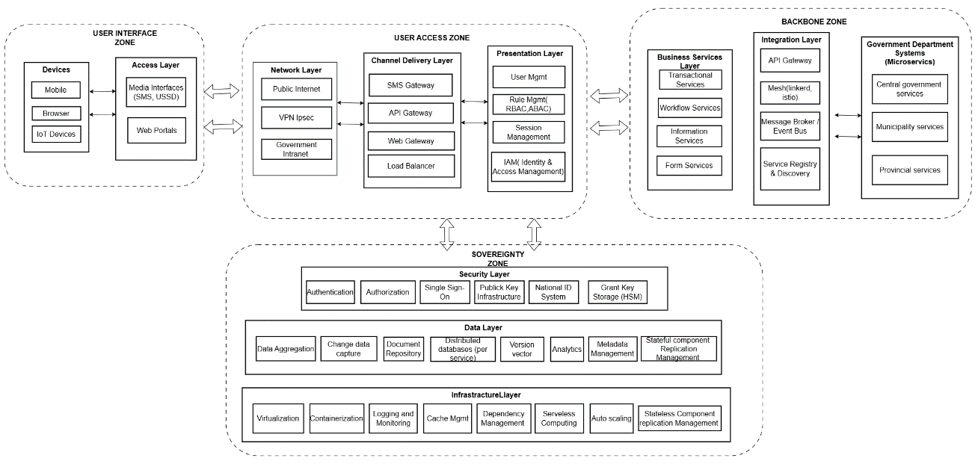
Figure 3.8. Sovereign Multi-Layer Framework
Source: Author

3.3.4.2 Business Process Reengineering
The identification and standardization of government forms represents a critical prerequisite for successful digital transformation. Every government service requires one or more forms that citizens, businesses, and employees must complete to initiate a transaction. These forms currently exist in hundreds of different formats across the DRC's 26 provinces and hundreds of municipalities, with significant variations in field names, data requirements, and validation rules.
The Business Process Reengineering (BPR) approach begins with discovery, where all existing forms are inventoried, current processes are documented, and pain points are identified through stakeholder interviews and observation. The analysis phase maps all data fields across different versions of similar forms, identifies redundancies where the same information is requested multiple times, and analyzes workflow inefficiencies that cause delays. The redesign phase simplifies form fields by removing unnecessary questions, standardizes formats across all tiers to ensure consistency, and eliminates duplication by reusing data already collected elsewhere. The implementation phase converts paper forms into digital versions, enables online submission with validation, and automates processing workflows to reduce manual intervention and processing time (Bernstein & Newcomer, 2009; Garcia-Molina & Salem, 1987; Hammer & Champy, 1993).
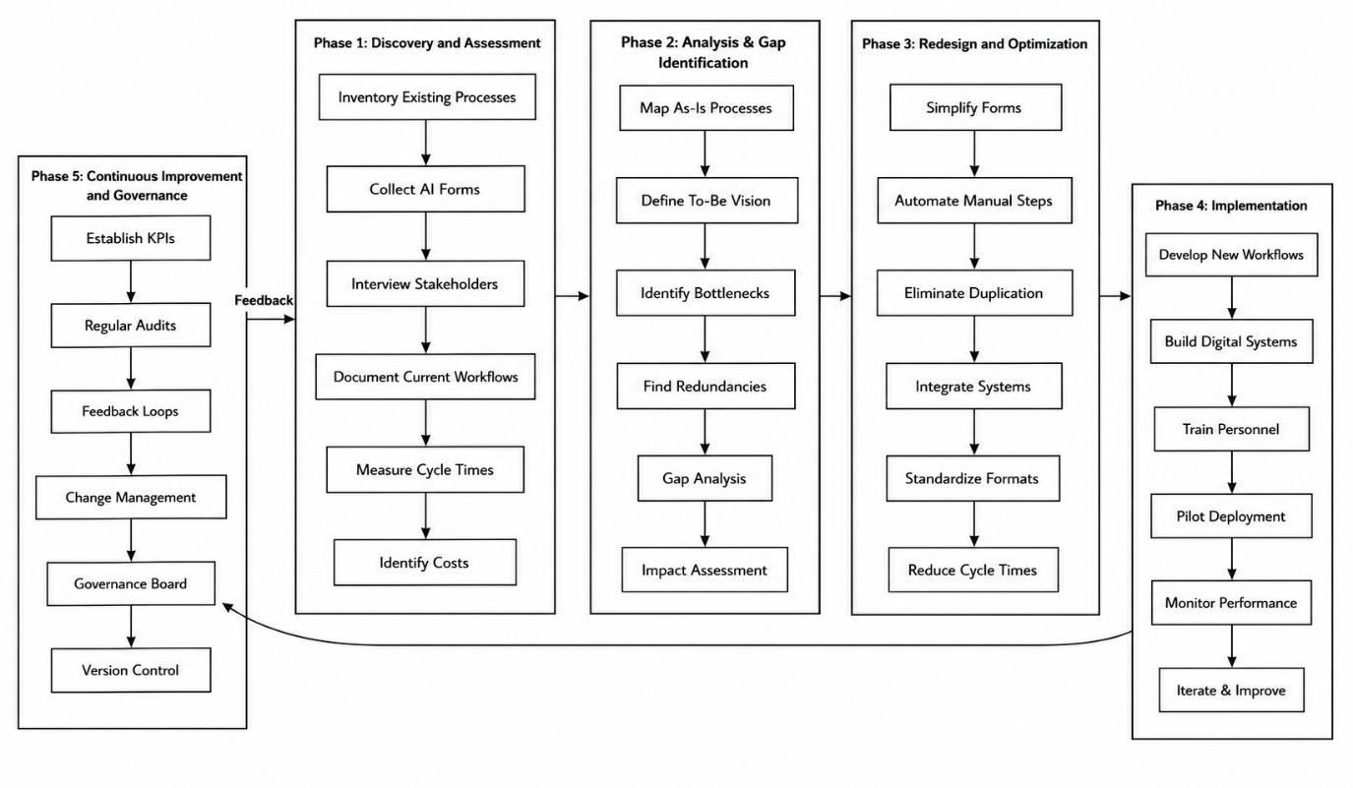
Figure 3.9. Business Process Reengineering Lifecycle
Source: Author

3.3.4.3 Architectural Overview

3.3.4.4 National Government Cloud
A national government cloud is a cloud infrastructure that is owned, operated, or strictly controlled by the state to host public sector applications and data while ensuring digital sovereignty, security, and regulatory compliance. Instead of each public administration maintaining its own independent IT infrastructure, the GovCloud provides a shared national platform where all government entities deploy their services. Physically, the infrastructure is centralized in one or more national data centers, but logically it is highly segmented to ensure strict separation between different administrative entities (Bernstein, 2014; Pahl & Jamshidi, 2016; Wang et al., 2015).
When we say the infrastructure is “centralized but logically segmented,” it means that although all administrative entities use the same underlying hardware and platform, each one operates in a fully isolated virtual environment. Each administrative entity is assigned its own logical space (often called a tenant or namespace), where it can run its applications, manage its databases, and enforce its own access control policies independently of others (Burns et al., 2016; Burns et al., 2019; Pahl, 2015).
This model is commonly referred to as a secure multi-tenant architecture. Administrative entities share the same physical infrastructure, but their environments are logically separated, ensuring that data, services, and operations from one administrative entity cannot be accessed by another unless explicitly allowed through controlled mechanisms such as APIs or broker-based communication (Fielding, 2000; Kim et al., 2016; March & Smith, 1995).

3.3.4.5 Architecture Framework Design

3.3.4.6 Municipal-Tier Architecture
The municipal tier is the primary point of contact for local service delivery. Its domain services support municipal responsibilities, while its broker distributes local events to authorized consumers. The broker can retain events temporarily when wide-area connectivity is interrupted, allowing routine municipal operations to continue and forwarding pending events after connectivity is restored. The Municipal Federator Service validates and filters events before sending them to the provincial tier or receiving authorized updates from it. Inter-municipal exchange is therefore mediated through governed federation paths rather than uncontrolled point-to-point links. This arrangement preserves local operational autonomy while keeping municipal services connected to the wider government ecosystem.
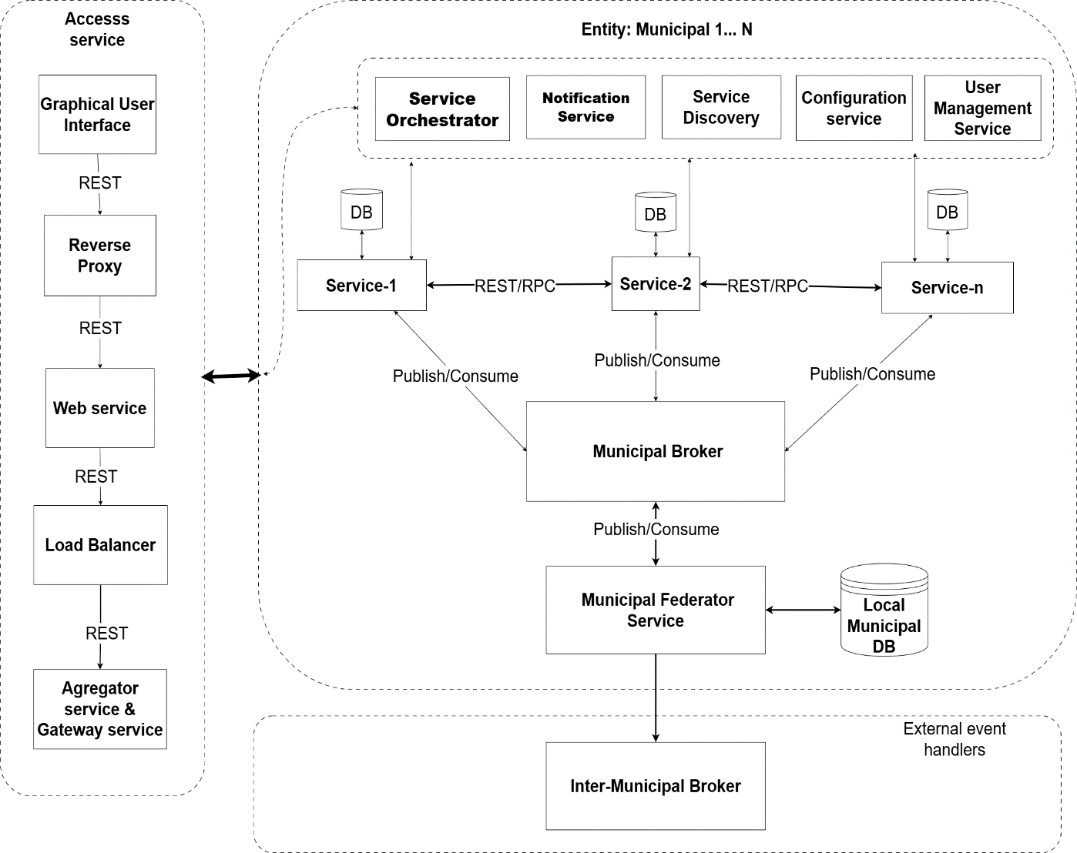
Figure 3.10. Municipal-Tier Architecture
Source: Author

3.3.4.7 Provincial-Tier Architecture
The provincial tier coordinates municipalities within a province and hosts services assigned to provincial authorities. Its Service Orchestrator manages workflows that involve several municipalities or provincial agencies, including conditional steps, timeouts, and compensating actions. The Provincial Ministry Broker carries provincial events, while the Provincial Federator Service aggregates relevant municipal events, applies regional governance rules, and routes approved information to national services. An Inter-Provincial Governments Broker or equivalent governed exchange channel supports cases that legitimately cross provincial boundaries. The tier consequently provides coordination and aggregation without absorbing municipal responsibilities or creating direct coupling among all participating systems.
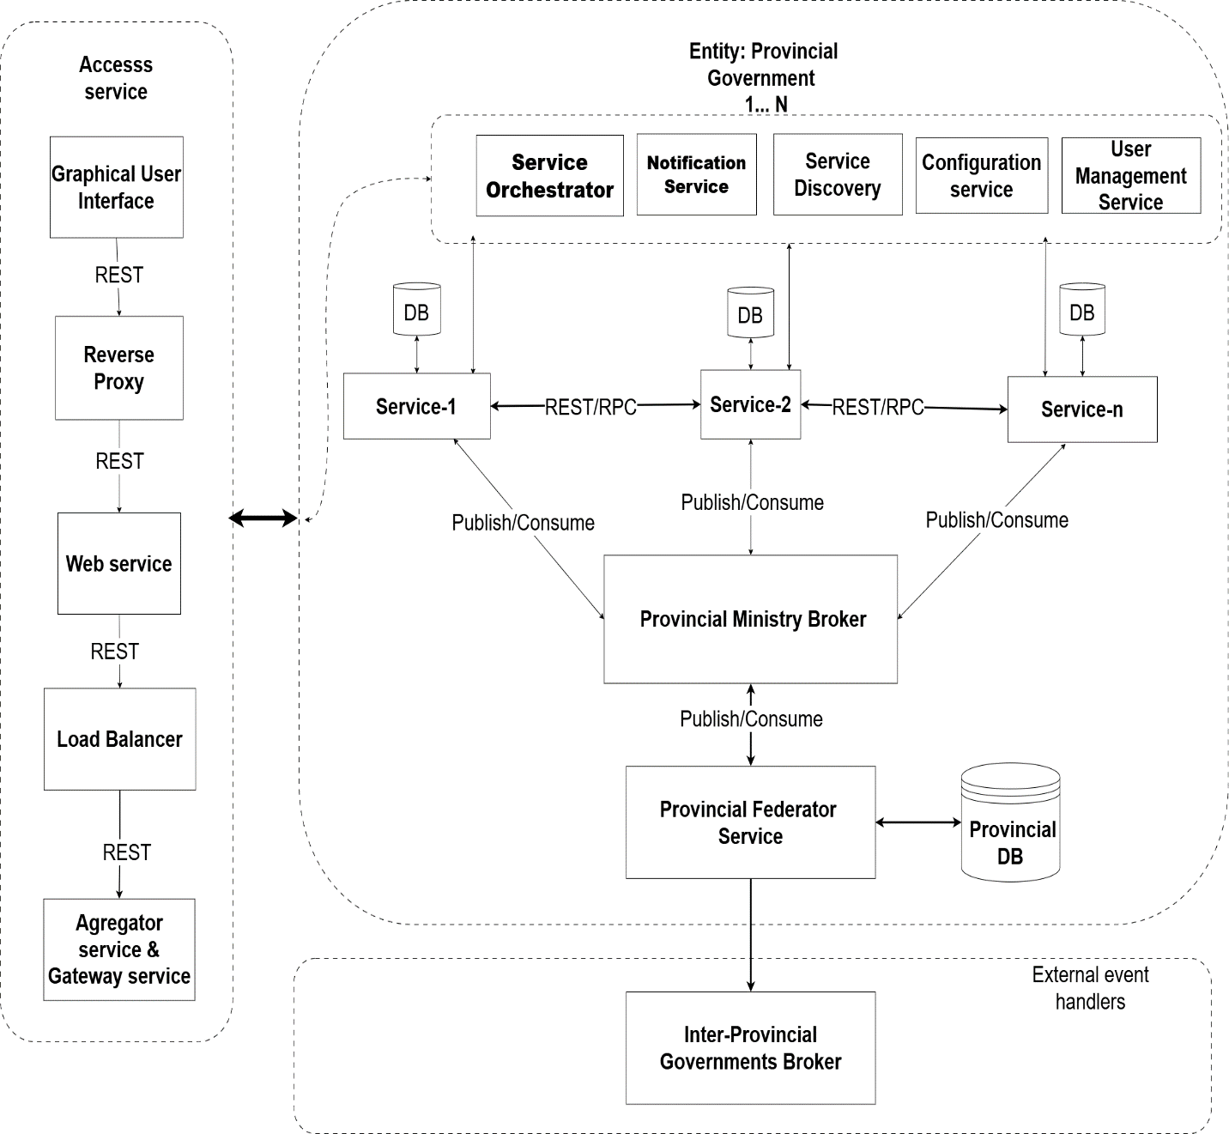
Figure 3.11. Provincial-Tier Architecture
Source: Author

3.3.4.8 National-Tier Architecture
The national tier coordinates central ministries, national agencies, cross-domain processes, and authoritative registries. A Central Ministry Orchestrator manages workflows that span multiple national institutions or administrative levels. The Central Ministry Federator Service enforces national interoperability, security, semantic, and routing policies, while national and inter-ministerial brokers distribute approved events across organizational boundaries. External handlers connect authorized international or partner systems through controlled interfaces.
National data management follows authoritative-source governance rather than placing all operational information in one unrestricted central database. Each service remains responsible for its own transactional data, while designated national registries publish governed authoritative records and reference data. The national tier applies the strongest availability, audit, and security controls, including multi-data-center failover for critical services, because disruption at this level may affect the entire public administration.
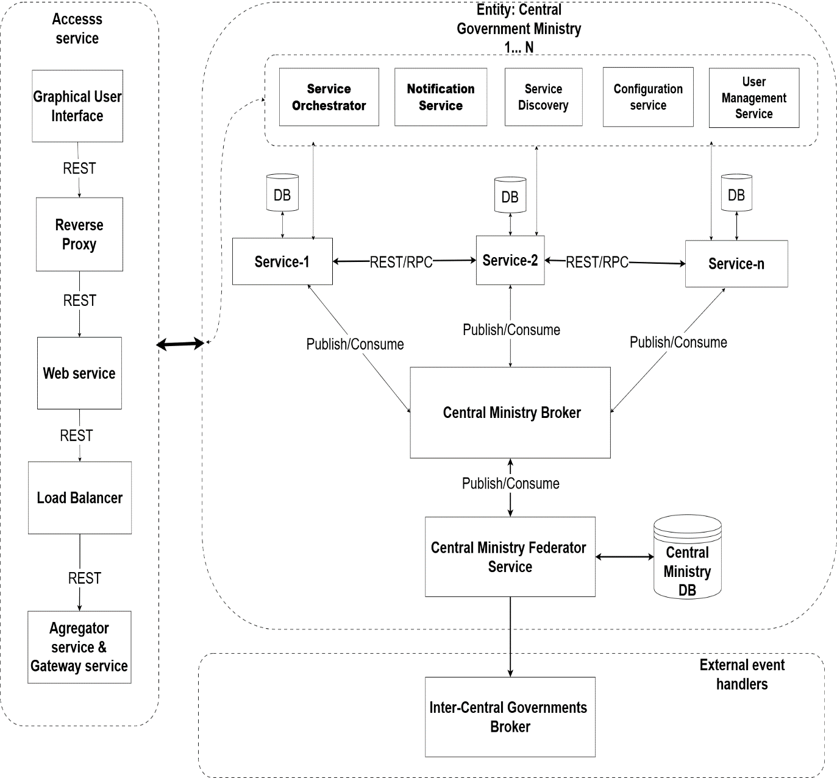
Figure 3.12. National-Tier Architecture
Source: Author

3.3.4.9 Global Federated Architecture
The global federated architecture integrates the three tiers without converting them into a single monolithic system. Operational events move upward from municipalities to provinces and then to national services when aggregation, national verification, or cross-domain action is required. Policies, reference data, configuration directives, and service updates move downward through the same governed federation structure. Correlation identifiers, versioned event schemas, access-control rules, and audit records preserve traceability across these exchanges.
A shared Government Support Layer consumes authorized events for analytics, dashboards, and ETL or batch processing. The analytical data warehouse stores governed copies prepared for reporting and policy analysis; it does not replace the operational databases owned by individual services. This separation protects transactional autonomy while providing national visibility into service performance, citizen interactions, and policy implementation. By defining common platform capabilities once and assigning distinct responsibilities to each administrative tier, the architecture supports interoperability, scalability, resilience, and constitutional autonomy without duplicating the same component description at every level.

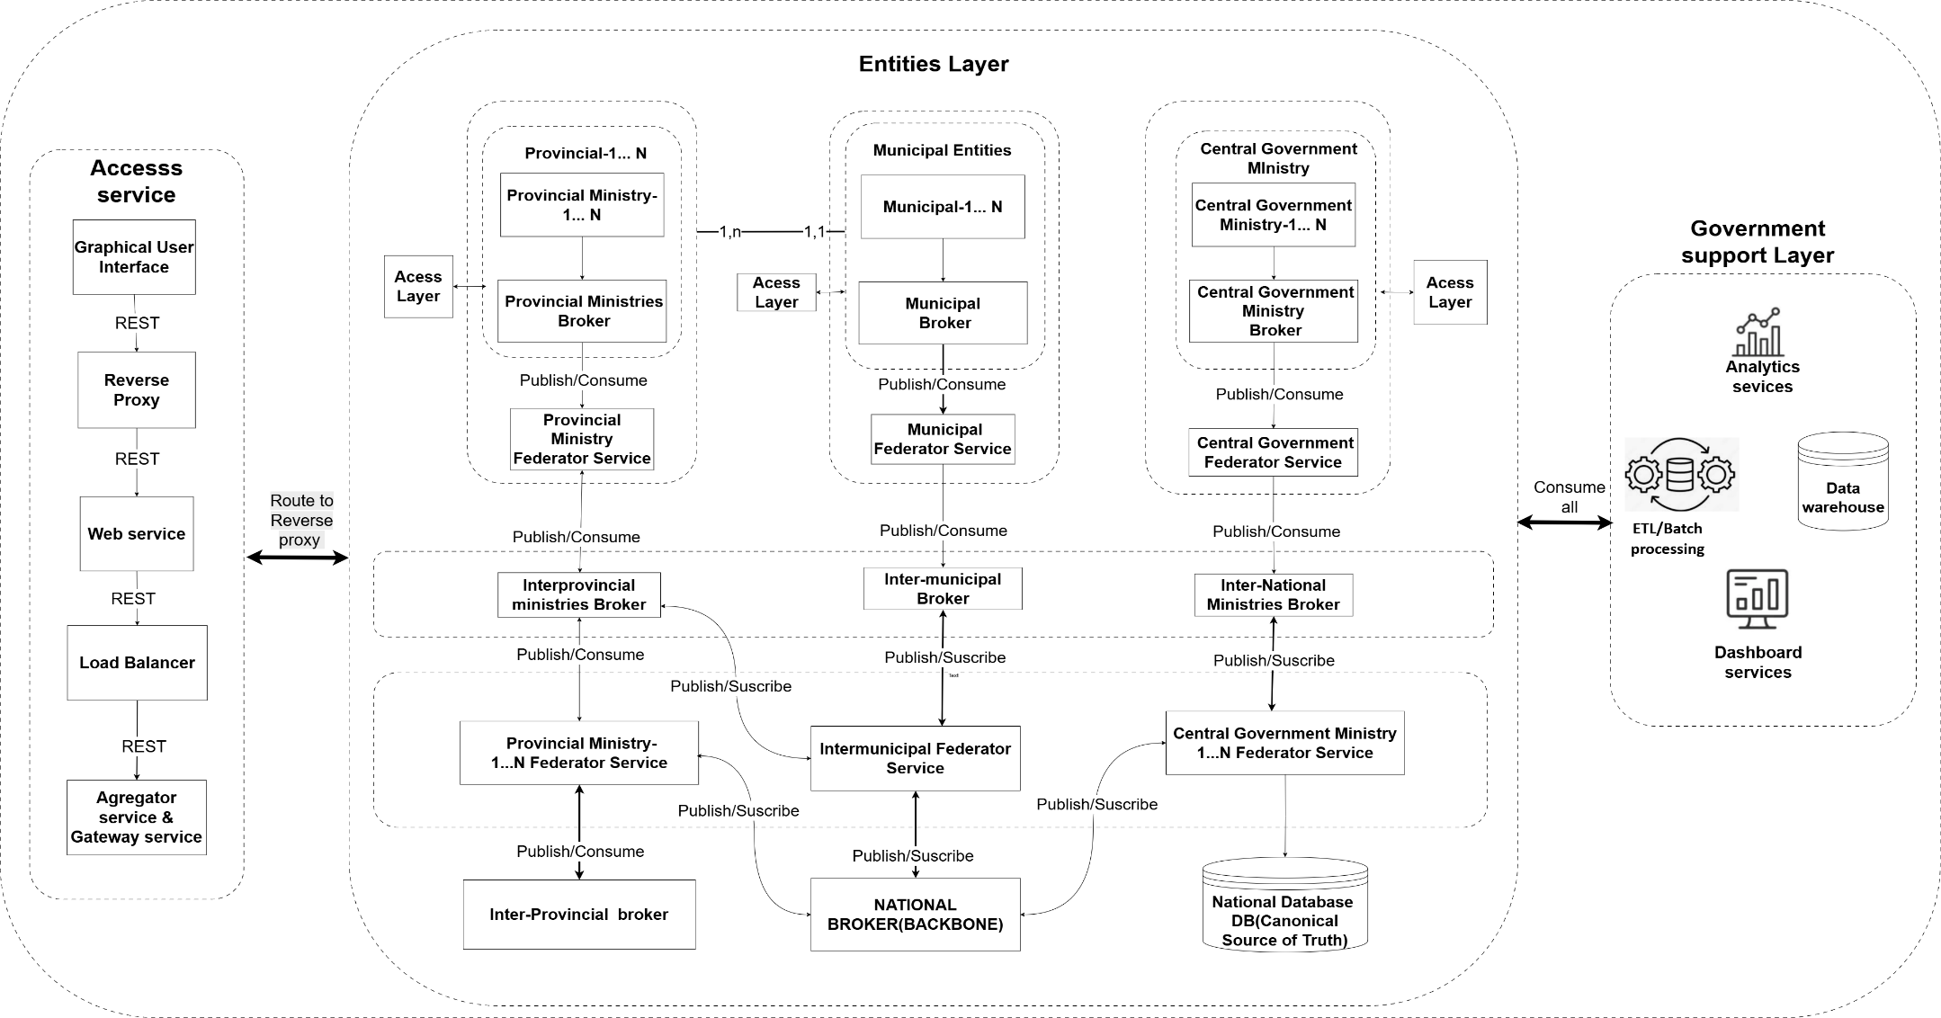
Figure 3.13. Global Federated E-Government Architecture
Source: Author

3.3.5 Routing Decision Engine
This architectural diagram illustrates the sophisticated routing decision engine and multi-tier security infrastructure that serves as the backbone of the e-government interoperability platform across municipal, provincial, and national levels. The architecture begins with a Routing Decision Engine that performs contextual routing by examining request attributes such as the nature of the service requested (health, tax, education), the administrative level of the request (national, provincial, municipal), and the geographic origin of the request, enabling intelligent, dynamic routing decisions at the edge. Based on these evaluations, the Routing Decision Engine directs traffic to the appropriate tier—National Reverse Proxy Cluster, Provincial Reverse Proxy Cluster, or Municipal Reverse Proxy Cluster—each serving as the entry point for its respective administrative level. The National Reverse Proxy Cluster handles the highest volume of traffic, implementing comprehensive SSL/TLS termination with robust certificate validation against the National Public Key Infrastructure (PKI), which provides the highest level of assurance for national-level services.
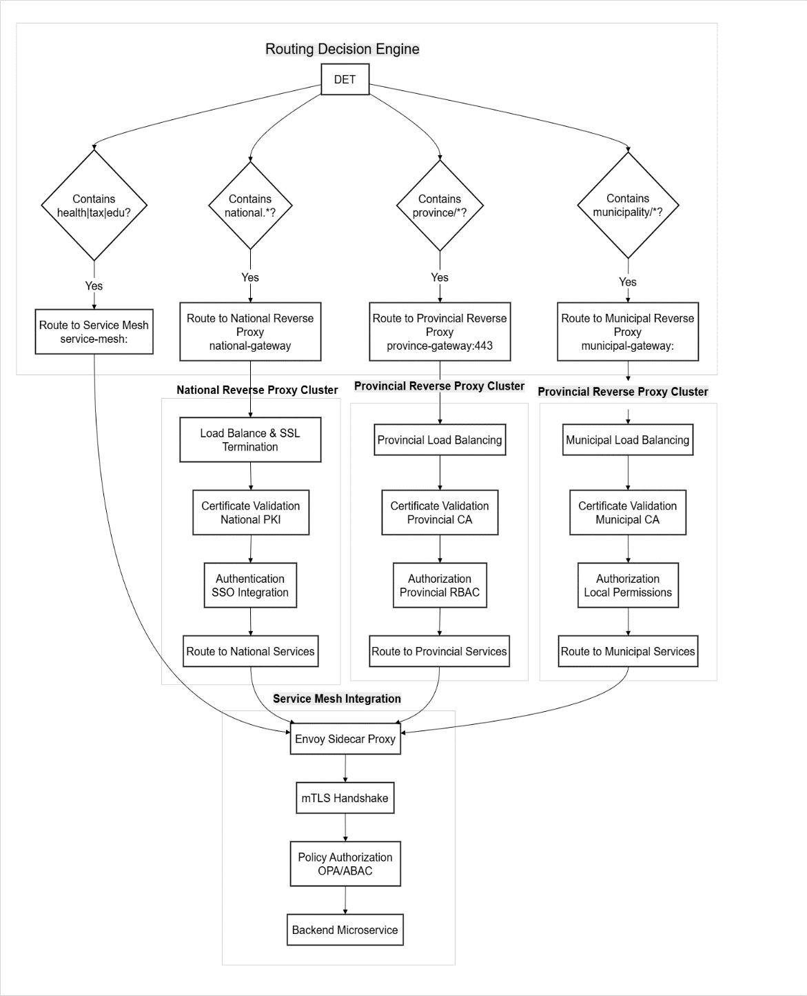
Figure 3.14. Routing Decision Engine
Source: Author

3.3.6 API Implementation
The implementation of microservice APIs for e-government interoperability is fundamentally about enabling disparate government systems to communicate and share data seamlessly, regardless of the programming languages, databases, or platforms on which they were originally built. Polyglot architecture — the practice of using multiple programming languages and technologies across different services — is not merely a technical choice but a strategic imperative in government contexts where systems have been developed independently over decades by different agencies with varying technical capabilities, legacy constraints, and institutional preferences. This approach acknowledges that no single programming language or framework is optimal for all tasks, and that the diversity of government functions — from high-throughput citizen-facing portals to computationally intensive analytics and legacy integration — demands a diversity of technical solutions.

3.3.6.1 Formalism for Tiered API Design
The principles above imply a stricter, machine-checkable standard than prose alone can enforce. Every endpoint in the platform, regardless of which agency or programmer builds it, follows one URI grammar:
/api/v{n}/{tier}/{domain}/{resource}[/{id}[/{sub-resource}]] (3.1)
where tier ∈ {national, provincial, municipal} — the governance level that owns the resource — and domain names the bounded context (civil-status, tax, land-registry). HTTP methods then carry fixed, non-negotiable semantics tied to the CQRS split in Principle 2:
Not every resource is exclusively owned by one tier, so lookups formally escalate rather than returning a bare 404 where a higher tier might hold the record:
Resolve(r, tier) = Local(r, tier) if r ∈ tier; else Resolve(r, parent(tier)) (parent(municipal) = provincial; parent(provincial) = national) (3.2)
A municipal registrar's GET for a citizen record absent from the local registry therefore escalates automatically to the provincial registry, then the national one, before failing — the same tier hierarchy already governing SLO ownership and data ownership elsewhere in this platform, now made binding on every endpoint a programmer writes.
A worked example makes the grammar concrete. A birth record owned at municipal level and a national policy resource share an identical shape, differing only in the tier segment: /api/v1/municipal/civil-status/citizens/{nin} for a citizen the municipality itself registered, and /api/v1/national/civil-status/citizens/{nin} for the same lookup once escalated. A programmer in any agency, writing in any of the platform's four languages, therefore needs to know only the domain name and the tier a resource belongs to — never a service-specific routing convention — to construct a correct request.
The grammar is enforced mechanically rather than by convention alone: an OpenAPI linter in the CI pipeline rejects any endpoint definition that does not match the URI pattern and method table above before it reaches code review, so standardization does not depend on individual programmers remembering the rule.

3.3.6.2 API Documentation Tooling
API documentation must serve two purposes for this platform: enabling discoverability for developers building on it, and establishing a contract between services in a polyglot ecosystem where no single language's native tooling covers every service. The landscape of available tools groups into functional categories.
The most common starting point, built around the OpenAPI specification (formerly Swagger). These generate interactive documentation, often with a “Try it out” feature that lets a user test the API directly from the browser.
Table 3.3. OpenAPI Documentation and Developer Portal Tools
Tool | Category | Key Strength | Best For
Swagger UI / Editor | Open source | Interactive “Try it out” debugging; deep OpenAPI ecosystem integration; easy to host with Docker | Backend teams who need immediate, code-first documentation and live API testing during development
Redoc | Open source | Generates beautiful, readable, and highly customizable API reference pages | Publishing public-facing developer portals where design and readability are paramount
Source: Author
These tools integrate directly with a codebase to generate the OpenAPI specification automatically, ensuring documentation never goes stale. Unlike static documentation approaches that require manual updates and inevitably drift from the actual implementation, framework-specific generators extract the API contract directly from the source code at build time or runtime, ensuring that the documentation is always an accurate reflection of the deployed service. This integration is particularly valuable in a polyglot e-government environment, where multiple services are developed and maintained by different teams using different languages and frameworks, and where manual documentation coordination would be impractical and error-prone.

3.3.7 Request Coordination

3.3.7.1 Hybrid Coordination Model
The hybrid model resolves this by applying each pattern where it fits best. Orchestration governs complex, multi-step, multi-agency processes needing strict sequence, compensation, and full auditability — citizen registration, business registration, social-benefits disbursement, and passport issuance are the DRC examples — where centralized control's benefits outweigh its costs. Choreography governs event-driven interactions needing loose coupling, scalability, and independent evolution — life-event propagation, policy-change dissemination, registry synchronization, and citizen notifications — where autonomy and resilience outweigh the need for central control. The two combine directly in a hybrid SAGA: the orchestrator maintains the transaction's global view, sequencing steps and triggering compensation on failure, while each step's completion is itself published as an event that downstream services consume asynchronously — coordinated where it matters, decoupled everywhere else, and well suited to a context where infrastructure variability makes pure orchestration impractical and accountability needs make pure choreography insufficient.

3.3.8 Message Broker Implementation
Apache Kafka has become one of the most influential technologies in modern distributed systems, redefining how organizations handle real-time data streaming, event processing, and high-throughput messaging at scale. Originally developed at LinkedIn and later open-sourced through the Apache Software Foundation, Kafka is the de facto standard for building event-driven architectures and data-streaming platforms. Unlike traditional message brokers that treat messages as ephemeral and delete them after consumption, Kafka functions as a distributed commit log — a durable, append-only sequence of records supporting publish-subscribe messaging with exceptional scalability, reliability, and fault tolerance. This transforms Kafka from a simple messaging system into a platform serving as both a real-time event bus and a long-term data store, enabling use cases from stream processing to system auditing to data integration across complex microservice ecosystems, built on a carefully designed set of interdependent components.
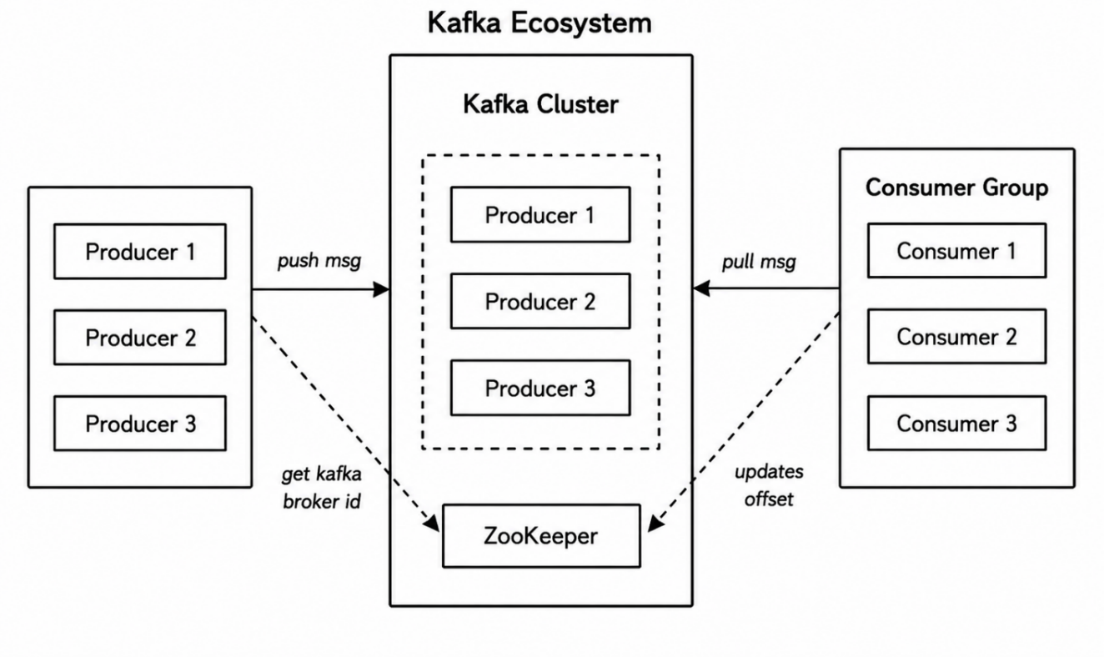
Figure 3.15. Kafka Ecosystem and Core Components
Source: Author

3.3.8.1 Kafka Implementation Framework in E-Government

The proposed event streaming architecture implements a three-tier Kafka-based messaging infrastructure that enables asynchronous, decoupled communication across municipal, provincial, and national levels of government. At the core of this architecture is a Kafka Gateway that serves as the unified entry point for all event producers—municipal, provincial, and national services—providing authentication, routing, rate limiting, and policy enforcement through an HTTP/HTTPS interface that ensures secure and controlled access to the event streaming infrastructure.
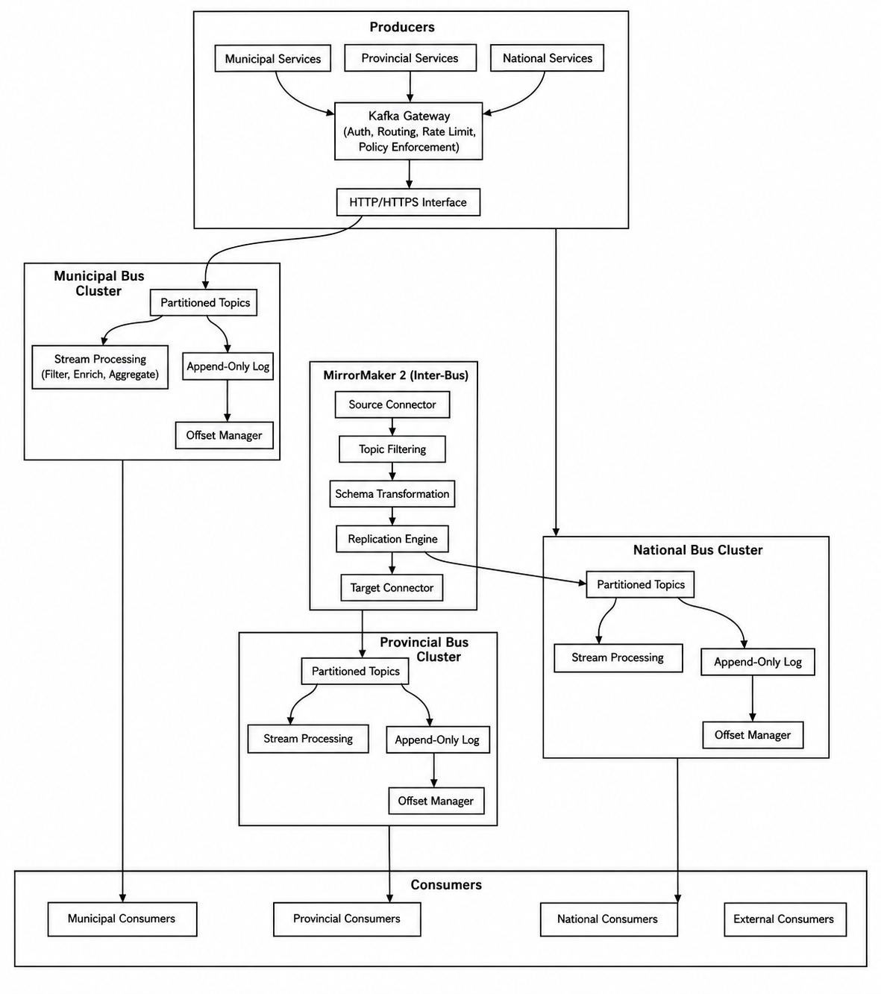
Figure 3.16. Three-Tier Kafka Event-Streaming Architecture
Source: Author
This multi-tier event streaming architecture is particularly well-suited to the Democratic Republic of Congo's decentralized governance structure, where 26 provinces and over 145 municipalities require autonomous operation while maintaining connectivity to the national ecosystem. Stream processing enables real-time enrichment and transformation of events as they flow through the tiers, ensuring that each level of government has the information it needs in the format it requires. The architecture's support for offline-first operation at the municipal level ensures service continuity despite the country's infrastructure challenges, while MirrorMaker 2.0's replication capabilities ensure that events are reliably propagated to higher tiers when connectivity is restored. This event streaming architecture thus provides the technical foundation for the event-driven, loosely coupled interoperability that is central to the e-government platform proposed in this dissertation.

3.3.8.2 Kafka Sequence Diagram
The diagram illustrates the complete flow of a Kafka consumer operating within a consumer group, showing the sequence of interactions between the consumer, group coordinator, Kafka broker, and topic partition log. The sequence begins when the consumer is created with a specified group.id (health-services), after which it joins the consumer group managed by the Group Coordinator. The Group Coordinator handles partition assignment, allocating partitions 0, 1, and 2 to the consumer, enabling parallel processing of events from the topic.
The consumer then enters a continuous poll loop, where it repeatedly invokes poll(timeout) to fetch new messages from the assigned partitions. The consumer reads records from the topic partition log, beginning at the current offset, and the broker returns a batch of messages, which the consumer deserializes from Avro or Protobuf format. The processed records are returned as ConsumerRecords, and the application processes each record individually.
The critical decision point in the flow is offset management, which determines the processing semantics. If processing succeeds, the consumer commits offsets—either synchronously (commitSync) or asynchronously (commitAsync)—which are written to the internal __consumer_offsets topic. If processing fails, the consumer performs no commit, leaving the messages uncommitted so they can be reprocessed on the next poll cycle. This pattern ensures reliable message processing: consumers can recover from failures by reprocessing uncommitted records, preventing data loss or duplication and guaranteeing exactly-once processing semantics essential for government applications. The consumer group architecture enables horizontal scalability, with each consumer handling a subset of partitions, while the offset management mechanism ensures data consistency across the distributed system.
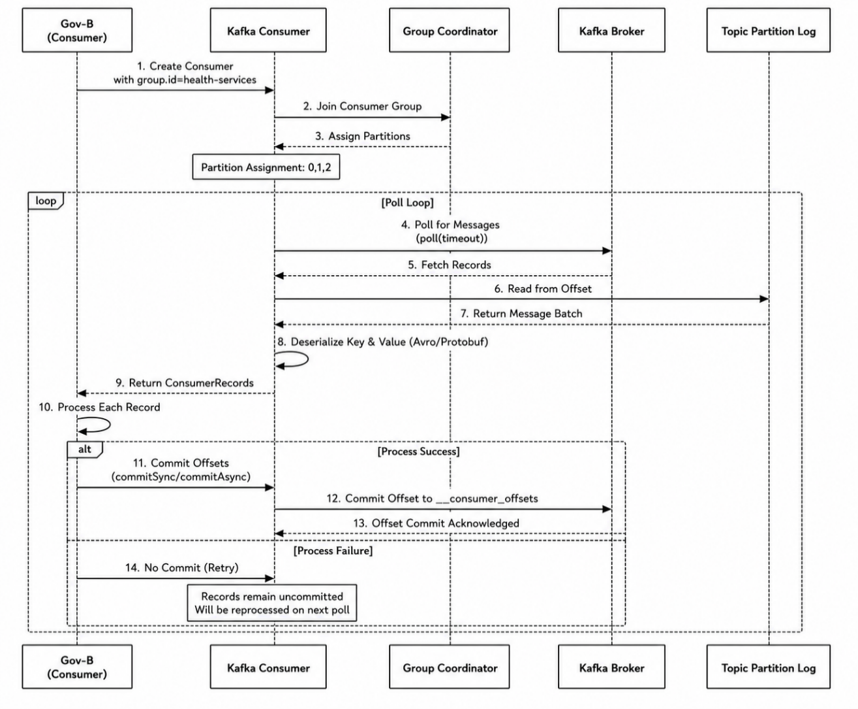
Figure 3.17. Kafka Consumer Group Processing Sequence
Source: Author
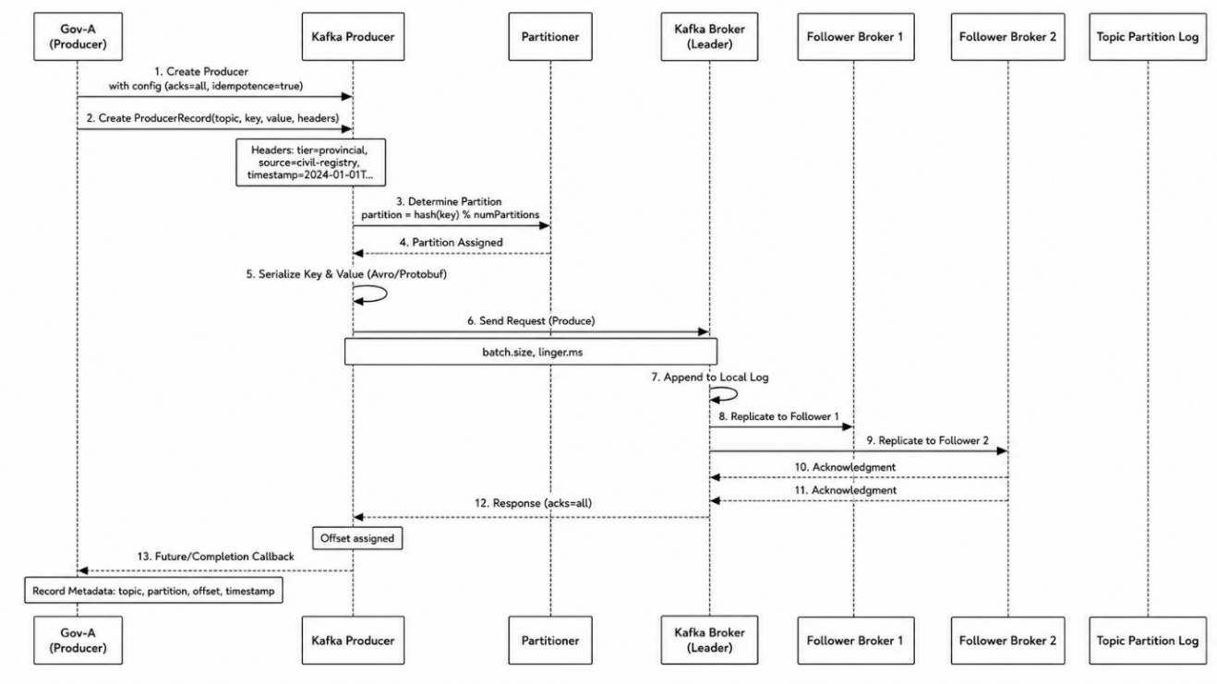
Figure 3.18. Kafka Producer and Replication Sequence
Source: Author

3.3.8.3 Kafka Technical Specifications and Redundancy
Broker redundancy in the DRC's eGovernment Kafka architecture is implemented through a stratified approach that recognizes the different availability requirements and infrastructure constraints of national, provincial, and municipal tiers, ensuring that no single point of failure can disrupt event-driven services across the federation.
At the national tier, redundancy is achieved through a six-broker cluster with replication factor three, meaning each topic partition has three copies distributed across different brokers.
At the provincial tier, twenty-six regional clusters deploy three brokers with replication factor three, providing redundancy within the cluster. This is the minimum viable configuration: with replication factor three, the cluster can tolerate the loss of one broker without data loss or service interruption.
At the municipal tier, edge brokers deploy as single nodes with no intra-tier replication, reflecting the practical reality that most municipalities lack the hardware, power, and technical expertise to operate multi-broker clusters.
Table 3.4. Kafka Redundancy Specifications by Governance Tier
Tier | Broker Count | Replication Factor | Min ISR | Failure Tolerance | Recovery Mechanism
National | 6 Brokers | 3 | 2 | Loss of 2 brokers | Automatic leader election
Provincial | 3 Brokers | 3 | 2 | Loss of 1 broker | Automatic leader election
Municipal | 1 Broker | 1 | 1 | Disk failure only | RAID mirroring + backup restore
Cross-Tier | MirrorMaker 2.0 | N/A | N/A | Loss of source cluster | Offset tracking + replay
Source: Author

3.3.8.4 Event-Driven Workflows between Government Agencies
The following sections present four critical event chains that illustrate the power of event-driven workflows in government service delivery: birth registration (foundational), death (service closure), marriage (family update cascade), and change of address (ripple effect). Each chain demonstrates how a single event propagates through the government ecosystem, triggering coordinated actions across multiple agencies without requiring central orchestration.

3.3.8.5 Birth Registration Service
The birth registration event chain represents the foundational workflow for establishing a citizen's legal identity and enabling access to government services. This chain is the most critical in the e-government ecosystem, as it initiates the citizen's digital identity and establishes their relationship with all government agencies.
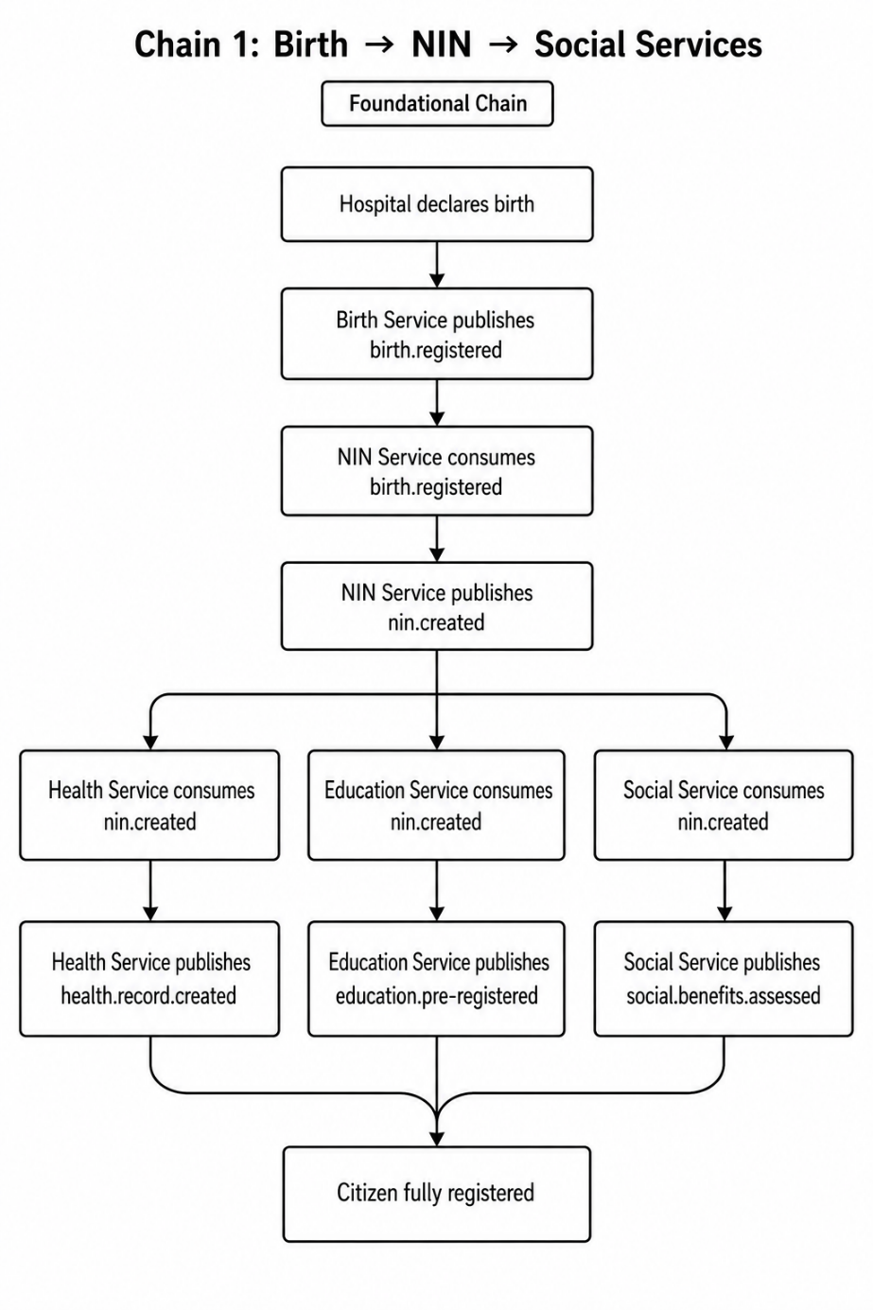
Figure 3.19. Birth Registration to NIN and Social Services Event Chain
Source: Author
The chain begins when a hospital declares a birth, triggering the Birth Service to publish the birth.registered event. This single event then triggers parallel actions across three services: the Health Service creates a health record, the Education Service pre-registers the child for future schooling, and the Social Service assesses family benefits. This parallel propagation ensures that all services act simultaneously without waiting for each other, reducing latency and enabling real-time responsiveness. The citizen becomes fully registered once all downstream services have completed their processing. This foundational chain demonstrates how event-driven architecture eliminates the need for citizens to visit multiple offices, realizing the "once-only" principle.

3.3.8.6 Death and Service Closure
The death event chain demonstrates how event-driven architecture handles the termination of services and closure of records when a citizen passes away, ensuring that all government systems are updated consistently and that erroneous payments or services are stopped.
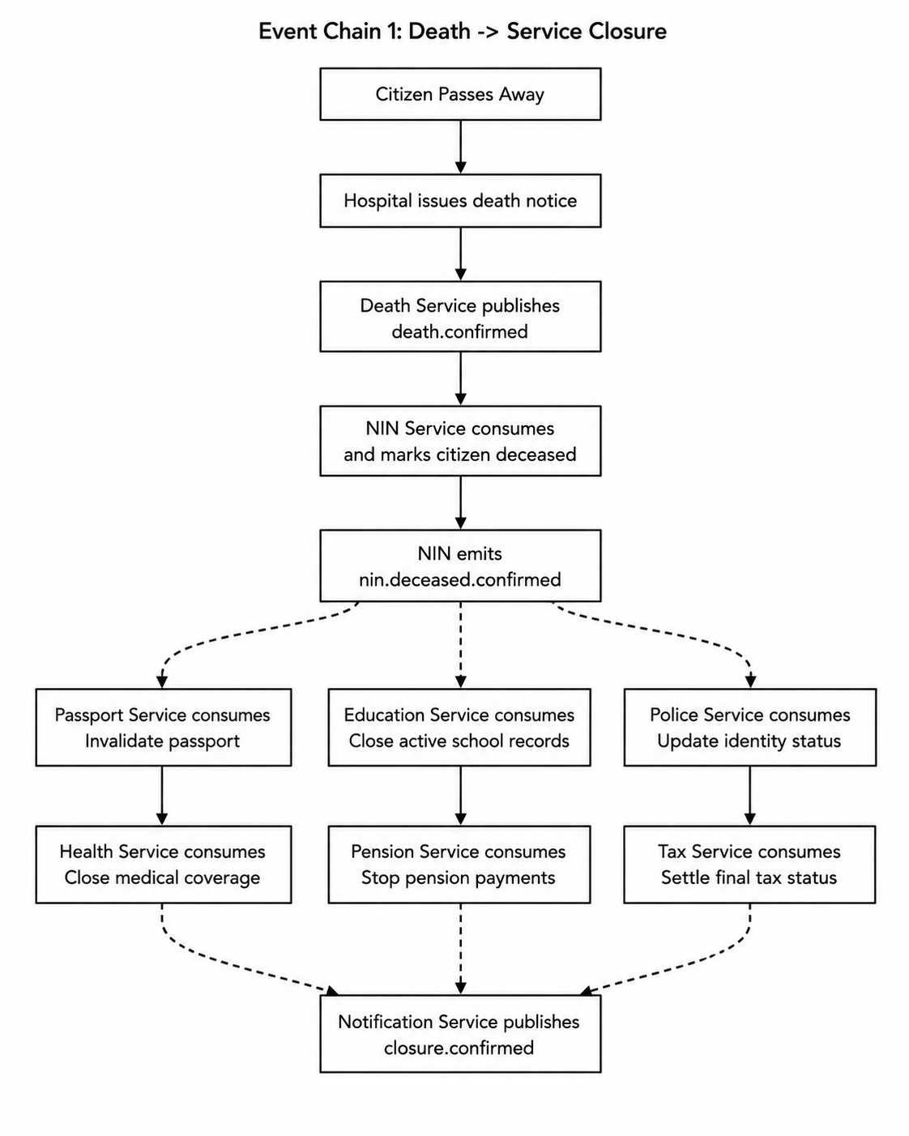
Figure 3.20. Death Registration and Service-Closure Event Chain
Source: Author
The chain begins when a citizen passes away and a hospital issues a death notice. The Death Service publishes death.confirmed, which the NIN Service consumes, marking the citizen as deceased and emitting nin.deceased.confirmed. This event triggers six parallel actions: the Passport Service invalidates the passport, the Education Service closes school records, the Police Service updates identity status, the Health Service closes medical coverage, the Pension Service stops pension payments, and the Tax Service settles the final tax status. All closure actions proceed in parallel, and once completed, the Notification Service publishes closure.confirmed. This chain ensures that no erroneous payments continue and that all government records are updated consistently, preventing fraud and maintaining data integrity.

3.3.8.7 Onboarding a Microservice in E-Government
In the complex ecosystem of a national e-government platform, where hundreds of microservices must operate seamlessly across municipal, provincial, and national tiers, the ability to introduce new services efficiently and consistently is not merely a technical convenience but a strategic imperative. The microservice onboarding flow establishes a structured, repeatable process that guides new services from initial conception through design, registration, implementation, deployment, validation, and production release—ensuring that every service, regardless of which ministry, province, or municipality develops it, adheres to the same rigorous standards for interoperability, security, observability, and operational readiness (Baldwin & Clark, 2000; Stallings, 2017; Taibi & Lenarduzzi, 2018).
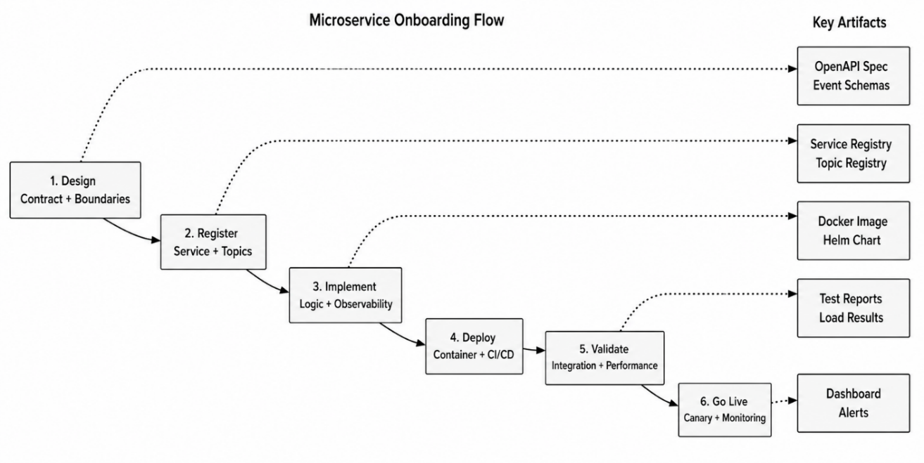
Figure 3.21. Microservice Onboarding Flow and Key Artifacts
Source: Author
The onboarding flow therefore operationalizes the national interoperability framework's four pillars—legal, semantic, organizational, and technical—by embedding them into a practical, step-by-step process that transforms abstract policies into concrete actions that developers, architects, and administrators can follow. By doing so, it enables the gradual, controlled expansion of the e-government platform while maintaining coherence across the entire system, ensuring that new services integrate seamlessly with existing ones and that citizens experience a consistent, reliable digital government regardless of which administrative level they are interacting with (Fayol, 1916; Layne & Lee, 2001; Rohr, 1986).

3.3.8.8 Conditions for Becoming a Service Producer or Consumer
In the e-government framework, producers are the applications that create and send events into Kafka topics, while consumers are the applications that read and process those events.
To become a producer or consumer on the Kafka e-government network, an entity must satisfy a comprehensive set of conditions aligned with the national interoperability framework's four pillars — legal, semantic, organizational, and technical — ensuring that only authorized, properly configured, compliant systems can inject or consume events from the event-streaming backbone.

3.3.8.9 Legal Conditions
The entity must possess explicit statutory authority to produce or consume the specific event types — a municipal civil registry must be legally recognized to publish birth and marriage events, a provincial health authority must have legislative mandate to consume patient-referral events, a national passport agency must be constitutionally empowered to consume NIN verification events. This mandate is verified through official documentation (gazette publications, ministerial decrees, provincial governor's orders), and the entity must obtain data-classification approval from the National Data Protection Authority certifying it may handle the classification level of the events involved, from Public for non-sensitive statistical events to Secret for casier judiciaire events. Producers must also demonstrate compliance with the consent framework, capturing and storing citizen consent where required by law, particularly for events involving medical records or criminal history, while consumers must demonstrate a lawful basis for processing, documented through formal data-processing agreements filed with the national data protection authority.

3.3.8.10 Semantic Conditions
Each producer must register its event schemas — Protocol Buffers for real-time online production, Avro for batch offline production — with the Central Schema Registry, ensuring all event definitions follow the national ontologies and controlled vocabularies the Ministry of Digital Affairs establishes. Schemas must pass backward-compatibility validation, so newer versions cannot break existing consumers by removing or renaming required fields, and must incorporate multilingual labels in French, Lingala, Swahili, and Kikongo where applicable. Consumers must declare the specific event types and field subsets they intend to consume, demonstrating that consumption respects data-minimization principles — a provincial health service consuming marriage events needs only spouse NINs and marriage date, not full ceremony or witness details. Both producers and consumers must implement semantic validation rejecting events with invalid codes — a gender value outside the national controlled vocabulary of M, F, or X must be rejected at the edge rather than propagated — and provinces with local terminology extensions must include mapping metadata letting national-level consumers interpret locally specific terms correctly.

3.3.8.11 Organizational Conditions
Each producer and consumer must sign formal service-level agreements with the National Interoperability Authority specifying expected event volumes, maximum acceptable latency, data-retention requirements, and escalation procedures for processing failures. Beyond formal agreements and governance structures, the framework requires harmonizing business processes across entities. The framework mandates that all entities document their processes using a standardized notation such as BPMN and submit these to a central repository managed by the National Digital Governance Council, where cross-process dependencies are analyzed and harmonized which should align with the DRC's constitutional decentralization, by establishing a common interoperability layer where processes from different tiers agree on shared interfaces, exchange formats, and handshake protocols while preserving internal variation.
Parties must also participate in interoperability reviews conducted by the National Digital Governance Council, examining event-quality metrics, processing latencies, and compliance violations, with corrective action plans for underperforming participants.

3.3.8.12 Technical Conditions
Each producer and consumer must implement configurations operationalizing the higher-level requirements above. Producers enable exactly-once semantics through idempotent-producer configuration and acknowledgment settings, preventing duplicate events even during network retries; consumers configure idempotent processing logic and commit offsets only after successfully processing events, ensuring at-least-once delivery that tolerates consumer crashes without data loss. Both parties use mutual TLS for authentication, presenting X.509 certificates issued by the National PKI that map to Role-Based Access Control roles granting precisely the permissions required — a municipal producer can write only to topics matching its jurisdiction pattern, while a provincial consumer can read only from topics within its province and cannot write to any topic. Producers implement exponential-backoff retry logic with a dead-letter queue for undeliverable events; consumers configure health-check endpoints the Kafka cluster uses to detect liveness and redistribute partitions when consumers fail.

3.3.9 Network and Hosting Paradigm
For countries with significant geographic diversity, such as the Democratic Republic of Congo, a hybrid network architecture offers the optimal balance of performance, security, and practicality (Abbott & Fisher, 2015; Stallings, 2017).
In our research, a government cloud would serve as the central backbone. It would host the event bus (such as Kafka), the microservices of each ministry, and the central data access layers that enable a unified. The use of commercial cloud capabilities for non-sensitive services while maintaining overall security. Pure public cloud deployment for core government functions remains generally inadvisable due to sovereignty concerns (Bogner et al., 2019; Hassan et al., 2020; Soldani et al., 2018).
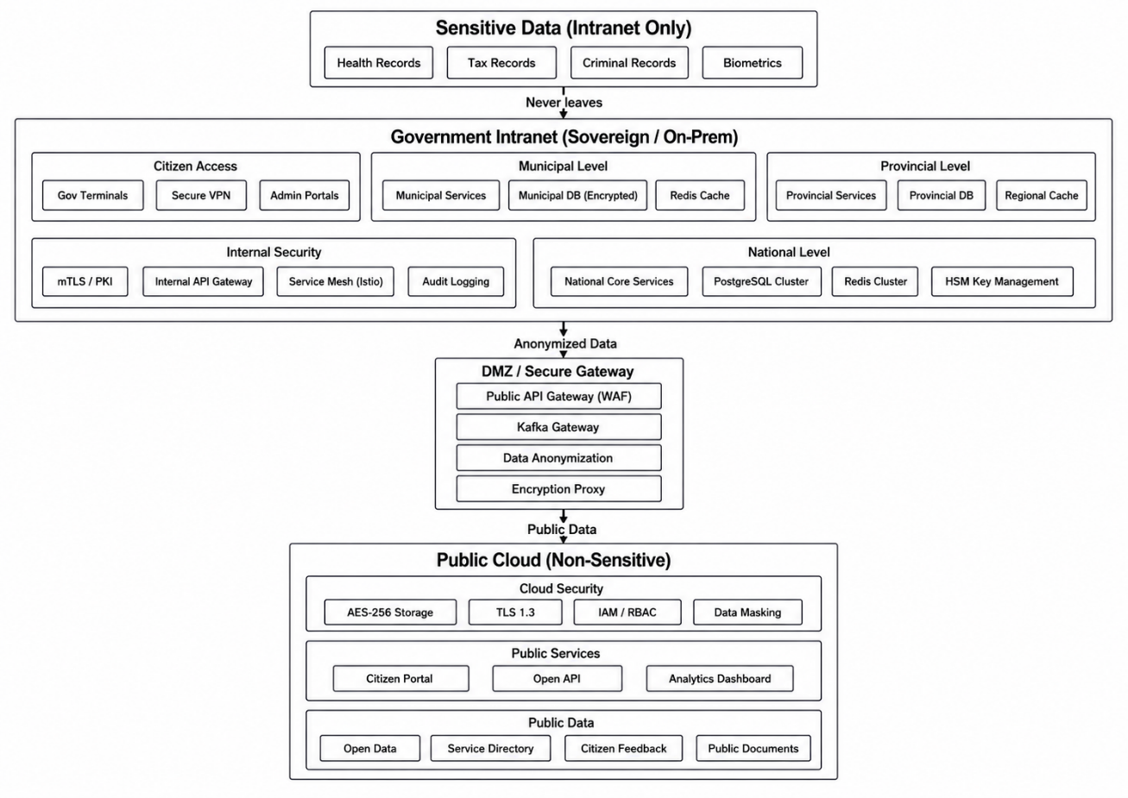
Figure 3.22. Hybrid Sovereign Hosting and Data-Classification Architecture
Source: Author
A hybrid e-government architecture ensures an optimal balance between digital sovereignty, performance, and scalability by strategically distributing workloads across government-controlled infrastructure and public cloud environments. In this model, all sensitive data—including citizen identity records, health records, civil registry databases, taxation information, etc, are strictly hosted within a secure government intranet, typically located in national or provincial data centers under full state control. This guarantees compliance with national regulations and prevents exposure to external jurisdictions. Conversely, non-sensitive services—such as public information portals, appointment scheduling platforms, service catalogs, and general administrative workflows—are deployed in the public cloud to leverage its elasticity, high availability, and cost-efficiency (Casalicchio, 2019; March & Smith, 1995; Pahl & Jamshidi, 2016).

3.4 Functional and Non-Functional Results

3.4.1 Functional Specifications

3.4.1.1 Functional Requirements
Functional specifications describe the services and capabilities that the proposed e-government platform must provide. Derived from the research objectives, SLEPT analysis, architectural design, and requirements of the DRC public administration, they are organized into eight categories.

3.4.1.2 Citizen-Centric Service Delivery
The platform shall provide a unified, multichannel portal through which citizens can discover and access public services. Users shall submit applications and supporting documents electronically, track requests in real time, receive notifications, download official documents, and make payments through mobile money, bank transfers, or cards. The platform shall apply the once-only principle so that information already provided to one authorized institution can be securely reused by others.

3.4.1.3 Interoperability and Data Exchange
The platform shall enable secure exchanges among municipal, provincial, and national institutions. It shall support asynchronous event-driven communication through publish-subscribe mechanisms and synchronous exchanges through REST and gRPC APIs. A central registry shall catalogue services, APIs, and data schemas. The platform shall also transform XML, JSON, Avro, and other formats, apply common semantic models, and coordinate cross-agency workflows with compensation mechanisms for failed transactions.

3.4.1.4 Data Management and Registries
The platform shall maintain authoritative registries for citizens, businesses, land, property, permits, licences, and judicial records. Each registry shall provide reliable and searchable information while reducing duplication and inconsistency. Registry data shall support versioning, standardized API exchange, complete audit trails, and consent management for the lawful sharing of personal information.

3.4.1.5 Identity and Access Management
The platform shall provide secure identity and access management through multifactor authentication and Single Sign-On. Role-based access control shall define permissions according to institutional responsibilities, while attribute-based access control shall support more detailed authorization based on clearance, data sensitivity, purpose, and context. Integration with the National Electronic Certification Authority shall support secure authentication and digital signatures.

3.4.1.6 Electronic Transactions and Legal Validity
The platform shall support legally valid electronic signatures, documents, payments, and timestamps. It shall accommodate simple and qualified electronic signatures according to transaction risk. Electronic records shall be securely stored, indexed, retrieved, versioned, and archived in formats that preserve their integrity, authenticity, and long-term accessibility.

3.4.1.7 Security and Data Protection
The platform shall protect the confidentiality, integrity, and availability of government information. Communications shall use TLS 1.3, stored data shall use AES-256 encryption, and service-to-service exchanges shall use mutual TLS. Comprehensive audit logs shall record data access and system operations. Anonymization, pseudonymization, and appropriate technical and organizational controls shall protect personal information and support regulatory compliance.

3.4.1.8 Reporting and Analytics
The platform shall provide dashboards showing service volumes, processing times, quality indicators, and operational bottlenecks. It shall generate standard and customized government reports, support statistical analysis for policy formulation and evaluation, and provide real-time monitoring of system health and performance.

3.4.1.9 Administrative Functions
Administrative interfaces shall support the management of users, roles, permissions, services, APIs, versions, and system configurations. The platform shall also support user onboarding and offboarding, service registration and discovery, feature configuration, and the controlled modification of system parameters without requiring major code changes.

3.4.1.10 Identity, Access Management, and Single Sign-On
The platform shall provide centralized identity and access management for citizens and government employees. A Single Sign-On (SSO) mechanism shall allow users to authenticate once and access all authorized government services without repeated logins. SSO shall support federated identity standards, centralized session management, secure logout, and multifactor authentication for sensitive operations. Role-based and attribute-based access controls shall restrict access according to institutional responsibilities, security clearance, data sensitivity, purpose, and context. Integration with the National Electronic Certification Authority shall support trusted digital identities, secure authentication, and legally valid digital signatures.

3.4.2 Security and Non-Functional Specifications

3.4.2.1 Security

3.4.2.2 Infrastructure Protection Solutions

3.4.2.3 Certificate Authority and Public Key Infrastructure
In e-government, a Government Certificate Authority (CA) and Public Key Infrastructure (PKI) form the foundational trust framework that enables secure, reliable, and legally recognized digital interactions between citizens, businesses, and government entities. For the highest assurance, governments often operate their own root CAs or partner with tightly controlled commercial authorities.
PKI is the complete system of hardware, software, policies, and procedures needed to create, manage, distribute, use, store, and revoke digital certificates — a multi-layered trust framework securing digital identities and transactions. A Time-Stamping Service provides trusted time evidence for synchronized, auditable event sequencing, and, at the foundation, Hardware Security Modules (HSMs) offer tamper-resistant secure key storage for the most sensitive cryptographic assets.
Government PKI typically follows a hierarchical structure with a National Root CA at the apex, often kept offline in a highly secure facility to prevent compromise. Below this root, issuing CAs serve different sectors — Citizen CAs for personal digital identities, Government CAs for employee credentials, and Infrastructure CAs for servers and devices — allowing tailored security policies and certificate characteristics for each use case (Figure 2).
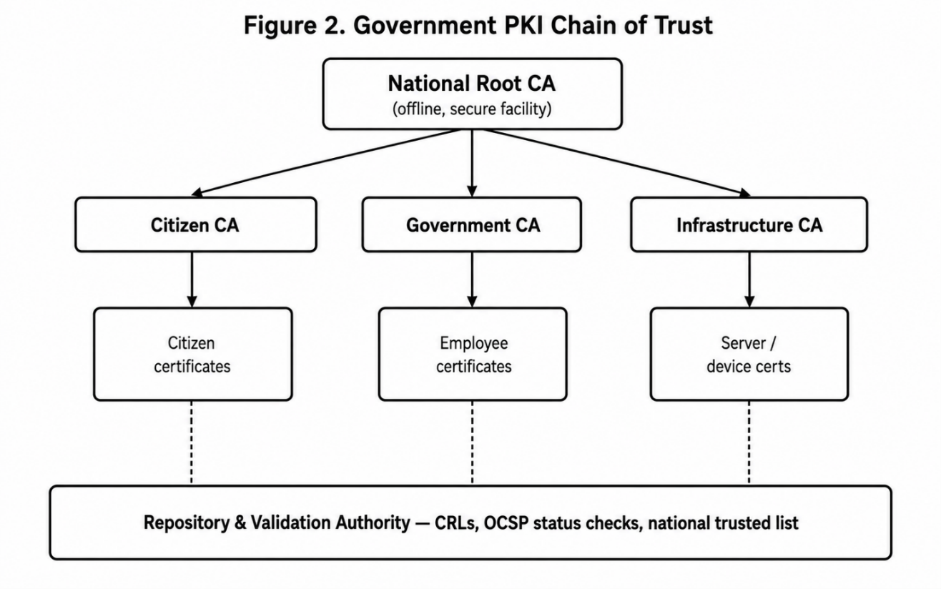
Figure 3.23. Government PKI Chain of Trust
Source: Author
The chain of trust ensures that every end-entity certificate can be traced back to a trusted Root CA through one or more intermediate CAs. Applying for a government CA certificate requires identity verification by the Verification Authority, a formal request via the Registry Authority, validation against policy rules, and final issuance by the appropriate government CA. All steps are audited and published on the national trusted
The operational side of government PKI involves meticulous lifecycle management; and renewal or revocation, when certificates expire or are compromised. At its core, a Government CA is the trusted entity that issues digital certificates; while the PKI is the complete system of policies, technologies, and procedures that manage those certificates throughout their lifecycle.

3.4.2.4 Security Framework

3.4.2.5 Security Conceptual Architecture
Infrastructure protection solutions establish defense-in-depth across the foundational layer of e-government systems, ensuring that physical and virtual resources remain resilient against evolving threats. The architecture (Figure 1) is built on a clear separation between public-facing and internal systems, implementing defense-in-depth through multiple security zones and strict access controls.
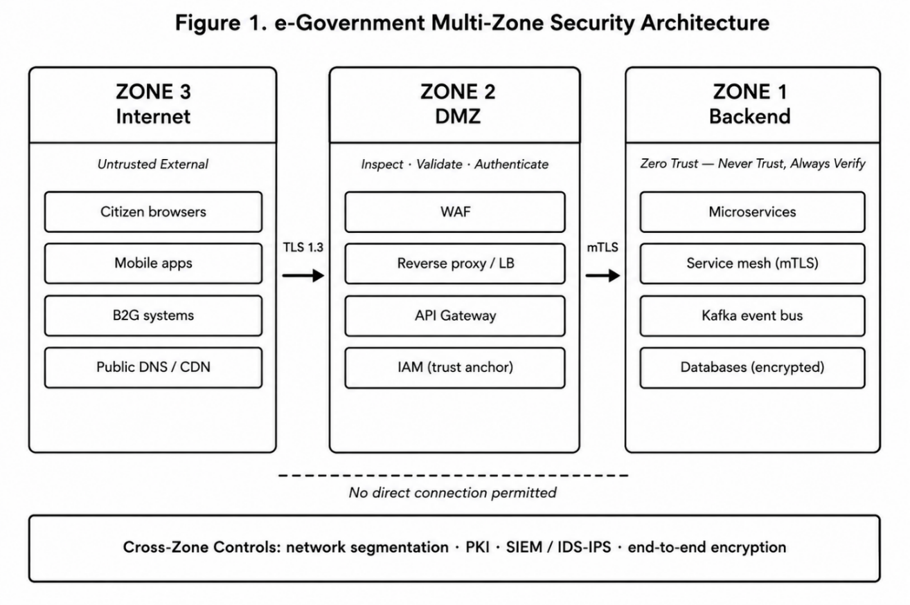
Figure 3.24. E-Government Multi-Zone Security Architecture
Source: Author
Zone 3; a Web Application Firewall, DDoS protection, SSL inspection, and IP-reputation filtering block malicious traffic at the earliest stage. No direct connection is ever permitted from Zone 3 to internal systems; all traffic must terminate in the DMZ, enforcing a strict boundary against lateral movement.
Zone 2; the API Gateway enforces rate limiting, validates request schemas, manages authentication delegation, and logs comprehensively for traceability. The guiding principle is to inspect, validate, and authenticate everything before it enters the core system; strict segmentation means that even a DMZ compromise cannot directly reach backend resources.
Zone 1 — Backend. Data protection at the storage level includes encryption at rest (AES-256), fine-grained access-control policies, and data masking for highly sensitive fields, with database access restricted exclusively to authorized services. The underlying infrastructure runs on platforms such as Kubernetes, providing workload isolation, secure deployment pipelines, and policy enforcement; the governing principle is never trust, always verify — even inside the network.
Cross-zone security controls. This multi-zonal architecture achieves three objectives: containment, so a breach in one zone does not propagate across the infrastructure; digital sovereignty, since sensitive data stays within the secure backend under full governmental control; and scalability, allowing public-facing services to evolve independently while critical systems remain strictly protected — together supporting governance at municipal, provincial, and national levels.

3.4.2.6 Study of Security Approaches

3.4.2.7 Identity and Access Management Solutions
Identity and Access Management (IAM) establishes the trusted relationship between individuals and government systems, ensuring authentication and authorization scale to millions of citizens while maintaining security and usability. The IAM framework must support the entire citizen lifecycle from birth registration to death-certificate issuance, and enable Single Sign-On so a citizen authenticated at a municipal office can access provincial health records and national civil-registry data without re-authenticating.

3.4.2.8 Authentication
A comprehensive strategy balances security with usability through a tiered approach; and privileged administrators face stricter controls including hardware tokens and just-in-time access. The optimal strategy is often hybrid; stateless authentication for broad, high-scalability services and stateful methods for the most sensitive operations.

3.4.2.9 Authorization
Authorization relies on policy-based access control that accommodates complex, dynamic requirements. For national digital infrastructure, this lets citizens authenticate once through the national identity provider and selectively grant applications access to specific data across agency boundaries, with fine-grained scopes ensuring citizens authorize only the minimum necessary access.

3.4.2.10 Single Sign-On
SSO concentrates authentication risk in one place, so its implementation demands rigorous controls; mandatory MFA for all administrative access to the identity provider, comprehensive logging of authentication events, and protocols (SAML, OpenID Connect) implemented with cryptographic message signing, replay protection through one-time-use constraints, appropriate assertion lifetimes, and recipient-endpoint validation. Because a failed SSO service makes every dependent service inaccessible, high availability; is essential, alongside monitoring for anomalous authentication patterns such as impossible-travel scenarios or credential-stuffing spikes.

3.4.2.11 Service Access Solutions
Securing service-to-service communication relies on identity-based authentication and authorization for every interaction, preventing lateral movement by attackers who compromise individual services. In practice, this is implemented using the SPIFFE/SPIRE framework: each service pod receives a unique X.509 certificate containing its SPIFFE ID as its cryptographic identity within the mesh, with the mesh control plane maintaining a registry of authenticated services.

3.4.2.12 Data Protection Solutions
Data protection solutions safeguard information throughout its entire lifecycle, recognizing that data is the most valuable asset within e-government systems and that its compromise undermines citizen trust and the legitimacy of digital governance.

3.4.2.13 Data Protection at Rest
Protecting data at rest uses layered encryption addressing different storage contexts; field-level encryption for highly sensitive data, applied at the application layer so that even database administrators cannot view plaintext; and file-level encryption protecting individual documents and backups. In cloud environments, customer-managed keys (CMKs) let government retain control over encryption keys even when data is held by a third-party provider.
This defense-in-depth approach to data at rest works in four overlapping layers. Layer 4, application encryption, covers password hashing with bcrypt or Argon2, real-time data masking in application interfaces, and secure storage of application secrets, protecting data from initial entry through processing to storage. Together, these four layers mean an attacker must defeat multiple independent mechanisms to reach sensitive information.

3.4.2.14 Data Protection in Transit
Protecting data in transit demands ubiquitous encryption for all government data in motion, whether over public networks or internal infrastructure. For particularly sensitive data, application-layer encryption provides a further layer in case network encryption is defeated through downgrade attacks or compromised endpoints, with strong ciphers and protocols kept under regular review, and certificate pinning offering additional protection against CA compromise where its rotation implications are carefully managed.
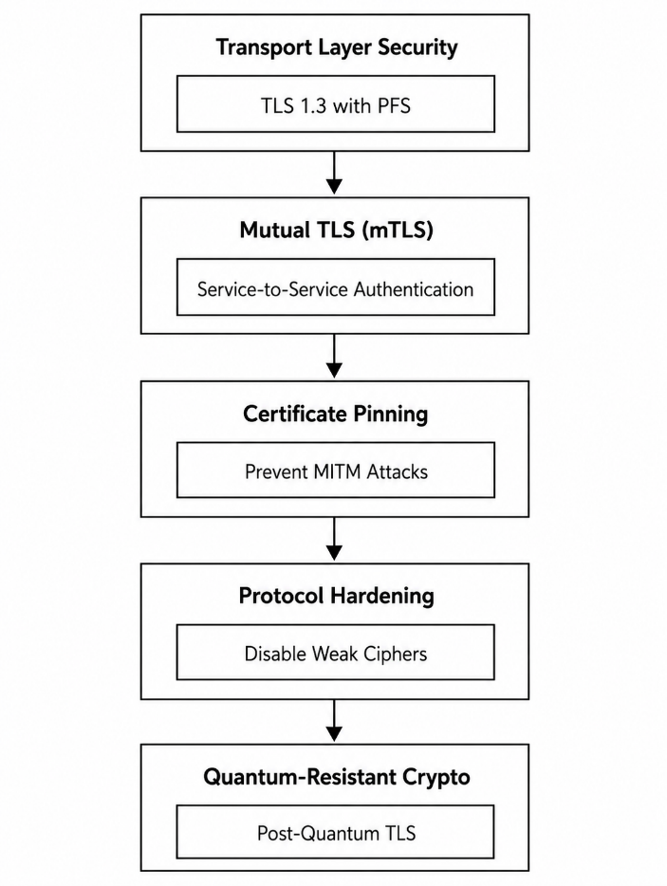
Figure 3.25. Data Protection in Transit Framework
Source: Author

3.4.2.15 Grant and Identity Storage
In OAuth 2.0/OpenID Connect deployments, e-government systems need strict token-management policies; tokens are short-lived (access tokens expiring in minutes to hours), refresh tokens are stored server-side in a dedicated secrets vault rather than accessible client-side locations, immediate revocation is supported for suspected compromise, and tokens can be bound to attributes such as client IP or user agent to make reuse from a different context difficult (Table 3.5). In e-government, the identity store is not just a database; it is a critical national asset requiring corresponding rigor.
Table 3.5. Token Storage Classification
Category | Token Type | Format | Validity | Storage | Use Case
Authentication | Session Token | JWT | 15 min – 8 hrs | HTTP-only secure cookie | Citizen portal sessions
Authentication | Refresh Token | Opaque | 7–90 days | Secure server storage | Extended sessions
Authentication | API Access Token | JWT/Bearer | 1–24 hours | Memory/client storage | Service-to-service calls
Authorization | OAuth Access Token | JWT/Opaque | 1–24 hours | Secure client storage | Third-party integrations
Authorization | Capability Token | UCAN/ZCAP | Custom | Encrypted storage | Fine-grained access control
Identity | SAML Assertion | XML | Minutes | Transient | Cross-domain SSO
Identity | OIDC ID Token | JWT | Minutes | Transient | User identity claims
Cryptographic | Digital Certificate | X.509 | 1–3 years | HSM/Smart card | Legal digital signatures
Cryptographic | Encryption Key | Symmetric | 90 days | HSM/Key vault | Data encryption
Transaction | One-Time Token | Numeric | 5–10 min | SMS/Email | Transaction confirmation
Source: Author
The encryption key hierarchy underlying database encryption establishes a layered structure where higher-level keys protect lower-level keys, so sensitive master material never appears in plaintext outside secure hardware while still enabling efficient encryption of large data volumes. In the DRC's e-government context, this hierarchy means a breach of the application server might expose column encryption keys but never the master key, which stays inside the HSM; a compromised column key requires re-encrypting only that column's data, while a compromised master key would require re-encrypting everything — which is exactly why it never leaves the tamper-resistant HSM.

3.4.3 Performance Strategies

3.4.3.1 Layered Performance Strategy
Performance problems in e-government systems manifest when request or job queues build up, causing citizen transactions to wait longer than acceptable limits. This queue buildup typically results from three interrelated factors: insufficient processing capacity (CPU, memory, disk I/O), inefficient request handling (blocking operations, poor algorithm choices), or contention for shared resources (database locks, connection pool limits). Understanding that queue growth is the universal symptom of performance problems is the first step toward effective remediation.
The performance of an e-government system is fundamentally characterized by three metrics: throughput, latency, and resource saturation. These three metrics are interdependent: as resource saturation approaches 100%, throughput plateaus or declines, and latency increases exponentially as requests queue behind saturated resources. The relationship follows the Universal Scalability Law (Gunther, 2008), which models how contention and coherency overhead cause performance to degrade as systems approach saturation.
When a service exceeds its capacity, the consequence is not merely slower responses but the potential for cascading failure. The following sections detail the specific strategies employed in the proposed e-government architecture to ensure that performance is maintained even under adverse conditions, with particular attention to the throughput, latency, and resource saturation constraints that characterize the DRC's infrastructure environment.

3.4.3.2 Layer 1: Web Application

3.4.3.3 Persistent Connections
Persistent connections are a fundamental optimization for e-government systems serving citizens across diverse network conditions, particularly in a geographically vast country like the DRC with varying internet infrastructure quality.

3.4.3.4 Efficient Encoding Algorithms
Choosing efficient algorithms is critical because algorithm efficiency directly determines whether a service scales to serve millions of citizens or fails catastrophically under load. The full classification of creational, structural, and behavioral patterns for e-government is developed separately in this dissertation's design-patterns chapter, including the Singleton, Factory, Builder, Adapter, Facade, Proxy, Observer, Mediator, Command, and Strategy patterns and their prioritization for the DRC context; it is not repeated here.

3.4.3.5 Web Content Caching
Caching implements a fundamental principle of web performance: serve static or infrequently changing content from locations closest to the user with minimal latency. Caching it at multiple levels creates a distributed delivery network that improves user experience while reducing load on central infrastructure: cache-control headers at the browser level prevent returning citizens re-downloading unchanged resources.

3.4.3.6 SSL/TLS Session Caching
Every citizen transaction must be encrypted to protect sensitive data and maintain public trust. Session caching and session tickets let a returning browser resume a previous secure session with an abbreviated handshake, shaving off that latency penalty.

3.4.3.7 Session Caching
Session caching enables stateless application design by storing citizen session data (user ID, permissions, form data, transaction state) in distributed in-memory caches like Redis rather than traditional databases — delivering microsecond read access, eliminating central bottlenecks, and letting any application server handle any request without sticky sessions.

3.4.3.8 Layer 2: Application Business Logic

3.4.3.9 Thread-Pool and Size Management
Thread pools are the fundamental mechanism for handling concurrency in e-government applications, which handle a mix of I/O-bound tasks (database queries, verification API calls, file access) and CPU-bound tasks (generating PDF certificates, validating complex forms, calculations).

3.4.3.10 Database Connection Pooling
A well-configured connection pool maintains a warm set of authenticated connections that threads borrow and return, eliminating setup overhead for the vast majority of requests and potentially raising throughput from hundreds to tens of thousands of requests per second on the same hardware, while also protecting the database server by capping concurrent connections.

3.4.3.11 Efficient Locking Strategies
As systems scale to high concurrency, shared resources — configuration caches, in-memory counters, rate limiters, distributed coordination mechanisms — need careful synchronization to prevent race conditions without serializing access unnecessarily. ReadWrite locks distinguish readers from writers, allowing concurrent reads with exclusive writes; lock striping partitions a resource into independently locked segments to reduce contention; and compare-and-swap operations enable lock-free or low-contention updates to shared counters or flags.

3.4.3.12 Query Optimization
Query optimization remains one of the most cost-effective ways to improve database performance, though its form varies across the polyglot landscape. In document databases, optimization means designing document structures to minimize joins and using compound indexes on frequently queried fields; in graph databases, it means optimizing traversal patterns and minimizing traversal depth; in key-value stores, it means key design that supports access patterns without secondary indexes.

3.4.3.13 Layer 3: Data and Storage Optimization with Polyglot Persistence

3.4.3.14 Strategic Database Selection
This dissertation applies the core principle of polyglot persistence: using different database technologies optimized for specific workload patterns rather than forcing all data into one model, recognizing that e-government systems serve diverse needs for consistency, availability, scalability, and query capability. These criteria guide technology choices across the DRC platform's system categories.

3.4.3.15 Denormalization and Normalization
In polyglot environments, this becomes a broader data-modeling decision rather than a purely relational concern. In polyglot architectures this often crosses database boundaries: normalized relational data is periodically extracted, transformed, and loaded into denormalized document or search-optimized stores built for specific query patterns, with materialized views serving the same purpose for frequently requested reports within a single relational database.

3.4.3.16 Indexing Strategies
Indexing must match each data model. Relational stores use B-tree, hash, spatial, BRIN, composite, or covering indexes according to query patterns; document stores index JSON fields, arrays, locations, and text; and graph stores index labels, relationships, and properties used in traversals. Indexes should be justified by measured workloads because each one accelerates reads while increasing storage and write cost.

3.4.3.17 Vertical Scalability
Vertical scalability is the ability to handle increasing workload by enhancing existing infrastructure — upgrading CPU, RAM, and storage within government data centers — rather than distributing load across nodes. In a hybrid e-government architecture, vertical scalability is therefore best reserved for mission-critical, high-security components, complemented by horizontal scaling in less sensitive, cloud-based services for overall resilience and efficiency.

3.4.4 Reliability and Recovery
Designing fault tolerance into e-government systems requires a proactive, architectural approach rather than reactive fixes. Fault tolerance must also extend to data-consistency models, employing techniques like sagas for distributed transactions so the system maintains legal and financial consistency across government records even during failures.
The goal for e-government architects is not a system that never experiences partial failure — impossible at scale — but one that expects failure at every level, isolates failures to prevent cascading collapse, degrades functionality gracefully while preserving core citizen services, recovers automatically and transparently where possible, and communicates status clearly to both operators and citizens when degraded.

3.4.4.1 Fault-Tolerance Principles
Redundancy is the duplication of critical components to provide backup when primary components fail. It ensures that when a database server fails in the capital, citizen services continue uninterrupted via replicas elsewhere — but redundancy must be implemented thoughtfully, since duplicating everything is cost-prohibitive. Government architects must perform criticality analyses to determine which services need active-active redundancy (immediate, zero-downtime failover) versus active-passive (brief downtime during failover).

3.4.4.2 Active Redundancy
Active redundancy is the highest tier of availability: every node in the cluster is active and processes workload simultaneously, sharing the operational burden in real time. This is ideal for mission-critical applications, such as financial platforms or emergency-response systems, where even milliseconds of downtime are unacceptable, at the cost of the operational expense of running all redundant hardware constantly.

3.4.4.3 Passive Redundancy
Passive redundancy balances high availability with resource conservation: only primary nodes perform actual data processing under normal conditions, while standby nodes remain powered on and ready — typically running a minimal OS or holding current application data in memory — without processing traffic. This suits services needing quick recovery while saving on the licensing and energy costs of running all hardware at full capacity simultaneously.

3.4.4.4 Cold Redundancy
Cold redundancy is the most resource-efficient and least resilient form: spare nodes remain fully powered off or disconnected during normal operations, existing purely as hardware on the shelf until a catastrophic failure. It is typically reserved for non-critical systems, development environments, or last-resort disaster recovery, where maintaining powered-on hardware is prohibitive and brief downtime is an acceptable risk.

3.4.4.5 Redundancy of Stateless Components
Stateless services retain no session or transaction data between requests, making them easier to scale, replace, and recover after failure. In e-government architectures, stateless services are preferred for user interfaces, gateways, and business logic because they can be restarted instantly without data loss; this reduces dependency on any individual service instance and makes stateless components ideal candidates for horizontal scaling and simple redundancy, since any instance can handle any request.

3.4.4.6 Web Application Layer
The web application layer is the public face of e-government — the front-end servers or containers serving the citizen portal, processing HTTP/API requests, and executing core business logic. The redundancy strategy relies on multiple identical instances behind a robust load balancer, with horizontal auto-scaling triggered by real-time metrics such as CPU utilization, memory consumption, or request-queue depth.

3.4.4.7 Microservice Layer
Beneath the web tier sits the service layer; encapsulating specific domains of government functionality, invoked by the web layer to fulfill complex business operations and themselves designed to be stateless, fetching required context from a central data store per request. The result is a self-healing fabric where a single instance's failure is invisible to the calling web layer; ensuring dependent agencies can reliably access needed data even as underlying infrastructure experiences partial failures.

3.4.4.8 Aggregator Service and API Gateway
The redundancy strategy for the API Gateway involves multiple active-active instances behind load balancing — a dedicated hardware appliance, cloud load balancer, or DNS round-robin for geographic distribution. Operating redundant, stateless gateway clusters keeps e-government's digital facade resilient and continuously available even as individual instances fail or traffic patterns shift unpredictably, protecting the integrity of citizen-facing services and public trust.

3.4.4.9 Redundancy of Stateful Components
Stateful components are fundamentally harder to replicate than stateless ones because they manage unique, persistent data with intrinsic value that cannot be regenerated or discarded without consequence. This distinction introduces real complexity: one cannot simply launch another database copy and hope for the best, since each copy must remain consistent with every other, and the failure of a primary node risks not just interruption but actual data loss or corruption. Redundancy for stateful components therefore shifts focus from instance replication to data replication.

3.4.4.10 Cache
Caches hold temporary but often mission-critical data — active citizen sessions, frequently accessed reference data like postal-code directories, and expensive computational results that would otherwise overwhelm downstream databases. At the national resilience level, forward-looking architectures implement active-passive replication across geographically separated data centers, so that even the loss of an entire facility does not force millions of citizens to re-authenticate simultaneously. Redundant, highly available caching protects session continuity, sub-second lookup performance, and downstream database stability alike.

3.4.4.11 Database Redundancy
In e-government systems, database replication is not merely a technical optimization but a foundational requirement for data sovereignty, service continuity, and citizen trust. The choice of replication model involves a fundamental trade-off between consistency, availability, and performance, and a pattern appropriate for a public information portal may be dangerously inadequate for a national identity registry.

3.4.4.12 Primary–Secondary Replication
This model establishes a clear hierarchy; and, most importantly for transactional integrity, no write conflicts, since all updates converge on a single master, eliminating the possibility of two nodes modifying the same record incompatibly; essential for systems of record such as property registries, court judgments, and citizen identity databases where conflicting versions of truth would create legal chaos.
Asynchronous replication in master-slave architectures optimizes performance by letting the master acknowledge writes immediately without waiting for replica confirmation — essential for high-frequency transactions like tax payments where citizens expect instant feedback — at the cost of eventual consistency (a citizen updating their address might see stale data from a replica) and, more seriously, risk of data loss if the master fails before replicating committed transactions. Table 5.3 compares the two.

3.4.4.13 Multi-Primary Replication
This model departs from the master-slave hierarchy by letting multiple nodes accept writes simultaneously, most commonly through asynchronous multi-master configurations where each node operates independently and propagates changes to peers through background replication streams. Despite this, asynchronous multi-master replication remains essential wherever local operational autonomy and resilience against network partitions matter more than the added complexity of conflict resolution.
The choice between the two ultimately depends on whether the application can tolerate write conflicts or requires absolute consistency. Master-master offers higher write availability and throughput, since any node can process updates even if others are offline, at the cost of potential conflicts requiring resolution via last-write-wins, version vectors, or application logic — appropriate for the DRC's public service directory, where a clinic address updated in two provinces simultaneously can be resolved by timestamp, or for citizen notification preferences where occasional conflicts have minimal consequence. Table 5.4 compares the two models directly.

3.4.4.14 Stateless Component Recovery
Stateless recovery is fundamentally trivial compared to stateful recovery because stateless components, by definition, retain no in-memory data that persists beyond individual request processing. When one instance of the municipal marriage service crashes, no citizen data is lost, because the registration was already committed to the stateful PostgreSQL database before the response reached the citizen — recovery is simply ensuring enough healthy instances remain to handle incoming requests.

3.4.4.15 Hot Standby for Stateless Services
Hot standby is achieved by over-provisioning: running more instances than the minimum required for expected load, so a single instance's failure does not reduce capacity below the required threshold. For critical citizen-facing services where any degradation would be noticed, hot standby delivers zero-downtime recovery without manual intervention.

3.4.4.16 Warm Standby for Stateless Services
Warm standby takes a more resource-efficient approach: running only the minimum instances required for normal load, with a mechanism to rapidly launch replacements when failures occur. Warm standby suits services where brief degradation during recovery is acceptable and the cost savings of not running excess capacity outweigh the slightly longer recovery time — the default choice for internal reporting or batch-processing jobs.
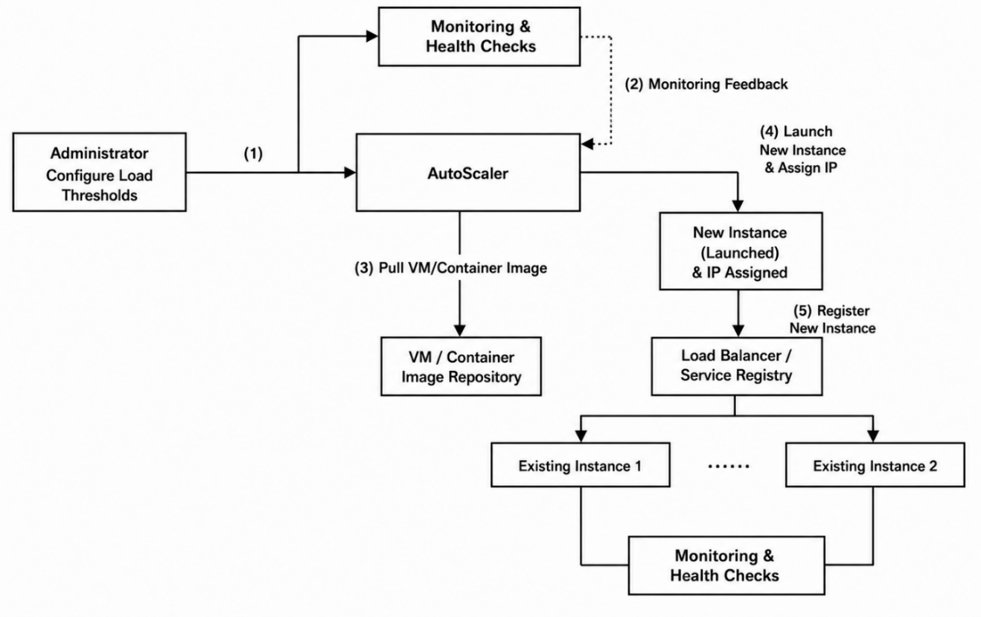
Figure 3.26. Autoscaling and Health-Check Feedback Loop
Source: Author

3.4.4.17 Integration with Existing Scaling Mechanisms
The elasticity of stateless components is one of the most powerful resilience mechanisms available, letting systems adapt dynamically to both failures and fluctuating demand without manual intervention. Because no instance holds unique session data or local state, any instance can replace any other at any time, making the entire fleet fungible and eliminating the operational toil of manual capacity planning and incident response.

3.4.4.18 Stateful Component Recovery

3.4.4.19 Database Recovery
Database recovery in e-government systems relies on three primary redundancy strategies; each trading recovery speed, data-loss risk, operational cost, and geographic flexibility differently, implemented within a master-slave replication framework where a primary database accepts all writes while one or more secondaries replicate. The choice among hot, warm, and cold standby directly implements each service's Recovery Point Objective (RPO) and Recovery Time Objective (RTO), with citizen-facing systems demanding near-zero downtime and zero data loss, while internal analytical systems can tolerate longer recovery windows and minimal loss.
Hot standby achieves the highest database availability through synchronous replication; every transaction commits on both primary and secondary before acknowledgment returns to the client, so the primary transmits each change and waits for the secondary's confirmation that it has been written to its transaction log before considering the transaction complete. For the DRC's most critical systems; hot standby is mandatory despite its performance cost.
Warm standby uses asynchronous replication; transactions commit and are acknowledged to the client immediately on the primary, while changes are batched and transmitted to the secondary at periodic intervals, typically every few seconds or after accumulating a threshold of changes, keeping the secondary nearly but not exactly current. For the DRC, a warm standby for the national NIN registry might sit in a neighboring country or a different geographic zone, accepting the risk of losing a few seconds of transactions in the rare event of simultaneous primary and network-link failure; a conscious trade-off, since recovering service with 99.99% of data intact is far better than having no recovery option at all.
Cold backups are the most fundamental and universally necessary recovery mechanism, based on periodic full backups combined with continuous transaction-log archives rather than redundant running servers. For the DRC's platform, cold backups should be taken at least daily, retained for legally mandated periods — seven years for tax records, permanently for civil-status changes — and regularly tested for restore integrity, since an untested backup is functionally equivalent to no backup at all.

3.4.4.20 Infrastructure and Geo-Redundancy
Data center redundancy, or geo-redundancy, is the ultimate expression of resilience in e-government architecture; earthquakes, floods, prolonged grid failures, fires, or human-initiated disruption. Its implementation follows one of two architectural patterns, each a distinct trade-off between recovery speed, operational complexity, and cost.

3.4.4.21 Multi-Region Active–Passive
The active-passive model establishes a hierarchy between regions; while a secondary region maintains a prepared but inactive copy, ranging along a spectrum from “warm” to “hot” depending on pre-provisioning and synchronization frequency. This model suits e-government services where the primary objective is business continuity rather than global low-latency access, avoiding the architectural overhead of maintaining active operation across regions simultaneously.

3.4.4.22 Multi-Region Active–Active
The active-active model represents the pinnacle of resilience and performance; archipelagic states, multiple major population centers, or federal systems requiring local data sovereignty; active-active offers transformative capability, giving citizens in distant provinces the same low-latency experience as those in the capital and rendering regional outages invisible to the broader population.
The justification for geo-redundancy, active-passive or active-active, extends beyond technical metrics into civic responsibility. Geo-redundancy ensures citizen services can be restored from another location within a pre-defined, publicly committed timeframe, upholding the social contract that the state remains accessible and responsive regardless of circumstances, and that the digital infrastructure of modern governance has been designed with the resilience expected of physical institutions.

3.4.5 Eventual Consistency and Conflict Resolution
Version vectors are a fundamental mechanism for maintaining causal consistency and detecting conflicts in distributed systems where data may be updated concurrently across multiple independent replicas. For any data object, the version vector encapsulates its complete causal history, serving as a concise fingerprint that lets replicas determine, through vector comparison, whether one state subsumes another (dominance), whether states are equal, or whether states have diverged through concurrent updates (conflict) — essential where citizen records may be modified simultaneously by municipal clerks in Kinshasa, provincial administrators in Lubumbashi, and national authorities in Goma, each with legitimate independent authority within its own jurisdiction.
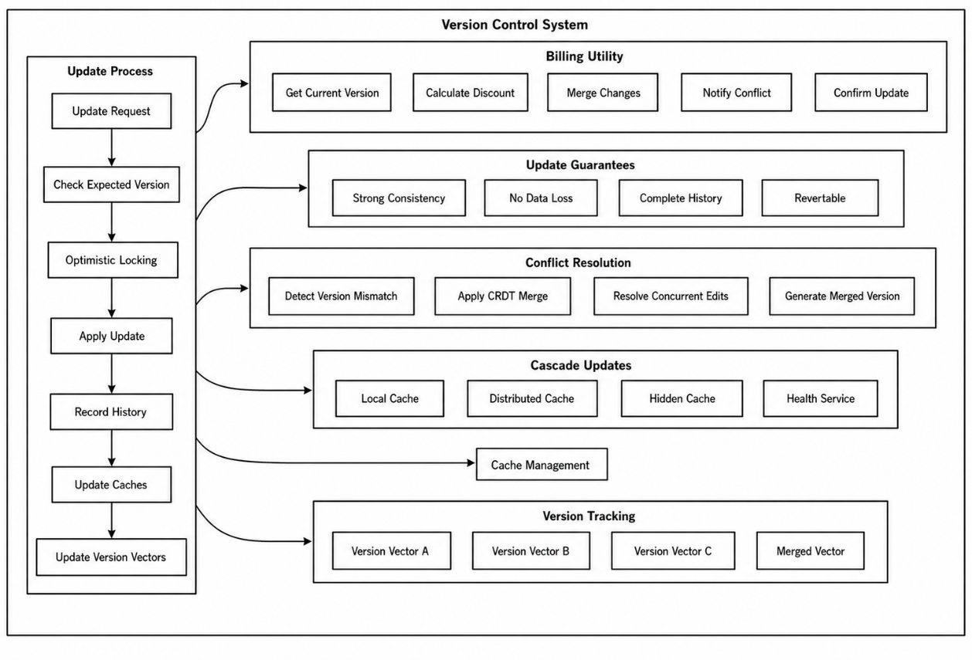
Figure 3.27. Version-Vector Update and Conflict-Resolution Process
Source: Author
The theoretical power of version vectors lies in encoding causal relationships through the partial order defined by vector comparison. When these vectors synchronize, the system detects that neither dominates — Kinshasa has a higher counter for its source, Lubumbashi for its own — indicating concurrent updates that occurred without mutual awareness, necessitating resolution through policies that may prioritize jurisdictional authority, apply domain-specific merge semantics, or defer to human adjudication.
Within event-sourced e-government architectures, version vectors are the foundational mechanism for maintaining consistency across distributed event stores and correct event ordering during replay. Events arriving out of order — common given variable network latency between Kinshasa, Lubumbashi, and Goma — are buffered until their causal prerequisites are satisfied, preventing inconsistent state from compromising the integrity of government operations.

3.4.5.1 Conflict Resolution through CRDTs and Reconciliation Protocols
When version vectors detect concurrent updates, the system must invoke appropriate conflict-resolution mechanisms. Different DRC data types call for different CRDT strategies. The choice of resolution strategy must be guided by each data domain's legal and operational requirements within the DRC's federal governance structure.
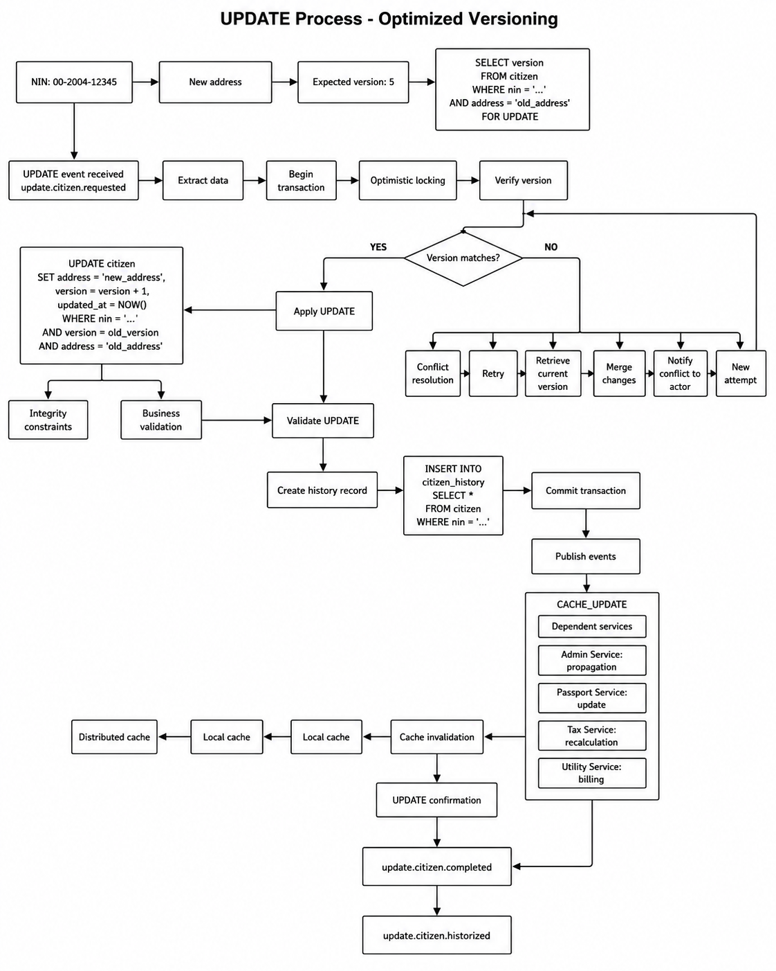
Figure 3.28. Optimized Versioning Update and Conflict-Resolution Process
Source: Author
The use of version vectors establishes several formal guarantees essential for legal and operational requirements in the DRC context. These properties are mathematically provable given correct implementation of version-vector protocols and CRDT merge semantics, a level of assurance particularly valuable for e-government systems subject to rigorous audit and compliance requirements across multiple administrative levels.

3.4.6 Scalability
A scalable design approach is fundamentally rooted in modularity, breaking an application into specialized functions or services that interact through a well-defined API protocol layer and data-access layer, promoting loose coupling between components such as the web browser, web application, business application, and DBMS. 19).

3.4.6.1 Horizontal Scalability
Horizontal scaling transforms a system from a monolithic entity into a distributed network of cooperating components — essential for any national e-government infrastructure serving millions of citizens reliably over decades. For a federated, interoperable e-government platform, horizontal scalability is not a technical preference or performance optimization; it is an existential necessity dictated by the nature of public-service demand.:
A monolithic system, however powerfully engineered at inception, inevitably meets physical and organizational limits that prevent it from growing indefinitely or adapting to the uneven, often unpredictable demand patterns characteristic of government services, and a system that cannot scale horizontally cannot absorb these spikes without global degradation or complete failure. 8).

3.4.6.2 Services and Microservice Architecture
Decomposing monolithic government applications into discrete, independently scalable services is not merely a software-architecture choice but the cornerstone of modern scalability, and a technical analog to the administrative decentralization at the center of this dissertation's broader governance framework. In a well-executed microservices architecture, distinct business capabilities — Citizen Identity Management, Passport Application, Tax Calculation and Collection, Social Benefit Disbursement, Business Registration and Licensing — are encapsulated as fully autonomous services, each with its own bounded context, independently versioned codebase, deployment pipeline, and dedicated data store isolated from other services' databases.
This decomposition enables a paradigm shift in how computational resources are allocated across the e-government ecosystem. It also enables organizational scalability to proceed alongside technical scalability: specialized agency teams can develop, deploy, and scale their services independently, using the languages, frameworks, and storage technologies most appropriate to their own domain, transforming the central IT department from a bureaucratic bottleneck that slows all innovation to the pace of the slowest agency into an enabler of rapid, decentralized civic innovation.

3.4.6.3 Caching
Caching, at scale, is the strategic insertion of multiple layers of high-speed memory between citizens and slower, more constrained backend data sources, serving simultaneously as a performance amplifier for end users and a protective buffer for systems of record. Caching also serves as an underappreciated resilience mechanism; graceful degradation that maintains a core level of public service even during partial failures, preserving public trust rather than producing complete service blackouts.

3.4.6.4 Components for Scalability

3.4.6.5 Reverse Proxy
A reverse proxy provides a controlled public entry point to distributed government services. It hides internal topology, routes requests by path or policy, terminates TLS, applies rate limits and web-application-firewall rules, records access, compresses responses, and can cache suitable content. Centralizing these cross-cutting controls simplifies service instances while reducing direct exposure of the internal network.

3.4.6.6 Load Balancer
Load balancing distributes requests among healthy service instances, database nodes, and network paths so horizontal capacity becomes usable. Its policies combine health, load, latency, affinity, and security requirements; failed or degraded instances are removed from rotation until recovery. This prevents local saturation from becoming a system-wide service interruption.

3.4.6.7 DNS as a Load Balancer
DNS-based global server load balancing distributes traffic across data centers or regions. Geographic and latency policies direct users to suitable endpoints, while health-checked failover switches the government domain to a secondary site when the primary is unavailable. DNS therefore supports cross-region continuity; local load balancers still handle rapid distribution among instances within each site.

3.4.6.8 Message Broker
A message broker is a key architectural component for improving the scalability of distributed and microservices-based systems by enabling asynchronous, decoupled, and reliable communication between services. Consequently, the message broker enables the system to absorb traffic variations, integrate new services without modifying existing producers, process large volumes of requests efficiently, and maintain service availability as the number of users, transactions, institutions, and exchanged events increases.

3.5 Prototype and Deployment Results
The successful operation of an e-government platform requires more than robust architecture and well-designed microservices—it demands a disciplined, automated approach to the entire lifecycle of service delivery. The diagram illustrates the DevOps and Site Reliability Engineering (SRE) lifecycle that underpins the proposed interoperability platform, organized into three interconnected domains: the inner development loop, the outer operations loop, and the cross-cutting practices that bridge them. The inner loop represents the activities of development teams—coding, testing, and building services—while the outer loop represents the responsibilities of operations teams—deploying, monitoring, and maintaining services in production. The bridge between these loops consists of the practices that enable continuous integration, continuous delivery, and continuous improvement: provisioning, configuration, rollout, deployment, logging, and scaling.
The graphic also highlights the critical reliability practices—liveness, load, performance, security events, and correctness monitoring—that ensure the platform meets its Service Level Objectives. Together, these practices form a virtuous cycle where feedback from production operations informs development priorities, and improvements in development practices enhance operational stability.
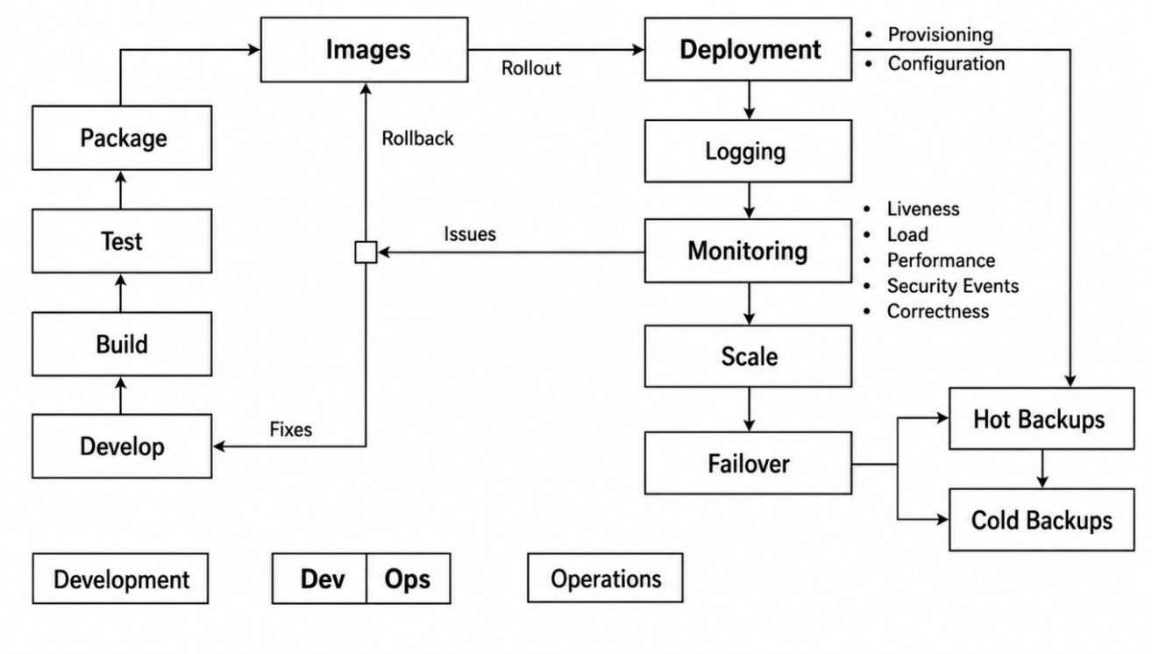
Figure 3.29. DevOps Container Deployment and Operations Lifecycle
Source: Author

3.5.1 Containerization
Unlike traditional virtual machines, containers do not require a complete operating system for each application instance. As a result, containers are significantly lighter, start faster, consume fewer resources, and support higher scalability. These characteristics make containerization particularly suitable for large-scale e-government platforms that must support millions of citizens and thousands of concurrent transactions.Containerization also improves portability and interoperability. Government services can be developed, tested, and deployed consistently across multiple environments without modification (Bernstein & Newcomer, 2009; Garcia-Molina & Salem, 1987; Hassan et al., 2020).
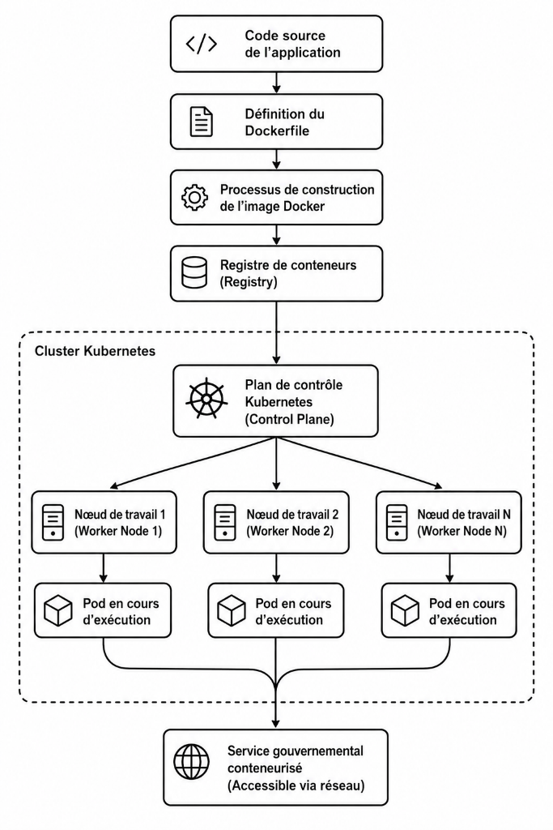
Figure 3.30. Containerization Workflow
Source: Author
Containerization is a cloud-native virtualization technique that packages applications and their dependencies into isolated, lightweight, and portable execution environments known as containers. In the proposed e-government platform for the Democratic Republic of Congo, containerization enables the independent deployment, scalability, portability, security, and maintainability of government microservices, thereby providing the technological foundation for Kubernetes-based orchestration and efficient digital public service delivery (Bogner et al., 2019; Burns et al., 2019; Casalicchio, 2019).

3.5.1.1 Docker and Container Images
The most widely adopted containerization technology is Docker, which lets developers package applications into container images — standardized deployment units serving as the blueprint for creating containers, containing the application code, required software packages, operating system components, and configuration settings. These images are stored in a container registry and deployed repeatedly across multiple servers; in the proposed architecture, each microservice is distributed as a Docker image and executed as one or more containers within a Kubernetes cluster.
Docker Compose extends Docker by enabling the definition and execution of multi-container applications through declarative configuration files. In the proposed e-government architecture, Docker is used to containerize individual government services, while Docker Compose facilitates local development and integration testing; for production deployment, Kubernetes replaces Docker Compose, providing the advanced orchestration, scalability, fault tolerance, and high-availability capabilities Docker Compose alone cannot offer.
All application components of the proposed e-government platform are containerized using Docker. Frontend portals, API gateways, business microservices, authentication services, monitoring tools, messaging systems, and database engines are all packaged as independent containers, deployed and managed within a Kubernetes cluster that provides automated orchestration, service discovery, scaling, load balancing, and fault tolerance. This architecture ensures portability, interoperability, high availability, and efficient resource utilization across the national digital government infrastructure.

3.5.2 Kubernetes Orchestration
In the proposed architecture, orchestration is achieved through Kubernetes, an open-source platform that automates the deployment, scaling, monitoring, recovery, and communication of containerized government microservices — enabling an integrated, resilient, and scalable digital government ecosystem capable of delivering seamless public services across municipal, provincial, and national levels. Each government service — Population Registry, Civil Status Management, Tax Administration, Health Information Systems, Education Services, Immigration, Business Registration, Social Protection — is packaged as a Docker container; rather than manually managing hundreds of containers across multiple servers, Kubernetes orchestrates the entire environment, automatically scheduling containers on available nodes, monitoring their health, and ensuring the desired number of service instances remains operational at all times.
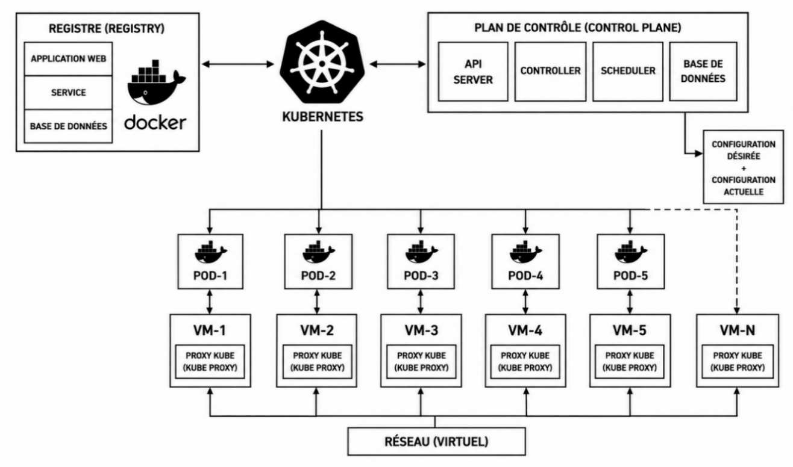
Figure 3.31. Kubernetes Containerization Workflow
Source: Author

3.5.2.1 General Principle of Kubernetes Deployment
Across all three governance tiers, Kubernetes provides the orchestration layer responsible for execution, deployment, availability, and scaling. Its control plane manages cluster state, scheduling, service discovery, configuration, and policy enforcement, while worker nodes host the application workloads.
Business applications are deployed as Deployments that control one or more Pods. Kubernetes can therefore increase or reduce the number of microservice instances according to demand, while ReplicaSets maintain the desired number of healthy instances and support rolling updates without unnecessary interruption.
Components requiring a stable identity or persistent storage, including databases and selected event-broker components, can be deployed as StatefulSets linked to Persistent Volume Claims. This arrangement preserves data across restarts and supports controlled recovery, replication, and backup procedures.
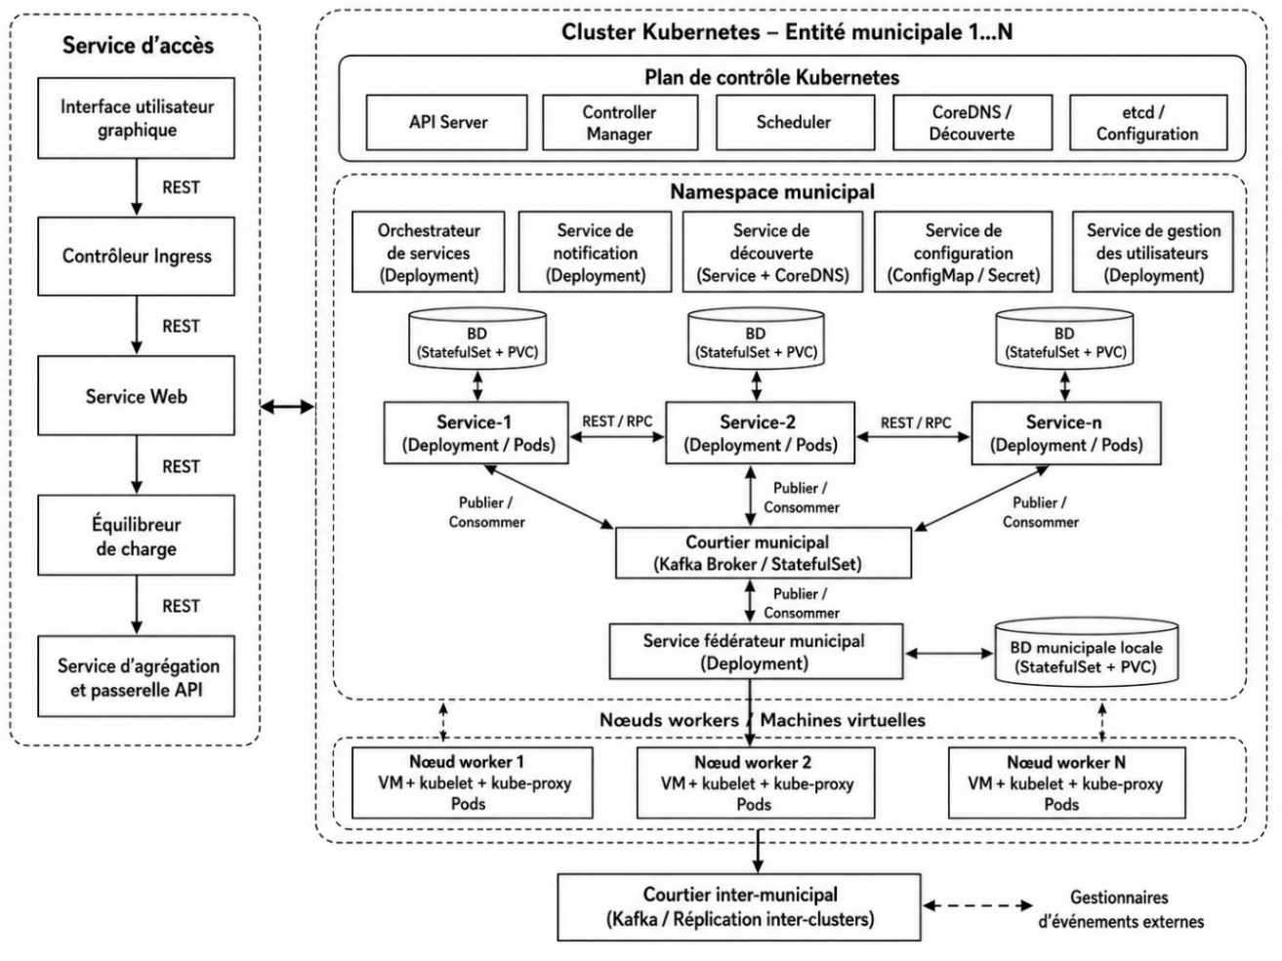

Figure 3.32. Municipal-Tier Kubernetes Deployment
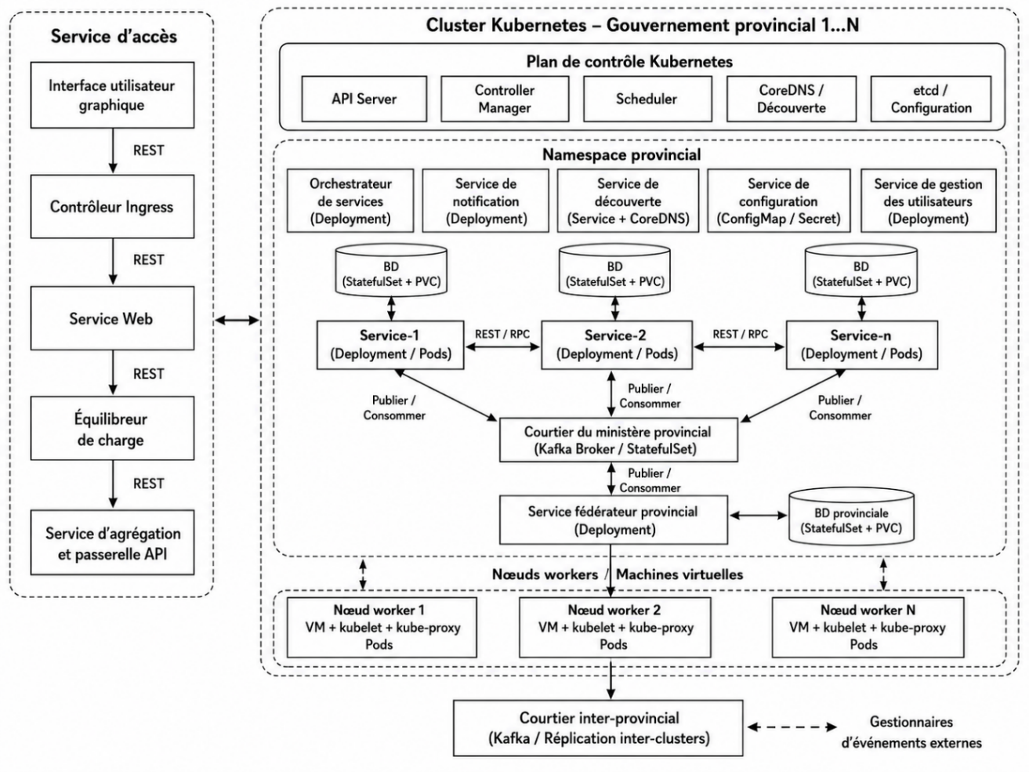
Figure 3.33. Provincial-Tier Kubernetes Deployment

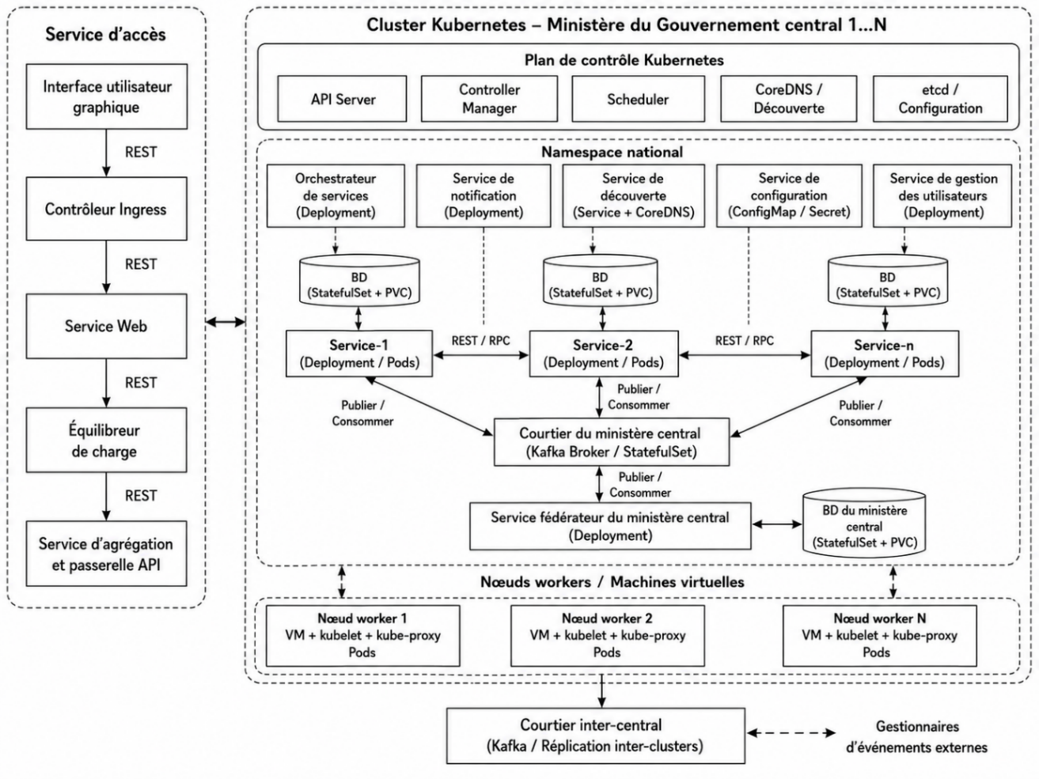
Figure 3.34. National-Tier Kubernetes Deployment

3.5.3 Implementation Roadmap and Feasibility
This document translates the Sovereign Multi-Layer Digital Public Service Architecture proposed in Joseph Ngwaba Bimbala's PhD research proposal, Contribution to e-Government Interoperability of Heterogeneous Systems Based on Asynchronous Microservices: A Case Study (Ngwaba, 2023), into a phased implementation roadmap and an accompanying feasibility study for the Democratic Republic of Congo (DRC). It treats the four categories of interoperability challenge already identified for this project — technical, semantic, organizational, and legal — as the operating risk register against which every phase is tested, rather than as a separate discussion.
Five phases are proposed, spanning roughly 4.5 years of active build-out (Phases 1–4) followed by an open-ended optimization phase (Phase 5): Foundations & Governance; a Pilot across the Home Affairs cluster already scoped in the thesis; Semantic Standardization & Provincial Extension; National Scale-Up through a government cloud and national broker; and continuous maturity management. The sequence mirrors the thesis's own municipal–provincial–national tier architecture, so that each phase both extends the technology and closes a specific, named challenge.
The feasibility study applies a Technical–Economic–Legal–Operational–Schedule (TELOS) assessment. The technology stack is mature and low-cost; the principal constraints are organizational (provincial capacity and constitutional autonomy) and legal (an incomplete implementing-decree framework), not the microservices architecture itself. The roadmap is timed to run alongside, and draw funding from, the DRC's own National Digital Plan 2026–2030, rather than compete with it.

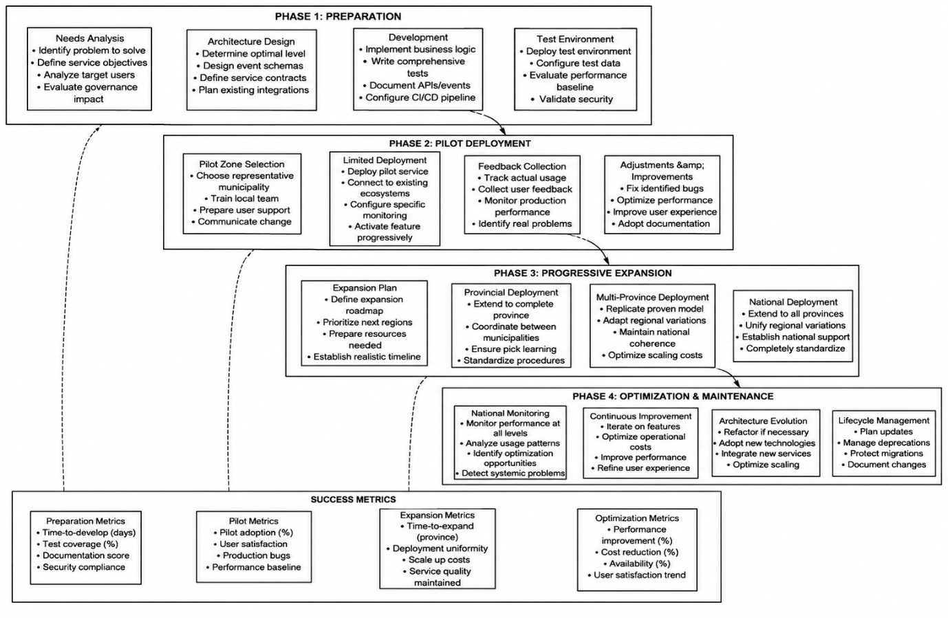
Figure 3.35. Five-Phase Implementation Roadmap for the Proposed E-Government Architecture
Source: Author

3.5.3.1 Strategic Alignment with the DRC National Digital Plan 2026–2030
The government initially committed US$1.5 billion, comprising US$1 billion in public funds and US$500 million from international partners. The broader programme envelope later reached approximately US$8.7 billion, including anticipated multilateral and private-sector investment through 2030 (Biometric Update, 2026; Tech In Africa, 2026a, 2026b). Planned outputs include expanded fibre and telecommunications infrastructure, 650 connected communities, 1,000 connected public institutions, and digital access for approximately 30 million additional people. Specific allocations include US$385 million for digital access and US$55 million for e-government infrastructure, complemented by digital identity, civil-registration, payment, and national digital-government platforms (iAfrica, 2026; TechAfrica News, 2026).
However, these initiatives do not clearly define an interoperability layer for secure data exchange among government platforms and across the DRC’s 26 provinces. The architecture proposed by Ngwaba (2023) addresses this gap: PNN2 defines the services and infrastructure to be digitized, while the proposed roadmap explains how those services should interconnect. Aligning its implementation with PNN2’s existing investments therefore strengthens the roadmap’s economic feasibility.

3.5.3.2 Economic Feasibility
PNN2 already earmarks approximately US$55 million for e-government infrastructure within a US$385 million digital-access project (iAfrica, 2026), inside an overall US$8.7 billion, 2026–2030 programme anchored by US$1.5 billion in direct government and already-secured partner funding (Tech In Africa, 2026b; BANKABLE, 2025). Phases 1 and 2 of this roadmap — governance and the Home Affairs pilot — are sized to fit within that specific US$55 million line; Phases 3 and 4 should draw on the broader connectivity and data-center pillars of PNN2 rather than requiring a new, stand-alone budget request. The allocation below is offered for planning purposes only; it is not an official budget figure.
Table 3.6. Relative Resource Intensity by Phase and PNN2 Funding Line
Phase | Primary PNN2 Funding Line | Relative Resource Intensity
Phase 1 — Foundations & Governance | e-Government infrastructure line (~US$55M pool) | Low
Phase 2 — Home Affairs Pilot | e-Government infrastructure line (~US$55M pool) | Medium
Phase 3 — Provincial Extension | Infrastructure & connectivity pillar | High
Phase 4 — National Scale-Up | Infrastructure & connectivity + data-center build-out | High
Phase 5 — Optimization | Recurring operating budget (post-PNN2) | Low (recurring)
Source: Author

3.5.3.3 Legal and Regulatory Feasibility
The Digital Code (Ordonnance-loi n° 23/010 of 13 March 2023) is now the DRC's primary digital-governance instrument, addressing cybercrime, digital services, and — in its Book III — data protection, alongside the earlier 2020 Telecommunications Law (Lexing, n.d.). Since August 2024, a ministerial order has instead assigned that authority's functions on an interim basis to ARPTIC, the telecommunications regulator, pending the Authority's formal establishment (Droit-Numérique.cd, 2025). This is a workable bridge for the pilot proposed in Phase 2, but it is not a substitute for the dedicated institution the law anticipates, and it leaves cross-tier data-sharing agreements, liability rules, and service-level commitments undocumented — precisely the gaps the Legal Challenges analysis identifies. The Phase 1 decree and the Phase 3 implementing-decree track proposed in Section 5 are accordingly treated as the critical legal path: without them, later technical phases would be built on legally contestable ground, particularly around cross-province data sovereignty.

3.5.3.4 Operational Feasibility
Survey evidence provides a clear mandate for interoperability because all 34 respondents considered interconnection necessary. Current cloud capability remains limited: 8 respondents (24%) reported using cloud services or GovCloud, while 26 (76%) reported no such use. The implementation roadmap must therefore combine the capacity programmes envisaged by PNN2 with platform-operations training, provincial support and staged adoption rather than assume existing cloud readiness.

3.5.3.5 Risk Assessment Matrix
The implementation of a national e-government interoperability platform in the Democratic Republic of Congo faces a complex landscape of risks spanning technical, semantic, organizational, legal, and economic dimensions. The SLEPT analysis presented in earlier chapters identified the structural constraints that have historically impeded digital transformation in the DRC, including infrastructure deficits, semantic fragmentation, institutional resistance, legal uncertainty, and fiscal dependency. Building on that analysis, this section consolidates the specific risks associated with the proposed interoperability framework into a comprehensive risk assessment matrix organized across the five TELOS dimensions: Technical, Economic, Legal, Operational (Organizational), and Semantic (Sociological). Each risk is evaluated in terms of its likelihood and potential impact, and assigned a mitigation strategy aligned with the phased implementation roadmap. The matrix serves both as a diagnostic tool for understanding the challenges ahead and as a planning instrument for allocating mitigation resources effectively.Table 6.8
Table 3.7. Risk Assessment Matrix Across TELOS Dimensions
Risk | Category | Likelihood | Impact | Mitigation (Roadmap Phase)
Rural/provincial connectivity and power gaps stall rollout outside Kinshasa, Lubumbashi, and Goma | Technical | High | High | K3s edge nodes; asynchronous Kafka integration; province sequencing follows PNN2 fibre build-out (Phase 3)
Incompatible legacy databases and formats across tiers | Technical | High | Medium | API gateway and event-driven integration instead of forced replacement (Phase 2–3)
No common National Identification Number format | Semantic | High | High | Canonical NIN schema fixed in the Phase 3 national registry
Administrative terms diverge across French, Lingala, Swahili, and Kikongo | Semantic | Medium | Medium | Multilingual glossary published in Phase 3
Provincial authorities withhold data, citing constitutional autonomy | Organizational | High | High | Steering Committee co-designed from Phase 1 rather than imposed centrally
High staff turnover erodes trained provincial capacity | Organizational | High | Medium | Training pipeline twinned with PNN2's 250,000-youth programme; local certification
No enforceable cross-tier Service Level Agreement | Organizational | Medium | Medium | SLA templates in Phase 3; sanctions regime in Phase 4
Dedicated Data Protection Authority remains unformed | Legal | High | High | Rely on ARPTIC's interim mandate; press implementing decree in Phase 1 and Phase 3
Liability for cross-tier failures is undefined | Legal | Medium | High | Liability apportionment rules drafted in Phase 4
Budget realization depends on PNN2 disbursement pace | Economic | Medium | High | Ring-fence Phases 1–2 to the existing $55M e-government line; phase-gate later spend to actual disbursement
Source: Author

3.5.4 E-Government System Prototype Design

3.5.4.1 Infrastructure and Platform Overview
The target architecture defines six independently deployable application services and a set of supporting platform components. The empirical benchmark evaluates four application services: Population, Police Records, Property Registry and the Dashboard backend-for-frontend. Java, C# and Python are represented in the measured prototype; PHP and the remaining target services belong to the proposed target state and are not included in the service-level benchmark. Temporal, Kafka, Consul, Redis, ZooKeeper, Kong and configuration or monitoring components are classified separately as platform services.

3.5.4.2 Technology Stack
The architectural design of the proposed e-government interoperability platform is realized through a carefully selected technology stack that balances technical excellence, operational feasibility, and alignment with the DRC's infrastructure constraints. Each layer of the architecture—from service discovery and configuration management to event streaming and container orchestration—has been evaluated against the requirements of the multi-tier governance structure, the polyglot nature of the service ecosystem, and the need for resilience in a resource-constrained environment. The selection prioritizes open-source technologies with active communities, proven scalability, and compatibility with the cloud-native principles that underpin the proposed framework. The following table presents the technology stack organized by architectural layer, with justifications that link each technology choice to the specific requirements of the DRC's e-government platform.
Table 3.8. Technology Stack by Architectural Layer
Layer | Technology | Justification
Service Discovery | Consul | Enables dynamic service registration and health checking across the polyglot environment
Configuration Management | Spring Cloud Config | Git-backed configuration service; non-Java clients consume documented endpoints or equivalent environment and GitOps mechanisms.
API Gateway | Kong | Provides unified entry point with authentication, rate limiting, and routing
Saga Orchestration | Temporal.io | Target-state orchestration mechanism; the workflow durations reported in Section 3.6 are modelled rather than direct recovery measurements.
Async Event Bus | Kafka + Zookeeper | Durable event transport with at-least-once delivery; idempotent processing and Kafka transactions are required where configured.
Cache | Redis | Provides distributed caching for high-performance data access
Database | SQL and NoSQL databases (per service) | Each service maintains its own database, ensuring autonomy and loose coupling
Container Orchestration (Prod) | Kubernetes (k3s) | Target production orchestration. The reported VPS benchmark uses container measurements and does not by itself validate a multi-node k3s deployment.
Load Balancer | NGINX | Suitable for high scale scalability
Source: Author

3.5.5 Microservice Granularity, Cohesion, Coupling, and Architectural Properties
The empirical prototype evaluated in Section 3.6 comprises three authoritative domain microservices—Population, Police Records and Property Registry—and one independently deployable composition service, the Dashboard backend-for-frontend. The broader target architecture also includes Tax, Health Record, Passport, a Saga Orchestrator and Search and Analysis capabilities, but these elements were not included in the measured service-level benchmark. Results in this chapter therefore refer only to the four evaluated application services unless they are explicitly identified as modelled or proposed.

3.5.5.1 Implemented Scope and Service Taxonomy
A microservice is treated as an independently deployable capability with a bounded context, explicit data responsibility, versioned interface or event contract, operational ownership and a defined administrative scope (Evans, 2003; Richardson, 2018; Newman, 2021). Kong, Consul, Redis, Kafka, ZooKeeper, MySQL, PostgreSQL, MongoDB, containerised configuration and the national portal are supporting platform components. They are not counted as domain microservices even though their performance and resource consumption influence the complete system.
Table 3.9. Implemented application-service boundaries evaluated in Section 3.6
Service | Primary responsibility | Administrative and data scope | Technology and store
Population Service | Citizen identity, NIN and demographic record retrieval | Municipal record ownership under national identity rules; federated read access | Java / Spring Boot; MySQL
Police Records Service | Infractions, warrants and police-record retrieval | Jurisdiction-bound law-enforcement records exposed through authorised contracts | C# / .NET 8; PostgreSQL
Property Registry Service | Land, vehicle, enterprise and ownership information | Municipal or provincial registry ownership with federation provenance | Python / FastAPI; MongoDB
Dashboard BFF | Aggregate statistics and one-, two- or three-commune citizen 360° composition | Cross-commune read-composition layer; no authority over source records | Python / FastAPI; optional Redis cache; no authoritative domain database
Source: Author
The classification separates domain authority from composition. Population, Police Records and Property Registry own official records within their bounded contexts. The Dashboard BFF exposes a unified citizen-facing view but remains a replaceable read layer. It may normalise, filter, cache and compose data; it may not write directly to a domain database or redefine the legal meaning of a source record. This distinction preserves municipal sovereignty while permitting national visibility.

3.5.5.2 Granularity Score

3.5.5.3 Consolidated Architecture and Performance Results
Distinguish structured architecture assessments from direct measurements. G, C, R, D and W are design-evaluation indices derived from service responsibilities, contracts and dependencies; they are not latency measurements. Health latency, CPU and memory values are direct observations reported in Section 3.6, whereas availability is an explicitly modelled planning result.
Table 3.10. Granularity component scores for the evaluated services
Service | gᴮ | gᴰ | gᵀ | gᴾ | G | Level
Population | 0.40 | 0.40 | 0.60 | 0.80 | 0.48 | Medium
Police Records | 0.60 | 0.60 | 0.60 | 0.80 | 0.62 | Medium-fine
Property Registry | 0.60 | 0.60 | 0.60 | 0.80 | 0.62 | Medium-fine
Dashboard BFF | 0.60 | 0.80 | 0.60 | 1.00 | 0.70 | Medium-fine
Source: Author
Table 3.11. Cohesion coupling decision and criticality metrics
Service | C | R | Coupling class | Decision | D | W
Population | 0.88 | 0.17 | Low | 18/19 | 0.95 | 0.30
Police Records | 0.86 | 0.17 | Low | 18/19 | 0.95 | 0.23
Property Registry | 0.87 | 0.17 | Low | 18/19 | 0.95 | 0.20
Dashboard BFF | 0.84 | 1.00 | High, intentional | 16/19 | 0.84 | 0.27
Source: Author
The three authoritative services satisfy the preferred pattern of high cohesion and low coupling. Their R value of 0.17 represents one required asynchronous relationship, weighted at 0.50, across three possible peer relationships. The BFF obtains R = 1.00 because the evaluated 360° path synchronously queries all three domain services. This is not treated as an undisclosed weakness. Composition is the BFF's bounded context, it remains stateless with respect to official records, and the benchmark demonstrates that concurrent fan-out limits the cost: adding two source communes increases the median composition time by only 2.1 ms.

3.5.5.4 Detailed Service Profiles
The following profiles define the properties required to implement, govern and evaluate the four services. Event names describe the architectural contracts and should be maintained in the interoperability registry with an owner, schema version, classification, retention rule and compatibility policy. Measured values are explicitly identified; targets remain proposed SLOs until they are validated by repeated long-duration tests.

3.5.5.5 Population Service
Table 3.12. Population Service profile
Property | Characterisation aligned with the implemented benchmark
Bounded context and capabilities | Citizen identity, NIN validation, demographic record retrieval and lifecycle status within the evaluated federation.
Administrative scope and authority | Municipal record ownership under national identity rules; the service remains authoritative for its own citizen records and exposes authorised federated reads.
Implementation | Java and Spring Boot; independently containerised and deployed on the municipal stack.
Owned data and store | MySQL; authoritative population records. Other services receive identifiers or decisions rather than direct database access.
Inbound contracts | Health check, citizen lookup by NIN, authorised registration or update commands, and internal federation queries.
Event contract | CitizenRegistered, CitizenUpdated and CitizenStatusChanged are the principal domain facts proposed for Kafka publication through a transactional outbox.
Consistency and CQRS | Strong local transactions for authoritative writes; read-optimised query handlers or replicas for lookup; eventual propagation to projections.
Applied patterns | Repository, Command and Factory Method inside the service; Observer-style publication to Kafka; Adapter at the BFF boundary.
Security and privacy | Highly restricted personal data protected by mTLS, OIDC, least privilege, field minimisation, encryption at rest and immutable access auditing.
Scalability and resilience | Independent horizontal scaling, replicated MySQL, idempotent commands, outbox publication, bounded retries, circuit breakers and distributed traces.
Observed performance | 1.54 ms median health response, 0.46% CPU and 409 MiB resident memory in the Gombe snapshot. The complete validation suite passes on both hosts.
Availability and SLO | Section 3.6 models 99.96% availability. Proposed target: at least 99.95%; P99 authorised identity lookup ≤ 200 ms; event publication P99 ≤ 2 s; RPO ≤ 5 min; RTO ≤ 30 min.
Architecture metrics | G = 0.48 (Medium); C = 0.88; R = 0.17 (Low); D = 0.95; W = 0.30.
Architectural decision | Retain a narrow identity boundary and prevent passport, police, tax, health or property rules from migrating into the population model.
Source: Author

3.5.5.6 Police Records Service
Table 3.13. Police Records Service profile
Property | Characterisation aligned with the implemented benchmark
Bounded context and capabilities | Police records, infractions, warrants and authorised clearance information included in the federated citizen view.
Administrative scope and authority | Jurisdiction-bound law-enforcement record ownership with role-restricted municipal, provincial or national access according to legal mandate.
Implementation | C# and .NET 8; independently containerised and deployed on the municipal stack.
Owned data and store | PostgreSQL; authoritative police records for the defined jurisdiction.
Inbound contracts | Health check, police-record retrieval by authorised NIN reference, warrant lookup and bounded federation queries.
Event contract | PoliceRecordCreated, WarrantIssued and PoliceRecordUpdated are proposed domain events; consumers must be authorised and idempotent.
Consistency and CQRS | Strong local command validation and PostgreSQL transactions; separate read handlers or projections for clearance and 360° composition.
Applied patterns | Command for write intent, Observer for events, Adapter for common citizen-record output and Strategy for jurisdiction-aware filtering.
Security and privacy | Highly restricted law-enforcement data protected by purpose limitation, dual control for sensitive actions, signed events, field masking and complete access logs.
Scalability and resilience | Indexed NIN and jurisdiction queries, read replicas where justified, bounded timeouts, idempotency keys, dead-letter handling and failover testing.
Observed performance | 0.48 ms median health response, the lowest of the three domain services; 0.78% CPU and 190 MiB resident memory in the Gombe snapshot.
Availability and SLO | Section 3.6 models 99.94% availability. Proposed minimum: 99.90%, with a production objective of 99.95%; P95 authorised record lookup ≤ 300 ms and event publication P99 ≤ 2 s.
Architecture metrics | G = 0.62 (Medium-fine); C = 0.86; R = 0.17 (Low); D = 0.95; W = 0.23.
Architectural decision | Keep police-record and warrant semantics together while retaining a hard boundary from courts and identity. Add redundant replicas to close the 0.01 percentage-point model gap to 99.95%.
Source: Author

3.5.5.7 Property Registry Service
Table 3.14. Property Registry Service profile
Property | Characterisation aligned with the implemented benchmark
Bounded context and capabilities | Registration and retrieval of land, vehicles, enterprises, ownership links and property values used in the evaluated aggregate and citizen view.
Administrative scope and authority | Municipal or provincial registry ownership with sourceCommune provenance retained after federation and national aggregation.
Implementation | Python and FastAPI; independently containerised and deployed on the municipal stack.
Owned data and store | MongoDB; authoritative property documents and ownership relationships for the defined jurisdiction.
Inbound contracts | Health check, property lookup by authorised NIN, registry query and bounded federation requests.
Event contract | PropertyRegistered, OwnershipTransferred and PropertyStatusChanged are proposed domain facts for Kafka publication.
Consistency and CQRS | Atomic local document updates, optimistic versioning and eventual projection; contested or legally irreversible changes require human approval.
Applied patterns | Repository and Command internally; Adapter normalises document-shaped data; Observer publishes registry changes; Strategy applies jurisdiction rules.
Security and privacy | Restricted personal and asset data protected by signed events, document hashes, immutable ownership history, encryption and jurisdiction-aware authorisation.
Scalability and resilience | Partition and index by jurisdiction, owner and asset identifier; isolate binary documents; retain complete version history; test restoration and reindexing.
Observed performance | 0.68 ms median health response, 0.38% CPU and 51 MiB resident memory. Provenance remains visible in the composed records and national aggregates reconcile correctly.
Availability and SLO | Section 3.6 models 99.95% availability. Proposed target: at least 99.95%; P95 authorised owner or asset lookup ≤ 300 ms; event publication P99 ≤ 3 s.
Architecture metrics | G = 0.62 (Medium-fine); C = 0.87; R = 0.17 (Low); D = 0.95; W = 0.20.
Architectural decision | Retain registry responsibility in one coherent context while separating tax assessment, payment, cadastral imagery and court disputes when their rules or scaling profiles diverge.
Source: Author

3.5.5.8 Dashboard Backend-for-Frontend
Table 3.15. Dashboard BFF profile
Property | Characterisation aligned with the implemented benchmark
Bounded context and capabilities | Citizen-facing aggregation, national statistics, one-, two- and three-commune 360° composition, payload normalisation and response shaping.
Administrative scope and authority | Cross-commune read layer used by the portal; never the system of record and never authorised to redefine domain facts.
Implementation | Python and FastAPI; independently deployable, replaceable and horizontally scalable.
Owned data and store | No authoritative domain database. Redis may hold bounded caches or ephemeral projections subject to invalidation and privacy rules.
Inbound contracts | Aggregate-statistics queries, citizen 360° queries and health checks exposed behind Kong.
Outbound contracts | Concurrent read calls to Population, Police Records and Property Registry; optional asynchronous subscriptions for cache invalidation or read-model refresh.
Consistency and CQRS | CQRS read side only. It composes current source responses or read models and preserves sourceCommune provenance; commands remain with the domain owners.
Applied patterns | BFF and Facade provide one client interface; Adapter normalises Java, .NET and Python payloads; Strategy selects commune or provider routes; Command represents explicit query and Saga intentions; Observer supports event-driven refresh.
Security and privacy | Kong authentication and rate limiting, least-privilege service credentials, field-level filtering, jurisdiction checks, secure cache keys and traceable correlation identifiers.
Scalability and resilience | Concurrent fan-out, per-call timeouts, partial-failure policy, circuit breakers, bulkheads, cache control, multiple workers, replicas behind Kong and autoscaling on latency or queue depth.
Observed performance | 11.94 ms median health response. Composition P50 rises only from 17.6 ms for one commune to 19.7 ms for three; P95 remains ≤ 31.9 ms. The federated endpoint sustains 76 req/s at 32 clients, and 101 citizen requests/s generate 303 downstream calls/s.
Availability and SLO | Section 3.6 models 99.97% availability. Proposed target: at least 99.95%; three-commune P95 ≤ 50 ms on the server baseline; P99 ≤ 200 ms through eight keep-alive clients; throughput ≥ 75 req/s at 32 clients.
Architecture metrics | G = 0.70 (Medium-fine); C = 0.84; R = 1.00 (High and intentional); D = 0.84; W = 0.27.
Architectural decision | Preserve the BFF as a stateless read-composition boundary. Its high coupling is acceptable because it is explicit, observable and empirically efficient; scale it out rather than moving composition into the domain services.
Source: Author

3.5.5.9 Cross-Service Dependencies and Architectural Controls
The synchronous query path is intentionally short: the client enters through Kong, the BFF performs parallel reads, and each authoritative service answers from its own store. Kafka carries durable change facts and projection updates outside the citizen request path. No service reads another service's database. Every event consumer records an idempotency key, and every producer should use a transactional outbox or equivalent atomic publication mechanism. Backward-compatible schemas remain on the same event version; incompatible changes require a new version and a controlled migration period.
Table 3.16. Principal dependencies and coupling controls
Service | Required relationship | Primary role | Control that limits propagation
Population | No peer call for core identity reads; publishes approved changes | Authoritative service and event producer | Outbox, schema versioning, idempotent consumers and no cross-database joins
Police Records | Verified NIN reference and approved federation query | Authoritative service and clearance-data producer | Local authority, bounded timeouts, least privilege and dead-letter handling
Property Registry | Verified NIN and jurisdiction reference | Authoritative service and registry-event producer | Optimistic versioning, human approval, provenance and immutable history
Dashboard BFF | Population, Police Records and Property Registry | Read-side Facade and concurrent composer | Parallel calls, per-service timeout, circuit breaker, bulkhead, cache policy and replicas
Source: Author
Table 3.17. Relationship between patterns and the evidence in Section 3.6
£Mechanism | Role in Section 3.5.5 | Consistent evidence from Section 3.6
Domain-aligned microservices | Separate ownership, release and scaling for three authoritative contexts | 0.48–1.54 ms domain-service medians and business-service CPU below 1%
CQRS | Commands remain in domain services while statistics and 360° views use read paths | 18–20 ms median server reads and 76–80 req/s for complex and simple queries
Event sourcing and Kafka | Chronological domain facts, replay and asynchronous projection refresh | Preserved provenance, coherent national totals and low compute overhead
Facade and BFF | One client contract hides three source services | Only 2.1 ms P50 growth from one to three communes
Adapter and Strategy | Normalise heterogeneous payloads and select commune routes | Java, .NET and Python outputs compose coherently on Hetzner and Contabo
Observer and Command | Decouple reactions and make intent retryable and auditable | Independent services, explicit event path and modelled Saga completion envelope
Polyglot persistence | MySQL, PostgreSQL and MongoDB selected by bounded context | All three domain services remain below 2 ms at the health median
Gateway, discovery and containers | Uniform ingress, service location and deployment packaging | 218/218 assertions pass and the same solution operates on two providers
Source: Author, synthesis of Sections 3.5.5 and 3.6
These mechanisms provide an integrated architectural explanation rather than isolated causal proof. The benchmark reports the behaviour of the combined configuration. Quantifying the separate effects of caching, concurrency, CQRS projections, event transport and provider routing requires controlled ablation experiments.

3.5.5.10 Decision Criteria and Acceptance Controls
The following vector operationalises the boundary decision. Four foundational criteria receive twice the weight of an operational criterion. The denominator remains nineteen, which allows the decision scores in Table 3.11 to be reproduced and audited.
Table 3.18. Architecture acceptance controls
Property | Target | Action outside target | Required evidence
Granularity | 0.30 ≤ G ≤ 0.70 | Review decomposition or merger | Capability, data, team and deployment inventory
Cohesion | C ≥ 0.75 | Split unrelated capabilities or revise the bounded context | Domain model and change-driver analysis
Coupling | R ≤ 0.50, except explicit composer | Reduce blocking calls or document an aggregator exception | API graph, topic subscriptions and traces
Decision score | D ≥ 0.67 | Reject or redesign the boundary | Fifteen-criterion review record
Data ownership | One authority per aggregate | Remove shared writes and direct database access | Schema ownership and access-control audit
Event reliability | No lost event; zero duplicate business effect | Introduce outbox/inbox, idempotency, retry and dead-letter handling | Broker logs and reconciliation records
Performance | Section 3.6 envelope maintained | Scale BFF, inspect routes and profile the affected service | P50/P95/P99, throughput, CPU, memory and traces
Security | All legal and technical controls pass | Block release or quarantine the affected flow | Policy decision, audit trace and security test
Source: Author

3.6 Performance Benchmarking Results

This section reports measurements obtained from the implemented federated prototype. In the experiment, Gombe and Lemba are logical municipal nodes hosted respectively on Hetzner in Falkenstein and Contabo in Nuremberg; the labels do not indicate physical hosting in the DRC. Direct measurements, derived values, calibrated models and qualitative assessments are identified separately.
Table 3.19. Monitoring interfaces
Interface | Gombe | Lemba
Portail e-Gov | http://195.201.30.69 | http://167.86.109.221
Consul | http://195.201.30.69:8500 | http://167.86.109.221:8500
Kafka UI | http://195.201.30.69:8089 | http://167.86.109.221:8089
Prometheus | http://195.201.30.69:9090 | http://167.86.109.221:9090
Grafana | http://195.201.30.69:3000 | http://167.86.109.221:3000
Temporal | http://195.201.30.69:8088 | http://167.86.109.221:8
Jaeger | http://195.201.30.69:16686 | http://167.86.109.221:16686
Kibana | http://195.201.30.69:5601 | http://167.86.109.221:5601

The evidence is strongly positive. Server-side request processing remains in the tens of milliseconds, three heterogeneous business services respond in less than 2 ms at the median, the federated 360° view sustains a throughput close to that of the simpler aggregate query, the infrastructure consumes modest CPU, and all 218 end-to-end assertions pass. At the same time, the separation between server time and user-observed time exposes a strategically useful result: the dominant performance penalty is the long Internet path between Kinshasa and the European hosts rather than the microservice execution path. This distinction supports both the architectural contribution of the research and the recommendation to territorialise production hosting in the Democratic Republic of the Congo.

3.6.1 Benchmark Scope and Evidence Classification
Table 3.20. Empirical deployment under evaluation
Experimental role | Provider and site | Endpoint disclosure | Primary experimental purpose
Gombe logical municipal node | Hetzner, Falkenstein, Germany | Redacted in public thesis | Reference municipal stack, service and container measurements
Lemba logical municipal node | Contabo, Nuremberg, Germany | Redacted in public thesis | Independent-provider node and inter-host federation
Client location | Kinshasa, DRC | Public Internet path | Citizen-side latency to both European municipal nodes
Source: Author
The implemented stack comprises a Population service in Java/Spring with MySQL, a Police Records service in C#/.NET 8 with PostgreSQL, and a Property Registry service in Python/FastAPI with MongoDB. A Python/FastAPI backend-for-frontend (BFF) composes the municipal and cross-municipal responses into a citizen 360° record. Kong, Consul, Redis, Kafka, ZooKeeper, containerised configuration, and a replicated national portal provide gateway, discovery, caching, event transport, coordination, configuration, and presentation capabilities. This deliberately polyglot deployment is important because it tests interoperability under realistic technological heterogeneity rather than within a single runtime.
Table 3.21. Classification of the evidence presented in Figures 6.5.1–6.5.21
Evidence class | Figures | Interpretive status
Directly measured | Figures 3.36–3.38 and 3.40–3.43 | Observed HTTP, application, validation, docker stats, ping or traceroute results
Derived from measurements | No separate figure; selected totals reported in text | Layer totals calculated from the observed container CPU and memory values
Model calibrated to observations | Figures 3.39, 3.44 and 3.45 | Projection used for capacity planning, topology or service-level analysis; not reported as a live measurement
Qualitative architectural assessment | Figure 3.46 | Structured comparison on a 1–5 scale; useful for synthesis but distinct from benchmark evidence
Source: Author
The two European data centres are approximately 200 km apart in straight-line distance, while the measured optical and transit path is approximately 300–500 km with about eight traceroute hops through Telia. The client-side tests originate in Kinshasa, more than 6,000 km from the European hosts. This geographical configuration is intentionally demanding: it allows the evaluation to distinguish computation and architectural overhead from wide-area network delay. It also prevents a misleading interpretation in which Internet transit time is attributed to microservice decomposition.
For reproducibility, future thesis appendices should archive the raw request logs, exact command lines, time stamps, host specifications, warm-up periods, and repeated-run distributions. This recommendation does not weaken the present evidence; it would make the already clear empirical pattern independently repeatable and would permit confidence intervals to be reported for every metric.

3.6.1.1 Results and Interpretation

3.6.2 Server-Side Latency and Polyglot Execution Efficiency
Figure 3.36 demonstrates excellent application-side responsiveness. The maximum observed P99 is only 34 ms for a 360° record spanning two communes; even the three-commune record remains at 32 ms. The increase from the one-commune to the three-commune case is only 2 ms at P50 and 4 ms at P99. Consequently, the addition of federated sources does not produce a latency increase proportional to the number of communes. This is consistent with parallel fan-out in the BFF and with independently executable bounded contexts. The result is particularly valuable for e-government because it preserves predictable response time while maintaining municipal data ownership.
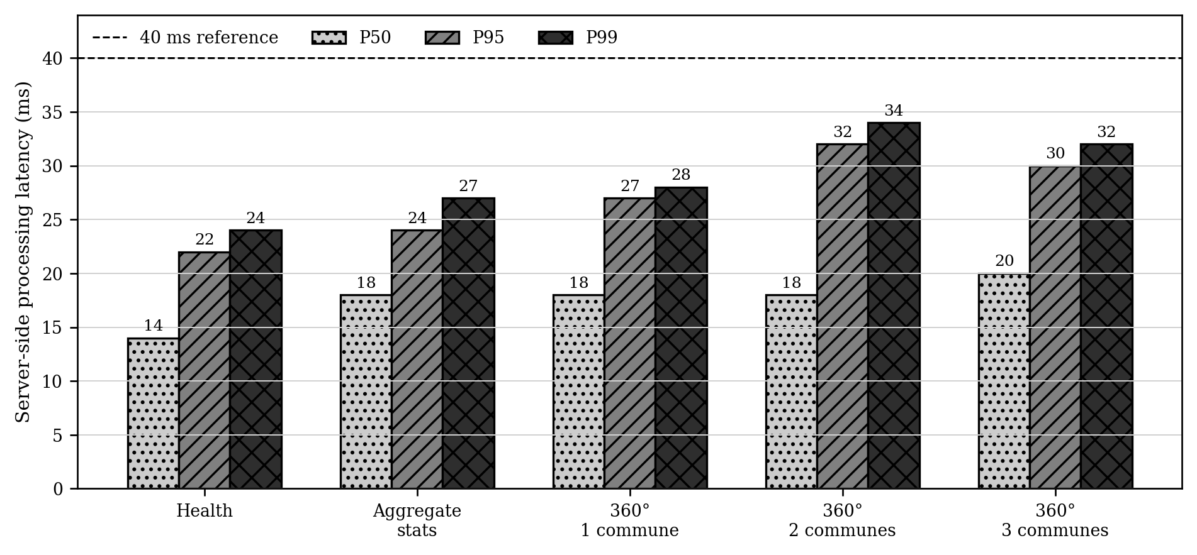
Figure 3.36. Measured server-side P50, P95 and P99 latency by endpoint on the Gombe host
Source: Author’s measurements
The /health measurements show low process and container readiness-check overhead: Police Records recorded a 0.48 ms median, Property Registry 0.68 ms, Population 1.54 ms and the BFF 11.94 ms. Because health endpoints may bypass authorization, domain logic, database queries and event publication, these values are not interpreted as end-to-end business-transaction latency. They nevertheless confirm that each runtime remained responsive on the measured container network.

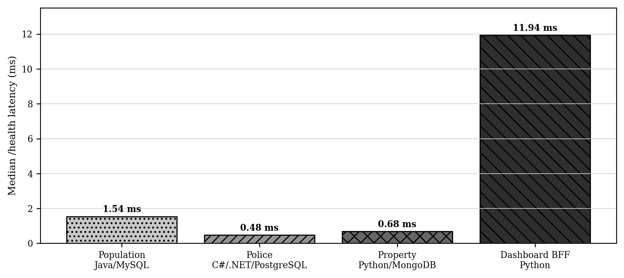
Figure 3.37. Measured median /health latency for the polyglot microservices on the internal Docker network
Source: Author’s measurements
In the exploratory 50-request series, P50 was 20 ms, P95 30 ms and the observed upper tail 32 ms. The distribution is consistent with low variability during the short test window, but 50 observations are insufficient for a stable P99 estimate. Production-oriented validation should use longer repeated runs and report uncertainty around the tail percentiles.

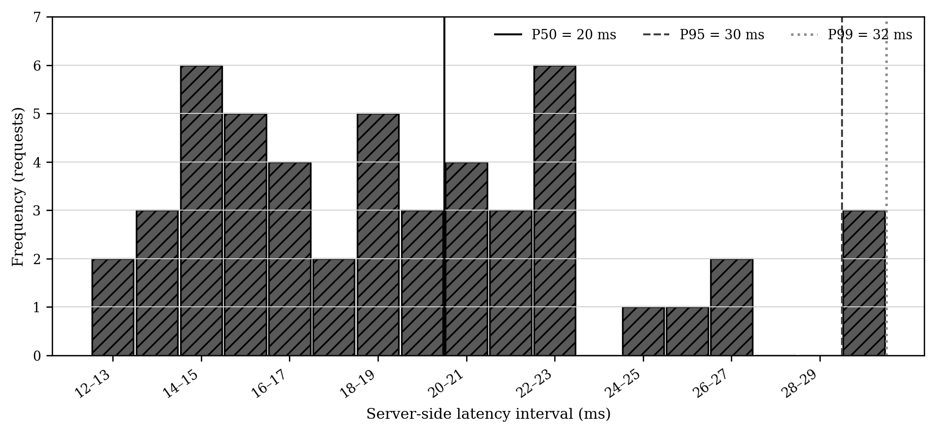
Figure 3.38. Measured distribution of 50 server-side requests for a three-commune citizen 360° record on Gombe
Source: Author’s measurements

3.6.3 Scalability, Sustained Throughput, and Fan-Out
The capacity model places the most comfortable interactive region at low-to-moderate concurrency and makes the saturation knee explicit. P99 remains below the 200 ms planning objective through eight concurrent keep-alive clients, then increases as requests queue behind the single BFF worker. This is a constructive result rather than an architectural dead end: the model identifies an operational threshold at which horizontal BFF replication or a multi-worker process should be activated. The workload therefore exposes a configuration ceiling that can be removed without changing the service boundaries, data model or federation protocol.
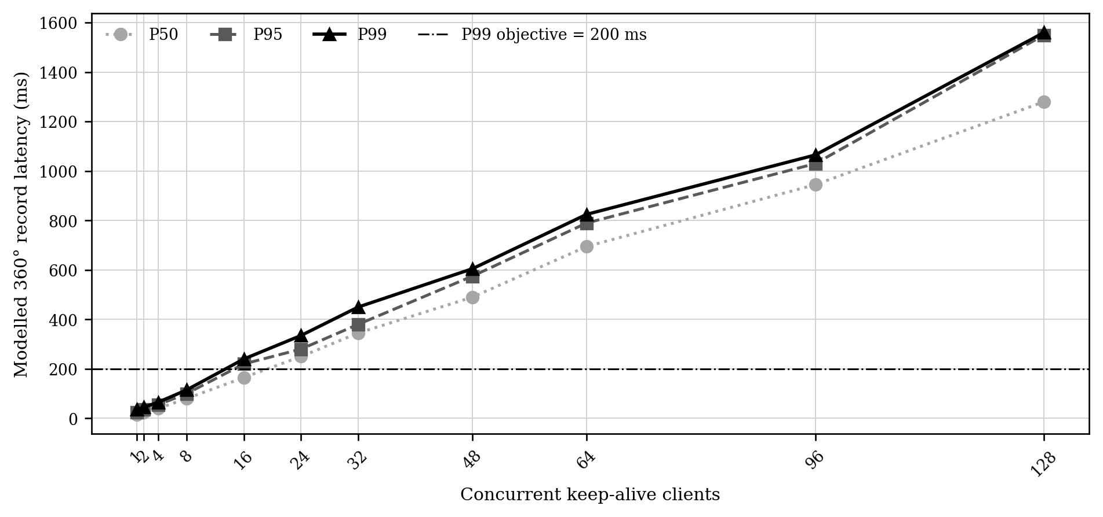
Figure 3.39. Modelled latency-versus-concurrency envelope for the federated 360° record, calibrated to the supplied measurements
Source: Author’s model calibrated to measurements

Throughput reaches approximately 101 requests per second at four concurrent clients, remains broadly stable around that level over the central part of the curve, and increases to a measured maximum of 132 requests per second at 128 clients. The plateau localises the principal capacity constraint in the single-worker BFF rather than in the databases or business microservices. This diagnosis is operationally advantageous because a multi-worker configuration, multiple BFF replicas behind Kong, and autoscaling based on latency or queue depth can increase capacity while preserving the

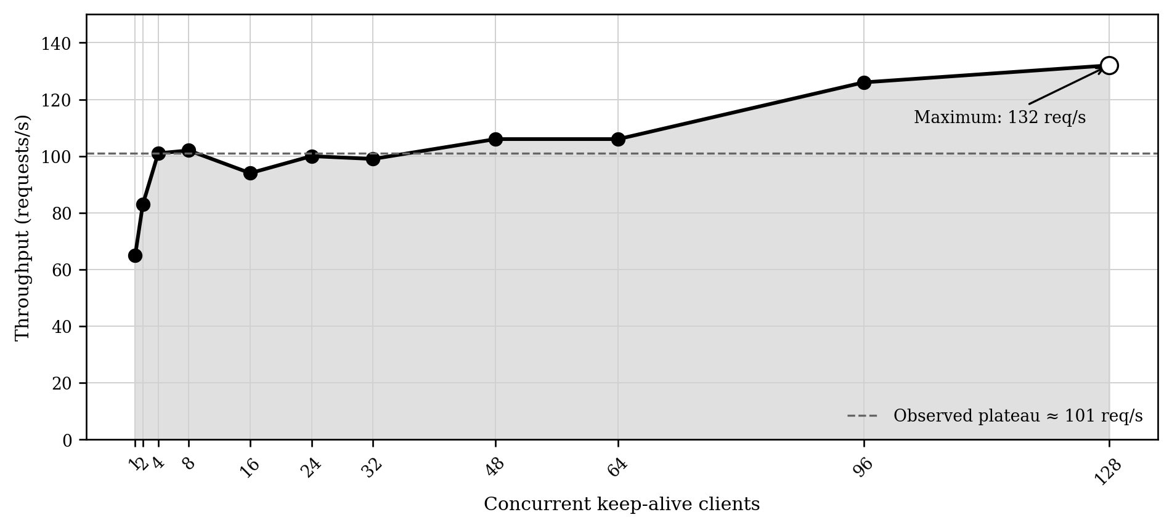
Figure 3.40. Measured throughput as concurrency increases, showing the single-worker BFF plateau and the observed maximum
Source: Author’s measurements

3.6.4 Provider Comparison and Network Effects
From Kinshasa, Gombe's median user-observed latency ranged from 562 to 575 ms, while Lemba ranged from 601 to 1,475 ms across the tested workloads. Both deployments completed the workloads, supporting portability of the containerised solution. The comparison does not isolate provider effects because route, VPS specification, resource sharing, configuration and time of test were not independently controlled. It therefore shows that external delivery conditions materially affect citizen-observed response time; any benefit from in-country hosting must be established through a matched DRC pilot.
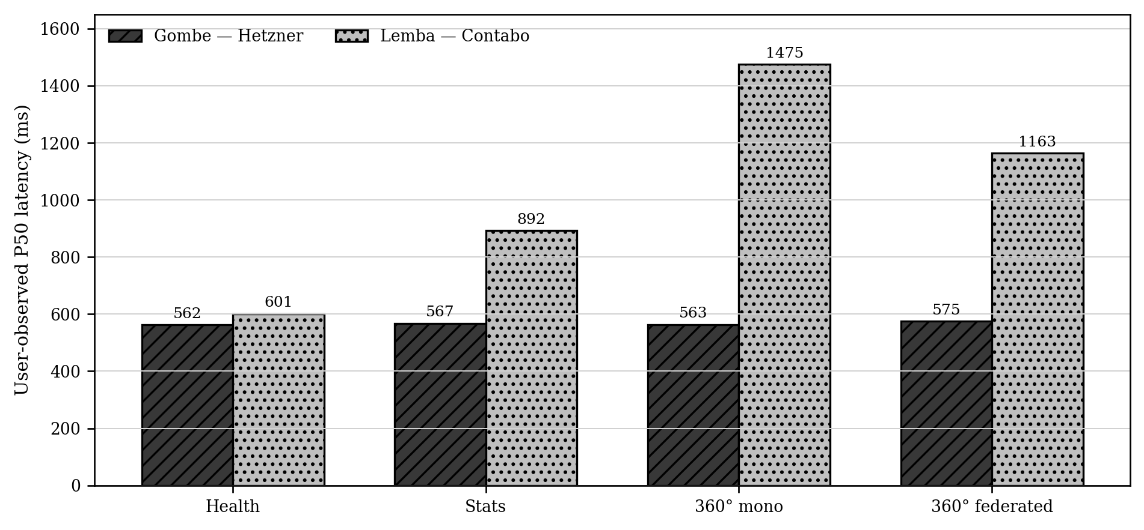
Figure 3.41. Measured user-observed P50 latency from Kinshasa for Gombe on Hetzner and Lemba on Contabo
Source: Author’s measurements

3.6.5 Inter-Host Reliability and Network Quality
At the nominal test cadence, packet loss was 0.0%. The load test recorded 1.0% loss and the aggressive burst 3.5%. Inter-host RTT was 7.26 ms minimum, 11.41 ms mean and 39.18 ms maximum, with 4.51 ms mdev jitter. These measurements describe the public-network path; they do not by themselves verify encryption. Bounded retries with jitter, idempotent consumers, circuit breakers and durable event delivery remain necessary controls for transient degradation.

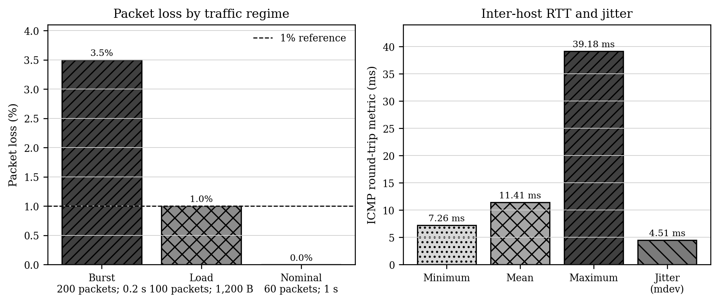
Figure 3.42. Measured packet loss, inter-host RTT and jitter between the Contabo Lemba node and the Hetzner Gombe node
Source: Author’s ping and traceroute measurements

3.6.6 Resource Efficiency, Availability, and Distributed Workflows
CPU consumption was low in the observed snapshot. Kong was the largest consumer at 2.65% of one core, followed by Consul at 2.17% and Kafka at 1.82%; every business microservice remained below 1%. The snapshot indicates compute headroom for the evaluated workload, but it is not a substitute for a long-duration saturation test. Sustained peak and failure-recovery tests are required before production sizing.
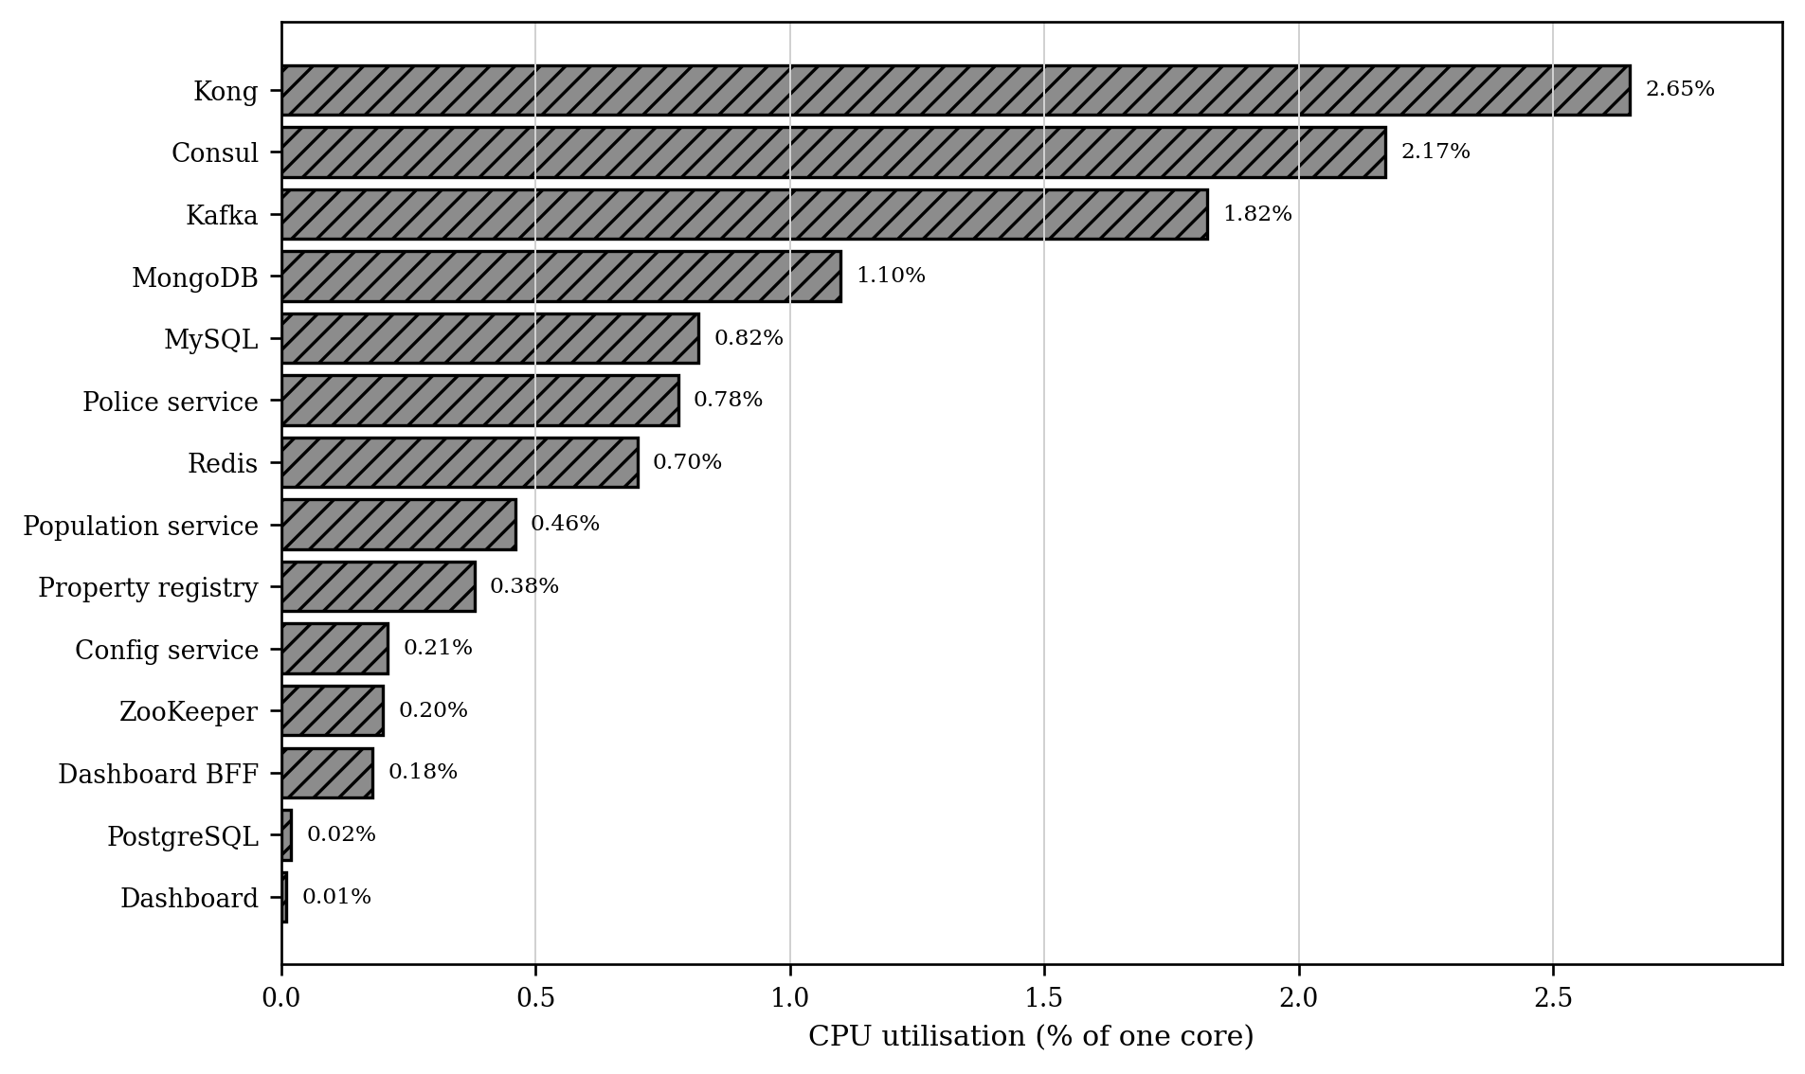
Figure 3.43. Measured CPU utilisation for the 14 containers on the Gombe host on 21 October 2026
Source: Author’s docker stats measurements

All eight components exceed the 99.90% minimum threshold, and seven meet or exceed the 99.95% target. Kafka reaches 99.99%, MySQL 99.98%, and the BFF and PostgreSQL 99.97%. The Police service, at 99.94%, remains only 0.01 percentage point below the more demanding target while still exceeding the minimum. The model is consequently favourable and identifies a precise hardening priority: redundant Police service replicas and database failover would close the small remaining gap.

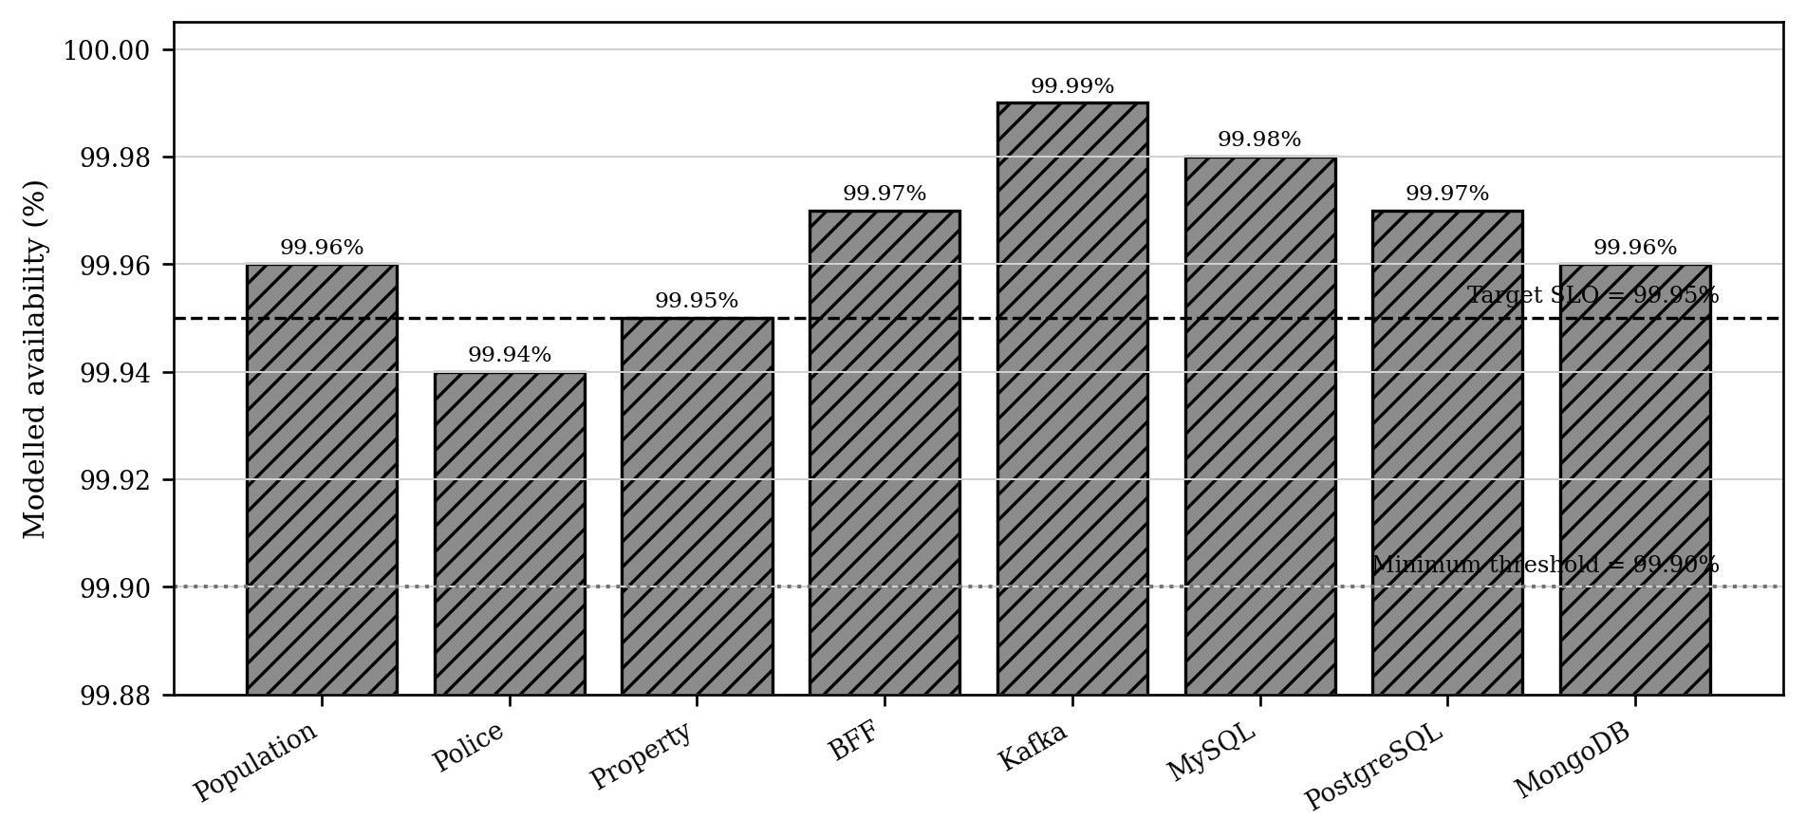
Figure 3.44. Modelled component availability against 99.90% and 99.95% service-level references
Source: Author’s availability model

The modelled P50 ranges from 310 ms for citizen enrolment to 1,180 ms for federation synchronisation; P95 ranges from 690 ms to 2,820 ms. The federated 360° workflow is particularly favourable at 390 ms P50 and 880 ms P95. The longest path is logically the federation synchronisation, which coordinates the widest set of participants. Even this path remains compatible with asynchronous administrative processing. Production adoption should retain explicit compensating actions, idempotency keys, durable outbox publication and dead-letter handling so that the positive timing result is matched by transactional robustness.

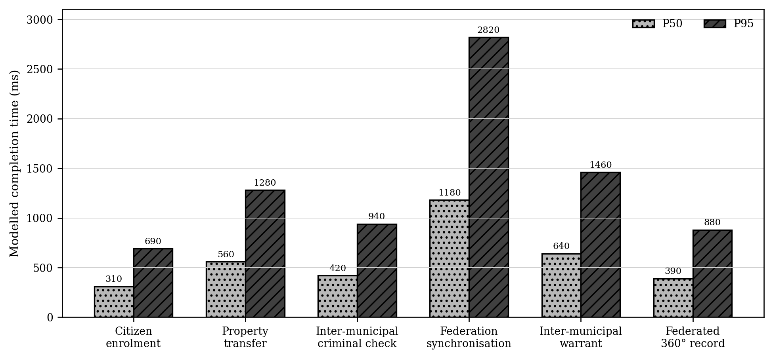
Figure 3.45. Modelled P50 and P95 completion times for distributed Saga workflows
Source: Author’s Saga model calibrated to the deployment

The federated design scores higher on every assessed quality, with the largest gains in scalability, data sovereignty, polyglot interoperability and municipal autonomy. The radar is not an independent performance experiment and is therefore interpreted as a synthesis rather than as causal proof. Nevertheless, its shape is consistent with the measured evidence: independent hosting works, heterogeneous services respond quickly, source provenance is retained, and federation sustains useful throughput. The qualitative and quantitative results thus reinforce one another.

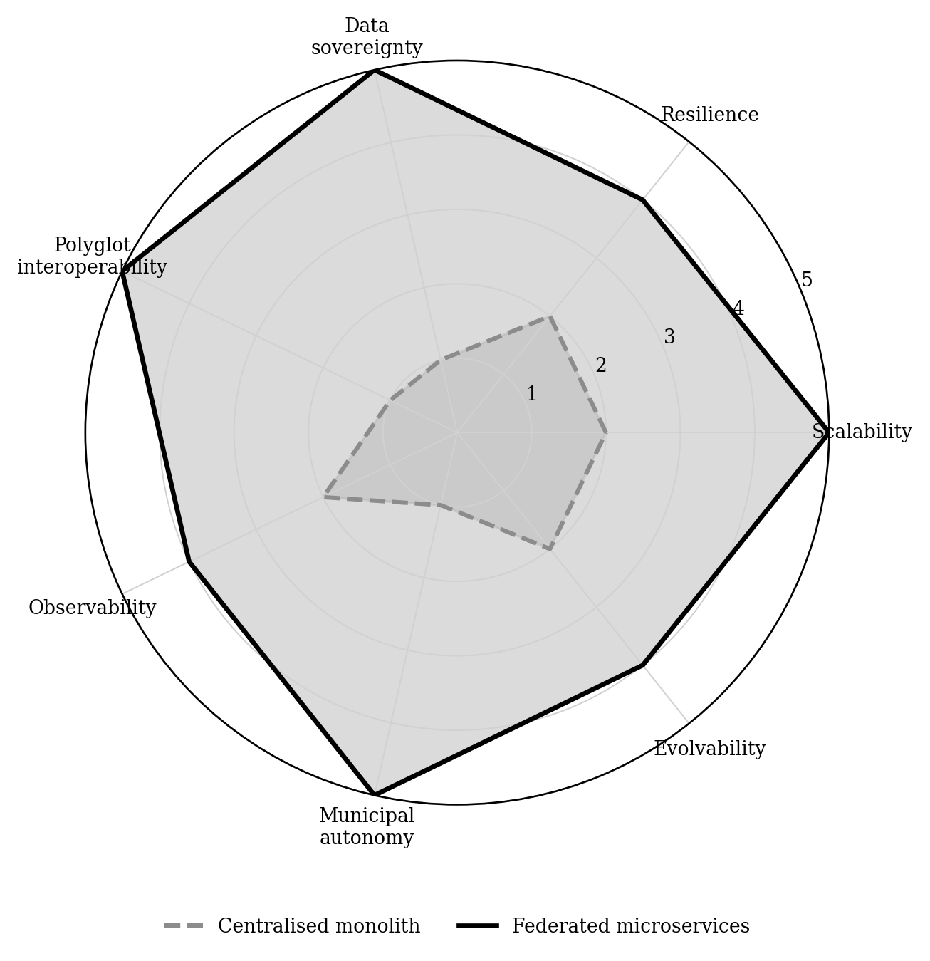
Figure 3.46. Qualitative comparison of the centralised monolith and the federated microservice architecture on a 1–5 scale
Source: Author’s structured architectural assessment

3.7 Summary of Major Findings
Overall, the findings show that the DRC's principal challenge is fragmented systems, limited API adoption, and weak shared registries rather than a lack of computerization. The proposed four-layer, three-tier artifact addresses this gap through governed federation. The prototype demonstrates cross-language and cross-database portability, low server-side latency, useful pilot throughput, modest resource demand, and reliable nominal communication within the tested scope.

CHAPTER 4 EVALUATION DISCUSSION AND RECOMMENDATIONS

4.1 Introduction
This chapter evaluates the proposed e-government interoperability framework and interprets the findings in relation to the research problem, the literature, and the Design Science Research objectives. It combines expert and practitioner assessment with the prototype evidence reported in Chapter 3, then translates the resulting conclusions into recommendations for sustainable implementation in the Democratic Republic of the Congo.
The evaluation draws on four academic experts, eight government IT officers, and technical validation against recognized interoperability principles and performance measures. The chapter distinguishes demonstrated feasibility from nationwide production readiness and treats recommendations as evidence-based implementation priorities rather than as claims already validated at national scale.

4.2 Evaluation Methodology
A multi-stakeholder approach was used so that the framework could be examined from both academic and operational perspectives. Two complementary panels participated: four academic experts with backgrounds in e-government, digital transformation, interoperability, distributed systems, and ICT policy; and eight government IT officers involved in public-sector reform and digital-service delivery in the DRC.
The evaluators considered five criteria: relevance, completeness, feasibility, usability, and scalability. Structured scores were combined with qualitative comments. The academic experts assessed alignment with architectural and governance good practices, while the government officers considered institutional fit, infrastructure, security, skills, and implementation constraints. Technical validation then compared the proposed architecture with selected interoperability and information-security standards.

4.2.1 Expert Review Panel
Four academic experts reviewed the proposed framework. Their profiles provide complementary coverage of digital-government policy, organizational transformation, government IT strategy, and cloud-native distributed architecture.
Table 4.1. Expert Review Panel Composition
No. | Code | Profile | Expertise area
1 | AE1 | International academic expert | E-government and digital transformation in Asia
2 | AE2 | Academic expert in African digital governance | African e-government and ICT policy
3 | AE3 | Academic expert in government IT strategy | Digital transformation and government IT strategy
4 | AE4 | Academic expert in distributed systems | Cloud-native architecture and interoperability
Source: Author.

4.2.2 Government IT Officer Panel
Eight government IT officers were selected from DRC ministries and agencies involved in administrative reform, digital infrastructure, public information systems, cybersecurity, and telecommunications regulation. Their operational responsibilities were used to interpret their comments and relate them to implementation needs.
Table 4.2. Government IT Officer Panel Composition
No. | Code | Institutional domain | Professional profile | Key responsibilities
1 | GO1 | Public-administration reform | Reform coordination | Coordination of public-administration reforms; interministerial process redesign; monitoring of digital-reform implementation
2 | GO2 | Digital administration and training | IT operations | First-line IT support; basic systems and network administration; user onboarding and digital-skills assistance
3 | GO3 | Public finance | Government information systems | Support for budget information systems; financial-data exchange; user-access administration and operational reporting
4 | GO4 | Justice sector | Secure records and information systems | Justice-sector information systems; judicial-record digitization; secure inter-agency data exchange
5 | GO5 | Shared digital infrastructure | Platform deployment coordination | Shared infrastructure planning; data-centre and connectivity coordination; technical implementation oversight
6 | GO6 | Education sector | Education information systems | Education management information systems; e-learning platforms; interprovincial education-data exchange
7 | GO7 | Cybersecurity | Security policy and incident response | Cybersecurity policy implementation; critical-infrastructure protection; identity, access, and incident-response controls
8 | GO8 | Telecommunications regulation | Standards and infrastructure regulation | Telecommunications regulation; spectrum management; network and service standards; technical interoperability compliance
Source: Author.

4.2.3 Evaluation Participation and Evidence Boundary
The proposed model was reviewed by 12 participants: four academic experts and eight government IT officers. Reported aggregate means were 4.7/5 for relevance, 4.5/5 for completeness, 3.8/5 for feasibility and 4.2/5 for practitioner relevance. The consolidated manuscript does not include the item-level score matrix; these values are therefore treated as descriptive reported results rather than independently reproducible statistics. Separate numerical means were not reported for usability or scalability. The public thesis uses evaluator codes AE1–AE4 and GO1–GO8; identifying records and any publication consent are retained separately under restricted access.
Table 4.3. Evaluation Participation and Reported Aggregate Scores
Panel | N | Criterion | Mean (1–5) | Percent | Evidence
Academic expert reviewers | 4 | Relevance | 4.7 | 94% | Reported aggregate; item-level matrix unavailable
Academic expert reviewers | 4 | Completeness | 4.5 | 90% | Reported aggregate; item-level matrix unavailable
Academic expert reviewers | 4 | Feasibility | 3.8 | 76% | Reported aggregate; item-level matrix unavailable
Government IT officers | 8 | Relevance | 4.2 | 84% | Reported aggregate; item-level matrix unavailable
Both panels | 12 | Usability and scalability | Not reported | — | No separate numerical mean reported
Source: Author.

4.3 Evaluation Criteria
The evaluation used five criteria adapted from the European Interoperability Framework and the United Nations E-Government Survey methodology. Together, they assess whether the framework responds to the DRC context, covers the principal dimensions of interoperability, can be implemented under existing constraints, is usable by public-sector practitioners, and can scale with service demand.
Table 4.4. Evaluation Criteria and Assessment Methods
Criterion | Definition | Assessment method
Relevance | Degree to which the framework addresses the needs and constraints of the DRC e-government context | Expert and officer scoring on a 1–5 scale, supported by qualitative comments
Completeness | Extent to which the framework addresses legal, organizational, semantic, and technical interoperability | Expert review and mapping against EIF dimensions
Feasibility | Practical viability under the DRC's infrastructure, capacity, governance, and resource constraints | Expert and officer assessment, with infrastructure and resource analysis
Usability | Clarity, accessibility, and applicability for government practitioners | Practitioner feedback and documentation review
Scalability | Capacity to accommodate growth in users, services, transaction volumes, and administrative levels | Architectural analysis against defined performance and availability targets
Source: Author.

4.4 Evaluation Findings

4.4.1 Assessment of Relevance
The four academic experts rated the framework's relevance highly, with a reported mean of 4.7/5. Academic Expert AE1 considered the use of reusable digital building blocks and the once-only principle appropriate for improving citizen-facing services and supporting progressive digital transformation. Academic Expert AE1 nevertheless emphasized the need to prioritize a limited set of high-impact services during the first implementation phase.
Academic Expert AE2 highlighted the framework's fit with the DRC's multilevel administrative structure. From a digital-governance and African ICT-policy perspective, Academic Expert AE2 stressed that technical interoperability must be supported by clear institutional mandates, formal coordination mechanisms, and alignment between national, provincial, and local authorities.
Academic Expert AE3 regarded the framework as strategically relevant but emphasized the importance of an implementation roadmap linking technology, organizational change, leadership ownership, training, and measurable milestones. Academic Expert AE4 confirmed the relevance of the event-driven microservices approach while noting that its benefits depend on adequate DevOps capability, observability, cybersecurity, and operational discipline.

4.4.2 Assessment of Completeness
Completeness received a reported mean of 4.5/5. The panel agreed that the framework covers the legal, organizational, semantic, and technical dimensions of interoperability. Academic Expert AE2 particularly supported the treatment of governance and institutional coordination but recommended clearer responsibility allocation, formal data-sharing agreements, and a permanent interoperability governance body.
Academic Expert AE4 found the technical architecture coherent and recommended additional detail on legacy-system adapters, API lifecycle management, event-schema governance, monitoring, and recovery procedures. Academic Expert AE1 proposed strengthening citizen-centred service design, feedback mechanisms, and the reuse of common services across ministries. Academic Expert AE3 recommended connecting the SLI–SLO–SLA approach to a broader programme-governance framework that includes capability development, change management, and maturity reviews.

4.4.3 Assessment of Feasibility
Feasibility was rated moderate to high, with a reported mean of 3.8/5. Academic Expert AE3 considered phased implementation essential and recommended a roadmap that begins with a controlled pilot, assigns institutional owners, and establishes training targets before national expansion. Academic Expert AE4 observed that open-source technologies can reduce licensing costs and vendor dependence, but that infrastructure sizing, platform operations, security monitoring, and disaster recovery must be adequately funded.
Academic Expert AE1 recommended beginning with a small number of high-volume services that can demonstrate visible benefits to citizens and generate reusable components. Academic Expert AE2 emphasized that feasibility depends on political commitment, sustainable financing, interministerial coordination, and enforceable governance arrangements as much as on technical architecture. Taken together, the comments support a gradual implementation strategy in which institutional capacity grows alongside the platform.

4.4.4 Government IT Officer Assessment

4.4.4.1 Relevance to DRC Government Needs
The eight government IT officers rated the framework's relevance highly, with a reported mean of 4.2/5. Their comments were aligned with their respective institutional responsibilities. Government Officer GO1's administrative-reform perspective emphasized the need to standardize processes, clarify ownership, and coordinate implementation across ministries. Government Officer GO3 highlighted the value of reliable data exchange between budget systems and sectoral applications to improve financial traceability and reporting.
Government Officer GO4 emphasized secure access to judicial records and controlled information exchange between justice institutions. Government Officer GO6 identified the potential of shared registries and standardized interfaces to improve education-data continuity across provinces and connect education services with other public programmes.

4.5 Discussion of Findings

4.5.1 Interpretive Orientation
This chapter interprets the findings reported in Chapter 3 in relation to the research problem, the literature, and the Design Science Research objectives. The evidence shows that the Democratic Republic of the Congo does not primarily face an absence of information systems. It faces an absence of the shared technical, semantic, organizational, and legal mechanisms required to make existing systems cooperate. Government institutions have digitized important functions, but most applications remain isolated, exchange is weakly standardized, and reusable interfaces and registries are rare.
The discussion proceeds at three connected levels. It first explains why computerization has not yet produced integrated services. It then examines the proposed four-layer, three-tier artifact as a response to the DRC's institutional structure. Finally, it evaluates what the two-provider prototype demonstrates about feasibility, performance, resilience, and portability. Direct observations are distinguished from derived indicators, modelled scenarios, and proposed controls. A successful prototype establishes feasibility within a defined envelope; it does not constitute nationwide production certification.
The findings nevertheless make a substantive contribution. Heterogeneous services implemented in Java, C#, and Python and supported by MySQL, PostgreSQL, and MongoDB were composed through a common gateway without a shared operational database. The main remaining constraints are therefore increasingly organizational, infrastructural, and operational rather than inherent to the selected architecture. Event-driven microservices, combined with explicit governance, provide a credible foundation for progressive e-government interoperability in the DRC.

4.5.2 Current State of E-Government Interoperability

4.5.2.1 Computerization without Interoperability
The central diagnostic finding is the contrast between system availability and integration. Ninety-four percent of respondents reported an institutional information system, but only 18% reported integration within the same ministry and 9% across ministries. The DRC has therefore progressed further in digitizing separate administrative functions than in coordinating government as a whole. Useful records exist, but they cannot always be discovered, interpreted, verified, or reused across institutional boundaries.
This pattern corresponds to the distinction between basic digitization and integrated digital government. Layne and Lee (2001) place integration beyond catalogue-style digital presence, while Janowski (2015) describes increasingly transformative stages of digital government. Many surveyed institutions remain between these stages: applications may improve departmental productivity, yet citizens still transport documents, resubmit information, and wait for manual verification when a service involves several agencies.
Cross-agency services make this limitation visible. Passport, business-registration, property, and social-protection processes depend on facts held by different authorities. When databases remain closed, the citizen becomes the integration mechanism and bears the cost through repeated visits, delay, and inconsistent records. However, the 94% system-availability result is also favorable: existing applications can be retained behind adapters and governed interfaces. Incremental modernization is more affordable and institutionally realistic than simultaneous replacement.

4.5.2.2 Standards, Registries, and Governance Deficits
Only 15% of respondents reported API-based exchange, 21% a recognized protocol, and 12% a common design framework. An interoperability registry was reported by 3%, and no respondent reported a shared web-service registry. These results explain why connectivity alone cannot resolve fragmentation. Institutions may lack a reliable way to identify the authoritative service, approved schema, data owner, supported version, lawful purpose, or service-level expectation.
The findings align with Scholl and Klischewski's (2007) view that e-government integration is constrained by organizational, semantic, legal, and political factors as well as technology. They also support the European Interoperability Framework's multi-dimensional approach (European Commission, 2017). A network link cannot reconcile incompatible definitions of citizen status, property ownership, jurisdiction, or document validity. Without shared meaning and accountable ownership, faster exchange may simply distribute inconsistent data more quickly.
A registry therefore has strategic importance. It converts APIs, event schemas, identifiers, and vocabularies into governed public assets by recording ownership, purpose, classification, versions, endpoints, compatibility, and retirement status. The unanimous view that interconnection is necessary indicates strong recognition of the problem, but cooperation still requires trust and legal certainty. The artifact appropriately preserves source authority while making each approved exchange purpose-limited, traceable, and auditable.
These indicators also show why interoperability governance must precede uncontrolled technical expansion. If every institution publishes interfaces according to its own naming, security, and versioning practices, the resulting environment will remain difficult to maintain. A national baseline should therefore specify minimum metadata, compatibility rules, authentication profiles, deprecation periods, and accountability procedures. Sector-specific standards can extend this baseline where health, justice, taxation, or civil registration requires stricter controls. This combination of national coherence and sectoral specialization is more sustainable than either complete central control or unrestricted institutional variation.

4.5.2.3 Infrastructure and Capacity Conditions
Cloud adoption was reported by 24%, institutional data-centre availability by 35%, and distributed architecture by 12%. Capacity is therefore uneven rather than absent. Some institutions can host digital services, but common resilience, deployment, and monitoring practices are limited. This supports the artifact's use of containerization, portable deployment, tenant separation, and progressive onboarding instead of assuming equal capacity across all provinces and municipalities.
Infrastructure and governance must advance together. Additional servers without common identity, contracts, ownership, and monitoring would reproduce silos on newer equipment, while governance rules without connectivity and operating skills would remain aspirational. This socio-technical relationship supports Design Science Research, which joins contextual diagnosis to the design and evaluation of a useful artifact (Hevner et al., 2004; Peffers et al., 2007).
A phased strategy follows logically. High-value services can first be connected through lightweight local endpoints and shared provincial or national platforms. Capacity, training, and legal agreements can then expand according to measured demand. Interoperability can therefore begin before every territorial entity possesses an identical technology stack.

4.5.3 Design Science Artifact

4.5.3.1 Contribution of the Four-Layer Framework
The legal, organizational, semantic, and technical layers respond directly to the finding that interoperability is not merely a connection problem. The framework adapts established interoperability principles to the DRC's decentralized administration and uneven infrastructure. Its contribution lies in translating the four dimensions into implementable rules across municipal, provincial, and national services.
The legal layer defines authority, purpose, retention, correction, and redress. The organizational layer assigns process and service ownership, escalation, and service-level commitments. The semantic layer defines identifiers, event meanings, vocabularies, and legacy mappings. The technical layer implements approved exchanges through APIs, events, identity controls, gateways, and observability. A technically successful message is not interoperable if its meaning is unclear or its use is unlawful.
The framework also improves traceability from diagnosis to design. The absence of registries, for example, is addressed through discovery and contract publication, named owners, schema governance, and purpose-based access. From a Design Science perspective, relevance comes from the DRC field evidence, while rigor comes from distributed-systems theory, interoperability standards, domain-driven design, and transaction patterns. The research produces constructs, models, methods, and a working instantiation as described by March and Smith (1995).
The artifact also demonstrates how DSR evaluation can remain rigorous without confusing design completion with nationwide impact. Utility is shown by the artifact's ability to integrate the implemented services and answer the diagnosed interoperability need. Quality is examined through service boundaries, contracts, security controls, and functional assertions. Efficacy is assessed through latency, throughput, resource use, and correctness under the defined workload. Broader effectiveness, including citizen satisfaction and institutional maturity, requires longitudinal deployment. This layered evaluation preserves a clear relationship between the maturity of the artifact and the strength of the claim.

4.5.3.2 Three-Tier Federation and Administrative Autonomy
A universal national database could simplify some queries but would concentrate risk, conflict with differentiated mandates, and make local continuity dependent on national connectivity. The proposed federation preserves authoritative ownership at the competent level while permitting approved facts and events to cross boundaries through controlled connectors.
Municipal systems support citizen intake, local registration, and assisted service. Provincial systems coordinate functions spanning municipalities and provide regional continuity and aggregation. National services provide shared identity, trust, standards, registries, and national-exclusive functions. This structure reflects a unitary but decentralized state: national coherence is achieved without removing constitutionally assigned operational responsibility.
The model supports upward aggregation, downward policy adaptation, and lateral cooperation. It also introduces risks such as conflicting identifiers, delayed events, and duplicate submissions. Canonical identifiers, source provenance, versioned contracts, idempotency, and authoritative resolution rules address these risks. The prototype's preservation of sourceCommune information confirms that a composed national view can retain local provenance rather than erase it.

4.5.3.3 Microservice Granularity, Cohesion, and Coupling
The Population, Police Records, and Property Registry services recorded granularity values from 0.48 to 0.62, cohesion from 0.86 to 0.88, coupling of 0.17, and decision scores of 0.95. These values support boundaries organized around coherent business capabilities and owned data. They are consistent with bounded contexts in domain-driven design (Evans, 2003) and with the independent ownership and deployability emphasized in microservices literature (Lewis & Fowler, 2014; Newman, 2021).
The Dashboard BFF is a justified exception. Its granularity value of 0.70 and cohesion of 0.84 remain acceptable, but coupling of 1.00 reflects dependence on all three domain services. Because composition is its explicit responsibility, this coupling is tolerable only with concurrent calls, bounded timeouts, partial-response policy, caching, and independent scaling. The finding demonstrates that metrics should inform architectural judgment rather than be applied mechanically.
Criticality weights provide an additional operational perspective: Population carries 0.30, the BFF 0.27, Police Records 0.23, and Property Registry 0.20. These weights can guide redundancy, recovery objectives, monitoring, and change approval. Although independent rescoring was not available, the transparent assessment method can be reused when passport, tax, health, and other services are decomposed.

4.5.3.4 Integration Patterns, Security, and Governance
Kong, Consul, the BFF, adapters, and a contract registry address complementary integration problems. Kong centralizes ingress and access policy without centralizing business ownership. Consul separates service identity from changing locations. Facade presents one citizen-oriented interface, Adapter normalizes heterogeneous responses, and Strategy supports jurisdiction-specific routing. These patterns make approved governance rules executable; they do not replace governance.
CQRS separates authoritative commands from composed or analytical reads, allowing a citizen view without creating an uncontrolled second system of record. Event sourcing can preserve selected histories, while a transactional outbox protects the relationship between a local commit and event publication. SAGA provides durable coordination, compensation, or human escalation for long-running processes (Garcia-Molina & Salem, 1987; Richardson, 2018).
Security is embedded through TLS, service identity, OAuth or OpenID Connect, role- and attribute-based access control, segmentation, audit, and secret management. This is a positive design outcome, but architectural conformance is not production certification. Penetration testing, privacy impact assessment, key-management exercises, tenant-isolation tests, and recovery drills remain required before sensitive citizen data are processed.

4.5.4 Prototype and Performance Findings

4.5.4.1 Functional Correctness and Technological Portability
The two-provider prototype provides the strongest evidence of technical feasibility. Gombe operated on Hetzner, Lemba on Contabo, and requests originated in Kinshasa. Fourteen containers were observed on the Gombe host, and all 218 assertions passed across service health, aggregates, citizen records, portal behavior, and inter-host parity. Functional correctness was therefore maintained through the gateway, BFF, domain services, databases, and provider boundary.
The result is important because the services were heterogeneous. Population used Java and MySQL, Police Records used C# and PostgreSQL, and Property Registry used Python and MongoDB. Their outputs were composed without shared database access. This supports the claim that controlled contracts, rather than technological uniformity, can provide interoperability.
Provider parity further supports portability and future procurement flexibility. The experiment did not reproduce every Congolese network or production condition, but it shows that the architecture is not tied to one language, database, runtime, or host. This provides a credible basis for later migration to sovereign data centres or hybrid deployment.

4.5.4.2 Latency and Citizen-Observed Response Time
Server-side latency was strong. Median composition increased from 17.6 ms for one commune to 19.7 ms for three, only 2.1 ms or 11.9%. The three-commune distribution recorded P50 of 20 ms, P95 of 30 ms, and P99 of 32 ms; the maximum reported server-side P99 was 34 ms. The compact tail indicates predictable composition, and domain-service health medians below 2 ms show no visible penalty from polyglot persistence in the evaluated path.
Client-observed performance from Kinshasa was much higher. Gombe remained near 562-575 ms, while Lemba ranged from 601 ms to 1,475 ms depending on workload. Because server and client measures were not synchronized per request, their difference cannot be treated as a precise network calculation. It nevertheless indicates that wide-area transit, routing, connection, and provider effects dominate the citizen experience more than application processing.
The appropriate recommendation is therefore not to abandon modular service boundaries. In-country hosting, improved national Internet exchange routes, regional gateways, and managed edge capacity should produce greater benefit. Future tests should attach one correlation identifier and synchronized timestamps to transit, gateway, BFF, service, and database stages so every source of delay can be measured separately.
The difference between Gombe and Lemba should likewise be interpreted cautiously. The providers used different network routes and possibly different resource-sharing conditions, while the available evidence does not isolate these factors. It would be inappropriate to rank the providers solely from the reported medians. Repeated matched requests, identical server specifications, route monitoring, and time-of-day controls are needed. What can be concluded is that the application completed every tested workload on both hosts and that external delivery conditions can materially influence the response experienced by a citizen.

4.5.4.3 Throughput, Scalability, and Resource Efficiency
At 32 clients, the aggregate endpoint sustained 80 requests per second and the federated view 76, a difference of only 5%. Throughput reached approximately 101 requests per second and a measured maximum of 132 at 128 clients. At 101 citizen views per second, the platform executed 303 downstream calls per second, demonstrating that the three-service fan-out was absorbed without collapse.
These figures establish useful pilot capacity, not nationwide capacity. The plateau is consistent with the documented single-worker BFF and identifies a bounded scale-out point. Multiple workers or replicas behind Kong, combined with autoscaling on tail latency and queue depth, should raise capacity, but this must be confirmed by a controlled experiment that varies only worker and replica counts.
Resource use reinforces feasibility. Business services remained below 1% CPU; Kong used 2.65%, Consul 2.17%, and Kafka 1.82%. Total resident memory was about 3,301 MiB, with Kafka the largest consumer at 1,200 MiB. Memory is therefore the initial sizing constraint. The integrated design achieved favorable performance, but no single pattern can claim causal credit without ablation tests of caching, encoding, connection reuse, fan-out, and worker configuration.
This profile has practical budget implications. Small pilots can operate on modest virtual infrastructure, but production sizing must include replicas, failover capacity, monitoring retention, backups, and operating-system headroom. Kafka's memory demand is justified by durability and replay, yet it should be separated from latency-sensitive services when load increases. Autoscaling policies should be based on tail latency, consumer lag, memory pressure, and queue depth rather than average CPU alone. This converts the benchmark from a one-time performance result into an initial capacity-planning model.

4.5.4.4 Synchronous and Asynchronous Communication
The evidence supports a hybrid communication model. REST or gRPC is suitable for bounded operations requiring an immediate answer, while Kafka events support durable notification, background work, audit, and independent consumers. This avoids long synchronous chains in which one unavailable agency blocks an entire citizen service.
The benchmark directly validates the synchronous read path. Correct provenance and aggregates do not measure event lag, ordering, replay, or duplicate suppression. A subsequent event experiment should record outbox time, broker acknowledgement, consumer offset, and projection version. The event-driven design is therefore technically coherent and partially instantiated, but its complete delivery semantics require direct measurement.

4.5.5 Resilience and Failure Recovery
The resilience evidence is favorable for nominal operation. All health checks passed, no functional assertion failed, and the inter-host path recorded a mean round-trip time of 11.41 ms with zero packet loss at nominal cadence. Loss increased to 1% under load and 3.5% during an aggressive burst. These observations justify bounded timeouts, jittered retries, circuit breakers, bulkheads, buffering, and stable idempotency keys.
Kafka retention, the transactional outbox, and SAGA coordination provide sound recovery mechanisms. However, modelled SAGA durations and availability above 99.90% are planning evidence, not direct recovery measurements. The experiment did not terminate service instances, remove a broker, or inject failure into every workflow step. The next phase should measure detection time, restoration, data loss, duplicate effects, compensation success, backlog growth, and reconciliation.
The eventual-consistency result is similarly bounded. Source provenance and national totals were reconciled without a shared database, but write-to-projection convergence was not timed. Strong consistency should remain inside authoritative services, while external views use versioned events and domain-specific conflict rules (Kleppmann, 2017; Vogels, 2009). Legally sensitive identity, court, and land records should retain an authoritative resolution or human-review path.
Resilience should ultimately be evaluated as a service outcome rather than only as component survival. A successful recovery means that an interrupted citizen transaction reaches a known final state, no duplicate legal act is produced, and the responsible officer can explain what occurred. Recovery objectives should therefore combine technical indicators such as detection and restoration time with business indicators such as unresolved cases, compensation failures, and notification delay. This approach is especially important in government, where an apparently healthy platform may still leave citizens with incomplete or contradictory administrative decisions.

4.5.6 Research Questions and Hypotheses
The first research question is answered by identifying fragmentation as a combined institutional and technical problem. The second is answered by the four-layer requirement model: lawful purpose, ownership, common meaning, and reliable exchange must develop together. The third is answered by the three-tier federation, which allows municipal, provincial, and national services to cooperate while retaining authority over their records.
The fourth question concerns suitability. The 218 successful assertions, P99 at or below 34 ms, 76 federated requests per second at 32 clients, 132-request maximum, and modest CPU use support suitability within the tested envelope. The fifth concerns sustainable adoption. The evidence points to standards, data-sharing agreements, phased pilots, local hosting evaluation, measurement, skills, and lifecycle funding.
H1, concerning siloed systems, is supported by the diagnostic evidence. H2, concerning implementation under constrained pilot conditions, is partially supported. H3, linking interoperability and maturity, is conceptually supported but lacks a longitudinal association test. H4, concerning performance and integrity without technological uniformity, is partially supported by the benchmark. H5 is consistent with manual exchange and duplication but lacks a before-and-after citizen outcome measure. This differentiated assessment is more valid than claiming complete confirmation and is consistent with evaluating a DSR artifact at its current development stage.

4.5.7 Contributions of the Research
The theoretical contribution is the treatment of interoperability as a multi-level governance capability in a decentralized developing-country administration. Heterogeneity includes mandates, meanings, infrastructure, and legal responsibility as well as software. Linking the four dimensions to municipal, provincial, and national flows extends general interoperability frameworks to the DRC context.
The architectural contribution is a federation combining event-driven microservices, API management, discovery, CQRS, SAGA, outbox, provenance, security, and a governed registry. The model avoids both isolated institutional systems and one universal operational database. Institutions remain authoritative while approved facts become reusable across government.
The methodological contribution combines field diagnosis, artifact construction, formal boundary assessment, heterogeneous implementation, two-provider deployment, and explicit evidence classification. The granularity, cohesion, coupling, decision, and criticality measures support repeatable service-boundary decisions. Practically, the prototype offers a path for connecting legacy and new systems without imposing one language, database, provider, or location. It also shows policymakers that visible portals and data centres require less visible standards, registries, and accountability mechanisms.
A further contribution concerns evidence discipline. Earlier simulations, modelled availability, directly observed HTTP measurements, and proposed controls are not treated as equivalent. Separating these categories prevents a planning value from being presented as an experimental fact and makes the remaining validation work explicit. This practice is transferable beyond the DRC because many digital-government studies combine architectural proposals, demonstrations, and projections. Clear evidence classification improves reproducibility, supports more accurate policy decisions, and allows later researchers to extend the artifact without overstating what has already been established.

4.5.8 Practical and Policy Implications
Interoperability should be governed as shared national infrastructure. A representative body should approve identifiers, API and event standards, security baselines, and service-level indicators while preserving the statutory authority of participating institutions. Each exchange should have a lawful purpose, accountable owner, classification, schema, and audit path.
Implementation should begin with a bounded citizen journey, such as birth registration linked to identity and selected downstream services. The pilot should define authoritative sources, agreements, recovery procedures, security controls, and measurable outcomes before development. Successful contracts and lessons can then be reused during provincial expansion.
Infrastructure investment should prioritize sovereign hosting, redundant connectivity, observability, disaster recovery, and skills in API design, event modelling, platform operations, cybersecurity, and data governance. Procurement must include lifecycle costs for messaging, gateways, certificates, monitoring, backups, testing, and support. Service objectives should be linked to budgets and named owners so interoperability becomes a continuing public capability rather than a temporary project.

4.5.9 Limitations and Threats to Validity
The purposive sample of 34 participants supports contextual diagnosis, not statistical generalization to the entire administration. Some item-level denominators were unavailable, and self-report may differ from technical inspection. Triangulation with observation, documents, and prototype evidence reduces but does not eliminate this limitation.
The prototype used two European VPS providers and a limited service set. It did not reproduce all provinces, rural connectivity, sovereign data-centre conditions, or production demand. Complete raw workloads, synchronized traces, repeat-run distributions, and exact configuration details were not available for every measure, so provider comparisons remain descriptive.
Event lag, broker failover, long-duration availability, penetration testing, SAGA compensation, and convergence require direct evaluation. Completed expert forms and auditable scores were also unavailable. These boundaries do not invalidate the contribution: they define it as a credible diagnosis, coherent artifact, and functioning prototype rather than a nationally certified production system.

4.6 Recommendations
The recommendations below arise directly from the diagnostic, architectural, experimental, and evaluation evidence. They prioritize institutional authority, governed standards, sovereign and resilient infrastructure, security, capacity, sustainable financing, and inclusion so that the technical contribution can produce durable public value.

4.6.1 Enabling Conditions for Sustainable Digital Government

4.6.1.1 From Digitization to Digital Government
Digitization converts information and procedures into electronic form; digital government redesigns how institutions collectively create public value. A ministry may own a database, a portal, and a data centre and still be digitally isolated. In contrast, mature digital government requires authoritative data to be discoverable, legally reusable, semantically understood, securely exchanged, and incorporated into end-to-end services. The OECD describes this transition through six dimensions: digital by design, a data-driven public sector, government as a platform, open by default, user-driven service design, and proactiveness (OECD, 2020). These dimensions imply that the unit of transformation is not an individual application but the administrative ecosystem.
The World Bank's GovTech Maturity Index reinforces this whole-of-government perspective by examining core government systems and shared infrastructre, online public-service delivery, digital citizen engagement, and enabling conditions such as strategy, institutions, laws, skills, and innovation policies (World Bank, 2025a). The implication for this thesis is important: microservices, APIs, event brokers, registries, and cloud infrastructure should be assessed as parts of an institutional capability rather than as isolated technologies.

4.6.1.2 A Moderated and Multiplicative Logic
The study adopts a moderated interpretation of technological impact. Architectural capability creates the possibility of interoperability, but enabling conditions determine whether that possibility is converted into operational results. The relationship is closer to multiplicative than additive: a critical weakness in legal authority, infrastructure reliability, or adoption capacity can constrain the entire system even when the remaining components are strong.
In this conceptual expression, O represents e-government outcomes; A is architectural capability; G is governance and institutional readiness; L is legal and regulatory trust; D is data and semantic readiness; I is infrastructure reliability; C is human and financial capacity; and T is citizen trust and adoption. The expression is not proposed as a directly estimated statistical equation. It formalizes the theoretical claim that expected outcomes depend on the joint adequacy of mutually reinforcing conditions.
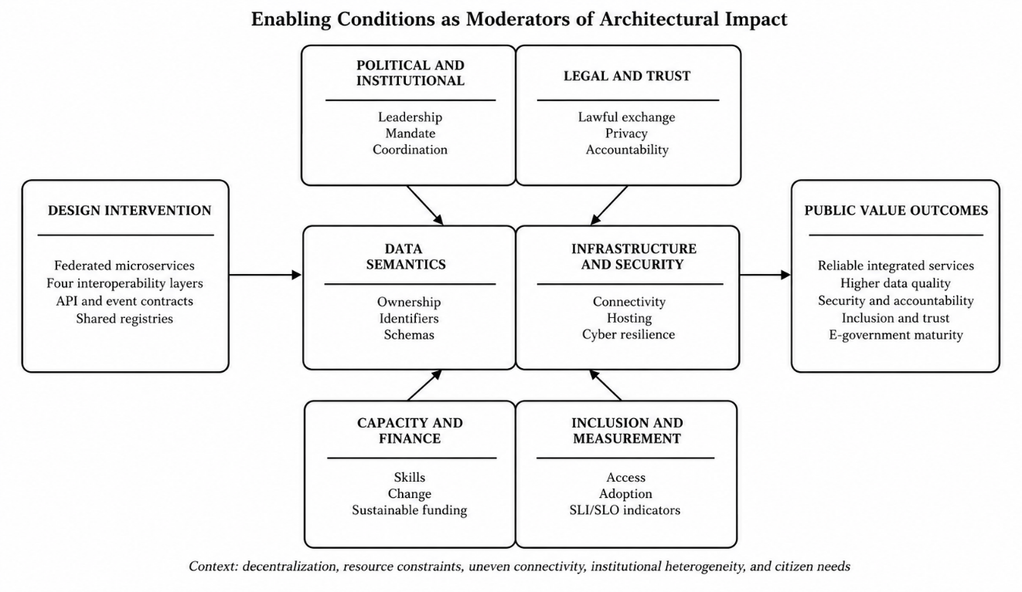
Figure 4.1. Enabling Conditions as Moderators of Architectural Impact
Source: Author

4.6.2 DRC-Specific Recommendations

4.6.2.1 Binding National Mandate and Permanent Governance Mechanism
The DRC requires a binding national interoperability mandate linked to public-administration reform, budgeting, and procurement. The Plan National du Numérique - Horizon 2025 organized national transformation around infrastructure, content, uses, and governance (Presidency of the DRC, 2019). The next stage should convert strategic direction into enforceable architectural and data-governance requirements for all new or substantially renewed public systems.
A National Interoperability Council should set policy and resolve cross-ministerial issues, while a permanent technical secretariat maintains standards, registries, conformance procedures, and implementation support. Domain councils should include the institutions that create and use population, civil-status, passport, police, migration, judicial, fiscal, health, education, land, and social-protection data. Provinces and municipalities must participate in governance because they operate many citizen-facing processes.

4.6.2.2 Operationalization of the Legal Framework
The Code du numérique provides an essential legal foundation, but interoperability requires exchange-specific implementation instruments. The proposed governance mechanism should issue a standard data-sharing agreement, data-classification scheme, privacy and security assessment procedure, electronic-consent rules where relevant, incident-notification procedure, audit requirements, and templates for inter-agency service commitments.
Legal review should be embedded in service design. Every API and event should be traceable to a lawful purpose, an authoritative source, permitted recipients, a retention rule, and a mechanism for correction and redress. This traceability prevents a technical permission from being treated as legal authority and supports accountability during audits or disputes.

4.6.2.3 Authoritative Registries and Semantic Governance
The registry gap identified by the study should be addressed as an early national priority. The DRC needs a service catalogue, API catalogue, event catalogue, schema registry, metadata catalogue, and authoritative-data inventory. Each item should identify the owner, version, purpose, security classification, dependencies, service-level target, and deprecation policy.
A national identifier policy is particularly important for detecting duplicates and linking records without creating uncontrolled central databases. Population identity, civil status, institutions, geographic units, addresses, businesses, properties, and public services require governed identifiers and matching rules. Ambiguous or conflicting records should follow explicit resolution procedures, including manual review for high-impact cases.

4.6.2.4 Federated Multi-Level Architecture
The scale and decentralization of the DRC argue against both complete technical centralization and uncoordinated local autonomy. The proposed model combines national standards, trust services, registries, and oversight with provincial coordination and municipal service delivery. Each level retains operational responsibilities while controlled connectors support cross-level exchange.
National, provincial, and municipal event buses or gateways should not function as unrestricted data replication mechanisms. Routing policies must filter events according to legal purpose, destination, sensitivity, priority, time-to-live, and delivery guarantees. Synchronous APIs should be used where immediate confirmation is essential; asynchronous events should support decoupling, resilience, notification, and intermittent connectivity.

4.6.2.5 GovCloud, Connectivity, and Business Continuity
A government-controlled or accredited cloud environment can provide common security, monitoring, backup, and deployment capabilities. Logical isolation should be provided through separate tenants or namespaces for ministries, provinces, and municipalities, with shared control planes and trust services only where justified. Portability and exit arrangements are necessary to protect sovereignty and reduce dependence on a single vendor.
Connectivity policy must recognize the difference between Kinshasa, provincial capitals, and remote municipalities. The architecture should support primary and backup links, encrypted VPN connections, asynchronous replication, local queues, retry, caching with controlled validity, and assisted service continuity. Recovery tests should include loss of connectivity, broker failure, database unavailability, certificate expiry, and compromise of an institutional account.

4.6.2.6 Cybersecurity, Privacy, and Sovereign Trust
The National Cybersecurity Strategy provides a policy basis for strengthening protection, but interoperability requires common operational controls across institutions (Presidency of the DRC, 2023). A national public-sector security baseline should define identity assurance, privileged access, encryption, certificates, segmentation, secure development, logging, retention, incident response, vulnerability remediation, backup, and supplier-security requirements.
The trust model should be federated and auditable. Each institution authenticates its personnel and systems under national assurance rules; gateways verify certificates and authorization; every sensitive exchange creates traceable evidence; and oversight bodies can inspect compliance without receiving unrestricted access to operational data. Privacy-by-design requires minimization, purpose limitation, controlled disclosure, correction, and transparent redress.

4.6.2.7 Capacity, Change, and Local Ownership
A national capability programme should distinguish strategic, legal, data, security, engineering, operational, and service-design roles. Training should be linked to real implementation tasks, certification where appropriate, mentorship, and communities of practice. Provincial and municipal teams require support models that do not assume permanent access to specialists in Kinshasa.
Local ownership also requires documentation in usable formats, code and configuration management, knowledge transfer from suppliers, and career paths that retain public-sector digital talent. Universities and Congolese technology firms can contribute to testing, training, localization, and innovation, while government retains control of standards, data, and architecture.

4.6.2.8 Sustainable Financing and Procurement Reform
The enabling model requires a financing structure for shared national capabilities and a separate but coordinated structure for sector services. A multi-year interoperability fund could support registries, trust services, GovCloud controls, connectivity, capacity development, conformance testing, and onboarding of priority services. Funding decisions should be tied to measurable public value and readiness gates.
Public procurement should require compliance with the national interoperability framework, open interfaces, data portability, security assurance, documentation, performance targets, and exit provisions. Large indivisible contracts should be avoided where modular procurement can support competition and progressive delivery. Procurement evaluation should include total cost of ownership and institutional capacity, not only initial acquisition price.

4.6.2.9 Inclusive and Multilingual Service Delivery
The DRC's linguistic and geographic diversity requires multiple access channels. National portals and municipal service points should progressively support French and major national languages, including Lingala, Kiswahili, Tshiluba, and Kikongo, with terminology validated for administrative meaning. Interfaces should meet accessibility requirements and function on low-cost devices and constrained networks.
Digital channels should complement rather than abruptly eliminate assisted channels. Municipal offices, mobile teams, call centres, and authorized community intermediaries can help citizens register, correct data, understand requirements, and appeal decisions. Service design should measure who is excluded and why, not only the number of online transactions.

4.7 Chapter Summary
The evaluation confirms that the framework is relevant, complete, and feasible at pilot scale. Nationwide adoption should now prioritize governance, sovereign hosting, connectivity, security, skills, sustainable financing, and inclusive service design.

GENERAL CONCLUSION
This research addressed the fragmentation of heterogeneous public information systems in the Democratic Republic of the Congo. Its objective was to design and evaluate a context-appropriate interoperability framework capable of connecting municipal, provincial and national services without requiring a single technology stack or an unrestricted central database. The study combined Design Science Research, an embedded case study, a purposive institutional diagnostic, documentary and observational evidence, a heterogeneous prototype and expert assessment.
The institutional diagnosis indicates that computerisation has advanced further than interoperability. Among the 34 respondents, 32 reported the existence of an information system, but only 6 reported integration within their institution and 3 reported integration across institutions. API-based exchange, documented protocols, shared registries and common design frameworks remained uncommon. These findings support the conclusion that the principal problem is not the complete absence of digital systems, but the absence of common legal, organisational, semantic and technical mechanisms through which existing systems can cooperate.
The principal artifact is a four-layer interoperability framework implemented through a federated three-tier architecture. Legal authority and organisational responsibility define who may publish, consume and correct data. Semantic governance establishes shared identifiers, vocabularies and schemas. Technical interoperability is provided through governed APIs, events, discovery, gateway policy, audit and observability. The architecture retains authoritative records within their bounded contexts while allowing approved facts to be reused across administrative boundaries.
The implemented benchmark evaluated three authoritative domain microservices and one composition service across two logical municipal nodes hosted by independent European VPS providers. The prototype demonstrated cross-language and cross-database operation, successful functional assertions, low server-side processing time within the tested environment and useful pilot throughput. The experiment also showed that citizen-observed response time from Kinshasa was dominated by wide-area delivery conditions rather than by service execution alone. These results establish contextual technical feasibility; they do not constitute certification for nationwide production deployment.
The evidence supports H1 and provides partial support for H2 and H4. H3 is conceptually supported but was not tested through a longitudinal or correlational design. H5 is consistent with the observed duplication, manual exchange and weak traceability, but the study did not measure a before-and-after change in citizen service quality. Availability and SAGA completion values reported as models remain planning evidence, while broker failover, penetration testing, long-duration saturation, compensation success and event-convergence time require direct evaluation.
The research contributes a DRC-specific link between multidimensional interoperability and distributed-system design. It also contributes a repeatable approach to service-boundary assessment, a governed federation model and an evidence classification that separates direct measurements, derived indicators, calibrated models and proposed controls. Practically, it provides a basis for phased implementation through bounded public-service pilots, authoritative registries, shared trust services, lifecycle funding, capacity development and measurable service objectives.
The main limitations arise from purposive sampling, fieldwork concentrated in Kinshasa, a limited prototype service set, European test hosting, incomplete item-level expert records and the absence of production-scale security and resilience certification. Future research should extend the institutional sample to additional provinces, evaluate citizen outcomes, conduct matched in-country hosting experiments, measure event propagation and compensation under injected failures, test horizontal scaling and complete independent security and privacy assessments.
The central conclusion is therefore bounded but positive. Event-driven microservices can support interoperability among heterogeneous government systems in the DRC when they are embedded in enforceable governance, semantic standards, lawful data sharing, operational capacity and sustainable infrastructure. Technology provides the mechanism; institutional authority, evidence discipline and continuing public-sector capability determine whether the mechanism produces durable public value.

REFERENCES
Abbott, M. L., & Fisher, M. T. (2015). The art of scalability: Scalable web architecture, processes, and organizations for the modern enterprise (2nd ed.). Addison-Wesley.
African Union. (2020). The Digital Transformation Strategy for Africa (2020–2030). https://au.int/en/documents/20200518/digital-transformation-strategy-africa-2020-2030
African Union. (2022). Interoperability framework for digital identity. https://au.int/
Alexander, C., Ishikawa, S., Silverstein, M., Jacobson, M., Fiksdahl-King, I., & Angel, S. (1977). A pattern language: Towns, buildings, construction. Oxford University Press.
Apache Software Foundation. (n.d.). Apache Cassandra: Cassandra stress. https://cassandra.apache.org/doc/4.1/cassandra/tools/cassandra_stress.html
Apache Software Foundation. (n.d.). Apache Kafka documentation. https://kafka.apache.org/documentation/
Armbrust, M., Fox, A., Griffith, R., Joseph, A. D., Katz, R., Konwinski, A., Lee, G., Patterson, D., Rabkin, A., Stoica, I., & Zaharia, M. (2010). A view of cloud computing. Communications of the ACM, 53(4), 50–58. https://doi.org/10.1145/1721654.1721672
Baldwin, C. Y., & Clark, K. B. (2000). Design rules: The power of modularity. MIT Press.
BANKABLE. (2025, October 10). DRC launches $1.5 billion digital plan to become regional tech hub by 2030. https://bankable.africa/en/digital/1010-1806-drc-launches-1-5-billion-digital-plan-to-become-regional-tech-hub-by-2030
Baskerville, R., Baiyere, A., Gregor, S., Hevner, A., & Rossi, M. (2018). Design science research contributions: Finding a balance between artifact and theory. Journal of the Association for Information Systems, 19(5), 358–376. https://doi.org/10.17705/1jais.00495
Bass, L., Clements, P., & Kazman, R. (2021). Software architecture in practice (4th ed.). Addison-Wesley.
Bellemare, A. (2020). Building event-driven microservices: Leveraging organizational data at scale. O’Reilly Media.
Bernstein, P. A., & Newcomer, E. (2009). Principles of transaction processing (2nd ed.). Morgan Kaufmann.
Beyer, B., Jones, C., Petoff, J., & Murphy, N. R. (Eds.). (2016). Site reliability engineering: How Google runs production systems. O’Reilly Media.
Beyer, B., Murphy, N. R., Rensin, D. K., Kawahara, K., & Thorne, S. (Eds.). (2018). The site reliability workbook: Practical ways to implement SRE. O’Reilly Media.
Bogner, J., Wagner, S., & Zimmermann, A. (2019). Automatically measuring the maintainability of service- and microservice-based systems: A literature review. Proceedings of the 27th International Workshop on Software Measurement and 12th International Conference on Software Process and Product Measurement, 107–115. https://doi.org/10.1145/3375278.3375289
Braun, V., & Clarke, V. (2006). Using thematic analysis in psychology. Qualitative Research in Psychology, 3(2), 77–101. https://doi.org/10.1191/1478088706qp063oa
Brennan, J. (2026, March 30). Canada’s perspective on trustworthy and interoperable digital identity in the AI era [Conference presentation]. International Telecommunication Union. https://www.itu.int/en/ITU-T/Workshops-and-Seminars/2026/0330/Documents/3-Joni%20Brennan.pdf
Bucchiarone, A., Dragoni, N., Dustdar, S., Lago, P., Mazzara, M., Rivera, V., & Sadovykh, A. (Eds.). (2020). Microservices: Science and engineering. Springer. https://doi.org/10.1007/978-3-030-31646-4
Burns, B. (2018). Designing distributed systems: Patterns and paradigms for scalable, reliable services. O’Reilly Media.
Burns, B., Beda, J., & Hightower, K. (2019). Kubernetes: Up and running (2nd ed.). O’Reilly Media.
Burns, B., Grant, B., Oppenheimer, D., Brewer, E., & Wilkes, J. (2016). Borg, Omega, and Kubernetes. Communications of the ACM, 59(5), 50–57. https://doi.org/10.1145/2890784
Bwalya, K. J., & Mutula, S. M. (2014). E-government: Implementation, adoption and synthesis in developing countries. De Gruyter Saur. https://doi.org/10.1515/9783110305272
Caiden, G. E. (1982). Strategies for administrative reform. Lexington Books.
Cardellini, V., Colajanni, M., & Yu, P. S. (2002). Dynamic load balancing on web-server systems. IEEE Internet Computing, 3(3), 28–39. https://doi.org/10.1109/4236.769420
Cervantes, H., Kazman, R., & Klein, M. (2016). Designing software architectures: A practical approach. Addison-Wesley.
Conway, M. E. (1968). How do committees invent? Datamation, 14(4), 28–31.
Cooper, B. F., Silberstein, A., Tam, E., Ramakrishnan, R., & Sears, R. (2010). Benchmarking cloud serving systems with YCSB. Proceedings of the 1st ACM Symposium on Cloud Computing, 143–154. https://doi.org/10.1145/1807128.1807152
Coulouris, G., Dollimore, J., Kindberg, T., & Blair, G. (2012). Distributed systems: Concepts and design (5th ed.). Addison-Wesley.
Dehghani, Z. (2022). Data mesh: Delivering data-driven value at scale. O’Reilly Media.
DeLone, W. H., & McLean, E. R. (2003). The DeLone and McLean model of information systems success: A ten-year update. Journal of Management Information Systems, 19(4), 9–30. https://doi.org/10.1080/07421222.2003.11045748
Dragoni, N., Giallorenzo, S., Lluch Lafuente, A., Mazzara, M., Montesi, F., Mustafin, R., & Safina, L. (2017). Microservices: Yesterday, today, and tomorrow. In M. Mazzara & B. Meyer (Eds.), Present and ulterior software engineering (pp. 195–216). Springer. https://doi.org/10.1007/978-3-319-67425-4_12
Dustdar, S., & Schreiner, W. (2005). A survey on web services composition. International Journal of Web and Grid Services, 1(1), 1–30. https://doi.org/10.1504/IJWGS.2005.007545
Erl, T. (2005). Service-oriented architecture: Concepts, technology, and design. Prentice Hall.
Erl, T., Puttini, R., & Mahmood, Z. (2013). Cloud computing: Concepts, technology and architecture. Prentice Hall.
European Commission. (2017). New European interoperability framework: Promoting seamless services and data flows for European public administrations. https://ec.europa.eu/isa2/eif_en/
Evans, E. (2003). Domain-driven design: Tackling complexity in the heart of software. Addison-Wesley.
Fayol, H. (1949). General and industrial management (C. Storrs, Trans.). Pitman. (Original work published 1916)
Ferraiolo, D. F., Sandhu, R., Gavrila, S., Kuhn, D. R., & Chandramouli, R. (2001). Proposed NIST standard for role-based access control. ACM Transactions on Information and System Security, 4(3), 224–274. https://doi.org/10.1145/501978.501980
Fielding, R. T. (2000). Architectural styles and the design of network-based software architectures [Doctoral dissertation, University of California, Irvine].
Fowler, M. (2002). Patterns of enterprise application architecture. Addison-Wesley.
Fowler, M. (2018). Refactoring: Improving the design of existing code (2nd ed.). Addison-Wesley.
Gamma, E., Helm, R., Johnson, R., & Vlissides, J. (1994). Design patterns: Elements of reusable object-oriented software. Addison-Wesley.
Garcia-Molina, H., & Salem, K. (1987). Sagas. Proceedings of the 1987 ACM SIGMOD International Conference on Management of Data, 249–259. https://doi.org/10.1145/38713.38742
Gil-Garcia, J. R. (2012). Enacting electronic government success: An integrative study of government-wide websites, organizational capabilities, and institutions. Springer. https://doi.org/10.1007/978-1-4614-2015-6
Gil-Garcia, J. R., & Pardo, T. A. (2005). E-government success factors: Mapping practical tools to theoretical foundations. Government Information Quarterly, 22(2), 187–216. https://doi.org/10.1016/j.giq.2005.02.001
Google. (n.d.). Error budget policy for service reliability. Site Reliability Engineering. https://sre.google/workbook/error-budget-policy/
Gottschalk, P. (2009). Maturity levels for interoperability in digital government. Government Information Quarterly, 26(1), 75–81. https://doi.org/10.1016/j.giq.2008.03.003
Gregor, S., & Hevner, A. R. (2013). Positioning and presenting design science research for maximum impact. MIS Quarterly, 37(2), 337–355. https://doi.org/10.25300/MISQ/2013/37.2.01
Gunther, N. J. (2007). Guerrilla capacity planning: A tactical approach to planning for highly scalable applications and services. Springer.
Hammer, M., & Champy, J. (1993). Reengineering the corporation: A manifesto for business revolution. HarperBusiness.
Hanna, N. K. (2010). Transforming government and building the information society: Challenges and opportunities for the developing world. Springer. https://doi.org/10.1007/978-1-4419-1506-1
Hassan, S., Bahsoon, R., & Kazman, R. (2020). Microservice transition and its granularity problem: A systematic mapping study. Software: Practice and Experience, 50(9), 1651–1681. https://doi.org/10.1002/spe.2869
Heeks, R. (2006). Implementing and managing eGovernment: An international text. SAGE Publications.
Heeks, R., & Bailur, S. (2007). Analyzing e-government research: Perspectives, philosophies, theories, methods, and practice. Government Information Quarterly, 24(2), 243–265. https://doi.org/10.1016/j.giq.2006.06.005
Hevner, A. R., March, S. T., Park, J., & Ram, S. (2004). Design science in information systems research. MIS Quarterly, 28(1), 75–105. https://doi.org/10.2307/25148625
Hohpe, G., & Woolf, B. (2003). Enterprise integration patterns: Designing, building, and deploying messaging solutions. Addison-Wesley.
Humble, J., & Farley, D. (2010). Continuous delivery: Reliable software releases through build, test, and deployment automation. Addison-Wesley.
iAfrica. (2026). DRC unveils $8.7 billion digital plan to expand connectivity and AI skills by 2030. https://iafrica.com/drc-unveils-8-7-billion-digital-plan-to-expand-connectivity-and-ai-skills-by-2030/
Idikat, T. (2004). Evaluation of readiness of Turkey for e-government [Master’s thesis, Middle East Technical University]. https://open.metu.edu.tr/handle/11511/14175
Iivari, J. (2015). Distinguishing and contrasting two strategies for design science research. European Journal of Information Systems, 24(1), 107–115. https://doi.org/10.1057/ejis.2013.35
International Organization for Standardization. (2016). ISO/IEC 25023:2016—Measurement of system and software product quality. https://www.iso.org/standard/35747.html
International Organization for Standardization. (2021). ISO/IEC TS 25025:2021—Measurement of IT service quality. https://www.iso.org/standard/74569.html
International Telecommunication Union. (2001). Recommendation ITU-T G.1010: End-user multimedia QoS categories. https://www.itu.int/rec/T-REC-G.1010/en
International Telecommunication Union. (2022). WSIS stocktaking: The coronavirus response—ICT case repository. https://www.itu.int/net4/wsis/stocktaking/Content/doc/reports/2022/WSISStocktakingCovid19Reponse2022.pdf
International Telecommunication Union. (2025). Recommendation ITU-T Y.3087: Self-controlled identity based on blockchain—Functional requirements and architecture. https://www.itu.int/rec/T-REC-Y.3087-202504-I
Jamshidi, P., Pahl, C., Mendonça, N. C., Lewis, J., & Tilkov, S. (2018). Microservices: The journey so far and challenges ahead. IEEE Software, 35(3), 24–35. https://doi.org/10.1109/MS.2018.2141039
Janowski, T. (2015). Digital government evolution: From transformation to contextualization. Government Information Quarterly, 32(3), 221–236. https://doi.org/10.1016/j.giq.2015.07.001
Jensen, K., & Kristensen, L. M. (2009). Coloured Petri nets: Modelling and validation of concurrent systems. Springer. https://doi.org/10.1007/b95112
Jones Lang LaSalle. (2026). 2026 global data center outlook. https://www.jll.com/content/dam/jllcom/en/global/documents/reports/research-reports/26-research-global-data-center-outlook-new.pdf
Josuttis, N. M. (2007). SOA in practice: The art of distributed system design. O’Reilly Media.
Kalske, M., Mäkitalo, N., & Mikkonen, T. (2018). Challenges when moving from monolith to microservice architecture. In I. Garrigós & M. Wimmer (Eds.), Current trends in web engineering (pp. 32–47). Springer. https://doi.org/10.1007/978-3-319-74433-9_3
Kandolo, B. (2024). ARPTIC/ARPTC investie des missions de l’Autorité de protection des données en RD Congo. Droit-Numérique.cd. https://droitnumerique.cd/arptic-arptc-investie-des-missions-de-lautorite-de-protection-des-donnees-en-rd-congo/
Kazman, R., Klein, M., & Clements, P. (2000). ATAM: Method for architecture evaluation (CMU/SEI-2000-TR-004). Software Engineering Institute, Carnegie Mellon University.
Kim, G., Humble, J., Debois, P., & Willis, J. (2016). The DevOps handbook: How to create world-class agility, reliability, and security in technology organizations. IT Revolution Press.
Kleppmann, M. (2017). Designing data-intensive applications: The big ideas behind reliable, scalable, and maintainable systems. O’Reilly Media.
Krafzig, D., Banke, K., & Slama, D. (2004). Enterprise SOA: Service-oriented architecture best practices. Prentice Hall.
Kreps, J., Narkhede, N., & Rao, J. (2011). Kafka: A distributed messaging system for log processing. Proceedings of the NetDB Workshop, 1–7.
Kruchten, P. (1995). The 4+1 view model of architecture. IEEE Software, 12(6), 42–50. https://doi.org/10.1109/52.469759
Kubernetes Authors. (n.d.). Kubernetes documentation. https://kubernetes.io/docs/
Lamport, L. (1978). Time, clocks, and the ordering of events in a distributed system. Communications of the ACM, 21(7), 558–565. https://doi.org/10.1145/359545.359563
Lankhorst, M. (2017). Enterprise architecture at work: Modelling, communication and analysis (4th ed.). Springer. https://doi.org/10.1007/978-3-662-53933-0
Layne, K., & Lee, J. (2001). Developing fully functional e-government: A four stage model. Government Information Quarterly, 18(2), 122–136. https://doi.org/10.1016/S0740-624X(01)00066-1
Lewis, J., & Fowler, M. (2014). Microservices: A definition of this new architectural term. MartinFowler.com. https://martinfowler.com/articles/microservices.html
Luenberger, D. G., & Ye, Y. (2016). Linear and nonlinear programming (4th ed.). Springer. https://doi.org/10.1007/978-3-319-18842-3
Luna-Reyes, L. F., & Gil-Garcia, J. R. (2014). Digital government transformation and internet portals: The co-evolution of technology, organizations, and institutions. Government Information Quarterly, 31(4), 545–555. https://doi.org/10.1016/j.giq.2014.08.001
Macdonald, A. (2026). DRC envisages a functional digital government platform by March. Biometric Update. https://www.biometricupdate.com/202601/drc-envisages-a-functional-digital-government-platform-by-march
March, S. T., & Smith, G. F. (1995). Design and natural science research on information technology. Decision Support Systems, 15(4), 251–266. https://doi.org/10.1016/0167-9236(94)00041-2
March, S. T., & Storey, V. C. (2008). Design science in the information systems discipline: An introduction to the special issue. MIS Quarterly, 32(4), 725–730. https://doi.org/10.2307/25148869
Martin, R. C. (2003). Agile software development: Principles, patterns, and practices. Prentice Hall.
Martin, R. C. (2017). Clean architecture: A craftsman’s guide to software structure and design. Prentice Hall.
Mergel, I. (2016). Agile innovation management in government: A research agenda. Government Information Quarterly, 33(3), 516–523. https://doi.org/10.1016/j.giq.2016.07.004
Merkel, D. (2014). Docker: Lightweight Linux containers for consistent development and deployment. Linux Journal, 2014(239), Article 2.
Microsoft. (2020). Distributed Component Object Model protocol. Microsoft Learn. https://learn.microsoft.com/en-us/openspecs/windows_protocols/ms-dcom/
MongoDB, Inc. (n.d.). Analyze query performance. https://www.mongodb.com/docs/manual/tutorial/evaluate-operation-performance/
Moon, M. J. (2002). The evolution of e-government among municipalities: Rhetoric or reality? Public Administration Review, 62(4), 424–433. https://doi.org/10.1111/0033-3352.00196
Murata, T. (1989). Petri nets: Properties, analysis and applications. Proceedings of the IEEE, 77(4), 541–580. https://doi.org/10.1109/5.24143
National Institute of Standards and Technology. (2025). Digital identity guidelines: Authentication and authenticator management (NIST SP 800-63B-4). https://doi.org/10.6028/NIST.SP.800-63B-4
Newman, S. (2015). Building microservices: Designing fine-grained systems. O’Reilly Media.
Newman, S. (2019). Monolith to microservices: Evolutionary patterns to transform your monolith. O’Reilly Media.
Newman, S. (2021). Building microservices: Designing fine-grained systems (2nd ed.). O’Reilly Media.
Ngwaba Bimbala, J., Kim, Y. S., Bilonda Tshinemu, V., Ngwaba, J., Museba, H., & You, S. (2022). Challenges of ICT penetration and e-government deployment in Democratic Republic of Congo. Journal of Regional Studies and Development, 31(2), 67–114. https://doi.org/10.22739/ipaid.2022.31.2.67
Ngwaba Bimbala, J., Kim, Y. S., You, S., Kamba, K., Bilonda Tshinemu, V., Ngwaba, J., Kanku, R., Choi, H., & Ngwaba, E. (2023). eGIF4DRC: E-government interoperability framework for DRC based on service-oriented architecture. International Journal of Contents, 19(3), 15–27. https://doi.org/10.5392/IJoC.2023.19.3.015
Nygard, M. T. (2018). Release it!: Design and deploy production-ready software (2nd ed.). Pragmatic Bookshelf.
OASIS. (2006). Reference model for service oriented architecture 1.0. https://docs.oasis-open.org/soa-rm/v1.0/soa-rm.html
Object Management Group. (2021). Common Object Request Broker Architecture specification, version 3.4. https://www.omg.org/spec/CORBA/3.4
OECD. (2020). The OECD digital government policy framework: Six dimensions of a digital government (OECD Public Governance Policy Papers No. 02). OECD Publishing. https://doi.org/10.1787/f64fed2a-en
Oracle Corporation. (n.d.). mysqlslap—A load emulation client. https://dev.mysql.com/doc/refman/8.2/en/mysqlslap.html
Pahl, C., & Jamshidi, P. (2016). Microservices: A systematic mapping study. Proceedings of the 6th International Conference on Cloud Computing and Services Science, 137–146. https://doi.org/10.5220/0005785501370146
Papazoglou, M. P., Traverso, P., Dustdar, S., & Leymann, F. (2007). Service-oriented computing: State of the art and research challenges. Computer, 40(11), 38–45. https://doi.org/10.1109/MC.2007.400
Pardo, T. A., Nam, T., & Burke, G. B. (2012). E-government interoperability: Interaction of policy, management, and technology dimensions. Social Science Computer Review, 30(1), 7–23. https://doi.org/10.1177/0894439310392184
Patton, M. Q. (2015). Qualitative research and evaluation methods: Integrating theory and practice (4th ed.). SAGE Publications.
Peffers, K., Tuunanen, T., Rothenberger, M. A., & Chatterjee, S. (2007). A design science research methodology for information systems research. Journal of Management Information Systems, 24(3), 45–77. https://doi.org/10.2753/MIS0742-1222240302
Peterson, J. L. (1981). Petri net theory and the modeling of systems. Prentice-Hall.
PostgreSQL Global Development Group. (n.d.). pgbench. https://www.postgresql.org/docs/current/pgbench.html
Presidency of the Democratic Republic of the Congo. (2019). Plan national du numérique—Horizon 2025. https://presidence.cd/
Rabaiah, A., & Vandijck, E. (2009). A strategic framework of e-government: Generic and best practice. Electronic Journal of e-Government, 7(3), 241–258.
Redis Ltd. (n.d.). Redis benchmark. https://redis.io/docs/latest/operate/oss_and_stack/management/optimization/benchmarks/
Reisig, W. (1998). Elements of distributed algorithms: Modeling and analysis with Petri nets. Springer. https://doi.org/10.1007/978-3-662-03687-7
Reisig, W. (2013). Understanding Petri nets: Modeling techniques, analysis methods, case studies. Springer. https://doi.org/10.1007/978-3-642-33278-4
République démocratique du Congo. (2020). Loi no 20/017 du 25 novembre 2020 relative aux télécommunications et aux technologies de l’information et de la communication. Journal officiel de la République démocratique du Congo.
République démocratique du Congo. (2023). Ordonnance-loi no 23/010 du 13 mars 2023 portant Code du numérique. Journal officiel de la République démocratique du Congo.
Richardson, C. (2018). Microservices patterns: With examples in Java. Manning.
Rodriguez, M. A., & Buyya, R. (2019). Container-based cluster orchestration systems: A taxonomy and future directions. Software: Practice and Experience, 49(5), 698–719. https://doi.org/10.1002/spe.2660
Rohr, J. A. (1986). To run a constitution: The legitimacy of the administrative state. University Press of Kansas.
Ross, J. W., Weill, P., & Robertson, D. C. (2006). Enterprise architecture as strategy: Creating a foundation for business execution. Harvard Business School Press.
Runeson, P., & Höst, M. (2009). Guidelines for conducting and reporting case study research in software engineering. Empirical Software Engineering, 14(2), 131–164. https://doi.org/10.1007/s10664-008-9102-8
Rziga, A. (2026, January 27). RDC: Plan numérique de 8,7 Md$—Télécoms, fintech, tech. Tech In Africa. https://www.techinafrica.fr/rdc-plan-numerique-de-87-md-telecoms-fintech-tech/
Saaty, T. L. (1980). The analytic hierarchy process: Planning, priority setting, resource allocation. McGraw-Hill.
Scholl, H. J., & Klischewski, R. (2007). E-government integration and interoperability: Framing the research agenda. International Journal of Public Administration, 30(8–9), 889–920. https://doi.org/10.1080/01900690701402668
Sein, M. K., Henfridsson, O., Purao, S., Rossi, M., & Lindgren, R. (2011). Action design research. MIS Quarterly, 35(1), 37–56. https://doi.org/10.2307/23043488
Soldani, J., Tamburri, D. A., & Van Den Heuvel, W.-J. (2018). The pains and gains of microservices: A systematic grey literature review. Journal of Systems and Software, 146, 215–232. https://doi.org/10.1016/j.jss.2018.09.082
Stallings, W. (2017). Cryptography and network security: Principles and practice (7th ed.). Pearson.
Stevens, W. P., Myers, G. J., & Constantine, L. L. (1974). Structured design. IBM Systems Journal, 13(2), 115–139. https://doi.org/10.1147/sj.132.0115
Taibi, D., & Lenarduzzi, V. (2018). On the definition of microservice bad smells. IEEE Software, 35(3), 56–62. https://doi.org/10.1109/MS.2018.2141031
Tanenbaum, A. S., & Van Steen, M. (2017). Distributed systems: Principles and paradigms (3rd ed.). CreateSpace Independent Publishing Platform.
TechAfrica News. (2026, February 20). DRC launches $500 million digital transformation with World Bank and AFD support. https://techafricanews.com/2026/02/20/drc-launches-500-million-digital-transformation-with-world-bank-and-afd-support/
Transaction Processing Performance Council. (n.d.). TPC-C benchmark. https://www.tpc.org/tpcc/
Twinomurinzi, H., Phahlamohlaka, J., & Byrne, E. (2012). The small group subtlety of using ICT for participatory governance: A South African experience. Government Information Quarterly, 29(2), 203–211. https://doi.org/10.1016/j.giq.2011.09.010
United Nations. (2024). United Nations e-government survey 2024: Accelerating digital transformation for sustainable development. https://desapublications.un.org/publications/un-e-government-survey-2024
van der Aalst, W. M. P. (1998). The application of Petri nets to workflow management. Journal of Circuits, Systems, and Computers, 8(1), 21–66. https://doi.org/10.1142/S0218126698000043
Vasconcelos, J. R., Dener, C., Nii-Aponsah, H., Blanco, C. V., Immonen, A. J., Nordlund, P., Siregar, F., & Song, Y. (2025). GovTech Maturity Index 2025: Tracking public sector digital transformation worldwide. World Bank Group. http://documents.worldbank.org/curated/en/099121725193511608
Venable, J., Pries-Heje, J., & Baskerville, R. (2016). FEDS: A framework for evaluation in design science research. European Journal of Information Systems, 25(1), 77–89. https://doi.org/10.1057/ejis.2014.36
Vernon, V. (2013). Implementing domain-driven design. Addison-Wesley.
Vogels, W. (2009). Eventually consistent. Communications of the ACM, 52(1), 40–44. https://doi.org/10.1145/1435417.1435432
Weber, M. (1947). The theory of social and economic organization (A. M. Henderson & T. Parsons, Trans.). Oxford University Press.
Weick, K. E. (1976). Educational organizations as loosely coupled systems. Administrative Science Quarterly, 21(1), 1–19. https://doi.org/10.2307/2391875
Wieringa, R. J. (2014). Design science methodology for information systems and software engineering. Springer. https://doi.org/10.1007/978-3-662-43839-8
Wiggins, A. (2011). The Twelve-Factor App. https://12factor.net/
World Bank. (2022). GovTech maturity index 2022 update. https://www.worldbank.org/en/programs/govtech/gtmi
World Bank. (2024, June 27). Inclusive Digitalization in Eastern and Southern Africa Program: Democratic Republic of Congo. https://www.worldbank.org/en/news/factsheet/2024/06/27/inclusive-digitalization-in-eastern-and-southern-africa-program-democratic-republic-of-congo-afe-drc
Yourdon, E., & Constantine, L. L. (1979). Structured design: Fundamentals of a discipline of computer program and systems design. Prentice Hall.

APPENDICES
The appendices consolidate the instruments, sampling documentation, analytical procedures, evaluation forms, and technical evidence used in the study. They support verification of the research process without duplicating the arguments developed in the main chapters. Blank forms and interface spaces are presented as documentary instruments; no response, measurement, or screenshot is invented.
Table APP.1 Organization and Purpose of the Appendices
Code | Appendix title | Principal content | Research purpose
A | Data Collection Instruments and Ethical Provisions | Participant information, consent, questionnaire, interview guide, observation checklist, and coding rules | Documents how primary evidence was collected and protected
B | Respondent Sampling and Data Processing Documentation | Case boundary, purposive sample, respondent profile, fieldwork period, cleaning, analysis, and reproducibility | Establishes the provenance and processing of survey and qualitative evidence
C | Artifact Evaluation and Research Traceability | Expert review, practitioner review, and Design Science Research traceability | Connects objectives, evidence, artifact elements, and validation criteria
D | Interface Capture Protocol and Placeholder Index | Capture protocol, evidence index and reserved placement areas | Defines the deployment evidence to archive without exposing operational endpoints
Source: Author

APPENDIX A DATA COLLECTION INSTRUMENTS AND ETHICAL PROVISIONS
Appendix A contains the instruments used to obtain institutional evidence and the controls applied to voluntary participation, anonymity, and data handling.

A.1 Participant Information Sheet
Research title: Contribution to the interoperability of heterogeneous systems through event-driven microservices in public administration. Researcher: NGWABA BIMBALA Joseph. Participation documents practices, constraints, and needs relating to digital transformation and public-administration interoperability in the Democratic Republic of the Congo. Participation is voluntary, and respondents may omit a question or withdraw without justification. Responses are analysed in aggregate; personal identifiers are excluded from the analytical dataset, and qualitative quotations are anonymised.

A.2 Informed Consent Form
The consent form records whether the participant received sufficient information and agreed to the specified uses of the evidence.
Table A.1 Informed Consent Form
Consent item | Participant choice
I received sufficient information about the purpose of the research and the scientific use of the data. | Yes / No
I understand that my participation is voluntary and may be withdrawn before final anonymization. | Yes / No
I agree that my anonymized responses may be analyzed for this dissertation. | Yes / No
I agree to a recorded interview only when separate authorization is provided. | Yes / No / Not applicable
Anonymous participant code, date, and signature. | Code: ______ Date: ______ Signature: ______
Source: Author

A.3 Institutional Diagnostic Questionnaire
For scaled questions, 1 means strongly disagree or no capability, and 5 means strongly agree or fully operational capability. Do not know and not applicable remain distinct options so that uncertainty is not converted into a negative response.
Table A.2 Interoperability and Digital Maturity Questionnaire
No. | Question or statement | Response format
1 | Institution or organization. | Open response
2 | Respondent's principal function. | Open response
3 | Length of service in public administration or ICT. | 0–2 years / 3–5 / 6–10 / more than 10
4 | Administrative tier primarily concerned. | Municipal / Provincial / National / Other
5 | Does your institution have an operational information system? | Yes / No / Do not know
6 | Are the principal administrative processes digitized end to end? | Yes / Partly / No
7 | Are applications integrated within the same ministry or agency? | Yes / No / Do not know
8 | Is there integration with other ministries or agencies? | Yes / No / Do not know
9 | Is a distributed or microservices-based architecture used? | Yes / No / Do not know
10 | Are data exchanged through documented APIs? | Yes / No / Do not know
11 | Is an institutional data-exchange protocol formally defined? | Yes / No / Do not know
12 | Is a common design or interoperability framework applied? | Yes / No / Do not know
13 | Does your institution use cloud services or a GovCloud? | Yes / No / Do not know
14 | Is there a registry of interoperability assets, schemas, or metadata? | Yes / No / Do not know
15 | Is there a registry of APIs or web services? | Yes / No / Do not know
16 | Does your institution have a data center or secure hosting? | Yes / No / Do not know
17 | Is interconnection of public systems necessary? | Yes / No / No opinion
18 | Available connectivity supports reliable exchange between sites. | 1–5 scale
19 | Technical interfaces and exchange formats are sufficiently standardized. | 1–5 scale
20 | Authentication and authorization mechanisms are interoperable. | 1–5 scale
21 | Systems produce usable audit logs. | 1–5 scale
22 | Identifiers, vocabularies, and schemas have shared meaning. | 1–5 scale
23 | Authoritative data sources are clearly identified. | 1–5 scale
24 | Versions of schemas and event contracts are governed. | 1–5 scale
25 | Responsibilities of service and data owners are defined. | 1–5 scale
26 | Inter-institutional processes are documented and coordinated. | 1–5 scale
27 | Staff have sufficient skills to operate distributed services. | 1–5 scale
28 | Budgets cover operations, maintenance, and cybersecurity. | 1–5 scale
29 | The legal basis for each data exchange is identifiable. | 1–5 scale
30 | Retention, correction, appeal, and audit rules are defined. | 1–5 scale
31 | Privacy and data-protection requirements are applied. | 1–5 scale
32 | Security and availability incidents are governed by formal procedures. | 1–5 scale
33 | Services achieve a satisfactory level of availability. | 1–5 scale
34 | Response times permit normal completion of procedures. | 1–5 scale
35 | The architecture can absorb growth in users and transactions. | 1–5 scale
36 | Distributed transactions preserve consistency and traceability. | 1–5 scale
37 | Citizens can determine the progress of their case files. | 1–5 scale
38 | What are the three principal obstacles to interoperability? | Open response
39 | Which public services should be interconnected first? | Open response
40 | Which legal, institutional, or technical risks must be addressed? | Open response
41 | Which capabilities or resources are currently missing? | Open response
42 | What recommendations do you propose for phased implementation? | Open response
Source: Author

A.4 Semi Structured Interview Guide
The interview guide uses fifteen open questions to obtain explanations, examples, and evidence categories that cannot be captured through closed survey items alone.
Table A.3 Interview Guide and Expected Evidence Categories
No. | Main question | Analytical category
1 | Describe the information systems in use and the processes that remain manual. | Current-state mapping
2 | How are data currently exchanged among services and institutions? | Flows, media, and breakdowns
3 | Which data or registries are considered authoritative? | Data ownership and quality
4 | Which semantic ambiguities cause errors or duplicates? | Semantic interoperability
5 | Who authorizes an exchange, and who is accountable for its accuracy? | Governance and accountability
6 | Which legal bases and restrictions govern sharing? | Legal interoperability
7 | Which availability, security, or integrity incidents have the greatest impact? | Operational risks
8 | How is an inter-institutional error corrected and communicated to the citizen? | Correction and redress
9 | Which connectivity, power, equipment, and skills constraints persist? | Contextual feasibility
10 | What benefits and risks do you associate with a federated, event-driven architecture? | Artifact acceptability
11 | Which services would constitute a realistic pilot? | Prioritization
12 | Which indicators would demonstrate success? | Evaluation criteria
13 | Which responsibilities should belong to municipalities, provinces, and national services? | Multilevel governance
14 | Which financing, maintenance, and skills-transfer conditions are required? | Sustainability
15 | What is your principal recommendation for the proposed framework? | Open synthesis
Source: Author

A.5 Direct Observation Checklist
The observation checklist directs attention to operational processes, system use, handoffs, controls, and infrastructure while separating observation from interpretation.
Table A.4 Observation Domains and Indicators
Domain | Observation points | Evidence to retain
Processes | Steps, actors, delays, rework, and bottlenecks | Document / observation / capture
Data | Sources, duplicates, errors, identifiers, and updates | Anonymized sample
Exchange | Email, paper, removable media, API, or message | Channel trace
Infrastructure | Network, power, servers, workstations, and backups | Dated inventory
Security | Authentication, permissions, encryption, and audit | Configuration or procedure
Continuity | Backup, restoration, recovery, and degraded mode | Test evidence
Users | Channels, languages, accessibility, and assistance | Observed journey
Governance | Owners, approval, escalation, and redress | Organization chart / instrument
Semantics | Dictionary, code, schema, version, and source of truth | Data artifact
Measurement | Availability, latency, success, error, and satisfaction | Dashboard / report
Source: Author

A.6 Data Coding and Processing Rules
The following coding rules preserve the distinction between valid responses, uncertainty, non-applicability, and missing evidence.
Table A.5 Response Coding Rules
Data type | Coding | Processing
Binary question | Yes = 1; No = 0; Do not know = distinct missing value | Valid frequencies and percentages
Likert scale | 1 to 5; NA retained separately | Median, distribution, and cautious use of the mean
Multiple response | One binary variable per option | Non-exclusive frequencies
Open response | Thematic code and anonymized excerpt | Thematic analysis and triangulation
Observation | Present / partial / absent / unverified | Evidence-convergence matrix
Sensitive data | Pseudonym and restricted access | Exclude identifiable material from publication
Source: Author
Missing data are not converted into negative responses. Descriptive results from purposive sampling are interpreted as a contextual diagnosis rather than a statistically representative estimate of the entire Congolese public administration.

APPENDIX B RESPONDENT SAMPLING AND DATA PROCESSING DOCUMENTATION
Appendix B records the source, scope, boundaries, and processing of the empirical evidence used in the institutional diagnosis.

B.1 Evidence Sources and Analytical Roles
Each source answers a different part of the research problem. The table separates the evidence supplied by the source from the limits placed on its interpretation.
Table B.1 Evidence Sources and Analytical Roles
Evidence source | Scope | Analytical role | Boundary
Field questionnaire | 34 purposively selected participants | Frequencies and percentages describing systems, integration, exchange mechanisms, infrastructure, standards, and perceived need | Contextual diagnostic; not nationally representative
Municipal observation | 24 municipal offices in Kinshasa | Observed processes, manual handoffs, exchange channels, equipment, security, continuity, and citizen-facing constraints | Observation sites; not additional questionnaire respondents
Semi-structured interviews | Key-informant interviews conducted from 15 March to 30 June 2024 | Explanation of authority, data ownership, governance, obstacles, risks, and implementation conditions | Qualitative evidence; not used as the percentage denominator
Documentary analysis | Legislation, policy, strategies, institutional documents, standards, and prior research | Legal and policy verification and requirements derivation | Documents describe formal rules and may differ from practice
Prototype evaluation | Gombe and Lemba deployments and model-calibrated results | Latency, throughput, resource, reliability, and architectural evaluation | Technical dataset kept separate from field-survey statistics
Source: Author’s research design and evidence inventory

B.2 Study Population Unit of Analysis and Case Boundary
The primary unit of analysis is the DRC e-government interoperability ecosystem: the institutions, information systems, rules, data meanings, infrastructure, and administrative practices through which public data are produced and exchanged. The embedded units include ministries and agencies that own or consume authoritative records, public-administration reform bodies, telecommunications and digital regulators, security institutions, legal specialists, and municipal offices that deliver citizen-facing services.
The population of interest comprises officials and specialists whose work exposes them to information systems, administrative processes, data exchange, legal authority, digital transformation, cybersecurity, infrastructure, or institutional governance. The case boundary is the Congolese public administration, with national institutions and Kinshasa municipal practice providing the principal field evidence. Findings must therefore be interpreted within that institutional and geographic boundary.
Three counts must remain separate throughout the dissertation. First, n = 34 is the number of questionnaire respondents in the consolidated survey sample. Second, 24 is the number of municipal offices investigated through observation. Third, any interview or expert-evaluation participants constitute separate qualitative or validation evidence and must be reported with their own verified counts. Only the first count supports the percentages in Table 6.2 and Figure 6.1.

B.3 Sampling Strategy and Participant Selection
The study used non-probability purposive sampling, also described as judgmental or criterion-based sampling. This strategy was appropriate because the research required respondents with direct knowledge of specialized institutional practices rather than a random cross-section of the general population. Purposive sampling is consistent with an embedded case study and the relevance cycle of Design Science Research, in which field evidence is used to define the problem, derive requirements, and assess institutional fit (Hevner et al., 2004; Patton, 2015).
The operational inclusion and exclusion criteria below were applied consistently when constructing the consolidated questionnaire sample.
Table B.2 Participant Inclusion and Exclusion Criteria
Criterion | Operational rule | Reason
Institutional relevance | Participant belonged to one of the selected public institutions or to the legal-professional group relevant to public data exchange | Ensured that responses addressed the defined case
Role relevance | Participant's duties concerned ICT, digital government, public administration, reform, regulation, security, law, management, or service delivery | Favoured informed institutional evidence
Knowledge of practice | Participant could describe systems, procedures, exchange mechanisms, infrastructure, governance, or constraints from direct professional exposure | Reduced uninformed or purely speculative answers
Voluntary consent | Participant received study information and agreed to anonymized academic use | Protected autonomy and ethical participation
Valid response | Questionnaire was sufficiently complete for the variables reported; duplicate submissions were excluded | Protected the integrity of the analytical matrix
Exclusion | Persons without relevant institutional exposure, without consent, or with unusable duplicate or substantially incomplete submissions were not included | Maintained alignment between evidence and research questions
Source: Author’s sampling protocol

B.4 Respondent Composition and Institutional Sources
The consolidated questionnaire sample contains 34 purposively selected respondents drawn from nine institutional or professional groups.
Table B.3 Institutional Composition of the Questionnaire Sample
Institution or respondent group | Respondents | % of sample | Relevance to the study
Ministry of Digital Economy | 4 | 11.8% | Digital-government policy, platforms, and national transformation priorities
Secretariat General for Public Service | 5 | 14.7% | Administrative systems, public-service processes, and institutional coordination
Cabinet of the Minister of Public Service | 5 | 14.7% | Policy direction, modernization, and cross-institutional implementation
CMRAP | 8 | 23.5% | Public-administration reform, process redesign, institutional change, and implementation
ARPTC | 3 | 8.8% | Telecommunications regulation, connectivity, standards, and infrastructure
Ministry of Foreign Affairs | 2 | 5.9% | Inter-institutional records, identity-related processes, and external administrative interfaces
Legal professionals | 2 | 5.9% | Legal basis, accountability, evidence, privacy, correction, and redress
Ministry of Interior and Home Affairs | 3 | 8.8% | Civil status, identity, security, local administration, and authoritative registries
National Intelligence Agency | 2 | 5.9% | Security, access control, confidentiality, and sovereign-risk considerations
Total | 34 | 100.0% | Purposive institutional sample used for Chapter 6 questionnaire indicators
Source: Author’s field records; n = 34. Percentages are rounded to one decimal place
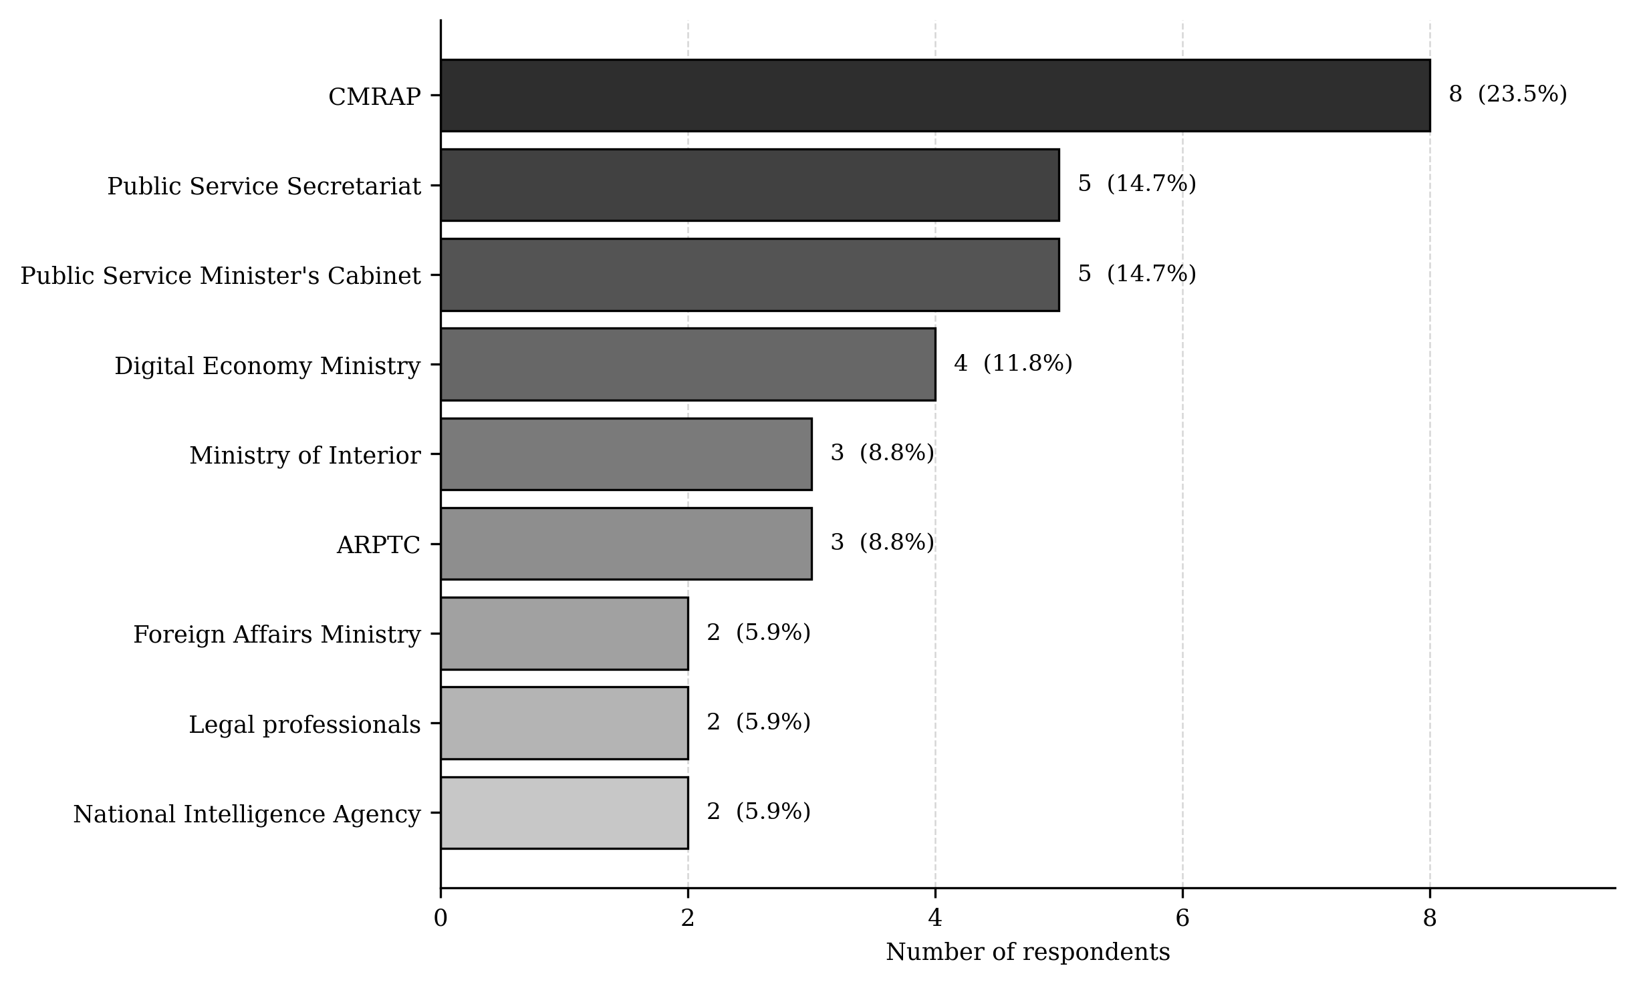
Figure B.1 Distribution of Questionnaire Respondents by Institutional Group
Source: Author’s field records; n = 34; black-and-white rendering
The distribution is deliberately heterogeneous, but it is not proportional to institutional workforce size. CMRAP's larger contribution reflects its direct responsibility for public-administration reform and its relevance to the research problem. The percentages in Table 3.4 describe sample composition only; they must not be interpreted as institutional weights or as estimates of the national workforce.

B.5 Data Collection Instruments
The instrument structure links each collection method to its intended analytical use.
Table B.4 Structure of the Data Collection Instruments
Instrument | Structure | Principal content | Use in analysis
Institutional diagnostic questionnaire | 42 items | Profile; system presence; integration; APIs; protocols; cloud; hosting; registries; interoperability layers; performance; risks; recommendations | Descriptive frequencies and percentages; Likert distributions; thematic coding of open responses
Semi-structured interview guide | 15 main questions; 60 to 90 minutes | Current systems; exchange channels; authoritative sources; semantic ambiguity; accountability; legal basis; incidents; correction; constraints; pilot and sustainability | Explains mechanisms, governance, and contextual conditions behind the survey pattern
Direct-observation checklist | 10 domains | Processes; data; exchange; infrastructure; security; continuity; users; governance; semantics; measurement | Confirms, qualifies, or contradicts self-reported practice
Document-review protocol | Purpose-led review | DRC law and policy; institutional strategies; technical standards; maturity and interoperability frameworks | Verifies formal requirements and supports comparative interpretation
Source: Author’s Appendix A instruments
Questionnaire indicators were traced to the descriptive results reported in the findings chapter so that each percentage retains a documented source item and denominator.
Table B.5 Traceability from Questionnaire Items to Reported Indicators
Item | Questionnaire indicator | Response options | Reported result
Q5 | Institution has an operational information system | Yes / No / Do not know | 94% Yes; 6% No
Q7 | Applications integrated within the same ministry or agency | Yes / No / Do not know | 18% Yes; 82% No
Q8 | Integration with other ministries or agencies | Yes / No / Do not know | 9% Yes; 91% No
Q9 | Distributed or microservices-based architecture used | Yes / No / Do not know | 12% Yes; 88% No
Q10 | Data exchanged through documented APIs | Yes / No / Do not know | 15% Yes; 85% No
Q11 | Institutional data-exchange protocol defined | Yes / No / Do not know | 21% Yes; 79% No
Q12 | Common design or interoperability framework applied | Yes / No / Do not know | 12% Yes; 88% No
Q13 | Cloud services or GovCloud used | Yes / No / Do not know | 24% Yes; 76% No
Q14 | Registry of interoperability assets, schemas, or metadata | Yes / No / Do not know | 3% Yes; 97% No
Q15 | Registry of APIs or web services | Yes / No / Do not know | 0% Yes; 100% No
Q16 | Institution has a data centre or secure hosting | Yes / No / Do not know | 35% Yes; 65% No
Q17 | Interconnection of public systems is necessary | Yes / No / No opinion | 100% Yes; 0% No
Source: Author’s institutional diagnostic questionnaire; n = 34 total respondents

B.6 Fieldwork Period Administration and Ethical Safeguards
The semi-structured interview phase was conducted from 15 March 2024 to 30 June 2024. This inclusive period is the temporal boundary for the interview evidence used in the empirical diagnosis. Interviews followed the 15-question guide and normally lasted between 60 and 90 minutes. Where separate recording authorization was granted, the interview was audio-recorded and transcribed; otherwise, the researcher retained detailed contemporaneous notes. Interview dates, participant codes, duration, consent status, recording status, and transcript or note references were maintained in the confidential field log.
The questionnaire was administered directly to selected participants during the empirical diagnostic stage. The researcher explained the purpose of the study, the academic use of the responses, the voluntary nature of participation, and the separation of identifying information from the analytical dataset. A participant could omit a question or withdraw before final anonymization. Recording an interview required separate authorization.
Each accepted questionnaire was assigned an anonymous respondent code, such as R01 to R34. Names, telephone numbers, addresses, signatures, and other direct identifiers were excluded from the analytical matrix. Consent records and contact information were stored separately from survey responses. Results were reported in aggregate, and qualitative excerpts were anonymized so that the quoted content could not reasonably identify an individual participant.
The exact questionnaire administration date, mode, institutional contact, consent status, and completion status for each instrument were retained at record level in the confidential field log. This log supports audit and response-rate calculation without being published in the dissertation. The dissertation may identify participating institutional groups and the verified interview period, but it should not disclose personal identities or security-sensitive operational details.
• Voluntary participation and the right to omit questions or withdraw before final anonymisation.
• Separate consent for any recorded interview.
• Pseudonymous respondent codes in the analytical matrix.
• Restricted storage of consent forms, contact details, and raw field material.
• Aggregate reporting and anonymisation of quotations and institutionally sensitive observations.
• No use of live sensitive citizen records in the prototype or survey analysis.

B.7 Data Preparation Coding and Cleaning
The completed questionnaires were transcribed into a spreadsheet-compatible rectangular data matrix and exported in a format readable by R. Each row represented one respondent and each column represented one questionnaire item or derived variable. The respondent code served as the record key. Institutional group and role category were stored as coded variables, while personal identifiers remained outside the matrix.
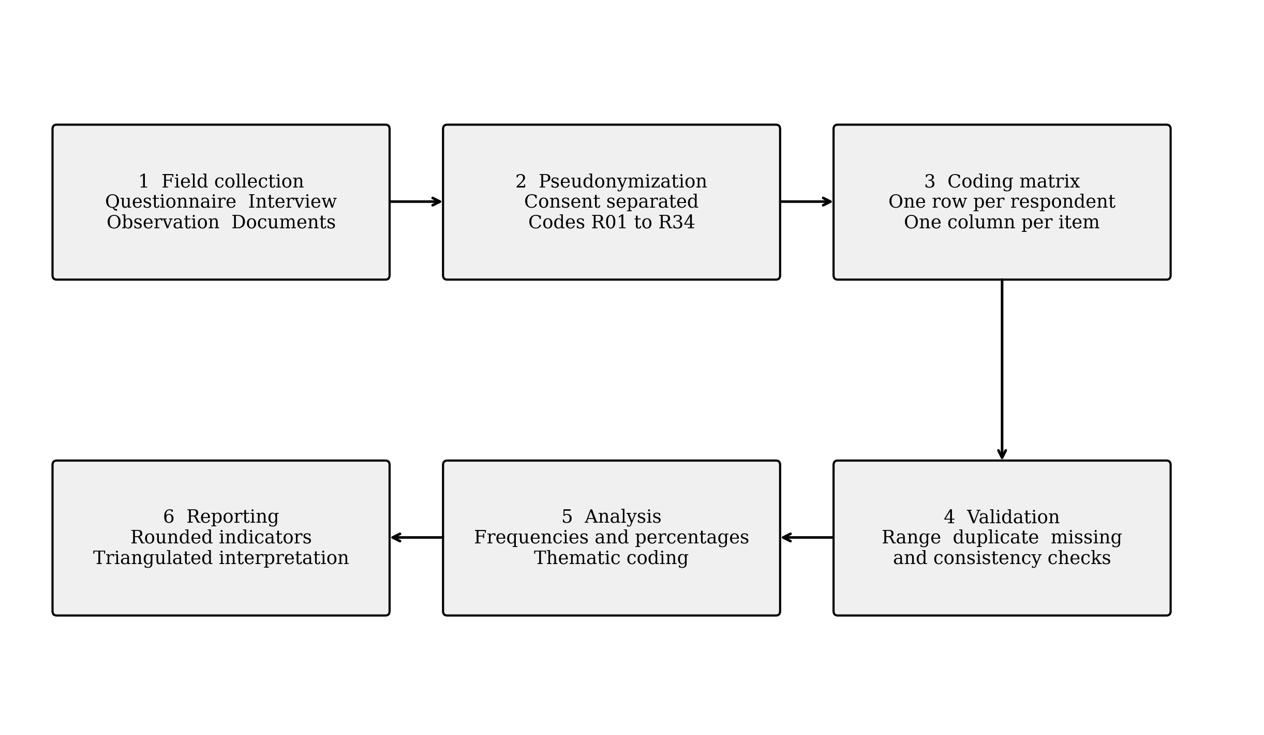
Figure B.2 Survey Data Processing and Reporting Workflow
Source: Author’s data-processing protocol; black-and-white rendering
The detailed rules below govern coding, valid denominators, missing values, derived variables, and qualitative material.
Table B.6 Response Coding Rules
Data type | Coding rule | Processing rule
Binary or categorical item | Yes = 1; No = 0; Do not know, no opinion, and not applicable retained as distinct codes | Compute valid category frequencies; do not recode uncertainty or missingness as No
Five-point scale | 1 to 5 in the direction stated by the instrument; NA retained separately | Report distribution and median; use the mean cautiously and only with the response count
Multiple-response item | One binary variable for each option | Report non-exclusive frequencies; percentages need not sum to 100%
Open response | Anonymized text plus one or more thematic codes | Analyse themes and retain a de-identified excerpt only when needed
Observation | Present / partial / absent / unverified with date and evidence reference | Compare with survey and interview evidence in a convergence matrix
Sensitive field material | Pseudonym or evidence reference; direct identifiers excluded | Restrict access and omit identifiable content from publication
Source: Author’s Appendix A coding rules
Cleaning consisted of checking respondent-code uniqueness, permissible values, internal consistency, missing values, and transcription accuracy. Duplicate records were removed only after comparison with the original forms. Out-of-range values were resolved against the source form rather than guessed. Missing, do-not-know, and not-applicable responses remained distinguishable. A correction log should record the original value, corrected value, reason, date, and person making the correction.
The analysis tools were selected according to the type of evidence and the output required.
Table B.7 Data Analysis Tools and Their Uses
Tool or method | Data processed | Purpose and output
R statistical environment | Anonymized questionnaire matrix | Data validation; frequencies; valid-denominator percentages; medians; means and standard deviations where appropriate; missingness checks; reproducible tables and figures
Manual thematic coding | Interview transcripts or notes and open questionnaire responses | Braun and Clarke six-phase analysis; deductive and inductive codes; theme matrix; anonymized supporting excerpts
Manual evidence-convergence matrix | Survey, interview, observation, and documentary evidence | Triangulation of confirming, qualifying, contradictory, and unavailable evidence without converting qualitative statements into survey counts
Source: Author’s analytical workflow
R was the statistical analysis tool used for the quantitative dataset. The analysis remained descriptive because the sample was purposive. The interview material and open responses were coded manually with a documented codebook and theme matrix; SPSS and NVivo were not used. Reproducibility requires preservation of the final de-identified input file, the R script, the output tables and figures, the codebook, and the R session information associated with the final run.

APPENDIX C ARTIFACT EVALUATION AND RESEARCH TRACEABILITY
Appendix C provides the forms used to assess the scientific and administrative quality of the artifact and the matrix used to trace research objectives to evidence and verifiable outputs.

C.1 Expert Evaluation Instrument
The expert instrument uses the following scale: 1 = insufficient, 2 = weak, 3 = conditionally acceptable, 4 = satisfactory, and 5 = excellent. Each score should be justified, and every score below 4 should be accompanied by a recommendation.
Table C.1 Scientific Artifact Evaluation Instrument
Criterion | Statement to assess | Score 1–5 | Comment
Relevance | The scientific and administrative problem is correctly formulated. | ___ | ________________
Relevance | The architecture addresses the DRC's multilevel context. | ___ | ________________
Completeness | Legal, organizational, semantic, and technical dimensions are covered. | ___ | ________________
Completeness | Registries, identities, contracts, audits, and governance mechanisms are integrated. | ___ | ________________
Coherence | Components, flows, and responsibilities contain no contradiction. | ___ | ________________
Feasibility | Phased deployment is compatible with available capacity. | ___ | ________________
Feasibility | Operational and skills requirements are realistic. | ___ | ________________
Security | The controls protect confidentiality, integrity, and availability. | ___ | ________________
Resilience | Failure, recovery, compensation, and degraded modes are addressed. | ___ | ________________
Scalability | The model can grow by territory, institution, service, and workload. | ___ | ________________
Interoperability | Contracts and governance permit integration of heterogeneous systems. | ___ | ________________
SAGA–Petri | The formalism makes states, compensations, and properties verifiable. | ___ | ________________
Event Sourcing | The event trace supports audit, reconstruction, and evidence. | ___ | ________________
Usability | The framework is understandable and applicable by public-sector teams. | ___ | ________________
Public value | Technical results are linked to effects on service delivery. | ___ | ________________
Source: Author

C.2 Government IT Officer Evaluation Instrument
The practitioner instrument focuses on institutional fit, feasibility, maintainability, governance, and the constraints of the DRC public-administration environment.
Table C.2 Practitioner Contextual Evaluation Instrument
Dimension | Score | Expected justification
Fit with institutional needs | 1–5 | Example or reservation
Clarity of responsibilities across administrative tiers | 1–5 | Example or reservation
Compatibility with existing systems | 1–5 | Example or reservation
Realism of connectivity and hosting requirements | 1–5 | Example or reservation
Availability of operational skills | 1–5 | Example or reservation
Acceptability of data-sharing mechanisms | 1–5 | Example or reservation
Ease of integrating a new service | 1–5 | Example or reservation
Quality of security and traceability mechanisms | 1–5 | Example or reservation
Capacity to operate with intermittent connectivity | 1–5 | Example or reservation
Usefulness of the interoperability registry | 1–5 | Example or reservation
Priority of a bounded pilot | 1–5 | Proposed service
Financial and organizational sustainability | 1–5 | Required condition
Source: Author

C.3 Design Science Research Traceability Matrix
The traceability matrix connects each research objective to its purpose, principal evidence, and verifiable result.
Table C.3 Alignment of Objectives Evidence and Artifacts
Objective | Purpose | Principal evidence | Verifiable result
SO1 | Diagnose barriers to interoperability | Questionnaire, interviews, documents, and observation | Four-layer diagnosis
SO2 | Derive requirements | Frameworks, standards, and contextual evidence | Requirements catalogue
SO3 | Design the federated framework | Architecture and governance models | Architectural artifact
SO4 | Formalize registries, security, and transactions | Contracts, SAGA–Petri, and Event Sourcing | Formal specifications
SO5 | Implement the heterogeneous prototype | Services, databases, broker, and orchestration | Demonstrable instantiation
SO6 | Evaluate technical qualities | Load, failure, consistency, and security tests | Measurements and limitations
SO7 | Evaluate relevance and feasibility | Experts and government IT officers | Decision and recommendations
Source: Author

APPENDIX D INTERFACE CAPTURE PROTOCOL AND PLACEHOLDER INDEX
Appendix D is reserved for verified screenshots from the two remote deployment environments used in the experimental evaluation: Gombe on Hetzner and Lemba on Contabo. The paired layout allows the same interface to be compared across both sites.

D.1 Capture Protocol and Index
Each inserted screenshot should identify the environment, interface, capture date, and relevant experiment while protecting credentials and sensitive information.
• Capture the complete application area needed to verify the stated function or metric.
• Retain the browser title, environment label, and visible time range when they support interpretation.
• Redact passwords, API keys, access tokens, personal data, and security-sensitive configuration.
• Use the original image without decorative effects and preserve readable text at the final page size.
• Record the capture date and the corresponding experiment or test run in the caption or research log.
Table D.1 Planned Interface Captures
Figure | Environment | Provider | Interface | Minimum evidence to display
D.1 | Gombe | Hetzner | e Government portal | Landing page, environment identity, and service access
D.2 | Lemba | Contabo | e Government portal | Landing page, environment identity, and service access
D.3 | Gombe | Hetzner | Consul | Registered services, health status, and discovery state
D.4 | Lemba | Contabo | Consul | Registered services, health status, and discovery state
D.5 | Gombe | Hetzner | Kafka UI | Topics, partitions, consumer groups, or event flow
D.6 | Lemba | Contabo | Kafka UI | Topics, partitions, consumer groups, or event flow
D.7 | Gombe | Hetzner | Prometheus | Selected metric, query, time range, and observed value
D.8 | Lemba | Contabo | Prometheus | Selected metric, query, time range, and observed value
D.9 | Gombe | Hetzner | Kong API Gateway | Route, service, upstream, or gateway status
D.10 | Lemba | Contabo | Kong API Gateway | Route, service, upstream, or gateway status
Source: Author’s planned documentation protocol

