

{{ corp_name }}

Security Assessment

Findings Report

## Business Confidential

*Date: {{ project_date }}*

Project: DC-001

Version 1.0

## Table of Contents

AUTORELLENAR como se pueda con jinja o dejarlo para que el usuario lo haga.

# Confidentiality Statement

This document is the exclusive property of {{ corp_name }} and {{ team_name }} ({{ team_abbreviature }}).

This document contains proprietary and confidential information. Duplication, redistribution, or use, in whole or in part, in any form, requires consent of both {{ corp_name }} and {{ team_abbreviature }}).

{{ corp_name }} may share this document with auditors under non-disclosure agreements to demonstrate penetration test requirement compliance.

# Disclaimer

A penetration test is considered a snapshot in time. The findings and recommendations reflect the information gathered during the assessment and not any changes or modifications made outside of that period.

Time-limited engagements do not allow for a full evaluation of all security controls. {{ team_abbreviature }} prioritized the assessment to identify the weakest security controls an attacker would exploit. {{ team_abbreviature }} recommends conducting similar assessments on an annual basis by internal or third-party assessors to ensure the continued success of the controls.

# Contact Information

|  |  |  |
| --- | --- | --- |
| **Name** | **Title** | **Contact Information** |
| {{ corp_name }} | | |
| John Smith | Global Information Security Manager | Email: {{ corp_email }} |
| {{ team_name }} | | |
| {{ pentester_name }} | Penetration Tester | Email: {{ pentester_email }} |

# Assessment Overview

From February 22nd, 2021 to March 5th, 2021, {{ corp_name }} engaged {{ team_abbreviature }} to evaluate the security posture of its infrastructure compared to current industry best practices that included an internal network penetration test. All testing performed is based on the NIST *SP 800-115 Technical Guide to Information Security Testing and Assessment, OWASP Testing Guide (v4), and customized testing frameworks*.

Phases of penetration testing activities include the following:

* Planning – Customer goals are gathered and rules of engagement obtained.
* Discovery – Perform scanning and enumeration to identify potential vulnerabilities, weak areas, and exploits.
* Attack – Confirm potential vulnerabilities through exploitation and perform additional discovery upon new access.
* Reporting – Document all found vulnerabilities and exploits, failed attempts, and company strengths and weaknesses.

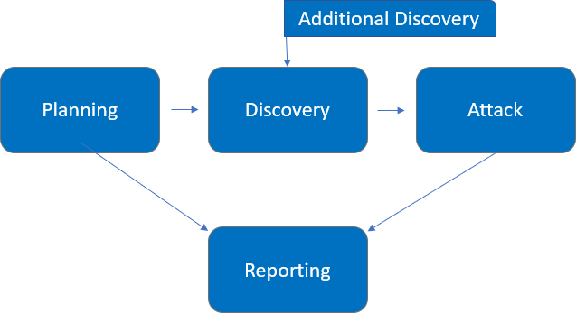

# Assessment Components

### Internal Penetration Test

An internal penetration test emulates the role of an attacker from inside the network. An engineer will scan the network to identify potential host vulnerabilities and perform common and advanced internal network attacks, such as: LLMNR/NBT-NS poisoning and other man- in-the-middle attacks, token impersonation, kerberoasting, pass-the-hash, golden ticket, and more. The engineer will seek to gain access to hosts through lateral movement, compromise domain user and admin accounts, and exfiltrate sensitive data.

# Finding Severity Ratings

The following table defines levels of severity and corresponding CVSS score range that are used throughout the document to assess vulnerability and risk impact.

|  |  |  |
| --- | --- | --- |
| **Severity** | **CVSS V3**  **Score Range** | **Definition** |
| Critical | 9.0-10.0 | Exploitation is straightforward and usually results in system-level compromise. It is advised to form a plan of action and patch immediately. |
| High | 7.0-8.9 | Exploitation is more difficult but could cause elevated privileges and potentially a loss of data or downtime. It is advised to form a plan of action and patch as soon as possible. |
| Moderate | 4.0-6.9 | Vulnerabilities exist but are not exploitable or require extra steps such as social engineering. It is advised to form a plan of action and patch after high-priority issues have been resolved. |
| Low | 0.1-3.9 | Vulnerabilities are non-exploitable but would reduce an organization’s attack surface. It is advised to form a plan of action and patch during the next maintenance window. |
| Informational | N/A | No vulnerability exists. Additional information is provided regarding items noticed during testing, strong controls, and additional documentation. |

# Risk Factors

Risk is measured by two factors: Likelihood and Impact:

### Likelihood

Likelihood measures the potential of a vulnerability being exploited. Ratings are given based on the difficulty of the attack, the available tools, attacker skill level, and client environment.

### Impact

Impact measures the potential vulnerability’s effect on operations, including confidentiality, integrity, and availability of client systems and/or data, reputational harm, and financial loss.

# Scope

|  |  |
| --- | --- |
| **Assessment** | **Details** |
| Internal Penetration Test | 10.x.x.x/8 |

### Scope Exclusions

Per client request, {{ team_abbreviature }} did not perform any of the following attacks during testing:

* Denial of Service (DoS)
* Phishing/Social Engineering

All other attacks not specified above were permitted by {{ corp_name }}.

### Client Allowances

{{ corp_name }} provided {{ team_abbreviature }} the following allowances:

* Internal access to network via dropbox and port allowances

# Executive Summary

{{ team_abbreviature }} evaluated {{ corp_name }}’s internal security posture through penetration testing from February 22nd, 2021 to March 5th, 2021. The following sections provide a high-level overview of vulnerabilities discovered, successful and unsuccessful attempts, and strengths and weaknesses.

### Scoping and Time Limitations

Scoping during the engagement did not permit denial of service or social engineering across all testing components.

Time limitations were in place for testing. Internal network penetration testing was permitted for ten

1. business days.

### Testing Summary

The network assessment evaluated {{ corp_name }}’s internal network security posture. From an internal perspective, the {{ team_abbreviature }} team performed vulnerability scanning against all IPs provided by {{ corp_name }} to evaluate the overall patching health of the network. The team also performed common Active Directory based attacks, such as Link-Local Multicast Name Resolution (LLMNR) Poisoning, SMB relaying, IPv6 man-in-the-middle relaying, and Kerberoasting. Beyond vulnerability scanning and Active Directory attacks, the {{ team_abbreviature }} evaluated other potential risks, such as open file shares, default credentials on servers/devices, and sensitive information disclosure to gain a complete picture of the network’s security posture.

The {{ team_abbreviature }} team discovered that LLMNR was enabled in the network (Finding IPT-001), which permitted the interception of user hashes via LLMNR poisoning. These hashes were taken offline and cracked via dictionary attacks, which signals a weak password policy (Finding IPT-005). Utilizing the cracked passwords, the {{ team_abbreviature }} team gained access to several machines within the network, which indicates overly permissive user accounts.

With machine access, and the use of older operating systems in the network (Finding IPT-009), the team was able to leverage WDigest (Finding IPT-003) to recover cleartext credentials to accounts. The team was also able to dump local account hashes on each machine accessed. The {{ team_abbreviature }} team discovered that the local account hashes were being re-used across devices (Finding IPT-002), which lead to additional machine access through pass-the-hash attacks.

Ultimately, the {{ team_abbreviature }} team was able to leverage accounts captured through WDigest and hash dumps to move laterally throughout the network until landing on a machine that had a Domain Administrator credential in cleartext via WDigest. The testing team was able to use this credential to log into the domain controller and compromise the entire domain. For a full walkthrough of the path to Domain Admin, please see Finding IPT-025.

In addition to the compromise listed above, the {{ team_abbreviature }} team found that users could be impersonated through delegation attacks (Finding IPT-004), SMB relay attacks were possible due to SMB signing being disabled (Finding IPT-007), and IPv6 traffic was not restricted, which could lead to LDAPS relaying and domain compromise (Finding IPT-006).

The remainder of critical findings relate to patch management as devices with critical out-of-date software (Finding IPT-008), operating systems (Finding IPT-009), and Microsoft RCE vulnerabilities (Findings IPT-010, IPT-011, IPT-012, IPT-013), were found to be present within the network.

The remainder of the findings were high, moderate, low, or informational. For further information on findings, please review the Technical Findings section.

### Tester Notes and Recommendations

Testing results of the {{ corp_name }} network are indicative of an organization undergoing its first penetration test, which is the case here. Many of the findings discovered are vulnerabilities within Active Directory that come enabled by default, such as LLMNR, IPv6, and Kerberoasting.

During testing, two constants stood out: a weak password policy and weak patching. The weak password policy led to the initial compromise of accounts and is usually one of the first footholds an attacker attempts to use in a network. The presence of a weak password policy is backed up by the evidence of our testing team cracking over 2,200 user account passwords, including a majority of the Domain Administrator accounts, through basic dictionary attacks.

We recommended that {{ corp_name }} re-evaluates their current password policy and considers a policy of 15 characters or more for their regular user accounts and 30 characters or more for their Domain Administrator accounts. We also recommend that {{ corp_name }} explore password blacklisting and will be supplying a list of cracked user passwords for the team to evaluate. Finally, a Privilege Access Management solution should be considered.

Weak patching and dated operating systems led to the compromise of dozens of machines within the network. We believe the number of compromised machines would have been significantly larger, however the {{ team_abbreviature }} and {{ corp_name }} teams agreed it was not necessary to attempt to exploit any remote code execution (RCE) based vulnerabilities, such as MS17-010 (Finding IPT-012), as the domain controller had already been compromised and the teams did not want to risk any denial of service through failed attacks.

We recommend that the {{ corp_name }} team review the patching recommendations made in the Technical Findings section of the report along with reviewing the provided Nessus scans for a full overview of items to be patched. We also recommend that {{ corp_name }} improve their patch management policies and procedures to help prevent potential attacks within their network.

On a positive note, our testing team triggered several alerts during the engagement. The {{ corp_name }} Security Operations team discovered our vulnerability scanning and was alerted when we attempted to use noisy attacks on a compromised machine. While not all attacks were discovered during testing, these alerts are a positive start. Additional guidance on alerting and detection has been provided for findings, when necessary, in the Technical Findings section.

Overall, the {{ corp_name }} network performed as expected for a first-time penetration test. We recommend that the {{ corp_name }} team thoroughly review the recommendations made in this report, patch the findings, and re-test annually to improve their overall internal security posture.

### Key Strengths and Weaknesses

The following identifies the key strengths identified during the assessment:

* 1. Observed some scanning of common enumeration tools (Nessus)
  2. Mimikatz detected on some machines
  3. Service accounts were not running as domain administrators
  4. {{ corp_name }} local administrator account password was unique to each device The following identifies the key weaknesses identified during the assessment:

1. Password policy found to be insufficient
2. Critically out-of-date operating systems and weak patching exist within the network
3. Passwords were observed in cleartext due to WDigest
4. LLMNR is enabled within the network
5. SMB signing is disabled on all non-server devices in the work
6. IPv6 is improperly managed within the network
7. User accounts can be impersonated through token delegation
8. Local admin accounts had password re-use and were overly permissive
9. Default credentials were discovered on critical infrastructure, such as iDRACs
10. Unauthenticated share access was permitted
11. User accounts were found to be running as service accounts
12. Service accounts utilized weak passwords
13. Domain administrator utilized weak passwords

# Vulnerability Summary & Report Card

The following tables illustrate the vulnerabilities found by impact and recommended remediations:

### Internal Penetration Test Findings

|  |  |  |  |  |
| --- | --- | --- | --- | --- |
| 13 | 5 | 6 | 0 | 1 |
| Critical | High | Moderate | Low | Informational |

|  |  |  |
| --- | --- | --- |
| **Finding** | **Severity** | **Recommendation** |
| Internal Penetration Test | | |
| IPT-001: Insufficient LLMNR Configuration | Critical | Disable multicast name resolution via GPO. |
| IPT-002: Security Misconfiguration – Local Admin Password Reuse | Critical | Utilize unique local admin passwords  and limit local admin users via least privilege. |
| IPT-003: Security Misconfiguration – Wdigest | Critical | Disable WDigest via GPO. |
| IPT-004: Insufficient Hardening – Token Impersonation | Critical | Restrict token delegation. |
| IPT-005: Insufficient Password Complexity | Critical | Implement CIS Benchmark password requirements / PAM solution. |
| IPT-006: Security Misconfiguration – IPv6 | Critical | Restrict DHCPv6 traffic and incoming router advertisements in Windows Firewall via GPO. |
| IPT-007: Insufficient Hardening – SMB Signing Disabled | Critical | Enable SMB signing on all {{ corp_name }} domain computers. |
| IPT-008: Insufficient Patch Management – Software | Critical | Update to the latest software version. |
| IPT-009: Insufficient Patch Management – Operating Systems | Critical | Update Operating Systems to the latest version. |
| IPT-010: Insufficient Patching – MS08-067 - ECLIPSEDWING/NETAPI | Critical | Apply the appropriate Microsoft patches to remediate the issue. |
| IPT-011: Insufficient Patching –  MS12-020 – Remote Desktop RCE | Critical | Apply the appropriate Microsoft  patches to remediate the issue. |
| IPT-012: Insufficient Patching – MS17-010 - EternalBlue | Critical | Apply the appropriate Microsoft patches to remediate the issue. |
| IPT-013: Insufficient Patching – CVE- 2019-0708 - BlueKeep | Critical | Apply the appropriate Microsoft patches to remediate the issue. |

|  |  |  |
| --- | --- | --- |
| **Finding** | **Severity** | **Recommendation** |
| IPT-014: Insufficient Privileged Account Management –  Kerberoasting | High | Use Group Managed Service Accounts (GMSA) for privileged  services. |
| IPT-015: Security Misconfiguration – GPP Credentials | High | Apply vendor patching. Do not use GPP cpasswords. |
| IPT-016: Insufficient Authentication - VNC | High | Enable authentication on the VNC Server. |
| IPT-017: Default Credentials on Web Services | High | Change default credentials or disable unused accounts. |
| IPT-018: Insufficient Hardening – Listable Directories | High | Restrict access and conduct web app assessment. |
| IPT-019: Unauthenticated SMB Share Access | Moderate | Disable SMB share or require authentication. |
| IPT-020: Insufficient Patch Management – SMBv1 | Moderate | Upgrade to SMBv3 and apply latest patching. |
| IPT-021: IPMI Hash Disclosure | Moderate | Disable IPMI over LAN if it is not needed. |
| IPT-022: Insufficient SNMP Community String Complexity | Moderate | Disabled SNMP if not required. |
| IPT-023: Insufficient Data in Transit Encryption - Telnet | Moderate | Migrate to TLS protected protocols. |
| IPT-024: Insufficient Terminal Services Configuration | Moderate | Enable Network Level Authentication (NLA) on the remote RDP server. |
| IPT-025: Steps to Domain Admin | Informational | Review action and remediation steps. |

# Technical Findings

### Internal Penetration Test Findings

Finding IPT-001: Insufficient LLMNR Configuration (Critical)

|  |  |
| --- | --- |
| Description: | {{ corp_name }} allows multicast name resolution on their end-user networks. {{ team_abbreviature }} captured 20 user account hashes by poisoning LLMNR traffic and cracked 2 with commodity cracking software.  The cracked accounts were used to leverage further access that led to the compromise of the Domain Controller. |
| Risk: | Likelihood: High – This attack is effective in environments allowing multicast name resolution.  Impact: Very High – LLMNR poisoning permits attackers to capture password hashes to either crack offline or relay in real-time and pivot laterally in the environment. |
| System: | All |
| Tools Used: | Responder, Hashcat |
| References: | [Stern Security](https://www.sternsecurity.com/blog/local-network-attacks-llmnr-and-nbt-ns-poisoning) - Local Network Attacks: LLMNR and NBT-NS Poisoning NIST SP800-53 r4 IA-3 - Device Identification and Authentication [NIST SP800-53 r4 CM-6(1)](https://nvd.nist.gov/800-53/Rev4/control/CM-6" \l "enhancement-1) - Configuration Settings |

Evidence



*Figure 1: Captured hash of “production”*

**

Remediation

*Figure 2: Cracked hash of “production”*

Disable multicast name resolution via GPO. For full mitigation and detection guidance, please reference the MITRE guidance [here.](https://attack.mitre.org/techniques/T1557/001/)

The cracked hashes demonstrate a deficient password complexity policy. If multicast name resolution is required, Network Access Control (NAC) combined with application whitelisting can limit these attacks.

Finding IPT-002: Security Misconfiguration – Local Admin Password Reuse (Critical)

|  |  |
| --- | --- |
| Description: | {{ team_abbreviature }} utilized local administrator hashes to gain access to other machines in the network via a ‘pass-the-hash’ attack. The local administrator hashes were obtained via machine access provided by the cracked account in IPT-001.  Pass-the-hash attacks do not require knowing the account password to successfully log into a machine. Thus, reusing the same local admin password (and therefore the same hash) on multiple machines will permit system access to those computers.  {{ team_abbreviature }} leveraged this attack to gain access to ~50 machines within the main  office. This led to further account access and the eventual compromise of the domain controller. |
| Risk: | Likelihood: High – This attack is effective in large networks with local admin password reuse.  Impact: Very High – Pass-the-hash permits an attacker to move laterally and vertically throughout the network. |
| System: | All |
| Tools Used: | Impacket, Crackmapexec |
| References: | <https://capec.mitre.org/data/definitions/644.html>  <https://tcm-sec.com/pentest-tales-001-you-spent-how-much-on-security/> |

Evidence



*Figure 3: Local admin hash used to gain access to machine*

Remediation

Utilize unique local admin passwords. Limit local admin users via least privilege. Consider implementing a PAM solution. For full mitigation and detection guidance, please reference the MITRE guidance [here.](https://attack.mitre.org/techniques/T1550/002/)

Finding IPT-003: Security Misconfiguration – WDigest (Critical)

|  |  |
| --- | --- |
| Description: | {{ corp_name }} permitted out-of-date operating systems within their network, including Windows 7, 8, Server 2008, and Server 2012.  These operating systems, by default, permit WDigest, which stores all current logged-in user’s passwords in clear-text.  {{ team_abbreviature }} leveraged machine access gained in IPT-001 and IPT-002 to move laterally throughout the network until uncovering a machine with Domain Admin  credentials stored in WDigest. |
| Risk: | Likelihood: Moderate – This attack is effective in networks with older operating systems.  Impact: Very High – WDigests credentials are stored in clear text, which can permit the theft of sensitive accounts, such as Domain Administrators. |
| System: | All systems older than Windows 10 and Server 2016 |
| Tools Used: | Metasploit, Kiwi |
| References: | [https://stealthbits.com/blog/wdigest-clear-text-passwords-stealing-more-than-](https://stealthbits.com/blog/wdigest-clear-text-passwords-stealing-more-than-a-hash/) [a-hash/](https://stealthbits.com/blog/wdigest-clear-text-passwords-stealing-more-than-a-hash/) |

Evidence

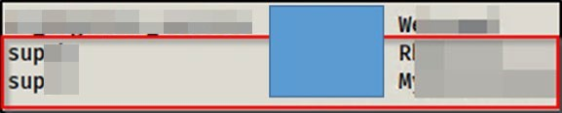

*Figure 4: Cleartext passwords of Domain Administrators*

Remediation

Disable WDigest via GPO. For full mitigation and detection guidance, please reference the guidance [here.](https://www.csoonline.com/article/3438824/how-to-detect-and-halt-credential-theft-via-windows-wdigest.html)

Finding IPT-004: Insufficient Hardening – Token Impersonation (Critical)

|  |  |
| --- | --- |
| Description: | {{ team_abbreviature }} impersonated the token of “supcb” to obtain Domain Administrator privileges. |
| Risk: | Likelihood: High – The penetration tester viewed and impersonated tokens with the use of open-source tools.  Impact: Very High - If exploited, an attacker gains domain administrator access. |
| System: | All |
| Tools Used: | Metasploit, Incognito |
| References: | [NIST SP800-53 r4 CM-7 -](https://nvd.nist.gov/800-53/Rev4/control/CM-7) Least Functionality [NIST SP800-53 r4 AC-6 -](https://nvd.nist.gov/800-53/Rev4/search/results?controlDesc=Least%2BPrivilege) Least Privilege  [https://docs.microsoft.com/en-us/windows-server/identity/ad-](https://docs.microsoft.com/en-us/windows-server/identity/ad-ds/manage/how-to-configure-protected-accounts) [ds/manage/how-to-configure- protected-accounts](https://docs.microsoft.com/en-us/windows-server/identity/ad-ds/manage/how-to-configure-protected-accounts) |

Evidence

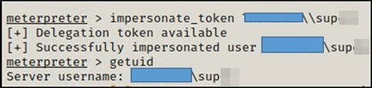

*Figure 5: Impersonation of “sup”*

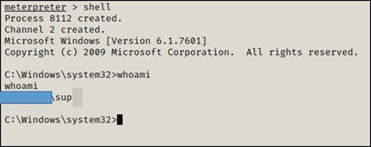

Remediation

*Figure 6: Shell access as Domain Admin “sup”*

Restrict token delegation. For full mitigation and detection guidance, please reference the MITRE guidance [here.](https://attack.mitre.org/techniques/T1134/003/)

Finding IPT-005: Insufficient Password Complexity (Critical)

|  |  |
| --- | --- |
| Description: | {{ team_abbreviature }} dumped hashes from the domain controller and proceeded to attempt common password guessing attacks against all users.  {{ team_abbreviature }} cracked 2,226 passwords using basic password list guessing attacks and low effort brute forcing attacks. 17 cracked accounts had domain administrator rights. |
| Risk: | Likelihood: High - Simple passwords are susceptible to password cracking attacks. Encryption provides some protection, but dictionary attacks base on common word lists often crack weak passwords.  Impact: Very High - Domain admin accounts with weak passwords could lead to an adversary critically impacting {{ corp_name }} ability to operate. |
| System: | All |
| Tools Used: | Manual Review |
| References: | [NIST SP800-53 IA-5(1)](https://nvd.nist.gov/800-53/Rev4/control/IA-5" \l "enhancement-1) - Authenticator Management <https://www.cisecurity.org/white-papers/cis-password-policy-guide/> |

Evidence

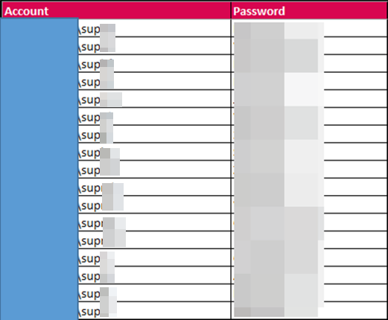

Remediation

*Figure 7: Excerpt of cracked domain hashes*

Implement CIS Benchmark password requirements / PAM solution. {{ team_abbreviature }} recommends that {{ corp_name }} enforce industry best practices around password complexity and management. A password filter to prevent users from using common and easily guessable passwords is also recommended. Additionally, {{ team_abbreviature }} recommends that {{ corp_name }} enforce stricter password requirements for Domain Administrator and other sensitive accounts.

Finding IPT-006: Security Misconfiguration – IPv6 (Critical)

|  |  |
| --- | --- |
| Description: | Through IPv6 DNS poisoning, the {{ team_abbreviature }} team was able to successfully relay credentials to the {{ corp_name }} domain controller. |
| Risk: | Likelihood: High – IPv6 is enabled by default on Windows networks. The tools and techniques required to perform this task are trivial.  Impact: Very High - If exploited, an attacker can gain domain administrator access. |
| System: | All |
| Tools Used: | Mitm6, Impacket |
| References: | [https://blog.fox-it.com/2018/01/11/mitm6-compromising-ipv4-networks-via-](https://blog.fox-it.com/2018/01/11/mitm6-compromising-ipv4-networks-via-ipv6/) [ipv6/](https://blog.fox-it.com/2018/01/11/mitm6-compromising-ipv4-networks-via-ipv6/) |

Evidence



Remediation

*Figure 8: Successfully relayed LDAP credentials via mitm6*

1. IPv6 poisoning abuses the fact that Windows queries for an IPv6 address even in IPv4-only environments. If you do not use IPv6 internally, the safest way to prevent mitm6 is to block DHCPv6 traffic and incoming router advertisements in Windows Firewall via Group Policy. Disabling IPv6 entirely may have unwanted side effects. Setting the following predefined rules to Block instead of Allow prevents the attack from working:
   1. (Inbound) Core Networking - Dynamic Host Configuration Protocol for IPv6(DHCPV6-In)
   2. (Inbound) Core Networking - Router Advertisement (ICMPv6-In)
   3. (Outbound) Core Networking - Dynamic Host Configuration Protocol for IPv6(DHCPV6- Out)
2. If WPAD is not in use internally, disable it via Group Policy and by disabling the WinHttpAutoProxySvc service.
3. Relaying to LDAP and LDAPS can only be mitigated by enabling both LDAP signing and LDAP channel binding.

Consider Administrative users to the Protected Users group or marking them as Account is sensitive and cannot be delegated, which will prevent any impersonation of that user via delegation.

Finding IPT-007: Insufficient Hardening – SMB Signing Disabled (Critical)

|  |  |
| --- | --- |
| Description: | {{ corp_name }} failed to implement SMB signing on multiple devices. The absence of SMB signing could lead to SMB relay attacks, yielding system-level shells without requiring a user password. |
| Risk: | Likelihood: High – Relaying password hashes is a basic technique not requiring offline cracking.  Impact: High – If exploited, an adversary gains code execution, leading to lateral movement across the network. |
| System: | Identified 709 machines, please see the below file for listing.  [file removed] |
| Tools Used: | Nessus, Nmap, MultiRelay, Responder |
| References: | [CIS Microsoft Windows Server 2012 R2 v2.2.0](https://www.cisecurity.org/wp-content/uploads/2017/04/CIS_Microsoft_Windows_Server_2012_R2_Benchmark_v2.2.0.pdf) (Page 180) <https://github.com/lgandx/Responder/blob/master/tools/MultiRelay.py> |

Evidence



Remediation

*Figure 9: Successful SMB relay*

Enable SMB signing on all {{ corp_name }} domain computers. Alternatively, as SMB signing can cause performance issues, disabling NTLM authentication, enforcing account tiering, and limiting local admin users can effectively help mitigate attacks. For full mitigation and detection guidance, please reference the MITRE guidance [here.](https://attack.mitre.org/techniques/T1557/001/)

Finding IPT-008: Insufficient Patch Management – Software (Critical)

|  |  |
| --- | --- |
| Description: | {{ corp_name }} permitted various deprecated software in their network. This includes:   * Apache version < 2.4.46 * Apache Tomcat version < 7.0.100, 8.5.51, 9.0.31 * Cisoco AireOS version 8.5.151.10 * CodeMeter version 3.05 (5.21.1478.500) * Dropbear SSH Server version 2015.68 * Dell iDRAC7 version 2.63.60.62.01 * Dell iDRAC8 version 2.63.60.61.06 * Dell iDRAC9 version 3.36.36.36.21 * ESXi version 5.5 * ESXi version 6.5 build 15256549 * Flexera FlexNet Publisher version 11.16.0 * IIS version 7.5 * ISC BIND version 9.6.2-P2 * Microsoft DNS Server version 6.1.7601.24261 * Microsoft SQL Server version 11.0.6594.0 * Netatalk OpenSession version < 3.1.12 * PHP version < 7.3.11 * Rockwell Automation RSLinx Classic   Above lists all critical and high-rated deprecated software, the majority of which permit serious vulnerabilities, such as remote code execution. For a full  patching list, please review the provided Nessus scan documentation. |
| Risk: | Likelihood: High – An attacker can discover these vulnerabilities with basic tools.  Impact: Very High – If exploited, an attacker could possibly gain full remote code execution on or deny service to a system. |
| Tools Used: | Nessus |
| References: | [NIST SP800-53 r4 MA-6](https://nvd.nist.gov/800-53/Rev4/control/MA-6) – Timely Maintenance [NIST SP800-53 r4 SI-2](https://nvd.nist.gov/800-53/Rev4/control/SI-2) – Flaw Remediation |

Remediation

Update to the latest software version. For a full list of vulnerable systems, versions, and patching requirements, please see the below document.

[file removed]

Finding IPT-009: Insufficient Patch Management – Operating Systems (Critical)

|  |  |
| --- | --- |
| Description: | {{ corp_name }} permitted various deprecated software in their network. This includes:   * Windows Server 2003 (end of life on July 14, 2015) * Windows Server 2008 R2 (end of life on January 14, 2020) * Windows XP (end of life on April 8, 2014) * Windows 7 (end of life on January 14, 2020) * Ubuntu 11 (end of life on May 9, 2013) * FreeBSD 11.0 (end of life on October, 2016)   End of life systems are susceptible to a multitude of vulnerabilities. {{ team_abbreviature }} did not attempt any attacks against these servers due to the risk of a denial of service, which is out of scope. |
| Risk: | Likelihood: High – An attacker can discover these vulnerabilities with basic tools.  Impact: High – If exploited, an attacker could possibly gain full remote code execution on or deny service to a system. |
| System: | Identified 139 machines, please see the below file for listing.  [file removed] |
| Tools Used: | Nessus |
| References: | [NIST SP800-53 r4 MA-6](https://nvd.nist.gov/800-53/Rev4/control/MA-6) – Timely Maintenance [NIST SP800-53 r4 SI-2](https://nvd.nist.gov/800-53/Rev4/control/SI-2) – Flaw Remediation |

Remediation

Update Operating Systems to the latest version.

Finding IPT-010: Insufficient Patching – MS08-067 - ECLIPSEDWING/NETAPI (Critical)

|  |  |
| --- | --- |
| Description: | {{ corp_name }} permitted an unpatched system on the internal network that is vulnerable to MS08-067. TCM Security confirmed that the vulnerability likely exists but did not attempt the exploit to prevent any denial of service. |
| Risk: | Likelihood: High – Considered one of the most exploited vulnerabilities in Microsoft Windows as it ships natively with Windows XP.  Impact: Very High – If exploited, an attacker gains code execution as the system  user. An adversary will require additional techniques to obtain domain administrator access. |
| System: | 10.x.x.x |
| Tools Used: | Nessus, Nmap |
| References: | [NIST SP800-53 r4 MA-6](https://nvd.nist.gov/800-53/Rev4/control/MA-6) – Timely Maintenance [NIST SP800-53 r4 SI-2](https://nvd.nist.gov/800-53/Rev4/control/SI-2) – Flaw Remediation |

Evidence

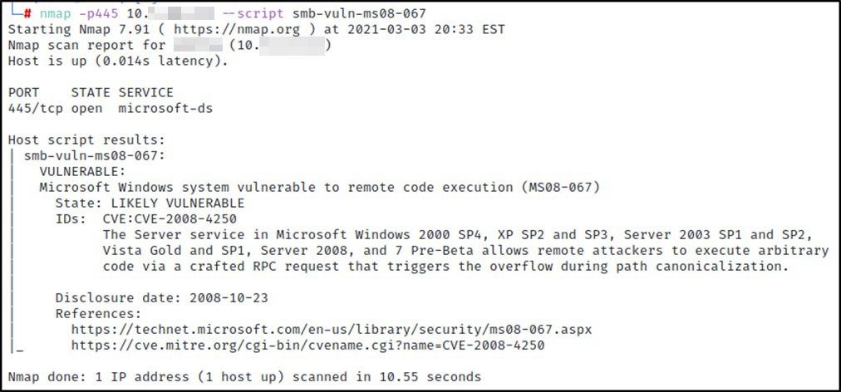

Remediation

*Figure 10: Unpatched MS08-067*

Apply the appropriate Microsoft patches to remediate the issue. More information on patching MS08-067 can be found here: [https://docs.microsoft.com/en-us/security-](https://docs.microsoft.com/en-us/security-updates/SecurityBulletins/2008/ms08-067) [updates/SecurityBulletins/2008/ms08-067](https://docs.microsoft.com/en-us/security-updates/SecurityBulletins/2008/ms08-067)

Finding IPT-011: Insufficient Patching – MS12-020 – Remote Desktop RCE (Critical)

|  |  |
| --- | --- |
| Description: | {{ corp_name }} permitted an unpatched system on the internal network that is vulnerable to MS12-020. TCM Security confirmed that the vulnerability likely exists but did not attempt the exploit to prevent any denial of service. |
| Risk: | Likelihood: High – The vulnerability is easily discoverable and exploitable with open-source tools.  Impact: Very High – If exploited, an attacker gains code execution as the system  user. An adversary will require additional techniques to obtain domain administrator access. |
| System: | 10.x.x.x |
| Tools Used: | Nessus, Nmap |
| References: | [NIST SP800-53 r4 MA-6](https://nvd.nist.gov/800-53/Rev4/control/MA-6) – Timely Maintenance [NIST SP800-53 r4 SI-2](https://nvd.nist.gov/800-53/Rev4/control/SI-2) – Flaw Remediation |

Evidence

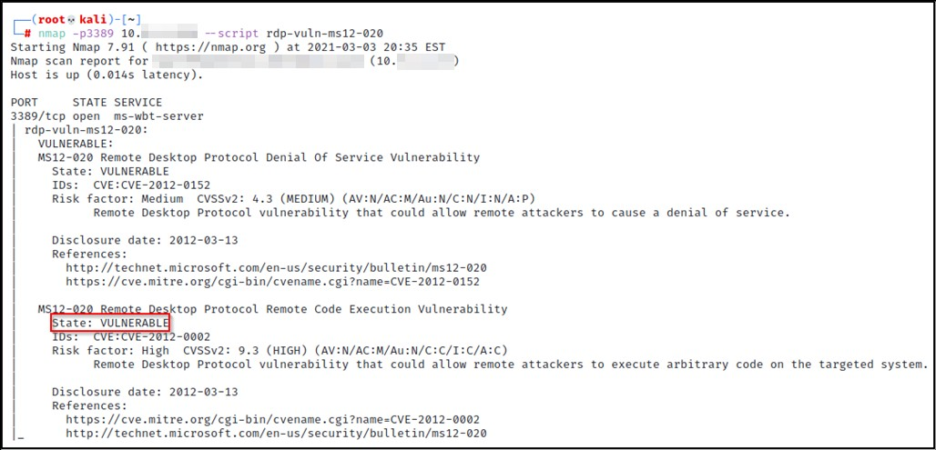

Remediation

*Figure 11: Unpatched MS12-020*

Apply the appropriate Microsoft patches to remediate the issue. More information on patching MS12-020 can be found here: [https://docs.microsoft.com/en-us/security-](https://docs.microsoft.com/en-us/security-updates/securitybulletins/2012/ms12-020) [updates/securitybulletins/2012/ms12-020](https://docs.microsoft.com/en-us/security-updates/securitybulletins/2012/ms12-020)

Finding IPT-012: Insufficient Patching – MS17-010 - EternalBlue (Critical)

|  |  |
| --- | --- |
| Description: | {{ corp_name }} permitted several unpatched systems on the internal network that are vulnerable to MS17-010 (EternalBlue). TCM Security confirmed that the vulnerability likely exists but did not attempt the exploit to prevent any denial of service. |
| Risk: | Likelihood: High – Malicious actors have used SMB exploitations like EternalBlue in recent breaches.  Impact: Very High – If exploited, an attacker gains code execution as the system user. An adversary will require additional techniques to obtain domain  administrator access. |
| System: | 10.x.x.x |
| Tools Used: | Nessus, Metasploit, AutoBlue |
| References: | [NIST SP800-53 r4 MA-6](https://nvd.nist.gov/800-53/Rev4/control/MA-6) – Timely Maintenance [NIST SP800-53 r4 SI-2](https://nvd.nist.gov/800-53/Rev4/control/SI-2) – Flaw Remediation |

Evidence

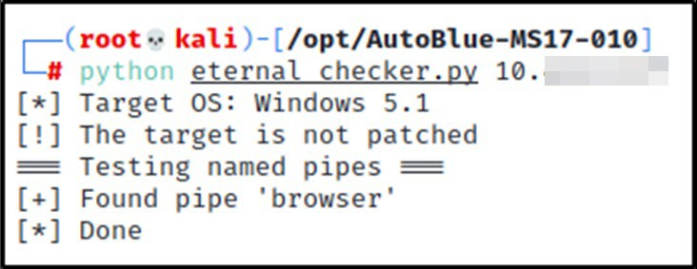

Remediation

*Figure 12: Unpatched MS17-010*

Apply the appropriate Microsoft patches to remediate the issue. More information on patching MS17-010 can be found here: [https://docs.microsoft.com/en-us/security-](https://docs.microsoft.com/en-us/security-updates/securitybulletins/2017/ms17-010) [updates/securitybulletins/2017/ms17-010](https://docs.microsoft.com/en-us/security-updates/securitybulletins/2017/ms17-010)

Finding IPT-013: Insufficient Patching – CVE-2019-0708 - BlueKeep (Critical)

|  |  |
| --- | --- |
| Description: | {{ corp_name }} permitted several unpatched systems on the internal network that are vulnerable to CVE-2019-0708 (BlueKeep). TCM Security confirmed that the vulnerability likely exists but did not attempt the exploit to prevent any denial of service. |
| Risk: | Likelihood: High – The vulnerability is easily discoverable and exploitable with open-source tools.  Impact: Very High – If exploited, an attacker gains code execution as the system user. An adversary will require additional techniques to obtain domain  administrator access. |
| System: | 10.x.x.x |
| Tools Used: | Nessus, Nmap |
| References: | [NIST SP800-53 r4 MA-6](https://nvd.nist.gov/800-53/Rev4/control/MA-6) – Timely Maintenance [NIST SP800-53 r4 SI-2](https://nvd.nist.gov/800-53/Rev4/control/SI-2) – Flaw Remediation |

Evidence

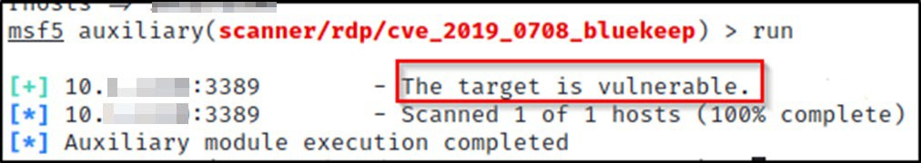

Remediation

*Figure 13: Unpatched CVE-2019-0708*

Apply the appropriate Microsoft patches to remediate the issue. More information on patching CVE- 2019-0708 can be found here: [https://support.microsoft.com/en-us/topic/customer-guidance-for-](https://support.microsoft.com/en-us/topic/customer-guidance-for-cve-2019-0708-remote-desktop-services-remote-code-execution-vulnerability-may-14-2019-0624e35b-5f5d-6da7-632c-27066a79262e) [cve-2019-0708-remote-desktop-services-remote-code-execution-vulnerability-may-14-2019-](https://support.microsoft.com/en-us/topic/customer-guidance-for-cve-2019-0708-remote-desktop-services-remote-code-execution-vulnerability-may-14-2019-0624e35b-5f5d-6da7-632c-27066a79262e) [0624e35b-5f5d-6da7-632c-27066a79262e](https://support.microsoft.com/en-us/topic/customer-guidance-for-cve-2019-0708-remote-desktop-services-remote-code-execution-vulnerability-may-14-2019-0624e35b-5f5d-6da7-632c-27066a79262e)

Finding IPT-014: Insufficient Privileged Account Management – Kerberoasting (High)

|  |  |
| --- | --- |
| Description: | {{ team_abbreviature }} retrieved all user service principal names (SPNs) from the {{ corp_name }} domain controller using a domain user-level account (IPT-001) in a Kerberoasting attack. Retrieving these user SPNs permitted {{ team_abbreviature }} to crack 4 account passwords.  No service accounts were observed running as domain administrators. User accounts were observed running as a service, which is not best practice. |
| Risk: | Likelihood: High – Any account joined to the domain can request user SPNs.  Impact: High – Using SPNs, it is possible to retrieve sensitive account password hashes and crack them offline. |
| Tools Used: | Impacket, Hashcat |
| References: | Kerberoasting details: <https://adsecurity.org/?p=2293> [Group Managed Service Accounts Overview](https://docs.microsoft.com/en-us/windows-server/security/group-managed-service-accounts/group-managed-service-accounts-overview) |

Evidence

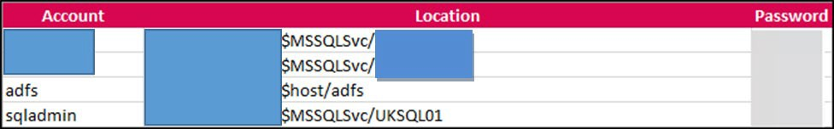

Remediation

*Figure 14: Cracked service accounts*

Use Group Managed Service Accounts (GMSA) for privileged services. GMSA accounts can be used to ensure passwords are long, complex, and change frequently. Where GMSA is not applicable, protect accounts by utilizing a password vaulting solution.

{{ team_abbreviature }} recommends configuring alert logging on domain controllers for Windows event ID 4769 whenever requesting a Kerberos service ticket. These alerts are prone to high false-positive rates but are a supplementary detective control. Tailor a security information and event management tool (SIEM) to alert on excessive user SPN requests.

Finding IPT-015: Security Misconfiguration – GPP Credentials (High)

|  |  |
| --- | --- |
| Description: | {{ corp_name }} utilized “cpasswords” in Group Policy Preference (GPP) which any domain user can query from a domain controller’s SYSVOL folder. Microsoft published the key to decrypt these passwords. |
| Risk: | Likelihood: High – Any authenticated user can obtain this information and decrypt the password with open source tools.  Impact: High – An adversary can use these credentials to move laterally within the network. |
| Tools Used: | Metasploit |
| References: | [NIST](https://nvd.nist.gov/800-53/Rev4/control/IA-5" \l "enhancement-1) SP800-53 IA-5(1) - Authenticator Management |

Evidence

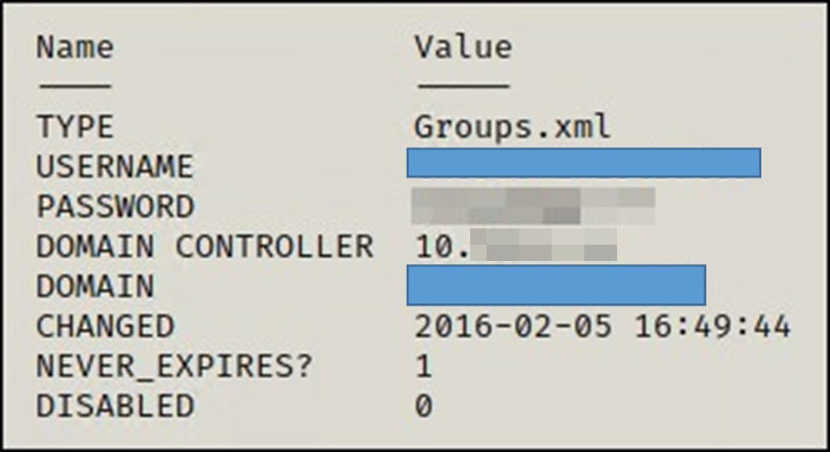

Remediation

*Figure 15: Dumped GPP credentials*

Apply vendor patching. Do not use GPP cpasswords. Additionally, enabling authentication on the NFS share will protect the confidentiality of the stored information. Exporting authentication logs to a SIEM solution will give incident response teams insights to brute force login attempts.

Finding IPT-016: Insufficient Authentication - VNC (High)

|  |  |
| --- | --- |
| Description: | {{ corp_name }} deployed 3 servers that permitted unauthenticated access via VNC Server. |
| Risk: | Likelihood: High – Discovering unauthenticated VNC servers is trivial and can be done with open-source tools.  Impact: High – Attackers can control industrial devices, destroy data, or shut down systems. |
| System: | 10.x.x.x, 10.x.x.x, 10.x.x.x |
| Tools Used: | Nessus, VNC Viewer |
| References: | [NIST](https://nvd.nist.gov/800-53/Rev4/control/IA-5" \l "enhancement-1) SP800-53 IA-5(1) - Authenticator Management |

Evidence

Remediation

[image redacted]

*Figure 16: Access to system via VNC*

Enable authentication on the VNC Server.

Finding IPT-017: Default Credentials on Web Services (High)

|  |  |
| --- | --- |
| Description: | {{ team_abbreviature }} validated default credentials worked on multiple web applications within the {{ corp_name }} environment. |
| Risk: | Likelihood: High – Credentials are published for these devices and an attackers first authentication attempt.  Impact: High – Attackers can control devices, destroy data, or shut down systems. |
| System: | Default credentials were tested on a sample set of web applications, but suggests checking the following addresses at a minimum:  [file removed] |
| Tools Used: | Manual Review |
| References: | [NIST](https://nvd.nist.gov/800-53/Rev4/control/IA-5" \l "enhancement-1) SP800-53 IA-5(1) - Authenticator Management |

Evidence

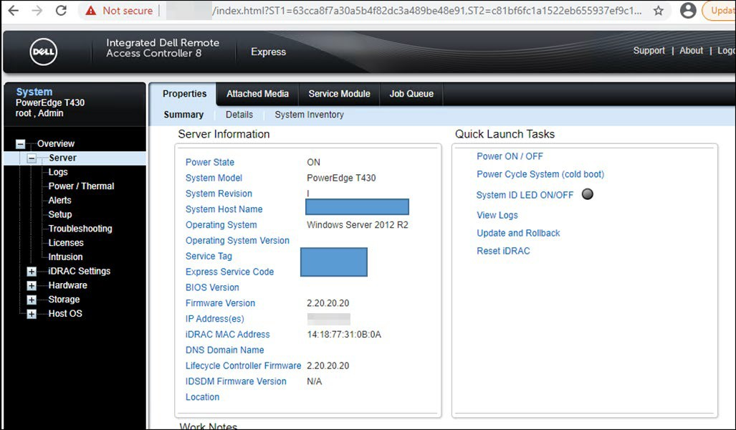

Remediation

*Figure 17: Dell iDRAC access via default credentials*

Change default credentials or disable unused accounts.

Finding IPT-018: Insufficient Hardening – Listable Directories (High)

|  |  |
| --- | --- |
| Description: | {{ corp_name }} disclosed information by allowing listable directories and storing potentially critical items on web server. It is strongly recommended that {{ corp_name }} perform a thorough web app assessment on this resource. |
| Risk: | Likelihood: Moderate – Adversaries will discovery content with open source tools.  Impact: High – Attackers use this information in conjunction with other attacks for enumeration and cataloging for rapid attacks when vulnerabilities arise. |
| System: | Full list of discovered listable directories:  [file removed] |
| Tools Used: | Manual Review |
| References: | [NIST SP800-53r4 CM-7 -](https://nvd.nist.gov/800-53/Rev4/control/CM-7) Least Functionality  [NIST](https://nvd.nist.gov/800-53/Rev4/control/AC-6" \l "enhancement-3) SP800-53r4 AC-6(3) - Least Privilege |

Evidence

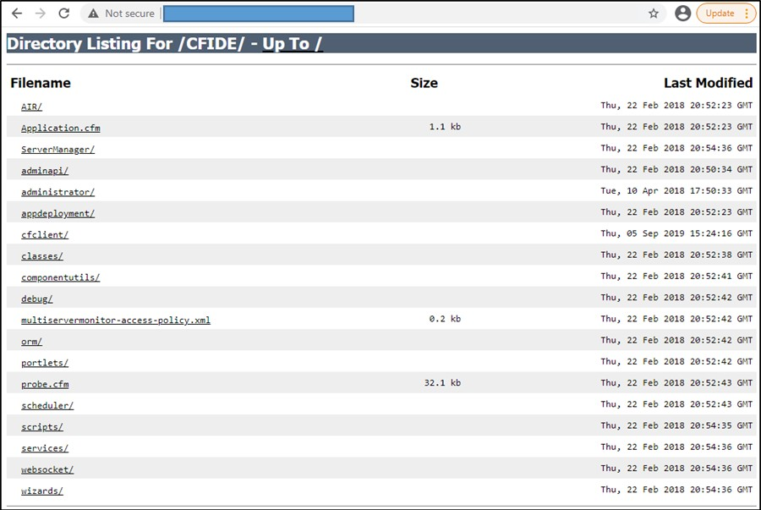

Remediation

*Figure 18: Listable directory*

Restrict access and conduct web app assessment.

Finding IPT-019: Unauthenticated SMB Share Access (Moderate)

|  |  |
| --- | --- |
| Description: | {{ corp_name }} exposed multiple servers with unauthenticated file server access. |
| Risk: | Likelihood: Moderate – Adversaries will discover these shares with low-noise, basic reconnaissance techniques.  Impact: Moderate – Attackers learn about the environment through information leaks. |
| System: | 10.x.x.x |
| Tools Used: | Nessus, smbclient |
| References: | [NIST](https://nvd.nist.gov/800-53/Rev4/control/AC-6" \l "enhancement-3) SP800-53r4 AC-6(3) - Least Privilege  [NIST SP800-53 r4 SC-4](https://nvd.nist.gov/800-53/Rev4/control/SC-4) - Information in Shared Resources |

Evidence

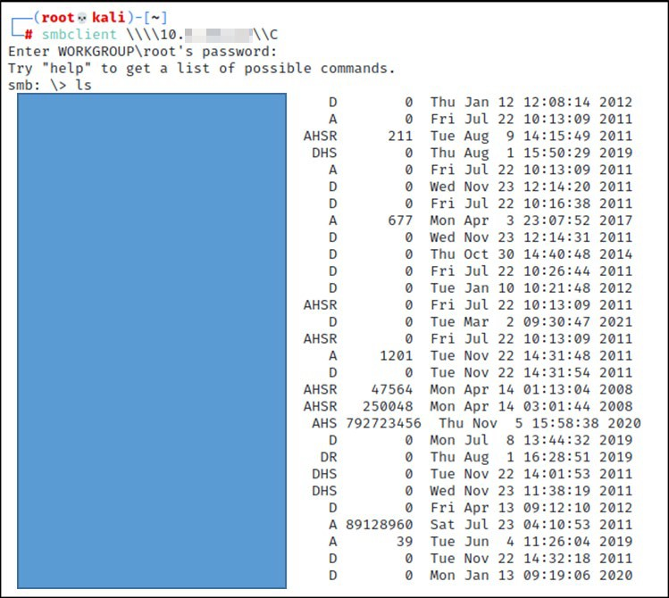

*Figure 19: Unauthenticated Share access*

Remediation

Disable SMB share or require authentication. Enabling authentication on the share will protect the confidentiality of the stored information. Exporting authentication logs to a SIEM solution will give incident response teams insights to brute force login attempts.

Finding IPT-020: Insufficient Patch Management – SMBv1 (Moderate)

|  |  |
| --- | --- |
| Description: | {{ corp_name }} failed to patch SMBv1. This version is vulnerable to multiple denial of service and remote code execution attacks. TCM Security confirmed that the vulnerability likely exists but did not attempt the exploit to prevent any denial of service. |
| Risk: | Likelihood: Moderate – Basic scans would identify the SMB version but would require an adversary to be on the internal network and identify an exploit.  Impact: Moderate – If exploited, an attacker gains denial of service and code execution capability. |
| System: | 10.x.x.x |
| Tools Used: | Nessus, Nmap |
| References: | <https://blogs.technet.microsoft.com/filecab/2016/09/16/stop-using-smb1/>  [NIST SP800-53 r4 SI-2 -](https://nvd.nist.gov/800-53/Rev4/control/SI-2) Flaw Remediation |

Evidence

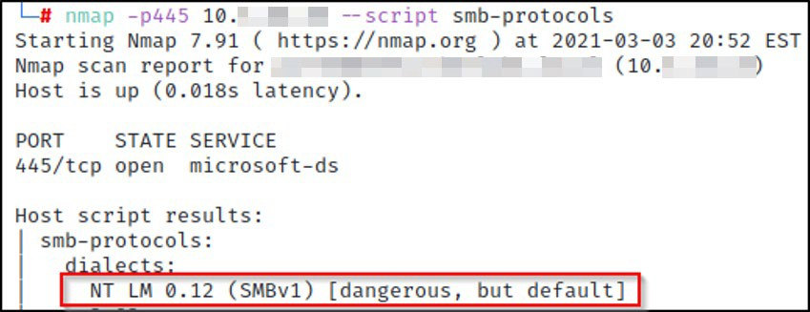

*Figure 20: Unauthenticated Share access*

Remediation

Upgrade to SMBv3 and apply latest patching.

Finding IPT-021: IPMI Hash Disclosure (Moderate)

|  |  |
| --- | --- |
| Description: | {{ corp_name }} deployed remote host supporting IPMI v2.0. The (IPMI) protocol is affected by an information disclosure vulnerability due to the support of RMCP+ Authenticated Key-Exchange Protocol (RAKP) authentication. A remote attacker  can obtain password hash information for valid user accounts via the HMAC from a RAKP message 2 response from a BMC. |
| Risk: | Likelihood: High – Basic network scans will identify this vulnerability.  Impact: Moderate – If exploited, an attacker can gain access to sensitive management devices. {{ team_abbreviature }} was unable to crack any hashes during the  assessment. |
| System: | Identified 34 machines, please see the below file for listing.  [file removed] |
| Tools Used: | Metasploit |
| References: | <https://blog.rapid7.com/2013/07/02/a-penetration-testers-guide-to-ipmi/> |

Evidence

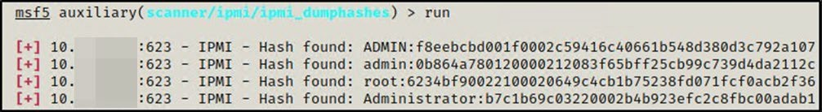

*Figure 21: IPMI Hash Disclosure*

Remediation

There is no patch for this vulnerability; it is an inherent problem with the specification for IPMI v2.0. Suggested mitigations include:

* Disabling IPMI over LAN if it is not needed.
* Using strong passwords to limit the successfulness of off-line dictionary attacks.
* Using Access Control Lists (ACLs) or isolated networks to limit access to your IPMI management interfaces.

Finding IPT-022: Insufficient SNMP Community String Complexity (Moderate)

|  |  |
| --- | --- |
| Description: | {{ corp_name }} deployed SNMP with default “public” community strings. This configuration exposed read-only access to the system’s management information base (MIB), including the network configurations. |
| Risk: | Likelihood: High – Basic network scans will identify this vulnerability.  Impact: Moderate – If exploited, an attacker can profile the device and focus attacks. |
| System: | Identified 45 machines, please see the below file for listing.  [file removed] |
| Tools Used: | Nessus, SNMP-Check, Ettercap |
| References: | [NIST SP800-53 r4 AC-17(2)](https://nvd.nist.gov/800-53/Rev4/control/AC-17?baseline=moderate&enhancement-2) - Remote Access Protection of Confidentiality/Integrity using Encryption |

Evidence

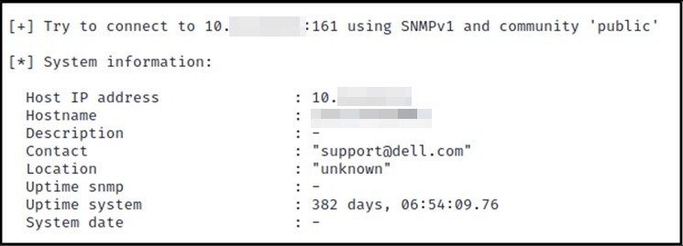

*Figure 22: Information disclosure via public SNMP community strings*

**

*Figure 23: Non-public SNMP string captured via Ettercap*

Remediation

TCM Security recommends {{ corp_name }} consider the following corrective actions:

* Disabled SNMP if not required
* Filter UDP packets going to port UDP – 161
* Evaluate migration to SNMPv3
* Use password complexity guidelines for community strings

Finding IPT-023: Insufficient Data in Transit Encryption - Telnet (Moderate)

|  |  |
| --- | --- |
| Description: | {{ corp_name }} permitted Telnet which does not encrypt data in transit. Telnet uses plain text authentication and passes all data (including passwords) in clear text and can be intercepted by an attacker. |
| Risk: | Likelihood: Low – An adversary requires a Man-in-the-Middle position between the client and server.  Impact: High – If exploited an adversary may intercept administrative credentials that can be used in other attacks. |
| System: | Identified 53 machines, please see the below file for listing.  [file removed] |
| Tools Used: | Telnet |
| References: | [NIST](https://nvd.nist.gov/800-53/Rev4/control/AC-17" \l "enhancement-2) SP800-53 r4 AC-17(2) - Remote Access |Protection of Confidentiality / Integrity Using Encryption |

Evidence

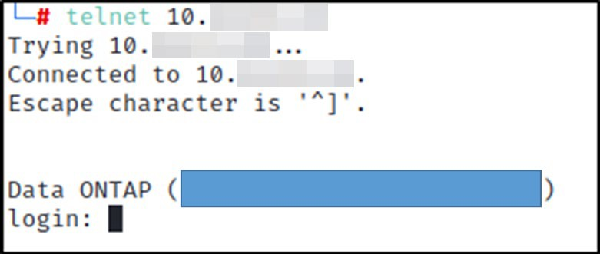

*Figure 24: Telnet login prompt*

Remediation

Migrate to TLS protected protocols.

Finding IPT-024: Insufficient Terminal Services Configuration (Moderate)

|  |  |
| --- | --- |
| Description: | The remote Terminal Services is not configured to use Network Level Authentication (NLA) only. NLA uses the Credential Security Support Provider (CredSSP) protocol to perform strong server authentication either through TLS/SSL or Kerberos mechanisms, which protect against man-in-the-middle attacks. In addition to improving authentication, NLA also helps protect the  remote computer from malicious users and software by completing user authentication before a full RDP connection is established. |
| Risk: | Likelihood: Low – An attacker can discover these vulnerabilities with basic tools.  Impact: High – If exploited, an adversary gains code execution, leading to lateral movement across the network. |
| System: | Identified 118 machines, please see the below file for listing.  [file removed] |
| Tools Used: | Nessus |
| References: | [https://docs.microsoft.com/en-us/previous-versions/windows/it-pro/windows-server-](https://docs.microsoft.com/en-us/previous-versions/windows/it-pro/windows-server-2008-R2-and-2008/cc732713(v%3Dws.11)) [2008-R2-and-2008/cc732713(v=ws.11)](https://docs.microsoft.com/en-us/previous-versions/windows/it-pro/windows-server-2008-R2-and-2008/cc732713(v%3Dws.11)) |

Remediation

Enable Network Level Authentication (NLA) on the remote RDP server. This is generally done on the 'Remote' tab of the 'System' settings on Windows.

Finding IPT-025: Steps to Domain Admin (Informational)

The steps below describe how the penetration tester obtained domain administrator access. Each step also provides remediation recommendations to help mitigate risk.

|  |  |  |
| --- | --- | --- |
| Step | Action | Remediation |
| 1 | Poisoned LLMNR responses to obtain NetNTLMv2 hash of regular network user | Disable multicast name resolution via GPO. |
| 2 | Cracked NTLM hash offline of domain administrator users ‘production’ and ‘[name removed]’ | Increase password complexity. Utilize multi-  factor. Implement a Privileged Account Management solution. Utilize a password filter. |
| 3 | Leveraged password of ‘production’ account to gain access to several machines within the network | Limit local administrator privileges and enforce least privilege. |
| 4 | Dumped hashes on accessed machines to find cleartext password of ‘Bartender’ account via  wdigest | Disable WDigest via GPO. |
| 5 | Overly-permissive ‘Bartender’ account permitted access to a large amount of machines within the  network | Limit local administrator privileges and enforce least privilege. |
| 6 | Dumped hashes on accessed machines to find cleartext password of Domain Administrator account | Disable WDigest via GPO. |
| 7 | Utilized discovered credentials to log into the domain controller. |  |

Remediation

Review action and remediation steps.

### Additional Scans and Reports

{{ team_abbreviature }} provides all clients with all report information gathered during testing. This includes Nessus files and full vulnerability scans in detailed formats. These reports contain raw vulnerability scans and additional vulnerabilities not exploited by TCM Security.

The reports identify hygiene issues needing attention but are less likely to lead to a breach, i.e. defense-in-depth opportunities. For more information, please see the documents in your shared drive folder labeled “Additional Scans and Reports”.



Last Page