Morphokinetic properties of mesenchymal stem cells as a predictor of differentiation potential
Y3948024
2026-04-26

Including Plots
You can also embed plots, for example:
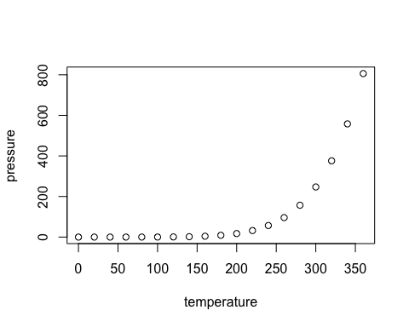
Note that the echo = FALSE parameter was added to the code chunk to prevent printing of the R code that generated the plot.

