**Data Set Title**

**Exploratory Analysis**

Jacob Redmon, [jredmon@bellarmine.edu](mailto:jredmon@bellarmine.edu)

1. **INTRODUCTION**

This data set contains some basic data from movies in the Internet Movie Database. It contains information about the number of Facebook likes the director and starring actors have, which will provide some interesting analysis. The data set can be found at <https://www.kaggle.com/carolzhangdc/imdb-5000-movie-dataset>.

1. **DATA SET DESCRIPTION**

This data set contains 5043 samples with 27 columns with various data types. A complete listing is shown in **Table 1**.

For data types you want to indicate two things (nominal, ordinal, interval, or ratio) and the Pandas data type. For example, age might be ratio/int32. For missing data, indicate what percentage of data from that column are missing. Ensure you check to for NaN, NA, or any other indicators that actually mean missing data.

**Table 1: Data Types and Missing Data**

|  |  |  |
| --- | --- | --- |
| *Variable Name* | *Data Type* | *Missing Data (%)* |
| movie_title | nominal/object | 0% |
| title_year | interval/int64 | 2% |
| country | nominal/object | 0.09% |
| language | nominal/object | 0.2% |
| budget | ratio/float64 | 9.7% |
| gross | ratio/float64 | 17.5% |
| imdb_score | ratio/float64 | 0% |
| duration | ratio/float64 | 0.3% |
| genres | nominal/object | 0% |
| plot_keywords | nominal/object | 3% |
| color | nominal/object | 0.3% |
| content_rating | nominal/object | 6% |
| facenumber_in_poster | ratio/float64 | 2.5% |
| num_critic_for_reviews | ratio/float64 | 0.9% |
| num_user_for_reviews | ratio/float64 | 0.4% |
| num_voted_users | ratio/int64 | 0% |
| director_name | nominal/object | 2% |
| actor_1_name | nominal/object | 1.4% |
| actor_2_name | nominal/object | 0.2% |
| actor_3_name | nominal/object | 4.5% |
| director_facebook_likes | ratio/int64 | 2% |
| actor_1_facebook_likes | ratio/int64 | 0.1% |
| actor_2_facebook_likes | ratio/int64 | 0.2% |
| actor_3_facebook_likes | ratio/int64 | 0.4% |
| cast_total_facebook_likes | ratio/int64 | 0% |
| movie_facebook_likes | ratio/int64 | 0% |
| movie_imdb_link | nominal/object | 0% |
| genres_first | nominal/object |  |

1. **Data Set Summary Statistics**

Narrative introduction to the section.

**Table 2: Summary Statistics for Movie Metadata**

|  |  |  |  |  |
| --- | --- | --- | --- | --- |
| *Variable Name* | *Count* | *Mean* | *Standard Deviation* | *Min* |
| title_year | 3756 | 2002.977 | 9.888108 | 1927 |
| budget | 3756 | 46236850 | 2.26E+08 | 218 |
| gross | 3756 | 52612824 | 70317867 | 162 |
| imdb_score | 3756 | 6.465282 | 1.056247 | 1.6 |
| duration | 3756 | 110.258 | 22.64672 | 37 |
| facenumber_in_poster | 3756 | 1.377263 | 2.041541 | 0 |
| num_critic_for_reviews | 3756 | 167.3783 | 123.452 | 2 |
| num_user_for_reviews | 3756 | 336.8432 | 411.2274 | 4 |
| num_voted_users | 3756 | 105826.7 | 152035.4 | 91 |
| director_facebook_likes | 3756 | 807.3365 | 3068.172 | 0 |
| actor_1_facebook_likes | 3756 | 7751.339 | 15519.34 | 0 |
| actor_2_facebook_likes | 3756 | 2021.776 | 4544.908 | 0 |
| actor_3_facebook_likes | 3756 | 771.2796 | 1894.25 | 0 |
| cast_total_facebook_likes | 3756 | 11527.1 | 19122.18 | 0 |
| movie_facebook_likes | 3756 | 9353.829 | 21462.89 | 0 |

|  |  |  |  |  |
| --- | --- | --- | --- | --- |
| *Variable Name* | *25th* | *50th* | *75th* | *Max* |
| title_year | 1999 | 2004 | 2010 | 2016 |
| budget | 10000000 | 25000000 | 50000000 | 1.22E+10 |
| gross | 8270233 | 30093107 | 66881941 | 7.61E+08 |
| imdb_score | 5.9 | 6.6 | 7.2 | 9.3 |
| duration | 96 | 106 | 120 | 330 |
| facenumber_in_poster | 0 | 1 | 2 | 43 |
| num_critic_for_reviews | 77 | 138.5 | 224 | 813 |
| num_user_for_reviews | 110 | 210 | 398.25 | 5060 |
| num_voted_users | 19667 | 53973.5 | 128602 | 1689764 |
| director_facebook_likes | 11 | 64 | 235 | 23000 |
| actor_1_facebook_likes | 745 | 1000 | 13000 | 640000 |
| actor_2_facebook_likes | 384.75 | 685.5 | 976 | 137000 |
| actor_3_facebook_likes | 194 | 436 | 691 | 23000 |
| cast_total_facebook_likes | 1919.75 | 4059.5 | 16240 | 656730 |
| movie_facebook_likes | 0 | 227 | 11000 | 349000 |

Table 3a: Proportions for Country (n=45)

|  |  |  |
| --- | --- | --- |
| *Category* | *Frequency* | *Proportion (%)* |
| Afghanistan | 1 | 0.026624 |
| Argentina | 3 | 0.079872 |
| Aruba | 1 | 0.026624 |
| Australia | 39 | 1.038339 |
| Belgium | 1 | 0.026624 |
| Brazil | 5 | 0.133120 |
| Canada | 59 | 1.570820 |
| Chile | 1 | 0.026624 |
| China | 13 | 0.346113 |
| Colombia | 1 | 0.026624 |
| Czech Republic | 3 | 0.079872 |
| Denmark | 8 | 0.212993 |
| Finland | 1 | 0.026624 |
| France | 101 | 2.689031 |
| Georgia | 1 | 0.026624 |
| Germany | 80 | 2.129925 |
| Greece | 1 | 0.026624 |
| Hong Kong | 13 | 0.346113 |
| Hungary | 2 | 0.053248 |
| Iceland | 1 | 0.026624 |
| India | 5 | 0.133120 |
| Indonesia | 1 | 0.026624 |
| Iran | 4 | 0.106496 |
| Ireland | 7 | 0.186368 |
| Israel | 1 | 0.026624 |
| Italy | 11 | 0.292865 |
| Japan | 15 | 0.399361 |
| Mexico | 6 | 0.159744 |
| Netherlands | 3 | 0.079872 |
| New Line | 1 | 0.026624 |
| New Zealand | 11 | 0.292865 |
| Norway | 4 | 0.106496 |
| Official site | 1 | 0.026624 |
| Peru | 1 | 0.026624 |
| Poland | 1 | 0.026624 |
| Romania | 2 | 0.053248 |
| Russia | 3 | 0.079872 |
| South Africa | 3 | 0.079872 |
| South Korea | 8 | 0.212993 |
| Spain | 21 | 0.559105 |
| Taiwan | 2 | 0.053248 |
| Thailand | 4 | 0.106496 |
| UK | 318 | 8.466454 |
| USA | 2987 | 79.526092 |
| West Germany | 1 | 0.026624 |

Table 3b: Proportions for Language (n=34)

|  |  |  |
| --- | --- | --- |
| *Category* | *Frequency* | *Proportion (%)* |
| Aboriginal | 2 | 0.053248 |
| Arabic | 1 | 0.026624 |
| Aramaic | 1 | 0.026624 |
| Bosnian | 1 | 0.026624 |
| Cantonese | 7 | 0.186368 |
| Czech | 1 | 0.026624 |
| Danish | 3 | 0.079872 |
| Dari | 2 | 0.053248 |
| Dutch | 3 | 0.079872 |
| English | 3598 | 95.793397 |
| Filipino | 1 | 0.026624 |
| French | 34 | 0.905218 |
| German | 10 | 0.266241 |
| Hebrew | 1 | 0.026624 |
| Hindi | 5 | 0.133120 |
| Hungarian | 1 | 0.026624 |
| Indonesian | 2 | 0.053248 |
| Italian | 7 | 0.186368 |
| Japanese | 10 | 0.266241 |
| Kazakh | 1 | 0.026624 |
| Korean | 5 | 0.133120 |
| Mandarin | 15 | 0.399361 |
| Maya | 1 | 0.026624 |
| Mongolian | 1 | 0.026624 |
| None | 1 | 0.026624 |
| Norwegian | 4 | 0.106496 |
| Persian | 3 | 0.079872 |
| Portuguese | 5 | 0.133120 |
| Romanian | 1 | 0.026624 |
| Russian | 1 | 0.026624 |
| Spanish | 23 | 0.612354 |
| Thai | 3 | 0.079872 |
| Vietnamese | 1 | 0.026624 |
| Zulu | 1 | 0.026624 |

Table 3c: Proportions for Color (n=2)

|  |  |  |
| --- | --- | --- |
| *Category* | *Frequency* | *Proportion (%)* |
| Black and White | 124 | 3.301384 |
| Color | 3632 | 96.698616 |

Table 3d: Proportions for Content Rating (n=12)

|  |  |  |
| --- | --- | --- |
| *Category* | *Frequency* | *Proportion (%)* |
| Approved | 17 | 0.452609 |
| G | 87 | 2.316294 |
| GP | 1 | 0.026624 |
| M | 2 | 0.053248 |
| NC-17 | 6 | 0.159744 |
| Not Rated | 34 | 0.905218 |
| PG | 566 | 15.069223 |
| PG-13 | 1308 | 34.824281 |
| Passed | 3 | 0.079872 |
| R | 1700 | 45.260916 |
| Unrated | 22 | 0.585729 |
| X | 10 | 0.266241 |

Table 3e: Proportions for First Genre (n=17)

|  |  |  |
| --- | --- | --- |
| *Category* | *Frequency* | *Proportion (%)* |
| Action | 959 | 25.53248 |
| Adventure | 369 | 9.824281 |
| Animation | 45 | 1.198083 |
| Biography | 205 | 5.457934 |
| Comedy | 989 | 26.3312 |
| Crime | 255 | 6.789137 |
| Documentary | 26 | 0.692226 |
| Drama | 668 | 17.78488 |
| Family | 3 | 0.079872 |
| Fantasy | 37 | 0.985091 |
| Horror | 164 | 4.366347 |
| Musical | 2 | 0.053248 |
| Mystery | 23 | 0.612354 |
| Romance | 1 | 0.026624 |
| Sci-Fi | 7 | 0.186368 |
| Thriller | 1 | 0.026624 |
| Western | 2 | 0.053248 |

Table 4: Correlation Table/Tables

|  |  |  |  |  |  |  |  |  |  |  |  |  |  |  |  |
| --- | --- | --- | --- | --- | --- | --- | --- | --- | --- | --- | --- | --- | --- | --- | --- |
|  | title_year | budget | gross | imdb_score | duration | facenumber_in_poster | num_critic_for_reviews | num_user_for_reviews | num_voted_users | director_facebook_likes | actor_1_facebook_likes | actor_2_facebook_likes | actor_3_facebook_likes | cast_total_facebook_likes | movie_facebook_likes |
| title_year | 1 | 0.047138 | 0.054808 | -0.13498 | -0.13021 | 0.070093 | 0.420202 | 0.01947 | 0.023687 | -0.04466 | 0.096194 | 0.12241 | 0.117475 | 0.127045 | 0.306987 |
| budget | 0.047138 | 1 | 0.099496 | 0.02919 | 0.068012 | -0.02167 | 0.104717 | 0.070372 | 0.065927 | 0.018167 | 0.016418 | 0.035715 | 0.039966 | 0.028682 | 0.05249 |
| gross | 0.054808 | 0.099496 | 1 | 0.21474 | 0.245726 | -0.03202 | 0.464187 | 0.544674 | 0.624949 | 0.138351 | 0.14401 | 0.252842 | 0.299864 | 0.235601 | 0.366933 |
| imdb_score | -0.13498 | 0.02919 | 0.21474 | 1 | 0.366221 | -0.06549 | 0.347886 | 0.325003 | 0.48243 | 0.192314 | 0.093597 | 0.102372 | 0.065544 | 0.106803 | 0.281155 |
| duration | -0.13021 | 0.068012 | 0.245726 | 0.366221 | 1 | 0.026919 | 0.228631 | 0.351595 | 0.339592 | 0.180644 | 0.083632 | 0.128935 | 0.125797 | 0.120179 | 0.215303 |
| facenumber_in_poster | 0.070093 | -0.02167 | -0.03202 | -0.06549 | 0.026919 | 1 | -0.03436 | -0.08097 | -0.03221 | -0.04807 | 0.057387 | 0.073098 | 0.106189 | 0.080687 | 0.015185 |
| num_critic_for_reviews | 0.420202 | 0.104717 | 0.464187 | 0.347886 | 0.228631 | -0.03436 | 1 | 0.563684 | 0.592473 | 0.175128 | 0.165986 | 0.253125 | 0.252782 | 0.236533 | 0.705226 |
| num_user_for_reviews | 0.01947 | 0.070372 | 0.544674 | 0.325003 | 0.351595 | -0.08097 | 0.563684 | 1 | 0.778881 | 0.217103 | 0.121935 | 0.187016 | 0.205343 | 0.178675 | 0.370465 |
| num_voted_users | 0.023687 | 0.065927 | 0.624949 | 0.48243 | 0.339592 | -0.03221 | 0.592473 | 0.778881 | 1 | 0.299624 | 0.17959 | 0.244822 | 0.267762 | 0.249119 | 0.517751 |
| director_facebook_likes | -0.04466 | 0.018167 | 0.138351 | 0.192314 | 0.180644 | -0.04807 | 0.175128 | 0.217103 | 0.299624 | 1 | 0.08963 | 0.116058 | 0.117405 | 0.118547 | 0.161962 |
| actor_1_facebook_likes | 0.096194 | 0.016418 | 0.14401 | 0.093597 | 0.083632 | 0.057387 | 0.165986 | 0.121935 | 0.17959 | 0.08963 | 1 | 0.391166 | 0.252408 | 0.944813 | 0.1303 |
| actor_2_facebook_likes | 0.12241 | 0.035715 | 0.252842 | 0.102372 | 0.128935 | 0.073098 | 0.253125 | 0.187016 | 0.244822 | 0.116058 | 0.391166 | 1 | 0.553755 | 0.642991 | 0.232769 |
| actor_3_facebook_likes | 0.117475 | 0.039966 | 0.299864 | 0.065544 | 0.125797 | 0.106189 | 0.252782 | 0.205343 | 0.267762 | 0.117405 | 0.252408 | 0.553755 | 1 | 0.489795 | 0.271508 |
| cast_total_facebook_likes | 0.127045 | 0.028682 | 0.235601 | 0.106803 | 0.120179 | 0.080687 | 0.236533 | 0.178675 | 0.249119 | 0.118547 | 0.944813 | 0.642991 | 0.489795 | 1 | 0.205564 |
| movie_facebook_likes | 0.306987 | 0.05249 | 0.366933 | 0.281155 | 0.215303 | 0.015185 | 0.705226 | 0.370465 | 0.517751 | 0.161962 | 0.1303 | 0.232769 | 0.271508 | 0.205564 | 1 |

1. **DATA SET GRAPHICAL EXPLORATION**

Narrative introduction to the section. In each section below, indicate any interesting distributions, anomalies, imbalance, etc. that you notice.

* 1. *Distributions*
  2. *ScatterPlots / Pairwise Plots (continuous variables)*
  3. *Barcharts (categorical variables)*
  4. *Other Plots - don’t skimp – there are likely other plots that would be useful that I haven’t already specified. Include those in this section.*

All figures should be cited formatted like this and mentioned in the text.

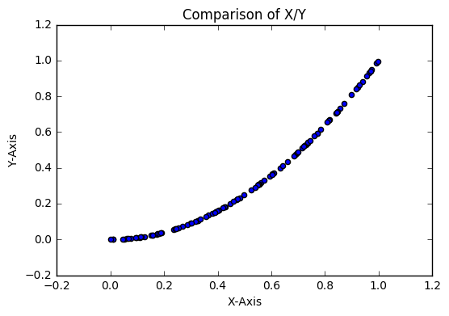

**Figure 1: Comparison of X/Y from dataset (single plot) (8 pt)**

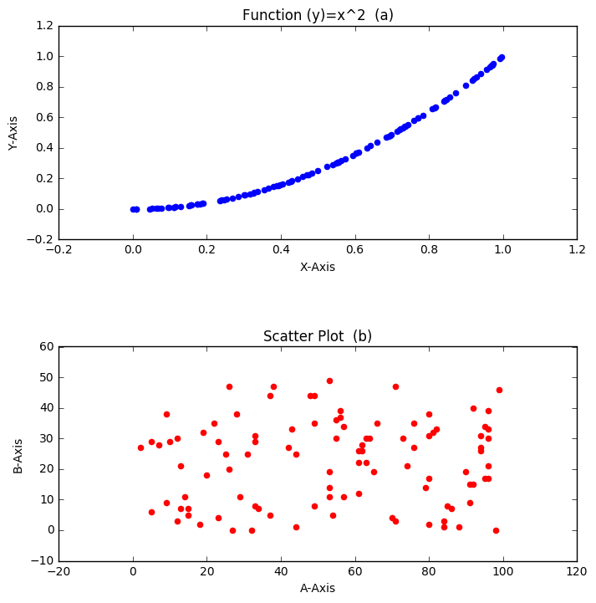

**Figure 2: (a) Function Output (b) A against B (multiple plots) (8 pt)**

1. **SUMMARY OF FINDINGS**

Finish up with a paragraph or two of summarizing your findings about this data set.