JACOB ELLIS
DS 5030
LAB 6 REPORT
10/1/2026
Overview
This study examines the results from a clinical trial considering three treatments for pre-diabetics to reduce progression to full diabetes. The three treatments are metformin, rosiglitazone, and lifestyle adjustments; the two outcomes are success (1) or failure (0). The goal of this analysis is to compare outcomes from the three treatments, and to determine which, if any, have better results than the others. 95% confidence is assumed to be sufficient for determining significance.
Analysis
Figure 1: Average outcomes and Crosstab

Looking at average outcomes, rosi appears to have the highest proportion of successes, followed by lifestyle and lastly met. To determine if their differences are statistically significant, conduct a bootstrap on the samples and collect both the distributions and pairwise ATE’s. The bootstrap results in the following KDE’s and ECDF’s.

Figure 2: Bootstrap KDE and ECDF
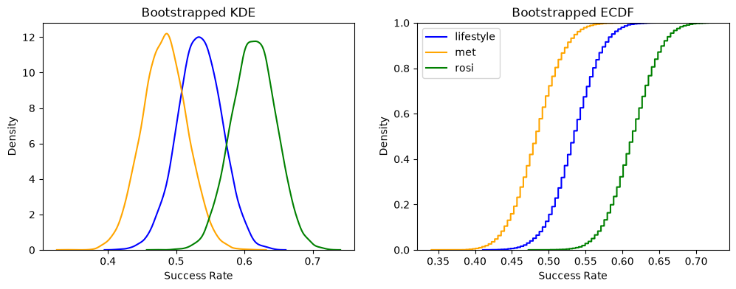
Figure 2 shows that the bootstrapped distributions are centered on and in the same order as the point estimate but add the insight that the distributions overlap. To determine how much the distributions overlap, and to determine if the differences between treatments are statistically significant, look at the ATE’s and corresponding confidence intervals.

Figure 3: KDE’s and ECDF’s of Pairwise ATE’s
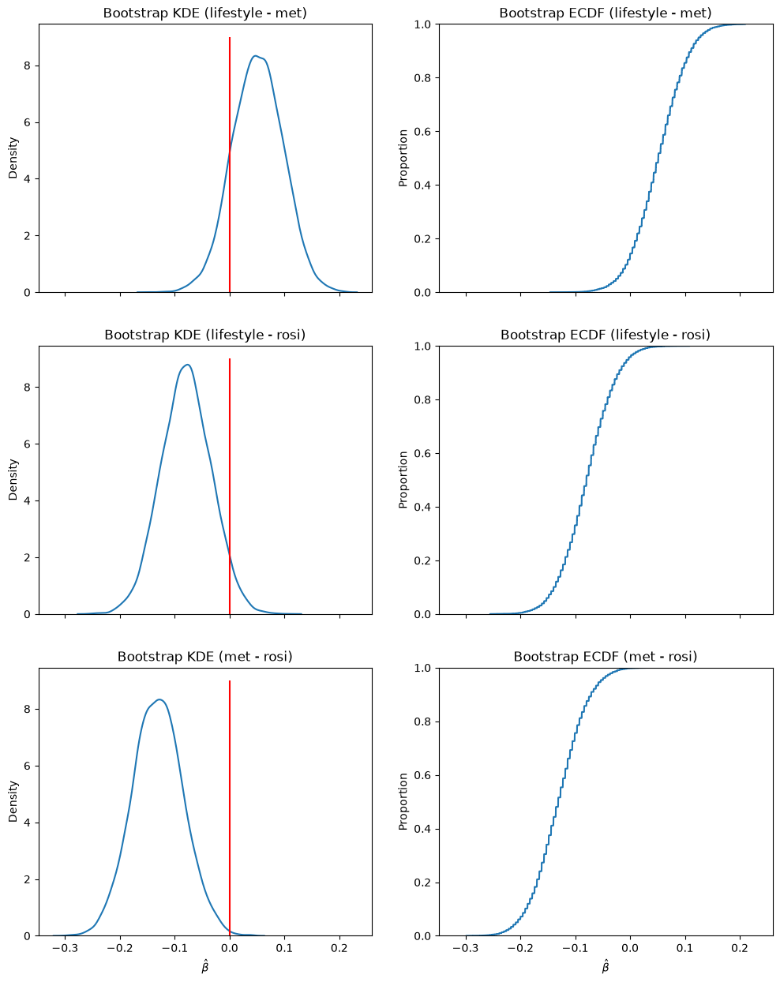
KDE for lifestyle-met and lifestyle-rosi seem to be centered on numbers close to zero, and include zero in the distribution. For met-rosi, zero appears to be close to outside the distribution. To know for sure, examine the 95% confidence interval for the ATE estimates.
Figure 4: 95% confidence interval for ATE estimates
95% CI (lifestyle - met): | [-0.03886678, 0.14150457]
95% CI (lifestyle - rosi): | [-0.16941785, 0.01038159]
95% CI (met - rosi): | [-0.22125203, -0.03644369]

We are 95% confident that the true difference in outcomes between met and rosi is -0.221 and -0.0364, which means that rosi has a higher proportion of successes than met. The other pairwise confidence intervals include zero, which means that we cannot say with 95% confidence that lifestyle has different outcomes from met, or that lifestyle has different outcomes from rosi. Confidence intervals are consistent with the illustrations in figure 3, with zero being included on the first two pairwise comparisons but not on the third.

Conclusions
The only pairwise interventions that have statistically different outcomes (95% confidence) are met and rosi. Rosi has better success rates, on average, then does met. There is not enough evidence to support that outcomes for lifestyle are different from met or that outcomes for lifestyle are different from rosi, because both 95% confidence intervals include zero.

