Notes
Fourier Series:
Fourier Constants:
- Fourier constants can be broken up into their real and imaginary parts.
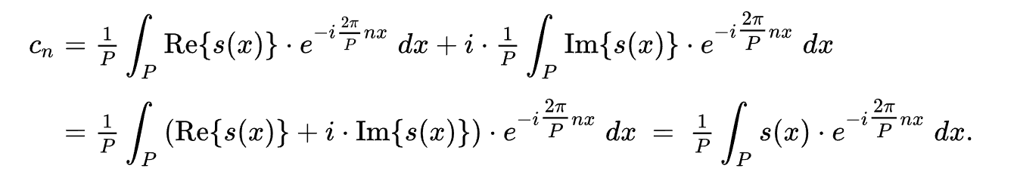
(https://en.wikipedia.org/wiki/Fourier_series)
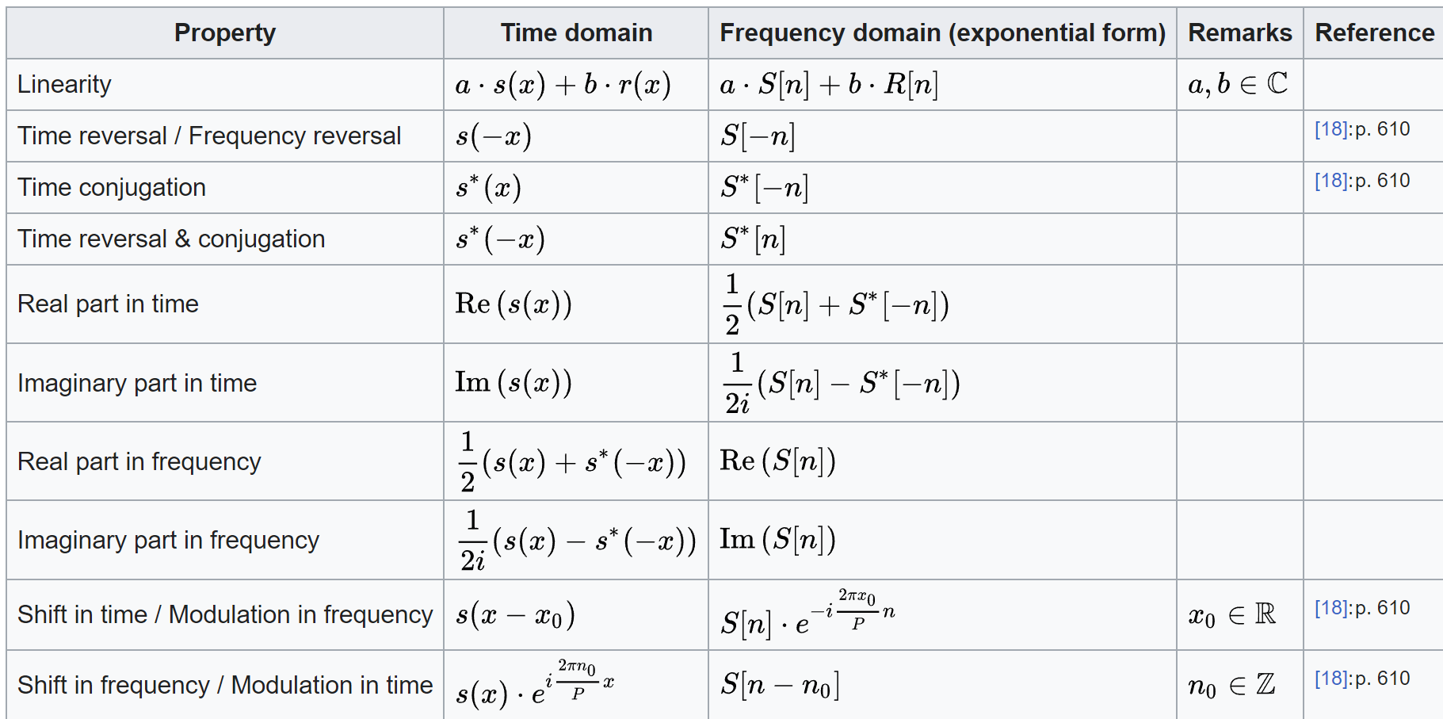
(https://en.wikipedia.org/wiki/Fourier_series)
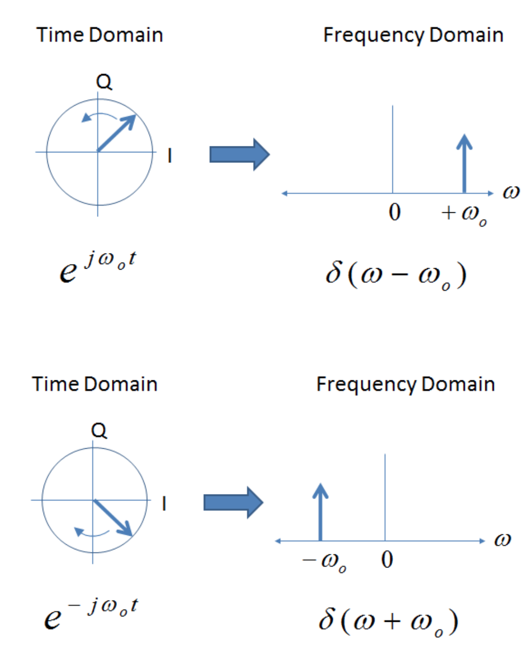
(https://electronics.stackexchange.com/questions/128898/why-is-the-frequency-complex)
(https://webspace.science.uu.nl/~kouzn101/USS2019.html)

Phase-Locking/Synchrony
Do Hermitian matrices that have the same phase, have the same eigenvectors?

Different Effects from single valued Hopf-Bifurcation:
Let the state, $z=(x+iy)$ , constant $α=(a+ib)$ and $β=(c+id)$. Define the Hopf-Bifurcation as follows,
$$\dot{z}=\left(α+β{\left|z\right|}^{2}\right)z$$
Then the following are the equations to the changes in $\dot{x}$, and $\dot{y}$,
$$\dot{y}=bx+dx^{3}+dxy^{2}+ay+cyx^{2}+cy^{3}$$
$$\dot{x}=ax+cx^{3}+cxy^{2}+by+dyx^{2}+dy^{3}$$
Hence, they are the exact same equations if $α=β$. For a stable limit-cycle to form $a>0$ and $c<0$. Where $c$ is the first Lyapunov Exponent to the dynamical system. The linear system, defined as follows,
$$\dot{y}=ax+by$$
$$\dot{x}=bx+ay$$
Generates perpendicular lines through the origin $0$. If $a=-c$ and $b=-d$ then a limit cycle forms with radius $r=\sqrt{a/c}$ . The phase of the limit-cycle is determined by the difference in the imaginary components $\dot{θ}=b-d{\left|z\right|}^{2}$.
Observations:
- All constants $a,b,c,d$ be equal
  - All constants positive.

Generates a line of separation from $(-x,y)$ to $(x,-y)$. Such that all values on the right-side of this line tend to infinity, while the values of the left-side of the line tend to negative infinity.

Function Mapping:
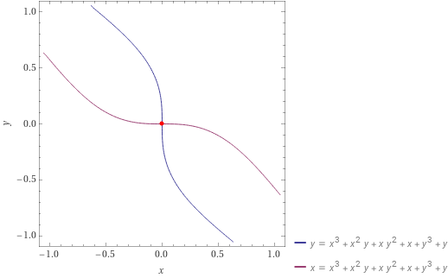

Phase Space Mapping:
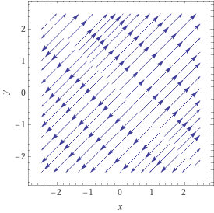

  - All constants negative.

Changes direction of the phase space. All values tend towards the line.

Function Mapping:
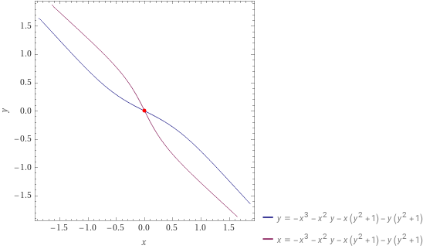

Phase space mapping:
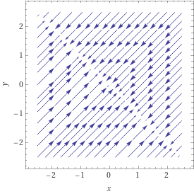

  - $a,b$ are positive & $c,d$ are negative.

Wraps the function around the origin so that three points of intersection occur. However, there is no rotation since there is no difference between our $b$ and $d$ values.
The phase space sends all points outside the unit circle towards the unit-circle or the line $y=-x$. All points inside the circle tend get sent away from the line $y=-x$.

Function Mapping:
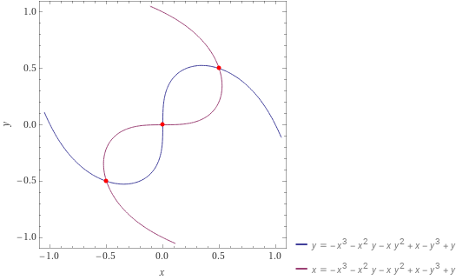
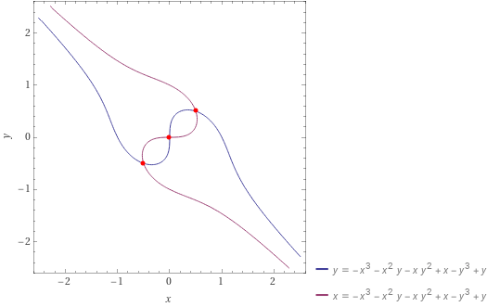

To get a unit circle we need the red function to tend towards the $y=x$ line.

Phase Space Mapping:
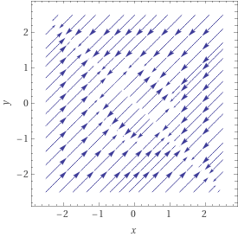

- Setting $b≠d$. (Attempting to update the phase-space)
  - Let $b=2$ and $d=-2$.

Again the map generated is the same as in (a).c above, but this time in the phase-plot the

Function Mapping:
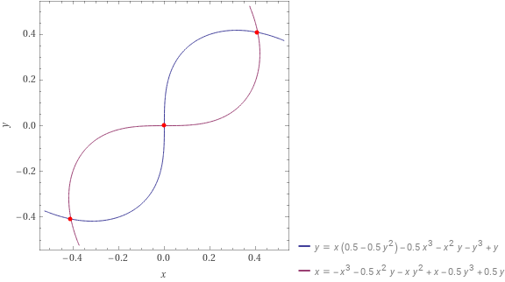

Phase Space Mapping:
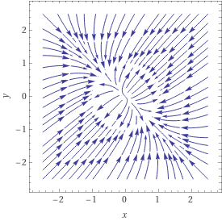

- Generating a Limit-Cycle:
  - We need the $c<0, a>0$ and the sign of $b$ to be opposite that of $d$.

Hence the working model is as such,
$$\dot{y}=-bx+dx^{3}+dxy^{2}+ay+cyx^{2}+cy^{3}$$
$$\dot{x}=ax+cx^{3}+cxy^{2}+by-dyx^{2}-dy^{3}$$
Additionally, the sign of the change in the imaginary unit $\dot{y}$ for $b$ and $d$ must be opposite. Hence, $b_{x}=-b_{y}$ .

Scaling the limit cycle is just changing the value of $a$ while keeping $c<0$. If $a<0$ the limit cycle tends to 0.

Function Mapping:
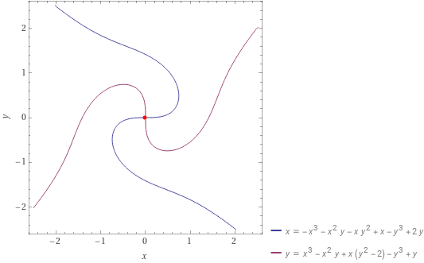

Phase Space Mapping:
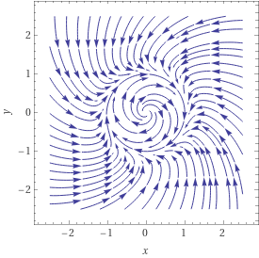

  - Increasing the difference between $b \& d$ increases the spin in the cycle.
  - Flipping the signs of $b \& d$ flips the spin of the cycle.
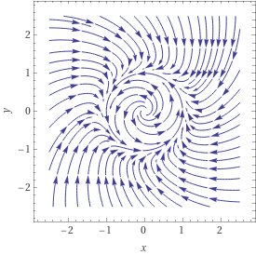
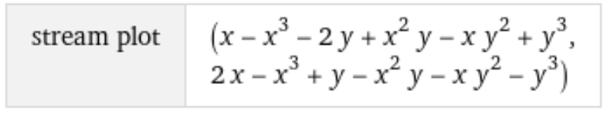

Lie Groups:
Lie Groups that are homomorphic to each other have lie algebras that are homomorphic to each other, but the converse is not necessarily true.

Method:
Unitary Matrix:
Let $A$ be an $(n×n)$ matrix, such that $AA^{*}=I$, and $A∈C^{n×n}$. Then $A$ is invertible and the eigenspace of $A$ has the following properties.
$Re\left(λ\left(A\right)\right)= Re(λ\left(A^{*}\right))$ and $Im\left(λ\left(A\right)\right)=- Im(λ\left(A^{*}\right))$

