question 1

MainActivity

import android.os.Bundle;
import android.view.View;
import android.widget.TextView;
import android.widget.Toast;
import java.util.Set;
public class MainActivity extends AppCompatActivity {
TextView iv;
TextView tv;
@Override
protected void onCreate(Bundle savedInstanceState) {
super.onCreate(savedInstanceState);
setContentView(R.layout.activity_main);
iv = (TextView)findViewById(R.id.iv);
tv = (TextView)findViewById(R.id.tv);
iv.setOnClickListener(new View.OnClickListener() {
@Override
public void onClick(View v) {
Toast.makeText(getApplicationContext(), "position 1 \n item value", Toast.LENGTH_SHORT).show();
}
});
tv.setOnClickListener(new View.OnClickListener() {
@Override
public void onClick(View v) {
Toast.makeText(getApplicationContext(), "position 2 \n item value", Toast.LENGTH_SHORT).show();
}
});
}
}

XML
<?xml version="1.0" encoding="utf-8"?>
<android.support.constraint.ConstraintLayout xmlns:android="http://schemas.android.com/apk/res/android"
xmlns:app="http://schemas.android.com/apk/res-auto"
xmlns:tools="http://schemas.android.com/tools"
android:layout_width="match_parent"
android:layout_height="match_parent"
tools:context=".MainActivity">
<TextView
android:id="@+id/iv"
android:layout_width="385dp"
android:layout_height="51dp"
android:text="London"
tools:layout_editor_absoluteX="0dp"
tools:layout_editor_absoluteY="4dp" />
<TextView
android:id="@+id/tv"
android:layout_width="382dp"
android:layout_height="53dp"
android:layout_marginTop="8dp"
android:layout_marginBottom="8dp"
android:text="India"
app:layout_constraintBottom_toBottomOf="parent"
app:layout_constraintTop_toTopOf="parent"
app:layout_constraintVertical_bias="0.131"
tools:layout_editor_absoluteX="0dp" />
</android.support.constraint.ConstraintLayout>

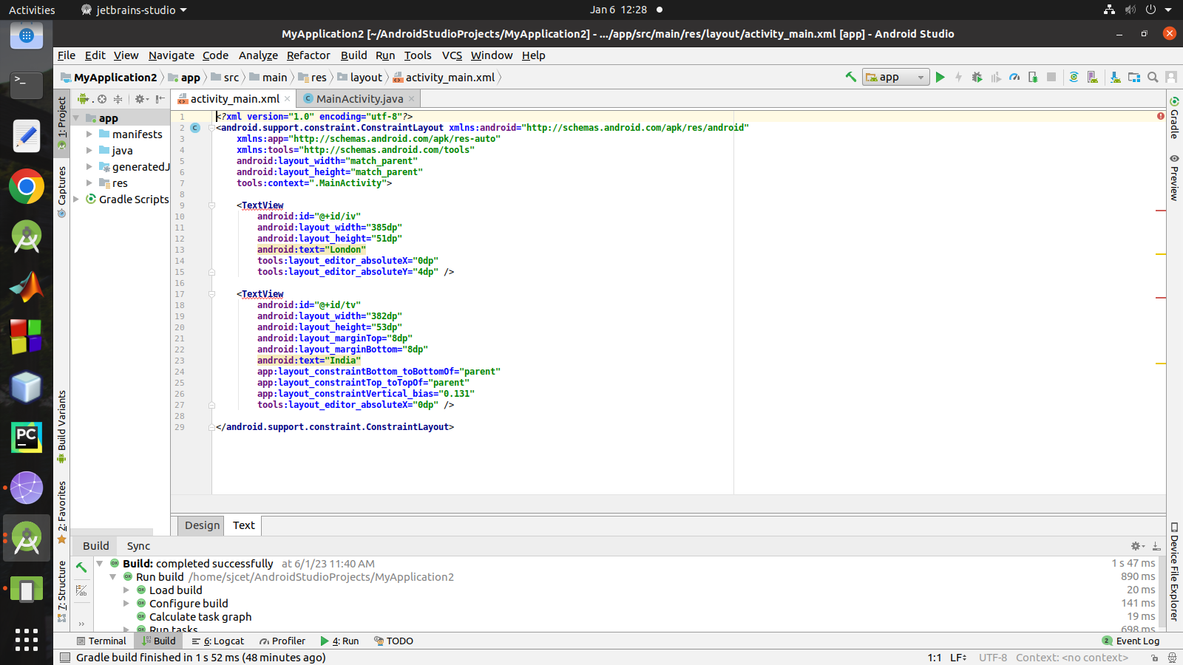
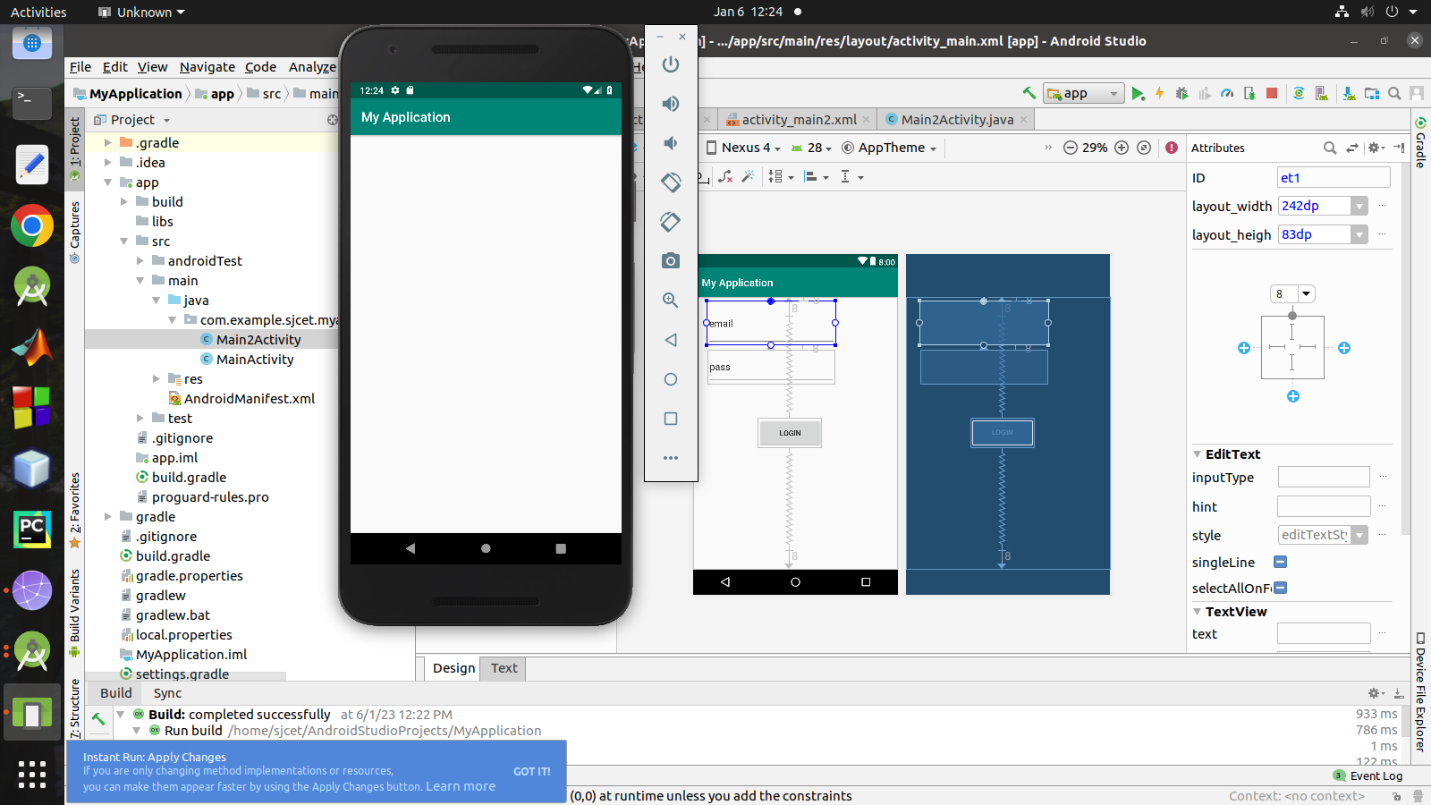
Question 2
package com.example.sjcet.myapplication;

import android.content.Intent;
import android.support.v7.app.AppCompatActivity;
import android.os.Bundle;
import android.view.View;
import android.widget.Button;
import android.widget.EditText;
public class MainActivity extends AppCompatActivity {
EditText email,pass;
Button login;
@Override
protected void onCreate(Bundle savedInstanceState) {
super.onCreate(savedInstanceState);
setContentView(R.layout.activity_main);
email = (EditText) findViewById(R.id.et1);
pass = (EditText) findViewById(R.id.et2);
login = (Button) findViewById(R.id.b1);
login.setOnClickListener(new View.OnClickListener() {
@Override
public void onClick(View v) {
if (email.length()==0) {
email.setError("enter a mail id");
}
else
{
Intent intent = new Intent(MainActivity.this, Main2Activity.class);
startActivity(intent);
}
}
});
}
}

<?xml version="1.0" encoding="utf-8"?>
<android.support.constraint.ConstraintLayout xmlns:android="http://schemas.android.com/apk/res/android"
xmlns:app="http://schemas.android.com/apk/res-auto"
xmlns:tools="http://schemas.android.com/tools"
android:layout_width="match_parent"
android:layout_height="match_parent"
tools:context=".MainActivity">
<EditText
android:id="@+id/et1"
android:layout_width="242dp"
android:layout_height="83dp"
android:layout_marginTop="8dp"
app:layout_constraintTop_toTopOf="parent"
tools:layout_editor_absoluteX="26dp"
tools:text="email" />
<EditText
android:id="@+id/et2"
android:layout_width="239dp"
android:layout_height="64dp"
android:layout_marginTop="8dp"
app:layout_constraintTop_toBottomOf="@+id/et1"
tools:layout_editor_absoluteX="27dp"
tools:text="pass" />
<Button
android:id="@+id/b1"
android:layout_width="120dp"
android:layout_height="56dp"
android:layout_marginTop="8dp"
android:layout_marginBottom="8dp"
android:text="login"
app:layout_constraintBottom_toBottomOf="parent"
app:layout_constraintTop_toTopOf="parent"
tools:layout_editor_absoluteX="122dp" />
</android.support.constraint.ConstraintLayout>
