Christopher Jacobs

12/16/2021

Math Methods

Graduate Work

# Homework

## Group: hodgepodge

This group of tasks was the beginnings of my understanding of how to make homework that deal with how math is used in physics context and do not have a specific goal in mind. Here the homework focus the context of the problems on Energy.

### Homework 1

Name:

Date:

Homework 1 (Draft 1)

Remember to keep your work simple, direct, specific, precise and consistent.

Consider an isolated baseball thrown at $5\frac{m}{s}$ and a 2nd baseball $2m$ from the earth thrown at the same speed. The baseballs are not rotating.

1. Write out an equation for the total energy of the baseball in the isolated case using general formulas, then calculate the total energy if the baseball has a mass.
2. Repeat the above question for the case of the baseball 2m from the earth.
3. Consider a catcher catching the isolated baseball and a 2nd catcher catching the baseball 2m from the earth. How, if at all, would the two catchers experience a different impact?

Name:

Date:

Homework 1 (Draft 2)

Remember to keep your work simple, direct, specific, precise and consistent.

Consider a baseball in free space thrown at $5\frac{m}{s}$ and a 2nd baseball $2m$ from the surface of the earth thrown at the same speed. Both baseballs are not rotating and traveling in the x-direction.

1. Write out an equation for the total energy of the baseball in the isolated case using general formulas, then calculate the total energy if the baseball has a $1kg$ mass. Make sure to explicitly state your system.
2. Repeat the above question for the case of the baseball 2m from the earth.
3. Consider a catcher catching the isolated baseball and a 2nd catcher catching the baseball 2m from the surface of the earth. How, if at all, would the two catchers experience catching the baseball differently?

Name:

Date:

Homework 1 (Draft 3)

Remember to keep your work simple, direct, specific, precise and consistent.

Consider a baseball in free space thrown at $5\frac{m}{s}$ and a 2nd baseball $2m$ from and travelling parallel to the surface of the earth thrown at the same speed, both balls are traveling in the x-direction and are not rotating.

1. Write out an equation for the total energy of the baseball in the free space case using the general total energy formula, then calculate the total energy if the baseball has a $1kg$ mass. Make sure to explicitly state your system.
2. Repeat the above question for the case of the baseball is 2m from the surface of the earth, making system the ball and earth.
3. Consider a catcher catching the baseball in free space and a 2nd catcher catching the baseball 2m from the surface of the earth. How, if at all, would the two catchers experience catching the baseball differently?

Homework 1 (Solutions 1)

Consider an isolated baseball thrown at $5\frac{m}{s}$ and a 2nd baseball $2m$ from the earth thrown at the same speed. The baseballs are not rotating.

1. Write out an equation for the total energy of the baseball in the isolated case using general formulas, then calculate the total energy if the baseball has a mass.
2. Repeat the above question for the case of the baseball 2m from the earth.
3. Consider a catcher catching the isolated baseball and a 2nd catcher catching the baseball 2m from the earth. How, if at all, would the two catchers experience a different impact?

How does homework 1 address the following questions:

1. The conceptual understanding of mathematics?

This is not the focus of this homework.

1. The differences between math in a mathematics context and math in a physics context?

The 2 scenarios proposed in homework 1 have different total energy equations due to one baseball being in free space and the other being near the surface of the Earth. The differences in total energy, kinetic energy, and potential energy between the two scenarios could cause a student to believe someone catching the 2 baseballs could experience the catch differently.

Mathematically one system has a greater magnitude in total energy, physically both baseballs have the same kinetic energy and in one the system is containing energy (potential energy). The homework should guide the student toward realizing that because the catchers only are changing the velocity of the baseballs that they will experience the catch of their respective baseball the same.

### Homework 3

Name:

Date:

Homework 3 (Draft 1)

Remember to keep your work simple, direct, specific, precise and consistent.

The following is a mathematical proof derives the kinetic energy formula for an object experiencing a constant total net force initially at rest. State how the reason for each step.

Note: bold letters denote vectors.

Step 1: $W ≡ \int{F∙dr}$

* W stands for work, **F** for force, **r** for position

Step 2: $\int{F∙dr}=$ $\int{(m*a)∙ dr}$

* m stands for mass, **a** for acceleration

Step 3: $\int{(m*a)∙dr}=\int{\left(m*\frac{dv}{dt}\right)∙ dr}$

* v stands for velocity as a function

Step 4: $m*\int{\frac{dv}{dt}∙dr}= m*\int{\frac{dr}{dt}∙dv}$

Step 5: $m*\int{\frac{dr}{dt}∙dv}= m*\int{v∙dv}$

Step 6: $m*\int{v∙dv}=m*\int{vdv}$

Step 7: $m*\int{vdv}=m*\left(\frac{v^{2}}{2}+C\right)$

Step 8: $m*\left(\frac{v^{2}}{2}+C\right)=\frac{mv^{2}}{2}$

Homework 3 (Draft 2)

Remember to keep your work simple, direct, specific, precise and consistent.

The following is a derivation of the kinetic energy formula for an object at rest experiencing a constant total net force initially. State the reason for each step.

Note: bold letters denote vectors.

Step 1: $W ≡ \int{F∙dr}$

* W stands for work, **F** for force, **r** for position

Step 2: $\int{F∙dr}=$ $\int{(m*a)∙ dr}$

* m stands for mass, **a** for acceleration

Step 3: $\int{(m*a)∙dr}=\int{\left(m*\frac{dv}{dt}\right)∙ dr}$

Step 4: $m*\int{\frac{dv}{dt}∙dr}= m*\int{\frac{dr}{dt}∙dv}$

Step 5: $m*\int{\frac{dr}{dt}∙dv}= m*\int{v∙dv}$

Step 6: $m*\int{v∙dv}=m*\int{vdv}$

Step 7: $m*\int{vdv}=m*\left(\frac{v^{2}}{2}+C\right)$

Step 8: $m*\left(\frac{v^{2}}{2}+C\right)=\frac{mv^{2}}{2}$

Proposed Answer key

Homework 3 (Solution 1)

Remember to keep your work simple, direct, specific, precise and consistent.

The following is a mathematical proof derives the kinetic energy formula for an object experiencing a constant total net force initially at rest. State how the reason for each step.

Note: bold letters denote vectors.

Step 1: $W ≡ \int{F∙dr}$

* W stands for work, **F** for force, **r** for position

This is the definition of work.

Step 2: $\int{F∙dr}=$ $\int{(m*a)∙ dr}$

* m stands for mass, **a** for acceleration

Newton’s second law states a total force on an object is equal to m $*a$.

Step 3: $\int{(m*a)∙dr}=\int{\left(m*\frac{dv}{dt}\right)∙ dr}$

* v stands for velocity as a function

The definition of acceleration is the change in velocity per unit time $a=\frac{dv}{dt}$.

Step 4: $m*\int{\frac{dv}{dt}∙dr}= m*\int{\frac{dr}{dt}∙dv}$

Property of dot products (dot products commute).

Step 5: $m*\int{\frac{dr}{dt}∙dv}= m*\int{v∙dv}$

The definition of velocity is the change in position per unit time $v = dr/dt$.

Step 6: $m*\int{v∙dv}=m*\int{vdv}$

From the directions the net force is constant and the object is initially at rest so between **v** and d**v** will be zero so the dot product is $vdv$

Step 7: $m*\int{vdv}=m*\left(\frac{v^{2}}{2}+C\right)$

The indefinite integral was computed with C being the constant of integration.

Step 8: $m*\left(\frac{v^{2}}{2}+C\right)=\frac{mv^{2}}{2}$

From the introduction the object is initially at rest so C is zero.

How is the mathematics in this homework important for a physics student?

With homework 3 the student is given the steps for how kinetic energy is derived mathematically in a specific physics scenario. Typically physics students do not have to derive formulas in mathematically rigorous ways so here the student would have to determine what mathematical idea was used to go from one step to the next. Getting physics students thinking about the differences between definitions, properties of mathematical operations, applying laws of physics, and using the directions in specific ways to go from one step in a proof to the next would be beneficial.

Also homework 4 was going to ask the student to compute the kinetic energy of an object in two different scenarios and compare the computations. This will help them understand how the physics relate to the math.

## Group: Interpreting Between Physics and Math Scenarios

The goal of this group of task will be for students to be able to recognize a physical scenario and relate that physical scenario to the type of math needed to answer questions prompted from that scenario. Here the physical scenarios will focus on the use of integrals, infinite series, and complex numbers.

### Homework 2

Name:

Date:

Homework 2 (Draft 1)

Remember to keep your work simple, direct, specific, precise and consistent.

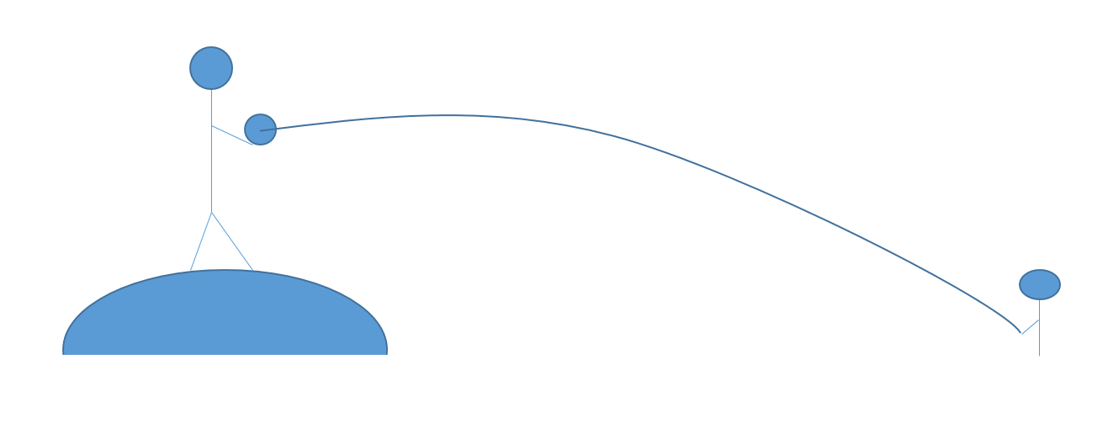

The above picture is of a $1.5kg$ baseball being thrown by a pitcher at a height of toward a catcher who catches the ball at a height of $0.5m$, both heights from the surface of the earth.

1) Find the work done on the ball by the Earth.

1. Explain what mathematical process you are going to use to answer the question and why.

1. Explain what physical relationship we going to use.
2. With the above relationship finish the problem.

Name:

Date:

Homework 2 (Draft 2)

Remember to keep your work simple, direct, specific, precise and consistent.



The above picture is of a $0.15kg$ baseball being thrown by a pitcher at a height of $1m$ toward a catcher who catches the ball at a height of $0.25 m$, both heights from the surface of a planet with a varying gravitational force equal to Newton’s gravitational force. The planet which has a radius of $100m$ and a mass equal to Earth’s.

1) Find the work done on the ball by the planet.

1. Explain what mathematical process you are going to use to answer the question and why.

1. Explain what physical relationship we going to use.
2. With the above relationship finish the problem.

How does homework 2 address the following questions:

1. The conceptual understanding of mathematics?

Work in physics is a discrete relationship $dW=F∙dr$ where W is work, F is force, and r is distance. To find the work done over a distance requires using an integral to sum up all of the discrete works done.

1. The differences between math in a mathematics context and math in a physics context?

In math the integrand, variable of integration, and bounds of the integral are typically given. Here the student must decide the integrand of the integral using the definition of work, determine the force asked for, decide what variable to integrate with respect to from the definition of work, decide a zero point in the problem and then finally determine the bounds of integration.

### Homework 4

Name:

Date:

Homework 4 (Draft 1)

Remember to keep your work simple, direct, specific, precise and consistent.

Consider a basketball 2m from the surface of the earth, which is falling toward the Earth and then bounces. Every time the basketball impacts the surface of the earth the ball stops short of its previous height by 50 percent.

1. What mathematical concept would we use for figuring out the total distance traveled by the basketball and why is that appropriate?
2. Using the concept above, would we be able to find a finite value for how far the basketball travelled?
3. How would the last 2 questions differ if the basketball returned it its original height after each bounce?

### Homework 5

Name:

Date:

Homework 5(Draft 1)

Remember to keep your work simple, direct, specific, precise and consistent.

1. Find the Taylor series of f(x) = $e^{x}$.
2. Plot the first 3 Taylor Polynomials (the 0th, 1st , and 2nd degree Taylor Polynomials) for f(x) = $e^{x}$ and discuss what happens as you add more terms of the Taylor series to the graphs.
3. In thermal dynamics there is a statistical distribution of the form $f\left(x\right)=\frac{1}{e^{x}-1}$. Using the first 2 questions above when would it be appropriate to approximate the distribution as f(x) = $\frac{1}{x}$?

Homework 5(Draft 2)

Remember to keep your work simple, direct, specific, precise and consistent.

1. Find the Taylor series of f(x) = $e^{-x}$.
2. Plot the first 3 Taylor Polynomials (the 0th, 1st , and 2nd degree Taylor Polynomials) for f(x) = $e^{x}$ and discuss what happens as you add more terms of the Taylor series to the graphs.
3. In thermodynamics there is a statistical distribution of the form $f\left(x\right)=\frac{1}{e^{x}-1}$. Using the first 2 questions above when would it be appropriate to approximate the distribution as f(x) = $\frac{1}{x}$? Use a few graphs to argue decide appropriateness.

Proposed Answer key

1. Find the Taylor series of f(x) = $e^{x}$.

Taylor series for $e^{x}=\sum_{k=0}^{∞}{x^{k}}=1+x+x^{2}+…$

1. Plot the first 3 Taylor Polynomials for f(x) = $e^{x}$ and discuss what happens as you add more terms of the Taylor series.

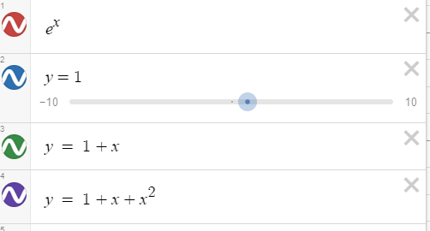

The graphs of each function are shown in the order that they appear above.

Graph of the function

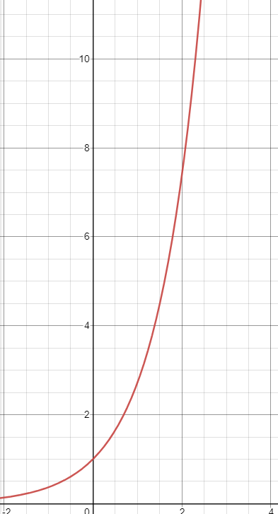

0th degree Polynomial

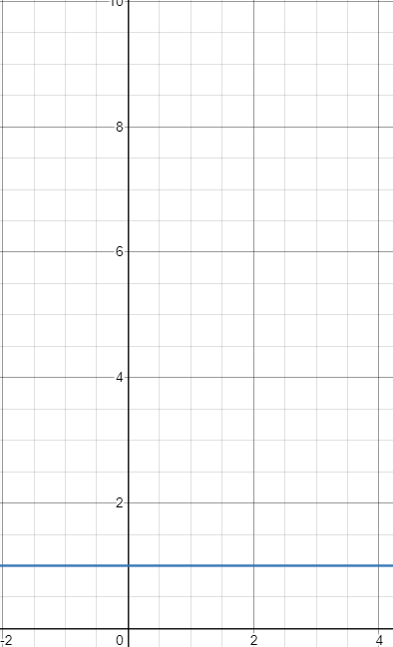

1st degree Polynomial

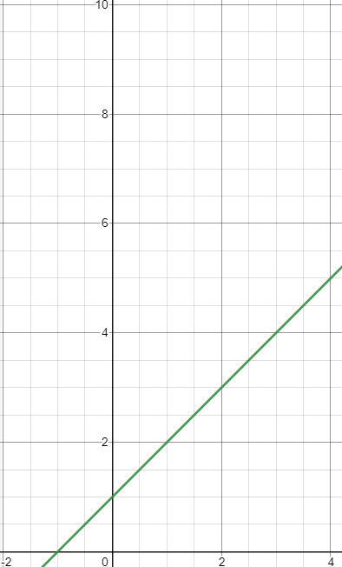

2nd degree Polynomial

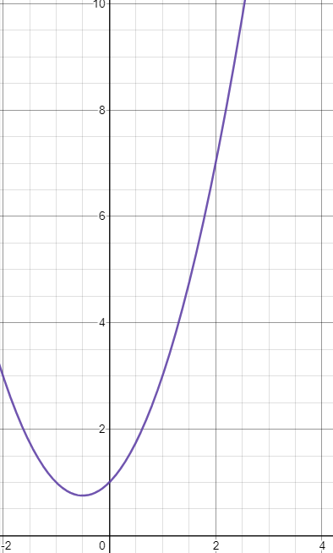

All 4

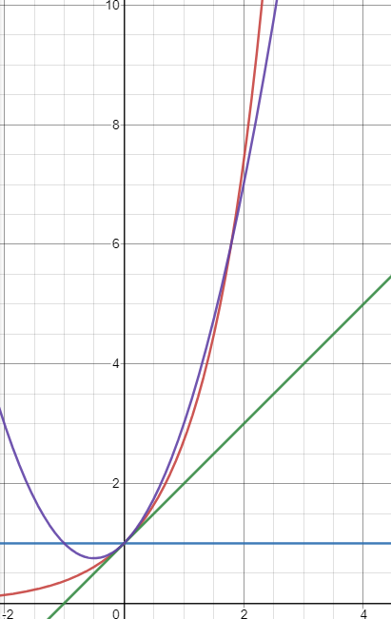

As more terms of the Taylor series are added the more the graph overlap. That is, the 2nd degree Taylor polynomial is a better approximation for the function than either the 0th or 1st degree Taylor polynomial.

1. In thermal dynamics there is a statistical distribution of the form $f\left(x\right)=\frac{1}{e^{x}-1}$. Using the first 2 questions above when would it be appropriate to approximate the distribution as f(x) = $\frac{1}{x}$ or would this approximation be appropriate at all?

If we apply the 1st degree Taylor polynomial approximation to $e^{x}$ then we would be able to approximate $\frac{1}{e^{x}-1}$ as $\frac{1}{x}$. This would only be appropriate for small values of x as can bee seen on the following graph (the smaller the x the better the graphs of the two functions overlap).

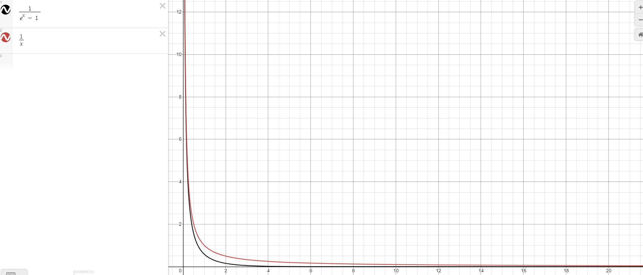

How does homework address the following questions:

1. The conceptual understanding of mathematics?

In physics we often use Taylor series approximations of sin(x), cos(x), tan(x), $e^{x}$, $\ln\left(1+x\right)$, and (1+x)n. This homework explores the validity of these approximations through graphing. Then we explore the usefulness of the approximation by looking at an example from thermal dynamics. For more difficulty or less I could add more of the functions above to the homework above or choose an easier function.

1. The differences between math in a mathematics context and math in a physics context?

Not the focus of this homework.

### Homework 6

Name:

Date:

Homework 6 (Draft 1)

Remember to keep your work simple, direct, specific, precise and consistent.

1. A student, Jamie, suggests the following Taylor series expansions for $e^{x}$: $\sum_{i=0}^{∞}{\frac{x^{i}}{i!}}$ contends that $e^{2}$ = $\sum_{i=0}^{∞}{\frac{2^{i}}{i!}}$.

The following conversation then arises between James, Roxanne, and Deante:

James states, “The Taylor series expansion is wrong here, so Jamie is wrong about saying $e^{2}$ = $\sum_{i=0}^{∞}{\frac{2^{i}}{i!}}$.”

Roxanne says, “The Taylor series expansion is correct, but the interval of convergence for the infinite series does not include 2, so Jamie’s contention is incorrect.”

Deante’s responses, “Jamie’s contention is correct, both the Taylor series is valid and 2 is in the interval of convergence.”

Which, if any, of the students are correct? If a student is incorrect state why. If in agreement with a student explain.

1. A physics student is collecting the height of a the mass in an oscillating pendulum, starting their measurement at where the string is connected to the post and the object’s position relative to the initial position the object is dropped at. Using geometry the student converts the latter data to an angle and plots the height of the mass as angle changes using Excel.

The following polynomial is produced from Excel’s curve fitting options and the student wonders if it is related to the Taylor Series of a well-known function.

$$y = -0.9+0.6 {\left(x-pi\right)}^{2}- .05{\left(x-pi\right)}^{4}$$

Help the student find a function or explain why it is not possible.

1. In physics there is a typically toy problem that mechanics students regularly contend with: the simple pendulum. The simple pendulum is a mass of small magnitude connected to an ideal string hanging from a frictionless hook in a vacuum. From this scenario the following differential equation arises:

$$θ_{tt}-\frac{m}{L}sin{θ=0}$$

$θ is the angle the mass is from equlibrium$

$θ_{tt} is the angluar accelaeration of the mass$

$m is the mass^{'} value in kg$

$L is the length of the string in m.$

Could we reasonably use a Taylor series approximation here?

If yes, what would the equation tell us about the simple pendulum?

### Homework 7

Name:

Date:

Homework 7(Draft 1)

Remember to keep your work simple, direct, specific, precise and consistent.

1. Rank the following complex numbers by their magnitudes from greatest to least. Then explain your reasoning for the ranking.

$Z_{1}=5$

$Z_{2}=-5i$

$Z_{3}=4+ 3i$

$Z_{4}=5e^{-iθ}$

Greatest` Least

|  |  |  |  |
| --- | --- | --- | --- |
|  |  |  |  |

Explanation:

1. If $z_{1}=4+3 i$ and $z_{2}=5-12 i$ Calculate the magnitude of $\frac{z_{1 }}{z_{2}}$ in 2 ways with the first steps being:
2. Leave the ratio in rectangular coordinates.
3. Convert the denominator and numerator into polar coordinates.

Compare the 2 processes above by stating which one is more difficult in your opinion and why.

Finally, produce an Argand diagram of $\frac{z_{1 }}{z_{2}}$ including information about $θ,r,x and y$.

1. From the following Argand diagram find the complex number in polar form then label r, $θ,$ and the complex conjugate.

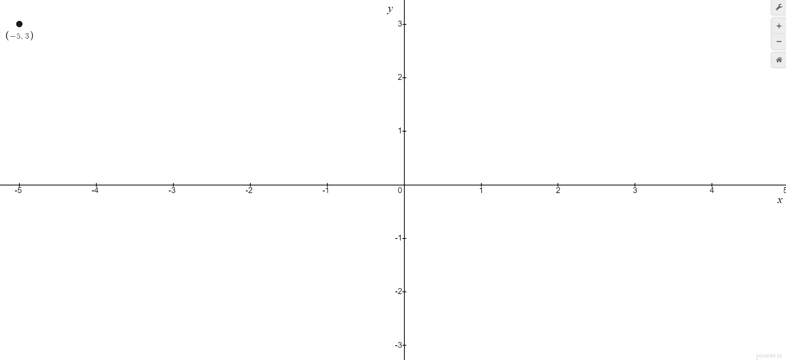

### Homework 8

Name:

Date:

Homework 8 (Draft 1)

Remember to keep your work simple, direct, specific, precise and consistent.

1. The following function is the real portion of a complex analytic function and is presented to several students:

$$u\left(x,y\right)=y(x-\frac{x^{3}}{2!}+\frac{x^{5}}{4!}-\frac{x^{7}}{6!}+…)$$

Brock states the full complex function is

$$f\left(z\right)=yxcos\left(x\right)+i [\frac{y^{2}\left(\cos\left(x\right)-xsin\left(x\right)\right)}{2}]$$

Then the following student conversation ensues.

Jeremy states, “The real function Brock supposes is not the same as the given real function so this cannot be correct.”

Linda responds, “This is the correct real function, Brock replaced the given real function using the Taylor series to replace the series with the function cos(x), but the imaginary portion is incorrect due to using the Cauchy-Riemann equations incorrectly.”

Slavoj replies, “The complex function is correct. The real portion is appropriately decided by Brock as Linda says, but the Cauchy-Riemann equations were applied correctly.”

Which if any of the students is correct? For the students you disagree with explain the problem(s) with their contention.

### Homework 9

Name:

Date:

Homework 9(Draft 1)

Remember to keep your work simple, direct, specific, precise and consistent.

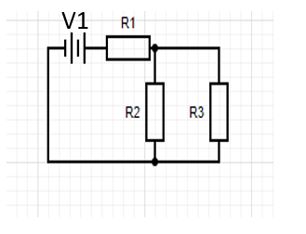

From the above circuit an augmented matrix was produced by Jeremy:

$$\begin{matrix}5Ω & 5Ω & 0 \\ 5Ω & 0 & 3Ω+2Ω \\ 0 & -5Ω & 3Ω+2Ω\end{matrix} \begin{matrix}12V \\ 12V \\ 0V\end{matrix}$$

1. Determine which loop corresponds to which row in the matrix, and explain how you know.
2. If possible, determine the value for V1, R1, R2, and R3 and explain how you know. If it is not possible to determine a V1, R1, R2, or R3 explain why.
3. Find the currents throughout the whole circuit and indicate on the diagram which current is in which part of the circuit.

## Group: Concept Heavy

### Homework 10

­­Name:

Date:

Homework 10 (Draft 1)

Remember to keep your work simple, direct, specific, precise and consistent.

The following questions are concept questions pertaining to matrices. Explain each answer to each question fully. A and B are both matrices.

1. Why is AB ≠ BA in general?

1. Which matrices have corresponding determinants and why? Be as specific as possible.

1. Which kind of matrices do not have corresponding determinants?

1. Is A* + A generally a matrix with real elements? Then compare this to adding a real number and its own conjugate.

1. What is similar between a general upper triangular matrix and a lower triangular matrix?

### Homework 11

Name:

Date:

Homework 11 (Draft 1)

Remember to keep your work simple, direct, specific, precise and consistent.

Categorize the following differential equations and give a method that can solve them. If we did not learn a method to solve the DE state that.

$$y^{''}+xy^{'}+x^{2}y=\cos\left(x\right)$$

Method:

$${y^{'''}}^{2}=xy$$

Method:

$$x\frac{∂^{2}u(x,t)}{∂x^{2}}=t{\left(\frac{∂^{2}u\left(x,t\right)}{∂t^{2}}\right)}^{2}$$

Method:

### Homework 12

Name:

Date:

Homework 12 (Draft 1)

Remember to keep your work simple, direct, specific, precise and consistent.

Solve the following partial differential equations using the method of separation of variables.

$$\frac{∂^{2}u\left(x,t\right)}{∂x^{2}}=\frac{∂^{2}u\left(x,t\right)}{∂t^{2}}$$

Solve the following differential equation using the method of variation of parameters.

$$y^{''}+xy^{'}+2y=e^{x}$$

This is intended to have the students use the ideas in class that there were not homework over.

### Homework 13

Name:

Date:

Homework 13 (Draft 1)

Remember to keep your work simple, direct, specific, precise and consistent.

1. How is a scalar and a vector with one component different?
2. What kind of output (i.e. scalar, matrix, vector, etc.) does multiplying a vector by a scalar have?
3. What kind of output (i.e. scalar, matrix, vector, etc.) does multiplying a vector by a by a matrix have?
4. What kind of output (i.e. scalar, matrix, or vector) does multiplying (remember there are 2 ways to do this) a vector by a vector have?
5. Describe a possible physical scenario for a 3 kg ball in the cartesian plane from the following displacement, velocity, and acceleration vectors:
$$\vec{r}=(3m,2m) \vec{v}= (0\frac{m}{s},2\frac{m}{s}) \vec{a}= (0\frac{m}{s^{2}} ,-1\frac{m}{s^{2}})$$

6. How does the above physical scenario change if the ball was in the polar plane?

# Discussions

These are notes from discussions with Dr. Maloney.

## Discussion from Mathematical Physics (2021)

### September 6th

* Focus on differences in math in math class vs math in physics courses
* Read articles by Joe Reddish in The Physics Teachers

### September 27th

* Focus better on showing my understanding of physics
* More contextual information
* Make homework realistic
* Physical scenario show focus on some mathematical tool, prompt students to ask how and why the tool is useful here
* Attempting to get students to build a tool in 1 task will not work as research shows
* Physics students do not think of proofs as cornerstones in the way mathematicians do
* A group of tasks should have an overall focus, does not mean the physics for each task will be the same
* Problems have an element of novelty, that is what makes them a problem
* Physics problems can take the form of a physical representation, a pictorial representation, and a mathematical representation. Problems can involve transferring from one representation to another, but including too many representations can be counter productive

### October 11th

* Class Structure
  + Not researched by Dr. Maloney
  + Had to choose most useful topics to deal with
  + Limited foci
* Important to choose topics and how to present them
* Do NOT do the thinking for the student
* Self-Explanation:
  + Given solved problems is not phased in my college professors yet.
    - This is due to profs being experts in the field; not pedagogical experts.
    - Changing this requires effort and part of this is due to the system of having professors hired to do research.
* Not complexity scale for difficulty of material
  + Dr. Maloney perhaps does this subconsciously
  + Dr. Maloney has knowledge of what is reasonable, what will work
  + This is an unreason scale to produce as it will be different for each student.
* Every time class is ran Dr. Maloney is probing the class for student positioning and with experience can anticipate common obstacles

## Discussions from Thermal (2020)

### September 25th

* A problem should examine a physical scenario using:
  + Graphs, math (equations, unknowns), words, pictorial representations
* Typical in Undergrad problems go from words to equations to unknowns
* To test understanding translate between representations
* Do not need to ask difficult questions , try to challenge understanding:
  + Ask difficult questions about simple things
  + Does not have to be creative

### October 9th

* Good to explicitly state, explain and justify answers
* Toss in an illegitimate question(s) to remove process of eliminations and expectation of only meeting instructor’s requirements
* “I know what is going on, I can’t explain it” is impossible. Explanations are the importance of the task.
* Asking questions is tough, never possible to be absolutely clear; do not want the majority to wrestle with what is being asked

### October 23rd

* A complete explanation is one such that a bright niece studying physics can follow the explanation without difficulty
* Produce definite and clear connections between representations
* Work on explaining; remove the rote memorization
* Important to write down questions for the bright niece as well

### October 28th

* We giving students a solved problems put in an error, reorder. Preface questions with “A student has proposed the following reasoning”
* If there are errors, explain the steps or where the student went wrong. “How do I know that was legitimate?”, “Is this a full argument?”
* When asking what to teach in a class 7 researchers would give 8 answers, but all would agree that reducing the content would be an improvement.
* Content it not all that important as long as you give a limited set of information and the student enough time to think about the ideas
* Eternal constrains will help, for example, look at what students need or later professional activities. What they do not need, dump it.
* Professors expect too much; the firehose approach does not allow thinking through it for the student
* If students have a bad HS experience in science they did worse in college. If the learned how to learn they did better

# Summaries

From reading several articles found in journals and online I’ve collected produces some summaries that will be added later.

### Using Math in Physics: Overview

By Joe Reddish

Summary:

Symbols in physics have relationships with reality that *blend* physical knowledge and understanding of mathematical elements. For example, mass is mathematically treated as a constant and physically the property of an object with the standard unit of kilograms. This blending allows for mathematics to be used as a tool for explaining in a physics course as opposed to for calculating in a mathematics course.

The mathematical tool belt as described by Reddish:

1. Dimensional Analysis
2. Estimation
3. Anchor equations
4. Toy models
5. Function dependence
6. Reading the physics in a graph
7. Telling the Story

### Using Math in Physics: Dimensional Analysis

### The Structure and Function of an Explanation