This is a test word Document!

This is a 7x5 table

This also includes images!
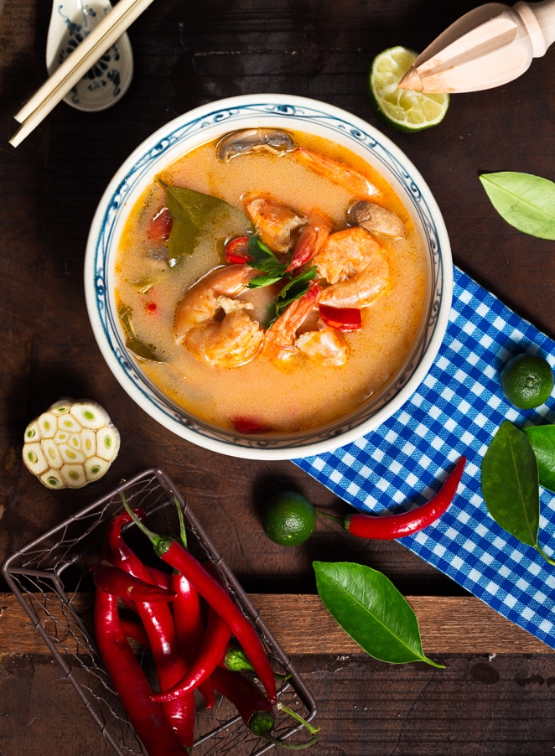

Everyone loves soup, right!?

