# This is a test word Document!

|  |  |  |  |  |  |  |
| --- | --- | --- | --- | --- | --- | --- |
| This is a 7x5 table |  |  |  |  |  |  |
|  |  |  |  |  |  |  |
|  |  |  |  |  |  |  |
|  |  |  |  |  |  |  |
|  |  |  |  |  |  |  |

This also includes images!

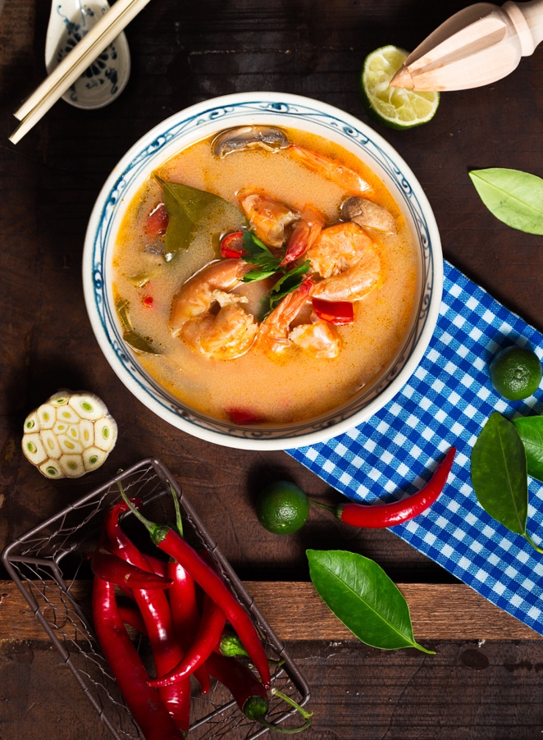

Everyone loves soup, right!?