Final Report

Grant NAG5-8009

Prepared by D. F. Smart and M. A. Shea
Center for Space Plasmas and Aeronomic Research
The University of Alabama in Huntsville
Huntsville, Alabama 35889

Synopsis. The access of charged particles to the earth from space through the geomagnetic field has been of interest since the discovery of the cosmic radiation. The early cosmic ray measurements found that cosmic ray intensity was ordered by the magnetic latitude and the concept of cutoff rigidity was developed. The pioneering work of Störmer (1930, 1955) resulted in the theory of particle motion in the geomagnetic field, but the fundamental mathematical equations developed have "no solution in closed form". This difficulty has forced researchers to use the "brute force" technique of numerical integration of individual trajectories to ascertain the behavior of trajectory families or groups. This requires that many of trajectories must be traced in order to determine what energy (or rigidity) a charged particle must have to penetrate the magnetic field and arrive at a specified position. It turned out the cutoff rigidity was not a simple quantity but had many unanticipated complexities that required many hundreds if not thousands of individual trajectory calculations to resolve. The accurate calculation of particle trajectories in the earth's magnetic field is a fundamental problem that limited the efficient utilization of cosmic ray measurements during the early years of cosmic ray research.

As the power of computers has improved over the decades, the numerical integration procedure has grown more tractable, and magnetic field models of increasing accuracy and complexity have been utilized. These improvements have made the general application of the numerical integration procedure more practicable and while the cutoff rigidity problem is still formidable, thousands of trajectories can be computed without the expenditure of excessive resources.

This report is documentation of a general FORTRAN computer program to trace the trajectory of a charged particle of a specified rigidity (momentum per unit charge) from a specified position and direction through a model of the geomagnetic field. This software has been incorporated into a general control program that makes the computation of a number of trajectories to scan through a rigidity interval to determine the cutoff rigidity of a specified location. The input control file may contain as many locations as deemed necessary for a specific study.

This report is organized in sections. Section I gives a scientific background. Section II gives program documentation for three versions of the program. Section III provides examples of the data input and examples of the program output for the station selected. Section IV is an appendix describing rigidity to energy conversion with tables and demonstration programs. The final section is a listing of the trajectory program FORTRAN source codes (with added line numbers).

This document is also included on a IOMEGA 100 MB ZIP disk, and the FORTRAN source code is also provided on a 1.44 MB 'floppy' disk.

1.1 Historical Background

The integration of the equation of motion of a charged particle in a magnetic field is a problem that has no solution in a closed form. The first numerical efforts at integration of the equations of particle motion began with Störmer (1930) who utilized a dipole representation of the earth's magnetic field. The work of Störmer is summarized in his book 'The Polar Aurora' (Störmer, 1950). Lemaitre and Vallarta (1936 a,b) used a "Bush differential analyzer" (what would now be called an analog computer) to obtain solutions for entire families of trajectories. Jory (1956), Lust (1957), and Kasper (1959) were among the first researchers to utilize the digital computer as a tool for trajectory calculations in a dipole magnetic field. More advanced magnetic field models were utilized by McCracken and his co-workers (McCracken et al., 1962, 1965, 1968). These workers were very successful in the use of high speed digital computers for the calculation of cosmic ray trajectories in high order simulations of the geomagnetic field. They calculated particle access to specific cosmic ray stations on the earth to describe the cosmic ray anisotropy and also showed that the observed cosmic ray intensity could be well ordered by geomagnetic cutoff rigidities derived from cosmic ray trajectories calculated in high order simulations of the earth's magnetic field (Shea et al., 1965). They also demonstrated that the earth's internal magnetic field is evolving (quite rapidly on geologic time scales), and that the use of updated magnetic field models is necessary to explain the changes observed in cosmic ray intensity in some areas of the world (Shea and Smart, 1970, 1990; Mischke et al., 1979). This is necessary because the earth’s geomagnetic field evolution is not uniform, and sudden changes (called geomagnetic “jerks”) have been found in the Earth’s magnetic field (Langel et al., 1986; Macmillan, 1996).

Advances in computer technology over the past decades have allowed researchers to more fully utilize the trajectory-tracing technique. As computers become more powerful, magnetic field models of increasing complexity, which better represent the earth's magnetic topology, have been developed and must be utilized for analyses of the higher precision measurements of cosmic radiation phenomena. As long as the measurement techniques increase in accuracy and as long as the geomagnetic field models continue to improve, the trajectory-tracing process will be used for cosmic radiation research.

1.2. The Equations Involved

1.2.1 The Charged Particle Equation of Motion

The equation of charged particle motion in a magnetic field may be written in vector form as

•• •
r = (e / m c) r × B.

•• •
In this equation, r is the particle acceleration, r the particle velocity, and B the magnetic field vector. The electronic charge is denoted by e, m is the particle’s relativistic mass, and c is the speed of light.v This equation, when expressed in r, θ, φ coordinates, results in three simultaneous differential equations with six unknowns.

dv_{r} = e (v_{θ} B_{φ} - v_{φ} B_{θ}) + v_{θ}² + v_{φ}²
⎯ ⎯ ⎯ ⎯
dt m c r r

dv_{θ} = e (v_{φ} B_{r} - v_{r} B_{φ}) - v_{r} v_{θ} + v_{φ}²
⎯ ⎯ ⎯ ⎯⎯
dt m c r r tanθ

dv_{φ} = e (v_{r} B_{θ} - v_{θ} B_{r}) - v_{r} v_{φ} - v_{θ} v_{φ}
⎯ ⎯ ⎯ ⎯⎯
dt m c r r tanθ

In these equations the particle velocity terms are

dr = v_{r}
⎯
dt

dθ = v_{θ}
⎯ ⎯
dt r

dφ = v_{φ}
⎯ ⎯⎯
dt r sinθ

This system of simultaneous linear differential equations can be integrated numerically if the components of magnetic induction B_{r,} B_{θ,} B_{φ,} are known as explicit functions of r, θ, φ. The method chosen by McCracken et al. (1962) to solve the above system of equations was fourth order Runge-Kutta integration (Ralston and Wilf, 1960). In this numerical integration process, when the magnetic field is known (see next section), a knowledge of the position and velocity coordinates on one point of the trajectory is used with the differential equations of motion to give the coordinates of subsequent points along the trajectory. Repeated application gives sufficient points to locate the trajectory in space. Adaptive step size control (see section 1.2.3.1) can make the process more efficient. This is sometimes called fifth order Runge-Kutta (see Press et al., 1989).

1.2.2 Computing the Earth's Magnetic Field

Computation of a high order simulation of the earth's magnetic field is a computer intensive process and to the surprise of many, even more demanding of computer resources than integration of particle trajectories.

If the field being modeled is composed of only internal sources, then it is possible to define a magnetic potential, V, that can be expanded in spherical harmonics.

∞ _{n}
V(r, θ, φ) = a Σ (a/r)^{n+1} Σ [ g^{m}_{n} cos mφ + h^{m}_{n} sin mφ ] P^{m}_{n} ( cos θ )
^{n=1 m=0}

In this equation g^{m}_{n} and h^{m}_{n} are the Gauss coefficients describing the magnetic field, P^{m}_{n} ( cos θ ) are the Schmidt-normalized associated Legendre polynomials, and a is the average radius of the earth. In the dipole case, the expansion results in simple algebraic equations in r, θ, φ that can be repeatedly evaluated to quickly find a solution for a specific trajectory initiated from a specified direction at a specific energy. However, as the complexity of the magnetic field expansion increases, the number of terms to be evaluated increases as n!. For a 10th order description of the earth's main magnetic field as provided by the International Geomagnetic Reference Field (IGRF, 1992; Sabaka, 1997), about 90 percent of the computer processing time is consumed in evaluating the magnetic field and only about 10 percent of the CPU time utilized in integrating the particle equation of motion. The most efficient computer techniques available for evaluating the Legendre polynomial expansion involve using the derivative of the previous term to obtain the current term, a process that is inherently serial. The use of the recursion process is about an order of magnitude slower. (All attempts to develop a very efficient parallel-processing algorithm to evaluate magnetic fields have so far met with failure.)

1.2.3 Methods for Efficient Computation of Cosmic-Ray Trajectories.

It is difficult to calculate the trajectory of an incoming cosmic ray particle through the magnetic field and expect to intersect the exact location for which the calculation was desired. Since the path of a negatively charged particle of a specific magnetic rigidity is identical (except for the sign of the velocity vector) to that of a positively charged particle reaching the same location in space, the common method of calculating cosmic ray trajectories in the earth’s magnetic field is to calculate the trajectory in the reverse direction. Thus for cosmic ray trajectory calculations the “starting point” of the reverse trajectory calculation is given by the geographic coordinates, direction and altitude of the location in question.

The extreme requirement of intensive computation to obtain a sufficient number of particle trajectories to evaluate cosmic ray access to a specific location on the earth or in the earth's magnetosphere may involve obtaining solutions to millions of individual cosmic ray trajectories. Therefore efficient computation is essential (and a fast computer desirable).

1.2.3.1 Variable Step Size Methods for Computation of Cosmic-Ray Trajectories.

One approach developed by Smart and Shea (1981a) was to compute a dynamic variable step length that was of the order of one percent of a particle gyro-distance in the magnetic field. This process allows computation of a simple cosmic ray trajectory from the "top" of the atmosphere to interplanetary space in about 100 Runge-Kutta iterations. Complex trajectories, or trajectories of low rigidity (rigidity is momentum per unit charge) take correspondingly more iterations. The gyro-radius of a charged particle in a magnetic field is given by

ρ = 33.33 R / B.

In this equation ρ is the particle gyro-radius in km, R is the particle rigidity in units of GV, and B is the magnitude of the magnetic field in units of Gauss.

The particle velocity can be specified as the ratio of the particle speed to the speed of light (v/c) and designated by the symbol β which can be derived from the relativistic factor, γ, as follows:

β = [ 1.0 - ( 1.0 / γ² ) ]^{1/2},

and
γ = { [ ( R Z ) / ( m_{o}c² A ) ]² + 1.0 }^{1/2},

where R is the particle rigidity, Z the atomic charge, A the atomic number and m_{o}c² is the rest mass energy.

1.3. Characteristics of Cosmic-Ray Trajectories in the Earth’s Magnetic Field

To examine the characteristic behavior of cosmic ray trajectories in the earth’s magnetic field we consider trajectories of cosmic ray particles with different energies as these trajectories are calculated from a location at the top of the atmosphere outward into the magnetic environment surrounding the earth. The trajectory for a very high-energy particle propagating outward through the earth’s magnetic field will reach interplanetary space with a minimum of geomagnetic bending. As the charged particle energy decreases, then it will undergo more geomagnetic bending before it can escape. At some lower energy, it will no longer have sufficient momentum to escape the magnetic field and in these cases the particle trajectory initiated in an outward direction near the top of the atmosphere, will re-enter (i.e. intersect the solid earth). The presence of a solid object in the magnetic field complicates the problem, and an analytical description of the phenomena becomes even more complicated if the solid object is not centered in the magnetic field.
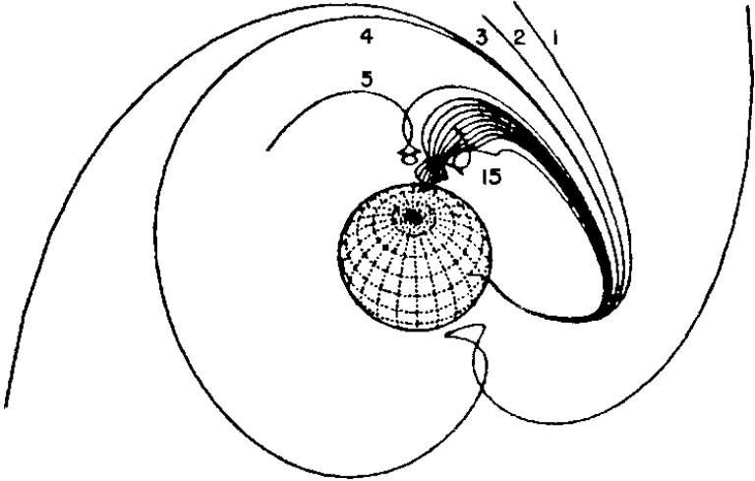

Figure 1. Illustration of charged particle trajectories of different energies (rigidities) traced out in the vertical direction from the same location. The trajectories undergo increased geomagnetic bending as the particle energy (rigidity) is decreased. Charged particle trajectories near the cutoff rigidity develop intermediate loops and become complex. In the cosmic ray penumbra, some trajectories are re-entrant, and some are allowed. See text for more details.

Some actual trajectory calculations are illustrated in Figure 1. All of the trajectories in this Figure were initiated in the vertical direction from the same location. The trajectories labeled 1, 2, and 3 show increasing geomagnetic bending before escaping into space. The trajectory labeled 4 develops intermediate loops before escaping. The lower energy trajectory labeled 5 develops complex loops near the earth before it escapes. As the charged particle energy is further reduced, there are a series of trajectories that intersect the earth (i.e. re-entrant trajectories). In a pure dipole field that does not have a physical barrier embedded in the field, these trajectories may be allowed, illustrating one of the differences between Störmer theory and trajectory calculations in the earth’s magnetic field. Finally the still lower energy trajectory labeled 15 escapes after a series of complex loops near the earth. These series of allowed and forbidden bands of particle access are called the cosmic ray penumbra. They also illustrate an often-ignored fact that cosmic ray geomagnetic cutoffs are not sharp (except for special cases in the equatorial regions).

1.3.1 Cutoff Rigidities

Our procedure for determining geomagnetic cutoff rigidities is to make trajectory calculations at discrete intervals through the rigidity spectrum with the assumption that the results of a specific trajectory at a specific rigidity are characteristic of adjacent trajectories at very slightly different rigidities or direction. These calculations begin at high rigidities (at a value above the highest possible cutoff) and progress down through the rigidity spectrum until the lowest possible allowed trajectory has been found. An examination of the characteristics of particle trajectories from high rigidities to low rigidities will show definitive fiducial marks. These are the first discontinuity in asymptotic direction, the first forbidden trajectory, and perhaps a range of allowed and forbidden trajectories called the cosmic ray penumbra, and the lowest allowed trajectory. In the cosmic ray penumbra, the highest rigidity forbidden band is called the “first forbidden band” (see Smart et al., 2000, for more discussion). We currently use three parameters to describe a geomagnetic cutoff rigidity. These are:
R_{u} The upper cutoff which is the rigidity of the last allowed before the first forbidden trajectory,
R_{l} The lower cutoff which is the rigidity of the last allowed trajectory in a decreasing rigidity scan, and
R_{c} The effective cutoff which is an average between R_{u} and R_{l} that accounts for the transparency of the penumbra.
A more detailed explanation of the characteristics of geomagnetic cutoffs derived from trajectory calculations is given by Cooke et al. (1991). Figure 2 illustrates cosmic ray penumbra structure and geomagnetic cutoffs determined by trajectory calculations for three North American neutron monitor stations.

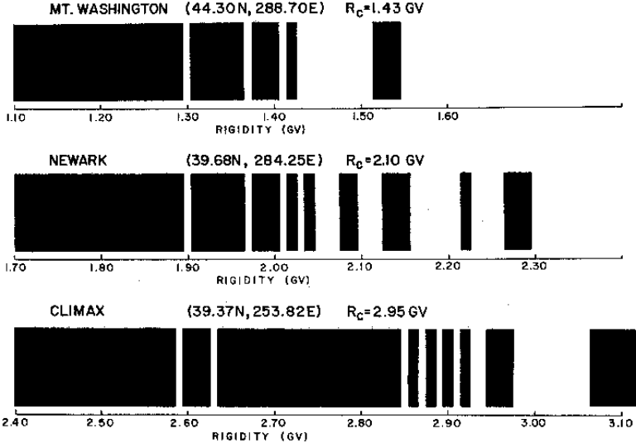
Figure 2. Illustration of trajectory-derived cosmic ray cutoff and the cosmic ray penumbra structure in the vertical direction. The calculations have been done for three North American neutron monitor stations. White indicates allowed rigidities, black indicates forbidden rigidities.

Since there are chaotic structures in the penumbral region with very small features there is no certainty that all features are identified in a rigidity scan. It is possible that we might not identify very small penumbral bands near the cutoff. When scanning the asymptotic directions that represent the interplanetary terminus of these trajectory calculations as a function of rigidity, there is a systematic increase in asymptotic longitude as the rigidity is decreased, until very near the cutoff there is a discontinuity in asymptotic direction. We have found that whenever there is a discontinuity in asymptotic direction and we investigate the rigidity region in minute detail, there is a forbidden (re-entrant) trajectory associated with the discontinuity. Therefore, the first discontinuity in asymptotic direction is always the start of the penumbra. Continuing downward through the penumbra and calculating trajectories for particles having successively lower rigidities results in a last allowed trajectory that identifies the lower rigidity end of the cosmic ray penumbra.

1.3.2 Asymptotic Directions of Approach

If we follow a charged particle trajectory away from the earth, the amount of geomagnetic bending per unit path length decreases. In a magnetic field extending to infinity, it can be said that the particle direction asymptotically approaches its final direction. If we introduce a boundary such as the magnetopause, we often use the same terms to describe the direction of the particle velocity vector at the penetration location. (Ruth Gall in her work was most specific that these were directions of approach.) McCracken and co-workers (McCracken et al., 1968; Shea et al., 1965), performed calculations in internal magnetic fields and utilized the particle velocity vector (expressed in geocentric coordinates at radial distance of 25 earth radii) to specify the asymptotic direction of approach. The set of asymptotic directions accessible to a specific location on the earth defines the asymptotic cone of acceptance. The asymptotic longitude can exceed 360 degrees. Large asymptotic longitudes are indicative of how many times the trajectory has circumnavigated the earth during its transit.

In early work on trajectory calculations Kasper (1959) found the “focusing effect” of the magnetic field where trajectories initiated outward from the earth with different azimuth and zenith angles of incidence (at high latitudes, within a factor of two above the cutoff rigidity) reached a similar final asymptotic direction at distances far from the earth. This “focusing effect” which is valid when the scale size of the gradient in the earth’s magnetic field is less than the particle gyro-radii, also leads to the concept that asymptotic directions computed for vertically arriving particles are a good approximation of the entire asymptotic cone of acceptance.

For polar or even mid-latitude muon detectors that only respond to high-energy particles, these asymptotic cones of acceptance are restricted to specific regions of the celestial sphere. Thus if multiple stations simultaneously observe an anisotropic solar cosmic ray flux, it is possible to deconvolve the flux direction in space and the anisotropy (see Cramp et al., 1995). If these stations are located at different geomagnetic cutoffs, it is possible to deduce the solar particle spectra. Similarly, if a number of cosmic ray stations, each having asymptotic cones of acceptance viewing a different portion of the celestial sphere, rotate through a slowly evolving cosmic ray anisotropy, then it is possible to deconvolve the spatial anisotropy. (See Nagashima and Fujimoto, 1994, for an example of this application.) The asymptotic directions of approach in the rigidity range from 20 GV to 5 GV computed for cosmic ray muon detectors for the maximum of the 29 September 1989 high-energy solar cosmic ray events are illustrated in Figure 3.

In a rigidity scan of the trajectories allowed at a specific location (cosmic ray detector) the geomagnetic bending of the particle trajectory increases as the particle rigidity decreases as illustrated in Figure 1. The amount of geomagnetic bending becomes very large as the particle rigidity approaches the geomagnetic cutoff rigidity, perhaps involving several circum-navigations of the earth. The result is an extremely broad asymptotic cone of acceptance for mid- or low-latitude stations with a large range of asymptotic longitudes involved. Figure 5 illustrates asymptotic cones of acceptance for selected neutron monitor stations projected on a spherical mapping of the earth. Note the longitudinal extent of the asymptotic cones for the Calgary, Deep River, and Goose Bay, Canada and the Hobart, Australia cosmic ray stations.

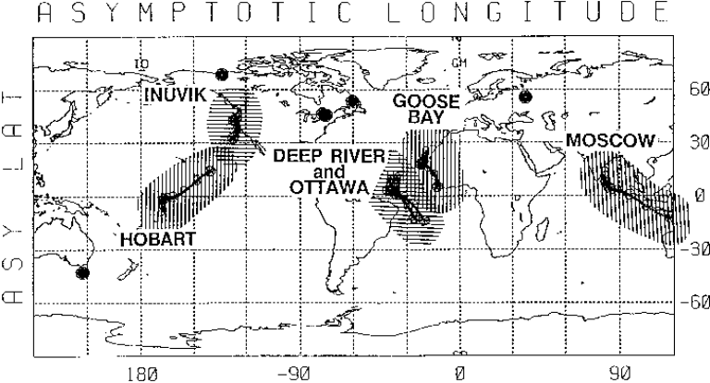
Figure 3. World map projection of the asymptotic directions of approach computed for cosmic ray muon detectors for the 29 September 1989 high-energy solar cosmic ray events.
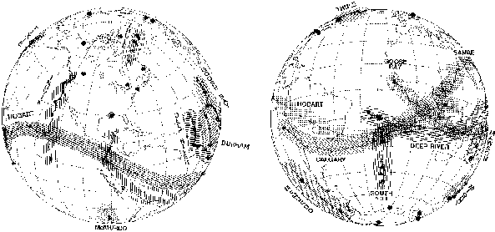
Figure 4. Asymptotic directions of approach computed for selected cosmic ray neutron monitors mapped on a spherical projection of the earth. These projections are oriented on the probable interplanetary magnetic field direction for two specific solar cosmic ray events.
Left: 29 September 1989. Right: 19 October 1989.

In the trajectory calculations, we compute a trajectory at a specific rigidity and direction and then assume that this result is representative of a finite domain of rigidity or angular space. There is the possibility that sampling the rigidity spectrum at uniform intervals such as 0.01 GV might not identify the first transition from the continuously allowed rigidities to the cosmic ray penumbral regions of alternating allowed and forbidden rigidity bands There is also the question of how valid is the approximation that a sample in one direction is truly representative of the entire asymptotic cone of acceptance for a wide variety of directions. We have no definitive answer as yet to these questions.

The problem of determining which trajectories are allowed and which are forbidden is not as simple as it might initially seem. In the internal magnetic field representations and especially in the more complex magnetospheric fields, there is a set of low rigidity trajectories that has very long path lengths, consisting of many complex loops. Often for the sake of economy of computer resources, trajectory calculations are terminated after a large number of steps. This results in groups of indeterminate trajectories whose fate is not resolved. In Störmer theory there is a special set of trajectories which will have an arbitrary number of loops before reaching a final solution. In a simple dipole field, these low rigidity trajectories having many loops were generally forbidden. Shea et al. (1965) adopted the convention of declaring these indeterminate solutions as forbidden. This convention is questionable, especially since these trajectory paths are the result of a stable magnetic field and the magnetosphere is a domain of dynamic plasma processes. Lin et al. (1995) found that their result of charged particle access to a cosmic ray detector in a balloon flown at high latitudes was consistent with defining these low rigidity indeterminate trajectories as representing allowed charged particle access through the earth’s magnetosphere. Boberg et al. (1995) considered any trajectory that originated at low altitudes and reached the altitude of a geosynchronous satellite to be allowed. Tylka et al. (1995) and Smart et al. (1999a,b,c) adopted the Boberg et al. (1995) definition in their recent work for calculating geomagnetic cutoff rigidities.

However, there are definite limits to the use of the vertically incident cosmic ray trajectories to provide an “exact” cutoff rigidity. The ‘pencil-thin’ particle beam being simulated may encounter a penumbral structure that is not truly representative of the cosmic ray access over a wider solid angle of acceptance. This leads to a ‘lumpy’ structure that may not properly order the counting rate acquired by a neutron monitor during a latitude survey. However, the time requirements of computing a complete world grid of cutoff rigidities for a variety of directions has been so formidable that the vertical cutoff approximation is the most widely used set of cutoff rigidities. Figure 5 shows the result of a trajectory derived vertical cutoff rigidity at one-degree intervals along the 285 degree East meridian from the cosmic ray knee to the cosmic ray equator. Note the irregular character of the calculated cutoff values.
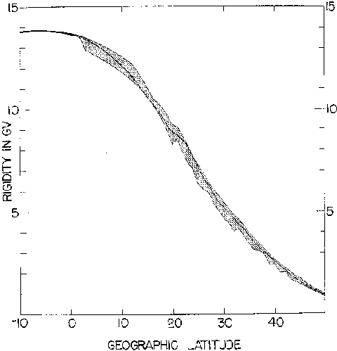

Figure 5. A set of trajectory derived vertical cutoff rigidity values, calculated at one degree intervals, along the 285-degree east meridian from the cosmic ray knee to the cosmic ray equator. Note the irregular character of the cutoff values. The upper computed cutoff, R_{u}, is indicated by the upper boundary of the shaded area; the lower computed cutoff, R_{l}, (the last allowed trajectory) is indicated by the lower boundary of the shaded area. The solid line is the ‘effective cutoff’, R_{c}, attempting to account for the transparency of the penumbra in the method as defined by Shea et al. (1965).

1.4. Accuracy of the Calculations

The accuracy of the magnetic field models employed is the limiting factor in charged particle trajectory calculations assuming that the numerical techniques yield an exact solution and the computers involved have sufficient numerical accuracy. The high order simulations of the earth’s magnetic field are better representations than the simple models.

For precise trajectories involving exact locations on the earth, then the initial directions must be specified in geodetic coordinates. See for example, Smart and Shea (1981b) for calculation of the termination of muon trajectories from the Batavia, Illinois, USA high-energy particle accelerator. For this mid-latitude location, the geodetic horizon is at an elevation angle of about ½ degree when transformed into geocentric coordinates. Shea and Smart (1983), Shea et al. (1987), and Smart and Shea (1997a) use geodetic coordinates when calculating cutoff rigidities for locations on the surface of the earth or in the earth's atmosphere, but use geocentric coordinates when calculating particle access or geomagnetic cutoff for spacecraft (Smart and Shea, 1997b). We have found a few noxious cases where, in complex particle trajectories near the cutoff rigidity, there were sudden, very small loops in the trajectory and the step size adjustment algorithm did not respond with sufficient agility to faithfully trace the trajectory. However, these cases are relatively rare. (The classic method to check the accuracy of a numerical integration procedure is to half the step length, repeat the calculation, and verify that the same solution is obtained.)

Some experimenters such as Dryer and Meyer (1975) have used the prediction of the geomagnetic cutoff derived from trajectory calculations in the design of experiments that respond to cosmic ray heavy nuclei in a specific rigidity range. These attempts have been very successful indicating that there is a general reliability in high-energy charged particle trajectory calculations in high degree simulations of the earth’s magnetic field.

1.5. Summary

The calculation of particle trajectories in the earth's magnetic field was a fundamental problem that limited the efficient utilization of cosmic ray measurements during the early years of cosmic ray research. As the power of computers has improved over the decades, the numerical integration procedure has grown more tractable, and magnetic field models of increasing accuracy and complexity can be utilized. The trajectory calculation process is sufficiently mature that it is possible to do sufficient trajectory calculation to determine and cutoff rigidities. It is now possible for experiments to be designed on the basis of trajectory calculations.

References

Boberg, P.R., Tylka, A.J., Adams, J.H., Flückiger, E.O., and Kobel, E.: 1995, ‘Geomagnetic Transmission of Solar Energetic Protons During the Geomagnetic Disturbances of October 1989’, Geophys. Res. Lett. 22, 1133-1136.
Cooke, D.J., Humble.J.E., Shea, M.A, Smart, D.F., Lund, N., Rasmussen, I.L., Byrnak, B., Goret, P and Petrou, N.: 1991, ‘On Cosmic-Ray Cutoff Terminology’, Il Nuovo Cimento 14C, 213-234.
Cramp, J.L., Duldig, M.L., and Humble, J.E.: 1995, ‘Neutron Monitor Response to Highly Anisotropic Ground Level Enhancements’, Proc. Int. Cosmic Ray Conf. 24th 4, 248-251.
Dryer, R., and Meyer, P.: 1975, ‘Isotopic Composition of Cosmic-Ray Nitrogen at 1.5 GeV/Amu’, Phys. Rev. Lett. 35, 601-604.
IGRF: 1992, ‘IGRF, 1991 Revision’, EOS, Trans. American Geophys. Union, 73 No.16, 182.
Jory, F.S.: 1956, ‘Selected Cosmic-Ray Orbits in the Earth's Magnetic Field’, Phys. Rev. 103, 1068-1075.
Kasper, J.K: 1959, ‘The Earth's Simple Shadow Effect on Cosmic Radiation’, Nuovo Cimento XI, (Supplemento) 1-26.
Langel, R.A., Kerridge, D.R., Barraclough, D.R., and Mailn, R.C.: 1986, ‘Geomagnetic Temporal Change: 1903-1982’, J. Geomag. Geoelectr. 38, 573-597.
Lemairte, G., and Vallarta, M.S.: 1936a, ‘On the Geomagnetic Analysis of Cosmic Radiation’, Phys. Rev. 49, 719-726.
Lemairte, G., and Vallarta, M.S.: 1936b, ‘On the Allowed Cone of Cosmic Radiation’, Phys. Rev. 50, 493-504.
Lin, Z., Bieber, J., and Evenson, P.: 1995, ‘Electron Trajectories in a Model Magnetosphere: Simulation and Observations under Active Conditions’, J. Geophys. Res., 100, 23543-23549.
Lust, R.: 1957, ‘Impact Zones for Solar Cosmic Ray Particles’, Phys. Rev. 105, 1827-1839.
Macmillan, S.: 1996, ‘A Geomagnetic Jerk for the Early 1990’s’, Earth Planet. Sci. Lett. 13, 189-192.
McCracken, K.G., Rao, U.R., and Shea, M.A.: 1962, ‘The Trajectories of Cosmic Rays in a High Degree Simulation of the Geomagnetic Field’, Massachusetts Institute of Technology, Laboratory for Nuclear Science, Technical Report 77.
McCracken, K.G., Rao, U.R., Fowler, B.C., Shea, M.A., and Smart, D.F: 1965, ‘Cosmic Ray Tables (Asymptotic directions, variational coefficients and cutoff rigidities)’, IQSY Instruction Manual No. 10, IQSY Committee, London.
McCracken, K.G., Rao, U.R., Fowler, B.C., Shea, M.A., and Smart, D.F: 1968, ‘Cosmic Ray Tables (Asymptotic Directions, etc.)’, Annals of the IQSY, 1,Chapter 14, 198-214. MIT Press, Cambridge
Mischke, C.F.W., Raubenheimer, B.C., Stoker, P.H., van der Walt, A.J., Shea, M.A., and Smart, D.F.: 1979, ‘Experimental Observations of Secular Changes in the Vertical Cutoff Rigidity’, Proc. Int. Conf. Cosmic Ray 16th 4, 279-284.
Nagashima, G., and Fujimoto, K.: 1994, ‘Interplanetary Magnetic Field Colliminated Cosmic Ray Flow Across Magnetic Shock From Inside of Forbush Decrease, Observed as Local-Time-Dependant Precursory Decrease on the Ground’, J. Geophys. Res. 99, 21419-21427.
Press, W.H., Flannery, B.P., Teukolsky, S.A.Vetterling, W.T.: 1989, ‘Numerical Recipes’, Cambridge University Press, London.
Ralston, A., and Wilf, S.H., Eds.: 1960, ‘Mathematical Methods for Digital Computers’, John Wiley and Sons, New York.
Sabaka, T.J., Langel, R.A., Baldwin, R.T., and Conrad, J.A.: 1997, ‘The Geomagnetic Field,1900-1995, Including the Large Scale Fields from Magnetospheric Sources and NASA Candidate Models for the 1995 Revision of the IGRF’, J. Geomag. Geoelectr. 49, 157-206.
Shea, M.A., and Smart, D.F.: 1970, ‘Secular Variation in Cosmic Ray Cutoff Rigidities’, J. Geophys. Res. 75, 3921-3922.
Shea, M.A., and Smart, D.F.: 1983, ‘A World Grid of Calculated Vertical Cutoff Rigidities for 1980.’, Proc. Int. Cosmic Ray Conf. 18th 3, 415-418.
Shea, M.A., and Smart, D.F.: 1990, ‘The Influence of the Changing Geomagnetic Field on Cosmic Ray Cutoff Rigidities’, J. Geomag. Geoelectr. 42, 1107-1121.
Shea, M.A., Smart, D.F., and Gentile, L.C.: 1987, ‘Vertical Cutoff Rigidities Calculated From the Estimated 1985 Geomagnetic Field Coefficients’, Proc. Int. Cosmic Ray Conf. 20th 4, 205-207.
Shea, M.A., Smart, D.F., and McCracken, K.G.: 1965, ‘A Study of Vertical Cutoff Rigidities Using Sixth Degree Simulations of the Geomagnetic Field’, J. Geophys. Res. 70, 4117-4130.
Smart, D.F., and Shea, M.A.: 1981a, ‘Optimum Step Length Control for Cosmic Ray Trajectory Calculations’, Proc. Int. Cosmic Ray Conf. 17th 4, 255-258.
Smart, D.F., and Shea, M.A.: 1981b, ‘Muon Trajectories from the Batavia Accelerator N-E Beam Dump’, Proc. Int. Cosmic Ray Conf. 17th 5, 6-9.
Smart, D.F., and Shea, M.A.: 1997a, ‘World Grid of Cosmic Ray Vertical Cutoff Rigidities for Epoch 1990.0’, Proc. Int. Cosmic Ray Conf. 25th 2, 401-404.
Smart, D.F., and Shea, M.A.: 1997b, ‘Calculated Cosmic Ray Cutoff Rigidities at 450 km for Epoch 1990.0’, Proc. Int. Cosmic Ray Conf. 25th 2, 397-400.
Smart, D.F., Shea, M.A., and Flückiger, E.O.: 1999a, ‘Calculated Vertical Cutoff Rigidities for the International Space Station During Magnetically Quiet Times’, Proc. Int. Cosmic Ray Conf. 26th 7, 394-397.
Smart, D.F., Shea, M.A., and Flückiger, E.O.: 2000, ‘Magnetospheric Models and Trajectories Calculations’, Space Science Rev., 93, 281-308.
Smart, D.F., Shea, M.A., Flückiger, E.O., Tylka, A.J., and Boberg, P.R.: 1999b, ‘Calculated Vertical Cutoff Rigidities for the International Space Station During Magnetically Active Times’, Proc. Int. Cosmic Ray Conf. 26th 7, 398-401.
Smart, D.F., Shea, M.A., Flückiger, E.O., Tylka, A.J., and Boberg, P.R.: 1999c, ‘Changes in Calculated Vertical Cutoff Rigidities at the Altitude of the International Space Station as a Function of Magnetic Activity’, Proc. Int. Cosmic Ray Conf. 26th 7, 337-340.
Störmer, C.: 1930, ‘Periodische Elektronenbabahnen im Feld lines Elementramagneton und ihre Anwendung auf Bruches Modellverauche und auf Eschenhagens Elementarwellen des Erdmagnetismus’. Zeits f. Astrophys. 1 237-274.
Störmer, C.: 1950, ‘The Polar Aurora’ Oxford University Press, London.
Tylka., A.J., Boberg, P.R., Adams, J.H., and Beahm, L.P.: 1995, ‘The Mean Ionic Charge State of Solar Energetic Fe Ions Above 200 MeV per Nucleon’, Astophys. J. Lett., 444, L109-L113.

Rigidity is momentum per unit charge and is a canonical unit that is especially useful in characterizing charged particle access in magnetic fields. All particles having the same magnetic rigidity, charge sign and initial conditions will have identical trajectories in the magnetic field, independent of elemental or isotopic composition, particle mass or atomic charge.

