**Ortholog Analysis Procedure**

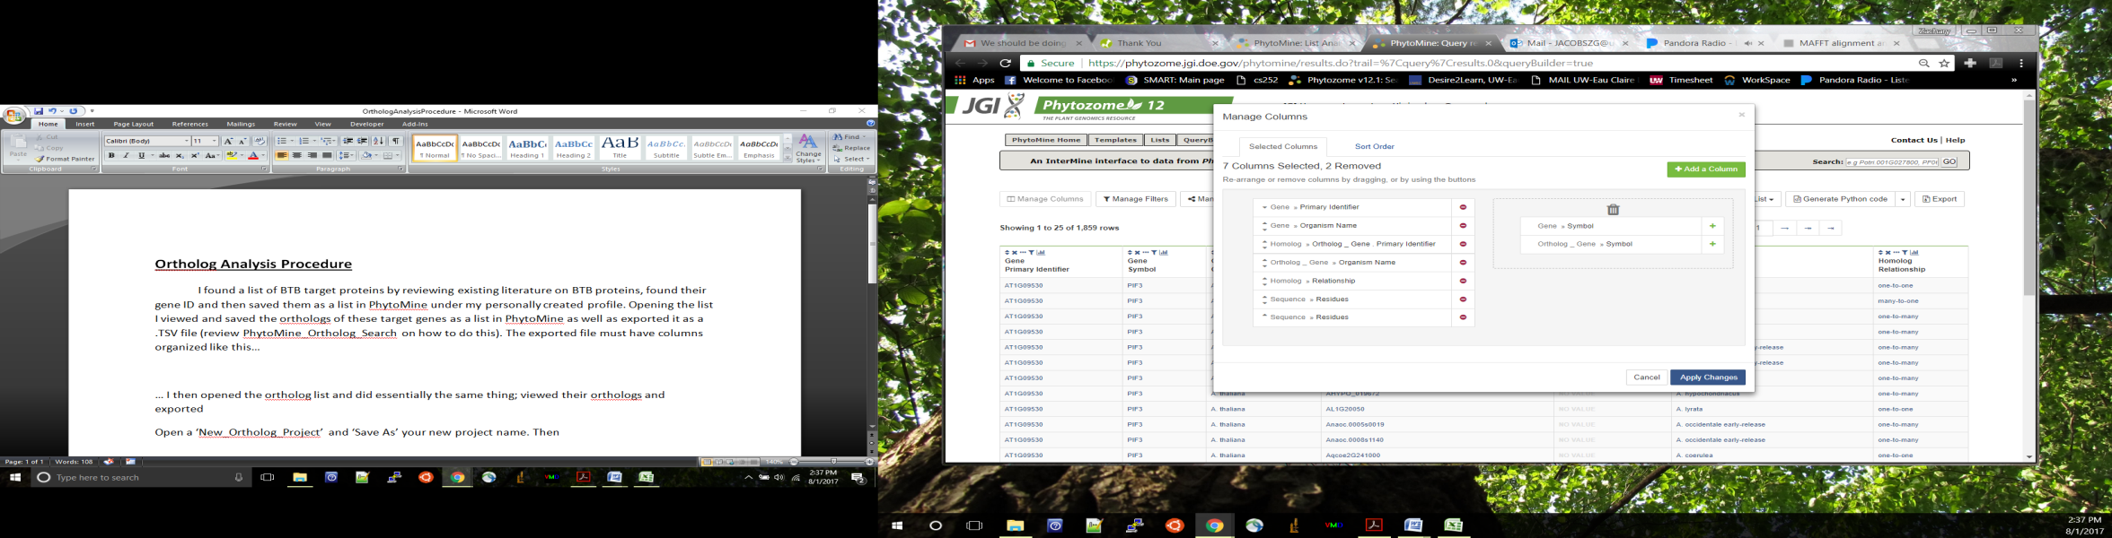 I found a list of BTB target proteins by reviewing existing literature on BTB proteins, found their gene ID and then saved them as a list in PhytoMine under my personally created profile. Opening the list I viewed and saved the orthologs of these target genes as a list in PhytoMine as well as exported it as a .TSV file (review PhytoMine_Ortholog_Search on how to do this). This first file is referred to as FILE_1. The exported file must have columns organized like this…

… I

Ortholog Protein Sequence (Selected Second)

Gene Protein Sequence (Selected First)

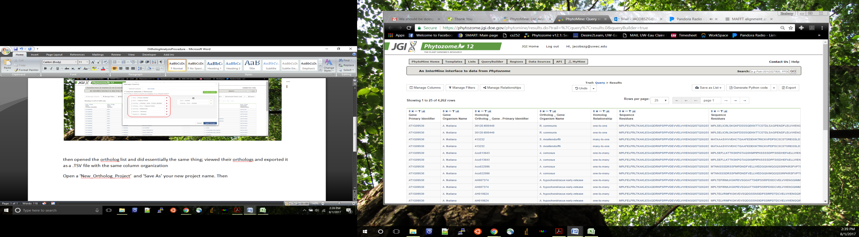

…I then opened the ortholog list and did essentially the same thing; viewed their orthologs and exported it as a .TSV file with the same column organization. This second file is referred to as FILE_2.

Open a ‘New_Ortholog_Project’ and ‘Save As’ your new project name. Then enter the paths of the corresponding FILEs (FILE_1 in ‘Orthologs’ and FILE_2 in ‘Orthologs_Orthologs’). Example paths look like “C:\Users\ZacharyandKaitlin\Desktop\1.UWECSchool\Research\(undergrad)\ZACH_PhylogeneticTree\GeneLists\FILE_1.TSV” and can be found under properties of file by right clicking on it (just be sure to add the file name to the end of the path).

Once the paths have been added to the appropriate cells, then hit “Load Files”. This will take a long time (especially for FILE_2) so be ready to do something else for a while not on excel. Once files are loaded “Remove Duplicates” from both files. Select any cell in the Black table, go under the “Data” tab and press “Remove Duplicates”. “Select All” then hit “OK”. Repeat that for the Blue table as well. Now make sure both files are sorted by ‘Gene_ID’ (seen as a the Red column title bars) and hit the “MAP Files” button. Make you keep both files sorted the same way they were when you hit the “MAP Files” button. Once mapped you can press the “Merge/Combine Files” button, and then open “OrthologAnalysis” sheet.

In the “OrthologAnalysis” sheet select any cell in the table (Red or Blue) and again”Remove Duplicates” except this time “Unselect All” and check the box next to “FILE_2 Row Index Pulled” at the bottom of the list and hit “OK”