**China**

The United States and China competition in big tech is becoming fiercer. Both the United States and China have duties of self-improvement, which is beginning to put the countries at odds with each other in the growth of each country’s technology infrastructures and advancements. The intensity of competition and desire to become the undisputed global leader in technology has created several conflicts of duties between China and the United States, as well as several internal conflicts of duties for reach country.

First, China and the United States have the duty of self-improvement. China’s GDP since 1960 remained just about constant at $300 (US Dollars) per capita for almost 40 years. It was not until the late 1990’s and early 200’s that the China GDP per capita began to skyrocket. 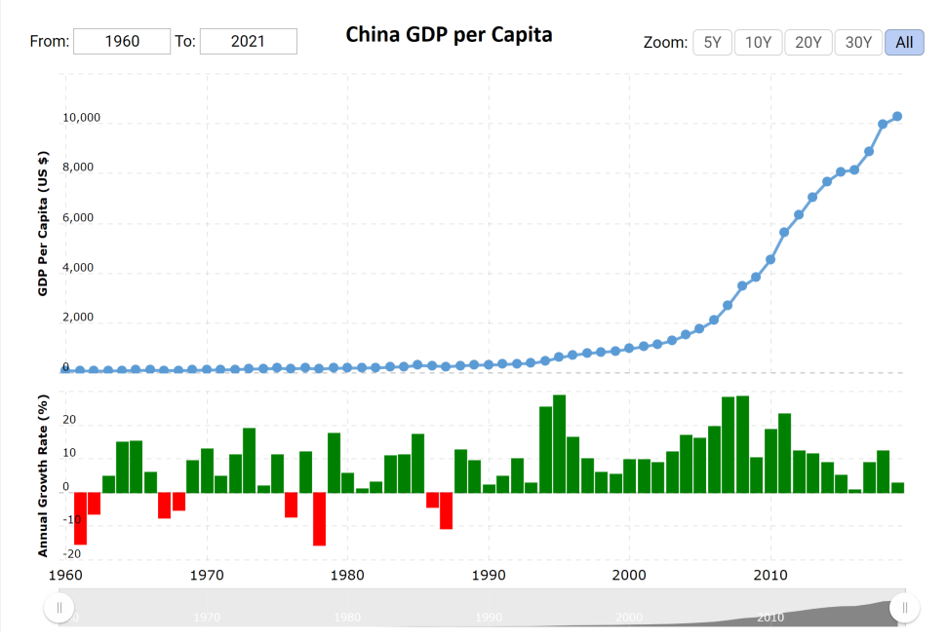The benefits of this GDP growth largely benefitted China’s people and lifted the standard of living for many of its citizens and China enjoyed more global influence. In the same period that China has enjoyed GDP growth, the USA has seen continual, linear improvement in GDP per capita. The current GDP per capita in China is about what the USA experienced in 1980. Both countries are well-fulling their duty of self-improvement, yet other duties are less clear.

The Chinese Communist Party (CCP) is willing to bend the rules and flex its unfair advantage when it comes to promoting the Growth of China. From the perspective of the United States, the CCP is willing to violate its duty of justice, non-injury, and fidelity evidenced by state sponsored cyber-attacks on US to cripple business and steal trade secrets. The CCP has a conflicting duty of Justice and Self-Beneficence and has shown that it values self-improvement over justice. Thanks to many of these attacks, China has gained valuable information that it has used to help in one of its greatest technological weaknesses- computer chips. Currently, China is about 5-7 years behind in its technological development for computer chips and is unable to meet its demand for computer chips thanks to the quick growth in technologies. The trade secrets China has stolen from the US has helped China play catch up.

The United States is not alone in unfair advantage. China’s huge manufacturing deficit for computer chips has created a dependence on the United States. The United States is in a unique situation because it can sell computer chips to China for a profit- potentially putting China in a better position to overtake the USA in long-term tech advancement- or it can elect to exercise unfair advantage and restrict sales of computer chips. The United States is put in a weird position here because it obviously wants to gain self-improvement through the sale of the chips but doing so might jeopardize the nation’s long-term self-improvement. Due to this conundrum, there is no right or wrong solution to this conflict of duty to self.

In the discussion of unfair advantage, it is important to outline another situation where China will have unfair advantage over the USA. Thanks to the China’s geographical location, it has the opportunity to make money from many of the smaller, poorer surrounding south-east Asian countries. China recently invested in a $1.4 Trillion package to beef up the country’s technological infrastructure. This funding is available to both government and private companies. A major component of this plan is to increase China’s 5G cell tower and other civilian tech related infrastructure. After much of the construction has taken place, China will be in a situation to sell its cell phone coverage to smaller countries who are incentivized to do business with China because they are weaker and less able to say no to such a powerful neighbor. This creates a more tense situation for China to coerce its neighbors into doing business. Thanks to this potential for future business, China will be fast tracked in its technological development.

China and the United States have different relationships with their big tech companies. The United States has worked hard to protect its economy and citizens against monopolies and invasive power. Lawsuits against Facebook and Google have been commonplace. There is much discussion about what legislation is appropriate for the US big tech companies. However, the US has taken a fairly liberal approach compared to China. In China, the government is more centralized, and monopolies are not necessarily seen as legal dangers. China is very interested in seeing its large tech companies perform well in hopes of driving China to global dominance. For China, the conflict between big tech companies and government happens when The CCP believes that big tech companies are too concerned with company growth and power and less concerned about advancing China’s interests. In 2019, the CCP began embedding officials inside of major tech companies, such as Alibaba, efforts to monitor and control these companies.

Due to these conflicting viewpoints on big tech and government involvement, many conflicts of interest and opportunities for unfair advantage arise between the USA and China. China has the opportunity for unfair advantage in the tech sector because it can coerce its big tech companies into acting as an arm of the government. China has already begun that process. The United States honors companies’ rights to be independent bodies that are not governmental puppets. The CCP exercises unfair advantage over its tech companies to promote state interests. The CCP rationalizes its actions by an appeal to higher loyalties – government over a single company’s interests. In the United States, individualism is more valued than collectivism, so the CCP may be able to justify its actions easier in a collectivist, Chinese culture.

In review, China exercises holds many opportunities for unfair advantage. First, China exercises unfair advantage through state sponsored cyber attacks on the USA. This is an unfair advantage because the United States has not proactively attacked China in an effort to maintain relationships because of its dependence on Chinese manufacturing. Secondly, China has exercised unfair advantage over its own companies by forcing them to advance state interests by planting secret government employees in its powerful companies. China will forcefully control companies through coercion and will retaliate against companies that do not wish to comply with the CCP’s interests. Third, China has exercised unfair technological advantage over its neighboring countries by developing an technological infrastructure in plans to coerce these weaker countries into doing business with China to improve its global dominance and economic power.

In review of the United States, the US exercises unfair advantage over China in the operation of its sales of computer Chips. The USA does not want to lose any advantage or footing that it has over China in the superconductor realm, so it limits its sales of computer chips to China. From the United States perspective, this is good business because the scarcity will increase the price at which they can sell to China, and the exclusivity means that China can only satisfy its computing needs as much as the United States is willing to let them. For this reason, China has stolen trade secrets for computer chip manufacturing and is working hard to develop its own technological prowess by creating Chinese equivalents of IBM, Oracle, etc.

It is my personal opinion that as the gap in technology between the USA and China narrows, the gap will exponentially close. China is willing to play the long game. It has invested in its technological future and has made the advancement of Chinese big tech a matter of state defense, not only an economic priority. I believe that as time goes on, China will gain more power, and with that greater power will come greater unfair advantage. Because China has already been exercising unfair advantage in the tech race, I believe that China will not break from its pattern of behavior and will only gain more power. To the USA’s top big tech figures such as Jeff Bezos and Mark Zuckerberg admit that the United States might lose its technological supremacy to China if changes are not made.

Sources:

* <https://fortune.com/2020/07/29/tech-ceos-congress-hearing-china/>
* <https://www.bloomberg.com/news/articles/2020-05-20/china-has-a-new-1-4-trillion-plan-to-overtake-the-u-s-in-tech>
* <https://www.macrotrends.net/countries/USA/united-states/gdp-per-capita>
* <https://www.macrotrends.net/countries/CHN/china/gdp-per-capita>
* <https://en.wikipedia.org/wiki/Alibaba_Group>
* <https://www.msnbc.com/opinion/china-s-big-tech-crackdown-not-model-u-s-n1261240>
* [https://www.foreignaffairs.com/articles/china/2021-02-04/why-beijing-bringing-big-tech-heel?utm_medium=email_notifications&utm_source=reg_confirmation&utm_campaign=reg_guestpass]( https://www.foreignaffairs.com/articles/china/2021-02-04/why-beijing-bringing-big-tech-heel?utm_medium=email_notifications&utm_source=reg_confirmation&utm_campaign=reg_guestpass)
* <https://www.cnbc.com/2021/02/01/new-chart-shows-china-gdp-could-overtake-us-sooner-as-covid-took-its-toll.html>