**Executive Summary**

Jacob West • Madison Brann • Braxton Barger • Paden Allsup

UNFAIR ADVANTAGE

**Scope**

The purpose of this paper is to discuss ethical situations arising from unfair advantage situations present in real situations. We discuss unfair advantage with China and big tech, AI and game bots in Starcraft, Amazon’s marketplace power, and Google AI. The analysis of these subjects will help us have a better understanding of the ethical issue of unfair advantage present in today’s global economy and political sphere.

**China and Big Tech**

The Chinese Communist Party has prioritized its duty of self-improvement over its duties of fidelity, justice, and non-injury. The big tech landscape is shifting as China continues to exercise unfair advantage on the global stage thanks to its increasing economic power and government backed cyber-attacks and trade secrets thefts. However, the United States is also not completely guilt-free in its use of unfair advantage of big tech. The gap between these two countries technological capabilities is closing. Major issues relate to this hot topic are explored through their ethical implications.

**AI and Game Bots**

A Starcraft bot called AlphaStar, trained with deep learning, has been dominating players online. Many players have pointed out that the way this bot processes information gives it an unfair advantage over humans. Does the fact that AlphaStar is beating these other players really matter? Ethical concerns related to this bot are explored.

**Amazon and Unfair Advantage**

Amazon has grown to be a strong presence in many markets. From AWS to Marketplace to Prime to Music, Movies, and Shipping, Amazon has resources and data that other companies can’t match. In fact, many of Amazon’s competitors rely on Amazon for infrastructure and for helping them sell and ship products. Does Amazon’s scale give it an unfair competitive advantage, and if so, how did the current antitrust laws let it get this way?

**Digital Media’s Unfair Advantage**

In 1996, the Communications Decency Act (CDA) was created as social media companies were too small to warrant attention. Complications arose from the side effects of the CDA and the rapid growth of social media companies. Thanks to this unforeseen change, social media companies are not held responsible for fake news and misinformation published through its sites like news companies might be. Social media companies are incentivized through profit to permit misinformation and personal information to be used in unethical ways.

**Conclusion**

China is flexing unfair advantage in the political and economic spheres and other countries are afraid to do anything past condemning these behaviors. Through dominance, StarCraft bots decrease enjoyment for human players and the future is trending towards more game bots. The House Judiciary antitrust subcommittee has suggested that current antitrust laws are not resilient enough to prevent companies like Amazon from gaining an unfair competitive advantage. No laws exist to discourage unethical profit gained by powerful social media companies. Our world has many opportunities to address and correct unfair advantage and would be improved if more action were to be taken.

**China**

The United States and China competition in big tech is becoming fiercer. Both the United States and China have duties of self-improvement, which is beginning to put the countries at odds with each other in the growth of each country’s technology infrastructures and advancements. The intensity of competition and desire to become the undisputed global leader in technology has created several conflicts of duties between China and the United States, as well as several internal conflicts of duties for reach country.

First, China and the United States have the duty of self-improvement. China’s GDP since 1960 remained just about constant at $300 (US Dollars) per capita for almost 40 years. It was not until the late 1990’s and early 200’s that the China GDP per capita began to skyrocket. 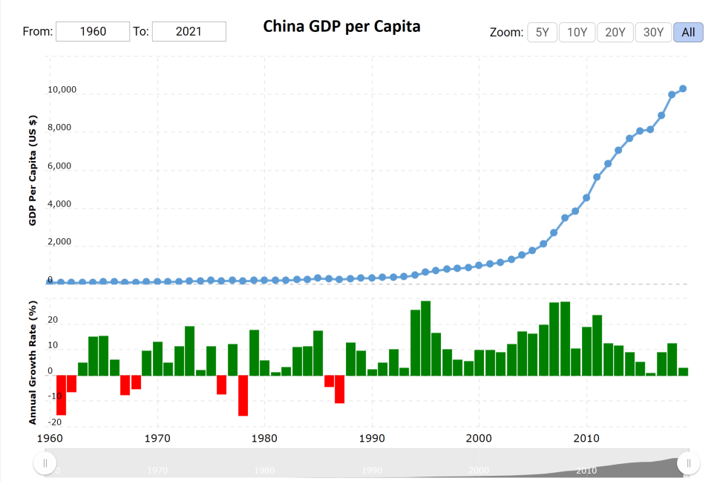The benefits of this GDP growth largely benefitted China’s people and lifted the standard of living for many of its citizens and China enjoyed more global influence. In the same period that China has enjoyed GDP growth, the USA has seen continual, linear improvement in GDP per capita. The current GDP per capita in China is about what the USA experienced in 1980. Both countries are well-fulling their duty of self-improvement, yet other duties are less clear.

The Chinese Communist Party (CCP) is willing to bend the rules and flex its unfair advantage when it comes to promoting the Growth of China. From the perspective of the United States, the CCP is willing to violate its duty of justice, non-injury, and fidelity evidenced by state sponsored cyber-attacks on US to cripple business and steal trade secrets. The CCP has a conflicting duty of Justice and Self-Beneficence and has shown that it values self-improvement over justice. Thanks to many of these attacks, China has gained valuable information that it has used to help in one of its greatest technological weaknesses- computer chips. Currently, China is about 5-7 years behind in its technological development for computer chips and is unable to meet its demand for computer chips thanks to the quick growth in technologies. The trade secrets China has stolen from the US has helped China play catch up.

The United States is not alone in unfair advantage. China’s huge manufacturing deficit for computer chips has created a dependence on the United States. The United States is in a unique situation because it can sell computer chips to China for a profit- potentially putting China in a better position to overtake the USA in long-term tech advancement- or it can elect to exercise unfair advantage and restrict sales of computer chips. The United States is put in a weird position here because it obviously wants to gain self-improvement through the sale of the chips but doing so might jeopardize the nation’s long-term self-improvement. Due to this conundrum, there is no right or wrong solution to this conflict of duty to self.

In the discussion of unfair advantage, it is important to outline another situation where China will have unfair advantage over the USA. Thanks to the China’s geographical location, it has the opportunity to make money from many of the smaller, poorer surrounding south-east Asian countries. China recently invested in a $1.4 Trillion package to beef up the country’s technological infrastructure. This funding is available to both government and private companies. A major component of this plan is to increase China’s 5G cell tower and other civilian tech related infrastructure. After much of the construction has taken place, China will be in a situation to sell its cell phone coverage to smaller countries who are incentivized to do business with China because they are weaker and less able to say no to such a powerful neighbor. This creates a more tense situation for China to coerce its neighbors into doing business. Thanks to this potential for future business, China will be fast tracked in its technological development.

China and the United States have different relationships with their big tech companies. The United States has worked hard to protect its economy and citizens against monopolies and invasive power. Lawsuits against Facebook and Google have been commonplace. There is much discussion about what legislation is appropriate for the US big tech companies. However, the US has taken a fairly liberal approach compared to China. In China, the government is more centralized, and monopolies are not necessarily seen as legal dangers. China is very interested in seeing its large tech companies perform well in hopes of driving China to global dominance. For China, the conflict between big tech companies and government happens when The CCP believes that big tech companies are too concerned with company growth and power and less concerned about advancing China’s interests. In 2019, the CCP began embedding officials inside of major tech companies, such as Alibaba, efforts to monitor and control these companies.

Due to these conflicting viewpoints on big tech and government involvement, many conflicts of interest and opportunities for unfair advantage arise between the USA and China. China has the opportunity for unfair advantage in the tech sector because it can coerce its big tech companies into acting as an arm of the government. China has already begun that process. The United States honors companies’ rights to be independent bodies that are not governmental puppets. The CCP exercises unfair advantage over its tech companies to promote state interests. The CCP rationalizes its actions by an appeal to higher loyalties – government over a single company’s interests. In the United States, individualism is more valued than collectivism, so the CCP may be able to justify its actions easier in a collectivist, Chinese culture.

In review, China exercises holds many opportunities for unfair advantage. First, China exercises unfair advantage through state sponsored cyber attacks on the USA. This is an unfair advantage because the United States has not proactively attacked China in an effort to maintain relationships because of its dependence on Chinese manufacturing. Secondly, China has exercised unfair advantage over its own companies by forcing them to advance state interests by planting secret government employees in its powerful companies. China will forcefully control companies through coercion and will retaliate against companies that do not wish to comply with the CCP’s interests. Third, China has exercised unfair technological advantage over its neighboring countries by developing an technological infrastructure in plans to coerce these weaker countries into doing business with China to improve its global dominance and economic power.

In review of the United States, the US exercises unfair advantage over China in the operation of its sales of computer Chips. The USA does not want to lose any advantage or footing that it has over China in the superconductor realm, so it limits its sales of computer chips to China. From the United States perspective, this is good business because the scarcity will increase the price at which they can sell to China, and the exclusivity means that China can only satisfy its computing needs as much as the United States is willing to let them. For this reason, China has stolen trade secrets for computer chip manufacturing and is working hard to develop its own technological prowess by creating Chinese equivalents of IBM, Oracle, etc.

It is my personal opinion that as the gap in technology between the USA and China narrows, the gap will exponentially close. China is willing to play the long game. It has invested in its technological future and has made the advancement of Chinese big tech a matter of state defense, not only an economic priority. I believe that as time goes on, China will gain more power, and with that greater power will come greater unfair advantage. Because China has already been exercising unfair advantage in the tech race, I believe that China will not break from its pattern of behavior and will only gain more power. To the USA’s top big tech figures such as Jeff Bezos and Mark Zuckerberg admit that the United States might lose its technological supremacy to China if changes are not made.

Sources:

* <https://fortune.com/2020/07/29/tech-ceos-congress-hearing-china/>
* <https://www.bloomberg.com/news/articles/2020-05-20/china-has-a-new-1-4-trillion-plan-to-overtake-the-u-s-in-tech>
* <https://www.macrotrends.net/countries/USA/united-states/gdp-per-capita>
* <https://www.macrotrends.net/countries/CHN/china/gdp-per-capita>
* <https://en.wikipedia.org/wiki/Alibaba_Group>
* <https://www.msnbc.com/opinion/china-s-big-tech-crackdown-not-model-u-s-n1261240>
* [https://www.foreignaffairs.com/articles/china/2021-02-04/why-beijing-bringing-big-tech-heel?utm_medium=email_notifications&utm_source=reg_confirmation&utm_campaign=reg_guestpass]( https://www.foreignaffairs.com/articles/china/2021-02-04/why-beijing-bringing-big-tech-heel?utm_medium=email_notifications&utm_source=reg_confirmation&utm_campaign=reg_guestpass)

**Starcraft AI Bot**

A recent trend that has been occurring in the CS world is the creation and use of bots. Bots can be used for a variety of things, from trying to reserve a high demand product when it is released (like the new Xbox and PS5), automating tedious and mindless work (I used this for some conversions at work), or even for creating opponents in video games.

Bots in video games have technically been around for a while. When computers were first created, there was quickly interesting in creating an AI that could play chess. Also, most single player games have some form of AI used in enemies that the players have to overcome. More complicated AI can be used to simulate other players in competitive strategy games such as Age of Empires.

However, with the recent popularization of Deep Learning, the heights that AI can reach has vastly expanded. Recently, DeepMind created a Starcraft bot called AlphaStar with deep learning. What this essentially means is that AlphaStar was shown thousands of examples of StarCraft games, and with that data used algorithms to create ‘neural connections’ and with that information make informed decisions on best how to play.

It would be an understatement to say that it was successful. As you can see from the graph below, it managed to increase its ranking past grandmaster in less than 2 weeks. If you play competitive games, you start to see how astounding this is. I personally don’t play Starcraft, but I play chess competitively online and if I’m doing unusually well, it takes me about 2 weeks to jump up 100 points in rank. Granted Starcraft is a different game and has a different scale, but the point is that it takes a lot of dedication to get good at these competitive games. Technically speaking AlphaStar did do a lot of grinding since it had to process through all that data, but it is also a computer so it doesn’t get tired and can work much faster than a human can.

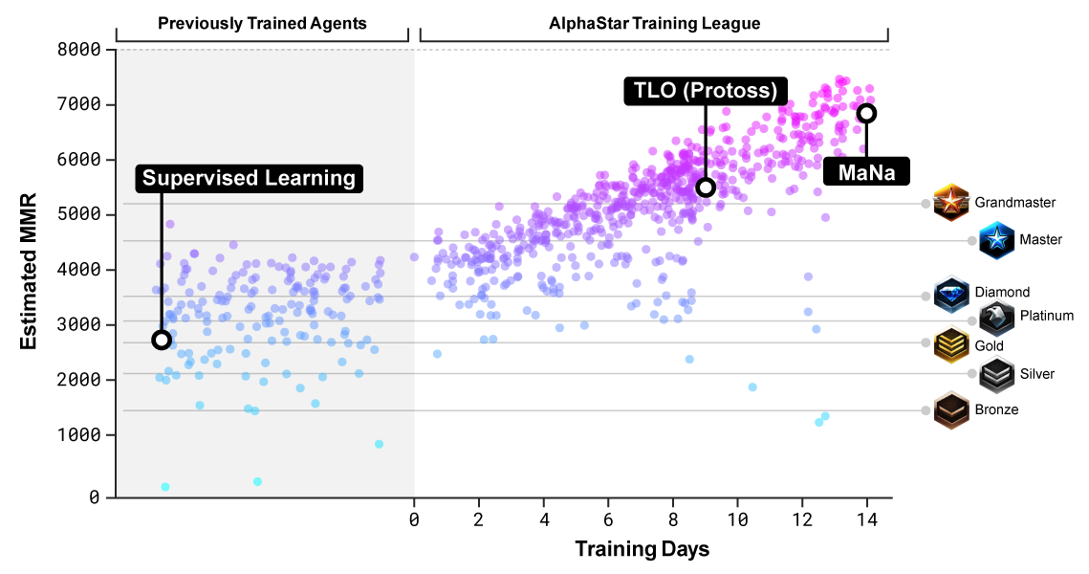

The ethics of using this bot against real players does raise some ethical questions, the main one being of unfair advantage. Is the playing field of this bot really the same as the human players? DeepMind did state that they did take steps to ensure that it played like a human. One example of these steps is when AlphaStar receives information that it can act on, there is a small delay inserted to simulate the processing time of a human. With a bunch of these limitations in place, you could argue that they’re on the same playing field.

However, there are still some gaps between how the computer sees things and how human players see them. For example, when human players are playing StarCraft, they can only see the part of the map that is enclosed in their monitor. AlphaStar on the other hand can see the whole map at all times (granted, only the parts of the map that have been explored by its troops). This could be seen as unfair since AlphaStar would be more aware of incoming enemy troops and would thus be able to respond faster.

This issue of speed comes up rather frequently. Another example of a human limitation that AlphaStar avoids is when a player spam clicks a location for their units to move. It’s a very human thing that a lot of people do but wastes lots of time. AlphaStar is very efficient in just telling the unit to move once, and then goes to work on other things. In more complex battles, AlphaStar could also micromanage the individual units much more efficiently than a human could.

There are a bunch of advantages that AlphaStar has over humans, but it also has some limitations which adds to our questioning of the even playing field. One limitation is the fact that AlphaStar has only been trained on one faction. If AlphaStar was to play as another faction it would most certainly lose just because it hasn’t trained on data with that faction yet. AlphaStar can also only deal with things it’s encountered before, if it sees a completely new situation it wouldn’t be able to take what it’s learned previously and apply it, it would just be confused and potentially freeze.

Let’s jump into the ethics a little deeper and talk about some of the prima facie involved. The first one would be Non-injury. This is a bot, playing a video game. One could argue that it is hard to see how what harm it would do beyond bruising a gamers ego. However, things could get more complicated. What if the bot was used in a competition that involved money? If it is true that it’s not on an even playing field, then it is essentially cheating another human player out of their prize money. I think the overall importance of the Non-injury prima facie is predicated on what this bot will be used for.

The second prima facie, which I feel like highlights the benefits of AlphaStar would be self-improvement. We are always trying to expand the limits of computers, and AlphaStar shows great promise in the field of Deep Learning. Granted, having a machine being really good at a video game isn’t in itself useful, but what the researchers learnt and published while creating this bot could be used to create a bot that would be helpful to society. For example, maybe in the future they could create a bot that would analyze economic markets and could better inform consumers. Of course, having a bot opens up a whole new can of worms in regards to ethics, but the point is by exploring the use of deep learning with video game bots, we could open up a lot of possibilities as a society.

The last prima facie that comes into question is veracity. This seemed to be a point that was focused on a lot in the ‘Don’t Expect AI to Play Like a Human’ article. One of the biggest issues with AlphaStar is that it’s playing a competitive game with humans but has extra advantages. This was discussed earlier, but this bot is somewhat expected to behave like a human but is able to cut corners with it’s processing power, unlimited map view, data API’s ect. In a sense AlphaStar could be seen as lying about what it really is and is in violation of the fidelity of the playing field which is expected from players on competitive games.

Lots of these prima facie come connected with potential neutralizations. For example, the prima facie of non-injury naturally comes with denial of injury. This argument was highlighted earlier, but one could argue that a bot being really good at video games doesn’t harm anyone. Another rationalization that is tied with an already explained argument is appeal to higher loyalties. This argument could easily be tied with the self-improvement prima facie. The creation of this bot and this lesson learnt could have higher implications than just being able to play a video game. For example, if this bot could be considered unethical in the gaming community, it doesn’t matter because it’s research for something more important than video games.

A potential neutralization whose argument hasn’t already been explored with prima facie could be denial of victim. Lots of gamers can be arrogant, and the ones at the top might feel like their better than everyone else. People who play competitive games know that elitism can get out of control and makes it hard for new players to get started. Some might say that these really good players deserved to be beaten by this bot because they could use a slice of humble pie. I personally don’t think this is a very strong neutralization, but it still could be one that comes up.

In conclusion, AlphaStar showcased some very exciting technology, but with new technologies comes the questions of ethics. Is it okay for this to be introduced into the gaming world, or could it be considered unfair? I think as deep learning continues to progress, we will see more of these bots in the future and will have to answer these questions.

Sources:

<https://deepmind.com/blog/article/alphastar-mastering-real-time-strategy-game-starcraft-ii>

<https://en.wikipedia.org/wiki/AlphaStar_(software)>

<https://www.pcmag.com/opinions/unfair-advantage-dont-expect-ai-to-play-like-a-human>

**Does Amazon Have Unfair Competitive Advantage?**

Amazon is the largest company in the world in the consumer services market, and the third largest company in any market. It is only topped by Apple and SaudiAramco, a Saudi Arabian energy company. However, Amazon differs from these companies in one key measure. In fact it differs from any other company that has ever existed. Amazon’s presence has such a large breadth that it doesn’t make sense to talk about Amazon’s market. Amazon competes in numerous markets and is continually widening its borders. This sort of widespread network scale and power has recently become a cause for concern for business ethicists and even the federal government. Many are concerned that Amazon has acquired an unfair competitive advantage.

In terms of ethics, unfair advantage is defined as enjoying “a benefit or position that comes at anther’s expense – without a good reason”. It is “the opportunity to wield an unfair upper hand” (The Business Ethics Field Guide). However, in the legal business world, unfair advantage is defined differently. The FTC (Federal Trade Commission) aims to “protect consumers and competition by preventing anticompetitive, deceptive, and unfair business practices through law enforcement, advocacy, and education without unduly burdening legitimate business activity”. The FTC has anticompetitive practice laws that aim to combat any ethical unfair advantage issues, stating “It is unlawful for a company to monopolize or attempt to monopolize trade, meaning a firm with market power cannot act to maintain or acquire a dominant position by excluding competitors or preventing new entry” (ftc.gov). Historically this has worked, but with Amazon’s recent rise to power, some feel that this law’s definition of anticompetitive practice is no longer sufficient.

Amazon hasn’t violated any anticompetition laws. In fact, generally the key indicator of anticompetitive practice is an increase in prices, because a company is able to do so without losing the business to other firms. But Amazon has actually reduced prices for consumers, and so antitrust laws view this as evidence of good competition. However, this may not be the case.

There have been instances where Amazon has demonstrated the risks of its dominant market power. In 2014, Amazon had an eventful negotiation period with French book publisher Hachette. Hachette used Amazon’s marketplace to sell books, and the publisher wanted control of its own pricing in the marketplace. Amazon wanted to lower the price of Hachette books, and used its leverage to put pressure on Hachette to comply. Amazon pulled many of Hachette’s books from its marketplace, it removed available customer discounts on their products, and it delayed shipping for many of their products. Amazon faced public criticism for these moves (*The Guardian*, “Amazon and Publisher Hachette End Dispute Over Online Book Sales”).

Although this seems unethical, there are some strong arguments to say that this is justified. There is debate as to whether these are just neutralizations or if Amazon’s actions are actually justified.

The first potential neutralization is denial of victim. Hachette uses Amazon to sell their books. They are not obligated to use Amazon, and if they want to use Amazon then they can expect to have to follow Amazon’s rules. And so this argument would say that Hachette is not a victim, and in fact should reasonably expect to have to follow Amazon’s rules if it wants to enjoy their benefits.

The second is denial of injury. Amazon did nothing illegal, because as in the denial of victim argument, it is their marketplace and they are not discouraging competition by wanting to have their marketplace prices low. Amazon would argue that in this way there is no injury. Both of these neutralizations can be argued for, but some still see Amazon’s actions as unethical business practices. The key here to both arguments is that Amazon is optional for these companies and for consumers. In this way it can be said that Amazon is not hurting anyone, and in fact the opposite is true. They have done so well because of how much value they provide to consumers and to other companies.

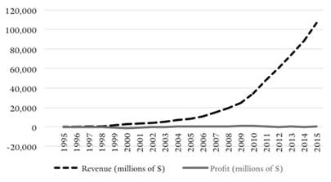**Amazon chooses to forego profits in favor of expansion**

As a wide company in terms of market coverage, Amazon has a lot of ways that it provides value. However, Amazon’s scale also provides the potential for monopoly power. Amazon’s business strategy has always revolved around scale, as the company even forgoes profits in favor of horizontal and vertical expansion, often through the acquisition of other firms. By this strategy, Amazon has become a dominant force in many different markets. Amazon is most well known as an online marketplace. They control over 50 percent of e-commerce in the United States, and almost half of all online buyers go directly to Amazon to search for products. In addition to this the company participates in cloud computing, payment processing, entertainment and streaming, shipping, and more. With their own payment processes, products, and a shipping fleet that rivals the federal postal service, Amazon controls all the stages of production and distribution of their products. This magnitude of market height and width gives Amazon leverage and power that most companies don’t have.

One of Amazon’s most profitable areas is their cloud computing service, Amazon Web Services. AWS makes it easy for companies to create an online presence through apps or websites. Instead of investing in servers and website infrastructure, the company can use AWS to accomplish all of this for much cheaper cost. Because of this, Amazon is in reality encouraging competition. Over 1 million different companies use AWS, and AWS controls over a third of the cloud computing market. This means that of all the online retail companies starting up, about a third are using AWS to power their website.

This creates interesting conflict-of-interest issues for Amazon. *The Business Ethics Field Guide* defined a conflict of interest as when “multiple roles put you at cross purposes”. Amazon’s two roles here, one as a cloud computer and one as an online marketplace, gives it different competing interests. As increasingly many online retailers use AWS, more and more of the market becomes dependent on Amazon to keep their site running and working. So as an online retailer Amazon is a competitor, but through AWS Amazon is also controlling the framework that their rivals depend on.

In addition to the conflicts of interest brought about through AWS, Amazon has another potential conflict of interest with regards to third-party data. Since Amazon hosts other retailer’s products on their site, they have access to all of the data on those companies’ products. This gives Amazon access to a far greater amount of data than do their competitors on their marketplace. They can see consumer habits and interests, what customers have viewed, and pricing for past, present, and future of other companies’ products. In October of 2020, the House Judiciary antitrust subcommittee reviewed Amazon’s potential monopoly power in the online retail market, and their potential unfair advantages with AWS. Although Amazon may not have exploited any of these advantages yet, the issue that the House Judiciary subcommittee sees is that Amazon certainly has the potential to exploit it. Should another company ever challenge Amazon in terms of scale and market share, Amazon would certainly be tempted to do so.

In their report, the House Judiciary subcommittee concluded that Amazon’s role as a dominant provider of cloud-computing services and its power in other markets creates a conflict of interest that “Amazon has the incentive and ability to exploit” (*CNBC*, “Amazon Bullies Partners and Vendors, Says Antitrust Subcommittee”). This suggests that they feel that the current antitrust laws are inadequate, focusing primarily on pricing and consumer good. Lina Kahn, who was recently nominated by President Biden to fill a vacancy in the FTC, wrote, “Focusing primarily on price and output undermines effective antitrust enforcement by delaying intervention until market power is being actively exercised, and largely ignoring whether and how it is being acquired. In other words, pegging anticompetitive harm to high prices and/or lower output—while disregarding the market structure and competitive process that gives rise to this market power—restricts intervention to the moment when a company has already acquired sufficient dominance to distort competition” (*The Yale Law Journal*, “Amazon’s Antitrust Paradox”, 2017). In other words, Ms. Kahn and the House Judiciary subcommittee both want to bring the FTC’s definition of unfair advantage more in line with the *Business Ethics Field Guide*’s definition of unfair advantage.

This exploration into Amazon’s unfair advantage shows how difficult it can be to apply certain ethical principles in the business world. Especially when dealing with the principles on the level of an entire firm rather than on an individual level, it can be difficult to capture what is required to enforce ethical practices legally. The positive note is that it is apparent that people are ethically aware, and are trying their best to make sure that Amazon and similar firms are held to a high ethical standard.

Sources:

* Lena M. Khan, *Amazon’s Antitrust Paradox*, Yale Law Journal 2017
* <https://www.cnbc.com/2020/10/06/amazon-bullies-partners-and-vendors-says-antitrust-subcommittee.html>
* <https://www.theguardian.com/books/2014/nov/13/amazon-hachette-end-dispute-ebooks>
* <https://techcrunch.com/2021/03/10/facebook-challenges-ftcs-antitrust-case-with-big-techs-tattered-playbook/amp/>

**Digital Media’s Unfair Advantage**

In 1996, an act was passed titled the “Communications Decency Act” or CDA, whose main purpose was to prohibit the spread of obscene content to minors through internet services. Among other things, the CDA enacted specific protections for providers of these services, provided they were not complicit in the spreading of obscene material through the services they provided. This reduced liability for all those whose service was misused, especially in illegal or immoral means. Section 230 of the CDA reads: “No provider or user of an interactive computer service shall be treated as the publisher or speaker of any information provided by another information content provider”. While the majority of the effects of the CDA were good, there were a few unseen side effects. In 1996, where social media was in its infancy, these protections allowed those social media users to be protected from other users misusing the platform.

When social media was purely social media (and not another type of news outlet), this protection was warranted. However in our day, giants like Facebook, Twitter, Instagram, and others are able to share news, marketplace info, and other information with the same protections. Why is this a problem? Because of the protections given to social media companies, there are little to no restrictions placed on these companies and their spread of information. This means that social media companies are not legally required to fact-check information in the same manner that other media companies are. Where other news outlets are completely liable for the effects of all information shared through their platform, social media companies are not. They can share any information they want, even if it is blatantly false (Bernard, 2019).

The legal immunities that big technology companies are given prevent any repercussions for their ability to market off of false information spread through their platform. These protections give digital media companies an unfair advantage over traditional media companies, because there are no restrictions against profiting off of false or questionable information. In the name of “preserving the freedom” to express opinions, social media giants need only provide a notification saying that they haven’t “verified’ the information contained in a post in order to negate all legal repercussions that can come from the spread of malicious or blatantly false information.

Other effects of this protection regard the use of personal information given to these companies. For legal and moral reasons, tech companies are required to keep confidentiality with most user information, in order to protect user identities. In 2019, Facebook was fined $5 billion for the misuse of user information, which conflicted with their company privacy policy. Essentially, Facebook sold private user information to 3rd party companies with the knowledge that they did not share Facebook’s privacy policy. These companies would use that information in ways that Facebook users were not aware of. Facebook was found guilty for illegal use of user information, and was required to pay a fine of $5 billion, and to remodel the way that company handled privacy issues (FTC, 2019). While Facebook as a company was not necessarily misusing user information, Facebook was deemed complicit in the misuse because they allowed information to pass to parties who did not share the same privacy guarantee. This incident is the largest one that directly addresses the unfair advantage created by the CDA.

One excuse frequently used by social media giants is that by virtue of the sheer number of users across the world, there is no way to technologically censor all false information spread, and even if there were a way, it would be unconstitutional to do so. However, this is not the case. During the 2020 election for President of the United States, the current President Donald Trump was banned from Twitter following accusations that his tweets “[incited] violence” (Sullivan, 2021). Many other accounts that shared similar views to President Trump were also locked, leading many Conservatives to leave the platform altogether. This mass-banning of accounts is evidence that big tech companies do have the means and infrastructure to censor and prohibit the spread of misinformation, and in fact, are legally required to in order to maintain freedom to profit through advertising on their platform. This is where the dilemma lies.

This advantage is a good example of legal but unethical advantage. While digital media companies are protected by section 230 of the CDA, this does not mean that their marketing and profiting off the spread of inaccurate or false information is ethical. Some typical rationalizations used by these digital media companies, relating to the CDA, are: 1) Denial of Responsibility. “By Section 230 of the CDA, we are legally protected from the misuse of any information spread through our platform”, (yet they have no problem profiting off that misinformation and the advantage it provides them over traditional media companies). 2) Denial of Victim. “Social media users sign statements acknowledging everything that they sign up for when making an account. This gives them all responsibility, and they should not trust all the things they read on our platform”. 3) Appeal to Normalcy. “Part of our business model depends on user interaction. We can’t limit how they interact, or the information they share, or we would be intentionally handicapping our business”. While none of these negate the ethical questions raised by this advantage, they do provide some context as to why this unfair advantage hasn’t been addressed on a broader scale.

Sources

* Bernard, J. (2019, October 05). End big tech's unfair advantage. Retrieved April 12, 2021, from <https://venturebeat.com/2019/10/05/end-big-techs-unfair-advantage/>
* FTC imposes $5 BILLION penalty and sweeping new privacy restrictions on Facebook. (2020, April 28). Retrieved April 12, 2021, from <https://www.ftc.gov/news-events/press-releases/2019/07/ftc-imposes-5-billion-penalty-sweeping-new-privacy-restrictions>
* Sullivan, M. (2021, January 12). 3 reasons why Twitter took a $5 billion stock hit after banning Trump. Retrieved April 12, 2021, from <https://www.fastcompany.com/90593224/twitter-stock-trump-ban>
* Zeigler, S. (n.d.). Communications decency act of 1996. Retrieved April 12, 2021, from <https://www.mtsu.edu/first-amendment/article/1070/communications-decency-act-of-1996>