Version 1

Main goal – Display multiple webpages and can go between them

Result:
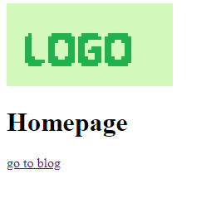
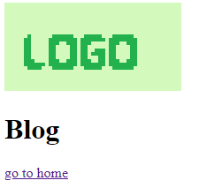
I have achieved exactly the above goal, with there being two pages that connect to each other. Neither of them look the part at the moment, but this version is much more a test of Flask than focussing on user experience. I also managed to include an image – this will be very important later down the line. As I was not given a logo for Health Advice Group, I have made a stock one to act as a placeholder.

The folder structure has been changed slightly to better match the Flask recommended structure.

The next task is to flesh out the homepage so that it matches the design I created (except for showing a blog post)

Version 2

Main goal – Homepage matches design created in Task 1
Result:
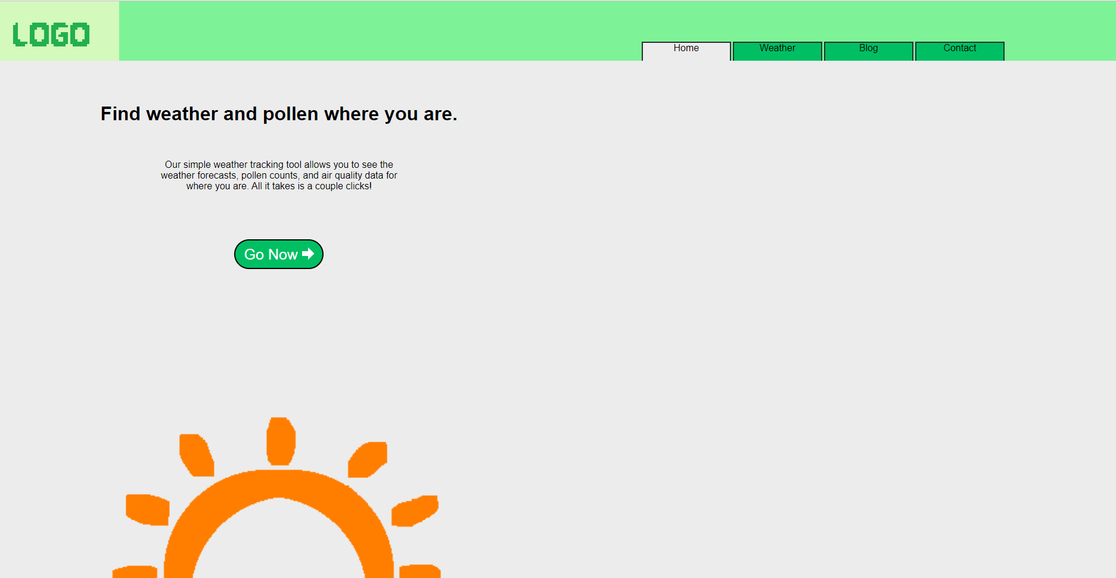
After further adjustments to the folder structure to allow for CSS files to be separate from their HTML so that it is easier to understand the code, the homepage is now much closer to the initially proposed design. This version uses the correct colour pallete, and I made my own version of the sun image so I could use it without copyright issues.

There are some key things missing from the design, however. Notably, the entire featured blog section on the right, as the blog system has not been implemented yet. Additionally, the setting for a dark mode toggle is also missing, as I will save accessibility features until later, after the core of the site works. Finally, the design shows each of the links at the top as if they are dividers in a folder; however, I could not find a reliable way to transform the links to be more trapezial.

The next goal, and the hopeful result of Version 3, is a working weather system. This will take some time.

Version 3

Main goal – Weather UI and connect to backend for data generation
Result:
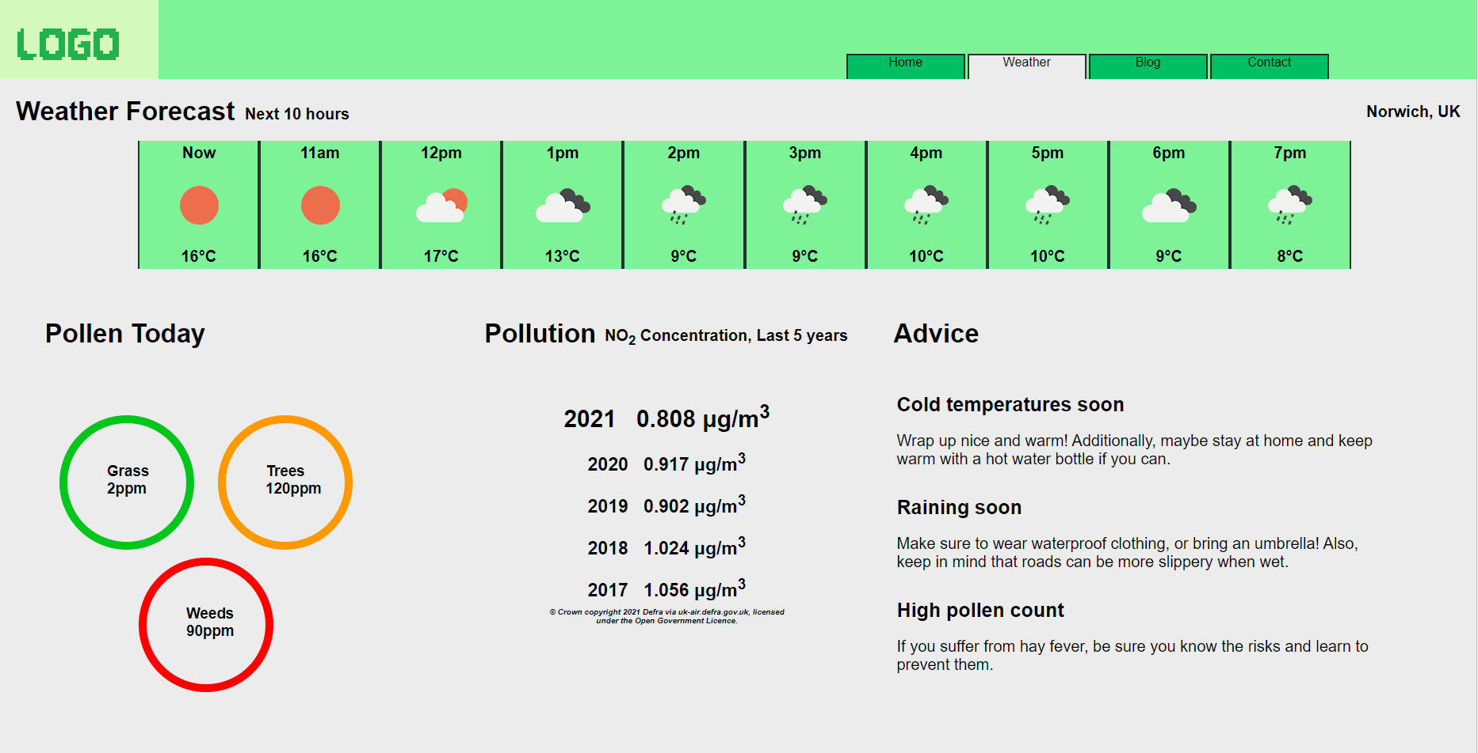
The design for the weather page is complete, as seen here. Some changes were made from the initial design, however. Firstly, the weather forecast has a green background, which was chosen so that the weather images (thanks to OpenWeather for their free weather icons) can be clearly seen, There was initially the same grey background, but it meant the clouds weren't visible at all. Secondly, the circles that show each type of pollen have been changed to rings so that the text in the center is clearer. Thirdly, the line graph for air quality has been changed to just showing the numbers, with the most recent data larger and at the top, and the title has been changed from 'Air Quality' to 'Pollution', to make it clear that lower is better without making the user feel stupid. Finally, the layout of the 'advice' section has been rearranged slightly to be clearer.

In the backend, there has also been some changes. The site can now respond to a POST (not GET anymore, see test log) request to /weather/content, which causes it to generate the weather data. For now, it is just using sample data instead of actually connecting to APIs and map data, so that the frontend could easily be tested. Also, the 'go now' button on the homepage actually works now.

In the next version, I will move away from the weather systems and start working on the contact page.

Version 4
Main goal – Completely functional contact page that can send emails
Result:
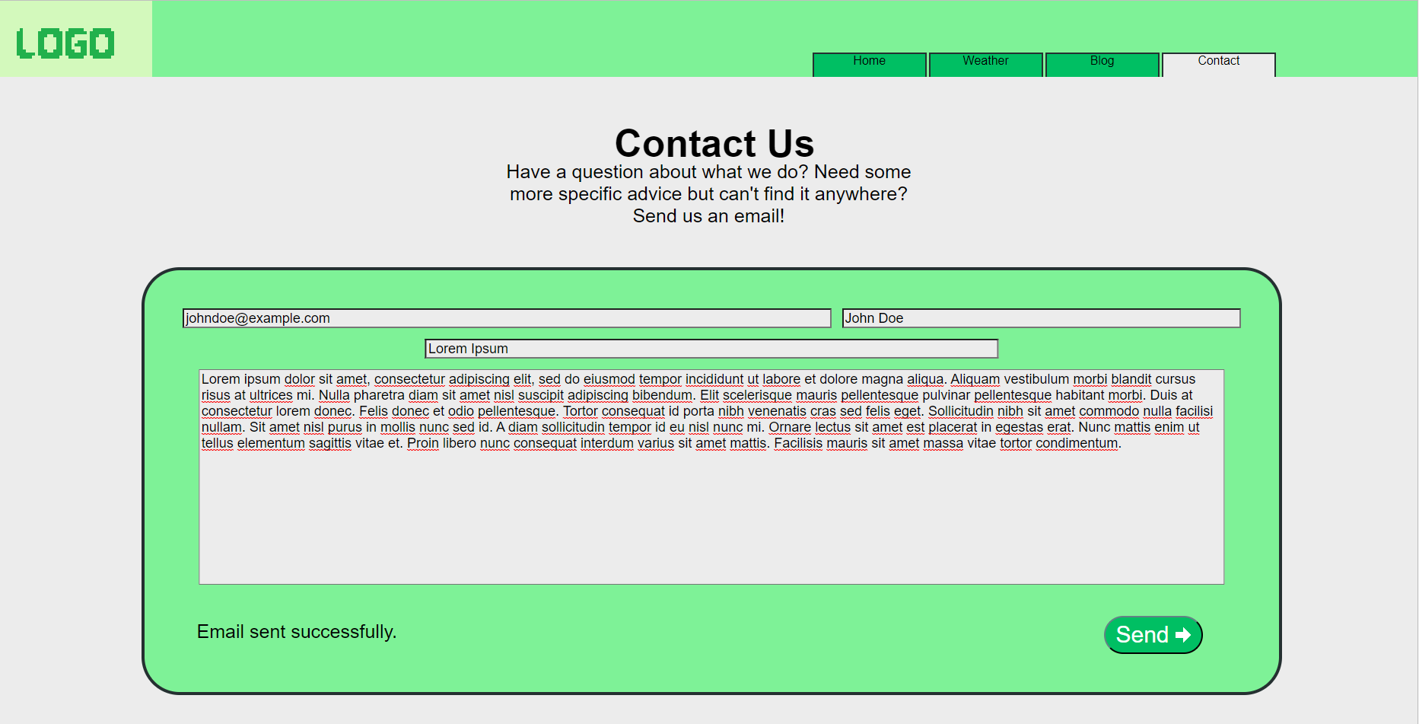
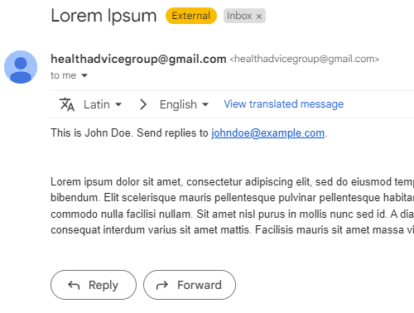
The contact page is now fully up and running, with a UI that almost perfectly matches the originally planned design from Task 1 and a working mail system that can send emails from healthadvicegroup@gmail.com, as you can see in the example above. For this to work, the Python Yagmail third-party module was used to make sending emaiils easier, though I still had some struggles allowing it to interact with the Gmail account.

The only thing that was changed between the originally planned design and the result is the addition of a small message that says 'Please wait...' once the send button is clicked and 'Email sent successfully' once the process is finished. The goal of the next version is to create the admin panel and allow it to change the destination email.

