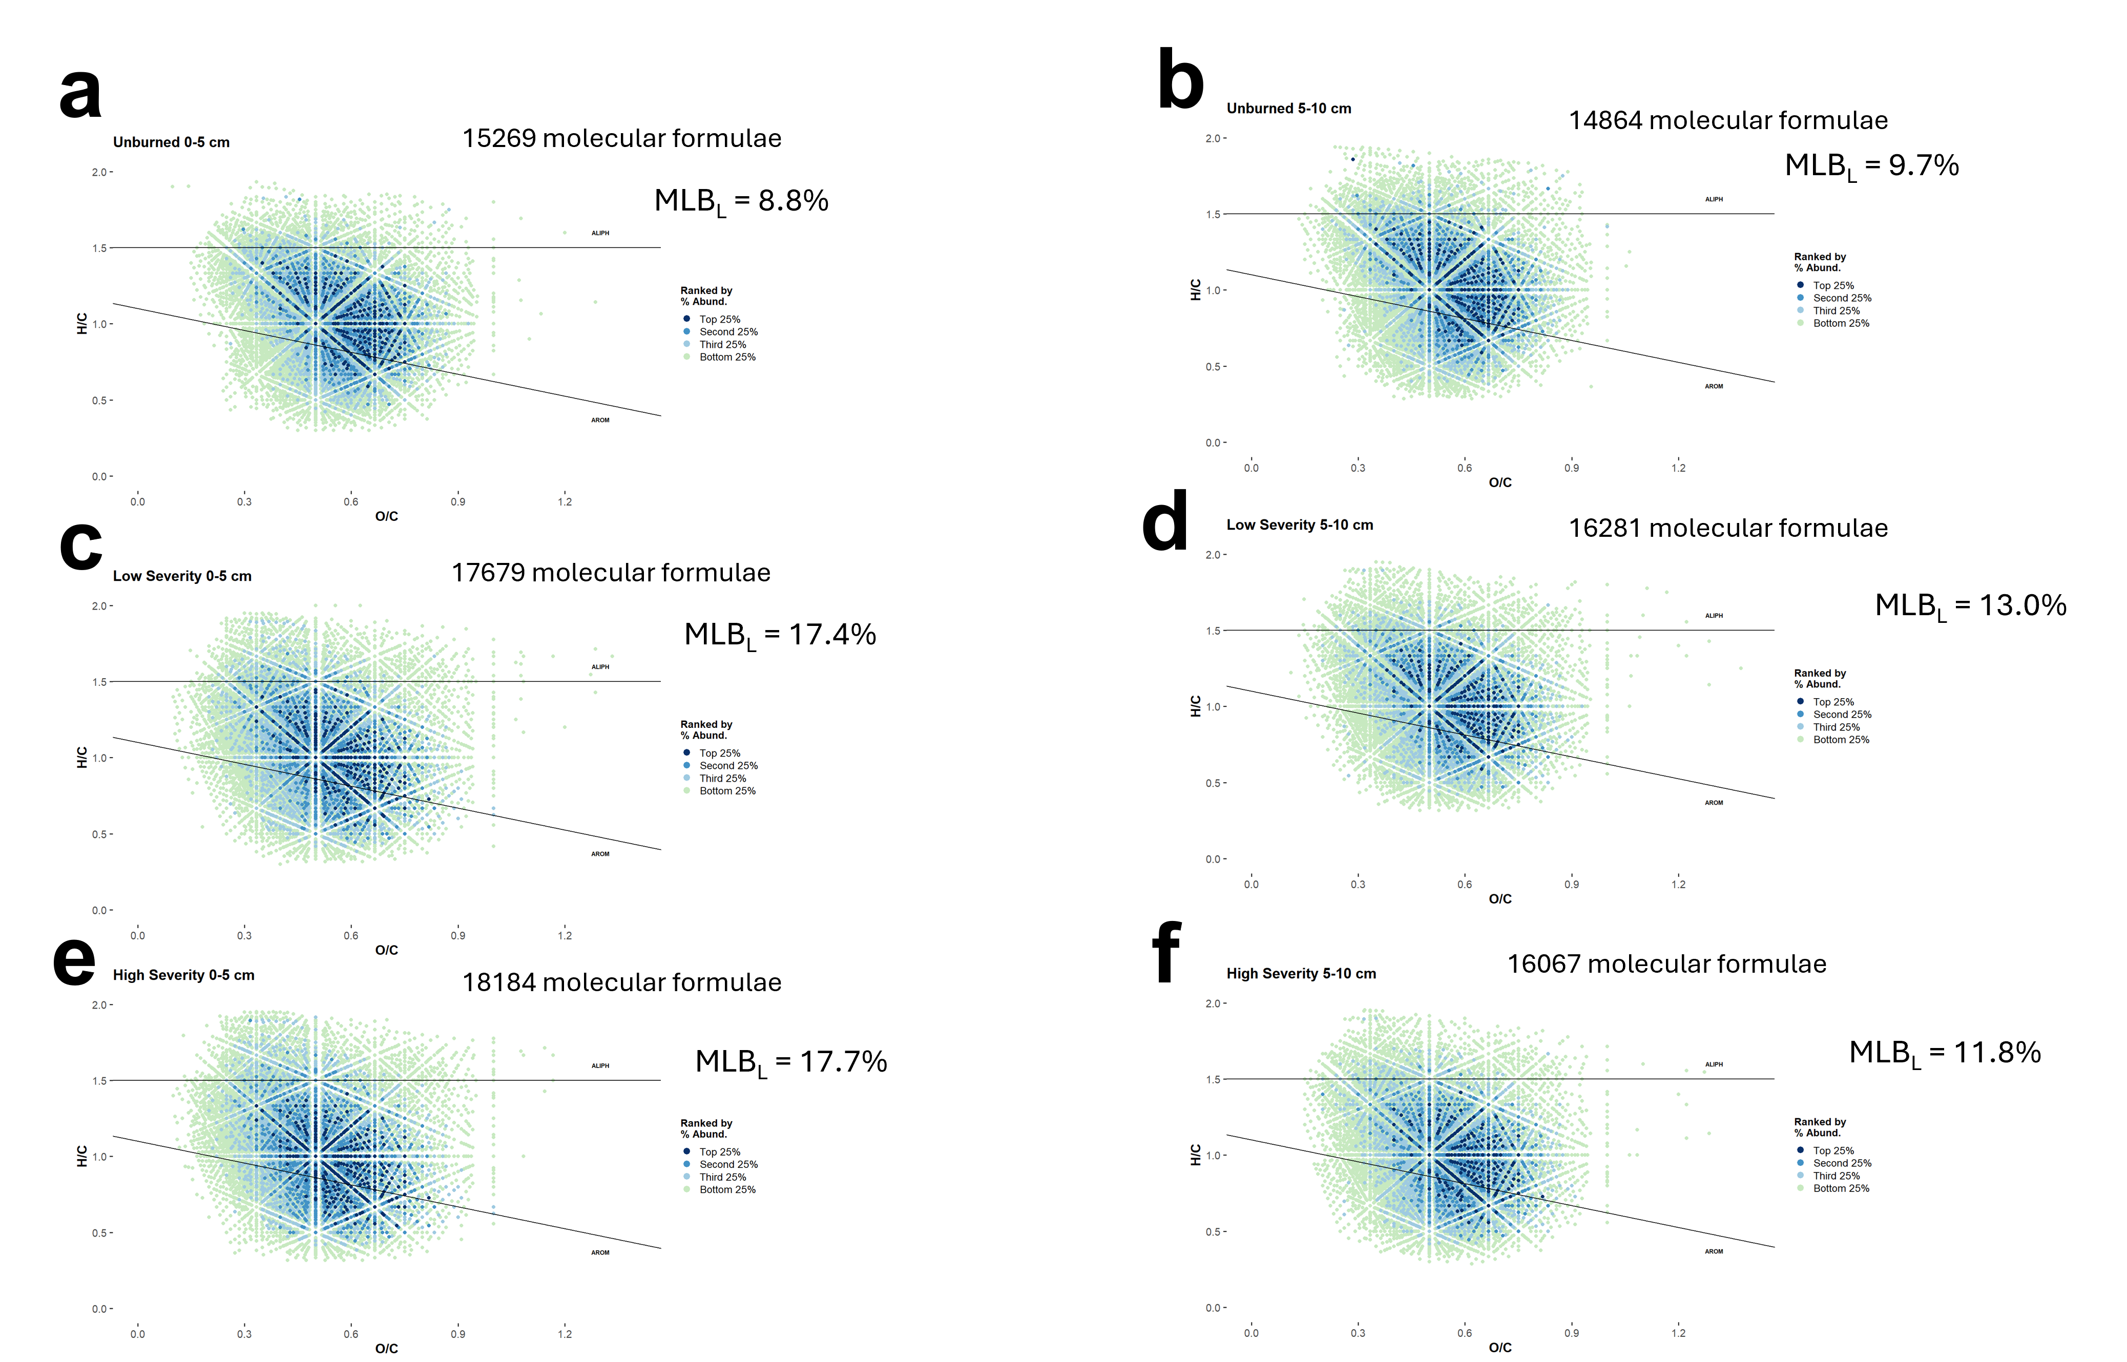
Fig. 1 | Fourier transform ion cyclotron resonance-mass spectrometry results plotted in van Krevelen diagrams.¹ All assigned molecular formulae for each sample are plotted in a, unburned 0-5 cm; b, unburned 5-10 cm; c, low severity 0-5 cm; d, low severity 5-10 cm; e, high severity 0-5 cm; and f, high severity 5-10 cm. The plotted molecular formulae were colored based on their abundances. For example, the “top 25%” data points are molecular formulas that have greater relative abundances than 75% of the total molecular formulas. “Second 25%” are molecular formulas that have greater relative abundances than 50% of the total molecular formulas and so on. MLB_{L} is the molecular lability boundary value indicates the percentage of assigned molecular formulae featuring H/C ratios greater than 1.5 and is a metric for quantifying more chemical constituents.²

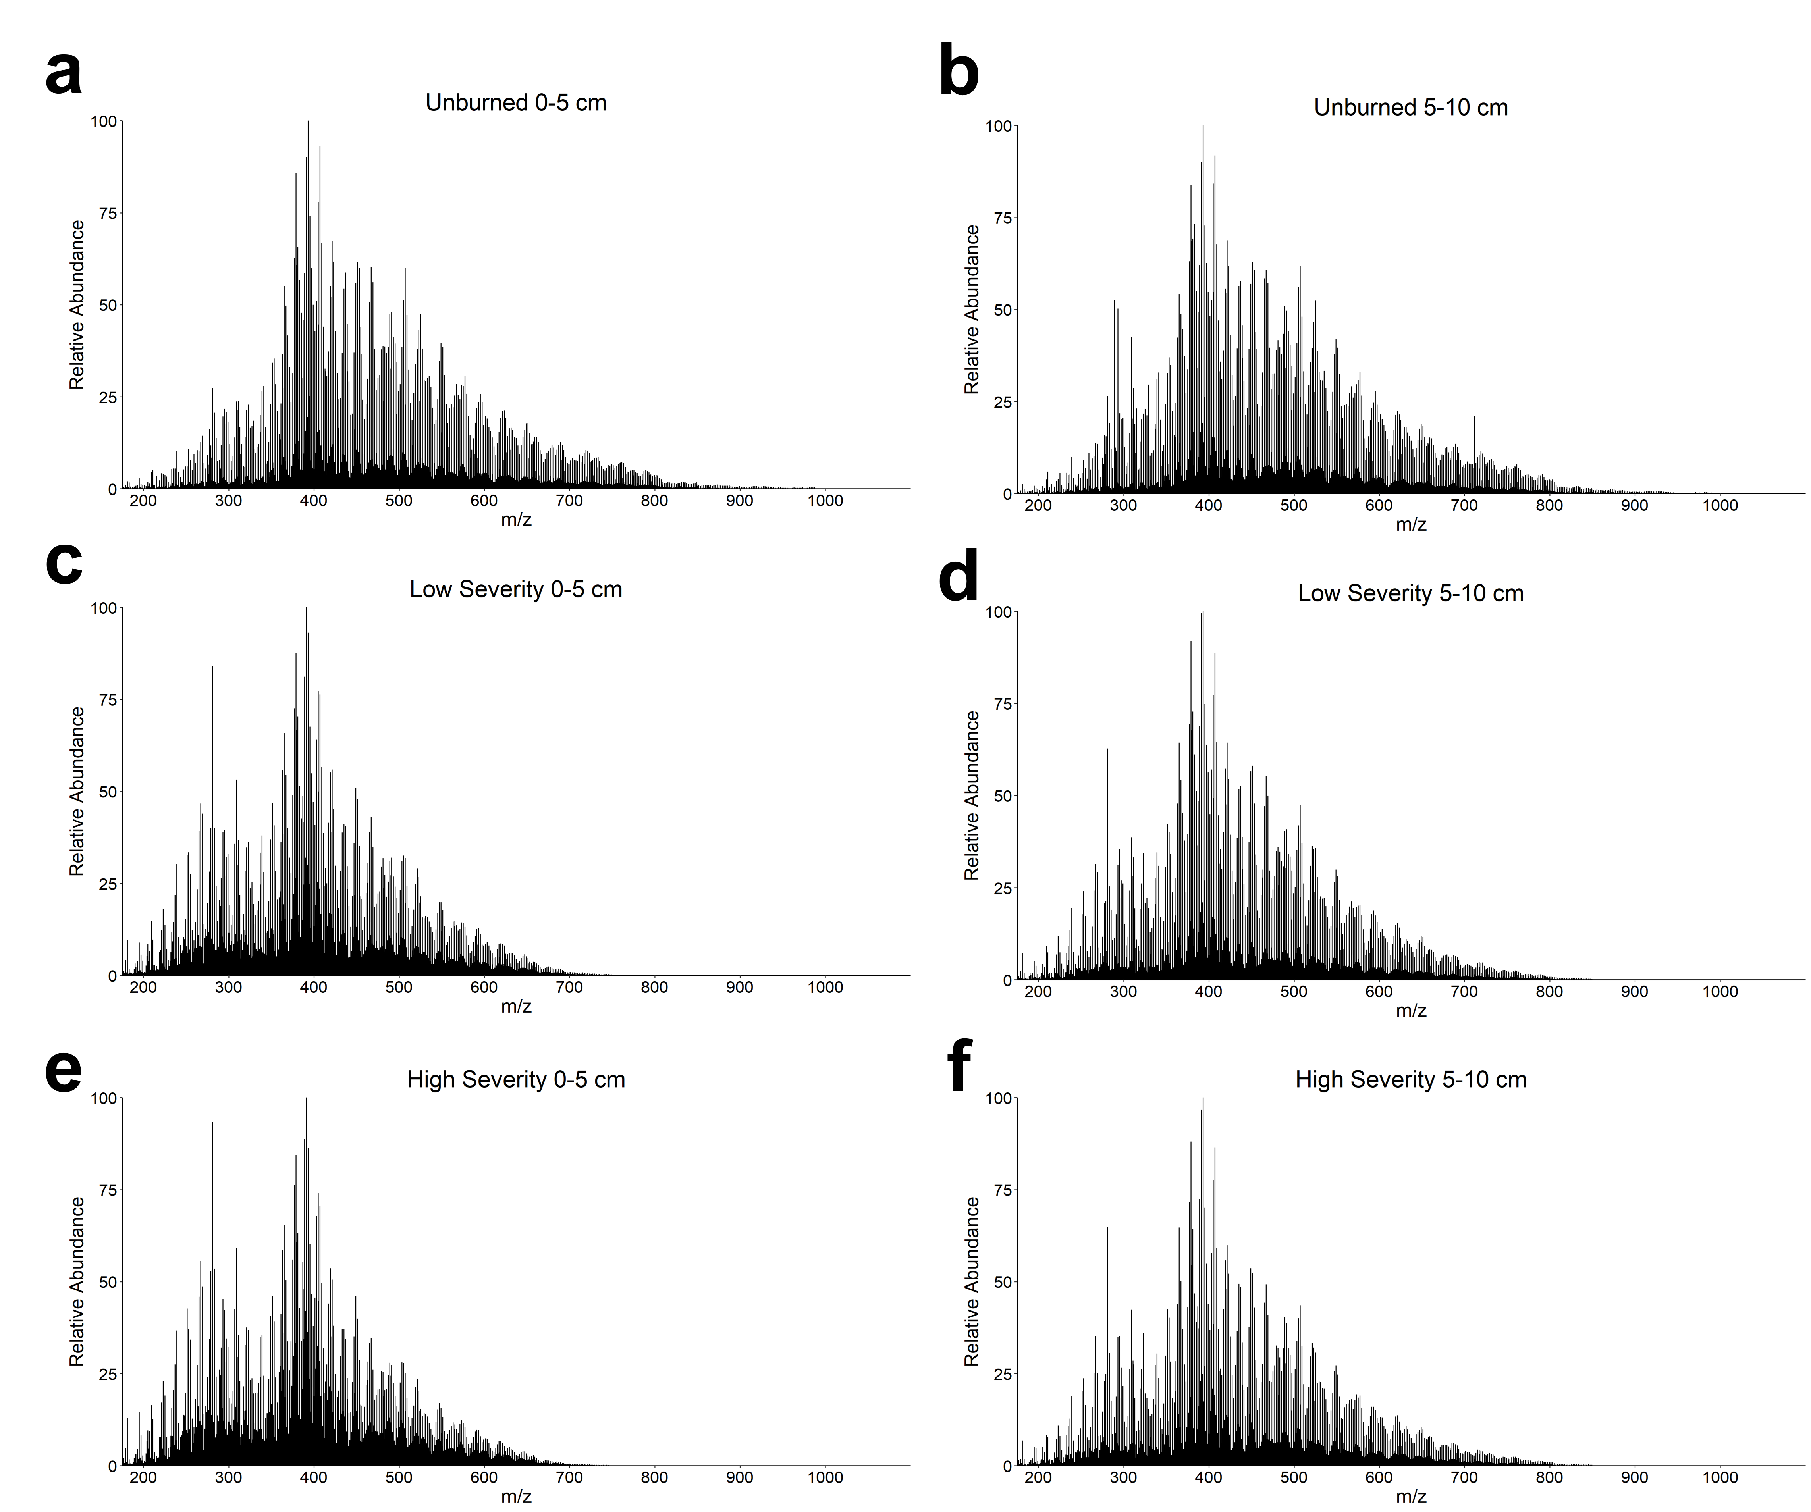
Fig. 2 | Fourier transform ion cyclotron resonance-mass spectrometry mass spectra. All assigned molecular formulae for each sample are plotted in a, unburned 0-5 cm; b, unburned 5-10 cm; c, low severity 0-5 cm; d, low severity 5-10 cm; e, high severity 0-5 cm; and f, high severity 5-10 cm.

(1) van Krevelen, D. W. Graphical-Statistical Method for the Study of Structure and Reaction Processes of Coal. Fuel 1950, 29, 269–284.
(2) D’Andrilli, J.; Cooper, W. T.; Foreman, C. M.; Marshall, A. G. An Ultrahigh‐resolution Mass Spectrometry Index to Estimate Natural Organic Matter Lability. Rapid Commun. Mass Spectrom. 2015, 29 (24), 2385–2401. https://doi.org/10.1002/rcm.7400.

