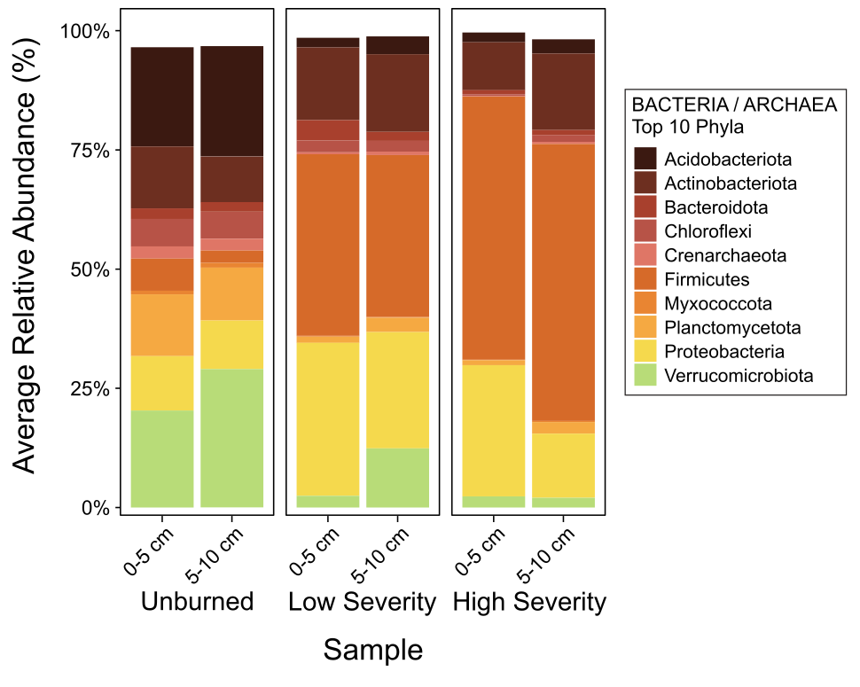
Fig. 1 | 16S rRNA gene amplicon sequencing results for bacterial and archaeal fungi. This bar plot features relative abundance values averaged across replicates for the top ten most abundant bacterial and archaeal phyla within soils collected at 0-5 cm and 5-10 cm depths. n=6 for unburned 0-5 cm, n=8 for unburned 5-10 cm, n=10 for low severity 0-5 cm, n=10 for low severity 5-10 cm, n=9 for high severity 0-5 cm, and n=10 for high severity 5-10 cm soils (post-rarefying).

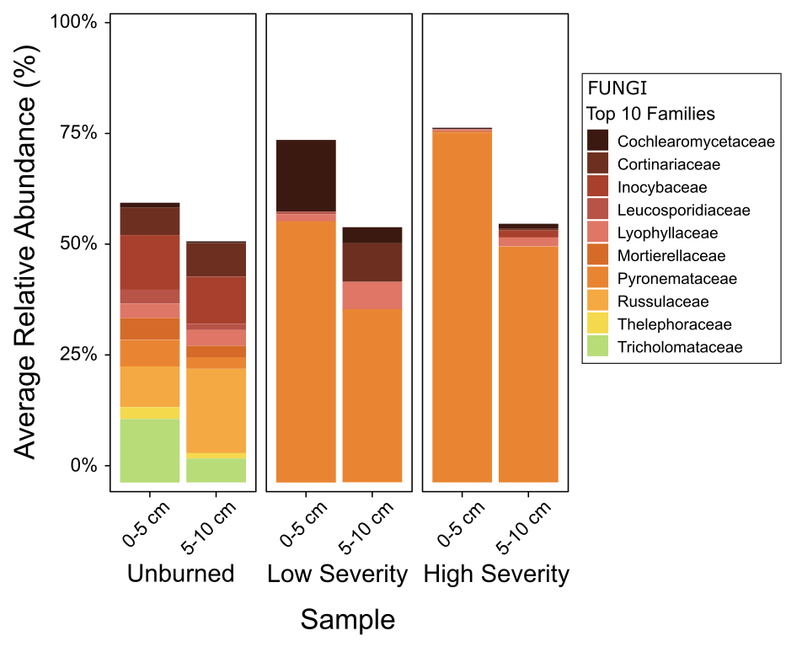
Fig. 2 | ITS amplicon sequencing results for fungal families. This bar plot features relative abundance values averaged across replicates for the top ten most abundant fungal families within soils collected at 0-5 cm and 5-10 cm depths. n=6 for unburned 0-5 cm, n=6 for unburned 5-10 cm, n=9 for low severity 0-5 cm, n=9 for low severity 5-10 cm, n=10 for high severity 0-5 cm, and n=8 for high severity 5-10 cm soils (post-rarefying).

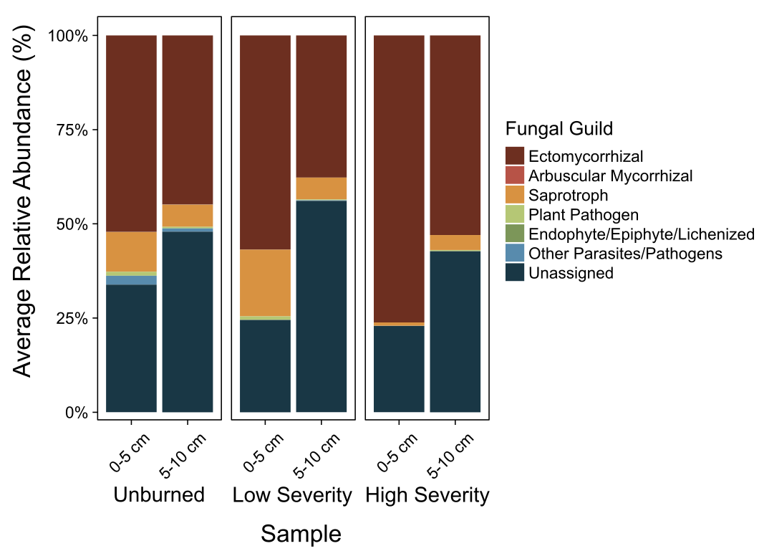
Fig. 3 | ITS amplicon sequencing results for fungal guilds. This bar plot features relative abundance values averaged across replicates for the top ten most abundant fungal families within soils collected at 0-5 cm and 5-10 cm depths. n=6 for unburned 0-5 cm, n=6 for unburned 5-10 cm, n=9 for low severity 0-5 cm, n=9 for low severity 5-10 cm, n=10 for high severity 0-5 cm, and n=8 for high severity 5-10 cm soils (post-rarefying).

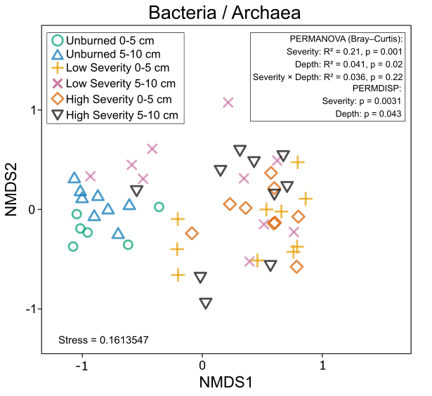
Fig. 4 | Nonmetric multidimensional scaling (NMDS) ordination plots including Bray-Curtis ASV microbial community composition dissimilarities for bacterial/archaeal communities. n=6 for unburned 0-5 cm, n=8 for unburned 5-10 cm, n=10 for low severity 0-5 cm, n=10 for low severity 5-10 cm, n=9 for high severity 0-5 cm, and n=10 for high severity 5-10 cm soils (post-rarefying).

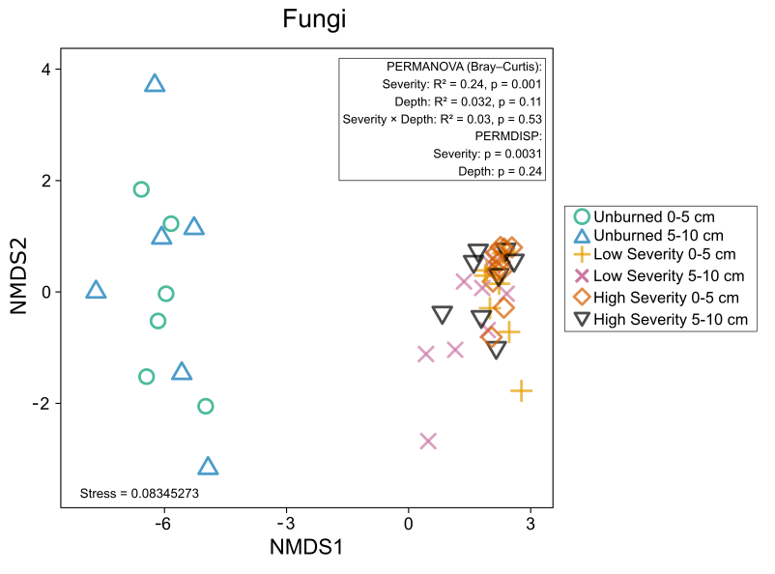
Fig. 5 | Nonmetric multidimensional scaling (NMDS) ordination plots including Bray-Curtis ASV microbial community composition dissimilarities for fungal communities. n=6 for unburned 0-5 cm, n=6 for unburned 5-10 cm, n=9 for low severity 0-5 cm, n=9 for low severity 5-10 cm, n=10 for high severity 0-5 cm, and n=8 for high severity 5-10 cm soils (post-rarefying).

When determining significant differences across mean values from three samples for plots a and b in all the following figures (Figs. 6-9), normality and equal variances were first determined using the Shapiro-Wilk test and Levene’s test, respectively. If the data were not normally distributed (P<0.05 for Shapiro-Wilk test), Kruskal-Wallis and Dunn’s tests were used (P<0.05 indicates significant differences). If the data were normally distributed (P>0.05 for Shapiro-Wilk test) but the variances of the data were not equal (P<0.05 for Levene’s test), Welch’s ANOVA and Games-Howell tests were used (P<0.05 indicates significant differences). If the data were normally distributed and the variances of the data were equal (P>0.05 for Levene’s test), ANOVA and Tukey HSD tests were used (P<0.05 indicates significant differences). normality and equal variances were first determined using the Shapiro-Wilk test and Levene’s test, respectively.
When determining significant differences between mean values from two samples for plot c in all the following figures (Figs. 6-9), normality and equal variances were once again first determined using the Shapiro-Wilk test and Levene’s test, respectively. If the data were not normally distributed (P<0.05 for Shapiro-Wilk test), Mann-Whitney U test (also known as the Wilcoxon rank-sum test) was used (P<0.05 indicates significant differences). If the data were normally distributed (P>0.05 for Shapiro-Wilk test) but the variances of the data were not equal (P<0.05 for Levene’s test), Welch’s t-test was used (P<0.05 indicates significant differences). If the data were normally distributed and the variances of the data were equal (P>0.05 for Levene’s test), Student’s t-test was used.

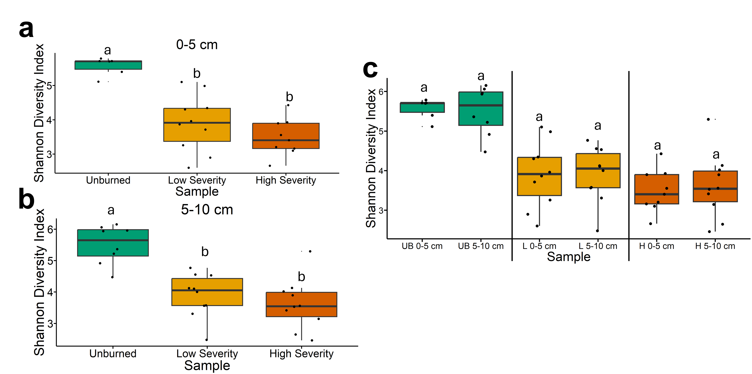
Fig. 6 | Shannon diversity index values for bacterial and archaeal communities. The statistical tests of a, b, and c were conducted independently of each other. a, Quantifying Shannon index values for bacterial and archaeal communities across soils collected at a depth of 0-5 cm. Letters above boxes indicate significant differences (P<0.05) amongst sample types. n=6 for unburned samples, n=10 for low severity samples, and n=9 for high severity samples (post-rarefying). b, Quantifying Shannon index values for bacterial and archaeal communities across soils collected at a depth of 5-10 cm. Letters above boxes indicate significant differences (P<0.05) amongst treatments. n=8 for unburned samples, n=10 for low severity samples, and n=10 for high severity samples (post-rarefying). c, Quantifying Shannon index values for bacterial and archaeal communities and comparing 0-5 cm soil depth with 5-10 cm soil depth. The statistical tests within sample types (i.e. unburned, low severity, and high severity) were conducted independently from each other. In other words, the “a” above “UB 0-5 cm” does not mean that there is no significant difference compared to “L 0-5 cm” which also has an “a” label because those statistical tests were conducted independently of each other. P<0.05 was the cutoff for significant differences. UB = unburned. L = low severity. H = high severity. n=6 for unburned 0-5 cm samples, n=8 for unburned 5-10 cm samples, n=10 for low severity 0-5 cm samples, n=10 for low severity 5-10 cm, n=9 for high severity 0-5 cm samples, and n=10 for high severity 5-10 cm samples (post-rarefying). Box plots show the median (central line), first and third quartiles (box edges), and whiskers extending to minimum and maximum values within 1.5 times the interquartile range. Smaller black dots (not the data points) indicate where the data points would lie if the data points weren’t jittered.

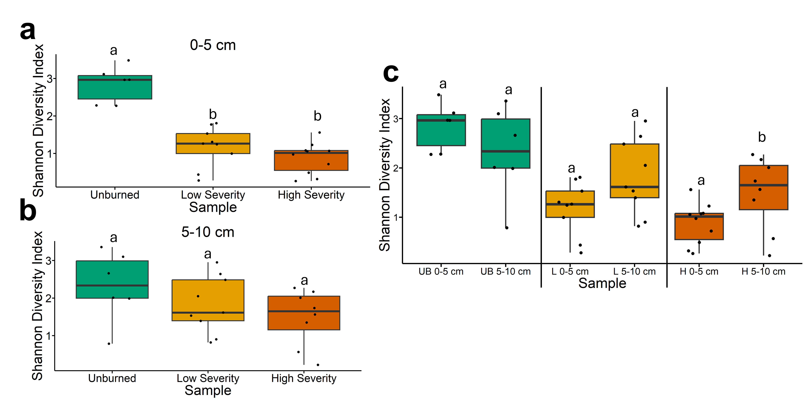
Fig. 7 | Shannon diversity index values for fungal communities. The statistical tests of a, b, and c were conducted independently of each other. a, Quantifying Shannon index values for fungal communities across soils collected at a depth of 0-5 cm. Letters above boxes indicate significant differences (P<0.05) amongst sample types. n=6 for unburned samples, n=9 for low severity samples, and n=10 for high severity samples (post-rarefying). b, Quantifying Shannon index values for fungal communities across soils collected at a depth of 5-10 cm. Letters above boxes indicate significant differences (P<0.05) amongst treatments. n=6 for unburned samples, n=9 for low severity samples, and n=8for high severity samples (post-rarefying). c, Quantifying Shannon index values for fungal communities and comparing 0-5 cm soil depth with 5-10 cm soil depth. The statistical tests within sample types (i.e. unburned, low severity, and high severity) were conducted independently from each other. In other words, the “a” above “UB 0-5 cm” does not mean that there is no significant difference compared to “L 0-5 cm” which also has an “a” label because those statistical tests were conducted independently of each other. P<0.05 was the cutoff for significant differences. UB = unburned. L = low severity. H = high severity. n=6 for unburned 0-5 cm samples, n=6 for unburned 5-10 cm samples, n=9 for low severity 0-5 cm samples, n=9 for low severity 5-10 cm, n=10 for high severity 0-5 cm samples, and n=8 for high severity 5-10 cm samples (post-rarefying). Box plots show the median (central line), first and third quartiles (box edges), and whiskers extending to minimum and maximum values within 1.5 times the interquartile range. Smaller black dots (not the data points) indicate where the data points would lie if the data points weren’t jittered.

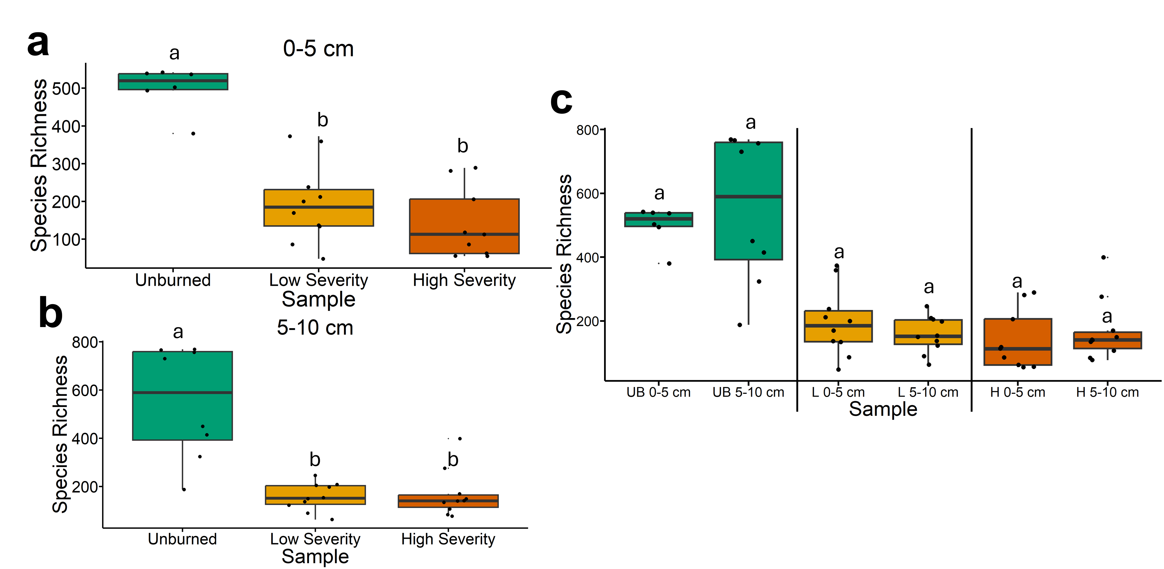
Fig. 8 | Species richness values for bacterial and archaeal communities. The statistical tests of a, b, and c were conducted independently of each other. a, Quantifying species richness values for bacterial and archaeal communities across soils collected at a depth of 0-5 cm. Letters above boxes indicate significant differences (P<0.05) amongst sample types. n=6 for unburned samples, n=10 for low severity samples, and n=9 for high severity samples (post-rarefying). b, Quantifying species richness values for bacterial and archaeal communities across soils collected at a depth of 5-10 cm. Letters above boxes indicate significant differences (P<0.05) amongst treatments. n=8 for unburned samples, n=10 for low severity samples, and n=10 for high severity samples (post-rarefying). c, Quantifying species richness values for bacterial and archaeal communities and comparing 0-5 cm soil depth with 5-10 cm soil depth. The statistical tests within sample types (i.e. unburned, low severity, and high severity) were conducted independently from each other. In other words, the “a” above “UB 0-5 cm” does not mean that there is no significant difference compared to “L 0-5 cm” which also has an “a” label because those statistical tests were conducted independently of each other. P<0.05 was the cutoff for significant differences. UB = unburned. L = low severity. H = high severity. n=6 for unburned 0-5 cm samples, n=8 for unburned 5-10 cm samples, n=10 for low severity 0-5 cm samples, n=10 for low severity 5-10 cm, n=9 for high severity 0-5 cm samples, and n=10 for high severity 5-10 cm samples (post-rarefying). Box plots show the median (central line), first and third quartiles (box edges), and whiskers extending to minimum and maximum values within 1.5 times the interquartile range. Smaller black dots (not the data points) indicate where the data points would lie if the data points weren’t jittered.

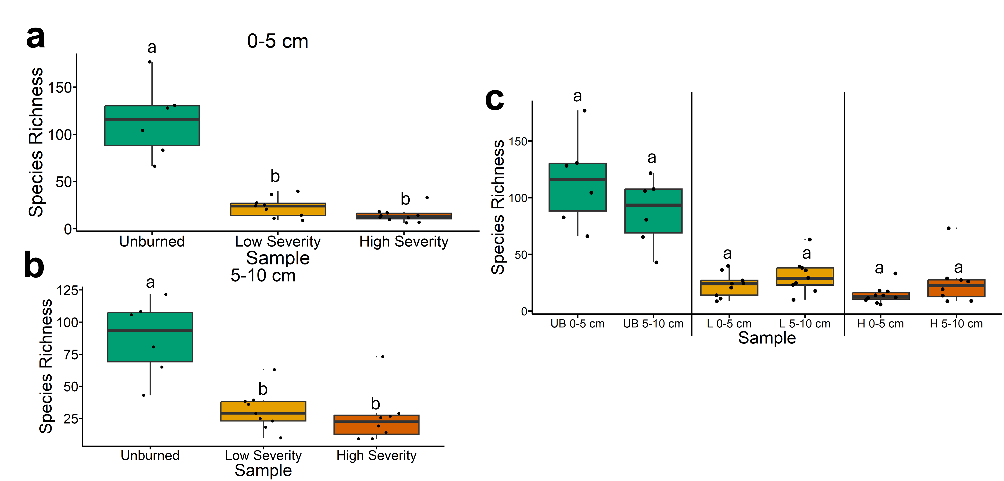
Fig. 7 | Species richness values for fungal communities. The statistical tests of a, b, and c were conducted independently of each other. a, Quantifying species richness values for fungal communities across soils collected at a depth of 0-5 cm. Letters above boxes indicate significant differences (P<0.05) amongst sample types. n=6 for unburned samples, n=9 for low severity samples, and n=10 for high severity samples (post-rarefying). b, Quantifying species richness values for fungal communities across soils collected at a depth of 5-10 cm. Letters above boxes indicate significant differences (P<0.05) amongst treatments. n=6 for unburned samples, n=9 for low severity samples, and n=8for high severity samples (post-rarefying). c, Quantifying species richness values for fungal communities and comparing 0-5 cm soil depth with 5-10 cm soil depth. The statistical tests within sample types (i.e. unburned, low severity, and high severity) were conducted independently from each other. In other words, the “a” above “UB 0-5 cm” does not mean that there is no significant difference compared to “L 0-5 cm” which also has an “a” label because those statistical tests were conducted independently of each other. P<0.05 was the cutoff for significant differences. UB = unburned. L = low severity. H = high severity. n=6 for unburned 0-5 cm samples, n=6 for unburned 5-10 cm samples, n=9 for low severity 0-5 cm samples, n=9 for low severity 5-10 cm, n=10 for high severity 0-5 cm samples, and n=8 for high severity 5-10 cm samples (post-rarefying). Box plots show the median (central line), first and third quartiles (box edges), and whiskers extending to minimum and maximum values within 1.5 times the interquartile range. Smaller black dots (not the data points) indicate where the data points would lie if the data points weren’t jittered.

