When determining significant differences across mean values from three samples for plots a and b in all figures, normality and equal variances were first determined using the Shapiro-Wilk test and Levene’s test, respectively. If the data were not normally distributed (P<0.05 for Shapiro-Wilk test), Kruskal-Wallis and Dunn’s tests were used (P<0.05 indicates significant differences). If the data were normally distributed (P>0.05 for Shapiro-Wilk test) but the variances of the data were not equal (P<0.05 for Levene’s test), Welch’s ANOVA and Games-Howell tests were used (P<0.05 indicates significant differences). If the data were normally distributed and the variances of the data were equal (P>0.05 for Levene’s test), ANOVA and Tukey HSD tests were used (P<0.05 indicates significant differences). normality and equal variances were first determined using the Shapiro-Wilk test and Levene’s test, respectively.
When determining significant differences between mean values from two samples for plot c in all figures, normality and equal variances were once again first determined using the Shapiro-Wilk test and Levene’s test, respectively. If the data were not normally distributed (P<0.05 for Shapiro-Wilk test), Mann-Whitney U test (also known as the Wilcoxon rank-sum test) was used (P<0.05 indicates significant differences). If the data were normally distributed (P>0.05 for Shapiro-Wilk test) but the variances of the data were not equal (P<0.05 for Levene’s test), Welch’s t-test was used (P<0.05 indicates significant differences). If the data were normally distributed and the variances of the data were equal (P>0.05 for Levene’s test), Student’s t-test was used.

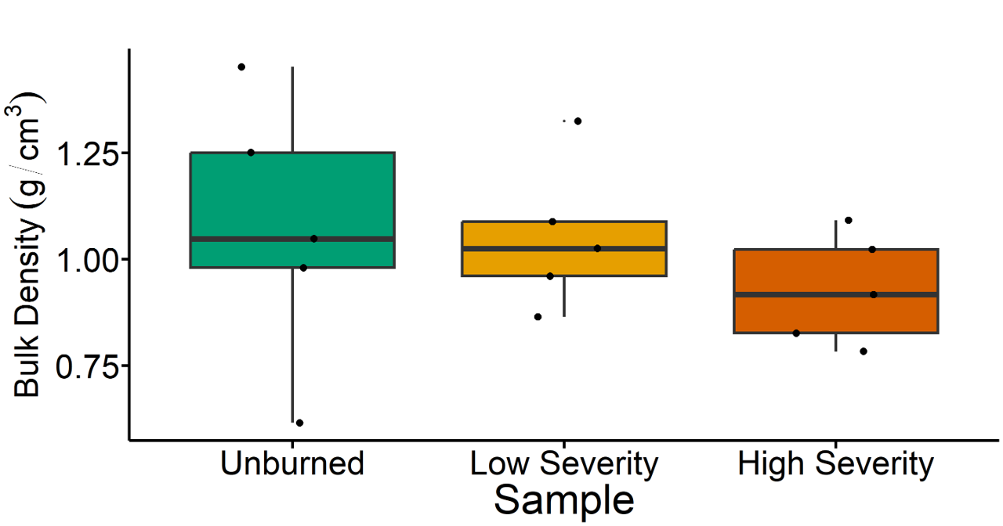
Fig. 1 | Soil bulk density results. The letters above boxes indicate significant differences between treatments determined by ANOVA and Tukey HSD tests (P<0.05). n = 5 for unburned, low severity, and high severity samples. Box plots show the median (central line), first and third quartiles (box edges), and whiskers extending to minimum and maximum values within 1.5 times the interquartile range. Smaller black dots (not the data points) indicate where the data points would lie if the data points weren’t jittered.

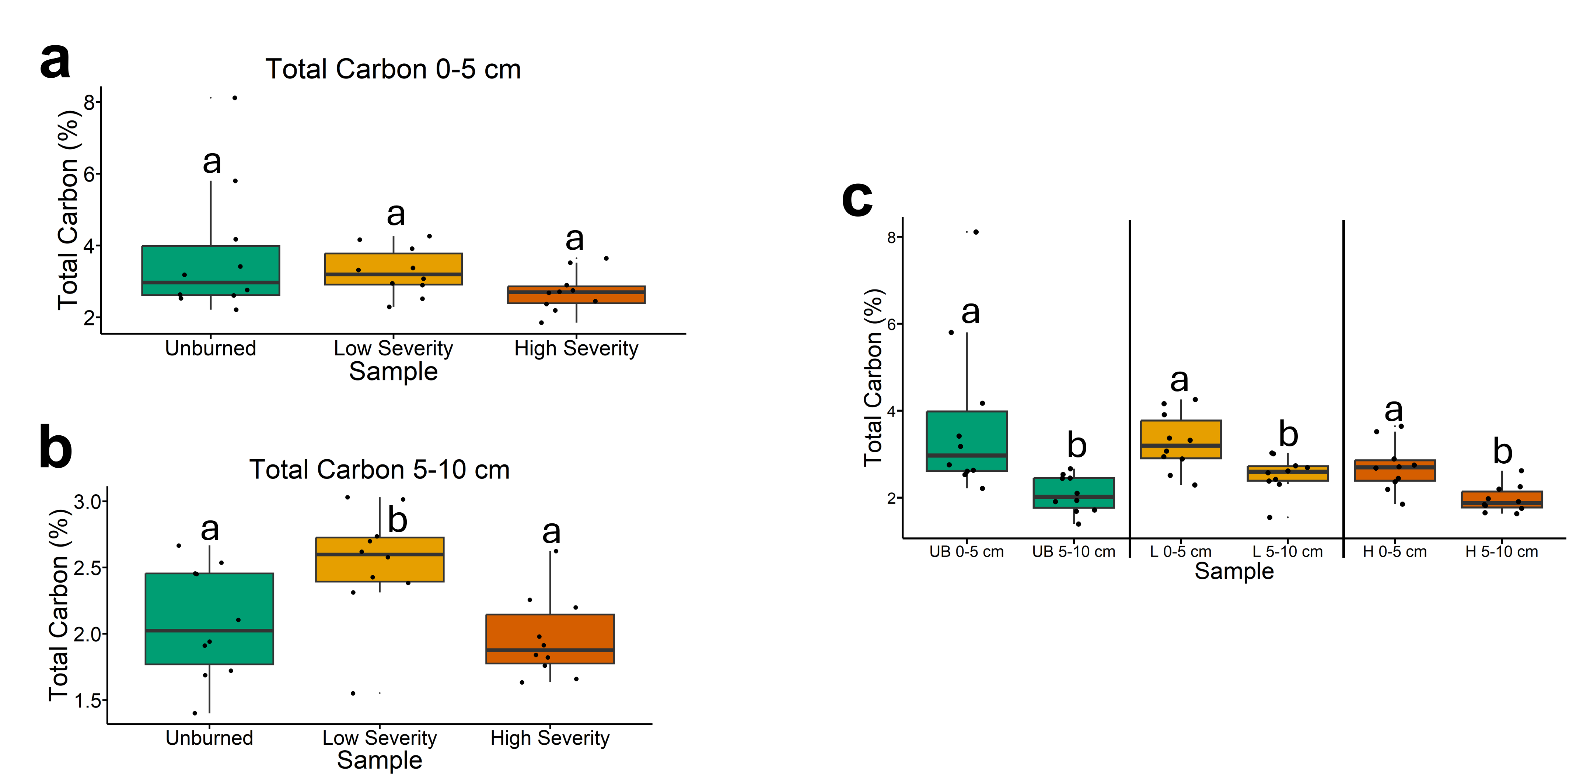
Fig. 2 | Total soil carbon results. The statistical tests of a, b, and c were conducted independently of each other. a, Quantifying total soil carbon across soils collected at a depth of 0-5 cm. Letters above boxes indicate significant differences (P<0.05) amongst sample types. n=10 for unburned, low severity, and high severity samples. b, Quantifying total soil carbon across soils collected at a depth of 5-10 cm. Letters above boxes indicate significant differences (P<0.05) amongst treatments. n=10 for unburned, low severity, and high severity samples. c, Quantifying total soil carbon and comparing 0-5 cm soil depth with 5-10 cm soil depth. The statistical tests within sample types (i.e. unburned, low severity, and high severity) were conducted independently from each other. In other words, the “a” above “UB 0-5 cm” does not mean that there is no significant difference compared to “L 0-5 cm” which also has an “a” label because those statistical tests were conducted independently of each other. P<0.05 was the cutoff for significant differences. UB = unburned. L = low severity. H = high severity. n=10 for unburned 0-5 cm, unburned 5-10 cm, low severity 0-5 cm, low severity 5-10 cm, high severity 0-5 cm, and high severity 5-10 cm samples. Box plots show the median (central line), first and third quartiles (box edges), and whiskers extending to minimum and maximum values within 1.5 times the interquartile range. Smaller black dots (not the data points) indicate where the data points would lie if the data points weren’t jittered.

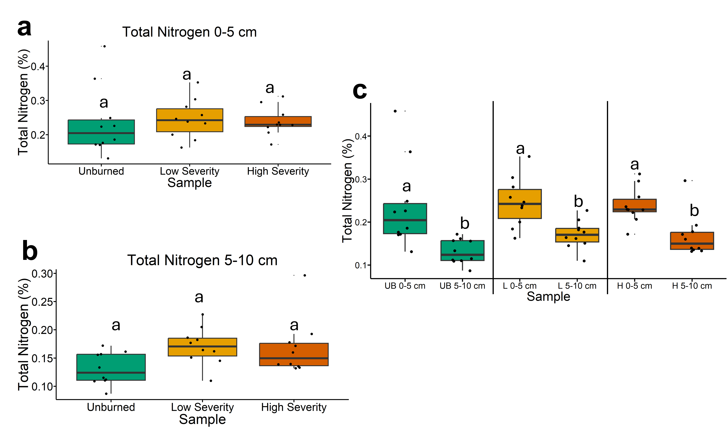
Fig. 3 | Total soil nitrogen results. The statistical tests of a, b, and c were conducted independently of each other. a, Quantifying total soil nitrogen across soils collected at a depth of 0-5 cm. Letters above boxes indicate significant differences (P<0.05) amongst sample types. n=10 for unburned, low severity, and high severity samples. b, Quantifying total soil nitrogen across soils collected at a depth of 5-10 cm. Letters above boxes indicate significant differences (P<0.05) amongst treatments. n=10 for unburned, low severity, and high severity samples. c, Quantifying total soil nitrogen and comparing 0-5 cm soil depth with 5-10 cm soil depth. The statistical tests within sample types (i.e. unburned, low severity, and high severity) were conducted independently from each other. In other words, the “a” above “UB 0-5 cm” does not mean that there is no significant difference compared to “L 0-5 cm” which also has an “a” label because those statistical tests were conducted independently of each other. P<0.05 was the cutoff for significant differences. UB = unburned. L = low severity. H = high severity. n=10 for unburned 0-5 cm, unburned 5-10 cm, low severity 0-5 cm, low severity 5-10 cm, high severity 0-5 cm, and high severity 5-10 cm samples. Box plots show the median (central line), first and third quartiles (box edges), and whiskers extending to minimum and maximum values within 1.5 times the interquartile range. Smaller black dots (not the data points) indicate where the data points would lie if the data points weren’t jittered.

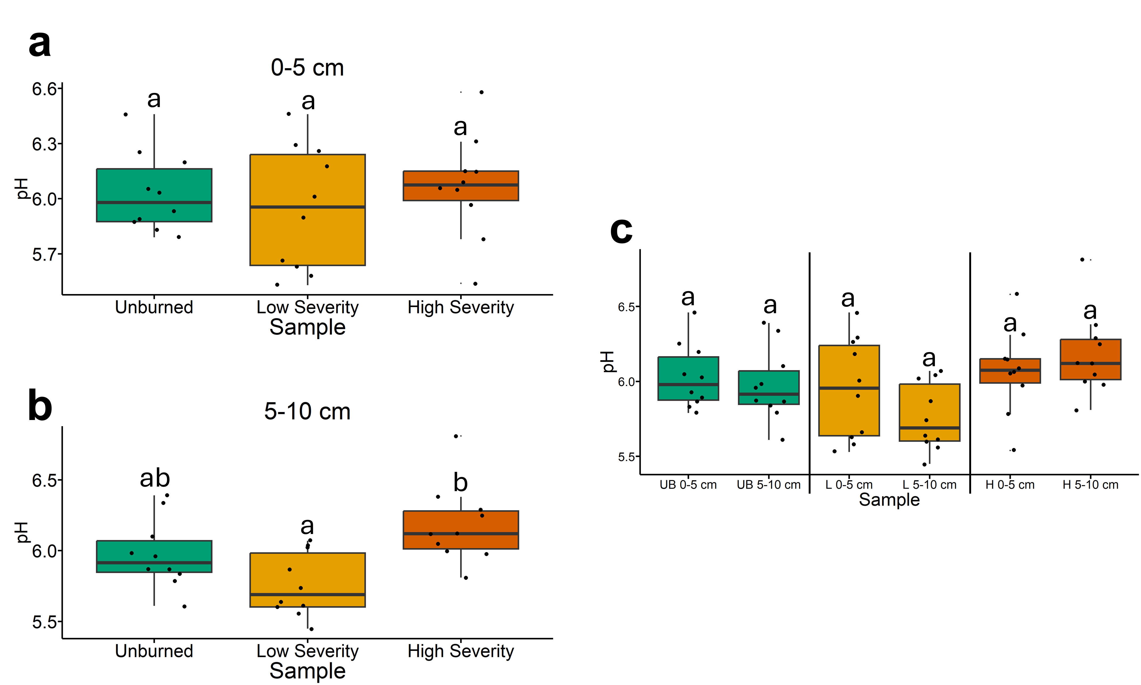
Fig. 4 | Soil pH results. The statistical tests of a, b, and c were conducted independently of each other. a, Quantifying soil pH across soils collected at a depth of 0-5 cm. Letters above boxes indicate significant differences (P<0.05) amongst sample types. n=10 for unburned, low severity, and high severity samples. b, Quantifying soil pH across soils collected at a depth of 5-10 cm. Letters above boxes indicate significant differences (P<0.05) amongst treatments. n=10 for unburned, low severity, and high severity samples. c, Quantifying soil pH and comparing 0-5 cm soil depth with 5-10 cm soil depth. The statistical tests within sample types (i.e. unburned, low severity, and high severity) were conducted independently from each other. In other words, the “a” above “UB 0-5 cm” does not mean that there is no significant difference compared to “L 0-5 cm” which also has an “a” label because those statistical tests were conducted independently of each other. P<0.05 was the cutoff for significant differences. UB = unburned. L = low severity. H = high severity. n=10 for unburned 0-5 cm, unburned 5-10 cm, low severity 0-5 cm, low severity 5-10 cm, high severity 0-5 cm, and high severity 5-10 cm samples. Box plots show the median (central line), first and third quartiles (box edges), and whiskers extending to minimum and maximum values within 1.5 times the interquartile range. Smaller black dots (not the data points) indicate where the data points would lie if the data points weren’t jittered.

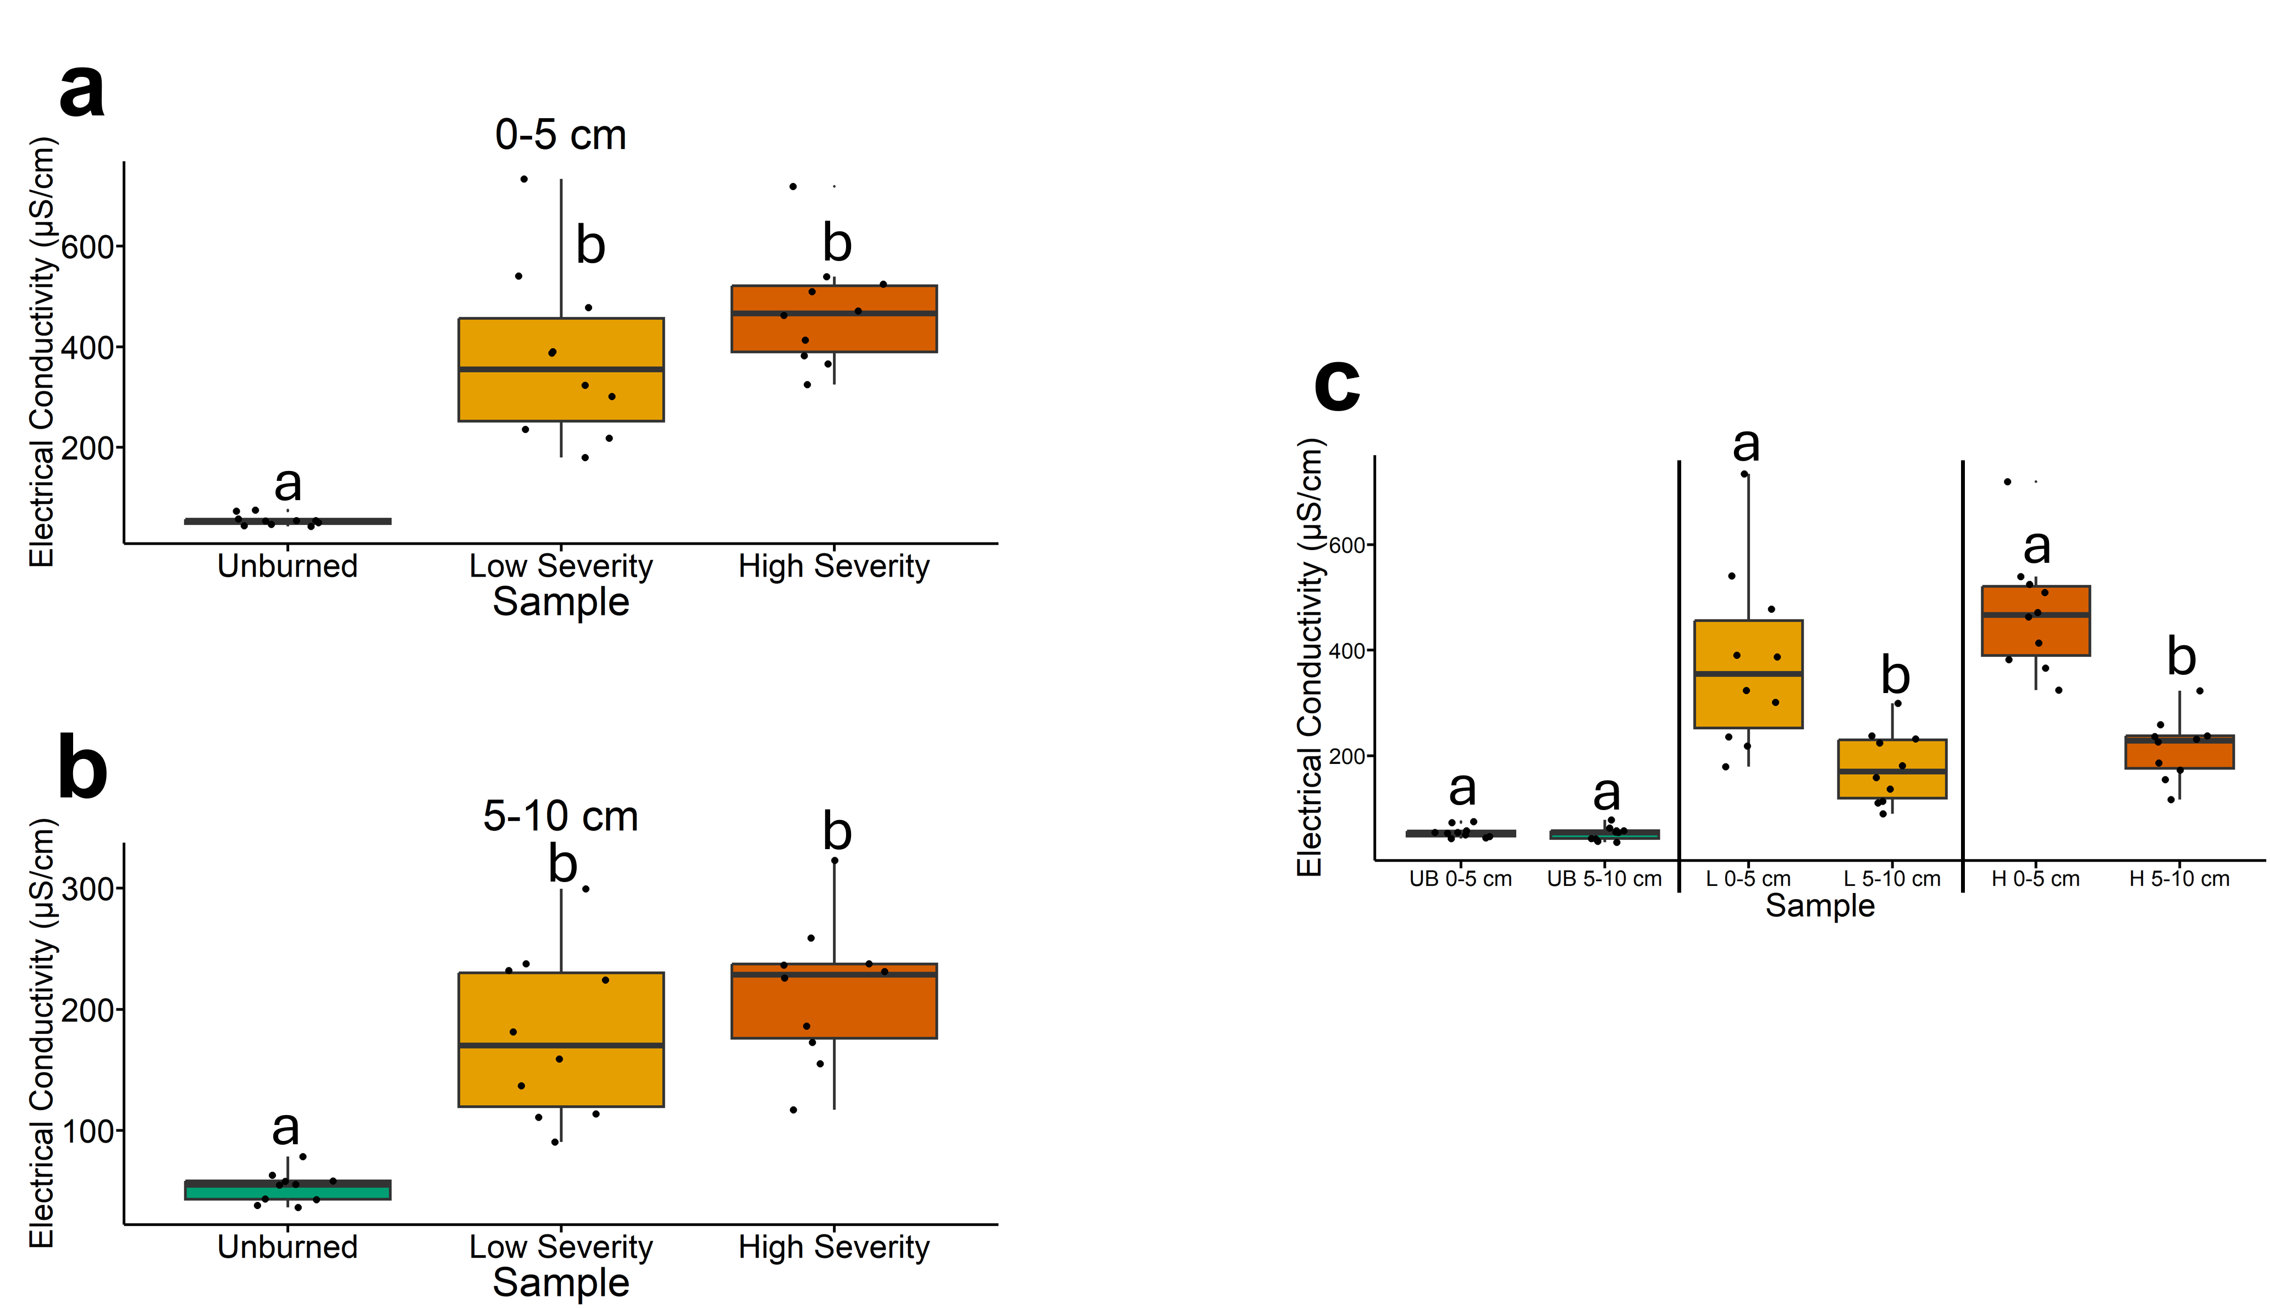
Fig. 5 | Soil electrical conductivity results. The statistical tests of a, b, and c were conducted independently of each other. a, Quantifying soil electrical conductivity across soils collected at a depth of 0-5 cm. Letters above boxes indicate significant differences (P<0.05) amongst sample types. n=10 for unburned, low severity, and high severity samples. b, Quantifying soil electrical conductivity across soils collected at a depth of 5-10 cm. Letters above boxes indicate significant differences (P<0.05) amongst treatments. n=10 for unburned, low severity, and high severity samples. c, Quantifying soil electrical conductivity and comparing 0-5 cm soil depth with 5-10 cm soil depth. The statistical tests within sample types (i.e. unburned, low severity, and high severity) were conducted independently from each other. In other words, the “a” above “UB 0-5 cm” does not mean that there is no significant difference compared to “L 0-5 cm” which also has an “a” label because those statistical tests were conducted independently of each other. P<0.05 was the cutoff for significant differences. UB = unburned. L = low severity. H = high severity. n=10 for unburned 0-5 cm, unburned 5-10 cm, low severity 0-5 cm, low severity 5-10 cm, high severity 0-5 cm, and high severity 5-10 cm samples. Box plots show the median (central line), first and third quartiles (box edges), and whiskers extending to minimum and maximum values within 1.5 times the interquartile range. Smaller black dots (not the data points) indicate where the data points would lie if the data points weren’t jittered.

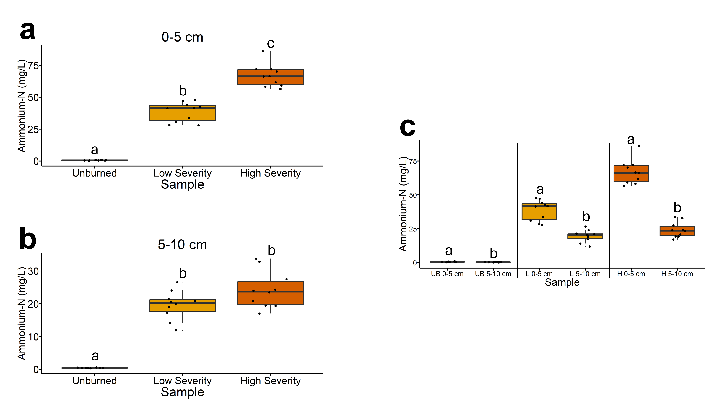

Fig. 6 | Ammonium-N concentrations for soil-water extracts. The statistical tests of a, b, and c were conducted independently of each other. a, Quantifying ammonium-N concentrations for soil-water extracts across soils collected at a depth of 0-5 cm. Letters above boxes indicate significant differences (P<0.05) amongst sample types. n=10 for unburned, low severity, and high severity samples. b, Quantifying ammonium-N concentrations for soil-water extracts across soils collected at a depth of 5-10 cm. Letters above boxes indicate significant differences (P<0.05) amongst treatments. n=10 for unburned, low severity, and high severity samples. c, Quantifying ammonium-N concentrations for soil-water extracts and comparing 0-5 cm soil depth with 5-10 cm soil depth. The statistical tests within sample types (i.e. unburned, low severity, and high severity) were conducted independently from each other. In other words, the “a” above “UB 0-5 cm” does not mean that there is no significant difference compared to “L 0-5 cm” which also has an “a” label because those statistical tests were conducted independently of each other. P<0.05 was the cutoff for significant differences. UB = unburned. L = low severity. H = high severity. n=10 for unburned 0-5 cm, unburned 5-10 cm, low severity 0-5 cm, low severity 5-10 cm, high severity 0-5 cm, and high severity 5-10 cm samples. Box plots show the median (central line), first and third quartiles (box edges), and whiskers extending to minimum and maximum values within 1.5 times the interquartile range. Smaller black dots (not the data points) indicate where the data points would lie if the data points weren’t jittered.

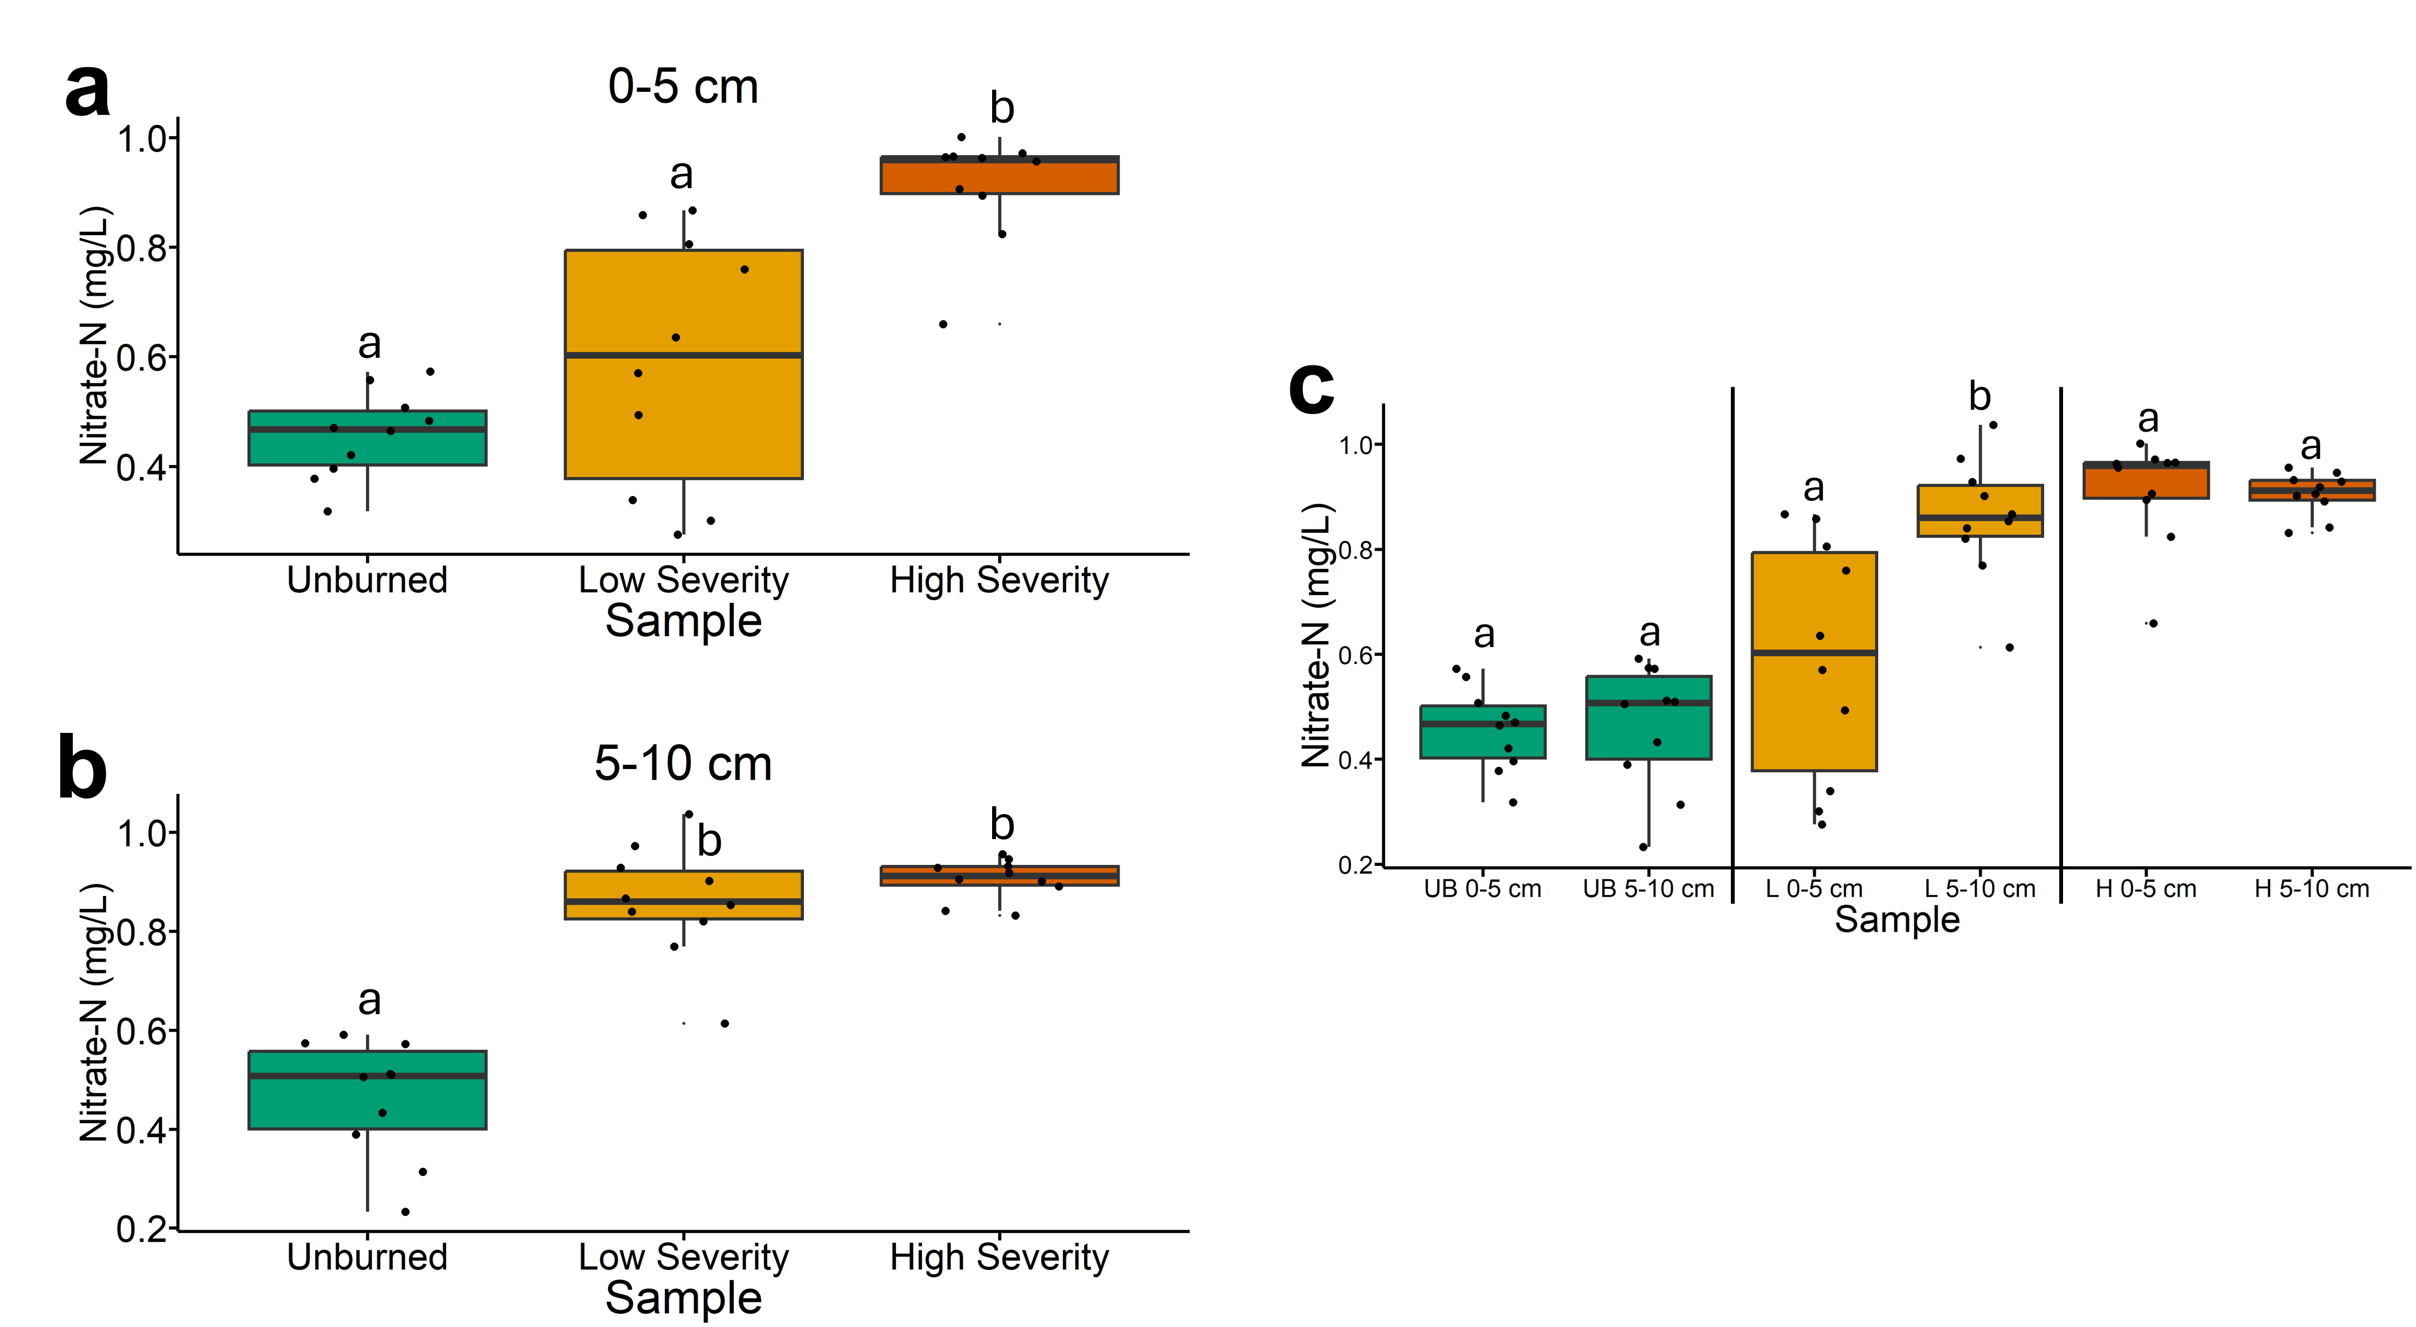
Fig. 7 | Nitrate-N concentrations for soil-water extracts. The statistical tests of a, b, and c were conducted independently of each other. a, Quantifying nitrate-N concentrations for soil-water extracts across soils collected at a depth of 0-5 cm. Letters above boxes indicate significant differences (P<0.05) amongst sample types. n=10 for unburned, low severity, and high severity samples. b, Quantifying nitrate-N concentrations for soil-water extracts across soils collected at a depth of 5-10 cm. Letters above boxes indicate significant differences (P<0.05) amongst treatments. n=10 for unburned, low severity, and high severity samples. c, Quantifying nitrate-N concentrations for soil-water extracts and comparing 0-5 cm soil depth with 5-10 cm soil depth. The statistical tests within sample types (i.e. unburned, low severity, and high severity) were conducted independently from each other. In other words, the “a” above “UB 0-5 cm” does not mean that there is no significant difference compared to “L 0-5 cm” which also has an “a” label because those statistical tests were conducted independently of each other. P<0.05 was the cutoff for significant differences. UB = unburned. L = low severity. H = high severity. n=10 for unburned 0-5 cm, unburned 5-10 cm, low severity 0-5 cm, low severity 5-10 cm, high severity 0-5 cm, and high severity 5-10 cm samples. Box plots show the median (central line), first and third quartiles (box edges), and whiskers extending to minimum and maximum values within 1.5 times the interquartile range. Smaller black dots (not the data points) indicate where the data points would lie if the data points weren’t jittered.

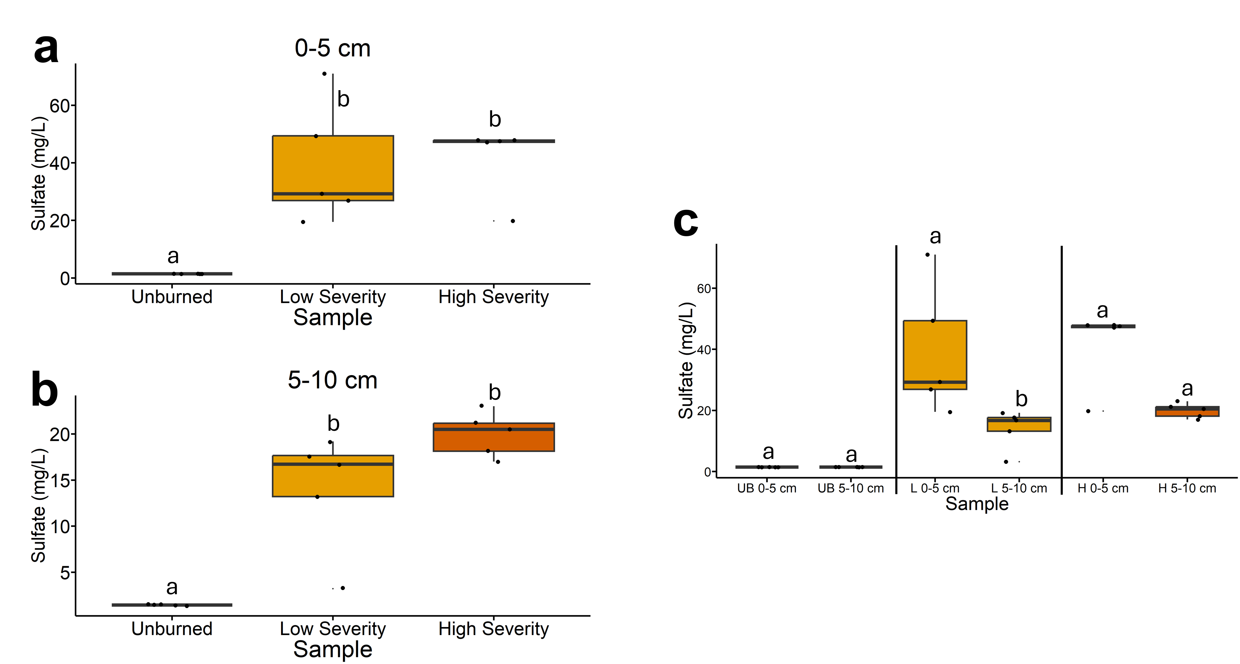
Fig. 8 | Sulfate concentrations for soil-water extracts. The statistical tests of a, b, and c were conducted independently of each other. a, Quantifying sulfate concentrations for soil-water extracts across soils collected at a depth of 0-5 cm. Letters above boxes indicate significant differences (P<0.05) amongst sample types. n=10 for unburned, low severity, and high severity samples. b, Quantifying sulfate concentrations for soil-water extracts across soils collected at a depth of 5-10 cm. Letters above boxes indicate significant differences (P<0.05) amongst treatments. n=10 for unburned, low severity, and high severity samples. c, Quantifying sulfate concentrations for soil-water extracts and comparing 0-5 cm soil depth with 5-10 cm soil depth. The statistical tests within sample types (i.e. unburned, low severity, and high severity) were conducted independently from each other. In other words, the “a” above “UB 0-5 cm” does not mean that there is no significant difference compared to “L 0-5 cm” which also has an “a” label because those statistical tests were conducted independently of each other. P<0.05 was the cutoff for significant differences. UB = unburned. L = low severity. H = high severity. n=10 for unburned 0-5 cm, unburned 5-10 cm, low severity 0-5 cm, low severity 5-10 cm, high severity 0-5 cm, and high severity 5-10 cm samples. Box plots show the median (central line), first and third quartiles (box edges), and whiskers extending to minimum and maximum values within 1.5 times the interquartile range. Smaller black dots (not the data points) indicate where the data points would lie if the data points weren’t jittered.

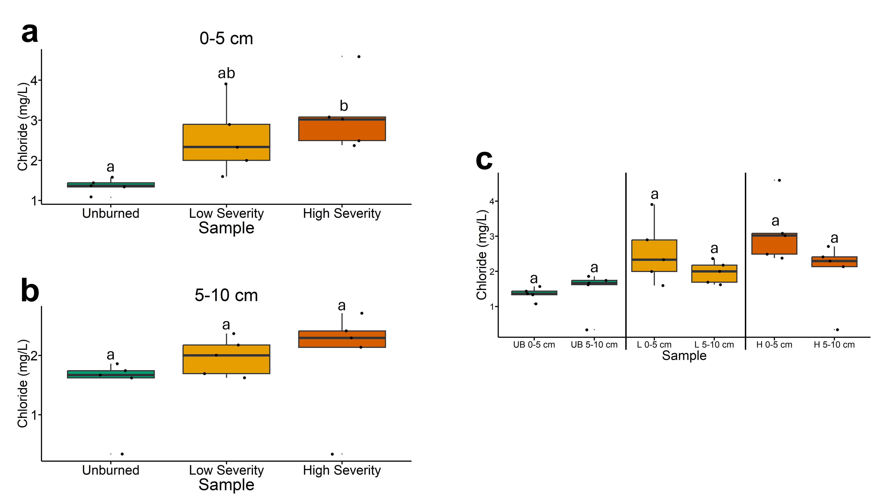
Fig. 9 | Chloride concentrations for soil-water extracts. The statistical tests of a, b, and c were conducted independently of each other. a, Quantifying chloride concentrations for soil-water extracts across soils collected at a depth of 0-5 cm. Letters above boxes indicate significant differences (P<0.05) amongst sample types. n=10 for unburned, low severity, and high severity samples. b, Quantifying chloride concentrations for soil-water extracts across soils collected at a depth of 5-10 cm. Letters above boxes indicate significant differences (P<0.05) amongst treatments. n=10 for unburned, low severity, and high severity samples. c, Quantifying chloride concentrations for soil-water extracts and comparing 0-5 cm soil depth with 5-10 cm soil depth. The statistical tests within sample types (i.e. unburned, low severity, and high severity) were conducted independently from each other. In other words, the “a” above “UB 0-5 cm” does not mean that there is no significant difference compared to “L 0-5 cm” which also has an “a” label because those statistical tests were conducted independently of each other. P<0.05 was the cutoff for significant differences. UB = unburned. L = low severity. H = high severity. n=10 for unburned 0-5 cm, unburned 5-10 cm, low severity 0-5 cm, low severity 5-10 cm, high severity 0-5 cm, and high severity 5-10 cm samples. Box plots show the median (central line), first and third quartiles (box edges), and whiskers extending to minimum and maximum values within 1.5 times the interquartile range. Smaller black dots (not the data points) indicate where the data points would lie if the data points weren’t jittered.

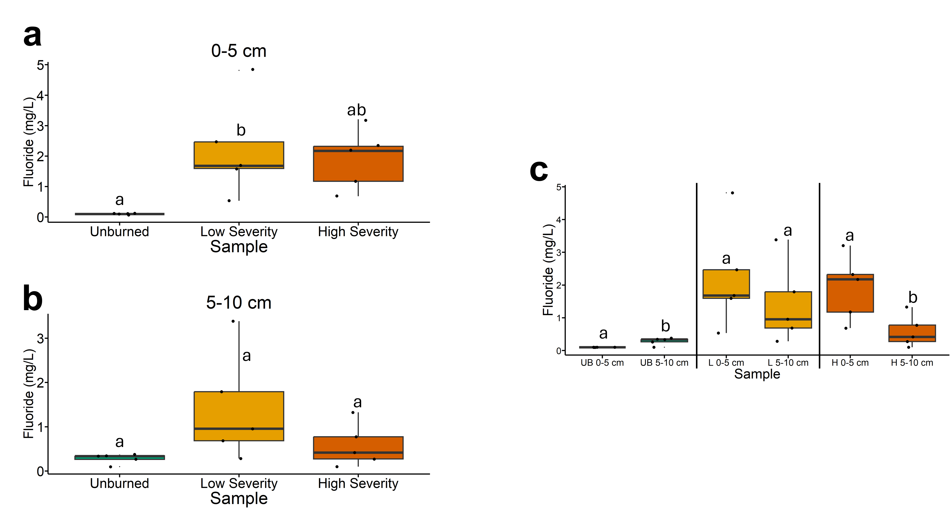
Fig. 10 | Fluoride concentrations for soil-water extracts. The statistical tests of a, b, and c were conducted independently of each other. a, Quantifying fluoride concentrations for soil-water extracts across soils collected at a depth of 0-5 cm. Letters above boxes indicate significant differences (P<0.05) amongst sample types. n=10 for unburned, low severity, and high severity samples. b, Quantifying fluoride concentrations for soil-water extracts across soils collected at a depth of 5-10 cm. Letters above boxes indicate significant differences (P<0.05) amongst treatments. n=10 for unburned, low severity, and high severity samples. c, Quantifying fluoride concentrations for soil-water extracts and comparing 0-5 cm soil depth with 5-10 cm soil depth. The statistical tests within sample types (i.e. unburned, low severity, and high severity) were conducted independently from each other. In other words, the “a” above “UB 0-5 cm” does not mean that there is no significant difference compared to “L 0-5 cm” which also has an “a” label because those statistical tests were conducted independently of each other. P<0.05 was the cutoff for significant differences. UB = unburned. L = low severity. H = high severity. n=10 for unburned 0-5 cm, unburned 5-10 cm, low severity 0-5 cm, low severity 5-10 cm, high severity 0-5 cm, and high severity 5-10 cm samples. Box plots show the median (central line), first and third quartiles (box edges), and whiskers extending to minimum and maximum values within 1.5 times the interquartile range. Smaller black dots (not the data points) indicate where the data points would lie if the data points weren’t jittered.

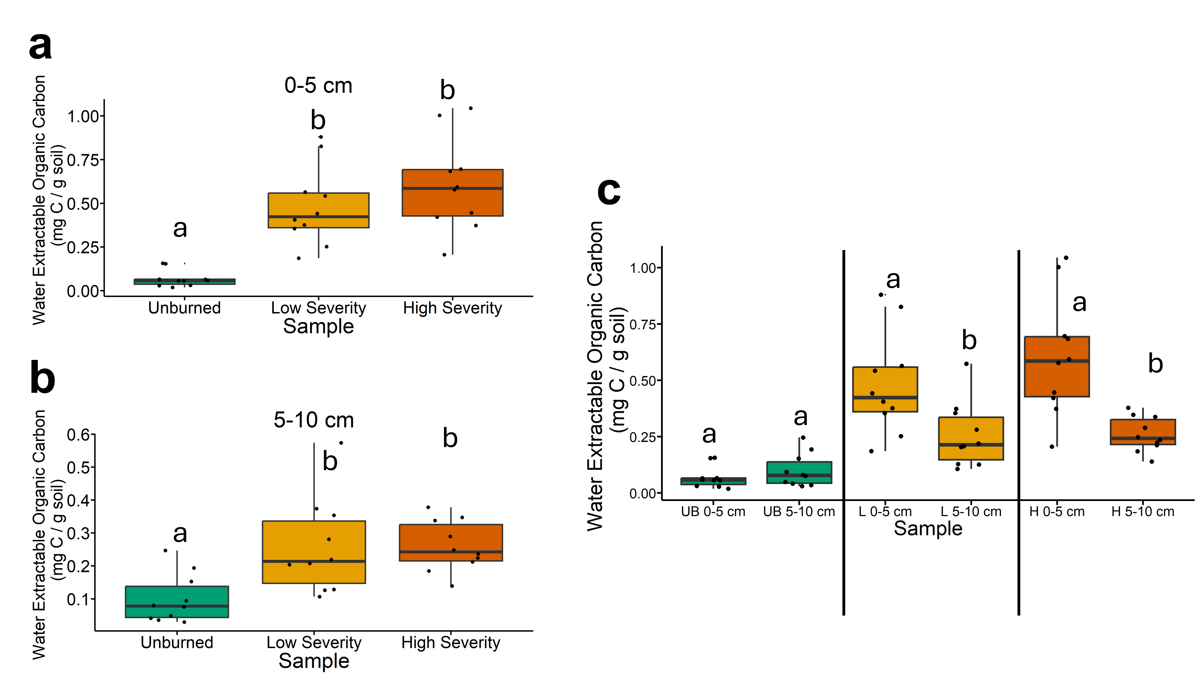
Fig. 11 | Water extractable organic carbon concentrations. The statistical tests of a, b, and c were conducted independently of each other. a, Quantifying water extractable organic carbon concentrations across soils collected at a depth of 0-5 cm. Letters above boxes indicate significant differences (P<0.05) amongst sample types. n=10 for unburned, low severity, and high severity samples. b, Quantifying water extractable organic carbon concentrations across soils collected at a depth of 5-10 cm. Letters above boxes indicate significant differences (P<0.05) amongst treatments. n=10 for unburned, low severity, and high severity samples. c, Quantifying water extractable organic carbon concentrations and comparing 0-5 cm soil depth with 5-10 cm soil depth. The statistical tests within sample types (i.e. unburned, low severity, and high severity) were conducted independently from each other. In other words, the “a” above “UB 0-5 cm” does not mean that there is no significant difference compared to “L 0-5 cm” which also has an “a” label because those statistical tests were conducted independently of each other. P<0.05 was the cutoff for significant differences. UB = unburned. L = low severity. H = high severity. n=10 for unburned 0-5 cm, unburned 5-10 cm, low severity 0-5 cm, low severity 5-10 cm, high severity 0-5 cm, and high severity 5-10 cm samples. Box plots show the median (central line), first and third quartiles (box edges), and whiskers extending to minimum and maximum values within 1.5 times the interquartile range. Smaller black dots (not the data points) indicate where the data points would lie if the data points weren’t jittered.

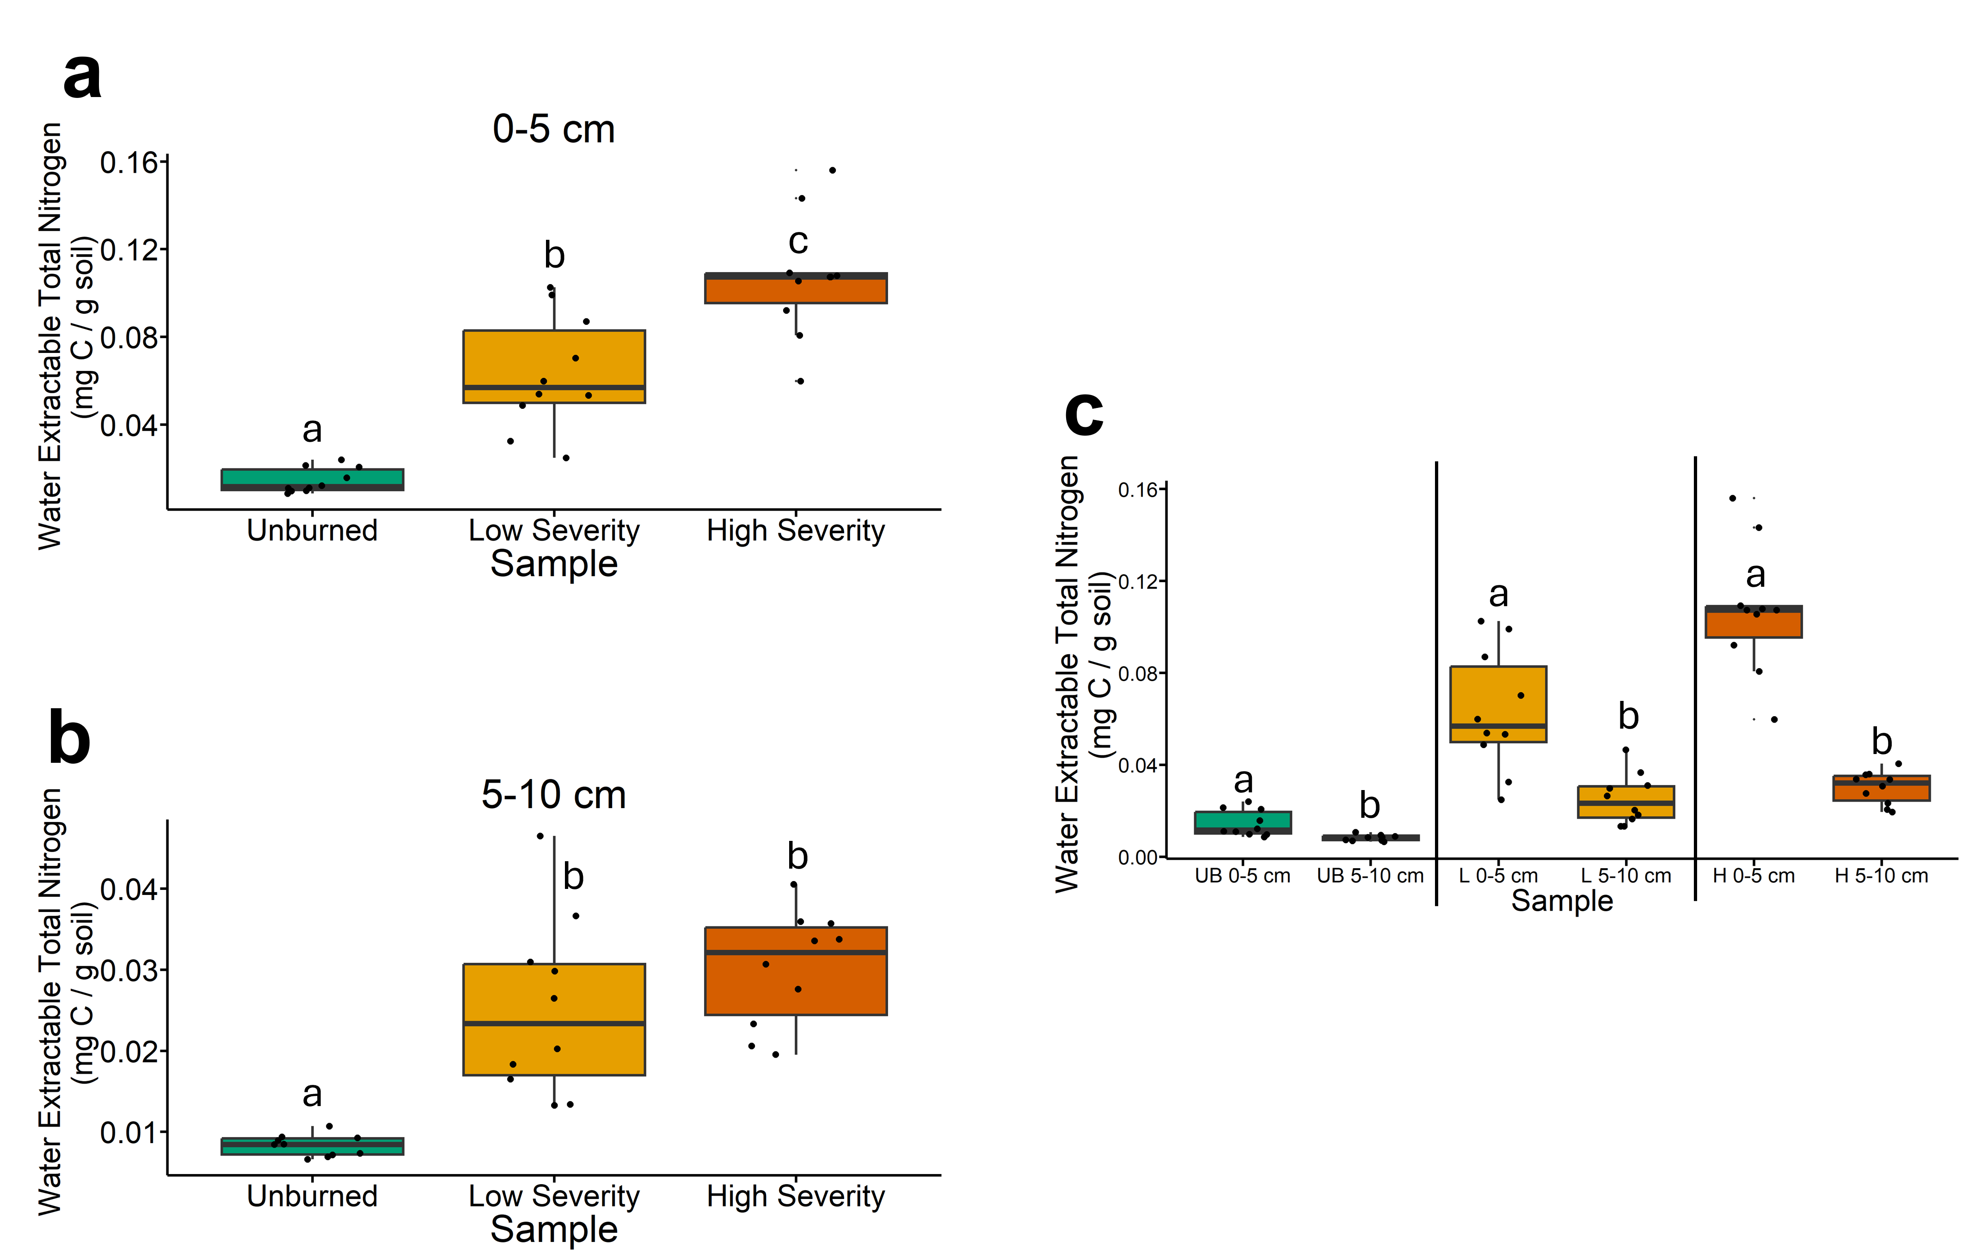
Fig. 12 | Water extractable total nitrogen concentrations. The statistical tests of a, b, and c were conducted independently of each other. a, Quantifying water extractable total nitrogen concentrations across soils collected at a depth of 0-5 cm. Letters above boxes indicate significant differences (P<0.05) amongst sample types. n=10 for unburned, low severity, and high severity samples. b, Quantifying water extractable total nitrogen concentrations across soils collected at a depth of 5-10 cm. Letters above boxes indicate significant differences (P<0.05) amongst treatments. n=10 for unburned, low severity, and high severity samples. c, Quantifying water extractable total nitrogen concentrations and comparing 0-5 cm soil depth with 5-10 cm soil depth. The statistical tests within sample types (i.e. unburned, low severity, and high severity) were conducted independently from each other. In other words, the “a” above “UB 0-5 cm” does not mean that there is no significant difference compared to “L 0-5 cm” which also has an “a” label because those statistical tests were conducted independently of each other. P<0.05 was the cutoff for significant differences. UB = unburned. L = low severity. H = high severity. n=10 for unburned 0-5 cm, unburned 5-10 cm, low severity 0-5 cm, low severity 5-10 cm, high severity 0-5 cm, and high severity 5-10 cm samples. Box plots show the median (central line), first and third quartiles (box edges), and whiskers extending to minimum and maximum values within 1.5 times the interquartile range. Smaller black dots (not the data points) indicate where the data points would lie if the data points weren’t jittered.

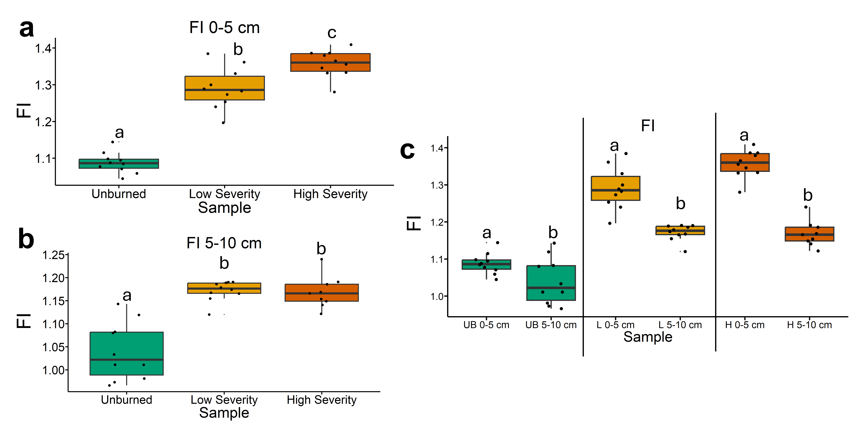
Fig. 13 | Fluorescence index (FI) values from excitation-emission fluorescence spectroscopy. FI approximates dissolved organic matter sources.¹ Higher FI values indicate microbially-derived DOM while lower values indicate terrestrially-derived DOM. The statistical tests of a, b, and c were conducted independently of each other. a, Quantifying FI values for soil-water extracts across soils collected at a depth of 0-5 cm. Letters above boxes indicate significant differences (P<0.05) amongst sample types. n=10 for unburned, low severity, and high severity samples. b, Quantifying FI values for soil-water extracts across soils collected at a depth of 5-10 cm. Letters above boxes indicate significant differences (P<0.05) amongst treatments. n=10 for unburned, low severity, and high severity samples. c, Quantifying FI values for soil-water extracts and comparing 0-5 cm soil depth with 5-10 cm soil depth. The statistical tests within sample types (i.e. unburned, low severity, and high severity) were conducted independently from each other. In other words, the “a” above “UB 0-5 cm” does not mean that there is no significant difference compared to “L 0-5 cm” which also has an “a” label because those statistical tests were conducted independently of each other. P<0.05 was the cutoff for significant differences. UB = unburned. L = low severity. H = high severity. n=10 for unburned 0-5 cm, unburned 5-10 cm, low severity 0-5 cm, low severity 5-10 cm, high severity 0-5 cm, and high severity 5-10 cm samples. Box plots show the median (central line), first and third quartiles (box edges), and whiskers extending to minimum and maximum values within 1.5 times the interquartile range. Smaller black dots (not the data points) indicate where the data points would lie if the data points weren’t jittered.

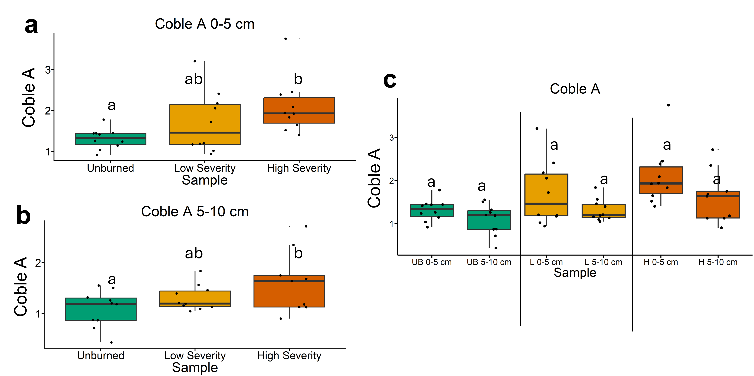
Fig. 14 | Coble A values from excitation-emission fluorescence spectroscopy. Higher Coble A values indicate dissolved organic matter with a terrestrial-like source.² The statistical tests of a, b, and c were conducted independently of each other. a, Quantifying Coble A values for soil-water extracts across soils collected at a depth of 0-5 cm. Letters above boxes indicate significant differences (P<0.05) amongst sample types. n=10 for unburned, low severity, and high severity samples. b, Quantifying Coble A values for soil-water extracts across soils collected at a depth of 5-10 cm. Letters above boxes indicate significant differences (P<0.05) amongst treatments. n=10 for unburned, low severity, and high severity samples. c, Quantifying Coble A values for soil-water extracts and comparing 0-5 cm soil depth with 5-10 cm soil depth. The statistical tests within sample types (i.e. unburned, low severity, and high severity) were conducted independently from each other. In other words, the “a” above “UB 0-5 cm” does not mean that there is no significant difference compared to “L 0-5 cm” which also has an “a” label because those statistical tests were conducted independently of each other. P<0.05 was the cutoff for significant differences. UB = unburned. L = low severity. H = high severity. n=10 for unburned 0-5 cm, unburned 5-10 cm, low severity 0-5 cm, low severity 5-10 cm, high severity 0-5 cm, and high severity 5-10 cm samples. Box plots show the median (central line), first and third quartiles (box edges), and whiskers extending to minimum and maximum values within 1.5 times the interquartile range. Smaller black dots (not the data points) indicate where the data points would lie if the data points weren’t jittered.

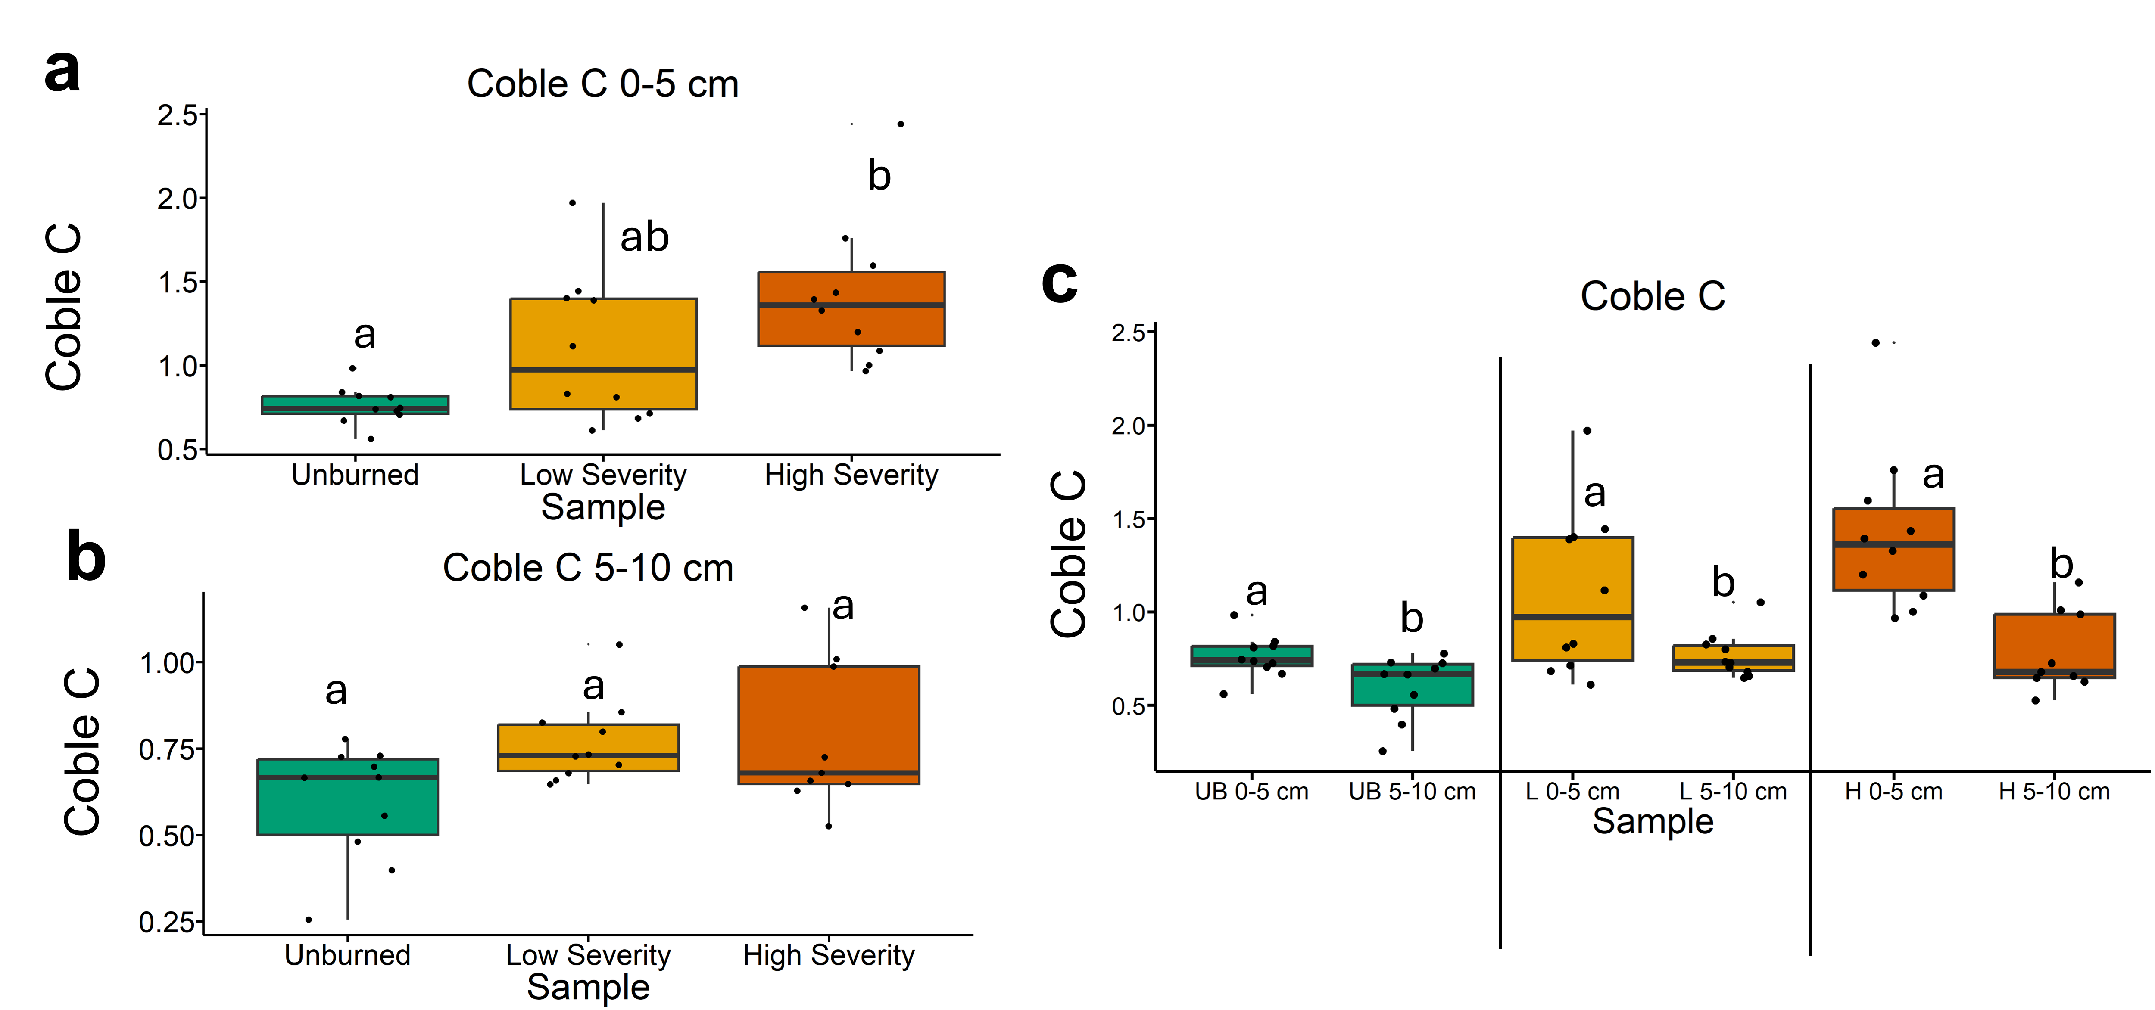
Fig. 15 | Coble C values from excitation-emission fluorescence spectroscopy. Higher Coble C values indicate dissolved organic matter with a terrestrial-like source.² The statistical tests of a, b, and c were conducted independently of each other. a, Quantifying Coble C values for soil-water extracts across soils collected at a depth of 0-5 cm. Letters above boxes indicate significant differences (P<0.05) amongst sample types. n=10 for unburned, low severity, and high severity samples. b, Quantifying Coble C values for soil-water extracts across soils collected at a depth of 5-10 cm. Letters above boxes indicate significant differences (P<0.05) amongst treatments. n=10 for unburned, low severity, and high severity samples. c, Quantifying Coble C values for soil-water extracts and comparing 0-5 cm soil depth with 5-10 cm soil depth. The statistical tests within sample types (i.e. unburned, low severity, and high severity) were conducted independently from each other. In other words, the “a” above “UB 0-5 cm” does not mean that there is no significant difference compared to “L 0-5 cm” which also has an “a” label because those statistical tests were conducted independently of each other. P<0.05 was the cutoff for significant differences. UB = unburned. L = low severity. H = high severity. n=10 for unburned 0-5 cm, unburned 5-10 cm, low severity 0-5 cm, low severity 5-10 cm, high severity 0-5 cm, and high severity 5-10 cm samples. Box plots show the median (central line), first and third quartiles (box edges), and whiskers extending to minimum and maximum values within 1.5 times the interquartile range. Smaller black dots (not the data points) indicate where the data points would lie if the data points weren’t jittered.

References
(1) Cory, R. M.; McKnight, D. M. Fluorescence Spectroscopy Reveals Ubiquitous Presence of Oxidized and Reduced Quinones in Dissolved Organic Matter. Environ. Sci. Technol. 2005, 39 (21), 8142–8149. https://doi.org/10.1021/es0506962.
(2) Coble, P. G. Characterization of Marine and Terrestrial DOM in Seawater Using Excitation-Emission Matrix Spectroscopy. Mar. Chem. 1996, 51 (4), 325–346. https://doi.org/10.1016/0304-4203(95)00062-3.

