Note: the exact molecular identify for the following were not known, so these metabolites were assigned names reflecting their chemical class and putatively identified molecular structure:
- Inositol
- Disaccharide 1
- Disaccharide 2
- Disaccharide 3
- Disaccharide 4
- Disaccharide 5
- Disaccharide 6
- Trisaccharide 1
- Trisaccharide 2
- Trisaccharide 3
- Peptide
- Acylaminosugar
- Amino sugar
- Pyranosylindole
- Diterpenoid 1
- Diterpenoid 2
- Diterpenoid 3
- Diterpenoid 4
- Diterpenoid 5
- Alkaloid 1
- Alkaloid 2
- Alkaloid 3
- Alkaloid 4
- Alkaloid 5
- Alkaloid 6
- Amino acid derivative alkaloid 1
- Amino acid derivative alkaloid 2
- Alpha amino acid 1
- Alpha amino acid 2
- Alpha amino acid 3
- Benzoic acid ester
- Dialkyl ether
- Polyethylene glycol
- Lipid like
- Purine nucleotide
- Fatty acid ester
- Azole

When determining significant differences across mean values from three samples for plots a and b in all figures, normality and equal variances were first determined using the Shapiro-Wilk test and Levene’s test, respectively. If the data were not normally distributed (P<0.05 for Shapiro-Wilk test), Kruskal-Wallis and Dunn’s tests were used (P<0.05 indicates significant differences). If the data were normally distributed (P>0.05 for Shapiro-Wilk test) but the variances of the data were not equal (P<0.05 for Levene’s test), Welch’s ANOVA and Games-Howell tests were used (P<0.05 indicates significant differences). If the data were normally distributed and the variances of the data were equal (P>0.05 for Levene’s test), ANOVA and Tukey HSD tests were used (P<0.05 indicates significant differences). normality and equal variances were first determined using the Shapiro-Wilk test and Levene’s test, respectively.
When determining significant differences between mean values from two samples for plot c in all figures, normality and equal variances were once again first determined using the Shapiro-Wilk test and Levene’s test, respectively. If the data were not normally distributed (P<0.05 for Shapiro-Wilk test), Mann-Whitney U test (also known as the Wilcoxon rank-sum test) was used (P<0.05 indicates significant differences). If the data were normally distributed (P>0.05 for Shapiro-Wilk test) but the variances of the data were not equal (P<0.05 for Levene’s test), Welch’s t-test was used (P<0.05 indicates significant differences). If the data were normally distributed and the variances of the data were equal (P>0.05 for Levene’s test), Student’s t-test was used.

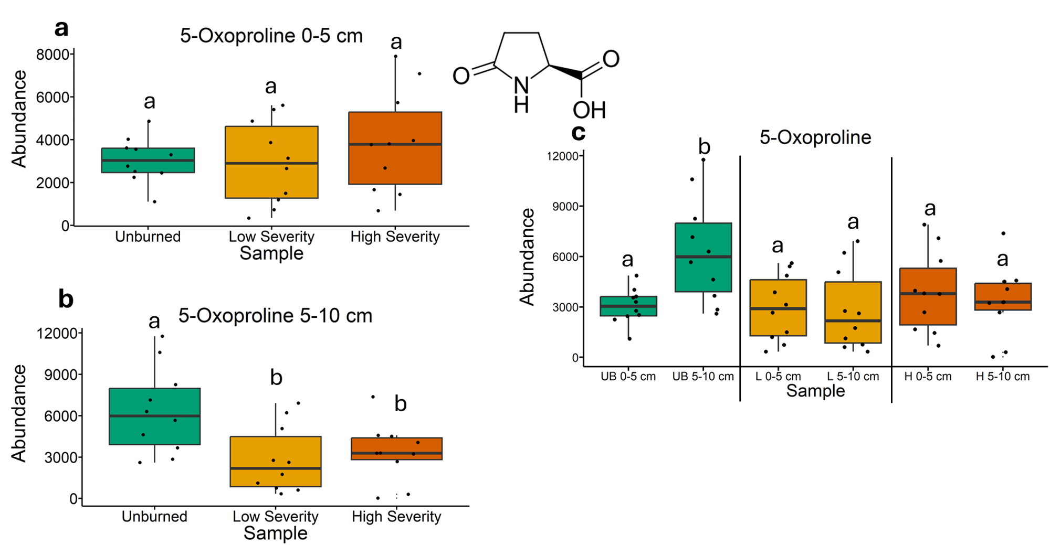
Fig. 1 | Quantification of 5-oxoproline abundances from gas chromatography-mass spectrometry analysis. The statistical tests of a, b, and c were conducted independently of each other. a, Quantifying abundances across soils collected at a depth of 0-5 cm. Letters above boxes indicate significant differences (P<0.05) amongst sample types. n=10 for unburned, low severity, and high severity samples. b, Quantifying abundances across soils collected at a depth of 5-10 cm. Letters above boxes indicate significant differences (P<0.05) amongst treatments. n=10 for unburned, low severity, and high severity samples. c, Quantifying abundances and comparing 0-5 cm soil depth with 5-10 cm soil depth. The statistical tests within sample types (i.e. unburned, low severity, and high severity) were conducted independently from each other. In other words, the “a” above “UB 0-5 cm” does not mean that there is no significant difference compared to “L 0-5 cm” which also has an “a” label because those statistical tests were conducted independently of each other. P<0.05 was the cutoff for significant differences. UB = unburned. L = low severity. H = high severity. n=10 for unburned 0-5 cm, unburned 5-10 cm, low severity 0-5 cm, low severity 5-10 cm, high severity 0-5 cm, and high severity 5-10 cm samples. Box plots show the median (central line), first and third quartiles (box edges), and whiskers extending to minimum and maximum values within 1.5 times the interquartile range. Smaller black dots (not the data points) indicate where the data points would lie if the data points weren’t jittered.

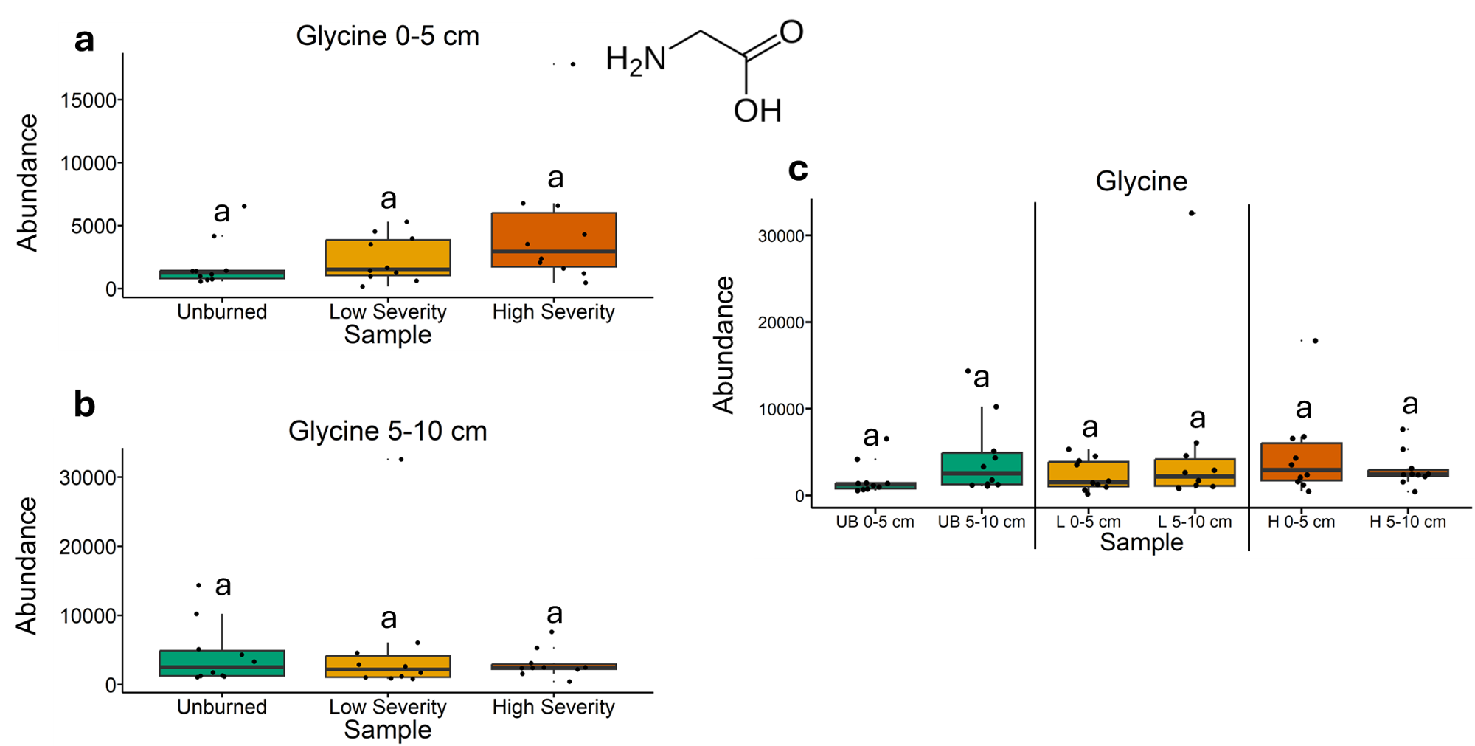
Fig. 2 | Quantification of glycine abundances from gas chromatography-mass spectrometry analysis. The statistical tests of a, b, and c were conducted independently of each other. a, Quantifying abundances across soils collected at a depth of 0-5 cm. Letters above boxes indicate significant differences (P<0.05) amongst sample types. n=10 for unburned, low severity, and high severity samples. b, Quantifying abundances across soils collected at a depth of 5-10 cm. Letters above boxes indicate significant differences (P<0.05) amongst treatments. n=10 for unburned, low severity, and high severity samples. c, Quantifying abundances and comparing 0-5 cm soil depth with 5-10 cm soil depth. The statistical tests within sample types (i.e. unburned, low severity, and high severity) were conducted independently from each other. In other words, the “a” above “UB 0-5 cm” does not mean that there is no significant difference compared to “L 0-5 cm” which also has an “a” label because those statistical tests were conducted independently of each other. P<0.05 was the cutoff for significant differences. UB = unburned. L = low severity. H = high severity. n=10 for unburned 0-5 cm, unburned 5-10 cm, low severity 0-5 cm, low severity 5-10 cm, high severity 0-5 cm, and high severity 5-10 cm samples. Box plots show the median (central line), first and third quartiles (box edges), and whiskers extending to minimum and maximum values within 1.5 times the interquartile range. Smaller black dots (not the data points) indicate where the data points would lie if the data points weren’t jittered.

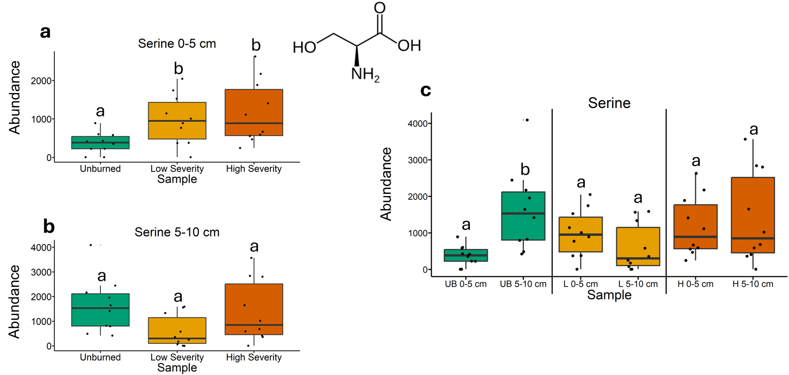
Fig. 3 | Quantification of serine abundances from gas chromatography-mass spectrometry analysis. The statistical tests of a, b, and c were conducted independently of each other. a, Quantifying abundances across soils collected at a depth of 0-5 cm. Letters above boxes indicate significant differences (P<0.05) amongst sample types. n=10 for unburned, low severity, and high severity samples. b, Quantifying abundances across soils collected at a depth of 5-10 cm. Letters above boxes indicate significant differences (P<0.05) amongst treatments. n=10 for unburned, low severity, and high severity samples. c, Quantifying abundances and comparing 0-5 cm soil depth with 5-10 cm soil depth. The statistical tests within sample types (i.e. unburned, low severity, and high severity) were conducted independently from each other. In other words, the “a” above “UB 0-5 cm” does not mean that there is no significant difference compared to “L 0-5 cm” which also has an “a” label because those statistical tests were conducted independently of each other. P<0.05 was the cutoff for significant differences. UB = unburned. L = low severity. H = high severity. n=10 for unburned 0-5 cm, unburned 5-10 cm, low severity 0-5 cm, low severity 5-10 cm, high severity 0-5 cm, and high severity 5-10 cm samples. Box plots show the median (central line), first and third quartiles (box edges), and whiskers extending to minimum and maximum values within 1.5 times the interquartile range. Smaller black dots (not the data points) indicate where the data points would lie if the data points weren’t jittered.

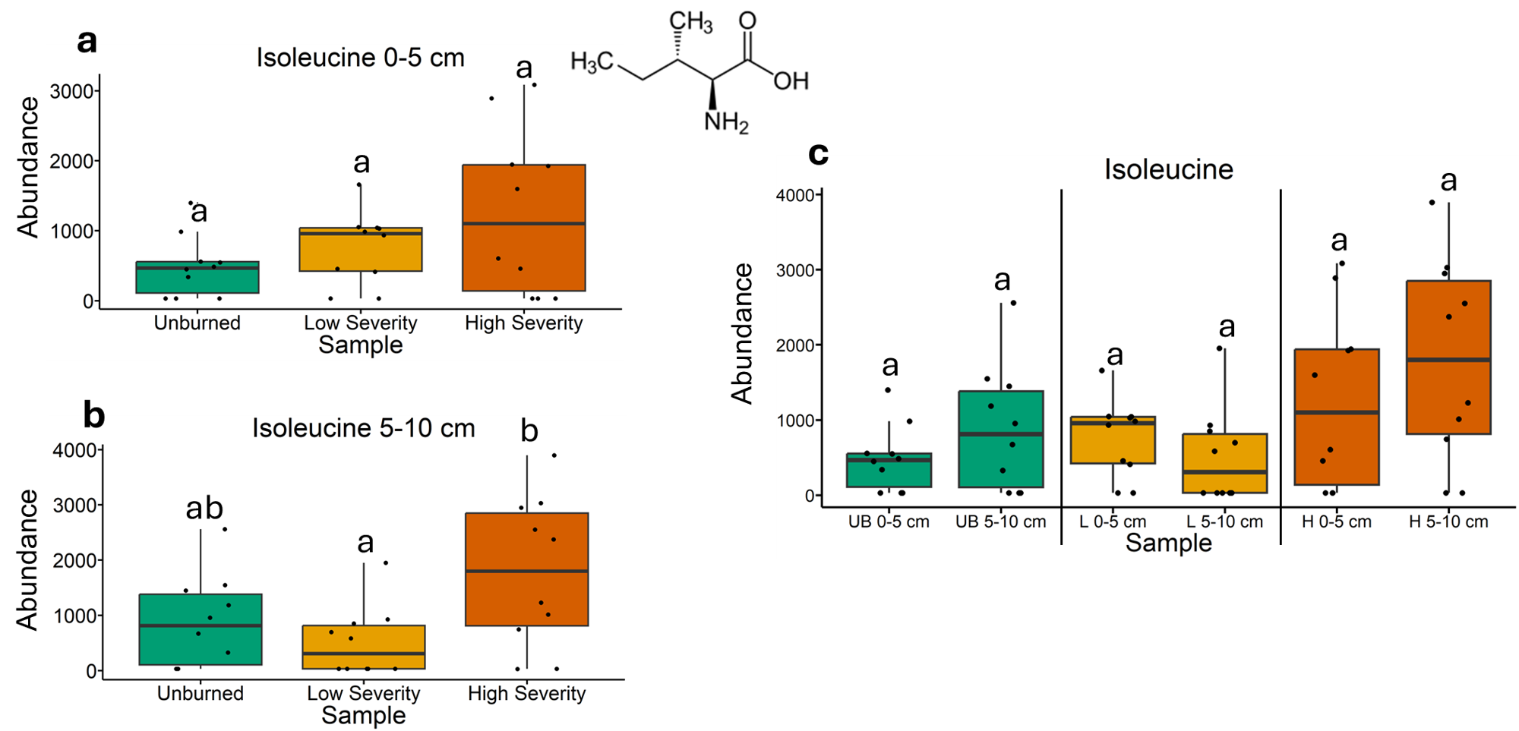
Fig. 4 | Quantification of isoleucine abundances from gas chromatography-mass spectrometry analysis. The statistical tests of a, b, and c were conducted independently of each other. a, Quantifying abundances across soils collected at a depth of 0-5 cm. Letters above boxes indicate significant differences (P<0.05) amongst sample types. n=10 for unburned, low severity, and high severity samples. b, Quantifying abundances across soils collected at a depth of 5-10 cm. Letters above boxes indicate significant differences (P<0.05) amongst treatments. n=10 for unburned, low severity, and high severity samples. c, Quantifying abundances and comparing 0-5 cm soil depth with 5-10 cm soil depth. The statistical tests within sample types (i.e. unburned, low severity, and high severity) were conducted independently from each other. In other words, the “a” above “UB 0-5 cm” does not mean that there is no significant difference compared to “L 0-5 cm” which also has an “a” label because those statistical tests were conducted independently of each other. P<0.05 was the cutoff for significant differences. UB = unburned. L = low severity. H = high severity. n=10 for unburned 0-5 cm, unburned 5-10 cm, low severity 0-5 cm, low severity 5-10 cm, high severity 0-5 cm, and high severity 5-10 cm samples. Box plots show the median (central line), first and third quartiles (box edges), and whiskers extending to minimum and maximum values within 1.5 times the interquartile range. Smaller black dots (not the data points) indicate where the data points would lie if the data points weren’t jittered.

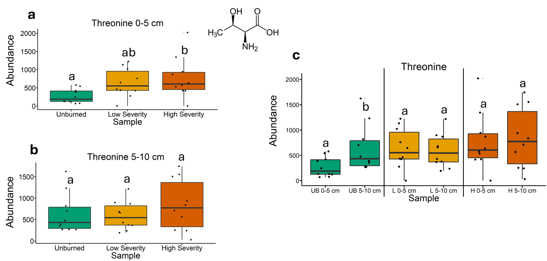
Fig. 5 | Quantification of threonine abundances from gas chromatography-mass spectrometry analysis. The statistical tests of a, b, and c were conducted independently of each other. a, Quantifying abundances across soils collected at a depth of 0-5 cm. Letters above boxes indicate significant differences (P<0.05) amongst sample types. n=10 for unburned, low severity, and high severity samples. b, Quantifying abundances across soils collected at a depth of 5-10 cm. Letters above boxes indicate significant differences (P<0.05) amongst treatments. n=10 for unburned, low severity, and high severity samples. c, Quantifying abundances and comparing 0-5 cm soil depth with 5-10 cm soil depth. The statistical tests within sample types (i.e. unburned, low severity, and high severity) were conducted independently from each other. In other words, the “a” above “UB 0-5 cm” does not mean that there is no significant difference compared to “L 0-5 cm” which also has an “a” label because those statistical tests were conducted independently of each other. P<0.05 was the cutoff for significant differences. UB = unburned. L = low severity. H = high severity. n=10 for unburned 0-5 cm, unburned 5-10 cm, low severity 0-5 cm, low severity 5-10 cm, high severity 0-5 cm, and high severity 5-10 cm samples. Box plots show the median (central line), first and third quartiles (box edges), and whiskers extending to minimum and maximum values within 1.5 times the interquartile range. Smaller black dots (not the data points) indicate where the data points would lie if the data points weren’t jittered.

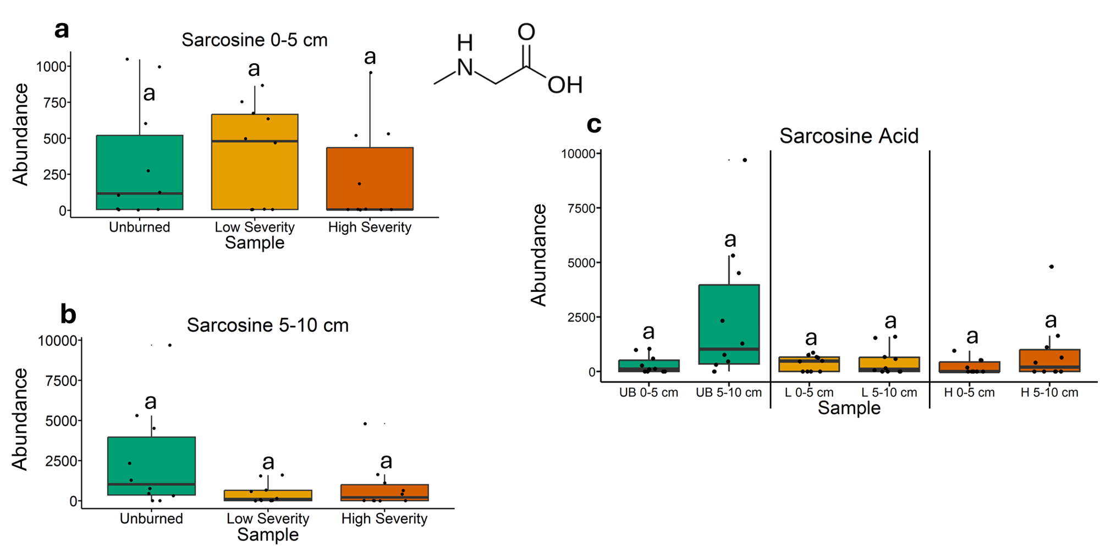
Fig. 6 | Quantification of sarcosine abundances from gas chromatography-mass spectrometry analysis. The statistical tests of a, b, and c were conducted independently of each other. a, Quantifying abundances across soils collected at a depth of 0-5 cm. Letters above boxes indicate significant differences (P<0.05) amongst sample types. n=10 for unburned, low severity, and high severity samples. b, Quantifying abundances across soils collected at a depth of 5-10 cm. Letters above boxes indicate significant differences (P<0.05) amongst treatments. n=10 for unburned, low severity, and high severity samples. c, Quantifying abundances and comparing 0-5 cm soil depth with 5-10 cm soil depth. The statistical tests within sample types (i.e. unburned, low severity, and high severity) were conducted independently from each other. In other words, the “a” above “UB 0-5 cm” does not mean that there is no significant difference compared to “L 0-5 cm” which also has an “a” label because those statistical tests were conducted independently of each other. P<0.05 was the cutoff for significant differences. UB = unburned. L = low severity. H = high severity. n=10 for unburned 0-5 cm, unburned 5-10 cm, low severity 0-5 cm, low severity 5-10 cm, high severity 0-5 cm, and high severity 5-10 cm samples. Box plots show the median (central line), first and third quartiles (box edges), and whiskers extending to minimum and maximum values within 1.5 times the interquartile range. Smaller black dots (not the data points) indicate where the data points would lie if the data points weren’t jittered.

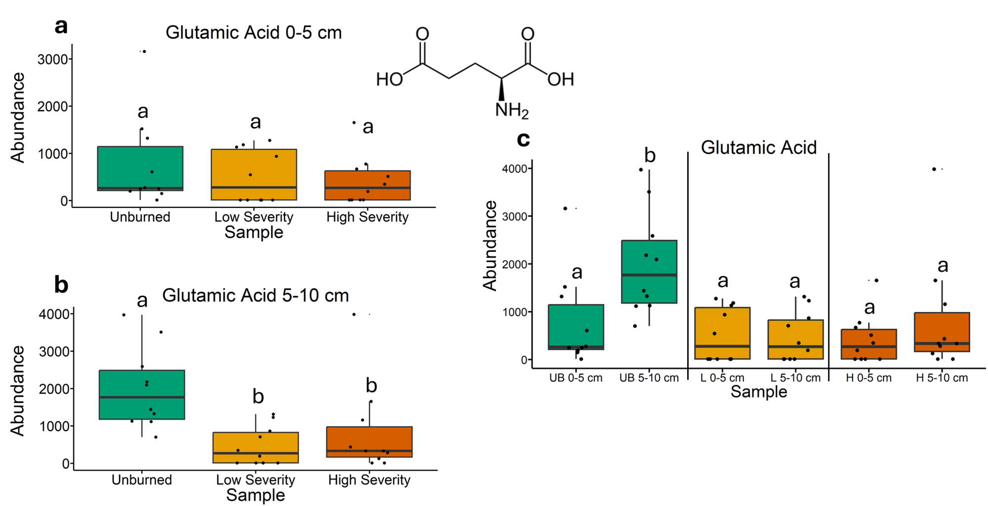
Fig. 7 | Quantification of glutamic acid abundances from gas chromatography-mass spectrometry analysis. The statistical tests of a, b, and c were conducted independently of each other. a, Quantifying abundances across soils collected at a depth of 0-5 cm. Letters above boxes indicate significant differences (P<0.05) amongst sample types. n=10 for unburned, low severity, and high severity samples. b, Quantifying abundances across soils collected at a depth of 5-10 cm. Letters above boxes indicate significant differences (P<0.05) amongst treatments. n=10 for unburned, low severity, and high severity samples. c, Quantifying abundances and comparing 0-5 cm soil depth with 5-10 cm soil depth. The statistical tests within sample types (i.e. unburned, low severity, and high severity) were conducted independently from each other. In other words, the “a” above “UB 0-5 cm” does not mean that there is no significant difference compared to “L 0-5 cm” which also has an “a” label because those statistical tests were conducted independently of each other. P<0.05 was the cutoff for significant differences. UB = unburned. L = low severity. H = high severity. n=10 for unburned 0-5 cm, unburned 5-10 cm, low severity 0-5 cm, low severity 5-10 cm, high severity 0-5 cm, and high severity 5-10 cm samples. Box plots show the median (central line), first and third quartiles (box edges), and whiskers extending to minimum and maximum values within 1.5 times the interquartile range. Smaller black dots (not the data points) indicate where the data points would lie if the data points weren’t jittered.

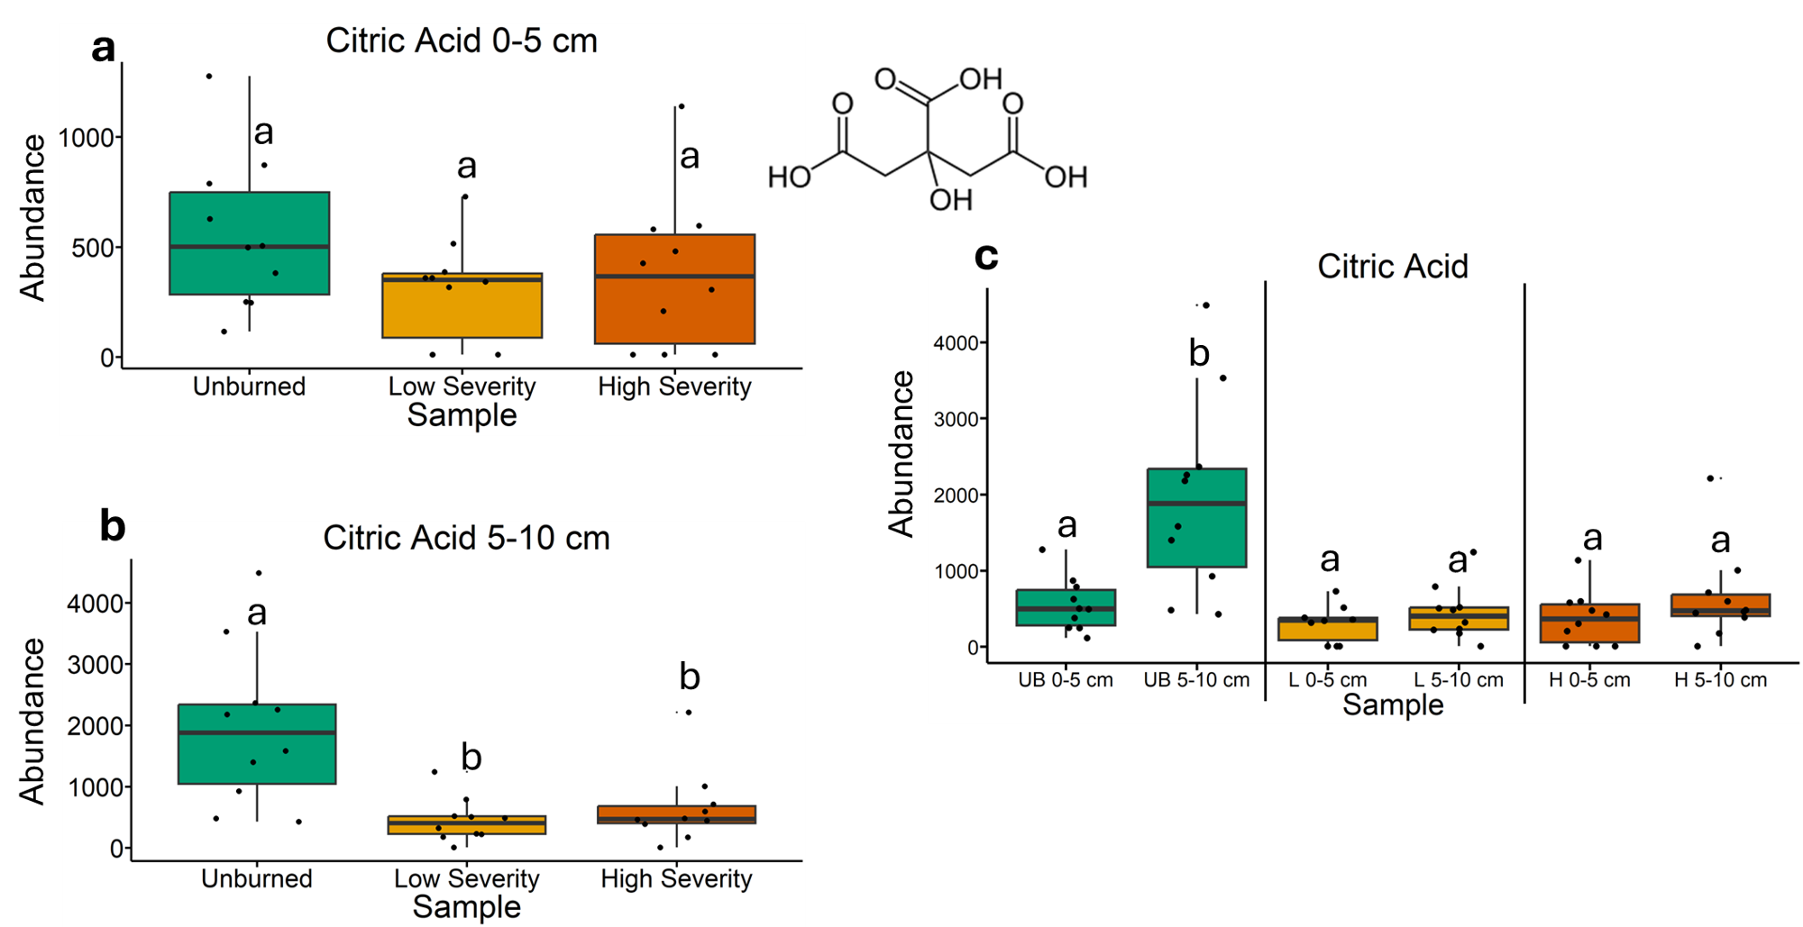
Fig. 8 | Quantification of citric acid abundances from gas chromatography-mass spectrometry analysis. The statistical tests of a, b, and c were conducted independently of each other. a, Quantifying abundances across soils collected at a depth of 0-5 cm. Letters above boxes indicate significant differences (P<0.05) amongst sample types. n=10 for unburned, low severity, and high severity samples. b, Quantifying abundances across soils collected at a depth of 5-10 cm. Letters above boxes indicate significant differences (P<0.05) amongst treatments. n=10 for unburned, low severity, and high severity samples. c, Quantifying abundances and comparing 0-5 cm soil depth with 5-10 cm soil depth. The statistical tests within sample types (i.e. unburned, low severity, and high severity) were conducted independently from each other. In other words, the “a” above “UB 0-5 cm” does not mean that there is no significant difference compared to “L 0-5 cm” which also has an “a” label because those statistical tests were conducted independently of each other. P<0.05 was the cutoff for significant differences. UB = unburned. L = low severity. H = high severity. n=10 for unburned 0-5 cm, unburned 5-10 cm, low severity 0-5 cm, low severity 5-10 cm, high severity 0-5 cm, and high severity 5-10 cm samples. Box plots show the median (central line), first and third quartiles (box edges), and whiskers extending to minimum and maximum values within 1.5 times the interquartile range. Smaller black dots (not the data points) indicate where the data points would lie if the data points weren’t jittered.

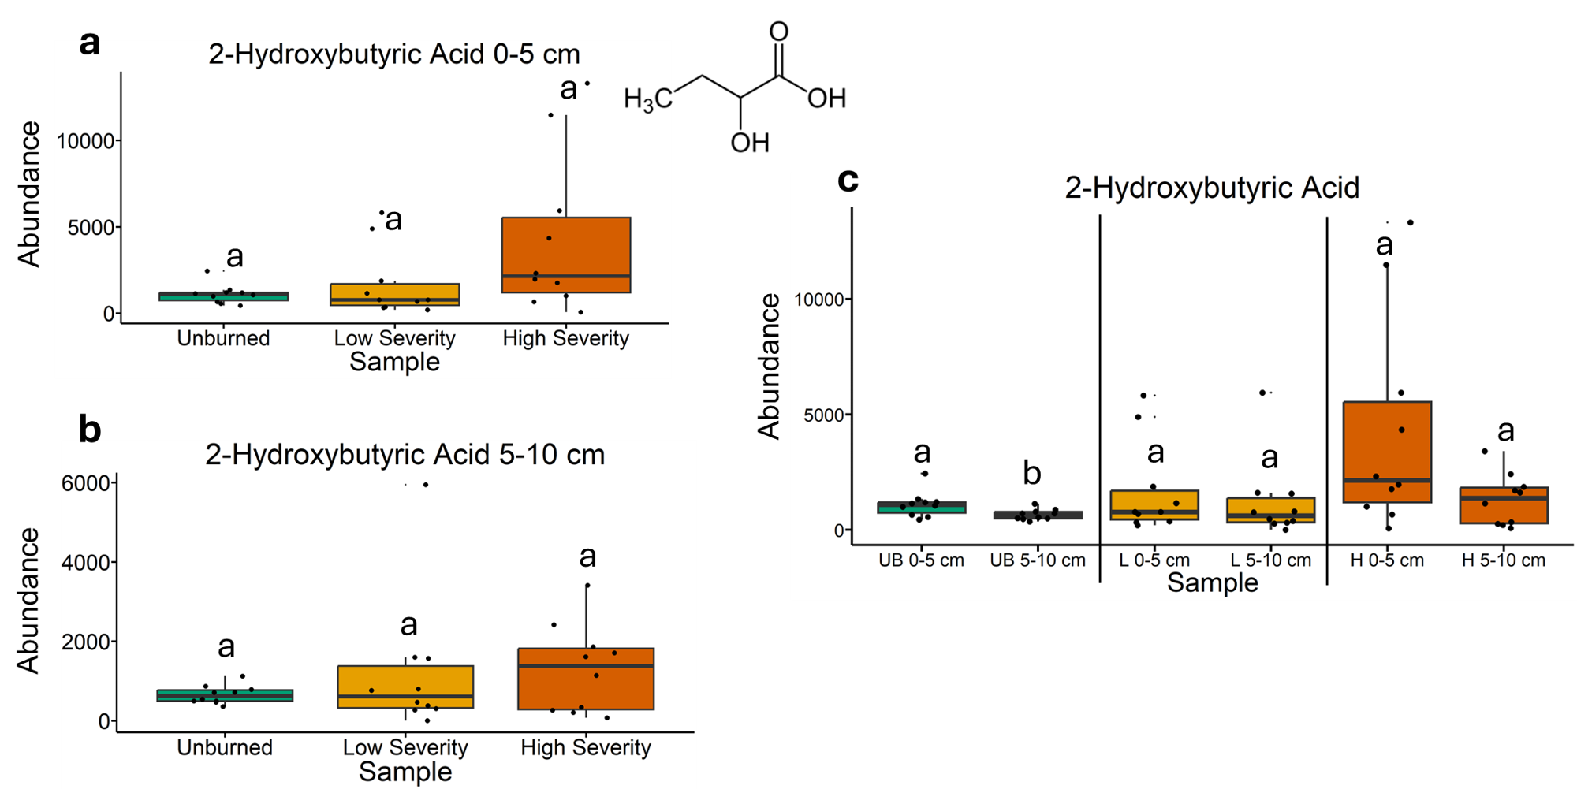
Fig. 9 | Quantification of 2-hydroxybutyric abundances from gas chromatography-mass spectrometry analysis. The statistical tests of a, b, and c were conducted independently of each other. a, Quantifying abundances across soils collected at a depth of 0-5 cm. Letters above boxes indicate significant differences (P<0.05) amongst sample types. n=10 for unburned, low severity, and high severity samples. b, Quantifying abundances across soils collected at a depth of 5-10 cm. Letters above boxes indicate significant differences (P<0.05) amongst treatments. n=10 for unburned, low severity, and high severity samples. c, Quantifying abundances and comparing 0-5 cm soil depth with 5-10 cm soil depth. The statistical tests within sample types (i.e. unburned, low severity, and high severity) were conducted independently from each other. In other words, the “a” above “UB 0-5 cm” does not mean that there is no significant difference compared to “L 0-5 cm” which also has an “a” label because those statistical tests were conducted independently of each other. P<0.05 was the cutoff for significant differences. UB = unburned. L = low severity. H = high severity. n=10 for unburned 0-5 cm, unburned 5-10 cm, low severity 0-5 cm, low severity 5-10 cm, high severity 0-5 cm, and high severity 5-10 cm samples. Box plots show the median (central line), first and third quartiles (box edges), and whiskers extending to minimum and maximum values within 1.5 times the interquartile range. Smaller black dots (not the data points) indicate where the data points would lie if the data points weren’t jittered.

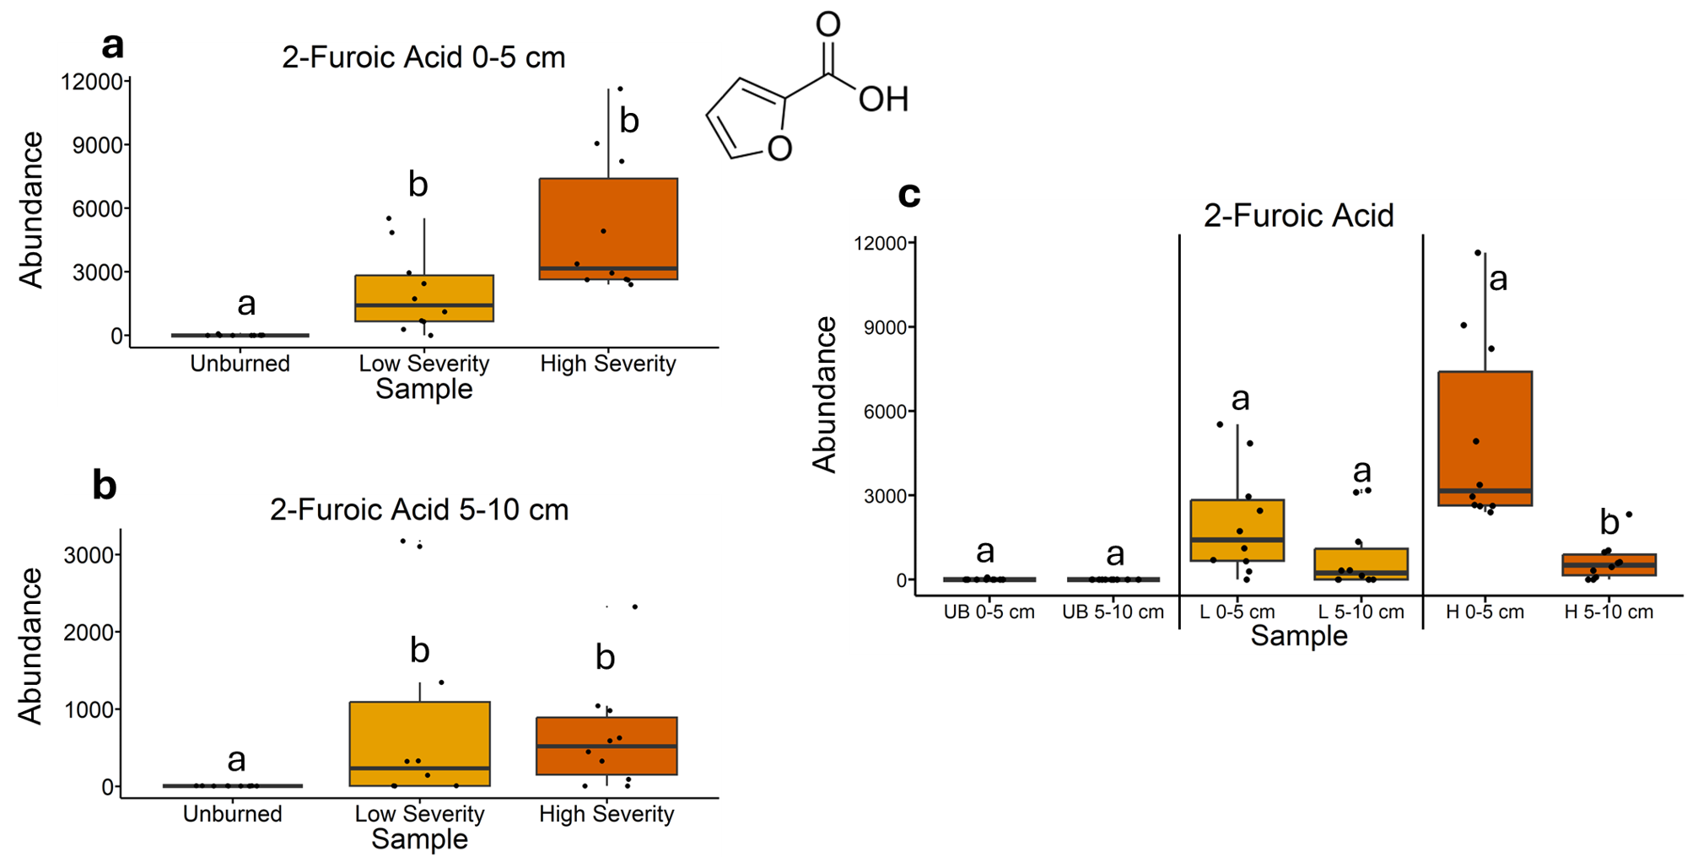
Fig. 10 | Quantification of 2-furoic acid abundances from gas chromatography-mass spectrometry analysis. The statistical tests of a, b, and c were conducted independently of each other. a, Quantifying abundances across soils collected at a depth of 0-5 cm. Letters above boxes indicate significant differences (P<0.05) amongst sample types. n=10 for unburned, low severity, and high severity samples. b, Quantifying abundances across soils collected at a depth of 5-10 cm. Letters above boxes indicate significant differences (P<0.05) amongst treatments. n=10 for unburned, low severity, and high severity samples. c, Quantifying abundances and comparing 0-5 cm soil depth with 5-10 cm soil depth. The statistical tests within sample types (i.e. unburned, low severity, and high severity) were conducted independently from each other. In other words, the “a” above “UB 0-5 cm” does not mean that there is no significant difference compared to “L 0-5 cm” which also has an “a” label because those statistical tests were conducted independently of each other. P<0.05 was the cutoff for significant differences. UB = unburned. L = low severity. H = high severity. n=10 for unburned 0-5 cm, unburned 5-10 cm, low severity 0-5 cm, low severity 5-10 cm, high severity 0-5 cm, and high severity 5-10 cm samples. Box plots show the median (central line), first and third quartiles (box edges), and whiskers extending to minimum and maximum values within 1.5 times the interquartile range. Smaller black dots (not the data points) indicate where the data points would lie if the data points weren’t jittered.

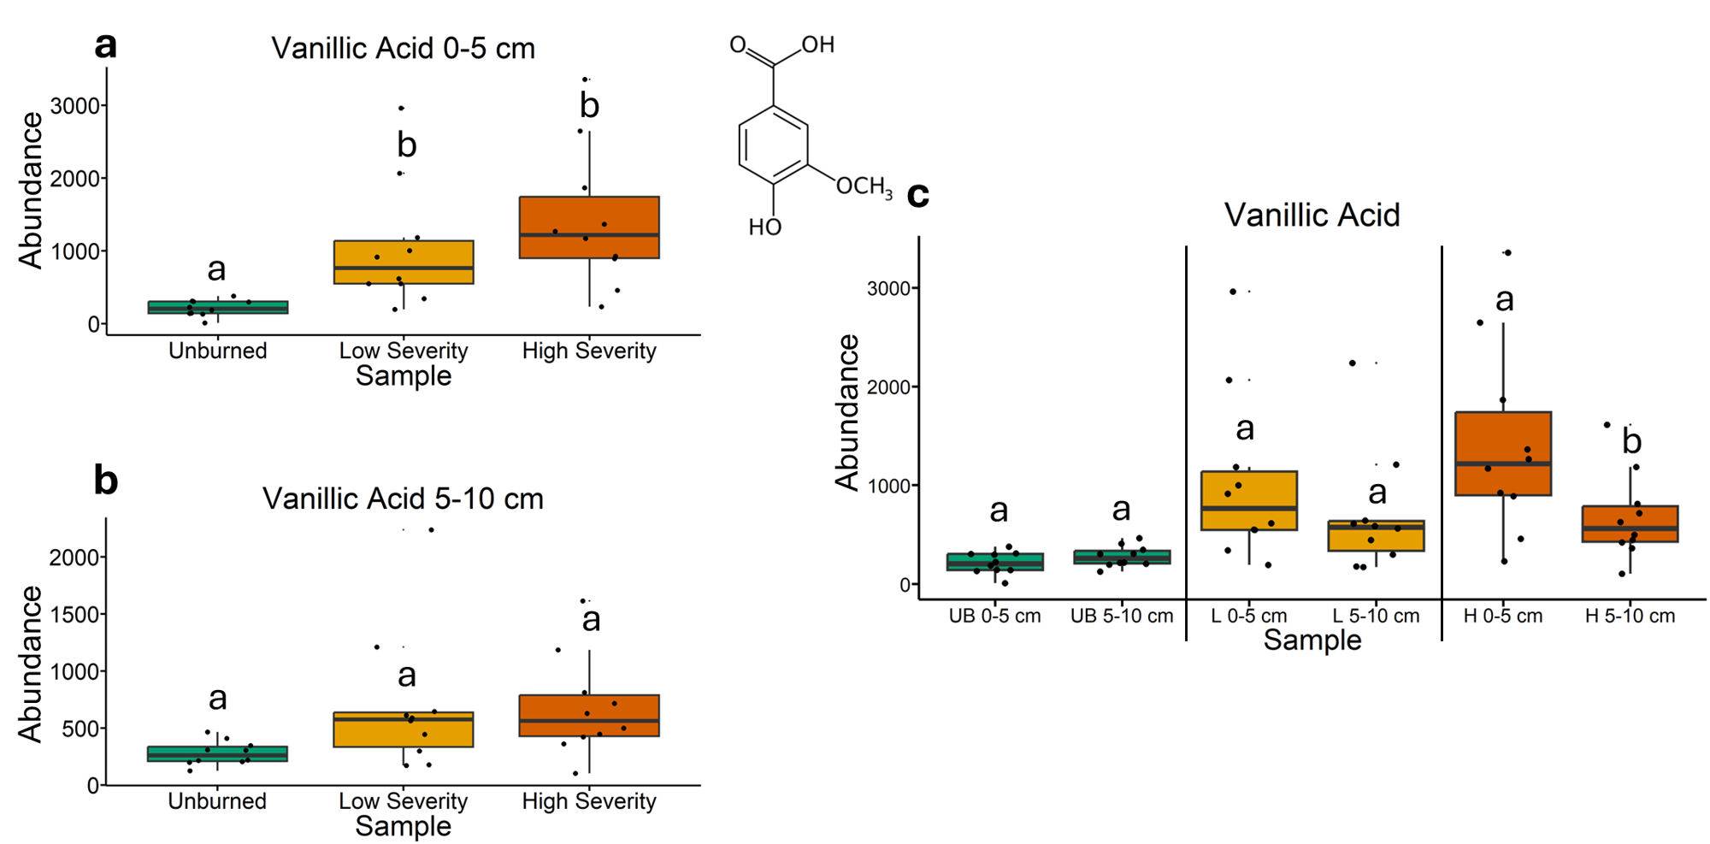
Fig. 11 | Quantification of vanillic acid abundances from gas chromatography-mass spectrometry analysis. The statistical tests of a, b, and c were conducted independently of each other. a, Quantifying abundances across soils collected at a depth of 0-5 cm. Letters above boxes indicate significant differences (P<0.05) amongst sample types. n=10 for unburned, low severity, and high severity samples. b, Quantifying abundances across soils collected at a depth of 5-10 cm. Letters above boxes indicate significant differences (P<0.05) amongst treatments. n=10 for unburned, low severity, and high severity samples. c, Quantifying abundances and comparing 0-5 cm soil depth with 5-10 cm soil depth. The statistical tests within sample types (i.e. unburned, low severity, and high severity) were conducted independently from each other. In other words, the “a” above “UB 0-5 cm” does not mean that there is no significant difference compared to “L 0-5 cm” which also has an “a” label because those statistical tests were conducted independently of each other. P<0.05 was the cutoff for significant differences. UB = unburned. L = low severity. H = high severity. n=10 for unburned 0-5 cm, unburned 5-10 cm, low severity 0-5 cm, low severity 5-10 cm, high severity 0-5 cm, and high severity 5-10 cm samples. Box plots show the median (central line), first and third quartiles (box edges), and whiskers extending to minimum and maximum values within 1.5 times the interquartile range. Smaller black dots (not the data points) indicate where the data points would lie if the data points weren’t jittered.

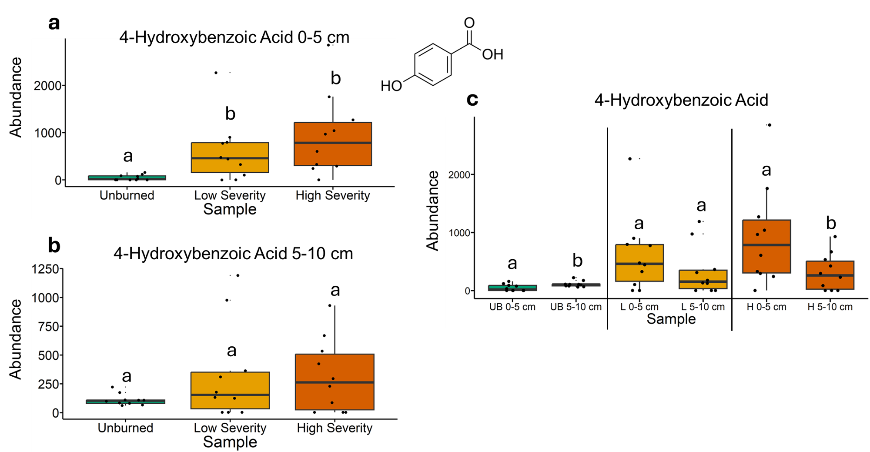
Fig. 12 | Quantification of 4-hydroxybenzoic acid abundances from gas chromatography-mass spectrometry analysis. The statistical tests of a, b, and c were conducted independently of each other. a, Quantifying abundances across soils collected at a depth of 0-5 cm. Letters above boxes indicate significant differences (P<0.05) amongst sample types. n=10 for unburned, low severity, and high severity samples. b, Quantifying abundances across soils collected at a depth of 5-10 cm. Letters above boxes indicate significant differences (P<0.05) amongst treatments. n=10 for unburned, low severity, and high severity samples. c, Quantifying abundances and comparing 0-5 cm soil depth with 5-10 cm soil depth. The statistical tests within sample types (i.e. unburned, low severity, and high severity) were conducted independently from each other. In other words, the “a” above “UB 0-5 cm” does not mean that there is no significant difference compared to “L 0-5 cm” which also has an “a” label because those statistical tests were conducted independently of each other. P<0.05 was the cutoff for significant differences. UB = unburned. L = low severity. H = high severity. n=10 for unburned 0-5 cm, unburned 5-10 cm, low severity 0-5 cm, low severity 5-10 cm, high severity 0-5 cm, and high severity 5-10 cm samples. Box plots show the median (central line), first and third quartiles (box edges), and whiskers extending to minimum and maximum values within 1.5 times the interquartile range. Smaller black dots (not the data points) indicate where the data points would lie if the data points weren’t jittered.

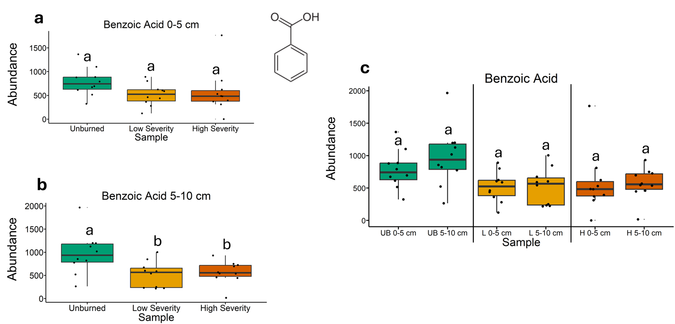
Fig. 13 | Quantification of benzoic acid abundances from gas chromatography-mass spectrometry analysis. The statistical tests of a, b, and c were conducted independently of each other. a, Quantifying abundances across soils collected at a depth of 0-5 cm. Letters above boxes indicate significant differences (P<0.05) amongst sample types. n=10 for unburned, low severity, and high severity samples. b, Quantifying abundances across soils collected at a depth of 5-10 cm. Letters above boxes indicate significant differences (P<0.05) amongst treatments. n=10 for unburned, low severity, and high severity samples. c, Quantifying abundances and comparing 0-5 cm soil depth with 5-10 cm soil depth. The statistical tests within sample types (i.e. unburned, low severity, and high severity) were conducted independently from each other. In other words, the “a” above “UB 0-5 cm” does not mean that there is no significant difference compared to “L 0-5 cm” which also has an “a” label because those statistical tests were conducted independently of each other. P<0.05 was the cutoff for significant differences. UB = unburned. L = low severity. H = high severity. n=10 for unburned 0-5 cm, unburned 5-10 cm, low severity 0-5 cm, low severity 5-10 cm, high severity 0-5 cm, and high severity 5-10 cm samples. Box plots show the median (central line), first and third quartiles (box edges), and whiskers extending to minimum and maximum values within 1.5 times the interquartile range. Smaller black dots (not the data points) indicate where the data points would lie if the data points weren’t jittered.

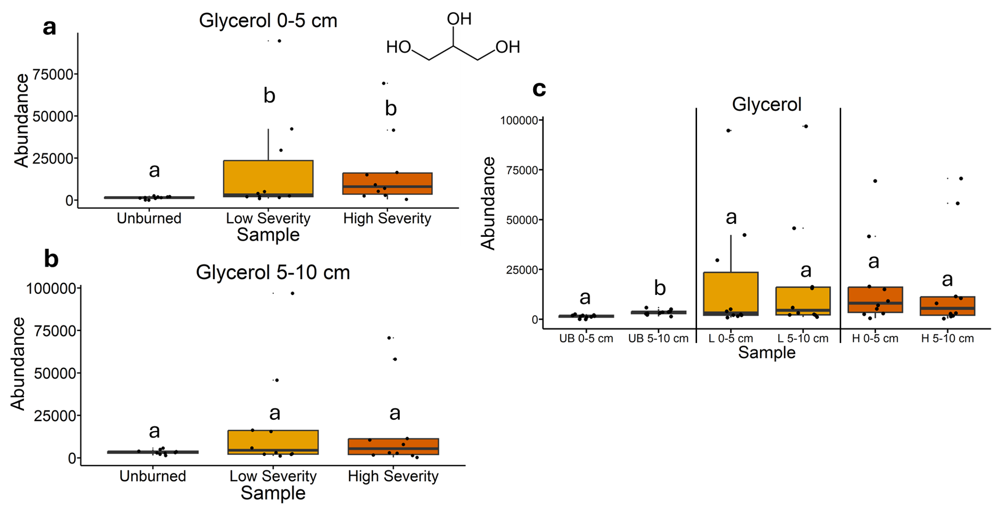
Fig. 14 | Quantification of glycerol abundances from gas chromatography-mass spectrometry analysis. The statistical tests of a, b, and c were conducted independently of each other. a, Quantifying abundances across soils collected at a depth of 0-5 cm. Letters above boxes indicate significant differences (P<0.05) amongst sample types. n=10 for unburned, low severity, and high severity samples. b, Quantifying abundances across soils collected at a depth of 5-10 cm. Letters above boxes indicate significant differences (P<0.05) amongst treatments. n=10 for unburned, low severity, and high severity samples. c, Quantifying abundances and comparing 0-5 cm soil depth with 5-10 cm soil depth. The statistical tests within sample types (i.e. unburned, low severity, and high severity) were conducted independently from each other. In other words, the “a” above “UB 0-5 cm” does not mean that there is no significant difference compared to “L 0-5 cm” which also has an “a” label because those statistical tests were conducted independently of each other. P<0.05 was the cutoff for significant differences. UB = unburned. L = low severity. H = high severity. n=10 for unburned 0-5 cm, unburned 5-10 cm, low severity 0-5 cm, low severity 5-10 cm, high severity 0-5 cm, and high severity 5-10 cm samples. Box plots show the median (central line), first and third quartiles (box edges), and whiskers extending to minimum and maximum values within 1.5 times the interquartile range. Smaller black dots (not the data points) indicate where the data points would lie if the data points weren’t jittered.

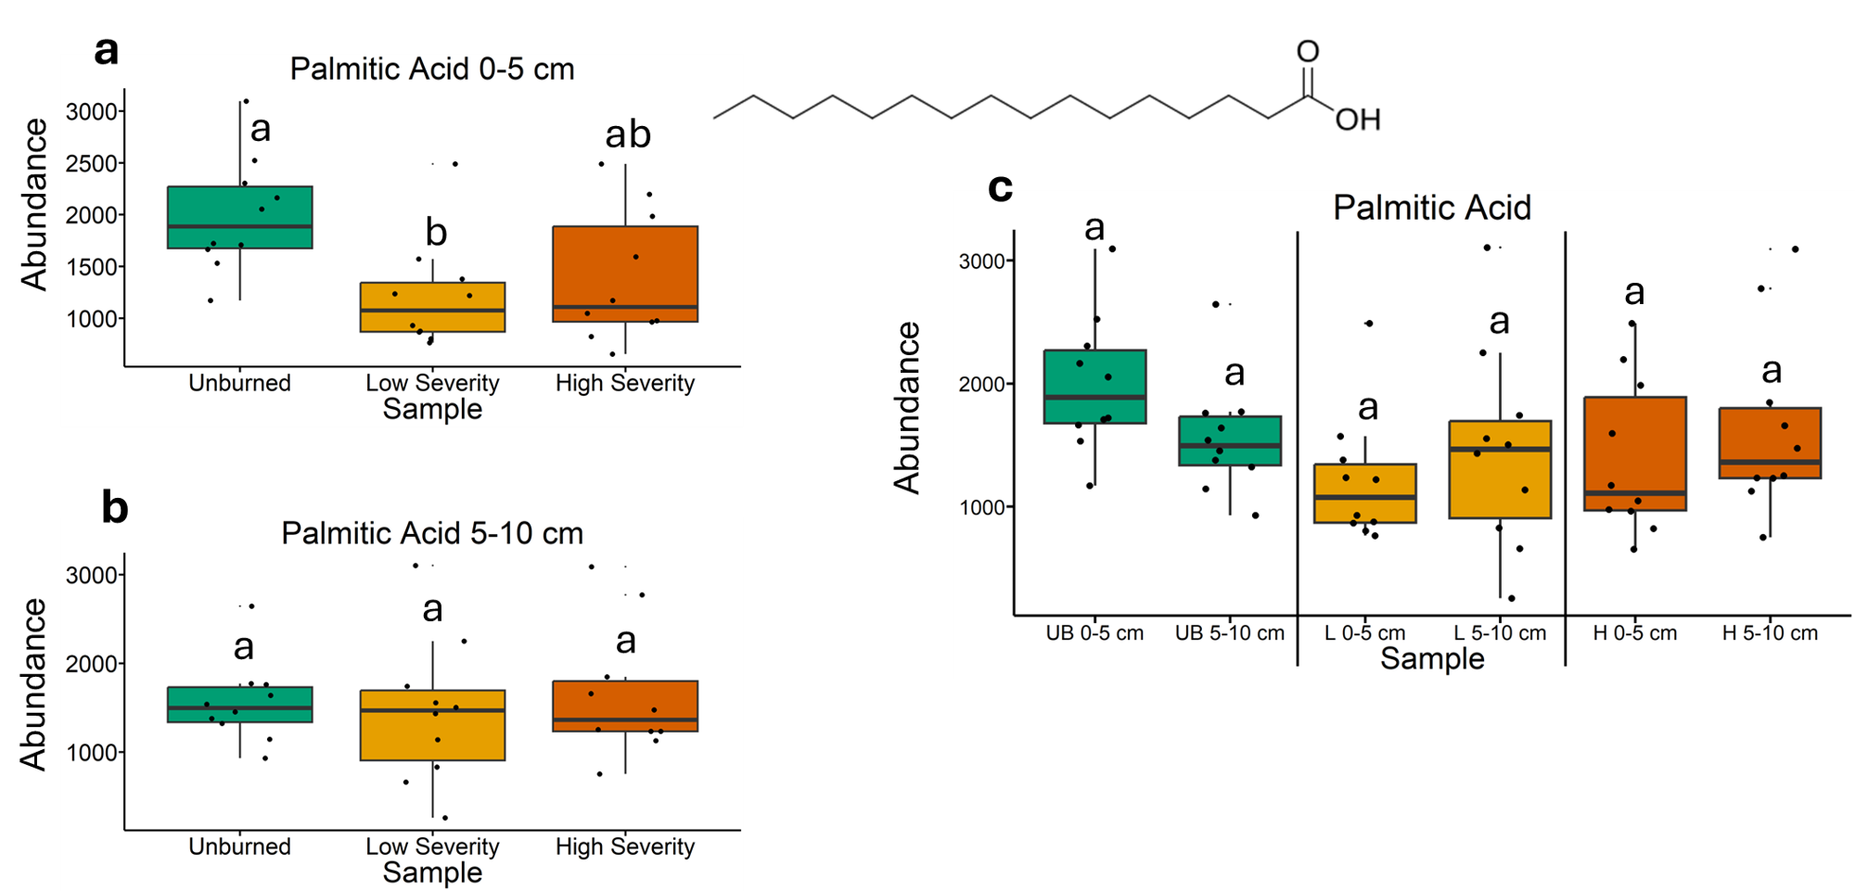
Fig. 15 | Quantification of palmitic acid abundances from gas chromatography-mass spectrometry analysis. The statistical tests of a, b, and c were conducted independently of each other. a, Quantifying abundances across soils collected at a depth of 0-5 cm. Letters above boxes indicate significant differences (P<0.05) amongst sample types. n=10 for unburned, low severity, and high severity samples. b, Quantifying abundances across soils collected at a depth of 5-10 cm. Letters above boxes indicate significant differences (P<0.05) amongst treatments. n=10 for unburned, low severity, and high severity samples. c, Quantifying abundances and comparing 0-5 cm soil depth with 5-10 cm soil depth. The statistical tests within sample types (i.e. unburned, low severity, and high severity) were conducted independently from each other. In other words, the “a” above “UB 0-5 cm” does not mean that there is no significant difference compared to “L 0-5 cm” which also has an “a” label because those statistical tests were conducted independently of each other. P<0.05 was the cutoff for significant differences. UB = unburned. L = low severity. H = high severity. n=10 for unburned 0-5 cm, unburned 5-10 cm, low severity 0-5 cm, low severity 5-10 cm, high severity 0-5 cm, and high severity 5-10 cm samples. Box plots show the median (central line), first and third quartiles (box edges), and whiskers extending to minimum and maximum values within 1.5 times the interquartile range. Smaller black dots (not the data points) indicate where the data points would lie if the data points weren’t jittered.

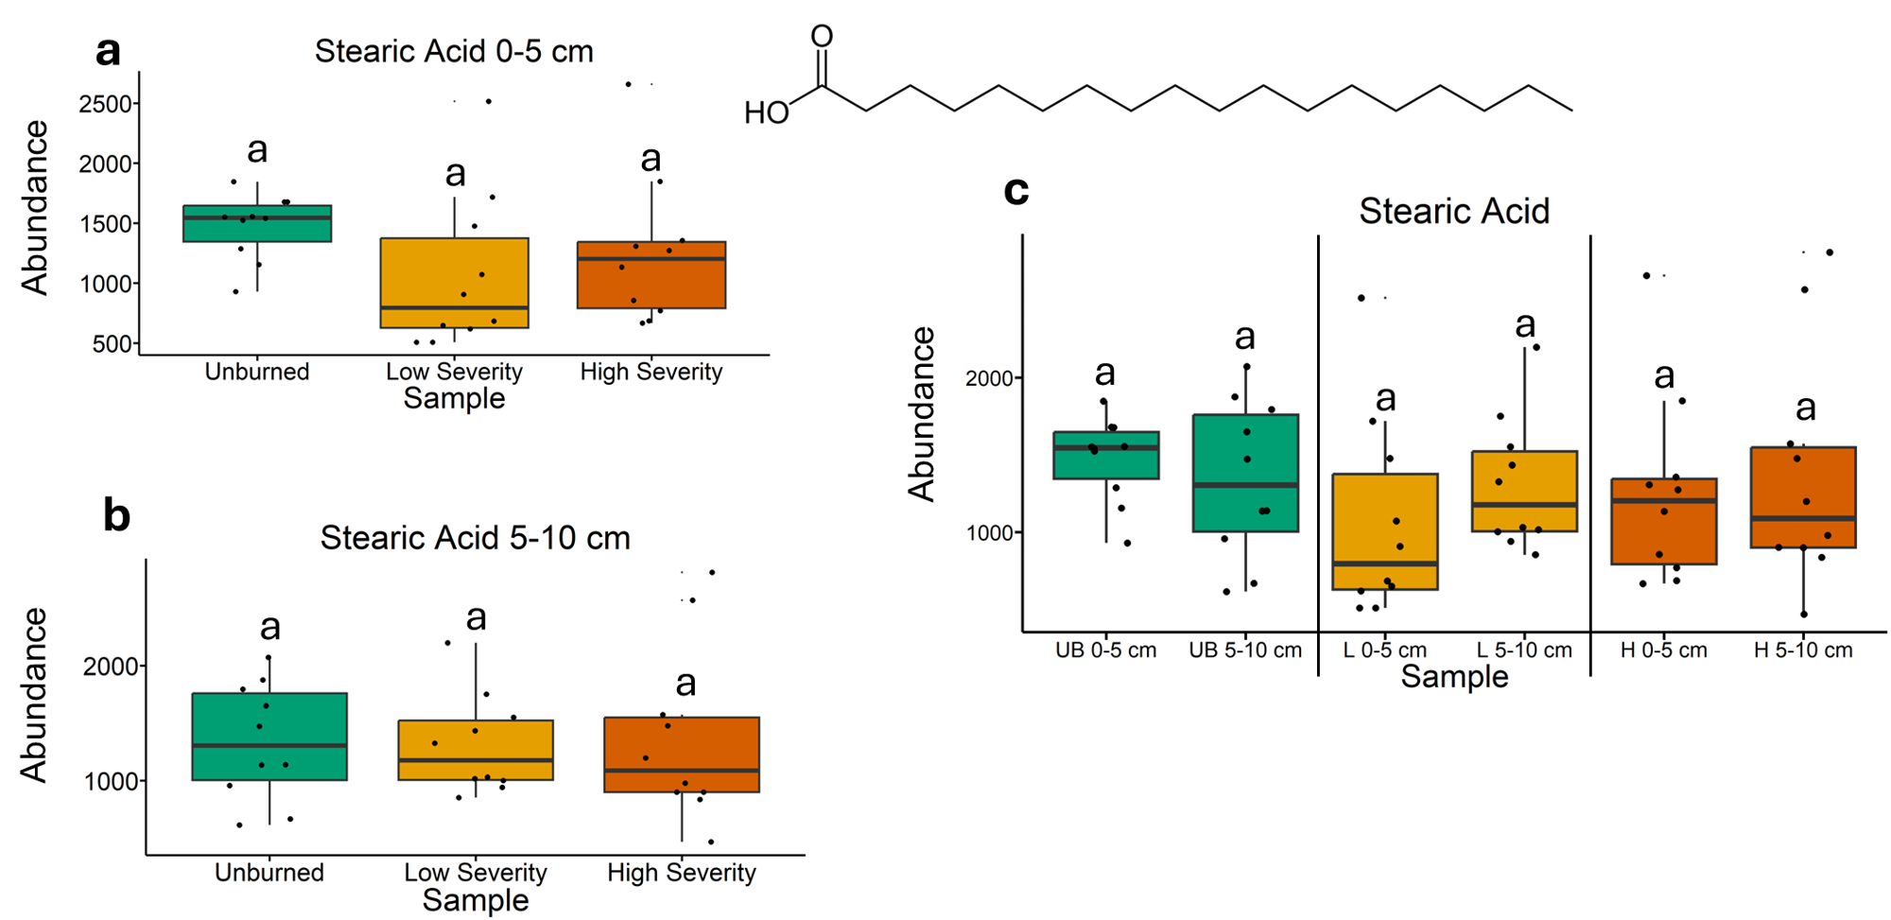
Fig. 16 | Quantification of stearic acid abundances from gas chromatography-mass spectrometry analysis. The statistical tests of a, b, and c were conducted independently of each other. a, Quantifying abundances across soils collected at a depth of 0-5 cm. Letters above boxes indicate significant differences (P<0.05) amongst sample types. n=10 for unburned, low severity, and high severity samples. b, Quantifying abundances across soils collected at a depth of 5-10 cm. Letters above boxes indicate significant differences (P<0.05) amongst treatments. n=10 for unburned, low severity, and high severity samples. c, Quantifying abundances and comparing 0-5 cm soil depth with 5-10 cm soil depth. The statistical tests within sample types (i.e. unburned, low severity, and high severity) were conducted independently from each other. In other words, the “a” above “UB 0-5 cm” does not mean that there is no significant difference compared to “L 0-5 cm” which also has an “a” label because those statistical tests were conducted independently of each other. P<0.05 was the cutoff for significant differences. UB = unburned. L = low severity. H = high severity. n=10 for unburned 0-5 cm, unburned 5-10 cm, low severity 0-5 cm, low severity 5-10 cm, high severity 0-5 cm, and high severity 5-10 cm samples. Box plots show the median (central line), first and third quartiles (box edges), and whiskers extending to minimum and maximum values within 1.5 times the interquartile range. Smaller black dots (not the data points) indicate where the data points would lie if the data points weren’t jittered.

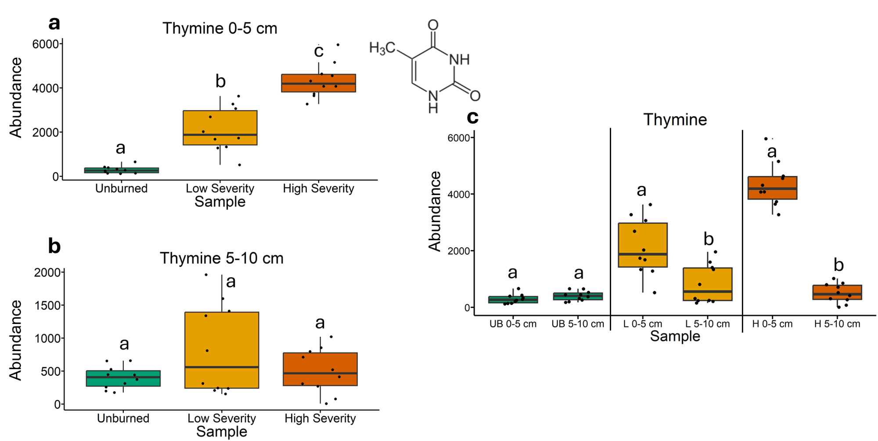
Fig. 17 | Quantification of thymine abundances from gas chromatography-mass spectrometry analysis. The statistical tests of a, b, and c were conducted independently of each other. a, Quantifying abundances across soils collected at a depth of 0-5 cm. Letters above boxes indicate significant differences (P<0.05) amongst sample types. n=10 for unburned, low severity, and high severity samples. b, Quantifying abundances across soils collected at a depth of 5-10 cm. Letters above boxes indicate significant differences (P<0.05) amongst treatments. n=10 for unburned, low severity, and high severity samples. c, Quantifying abundances and comparing 0-5 cm soil depth with 5-10 cm soil depth. The statistical tests within sample types (i.e. unburned, low severity, and high severity) were conducted independently from each other. In other words, the “a” above “UB 0-5 cm” does not mean that there is no significant difference compared to “L 0-5 cm” which also has an “a” label because those statistical tests were conducted independently of each other. P<0.05 was the cutoff for significant differences. UB = unburned. L = low severity. H = high severity. n=10 for unburned 0-5 cm, unburned 5-10 cm, low severity 0-5 cm, low severity 5-10 cm, high severity 0-5 cm, and high severity 5-10 cm samples. Box plots show the median (central line), first and third quartiles (box edges), and whiskers extending to minimum and maximum values within 1.5 times the interquartile range. Smaller black dots (not the data points) indicate where the data points would lie if the data points weren’t jittered.

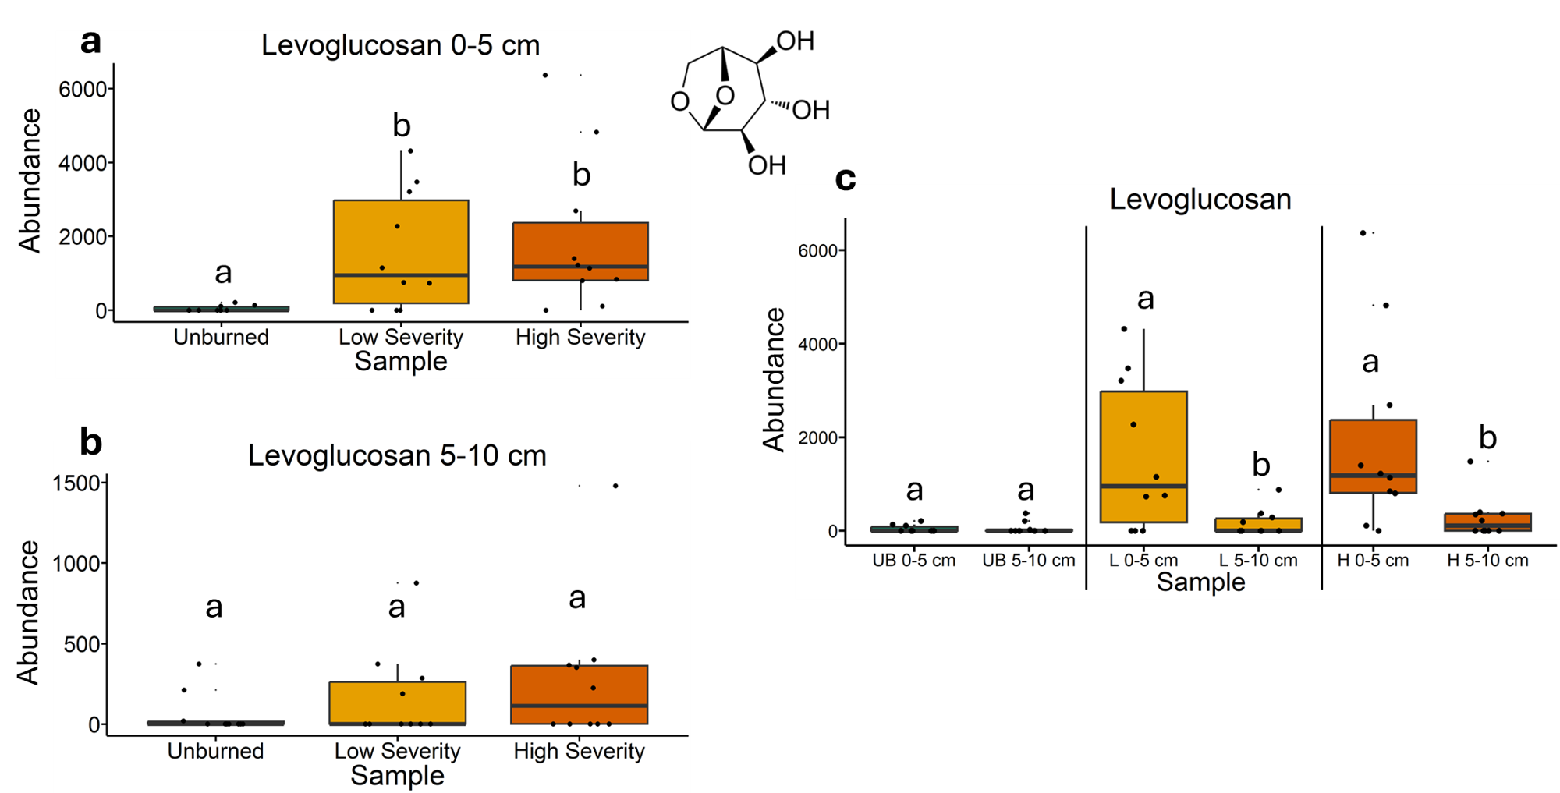
Fig. 18 | Quantification of levoglucosan abundances from gas chromatography-mass spectrometry analysis. The statistical tests of a, b, and c were conducted independently of each other. a, Quantifying abundances across soils collected at a depth of 0-5 cm. Letters above boxes indicate significant differences (P<0.05) amongst sample types. n=10 for unburned, low severity, and high severity samples. b, Quantifying abundances across soils collected at a depth of 5-10 cm. Letters above boxes indicate significant differences (P<0.05) amongst treatments. n=10 for unburned, low severity, and high severity samples. c, Quantifying abundances and comparing 0-5 cm soil depth with 5-10 cm soil depth. The statistical tests within sample types (i.e. unburned, low severity, and high severity) were conducted independently from each other. In other words, the “a” above “UB 0-5 cm” does not mean that there is no significant difference compared to “L 0-5 cm” which also has an “a” label because those statistical tests were conducted independently of each other. P<0.05 was the cutoff for significant differences. UB = unburned. L = low severity. H = high severity. n=10 for unburned 0-5 cm, unburned 5-10 cm, low severity 0-5 cm, low severity 5-10 cm, high severity 0-5 cm, and high severity 5-10 cm samples. Box plots show the median (central line), first and third quartiles (box edges), and whiskers extending to minimum and maximum values within 1.5 times the interquartile range. Smaller black dots (not the data points) indicate where the data points would lie if the data points weren’t jittered.

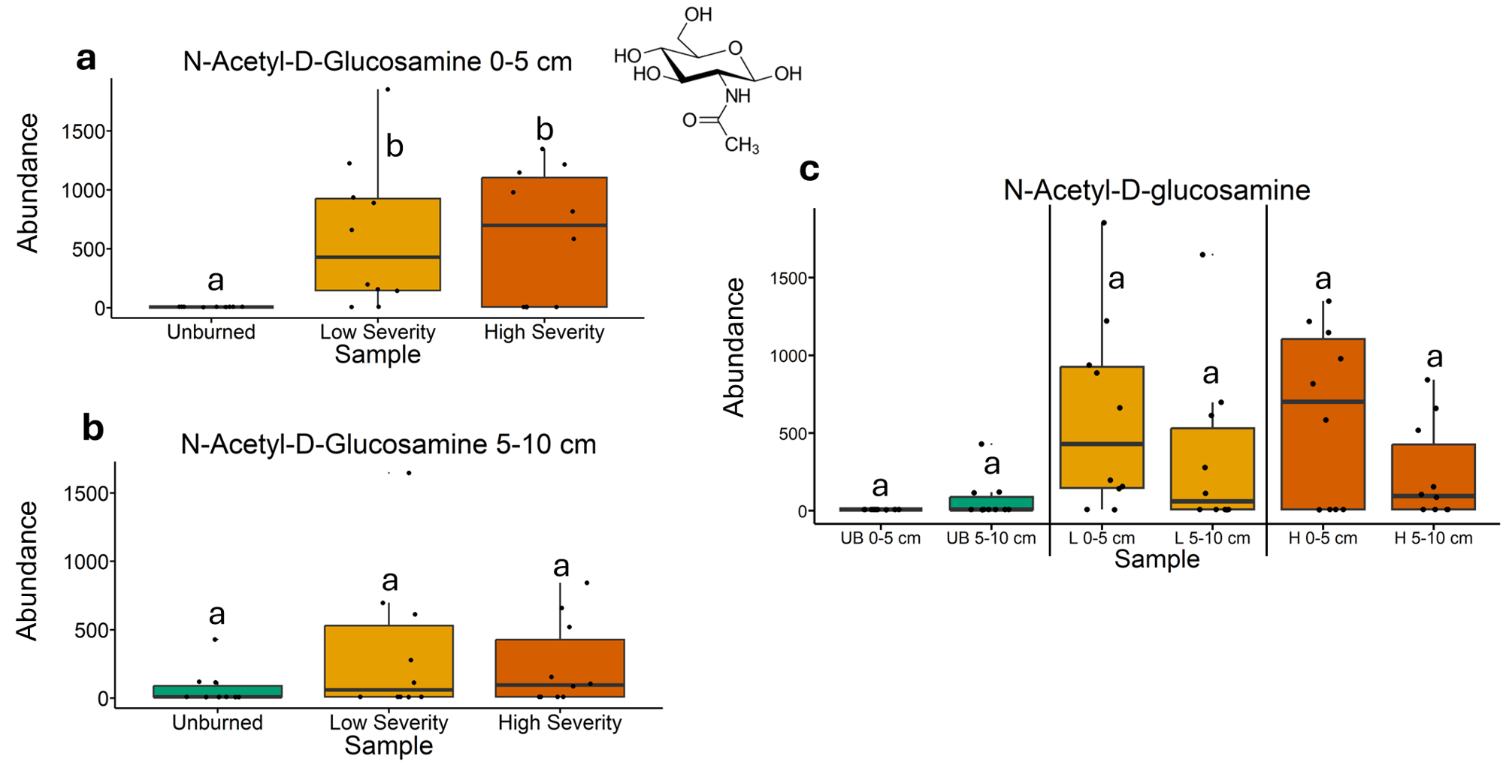
Fig. 19 | Quantification of n-acetyl-D-glucosamine abundances from gas chromatography-mass spectrometry analysis. The statistical tests of a, b, and c were conducted independently of each other. a, Quantifying abundances across soils collected at a depth of 0-5 cm. Letters above boxes indicate significant differences (P<0.05) amongst sample types. n=10 for unburned, low severity, and high severity samples. b, Quantifying abundances across soils collected at a depth of 5-10 cm. Letters above boxes indicate significant differences (P<0.05) amongst treatments. n=10 for unburned, low severity, and high severity samples. c, Quantifying abundances and comparing 0-5 cm soil depth with 5-10 cm soil depth. The statistical tests within sample types (i.e. unburned, low severity, and high severity) were conducted independently from each other. In other words, the “a” above “UB 0-5 cm” does not mean that there is no significant difference compared to “L 0-5 cm” which also has an “a” label because those statistical tests were conducted independently of each other. P<0.05 was the cutoff for significant differences. UB = unburned. L = low severity. H = high severity. n=10 for unburned 0-5 cm, unburned 5-10 cm, low severity 0-5 cm, low severity 5-10 cm, high severity 0-5 cm, and high severity 5-10 cm samples. Box plots show the median (central line), first and third quartiles (box edges), and whiskers extending to minimum and maximum values within 1.5 times the interquartile range. Smaller black dots (not the data points) indicate where the data points would lie if the data points weren’t jittered.

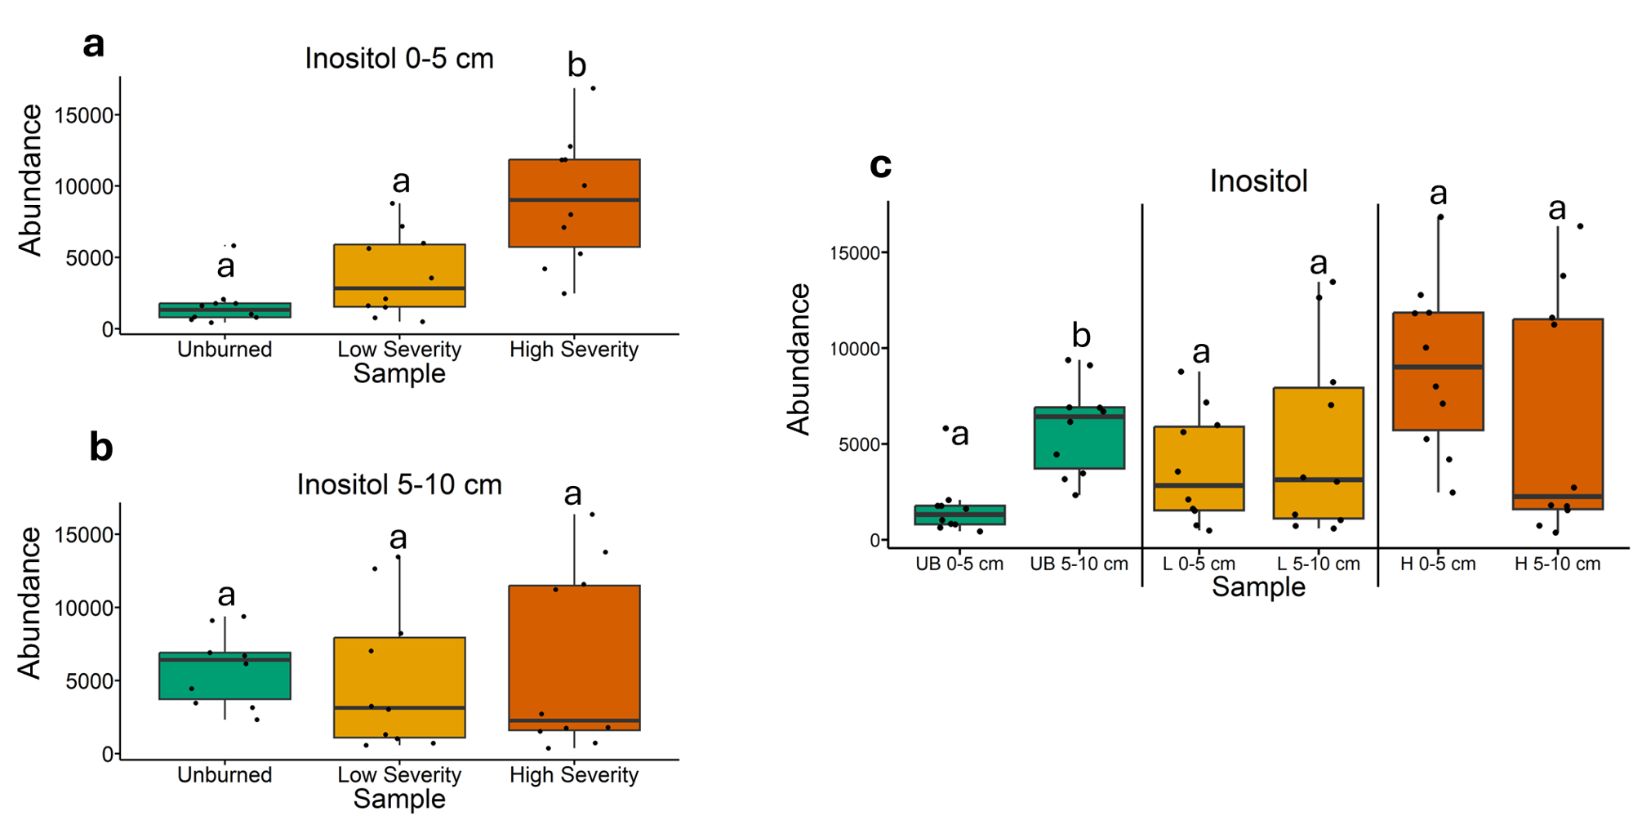
Fig. 20 | Quantification of inositol abundances from gas chromatography-mass spectrometry analysis. The statistical tests of a, b, and c were conducted independently of each other. a, Quantifying abundances across soils collected at a depth of 0-5 cm. Letters above boxes indicate significant differences (P<0.05) amongst sample types. n=10 for unburned, low severity, and high severity samples. b, Quantifying abundances across soils collected at a depth of 5-10 cm. Letters above boxes indicate significant differences (P<0.05) amongst treatments. n=10 for unburned, low severity, and high severity samples. c, Quantifying abundances and comparing 0-5 cm soil depth with 5-10 cm soil depth. The statistical tests within sample types (i.e. unburned, low severity, and high severity) were conducted independently from each other. In other words, the “a” above “UB 0-5 cm” does not mean that there is no significant difference compared to “L 0-5 cm” which also has an “a” label because those statistical tests were conducted independently of each other. P<0.05 was the cutoff for significant differences. UB = unburned. L = low severity. H = high severity. n=10 for unburned 0-5 cm, unburned 5-10 cm, low severity 0-5 cm, low severity 5-10 cm, high severity 0-5 cm, and high severity 5-10 cm samples. Box plots show the median (central line), first and third quartiles (box edges), and whiskers extending to minimum and maximum values within 1.5 times the interquartile range. Smaller black dots (not the data points) indicate where the data points would lie if the data points weren’t jittered.

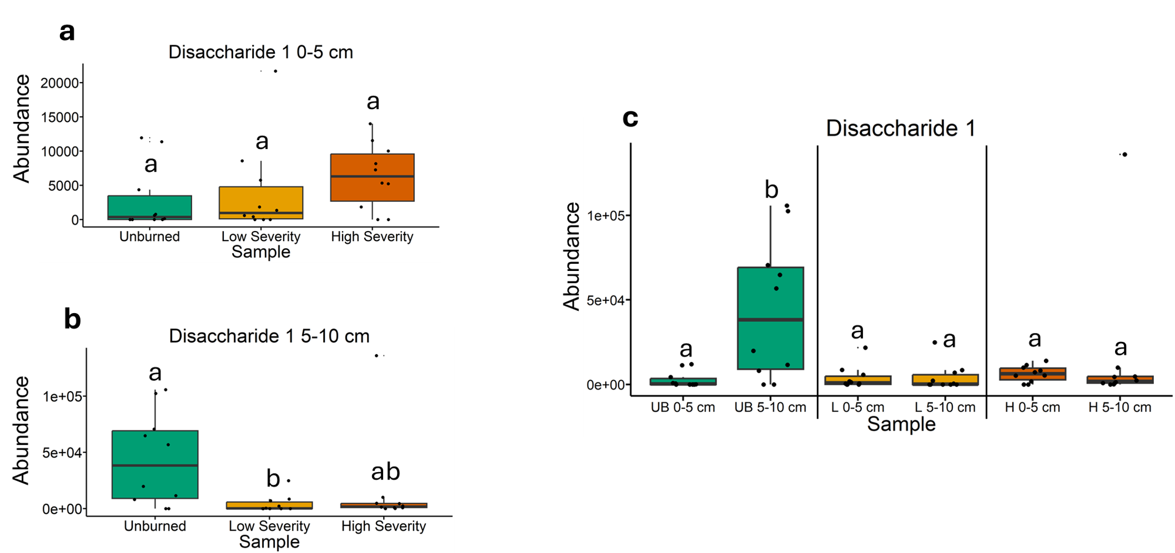
Fig. 21 | Quantification of disaccharide 1 abundances from gas chromatography-mass spectrometry analysis. The statistical tests of a, b, and c were conducted independently of each other. a, Quantifying abundances across soils collected at a depth of 0-5 cm. Letters above boxes indicate significant differences (P<0.05) amongst sample types. n=10 for unburned, low severity, and high severity samples. b, Quantifying abundances across soils collected at a depth of 5-10 cm. Letters above boxes indicate significant differences (P<0.05) amongst treatments. n=10 for unburned, low severity, and high severity samples. c, Quantifying abundances and comparing 0-5 cm soil depth with 5-10 cm soil depth. The statistical tests within sample types (i.e. unburned, low severity, and high severity) were conducted independently from each other. In other words, the “a” above “UB 0-5 cm” does not mean that there is no significant difference compared to “L 0-5 cm” which also has an “a” label because those statistical tests were conducted independently of each other. P<0.05 was the cutoff for significant differences. UB = unburned. L = low severity. H = high severity. n=10 for unburned 0-5 cm, unburned 5-10 cm, low severity 0-5 cm, low severity 5-10 cm, high severity 0-5 cm, and high severity 5-10 cm samples. Box plots show the median (central line), first and third quartiles (box edges), and whiskers extending to minimum and maximum values within 1.5 times the interquartile range. Smaller black dots (not the data points) indicate where the data points would lie if the data points weren’t jittered.

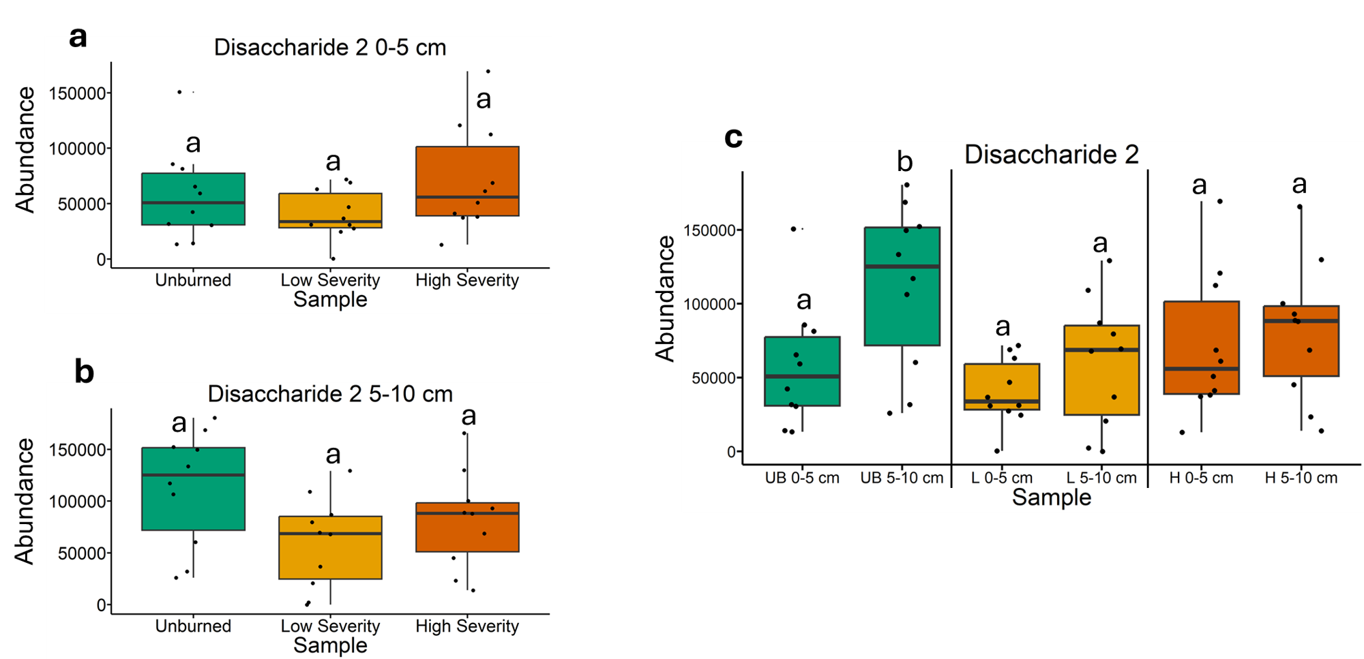
Fig. 22 | Quantification of disaccharide 2 abundances from gas chromatography-mass spectrometry analysis. The statistical tests of a, b, and c were conducted independently of each other. a, Quantifying abundances across soils collected at a depth of 0-5 cm. Letters above boxes indicate significant differences (P<0.05) amongst sample types. n=10 for unburned, low severity, and high severity samples. b, Quantifying abundances across soils collected at a depth of 5-10 cm. Letters above boxes indicate significant differences (P<0.05) amongst treatments. n=10 for unburned, low severity, and high severity samples. c, Quantifying abundances and comparing 0-5 cm soil depth with 5-10 cm soil depth. The statistical tests within sample types (i.e. unburned, low severity, and high severity) were conducted independently from each other. In other words, the “a” above “UB 0-5 cm” does not mean that there is no significant difference compared to “L 0-5 cm” which also has an “a” label because those statistical tests were conducted independently of each other. P<0.05 was the cutoff for significant differences. UB = unburned. L = low severity. H = high severity. n=10 for unburned 0-5 cm, unburned 5-10 cm, low severity 0-5 cm, low severity 5-10 cm, high severity 0-5 cm, and high severity 5-10 cm samples. Box plots show the median (central line), first and third quartiles (box edges), and whiskers extending to minimum and maximum values within 1.5 times the interquartile range. Smaller black dots (not the data points) indicate where the data points would lie if the data points weren’t jittered.

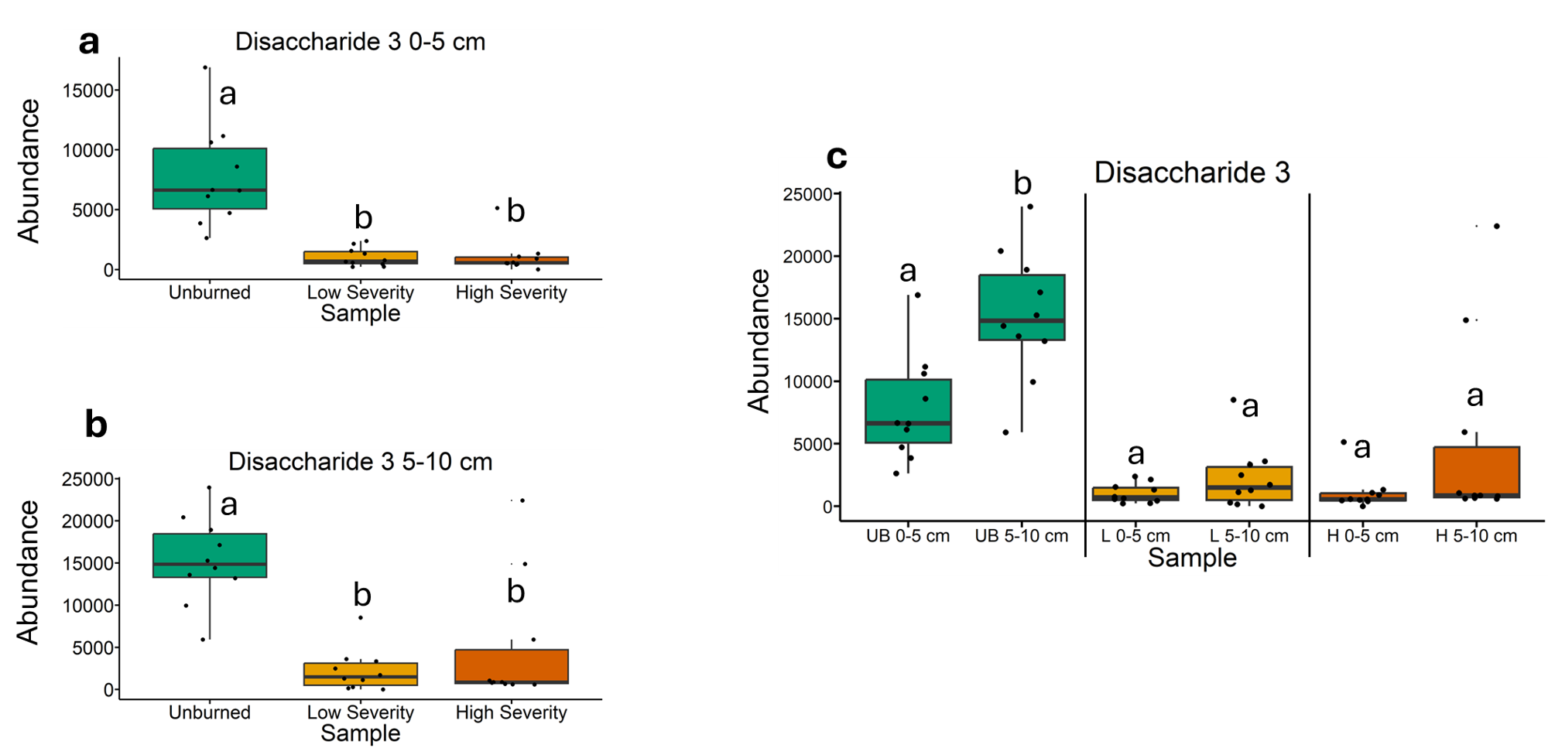
Fig. 23 | Quantification of disaccharide 3 abundances from gas chromatography-mass spectrometry analysis. The statistical tests of a, b, and c were conducted independently of each other. a, Quantifying abundances across soils collected at a depth of 0-5 cm. Letters above boxes indicate significant differences (P<0.05) amongst sample types. n=10 for unburned, low severity, and high severity samples. b, Quantifying abundances across soils collected at a depth of 5-10 cm. Letters above boxes indicate significant differences (P<0.05) amongst treatments. n=10 for unburned, low severity, and high severity samples. c, Quantifying abundances and comparing 0-5 cm soil depth with 5-10 cm soil depth. The statistical tests within sample types (i.e. unburned, low severity, and high severity) were conducted independently from each other. In other words, the “a” above “UB 0-5 cm” does not mean that there is no significant difference compared to “L 0-5 cm” which also has an “a” label because those statistical tests were conducted independently of each other. P<0.05 was the cutoff for significant differences. UB = unburned. L = low severity. H = high severity. n=10 for unburned 0-5 cm, unburned 5-10 cm, low severity 0-5 cm, low severity 5-10 cm, high severity 0-5 cm, and high severity 5-10 cm samples. Box plots show the median (central line), first and third quartiles (box edges), and whiskers extending to minimum and maximum values within 1.5 times the interquartile range. Smaller black dots (not the data points) indicate where the data points would lie if the data points weren’t jittered.

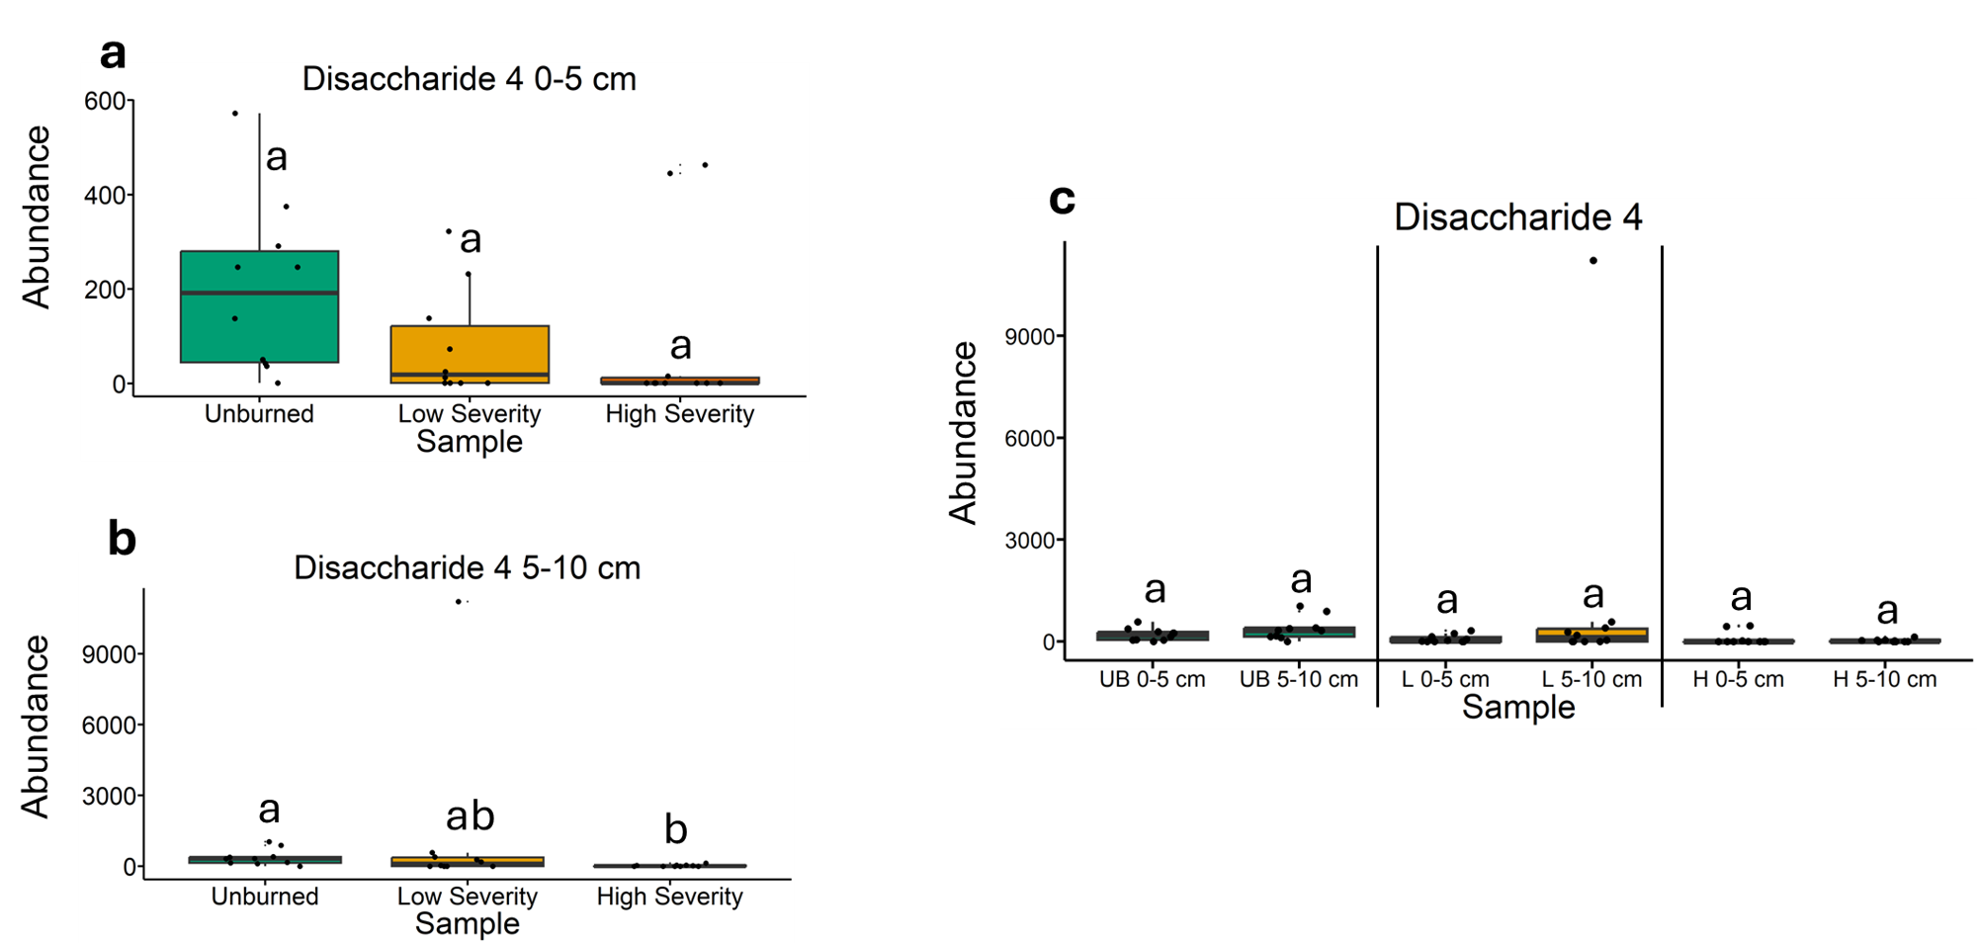
Fig. 24 | Quantification of disaccharide 4 abundances from gas chromatography-mass spectrometry analysis. The statistical tests of a, b, and c were conducted independently of each other. a, Quantifying abundances across soils collected at a depth of 0-5 cm. Letters above boxes indicate significant differences (P<0.05) amongst sample types. n=10 for unburned, low severity, and high severity samples. b, Quantifying abundances across soils collected at a depth of 5-10 cm. Letters above boxes indicate significant differences (P<0.05) amongst treatments. n=10 for unburned, low severity, and high severity samples. c, Quantifying abundances and comparing 0-5 cm soil depth with 5-10 cm soil depth. The statistical tests within sample types (i.e. unburned, low severity, and high severity) were conducted independently from each other. In other words, the “a” above “UB 0-5 cm” does not mean that there is no significant difference compared to “L 0-5 cm” which also has an “a” label because those statistical tests were conducted independently of each other. P<0.05 was the cutoff for significant differences. UB = unburned. L = low severity. H = high severity. n=10 for unburned 0-5 cm, unburned 5-10 cm, low severity 0-5 cm, low severity 5-10 cm, high severity 0-5 cm, and high severity 5-10 cm samples. Box plots show the median (central line), first and third quartiles (box edges), and whiskers extending to minimum and maximum values within 1.5 times the interquartile range. Smaller black dots (not the data points) indicate where the data points would lie if the data points weren’t jittered.

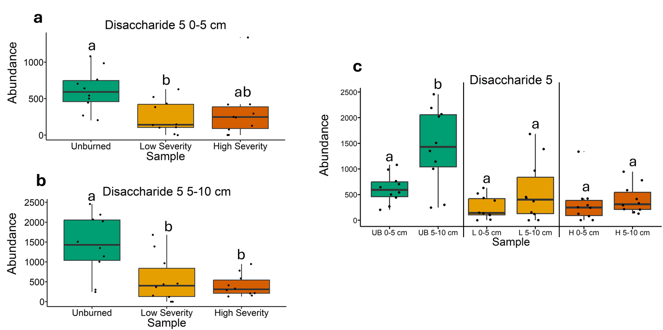
Fig. 25 | Quantification of disaccharide 5 abundances from gas chromatography-mass spectrometry analysis. The statistical tests of a, b, and c were conducted independently of each other. a, Quantifying abundances across soils collected at a depth of 0-5 cm. Letters above boxes indicate significant differences (P<0.05) amongst sample types. n=10 for unburned, low severity, and high severity samples. b, Quantifying abundances across soils collected at a depth of 5-10 cm. Letters above boxes indicate significant differences (P<0.05) amongst treatments. n=10 for unburned, low severity, and high severity samples. c, Quantifying abundances and comparing 0-5 cm soil depth with 5-10 cm soil depth. The statistical tests within sample types (i.e. unburned, low severity, and high severity) were conducted independently from each other. In other words, the “a” above “UB 0-5 cm” does not mean that there is no significant difference compared to “L 0-5 cm” which also has an “a” label because those statistical tests were conducted independently of each other. P<0.05 was the cutoff for significant differences. UB = unburned. L = low severity. H = high severity. n=10 for unburned 0-5 cm, unburned 5-10 cm, low severity 0-5 cm, low severity 5-10 cm, high severity 0-5 cm, and high severity 5-10 cm samples. Box plots show the median (central line), first and third quartiles (box edges), and whiskers extending to minimum and maximum values within 1.5 times the interquartile range. Smaller black dots (not the data points) indicate where the data points would lie if the data points weren’t jittered.

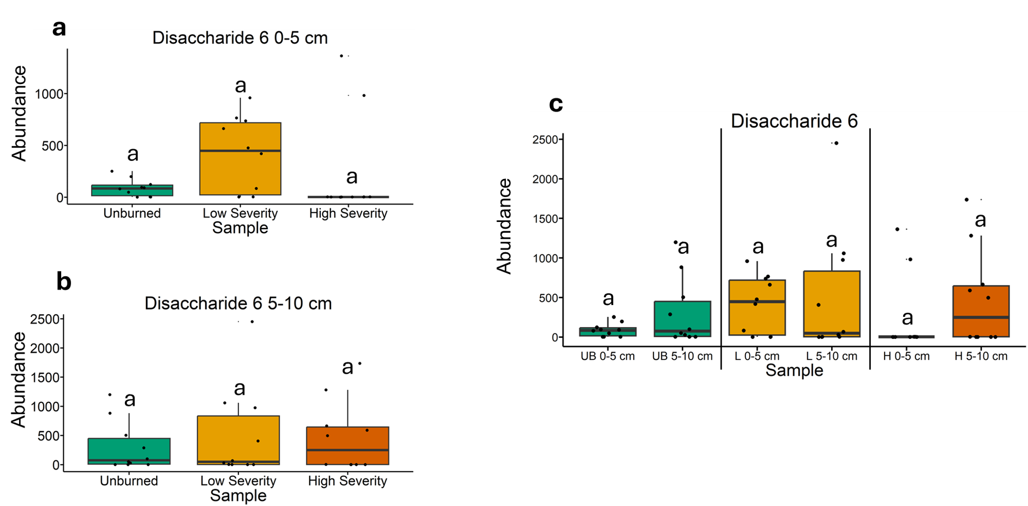
Fig. 26 | Quantification of disaccharide 6 abundances from gas chromatography-mass spectrometry analysis. The statistical tests of a, b, and c were conducted independently of each other. a, Quantifying abundances across soils collected at a depth of 0-5 cm. Letters above boxes indicate significant differences (P<0.05) amongst sample types. n=10 for unburned, low severity, and high severity samples. b, Quantifying abundances across soils collected at a depth of 5-10 cm. Letters above boxes indicate significant differences (P<0.05) amongst treatments. n=10 for unburned, low severity, and high severity samples. c, Quantifying abundances and comparing 0-5 cm soil depth with 5-10 cm soil depth. The statistical tests within sample types (i.e. unburned, low severity, and high severity) were conducted independently from each other. In other words, the “a” above “UB 0-5 cm” does not mean that there is no significant difference compared to “L 0-5 cm” which also has an “a” label because those statistical tests were conducted independently of each other. P<0.05 was the cutoff for significant differences. UB = unburned. L = low severity. H = high severity. n=10 for unburned 0-5 cm, unburned 5-10 cm, low severity 0-5 cm, low severity 5-10 cm, high severity 0-5 cm, and high severity 5-10 cm samples. Box plots show the median (central line), first and third quartiles (box edges), and whiskers extending to minimum and maximum values within 1.5 times the interquartile range. Smaller black dots (not the data points) indicate where the data points would lie if the data points weren’t jittered.

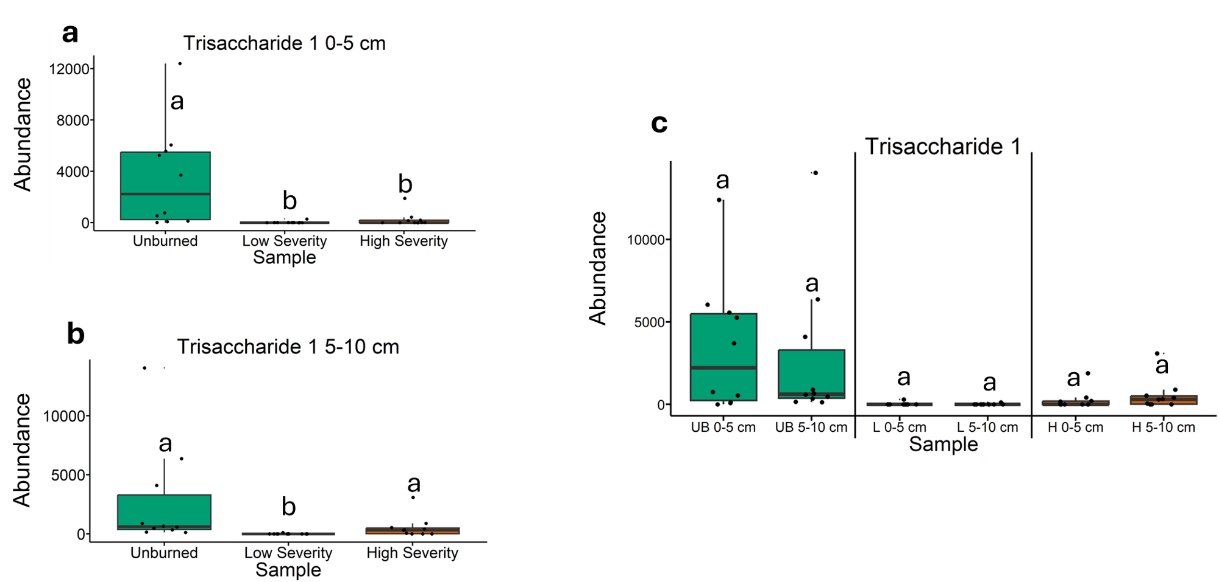
Fig. 27 | Quantification of trisaccharide 1 abundances from gas chromatography-mass spectrometry analysis. The statistical tests of a, b, and c were conducted independently of each other. a, Quantifying abundances across soils collected at a depth of 0-5 cm. Letters above boxes indicate significant differences (P<0.05) amongst sample types. n=10 for unburned, low severity, and high severity samples. b, Quantifying abundances across soils collected at a depth of 5-10 cm. Letters above boxes indicate significant differences (P<0.05) amongst treatments. n=10 for unburned, low severity, and high severity samples. c, Quantifying abundances and comparing 0-5 cm soil depth with 5-10 cm soil depth. The statistical tests within sample types (i.e. unburned, low severity, and high severity) were conducted independently from each other. In other words, the “a” above “UB 0-5 cm” does not mean that there is no significant difference compared to “L 0-5 cm” which also has an “a” label because those statistical tests were conducted independently of each other. P<0.05 was the cutoff for significant differences. UB = unburned. L = low severity. H = high severity. n=10 for unburned 0-5 cm, unburned 5-10 cm, low severity 0-5 cm, low severity 5-10 cm, high severity 0-5 cm, and high severity 5-10 cm samples. Box plots show the median (central line), first and third quartiles (box edges), and whiskers extending to minimum and maximum values within 1.5 times the interquartile range. Smaller black dots (not the data points) indicate where the data points would lie if the data points weren’t jittered.

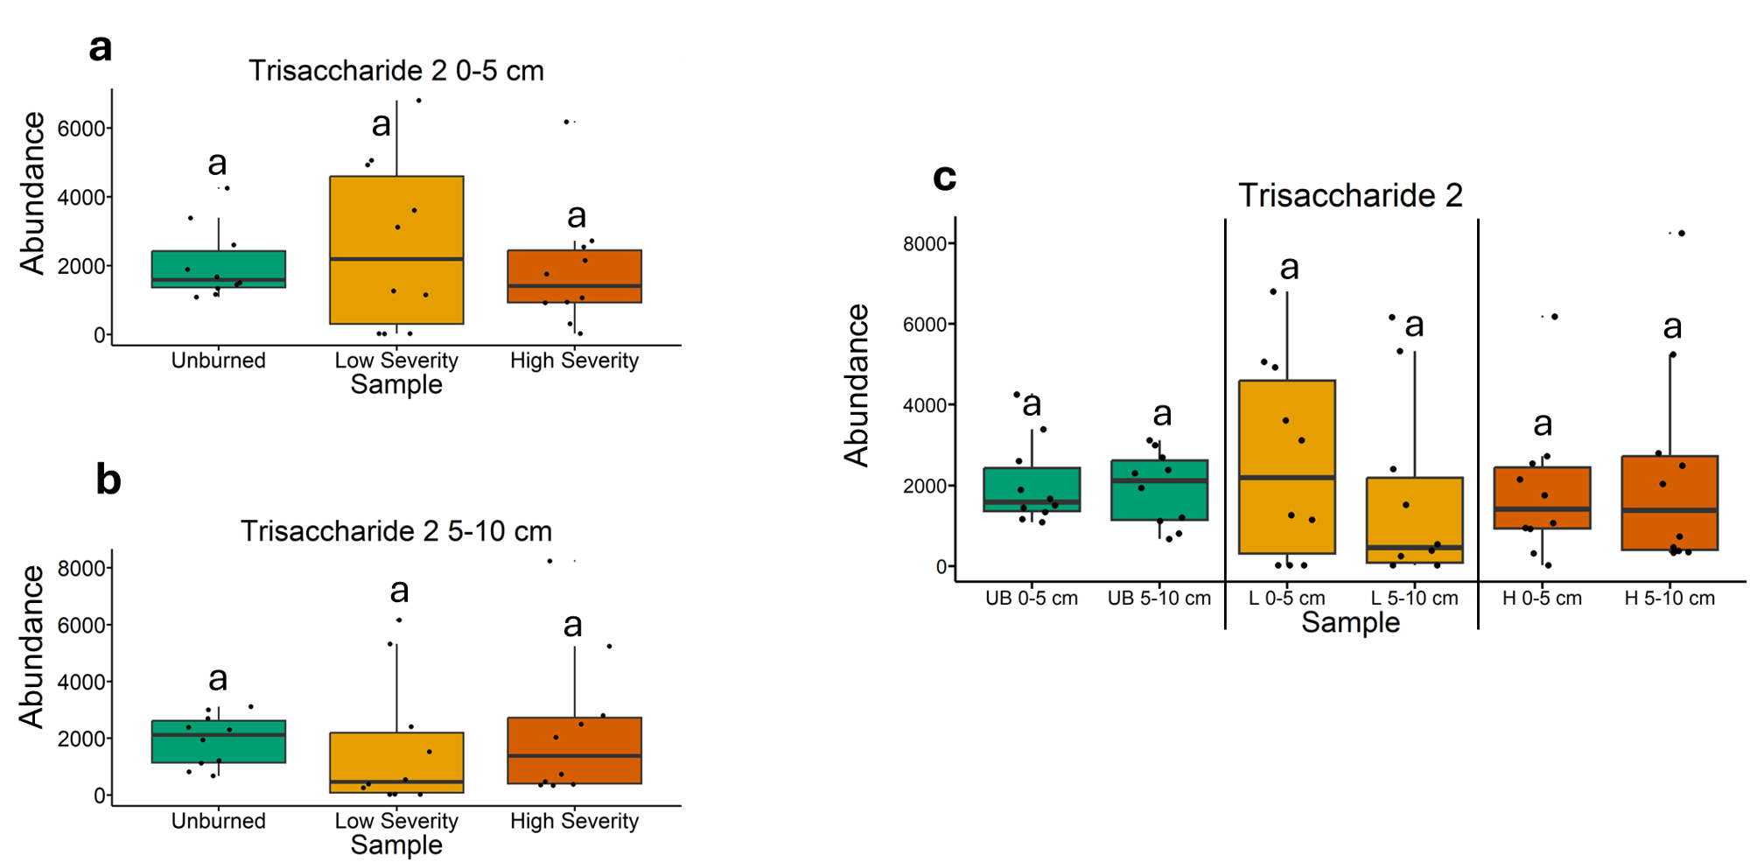
Fig. 28 | Quantification of trisaccharide 2 abundances from gas chromatography-mass spectrometry analysis. The statistical tests of a, b, and c were conducted independently of each other. a, Quantifying abundances across soils collected at a depth of 0-5 cm. Letters above boxes indicate significant differences (P<0.05) amongst sample types. n=10 for unburned, low severity, and high severity samples. b, Quantifying abundances across soils collected at a depth of 5-10 cm. Letters above boxes indicate significant differences (P<0.05) amongst treatments. n=10 for unburned, low severity, and high severity samples. c, Quantifying abundances and comparing 0-5 cm soil depth with 5-10 cm soil depth. The statistical tests within sample types (i.e. unburned, low severity, and high severity) were conducted independently from each other. In other words, the “a” above “UB 0-5 cm” does not mean that there is no significant difference compared to “L 0-5 cm” which also has an “a” label because those statistical tests were conducted independently of each other. P<0.05 was the cutoff for significant differences. UB = unburned. L = low severity. H = high severity. n=10 for unburned 0-5 cm, unburned 5-10 cm, low severity 0-5 cm, low severity 5-10 cm, high severity 0-5 cm, and high severity 5-10 cm samples. Box plots show the median (central line), first and third quartiles (box edges), and whiskers extending to minimum and maximum values within 1.5 times the interquartile range. Smaller black dots (not the data points) indicate where the data points would lie if the data points weren’t jittered.

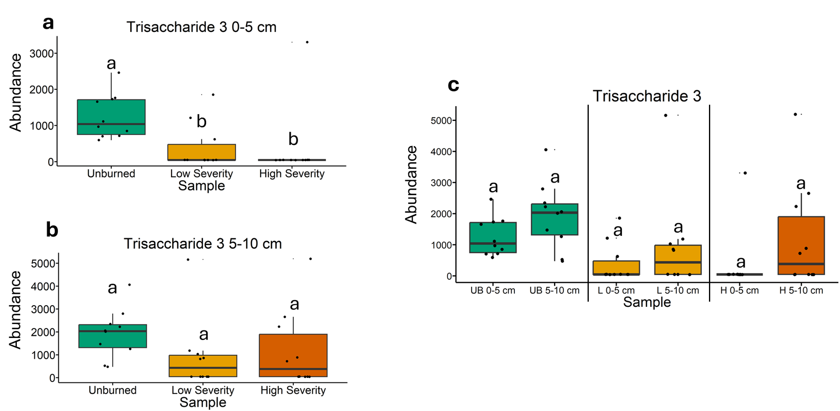
Fig. 29 | Quantification of trisaccharide 3 abundances from gas chromatography-mass spectrometry analysis. The statistical tests of a, b, and c were conducted independently of each other. a, Quantifying abundances across soils collected at a depth of 0-5 cm. Letters above boxes indicate significant differences (P<0.05) amongst sample types. n=10 for unburned, low severity, and high severity samples. b, Quantifying abundances across soils collected at a depth of 5-10 cm. Letters above boxes indicate significant differences (P<0.05) amongst treatments. n=10 for unburned, low severity, and high severity samples. c, Quantifying abundances and comparing 0-5 cm soil depth with 5-10 cm soil depth. The statistical tests within sample types (i.e. unburned, low severity, and high severity) were conducted independently from each other. In other words, the “a” above “UB 0-5 cm” does not mean that there is no significant difference compared to “L 0-5 cm” which also has an “a” label because those statistical tests were conducted independently of each other. P<0.05 was the cutoff for significant differences. UB = unburned. L = low severity. H = high severity. n=10 for unburned 0-5 cm, unburned 5-10 cm, low severity 0-5 cm, low severity 5-10 cm, high severity 0-5 cm, and high severity 5-10 cm samples. Box plots show the median (central line), first and third quartiles (box edges), and whiskers extending to minimum and maximum values within 1.5 times the interquartile range. Smaller black dots (not the data points) indicate where the data points would lie if the data points weren’t jittered.

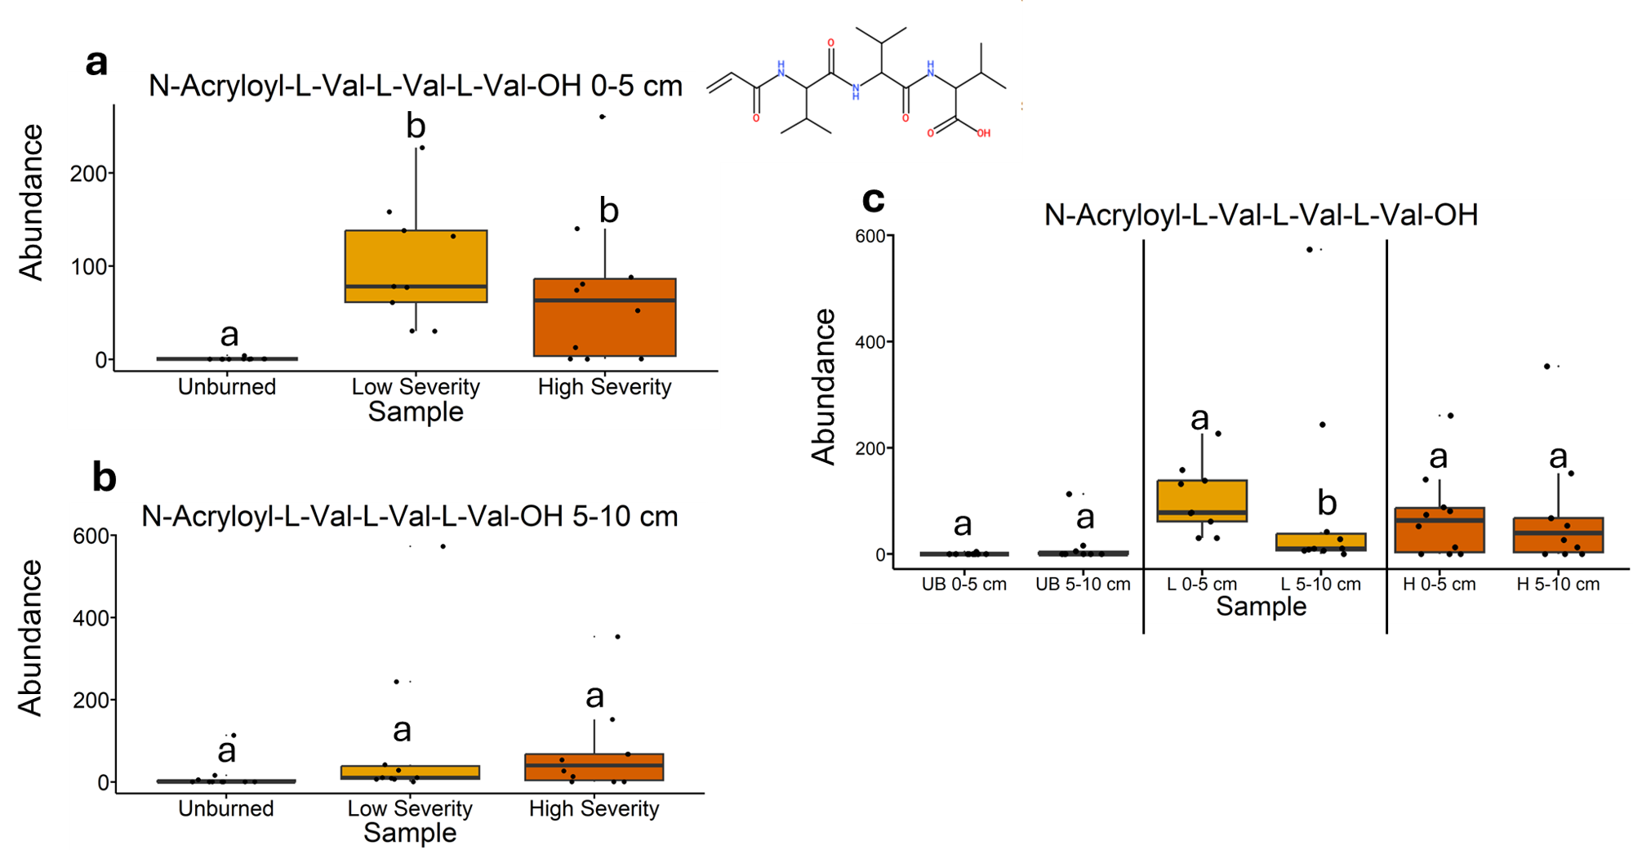
Fig. 30 | Quantification of N-Acryloyl-L-Val-L-Val-L-Val-OH abundances from liquid chromatography-mass spectrometry analysis. The statistical tests of a, b, and c were conducted independently of each other. a, Quantifying abundances across soils collected at a depth of 0-5 cm. Letters above boxes indicate significant differences (P<0.05) amongst sample types. n=10 for unburned, n=9 for low severity, and n=10 high severity samples. b, Quantifying abundances across soils collected at a depth of 5-10 cm. Letters above boxes indicate significant differences (P<0.05) amongst treatments. n=10 for unburned, low severity, and high severity samples. c, Quantifying abundances and comparing 0-5 cm soil depth with 5-10 cm soil depth. The statistical tests within sample types (i.e. unburned, low severity, and high severity) were conducted independently from each other. In other words, the “a” above “UB 0-5 cm” does not mean that there is no significant difference compared to “L 0-5 cm” which also has an “a” label because those statistical tests were conducted independently of each other. P<0.05 was the cutoff for significant differences. UB = unburned. L = low severity. H = high severity. n=10 for unburned 0-5 cm, unburned 5-10 cm, low severity 5-10 cm, high severity 0-5 cm, and high severity 5-10 cm samples. n=10 for low severity 0-5 cm samples. Box plots show the median (central line), first and third quartiles (box edges), and whiskers extending to minimum and maximum values within 1.5 times the interquartile range. Smaller black dots (not the data points) indicate where the data points would lie if the data points weren’t jittered. The chemical structure was copied from SIRUIS software (Version 6.2.2).

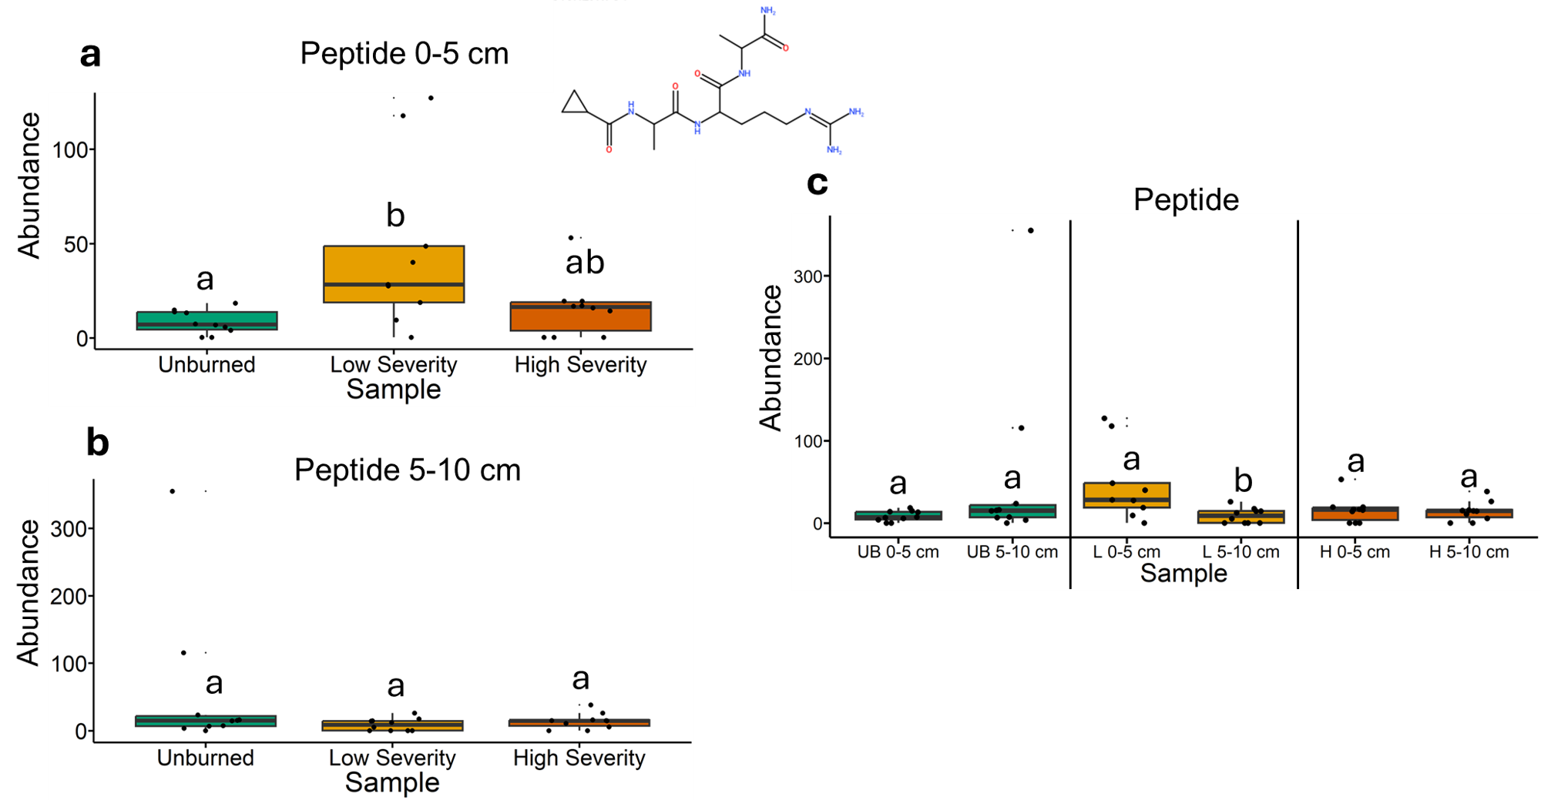
Fig. 31 | Quantification of peptide abundances from liquid chromatography-mass spectrometry analysis. The statistical tests of a, b, and c were conducted independently of each other. a, Quantifying abundances across soils collected at a depth of 0-5 cm. Letters above boxes indicate significant differences (P<0.05) amongst sample types. n=10 for unburned, n=9 for low severity, and n=10 high severity samples. b, Quantifying abundances across soils collected at a depth of 5-10 cm. Letters above boxes indicate significant differences (P<0.05) amongst treatments. n=10 for unburned, low severity, and high severity samples. c, Quantifying abundances and comparing 0-5 cm soil depth with 5-10 cm soil depth. The statistical tests within sample types (i.e. unburned, low severity, and high severity) were conducted independently from each other. In other words, the “a” above “UB 0-5 cm” does not mean that there is no significant difference compared to “L 0-5 cm” which also has an “a” label because those statistical tests were conducted independently of each other. P<0.05 was the cutoff for significant differences. UB = unburned. L = low severity. H = high severity. n=10 for unburned 0-5 cm, unburned 5-10 cm, low severity 5-10 cm, high severity 0-5 cm, and high severity 5-10 cm samples. n=10 for low severity 0-5 cm samples. Box plots show the median (central line), first and third quartiles (box edges), and whiskers extending to minimum and maximum values within 1.5 times the interquartile range. Smaller black dots (not the data points) indicate where the data points would lie if the data points weren’t jittered. The chemical structure was copied from SIRUIS software (Version 6.2.2).

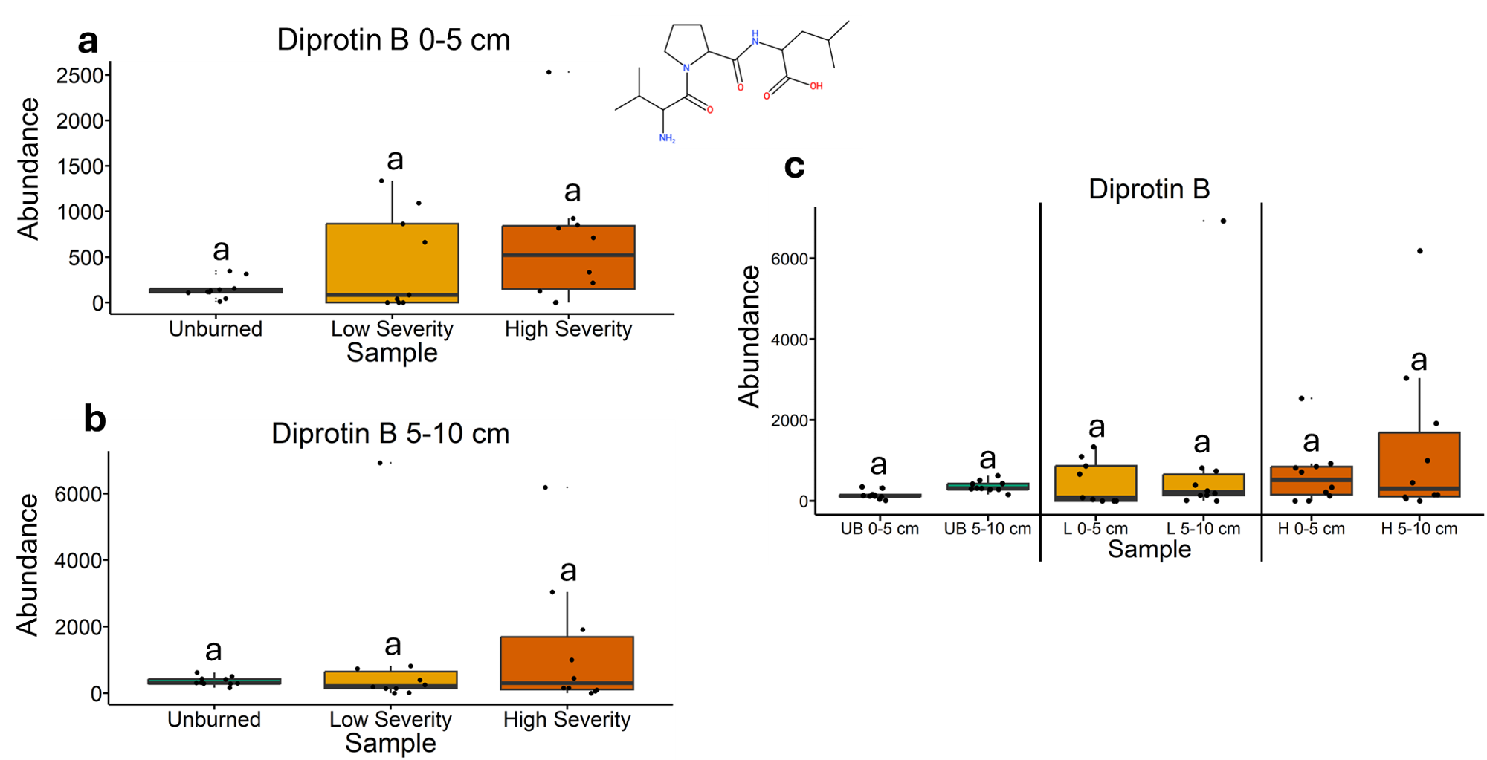
Fig. 32 | Quantification of diprotin B abundances from liquid chromatography-mass spectrometry analysis. The statistical tests of a, b, and c were conducted independently of each other. a, Quantifying abundances across soils collected at a depth of 0-5 cm. Letters above boxes indicate significant differences (P<0.05) amongst sample types. n=10 for unburned, n=9 for low severity, and n=10 high severity samples. b, Quantifying abundances across soils collected at a depth of 5-10 cm. Letters above boxes indicate significant differences (P<0.05) amongst treatments. n=10 for unburned, low severity, and high severity samples. c, Quantifying abundances and comparing 0-5 cm soil depth with 5-10 cm soil depth. The statistical tests within sample types (i.e. unburned, low severity, and high severity) were conducted independently from each other. In other words, the “a” above “UB 0-5 cm” does not mean that there is no significant difference compared to “L 0-5 cm” which also has an “a” label because those statistical tests were conducted independently of each other. P<0.05 was the cutoff for significant differences. UB = unburned. L = low severity. H = high severity. n=10 for unburned 0-5 cm, unburned 5-10 cm, low severity 5-10 cm, high severity 0-5 cm, and high severity 5-10 cm samples. n=10 for low severity 0-5 cm samples. Box plots show the median (central line), first and third quartiles (box edges), and whiskers extending to minimum and maximum values within 1.5 times the interquartile range. Smaller black dots (not the data points) indicate where the data points would lie if the data points weren’t jittered. The chemical structure was copied from SIRUIS software (Version 6.2.2).

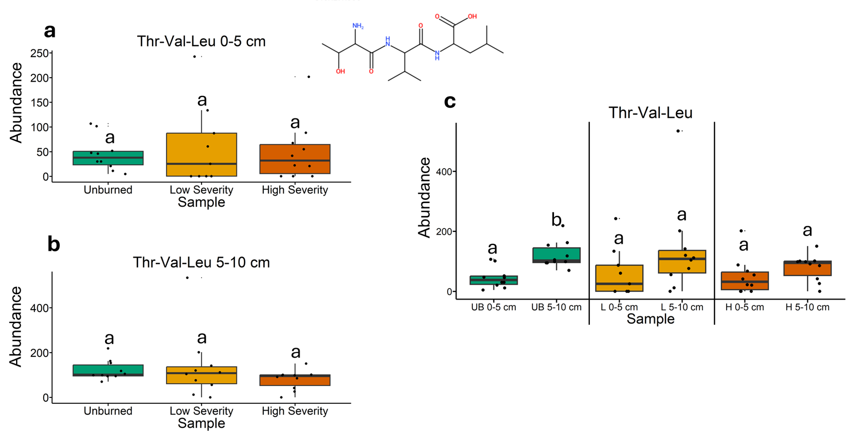
Fig. 33 | Quantification of Thr-Val-Leu abundances from liquid chromatography-mass spectrometry analysis. The statistical tests of a, b, and c were conducted independently of each other. a, Quantifying abundances across soils collected at a depth of 0-5 cm. Letters above boxes indicate significant differences (P<0.05) amongst sample types. n=10 for unburned, n=9 for low severity, and n=10 high severity samples. b, Quantifying abundances across soils collected at a depth of 5-10 cm. Letters above boxes indicate significant differences (P<0.05) amongst treatments. n=10 for unburned, low severity, and high severity samples. c, Quantifying abundances and comparing 0-5 cm soil depth with 5-10 cm soil depth. The statistical tests within sample types (i.e. unburned, low severity, and high severity) were conducted independently from each other. In other words, the “a” above “UB 0-5 cm” does not mean that there is no significant difference compared to “L 0-5 cm” which also has an “a” label because those statistical tests were conducted independently of each other. P<0.05 was the cutoff for significant differences. UB = unburned. L = low severity. H = high severity. n=10 for unburned 0-5 cm, unburned 5-10 cm, low severity 5-10 cm, high severity 0-5 cm, and high severity 5-10 cm samples. n=10 for low severity 0-5 cm samples. Box plots show the median (central line), first and third quartiles (box edges), and whiskers extending to minimum and maximum values within 1.5 times the interquartile range. Smaller black dots (not the data points) indicate where the data points would lie if the data points weren’t jittered. The chemical structure was copied from SIRUIS software (Version 6.2.2).

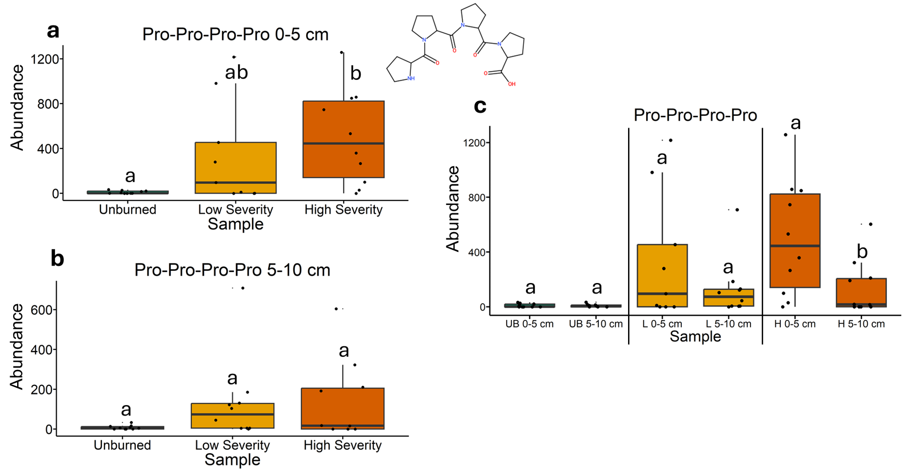
Fig. 34 | Quantification of Pro-Pro-Pro-Pro abundances from liquid chromatography-mass spectrometry analysis. The statistical tests of a, b, and c were conducted independently of each other. a, Quantifying abundances across soils collected at a depth of 0-5 cm. Letters above boxes indicate significant differences (P<0.05) amongst sample types. n=10 for unburned, n=9 for low severity, and n=10 high severity samples. b, Quantifying abundances across soils collected at a depth of 5-10 cm. Letters above boxes indicate significant differences (P<0.05) amongst treatments. n=10 for unburned, low severity, and high severity samples. c, Quantifying abundances and comparing 0-5 cm soil depth with 5-10 cm soil depth. The statistical tests within sample types (i.e. unburned, low severity, and high severity) were conducted independently from each other. In other words, the “a” above “UB 0-5 cm” does not mean that there is no significant difference compared to “L 0-5 cm” which also has an “a” label because those statistical tests were conducted independently of each other. P<0.05 was the cutoff for significant differences. UB = unburned. L = low severity. H = high severity. n=10 for unburned 0-5 cm, unburned 5-10 cm, low severity 5-10 cm, high severity 0-5 cm, and high severity 5-10 cm samples. n=10 for low severity 0-5 cm samples. Box plots show the median (central line), first and third quartiles (box edges), and whiskers extending to minimum and maximum values within 1.5 times the interquartile range. Smaller black dots (not the data points) indicate where the data points would lie if the data points weren’t jittered. The chemical structure was copied from SIRUIS software (Version 6.2.2).

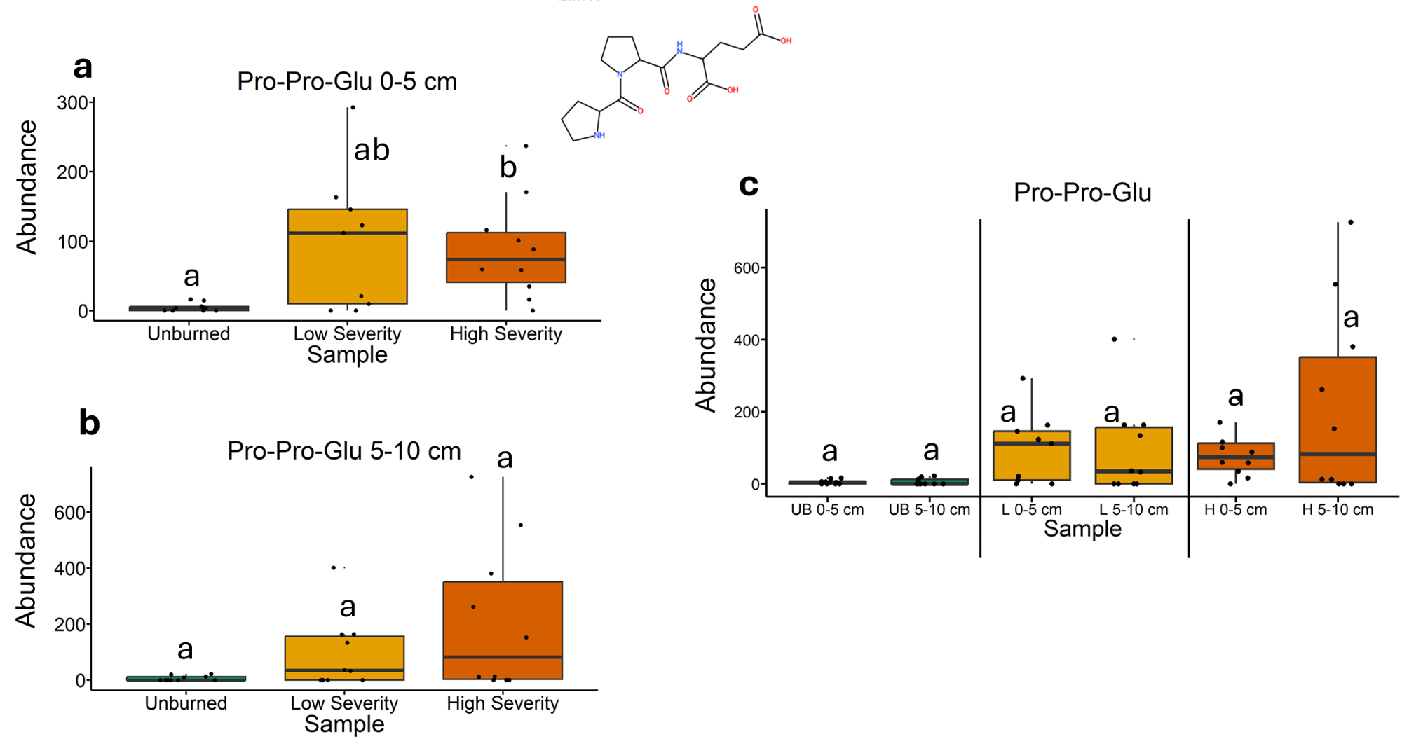
Fig. 35 | Quantification of Pro-Pro-Glu abundances from liquid chromatography-mass spectrometry analysis. The statistical tests of a, b, and c were conducted independently of each other. a, Quantifying abundances across soils collected at a depth of 0-5 cm. Letters above boxes indicate significant differences (P<0.05) amongst sample types. n=10 for unburned, n=9 for low severity, and n=10 high severity samples. b, Quantifying abundances across soils collected at a depth of 5-10 cm. Letters above boxes indicate significant differences (P<0.05) amongst treatments. n=10 for unburned, low severity, and high severity samples. c, Quantifying abundances and comparing 0-5 cm soil depth with 5-10 cm soil depth. The statistical tests within sample types (i.e. unburned, low severity, and high severity) were conducted independently from each other. In other words, the “a” above “UB 0-5 cm” does not mean that there is no significant difference compared to “L 0-5 cm” which also has an “a” label because those statistical tests were conducted independently of each other. P<0.05 was the cutoff for significant differences. UB = unburned. L = low severity. H = high severity. n=10 for unburned 0-5 cm, unburned 5-10 cm, low severity 5-10 cm, high severity 0-5 cm, and high severity 5-10 cm samples. n=10 for low severity 0-5 cm samples. Box plots show the median (central line), first and third quartiles (box edges), and whiskers extending to minimum and maximum values within 1.5 times the interquartile range. Smaller black dots (not the data points) indicate where the data points would lie if the data points weren’t jittered. The chemical structure was copied from SIRUIS software (Version 6.2.2).

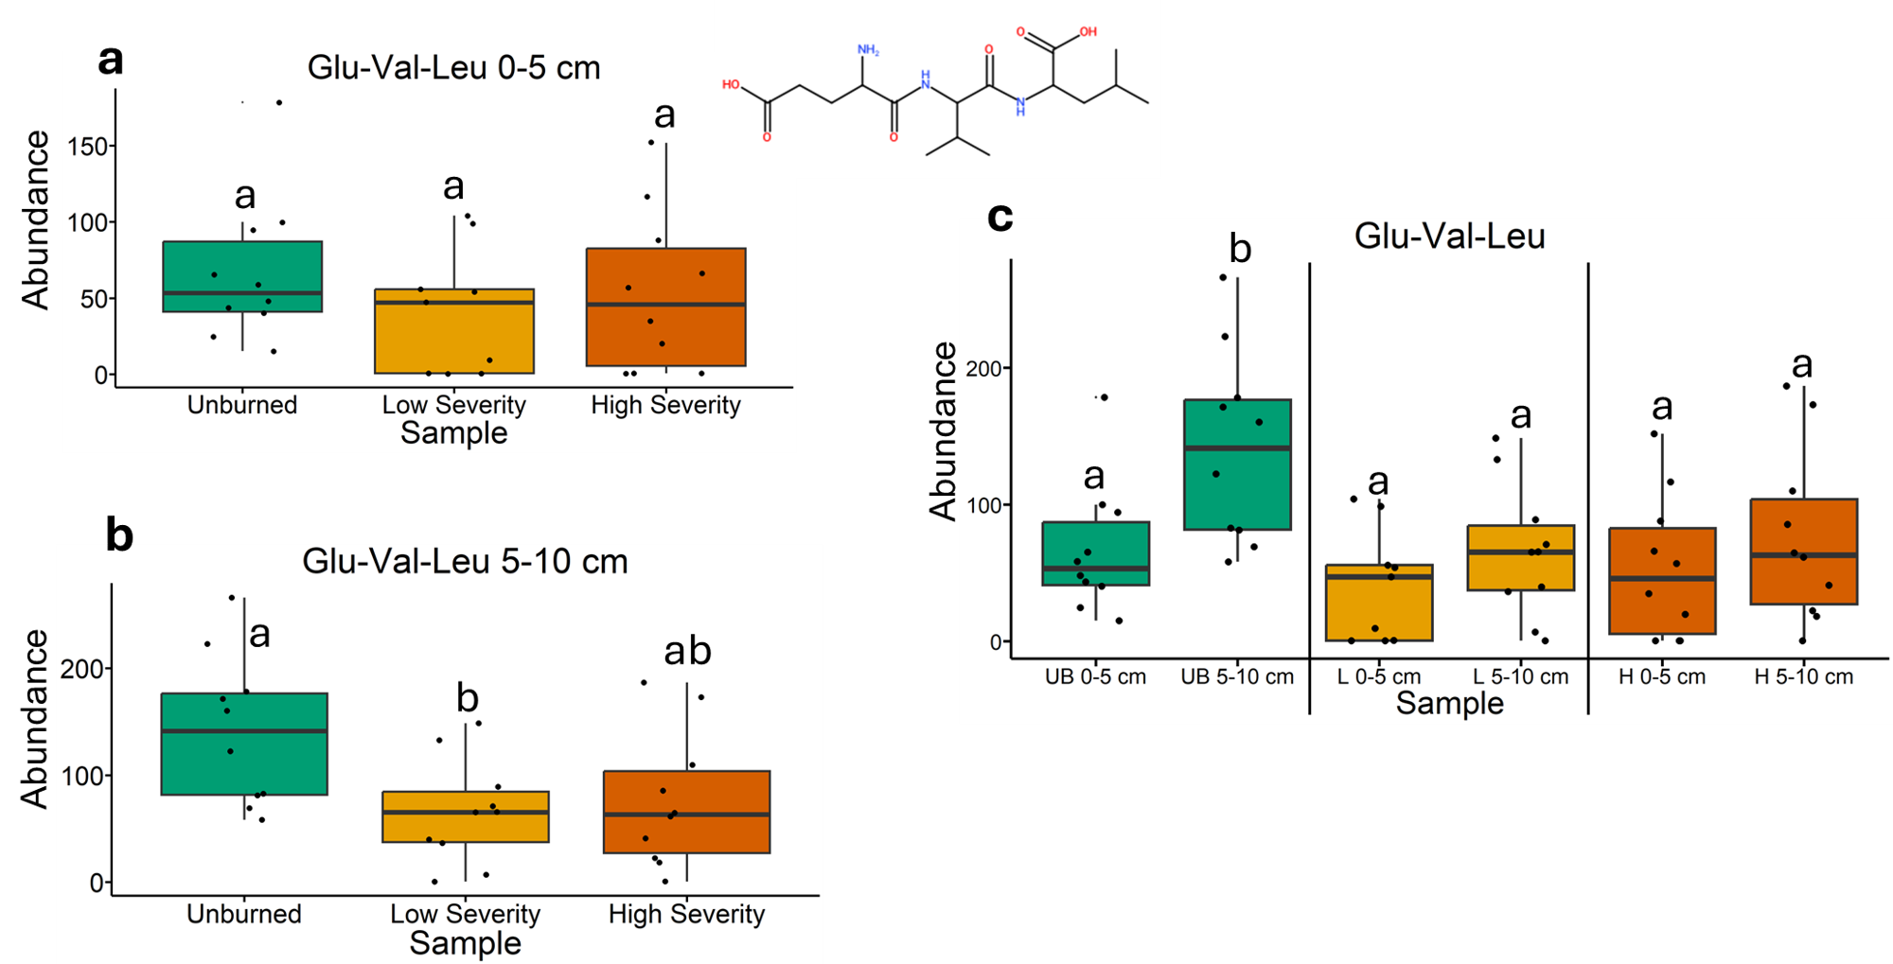
Fig. 36 | Quantification of Glu-Val-Leu abundances from liquid chromatography-mass spectrometry analysis. The statistical tests of a, b, and c were conducted independently of each other. a, Quantifying abundances across soils collected at a depth of 0-5 cm. Letters above boxes indicate significant differences (P<0.05) amongst sample types. n=10 for unburned, n=9 for low severity, and n=10 high severity samples. b, Quantifying abundances across soils collected at a depth of 5-10 cm. Letters above boxes indicate significant differences (P<0.05) amongst treatments. n=10 for unburned, low severity, and high severity samples. c, Quantifying abundances and comparing 0-5 cm soil depth with 5-10 cm soil depth. The statistical tests within sample types (i.e. unburned, low severity, and high severity) were conducted independently from each other. In other words, the “a” above “UB 0-5 cm” does not mean that there is no significant difference compared to “L 0-5 cm” which also has an “a” label because those statistical tests were conducted independently of each other. P<0.05 was the cutoff for significant differences. UB = unburned. L = low severity. H = high severity. n=10 for unburned 0-5 cm, unburned 5-10 cm, low severity 5-10 cm, high severity 0-5 cm, and high severity 5-10 cm samples. n=10 for low severity 0-5 cm samples. Box plots show the median (central line), first and third quartiles (box edges), and whiskers extending to minimum and maximum values within 1.5 times the interquartile range. Smaller black dots (not the data points) indicate where the data points would lie if the data points weren’t jittered. The chemical structure was copied from SIRUIS software (Version 6.2.2).

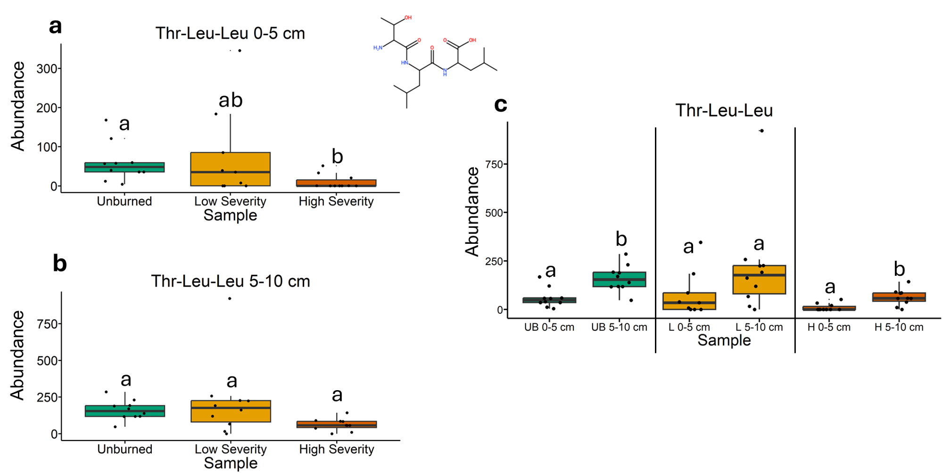
Fig. 37 | Quantification of Thr-Leu-Leu abundances from liquid chromatography-mass spectrometry analysis. The statistical tests of a, b, and c were conducted independently of each other. a, Quantifying abundances across soils collected at a depth of 0-5 cm. Letters above boxes indicate significant differences (P<0.05) amongst sample types. n=10 for unburned, n=9 for low severity, and n=10 high severity samples. b, Quantifying abundances across soils collected at a depth of 5-10 cm. Letters above boxes indicate significant differences (P<0.05) amongst treatments. n=10 for unburned, low severity, and high severity samples. c, Quantifying abundances and comparing 0-5 cm soil depth with 5-10 cm soil depth. The statistical tests within sample types (i.e. unburned, low severity, and high severity) were conducted independently from each other. In other words, the “a” above “UB 0-5 cm” does not mean that there is no significant difference compared to “L 0-5 cm” which also has an “a” label because those statistical tests were conducted independently of each other. P<0.05 was the cutoff for significant differences. UB = unburned. L = low severity. H = high severity. n=10 for unburned 0-5 cm, unburned 5-10 cm, low severity 5-10 cm, high severity 0-5 cm, and high severity 5-10 cm samples. n=10 for low severity 0-5 cm samples. Box plots show the median (central line), first and third quartiles (box edges), and whiskers extending to minimum and maximum values within 1.5 times the interquartile range. Smaller black dots (not the data points) indicate where the data points would lie if the data points weren’t jittered. The chemical structure was copied from SIRUIS software (Version 6.2.2).

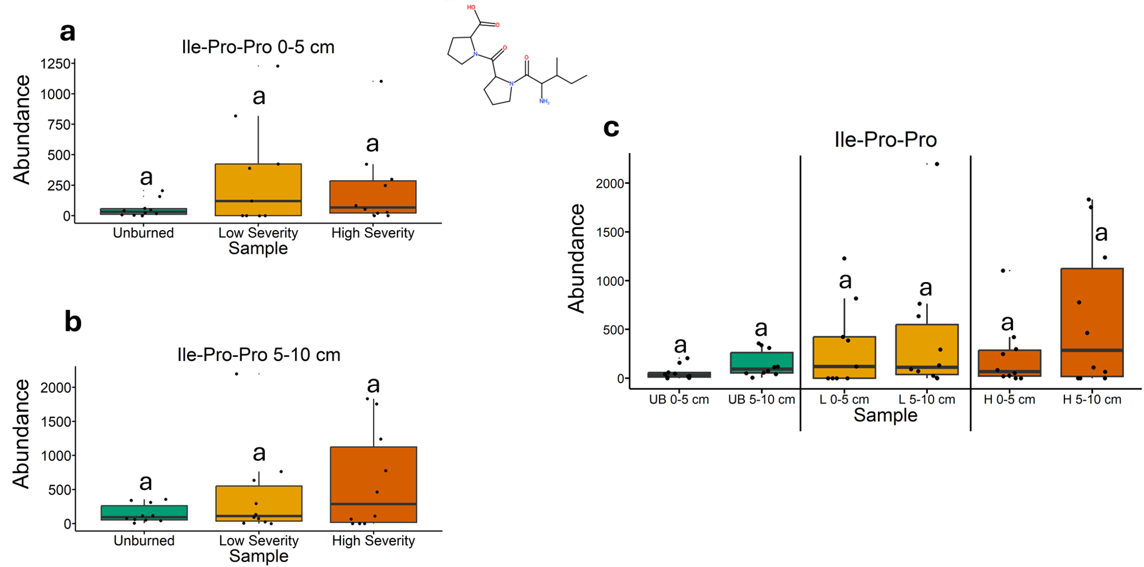
Fig. 38 | Quantification of Ile-Pro-Pro abundances from liquid chromatography-mass spectrometry analysis. The statistical tests of a, b, and c were conducted independently of each other. a, Quantifying abundances across soils collected at a depth of 0-5 cm. Letters above boxes indicate significant differences (P<0.05) amongst sample types. n=10 for unburned, n=9 for low severity, and n=10 high severity samples. b, Quantifying abundances across soils collected at a depth of 5-10 cm. Letters above boxes indicate significant differences (P<0.05) amongst treatments. n=10 for unburned, low severity, and high severity samples. c, Quantifying abundances and comparing 0-5 cm soil depth with 5-10 cm soil depth. The statistical tests within sample types (i.e. unburned, low severity, and high severity) were conducted independently from each other. In other words, the “a” above “UB 0-5 cm” does not mean that there is no significant difference compared to “L 0-5 cm” which also has an “a” label because those statistical tests were conducted independently of each other. P<0.05 was the cutoff for significant differences. UB = unburned. L = low severity. H = high severity. n=10 for unburned 0-5 cm, unburned 5-10 cm, low severity 5-10 cm, high severity 0-5 cm, and high severity 5-10 cm samples. n=10 for low severity 0-5 cm samples. Box plots show the median (central line), first and third quartiles (box edges), and whiskers extending to minimum and maximum values within 1.5 times the interquartile range. Smaller black dots (not the data points) indicate where the data points would lie if the data points weren’t jittered. The chemical structure was copied from SIRUIS software (Version 6.2.2).

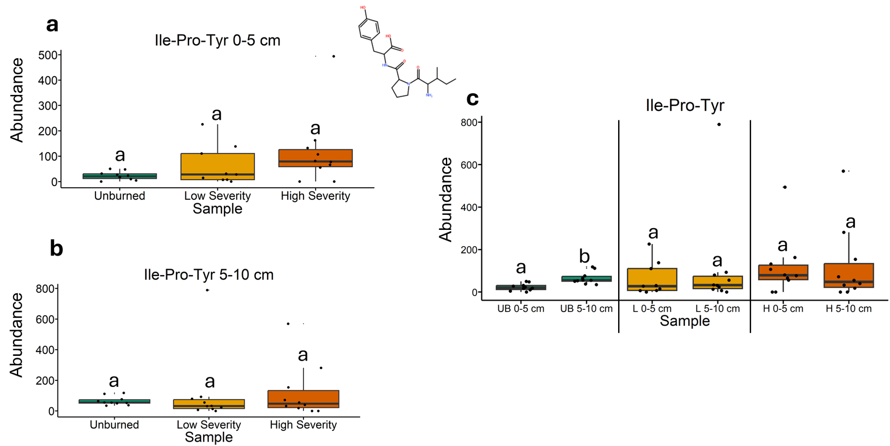
Fig. 39 | Quantification of Ile-Pro-Tyr abundances from liquid chromatography-mass spectrometry analysis. The statistical tests of a, b, and c were conducted independently of each other. a, Quantifying abundances across soils collected at a depth of 0-5 cm. Letters above boxes indicate significant differences (P<0.05) amongst sample types. n=10 for unburned, n=9 for low severity, and n=10 high severity samples. b, Quantifying abundances across soils collected at a depth of 5-10 cm. Letters above boxes indicate significant differences (P<0.05) amongst treatments. n=10 for unburned, low severity, and high severity samples. c, Quantifying abundances and comparing 0-5 cm soil depth with 5-10 cm soil depth. The statistical tests within sample types (i.e. unburned, low severity, and high severity) were conducted independently from each other. In other words, the “a” above “UB 0-5 cm” does not mean that there is no significant difference compared to “L 0-5 cm” which also has an “a” label because those statistical tests were conducted independently of each other. P<0.05 was the cutoff for significant differences. UB = unburned. L = low severity. H = high severity. n=10 for unburned 0-5 cm, unburned 5-10 cm, low severity 5-10 cm, high severity 0-5 cm, and high severity 5-10 cm samples. n=10 for low severity 0-5 cm samples. Box plots show the median (central line), first and third quartiles (box edges), and whiskers extending to minimum and maximum values within 1.5 times the interquartile range. Smaller black dots (not the data points) indicate where the data points would lie if the data points weren’t jittered. The chemical structure was copied from SIRUIS software (Version 6.2.2).

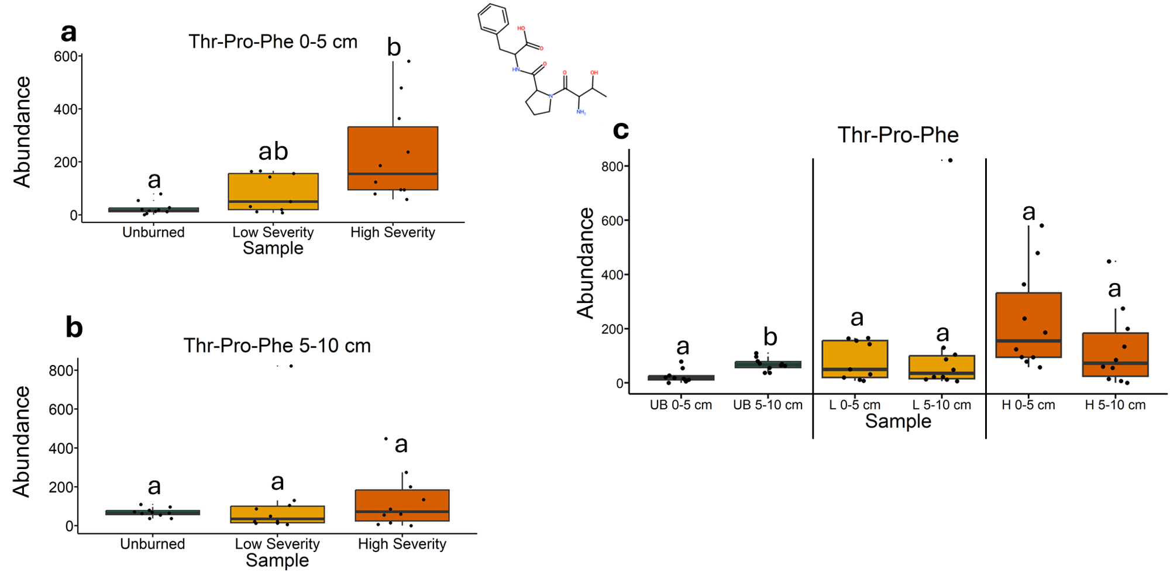
Fig. 40 | Quantification of Thr-Pro-Phe abundances from liquid chromatography-mass spectrometry analysis. The statistical tests of a, b, and c were conducted independently of each other. a, Quantifying abundances across soils collected at a depth of 0-5 cm. Letters above boxes indicate significant differences (P<0.05) amongst sample types. n=10 for unburned, n=9 for low severity, and n=10 high severity samples. b, Quantifying abundances across soils collected at a depth of 5-10 cm. Letters above boxes indicate significant differences (P<0.05) amongst treatments. n=10 for unburned, low severity, and high severity samples. c, Quantifying abundances and comparing 0-5 cm soil depth with 5-10 cm soil depth. The statistical tests within sample types (i.e. unburned, low severity, and high severity) were conducted independently from each other. In other words, the “a” above “UB 0-5 cm” does not mean that there is no significant difference compared to “L 0-5 cm” which also has an “a” label because those statistical tests were conducted independently of each other. P<0.05 was the cutoff for significant differences. UB = unburned. L = low severity. H = high severity. n=10 for unburned 0-5 cm, unburned 5-10 cm, low severity 5-10 cm, high severity 0-5 cm, and high severity 5-10 cm samples. n=10 for low severity 0-5 cm samples. Box plots show the median (central line), first and third quartiles (box edges), and whiskers extending to minimum and maximum values within 1.5 times the interquartile range. Smaller black dots (not the data points) indicate where the data points would lie if the data points weren’t jittered. The chemical structure was copied from SIRUIS software (Version 6.2.2).

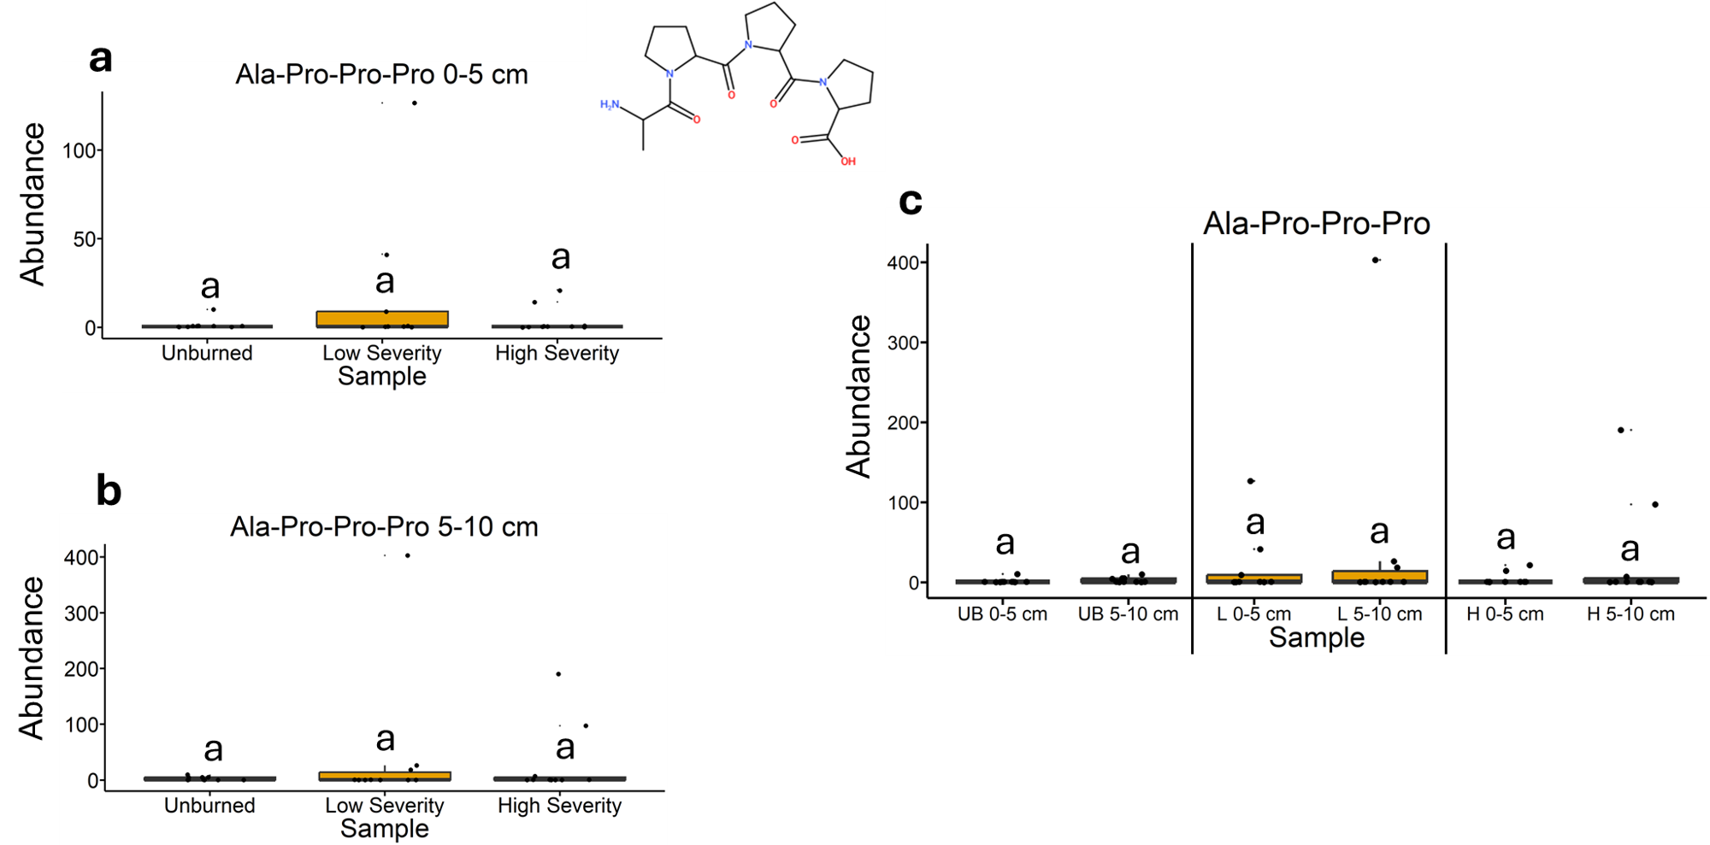
Fig. 41 | Quantification of Ala-Pro-Pro-Pro abundances from liquid chromatography-mass spectrometry analysis. The statistical tests of a, b, and c were conducted independently of each other. a, Quantifying abundances across soils collected at a depth of 0-5 cm. Letters above boxes indicate significant differences (P<0.05) amongst sample types. n=10 for unburned, n=9 for low severity, and n=10 high severity samples. b, Quantifying abundances across soils collected at a depth of 5-10 cm. Letters above boxes indicate significant differences (P<0.05) amongst treatments. n=10 for unburned, low severity, and high severity samples. c, Quantifying abundances and comparing 0-5 cm soil depth with 5-10 cm soil depth. The statistical tests within sample types (i.e. unburned, low severity, and high severity) were conducted independently from each other. In other words, the “a” above “UB 0-5 cm” does not mean that there is no significant difference compared to “L 0-5 cm” which also has an “a” label because those statistical tests were conducted independently of each other. P<0.05 was the cutoff for significant differences. UB = unburned. L = low severity. H = high severity. n=10 for unburned 0-5 cm, unburned 5-10 cm, low severity 5-10 cm, high severity 0-5 cm, and high severity 5-10 cm samples. n=10 for low severity 0-5 cm samples. Box plots show the median (central line), first and third quartiles (box edges), and whiskers extending to minimum and maximum values within 1.5 times the interquartile range. Smaller black dots (not the data points) indicate where the data points would lie if the data points weren’t jittered. The chemical structure was copied from SIRUIS software (Version 6.2.2).

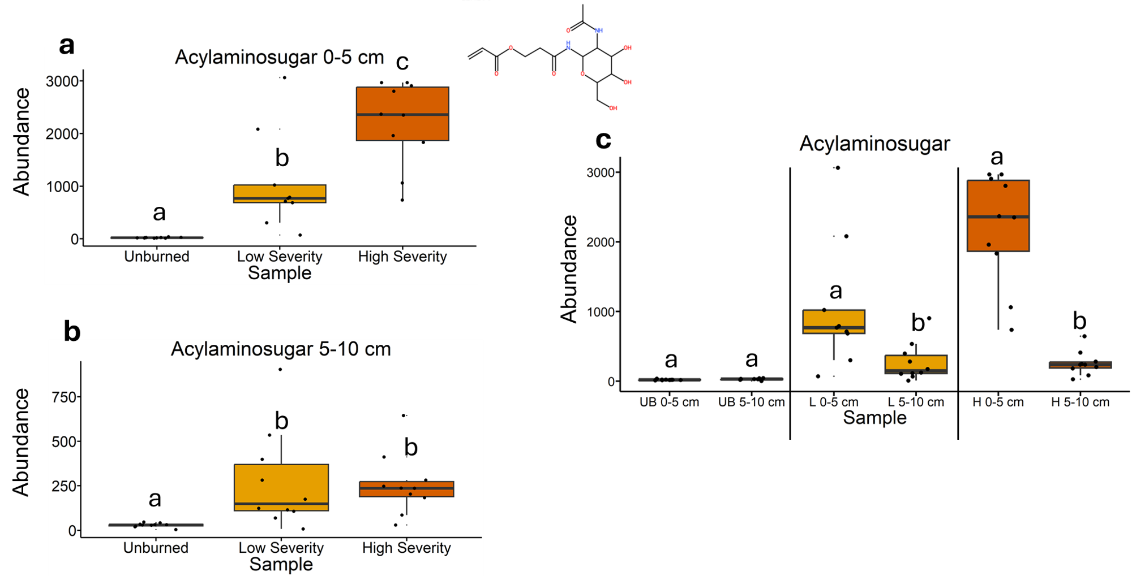
Fig. 42 | Quantification of acylaminosugar abundances from liquid chromatography-mass spectrometry analysis. The statistical tests of a, b, and c were conducted independently of each other. a, Quantifying abundances across soils collected at a depth of 0-5 cm. Letters above boxes indicate significant differences (P<0.05) amongst sample types. n=10 for unburned, n=9 for low severity, and n=10 high severity samples. b, Quantifying abundances across soils collected at a depth of 5-10 cm. Letters above boxes indicate significant differences (P<0.05) amongst treatments. n=10 for unburned, low severity, and high severity samples. c, Quantifying abundances and comparing 0-5 cm soil depth with 5-10 cm soil depth. The statistical tests within sample types (i.e. unburned, low severity, and high severity) were conducted independently from each other. In other words, the “a” above “UB 0-5 cm” does not mean that there is no significant difference compared to “L 0-5 cm” which also has an “a” label because those statistical tests were conducted independently of each other. P<0.05 was the cutoff for significant differences. UB = unburned. L = low severity. H = high severity. n=10 for unburned 0-5 cm, unburned 5-10 cm, low severity 5-10 cm, high severity 0-5 cm, and high severity 5-10 cm samples. n=10 for low severity 0-5 cm samples. Box plots show the median (central line), first and third quartiles (box edges), and whiskers extending to minimum and maximum values within 1.5 times the interquartile range. Smaller black dots (not the data points) indicate where the data points would lie if the data points weren’t jittered. The chemical structure was copied from SIRUIS software (Version 6.2.2).

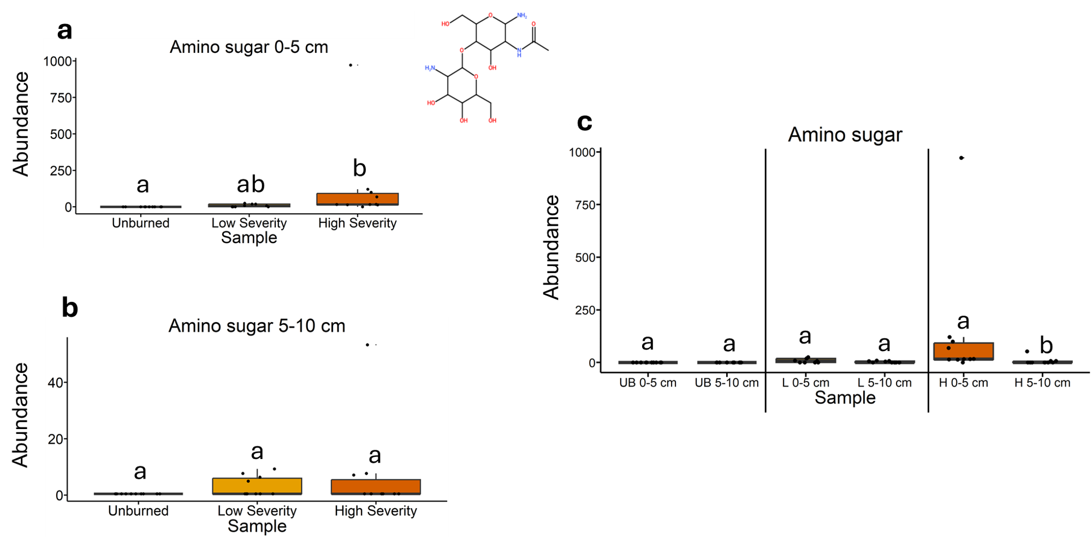
Fig. 43 | Quantification of amino sugar abundances from liquid chromatography-mass spectrometry analysis. The statistical tests of a, b, and c were conducted independently of each other. a, Quantifying abundances across soils collected at a depth of 0-5 cm. Letters above boxes indicate significant differences (P<0.05) amongst sample types. n=10 for unburned, n=9 for low severity, and n=10 high severity samples. b, Quantifying abundances across soils collected at a depth of 5-10 cm. Letters above boxes indicate significant differences (P<0.05) amongst treatments. n=10 for unburned, low severity, and high severity samples. c, Quantifying abundances and comparing 0-5 cm soil depth with 5-10 cm soil depth. The statistical tests within sample types (i.e. unburned, low severity, and high severity) were conducted independently from each other. In other words, the “a” above “UB 0-5 cm” does not mean that there is no significant difference compared to “L 0-5 cm” which also has an “a” label because those statistical tests were conducted independently of each other. P<0.05 was the cutoff for significant differences. UB = unburned. L = low severity. H = high severity. n=10 for unburned 0-5 cm, unburned 5-10 cm, low severity 5-10 cm, high severity 0-5 cm, and high severity 5-10 cm samples. n=10 for low severity 0-5 cm samples. Box plots show the median (central line), first and third quartiles (box edges), and whiskers extending to minimum and maximum values within 1.5 times the interquartile range. Smaller black dots (not the data points) indicate where the data points would lie if the data points weren’t jittered. The chemical structure was copied from SIRUIS software (Version 6.2.2).

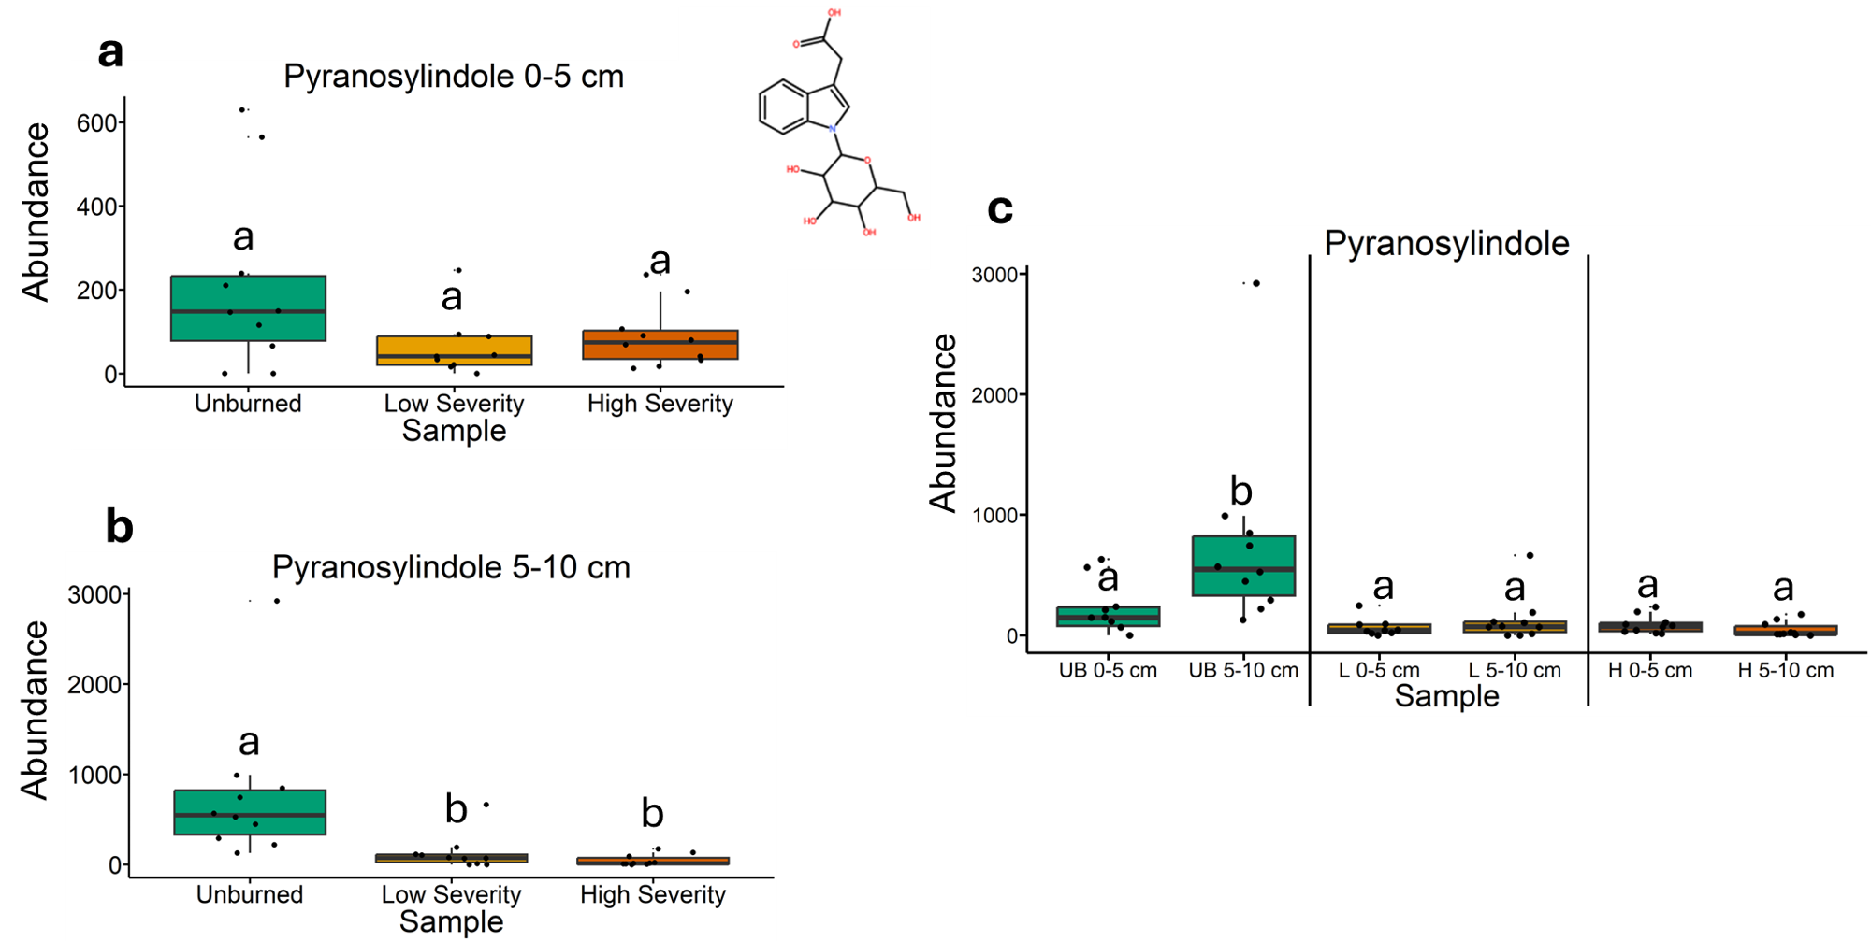
Fig. 44 | Quantification of pyranosylindole abundances from liquid chromatography-mass spectrometry analysis. The statistical tests of a, b, and c were conducted independently of each other. a, Quantifying abundances across soils collected at a depth of 0-5 cm. Letters above boxes indicate significant differences (P<0.05) amongst sample types. n=10 for unburned, n=9 for low severity, and n=10 high severity samples. b, Quantifying abundances across soils collected at a depth of 5-10 cm. Letters above boxes indicate significant differences (P<0.05) amongst treatments. n=10 for unburned, low severity, and high severity samples. c, Quantifying abundances and comparing 0-5 cm soil depth with 5-10 cm soil depth. The statistical tests within sample types (i.e. unburned, low severity, and high severity) were conducted independently from each other. In other words, the “a” above “UB 0-5 cm” does not mean that there is no significant difference compared to “L 0-5 cm” which also has an “a” label because those statistical tests were conducted independently of each other. P<0.05 was the cutoff for significant differences. UB = unburned. L = low severity. H = high severity. n=10 for unburned 0-5 cm, unburned 5-10 cm, low severity 5-10 cm, high severity 0-5 cm, and high severity 5-10 cm samples. n=10 for low severity 0-5 cm samples. Box plots show the median (central line), first and third quartiles (box edges), and whiskers extending to minimum and maximum values within 1.5 times the interquartile range. Smaller black dots (not the data points) indicate where the data points would lie if the data points weren’t jittered. The chemical structure was copied from SIRUIS software (Version 6.2.2).

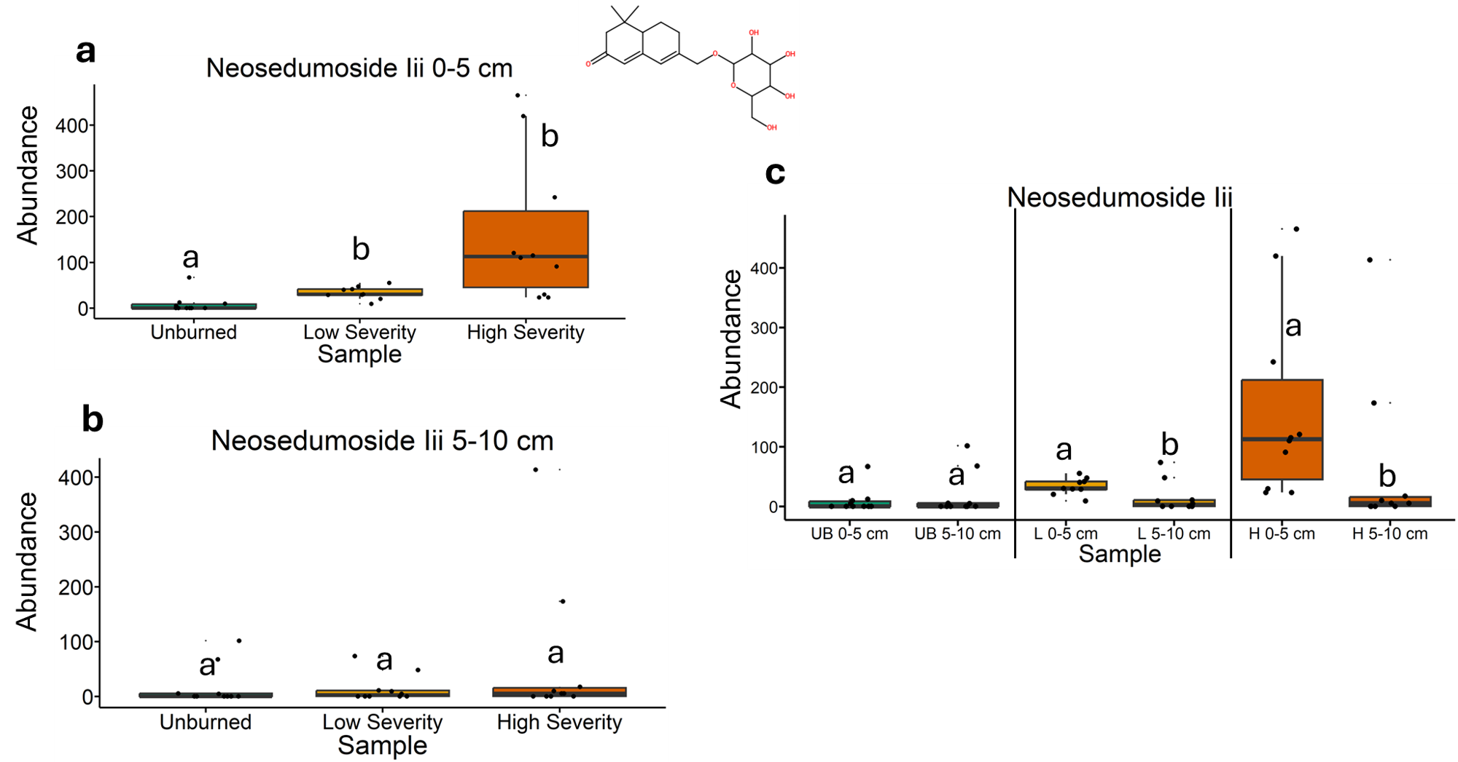
Fig. 45 | Quantification of neosedumoside Iii abundances from liquid chromatography-mass spectrometry analysis. The statistical tests of a, b, and c were conducted independently of each other. a, Quantifying abundances across soils collected at a depth of 0-5 cm. Letters above boxes indicate significant differences (P<0.05) amongst sample types. n=10 for unburned, n=9 for low severity, and n=10 high severity samples. b, Quantifying abundances across soils collected at a depth of 5-10 cm. Letters above boxes indicate significant differences (P<0.05) amongst treatments. n=10 for unburned, low severity, and high severity samples. c, Quantifying abundances and comparing 0-5 cm soil depth with 5-10 cm soil depth. The statistical tests within sample types (i.e. unburned, low severity, and high severity) were conducted independently from each other. In other words, the “a” above “UB 0-5 cm” does not mean that there is no significant difference compared to “L 0-5 cm” which also has an “a” label because those statistical tests were conducted independently of each other. P<0.05 was the cutoff for significant differences. UB = unburned. L = low severity. H = high severity. n=10 for unburned 0-5 cm, unburned 5-10 cm, low severity 5-10 cm, high severity 0-5 cm, and high severity 5-10 cm samples. n=10 for low severity 0-5 cm samples. Box plots show the median (central line), first and third quartiles (box edges), and whiskers extending to minimum and maximum values within 1.5 times the interquartile range. Smaller black dots (not the data points) indicate where the data points would lie if the data points weren’t jittered. The chemical structure was copied from SIRUIS software (Version 6.2.2).

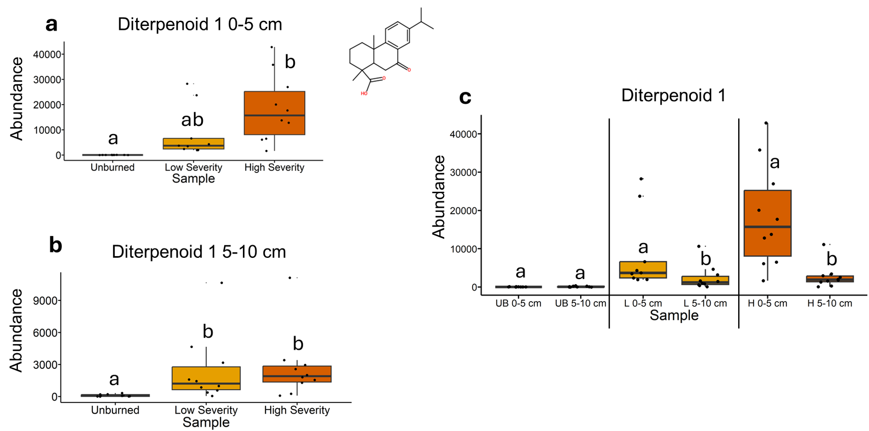
Fig. 46 | Quantification of diterpenoid 1 abundances from liquid chromatography-mass spectrometry analysis. The statistical tests of a, b, and c were conducted independently of each other. a, Quantifying abundances across soils collected at a depth of 0-5 cm. Letters above boxes indicate significant differences (P<0.05) amongst sample types. n=10 for unburned, n=9 for low severity, and n=10 high severity samples. b, Quantifying abundances across soils collected at a depth of 5-10 cm. Letters above boxes indicate significant differences (P<0.05) amongst treatments. n=10 for unburned, low severity, and high severity samples. c, Quantifying abundances and comparing 0-5 cm soil depth with 5-10 cm soil depth. The statistical tests within sample types (i.e. unburned, low severity, and high severity) were conducted independently from each other. In other words, the “a” above “UB 0-5 cm” does not mean that there is no significant difference compared to “L 0-5 cm” which also has an “a” label because those statistical tests were conducted independently of each other. P<0.05 was the cutoff for significant differences. UB = unburned. L = low severity. H = high severity. n=10 for unburned 0-5 cm, unburned 5-10 cm, low severity 5-10 cm, high severity 0-5 cm, and high severity 5-10 cm samples. n=10 for low severity 0-5 cm samples. Box plots show the median (central line), first and third quartiles (box edges), and whiskers extending to minimum and maximum values within 1.5 times the interquartile range. Smaller black dots (not the data points) indicate where the data points would lie if the data points weren’t jittered. The chemical structure was copied from SIRUIS software (Version 6.2.2).

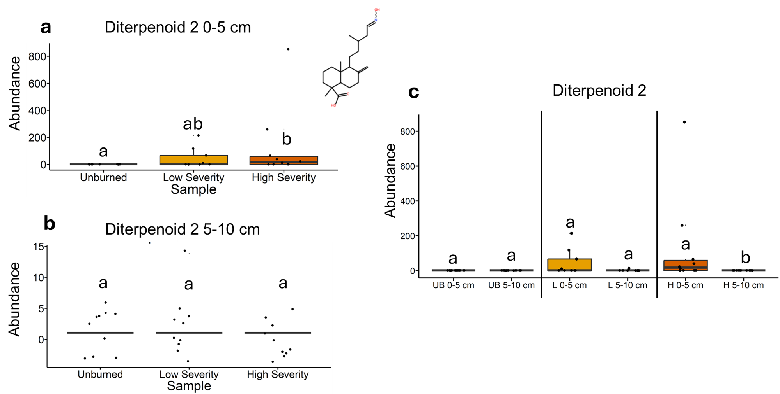
Fig. 47 | Quantification of diterpenoid 2 abundances from liquid chromatography-mass spectrometry analysis. The statistical tests of a, b, and c were conducted independently of each other. a, Quantifying abundances across soils collected at a depth of 0-5 cm. Letters above boxes indicate significant differences (P<0.05) amongst sample types. n=10 for unburned, n=9 for low severity, and n=10 high severity samples. b, Quantifying abundances across soils collected at a depth of 5-10 cm. Letters above boxes indicate significant differences (P<0.05) amongst treatments. n=10 for unburned, low severity, and high severity samples. c, Quantifying abundances and comparing 0-5 cm soil depth with 5-10 cm soil depth. The statistical tests within sample types (i.e. unburned, low severity, and high severity) were conducted independently from each other. In other words, the “a” above “UB 0-5 cm” does not mean that there is no significant difference compared to “L 0-5 cm” which also has an “a” label because those statistical tests were conducted independently of each other. P<0.05 was the cutoff for significant differences. UB = unburned. L = low severity. H = high severity. n=10 for unburned 0-5 cm, unburned 5-10 cm, low severity 5-10 cm, high severity 0-5 cm, and high severity 5-10 cm samples. n=10 for low severity 0-5 cm samples. Box plots show the median (central line), first and third quartiles (box edges), and whiskers extending to minimum and maximum values within 1.5 times the interquartile range. Smaller black dots (not the data points) indicate where the data points would lie if the data points weren’t jittered. The chemical structure was copied from SIRUIS software (Version 6.2.2).

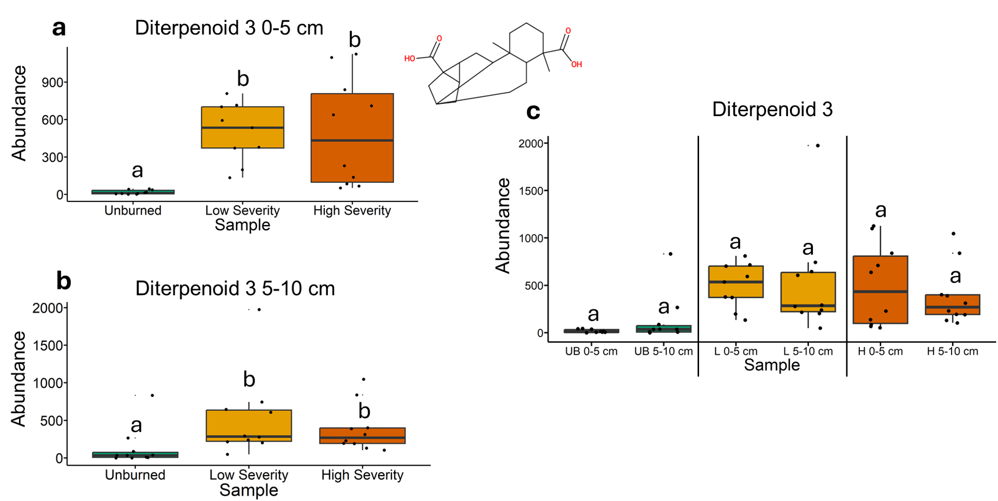
Fig. 48 | Quantification of diterpenoid 3 abundances from liquid chromatography-mass spectrometry analysis. The statistical tests of a, b, and c were conducted independently of each other. a, Quantifying abundances across soils collected at a depth of 0-5 cm. Letters above boxes indicate significant differences (P<0.05) amongst sample types. n=10 for unburned, n=9 for low severity, and n=10 high severity samples. b, Quantifying abundances across soils collected at a depth of 5-10 cm. Letters above boxes indicate significant differences (P<0.05) amongst treatments. n=10 for unburned, low severity, and high severity samples. c, Quantifying abundances and comparing 0-5 cm soil depth with 5-10 cm soil depth. The statistical tests within sample types (i.e. unburned, low severity, and high severity) were conducted independently from each other. In other words, the “a” above “UB 0-5 cm” does not mean that there is no significant difference compared to “L 0-5 cm” which also has an “a” label because those statistical tests were conducted independently of each other. P<0.05 was the cutoff for significant differences. UB = unburned. L = low severity. H = high severity. n=10 for unburned 0-5 cm, unburned 5-10 cm, low severity 5-10 cm, high severity 0-5 cm, and high severity 5-10 cm samples. n=10 for low severity 0-5 cm samples. Box plots show the median (central line), first and third quartiles (box edges), and whiskers extending to minimum and maximum values within 1.5 times the interquartile range. Smaller black dots (not the data points) indicate where the data points would lie if the data points weren’t jittered. The chemical structure was copied from SIRUIS software (Version 6.2.2).

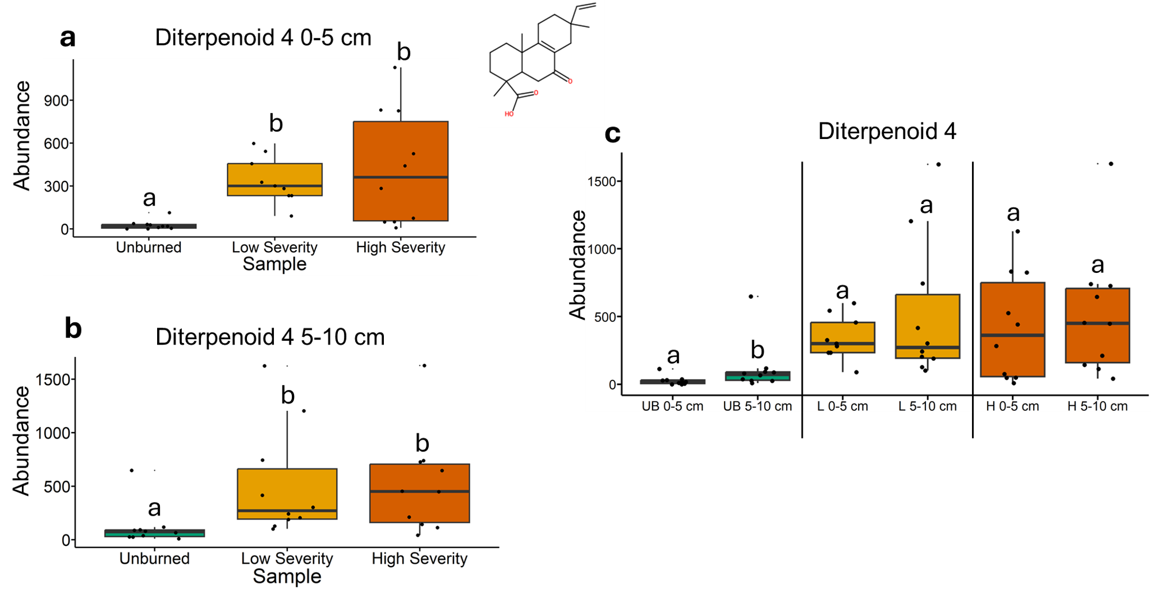
Fig. 49 | Quantification of diterpenoid 4 abundances from liquid chromatography-mass spectrometry analysis. The statistical tests of a, b, and c were conducted independently of each other. a, Quantifying abundances across soils collected at a depth of 0-5 cm. Letters above boxes indicate significant differences (P<0.05) amongst sample types. n=10 for unburned, n=9 for low severity, and n=10 high severity samples. b, Quantifying abundances across soils collected at a depth of 5-10 cm. Letters above boxes indicate significant differences (P<0.05) amongst treatments. n=10 for unburned, low severity, and high severity samples. c, Quantifying abundances and comparing 0-5 cm soil depth with 5-10 cm soil depth. The statistical tests within sample types (i.e. unburned, low severity, and high severity) were conducted independently from each other. In other words, the “a” above “UB 0-5 cm” does not mean that there is no significant difference compared to “L 0-5 cm” which also has an “a” label because those statistical tests were conducted independently of each other. P<0.05 was the cutoff for significant differences. UB = unburned. L = low severity. H = high severity. n=10 for unburned 0-5 cm, unburned 5-10 cm, low severity 5-10 cm, high severity 0-5 cm, and high severity 5-10 cm samples. n=10 for low severity 0-5 cm samples. Box plots show the median (central line), first and third quartiles (box edges), and whiskers extending to minimum and maximum values within 1.5 times the interquartile range. Smaller black dots (not the data points) indicate where the data points would lie if the data points weren’t jittered. The chemical structure was copied from SIRUIS software (Version 6.2.2).

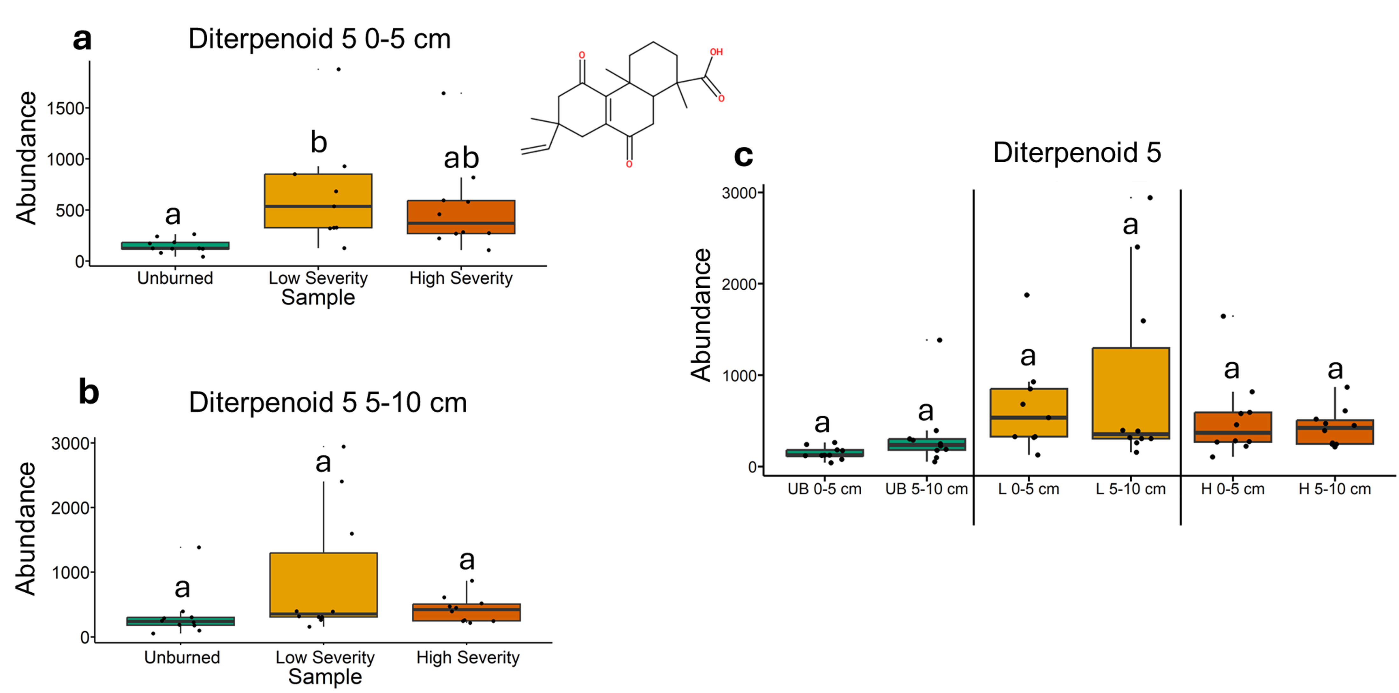
Fig. 50 | Quantification of diterpenoid 5 abundances from liquid chromatography-mass spectrometry analysis. The statistical tests of a, b, and c were conducted independently of each other. a, Quantifying abundances across soils collected at a depth of 0-5 cm. Letters above boxes indicate significant differences (P<0.05) amongst sample types. n=10 for unburned, n=9 for low severity, and n=10 high severity samples. b, Quantifying abundances across soils collected at a depth of 5-10 cm. Letters above boxes indicate significant differences (P<0.05) amongst treatments. n=10 for unburned, low severity, and high severity samples. c, Quantifying abundances and comparing 0-5 cm soil depth with 5-10 cm soil depth. The statistical tests within sample types (i.e. unburned, low severity, and high severity) were conducted independently from each other. In other words, the “a” above “UB 0-5 cm” does not mean that there is no significant difference compared to “L 0-5 cm” which also has an “a” label because those statistical tests were conducted independently of each other. P<0.05 was the cutoff for significant differences. UB = unburned. L = low severity. H = high severity. n=10 for unburned 0-5 cm, unburned 5-10 cm, low severity 5-10 cm, high severity 0-5 cm, and high severity 5-10 cm samples. n=10 for low severity 0-5 cm samples. Box plots show the median (central line), first and third quartiles (box edges), and whiskers extending to minimum and maximum values within 1.5 times the interquartile range. Smaller black dots (not the data points) indicate where the data points would lie if the data points weren’t jittered. The chemical structure was copied from SIRUIS software (Version 6.2.2).

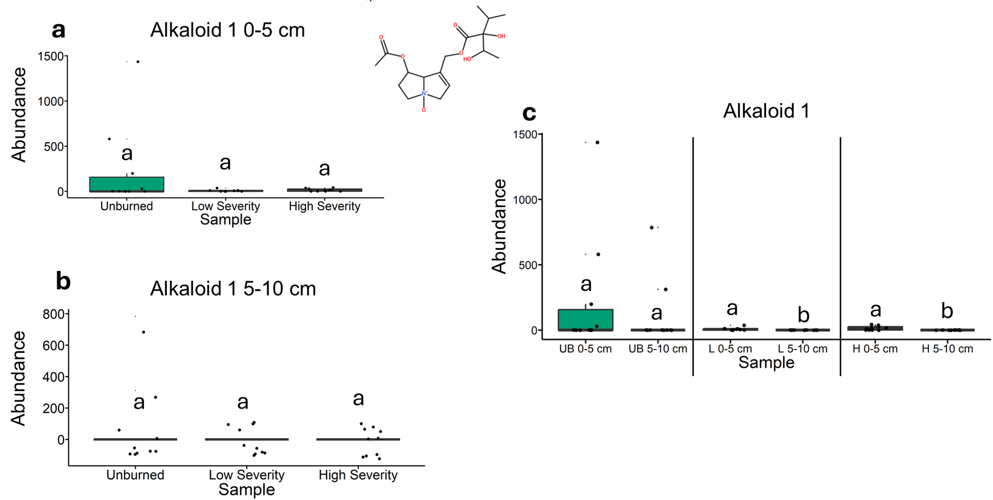
Fig. 51 | Quantification of alkaloid 1 abundances from liquid chromatography-mass spectrometry analysis. The statistical tests of a, b, and c were conducted independently of each other. a, Quantifying abundances across soils collected at a depth of 0-5 cm. Letters above boxes indicate significant differences (P<0.05) amongst sample types. n=10 for unburned, n=9 for low severity, and n=10 high severity samples. b, Quantifying abundances across soils collected at a depth of 5-10 cm. Letters above boxes indicate significant differences (P<0.05) amongst treatments. n=10 for unburned, low severity, and high severity samples. c, Quantifying abundances and comparing 0-5 cm soil depth with 5-10 cm soil depth. The statistical tests within sample types (i.e. unburned, low severity, and high severity) were conducted independently from each other. In other words, the “a” above “UB 0-5 cm” does not mean that there is no significant difference compared to “L 0-5 cm” which also has an “a” label because those statistical tests were conducted independently of each other. P<0.05 was the cutoff for significant differences. UB = unburned. L = low severity. H = high severity. n=10 for unburned 0-5 cm, unburned 5-10 cm, low severity 5-10 cm, high severity 0-5 cm, and high severity 5-10 cm samples. n=10 for low severity 0-5 cm samples. Box plots show the median (central line), first and third quartiles (box edges), and whiskers extending to minimum and maximum values within 1.5 times the interquartile range. Smaller black dots (not the data points) indicate where the data points would lie if the data points weren’t jittered. The chemical structure was copied from SIRUIS software (Version 6.2.2).

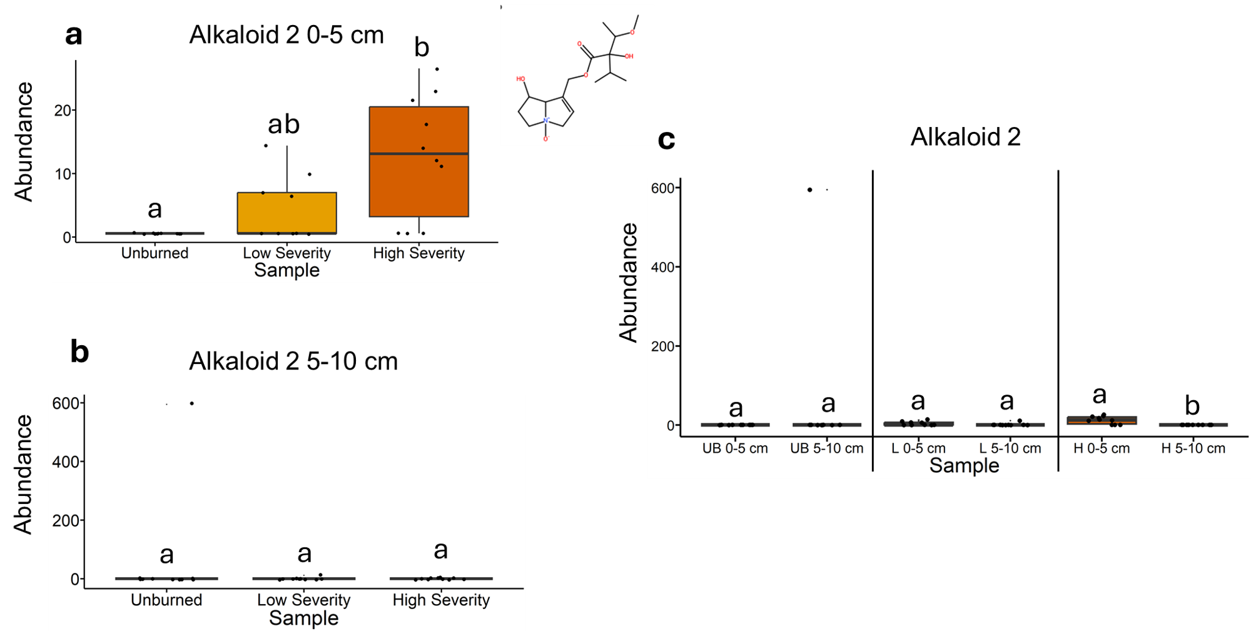
Fig. 52 | Quantification of alkaloid 2 abundances from liquid chromatography-mass spectrometry analysis. The statistical tests of a, b, and c were conducted independently of each other. a, Quantifying abundances across soils collected at a depth of 0-5 cm. Letters above boxes indicate significant differences (P<0.05) amongst sample types. n=10 for unburned, n=9 for low severity, and n=10 high severity samples. b, Quantifying abundances across soils collected at a depth of 5-10 cm. Letters above boxes indicate significant differences (P<0.05) amongst treatments. n=10 for unburned, low severity, and high severity samples. c, Quantifying abundances and comparing 0-5 cm soil depth with 5-10 cm soil depth. The statistical tests within sample types (i.e. unburned, low severity, and high severity) were conducted independently from each other. In other words, the “a” above “UB 0-5 cm” does not mean that there is no significant difference compared to “L 0-5 cm” which also has an “a” label because those statistical tests were conducted independently of each other. P<0.05 was the cutoff for significant differences. UB = unburned. L = low severity. H = high severity. n=10 for unburned 0-5 cm, unburned 5-10 cm, low severity 5-10 cm, high severity 0-5 cm, and high severity 5-10 cm samples. n=10 for low severity 0-5 cm samples. Box plots show the median (central line), first and third quartiles (box edges), and whiskers extending to minimum and maximum values within 1.5 times the interquartile range. Smaller black dots (not the data points) indicate where the data points would lie if the data points weren’t jittered. The chemical structure was copied from SIRUIS software (Version 6.2.2).

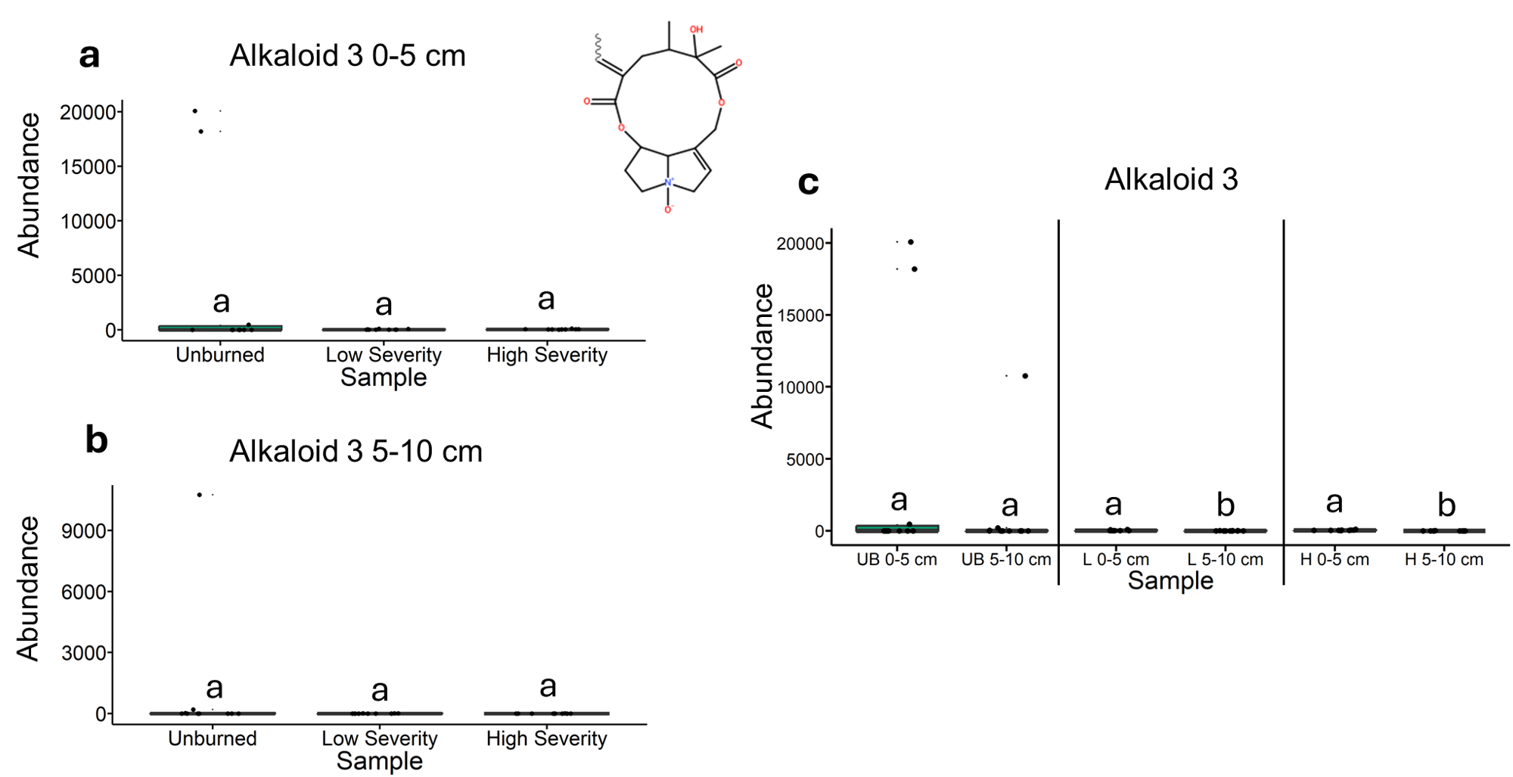
Fig. 53 | Quantification of alkaloid 3 abundances from liquid chromatography-mass spectrometry analysis. The statistical tests of a, b, and c were conducted independently of each other. a, Quantifying abundances across soils collected at a depth of 0-5 cm. Letters above boxes indicate significant differences (P<0.05) amongst sample types. n=10 for unburned, n=9 for low severity, and n=10 high severity samples. b, Quantifying abundances across soils collected at a depth of 5-10 cm. Letters above boxes indicate significant differences (P<0.05) amongst treatments. n=10 for unburned, low severity, and high severity samples. c, Quantifying abundances and comparing 0-5 cm soil depth with 5-10 cm soil depth. The statistical tests within sample types (i.e. unburned, low severity, and high severity) were conducted independently from each other. In other words, the “a” above “UB 0-5 cm” does not mean that there is no significant difference compared to “L 0-5 cm” which also has an “a” label because those statistical tests were conducted independently of each other. P<0.05 was the cutoff for significant differences. UB = unburned. L = low severity. H = high severity. n=10 for unburned 0-5 cm, unburned 5-10 cm, low severity 5-10 cm, high severity 0-5 cm, and high severity 5-10 cm samples. n=10 for low severity 0-5 cm samples. Box plots show the median (central line), first and third quartiles (box edges), and whiskers extending to minimum and maximum values within 1.5 times the interquartile range. Smaller black dots (not the data points) indicate where the data points would lie if the data points weren’t jittered. The chemical structure was copied from SIRUIS software (Version 6.2.2).

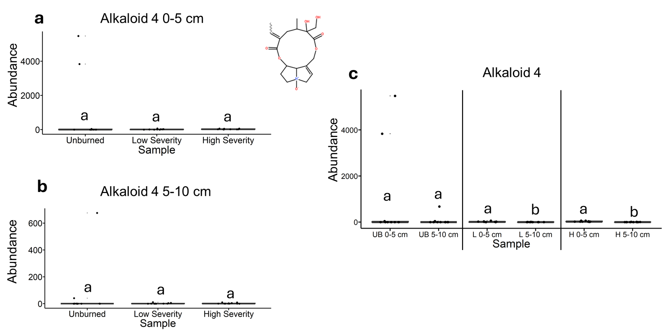
Fig. 54 | Quantification of alkaloid 4 abundances from liquid chromatography-mass spectrometry analysis. The statistical tests of a, b, and c were conducted independently of each other. a, Quantifying abundances across soils collected at a depth of 0-5 cm. Letters above boxes indicate significant differences (P<0.05) amongst sample types. n=10 for unburned, n=9 for low severity, and n=10 high severity samples. b, Quantifying abundances across soils collected at a depth of 5-10 cm. Letters above boxes indicate significant differences (P<0.05) amongst treatments. n=10 for unburned, low severity, and high severity samples. c, Quantifying abundances and comparing 0-5 cm soil depth with 5-10 cm soil depth. The statistical tests within sample types (i.e. unburned, low severity, and high severity) were conducted independently from each other. In other words, the “a” above “UB 0-5 cm” does not mean that there is no significant difference compared to “L 0-5 cm” which also has an “a” label because those statistical tests were conducted independently of each other. P<0.05 was the cutoff for significant differences. UB = unburned. L = low severity. H = high severity. n=10 for unburned 0-5 cm, unburned 5-10 cm, low severity 5-10 cm, high severity 0-5 cm, and high severity 5-10 cm samples. n=10 for low severity 0-5 cm samples. Box plots show the median (central line), first and third quartiles (box edges), and whiskers extending to minimum and maximum values within 1.5 times the interquartile range. Smaller black dots (not the data points) indicate where the data points would lie if the data points weren’t jittered. The chemical structure was copied from SIRUIS software (Version 6.2.2).

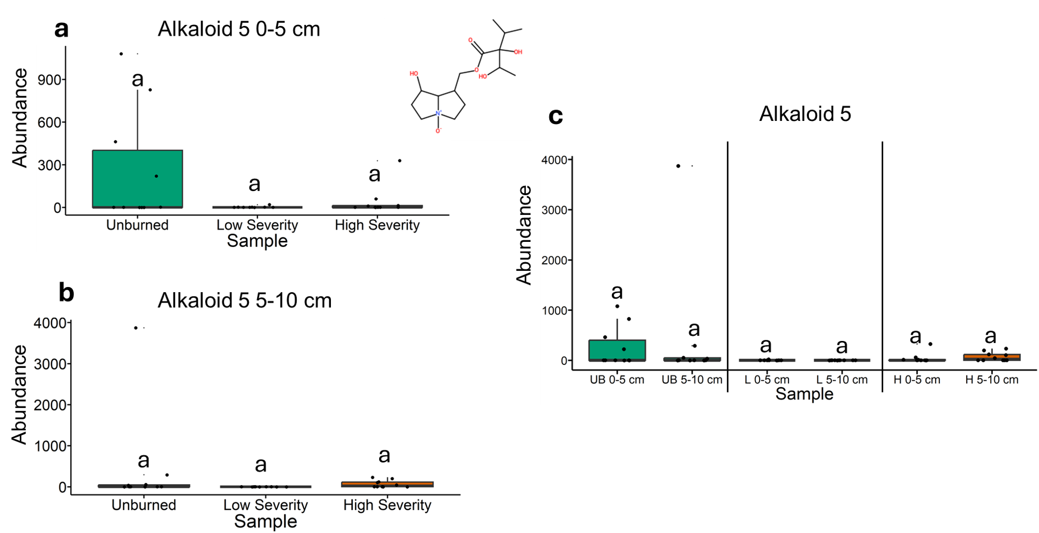
Fig. 55 | Quantification of alkaloid 5 abundances from liquid chromatography-mass spectrometry analysis. The statistical tests of a, b, and c were conducted independently of each other. a, Quantifying abundances across soils collected at a depth of 0-5 cm. Letters above boxes indicate significant differences (P<0.05) amongst sample types. n=10 for unburned, n=9 for low severity, and n=10 high severity samples. b, Quantifying abundances across soils collected at a depth of 5-10 cm. Letters above boxes indicate significant differences (P<0.05) amongst treatments. n=10 for unburned, low severity, and high severity samples. c, Quantifying abundances and comparing 0-5 cm soil depth with 5-10 cm soil depth. The statistical tests within sample types (i.e. unburned, low severity, and high severity) were conducted independently from each other. In other words, the “a” above “UB 0-5 cm” does not mean that there is no significant difference compared to “L 0-5 cm” which also has an “a” label because those statistical tests were conducted independently of each other. P<0.05 was the cutoff for significant differences. UB = unburned. L = low severity. H = high severity. n=10 for unburned 0-5 cm, unburned 5-10 cm, low severity 5-10 cm, high severity 0-5 cm, and high severity 5-10 cm samples. n=10 for low severity 0-5 cm samples. Box plots show the median (central line), first and third quartiles (box edges), and whiskers extending to minimum and maximum values within 1.5 times the interquartile range. Smaller black dots (not the data points) indicate where the data points would lie if the data points weren’t jittered. The chemical structure was copied from SIRUIS software (Version 6.2.2).

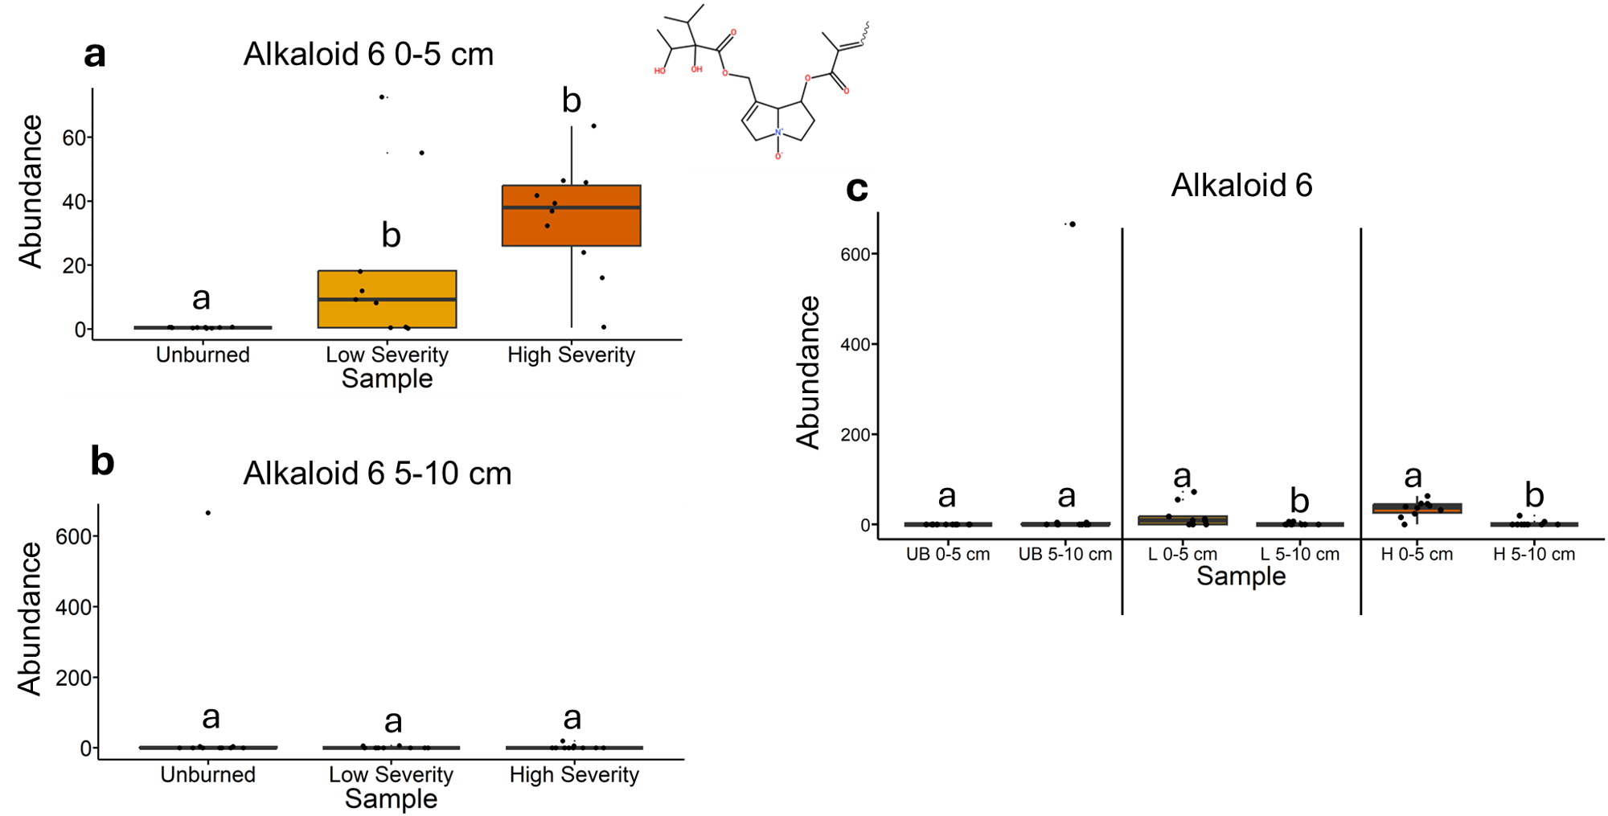
Fig. 56 | Quantification of alkaloid 6 abundances from liquid chromatography-mass spectrometry analysis. The statistical tests of a, b, and c were conducted independently of each other. a, Quantifying abundances across soils collected at a depth of 0-5 cm. Letters above boxes indicate significant differences (P<0.05) amongst sample types. n=10 for unburned, n=9 for low severity, and n=10 high severity samples. b, Quantifying abundances across soils collected at a depth of 5-10 cm. Letters above boxes indicate significant differences (P<0.05) amongst treatments. n=10 for unburned, low severity, and high severity samples. c, Quantifying abundances and comparing 0-5 cm soil depth with 5-10 cm soil depth. The statistical tests within sample types (i.e. unburned, low severity, and high severity) were conducted independently from each other. In other words, the “a” above “UB 0-5 cm” does not mean that there is no significant difference compared to “L 0-5 cm” which also has an “a” label because those statistical tests were conducted independently of each other. P<0.05 was the cutoff for significant differences. UB = unburned. L = low severity. H = high severity. n=10 for unburned 0-5 cm, unburned 5-10 cm, low severity 5-10 cm, high severity 0-5 cm, and high severity 5-10 cm samples. n=10 for low severity 0-5 cm samples. Box plots show the median (central line), first and third quartiles (box edges), and whiskers extending to minimum and maximum values within 1.5 times the interquartile range. Smaller black dots (not the data points) indicate where the data points would lie if the data points weren’t jittered. The chemical structure was copied from SIRUIS software (Version 6.2.2).

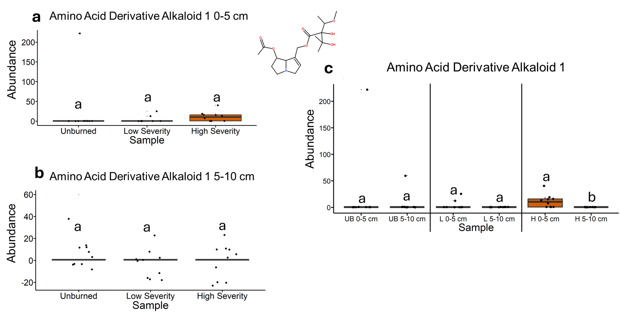
Fig. 57 | Quantification of amino acid derivative alkaloid 1 abundances from liquid chromatography-mass spectrometry analysis. The statistical tests of a, b, and c were conducted independently of each other. a, Quantifying abundances across soils collected at a depth of 0-5 cm. Letters above boxes indicate significant differences (P<0.05) amongst sample types. n=10 for unburned, n=9 for low severity, and n=10 high severity samples. b, Quantifying abundances across soils collected at a depth of 5-10 cm. Letters above boxes indicate significant differences (P<0.05) amongst treatments. n=10 for unburned, low severity, and high severity samples. c, Quantifying abundances and comparing 0-5 cm soil depth with 5-10 cm soil depth. The statistical tests within sample types (i.e. unburned, low severity, and high severity) were conducted independently from each other. In other words, the “a” above “UB 0-5 cm” does not mean that there is no significant difference compared to “L 0-5 cm” which also has an “a” label because those statistical tests were conducted independently of each other. P<0.05 was the cutoff for significant differences. UB = unburned. L = low severity. H = high severity. n=10 for unburned 0-5 cm, unburned 5-10 cm, low severity 5-10 cm, high severity 0-5 cm, and high severity 5-10 cm samples. n=10 for low severity 0-5 cm samples. Box plots show the median (central line), first and third quartiles (box edges), and whiskers extending to minimum and maximum values within 1.5 times the interquartile range. Smaller black dots (not the data points) indicate where the data points would lie if the data points weren’t jittered. The chemical structure was copied from SIRUIS software (Version 6.2.2).

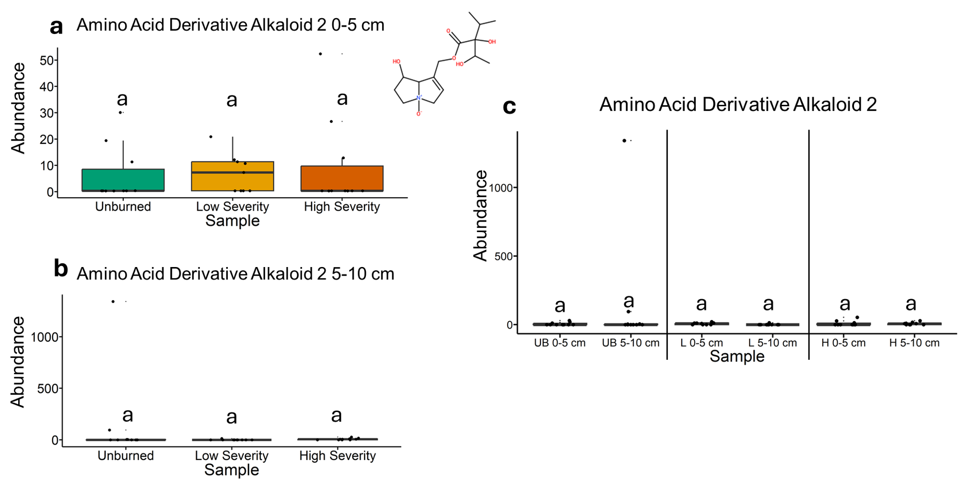
Fig. 58 | Quantification of amino acid derivative alkaloid 2 abundances from liquid chromatography-mass spectrometry analysis. The statistical tests of a, b, and c were conducted independently of each other. a, Quantifying abundances across soils collected at a depth of 0-5 cm. Letters above boxes indicate significant differences (P<0.05) amongst sample types. n=10 for unburned, n=9 for low severity, and n=10 high severity samples. b, Quantifying abundances across soils collected at a depth of 5-10 cm. Letters above boxes indicate significant differences (P<0.05) amongst treatments. n=10 for unburned, low severity, and high severity samples. c, Quantifying abundances and comparing 0-5 cm soil depth with 5-10 cm soil depth. The statistical tests within sample types (i.e. unburned, low severity, and high severity) were conducted independently from each other. In other words, the “a” above “UB 0-5 cm” does not mean that there is no significant difference compared to “L 0-5 cm” which also has an “a” label because those statistical tests were conducted independently of each other. P<0.05 was the cutoff for significant differences. UB = unburned. L = low severity. H = high severity. n=10 for unburned 0-5 cm, unburned 5-10 cm, low severity 5-10 cm, high severity 0-5 cm, and high severity 5-10 cm samples. n=10 for low severity 0-5 cm samples. Box plots show the median (central line), first and third quartiles (box edges), and whiskers extending to minimum and maximum values within 1.5 times the interquartile range. Smaller black dots (not the data points) indicate where the data points would lie if the data points weren’t jittered. The chemical structure was copied from SIRUIS software (Version 6.2.2).

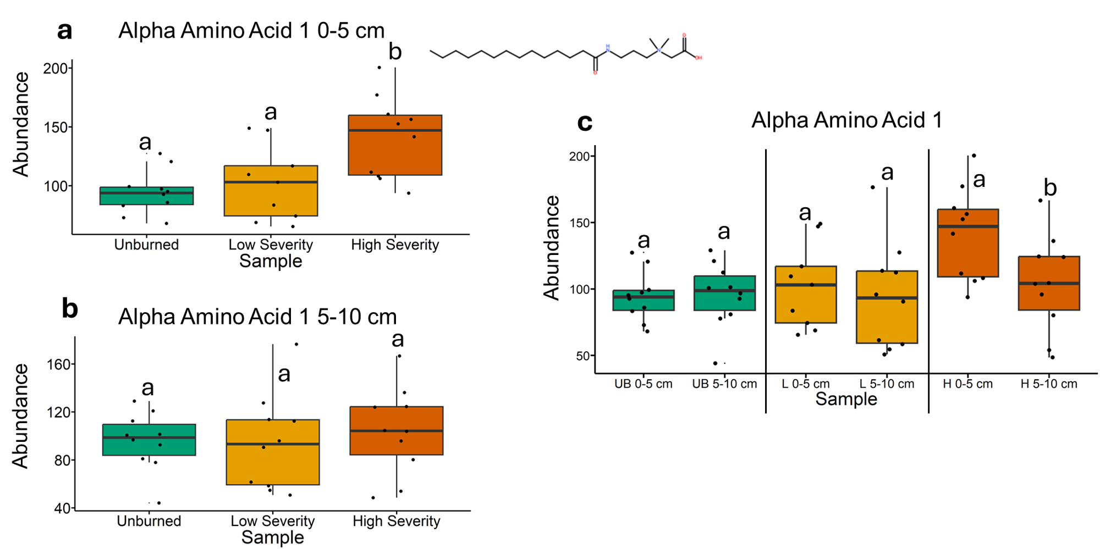
Fig. 59 | Quantification of alpha amino acid 1 abundances from liquid chromatography-mass spectrometry analysis. The statistical tests of a, b, and c were conducted independently of each other. a, Quantifying abundances across soils collected at a depth of 0-5 cm. Letters above boxes indicate significant differences (P<0.05) amongst sample types. n=10 for unburned, n=9 for low severity, and n=10 high severity samples. b, Quantifying abundances across soils collected at a depth of 5-10 cm. Letters above boxes indicate significant differences (P<0.05) amongst treatments. n=10 for unburned, low severity, and high severity samples. c, Quantifying abundances and comparing 0-5 cm soil depth with 5-10 cm soil depth. The statistical tests within sample types (i.e. unburned, low severity, and high severity) were conducted independently from each other. In other words, the “a” above “UB 0-5 cm” does not mean that there is no significant difference compared to “L 0-5 cm” which also has an “a” label because those statistical tests were conducted independently of each other. P<0.05 was the cutoff for significant differences. UB = unburned. L = low severity. H = high severity. n=10 for unburned 0-5 cm, unburned 5-10 cm, low severity 5-10 cm, high severity 0-5 cm, and high severity 5-10 cm samples. n=10 for low severity 0-5 cm samples. Box plots show the median (central line), first and third quartiles (box edges), and whiskers extending to minimum and maximum values within 1.5 times the interquartile range. Smaller black dots (not the data points) indicate where the data points would lie if the data points weren’t jittered. The chemical structure was copied from SIRUIS software (Version 6.2.2).

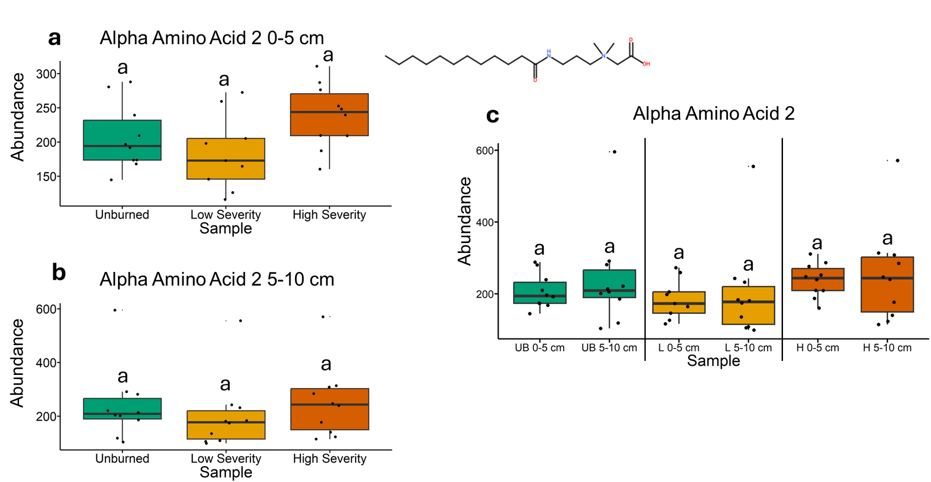
Fig. 60 | Quantification of alpha amino acid 2 abundances from liquid chromatography-mass spectrometry analysis. The statistical tests of a, b, and c were conducted independently of each other. a, Quantifying abundances across soils collected at a depth of 0-5 cm. Letters above boxes indicate significant differences (P<0.05) amongst sample types. n=10 for unburned, n=9 for low severity, and n=10 high severity samples. b, Quantifying abundances across soils collected at a depth of 5-10 cm. Letters above boxes indicate significant differences (P<0.05) amongst treatments. n=10 for unburned, low severity, and high severity samples. c, Quantifying abundances and comparing 0-5 cm soil depth with 5-10 cm soil depth. The statistical tests within sample types (i.e. unburned, low severity, and high severity) were conducted independently from each other. In other words, the “a” above “UB 0-5 cm” does not mean that there is no significant difference compared to “L 0-5 cm” which also has an “a” label because those statistical tests were conducted independently of each other. P<0.05 was the cutoff for significant differences. UB = unburned. L = low severity. H = high severity. n=10 for unburned 0-5 cm, unburned 5-10 cm, low severity 5-10 cm, high severity 0-5 cm, and high severity 5-10 cm samples. n=10 for low severity 0-5 cm samples. Box plots show the median (central line), first and third quartiles (box edges), and whiskers extending to minimum and maximum values within 1.5 times the interquartile range. Smaller black dots (not the data points) indicate where the data points would lie if the data points weren’t jittered. The chemical structure was copied from SIRUIS software (Version 6.2.2).

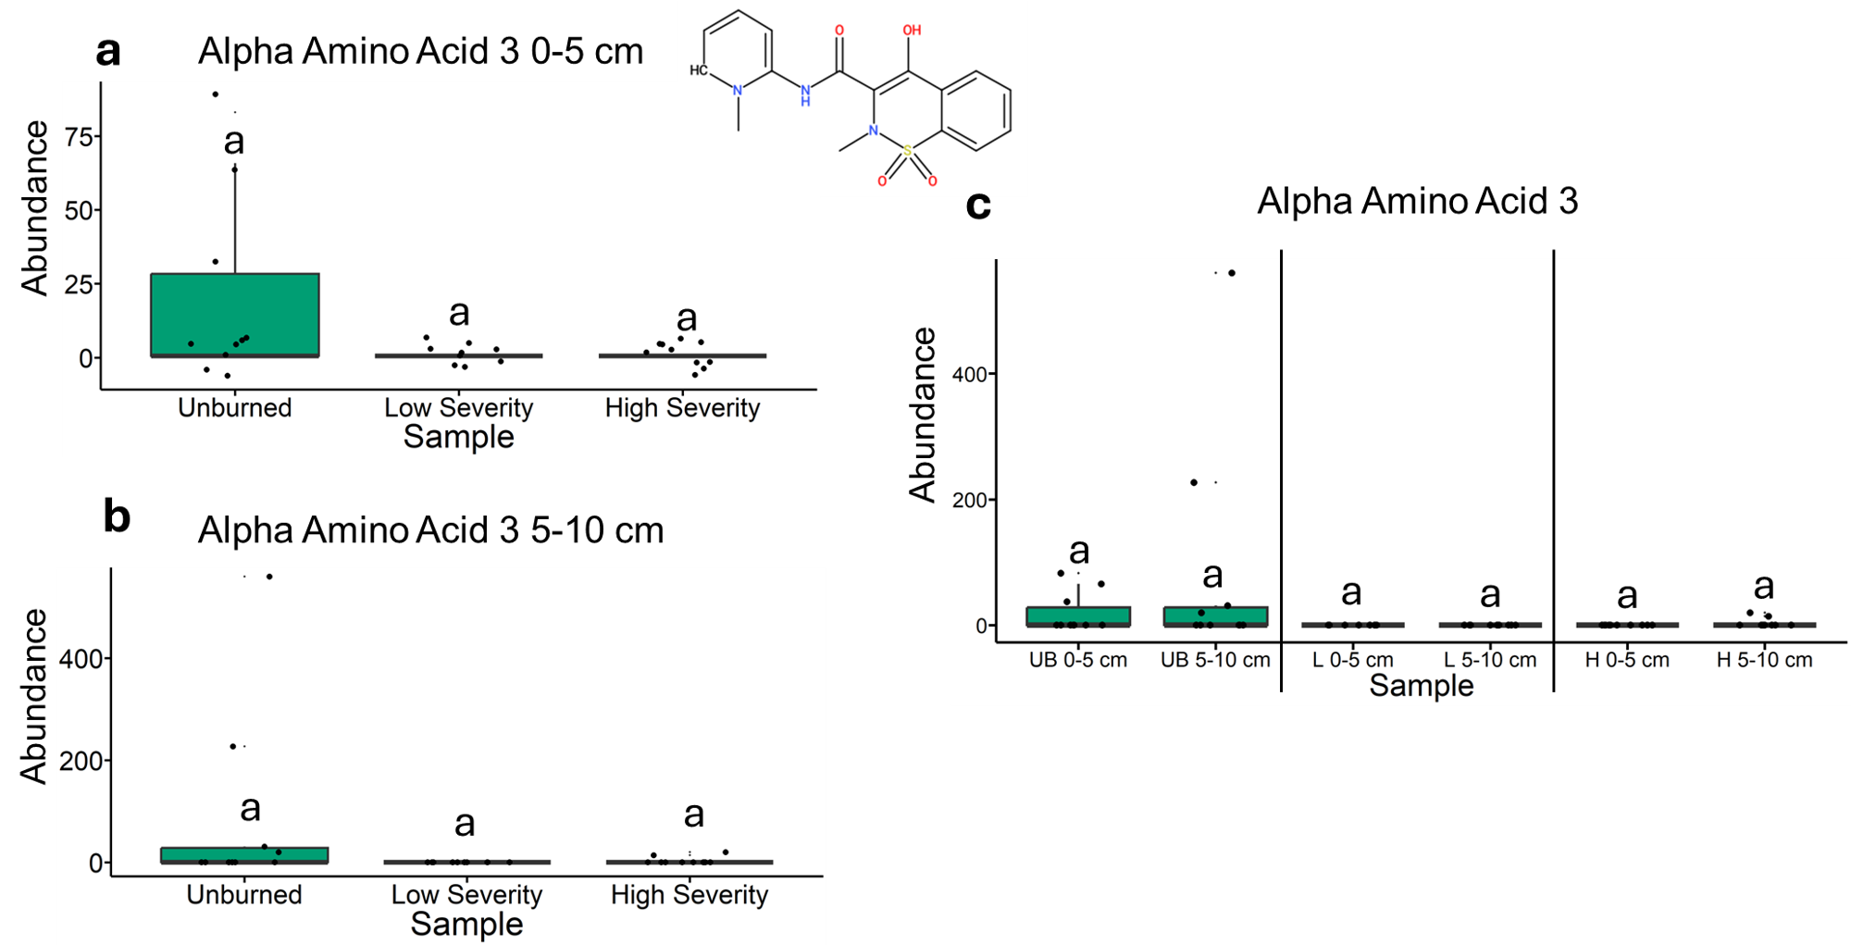
Fig. 61 | Quantification of alpha amino acid 3 abundances from liquid chromatography-mass spectrometry analysis. The statistical tests of a, b, and c were conducted independently of each other. a, Quantifying abundances across soils collected at a depth of 0-5 cm. Letters above boxes indicate significant differences (P<0.05) amongst sample types. n=10 for unburned, n=9 for low severity, and n=10 high severity samples. b, Quantifying abundances across soils collected at a depth of 5-10 cm. Letters above boxes indicate significant differences (P<0.05) amongst treatments. n=10 for unburned, low severity, and high severity samples. c, Quantifying abundances and comparing 0-5 cm soil depth with 5-10 cm soil depth. The statistical tests within sample types (i.e. unburned, low severity, and high severity) were conducted independently from each other. In other words, the “a” above “UB 0-5 cm” does not mean that there is no significant difference compared to “L 0-5 cm” which also has an “a” label because those statistical tests were conducted independently of each other. P<0.05 was the cutoff for significant differences. UB = unburned. L = low severity. H = high severity. n=10 for unburned 0-5 cm, unburned 5-10 cm, low severity 5-10 cm, high severity 0-5 cm, and high severity 5-10 cm samples. n=10 for low severity 0-5 cm samples. Box plots show the median (central line), first and third quartiles (box edges), and whiskers extending to minimum and maximum values within 1.5 times the interquartile range. Smaller black dots (not the data points) indicate where the data points would lie if the data points weren’t jittered. The chemical structure was copied from SIRUIS software (Version 6.2.2).

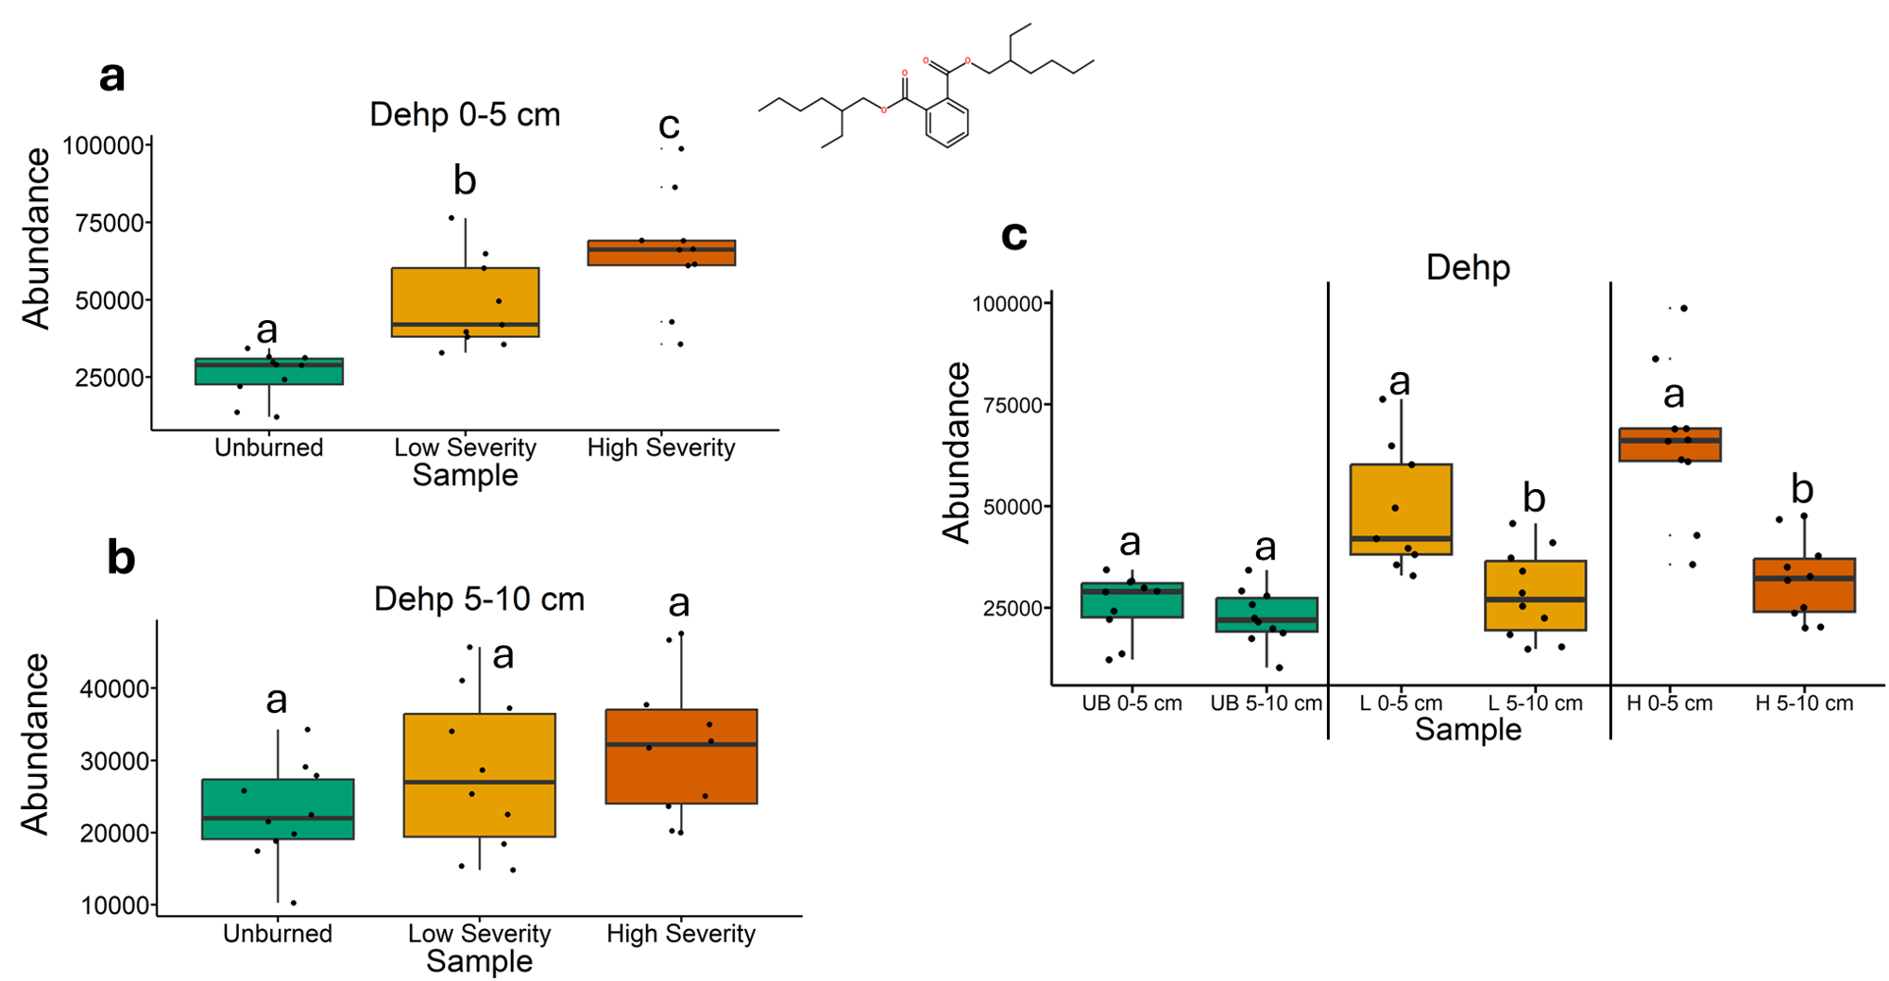
Fig. 62 | Quantification of dehp abundances from liquid chromatography-mass spectrometry analysis. The statistical tests of a, b, and c were conducted independently of each other. a, Quantifying abundances across soils collected at a depth of 0-5 cm. Letters above boxes indicate significant differences (P<0.05) amongst sample types. n=10 for unburned, n=9 for low severity, and n=10 high severity samples. b, Quantifying abundances across soils collected at a depth of 5-10 cm. Letters above boxes indicate significant differences (P<0.05) amongst treatments. n=10 for unburned, low severity, and high severity samples. c, Quantifying abundances and comparing 0-5 cm soil depth with 5-10 cm soil depth. The statistical tests within sample types (i.e. unburned, low severity, and high severity) were conducted independently from each other. In other words, the “a” above “UB 0-5 cm” does not mean that there is no significant difference compared to “L 0-5 cm” which also has an “a” label because those statistical tests were conducted independently of each other. P<0.05 was the cutoff for significant differences. UB = unburned. L = low severity. H = high severity. n=10 for unburned 0-5 cm, unburned 5-10 cm, low severity 5-10 cm, high severity 0-5 cm, and high severity 5-10 cm samples. n=10 for low severity 0-5 cm samples. Box plots show the median (central line), first and third quartiles (box edges), and whiskers extending to minimum and maximum values within 1.5 times the interquartile range. Smaller black dots (not the data points) indicate where the data points would lie if the data points weren’t jittered. The chemical structure was copied from SIRUIS software (Version 6.2.2).

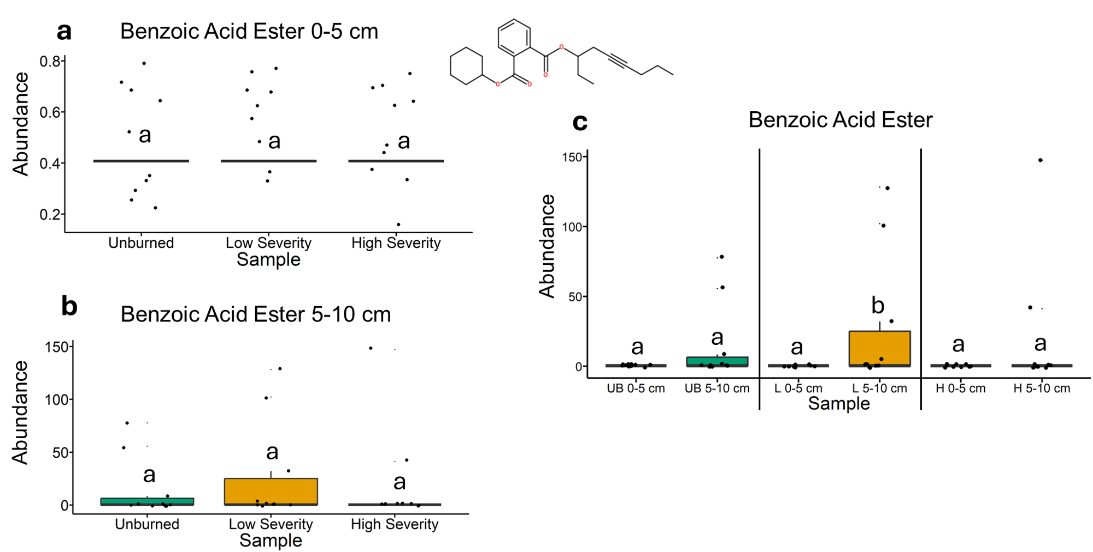
Fig. 63 | Quantification of dehp abundances from liquid chromatography-mass spectrometry analysis. The statistical tests of a, b, and c were conducted independently of each other. a, Quantifying abundances across soils collected at a depth of 0-5 cm. Letters above boxes indicate significant differences (P<0.05) amongst sample types. n=10 for unburned, n=9 for low severity, and n=10 high severity samples. b, Quantifying abundances across soils collected at a depth of 5-10 cm. Letters above boxes indicate significant differences (P<0.05) amongst treatments. n=10 for unburned, low severity, and high severity samples. c, Quantifying abundances and comparing 0-5 cm soil depth with 5-10 cm soil depth. The statistical tests within sample types (i.e. unburned, low severity, and high severity) were conducted independently from each other. In other words, the “a” above “UB 0-5 cm” does not mean that there is no significant difference compared to “L 0-5 cm” which also has an “a” label because those statistical tests were conducted independently of each other. P<0.05 was the cutoff for significant differences. UB = unburned. L = low severity. H = high severity. n=10 for unburned 0-5 cm, unburned 5-10 cm, low severity 5-10 cm, high severity 0-5 cm, and high severity 5-10 cm samples. n=10 for low severity 0-5 cm samples. Box plots show the median (central line), first and third quartiles (box edges), and whiskers extending to minimum and maximum values within 1.5 times the interquartile range. Smaller black dots (not the data points) indicate where the data points would lie if the data points weren’t jittered. The chemical structure was copied from SIRUIS software (Version 6.2.2).

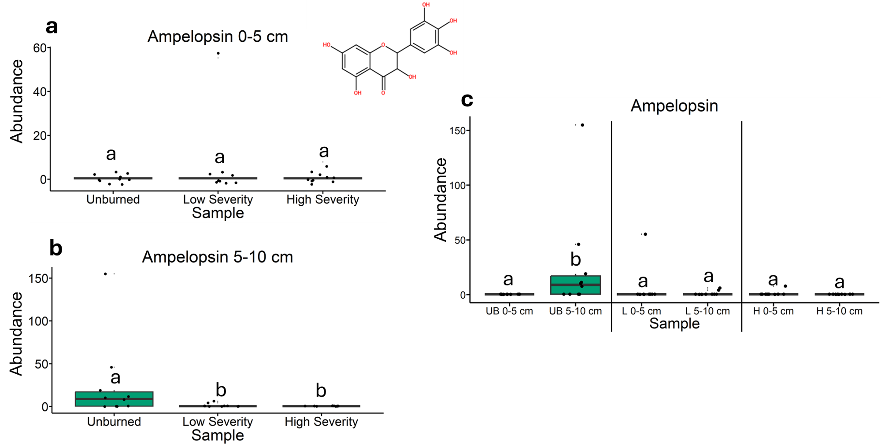
Fig. 64 | Quantification of ampelopsin abundances from liquid chromatography-mass spectrometry analysis. The statistical tests of a, b, and c were conducted independently of each other. a, Quantifying abundances across soils collected at a depth of 0-5 cm. Letters above boxes indicate significant differences (P<0.05) amongst sample types. n=10 for unburned, n=9 for low severity, and n=10 high severity samples. b, Quantifying abundances across soils collected at a depth of 5-10 cm. Letters above boxes indicate significant differences (P<0.05) amongst treatments. n=10 for unburned, low severity, and high severity samples. c, Quantifying abundances and comparing 0-5 cm soil depth with 5-10 cm soil depth. The statistical tests within sample types (i.e. unburned, low severity, and high severity) were conducted independently from each other. In other words, the “a” above “UB 0-5 cm” does not mean that there is no significant difference compared to “L 0-5 cm” which also has an “a” label because those statistical tests were conducted independently of each other. P<0.05 was the cutoff for significant differences. UB = unburned. L = low severity. H = high severity. n=10 for unburned 0-5 cm, unburned 5-10 cm, low severity 5-10 cm, high severity 0-5 cm, and high severity 5-10 cm samples. n=10 for low severity 0-5 cm samples. Box plots show the median (central line), first and third quartiles (box edges), and whiskers extending to minimum and maximum values within 1.5 times the interquartile range. Smaller black dots (not the data points) indicate where the data points would lie if the data points weren’t jittered. The chemical structure was copied from SIRUIS software (Version 6.2.2).

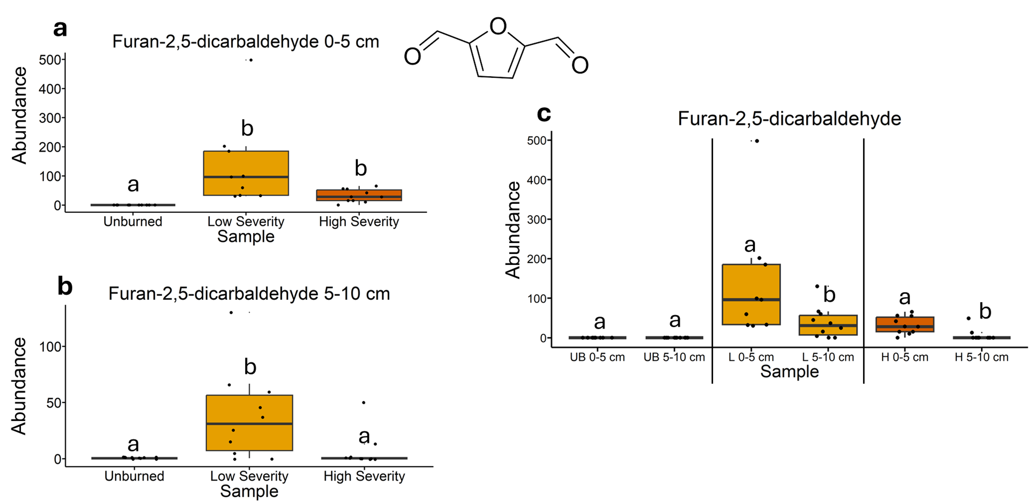
Fig. 65 | Quantification of furan-2,5-dicarbaldehyde abundances from liquid chromatography-mass spectrometry analysis. The statistical tests of a, b, and c were conducted independently of each other. a, Quantifying abundances across soils collected at a depth of 0-5 cm. Letters above boxes indicate significant differences (P<0.05) amongst sample types. n=10 for unburned, n=9 for low severity, and n=10 high severity samples. b, Quantifying abundances across soils collected at a depth of 5-10 cm. Letters above boxes indicate significant differences (P<0.05) amongst treatments. n=10 for unburned, low severity, and high severity samples. c, Quantifying abundances and comparing 0-5 cm soil depth with 5-10 cm soil depth. The statistical tests within sample types (i.e. unburned, low severity, and high severity) were conducted independently from each other. In other words, the “a” above “UB 0-5 cm” does not mean that there is no significant difference compared to “L 0-5 cm” which also has an “a” label because those statistical tests were conducted independently of each other. P<0.05 was the cutoff for significant differences. UB = unburned. L = low severity. H = high severity. n=10 for unburned 0-5 cm, unburned 5-10 cm, low severity 5-10 cm, high severity 0-5 cm, and high severity 5-10 cm samples. n=10 for low severity 0-5 cm samples. Box plots show the median (central line), first and third quartiles (box edges), and whiskers extending to minimum and maximum values within 1.5 times the interquartile range. Smaller black dots (not the data points) indicate where the data points would lie if the data points weren’t jittered.

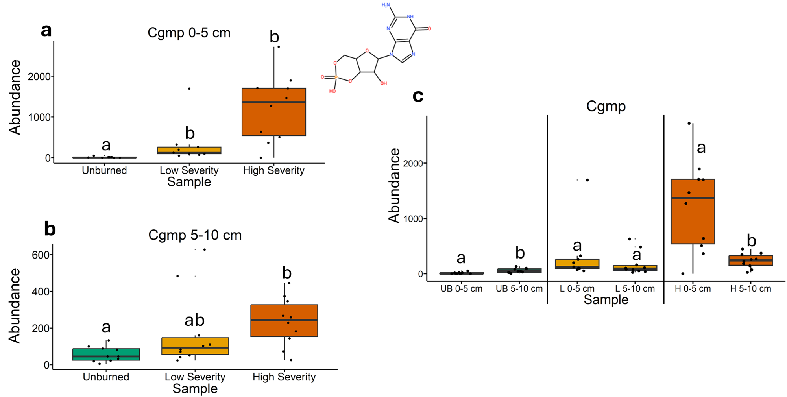
Fig. 66 | Quantification of cgmp abundances from liquid chromatography-mass spectrometry analysis. The statistical tests of a, b, and c were conducted independently of each other. a, Quantifying abundances across soils collected at a depth of 0-5 cm. Letters above boxes indicate significant differences (P<0.05) amongst sample types. n=10 for unburned, n=9 for low severity, and n=10 high severity samples. b, Quantifying abundances across soils collected at a depth of 5-10 cm. Letters above boxes indicate significant differences (P<0.05) amongst treatments. n=10 for unburned, low severity, and high severity samples. c, Quantifying abundances and comparing 0-5 cm soil depth with 5-10 cm soil depth. The statistical tests within sample types (i.e. unburned, low severity, and high severity) were conducted independently from each other. In other words, the “a” above “UB 0-5 cm” does not mean that there is no significant difference compared to “L 0-5 cm” which also has an “a” label because those statistical tests were conducted independently of each other. P<0.05 was the cutoff for significant differences. UB = unburned. L = low severity. H = high severity. n=10 for unburned 0-5 cm, unburned 5-10 cm, low severity 5-10 cm, high severity 0-5 cm, and high severity 5-10 cm samples. n=10 for low severity 0-5 cm samples. Box plots show the median (central line), first and third quartiles (box edges), and whiskers extending to minimum and maximum values within 1.5 times the interquartile range. Smaller black dots (not the data points) indicate where the data points would lie if the data points weren’t jittered. The chemical structure was copied from SIRUIS software (Version 6.2.2).

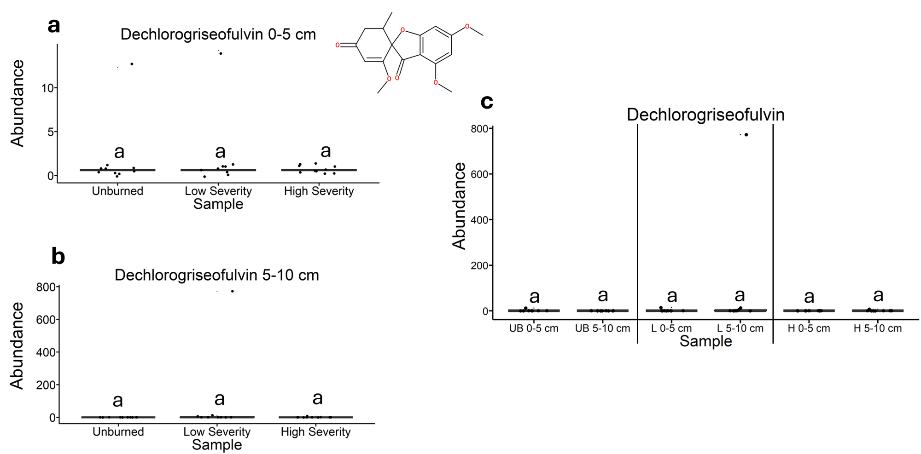
Fig. 67 | Quantification of dechlorogriseofulvin abundances from liquid chromatography-mass spectrometry analysis. The statistical tests of a, b, and c were conducted independently of each other. a, Quantifying abundances across soils collected at a depth of 0-5 cm. Letters above boxes indicate significant differences (P<0.05) amongst sample types. n=10 for unburned, n=9 for low severity, and n=10 high severity samples. b, Quantifying abundances across soils collected at a depth of 5-10 cm. Letters above boxes indicate significant differences (P<0.05) amongst treatments. n=10 for unburned, low severity, and high severity samples. c, Quantifying abundances and comparing 0-5 cm soil depth with 5-10 cm soil depth. The statistical tests within sample types (i.e. unburned, low severity, and high severity) were conducted independently from each other. In other words, the “a” above “UB 0-5 cm” does not mean that there is no significant difference compared to “L 0-5 cm” which also has an “a” label because those statistical tests were conducted independently of each other. P<0.05 was the cutoff for significant differences. UB = unburned. L = low severity. H = high severity. n=10 for unburned 0-5 cm, unburned 5-10 cm, low severity 5-10 cm, high severity 0-5 cm, and high severity 5-10 cm samples. n=10 for low severity 0-5 cm samples. Box plots show the median (central line), first and third quartiles (box edges), and whiskers extending to minimum and maximum values within 1.5 times the interquartile range. Smaller black dots (not the data points) indicate where the data points would lie if the data points weren’t jittered. The chemical structure was copied from SIRUIS software (Version 6.2.2).

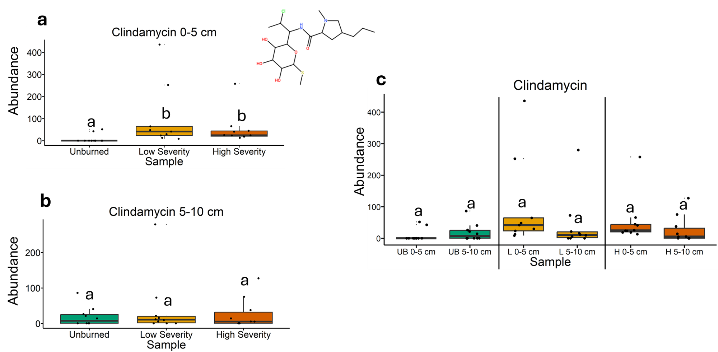
Fig. 68 | Quantification of clindamycin abundances from liquid chromatography-mass spectrometry analysis. The statistical tests of a, b, and c were conducted independently of each other. a, Quantifying abundances across soils collected at a depth of 0-5 cm. Letters above boxes indicate significant differences (P<0.05) amongst sample types. n=10 for unburned, n=9 for low severity, and n=10 high severity samples. b, Quantifying abundances across soils collected at a depth of 5-10 cm. Letters above boxes indicate significant differences (P<0.05) amongst treatments. n=10 for unburned, low severity, and high severity samples. c, Quantifying abundances and comparing 0-5 cm soil depth with 5-10 cm soil depth. The statistical tests within sample types (i.e. unburned, low severity, and high severity) were conducted independently from each other. In other words, the “a” above “UB 0-5 cm” does not mean that there is no significant difference compared to “L 0-5 cm” which also has an “a” label because those statistical tests were conducted independently of each other. P<0.05 was the cutoff for significant differences. UB = unburned. L = low severity. H = high severity. n=10 for unburned 0-5 cm, unburned 5-10 cm, low severity 5-10 cm, high severity 0-5 cm, and high severity 5-10 cm samples. n=10 for low severity 0-5 cm samples. Box plots show the median (central line), first and third quartiles (box edges), and whiskers extending to minimum and maximum values within 1.5 times the interquartile range. Smaller black dots (not the data points) indicate where the data points would lie if the data points weren’t jittered. The chemical structure was copied from SIRUIS software (Version 6.2.2).

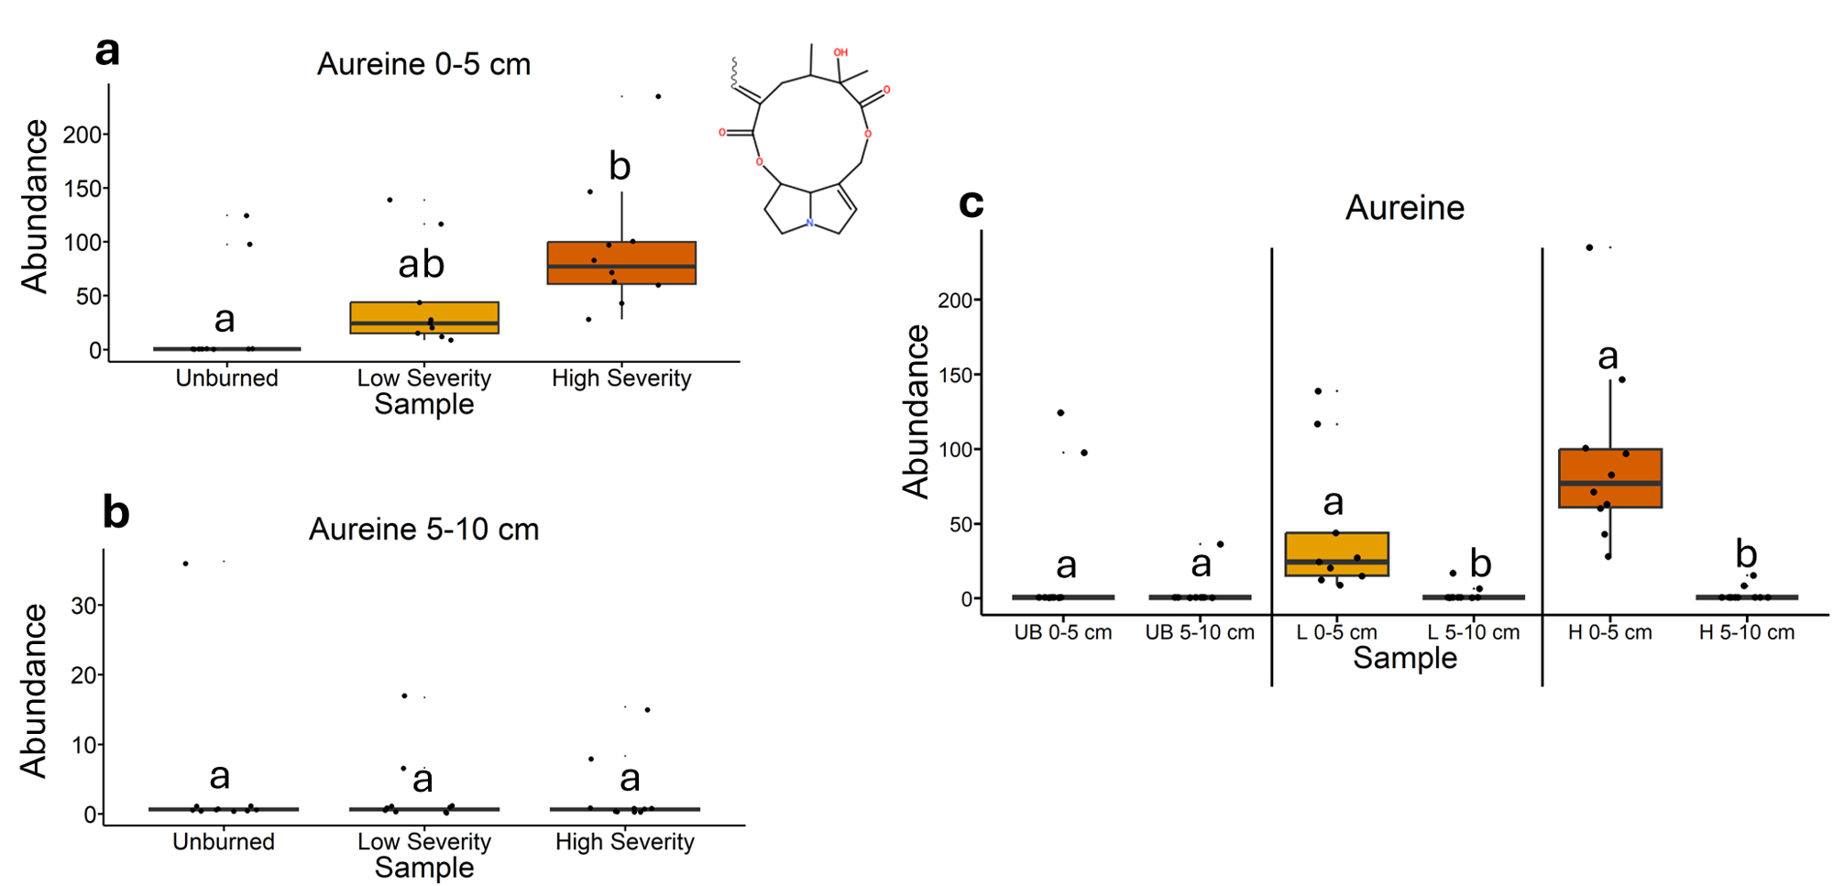
Fig. 69 | Quantification of aureine abundances from liquid chromatography-mass spectrometry analysis. The statistical tests of a, b, and c were conducted independently of each other. a, Quantifying abundances across soils collected at a depth of 0-5 cm. Letters above boxes indicate significant differences (P<0.05) amongst sample types. n=10 for unburned, n=9 for low severity, and n=10 high severity samples. b, Quantifying abundances across soils collected at a depth of 5-10 cm. Letters above boxes indicate significant differences (P<0.05) amongst treatments. n=10 for unburned, low severity, and high severity samples. c, Quantifying abundances and comparing 0-5 cm soil depth with 5-10 cm soil depth. The statistical tests within sample types (i.e. unburned, low severity, and high severity) were conducted independently from each other. In other words, the “a” above “UB 0-5 cm” does not mean that there is no significant difference compared to “L 0-5 cm” which also has an “a” label because those statistical tests were conducted independently of each other. P<0.05 was the cutoff for significant differences. UB = unburned. L = low severity. H = high severity. n=10 for unburned 0-5 cm, unburned 5-10 cm, low severity 5-10 cm, high severity 0-5 cm, and high severity 5-10 cm samples. n=10 for low severity 0-5 cm samples. Box plots show the median (central line), first and third quartiles (box edges), and whiskers extending to minimum and maximum values within 1.5 times the interquartile range. Smaller black dots (not the data points) indicate where the data points would lie if the data points weren’t jittered. The chemical structure was copied from SIRUIS software (Version 6.2.2).

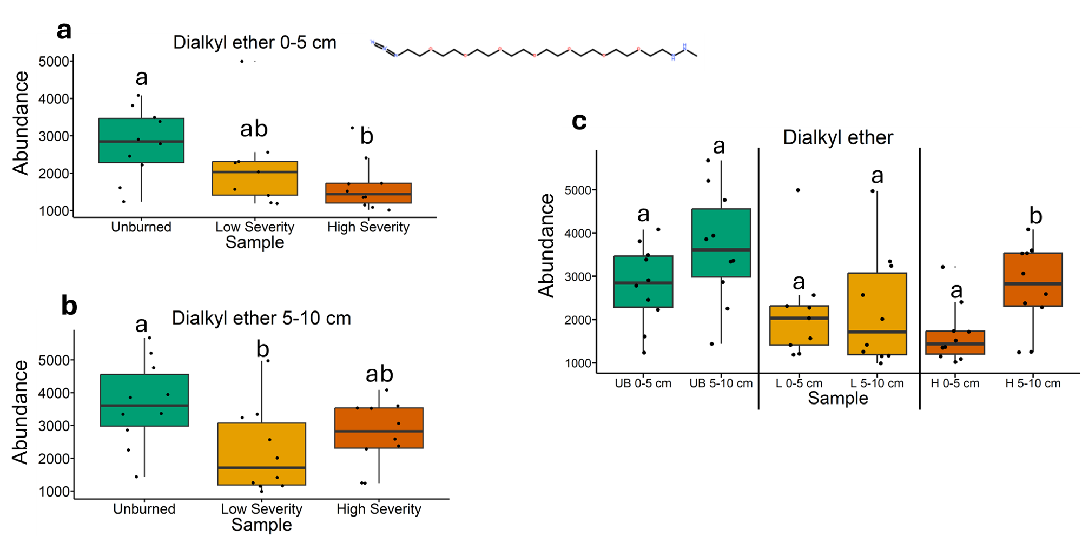
Fig. 70 | Quantification of dialkyl ether abundances from liquid chromatography-mass spectrometry analysis. The statistical tests of a, b, and c were conducted independently of each other. a, Quantifying abundances across soils collected at a depth of 0-5 cm. Letters above boxes indicate significant differences (P<0.05) amongst sample types. n=10 for unburned, n=9 for low severity, and n=10 high severity samples. b, Quantifying abundances across soils collected at a depth of 5-10 cm. Letters above boxes indicate significant differences (P<0.05) amongst treatments. n=10 for unburned, low severity, and high severity samples. c, Quantifying abundances and comparing 0-5 cm soil depth with 5-10 cm soil depth. The statistical tests within sample types (i.e. unburned, low severity, and high severity) were conducted independently from each other. In other words, the “a” above “UB 0-5 cm” does not mean that there is no significant difference compared to “L 0-5 cm” which also has an “a” label because those statistical tests were conducted independently of each other. P<0.05 was the cutoff for significant differences. UB = unburned. L = low severity. H = high severity. n=10 for unburned 0-5 cm, unburned 5-10 cm, low severity 5-10 cm, high severity 0-5 cm, and high severity 5-10 cm samples. n=10 for low severity 0-5 cm samples. Box plots show the median (central line), first and third quartiles (box edges), and whiskers extending to minimum and maximum values within 1.5 times the interquartile range. Smaller black dots (not the data points) indicate where the data points would lie if the data points weren’t jittered. The chemical structure was copied from SIRUIS software (Version 6.2.2).

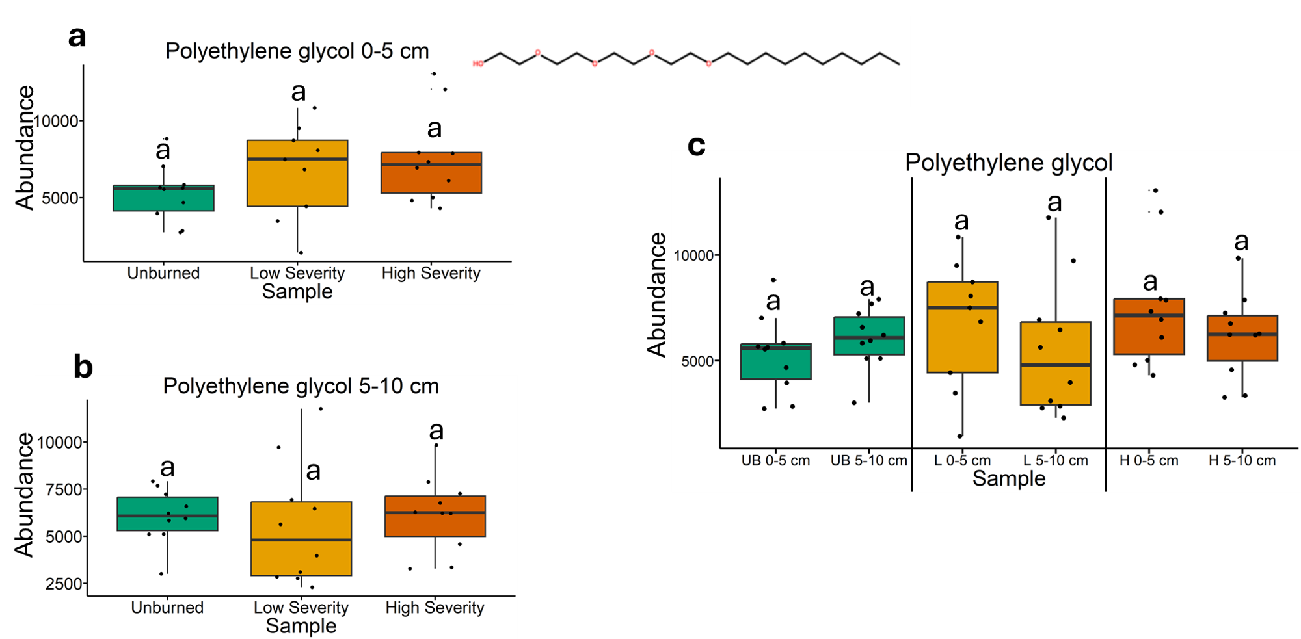
Fig. 71 | Quantification of polyethylene glycol abundances from liquid chromatography-mass spectrometry analysis. The statistical tests of a, b, and c were conducted independently of each other. a, Quantifying abundances across soils collected at a depth of 0-5 cm. Letters above boxes indicate significant differences (P<0.05) amongst sample types. n=10 for unburned, n=9 for low severity, and n=10 high severity samples. b, Quantifying abundances across soils collected at a depth of 5-10 cm. Letters above boxes indicate significant differences (P<0.05) amongst treatments. n=10 for unburned, low severity, and high severity samples. c, Quantifying abundances and comparing 0-5 cm soil depth with 5-10 cm soil depth. The statistical tests within sample types (i.e. unburned, low severity, and high severity) were conducted independently from each other. In other words, the “a” above “UB 0-5 cm” does not mean that there is no significant difference compared to “L 0-5 cm” which also has an “a” label because those statistical tests were conducted independently of each other. P<0.05 was the cutoff for significant differences. UB = unburned. L = low severity. H = high severity. n=10 for unburned 0-5 cm, unburned 5-10 cm, low severity 5-10 cm, high severity 0-5 cm, and high severity 5-10 cm samples. n=10 for low severity 0-5 cm samples. Box plots show the median (central line), first and third quartiles (box edges), and whiskers extending to minimum and maximum values within 1.5 times the interquartile range. Smaller black dots (not the data points) indicate where the data points would lie if the data points weren’t jittered. The chemical structure was copied from SIRUIS software (Version 6.2.2).

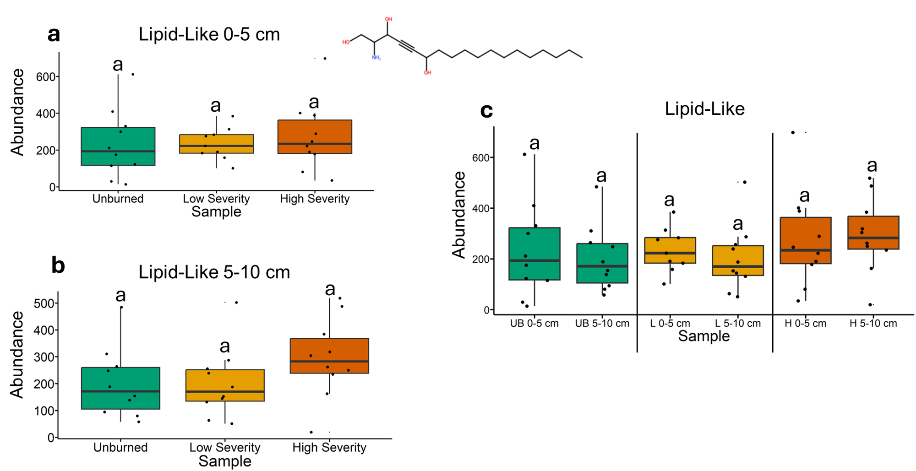
Fig. 72 | Quantification of a lipid-like compound abundances from liquid chromatography-mass spectrometry analysis. The statistical tests of a, b, and c were conducted independently of each other. a, Quantifying abundances across soils collected at a depth of 0-5 cm. Letters above boxes indicate significant differences (P<0.05) amongst sample types. n=10 for unburned, n=9 for low severity, and n=10 high severity samples. b, Quantifying abundances across soils collected at a depth of 5-10 cm. Letters above boxes indicate significant differences (P<0.05) amongst treatments. n=10 for unburned, low severity, and high severity samples. c, Quantifying abundances and comparing 0-5 cm soil depth with 5-10 cm soil depth. The statistical tests within sample types (i.e. unburned, low severity, and high severity) were conducted independently from each other. In other words, the “a” above “UB 0-5 cm” does not mean that there is no significant difference compared to “L 0-5 cm” which also has an “a” label because those statistical tests were conducted independently of each other. P<0.05 was the cutoff for significant differences. UB = unburned. L = low severity. H = high severity. n=10 for unburned 0-5 cm, unburned 5-10 cm, low severity 5-10 cm, high severity 0-5 cm, and high severity 5-10 cm samples. n=10 for low severity 0-5 cm samples. Box plots show the median (central line), first and third quartiles (box edges), and whiskers extending to minimum and maximum values within 1.5 times the interquartile range. Smaller black dots (not the data points) indicate where the data points would lie if the data points weren’t jittered. The chemical structure was copied from SIRUIS software (Version 6.2.2).

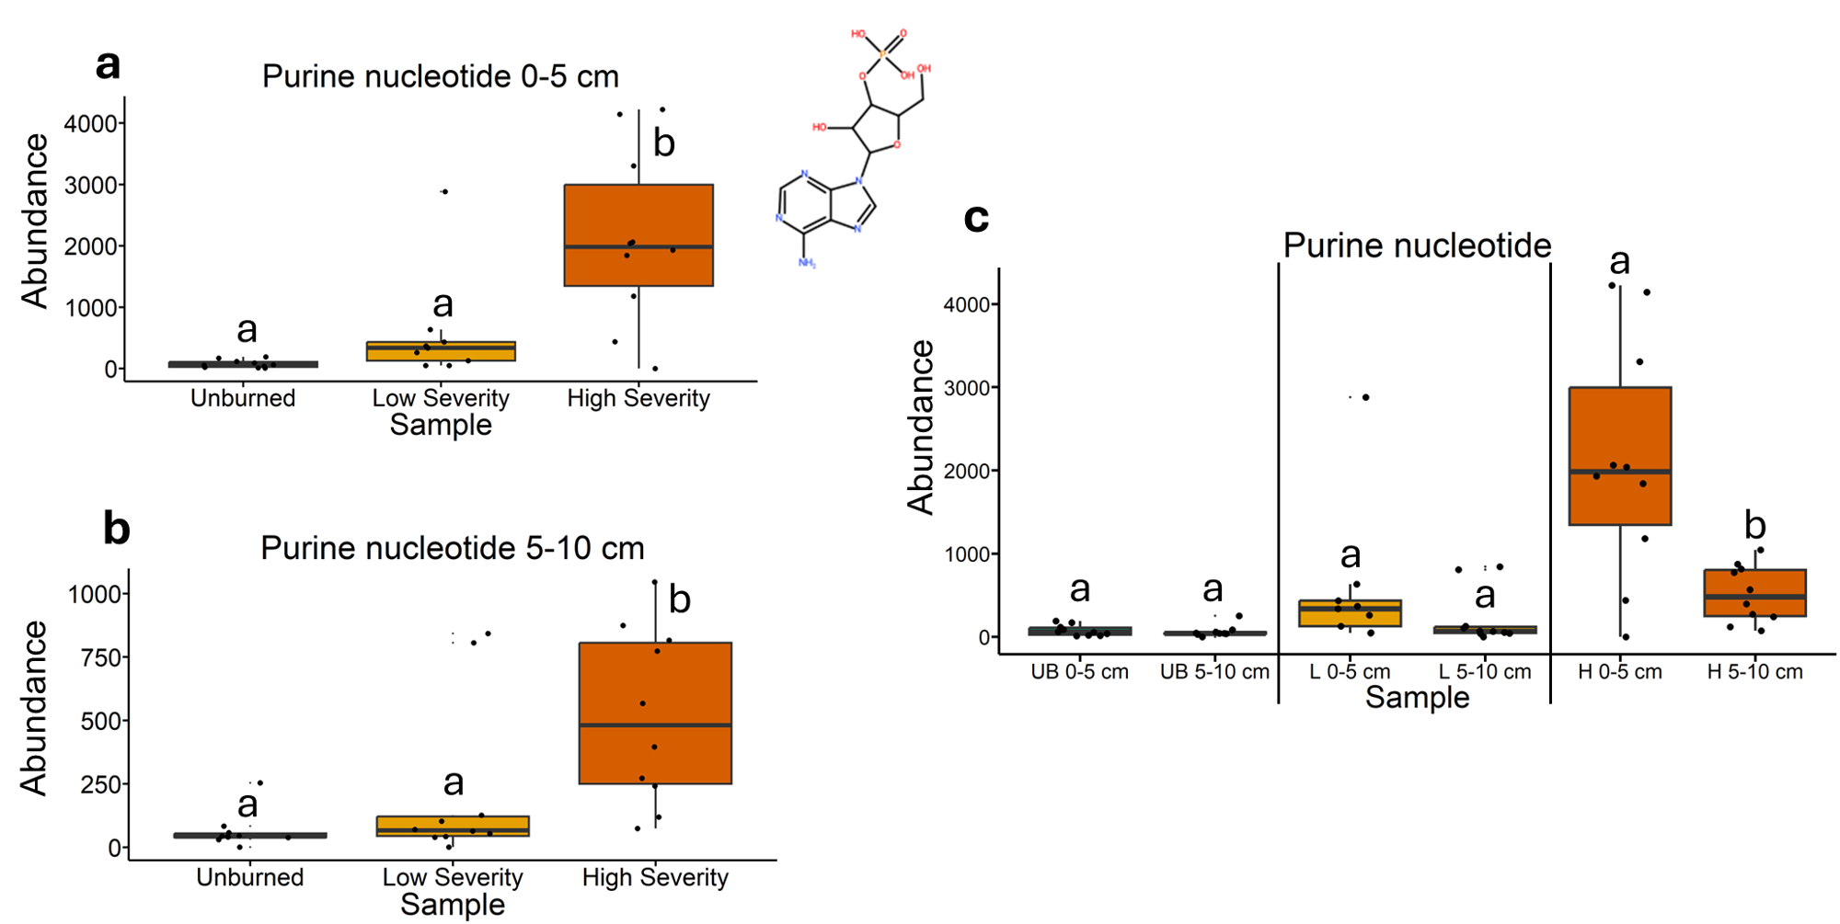
Fig. 73 | Quantification of a purine nucleotide compound abundances from liquid chromatography-mass spectrometry analysis. The statistical tests of a, b, and c were conducted independently of each other. a, Quantifying abundances across soils collected at a depth of 0-5 cm. Letters above boxes indicate significant differences (P<0.05) amongst sample types. n=10 for unburned, n=9 for low severity, and n=10 high severity samples. b, Quantifying abundances across soils collected at a depth of 5-10 cm. Letters above boxes indicate significant differences (P<0.05) amongst treatments. n=10 for unburned, low severity, and high severity samples. c, Quantifying abundances and comparing 0-5 cm soil depth with 5-10 cm soil depth. The statistical tests within sample types (i.e. unburned, low severity, and high severity) were conducted independently from each other. In other words, the “a” above “UB 0-5 cm” does not mean that there is no significant difference compared to “L 0-5 cm” which also has an “a” label because those statistical tests were conducted independently of each other. P<0.05 was the cutoff for significant differences. UB = unburned. L = low severity. H = high severity. n=10 for unburned 0-5 cm, unburned 5-10 cm, low severity 5-10 cm, high severity 0-5 cm, and high severity 5-10 cm samples. n=10 for low severity 0-5 cm samples. Box plots show the median (central line), first and third quartiles (box edges), and whiskers extending to minimum and maximum values within 1.5 times the interquartile range. Smaller black dots (not the data points) indicate where the data points would lie if the data points weren’t jittered. The chemical structure was copied from SIRUIS software (Version 6.2.2).

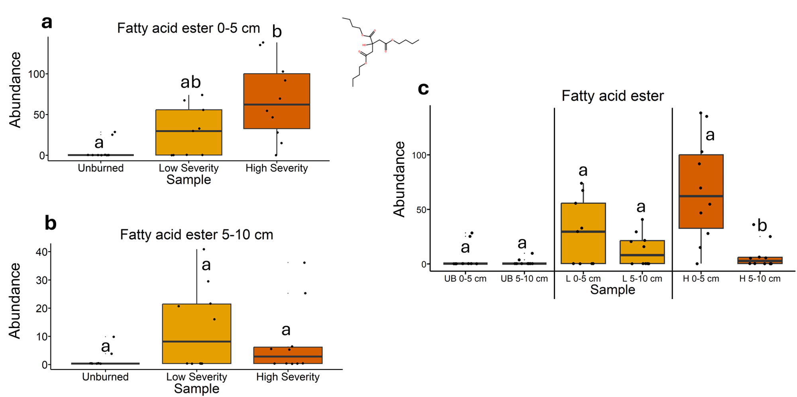
Fig. 74 | Quantification of a fatty acid ester compound abundances from liquid chromatography-mass spectrometry analysis. The statistical tests of a, b, and c were conducted independently of each other. a, Quantifying abundances across soils collected at a depth of 0-5 cm. Letters above boxes indicate significant differences (P<0.05) amongst sample types. n=10 for unburned, n=9 for low severity, and n=10 high severity samples. b, Quantifying abundances across soils collected at a depth of 5-10 cm. Letters above boxes indicate significant differences (P<0.05) amongst treatments. n=10 for unburned, low severity, and high severity samples. c, Quantifying abundances and comparing 0-5 cm soil depth with 5-10 cm soil depth. The statistical tests within sample types (i.e. unburned, low severity, and high severity) were conducted independently from each other. In other words, the “a” above “UB 0-5 cm” does not mean that there is no significant difference compared to “L 0-5 cm” which also has an “a” label because those statistical tests were conducted independently of each other. P<0.05 was the cutoff for significant differences. UB = unburned. L = low severity. H = high severity. n=10 for unburned 0-5 cm, unburned 5-10 cm, low severity 5-10 cm, high severity 0-5 cm, and high severity 5-10 cm samples. n=10 for low severity 0-5 cm samples. Box plots show the median (central line), first and third quartiles (box edges), and whiskers extending to minimum and maximum values within 1.5 times the interquartile range. Smaller black dots (not the data points) indicate where the data points would lie if the data points weren’t jittered. The chemical structure was copied from SIRUIS software (Version 6.2.2).

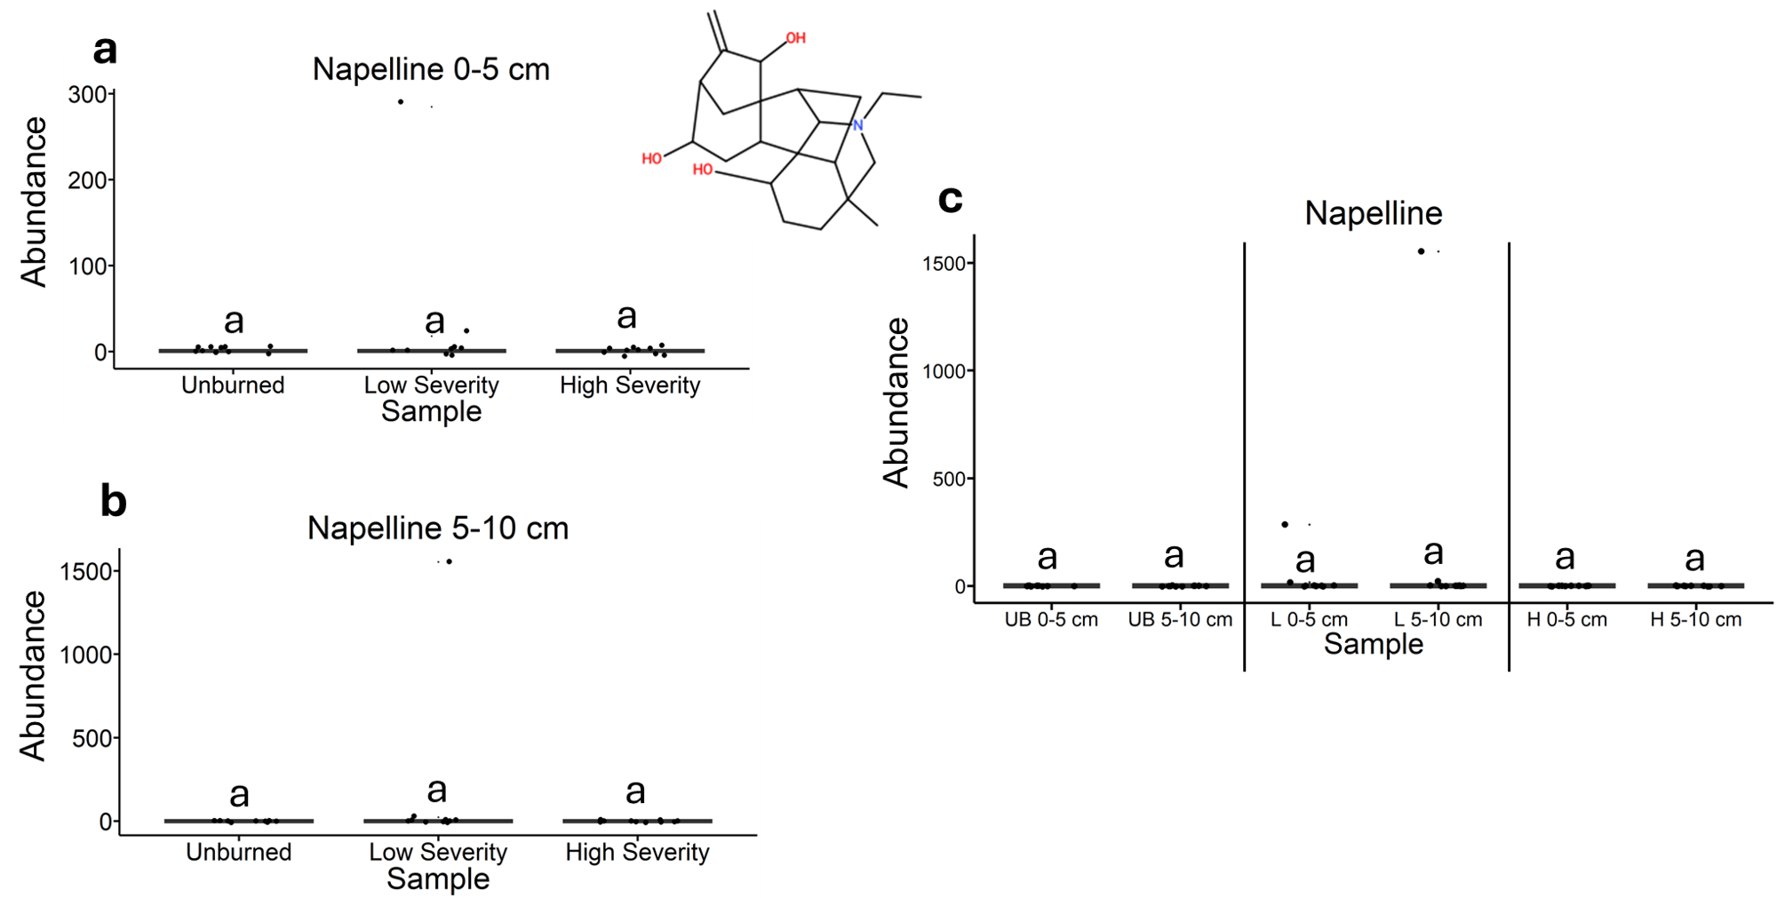
Fig. 75 | Quantification of napelline abundances from liquid chromatography-mass spectrometry analysis. The statistical tests of a, b, and c were conducted independently of each other. a, Quantifying abundances across soils collected at a depth of 0-5 cm. Letters above boxes indicate significant differences (P<0.05) amongst sample types. n=10 for unburned, n=9 for low severity, and n=10 high severity samples. b, Quantifying abundances across soils collected at a depth of 5-10 cm. Letters above boxes indicate significant differences (P<0.05) amongst treatments. n=10 for unburned, low severity, and high severity samples. c, Quantifying abundances and comparing 0-5 cm soil depth with 5-10 cm soil depth. The statistical tests within sample types (i.e. unburned, low severity, and high severity) were conducted independently from each other. In other words, the “a” above “UB 0-5 cm” does not mean that there is no significant difference compared to “L 0-5 cm” which also has an “a” label because those statistical tests were conducted independently of each other. P<0.05 was the cutoff for significant differences. UB = unburned. L = low severity. H = high severity. n=10 for unburned 0-5 cm, unburned 5-10 cm, low severity 5-10 cm, high severity 0-5 cm, and high severity 5-10 cm samples. n=10 for low severity 0-5 cm samples. Box plots show the median (central line), first and third quartiles (box edges), and whiskers extending to minimum and maximum values within 1.5 times the interquartile range. Smaller black dots (not the data points) indicate where the data points would lie if the data points weren’t jittered. The chemical structure was copied from SIRUIS software (Version 6.2.2).

Fig. 76 | Quantification of azole abundances from liquid chromatography-mass spectrometry analysis. The statistical tests of a, b, and c were conducted independently of each other. a, Quantifying abundances across soils collected at a depth of 0-5 cm. Letters above boxes indicate significant differences (P<0.05) amongst sample types. n=10 for unburned, n=9 for low severity, and n=10 high severity samples. b, Quantifying abundances across soils collected at a depth of 5-10 cm. Letters above boxes indicate significant differences (P<0.05) amongst treatments. n=10 for unburned, low severity, and high severity samples. c, Quantifying abundances and comparing 0-5 cm soil depth with 5-10 cm soil depth. The statistical tests within sample types (i.e. unburned, low severity, and high severity) were conducted independently from each other. In other words, the “a” above “UB 0-5 cm” does not mean that there is no significant difference compared to “L 0-5 cm” which also has an “a” label because those statistical tests were conducted independently of each other. P<0.05 was the cutoff for significant differences. UB = unburned. L = low severity. H = high severity. n=10 for unburned 0-5 cm, unburned 5-10 cm, low severity 5-10 cm, high severity 0-5 cm, and high severity 5-10 cm samples. n=10 for low severity 0-5 cm samples. Box plots show the median (central line), first and third quartiles (box edges), and whiskers extending to minimum and maximum values within 1.5 times the interquartile range. Smaller black dots (not the data points) indicate where the data points would lie if the data points weren’t jittered. The chemical structure was copied from SIRUIS software (Version 6.2.2).

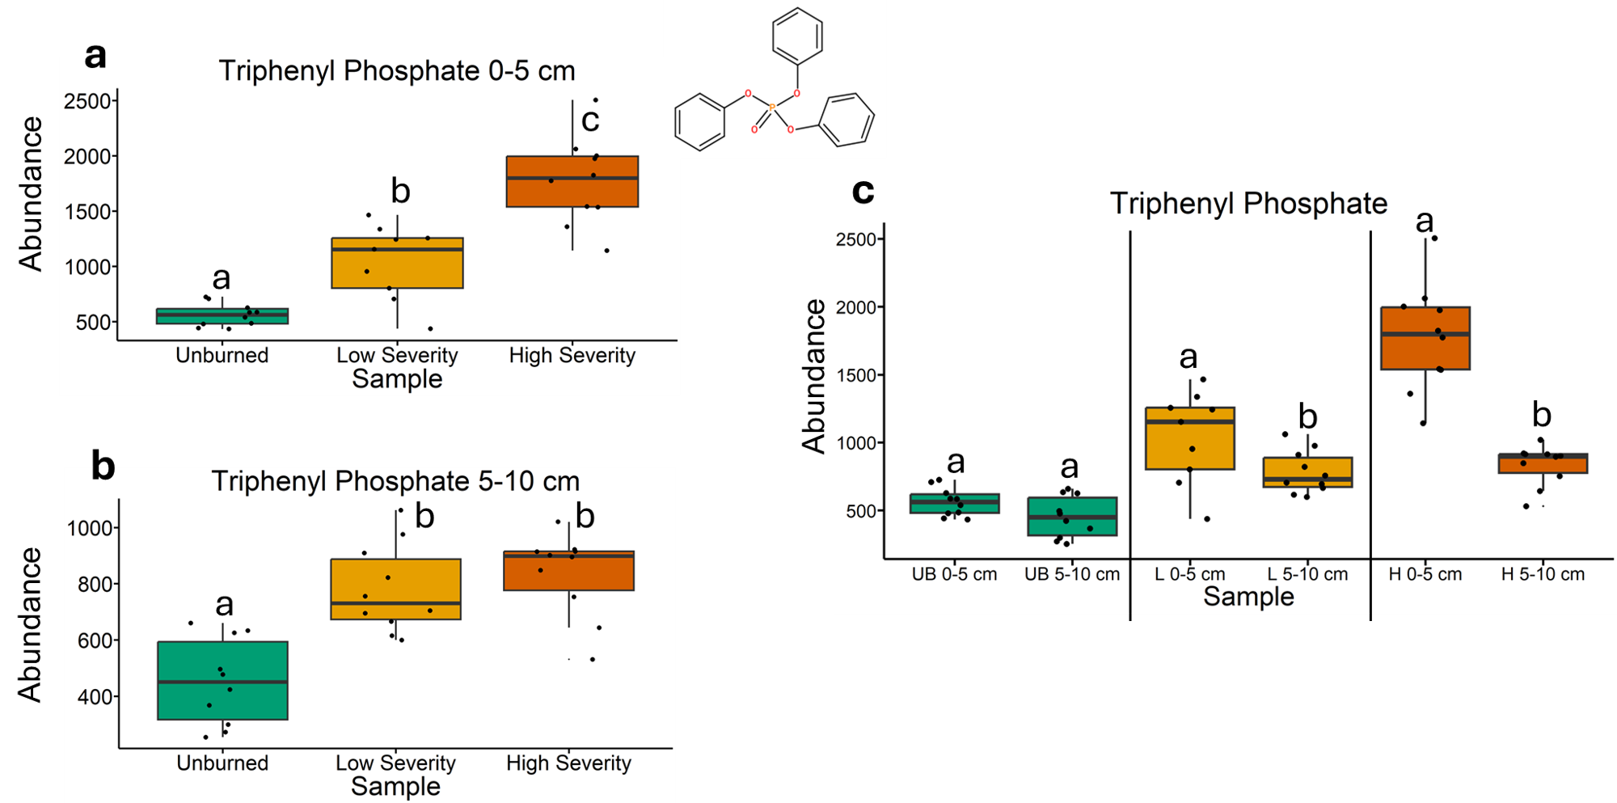
Fig. 77 | Quantification of triphenyl phosphate abundances from liquid chromatography-mass spectrometry analysis. The statistical tests of a, b, and c were conducted independently of each other. a, Quantifying abundances across soils collected at a depth of 0-5 cm. Letters above boxes indicate significant differences (P<0.05) amongst sample types. n=10 for unburned, n=9 for low severity, and n=10 high severity samples. b, Quantifying abundances across soils collected at a depth of 5-10 cm. Letters above boxes indicate significant differences (P<0.05) amongst treatments. n=10 for unburned, low severity, and high severity samples. c, Quantifying abundances and comparing 0-5 cm soil depth with 5-10 cm soil depth. The statistical tests within sample types (i.e. unburned, low severity, and high severity) were conducted independently from each other. In other words, the “a” above “UB 0-5 cm” does not mean that there is no significant difference compared to “L 0-5 cm” which also has an “a” label because those statistical tests were conducted independently of each other. P<0.05 was the cutoff for significant differences. UB = unburned. L = low severity. H = high severity. n=10 for unburned 0-5 cm, unburned 5-10 cm, low severity 5-10 cm, high severity 0-5 cm, and high severity 5-10 cm samples. n=10 for low severity 0-5 cm samples. Box plots show the median (central line), first and third quartiles (box edges), and whiskers extending to minimum and maximum values within 1.5 times the interquartile range. Smaller black dots (not the data points) indicate where the data points would lie if the data points weren’t jittered. The chemical structure was copied from SIRUIS software (Version 6.2.2).

