Lab 2 Cover Letter

Option B:

For option B I implemented the code I had developed for option D. This includes the 16 bit blocking and taking keys from files. This time I implemented a server to accept a client public key, and respond with a file containing an encrypted message and hash of the message which I encrypted with the clients public key. The client would then decrypt the message. Note: The N, D, and E values are displayed on screen and are concurrent with the requested keys to be used for the B option.

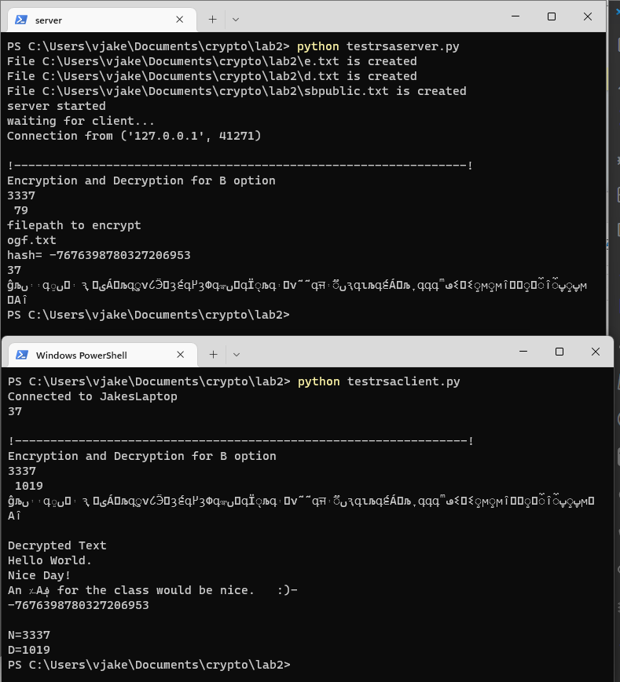

Option C:

For option C I created a program that would store the test values inside of individual files. Then it would take the values from a file and run a calculation to find phi of n and whether phi of n and e are coprime (relatively prime).

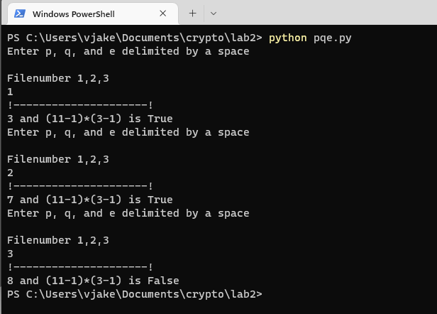

Option D:

For the D option I was stored the public key in testpublic.txt and the private key in testprivate.txt. The program would retrieve keys from those key files. I was also able to implement 16 bit blocking for the D and B options. To do this I calculated the largest value 16bits could hold, then created a running total that would accumulate the integer value of each character and append the characters into an array. When the running total exceeded the N value, that array would be defined as a single block and padded to 16bit. Then I would encrypt by each block. 