**ChurchTrac Budget Report Production Instructions**

From ChurchTrac, go to accounting / budgets, select the desired budget and ending date, then from budget reports, choose budget vs actual and press “Export as csv”. It will save a file named export.csv (or possibly export(n).csv if one is already present)

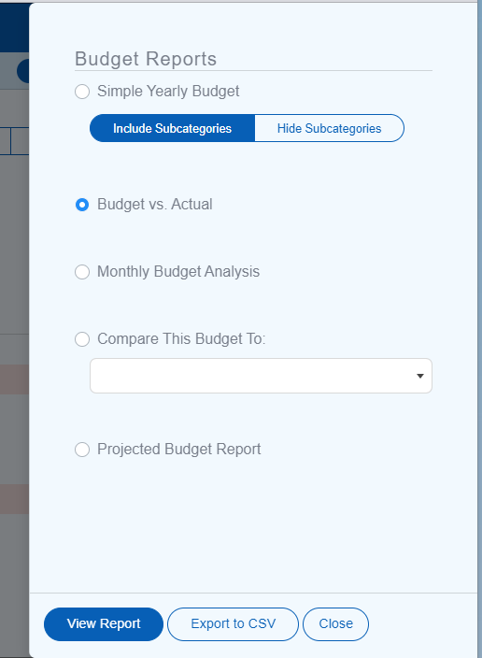

Navigate to <https://www.spiritofpeacecommunity.org/tools/>

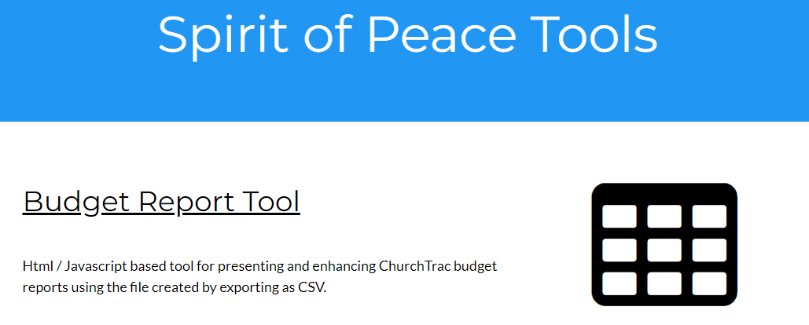

Select Budget Report Tool. It will open in a browser and look something like this. Note that the browser tries to remember the Page Heading and most of the checkboxes that were used in the most recent “(re)Display”.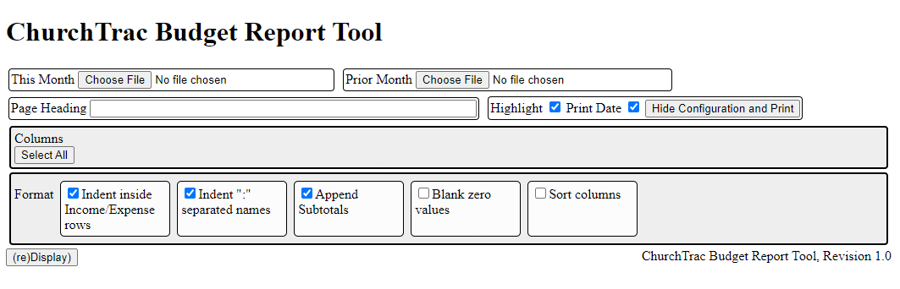Click “Choose File” for “**This Month**”, and a file open dialog will appear. Navigate to Downloads if not already there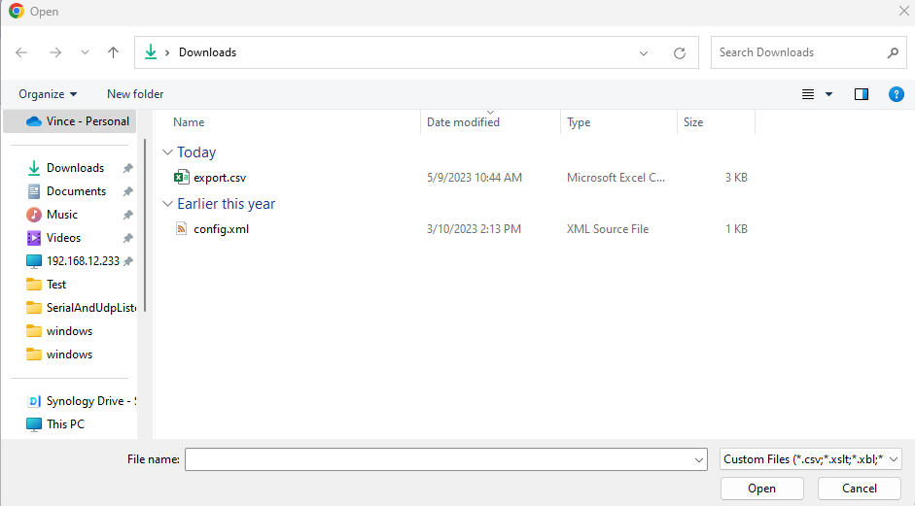

You can rename it from here by right clicking and selecting rename from the context menu.

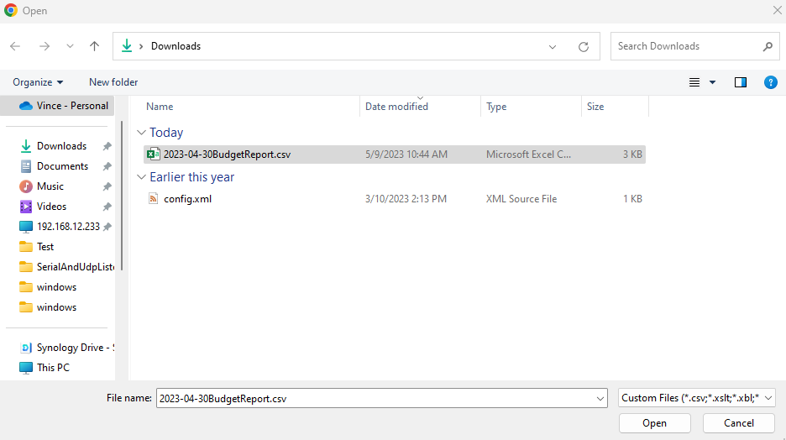

Rename the file. Our naming convention is yyyy-mm-ddContentName. Note that the report title is derived from the filename, and is intended to allow correlating it to the origin csv file (which should be saved along with other reporting artifacts) Select the renamed file and press “Open”

The report tool display will refresh showing the columns contained in the csv file.

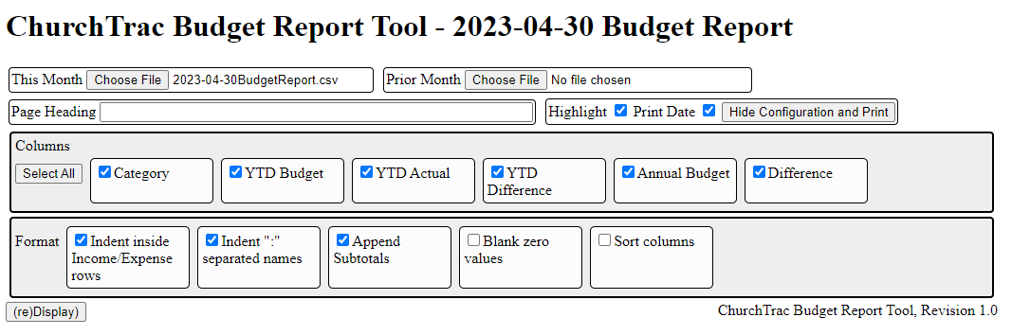

If you want values for the current month, you can do so by clicking “Choose File” for “**Prior Month**”,

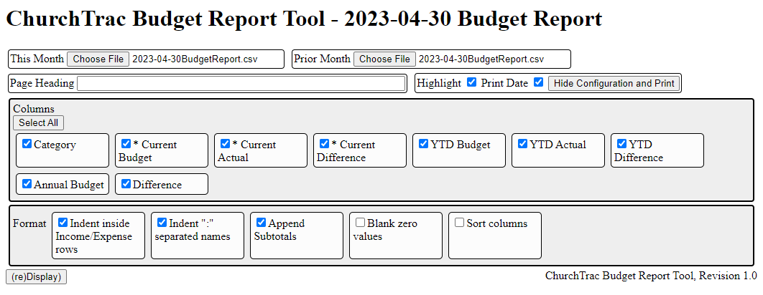

**The current month Budget / Actual / Difference columns are now available for the report**

Creating Report

* Check the boxes for the columns that you want in the report, and the format features you want to use.
* Enter a page heading, such as the church name and address.
* Check the Highlight box to have under-budget income and over-budget expenses highlighted
* Check the Print Date box if you want the printed date in the report
* Press (re)Display to see the report. You may experiment by checking / unchecking various selections and redisplaying using the modified configuration.

Saving PDF version of report

* Press “Hide Configuration and Print” and you will get a print dialog allowing you to print only the report part of what you see.
* **NOTE** the background coloring will only appear in the PDF file if “More Settings->Background Graphics” is check marked.
* Choose the destination “Save as PDF” and press “Save”.
* Browse to destination location and specify filename to save.