Santos Velasco

Dr. Lehr

CSC17B

Instructions to run code on xammp.

1. Start apache server and mysql server
2. Create a new database called “velasco” (all lowercase)
3. Import into the “velasco” database the SQL file “velasco.sql” that is found in the FINAL_PROJECTS folder.
4. Place the “FINAL_PROJECTS” folder in htdocs and load the files via localhost : enter into URL : localhost/FINAL_PROJECTS/

**GROUP PROJECT – ZELDA**

Santos Velasco Github.com/jacobvelasco91

I assisted to create the landing page. This landing page encompassed the login system, which included logging in and signing out. Concepts that were used were that of using *regular expression*s to check user input upon log in and sign-up, use of *PHP objects* to create a new user, and use of *cookies* to store the current user who logged in.

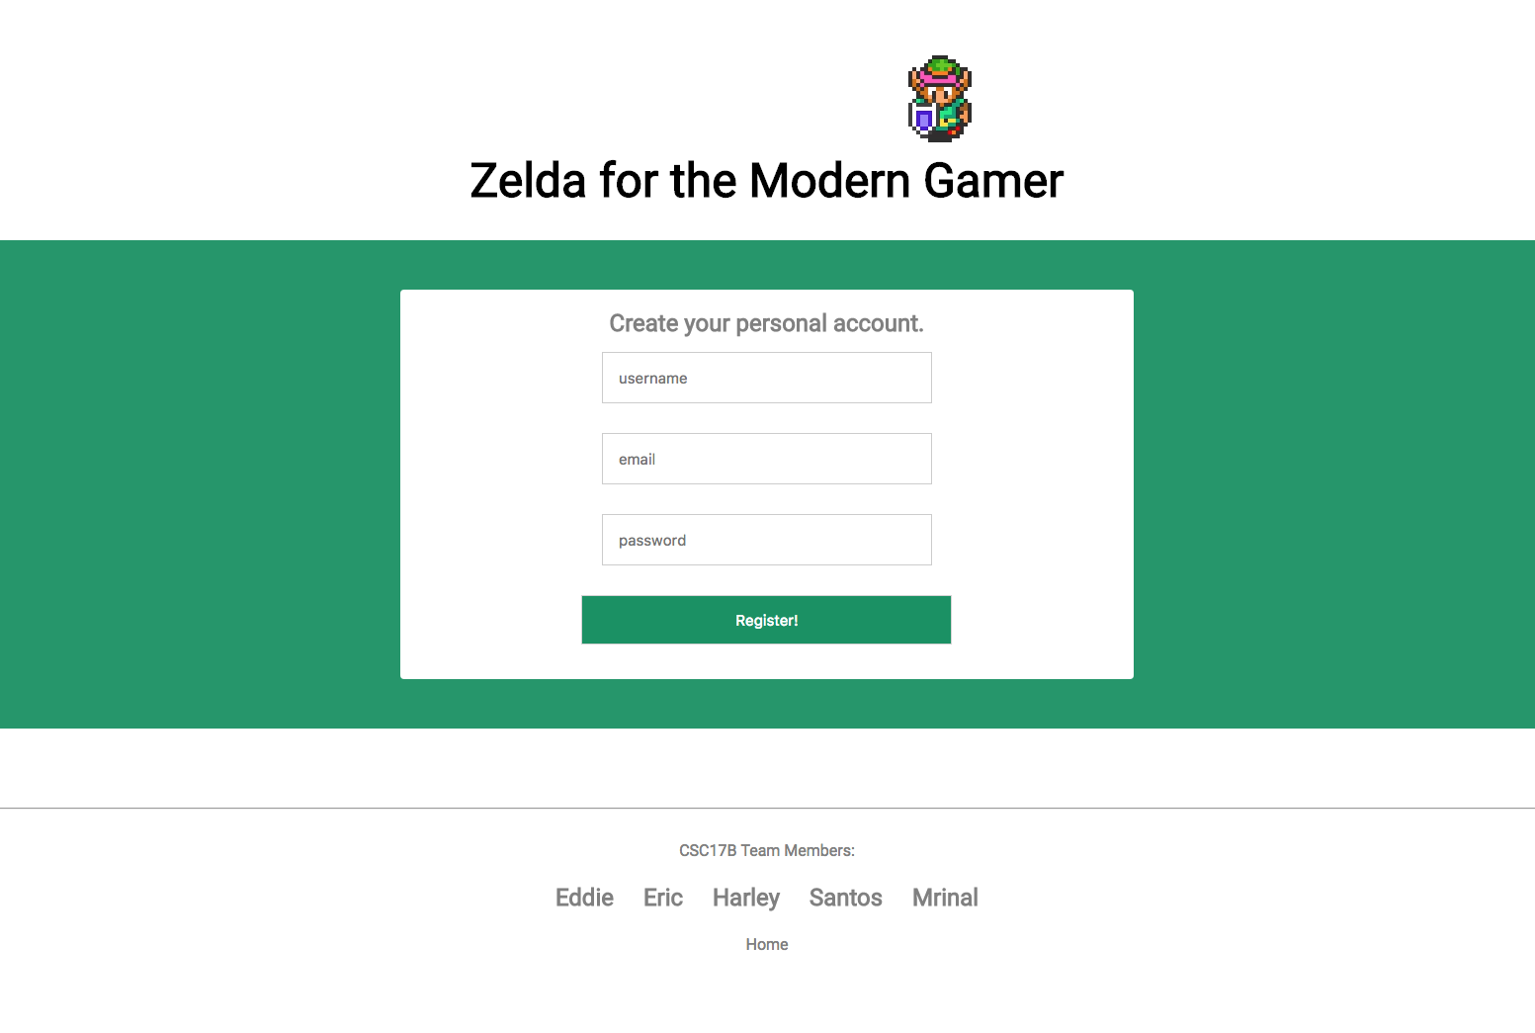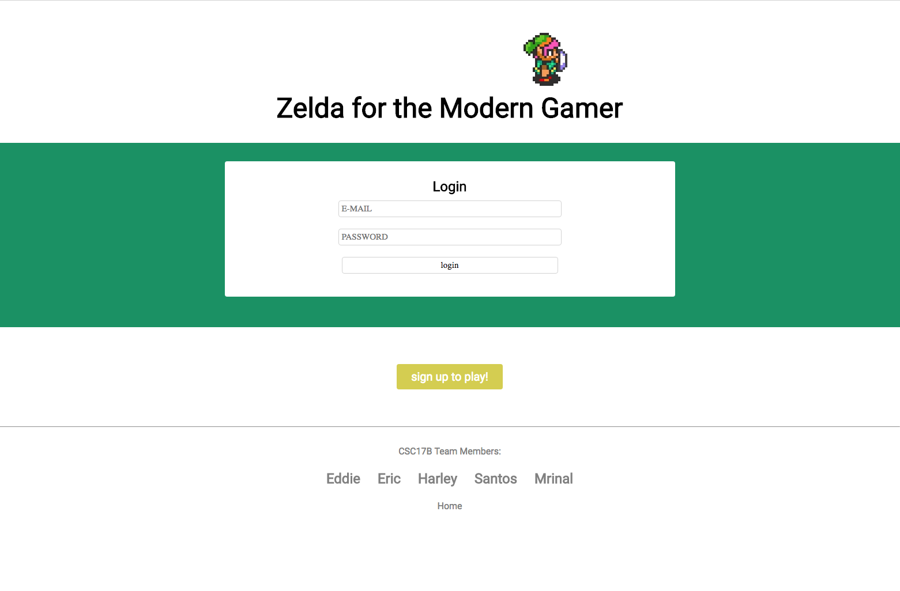

Shopping cart

*1) MVC - How you delineated your objects*

- this is found in shopping_cart ->include->classes : When I signed up new accounts I created an object to gather all their information, sanitized and ready for database insert. Also I created product objects to display.

- this is seen in the admin side of the shopping_cart: **localhost/FINAL_PROJECTS/shopping_cart/admin.php**

when we add new products its adding new objects .

in files : signup.php line 75 & admin_add.php line 18

*4) Databases SQL - Identify Entities, Xref, and Enum Tables*

for the shopping cart I created three tables.

1 to store the user accounts

2 to store the users order

3 to store the users current order

*5) Form Validation - Reqular Expressions*

regular expressions were used in file signup.php on lines 21,32,44,56 to make sure that user input was according to the standard I set.

*6) User-Admin-Login*

users can login from the button displayed at each home page. Admin featuers are added in this shopping_cart project only.

The admin uses the files:

admin_add.php

admin_delete.php

admin_edit.php

*7) Cookies - Sessions - Securing Pages*

the shopping cart uses sessions, as I thought it was easier to keep track of the user.

I have placed session_start() in the header file: head.php so that all my pages can have an active session.

A session for the user begins in file: login.php on line 13

That is the start of that users visit.

Once the user logs out, the session is destroyed. File : logout.php

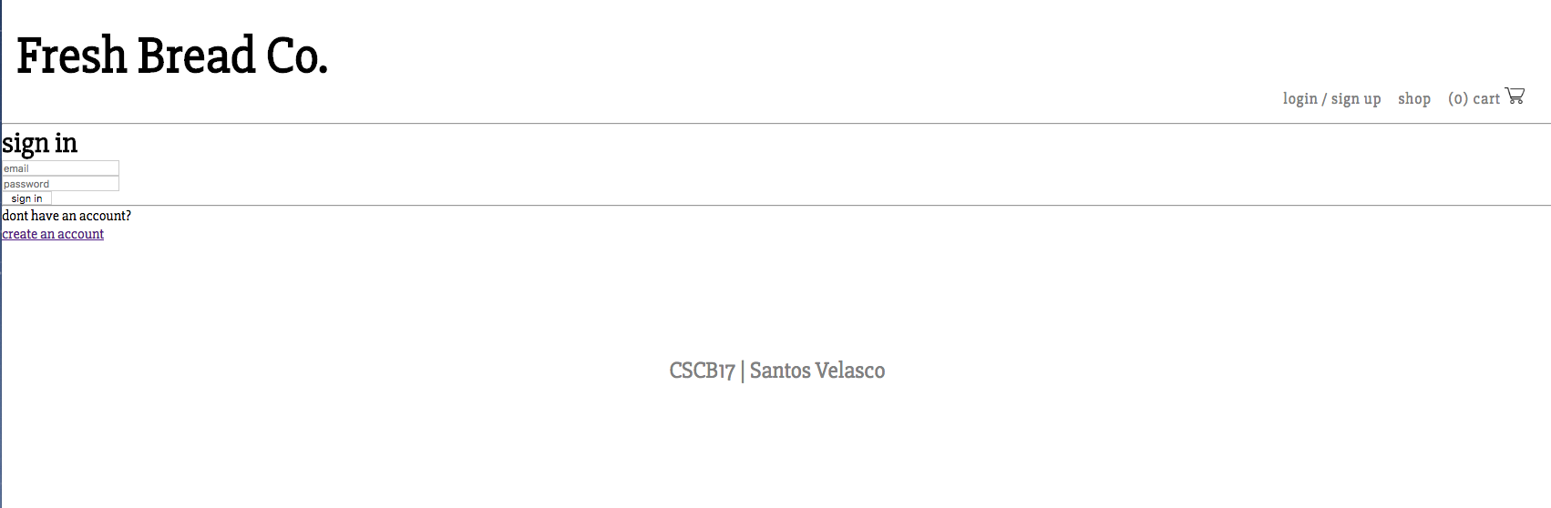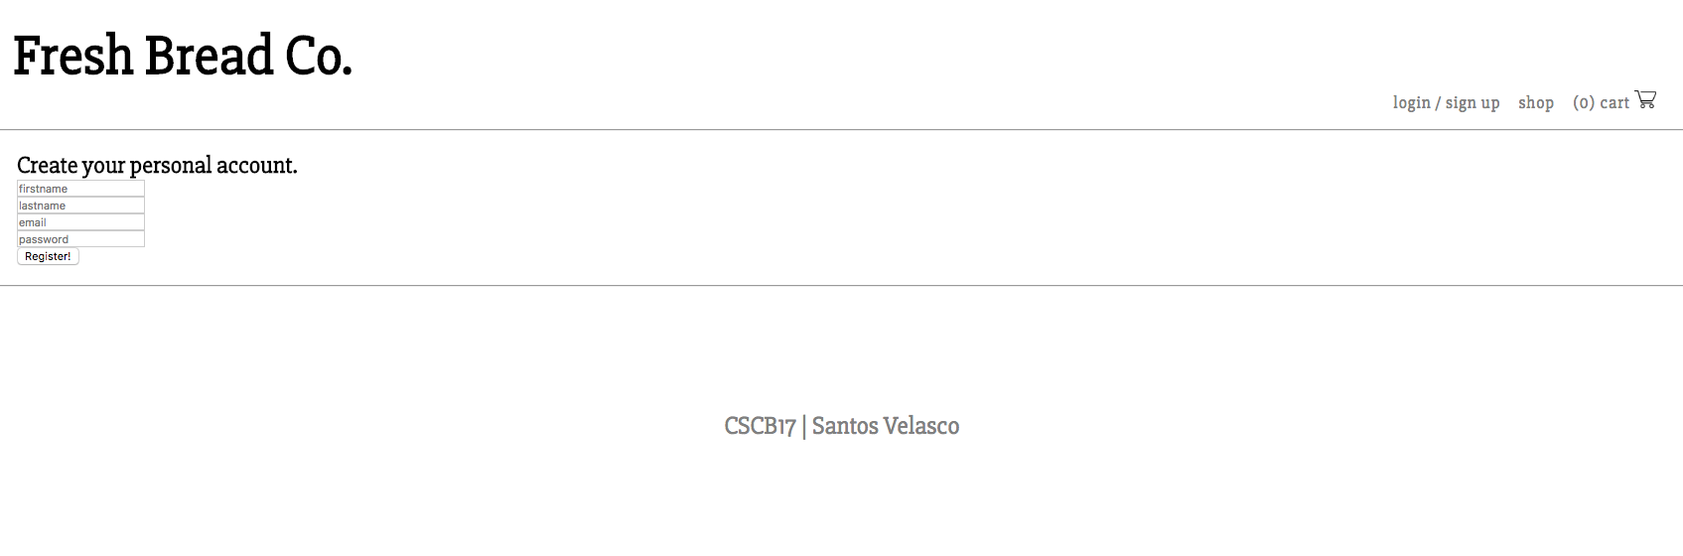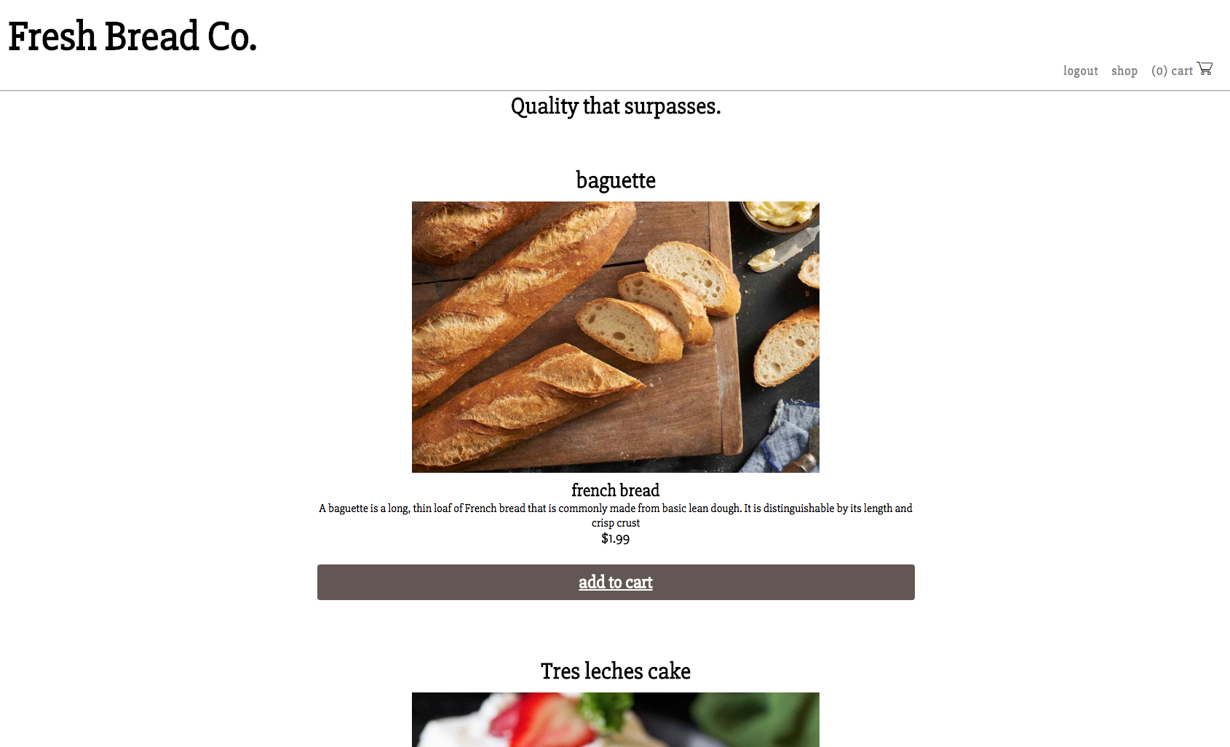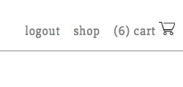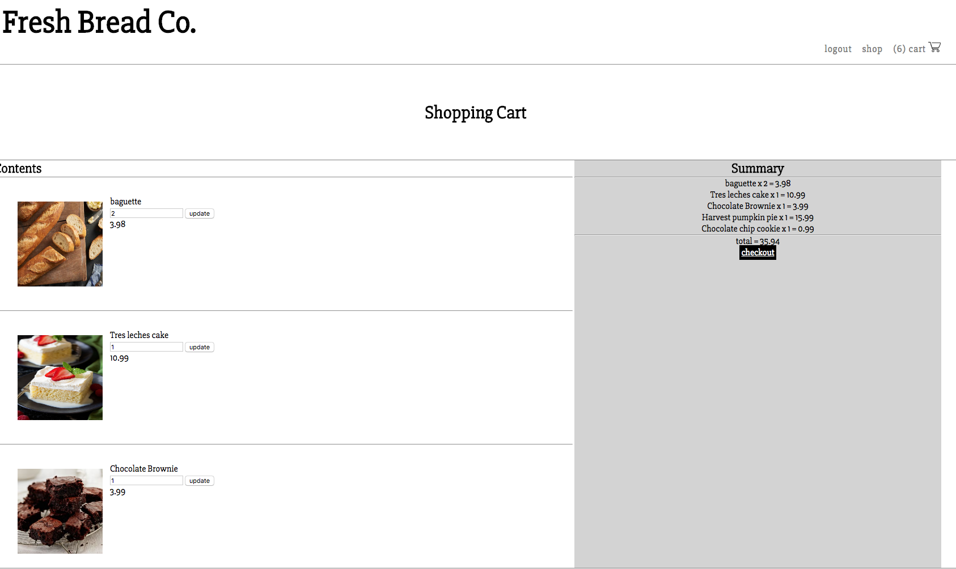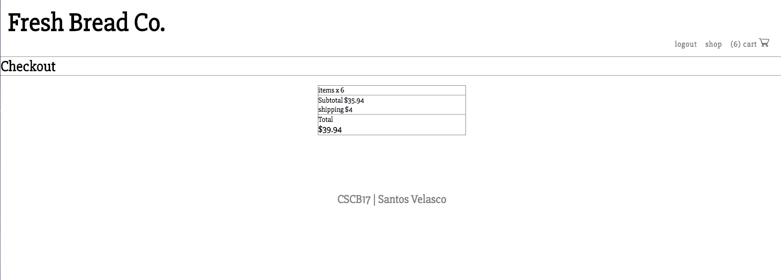

Survey

*1) MVC - How you delineated your objects*

the way that I used MVC was by making separating the logic from html output. I placed folder outside of the index.php and including certain files to make the logic work.

2) Objects - Javascript/PHP - Serialization

The way used the objects was by creating new users and placing them on the database

3) Reading/Writing Files/Local Storage

JSON – Javascript

The way that JSON was used in this project was by creating an two arrays one for the questions and one for the answers then I encoded them in JSON strings to store into the database.

File : createSurvey.php line 54-62

Then in file : displaysurvey.php line 13-14 I was able to convert them back into arrays

4) Databases SQL - Identify Entities, Xref, and Enum Tables

for the survey I created 2 tables

s_accounts will hold the id for every user created

s_survey will hold every survey created

5) Form Validation - Reqular Expressions

javascript was used for regular expressions this time.

In file : index.php the form to login has a validation call to ‘validate()’ the javascript file is : valLogin.js

7) Cookies - Sessions - Securing Pages

A session for the user begins in file: login.php on line 14

That is the start of that users visit.

Once the user logs out, the session is destroyed. File : logout.php

