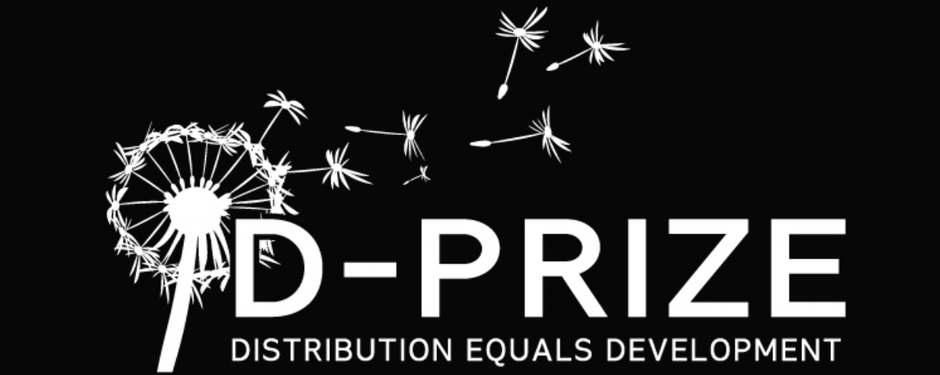

Name: D-Prize
Organization website
Location: US
Founded in: 2013
Team size: 2 (10 volunteers)
2020 Funding: $1.2M

Purpose
D-Prize seeds new ventures scaling access to evidence-based poverty interventions.
Many solutions to poverty already exist. The challenge is distributing to the people who need them most. Our work identifies effective interventions, then activates new entrepreneurs to scale delivery where distribution gaps exist.
Impact
Since 2013, D-Prize has used seed support to help activate more than 200 social ventures and NGOs. Every six months 1700+ teams apply to our global competition, and about 1-1.5% are selected for startup support.
Ventures we support consistently achieve early-stage scale. 13% have grown to serve at least 100K people within their first five years, or are on track to reach this milestone. Cumulatively the network has delivered more than a dozen proven poverty interventions and reached 5.3M people.
Our marginal impact comes from helping new leaders build organizations that we believe otherwise wouldn’t find support. 80% of ventures we award have raised less than $5K when we partner. We support talented people from across the globe, but especially target leaders operating in their home geography. 90% of the ventures we support have founders local to a developing region. 40% are female-founded.
Current Prizes
HEALTH ACCESS
- SELF-INJECTABLE CONTRACEPTIVE: distribute a self-injectable contraceptive to underserved women
- OXYGEN: service and repair existing oxygen concentrators
- PATIENT IDENTIFICATION: identify patients needing treatment then connect them with existing treatment services
- MATERNAL HEALTH: train birth attendants to prevent maternal deaths from postpartum hemorrhaging
- VOLUNTARY MEDICAL MALE CIRCUMCISION: identify voluntary candidates to reduce the risk of HIV acquisition
- PREVENTION OF MOTHER-TO-CHILD TRANSMISSION: counsel and motivate HIV-positive pregnant women
- CHILD IMMUNIZATION: direct caregivers to bring their infants to health facilities for routine immunizations
- SUGAR DADDY AWARENESS: teach “sugar daddy awareness” to 8th grade classes to reduce unwanted teen pregnancies
CLEAN WATER
- CHLORINE DISPENSER: install and promote community chlorine dispensers to increase access to clean water
EDUCATION
- TEACHING AT THE RIGHT LEVEL: teach basic reading and mathematics skills to primary school students
AGRICULTURE
- QUALITY INPUTS: provide smallholder farmers high-quality inputs and training
- POST-HARVEST SUPPORT: provide smallholder farmers post-harvest loans and storage technology
- PROPOSE YOUR OWN AGRICULTURE: highly-effective intervention that is backed by credible evidence
- PROPOSE YOUR OWN LIVESTOCK: highly-effective intervention that is backed by credible evidence
LIVELIHOODS
- POVERTY GRADUATION: provide business coaching, capital, and social support to lift people out of ultra poverty
- PROPOSE YOUR OWN FINANCIAL INCLUSION: highly-effective intervention backed by credible evidence
ENERGY
- SOLAR LAMP: sell pico solar lamps to rural or slum-dwelling households without regular access to electricity
PUBLIC SERVICES
- GOVERNMENT TRANSPARENCY: monitor and report data to reduce corruption and improve public service
- ROAD SAFETY: reduce road fatalities by mobilizing the public with a proven public transportation safety campaign
CUSTOM
- PROPOSE YOUR OWN: highly-effective intervention that is backed by credible evidence

