Candy Cane Fudge Cookies | Coconut Butter Gingersnaps | Oatmeal Raisin
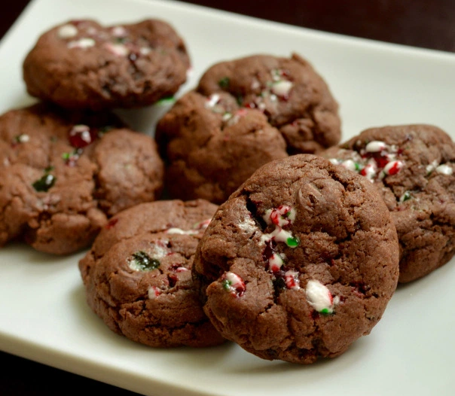 | 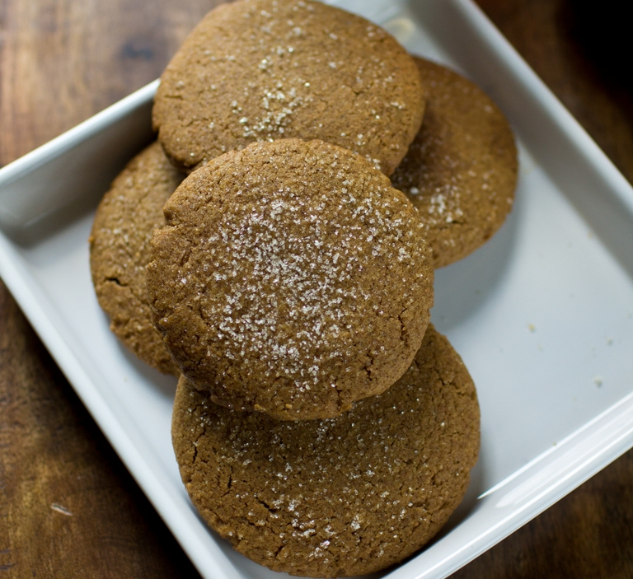 | 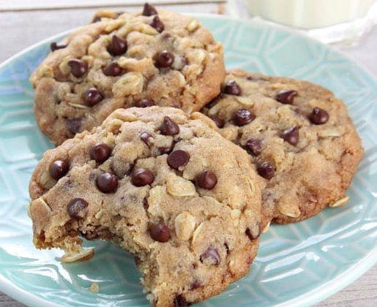
Something went horribly wrong and our cookies just spread out when we baked them. Instead of throwing them out we decided to go cookie balls. | We substituted whole wheat flour for the spelt flour 1:1. They definitely get better the day after baking. Next time probably increasing the ginger a bit. | We substituted raisins for the chocolate chips and only baked 10 minutes.
 |  | 

Candy Cane Fudge Cookies | Coconut Butter Gingersnaps | Oatmeal Raisin
Something went horribly wrong and our cookies just spread out when we baked them. Instead of throwing them out we decided to go cookie balls. | We substituted whole wheat flour for the spelt flour 1:1. They definitely get better the day after baking. Next time probably increasing the ginger a bit. | We substituted raisins for the chocolate chips and only baked 10 minutes.

