CHOZ
User Guide
Version 1.3.16 · Linux (ALSA / JACK / PipeWire)

About this document. This guide documents choz 1.3.18. It is written for the terminal application; choz's effects and its four artifacts (arpeggiator, step sequencer, metronome and arranger) are also published as a CLAP plugin for other hosts, and choz itself runs inside a DAW as a CLAP instrument — see section 2.5.
Screenshots were taken from choz running on Linux with the JACK/PipeWire backend. Device, bank and preset names in them belong to that installation and will differ on yours.
Contents
CHOZ 1
1. Welcome to choz 4
1.1 What choz is 4
1.2 About this guide 4
1.3 Document conventions 5
1.4 System requirements 5
1.5 Installing 5
1.6 What an uninstall leaves behind 6
1.7 Starting choz 6
1.8 Getting help 6
2. First steps 7
2.1 Play a SoundFont from a MIDI keyboard 7
2.2 Add an effect 7
2.3 Play choz from a DAW and record it back 8
2.4 Save the project 8
2.5 Run choz inside a DAW (REAPER) 8
3. choz overview 9
3.1 The screen 9
3.2 The menu bar and the transport cluster 9
3.3 The rack 10
3.4 The drawers 10
3.5 The bottom panel 10
3.6 The status line 10
3.7 Mouse, wheel and keyboard 10
4. Inputs and outputs 11
4.1 The IN drawer 11
4.2 choz MIDI IN 11
4.3 choz on the JACK/PipeWire graph 12
4.4 The OUT drawer 12
4.5 Audio inputs and the microphone 13
4.6 Direct outs 13
5. Instruments 14
5.1 The source picker 14
5.2 SoundFonts 15
5.3 SFZ and WAV 16
5.4 Banks and presets 16
5.5 Parameters, pages and search 16
5.6 The sampler 17
6. Effects 18
6.1 The catalogue 18
6.2 The chain 19
6.3 The built-in effects 20
6.4 Effect presets 20
6.5 Chord source and the gate 20
7. Plugins 22
7.1 Formats 22
7.2 Scanning and paths 25
7.3 A plugin's own window 25
7.4 Sandbox and quarantine 26
7.5 Plugin state in a project 27
8. Playing and MIDI 27
8.1 LIVE and MULTI 27
8.2 The monitor 28
8.3 MIDI learn 28
8.4 KEYS and panic 29
8.5 OSC 29
8.6 Clock 30
9. Arpeggiator, step sequencer and arranger 30
9.1 Arpeggiator 30
9.2 Step sequencer 31
9.3 Arranger 32
9.4 Chord charts 34
9.5 MIDI import and export 43
9.6 The arranger and the click 43
10. Transport, tempo and metronome 44
10.1 Transport 44
10.2 Metronome 44
10.3 TAP 45
11. Mixer, routing and views 46
11.1 The mixer 46
11.2 Groups and the main mix 46
11.3 Direct outs 47
11.4 The views 47
12. Projects 48
13. Preferences 49
13.1 Audio 49
13.2 Plugin paths 50
13.3 Theme and wallpaper 50
13.4 Language 51
14. Reference: keyboard shortcuts 52
15. Reference: environment variables and files 53
16. Troubleshooting 54
17. Glossary 55

1. Welcome to choz
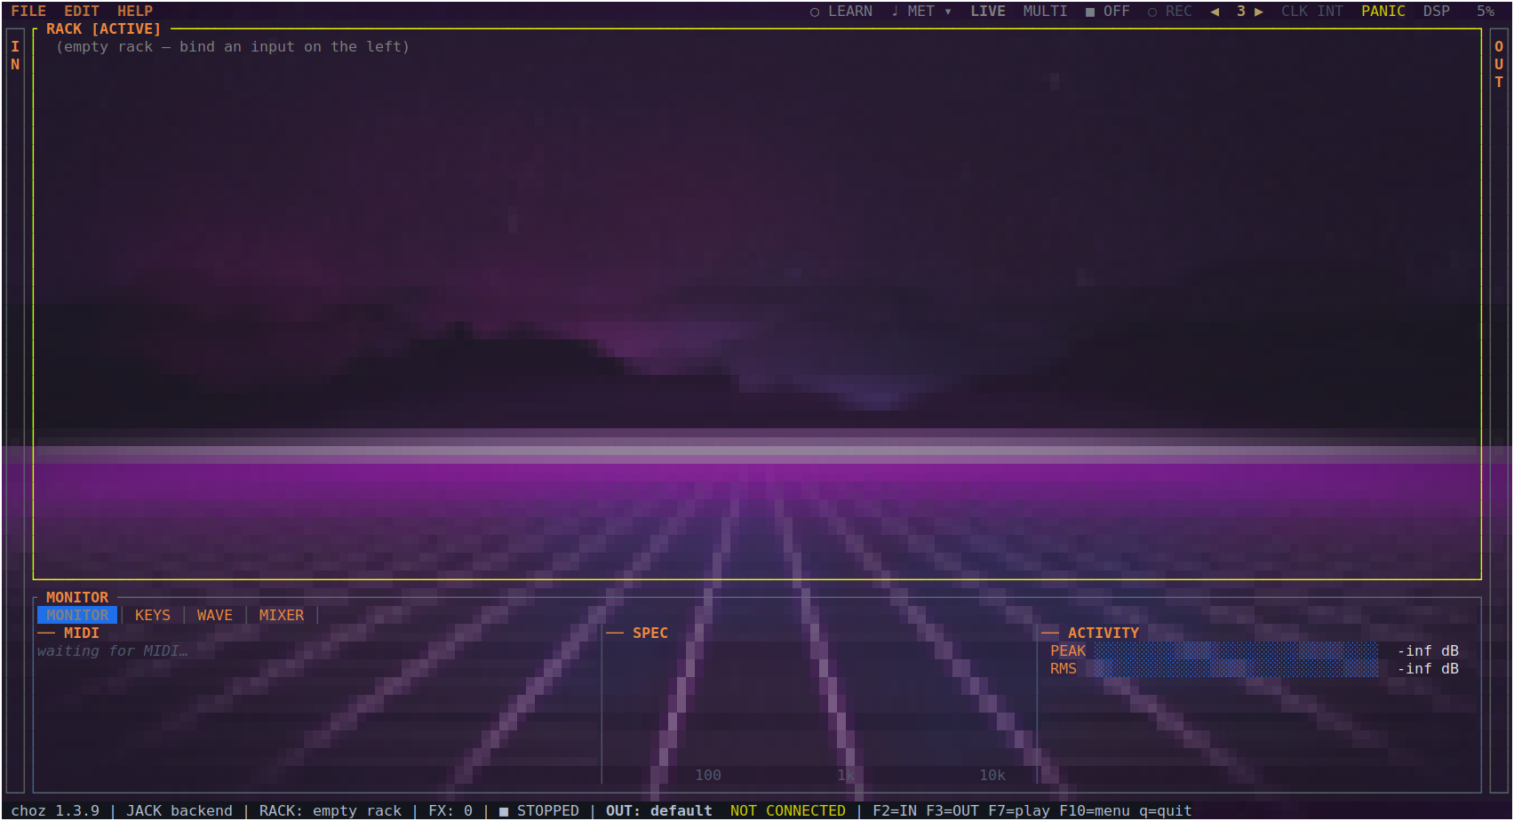
Figure 1.1 — choz just opened: the menu bar, an empty RACK, the IN and OUT drawers at the edges, and the MONITOR panel along the bottom.

1.1 What choz is
choz is an audio plugin host for the terminal. It gives you a rack of tabs; each tab takes notes or audio in, loads an instrument, chains effects onto it, and leaves either through the main mix or through a port of its own on the JACK/PipeWire graph.
- Instruments: SoundFont (SF2), SFZ, WAV, and CLAP, LV2, VST2, VST3, DSSI and LADSPA plugins, plus Pure Data patches.
- Effects: 56 of choz's own, plus every effect plugin installed on the machine, up to twelve per tab.
- Note sources: any MIDI port, choz's own ALSA and JACK ports, OSC, the computer keyboard, an arpeggiator and a step sequencer per tab, and audio-to-note tracking from a microphone.
- Outputs: the main stereo mix, four groups, and one direct out per tab for recording each tab on its own track in a DAW.

1.2 About this guide
Chapters 1 to 3 are the introduction: what choz needs, how to install it, and what is on the screen. Chapter 2 is a short walk-through that gets a sound out of it. Chapters 4 to 13 are the reference, one chapter per area of the program. Chapters 14 and 15 are lookup tables — shortcuts, environment variables, files. Chapter 16 collects the problems people actually hit, and chapter 17 is a glossary of the terms used throughout.

1.3 Document conventions
Convention | Meaning
BOLD CAPITALS | Something written on the screen: a button, a panel, a knob — MIXER, PANIC, SENS.
Monospace | Something you type, or a name outside choz: a command, a file, a port — choz:midi_in.
F2, Enter, a | A key to press. Capitals mean the shifted key: A is Shift+a.
→ | A path through menus: EDIT → Settings → THEME.
Note. Grey boxes like this one carry something worth knowing before it bites: a limit, an interaction with another program, or a setting that only takes effect on the next start.

1.4 System requirements
Requirement | Detail
System | Linux with glibc; x86-64, aarch64 or armv7
Audio | libasound.so.2 (required); libjack.so.0 (optional, opened at runtime — normally PipeWire's, from pipewire-jack)
Terminal | 24-bit colour, at least 80×24 — 120×40 to work comfortably. kitty, Ghostty and WezTerm also draw the wallpaper through the terminal's graphics protocol
Plugin windows | X11 or XWayland, and only to open a plugin's own window: every plugin parameter also appears as a knob in the rack
Privileges | rtprio and memlock (membership of the audio group) recommended for small buffers

1.5 Installing
# from a release (no toolchain needed)
tar xzf choz-1.3.18-x86_64-unknown-linux-gnu.tar.gz
cd choz-1.3.18-x86_64-unknown-linux-gnu
./install.sh

# from the repository
cargo build --release
./packaging/install.sh --binary target/release/choz
There are also .deb and .rpm packages, and an Arch PKGBUILD. All of them add a desktop entry under Audio, so choz can be started from the application menu as well as from a shell.
The install leaves four things besides the binary: choz.clap (choz's 56 effects plus the arpeggiator, the step sequencer, the metronome and the arranger, as CLAP plugins for other hosts), choz-rack.clap (choz itself as a CLAP instrument, section 2.5), the wallpapers, and — when libpd is present — the choz-pd-host binary that runs Pure Data patches.
Upgrading. install.sh lists what it is about to replace — the binaries with their --version, and ~/.clap/choz.clap and ~/.clap/choz-rack.clap — and asks before it does. --yes skips the question; run without a terminal (a script, CI) it replaces, as it always has.
Packages and old copies in ~/.clap. A CLAP host reads ~/.clap before /usr/lib/clap, so a bundle left there by an earlier install.sh hides the one a package installs and the host keeps running the old version. The .deb asks (debconf) whether to set those copies aside; the .rpm and the Arch package cannot ask and set them aside directly. Set aside means renamed to *.bak, which no host loads and which can be renamed back.
JACK. Current desktops run PipeWire with its JACK layer (pipewire-jack), which is all choz needs for the graph; jack2 works the same. Neither is required: without libjack choz runs on ALSA.

1.6 What an uninstall leaves behind
No uninstaller touches ~/.local/state/choz. Projects, plugin paths, scan caches and interface preferences live there and survive upgrades and removals; see section 15 for what each file holds.
Everything else goes. Removing the .deb, the .rpm or the Arch package removes /usr/lib/clap/choz.clap and /usr/lib/clap/choz-rack.clap with the program; install.sh --uninstall removes the binaries, the desktop files and both bundles from ~/.clap, and names each file as it goes.
- Left on purpose: ~/.local/state/choz (projects and settings).
- Left because it is yours: any *.clap.bak a package set aside in ~/.clap. Hosts do not load them; delete them by hand.
- Left by the host, not by choz: its plugin cache. Rescan plugins in the DAW so it forgets choz.

1.7 Starting choz
choz # an empty rack
choz project.yml # open a project
choz instrument.sf2 # load a file straight into a tab
choz --osc-port 9000 # pin the OSC port instead of letting the OS pick
choz --version # print the version and exit
choz --help # print the options and exit

1.8 Getting help
HELP → About choz shows the version and the build. The log at ~/.local/state/choz/choz.log is the first place to look when something goes wrong, and chapter 16 explains the messages that are worth acting on. Running choz from a terminal also prints its diagnostics to standard error as they happen.

2. First steps
This chapter gets a sound out of choz and back into a DAW. It assumes nothing has been configured.

2.1 Play a SoundFont from a MIDI keyboard
- Start choz. The rack is empty and says so.
- Press F2 to open the IN drawer. The note inputs are at the top: every MIDI port on the system, choz's own ports, and OSC.
- Move to your keyboard's port and press Enter. choz makes tab 1 and binds the port to it — the row says → tab 1.
- Press F2 again to close the drawer, then 1 to open the source picker.
- Type part of a SoundFont's name, or open the SF2 tab, and press Enter. The bank loads into the tab.
- Play. If nothing sounds, check the MONITOR panel at the bottom: it shows every MIDI message as it arrives, so it answers "is the keyboard reaching choz?" before you look anywhere else.
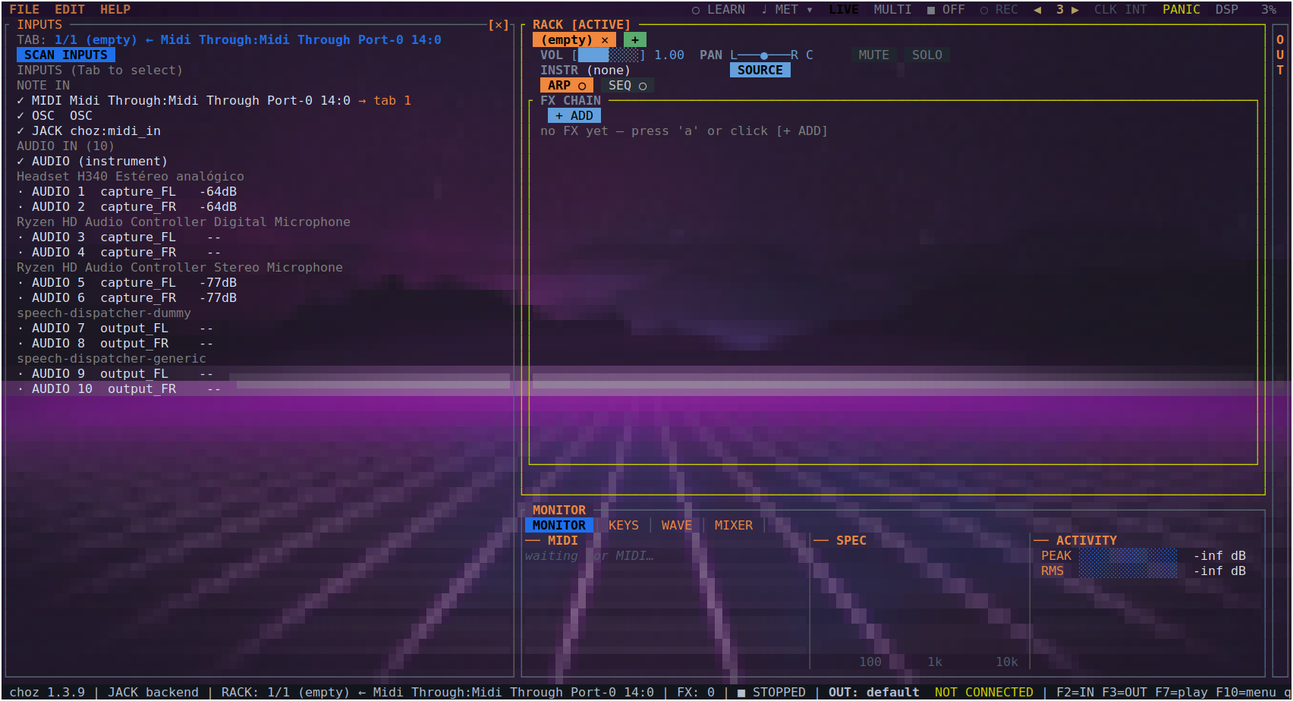
Figure 2.1 — Accepting the MIDI row: choz makes tab 1 and feeds it from that port.

2.2 Add an effect
- With the tab active, press a to open the effect catalogue.
- Pick a category on the left — REVERB, say — and an effect on the right. BUILT-IN at the top narrows the list to choz's own.
- Press Enter. The effect is added to the tab's chain with all of its knobs.
- Move between knobs with ↑ ↓, change one with the wheel or w/s, and switch the whole effect on or off with Space.

2.3 Play choz from a DAW and record it back
The usual round trip is: the DAW's MIDI out plays a choz tab, and choz's audio comes back into the DAW to be recorded.
- MIDI in. In your DAW's MIDI device list, pick choz MIDI IN as the track's output. choz publishes that ALSA port itself, so nothing else is needed — see section 4.2.
- Audio out. In choz, open EDIT → Settings → AUDIO and set the backend to JACK, then restart choz. It now has choz:out_1..N on the graph.
- Patch. With any patchbay (qpwgraph, Carla, jack_connect), wire choz:out_1 and choz:out_2 into the DAW's inputs, and arm a track on them.
- Per-tab tracks. To record several tabs separately, give each one its own direct out (section 4.6) and patch those instead of the main mix.
Note. On PipeWire, its JACK layer is enough — there is no need to start a separate jackd. The MIDI half of this round trip does not need the graph at all: choz MIDI IN is an ALSA sequencer port.

2.4 Save the project
Press F10, open FILE and choose Save as. A project is a readable YAML file that carries the rack, the routing, the effect chains, and the plugins' own state — the patch you chose in a plugin's browser comes back with the project.

2.5 Run choz inside a DAW (REAPER)
Section 2.3 runs choz beside the DAW and wires the two together. The other way is to put choz inside it: choz-rack.clap is the whole rack as a CLAP instrument on one track — its own window, every tab, and the project saved in the host's session.
REAPER
- Options → Preferences → Plug-ins → CLAP: make sure /usr/lib/clap (packages) or ~/.clap (install.sh) is on the path, and press Re-scan.
- Insert choz (choz) as a virtual instrument on a track. Its window is choz's interface, keyboard and mouse included.
- The track's MIDI reaches the rack as the host's note port: a tab set to listen to it (section 4.1) plays what the track sends.
- The track's audio arrives as host:in_1 / host:in_2, so a tab with that input processes it: the rack is an effect chain too.
- Sixteen stereo outputs. Put a tab on output pair 4 in the rack and it comes out of the plugin's fourth pair. In the FX chain, right-click the plugin → Build multichannel routing for output of selected FX to get a track per pair, the way a multi-out sampler is recorded.
- The rack is stored in the REAPER project; reopening the project reopens the rack.
Note. The embedded rack keeps its own tempo, time signature and play state: it takes notes and MIDI from the host but not the host's transport. Set choz's tempo (TAP, or the metronome's menu) to the session's. The plugins in choz.clap — effects, arpeggiator, sequencer, metronome and arranger as separate plugins — do follow the host's transport. Only one rack runs per process.

If REAPER shows an old version. A copy of choz-rack.clap or choz.clap in ~/.clap wins over /usr/lib/clap. Remove or rename it, quit REAPER completely (the old one is loaded in memory) and re-scan.

3. choz overview

3.1 The screen
The screen has four fixed areas: the menu bar along the top, the RACK in the middle, the IN and OUT drawers at the left and right edges, and the MONITOR / KEYS / WAVE / MIXER panel along the bottom. The last line is the status line.
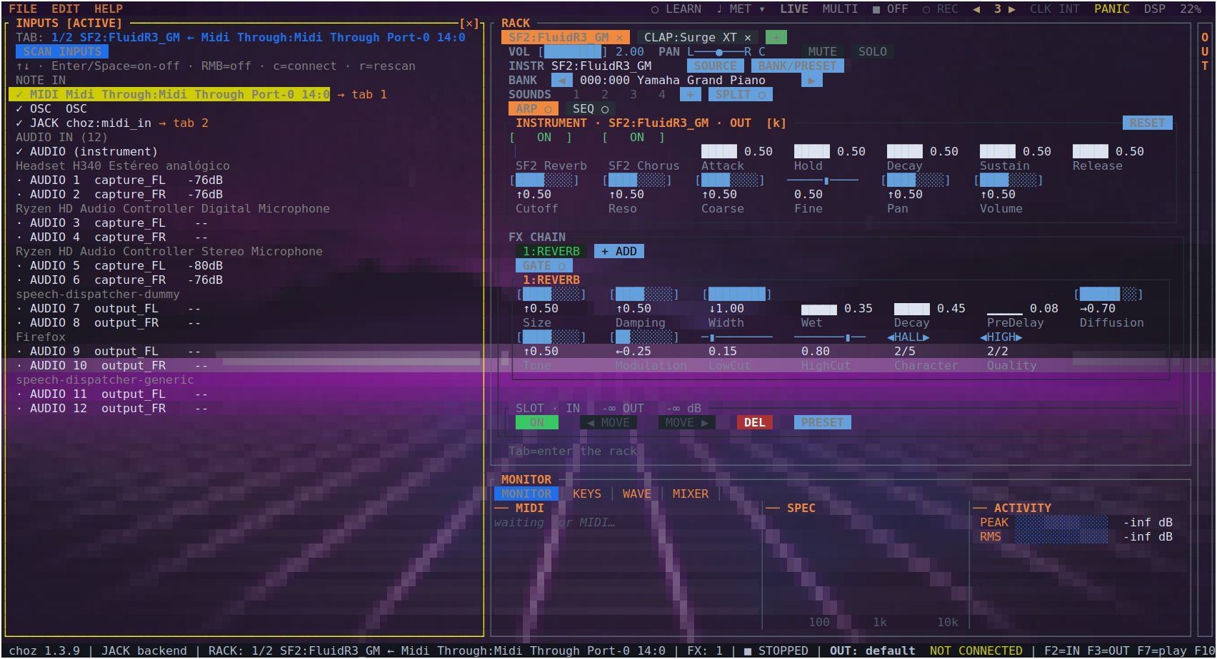
Figure 3.1 — The whole screen: the IN drawer open on the left, tab 1 with a SoundFont and an internal reverb, and the bottom panel below.

3.2 The menu bar and the transport cluster
FILE, EDIT and HELP sit on the left. Everything true of the whole rack rather than of one tab sits on the right:
Control | What it does
LEARN | Arms MIDI learn by pointing: click a knob, then move a controller (section 8.3).
TAP | Plays the tempo in. Four clicks set it, and the fourth starts the metronome (section 10.3).
MET and ▾ | The metronome and its options — click, tempo, time signature, grouping, sound, output, level.
LIVE / MULTI | Whether every tab plays at once or each listens on its own MIDI channel (section 8.1).
▶ ON / ■ OFF | The transport: what starts every sequencer, every synced delay and the automation.
REC | Arms automation recording. A right-click clears the lanes.
◀ n ▶ | The automation loop, in bars. Click the left half to shorten it, the right half to lengthen it.
CLK | The clock source: choz's own, or the external device driving it, by name.
PANIC | Silences every note that is still sounding.
DSP | What the audio thread is spending, as a percentage of the block budget.
MEM | The memory choz holds right now, resident. It turns amber when the machine has less than 15% left — where a streamed sample library starts reading back late. The first thing given up on a narrow window.
When the window is too narrow for the whole cluster, controls are given up in a fixed order: the ones a key can still reach go first, and the switches with no other home go last.

3.3 The rack
One tab per channel. A tab holds its input binding, its instrument, its effect chain, its arpeggiator and sequencer, its volume, pan and routing. [ and ] move between tabs; the mouse works everywhere.

3.4 The drawers
F2 opens IN, F3 opens OUT. They are lists of everything choz can hear and everything it can reach, and binding is done from them (chapter 4).

3.5 The bottom panel
F5 cycles MONITOR, KEYS, WAVE and MIXER; clicking a tab goes straight there (section 11.4).

3.6 The status line
Version, audio backend, active tab, how many effects it carries, the transport, and where the output is going.

3.7 Mouse, wheel and keyboard
Everything on the screen is clickable, and the wheel over a knob changes its value. The keyboard reaches everything the mouse does: chapter 14 is the full list. Inside the rack, k moves the cursor between the instrument and the effects, the arrows walk the knobs, and Enter opens a list for a knob that has named values instead of a range.

4. Inputs and outputs

4.1 The IN drawer
At the top are the note inputs: every MIDI port on the system, OSC, choz's own JACK port (choz:midi_in) and choz's own ALSA port (choz MIDI IN). Below them are the audio inputs the device or the graph offers, with their level in dB live, grouped by device — and, on PipeWire, the outputs of other applications as well.
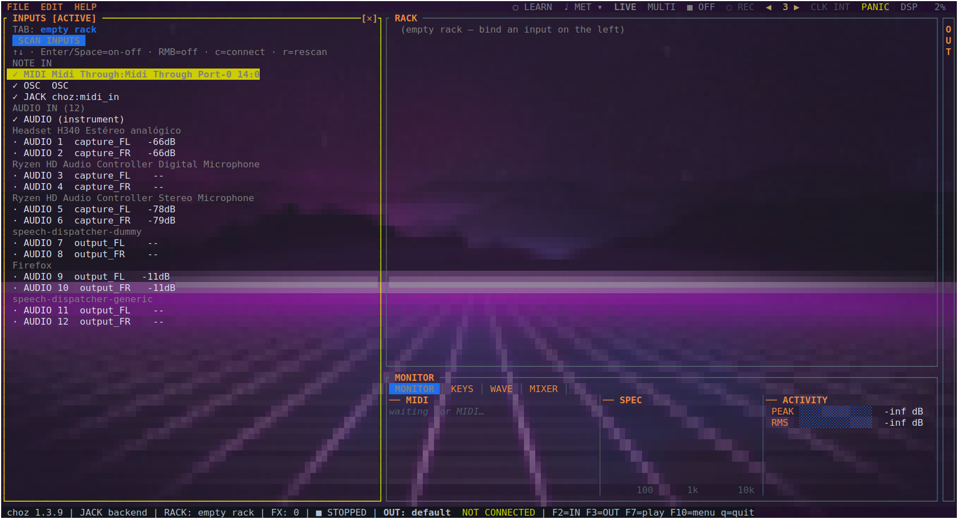
Figure 4.1 — The IN drawer: note inputs and the audio inputs found, each with its current level.
Key | Action
Enter / Space | Bind that input to a tab — choz makes one if there is none. Again to unbind (a right-click does the same).
c | Connect or disconnect the port.
r | Rescan the inputs.
choz connects to every enabled MIDI input by itself, so a controller plugged in mid-session starts playing without any wiring. Ports you never want are switched off in this drawer and stay off.

4.2 choz MIDI IN
ALSA's sequencer only lets a program subscribe to ports that already exist, and a DAW's MIDI output is not one of them: it opens the devices it was told to and publishes nothing anybody else can send to. So choz publishes the port instead. choz MIDI IN is a writable port on the ALSA client choz: a DAW picks it out of its own MIDI output list and plays a rack tab — with no snd-virmidi, no a2jmidid and no JACK graph.
- It is opened once and lives as long as choz does. Plugging or unplugging a controller re-scans the inputs, and a port remade there would drop the DAW's subscription every time somebody touched a USB cable — silently, because neither side reports it.
- It is the first row of the note inputs, and it can be switched off like any other port. Switching it off closes it, so it leaves the DAW's list too.
- It carries everything a DIN cable carries: notes, controllers, program change, pitch bend and MIDI Clock — so a DAW's transport can drive choz's tempo (section 8.6).

4.3 choz on the JACK/PipeWire graph
With the JACK backend (section 13.1), choz registers as the client choz:
Port | What it is
choz:out_1 … out_N | The output channels: the device's own, plus two more for each tab that has a direct out.
choz:in_1 … in_N | The capture jacks in the graph, whatever card they belong to.
choz:midi_in | MIDI from the graph: notes, controllers and clock published by a DAW on the same session.
choz:midi_out | What the arpeggiator, the sequencer and the tabs send out — to a synth on the graph, or to the DAW's recorder.
Nothing is auto-connected to the two MIDI ports: what talks to choz is a patch you make, not a guess choz makes for you.

4.4 The OUT drawer
F3 lists the playback device and its channels, and the MIDI output ports available — including choz:midi_out.
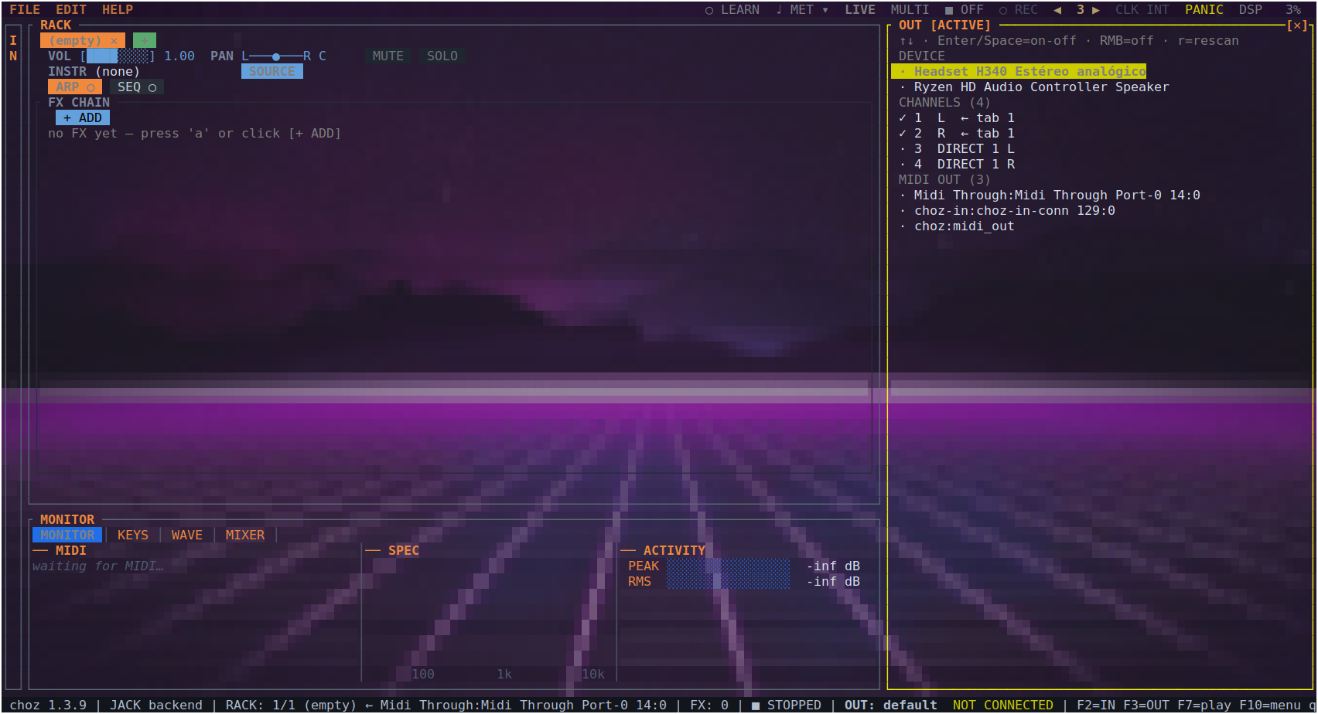
Figure 4.2 — The OUT drawer: output device, channels, and MIDI output ports.

4.5 Audio inputs and the microphone
An audio input binds to a tab exactly like a note input: open IN, pick the channel, press Enter. The tab gains two controls of its own — IN, the input trim (< and >), and SENS, the sensitivity of the audio-to-note follower (; and :) — and the A→M button, which turns what comes in into MIDI notes for the instrument or for other tabs.
FOLLOW sits beside WET while A→M is on. Off (the default) a note is a note, which is what a synth played from a guitar wants. On, the instrument also follows the input between notes: how far the note has fallen from its own peak goes out as CC 11 (expression; 40 dB under the peak is 0) and its drift from the note as pitch bend (±2 semitones), so a recorded sound breathes and bends with whatever drives it. Only what changes is sent, and switching it off puts expression back to full and the bend to the centre. It is saved with the project.
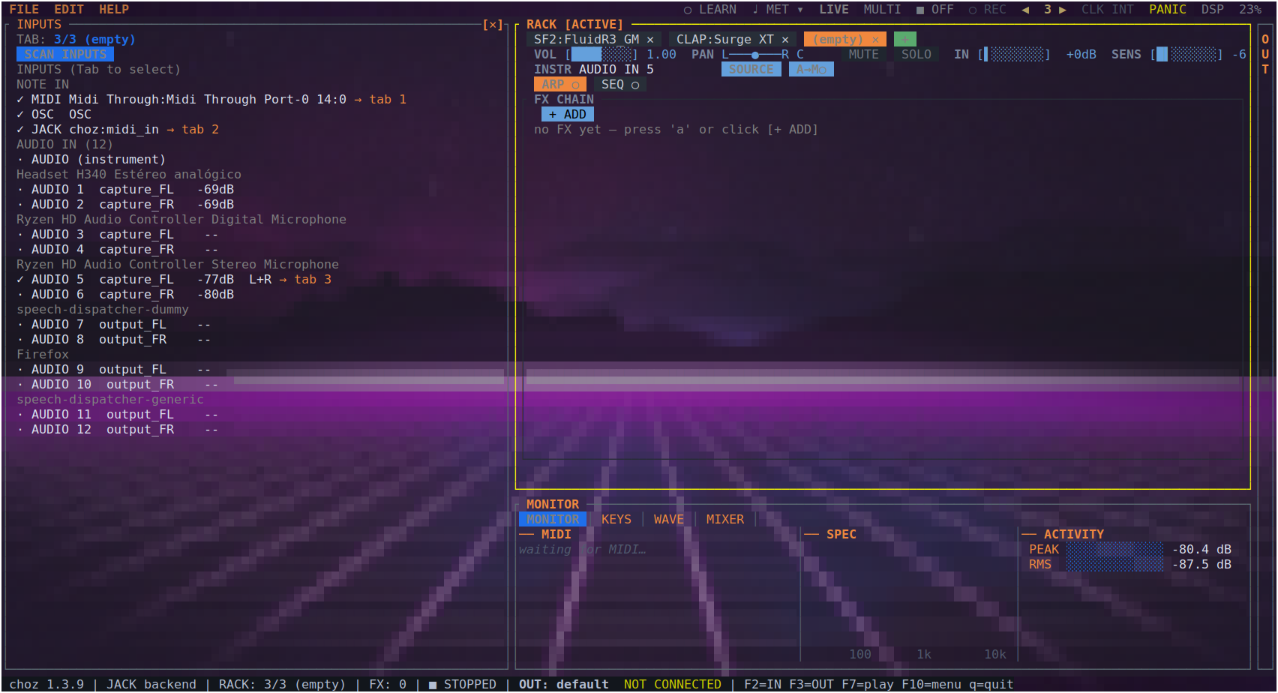
Figure 4.3 — A stereo microphone bound to tab 3: the IN row with the trim, SENS, and the A→M button.
- A mono channel stays mono all the way through — one fader on the mixer, one port on the graph — until something in the chain has a reason to pull the two sides apart.
- n levels the tab against what it has played since it was loaded; N levels the whole rack.
- The feedback guard (section 13.1) cuts the loop when a microphone starts to howl.
- choz as a microphone, and as an effect for the whole system. Under the JACK/PipeWire backend choz adds two devices to the system while it runs, and takes them away when it closes. choz Mic is a microphone that carries the main mix — what is in the headphones — so Meet, Zoom, Teams or WhatsApp can pick it as their microphone. choz System FX is a speaker: set it as the system output and whatever the system plays arrives in the IN drawer as SYSTEM AUDIO — choz System FX, ready to be bound to a tab and given effects. Neither is offered as choz's own output (a speaker nobody hears), and an output saved as one of them is ignored. In a call, keep the real headphones as the system output: a call routed into choz System FX and back out through choz Mic is heard by the others as an echo. CHOZ_NO_VIRTUAL_DEVICES=1 turns them off.

4.6 Direct outs
See section 11.3: a tab can leave the master mix through a pair of ports of its own, which is how a DAW records each tab on its own track.

5. Instruments

5.1 The source picker
With a tab active, 1 (or i) opens the picker. The tabs across the top filter by format — ALL, CLAP, SF2, WAV, SFZ, LV2, VST2, VST3, DSSI, LADSPA. Type to search, move with the arrows, accept with Enter; F5 rescans.
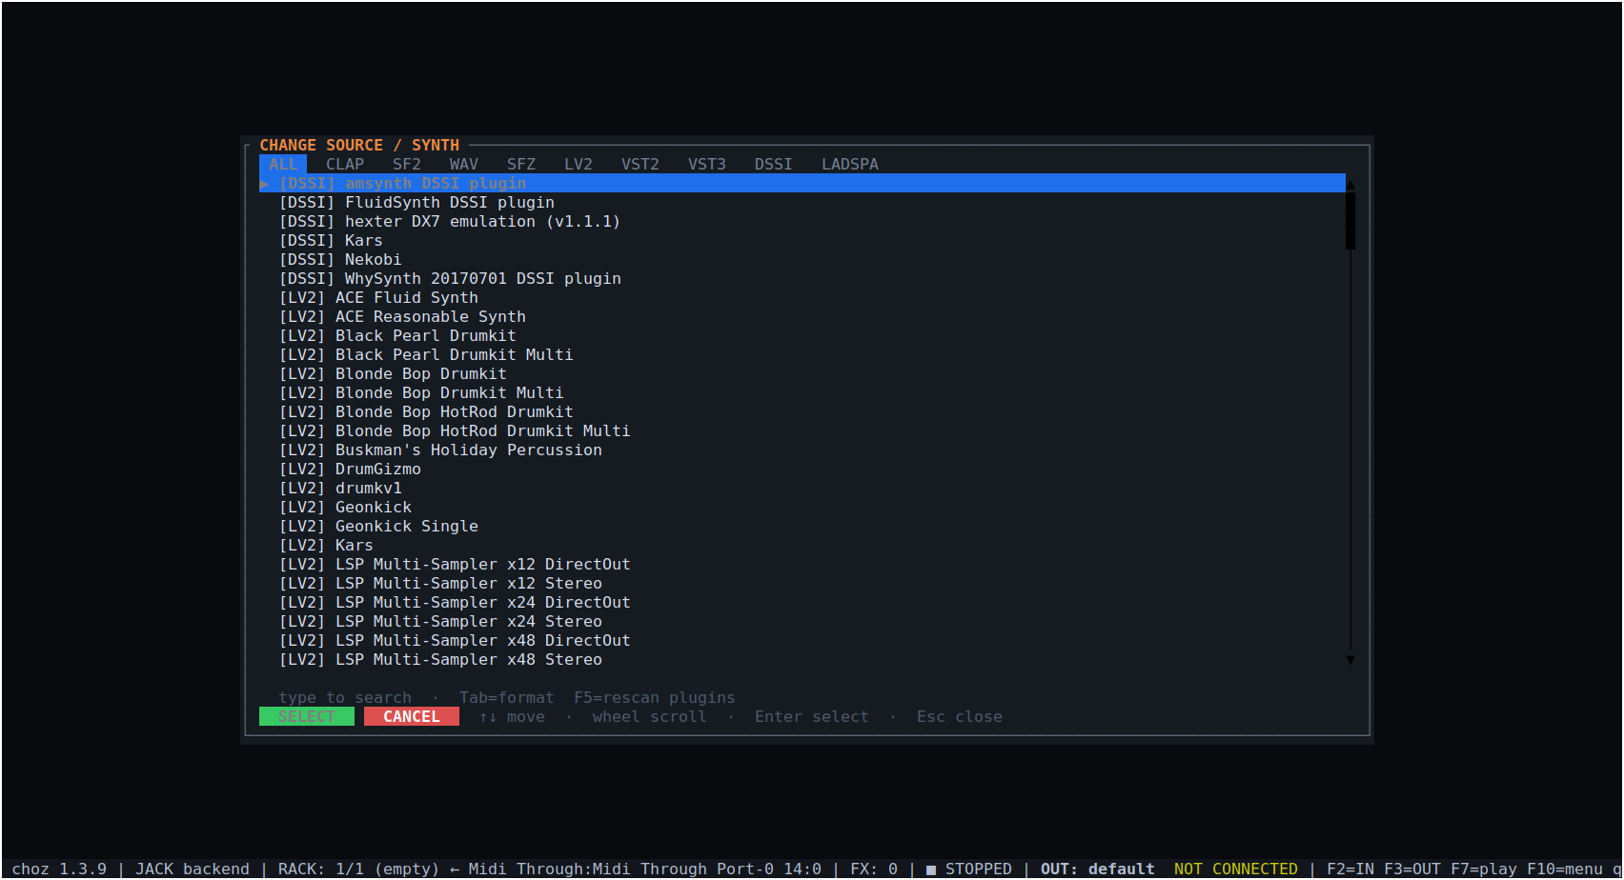
Figure 5.1 — The source picker: every instrument found, with its format in brackets.

5.2 SoundFonts
choz synthesises SF2 with its own engine, with no dependency on FluidSynth. Loaded, the tab shows the preset on the BANK row and the engine's knob box: the bank's reverb and chorus sends, the envelope (Attack, Hold, Decay, Sustain, Release), the filter (Cutoff, Reso), tuning (Coarse, Fine) and output (Pan, Volume).
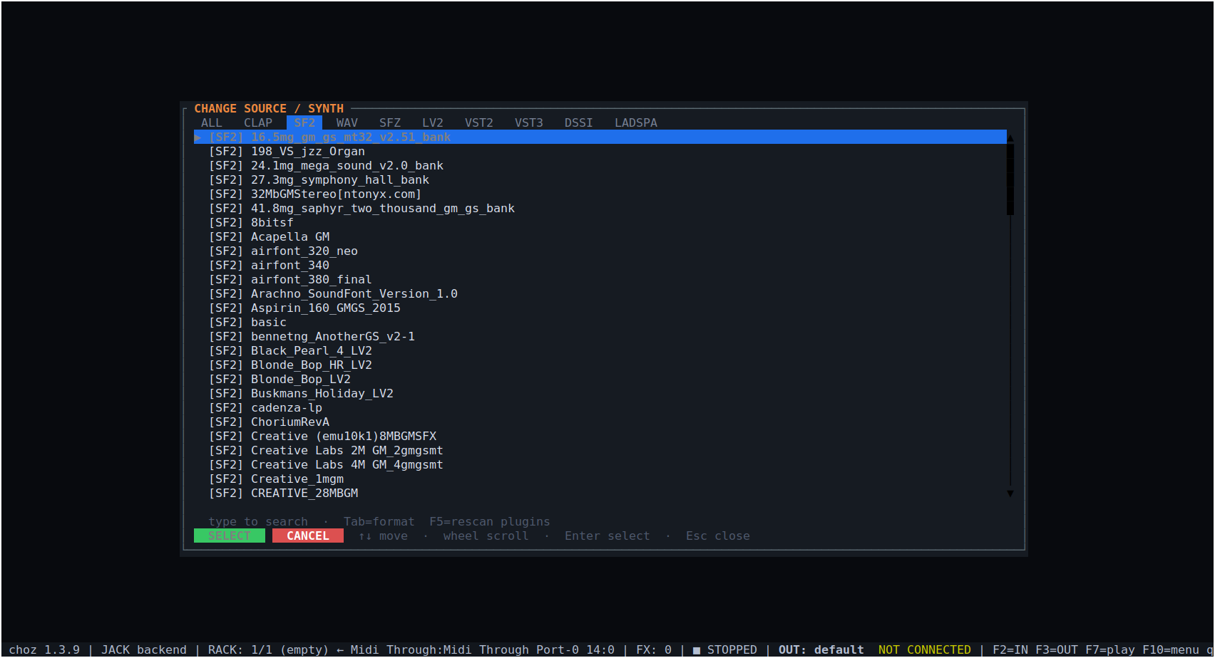
Figure 5.2 — The picker's SF2 tab: the SoundFont banks installed on this machine.
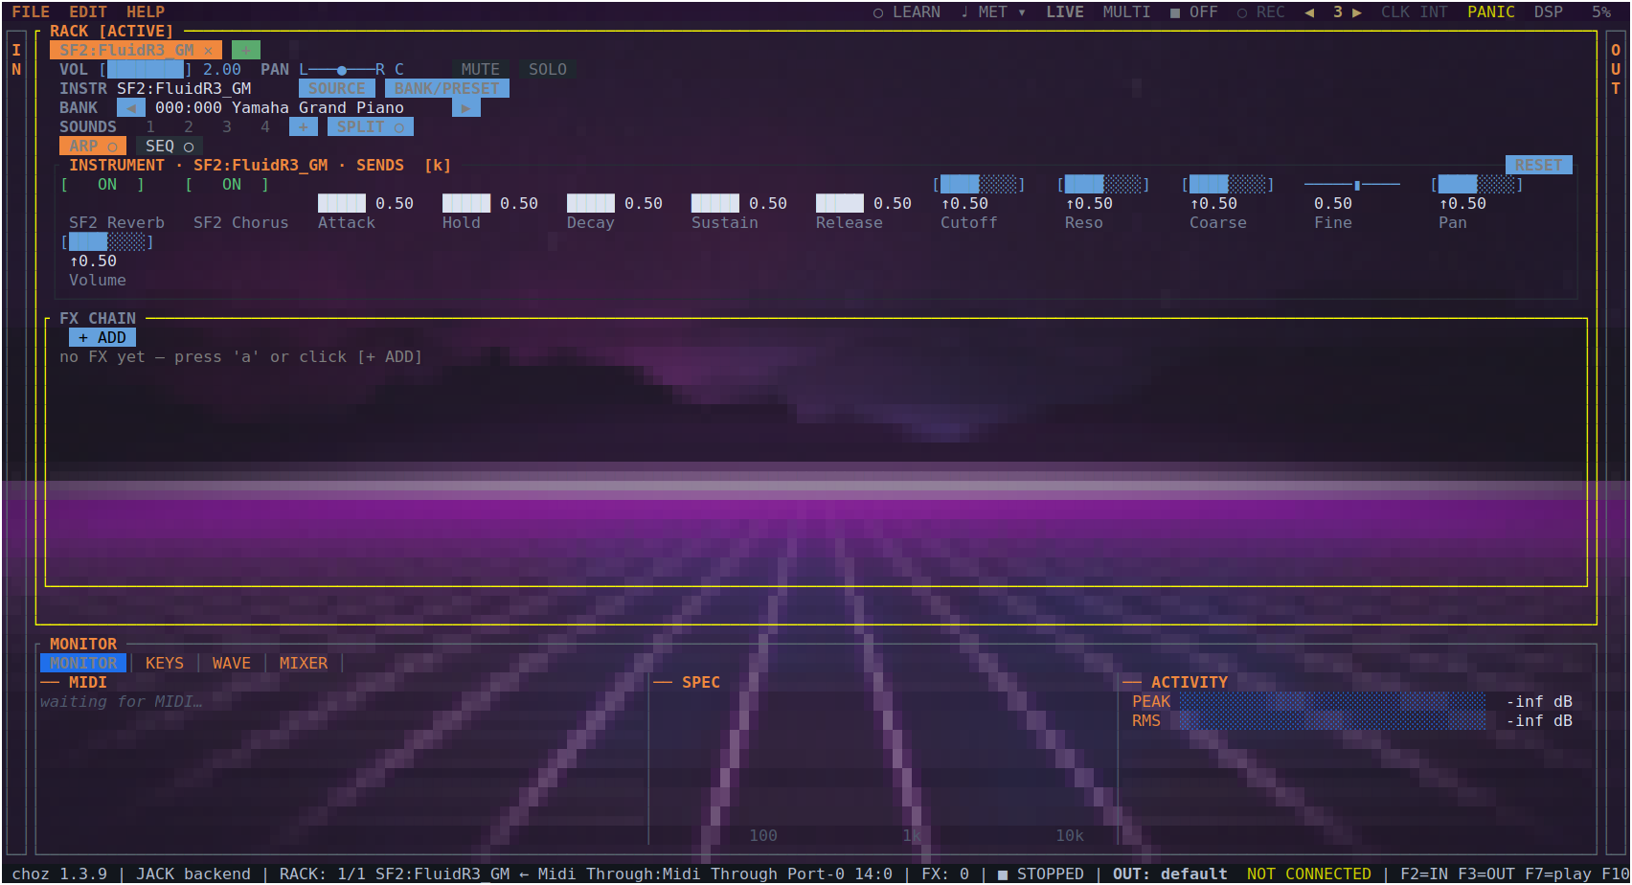
Figure 5.3 — A SoundFont loaded in tab 1: the BANK/PRESET row and the SF2 engine's knob box.

5.3 SFZ and WAV
SFZ instruments play on choz's own 32-voice sampler and a WAV plays as a rack source; both load from the same picker. A SoundFont player installed as a plugin appears under its own format tab and is used like any other plugin.

5.4 Banks and presets
2 (or b) opens the bank and preset browser. The highlighted row sounds while you move through it, and SELECT keeps it. When a plugin's patches are files rather than numbered programs, the same button opens the categories its own window would show.
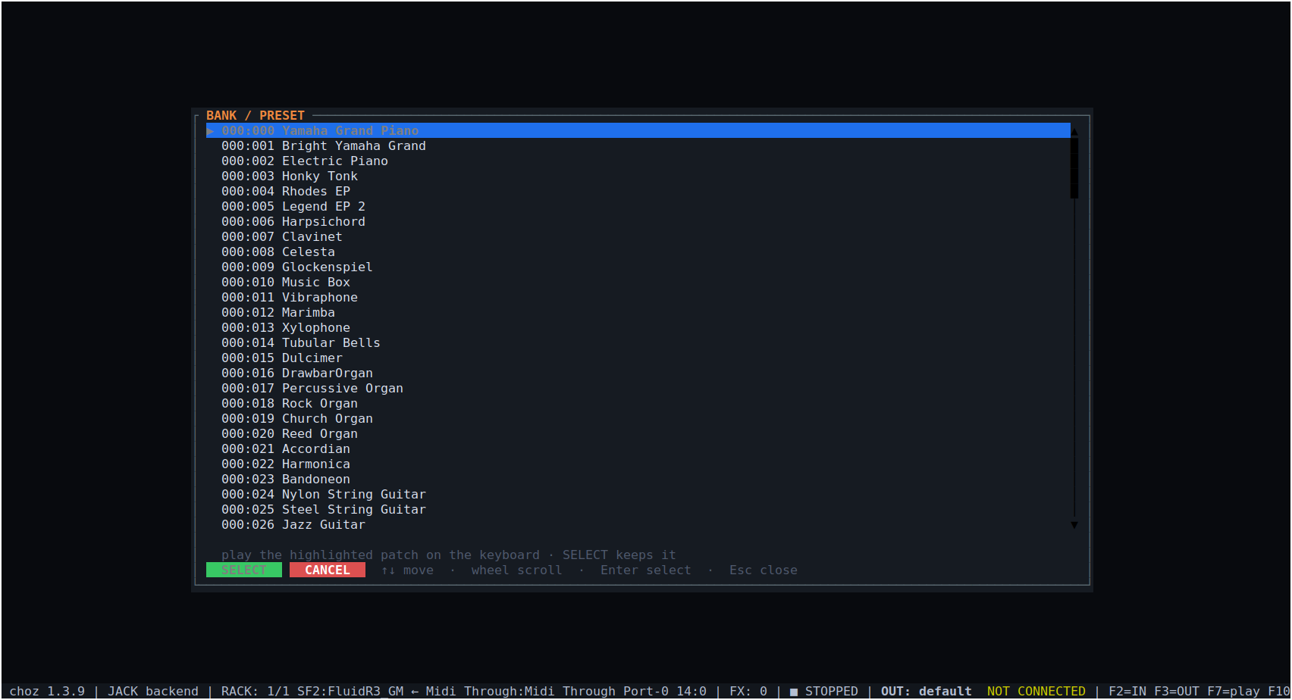
Figure 5.4 — An SF2 bank browser: the 128 programs of bank 0 and the file's other banks.

5.5 Parameters, pages and search
p opens the parameter list with exact values; l on a row learns a CC for it. A plugin with hundreds of parameters is shown two rows at a time — PgUp and PgDn turn the page, and learned CCs move with the box, so eight faders reach every parameter the plugin has. / searches a knob by name and jumps to the page holding it.
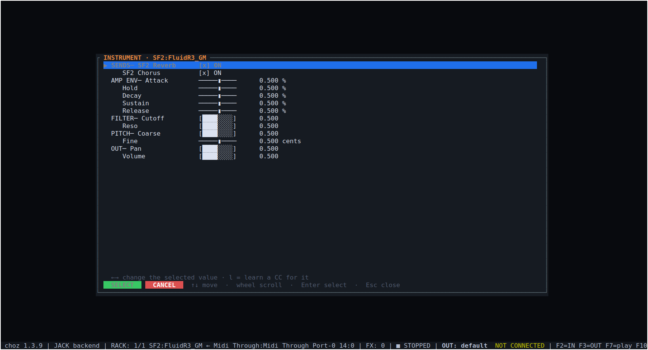
Figure 5.5 — A SoundFont's parameters: sends, envelope, filter, tuning and output.

5.6 The sampler
choz plays folders of samples as instruments. choz-sampler is always in the source picker under CLAP; sample libraries found on the plugin paths (~/Samples and ~/samples by default, Preferences → Plugin paths) are listed under the SAMPLE chip. Picking the sampler puts it in the tab empty; LOAD asks for a folder, a .zip or a single audio file (.wav, .flac, .aiff, .mp3, .ogg).
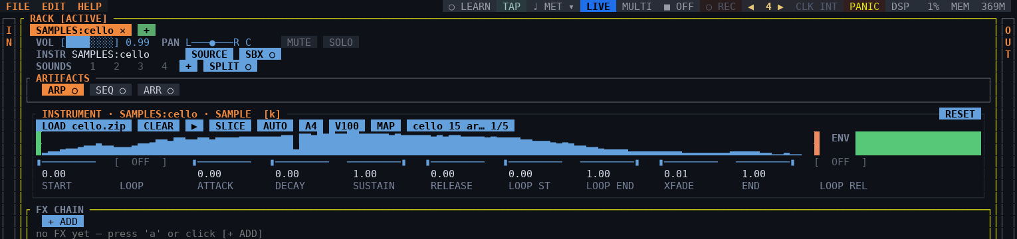
Figure 5.6 — The sampler playing Philharmonia's cello: the note's own waveform with its start mark, the envelope, and the knobs.
How a folder becomes an instrument. File names first — violin_C4_mf_RR2.wav says the note, the dynamic and the take — then the folder names, then, only for what is still open, the audio itself (pitch detection). Dynamics become velocity layers, takes become round robins, and a pack with several articulations keeps all of them, selected by keyswitches on the keys below the playing range. Each instrument is levelled on loading, so a flute and a tuba start at the same height, and large libraries stream from disk instead of loading whole into memory.
The panel. A tab with the sampler shows its own panel in the RACK:
- LOAD (with the folder it is playing) and CLEAR.
- The layout: AUTO (worked out from the files), STRETCH (one sample across the keyboard), KIT (one sample a key, drums on their GM keys) and SLICE, which cuts the longest file into 8, 16, 24 or 32 pieces, one a key from C2.
- ▶ / ■ to audition without a keyboard, with the key (NOTE) and the velocity (V) it plays, and the articulation when the pack has several.
- MAP opens the mapping editor: a row a region with root, low key, high key and tune. Arrows move, PageUp/PageDown move by an octave, F2 saves an .smpreset beside the folder and reloads the tab from it, F3 relinks a library that moved, Esc discards.
- The waveform of the sample the key plays, with the start point and the slices marked — a click on it sets the start — and the envelope, which can be dragged.
Its knobs are ordinary instrument parameters — START, LOOP, ATTACK, DECAY, SUSTAIN, RELEASE, LOOP ST, LOOP END and XFADE — so they are saved with the project, move with the arrows and can be MIDI-learned. The loop runs while the key is down and is crossfaded at the join. Channel and polyphonic aftertouch arrive as expression (CC 11).
Recording a sampler. REC on the panel records the tab's audio input — before the trim, up to 60 seconds; on a tab with no input it does nothing and says so in the log. Press it again to stop: the take is cut at its silences, one WAV per sound, and loaded into the sampler at once. The files carry no note in their names, so the sampler reads each one's pitch off the audio, spreads the pitched ones over the keyboard and builds a kit from the rest; two takes of the same note become round robins. Pair it with A→M and FOLLOW and anything you record can be played by your voice or your guitar.
SAVE, or it goes. A new take is kept in a scratch folder and SAVE appears on the panel: it moves the take to ~/.local/state/choz/recordings (a sample path of its own, so SOURCE lists every saved take and a project finds it again) and reloads the sampler from there. A take nobody saved is deleted as soon as nothing plays it — another instrument, CLEAR, a project loaded or the tab closed — and whatever is left when choz exits. Save a take before saving a project that plays it.

6. Effects

6.1 The catalogue
a (or [+ ADD] in the FX CHAIN section) opens it. The left column is categories with how many effects each holds; the right column is the list. The tabs filter by format, and BUILT-IN leaves only choz's own.
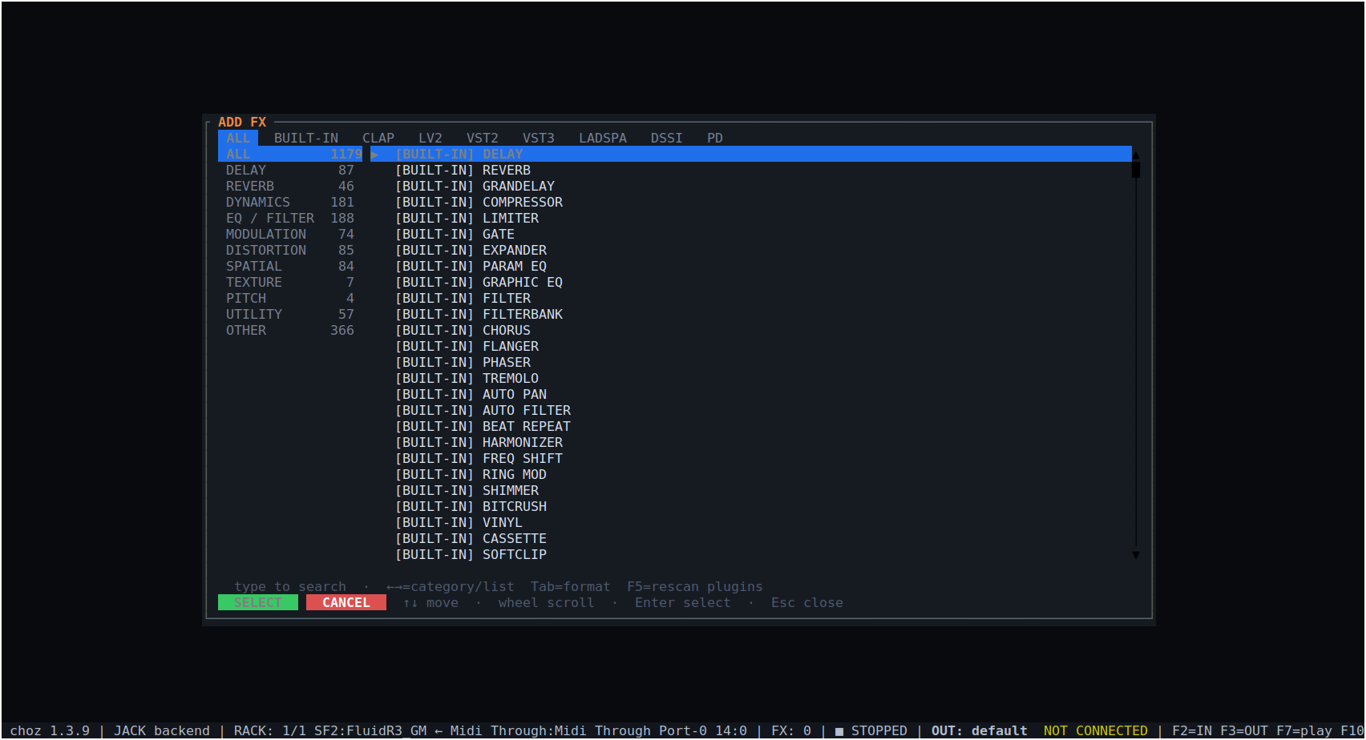
Figure 6.1 — The effect catalogue: everything available between the built-ins and the installed plugins.

6.2 The chain
A tab holds up to twelve effects, in order. Each shows all of its knobs and, underneath, its slot row: ON/OFF, input and output level in dB, moving it along the chain, deleting it, and its preset buttons.
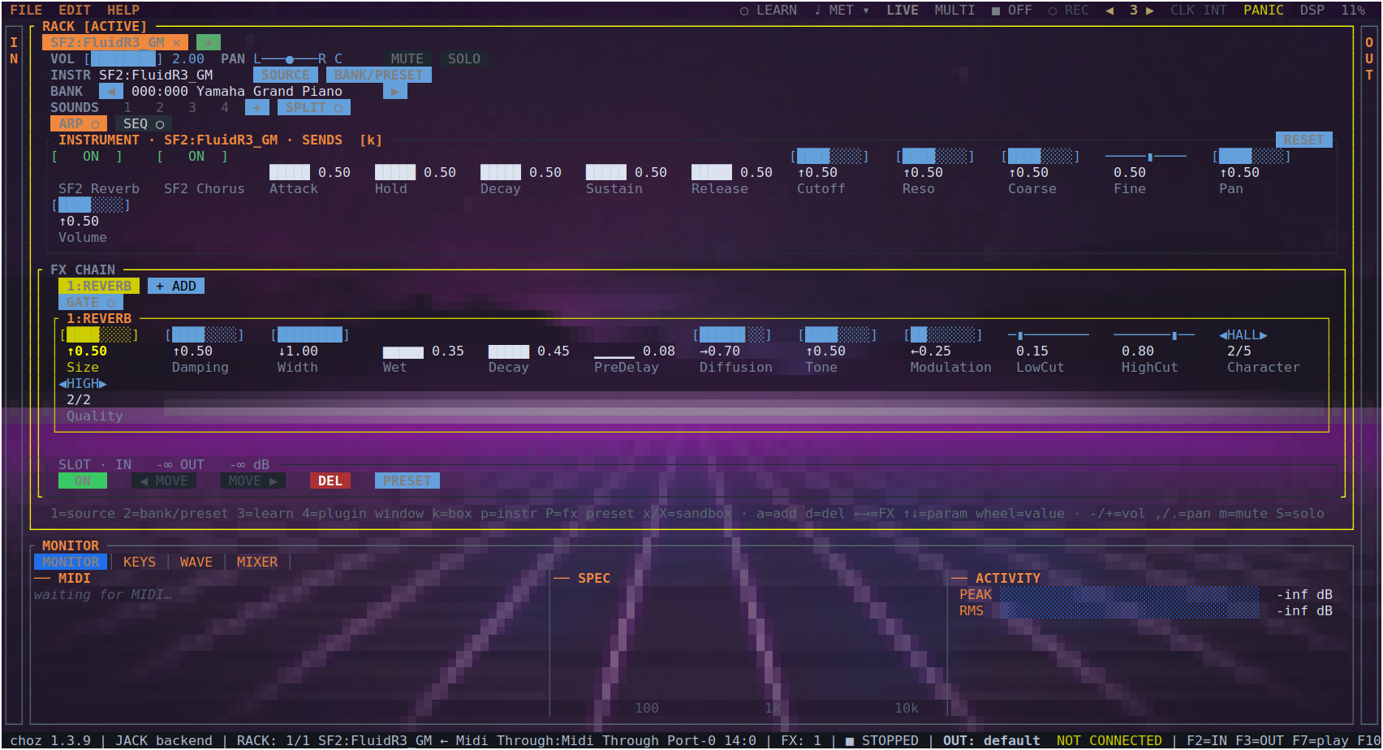
Figure 6.2 — The internal reverb in the chain, with its own parameters.
Key | Action
Space | Switch the selected effect on or off
← → | Move between effects in the chain
↑ ↓, wheel, w/s | Pick a knob and move it
d | Delete the selected effect
G | Open the effect's own window, if it is a plugin that has one
X | Run the effect isolated in another process

6.3 The built-in effects
Fifty-six effects ship with choz. They need no plugin, they are always present, and they are the ones published in choz.clap for other hosts.
Category | Effects
Delay (5) | DELAY, GRANDELAY, SPACE ECHO, REVERSE, MULTI-TAP
Reverb (3) | REVERB, SHIMMER, PLATE
Dynamics (9) | COMPRESSOR, LIMITER, GATE, EXPANDER, SIDECHAIN, DE-ESSER, TRANSIENT, MULTIBAND, ENVELOPE
EQ / Filter (6) | PARAM EQ, GRAPHIC EQ, FILTER, FILTERBANK, ISOLATOR, LADDER
Modulation (9) | CHORUS, FLANGER, PHASER, TREMOLO, AUTO PAN, AUTO FILTER, FREQ SHIFT, RING MOD, VIBRATO
Distortion (11) | BITCRUSH, VINYL, CASSETTE, SOFTCLIP, SATURATOR, WAVESHAPER, TUBE SAT, AMBER FANG, VELVET FUZZ, EXCITER, BASS ENH
Spatial (2) | WIDENER, PAN
Texture (4) | BEAT REPEAT, LOOPER, PROTOCOSMOS, Z5 TEXTURE
Pitch (4) | HARMONIZER, VOCODER, AUTO-TUNE, PITCH SHIFT
Utility (3) | GAIN, PHASE INV, MONO
Tape, clouds and textures. SPACE ECHO picks its heads like the machine it is modelled on — Heads: 1, 2, 3, 1+2, 2+3, 1+3, 1+2+3 or REV, the spring alone — with the heads evenly spaced 1:2:3, Bass and Treble on the echoes, and a spring that hears the input as well as the repeats. PROTOCOSMOS has Repeats (its feedback) and a resonant low-pass Filter on the cloud. Both follow the tempo with Sync (FREE, or 1/32 to a whole bar): SPACE ECHO puts its heads on the grid, PROTOCOSMOS starts one grain per division. Z5 TEXTURE has Contour, the shape of its grains (percussive to flat-topped, the middle is the classic window), and an LFO of its own (Rate, Depth, Shape, Dest). Every one of these starts where the effect sounded before, so an older project opens unchanged.

6.4 Effect presets
Each slot can save and load a preset of its own effect, so a compressor setting that works on a voice can be carried to another tab or another project without saving the whole rack.

6.5 Chord source and the gate
- C chooses which keyboard the selected effect takes its chord from — the harmoniser, for instance, with two controllers on a hub.
How the HARMONIZER sings. It listens for the note being sung (the same detector as AUTO-TUNE, with a 32 ms window: a new note is followed in under 40 ms) and builds every voice from it: the note, plus the interval the Shape names — 3rds a third and a fifth, OCT octaves, CHORD any chord the arranger can write — moved onto the nearest note of the Key and Scale. A third over C in C major is E; over D it is F. Chromatic keeps the intervals as written, which is the parallel sound. With a chord to follow, the voices land on that chord's notes instead of the scale's; with nothing sung yet, the chord itself is the harmony. A note counts once it has held for a few milliseconds, so the first instant of an attack does not move the voices; after a second of silence the note is forgotten and the next one is measured from itself. No two voices sing the same note, and they glide to a new harmony rather than jumping. Env closes the voices only in real gaps: a decaying note keeps its harmony. MIDI on the keys that play the tab: with no keyboard picked in CHORD, the chord followed is the notes the instrument is already playing, and the voices double them — the log says so once. Pick another keyboard, or switch MIDI off to harmonise on the scale or a chart.
Voices that sound like voices. Each voice is moved with PSOLA: short grains cut at every pulse of the voice and laid down again at the new pitch, so the vowels stay where the mouth put them and a voice two octaves away is still a voice, not the singer in a tube. With a chord to follow, the voices move like a choir — each one to the chord tone nearest where it was, keeping common notes — instead of all jumping with the melody. CHORD in Shape opens the arranger's chord dialogue (FAMILY, 6/7, TENSION, 9, 11, 13, 5; ←→ turn a row) without a root: the root is the note being sung. OCT on the GATE/CHORD row opens the piano to choose the octave the voices sing in — click a key, ←→ to step, A for AUTO — and no voice goes further than two octaves from the singer. Lead is how much of the singer comes out with the harmony: at its default, 0, a fully wet harmoniser gives only the voices, which is what a call through choz Mic should hear. ARR on the chart row follows the arranger instead: while any tab's arranger plays, its chord is the harmony.
Shapes, places and octaves. Voices is a slider from 1 to 10. SHAPE is listed by category: STACKS (3rds, 5ths, OCT, 4THS — a chord in fourths), INTERVALS (2m to 7M) and CHORD. Place decides where the voices of every shape but CHORD go: ABOVE, BELOW, MIDDLE (the default, alternating up and down) or CLUSTER (the same notes folded to within a tritone of the sung note). A new harmoniser opens chromatic, with no key. RESET on the GATE/CHORD row puts every knob back to how a new one opens. OCT cycles ON → OFF → AUTO: ON opens the piano to choose the octave (CANCEL goes back), OFF leaves the voices where the shape puts them, AUTO keeps every voice within an octave of the singer. The CHORD dialogue's rows are no longer on the knob grid, but they are still parameters: saved and learnable. The mouse wheel works in the harmoniser's dialogues: in a list it moves one row and applies it without closing, so you can try shapes by ear.
Following a chart. The row under GATE and CHORD plays a .chord progression for the harmoniser to follow, the way the arranger plays one for its band: LOAD picks the file (.chord or .mid, kept in the project), ▶ starts it on the next downbeat of the metronome and switches the effect's Chart on, ■ stops it and puts the harmony back on its scale (or on the keyboard, with MIDI on). The lights are the metronome's beats; while the chart plays, the one lit is the beat the click is on (stopped, they stand still) — the same count the beep follows, bar by bar through a chart that changes meter — and beside them the chord and the bar the chart is at. CLICK is the metronome's own switch. From the keyboard: y is ▶/■, Y is LOAD and o is CLICK. One harmoniser follows a chart at a time; the chart takes precedence over a keyboard chord while it plays. The log (~/.local/state/choz/choz.log) says what the harmoniser did: ▶ and ■, every chord the chart moves to, and once a second while anything changes the note it hears, how often its voices moved and where to, and its output peak.
- c opens the gate: another tab drives this effect's dry/wet or one of its knobs, with its level or with the notes it receives. That is how a kick ducks a pad, or a vocal opens a delay.

7. Plugins

7.1 Formats
choz hosts CLAP, LV2, VST2, VST3, LADSPA, DSSI and Pure Data patches, as instruments and as effects. What appears in the rack is what the plugin declares: a parameter that says it cannot be automated is not drawn as a knob, and a parameter whose whole integer range reads as two words is drawn as a switch rather than a fader.
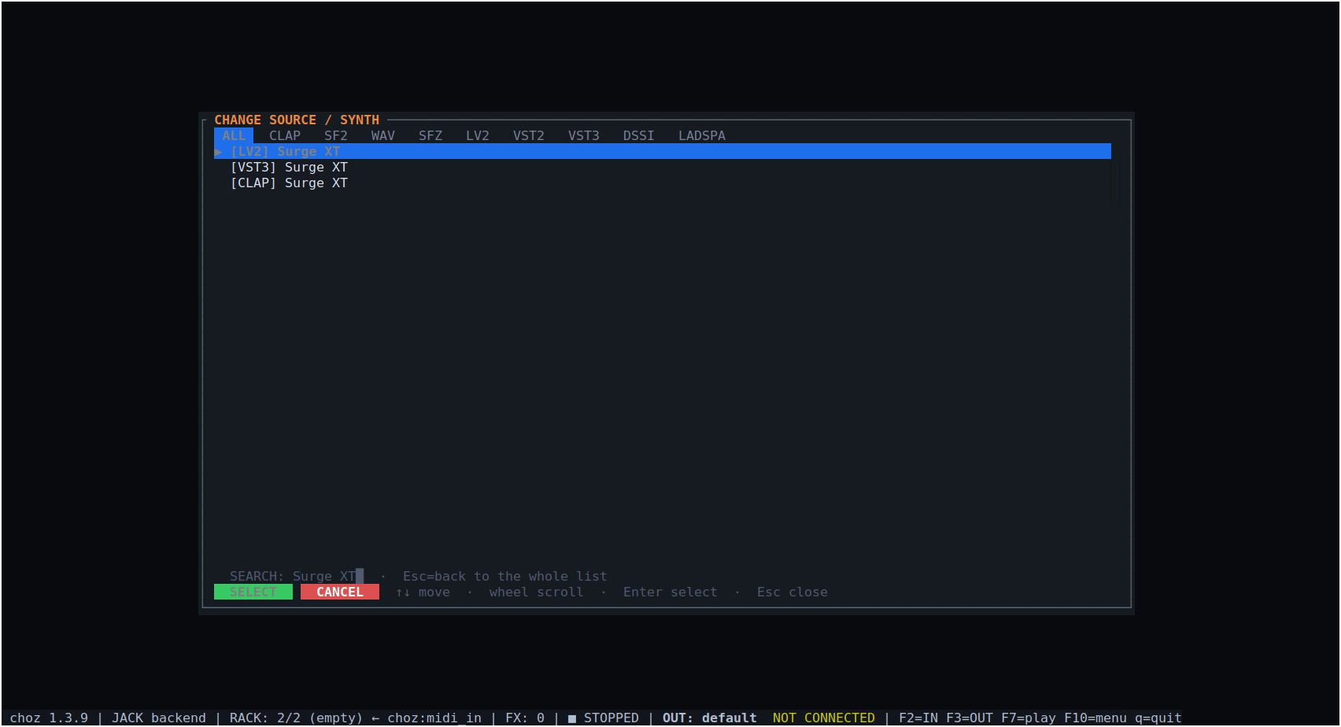
Figure 7.1 — One synthesiser found in three formats; which you pick only changes the host choz uses.
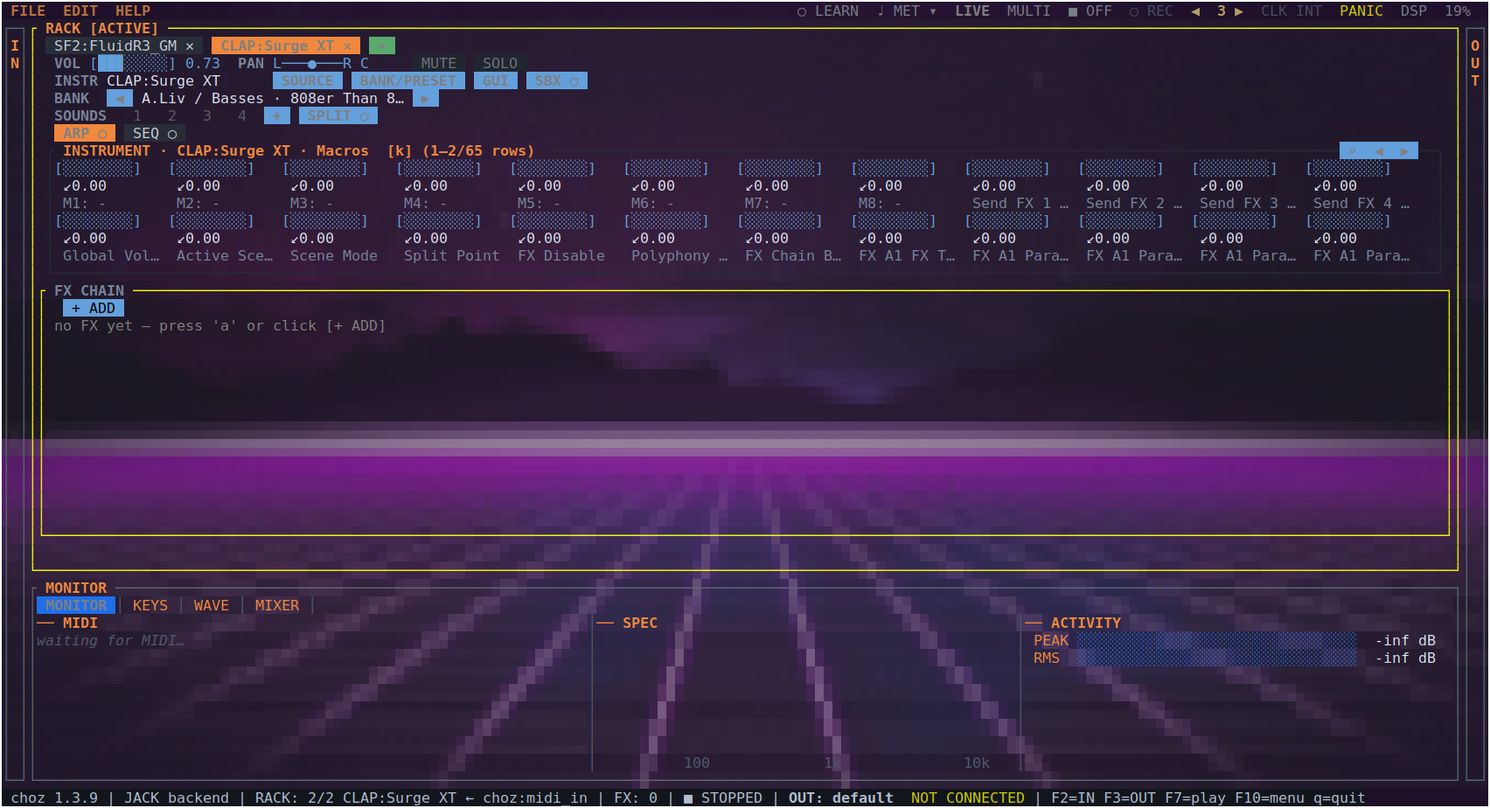
Figure 7.2 — A plugin loaded: its macros, its sends, and the first page of its parameters.
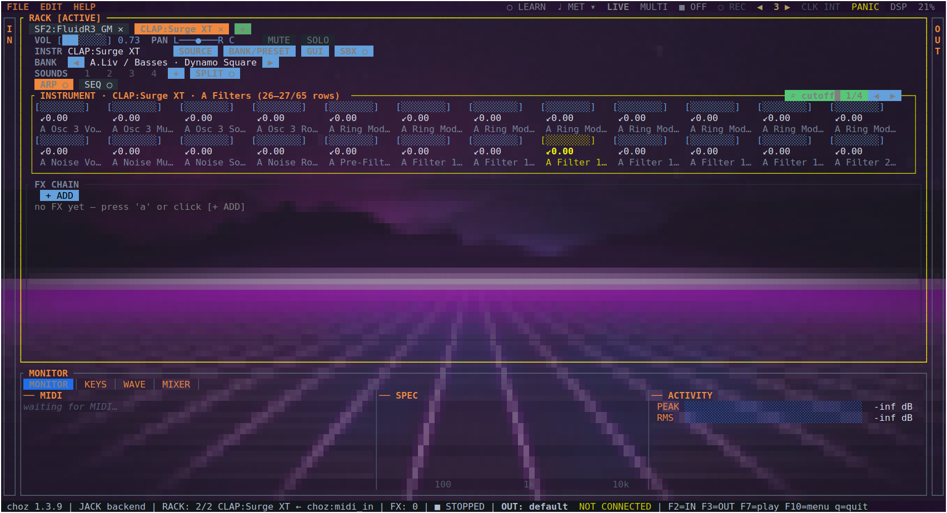
Figure 7.3 — Searching a knob by name jumps to the page that holds it and says how many matches there are.
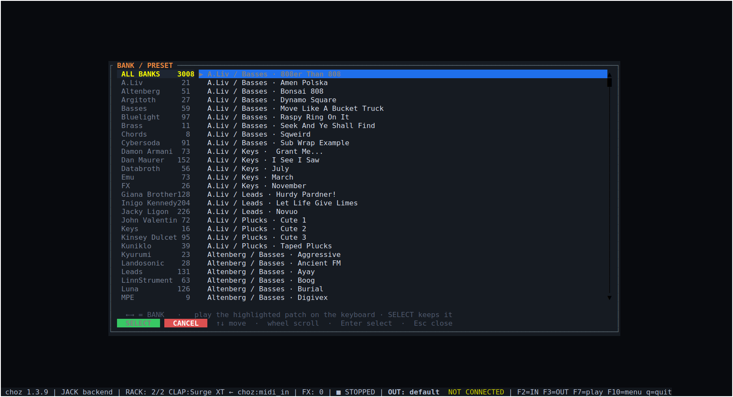
Figure 7.4 — A plugin whose patches are files: its own categories, browsed from choz.
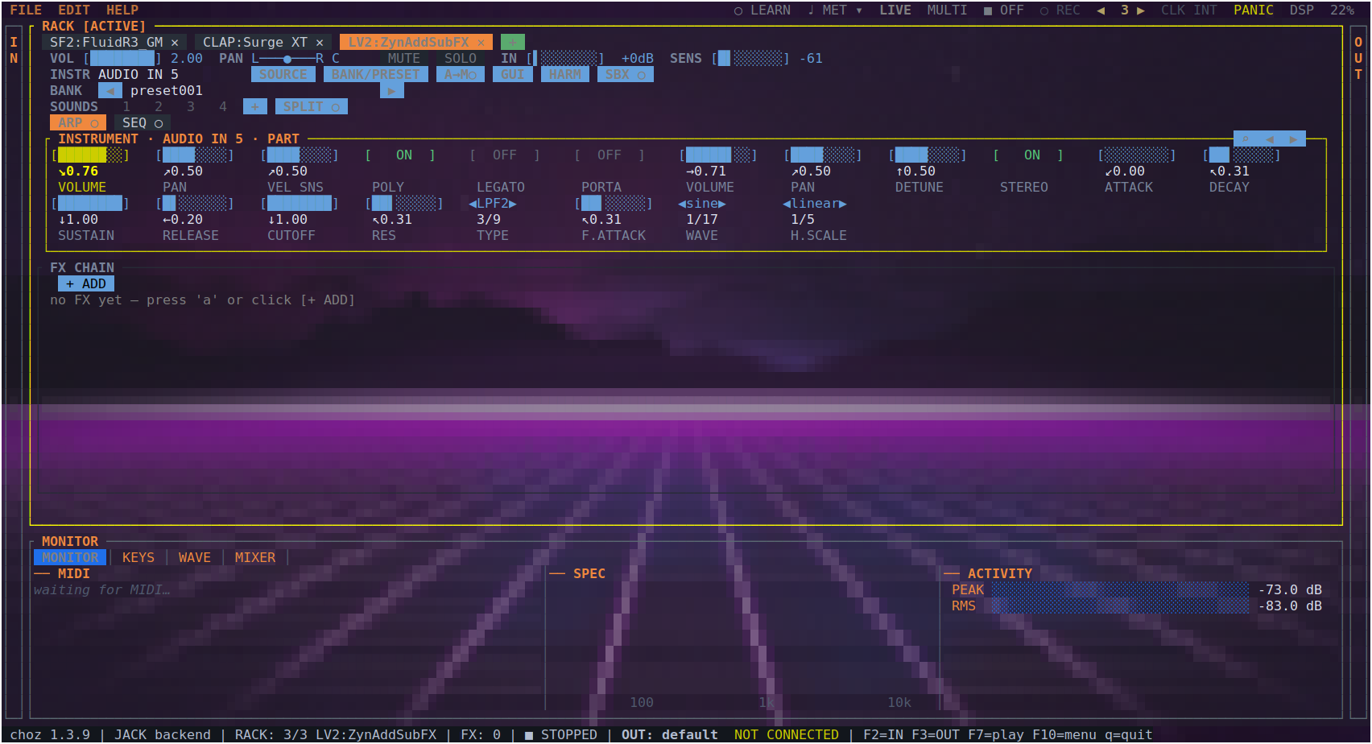
Figure 7.5 — An LV2 synthesiser in the rack, its parameters as native choz knobs.
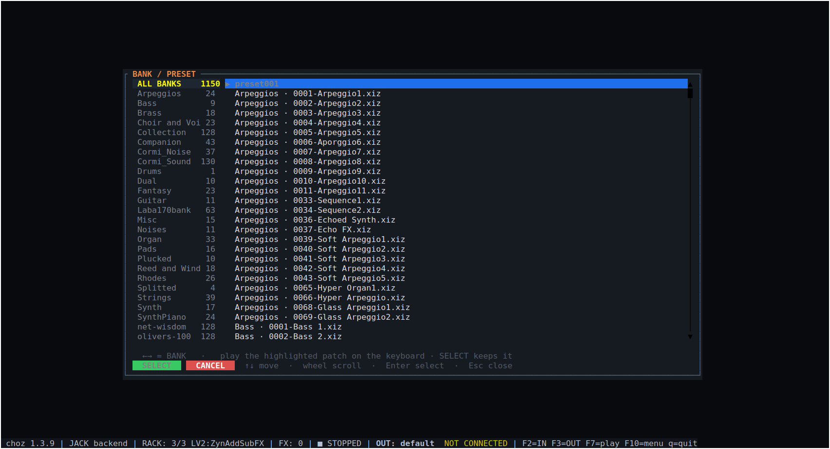
Figure 7.6 — The same plugin's presets, grouped by folder.

7.2 Scanning and paths
Plugins are scanned in the background and cached, so the picker opens instantly on later starts. EDIT → Rescan plugin paths repeats the scan; F5 in the picker does the same. Where choz looks is set in Settings (section 13.2).

7.3 A plugin's own window
g opens the instrument's window and G the selected effect's. choz embeds it in an X11 window of its own — LV2 ui:X11UI, VST2 effEditOpen, CLAP clap.gui on the host's timer, VST3 IPlugView on the Linux event loop. LADSPA, DSSI and Pure Data have no embeddable window; their parameters are driven from the rack.
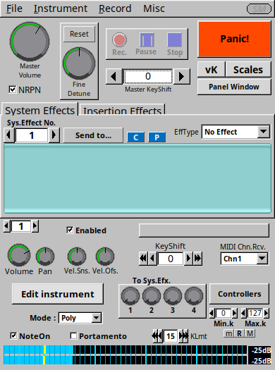
Figure 7.7 — A plugin's own window, opened from choz with g.
Moves made inside that window are followed by choz, so "move the knob in the plugin, then move a fader on the controller" is enough to bind a CC to it.
An instrument that publishes its oscillator's harmonics — over its own OSC server, say — also gets the HARMONICS view (h, or the HARM button), which draws the harmonic series as bars and edits it in place.

7.4 Sandbox and quarantine
x runs the instrument in a child process and X the selected effect (the SBX button does the same). Audio and the window travel over shared memory, so a plugin that crashes does not take choz with it. Before trusting a new plugin, choz probes it in a separate process — a plugin that dies there is remembered and hosted out of process from then on.
The SBX button also reads what the sandboxed plugin has cost: a number and lost counts audio blocks the child failed to answer in time (silence the user heard), and a number with ↻ counts times it crashed and was restarted. A plugin that keeps crashing — five times inside ten seconds — or that floods its own log — more than 16 MiB of output in two seconds, the case a badly behaved LV2 synth caused in practice — is no longer restarted: choz gives up on it, quarantines it for next time, and the button reads DEAD instead of counting another restart.
Note. CHOZ_SANDBOX_GUI=1 isolates every plugin with a window up front, which is the setting to reach for on a machine where one badly behaved GUI keeps taking the rack down.

7.5 Plugin state in a project
A project saves what a parameter list cannot: VST2 chunks, VST3 IComponent::getState, clap.state and LV2 state#interface — the patch chosen in the plugin's own browser comes back with the project.

8. Playing and MIDI

8.1 LIVE and MULTI
In LIVE, every tab plays at once. In MULTI (F4), each tab listens on a MIDI channel of its own, shown as CH n beside the instrument's name — a keyboard split across a rack, or a DAW driving eight tabs down one port.
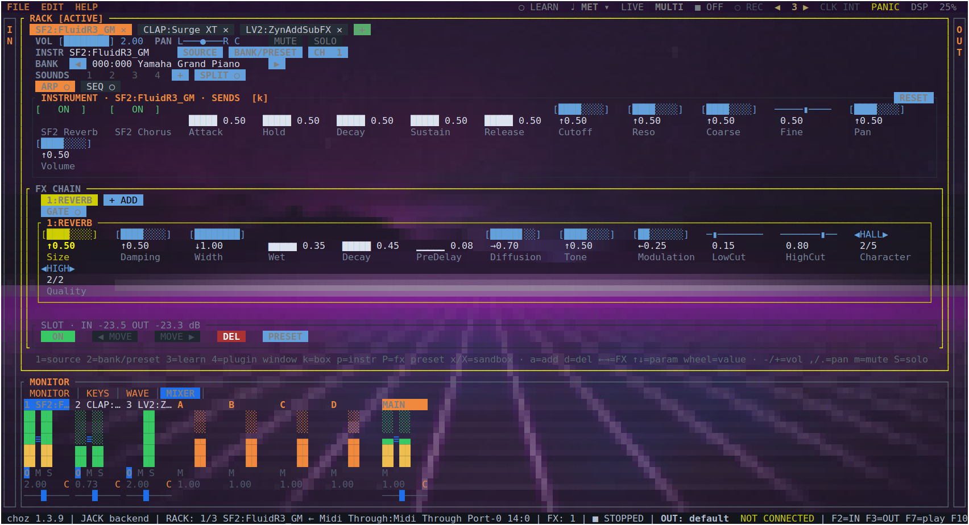
Figure 8.1 — MULTI mode: each tab bound to its own MIDI channel.

8.2 The monitor
The MONITOR panel shows incoming MIDI as it arrives — port, message, note, velocity — beside the spectrum of the output and the peak and RMS meters. It answers three questions at once: did it arrive, what came out, how loud.
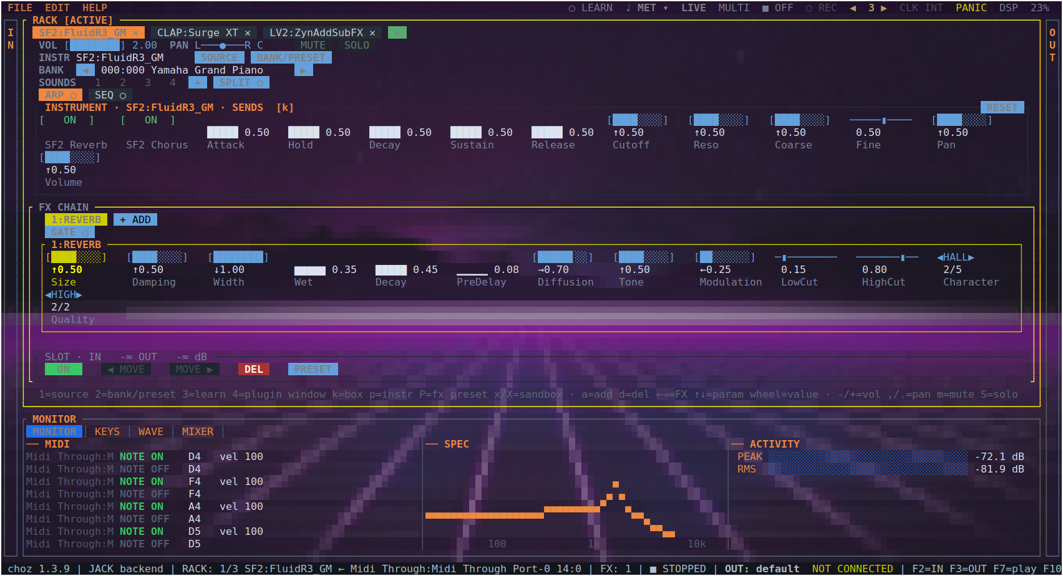
Figure 8.2 — MONITOR: NOTE ON / NOTE OFF with velocity, the spectrum, and the meters.

8.3 MIDI learn
l lists the learnable targets of the active tab: volume and pan, mute and solo, bank up and down, parameter page, instrument reset, effects on and moved, add effect, the arpeggiator (on/off, tap, hold), the four sounds, the tabs, and every instrument parameter. Pick one, then move the controller. 3 does it the other way round — pick the control on screen first — and the LEARN button lets you learn by clicking a knob.
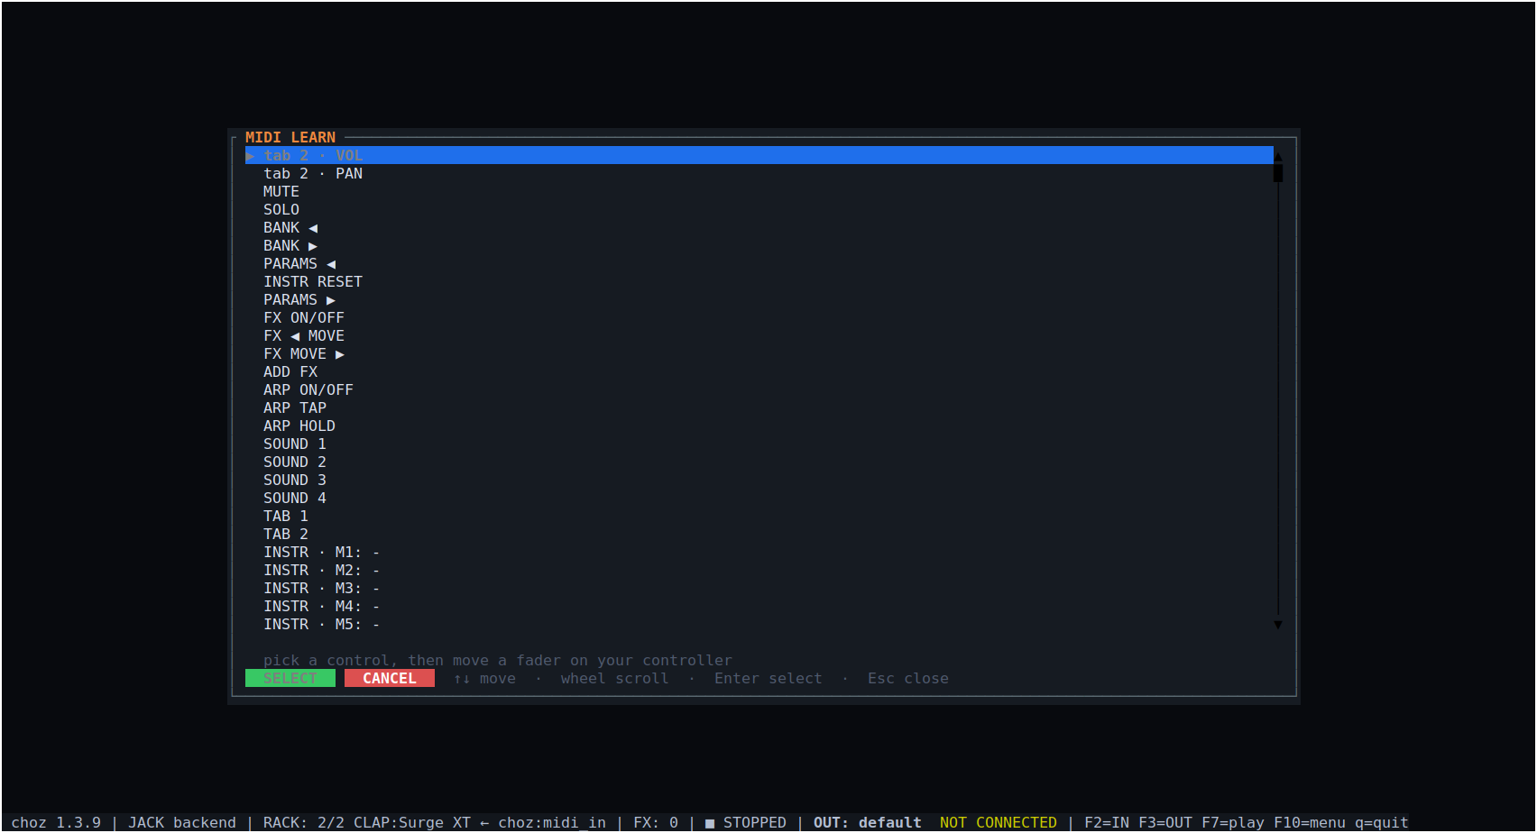
Figure 8.3 — MIDI learn: the tab's targets, including every plugin parameter.

8.4 KEYS and panic
The KEYS panel draws the keyboard with the notes sounding, the pitch bend and the modulation wheel, one colour per tab. P (or F9, or PANIC) silences everything left hanging.
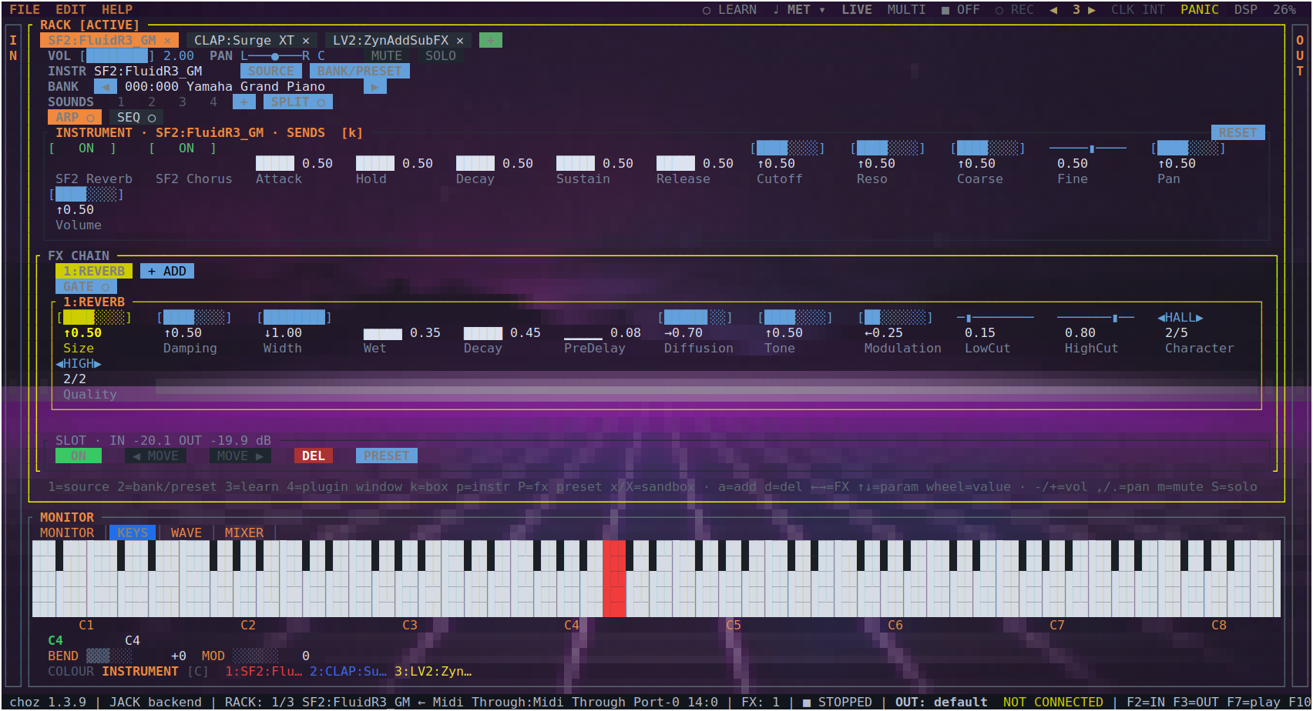
Figure 8.4 — The KEYS panel: a note sounding, bend and modulation, and each tab's colour.

8.5 OSC
choz listens for OSC as one more note input; --osc-port pins the port instead of letting the OS pick one. It appears in the IN drawer and binds to a tab like any other source.

8.6 Clock
CLK on the menu bar chooses what drives the transport: choz's own clock, or an external device by name. MIDI Clock arriving on a port choz is following moves the tempo, and START, CONTINUE and STOP move the transport with it — so a DAW's play button starts the arpeggiators, the sequencers and the synced delays.

9. Arpeggiator, step sequencer and arranger

9.1 Arpeggiator
A switches on the active tab's arpeggiator (so does the ARP button). Its controls are the mode (UP, DOWN and the rest), the division (1/16, 1/8 …), BPM, gate, swing, octaves, HOLD, CHORD and TAP. HOLD behaves like a hardware sequencer's: letting go keeps the chord sounding, and the next key pressed with nothing held starts a new chord instead of adding to the old one.
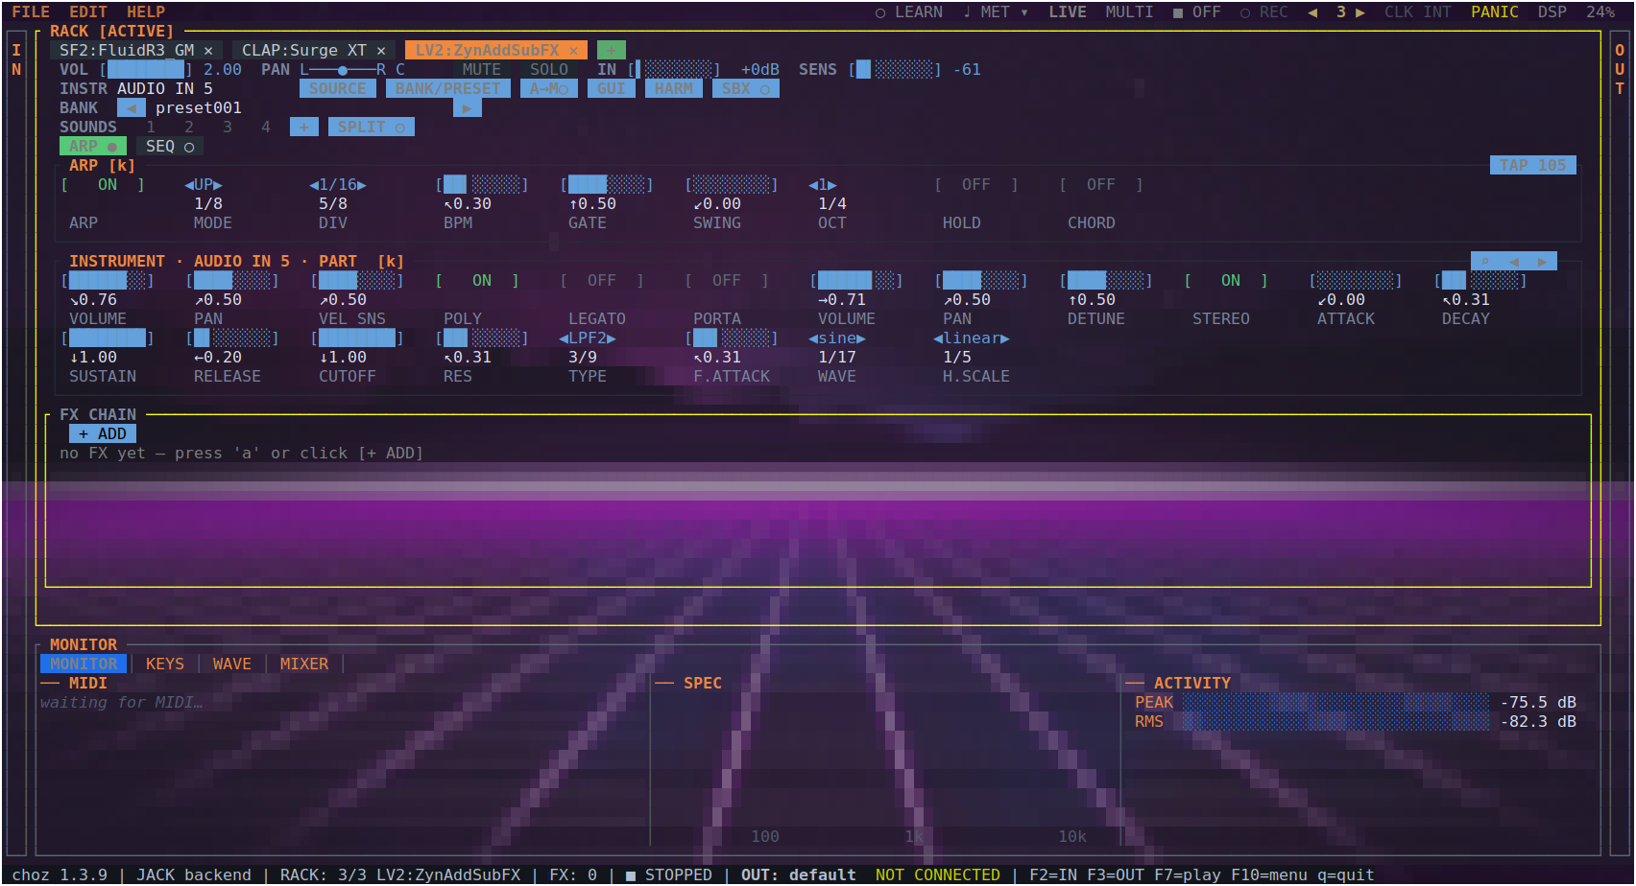
Figure 9.1 — The tab's arpeggiator: mode, division, BPM, gate, swing, octaves, hold, chord and tap.
One clock. The arpeggiator, the sequencer, the arranger and the metronome count the same position — the transport while it rolls, a free clock that never stops otherwise — so anything started at any time lands on the same grid. The first note of a chord sounds when the key is pressed; the rest fall on the grid. Swing lengthens the same steps it does in the sequencer.

9.2 Step sequencer
Every tab also carries a sequencer built like a hardware step machine: eight tracks (A–H), sixteen steps, eight parts and a song chain. It is drawn above the instrument because that is the order the notes travel in. REC writes what you play, quantised to the step the play head is on, and each step passes through the tab's arpeggiator when there is one.
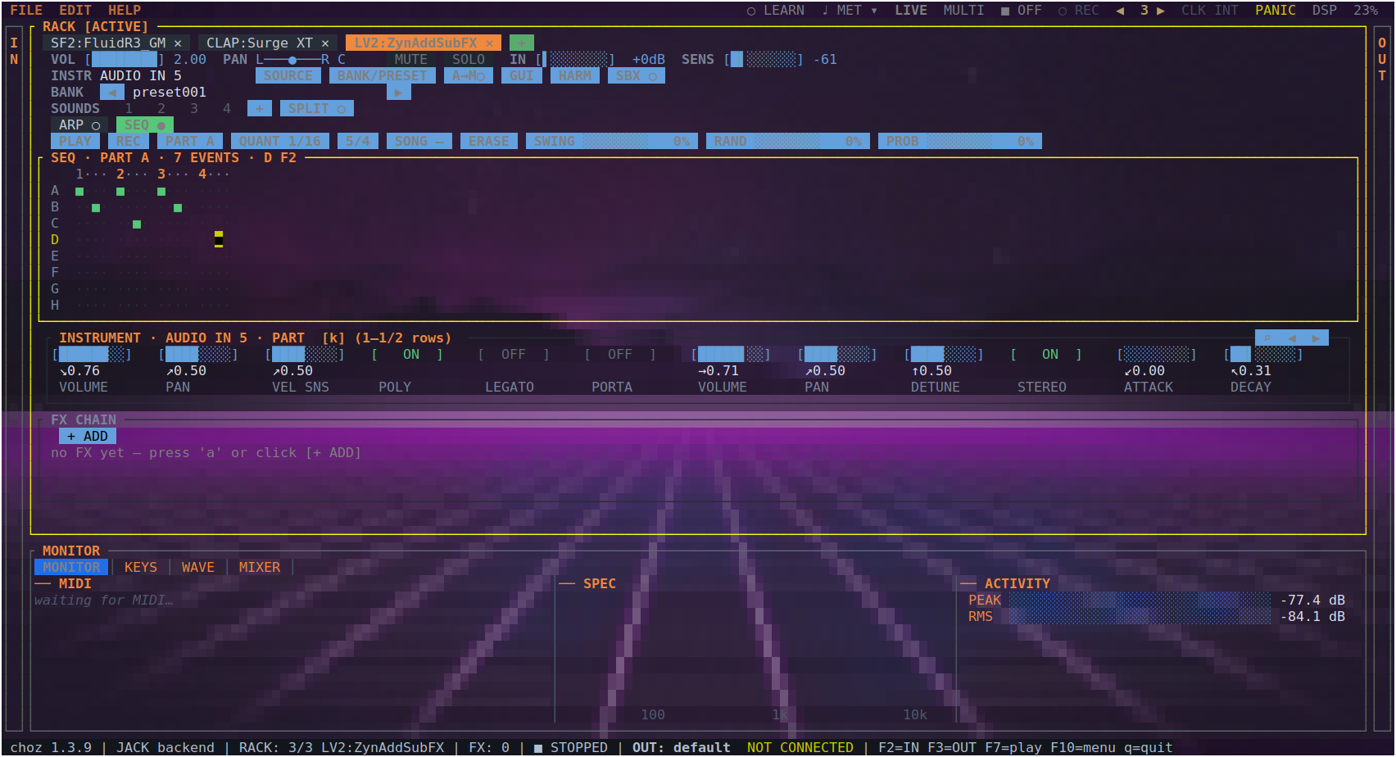
Figure 9.2 — The sequencer: play, record, part, quantise, time signature, song chain, clear, swing, randomness and probability.
- ▶ plays the pattern from the top of the song chain, ⏸ leaves and comes back in the same part of the chain, ■ stops and rewinds. K in the box still toggles play and stop.
- ■ takes the metronome with it when something was playing: a click over a stopped rack is a click nobody asked for. Pausing does not.
- METER opens the bar: beats, unit, grouping, and how many steps that makes. It is the session's time signature — the metronome's — because there is one bar in this program.
- Steps are counted from every downbeat of that bar. A bar that is not a whole number of steps (7/8 at quarter steps is three and a half) ends on a short step, and steps past the sixteen the grid holds are rests, so step 1 is always the metronome's one.

9.3 Arranger
The arranger is a backing band from a chord chart: bass, drums, piano and guitar playing a progression in a style. A tab plays one artifact at a time, so switching the arranger on (its tab switch on the ARR tab of the generator box) switches that tab's arpeggiator and sequencer off. Switching it on does not start it: ▶ does.
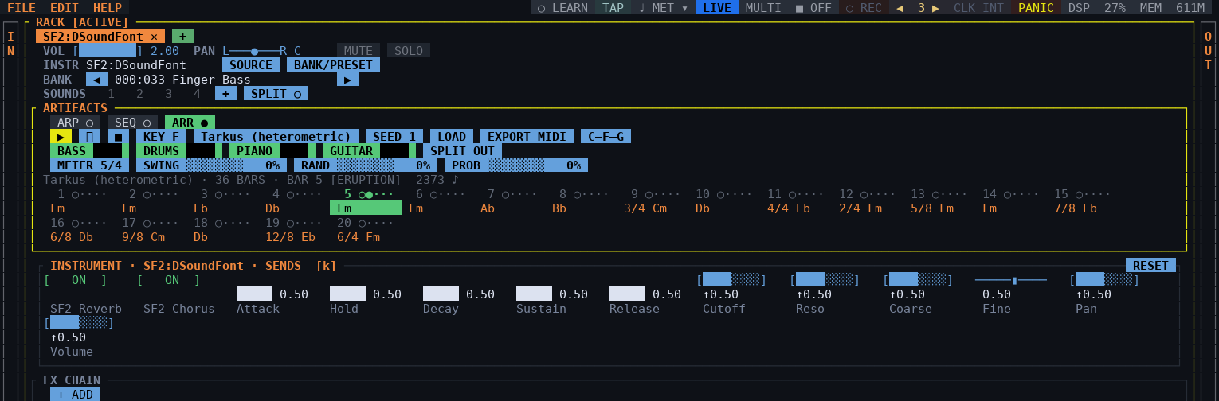
Figure 9.3 — The arranger on a SoundFont, playing the heterometric Tarkus chart: the band row with SPLIT OUT, the bar the band counts (5/4) and the chart, bar 5 lit.
- ▶ plays the form from bar one, ⏸ leaves and comes back at the top of the bar it was left in, ■ stops, lets go of everything and rewinds (and takes the click, as in the sequencer).
- ▶ comes in on the next downbeat of the metronome's bar, not on the press, so the band's one is the click's one — at most a bar's wait, half a bar on average. Pressed on the one (up to an eighth of a beat late) it starts that bar at once.
- KEY picks the tonic on a piano; the style button opens the list of every style (about two hundred, measured from real accompaniments), each described by how it plays — and choosing one loads its time signature (a waltz 3/4, a 6/8 blues 6/8) into METER, the metronome and the session, unless the chart names its own; SEED picks another interpretation of the same chart.
- C–F–G / I–IV–V switches the chart between chord letters and roman degrees — it rewrites the text.
- BASS DRUMS PIANO GUITAR: a click puts a musician in or out of the band, the wheel over the bar sets how loud. On a SoundFont every musician gets its own program (a kit for the drums, a bass for the bass); on other instruments the whole band plays the tab's one sound. The right button on a musician opens the SoundFont's programs for that musician alone (BANK/PRESET), with AUTO on top — the style's choice, named beside it; the pick is kept in the project. n in the MIXER on a tab playing a band levels it musician by musician, from the loudest each one played since the last time, and puts the tab back at 1.00: a font's kit can sit 15 dB over its piano, which the faders here — they set how hard each one plays — cannot make up. Loading an instrument only ever turns its tab down, never up: one middle C is not a band.
- SPLIT OUT (off by default) puts every musician on a strip of their own in the MIXER — after the tabs, before the groups — without opening any tab: a fader, a pan and a mute on that musician's channel of the tab's instrument, with its own meter. It needs the band to have channels to separate, which a SoundFont with the programs for it gives; reverb and chorus stay on the tab.
- METER is the bar the band counts; SWING, RAND and PROB vary the part the way the sequencer's knobs do.
- LOAD opens a .chord chart or a MIDI file (section 9.5); EXPORT MIDI writes the band out (section 9.5).
- The bars at the bottom of the box are the progression: a click opens the grid editor, a chord a subdivision, with CHORD, GROUP, HOLD, BAR +, BAR - and BAND BAR. Every bar is drawn once, however often the form plays it: form = turn turn turn is the twelve bars of the turn, and the light goes back to its first bar each time round, with the header saying which pass it is (BAR 13 [TURN] 2/3). Every chord of a bar is played by every musician: a chord the style's pattern has no hit for is struck where it starts.

9.4 Chord charts
A chart is a plain-text .chord file. The settings go on top, the bars below; # starts a comment. A fresh tab plays a twelve-bar blues in C — in the source tree it is assets/default.chord, a chart like any other.
key = D
style = strtrock
meter = 7/8 # or: time = 7/8
groups = 3+2+2 # or: grouping = 3 2 2

[A]
| Dm7 | G7:3 C:4 | Cmaj7 - | A7 |
[B]
| IIm7 | V7 | I | % |
form = A A B A

- | separates bars, and so does the end of a line. A bar with two chords splits it evenly; C:3 gives a chord three of the bar's units.
- A chart can change meter: a bar that starts with a signature is in it, and so is every bar after it in the part until the next one — | 5/4 Fm | Eb | 3/4 Db | 7/8 Cm |. Each bar lasts what its signature says; a part starts back in the chart's bar. The source tree has an example, assets/tarkus.chord, for the tarkus style — which has a groove for each of the signatures it changes to.
- - holds the chord before it, % repeats the bar before.
- Letters (C7, F#m7b5, Bbmaj9) or degrees against the key (I7, IVm7, VIIb7).
- [A], [intro]: parts; form says which are played in what order (without it, the order they were written in).
- meter and groups: the bar the chart is written in and how it is counted. They win over the session and the style, and LOAD hands them to the metronome and the grid. Groups that do not add up to the numerator are an error. A chart that changes meter counts each meter with a line of its own — groups 7/8 = 2+2+3, groups 5/8 = 3+2 — and while the band plays, the click accents the grouping of the bar it is in; a meter with no line gets the downbeat alone.
- A chart that does not read leaves the band playing what it had, and says why on the box.
Styles. style = takes a style by its id, its name or the label the picker shows — style = 42, style = drumnbass and style = Drum & Bass are the same chart. The id is the number the STYLE list shows beside each style, and it does not change when styles are added. A name that matches none plays the first style. Every style is measured off a rhythm; the definition says what the band plays in it.
ID | style = | Name | Meter | Definition
1 | 16_beat | 16 Beat | 4/4 | straight; bass on the changes; hi-hat in sixteenths
2 | 16bt_bld | 16 Beat Ballad | 4/4 | straight; bass on the changes; hi-hat in sixteenths
3 | 16btshfl | 16 Beat Shuffle | 4/4 | swing 67%; walking bass; hi-hat in eighths
4 | 50_srock | 50s Rock | 4/4 | swing 42%; walking bass; hi-hat in quarter-note triplets
5 | 50spnrck | 50s Piano Rock | 4/4 | straight; walking bass; ride in eighths
6 | 60_s_8bt | 60s 8 Beat | 4/4 | straight; bass on the changes; hi-hat in eighths
7 | 60_s_pop | 60s Pop | 4/4 | straight; bass on the changes; hi-hat in eighths
8 | 60_srock | 60s Rock | 4/4 | straight; bass on the changes; hi-hat in eighths
9 | 60_srock_2 | 60s Rock 2 | 4/4 | straight; bass on the changes; hi-hat in eighths
10 | 60_sshfl | 60s Shuffle | 4/4 | swing 67%; bass on the changes; hi-hat in eighths
11 | 60_ssoul | 60s Soul | 4/4 | straight; walking bass; hi-hat in eighths
12 | 6_8_bld | 6/8 Ballad | 6/8 | straight; bass on the changes; hi-hat in eighths
13 | 6_8_enka | 6/8 Enka | 4/4 | swing 33%; walking bass; hi-hat in eighth-note triplets
14 | 6_8_pop | 6/8 Pop | 6/8 | swing 8%; bass on the changes; hi-hat in eighths
15 | 6_8bld_1 | 6/8 Ballad 1 | 6/8 | straight; walking bass; hi-hat in every 1.25 beats
16 | 6_8bld_2 | 6/8 Ballad 2 | 4/4 | swing 33%; bass on the changes; hi-hat in eighth-note triplets
17 | 6_8bld_3 | 6/8 Ballad 3 | 6/8 | straight; bass on the changes; hi-hat in eighths
18 | 6_8blues | 6/8 Blues | 6/8 | straight; bass on the changes; hi-hat in eighths
19 | 6_8rkbld | 6/8 Rock Ballad | 6/8 | straight; bass on the changes; hi-hat in eighths
20 | 90_s_bld | 90s Ballad | 4/4 | straight; bass on the changes; hi-hat in eighths
21 | a_gt_pop | Acoustic Guitar Pop | 4/4 | straight; bass on the changes; hi-hat in sixteenths
22 | adani | Adani | 4/4 | straight; bass on the changes; hi-hat in eighths
23 | amrcnrck | American Rock | 4/4 | straight; bass on the changes; hi-hat in eighths
24 | argcmbia | Argentine Cumbia | 4/4 | swing 48%; bass on the changes; hi-hat in thirty-seconds
25 | arpegio1 | Arpeggio 1 | 4/4 | straight; bass on the changes; hi-hat in thirty-seconds
26 | arpegio2 | Arpeggio 2 | 4/4 | straight; bass on the changes; hi-hat in thirty-seconds
27 | arpegio3 | Arpeggio 3 | 4/4 | straight; bass on the changes; hi-hat in thirty-seconds
28 | bachata | Bachata | 4/4 | straight; bass on the changes; hi-hat in thirty-seconds
29 | baladi | Baladi | 4/4 | swing 50%; bass on the changes; hi-hat in eighths
30 | banda | Banda | 4/4 | straight; bass on the changes; hi-hat in thirty-seconds
31 | beguine | Beguine | 4/4 | swing 38%; bass on the changes; hi-hat in thirty-seconds
32 | beijing | Beijing | 2/4 | straight; bass on the changes; ride in quarters
33 | bhajan | Bhajan | 4/4 | swing 21%; walking bass; hi-hat in thirty-seconds
34 | bhangra | Bhangra | 4/4 | swing 65%; bass on the changes; ride in quarters
35 | bluegras | Bluegrass | 4/4 | swing 67%; bass on the changes; hi-hat in thirty-seconds
36 | bluesbld | Blues Ballad | 6/4 | straight; bass on the changes; hi-hat in quarters
37 | bolero | Bolero | 4/4 | swing 48%; bass on the changes; hi-hat in half notes
38 | boogie | Boogie | 4/4 | swing 33%; walking bass; hi-hat in thirty-seconds
39 | bosanova | Bossa Nova | 4/4 | straight; walking bass; hi-hat in half notes
40 | brushbld | Brush Ballad | 4/4 | straight; bass on the changes; hi-hat in thirty-seconds
41 | calypso | Calypso | 4/4 | straight; bass on the changes; hi-hat in thirty-seconds
42 | caucasia | Caucasia | 4/4 | swing 58%; bass on the changes; hi-hat in eighths
43 | cha_cha | Cha Cha | 4/4 | swing 48%; bass on the changes; hi-hat in thirty-seconds
44 | chinspop | Chinese Pop | 4/4 | swing 62%; bass on the changes; hi-hat in eighth-note triplets
45 | cnty_8bt | Country 8 Beat | 4/4 | straight; bass on the changes; hi-hat in eighths
46 | cnty_bld | Country Ballad | 4/4 | straight; walking bass; hi-hat in eighths
47 | cnty_pop | Country Pop | 4/4 | straight; bass on the changes; hi-hat in eighths
48 | cntyshfl | Country Shuffle | 4/4 | swing 29%; bass on the changes; hi-hat in every 0.625 beats
49 | cntywltz | Country Waltz | 3/4 | straight; bass on the changes; hi-hat in quarters
50 | cumbia_1 | Cumbia 1 | 4/4 | swing 50%; walking bass; hi-hat in sixteenths
51 | cumbia_2 | Cumbia 2 | 4/4 | swing 50%; bass on the changes; hi-hat in eighth-note triplets
52 | dadra | Dadra | 6/4 | swing 50%; walking bass; hi-hat in sixteenths
53 | daizu | Daizu | 3/4 | straight; bass on the changes; hi-hat in thirty-seconds
54 | dandiya | Dandiya | 4/4 | swing 31%; walking bass; hi-hat in sixteenths
55 | dangdut | Dangdut | 4/4 | swing 50%; bass on the changes; hi-hat in quarters
56 | discopop | Disco Pop | 4/4 | swing 58%; bass on the changes; hi-hat in eighths
57 | dixie | Dixie | 4/4 | swing 33%; walking bass; hi-hat in quarter-note triplets
58 | dongbeiy | Dongbeiy | 4/4 | straight; walking bass; hi-hat in thirty-seconds
59 | drngense | Drngense | 4/4 | straight; walking bass; hi-hat in quarters
60 | drumnbass | Drum & Bass | 4/4 | straight; bass on the changes; hi-hat in sixteenths
61 | dscosoul | Disco Soul | 4/4 | swing 62%; walking bass; hi-hat in eighths
62 | e_hiphop | Electro Hip Hop | 4/4 | straight; bass on the changes; hi-hat in eighths
63 | e_hiphop_2 | Electro Hip Hop 2 | 4/4 | straight; bass on the changes; hi-hat in eighths
64 | easy_bld | Easy Ballad | 4/4 | straight; bass on the changes; hi-hat in sixteenths
65 | elec_bld | Electric Ballad | 4/4 | straight; bass on the changes; hi-hat in eighths
66 | enka | Enka | 4/4 | straight; bass on the changes; hi-hat in eighths
67 | ep_bld_1 | Electric Piano Ballad 1 | 4/4 | straight; bass on the changes; hi-hat in sixteenths
68 | ep_bld_2 | Electric Piano Ballad 2 | 4/4 | straight; bass on the changes; hi-hat in sixteenths
69 | euro_pop | Euro Pop | 4/4 | straight; bass on the changes; hi-hat in eighths
70 | f_gospel | Fast Gospel | 4/4 | straight; walking bass; hi-hat in eighths
71 | fastsoul | Fast Soul | 4/4 | straight; bass on the changes; hi-hat in quarters
72 | fingcnty | Fingerpicking Country | 4/4 | straight; bass on the changes; hi-hat in eighths
73 | folklore | Folklore | 4/4 | straight; bass on the changes; hi-hat in thirty-seconds
74 | forro | Forro | 4/4 | straight; bass on the changes; hi-hat in thirty-seconds
75 | fox_trot | Foxtrot | 4/4 | swing 33%; bass on the changes; hi-hat in quarter-note triplets
76 | fr_waltz | French Waltz | 3/4 | swing 33%; bass on the changes; hi-hat in quarters
77 | fstbband | Fast Big Band | 4/4 | swing 42%; walking bass; hi-hat in quarter-note triplets
78 | funk16bt | Funk 16 Beat | 4/4 | swing 50%; bass on the changes; hi-hat in eighths
79 | funk_8bt | Funk 8 Beat | 4/4 | swing 50%; bass on the changes; hi-hat in eighths
80 | funkshfl | Funk Shuffle | 4/4 | swing 67%; bass on the changes; hi-hat in eighth-note triplets
81 | garba | Garba | 4/4 | swing 33%; walking bass; ride in quarters
82 | grmnmrch | German March | 4/4 | swing 50%; walking bass; ride in sixteenths
83 | gtr_8bt | Guitar 8 Beat | 4/4 | straight; bass on the changes; hi-hat in eighths
84 | guangdon | Guangdong | 4/4 | straight; bass on the changes; hi-hat in thirty-seconds
85 | hawaiian | Hawaiian | 4/4 | swing 33%; bass on the changes; hi-hat in half notes
86 | hip_hop1 | Hip Hop 1 | 4/4 | swing 50%; bass on the changes; hi-hat in eighths
87 | hip_hop1_2 | Hip Hop 1 2 | 4/4 | swing 50%; bass on the changes; hi-hat in eighths
88 | hip_hop2 | Hip Hop 2 | 4/4 | straight; walking bass; hi-hat in sixteenths
89 | hip_hop2_2 | Hip Hop 2 2 | 4/4 | straight; walking bass; hi-hat in sixteenths
90 | huangmei | Huangmei | 4/4 | straight; bass on the changes; hi-hat in eighths
91 | indipop1 | Indian Pop 1 | 4/4 | swing 12%; bass on the changes; hi-hat in sixteenths
92 | indipop2 | Indian Pop 2 | 4/4 | swing 23%; walking bass; hi-hat in every 0.5833 beats
93 | jhaptaal | Jhaptaal | 10/4 | swing 58%; bass on the changes; hi-hat in thirty-seconds
94 | jiangnan | Jiangnan | 4/4 | swing 50%; walking bass; hi-hat in sixteenths
95 | jingju | Jingju | 4/4 | straight; bass on the changes; hi-hat in thirty-seconds
96 | jz_waltz | Jazz Waltz | 3/4 | swing 33%; bass on the changes; hi-hat in quarters
97 | jzcombo1 | Jazz Combo 1 | 4/4 | swing 33%; walking bass; ride in quarter-note triplets
98 | jzcombo2 | Jazz Combo 2 | 4/4 | swing 33%; bass on the changes; hi-hat in half notes
99 | jzcombo3 | Jazz Combo 3 | 4/4 | swing 42%; bass on the changes; hi-hat in half notes
100 | keharwa | Keharwa | 4/4 | straight; bass on the changes; hi-hat in thirty-seconds
101 | khaliji | Khaliji | 4/4 | straight; bass on the changes; hi-hat in sixteenths
102 | kroncong | Kroncong | 4/4 | straight; walking bass; ride in half notes
103 | kwaito | Kwaito | 4/4 | swing 12%; walking bass; hi-hat in dotted eighths
104 | kwaito_2 | Kwaito 2 | 4/4 | swing 12%; walking bass; hi-hat in dotted eighths
105 | ltinfusn | Latin Fusion | 4/4 | straight; walking bass; ride in eighths
106 | ltinrock | Latin Rock | 4/4 | swing 42%; bass on the changes; hi-hat in eighths
107 | malfouf | Malfouf | 4/4 | swing 67%; bass on the changes; hi-hat in thirty-seconds
108 | mambo | Mambo | 4/4 | swing 50%; bass on the changes; hi-hat in thirty-seconds
109 | march | March | 4/4 | swing 33%; walking bass; hi-hat in quarters
110 | mdrn_bld | Modern Ballad | 4/4 | straight; walking bass; hi-hat in sixteenths
111 | mdrn_r_b | Modern R&B | 4/4 | swing 65%; bass on the changes; hi-hat in eighths
112 | mdrncnty | Modern Country | 4/4 | swing 67%; bass on the changes; hi-hat in eighths
113 | melow8bt | Mellow 8 Beat | 4/4 | straight; bass on the changes; hi-hat in eighths
114 | menggu | Menggu | 4/4 | swing 58%; walking bass; hi-hat in thirty-seconds
115 | merengue | Merengue | 4/4 | swing 50%; bass on the changes; hi-hat in sixteenths
116 | miaozu | Miaozu | 4/4 | straight; bass on the changes; hi-hat in thirty-seconds
117 | midbband | Mid Big Band | 4/4 | straight; bass on the changes; ride in quarters
118 | mus | Mus | 5/8 | straight; walking bass; hi-hat in sixteenths
119 | n_o_r_r | New Orleans Rock & Roll | 4/4 | swing 8%; walking bass; hi-hat in half notes
120 | norteno | Norteno | 4/4 | straight; bass on the changes; hi-hat in quarters
121 | ochswing | Orchestral Swing | 4/4 | swing 35%; walking bass; hi-hat in half notes
122 | old_rock | Old Rock | 4/4 | straight; bass on the changes; hi-hat in eighths
123 | old_soul | Old Soul | 4/4 | straight; bass on the changes; hi-hat in eighths
124 | oldie8bt | Oldies 8 Beat | 4/4 | swing 33%; bass on the changes; hi-hat in quarter-note triplets
125 | orgnrock | Organ Rock | 4/4 | swing 50%; bass on the changes; hi-hat in eighths
126 | pagode | Pagode | 4/4 | swing 8%; bass on the changes; hi-hat in thirty-seconds
127 | pasillo | Pasillo | 3/4 | straight; bass on the changes; hi-hat in thirty-seconds
128 | pasodble | Paso Doble | 4/4 | straight; walking bass; ride in quarters
129 | pianor_r | Piano Rock & Roll | 4/4 | straight; bass on the changes; hi-hat in thirty-seconds
130 | pno8beat | Piano 8 Beat | 4/4 | swing 50%; bass on the changes; hi-hat in sixteenths
131 | pnobld_1 | Piano Ballad 1 | 4/4 | straight; bass on the changes; hi-hat in eighths
132 | pnobld_2 | Piano Ballad 2 | 4/4 | straight; walking bass; hi-hat in eighths
133 | pnomrch1 | Piano March 1 | 4/4 | straight; walking bass; hi-hat in thirty-seconds
134 | pnomrch2 | Piano March 2 | 4/4 | straight; bass on the changes; hi-hat in thirty-seconds
135 | pnowaltz | Piano Waltz | 3/4 | straight; bass on the changes; hi-hat in quarters
136 | pnrckbld | Piano Rock Ballad | 4/4 | straight; bass on the changes; ride in eighths
137 | polka | Polka | 4/4 | straight; walking bass; hi-hat in quarters
138 | polwaltz | Polka Waltz | 3/4 | swing 40%; bass on the changes; hi-hat in quarters
139 | pop | Pop | 4/4 | straight; bass on the changes; hi-hat in eighths
140 | pop_bld | Pop Ballad | 4/4 | swing 50%; bass on the changes; hi-hat in eighths
141 | pop_rock | Pop Rock | 4/4 | swing 50%; bass on the changes; hi-hat in eighths
142 | pop_shfl | Pop Shuffle | 4/4 | swing 33%; bass on the changes; hi-hat in eighth-note triplets
143 | popregae | Pop Reggae | 4/4 | swing 65%; bass on the changes; hi-hat in eighth-note triplets
144 | punta | Punta | 4/4 | swing 50%; walking bass; hi-hat in thirty-seconds
145 | qinqiang | Qinqiang | 4/4 | straight; walking bass; hi-hat in thirty-seconds
146 | quickstp | Quickstep | 4/4 | swing 33%; bass on the changes; hi-hat in quarter-note triplets
147 | r_b | R&B | 4/4 | swing 50%; bass on the changes; hi-hat in eighths
148 | r_b_bld | R&B Ballad | 4/4 | swing 50%; bass on the changes; hi-hat in quarters
149 | r_r | Rock & Roll | 4/4 | swing 33%; walking bass; hi-hat in half notes
150 | ragtime | Ragtime | 4/4 | straight; bass on the changes; hi-hat in thirty-seconds
151 | rckblues | Rock Blues | 4/4 | straight; bass on the changes; hi-hat in eighths
152 | regeton1 | Reggaeton 1 | 4/4 | swing 50%; bass on the changes; hi-hat in thirty-seconds
153 | regeton2 | Reggaeton 2 | 4/4 | straight; bass on the changes; hi-hat in sixteenths
154 | reggae | Reggae | 4/4 | swing 62%; walking bass; hi-hat in eighths
155 | rhumba | Rhumba | 4/4 | swing 50%; walking bass; ride in eighths
156 | rock | Rock | 4/4 | swing 8%; bass on the changes; hi-hat in quarters
157 | rock_bld | Rock Ballad | 4/4 | swing 50%; walking bass; hi-hat in quarters
158 | rockwltz | Rock Waltz | 6/4 | swing 17%; bass on the changes; hi-hat in quarters
159 | ruchnsn1 | Ruchnsn1 | 4/4 | straight; walking bass; hi-hat in quarters
160 | ruchnsn2 | Ruchnsn2 | 4/4 | straight; walking bass; hi-hat in eighths
161 | rupak | Rupak | 7/4 | swing 50%; walking bass; hi-hat in sixteenths
162 | s_gospel | Slow Gospel | 6/4 | straight; bass on the changes; hi-hat in quarters
163 | salsa_1 | Salsa 1 | 4/4 | straight; walking bass; hi-hat in thirty-seconds
164 | salsa_2 | Salsa 2 | 4/4 | straight; walking bass; hi-hat in thirty-seconds
165 | samba_1 | Samba 1 | 4/4 | straight; bass on the changes; ride in sixteenths
166 | samba_2 | Samba 2 | 4/4 | swing 8%; bass on the changes; hi-hat in quarters
167 | schlager | Schlager | 4/4 | straight; bass on the changes; hi-hat in eighths
168 | scrswing | Scrswing | 4/4 | straight; bass on the changes; hi-hat in half notes
169 | serenade | Serenade | 4/4 | straight; walking bass; hi-hat in thirty-seconds
170 | shfblues | Shuffle Blues | 4/4 | swing 35%; walking bass; hi-hat in quarters
171 | shflrock | Shuffle Rock | 4/4 | swing 33%; bass on the changes; hi-hat in quarter-note triplets
172 | shouka_1 | Shouka 1 | 4/4 | straight; bass on the changes; hi-hat in quarters
173 | shouka_2 | Shouka 2 | 3/4 | straight; bass on the changes; hi-hat in thirty-seconds
174 | sirtaki | Sirtaki | 4/4 | straight; walking bass; ride in quarters
175 | ska | Ska | 4/4 | swing 54%; walking bass; hi-hat in quarters
176 | slow_bld | Slow Ballad | 4/4 | straight; bass on the changes; hi-hat in eighths
177 | slowbld1 | Slow Ballad 1 | 4/4 | straight; bass on the changes; hi-hat in eighths
178 | slowbld2 | Slow Ballad 2 | 4/4 | straight; walking bass; hi-hat in eighths
179 | slowrock | Slow Rock | 4/4 | swing 33%; bass on the changes; hi-hat in half notes
180 | slowsoul | Slow Soul | 6/8 | swing 67%; bass on the changes; hi-hat in eighths
181 | slwbband | Slow Big Band | 4/4 | straight; walking bass; hi-hat in half notes
182 | slwblues | Slow Blues | 4/4 | swing 33%; bass on the changes; hi-hat in eighth-note triplets
183 | slwbossa | Slow Bossa | 4/4 | straight; bass on the changes; hi-hat in half notes
184 | slwswing | Slow Swing | 4/4 | straight; walking bass; hi-hat in half notes
185 | slwwaltz | Slow Waltz | 3/4 | straight; bass on the changes; hi-hat in quarters
186 | strd_pno | Stride Piano | 4/4 | straight; bass on the changes; hi-hat in thirty-seconds
187 | strqrtet | String Quartet | 4/4 | straight; bass on the changes; hi-hat in thirty-seconds
188 | strt_8bt | Straight 8 Beat | 4/4 | straight; bass on the changes; hi-hat in eighths
189 | strtrock | Straight Rock | 4/4 | straight; bass on the changes; hi-hat in eighths
190 | swing | Swing | 4/4 | swing 33%; walking bass; ride in quarter-note triplets
191 | synthpop | Synth Pop | 4/4 | straight; bass on the changes; hi-hat in eighths
192 | tango | Tango | 4/4 | swing 46%; bass on the changes; hi-hat in thirty-seconds
193 | tarkus | Tarkus (heterometric) | 5/4 | straight; bass on the changes; ride in eighths
194 | teccmbia | Techno Cumbia | 4/4 | swing 52%; walking bass; hi-hat in thirty-seconds
195 | tech_pop | Techno Pop | 4/4 | straight; bass on the changes; hi-hat in eighths
196 | teentaal | Teentaal | 4/4 | swing 50%; walking bass; ride in eighths
197 | tex_mex | Tex Mex | 4/4 | swing 54%; bass on the changes; hi-hat in quarters
198 | trance | Trance | 4/4 | straight; bass on the changes; hi-hat in sixteenths
199 | uk_beat | UK Beat | 4/4 | straight; bass on the changes; hi-hat in eighths
200 | unplgbld | Unplugged Ballad | 4/4 | straight; bass on the changes; hi-hat in thirty-seconds
201 | valenato | Vallenato | 4/4 | straight; bass on the changes; hi-hat in sixteenths
202 | vienwltz | Viennese Waltz | 3/4 | swing 50%; walking bass; hi-hat in thirty-seconds
203 | waltz_1 | Waltz 1 | 3/4 | straight; bass on the changes; hi-hat in quarters
204 | waltz_2 | Waltz 2 | 3/4 | straight; bass on the changes; hi-hat in thirty-seconds
205 | waltz_3 | Waltz 3 | 3/4 | straight; bass on the changes; hi-hat in thirty-seconds
206 | waltz_4 | Waltz 4 | 3/4 | straight; bass on the changes; hi-hat in thirty-seconds
207 | xinjiang | Xinjiang | 4/4 | swing 46%; bass on the changes; hi-hat in sixteenths
208 | xmassong | Christmas Song | 4/4 | straight; bass on the changes; hi-hat in half notes
209 | xmaswltz | Christmas Waltz | 3/4 | straight; bass on the changes; hi-hat in quarters
210 | yaozu | Yaozu | 4/4 | straight; bass on the changes; hi-hat in thirty-seconds
211 | yuju | Yuju | 4/4 | swing 31%; bass on the changes; hi-hat in thirty-seconds
212 | zangzu | Zangzu | 4/4 | straight; bass on the changes; hi-hat in thirty-seconds

9.5 MIDI import and export
EXPORT MIDI asks for a folder and then a file name (.mid is added; an existing file is asked about). The file is type 1: a conductor track with the tempo, the time signature, a marker at every chord change and the chart itself, then one track per musician on the channel a GM player expects — drums on 10 — with the style's program.
Levels. Inside a tab the whole band plays one instrument, so the parts are baked to sit under each other. In the file each musician has a channel of its own, so each part is brought to its own average velocity — drums 96, bass 92, piano 80, guitar 74, accents kept — and each musician's fader goes on the channel volume (CC 7; 100 at full), where the DAW's mixer can find it.
LOAD opens .chord, .mid and .midi. A MIDI file choz wrote opens as exactly the chart that wrote it. Any other is listened to: one chord a bar, or two when the halves of the bar are plainly different, with the root taken from the bass register and the drum channel ignored. It is a heuristic — a melody full of passing notes can split a bar that is one chord — and the grid editor is where to correct it.
Note. The arranger reads and writes two to four instruments (channels with notes, drums included). A single melody or a full GM song is not a backing and is refused; so is exporting a band of one — put a second musician in first.

9.6 The arranger and the click
While an arranger plays, the metronome follows its bar: the chart's meter, else the style's own (a waltz clicks in three), with its grouping. The sequencer's grid follows too, and the session's own time signature comes back when the band stops. In a chart that changes meter the click changes with every bar, and counts its one from that bar's downbeat. FOLLOW ARR in the metronome's menu turns this off; setting BEATS or UNIT by hand turns it off as well, because that is the player taking the count back.

10. Transport, tempo and metronome

10.1 Transport
F7 starts and stops the rack, F8 arms automation recording, F9 fires panic — the same three controls that sit on the menu bar. The transport is what every sequencer, every synced delay and the automation count against.

10.2 Metronome
F6 switches the click on; the ▾ beside MET opens its options: click, tempo, beats and unit of the bar, grouping, sound, output and level. It keeps counting with the transport stopped — which is usually when it is needed — and it counts the same tempo the tempo-synced plugins read.
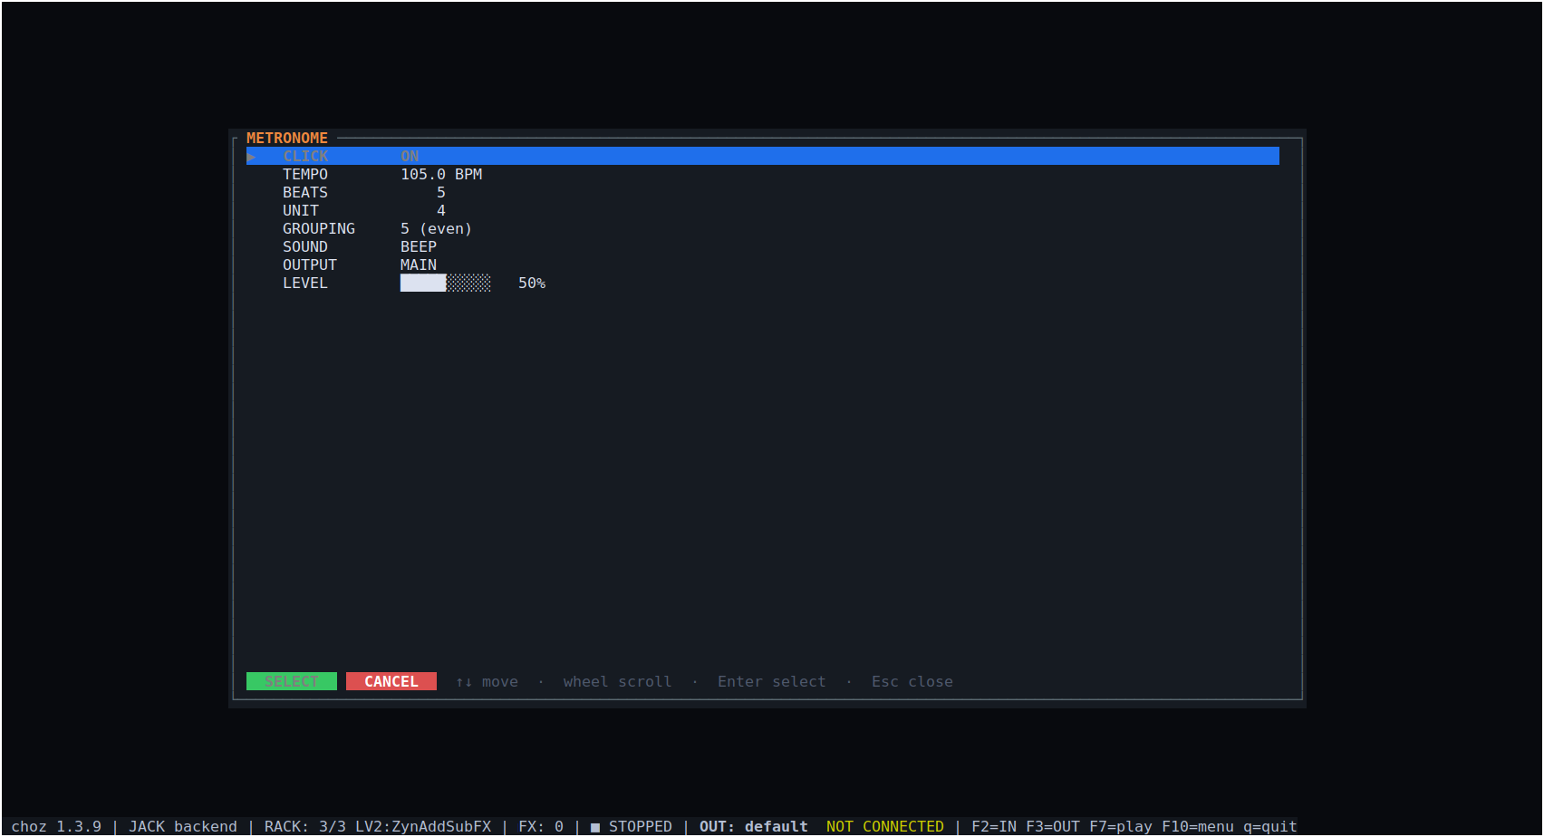
Figure 10.1 — The metronome's options: click, tempo, time signature, grouping, sound, output and level.
Its last row, FOLLOW ARR, makes the click count the bar of a playing arranger (section 9.6). Switching the click on never restarts the count: it joins on the beat the music is already on, and a sequencer's or an arranger's ■ switches it off with the band.

10.3 TAP
TAP sits immediately left of MET: four clicks set the transport's tempo. It is the same count the arpeggiator's own TAP does — the average of the last four intervals, with a gap longer than two seconds starting a new count, because that was somebody stopping rather than playing very slowly.
- The button lights on every tap: playing a tempo in is a gesture with no other feedback, and a button that never moves cannot say whether the click landed.
- On the fourth tap the metronome starts by itself — counting four in is counting for a click, and the click you were counting for is the one you want to hear.
- Taps are quarter notes whatever division the arpeggiator is running, and the tempo they set is the transport's, so everything synced follows.
Tip. TAP is also a MIDI learn target, so a pad on a controller can play the tempo in without reaching for the mouse.
TAP has a colour of its own — a muted teal, softer than the metronome's gold — so it reads as a button to press rather than as part of the MET switch.

11. Mixer, routing and views

11.1 The mixer
The MIXER panel shows the whole rack at once as channel strips: one vertical fader per output channel with a link between the two, pan, and the O M S row under the fader (output, mute, solo).
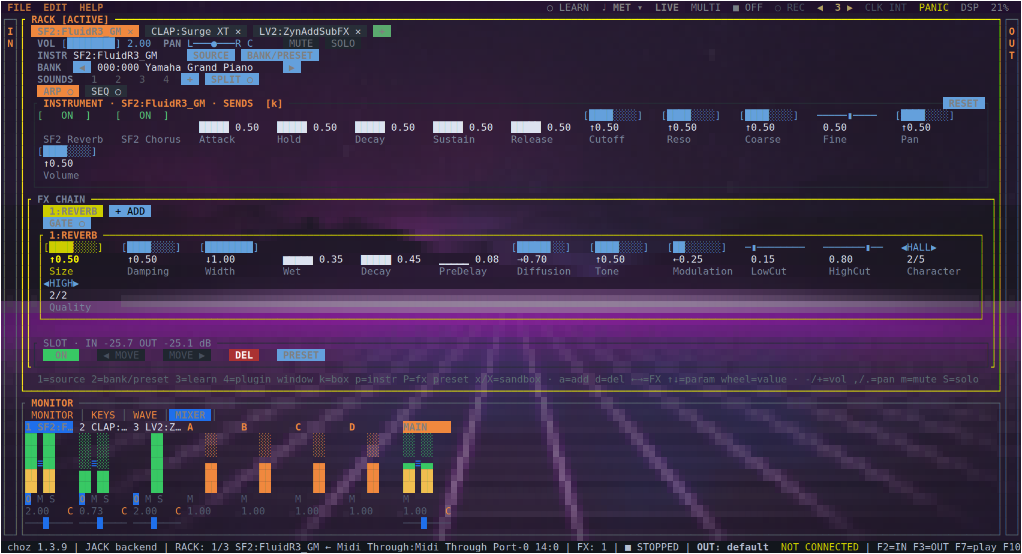
Figure 11.1 — MIXER: tabs, groups and the main mix, each strip with its faders, pan and O M S.
Key | Action
Tab | Focus the mixer while it is on screen (clicking a strip does the same)
↑ ↓ / wheel | The strip's level, in the same step VOL uses in the rack
← → | Next strip: the tabs, then the four groups, then the main mix
l / k | Link or unlink the strip's two channels / choose which side the arrows move
, . / m / S | Pan / mute / solo
A split-out band. With the arranger's SPLIT OUT up (section 9.3), each musician of a SoundFont tab's band gets a strip of its own after the tabs and before the groups — 1·BASS, 1·DRUMS — with one fader, a pan, a mute and its own meter, acting on that musician's channel inside the tab before the tab's fader. No tab is added. The mouse and the wheel move them; the arrows walk the tabs and the desk and skip them, and they are not MIDI-learn targets yet.

11.2 Groups and the main mix
Four groups (A, B, C, D) sit between the tabs and the main mix, for a submix with one fader on it. The main is a stereo pair with its two sides tied by default and a balance rather than a pan: a centred main is untouched, and the sides are broken apart only to trim one wedge against the other.

11.3 Direct outs
The O button on a strip opens the list of where that tab sums: MAIN, the four groups, and DIRECT n — a pair of JACK ports of the tab's own with nothing on the other end, for a DAW to patch into. The main fader only ever touches the first pair, so a tab on its direct out is off the master mix by construction.
- One direct per tab, at a fixed place. Tab 1 owns the first pair, tab 2 the second, and each strip offers only its own — a shared list let two tabs pick the same one and land on the same ports. The place never moves: a layout that shifted when the rack changed shape would break the patch in the DAW that the feature exists for.
- As wide as the tab is. A mono tab routes to a single port — what a DAW wants to record off a guitar is one track, not two identical ones. It becomes stereo the moment something in the chain has a reason for the sides to differ: a reverb tail, a chorus spread, a pan, a ping-pong delay, or any hosted plugin. A bypassed effect does not count, and the width is re-measured when the chain or the jack changes.
- The strip's destination cell says where it is going: D1…D8 for a direct out, the group's letter for a group, nothing for the main mix.

11.4 The views
View | What it answers
MONITOR | Did the note arrive, what came out, how loud: the MIDI log, the spectrum and the meters, side by side.
KEYS | What is sounding right now — held notes, bend and modulation, one colour per tab.
WAVE | The waveform of what is playing.
MIXER | The whole desk: every tab, the four groups and the main mix.
HARMONICS | Not a panel tab but a view of its own (h): the harmonic series of an instrument that publishes it, edited in place.
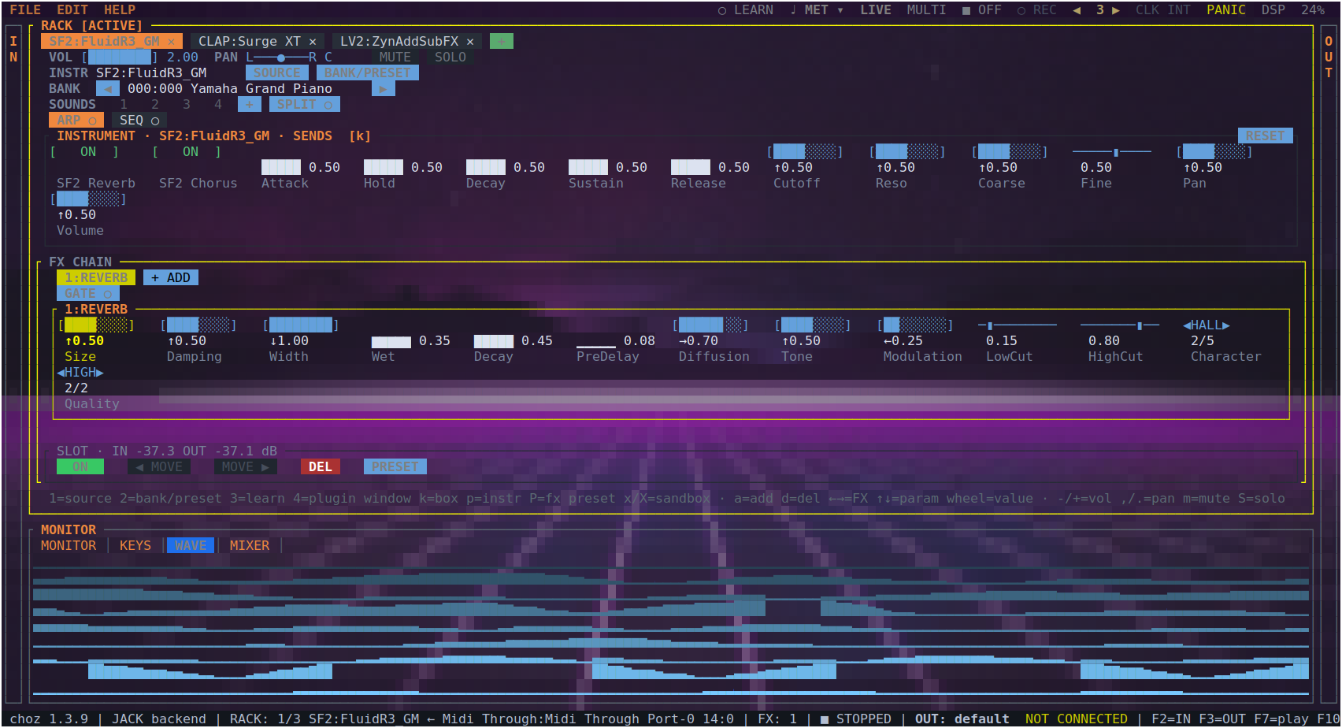
Figure 11.2 — The WAVE panel with a SoundFont's signal going through the internal reverb.

12. Projects
F10 opens the menu bar. FILE makes, saves and opens projects; EDIT leads to Settings and to rescanning the plugin paths; HELP shows the About box.
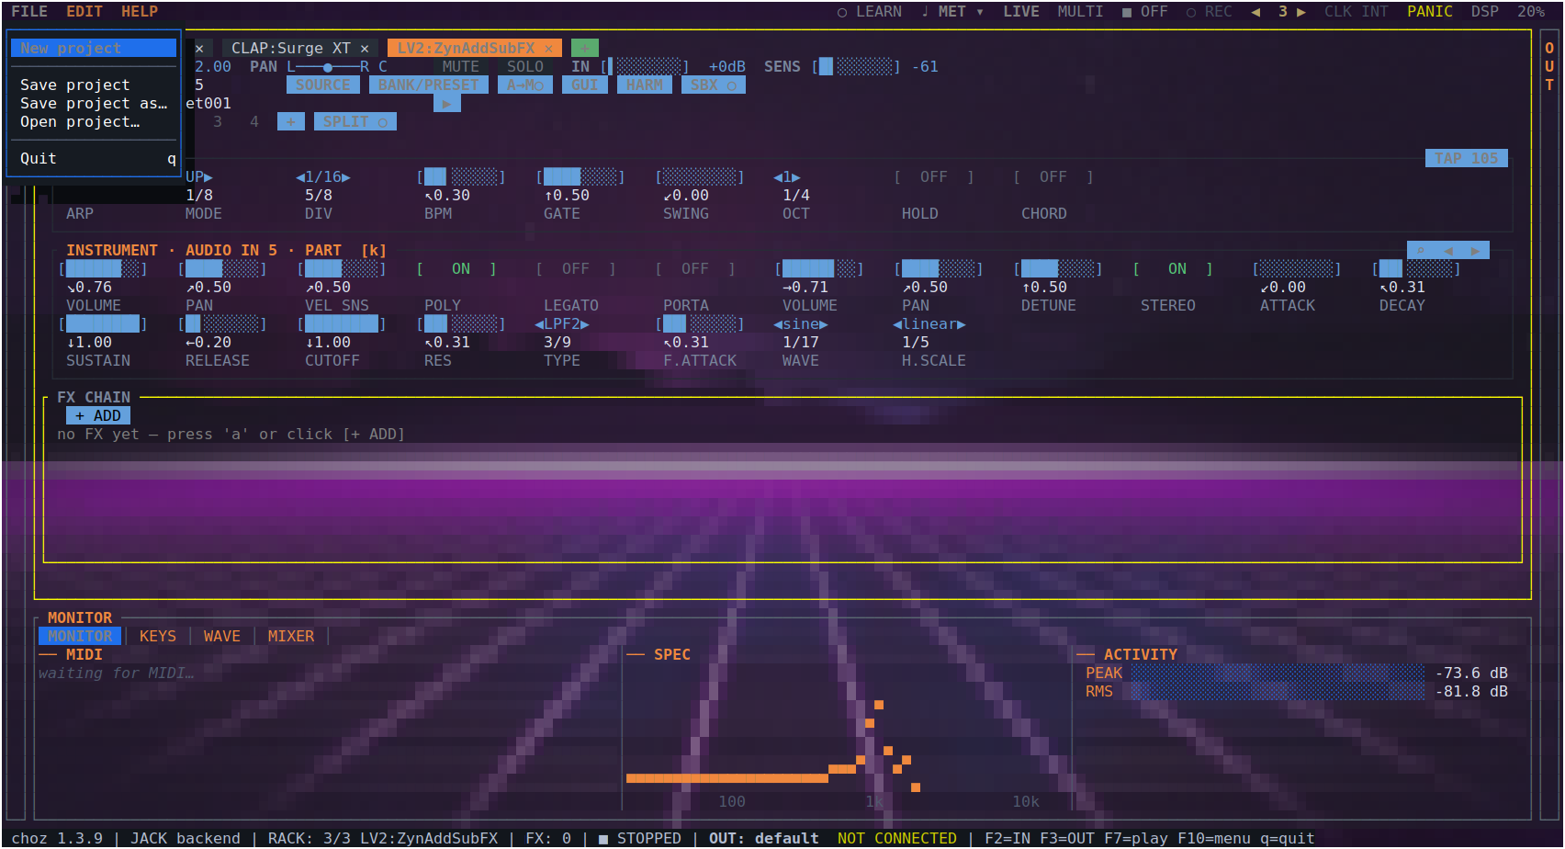
Figure 12.1 — The FILE menu: new project, save, save as, open and quit.
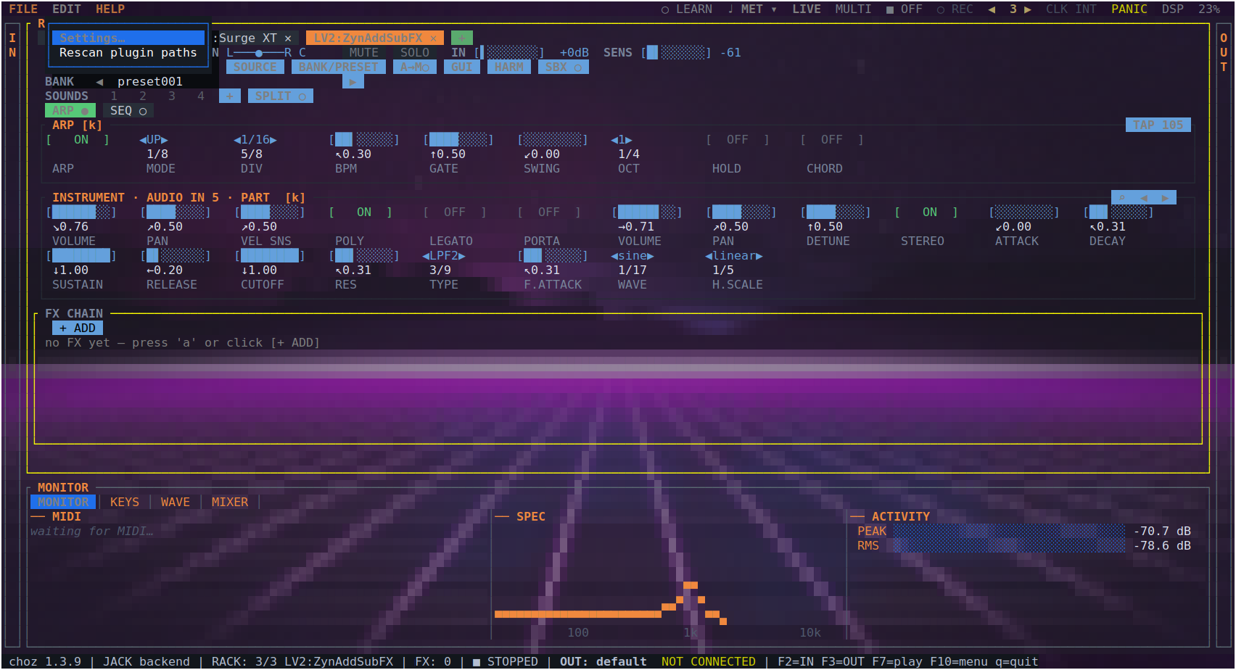
Figure 12.2 — The EDIT menu: Settings and rescanning the plugin paths.
A project is readable YAML that can be kept under version control. Besides the rack and its routing it carries each plugin's own state (section 7.5). Looper takes are saved as WAV inside <project>.loops/ next to the file: moving a project means moving the .yml and its folder. A take recorded at another sample rate is resampled on open, keeping its pitch and its length in seconds.

13. Preferences
EDIT → Settings has three tabs: AUDIO, THEME and LANGUAGE.

13.1 Audio
The engine: backend (AUTO, ALSA or JACK), device, input, sample rate, buffer size, tempo, time signature, feedback guard, polyphony, SF2 engine, the resulting latency and the PipeWire quantum.
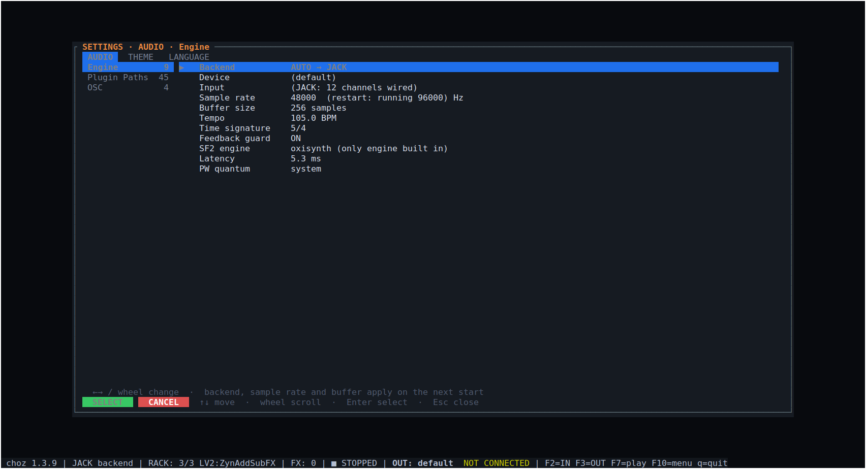
Figure 13.1 — Settings · AUDIO: backend, device, rate, buffer and the latency they add up to.
Note. The backend, the sample rate and the buffer size take effect on the next start. Choosing JACK is what puts choz:out_*, choz:in_*, choz:midi_in and choz:midi_out on the graph.
Polyphony is how many voices one instrument may sound at once — a SoundFont tab and a sampler tab each: 16 to 1024, 256 by default (FluidSynth's own). It is a CPU budget rather than a musical limit: a voice costs only while it sounds, but a held sustain pedal on a layered preset fills the pool and keeps it full. It applies to instruments loaded after the change. On a 96 kHz graph with several SoundFont tabs under the pedal, 128 is the safer choice.

13.2 Plugin paths
Per format, every search folder with how many plugins were found in it, or (missing). The buttons edit, add, browse, remove or restore the defaults. The format's environment variable, when set, replaces the list (section 15).
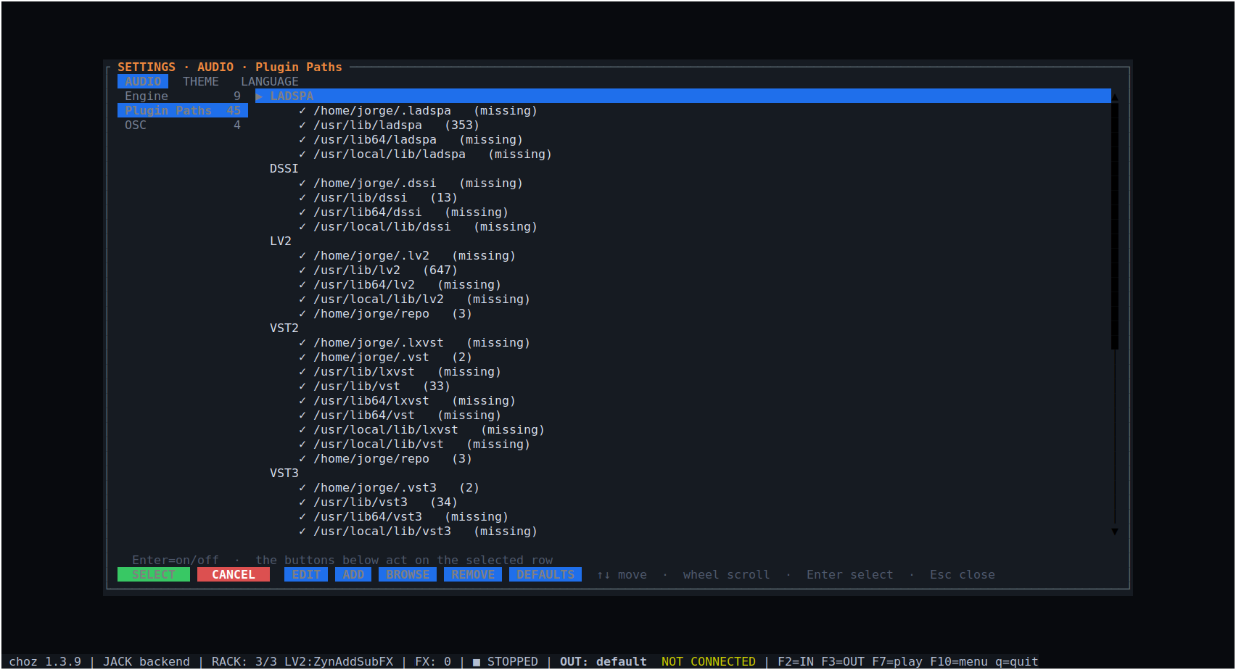
Figure 13.2 — The search paths per format, with how many plugins each holds.

13.3 Theme and wallpaper
Every change here applies live and is saved.
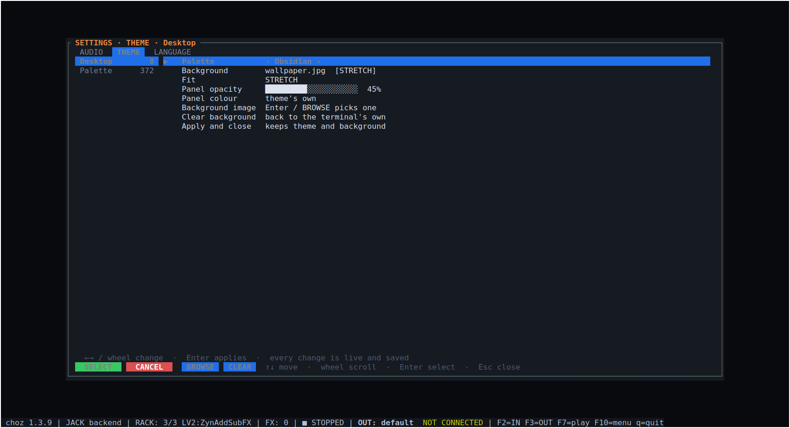
Figure 13.3 — Settings · THEME: palette, wallpaper, fit and panel opacity.
Row | What it does
Palette | 372 colour schemes — choz's own eleven first, then the Gogh terminal schemes. ← → try one in place without leaving the row; Enter opens the full list at the scheme currently worn.
Background | Cycles the terminal's own background and the scheme's flat colour.
Pick image | Opens the file browser on the project's assets/ to set a wallpaper; the installed wallpapers live there.
Fit | Stretch or tile. Present only while an image is set.
Panel opacity | How strongly the panel colour washes over the wallpaper. Absent on the terminal's own background: choz cannot read that colour, so there is nothing to be translucent against.
Panel colour | Which colour that wash is — the scheme's own, or any palette entry.
Clear background | Back to the terminal's own background.
On kitty, Ghostty and WezTerm the wallpaper is drawn with the terminal's graphics protocol; elsewhere it is painted with cell colours, and CHOZ_KITTY_BG=0 forces that path. The picture is re-sent only once the window size has settled, so dragging a window edge does not re-scale a large image on every frame.

13.4 Language
The LANGUAGE tab switches the interface language live, with no restart. Nine are available:
Language | Code
English | en
Español | es
Português | pt
Français | fr
Italiano | it
Deutsch | de
Русский | ru
日本語 | ja
中文 | zh
At first start choz takes the language from the environment (LC_ALL, then LC_MESSAGES, then LANG) and falls back to English. What you pick here is saved in ui.json and wins from then on.

14. Reference: keyboard shortcuts
Key | Where | Action
F2 / F3 | anywhere | The IN and OUT drawers
Enter / Space | a drawer row | Bind that input to the active tab (or unbind it)
c / r | IN drawer | Connect or disconnect the port / rescan
F4 | anywhere | LIVE ↔ MULTI
F5 | anywhere | Bottom panel: MONITOR / KEYS / WAVE / MIXER
F6 | anywhere | Metronome (the ▾ opens its options)
F7 / F8 / F9 | anywhere | Start the rack / arm automation / panic
F10 | anywhere | The menu bar
[ / ] | rack | Previous / next tab
1 or i | rack | Change the tab's instrument
2 or b | rack | Bank and preset
p | rack | The instrument's parameter list
/ | rack (instrument) | Search a knob by name
PgUp / PgDn | rack | Page the knob box (learned CCs move with it)
h | rack | HARMONICS, for an instrument that publishes them
k | rack | Move the cursor between instrument and effects
a / d | rack | Add an effect / delete the selected one
Space | rack (FX) | Switch the effect on or off
g / G | rack | The instrument's own window / the selected effect's
x / X | rack | Run the instrument / the effect isolated
l | rack | MIDI learn
3 | rack | MIDI learn, picking the control first
A | anywhere | The active tab's arpeggiator
C / c | rack (FX) | The chord's keyboard / the gate from another tab
v | rack | Split: which sound each octave plays
< > and ; : | rack | Input trim and A→M sensitivity on an audio tab
- / + | rack | The tab's volume
, / . | rack, MIXER | Pan
m / S | rack, MIXER | Mute / solo
n / N | rack, MIXER | Level the tab / the whole rack
↑ ↓ / wheel | MIXER | The strip's level
← → | MIXER | Next strip: tabs, groups, main
Tab | MIXER | Focus the mixer
P | anywhere | Panic: silence every note
q | anywhere | Quit
TAP, LEARN, the O button on a strip and the metronome's ▾ are mouse controls.

15. Reference: environment variables and files
Variable | Effect
PIPEWIRE_LATENCY / PIPEWIRE_QUANTUM | Set by choz from the configured buffer before it opens the JACK client
CHOZ_SANDBOX_GUI=1 | Isolate every plugin with a window, not only the ones that have crashed before
CHOZ_NO_VIRTUAL_DEVICES=1 | Do not add the choz Mic and choz System FX devices to the system
CHOZ_PROBE_RUNS=N | How many times a plugin is probed before it is called safe (3 by default)
CHOZ_KITTY_BG=0 | Draw the wallpaper with cell colours instead of the terminal's graphics protocol
CHOZ_CLAP_STRICT_TEARDOWN / CHOZ_LV2_STRICT_TEARDOWN | Destroy plugins properly instead of leaking the ones known to crash on teardown (debugging)
LC_ALL / LC_MESSAGES / LANG | The interface language at first start, until one is chosen in Settings
LV2_PATH, VST_PATH, VST3_PATH, CLAP_PATH, LADSPA_PATH, DSSI_PATH, SF2_PATH, SFZ_PATH | Replace the search path for that format
File in ~/.local/state/choz/ | What it holds
choz.log | The log
plugins.json | The scan cache: what was found, where, and when
plugin-paths.json | The search folders per format
plugin-verdicts.json | Which plugin passed quarantine and which did not
plugin-sandbox.json | Which plugins are hosted out of process
ui.json | Interface preferences: theme, wallpaper, language, panel opacity

16. Troubleshooting
Symptom | What it usually is
No sound, and MONITOR shows no MIDI | The port is not bound. Open IN (F2), select the port, press Enter — the row should say → tab n. If the port is not listed at all, press r to rescan.
MONITOR shows MIDI but nothing sounds | The tab has no instrument (press 1), the tab is muted or soloed away in the MIXER, or in MULTI the tab is listening on another channel (F4).
A DAW cannot see choz | For MIDI, look for choz MIDI IN in the DAW's MIDI output list — it is a destination, not a source. If it is missing, it was switched off in the IN drawer. For audio, the backend must be JACK (Settings → AUDIO) and choz must be restarted after changing it.
Clicks and dropouts | Raise the buffer size in Settings → AUDIO, or lower the DSP load by bypassing effects. The DSP figure on the menu bar says which of the two you are short of.
Dropouts, but DSP is low | The graph itself is dropping cycles, and the cause is outside choz: another client, or another card xrunning in the same graph. choz says so in the log when it detects it; journalctl --user -q | grep spa.alsa names the device.
Everything is slow when built from source | A debug build renders roughly ten times dearer than a release one. Build with --release.
A DAW still shows an old choz | A copy of choz.clap or choz-rack.clap in ~/.clap wins over the packaged one in /usr/lib/clap. Remove or rename it (the packages set it aside as *.bak), quit the DAW completely and rescan (section 2.5).
The arranger's band clips | A new tab is trimmed on a middle C of its first preset, and a quiet piano can leave it at ×2 — which a whole band then pushes past full scale. Pull the tab's VOL down, or press n in the MIXER to trim it again while the band plays.
▶ on the arranger takes a moment | It waits for the metronome's next downbeat — at most a bar. Press on the one to start that bar at once.
The click and the band count different bars | FOLLOW ARR is off (the metronome's menu), or the bar was set by hand, which turns it off. Switch it back on and the click takes the band's meter while it plays.
choz disappeared when a plugin crashed | Run that plugin isolated: x for an instrument, X for an effect, or CHOZ_SANDBOX_GUI=1 for every plugin with a window. A plugin that has crashed once is remembered and hosted out of process from then on.
A plugin is not in the picker | Its folder is not on the search path: Settings → Plugin Paths, then add it and rescan (EDIT → Rescan plugin paths, or F5 in the picker). A format's environment variable, when set, replaces the whole list for that format.
A plugin window does not open | LADSPA, DSSI and Pure Data have no embeddable window by design — use the knobs in the rack. Otherwise choz needs X11 or XWayland.
A microphone tab howls | The feedback guard cuts the loop; leave it on (Settings → AUDIO). Lower IN on the tab and check that the tab is not routed into what the microphone hears.
The wallpaper is missing or flickers | Outside kitty, Ghostty and WezTerm it is painted with cell colours. CHOZ_KITTY_BG=0 forces that path everywhere; Clear background turns it off.
The tempo drifts or will not change | Something else is driving the clock: check CLK on the menu bar. On an external source, the tempo is the sender's and TAP will not hold.

17. Glossary
Term | Meaning in this guide
Rack | The middle of the screen: all the tabs, and what they hold.
Tab | One channel of the rack: an input, an instrument, an effect chain, an arpeggiator, a sequencer, a fader and a destination.
Drawer | The IN and OUT lists at the screen's edges (F2, F3).
Direct out | A pair of graph ports belonging to one tab, off the master mix, for a DAW to record.
Group | One of four submixes (A–D) between the tabs and the main mix.
Sandbox | Running a plugin in a child process so its crash cannot take choz down.
Quarantine | The probe choz runs on an unknown plugin before hosting it in its own process.
Gate (on an effect) | Another tab driving this effect's dry/wet or a knob, with its level or its notes.
A→M | Audio to MIDI: turning what an audio tab hears into notes.
Quantum | PipeWire's block size, which choz asks for from the configured buffer.
xrun | A cycle the audio graph failed to deliver on time; heard as a click.

Notes on this edition. The screenshots come from choz 1.3.9 running with the plugins installed on that machine; the screen is unchanged in 1.3.10 apart from the TAP button described in section 10.3, which sits immediately left of MET. Plugin names, banks and presets shown are examples, not requirements.

