Firstly, some aggreagate information:
- Total profit: 870,989
- Total revenue: 4972,965
- Profit margin: 18.0 %
- Mean revenue per order: 756.8
- Median revenue per order: 199.3
- The order size is usually 2-3 products
- Nr of suppliers: 29
- Nr of customers: 90
- Average discount: 14.4 %
- There is no seasonality, so the revenue and profit is distributed uniformly during the year.
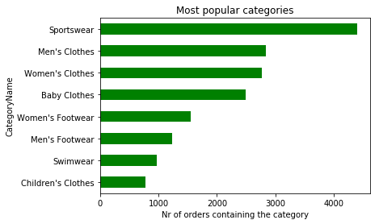
From this green graph,
we see which products
are the most popular.

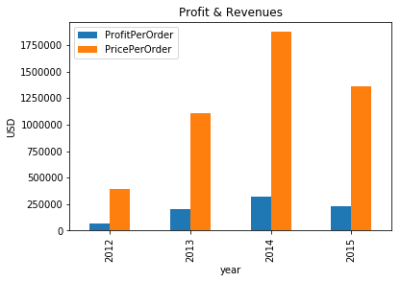
From this blue & orage graph,
we see how the profit och revenue has developed over the years.

There are 77 different products. The 50 least profitable products stand for 3.3 % of total profit
The single most profitable product stands for 36.0 % of the total profits Five most profitable products and their % contributed profit:
PRODUCT PROFIT
Halter Dress 36.1%
Davenport Shoes 14.6%
Tennis Suit 5.4%
RDL Suit 5.3%
WFS Shoes 3.3%
It is statistically significant that, for the top 2 products: (i) The quantity is higher when there is a discount, and (ii) The profit per order is lower when there is a discount. Based on these findings, a discussion of whether discounts should be reduced or eliminated migh be fruitful.
The seasonality for the top 2 products, Halter Dress and Davenport Shoes, is slightly higher than for all the products - we can see that these 2 products have slighlty more profit in December than during other months.
Having said that, when we look at profit over year & month (i.e. we graph y=profit x=yearmonth) we can see that some months sell much better than others - even much better than December that year. It is unclear why these months sell so good. We need more data to know why. This is evident from the table below, because if all months sold equally well, the profit percentage for any months would be 1.8% but for the five best selling months in the dataset, we see profits more than 2 times 1.8%
YEARMONTH PROFIT
2014-02 3.87%
2014-03 3.98%
2015-05 4.16%
2014-12 4.78%
2014-10 4.88%
These well performing months should be looked into further.

