Abstract

Natural Language is a difficult task for humans. Grammar is not structured like a programming language and patterns are sparse, especially with local slang and other colloquialisms. Researchers attempting to model natural language used a methodology called recurrence in order to predict sequences. Later on in 2017, researchers discovered Transformers, which utilizes a mechanism called attention and throws out sequences entirely. Using the excellent PyTorch framework and consequently the Python programming language, I created three models featuring three architectures, a vanilla Recurrent Neural Network, Long Short-Term Memory, and Transformer. After running benchmarks, the LSTM yielded the best natural language sequences.

Methodology
I prepared the data using the command line tool degit via npx and the standard GNU coreutils to quickly accumulate all of the text files into one corpus.

npx degit jghawaly/CSC7809_FoundationModels/Project2/data/raw raw/ && cat ./raw/* > corpus.txt

This command clones and concatenates all of the text files into a single corpus.txt. Afterwards, I set up my byte pair encoding tokenizer using the sentencepiece library which proved as a quick and efficient way to tokenize text. The training procedure had configurable hyperparameters. Vocabulary size was set to 10,000, model type set to “bpe”, adding additional control symbols '<bos>', '<eos>', '<pad>', and assigning the control symbols 1,2,3, respectively.

This tokenizer is learned; sentencepiece creates a model and vocab file, and then is usable with sentencepiece’s Processor class. After the tokenizer had been trained, the model training was next. Using the provided train.jsonl, I parsed the file and combined the completion and prompt into one string and converted the string into a list of tokenized sequences using the tokenizer I had created, truncating the tokenized sequences by maximum sequence length. I also used the Dataloader that pytorch provides, and utilized the collate function, which pads the sequences with the pad_id (3). The data had finally been prepped, and training commenced after.

I created a CLI using argparse to test and train different models.
Figure 1: Training a RNN model with a CLI.
Figure 2: Testing an RNN model with Perplexity score, BLEU score, and prompting the model with input ‘Alice’.

Models were subject to the same tokenizer and trained on a ROG Zephyrus G14 2021, boasting a NVIDIA 3060 Mobile GPU and Ryzen 9 5000 Series CPU. The operating system is the latest stable version of Linux Mint. They were trained using the AdamW optimizer, with a learning rate of 0.0001, 30 epochs, weight decay of 0.01, a ReduceLROnPlateau scheduler with mode ‘min’, patience of 3, and factor of 0.5. Mini-batch Stochastic Gradient Descent was used, along with early stopping, patience set to five. In addition, a validation dataset was used while training to ensure training seemed similar to validation. All models were evaluated using the Perplexity score, BLEU score, and a simple prompt to see the model’s response.
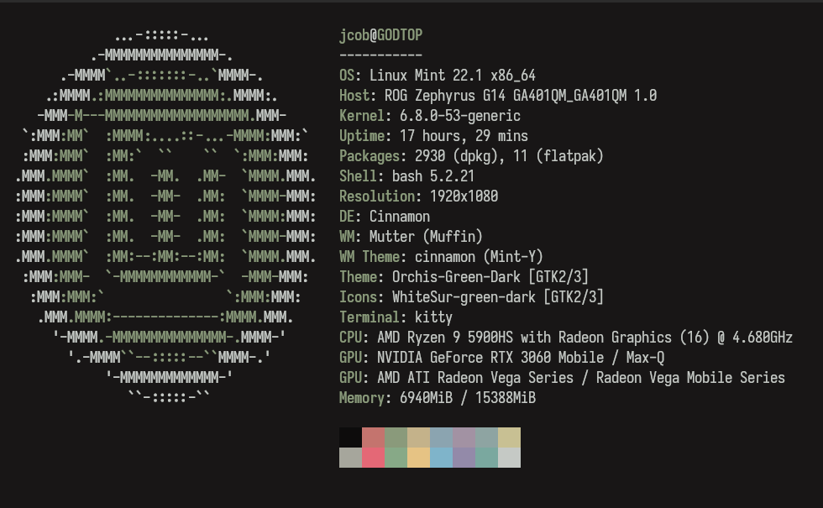Figure 3: The computer I trained on

I used the torchview package to generate my torch module’s layers architecture into a good image. To create an image and a graphviz object, I ran these commands in my command line

Figure 4: Draw command
In the picture above, this command draws the diagram of the transformers architecture which is used further down the paper.

Vanilla Recurrent Neural Network
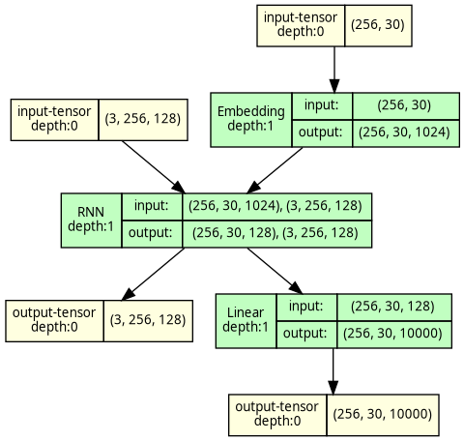Figure 5: Architecture of my Vanilla RNN

It features hidden dimensions of 128, sequence length of 30, and batch size of 256, and three layers, a simple Embedding layer, a torch RNN layer, and finally a fully connected layer using Cross Entropy Loss, ignoring index 3 (my tokenizer’s padding index).

One thing I had noticed with my RNN is that the hidden size has to be small or else my validation loss would spike very high. This may be a sign of the dreaded gradient issues common with RNNs. I had originally tested it with hidden size of 1024, but downsized to 128, yielding better results.

Long Short Term Memory

It features hidden dimensions of 1024, sequence length of 30, and batch size of 256, and three layers, a simple Embedding layer, a torch LSTM layer, and finally a fully connected layer using Cross Entropy Loss, ignoring index 3 (my tokenizer’s padding index).
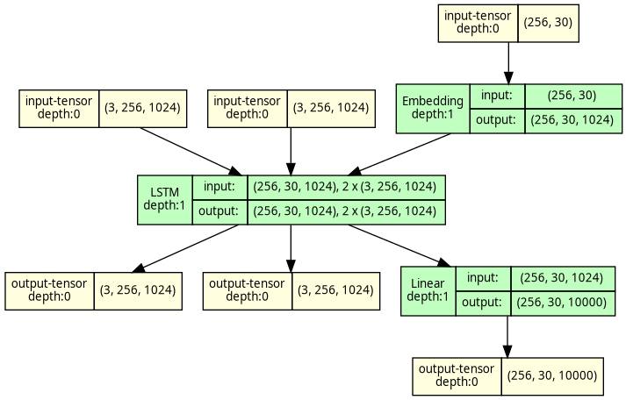Figure 6: My LSTM model

Unlike the Vanilla RNN, the LSTM was capable of handling a larger hidden size of 1024. However, the LSTM model took a lot longer to train, on average 24 seconds per epoch compared to the RNN’s 6 seconds per epoch.

Transformer
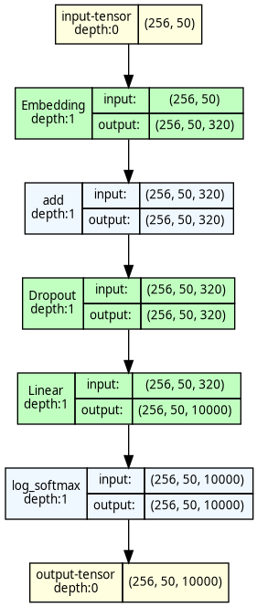Figure 7: My Transformer Architecture
My model features sequence lengths of 50, embed_dimension of 320, a fully connected layer of 1024 neurons, batch size of 256, sequence length of 50, trained for 75 epochs. On my computer, I could not increase embedding dimensions, which I believe would make my model capture more intricate details and yield better results. In addition, I had 8 number of attention heads.

To evaluate these models, I used my CLI again. It has a test mode
which runs tests, as stated previously, Perplexity scores, BLEU score, and a simple prompt.

Results

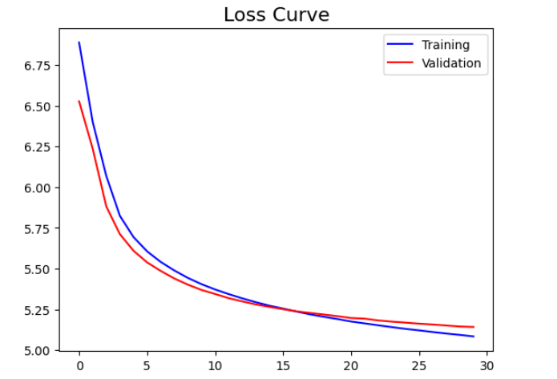Figure 8: Loss curve for my Vanilla RNN model

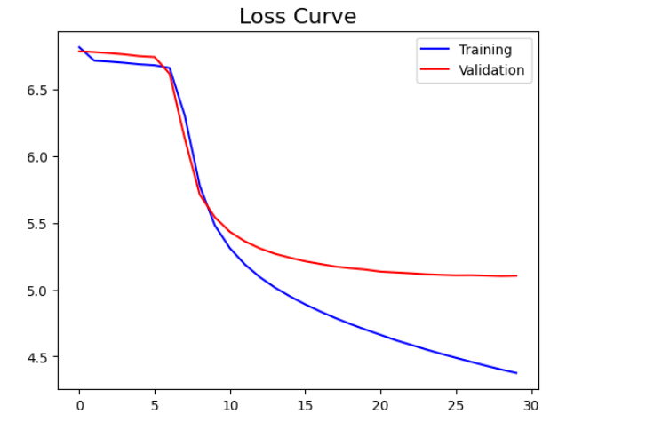Figure 9: Loss curve for LSTM
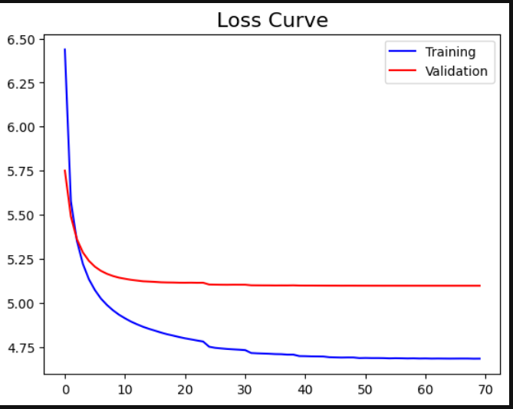Figure 10: Loss curve for Transformer model

Scores

 | Perplexity | BLEU (ngram=2)
Vanilla RNN | 168.78 | 1.2%
LSTM | 146.88 | 1.3%
Transformer | 163.54 | 1.7%

BLEU score was tested with prompting the model with nucleus sampling, and a max sequence of 10, and perplexity tested

Prompts
 | 'Which do you prefer? Dogs or cats?' | 'Who is Alice?'
Vanilla RNN | i shall be able to be seen in his own, but the whole of the state, and i had to go in the house and the old man who, and he had a little of them, i have been a great man, and the most | he was a little of the same day of a certain of the world. and i was sure, and i have been in the same time. he was not able to do you, and he had been seen in the same way. and, i
LSTM | said jean valjean. i was very sorry to go to see her. you have the first of the men who were the first time. the count was a little old woman. this time i had a moment, and that she had a long | yes, replied danglars, you have been the best thing to be in the way, i will tell you what you are right. the professor went on: how could you not be a great thing in the country? i have been thinking,
Transformer | yes, the whole of the same time. but he had a little, and a man who was, and he is not the door of the old man, and a great dealing his eyes, but the other of the same time he would have | no one of the world, and a man, i have been the door and the same way. and, the old, and then, and the first. the old, the first, the other. the same thing, and then he had been

Code Repository Link
All of the above can be replicated with the GitHub repository linked below

https://github.com/jacoobes/text-gen-p2

Discussion & Conclusion
In conclusion, I learned a lot about how language models work. This removed the magic from LLMs and other models. It was a good introduction into AI. In addition, I learned that it is pretty computationally expensive to train these models. However, the tooling is out there and documentation is out there, hopefully leading to better democratization of AI in the future. This was a good project!

