Exploring Drug–Drug Interactions in the FDA Adverse Event Reporting System
Jacopo Palombarini, Angela Boccia

Abstract

Introduction
Drug–drug interactions (DDIs) represent a substantial risk factor for adverse outcomes within pharmacotherapy. These interactions occur when 2 or more drugs interact, altering the effectiveness or toxicity of 1 or more medications¹. Individual case reports of suspected ADRs can be an important source of information of possible adverse reactions resulting from drug interactions² . Reports often relate to individuals who have taken more than one drug at the same time, where some reporters express explicit suspicions that two or more drugs might have interacted to cause the adverse event³.

This study aims to analyze and characterize reports of drug–drug interactions documented in the FAERS database.

Methods
Data for this study was obtained from the FDA Adverse Event Reporting System (FAERS), including all reports submitted up to December 31, 2024 (24Q4). The analysis focused on reports containing at least one drug coded as an interacting agent (“I”). All relevant variables available in FAERS were included in descriptive analyses to summarize the main characteristics of the selected reports. These analyses provided a comprehensive overview of the data structure and enabled the exploration of relationships between reporting features, drug roles, and reported outcomes.
A specific comparison was performed to evaluate the frequency of reports in which a given drug appeared as an interacting agent (role code “I”) relative to the total number of reports in which the same drug was recorded with other role codes (“C”, “PS”, or “SS”). In addition, the number and types of adverse drug reactions (ADRs) associated with each interacting drug were identified and summarized to describe the spectrum of reported reactions.
Graphical visualizations were then generated to illustrate the distribution of drugs reported as interacting, grouped according to their therapeutic class by Anatomical Therapeutic Chemical (ATC) classification. These plots were used to highlight reporting trends and to identify therapeutic classes more frequently involved in potential drug–drug interactions.
To investigate potential baseline heterogeneity between the interacting and non-interacting drugs, we conducted an exploratory series of chi-square tests of independence on key categorical characteristics. For each variable, we inspected the standardized residuals to identify categories disproportionately represented in one group relative to the expected distribution under independence, and quantified the strength of association using Cramér’s V. These procedures were descriptive in nature and were not intended to assess causal effects or infer treatment impact.

Results
A total of 95,947 reports containing at least one drug coded as an interacting agent were identified in the FAERS database. Most reports involved female patients (51.64%), and the majority were submitted by physicians (32.10%). Regarding reported outcomes, hospitalization was the most frequently documented event (38.01%), followed by other serious medical events (52.54%). In terms of geographic distribution, Europe accounted for the largest proportion of reports (54.40%), followed by North America (32.85%). The median age of patients in the selected reports was 62 years (Interquartile Range (IQR) : 46–75 years).

Among reports containing at least one interacting drug, 99.98% also included a suspected drug, and 53.90% listed concomitant drugs. Overall, most reports documented a median of six drugs. In 95% of reports involving at least one interacting drug, when two drugs were reported, one was classified as an interacting agent and the other as a suspected drug. As the number of reported drugs increased, the most commonly assigned role shifted toward “concomitant” (Figure 2).

According to the ATC classification system, the class most frequently associated with interacting agents was the Nervous System (ATC Class N), with acetylsalicylic acid being the most frequently reported interacting drug (N = 4,854). This was followed by the Cardiovascular System (ATC Class C), with furosemide (N = 2,460), and by Antiinfectives for Systemic Use (ATC Class J), with ritonavir (N = 2,817) (Figure 1).

The most frequently reported interacting drugs were: warfarin (n = 5,699, 2,1%), tacrolimus (n = 5,627, 2%), acetylsalicylic acid (n = 4,854, 1.8%), quetiapine (n = 4690, 1.7%), valproic acid (n= 3954, 1.4%), rivaroxaban (n= 3545, 1.3%), paracetamol (n = 3078, 1.1%), ritonavir (n =2817, 1%), clozapine (n=2810, 1%), furosemide (n=2460, 0.9%).

For all of these drugs, the most frequently reported adverse drug reaction (ADR) was “drug interaction.” For warfarin and acetylsalicylic acid, the predominant ADRs were coagulation-related events, such as increased INR (warfarin: N = 1,502; acetylsalicylic acid: N = 189) and signs or symptoms of hemorrhage; rivaroxaban similarly showed hemorrhagic events. Tacrolimus was primarily associated with renal toxicity (N = 1,058). Quetiapine and valproic acid were most frequently linked to neuropsychiatric disorders. Paracetamol, ritonavir, and clozapine were associated with a range of heterogeneous events, while reports involving furosemide primarily described cardiovascular disorders (Table 2).

The distribution of sex differed significantly between groups (p-value <0.001), with standardized residuals indicating an overrepresentation of males in the interacting group and a moderate association according to Cramér’s V (value ?). Age distribution also showed a significant deviation from independence, with elderly categories - particularly individuals aged ≥75 years - strongly overrepresented in the interacting group, and younger age groups underrepresented; the magnitude of this association was large by Cramér’s V (value ?). Outcome severity exhibited the most pronounced imbalance, with the interacting group showing markedly elevated contributions to life-threatening and hospitalization outcomes, while the non-interacting group contributed disproportionately to non-serious events, yielding very large standardized residuals and a large Cramér’s V (value ?). Continental representation was likewise heterogeneous: reports contributing to the Int group originated disproportionately from Europe and less from North America, suggesting a region-dependent pattern of reporting intensity (value ?) (Figure 3).

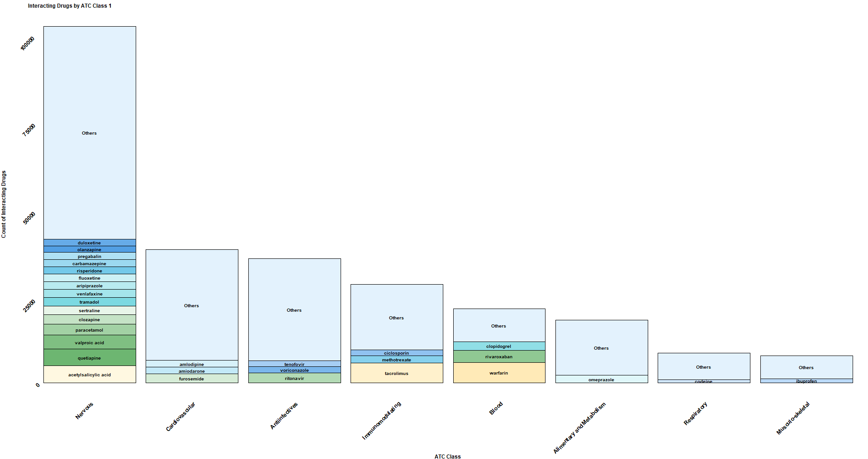

Figure 1: Most reported interacting drugs by ATC Class 1, and within the three most frequent Class 1 categories: Nervous system (1A), Cardiovascular system (1B), and Anti-infectives for systemic use (1C). “Other” refers to drugs with < o >X% of frequency.

Figure 2: Barplot and lineplot for number of reported drugs divided by role (S = Suspects, I = Interacting, C = Concomitant).

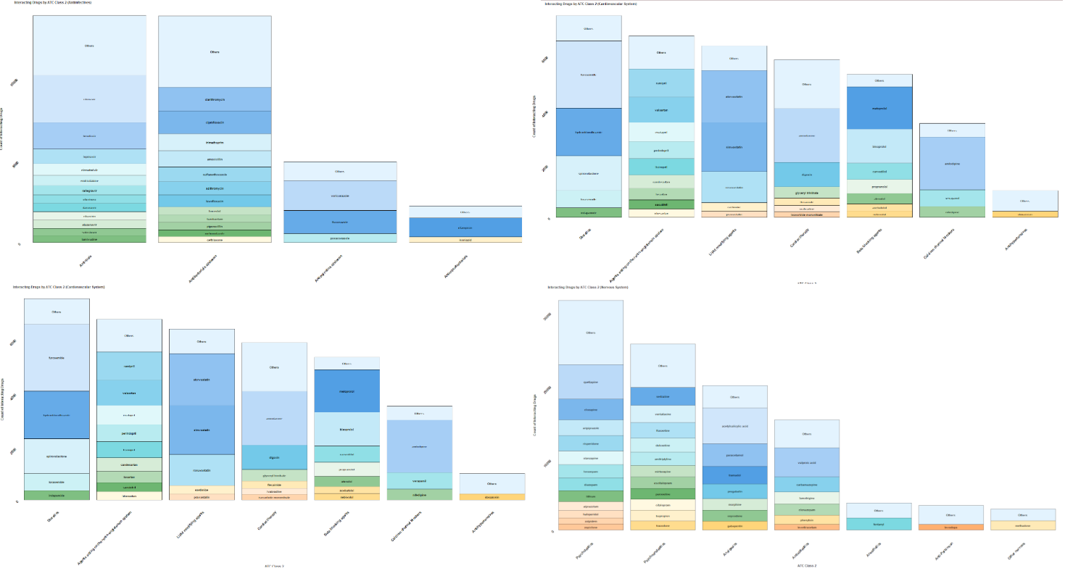

Table 1: Demographic and clinical characteristics of the ten most frequently reported interacting drugs.
Variable N/% | warfarin | tacrolimus | acetylsalicylic acid | quetiapine | valproic acid | rivaroxaban | paracetamol | ritonavir | clozapine | furosemide
Sex
Female | 1746/48.30% | 1039/37.24% | 1537/40.11% | 1230/50.87% | 1044/48.54% | 779/39.22% | 1161/61.72 | 776/36.38% | 516/43.29% | 982/56.24%
Male | 1869/51.70% | 1751/62.76% | 2295/59.89% | 1188/49.13% | 1107/51.46% | 1207/60.78% | 720/38.28% | 1357/63.62% | 676/56.71% | 764/43.76%
Unknown | 440/ | 265/ | 407/ | 275/ | 306/ | 161/ | 196/ | 277/ | 113/ | 187/
Outcome
Death | 402/9.91% | 174/5.70% | 556/13.12% | 308/11.44% | 211/8.59% | 252/11.74% | 331/15.94% | 178/7.39% | 111/8.51% | 142/7.35%
Life threatening | 368/9.08% | 205/6.71% | 518/12.22% | 356/13.22% | 226/9.20% | 153/7.13% | 276/13.29% | 165/6.85% | 103/7.89% | 289/14.95%
Disability | 46/1.13% | 32/1.05% | 70/1.65% | 62/2.30% | 28/1.14% | 15/0.70% | 36/1.73% | 31/1.29% | 15/1.15% | 26/1.35%
Hospitalization | 1746/43.06% | 1458/47.73% | 2119/49.99% | 1088/40.40% | 1038/42.25% | 1164/54.22% | 662/31.87% | 953/39.54% | 562/43.07% | 1111/57.48%
Congenital anomaly | 0/0.00% | 0/0.00% | 2/0.05% | 3/0.11% | 7/0.28% | 0/0.00% | 0/0.00% | 2/0.08% | 0/0.00% | 0/0.00%
Other serious | 1226/30.23% | 1031/33.75% | 824/19.44% | 769/28.56% | 856/34.84% | 522/24.31% | 565/27.20% | 972/40.33% | 487/37.32% | 310/16.04%
Non Serious | 267/6.58% | 155/5.07% | 150/3.54% | 107/3.97% | 91/3.70% | 41/1.91% | 207/9.97% | 109/4.52% | 27/2.07% | 55/2.85%
Continent
North America | 1257/31.28% | 1034/33.88% | 1046/24.72% | 872/32.54% | 714/29.29% | 1094/50.95 | 697/33.70% | 894/37.33% | 402/31.04% | 242/12.57%
Europe | 1913/47.60% | 1395/45.71% | 2792/65.99% | 1527/56.98% | 1230/50.45% | 915/42.62% | 1151/55.66% | 1195/49.90% | 752/58.07% | 1542/80.10%
Asia | 722/17.96% | 507/16.61% | 304/7.19% | 180/6.72% | 351/14.40% | 104/4.84% | 81/3.92% | 226/9.44% | 82/6.33% | 82/4.26%
South America | 38/0.95% | 40/1.31% | 47/1.11% | 8/0.30% | 56/2.30% | 13/0.61% | 12/0.58% | 22/0.92% | 3/0.23% | 13/0.68%
Oceania | 51/1.27% | 58/1.90% | 32/0.76% | 87/3.25% | 60/2.46% | 21/0.98% | 125/6.04% | 39/1.63% | 56/4.32% | 39/2.03%
Africa | 38/0.95% | 18/0.59% | 10/0.24% | 6/0.22% | 27/1.11% | 0/0.00% | 2/0.10% | 19/0.79% | 0/0.00% | 7/0.36%
Unknown | 36/ | 3/ | 8/ | 13/ | 19/ | / | 9/ | 15/ | 10/ | 8/
Reporter
Consumer | 678/17.00% | 213/7.03% | 730/17.41% | 425/16.15% | 289/12.01% | 583/27.28% | 492/24.02% | 207/8.66% | 141/11.02% | 218/11.43%
Healthcare practitioner | 455/11.41% | 1051/34.69% | 434/10.35% | 592/22.49% | 523/21.74% | 253/11.84% | 371/18.12% | 806/33.74% | 255/19.92% | 237/12.42%
Lawyer | 1/0.03% | / | 8/0.19% | 2/0.08% | / | 7/0.33% | 3/0.15% | 1/0.04% | 2/0.16% | /
Other | 1169/29.31% | 539/17.79% | 1027/24.49% | 495/18.81% | 681/28.30% | 580/27.14% | 418/20.41% | 529/22.14% | 338/26.41% | 447/23.43%
Pharmacist | 468/11.74% | 341/11.25% | 332/7.92% | 163/6.19% | 164/6.82% | 162/7.58% | 120/5.86% | 238/9.96% | 106/8.28% | 191/10.01%
Physician | 1217/30.52% | 886/29.24% | 1663/39.65% | 955/36.28% | 749/31.13% | 552/25.83% | 644/31.45% | 608/25.45% | 438/34.22% | 815/42.71%
Unknown | 67/ | 25/ | 45/ | 61/ | 51/ | 10/ | 29/ | 21/ | 25/ | 25/

Table 2: Most frequently reported adverse drug reactions (ADRs) for the ten most commonly reported interacting drugs.
Most reported reactions for most reported interacting drugs
warfarin | tacrolimus | acetylsalicylic acid | quetiapine | valproic acid | rivaroxaban | paracetamol | ritonavir | clozapine | furosemide
drug interaction (N =3137) | drug interaction (N=2748) | drug interaction (N=2647) | drug interaction (N=2351) | drug interaction (N=2208) | drug interaction (N=1038) | drug interaction (N=1758) | drug interaction (N=2194) | drug interaction (N=1164) | drug interaction (N=1530)
international normalised ratio increased (N =1502) | acute kidney injury (N=686) | labelled drug-drug interaction medication error (N=618) | toxicity to various agents (N=294) | toxicity to various agents (N=236) | gastrointestinal haemorrhage (N=449) | toxicity to various agents (N=275) | toxicity to various agents (N=386) | drug level increased (N=188) | acute kidney injury (N=653)
labelled drug-drug interaction medication error (N=492) | immunosuppressant drug level increased (N=570) | Anaemia (N=401) | off label use (N=225) | Seizure (N=231) | Epistaxis (N=150) | Overdose (N=173) | acute kidney injury (N=372) | toxicity to various agents (N=134) | Hyperkalaemi (N=262)
Anaemia (N=254) | drug level increased (N=563) | gastrointestinal haemorrhage (N=367) | Somnolence (N=223) | Somnolence (N=178) | labelled drug-drug interaction medication error (N=137) | drug ineffective (N=170) | off label use (N=307) | antipsychotic drug level increased (N=119) | Hyponatraemi (N=237)
Haematuria (N=217) | toxicity to various agents (N=527) | Melaena (N=270) | Depression (N=220) | off label use (N=151) | Haemorrhage (N=124) | Nausea (N=148) | drug level increased (N=246) | electrocardiogram qt prolonged (N=107) | Hypotension (N=189)
gastrointestinal haemorrhage (N=213) | off label use (N=313) | acute kidney injury (N=236) | depressed level of consciousness (N=193) | drug level increased (N=145) | Anaemia (N=114) | confusional state (N=135) | covid-19 (N=242) | Somnolence (N=100) | toxicity to various agents (N=109)
Haemorrhage (N=205) | covid-19 (N=211) | Epistaxis (N=194) | confusional state (N=182) | depressed level of consciousness (N=129) | rectal haemorrhage (N=104) | serotonin syndrome (N=133) | immunosuppressant drug level increased (N=221) | drug ineffective (N=93) | Dehydration (N=104)
Epistaxis (N=192) | Diarrhoea (N=195) | international normalised ratio increased (N=189) | serotonin syndrome (N=173) | drug ineffective (N=128) | upper gastrointestinal haemorrhage (N=95) | Fall (N=125) | cushing's syndrome (N=217) | Sedation (N=85) | Fall (N=104)
Melaena (N=185) | renal impairment (N=187) | product administration error (N=188) | Tremor (N=166) | Depression (N=118) | Haematuria (N=93) | Pain (N=125) | electrocardiogram qt prolonged (N=142) | salivary hypersecretio (N=78) | electrocardiogram qt prolonged (N=101)
Haematoma (N=157) | blood creatinine increased (N=185) | off label use (N=180) | Dizziness (N=165) | hyperammonaemic encephalopathy (N=110) | acute kidney injury (N=93) | Dizziness (N=124) | Diarrhoea (N=112) | Neutropenia (N=71) | Hypokalaemia (N=91)

Figure 3: Std. Residuals plots of Chi-squared test for sex, age, outcome and continent.

Variable | p.value | Cramer V
Sex | <0.001 | 0.014
Age | <0.001 | 0.024
Outcome | <0.001 | 0.063
Continent | <0.001 | 0.092

Table 3: Results for Chi-squared test and Cramer’s V computation (A Cramer’s V higher than 0.3 signals a significantly strong imbalance).

Most reported interacting drugs over time

Figure ?: …

Discussion & Conclusions
Overall, the chi-square statistics, standardized residual patterns, and Cramér’s V estimates jointly demonstrate substantial structural differences between the two groups across demographic, clinical, and geographic variables. These imbalances underscore the need for careful adjustment or stratification in subsequent inferential or causal analyses (e.g., multivariable models, propensity score methods), to mitigate the risk of confounding or, depending on the research aim, to appropriately model potential mediating pathways (Table 3).

References
1. Handbook of Drug Interactions: A Clinical and Forensic Guide | SpringerLink. Accessed December 2, 2025. https://link.springer.com/book/10.1007/978-1-61779-222-9
2. van Puijenbroek EP, Egberts AC, Heerdink ER, Leufkens HG. Detecting drug-drug interactions using a database for spontaneous adverse drug reactions: an example with diuretics and non-steroidal anti-inflammatory drugs. Eur J Clin Pharmacol. 2000;56(9-10):733-738. doi:10.1007/s002280000215
3. Hult S, Sartori D, Bergvall T, et al. A Feasibility Study of Drug–Drug Interaction Signal Detection in Regular Pharmacovigilance. Drug Saf. 2020;43(8):775-785. doi:10.1007/s40264-020-00939-y

Appendix

Role code | Frequency | Percentage
PS | 14736511 | 57,41
SS | 5712707 | 22,26
C | 5122564 | 19,96
I | 95947 | 0,37
NA | 7 | 0
TOT | 25667736 | 100

Table 1: Frequency table for roles across full dataset

Role code | Frequency | Percentage
I | 95947 | 100,00
PS | 95931 | 99,98
C | 51718 | 53,90
SS | 19258 | 20,07

Table 2: Frequency table for roles across reports with at least one interacting drug reported

Variable | Cases | Percentage | Variable | Cases | Percentage
Sex |  |  | Outcome
Female | 44,341 | 51.64 | Death | 8,46 | 8.82
Male | 41,525 | 48.36 | Life threatening | 9,374 | 9.77
Unknown | 10,081 |  | Disability | 1,519 | 1.58
Age in years | 62 (46.00-75) [0.00-104] |  | Required intervention | 5 | 0.01
Weight in kgs | 72 (60.00-86) [0.00-292] |  | Hospitalization | 36,465 | 38.01
Reporter |  |  | Congenital anomaly | 75 | 0.08
Consumer | 18,98 | 20.16 | Other serious | 30,975 | 32.28
Healthcare practitioner | 14,657 | 15.57 | Non Serious | 9,074 | 9.46
Lawyer | 100 | 0.11 | Continent
Other | 21,83 | 23.19 | North America | 31,313 | 32.85
Pharmacist | 8,355 | 8.88 | Europe | 51,859 | 54.40
Physician | 30,214 | 32.10 | Asia | 8,843 | 9.28
Unknown | 1,811 |  | South America | 1,012 | 1.06
 |  |  | Oceania | 1,875 | 1.97
 |  |  | Africa | 422 | 0.44
 |  |  | Unknown | 623
Table 3: Descriptive analysis of reports containing at least one drug coded as interacting (“I”).

Most reported non-interacting drugs for most reported interacting drugs

substance | N | substance | N
Drug: warfarin |  | Drug: rivaroxaban
Role: C |  | Role: C
furosemide | 620 | furosemide | 620
bisoprolol | 380 | bisoprolol | 380
paracetamol | 312 | paracetamol | 312
acetylsalicylic acid | 244 | acetylsalicylic acid | 244
amlodipine | 233 | amlodipine | 233
digoxin | 224 | digoxin | 224
metoprolol | 221 | metoprolol | 221
atorvastatin | 216 | atorvastatin | 216
omeprazole | 209 | omeprazole | 209
pantoprazole | 199 | pantoprazole | 199
Role: SS |  | Role: SS
miconazole | 139 | miconazole | 139
paracetamol | 81 | paracetamol | 81
rivaroxaban | 63 | acetylsalicylic acid | 55
acetylsalicylic acid | 55 | tramadol | 24
tramadol | 24 | warfarin | 22
hydroxychloroquine | 22 | hydroxychloroquine | 22
furosemide | 21 | furosemide | 21
enoxaparin | 21 | enoxaparin | 21
prednisone | 20 | prednisone | 20
clopidogrel | 18 | clopidogrel | 18
Role: PS |  | Role: PS
acetylsalicylic acid | 339 | acetylsalicylic acid | 339
miconazole | 156 | warfarin | 288
paracetamol | 125 | miconazole | 156
clopidogrel | 121 | paracetamol | 125
amiodarone | 106 | clopidogrel | 121
tramadol | 95 | amiodarone | 106
clarithromycin | 93 | tramadol | 95
levofloxacin | 93 | clarithromycin | 93
omeprazole | 75 | levofloxacin | 93
fluconazole | 75 | omeprazole | 75
Drug: tacrolimus |  | Drug: paracetamol
Role: C |  | Role: C
furosemide | 620 | furosemide | 620
bisoprolol | 380 | bisoprolol | 380
paracetamol | 312 | acetylsalicylic acid | 244
acetylsalicylic acid | 244 | amlodipine | 233
amlodipine | 233 | digoxin | 224
digoxin | 224 | metoprolol | 221
metoprolol | 221 | atorvastatin | 216
atorvastatin | 216 | omeprazole | 209
omeprazole | 209 | pantoprazole | 199
pantoprazole | 199 | insulin | 181
Role: SS |  | Role: SS
miconazole | 139 | miconazole | 139
paracetamol | 81 | rivaroxaban | 63
rivaroxaban | 63 | acetylsalicylic acid | 55
acetylsalicylic acid | 55 | tramadol | 24
tramadol | 24 | warfarin | 22
warfarin | 22 | hydroxychloroquine | 22
hydroxychloroquine | 22 | furosemide | 21
furosemide | 21 | enoxaparin | 21
enoxaparin | 21 | prednisone | 20
prednisone | 20 | clopidogrel | 18
Role: PS |  | Role: PS
acetylsalicylic acid | 339 | acetylsalicylic acid | 339
warfarin | 288 | warfarin | 288
miconazole | 156 | miconazole | 156
paracetamol | 125 | clopidogrel | 121
clopidogrel | 121 | amiodarone | 106
amiodarone | 106 | tramadol | 95
tramadol | 95 | clarithromycin | 93
clarithromycin | 93 | levofloxacin | 93
levofloxacin | 93 | omeprazole | 75
omeprazole | 75 | fluconazole | 75
Drug: acetylsalicylic acid |  | Drug: ritonavir
Role: C |  | Role: C
furosemide | 620 | furosemide | 620
bisoprolol | 380 | bisoprolol | 380
paracetamol | 312 | paracetamol | 312
amlodipine | 233 | acetylsalicylic acid | 244
digoxin | 224 | amlodipine | 233
metoprolol | 221 | digoxin | 224
atorvastatin | 216 | metoprolol | 221
omeprazole | 209 | atorvastatin | 216
pantoprazole | 199 | omeprazole | 209
insulin | 181 | pantoprazole | 199
Role: SS |  | Role: SS
miconazole | 139 | miconazole | 139
paracetamol | 81 | paracetamol | 81
rivaroxaban | 63 | rivaroxaban | 63
tramadol | 24 | acetylsalicylic acid | 55
warfarin | 22 | tramadol | 24
hydroxychloroquine | 22 | warfarin | 22
furosemide | 21 | hydroxychloroquine | 22
enoxaparin | 21 | furosemide | 21
prednisone | 20 | enoxaparin | 21
clopidogrel | 18 | prednisone | 20
Role: PS |  | Role: PS
warfarin | 288 | acetylsalicylic acid | 339
miconazole | 156 | warfarin | 288
paracetamol | 125 | miconazole | 156
clopidogrel | 121 | paracetamol | 125
amiodarone | 106 | clopidogrel | 121
tramadol | 95 | amiodarone | 106
clarithromycin | 93 | tramadol | 95
levofloxacin | 93 | clarithromycin | 93
omeprazole | 75 | levofloxacin | 93
fluconazole | 75 | omeprazole | 75
Drug: quetiapine |  | Drug: clozapine
Role: C |  | Role: C
furosemide | 620 | furosemide | 620
bisoprolol | 380 | bisoprolol | 380
paracetamol | 312 | paracetamol | 312
acetylsalicylic acid | 244 | acetylsalicylic acid | 244
amlodipine | 233 | amlodipine | 233
digoxin | 224 | digoxin | 224
metoprolol | 221 | metoprolol | 221
atorvastatin | 216 | atorvastatin | 216
omeprazole | 209 | omeprazole | 209
pantoprazole | 199 | pantoprazole | 199
Role: SS |  | Role: SS
miconazole | 139 | miconazole | 139
paracetamol | 81 | paracetamol | 81
rivaroxaban | 63 | rivaroxaban | 63
acetylsalicylic acid | 55 | acetylsalicylic acid | 55
tramadol | 24 | tramadol | 24
warfarin | 22 | warfarin | 22
hydroxychloroquine | 22 | hydroxychloroquine | 22
furosemide | 21 | furosemide | 21
enoxaparin | 21 | enoxaparin | 21
prednisone | 20 | prednisone | 20
Role: PS |  | Role: PS
acetylsalicylic acid | 339 | acetylsalicylic acid | 339
warfarin | 288 | warfarin | 288
miconazole | 156 | miconazole | 156
paracetamol | 125 | paracetamol | 125
clopidogrel | 121 | clopidogrel | 121
amiodarone | 106 | amiodarone | 106
tramadol | 95 | tramadol | 95
clarithromycin | 93 | clarithromycin | 93
levofloxacin | 93 | levofloxacin | 93
omeprazole | 75 | omeprazole | 75
Drug: valproic acid |  | Drug: furosemide
Role: C |  | Role: C
furosemide | 620 | bisoprolol | 380
bisoprolol | 380 | paracetamol | 312
paracetamol | 312 | acetylsalicylic acid | 244
acetylsalicylic acid | 244 | amlodipine | 233
amlodipine | 233 | digoxin | 224
digoxin | 224 | metoprolol | 221
metoprolol | 221 | atorvastatin | 216
atorvastatin | 216 | omeprazole | 209
omeprazole | 209 | pantoprazole | 199
pantoprazole | 199 | insulin | 181
Role: SS |  | Role: SS
miconazole | 139 | miconazole | 139
paracetamol | 81 | paracetamol | 81
rivaroxaban | 63 | rivaroxaban | 63
acetylsalicylic acid | 55 | acetylsalicylic acid | 55
tramadol | 24 | tramadol | 24
warfarin | 22 | warfarin | 22
hydroxychloroquine | 22 | hydroxychloroquine | 22
furosemide | 21 | enoxaparin | 21
enoxaparin | 21 | prednisone | 20
prednisone | 20 | clopidogrel | 18
Role: PS |  | Role: PS
acetylsalicylic acid | 339 | acetylsalicylic acid | 339
warfarin | 288 | warfarin | 288
miconazole | 156 | miconazole | 156
paracetamol | 125 | paracetamol | 125
clopidogrel | 121 | clopidogrel | 121
amiodarone | 106 | amiodarone | 106
tramadol | 95 | tramadol | 95
clarithromycin | 93 | clarithromycin | 93
levofloxacin | 93 | levofloxacin | 93
omeprazole | 75 | omeprazole | 75

Descriptives (bivariates) for most reported interacting drugs
Example for warfarin
sex – age_range
Age category | Female | Male | Total
Neonate (<28d) | 3458603,164 | 3238954,836 | 6697558
Infant (28d-1y) | 13790072,17 | 12914294,83 | 26704367
Child (2y-11y) | 68994702,38 | 64612999,62 | 133607702
Teenager (12y-17y) | 83449890,58 | 78150170,42 | 161600061
Adult (18y-29y) | 206274650,1 | 193174597,9 | 399449248
Adult (30y-49y) | 616651237,7 | 577489065,3 | 1194140303
Adult (50y-64y) | 829976117,1 | 777266147,9 | 1607242265
Elderly (65y-74y) | 683694933 | 640274962 | 1323969895
Elderly (75y-84y) | 577675438,3 | 540988533,7 | 1118663972
Elderly (85y-99y) | 265292612 | 248444458 | 513737070
Elderly (>99y) | 886821,5492 | 830501,4508 | 1717323
Total | 3350145078 | 3137384686 | 6487529764

sex – Outcome
Outcome | Female | Male | Total
Death | 375125315 | 351301927 | 726427242
Life threatening | 415653039 | 389255822 | 804908861
Disability | 67354061 | 63076551 | 130430612
Required intervention | 221706 | 207625 | 429331
Hospitalization | 1616896528 | 1514210963 | 3131107491
Congenital anomaly | 3325579 | 3114379 | 6439958
Other serious | 1373464142 | 1286238436 | 2659702578
Non Serious | 402350723 | 376798307 | 779149030
Total | 4254391092 | 3984204011 | 8238595103

Chi-squared test for Outcome, Sex, Age and Continent for Interacting and Non-interacting reported drugs

Category | Interacting | Non-interacting
Continent
North America | 31313 | 10706419
Europe | 51859 | 2125978
Asia | 8843 | 1046123
South America | 1012 | 324916
Oceania | 1875 | 144042
Africa | 422 | 61853
Outcome
Death | 8460 | 1310693
Life threatening | 9374 | 382258
Disability | 1519 | 238307
Required intervention | 5 | 61259
Hospitalization | 36465 | 2923212
Congenital anomaly | 75 | 34087
Other serious | 30975 | 3942555
Non Serious | 9074 | 5846918
Age
Neonate (<28d) | 78 | 30027
Infant (28d-1y) | 311 | 60852
Child (2y-11y) | 1556 | 232432
Teenager (12y-17y) | 1882 | 263250
Adult (18y-29y) | 4652 | 731920
Adult (30y-49y) | 13907 | 2081495
Adult (50y-64y) | 18718 | 2879408
Elderly (65y-74y) | 15419 | 1920750
Elderly (75y-84y) | 13028 | 1223912
Elderly (85y-99y) | 5983 | 376618
Elderly (>99y) | 20 | 3335
Sex
Male | 41525 | 5309231
Female | 44341 | 8059748

Table ?: Absolute frequency table for Continent, Outcome, Age and Sex variables.
Most reported indications for most reported interacting drugs

Indication | N
warfarin
atrial fibrillation | 27
anticoagulant therapy | 20
product used for unknown indication | 20
tacrolimus
immunosuppressant drug therapy | 44
renal transplant | 21
immunosuppression | 13
acetylsalicylic acid
product used for unknown indication | 74
antiplatelet therapy | 26
myocardial ischaemia | 16
quetiapine
product used for unknown indication | 11
bipolar disorder | 8
schizophrenia | 8
valproic acid
epilepsy | 16
product used for unknown indication | 10
seizure | 9
rivaroxaban
atrial fibrillation | 201
thrombosis prophylaxis | 126
cerebrovascular accident prophylaxis | 97
paracetamol
product used for unknown indication | 51
pain | 31
depression | 21
ritonavir
hiv infection | 12
antiretroviral therapy | 4
exposure during pregnancy | 1
clozapine
schizophrenia | 53
schizoaffective disorder | 13
product used for unknown indication | 12
furosemide
hypertension | 20
product used for unknown indication | 8
cardiac failure | 6

Table ?: …

