MODELS EVALUATION

Decision Tree with no cross validation (only train-test splitting)

Confusion Matrix | NO ASD | ASD
NO ASD | 31 | 67
ASD | 17 | 202

Metrics | Value
Sensitivity | 0.92
Specificity | 0.32

ROC Curve
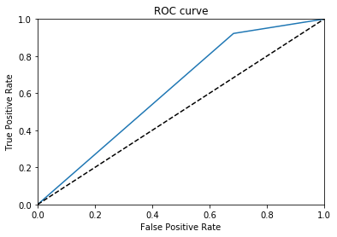

Area Under the Curve (AUC) = 0.62

Decision Tree with K-Cross Validation (K = 10)

Metrics | Value
Sensitivity | 0.69
Specificity | 0.68

ROC Curve
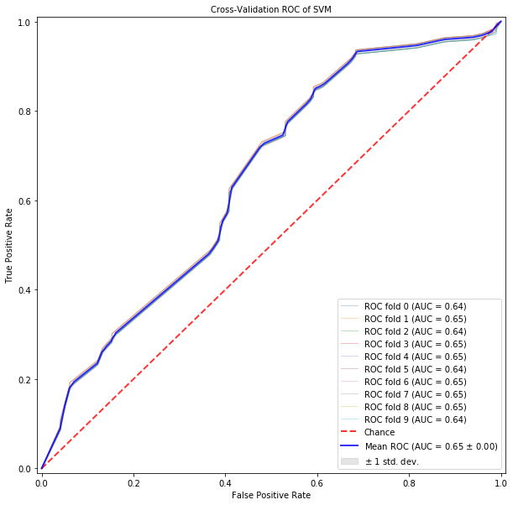

Area Under the Curve (AUC) = 0.65

Random Forest with no cross validation (only train-test splitting)

Confusion Matrix | NO ASD | ASD
NO ASD | 31 | 67
ASD | 15 | 204

Metrics | Value
Sensitivity | 0.93
Specificity | 0.32

ROC Curve
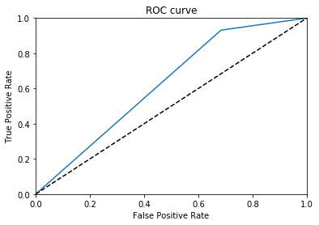

Area Under the Curve (AUC) = 0.62

Random Forest with K-Cross Validation (K = 10)

Metrics | Value
Sensitivity | 0.69
Specificity | 0.68

ROC Curve
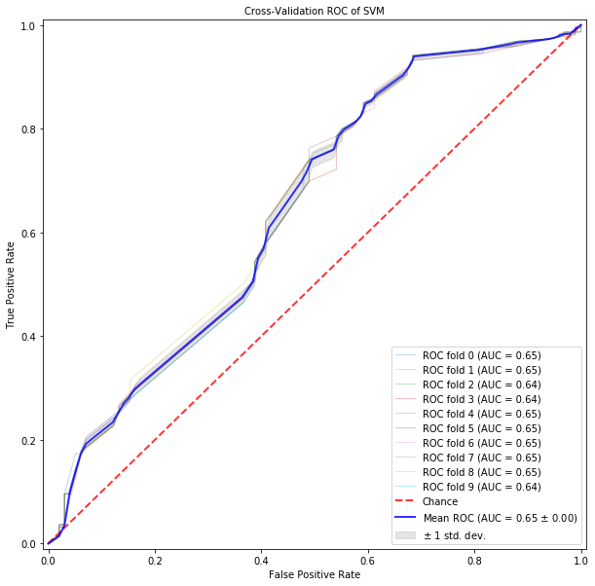

Area Under the Curve (AUC) = 0.62

Gaussian Naïve Bayes with no cross validation (only train-test splitting)

Confusion Matrix | NO ASD | ASD
NO ASD | 31 | 67
ASD | 15 | 204

Metrics | Value
Sensitivity | 0.93
Specificity | 0.32

ROC Curve

Area Under the Curve (AUC) = 0.62

Gaussian Naïve Bayes with K-Cross Validation (K = 10)

Metrics | Value
Sensitivity | 0.34
Specificity | 0.34

ROC Curve
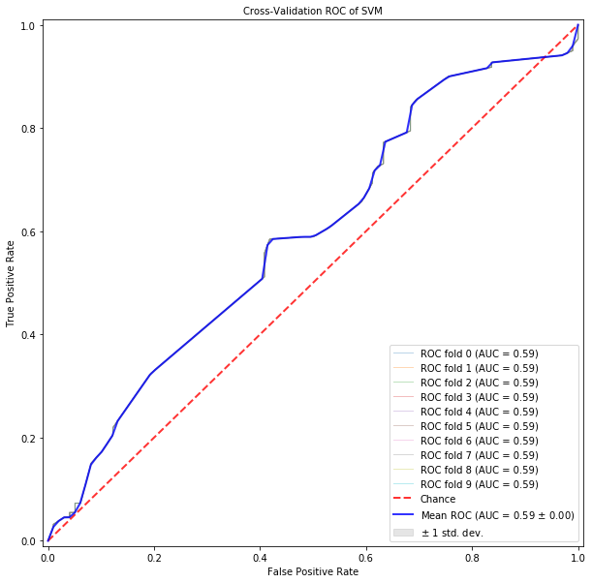

Area Under the Curve (AUC) = 0.59

