CSC418H1F Computer Graphics Assignment 3 Report

**Overall submission**

Our team of two has implemented four features for this assignment. Several different material colors were added to main.cpp.

Aside: we both had a final on the same day so less time was put into this assignment. Apologies if this seemed like a rush!

1. Anti-aliasing: instead of having one ray to determine a pixel’s color, we send out 16 rays that are slightly off the pixel and calculate the average of the accumulated color. We included a picture of the results of anti-aliasing.

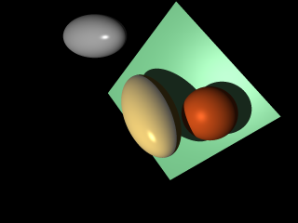

1. Depth of Field: we basically thought this as of camera focusing a point. To implement this feature, we defined a focal plane and created a new ray based on the original ray.The new ray has equation:



Where **O** is the position of the camera, origin. **r** is the randomly biased parallel ray. **C** is the focal point. This equation came from an external source. The picture included focuses on the bronze sphere.

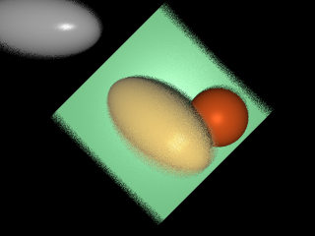

1. Soft Shadow: before implementing soft shadow, the shadow was created by a point light souce. The overall idea is to use multiple parallel light sources (like a light bulb) to smoothen the shadow.

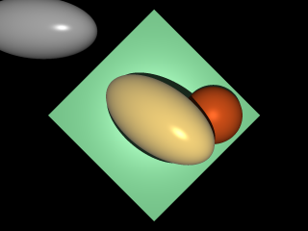

1. Refraction:

The refraction is based on the Snell’s Law to calculate the relation between the outside refraction index and the inside refraction index. Also it uses Fresnel Coefficient to calculate its portion of transmiton and refraction.

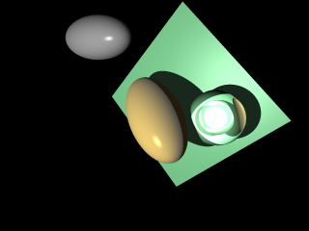

**Code and file structure of submission**

Our team decided to submit part A and part B in separate folders, including pictures for each individual feature. Modifications have been made on most files excluding util.cpp,util.h,bmp_io.cpp,bmp_io.h.

**External sources we have read**

We were confused with how to enable global illumination at the beginning. We became much more comfortable with the concept after reading from these links:

[**https://www.scratchapixel.com/lessons/3d-basic-rendering/global-illumination-path-tracing**](https://www.scratchapixel.com/lessons/3d-basic-rendering/global-illumination-path-tracing)

[**https://computergraphics.stackexchange.com/questions/5152/progressive-path-tracing-with-explicit-light-sampling**](https://computergraphics.stackexchange.com/questions/5152/progressive-path-tracing-with-explicit-light-sampling)

[**https://computergraphics.stackexchange.com/questions/4979/what-is-importance-sampling/4994**](https://computergraphics.stackexchange.com/questions/4979/what-is-importance-sampling/4994)

This source talked about Glossy reflection. We were interested in doing it but really didn’t have time to take a closer look at it. Just included so we might come back to it in the future.

[**http://www.raytracegroundup.com/downloads/Chapter25.pdf**](http://www.raytracegroundup.com/downloads/Chapter25.pdf)

The following three links helped with defining new material colours.

[**https://support.solidangle.com/display/ARNTUT/Standard+Material+Presets**](https://support.solidangle.com/display/ARNTUT/Standard+Material+Presets)

[**http://devernay.free.fr/cours/opengl/materials.html**](http://devernay.free.fr/cours/opengl/materials.html)

[**http://blog.lexique-du-net.com/index.php?post/2009/07/24/AmbientDiffuseEmissive-and-specular-colorSome-examples**](http://blog.lexique-du-net.com/index.php?post/2009/07/24/AmbientDiffuseEmissive-and-specular-colorSome-examples)

This is the source where I found the document to help with our depth of field feature.

[**https://computergraphics.stackexchange.com/questions/4344/depth-of-field-in-path-tracing-what-do-i-do-with-the-secondary-ray**](https://computergraphics.stackexchange.com/questions/4344/depth-of-field-in-path-tracing-what-do-i-do-with-the-secondary-ray)

The document:

<https://courses.cs.washington.edu/courses/csep557/99au/projects/trace/depthoffield.doc>

And of course, thanks to the teaching team, the bulletin-board:

<https://bb-2017-09.teach.cs.toronto.edu/t/assignment-3-part-b-extended-light-sources/1878/5>

**Role of each member**

Shengfeng Ji:

Ray casting

Phong illumination

Generating scene signature, diffuse+ ambient rendered phong model and full phong model images.

Add material colour.

Anti-aliasing

Depth of field

Extended light sources

Report writing

Enable global illumination

Xiarui Huang:

Ray-sphere intersection

Ray-square intersection

BRDF-weighted sampling

Refraction