Regresión_guion

Alejandro Correa

library(languageR)

Warning: package 'languageR' was built under R version 4.2.3

data("durationsGe")  
data("durationsOnt")

## Condiciones de las tablas de datos

1. **Datos**: deben estar expresados en cuadros de datos (*Data Frame*)
2. Las **filas** son casos (*tokens*) o participantes, mientras que las **columnas** son variables
3. Las **variables dependientes** pueden ser numéricas
4. Las tablas no deben incluír **celdas vacíos** o las celdas deben estar marcadas como NA.

summary(durationsGe)

Word Frequency Speaker Sex YearOfBirth   
 geabonneerd : 1 Min. : 1.00 N01096 : 12 female:234 Min. :1923   
 geaccepteerd: 1 1st Qu.: 6.00 N01204 : 11 male :193 1st Qu.:1949   
 geacht : 1 Median : 18.00 N01031 : 9 NA's : 1 Median :1969   
 geactiveerd : 1 Mean : 125.35 N01133 : 8 Mean :1963   
 geadopteerd : 1 3rd Qu.: 59.25 N01159 : 8 3rd Qu.:1977   
 geadresseerd: 1 Max. :8104.00 (Other):379 Max. :1983   
 (Other) :422 NA's : 1 NA's :3   
 DurationOfPrefix SpeechRate NumberSegmentsOnset  
 Min. :0.02481 Min. : 0.4203 Min. :0.000   
 1st Qu.:0.09103 1st Qu.: 4.4718 1st Qu.:1.000   
 Median :0.11958 Median : 5.6089 Median :1.000   
 Mean :0.12525 Mean : 5.5392 Mean :1.341   
 3rd Qu.:0.15187 3rd Qu.: 6.4845 3rd Qu.:2.000   
 Max. :0.31180 Max. :11.0865 Max. :3.000

durationsGeNA<- na.exclude(durationsGe)  
summary(durationsGeNA)

Word Frequency Speaker Sex YearOfBirth   
 geabonneerd : 1 Min. : 1.0 N01096 : 12 female:234 Min. :1923   
 geaccepteerd: 1 1st Qu.: 6.0 N01204 : 11 male :191 1st Qu.:1949   
 geacht : 1 Median : 18.0 N01031 : 9 Median :1969   
 geactiveerd : 1 Mean : 126.2 N01133 : 8 Mean :1963   
 geadopteerd : 1 3rd Qu.: 60.0 N01159 : 8 3rd Qu.:1977   
 geadresseerd: 1 Max. :8104.0 N01005 : 7 Max. :1983   
 (Other) :419 (Other):370   
 DurationOfPrefix SpeechRate NumberSegmentsOnset  
 Min. :0.02481 Min. : 0.4203 Min. :0.000   
 1st Qu.:0.09107 1st Qu.: 4.4743 1st Qu.:1.000   
 Median :0.11964 Median : 5.5978 Median :1.000   
 Mean :0.12550 Mean : 5.5411 Mean :1.346   
 3rd Qu.:0.15201 3rd Qu.: 6.4846 3rd Qu.:2.000   
 Max. :0.31180 Max. :11.0865 Max. :3.000

## Modelos de regresión para los afijos

mGe <- lm(DurationOfPrefix ~ Frequency + SpeechRate+ Sex + SpeechRate*Sex, data = durationsGeNA)  
summary(mGe)

Call:  
lm(formula = DurationOfPrefix ~ Frequency + SpeechRate + Sex +   
 SpeechRate * Sex, data = durationsGeNA)  
  
Residuals:  
 Min 1Q Median 3Q Max   
-0.094781 -0.032729 -0.000638 0.024772 0.177933   
  
Coefficients:  
 Estimate Std. Error t value Pr(>|t|)   
(Intercept) 1.729e-01 1.170e-02 14.776 < 2e-16 ***  
Frequency -1.066e-05 4.027e-06 -2.647 0.00842 **   
SpeechRate -8.676e-03 2.092e-03 -4.148 4.06e-05 ***  
Sexmale 1.248e-02 1.817e-02 0.687 0.49262   
SpeechRate:Sexmale -1.391e-03 3.159e-03 -0.440 0.65990   
---  
Signif. codes: 0 '***' 0.001 '**' 0.01 '*' 0.05 '.' 0.1 ' ' 1  
  
Residual standard error: 0.04543 on 420 degrees of freedom  
Multiple R-squared: 0.09315, Adjusted R-squared: 0.08451   
F-statistic: 10.78 on 4 and 420 DF, p-value: 2.488e-08

## Selección de las variables independientes

**El parámetro es AIC (Akaike Information Criterion)**

En el método *forward direction* se inicia con un modelo nulo (b0). El computador luego busca el predictor que mejor predice el valor de la variable dependiente y lo retiene en el modelo.

m0 <- lm(DurationOfPrefix ~ 1, data = durationsGeNA)  
m.fw <- step(m0, direction = "forward", scope = ~ Frequency + SpeechRate+ Sex + SpeechRate*Sex)

Start: AIC=-2589.34  
DurationOfPrefix ~ 1  
  
 Df Sum of Sq RSS AIC  
+ SpeechRate 1 0.072542 0.88328 -2620.9  
+ Frequency 1 0.015776 0.94004 -2594.4  
<none> 0.95582 -2589.3  
+ Sex 1 0.000181 0.95564 -2587.4  
  
Step: AIC=-2620.89  
DurationOfPrefix ~ SpeechRate  
  
 Df Sum of Sq RSS AIC  
+ Frequency 1 0.0137775 0.86950 -2625.6  
<none> 0.88328 -2620.9  
+ Sex 1 0.0016745 0.88160 -2619.7  
  
Step: AIC=-2625.57  
DurationOfPrefix ~ SpeechRate + Frequency  
  
 Df Sum of Sq RSS AIC  
<none> 0.86950 -2625.6  
+ Sex 1 0.0023113 0.86719 -2624.7

m.fw

Call:  
lm(formula = DurationOfPrefix ~ SpeechRate + Frequency, data = durationsGeNA)  
  
Coefficients:  
(Intercept) SpeechRate Frequency   
 1.774e-01 -9.121e-03 -1.039e-05

Con el método inverso (The backward method) se inicia con todos los predictores y, de acuerdo con el AIC, remueve los predictores que no contribuyen al modelo.

m.bw <- step(mGe, direction = "backward")

Start: AIC=-2622.9  
DurationOfPrefix ~ Frequency + SpeechRate + Sex + SpeechRate *   
 Sex  
  
 Df Sum of Sq RSS AIC  
- SpeechRate:Sex 1 0.0004002 0.86719 -2624.7  
<none> 0.86679 -2622.9  
- Frequency 1 0.0144623 0.88125 -2617.9  
  
Step: AIC=-2624.7  
DurationOfPrefix ~ Frequency + SpeechRate + Sex  
  
 Df Sum of Sq RSS AIC  
- Sex 1 0.002311 0.86950 -2625.6  
<none> 0.86719 -2624.7  
- Frequency 1 0.014414 0.88160 -2619.7  
- SpeechRate 1 0.072397 0.93958 -2592.6  
  
Step: AIC=-2625.57  
DurationOfPrefix ~ Frequency + SpeechRate  
  
 Df Sum of Sq RSS AIC  
<none> 0.86950 -2625.6  
- Frequency 1 0.013778 0.88328 -2620.9  
- SpeechRate 1 0.070544 0.94004 -2594.4

m.bw

Call:  
lm(formula = DurationOfPrefix ~ Frequency + SpeechRate, data = durationsGeNA)  
  
Coefficients:  
(Intercept) Frequency SpeechRate   
 1.774e-01 -1.039e-05 -9.121e-03

Con el método bidireccional inicia como el método hacia adelante (forward method), pero cada vez que añade un predictor, remueve los que son redundantes.

m.both <- step(mGe, scope = ~ Frequency + SpeechRate+ Sex + SpeechRate*Sex)

Start: AIC=-2622.9  
DurationOfPrefix ~ Frequency + SpeechRate + Sex + SpeechRate *   
 Sex  
  
 Df Sum of Sq RSS AIC  
- SpeechRate:Sex 1 0.0004002 0.86719 -2624.7  
<none> 0.86679 -2622.9  
- Frequency 1 0.0144623 0.88125 -2617.9  
  
Step: AIC=-2624.7  
DurationOfPrefix ~ Frequency + SpeechRate + Sex  
  
 Df Sum of Sq RSS AIC  
- Sex 1 0.002311 0.86950 -2625.6  
<none> 0.86719 -2624.7  
+ SpeechRate:Sex 1 0.000400 0.86679 -2622.9  
- Frequency 1 0.014414 0.88160 -2619.7  
- SpeechRate 1 0.072397 0.93958 -2592.6  
  
Step: AIC=-2625.57  
DurationOfPrefix ~ Frequency + SpeechRate  
  
 Df Sum of Sq RSS AIC  
<none> 0.86950 -2625.6  
+ Sex 1 0.002311 0.86719 -2624.7  
- Frequency 1 0.013778 0.88328 -2620.9  
- SpeechRate 1 0.070544 0.94004 -2594.4

m.both

Call:  
lm(formula = DurationOfPrefix ~ Frequency + SpeechRate, data = durationsGeNA)  
  
Coefficients:  
(Intercept) Frequency SpeechRate   
 1.774e-01 -1.039e-05 -9.121e-03

## Verificación de las condiciones de la regresión lineal

mGe2 <- lm(DurationOfPrefix ~ Frequency + SpeechRate, data = durationsGeNA)  
summary(mGe2)

Call:  
lm(formula = DurationOfPrefix ~ Frequency + SpeechRate, data = durationsGeNA)  
  
Residuals:  
 Min 1Q Median 3Q Max   
-0.093289 -0.033755 -0.001836 0.024928 0.175446   
  
Coefficients:  
 Estimate Std. Error t value Pr(>|t|)   
(Intercept) 1.774e-01 8.913e-03 19.898 < 2e-16 ***  
Frequency -1.039e-05 4.016e-06 -2.586 0.01 *   
SpeechRate -9.121e-03 1.559e-03 -5.851 9.8e-09 ***  
---  
Signif. codes: 0 '***' 0.001 '**' 0.01 '*' 0.05 '.' 0.1 ' ' 1  
  
Residual standard error: 0.04539 on 422 degrees of freedom  
Multiple R-squared: 0.09031, Adjusted R-squared: 0.086   
F-statistic: 20.95 on 2 and 422 DF, p-value: 2.121e-09

### A. Valores atípicos y observaciones con influencia o peso

library(car)

Loading required package: carData

El argumento id.method = "identify" de la función influencePlot () permite elegir interactivamente los valores atípicos:

1. En la ordenada **Studentized residuals**\*: muestran la discrepancia entre los valores ajustados y los valores observados: identificar los casos por encima de 2 y por debajo de -2.
2. **Hat value**: la influencia de un dato sobre los valores ajustados (lénas verticales).
3. **Cook’s distance**: el tamaño de las burbujas indica las consecuencias de remover de una caso sobre los coeficientes y los valores ajustados.

influencePlot(mGe2, id.method = "identify")

Warning in plot.window(...): "id.method" is not a graphical parameter

Warning in plot.xy(xy, type, ...): "id.method" is not a graphical parameter

Warning in axis(side = side, at = at, labels = labels, ...): "id.method" is not  
a graphical parameter  
  
Warning in axis(side = side, at = at, labels = labels, ...): "id.method" is not  
a graphical parameter

Warning in box(...): "id.method" is not a graphical parameter

Warning in title(...): "id.method" is not a graphical parameter

Warning in plot.xy(xy.coords(x, y), type = type, ...): "id.method" is not a  
graphical parameter

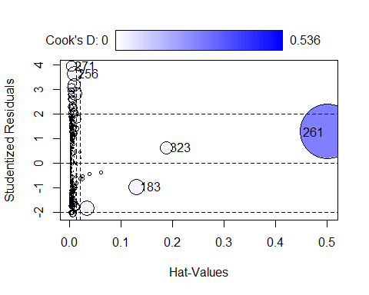

StudRes Hat CookD  
183 -0.9687157 0.130506303 0.04695695  
256 3.6304414 0.009756288 0.04207098  
261 1.2637538 0.501884019 0.53562708  
271 3.9384617 0.003762546 0.01887851  
323 0.6333545 0.188217533 0.03104628

durationsGeNA[c(256, 261,271,323),]

Word Frequency Speaker Sex YearOfBirth DurationOfPrefix SpeechRate  
259 gespoeld 9 N01115 female 1977 0.154512 6.067292  
264 gestapeld 6 N01005 female 1944 0.050903 3.630705  
274 gebeld 1155 N01110 female 1977 0.144874 4.909180  
326 geprijsd 5 N01141 female 1943 0.158563 5.941771  
 NumberSegmentsOnset  
259 2  
264 2  
274 1  
326 2

### C. Las variable dependiente debe ser numérica

la duración es numérica

### D. La relación entre la variable dependiente y la variable indenpendiente es lineal

La función crPlot() permite verificar la linealidad

par(mfrow = c(1, 2))  
  
crPlot(mGe2, var = "Frequency")  
  
crPlot(mGe2, var = "SpeechRate")

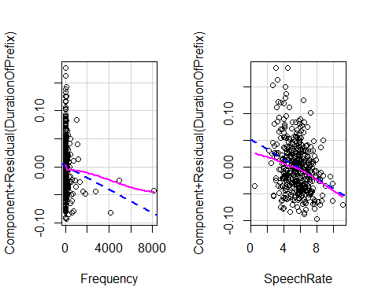

par(mfrow = c(1, 1))

### E. Ausencia de heterocedasticidad

plot(mGe2, which = 1)

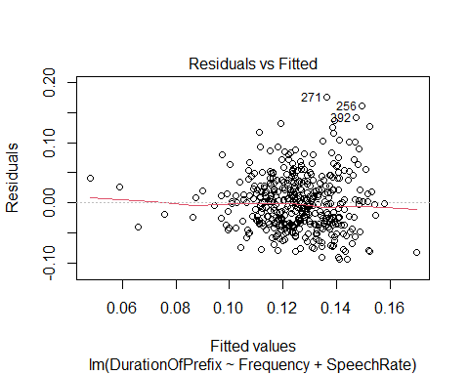

La función ncvTest(m) permite aplicar la prueba *constant variance*, cuya hipótesis nula es que los residuos tienen una varianza constante (*homocedasticidad*).

ncvTest(mGe2)

Non-constant Variance Score Test   
Variance formula: ~ fitted.values   
Chisquare = 24.92641, Df = 1, p = 5.9561e-07

boxCox(mGe2)

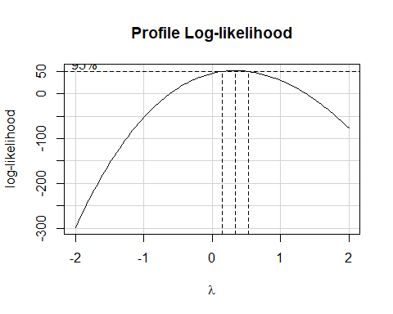

boxCox(mGe2, lambda = seq(0,1, 1/10))

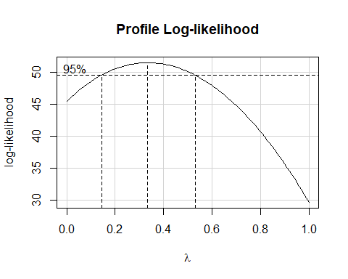

m.trans<- lm(DurationOfPrefix^0.3 ~ Frequency + SpeechRate, data = durationsGeNA)  
ncvTest(m.trans)

Non-constant Variance Score Test   
Variance formula: ~ fitted.values   
Chisquare = 2.871763, Df = 1, p = 0.090146

**Con la transformación queda solucionado el problema de la heterocedasticidad**

### F. Debe haber ausencia de multicolinealidad.

La multicolinealidad se presenta cuando hay una fuerte correlación entre dos variables independientes y descarta el efectos de factores subyacentes. la función vif() permite detectarla (VIF no debe superar el valor de 10).

car::vif(m.trans)

Frequency SpeechRate   
 1.000946 1.000946

### G. Los residuos no deben estar autocorrelacionados

durbinWatsonTest(m.trans)

lag Autocorrelation D-W Statistic p-value  
 1 -0.02108955 2.034179 0.742  
 Alternative hypothesis: rho != 0

**No hay autocorrelación**

### H. Los residuos deben tener una distribución normal

shapiro.test(residuals(m.trans))

Shapiro-Wilk normality test  
  
data: residuals(m.trans)  
W = 0.99611, p-value = 0.3848

plot(m.trans, which=2)

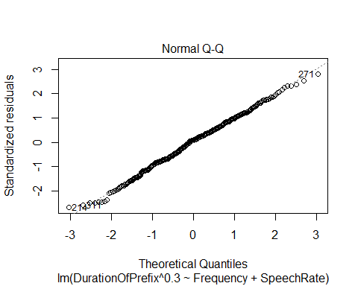

# Ont-

## 1. Condiciones de las tablas de datos

1. **Datos**: deben estar expresados en cuadros de datos (*Data Frame*)
2. Las **filas** son casos (*tokens*) o participantes, mientras que las **columnas** son variables
3. Las **variables dependientes** pueden ser numéricas
4. Las tablas no deben incluír **celdas vacíos** o las celdas deben estar marcadas como NA.

library(languageR)  
data("durationsOnt")  
summary(durationsOnt)

Word Frequency Speaker Sex YearOfBirth   
 ontbeten : 1 Min. :0.000 N01014 : 4 female:49 Min. :23.00   
 ontbijt : 1 1st Qu.:1.609 N01068 : 4 male :53 1st Qu.:52.00   
 ontbijtbuffet : 1 Median :2.562 N01085 : 4 Median :70.00   
 ontbijten : 1 Mean :2.660 N01157 : 4 Mean :64.21   
 ontbijtje : 1 3rd Qu.:3.859 N01019 : 3 3rd Qu.:77.00   
 ontbijtservies: 1 Max. :6.725 N01020 : 3 Max. :83.00   
 (Other) :96 (Other):80   
 DurationOfPrefix DurationPrefixVowel DurationPrefixNasal DurationPrefixPlosive  
 Min. :0.0393 Min. :0.01648 Min. :0.00000 Min. :0.00000   
 1st Qu.:0.1167 1st Qu.:0.04577 1st Qu.:0.03693 1st Qu.:0.00000   
 Median :0.1581 Median :0.06357 Median :0.04985 Median :0.03866   
 Mean :0.1488 Mean :0.06268 Mean :0.04982 Mean :0.03633   
 3rd Qu.:0.1743 3rd Qu.:0.07736 3rd Qu.:0.06403 3rd Qu.:0.05559   
 Max. :0.2392 Max. :0.12322 Max. :0.09738 Max. :0.11473   
   
 NumberOfSegmentsOnset PlosivePresent SpeechRate   
 Min. :1.000 no :28 Min. :2.460   
 1st Qu.:1.000 yes:74 1st Qu.:4.846   
 Median :1.000 Median :5.451   
 Mean :1.304 Mean :5.555   
 3rd Qu.:2.000 3rd Qu.:6.339   
 Max. :2.000 Max. :8.479

## Modelos de regresión para los afijos

mOnt <- lm(DurationOfPrefix ~ Frequency + SpeechRate+ Sex + YearOfBirth+ PlosivePresent+ Frequency*PlosivePresent, data = durationsOnt)  
summary(mOnt)

Call:  
lm(formula = DurationOfPrefix ~ Frequency + SpeechRate + Sex +   
 YearOfBirth + PlosivePresent + Frequency * PlosivePresent,   
 data = durationsOnt)  
  
Residuals:  
 Min 1Q Median 3Q Max   
-0.10224 -0.01983 -0.00059 0.02439 0.10372   
  
Coefficients:  
 Estimate Std. Error t value Pr(>|t|)   
(Intercept) 0.2054727 0.0220145 9.334 4.39e-15 ***  
Frequency 0.0015387 0.0038109 0.404 0.6873   
SpeechRate -0.0076452 0.0030201 -2.531 0.0130 *   
Sexmale -0.0101445 0.0070684 -1.435 0.1545   
YearOfBirth -0.0004851 0.0002403 -2.019 0.0463 *   
PlosivePresentyes 0.0361461 0.0148533 2.434 0.0168 *   
Frequency:PlosivePresentyes -0.0040897 0.0046615 -0.877 0.3825   
---  
Signif. codes: 0 '***' 0.001 '**' 0.01 '*' 0.05 '.' 0.1 ' ' 1  
  
Residual standard error: 0.03515 on 95 degrees of freedom  
Multiple R-squared: 0.2366, Adjusted R-squared: 0.1883   
F-statistic: 4.906 on 6 and 95 DF, p-value: 0.0002072

mOnt

Call:  
lm(formula = DurationOfPrefix ~ Frequency + SpeechRate + Sex +   
 YearOfBirth + PlosivePresent + Frequency * PlosivePresent,   
 data = durationsOnt)  
  
Coefficients:  
 (Intercept) Frequency   
 0.2054727 0.0015387   
 SpeechRate Sexmale   
 -0.0076452 -0.0101445   
 YearOfBirth PlosivePresentyes   
 -0.0004851 0.0361461   
Frequency:PlosivePresentyes   
 -0.0040897

## Selección de las variables independientes

**El parámetro es AIC (Akaike Information Criterion)**

En el método *forward direction* se inicia con un modelo nulo (b0). El computador luego busca el predictor que mejor predice el valor de la variable dependiente y lo retiene en el modelo.

m02 <- lm(DurationOfPrefix ~ 1, data = durationsOnt)  
m.fw2 <- step(m02, direction = "forward", scope = ~ Frequency + SpeechRate+ Sex + YearOfBirth+ PlosivePresent+ Frequency*PlosivePresent)

Start: AIC=-660.74  
DurationOfPrefix ~ 1  
  
 Df Sum of Sq RSS AIC  
+ YearOfBirth 1 0.0173281 0.13642 -670.94  
+ PlosivePresent 1 0.0124341 0.14131 -667.34  
+ SpeechRate 1 0.0099765 0.14377 -665.58  
<none> 0.15374 -660.74  
+ Sex 1 0.0021996 0.15154 -660.21  
+ Frequency 1 0.0003733 0.15337 -658.99  
  
Step: AIC=-670.94  
DurationOfPrefix ~ YearOfBirth  
  
 Df Sum of Sq RSS AIC  
+ PlosivePresent 1 0.0078460 0.12857 -674.98  
+ SpeechRate 1 0.0044463 0.13197 -672.32  
<none> 0.13642 -670.94  
+ Sex 1 0.0017228 0.13469 -670.23  
+ Frequency 1 0.0001268 0.13629 -669.03  
  
Step: AIC=-674.98  
DurationOfPrefix ~ YearOfBirth + PlosivePresent  
  
 Df Sum of Sq RSS AIC  
+ SpeechRate 1 0.0074921 0.12108 -679.10  
<none> 0.12857 -674.98  
+ Sex 1 0.0023511 0.12622 -674.86  
+ Frequency 1 0.0003234 0.12825 -673.24  
  
Step: AIC=-679.1  
DurationOfPrefix ~ YearOfBirth + PlosivePresent + SpeechRate  
  
 Df Sum of Sq RSS AIC  
+ Sex 1 0.00238153 0.11870 -679.13  
<none> 0.12108 -679.10  
+ Frequency 1 0.00014483 0.12093 -677.22  
  
Step: AIC=-679.13  
DurationOfPrefix ~ YearOfBirth + PlosivePresent + SpeechRate +   
 Sex  
  
 Df Sum of Sq RSS AIC  
<none> 0.11870 -679.13  
+ Frequency 1 0.00037183 0.11832 -677.45

m.fw2

Call:  
lm(formula = DurationOfPrefix ~ YearOfBirth + PlosivePresent +   
 SpeechRate + Sex, data = durationsOnt)  
  
Coefficients:  
 (Intercept) YearOfBirth PlosivePresentyes SpeechRate   
 0.2103870 -0.0005268 0.0249334 -0.0073414   
 Sexmale   
 -0.0097087

Con el método inverso (The backward method) se inicia con todos los predictores y, de acuerdo con el AIC, remueve los predictores que no contribuyen al modelo.

m.bw2 <- step(mOnt, direction = "backward")

Start: AIC=-676.27  
DurationOfPrefix ~ Frequency + SpeechRate + Sex + YearOfBirth +   
 PlosivePresent + Frequency * PlosivePresent  
  
 Df Sum of Sq RSS AIC  
- Frequency:PlosivePresent 1 0.0009510 0.11832 -677.45  
<none> 0.11737 -676.27  
- Sex 1 0.0025449 0.11992 -676.08  
- YearOfBirth 1 0.0050366 0.12241 -673.99  
- SpeechRate 1 0.0079176 0.12529 -671.61  
  
Step: AIC=-677.45  
DurationOfPrefix ~ Frequency + SpeechRate + Sex + YearOfBirth +   
 PlosivePresent  
  
 Df Sum of Sq RSS AIC  
- Frequency 1 0.0003718 0.11870 -679.13  
<none> 0.11832 -677.45  
- Sex 1 0.0026085 0.12093 -677.22  
- YearOfBirth 1 0.0059261 0.12425 -674.46  
- SpeechRate 1 0.0072570 0.12558 -673.38  
- PlosivePresent 1 0.0118560 0.13018 -669.71  
  
Step: AIC=-679.13  
DurationOfPrefix ~ SpeechRate + Sex + YearOfBirth + PlosivePresent  
  
 Df Sum of Sq RSS AIC  
<none> 0.11870 -679.13  
- Sex 1 0.0023815 0.12108 -679.10  
- YearOfBirth 1 0.0061209 0.12482 -676.00  
- SpeechRate 1 0.0075224 0.12622 -674.86  
- PlosivePresent 1 0.0116172 0.13031 -671.60

m.bw2

Call:  
lm(formula = DurationOfPrefix ~ SpeechRate + Sex + YearOfBirth +   
 PlosivePresent, data = durationsOnt)  
  
Coefficients:  
 (Intercept) SpeechRate Sexmale YearOfBirth   
 0.2103870 -0.0073414 -0.0097087 -0.0005268   
PlosivePresentyes   
 0.0249334

Con el método bidireccional inicia como el método hacia adelante (forward method), pero cada vez que añade un predictor, remueve los que son redundantes.

m.both2 <- step(mOnt, scope = ~ Frequency + SpeechRate+ Sex + YearOfBirth+ PlosivePresent+ Frequency*PlosivePresent)

Start: AIC=-676.27  
DurationOfPrefix ~ Frequency + SpeechRate + Sex + YearOfBirth +   
 PlosivePresent + Frequency * PlosivePresent  
  
 Df Sum of Sq RSS AIC  
- Frequency:PlosivePresent 1 0.0009510 0.11832 -677.45  
<none> 0.11737 -676.27  
- Sex 1 0.0025449 0.11992 -676.08  
- YearOfBirth 1 0.0050366 0.12241 -673.99  
- SpeechRate 1 0.0079176 0.12529 -671.61  
  
Step: AIC=-677.45  
DurationOfPrefix ~ Frequency + SpeechRate + Sex + YearOfBirth +   
 PlosivePresent  
  
 Df Sum of Sq RSS AIC  
- Frequency 1 0.0003718 0.11870 -679.13  
<none> 0.11832 -677.45  
- Sex 1 0.0026085 0.12093 -677.22  
+ Frequency:PlosivePresent 1 0.0009510 0.11737 -676.27  
- YearOfBirth 1 0.0059261 0.12425 -674.46  
- SpeechRate 1 0.0072570 0.12558 -673.38  
- PlosivePresent 1 0.0118560 0.13018 -669.71  
  
Step: AIC=-679.13  
DurationOfPrefix ~ SpeechRate + Sex + YearOfBirth + PlosivePresent  
  
 Df Sum of Sq RSS AIC  
<none> 0.11870 -679.13  
- Sex 1 0.0023815 0.12108 -679.10  
+ Frequency 1 0.0003718 0.11832 -677.45  
- YearOfBirth 1 0.0061209 0.12482 -676.00  
- SpeechRate 1 0.0075224 0.12622 -674.86  
- PlosivePresent 1 0.0116172 0.13031 -671.60

m.both2

Call:  
lm(formula = DurationOfPrefix ~ SpeechRate + Sex + YearOfBirth +   
 PlosivePresent, data = durationsOnt)  
  
Coefficients:  
 (Intercept) SpeechRate Sexmale YearOfBirth   
 0.2103870 -0.0073414 -0.0097087 -0.0005268   
PlosivePresentyes   
 0.0249334

## Verificación de las condiciones de la regresión lineal

mOnt2 <- lm(DurationOfPrefix ~ SpeechRate+ Sex + YearOfBirth+ PlosivePresent, data = durationsOnt)  
summary(mOnt2)

Call:  
lm(formula = DurationOfPrefix ~ SpeechRate + Sex + YearOfBirth +   
 PlosivePresent, data = durationsOnt)  
  
Residuals:  
 Min 1Q Median 3Q Max   
-0.100445 -0.022487 -0.000233 0.025945 0.096190   
  
Coefficients:  
 Estimate Std. Error t value Pr(>|t|)   
(Intercept) 0.2103870 0.0200264 10.505 < 2e-16 ***  
SpeechRate -0.0073414 0.0029609 -2.479 0.01489 *   
Sexmale -0.0097087 0.0069593 -1.395 0.16618   
YearOfBirth -0.0005268 0.0002355 -2.237 0.02761 *   
PlosivePresentyes 0.0249334 0.0080921 3.081 0.00268 **   
---  
Signif. codes: 0 '***' 0.001 '**' 0.01 '*' 0.05 '.' 0.1 ' ' 1  
  
Residual standard error: 0.03498 on 97 degrees of freedom  
Multiple R-squared: 0.228, Adjusted R-squared: 0.1961   
F-statistic: 7.16 on 4 and 97 DF, p-value: 4.282e-05

### A. Valores atípicos y observaciones con influencia o peso

El argumento id.method = "identify" de la función influencePlot () permite elegir interactivamente los valores atípicos:

1. En la ordenada **Studentized residuals**\*: muestran la discrepancia entre los valores ajustados y los valores observados: identificar los casos por encima de 2 y por debajo de -2.
2. **Hat value**: la influencia de un dato sobre los valores ajustados (lénas verticales).
3. **Cook’s distance**: el tamaño de las burbujas indica las consecuencias de remover de una caso sobre los coeficientes y los valores ajustados.

influencePlot(mOnt2, id.method = "identify")

Warning in plot.window(...): "id.method" is not a graphical parameter

Warning in plot.xy(xy, type, ...): "id.method" is not a graphical parameter

Warning in axis(side = side, at = at, labels = labels, ...): "id.method" is not  
a graphical parameter  
  
Warning in axis(side = side, at = at, labels = labels, ...): "id.method" is not  
a graphical parameter

Warning in box(...): "id.method" is not a graphical parameter

Warning in title(...): "id.method" is not a graphical parameter

Warning in plot.xy(xy.coords(x, y), type = type, ...): "id.method" is not a  
graphical parameter

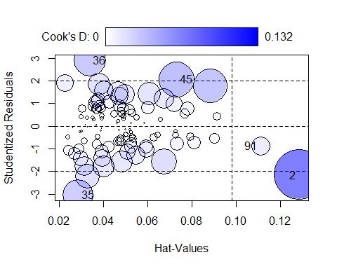

StudRes Hat CookD  
45 2.0716772 0.07313941 0.06551147  
35 -3.0342242 0.02867267 0.05011376  
2 -2.1529319 0.12846574 0.13170905  
91 -0.8579944 0.11099466 0.01843230  
36 2.9025569 0.03379372 0.05474261

durationsOnt[c(85,36,71,66,2), ]

Word Frequency Speaker Sex YearOfBirth DurationOfPrefix  
49 ontwijken 2.639057 N01089 female 75 0.187598  
31 ontmoet 5.087596 N01212 female 83 0.119349  
7 ontvangst 3.951244 N01062 male 48 0.102165  
102 ontstekingsvocht 0.000000 N01037 female 81 0.099240  
58 ontbijt 4.844187 N01041 female 80 0.100478  
 DurationPrefixVowel DurationPrefixNasal DurationPrefixPlosive  
49 0.089345 0.041068 0.057185  
31 0.037293 0.028064 0.053992  
7 0.033733 0.042036 0.026396  
102 0.036075 0.063166 0.000000  
58 0.035380 0.065099 0.000000  
 NumberOfSegmentsOnset PlosivePresent SpeechRate  
49 1 yes 5.038937  
31 1 yes 6.736842  
7 1 yes 5.215124  
102 2 no 5.138340  
58 1 no 6.884682

### C. Las variable dependiente debe ser numérica

¿Los tiempos de reacción son numéricos?

### D. La relación entre la variable dependiente y la variable indenpendiente es lineal

La función crPlot() permite verificar la linealidad

par(mfrow = c(1, 3))  
  
crPlot(mOnt2, var = "SpeechRate")  
  
crPlot(mOnt2, var = "YearOfBirth")  
  
crPlot(mOnt2, var = "PlosivePresent")

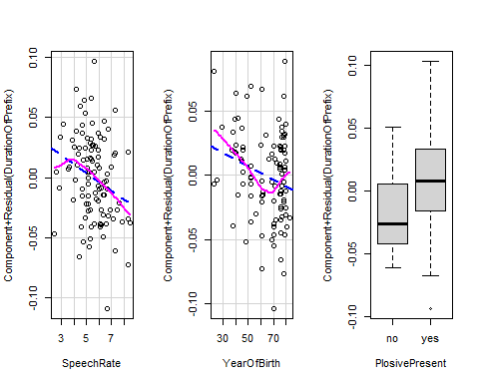

par(mfrow = c(1, 1))

### E. Ausencia de heterocedasticidad

plot(mOnt2, which = 1)

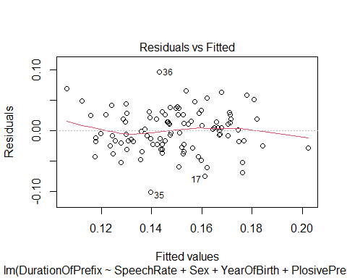

La función ncvTest(m) permite aplicar la prueba *constant variance*, cuya hipótesis nula es que los residuos tienen una varianza constante (*homocedasticidad*).

ncvTest(mOnt)

Non-constant Variance Score Test   
Variance formula: ~ fitted.values   
Chisquare = 0.06935309, Df = 1, p = 0.79228

*No hay problema con la homocedasticidad*

durbinWatsonTest(mOnt)

lag Autocorrelation D-W Statistic p-value  
 1 0.04643942 1.898347 0.564  
 Alternative hypothesis: rho != 0

**No hay autocorrelación**

### H. Los residuos deben tener una distribución normal

shapiro.test(residuals(mOnt))

Shapiro-Wilk normality test  
  
data: residuals(mOnt)  
W = 0.99395, p-value = 0.9338

plot(mOnt, which=2)

