Part 1 – Data Analytics: Understanding Traffic Patterns

Task 1: SQL-Based Traffic Analysis

1.1 Load and Verify the Dataset
The Metro Interstate Traffic Volume CSV dataset was successfully imported into SQLite. The imported table contained 48,204 records.
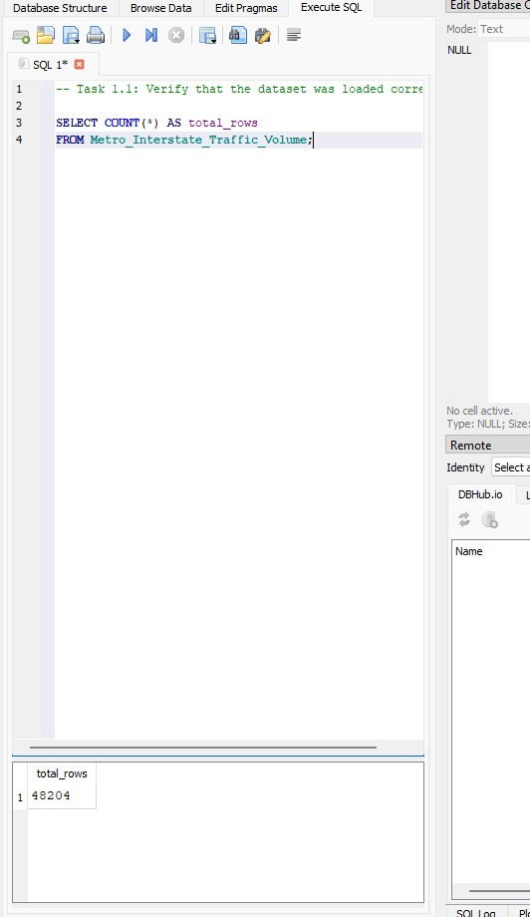
Duplicate and repeated observations were investigated during data validation. Repeated timestamps were identified, but these did not necessarily represent exact duplicate records because the same timestamp could contain different weather information. Where timestamps were repeated, the associated traffic-volume values were identical.
Therefore, for analyses involving hourly traffic volume, one traffic-volume observation per unique timestamp was used to prevent the same hour from being counted more than once. This resulted in 40,575 unique hourly traffic observations for the traffic-volume analysis.

1.2 Annual Traffic Trends
Annual traffic totals showed the following overall pattern:
- Traffic increased from 2012 to 2013.
- Traffic decreased in 2014 and again in 2015.
- Traffic increased in 2016 and again in 2017.
However, the annual totals should not be interpreted as if every year contained a complete and comparable set of hourly observations.
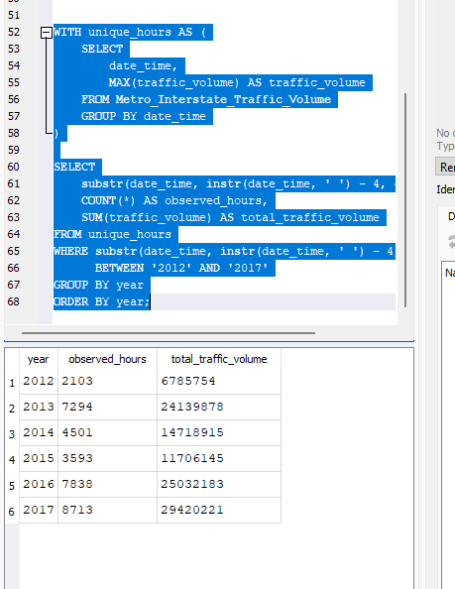
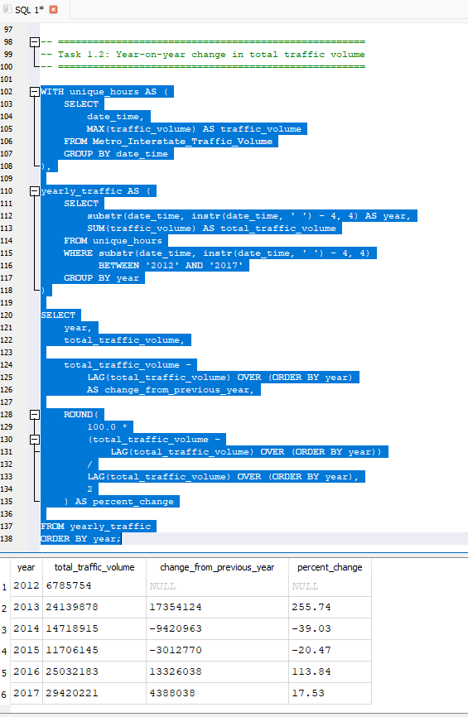
Key observations
- 2012 has an unusually low base. Only 2,103 unique observed hours were available because the dataset begins in October 2012. This explains the very low annual total and much of the apparent 255.74% increase from 2012 to 2013.
- Data coverage varies substantially between years. In particular, there were 4,501 observed hours in 2014 and 3,593 in 2015, compared with 7,838 in 2016 and 8,713 in 2017.
- Missing periods were identified in the dataset, including missing observations from approximately 30 April to 3 May 2014.
- Some timestamps occurred more than once because different weather records were recorded for the same hour. SQL analysis showed that these repeated timestamps had identical traffic-volume values. One traffic value per unique timestamp was therefore used to prevent double-counting.
Overall, the raw annual traffic totals should not be compared as though each year contained a complete 8,760 hours of observations. The apparent year-to-year changes reflect differences in data coverage as well as possible changes in actual traffic. The timing of missing hourly observations could also influence interpretation of the annual totals.

1.3 Temperature Around Holidays
Temperature and traffic patterns were compared for New Year's Day and Labor Day in 2015, 2016 and 2017.
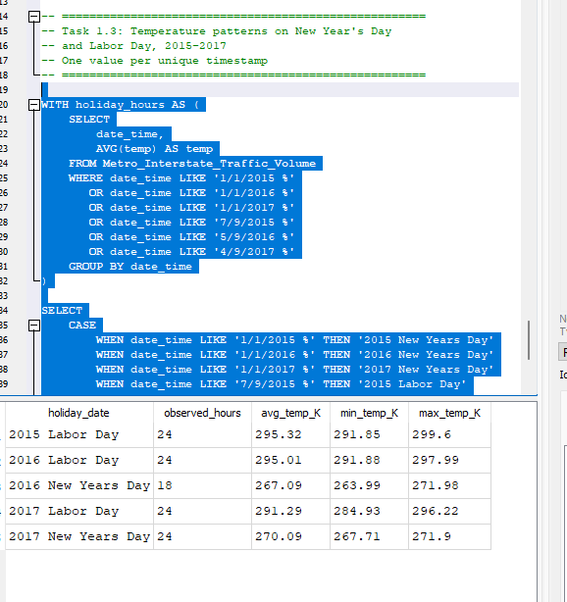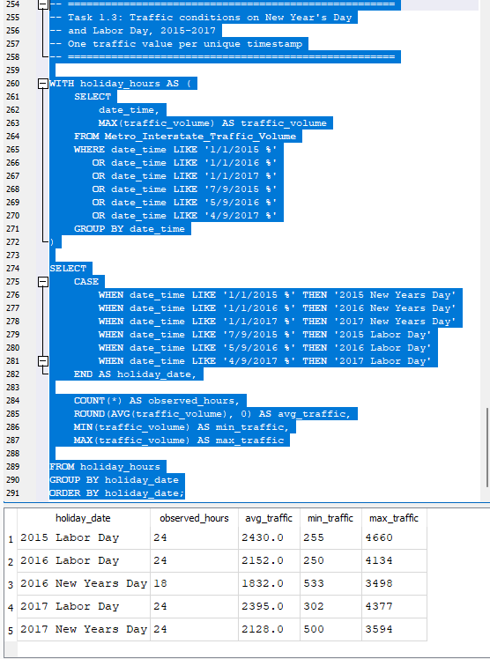
Labor Day provided the more reliable comparison, because all three years contained 24 observed hours.
- 2015: average temperature 295.32 K; average traffic 2,430 vehicles/hour
- 2016: average temperature 295.01 K; average traffic 2,152 vehicles/hour
- 2017: average temperature 291.29 K; average traffic 2,395 vehicles/hour
Temperatures were almost identical in 2015 and 2016, yet average traffic decreased. In 2017, temperature was substantially lower, but average traffic increased again. Therefore, there is no obvious consistent relationship between Labor Day temperature and traffic volume across these three years.
The New Year's Day comparison is less reliable because there were no observations for 2015, while 2016 contained only 18 observed hours. In the available data, 2017 was approximately 3 K warmer than 2016 and had higher average traffic (2,128 versus 1,832 vehicles/hour). However, given the incomplete observations, this is insufficient evidence that warmer temperature caused the higher traffic volume.

Task 2: Descriptive Statistics and Correlation

2.1 Traffic Volume Statistics
Using one traffic-volume observation per unique hourly timestamp:
Statistic | Traffic Volume
Mean | 3,290.65
Median | 3,427.00
Standard deviation | 1,984.75
Variance | 3,939,226.41
Minimum | 0
Maximum | 7,280
Range | 7,280
Unique hourly observations | 40,575
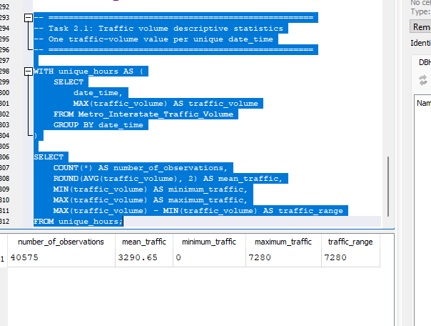 | 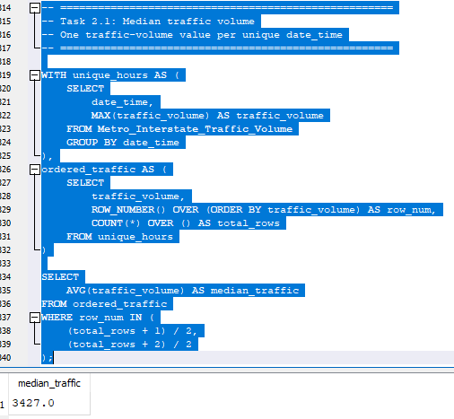
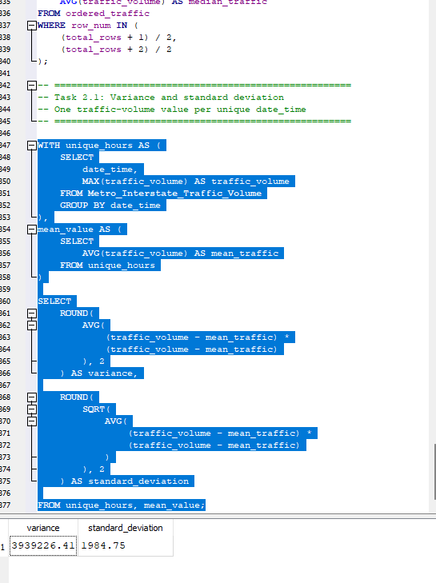
The mean traffic volume was 3,290.65 vehicles per observed hour, while the median was slightly higher at 3,427 vehicles. Their similarity suggests that the centre of the traffic-volume distribution is approximately 3,300–3,400 vehicles per hour, although lower-volume observations pull the mean slightly below the median.
Traffic volume showed substantial variability. The standard deviation of 1,984.75 vehicles is large relative to the mean, indicating considerable variation between observed hours. Traffic ranged from 0 to 7,280 vehicles per hour.
The variance was 3,939,226.41 vehicles². Its large numerical value reflects the wide dispersion in traffic volumes, although standard deviation is easier to interpret because it is expressed in the same units as traffic volume.
Overall, traffic volume varies considerably between different hours rather than remaining relatively constant throughout the day.

2.2 Correlation Analysis
The Pearson correlation coefficient between temperature and traffic volume was:
r = 0.1369
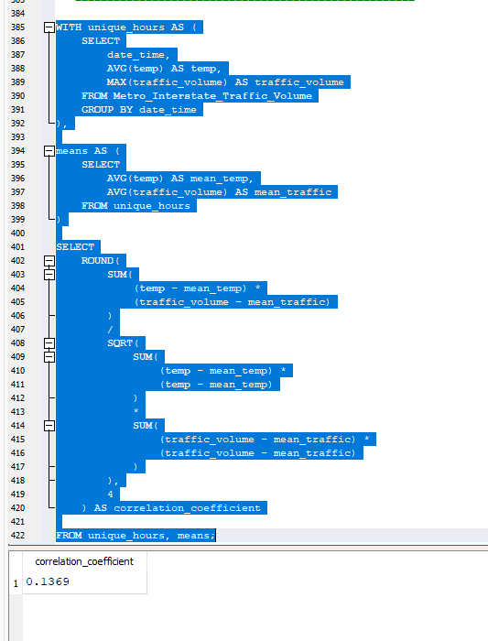
The correlation is positive, meaning that traffic volume tends to increase slightly as temperature increases. However, the coefficient is close to zero, indicating that the relationship is weak. Temperature alone therefore has little linear association with traffic volume in this dataset.
Correlation does not imply causation. The positive correlation does not demonstrate that higher temperatures cause higher traffic volumes. Traffic may also be influenced by factors such as time of day, day of the week, holidays, commuting patterns and weather conditions. Temperature itself also varies with season and time of day.
The analysis therefore demonstrates a weak positive association, but not a causal relationship between temperature and traffic volume.

Task 3: Probability and Congestion Analysis
Congestion was defined as:
Traffic volume > 5,500 vehicles
The corrected probability analysis used 47,893 records.

3.1 Basic Probability
- P(Congestion) = 0.1475 = 14.75%
- P(Clear Weather) = 0.2792 = 27.92%
- P(Congestion AND Clear Weather) = 0.0368 = 3.68%
- 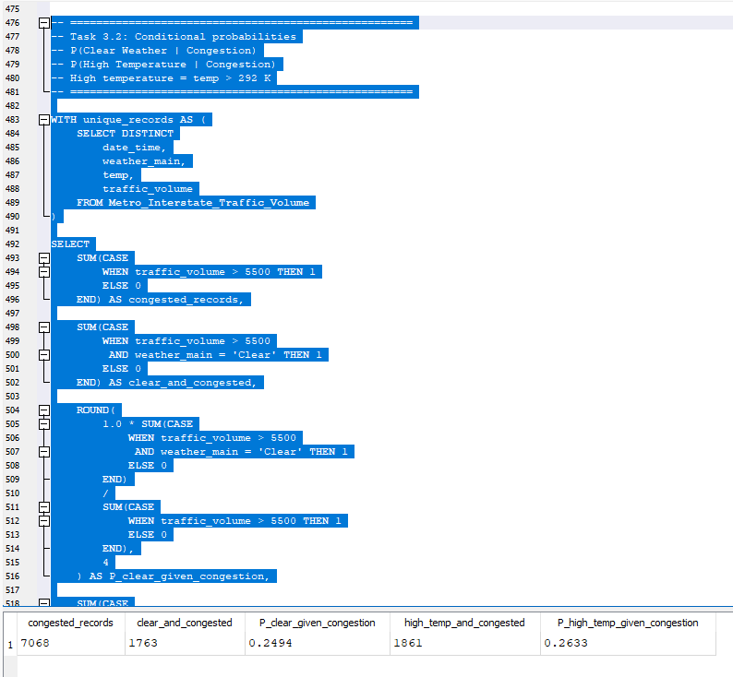
Therefore, approximately 14.75% of the analysed records were classified as congested, 27.92% occurred during clear weather, and 3.68% represented both congestion and clear weather.

3.2 Conditional Probability
There were 7,062 congested records.
Of these:
- Clear weather and congestion: 1,763
- High temperature (>292 K) and congestion: 1,860
Therefore:
P(Clear Weather | Congestion)
= 1,763 / 7,062
= 0.2496 = 24.96%
P(High Temperature | Congestion)
= 1,860 / 7,062
= 0.2634 = 26.34%

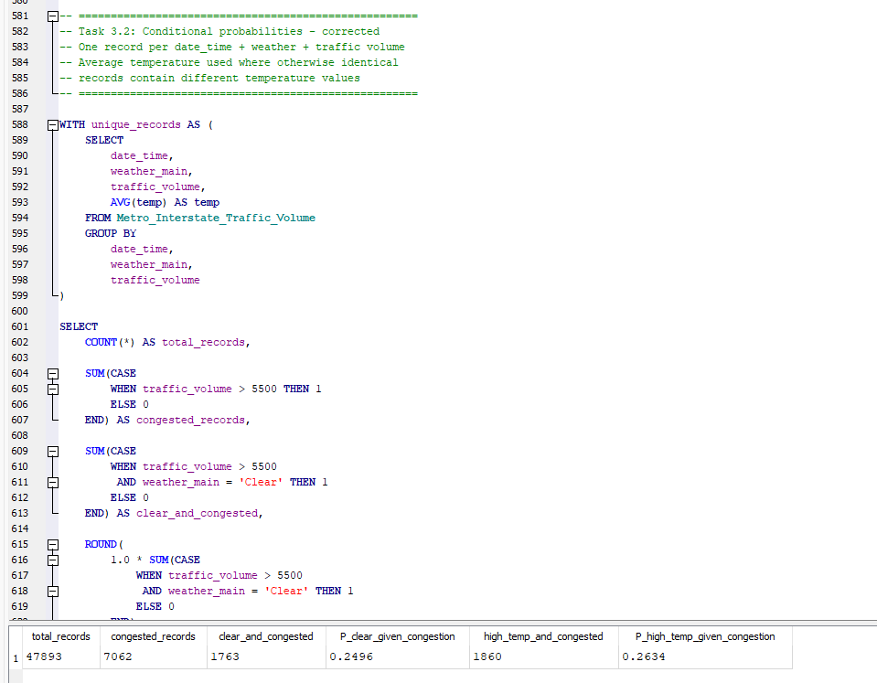
Thus, among congested observations, 24.96% occurred during clear weather, while 26.34% occurred at temperatures above 292 K.

Independence Test
For congestion and clear weather to be independent:
P(Congestion ∩ Clear Weather) = P(Congestion) × P(Clear Weather)
The results were:
- P(Congestion ∩ Clear Weather) = 0.0368
- P(Congestion) × P(Clear Weather) = 0.0412
Since:
0.0368 ≠ 0.0412
the equality required for independence is not satisfied. Therefore, congestion and clear weather were not independent according to this test.
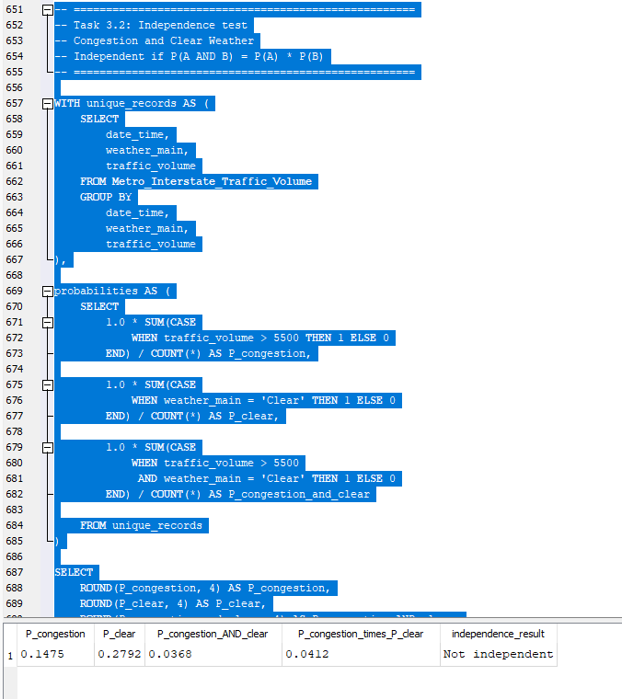

Odds Ratio: Clear Versus Cloudy Weather
Condition | Congested | Not Congested
Clear | 1,763 | 11,608
Clouds | 2,587 | 12,540
The congestion odds were:
- Clear weather = 0.1519
- Cloudy weather = 0.2063
Therefore:
Odds ratio (Clear vs Clouds) = 0.7362
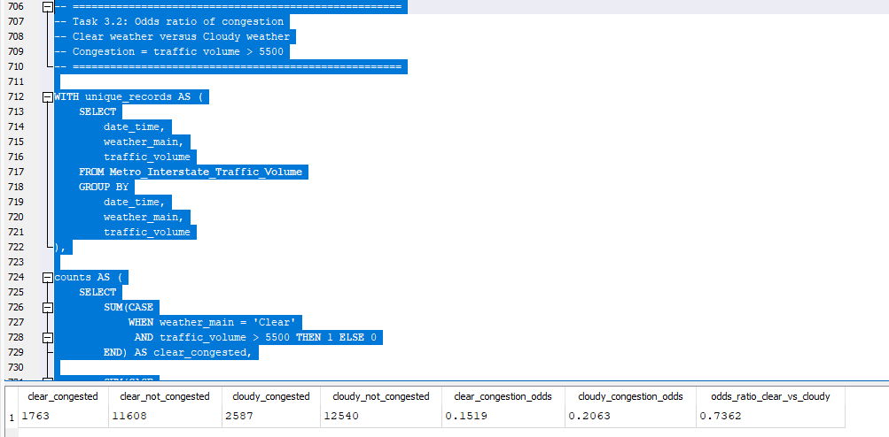
An odds ratio of 0.7362 means that the observed odds of congestion during clear-weather records were approximately 0.74 times the odds during cloudy-weather records, equivalent to approximately 26% lower odds in this dataset.
Overall, the probability analysis suggests an association between weather conditions and congestion, but it does not demonstrate that weather causes congestion. Other factors, particularly time of day, day of the week and travel patterns, may also influence traffic volume.

Task 4: Power BI Traffic Intelligence Dashboard

4.1 Data Quality and Preparation
The imported dataset contained:
- 48,204 rows
- 9 original columns
Power Query transformations added three columns:
- Hour
- Temperature_C
- Traffic Category
The transformed dataset therefore contained 12 columns.
Power Query's entire-dataset column profiling showed 100% valid and 0% empty values across all nine original columns, so no null/missing values were identified.
The original data types were reviewed and found to be appropriate for the analysis. Hour was extracted from date_time, temperature was converted from Kelvin to Celsius, and traffic volume was classified as:
- Low: <4,500
- Medium: 4,500–5,500
- High: >5,500
Implausible temperature values near −273°C, corresponding approximately to 0 K, were identified as data-quality outliers. These were excluded from the temperature–traffic visualisation using Temperature_C > −50°C.
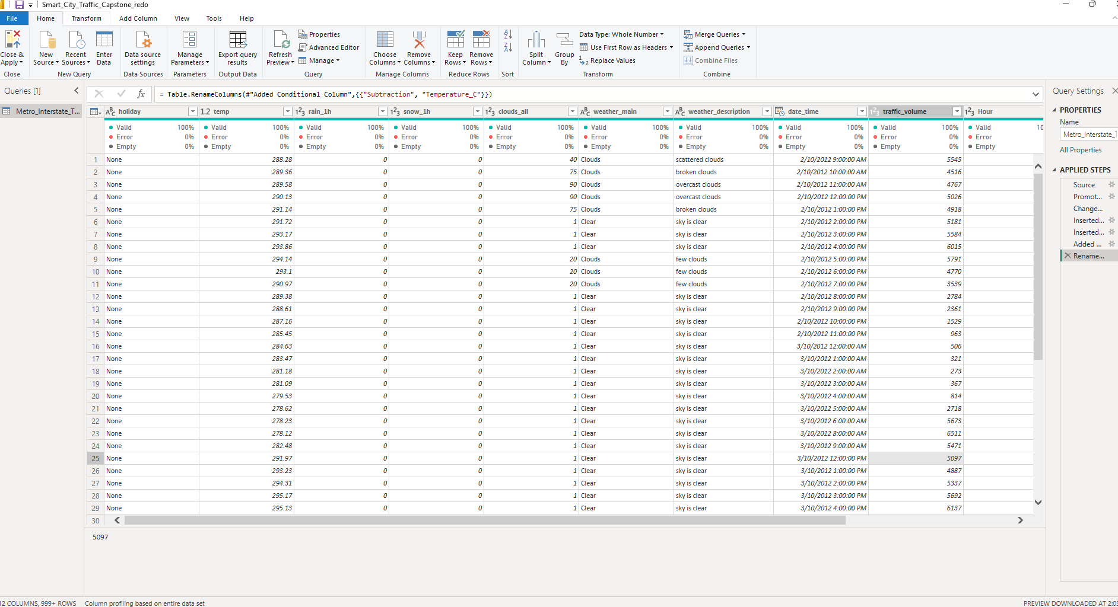

4.2 Dashboard Analysis

A. Daily Traffic Trends
A line chart was created showing daily average traffic volume for 2015–2017.
The chart demonstrates considerable day-to-day variation in traffic. The analysis also needs to be interpreted in the context of the previously identified missing observations, as incomplete coverage may affect some periods.

B. Hourly Traffic Patterns
A column chart of average traffic volume by hour for 2017 showed a clear time-of-day pattern.
Traffic was lowest overnight and during the early morning hours, increased sharply during the morning commuting period, remained relatively high during the daytime and reached another high level in the late afternoon before declining during the evening.
This indicates that hour of day is an important factor associated with traffic volume and is potentially useful for congestion-management planning.

C. Weather Impact

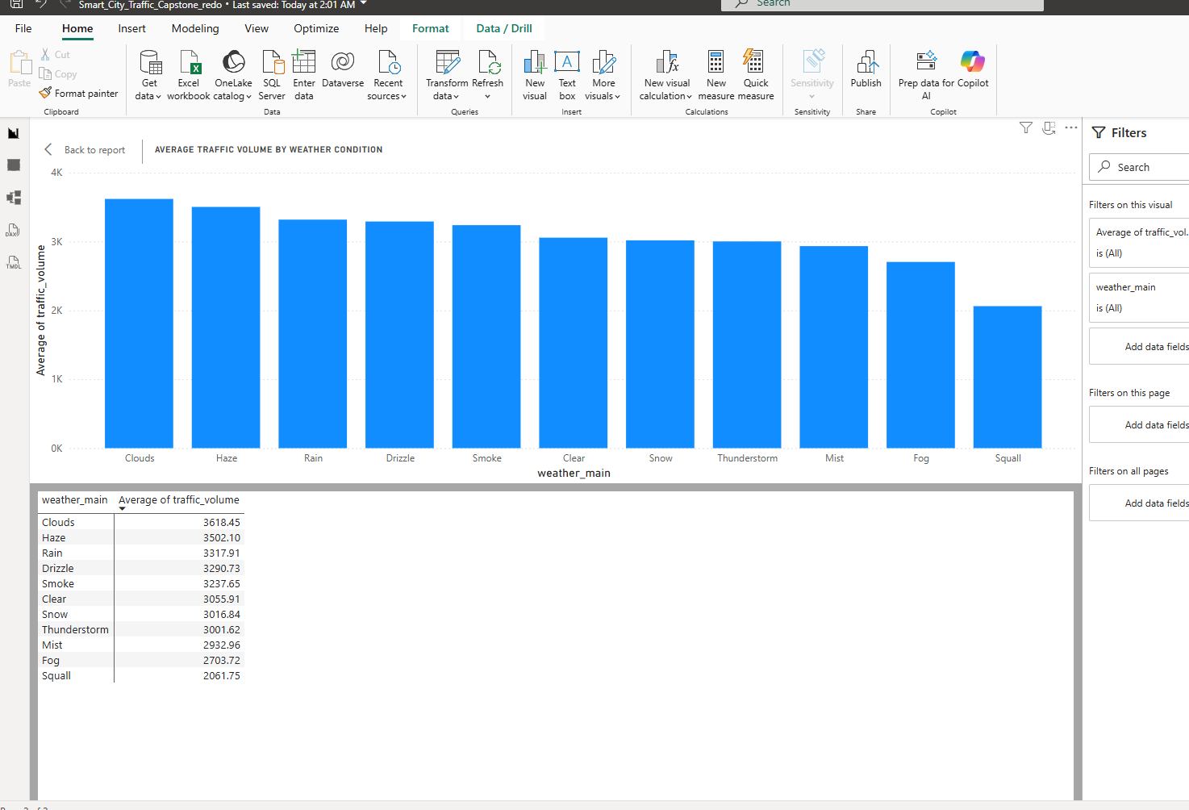
Average traffic volume differed across weather conditions.
- Highest: Clouds = 3,618.45 vehicles/hour
- Lowest: Squall = 2,061.75 vehicles/hour
- Difference: 1,556.70 vehicles/hour
Therefore, cloudy conditions had the highest observed average traffic volume, while squall conditions had the lowest.
These results should be interpreted cautiously because weather categories may contain different numbers of observations; in particular, uncommon conditions such as squalls may be represented by relatively few records.

D. Temperature and Traffic
The scatter plot of temperature against traffic volume showed no strong visible linear relationship, consistent with the weak positive Pearson correlation of r = 0.1369.
A supplementary 5°C temperature-bin analysis showed that higher average traffic volumes were observed at warmer temperatures, particularly around 30–35°C:
- 30°C bin: approximately 3,863.49 vehicles/hour
- 35°C bin: approximately 3,811 vehicles/hour
The 30°C bin therefore had the highest observed average traffic volume.
Notable temperature outliers occurred near −273°C, representing implausible values around 0 K. These were treated as erroneous observations and excluded from the temperature–traffic visualisation.
Overall, temperature shows only a weak positive association with traffic volume and should not be interpreted as a strong independent predictor of traffic conditions.

4.3 KPI Cards and Filters
The dashboard contains the three required KPI cards:
- Total hours analysed: 40,575 distinct hourly timestamps
- Average traffic volume: approximately 3.26K vehicles/hour
- Average temperature: approximately 8.06°C
The dashboard also contains the required interactive slicers for:
- Hour range
- Weather condition
- Traffic category
These allow users to explore how the dashboard results change under different traffic and environmental conditions.
