Spellbinder

21M.385 Final Project Proposal

# Team

Jacqui Liu and Yuge Ji

# Project Goal

Our aim is to create a fully immersive music game where the user engages their whole body while playing in an intuitive manner. We want the user to experience the satisfaction of creation with rhythmic precision and responsive visuals.

# Project Description

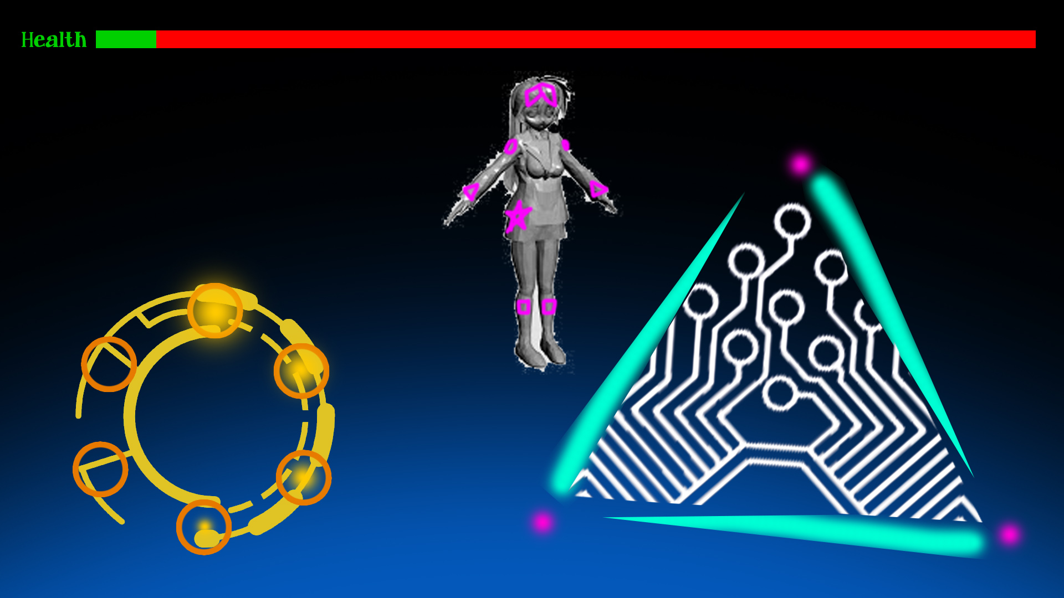

We plan on using a variety of music, from classical to electronic to pop. We will use Kivy’s 3-D functionality for graphics. Since the game requires both exact timing from the user and drawing in space, we plan on using the PlayStation Move wands. They provide two-handed spatial positioning for drawing and triggers for precise timing.

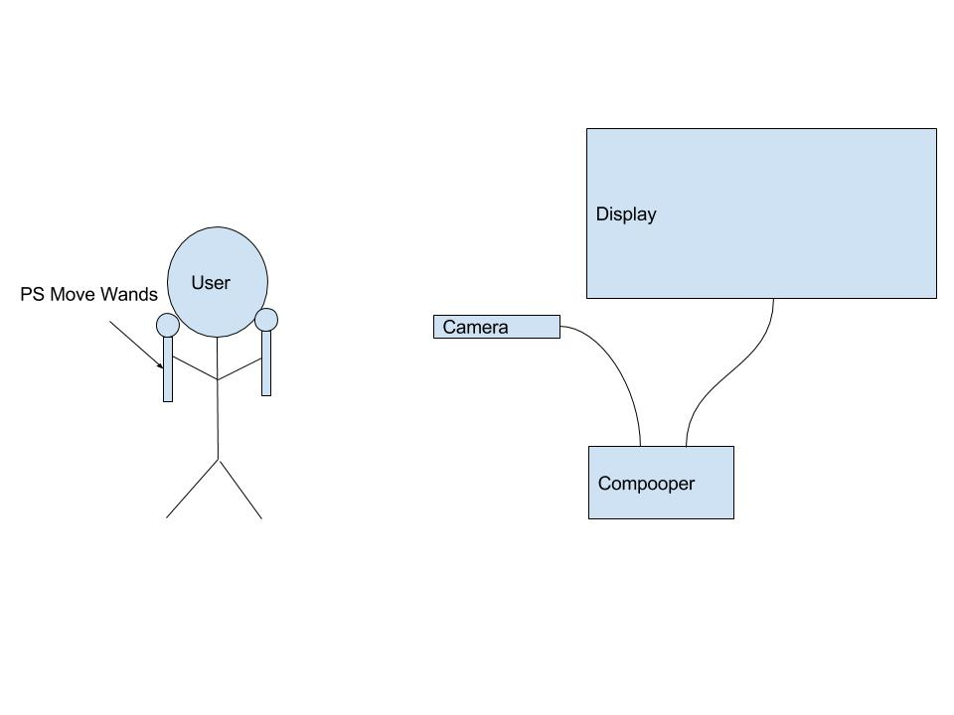

# Major Risks / Challenges

One of the main challenges that we’re anticipating is getting the PS Move to work with our setup. (To mitigate risk, we can bribe Billy with cookies and chocolate to make this possible.) We were also thinking about using Unity for this project, but as we have little experience with it, we were planning to use Kivy/Python with our project. We want to implement 3D objects in Kivy, and that will also require some learning. Our backup plan is to perhaps use phone tracking or snapping (sound) to achieve precise timing instead of the PS Move wands if necessary.

# Division of Labor

Yuge and Jacqui will contribute equally in designing the game and implementing ideas. We will meet at least twice a week to review progress and determine what needs to be. Once we decide more of the specific design ideas and split tasks after our meetings, implementation can happen in parallel; for example, one of us could do animation as the other does beat matching analysis.

# Timeline / Milestones

Nov 12 Finalize “meta” storyline and game details

Nov 21 Milestone 1 – completion of basic gameplay (visual cues, timing, shape detection) with one song

Nov 30 Milestone 2 – completion of gameplay details (level completion, scoring, storyline) for a full level

Dec 4 Polish graphics

Dec 10 Finish game

Dec 12/14 Final project presentation