SEO AUDIT
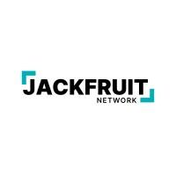

jackfruitnetwork.com SEO Audit

Organic performance
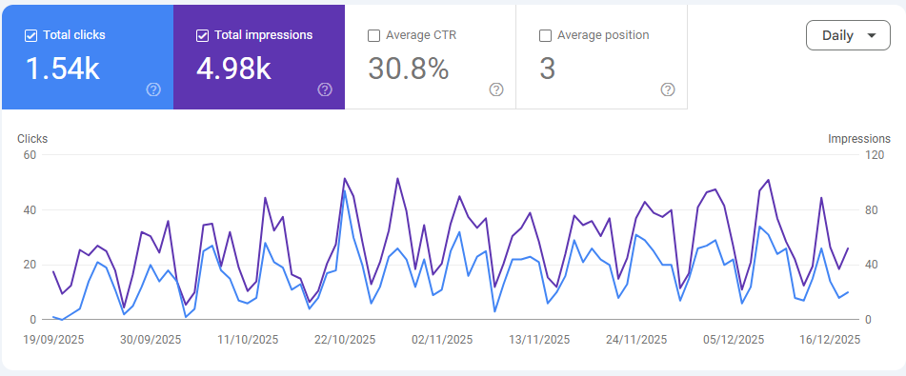
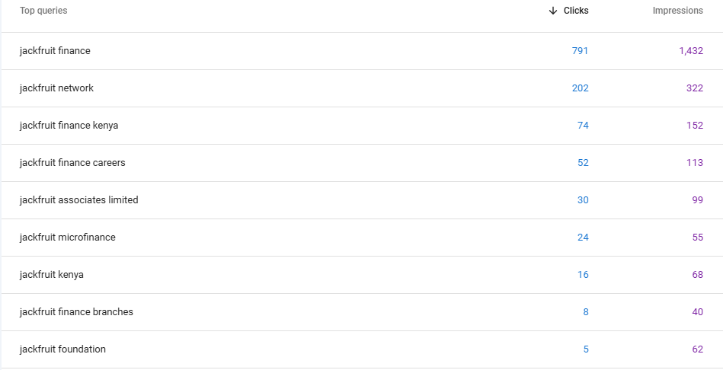

Total Clicks: 1.54K
Jackfruit Network earned 1,540 organic clicks in the period shown. This confirms the site is already generating meaningful organic traffic, not “zero traffic” as some third-party tools may estimate. The daily trend line shows consistent activity with recurring peaks and dips, which often reflect weekly search behavior patterns (users searching more on specific days).

Total Impressions: 4.98K
The site generated 4,980 impressions, meaning Jackfruit Network appeared in Google search results almost 5,000 times. This is a solid foundation, but it also signals that the current SEO footprint is still narrow. In simple terms:
- The site converts visibility into clicks very well (high CTR),
- but the site needs more visibility opportunities (more impressions) to scale traffic.

Average CTR: 30.8% (Very Strong)
A 30.8% CTR is exceptionally high and is typically driven by brand-led searches where users already intend to click your result. This is a strong trust signal: when people see Jackfruit in Google results, they choose it at a high rate.
Your brand demand and search snippet relevance are strong. The next growth lever is not CTR—it is expanding reach through more non-brand keywords.

Average Position: 3 (Excellent)
An average position of 3 means the site is ranking near the top for the queries it already appears for. However, this metric can look “too good” when most rankings come from branded queries, because branded terms typically rank #1–#3 naturally.
Rankings are strong where Jackfruit is already visible. The biggest opportunity is increasing how often Jackfruit appears for new, non-brand searches.

Query Performance (what’s driving these results)

Top Query: “jackfruit finance” — 791 clicks / 1,432 impressions
This single query contributes about 51% of total clicks (791 out of 1.54K). This confirms that organic performance is currently highly concentrated around one branded term.
What it means: The brand is strong, but traffic growth is capped because it depends heavily on people already searching for “Jackfruit Finance.”

Second Query: “jackfruit network” — 202 clicks / 322 impressions
This contributes another ~13% of clicks, reinforcing that the majority of traffic is navigational (people looking specifically for Jackfruit).
High-intent brand modifiers (good signs of user needs)
- “jackfruit finance kenya” — 74 clicks / 152 impressions
Shows location-based intent (national relevance) and an opportunity to strengthen “Kenya” positioning pages.
- “jackfruit finance careers” — 52 clicks / 113 impressions
Shows real demand for employment information—this should be supported with a strong careers hub and job pages.
- “jackfruit finance branches” — 8 clicks / 40 impressions
Even with low volume, this is a high-conversion intent query. Users searching branches often want contact, location, or visits—ideal for local SEO expansion.

Lower-performing CTR opportunities (where improvement can unlock growth)
- “jackfruit foundation” — 5 clicks / 62 impressions (~8% CTR)
This is far below the site average CTR (30.8%), which suggests either:
- The page shown is not the best match, or
- The title/meta snippet is not compelling, or
- competitors/Google SERP features are taking attention.
This is a clear metadata + page relevance optimization target.
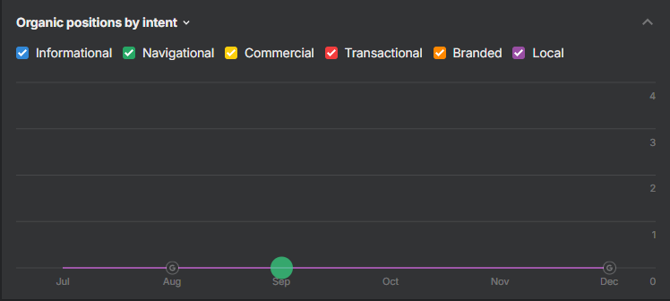

Organic Positions by Intent: Analysis and Impact on Organic Performance
This chart categorizes your organic rankings by search intent:
- Navigational: Users searching specifically for your brand or name (for example, “Jackfruit Finance”)
- Informational: Users searching for answers and guidance (for example, “how microfinance works”)
- Commercial: Users comparing options before choosing a provider (for example, “best microfinance in Kenya”)
- Transactional: Users ready to take action (for example, “apply for a loan”)
- Local: Users looking for nearby locations or branches (for example, “microfinance near me”)
Key insight: The chart indicates that Jackfruit Network’s ranking visibility is concentrated almost entirely in navigational intent, with minimal presence across informational, commercial, transactional, branded, and local categories.
This aligns with the Google Search Console query data, where the majority of clicks come from branded searches such as “jackfruit finance” and “jackfruit network.”

Impact on organic performance

High CTR is largely driven by navigational searches
When search visibility is dominated by navigational intent, users typically already intend to visit the brand’s site. This increases click-through rate significantly because users are searching for a specific destination rather than comparing alternatives.
Impact: CTR is strong because the site is capturing branded demand effectively.

Limited impressions restrict scalable growth
Navigational search volume is inherently capped by how many people already know the brand. If the site has limited visibility for informational, commercial, and transactional searches, Google has fewer opportunities to surface the site to new audiences.
Impact: Impressions remain constrained, limiting the ability to scale organic traffic.

Organic traffic becomes brand-demand dependent
When rankings are concentrated in navigational intent, organic growth is driven mostly by brand awareness gains from offline marketing, PR, or returning users, rather than SEO-driven discovery.
Impact: SEO performance is less resilient and less scalable because it depends on existing brand demand.

Third-party tools may under-report visibility
Third-party tools typically estimate visibility based on tracked keyword sets and ranking detection. When a site’s visibility is primarily navigational, localized, or long-tail, third-party platforms often under-detect rankings and may report low or zero organic visibility despite real traffic being present in Google Search Console.
Impact: Disparities between first-party and third-party reporting are expected under a brand-led visibility profile.

What must change to improve organic performance?
To shift from brand-led performance to scalable organic acquisition, Jackfruit Network should expand rankings across the full intent funnel.
- Informational intent to expand impressions and reach; Develop content that addresses common user questions in the Kenyan context, such as eligibility, requirements, repayment terms, and financial literacy topics relevant to the services offered.
- Commercial intent to capture comparison-stage users; Create pages that support research and evaluation intent, such as product overviews, solution comparisons, and trust-building content that clarifies why Jackfruit is a strong option.
- Transactional intent to improve conversion from search; Strengthen product and service landing pages with clear value propositions, eligibility details, FAQs, and prominent calls to action supported by internal linking.
- Local intent to capture high-conversion branch searches; Develop a branch locator and branch-level pages with consistent NAP details, maps, hours, services, and location-specific information.
Jackfruit Network is currently performing well for navigational brand searches, which supports strong CTR and high average rankings. However, limited visibility across informational, commercial, transactional, and local intents constrains impressions and restricts scalable organic growth. Expanding into non-brand intent categories is the most direct path to increasing reach, acquisition, and long-term organic resilience.
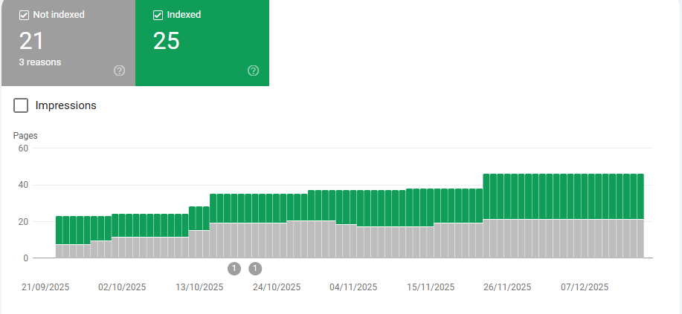

Index Coverage Breakdown – JackfruitNetwork.com (Google Search Console)
Indexed vs Not Indexed Distribution
Total Pages Discovered by Google: 46
- Indexed: 25 pages (54.3%)
- Not Indexed: 21 pages (45.7%)
Exclusion Reasons: 3
Jackfruit Network currently has a moderate indexation footprint, with just over half of discovered URLs being indexed. However, the remaining 21 excluded pages represent a significant indexation gap that limits the site’s ability to expand search visibility beyond branded queries.

Indexation Trend Analysis
The chart shows a steady rise in total discovered pages between late September and early December, with a noticeable increase in indexed pages around late November. This pattern commonly occurs when Google gains improved access or stronger signals through sitemap submission, improved internal linking, or the publication of new pages.
Despite index growth, the “Not indexed” section rises in parallel, indicating that as Google discovers more URLs, a sizable portion are still being filtered out due to technical, duplication, or content-quality signals.

Impact on Organic Performance

1) Organic Reach and Impression Growth are Constrained
Only indexed pages can reliably rank and generate search impressions. With 21 pages excluded, Jackfruit Network’s ability to scale impressions is limited, especially for non-branded informational, commercial, and transactional searches.

2) Branded Search Dominance is Reinforced
Your organic performance is currently heavily driven by navigational brand queries. A restricted index footprint contributes to this dependency because fewer indexable pages exist to target broader, discovery-based keywords.

3) Potential Quality or Duplication Filtering
When nearly half of the discovered pages are not indexed, it frequently indicates that Google may be:
- Filtering duplicate or near-duplicate URLs
- Deprioritizing thin/low-value pages
- Selecting alternate canonical versions
- Encountering noindex directives, redirects, or parameter-driven duplicates
Since the report shows 3 distinct exclusion reasons, the issue is likely systematic rather than isolated to one page.

Updated Trends and Risk Signals

Indexation Gap
A 45.7% exclusion rate is high enough to slow organic growth. Even with strong branded performance, the site will struggle to expand into broader keyword categories if key pages are not consistently indexed.

Crawl vs Index Efficiency
Google appears to be discovering URLs, but not committing many of them to the index. This usually points to a mismatch between what Google is crawling and what it considers valuable enough to rank.

Scalability Risk
If indexation is not improved, future content publishing may not translate into visibility gains, because new pages can be discovered but still excluded due to recurring technical or quality patterns.

Refined Recommendations

1) Diagnose and Resolve the 3 Exclusion Reasons (Highest Priority)
Pull the “Why pages aren’t indexed” breakdown and address the reasons in order of impact, focusing first on any that affect:
- Product/service pages
- Branch/location pages
- Careers pages
- Key brand credibility pages (About, Foundation, Contact)
This is the single fastest way to unlock additional rankings and impressions.

2) Sitemap Quality and Indexation Hygiene
- Ensure the XML sitemap includes only canonical, indexable URLs returning 200 status
- Exclude non-canonical variants (www vs non-www, trailing slash duplicates, parameter URLs)
- Confirm the sitemap is submitted and regularly refreshed

3) Canonical and Duplicate Control
- Enforce one preferred URL structure (HTTPS + preferred hostname + consistent trailing slash rules)
- Correct canonical tags so important pages self-canonicalize
- Remove or consolidate duplicate pages that compete for the same intent

4) Strengthen Internal Linking to “Index-Worthy” Pages
Pages that are weakly linked internally are more likely to be crawled but not indexed. Use:
- Navigation links
- Footer links
- Contextual in-content links
to reinforce priority pages and improve indexation consistency.

5) Improve Content Depth on Low-Value Pages
If exclusions include “Crawled – currently not indexed” or “Discovered – currently not indexed,” Google is often signaling perceived low value. Improve:
- uniqueness of content
- helpfulness and depth
- on-page structure (headings, FAQs, internal links)
to trigger indexing.

Onpage SEO audit
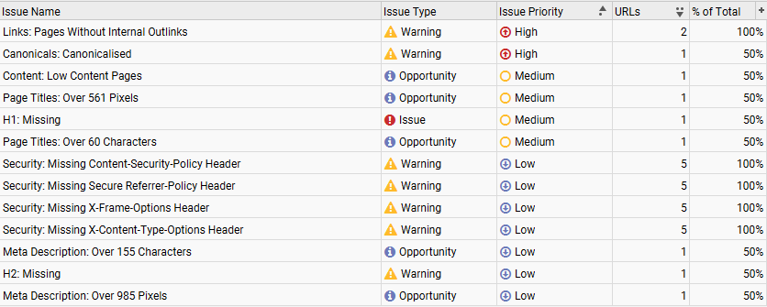

Canonicals: Non-indexable Canonical
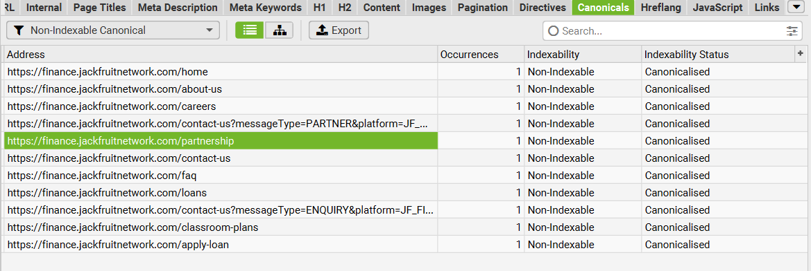
Description : This report shows these URLs are being treated as non-canonical duplicates as their rel="canonical" points to a different page, so they’re marked Non-Indexable with status Canonicalised. In practice, Google will usually ignore indexing these exact URLs and instead index the canonical target, which can accidentally suppress important pages (e.g., About, Loans, Apply-loan) if the canonicals are mis-set.
How To Fix : Verify each page’s canonical tag and make key pages self-referencing canonicals, while only canonicalising true duplicates/parameter URLs .

Images: Missing Alt Text
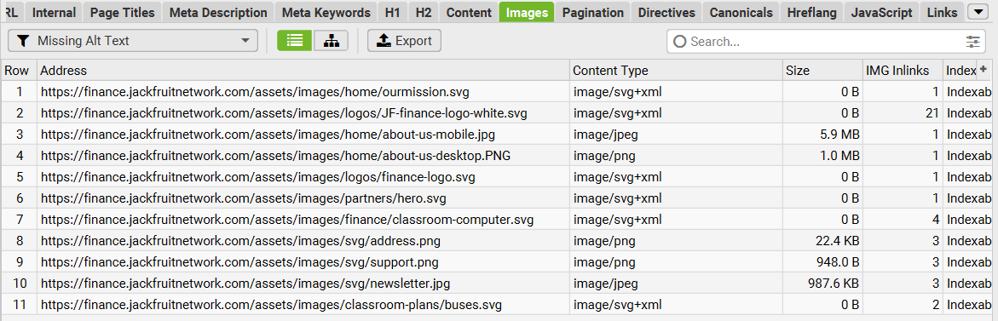

Description : This report shows image files on the site (logos, hero graphics, section images, etc.) that are being used on pages without an alt attribute, therefore Google and screen readers don’t get a clear description of what the image represents. That weakens accessibility and image SEO, and it can reduce relevance signals on key pages especially for important visuals like your logo, hero banners, and “about us” section images.

How To Fix: Add short, descriptive alt text for meaningful images (e.g., “JF Finance logo”, “JF Finance loans hero banner”)

Images: Missing Alt Attribute
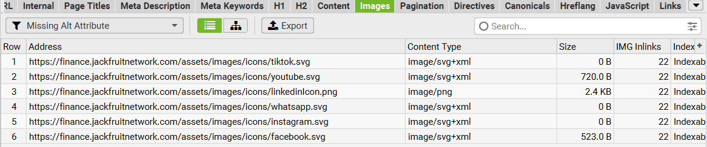
Description : This shows images (mainly social icons like TikTok, YouTube, LinkedIn, WhatsApp, Instagram, Facebook) that are placed on the site without any alt attribute at all. That’s an accessibility issue because screen readers can’t interpret the icon's purpose, and it’s a minor SEO/UX quality signal—especially since these icons appear across many pages.
How To Fix : add an alt attribute to each icon image or, if they’re purely decorative and the link already has readable text/ARIA labels, set alt="" and ensure the link is properly labeled e.g., aria-label="Visit our Facebook page".

Canonicals: Canonicalized
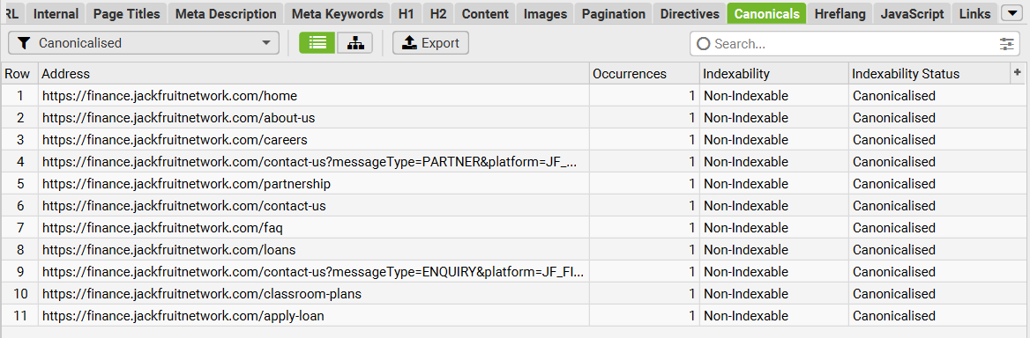
Description: Pages that have a canonical to a different URL. The URL is 'canonicalized' to another location. This means the search engines are being instructed to not index the page, and the indexing and linking properties should be consolidated to the URL in the canonical.
How To Fix: These URLs should be reviewed carefully to ensure the indexing and link signals are being consolidated to the correct URL. In a perfect world, a website wouldn't need to canonicalize any URLs as only canonical versions would be linked to internally on a website, but often they are required due to various circumstances outside of control, and to prevent duplicate content. Update internal links to canonical versions of URLs where possible.

Security: Missing Content-Security-Policy Header
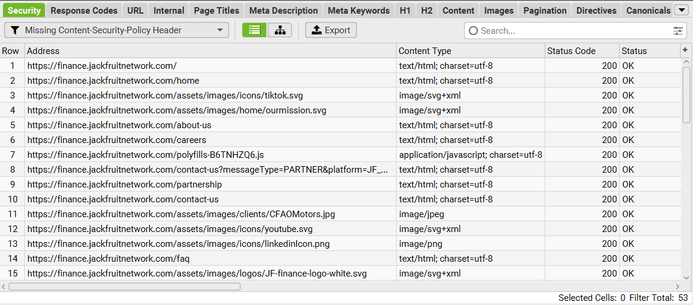
Description: URLs that are missing the Content-Security-Policy response header. This header allows a website to control which resources are loaded for a page. This policy can help guard against cross-site scripting (XSS) attacks that exploit the browser's trust of the content received from the server.
How To Fix: Set a strict Content-Security-Policy response header across all pages to help mitigate cross-site scripting (XSS) and data injection attacks.

Security: Missing Secure Referrer-Policy Header
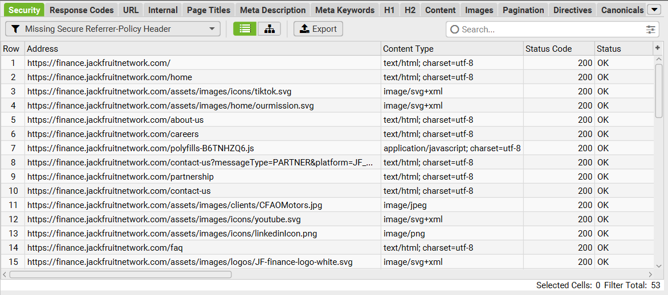
Description: URLs missing 'no-referrer-when-downgrade', 'strict-origin-when-cross-origin', 'no-referrer' or 'strict-origin' policies in the Referrer-Policy header. When using HTTPS, the URLs mustn't leak in non-HTTPS requests. This can expose users to 'man in the middle' attacks, as anyone on the network can view them.
How To Fix: Consider setting a referrer policy of strict-origin-when-cross-origin. It retains much of the referrer's usefulness while mitigating the risk of leaking data across origins.

Security: Missing X-Frame-Options Header
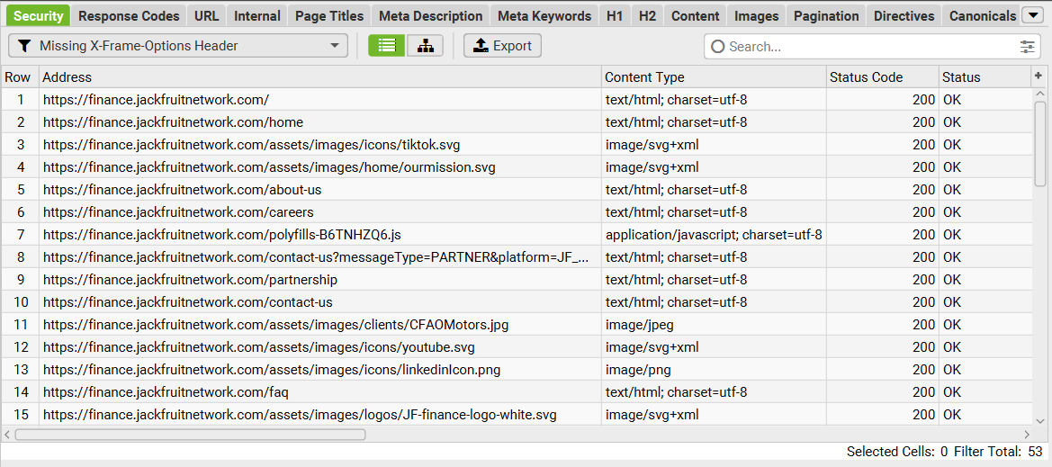
Description: URLs missing an X-Frame-Options response header with a 'DENY' or 'SAMEORIGIN' value. This instructs the browser not to render a page within a frame, iframe, embed or object. This helps avoid 'clickjacking' attacks, where your content is displayed on another web page that is controlled by an attacker.
How To Fix: To minimize security issues, the X-Frame-Options response header should be supplied with a 'DENY' or 'SAMEORIGIN' value.

Security: Missing X-Content-Type-Options Header
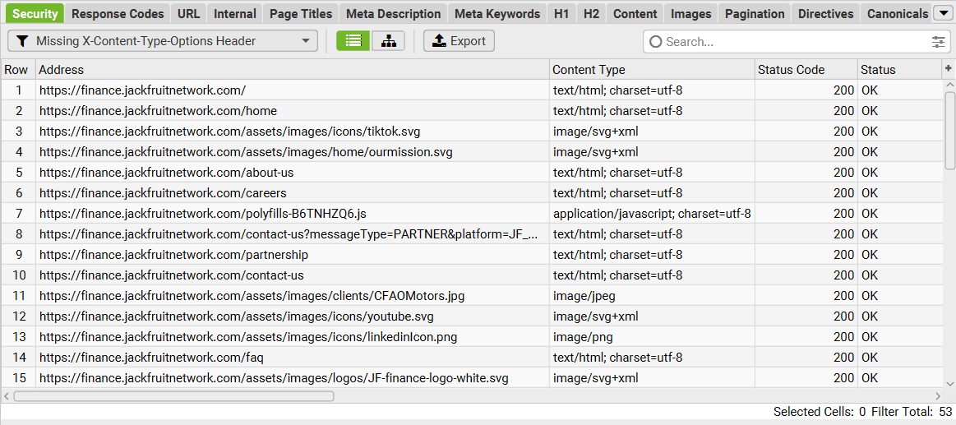
Description: URLs that are missing the 'X-Content-Type-Options' response header with a 'nosniff' value. In the absence of a MIME type, browsers may 'sniff' to guess the content type to interpret it correctly for users. However, this can be exploited by attackers who can try and load malicious code, such as JavaScript, via an image they have compromised.
How To Fix: To minimise security issues, the X-Content-Type-Options response header should be supplied and set to 'nosniff'. This instructs browsers to rely only on the Content-Type header and block anything that does not match accurately. This also means the content-type set needs to be accurate.

Security: Unsafe Cross Origin Links
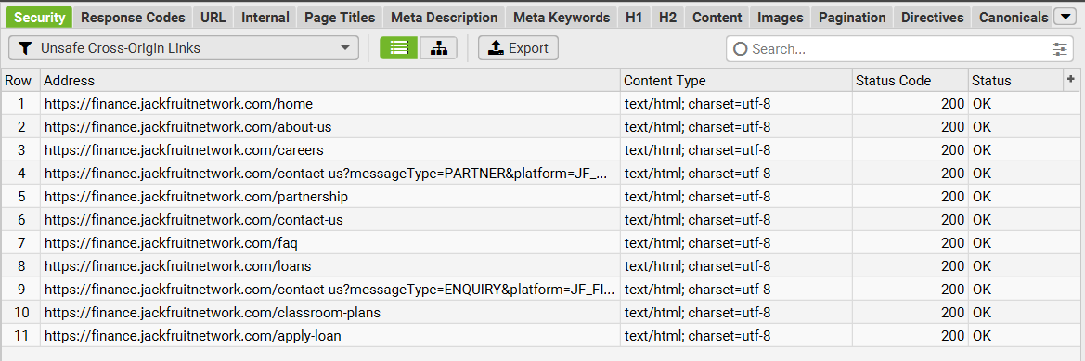
Description : Pages that contain external links opening in a new tab (typically target="_blank") without the safety attributes rel="noopener noreferrer". It’s mainly a security/UX risk (tabnabbing) rather than a direct ranking issue, but it’s still a best-practice fix especially because it appears across key pages like Home, About, Loans, and Contact.
How To Fix: Update those outbound links to include rel="noopener noreferrer" (or configure it site-wide), and the warnings will clear while keeping user navigation safe.

Links: Pages With High External Outlinks
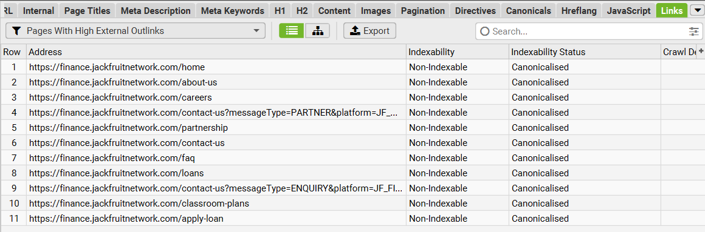
Description : These are Pages With High External Outlinks view lists, that is pages that contain many outbound links to other domains, which can dilute user focus and leak some link equity if it’s excessive or poorly controlled. What stands out here is that every listed URL is also Non-Indexable meaning Google is likely not indexing these pages as-is, so any outbound-link value and topical relevance is being attributed to the canonical target page instead.
How To Fix : first fix the canonicalisation issue for key pages (home/about/loans/apply-loan), then review outbound links for necessity, use clean link placement to avoid sitewide repeats where possible, and add nofollow/sponsored where the link is paid/affiliate/partner-based.

URL: Parameters
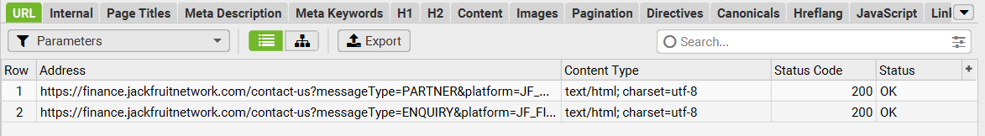
Description : This shows you have parameterised versions of the Contact page (e.g., contact-us?messageType=PARTNER... and contact-us?messageType=ENQUIRY...) that return 200 OK, meaning they’re crawlable and can be treated as separate URLs. If these parameter URLs render near-identical content, they create duplicate-page risk and can waste crawl budget, split link signals, or cause indexing confusion.
How To Fix : keep the main /contact-us as the primary URL, then either self-canonicalise to /contact-us, block/limit crawling of those parameters in Search Console URL Parameters or via robots rules where appropriate, and ensure internal links point to the clean version

URL: Uppercase
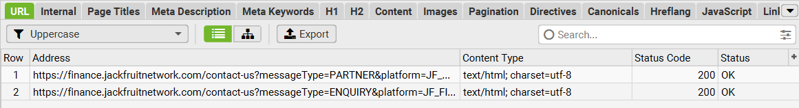
Description : These are URLs that contain uppercase characters even though the pages return 200 OK. Uppercase/lowercase variations can lead to URL inconsistency and duplicate tracking signals, especially if the site or external links sometimes use different casing.
How To Fix: Standardize by keeping URLs and parameters lowercase where possible, and ensure these parameter URLs canonicalise to the clean /contact-us to avoid duplication.

Response Codes : Internal Redirection (Meta Refresh)
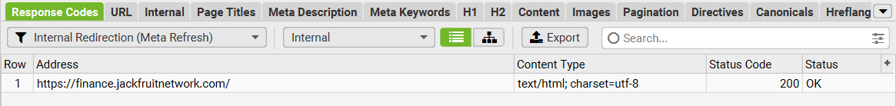
This Internal Redirection (Meta Refresh) flag means the URL is using a meta refresh redirect (a redirect triggered in the page’s HTML) instead of a proper server-side 301/302 redirect. Even though it shows 200 OK, meta refresh is a weaker redirect method and can cause slower crawling, inconsistent indexing, and a poorer user experience compared to server redirects.
How To Fix : Replace it with a server-side 301 to the correct destination or a JavaScript redirect only if absolutely necessary, and ensure internal links point directly to the final URL.

Images : Over 100 KB
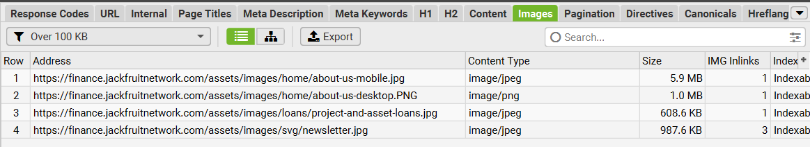
Description: This highlights image files that are too heavy and likely slowing down page load. These oversized images can directly hurt Core Web Vitals especially LCP and mobile performance, which reduces rankings and conversions over time.
How To Fix : Convert to WebP/AVIF, resize to the exact display dimensions, compress aggressively aiming <100KB, hero images ideally <200–300KB, and enable lazy-load for below-the-fold images.

Images : Missing Size Attributes
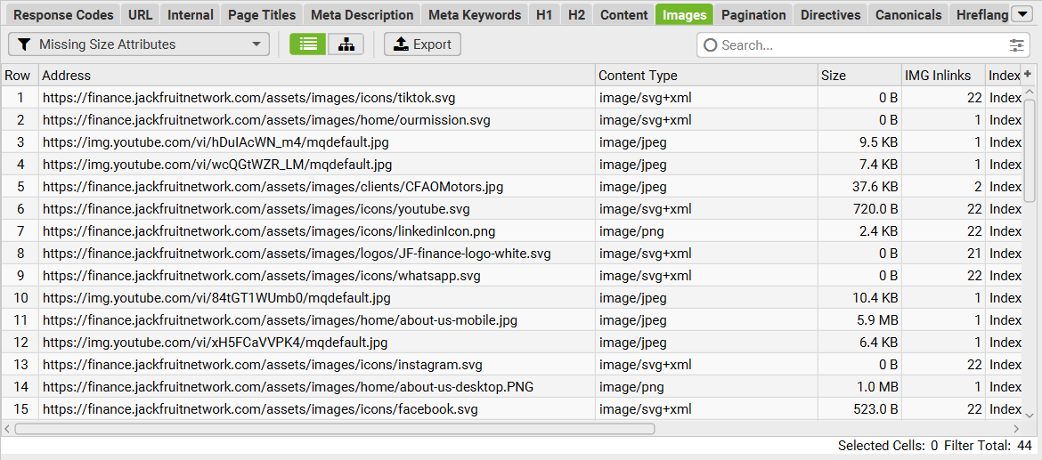
Description: This shows images that are missing explicit width/height or aspect-ratio definitions, so the browser can’t reserve space before they load. That often causes layout shifts (CLS) and can slow rendering, especially on pages with many icons/SVGs and large images like the 5.9MB about-us-mobile.jpg.
How To Fix : Add width and height attributes or CSS aspect-ratio for every image, ensuring responsive images use correct sizing (srcset/sizes), and prioritizing the biggest above-the-fold images first.

Links: Internal Outlinks With No Anchor Text
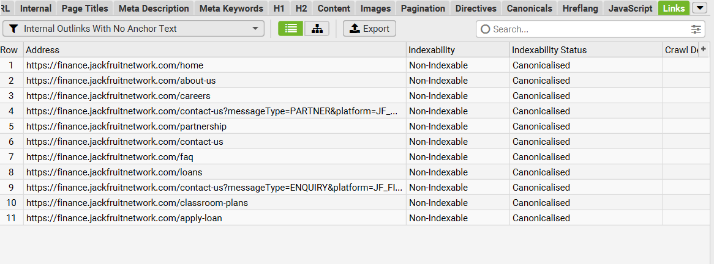
Description: These pages contain internal links where the clickable element has no readable anchor text, often icon-only links, empty <a> tags, or links where text is injected by JavaScript. That weakens internal linking signals because Google can’t easily understand the context of the link, and it also hurts accessibility since screen readers may read it as an unlabeled link.
How To Fix : Ensure every internal link has descriptive text (or an aria-label/alt text for icon links), and note that these pages also show Non-Indexable / Canonicalised, so you should correct canonicals too so the improved internal linking benefits indexable URLs.

URL: Underscores
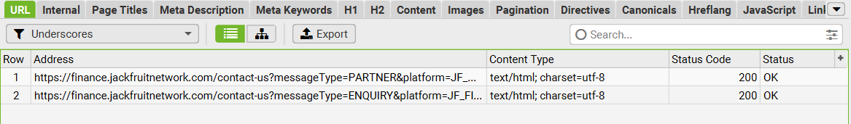
Description : This shows URLs that contain underscores, it’s the tracking/parameter portion like platform=JF_FI.... Underscores aren’t a critical ranking issue, but they can create messy, inconsistent URLs and, when combined with parameters, increase the risk of duplicate versions of the same page being crawled and indexed.
How To Fix : keep the main /contact-us clean, limit/standardize parameters, prefer hyphens over underscores where you control it, and canonicalise or block these parameter URLs so Google focuses on one primary version.

Offpage
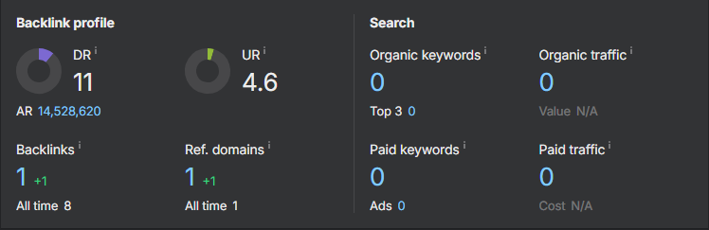
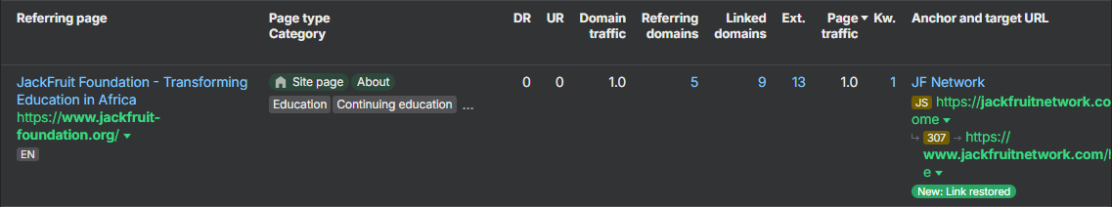
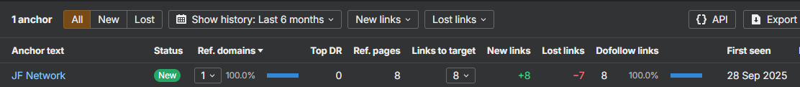

Off-Page SEO Audit – JackfruitNetwork.com

Backlink Profile Overview
Domain Rating (DR): 11 (+0)
Jackfruit Network has a DR of 11, placing it in the early authority tier. This indicates limited domain trust and weak competitive power for non-branded finance and microfinance queries. With DR remaining unchanged, authority growth is currently constrained by a very small number of unique referring domains and minimal editorial validation from third-party websites.
URL Rating (UR): 4.6
A UR of 4.6 confirms that page-level authority is weak. This typically means priority pages are not receiving meaningful external equity, and internal authority flow is likely limited. Low UR reduces the ability of important pages to rank for high-intent non-brand searches, even when on-page SEO is well implemented.
Total Backlinks: 1 (+1) | All time: 8
The tool currently detects 1 live backlink, while historical data suggests up to 8 links have existed. This gap signals a link retention issue where links are either being removed, redirected incorrectly, or not consistently accessible to crawlers. With such low volume, every lost link materially impacts authority and discovery.
Referring Domains: 1 (+1) | All time: 1
Jackfruit Network has only 1 referring domain, which is the primary off-page bottleneck. Google typically needs broader third-party validation across multiple reputable domains to grow trust and improve rankings for competitive, non-branded keywords. A single referring domain profile limits topical authority, reduces resilience, and slows keyword expansion.
Organic Keywords: 0 | Organic Traffic: 0 (Third-party estimate)
Third-party tools are currently not detecting trackable keyword rankings, which is consistent with the very low authority footprint. This does not override first-party performance in Google Search Console, but it confirms that off-page signals are still too limited for third-party ranking detection and broad-market visibility.

Analysis of Top Referring Domains and Pages
Primary referrer: JackFruit Foundation – Transforming Education in Africa (jackfruit-foundation.org)
The only detected referring source is a foundation-related page linking to Jackfruit Network. This provides some brand ecosystem validation, but it appears more aligned to education and foundation context than core finance intent, which reduces topical reinforcement for financial services and microfinance visibility. If this referring domain is part of the same organization group, it functions more like an owned-network signal than an independent editorial endorsement.
Redirect and target URL behavior: 307 redirect detected
The link path shows a 307 redirect to a www version. A 307 indicates a temporary redirect and is not ideal for SEO consolidation. For link equity preservation, permanent redirects should typically be implemented as 301, and canonical host preference should be consistent. This matters more when backlink volume is low because redirect inefficiencies can dilute already limited authority transfer.

Concerning Link Patterns and Risks
1) Link retention volatility
The anchor report shows 8 links discovered to the target with a pattern of links gained and links lost. With only one referring domain, this level of fluctuation creates instability in authority signals and can slow trust building.
2) Over-reliance on one referring domain
A single-domain backlink profile creates concentration risk. If that one domain removes links, changes pages, or is deindexed, the site’s authority baseline weakens immediately.
3) Weak topical reinforcement for finance queries
The current referrer context is not strongly aligned with finance, lending, microfinance, or SME funding. This limits the site’s ability to build topical authority signals that support non-branded commercial rankings.

Anchor Text Distribution
Branded anchors: 100 percent concentration
The anchor snapshot shows “JF Network” as the key anchor in use. This is safe from a spam perspective, but it is not enough to build relevance for non-brand keywords. The current anchor profile contains no meaningful keyword-rich anchors aligned to finance services.
Keyword-rich anchors: Near zero
There is no evidence of anchors supporting high-intent discovery topics such as microfinance, loans, SME financing, branch locations, or service categories. This is one reason broader keyword footprint expansion remains limited.

Link Acquisition Trends
Velocity: Extremely low
Backlink growth is minimal and dependent on a single referring domain. This does not create the authority momentum needed to improve rankings for competitive queries.
Targeting: Homepage-heavy
The linking appears concentrated on the homepage level. Without deep links pointing to priority service pages, branch pages, or key conversion pages, ranking potential remains restricted for non-brand transactional intent.

Recommendations (Actionable and Priority Ordered)
1) Expand Referring Domains with Editorial, Relevant Placements (Priority: High)
Target finance-adjacent and business-relevant sources to build independent trust signals:
- Kenyan business news and SME platforms
- Finance and microfinance directories with editorial review standards
- Entrepreneurship hubs, SACCO and SME communities, university and NGO partnerships
- Local publisher features and interviews tied to leadership, impact, and products
Target outcome: grow from 1 referring domain to 20 to 40 quality referring domains over 90 to 120 days.

2) Fix Redirect Equity Flow (Priority: High)
- Replace any 307 temporary redirects in the primary link path with 301 where appropriate
- Enforce one preferred canonical host (www or non-www) and ensure internal and external links resolve cleanly to the canonical version
This protects link equity and reduces dilution, especially critical with low backlink volume.
3) Build a Deep-Linking Strategy (Priority: High)
Acquire links not only to the homepage but also to high-value pages such as:
- core services and product pages
- careers hub (already showing demand in GSC)
- branches and location pages
- foundation and impact pages where relevant
Deep links improve page-level UR and increase the chance of ranking for non-brand intent queries.
4) Rebuild Anchor Strategy with Safe, Intent-Based Variation (Priority: Medium)
Introduce a controlled distribution:
- 60 to 70 percent branded anchors (Jackfruit Finance, Jackfruit Network, variations)
- 20 to 30 percent partial-match anchors aligned to services (microfinance solutions, SME financing, loan services)
- 10 percent generic or URL anchors
This improves topical relevance without introducing spam risk.
5) Create Linkable Assets that Earn Natural Mentions (Priority: Medium)
Develop content assets that publishers can reference:
- Kenya-focused guides and FAQs on lending, eligibility, and financial literacy
- branch locator and branch profiles for local citations
- impact stories and case studies
- thought leadership articles from executives
6) Monthly Link Monitoring and Reclamation (Priority: Medium)
Track lost links and reclaim where possible through outreach. With a small backlink profile, recovering a single lost link can materially improve authority stability.
Jackfruit Network’s off-page profile is constrained by a single referring domain, minimal live backlinks, and weak finance-relevant topical reinforcement. The immediate growth lever is increasing the number of quality referring domains, improving link equity flow through redirect and canonical consistency, and building a deep-linking and anchor strategy that supports non-branded discovery.

Technical SEO
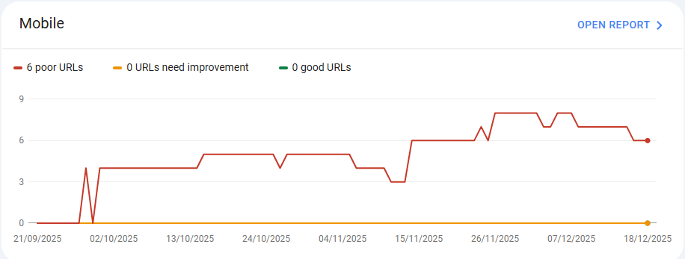
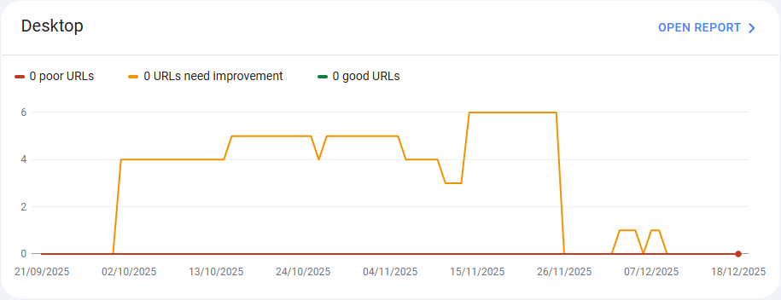

Technical SEO (First-Party) – Core Web Vitals Summary for JackfruitNetwork.com

Mobile Core Web Vitals Status
Total affected URLs: 6
- Poor URLs: 6
- URLs need improvement: 0
- Good URLs: 0
Jackfruit Network currently fails Core Web Vitals on mobile across all measured URLs. This is a critical technical constraint because Google evaluates most websites using mobile-first indexing, and mobile performance is often the primary experience for users. With no URLs passing, the site is exposed to reduced ranking competitiveness on mobile search results, weaker engagement signals, and lower eligibility for high-visibility surfaces such as Google Discover.
Trend insight: The poor URL count increases and remains persistent through the period shown, indicating the issue is not isolated or temporary. This usually points to systemic performance bottlenecks such as slow LCP elements, heavy JavaScript execution, unoptimized images, or unstable layout behavior.

Desktop Core Web Vitals Status
Total affected URLs: 0 poor | 0 good (with “needs improvement” volatility)
The desktop report shows no URLs classified as “poor,” but it also shows no URLs classified as “good.” Instead, the site fluctuates within the “needs improvement” category earlier in the timeline, then drops toward zero later, which typically happens when:
- the set of evaluated URLs changes due to traffic thresholds,
- Google updates its field data window,
- or pages are not receiving enough desktop field data to be reported consistently.
While the desktop does not show a “poor” classification, it does not provide a reliable pass signal either. Mobile remains the priority concern because it has clear, consistent poor classifications and is more influential for SEO outcomes.

Impact on SEO and Organic Performance

1) Reduced mobile ranking competitiveness
Failing mobile Core Web Vitals makes it harder for pages to compete for non-branded queries, where Google has many options. Even strong content and relevance can underperform when user experience signals are weak.

2) Lower engagement and conversion rates
Poor mobile experience typically increases bounce rates and decreases time on site, form completions, and call-to-action engagement. For a finance brand, this can directly affect lead generation and trust.

3) Weaker scalability of organic growth
Your current organic performance is primarily brand-led. To scale into non-brand discovery queries, the site must compete on both relevance and user experience. Core Web Vitals issues slow that expansion.
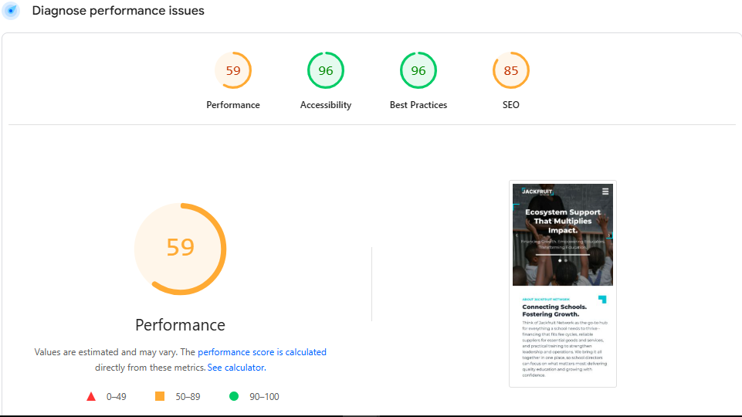
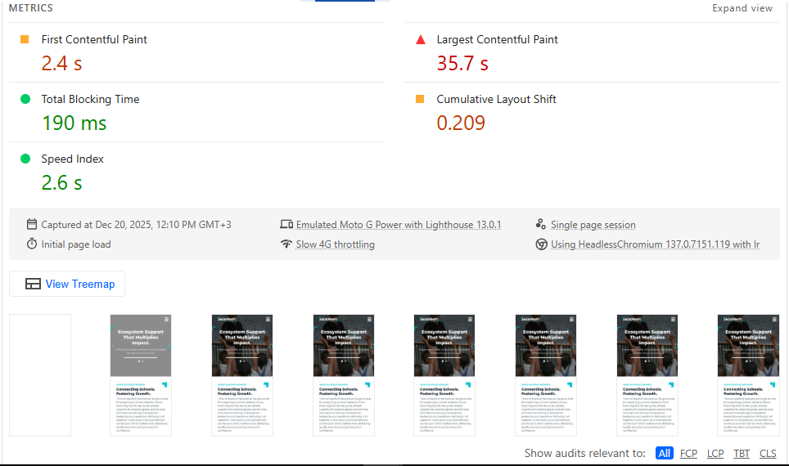
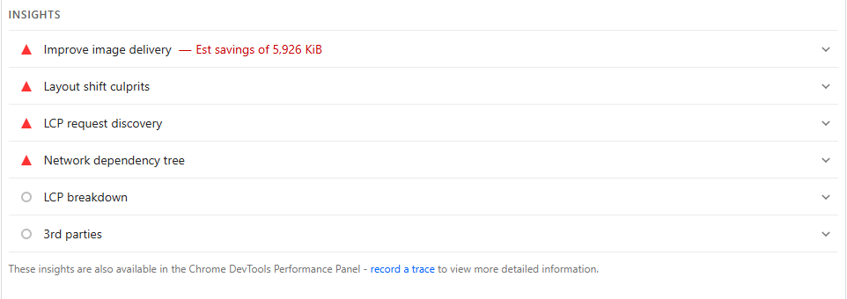
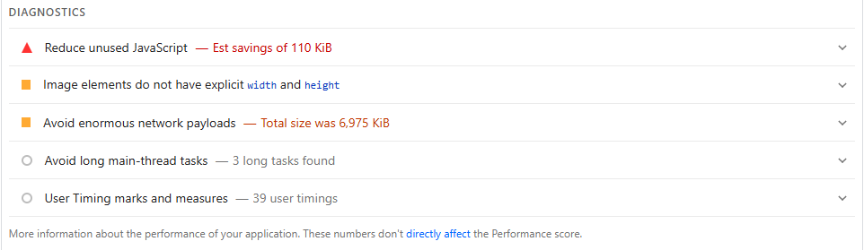

Technical Performance Audit – JackfruitNetwork.com (Third-Party Tools)

Key Visual Metrics
Performance Score: 59 (Amber Zone)
Jackfruit Network’s Lighthouse performance score of 59 indicates a materially slow user experience under simulated mobile conditions (Moto G Power, Slow 4G). While the site performs well in accessibility and best practices, the performance score is being dragged down primarily by an extreme Largest Contentful Paint delay and heavy page weight.
Accessibility: 96 (Green Zone)
Accessibility is strong, indicating the site is generally usable and readable for most users, including assistive technology support. This is a positive signal for user experience quality, but it does not offset performance constraints affecting rankings and engagement.
Best Practices: 96 (Green Zone)
Best practice compliance is high. However, performance limitations remain the primary technical blocker rather than compliance issues.
SEO Score: 85 (Amber Zone)
The SEO score is generally solid, but not perfect. This indicates there are likely some technical SEO improvements still required (metadata hygiene, indexing controls, structured data, or performance-related SEO signals). The biggest SEO limiter in this snapshot remains load performance rather than fundamental crawl settings.

Core Web Vitals and Lab Performance Indicators

Largest Contentful Paint (LCP): 35.7s (Critical Failure)
LCP measures how quickly the largest visible element (typically the hero section or main banner) renders for users.
An LCP of 35.7 seconds is severely above Google’s recommended threshold of under 2.5 seconds and is the dominant reason the page fails performance expectations.
This level of delay strongly suggests one or more of the following:
- The hero image or primary above-the-fold element is extremely heavy and not compressed
- The LCP asset is not prioritized and loads late in the request chain
- Render-blocking JavaScript or CSS is delaying the hero element from painting
- Server response and asset delivery are slow under mobile conditions
A poor LCP directly increases bounce rates and reduces trust, particularly for first-time visitors on mobile networks.

Cumulative Layout Shift (CLS): 0.209 (Red Zone)
CLS measures how much content shifts unexpectedly during page load.
A CLS of 0.209 exceeds Google’s recommended target of 0.1 and indicates visible instability during loading. This often results from images, banners, or dynamic sections loading without reserved space.
Likely drivers include:
- Images missing explicit width and height attributes
- Late-loading hero content or embedded sections
- Fonts loading late and causing layout movement
Layout shifts degrade user experience and can reduce conversion performance by causing mis-clicks and interaction friction.

First Contentful Paint (FCP): 2.4s (Borderline)
FCP measures how quickly the first visible content appears.
At 2.4 seconds, the site appears moderately responsive early on, but the extreme LCP indicates that users see partial content quickly while the most important visual element takes too long to load. This creates a “looks loaded but isn’t” experience, which is frustrating on mobile.

Total Blocking Time (TBT): 190ms (Good)
TBT measures how much JavaScript blocks the main thread during load.
190ms is relatively controlled, suggesting JavaScript is not the primary bottleneck compared to image delivery and LCP prioritization. That said, unused JavaScript and long main-thread tasks still appear in diagnostics, meaning there are meaningful improvements available.

Speed Index: 2.6s (Good)
Speed Index is strong, implying the page’s visible parts populate reasonably quickly. However, the user experience is still poor because the largest above-the-fold element is arriving extremely late.

Diagnostics and Insights (Key Issues Identified)

Improve image delivery — Estimated savings: 5,926 KiB
This is the most significant issue in the audit. The site is delivering several megabytes more image data than necessary.
This directly drives slow mobile performance and is a primary cause of the extreme LCP.

Avoid enormous network payloads — Total page size: 6,975 KiB
A nearly 7MB payload is too heavy for mobile-first performance.
This causes slower load times, higher data usage, and weaker user experience in markets where mobile networks and device performance vary widely.

LCP request discovery and network dependency tree
The report flags LCP request discovery issues and a heavy dependency chain. This indicates the browser is either:
- discovering the LCP resource too late, or
- forced to wait on other resources before the LCP asset can be fetched and rendered.
This is a classic cause of very slow LCP even when FCP looks acceptable.

Layout shift culprits
CLS issues are reinforced by diagnostics showing image elements without explicit width and height. Without fixed dimensions, the browser cannot reserve layout space, causing content movement as assets load.

Reduce unused JavaScript — Estimated savings: 110 KiB
While JavaScript is not the dominant blocker versus images, unused JavaScript still contributes to payload bloat and can worsen responsiveness on low-end devices.

Long main-thread tasks — 3 long tasks found
These tasks can delay interactivity and contribute indirectly to load instability. They should be reduced via script deferral, bundling improvements, and third-party script control.

Business and SEO Impact

1) Reduced mobile ranking competitiveness
A mobile LCP in the critical zone makes it significantly harder to compete for non-branded queries. Even strong on-page SEO can underperform when user experience is poor.

2) Lower trust and conversion performance
For a finance brand, slow loading and unstable layout reduces credibility and increases abandonment, particularly when users are researching services and making trust-based decisions.

3) Weak ability to scale beyond branded search
Your Google Search Console performance indicates strong branded CTR. To expand discovery traffic, the site must compete against faster, more stable pages in the same category.

Recommendations (Action Plan)

1) Fix Largest Contentful Paint (Highest Priority)
- Convert all hero and above-the-fold images to WebP or AVIF and enforce strict size targets
- Preload the LCP image using proper preload tags
- Ensure the hero image is not lazy-loaded
- Remove render-blocking CSS and inline critical CSS for above-the-fold layout
- Defer non-critical JavaScript and delay third-party scripts until after first render
- Implement CDN delivery for static assets and ensure strong caching headers
Target outcome: LCP under 2.5–3.0 seconds on mobile.

2) Reduce page weight aggressively
- Compress all images and remove oversized background images
- Use responsive image sizing (srcset) so mobile downloads smaller files
- Eliminate unused assets and reduce media embeds that inflate payload
Target outcome: reduce page payload from ~7MB to under 2MB.

3) Resolve Cumulative Layout Shift (CLS)
- Add explicit width and height attributes to all images
- Reserve layout space for any dynamic sections and banners
- Stabilize font loading using preload and font-display: swap
Target outcome: CLS under 0.1.

4) Optimize JavaScript execution and long tasks
- Remove unused JavaScript and reduce bundle size
- Delay third-party scripts and load them only when needed
- Break up long tasks and reduce main-thread workload
Target outcome: lower INP risk and smoother interactivity on low-end devices.

5) Confirm improvements using field data and continuous monitoring
After fixes, validate through:
- PageSpeed Insights (mobile)
- Chrome UX report in GSC Core Web Vitals
- Lighthouse retesting using the same throttling profile
This ensures improvements translate from lab results into real user experience gains.
Jackfruit Network’s technical bottleneck is dominated by an extreme LCP failure and heavy network payloads driven by unoptimized image delivery. While accessibility and best practices are strong, performance constraints will continue to suppress mobile rankings, reduce trust, and limit non-branded organic growth until image optimization, LCP prioritization, and layout stability are resolved.

Schema Markup
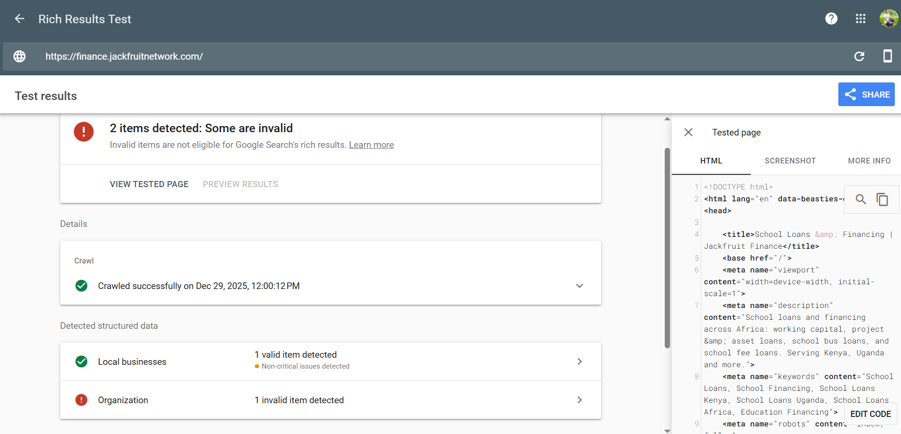
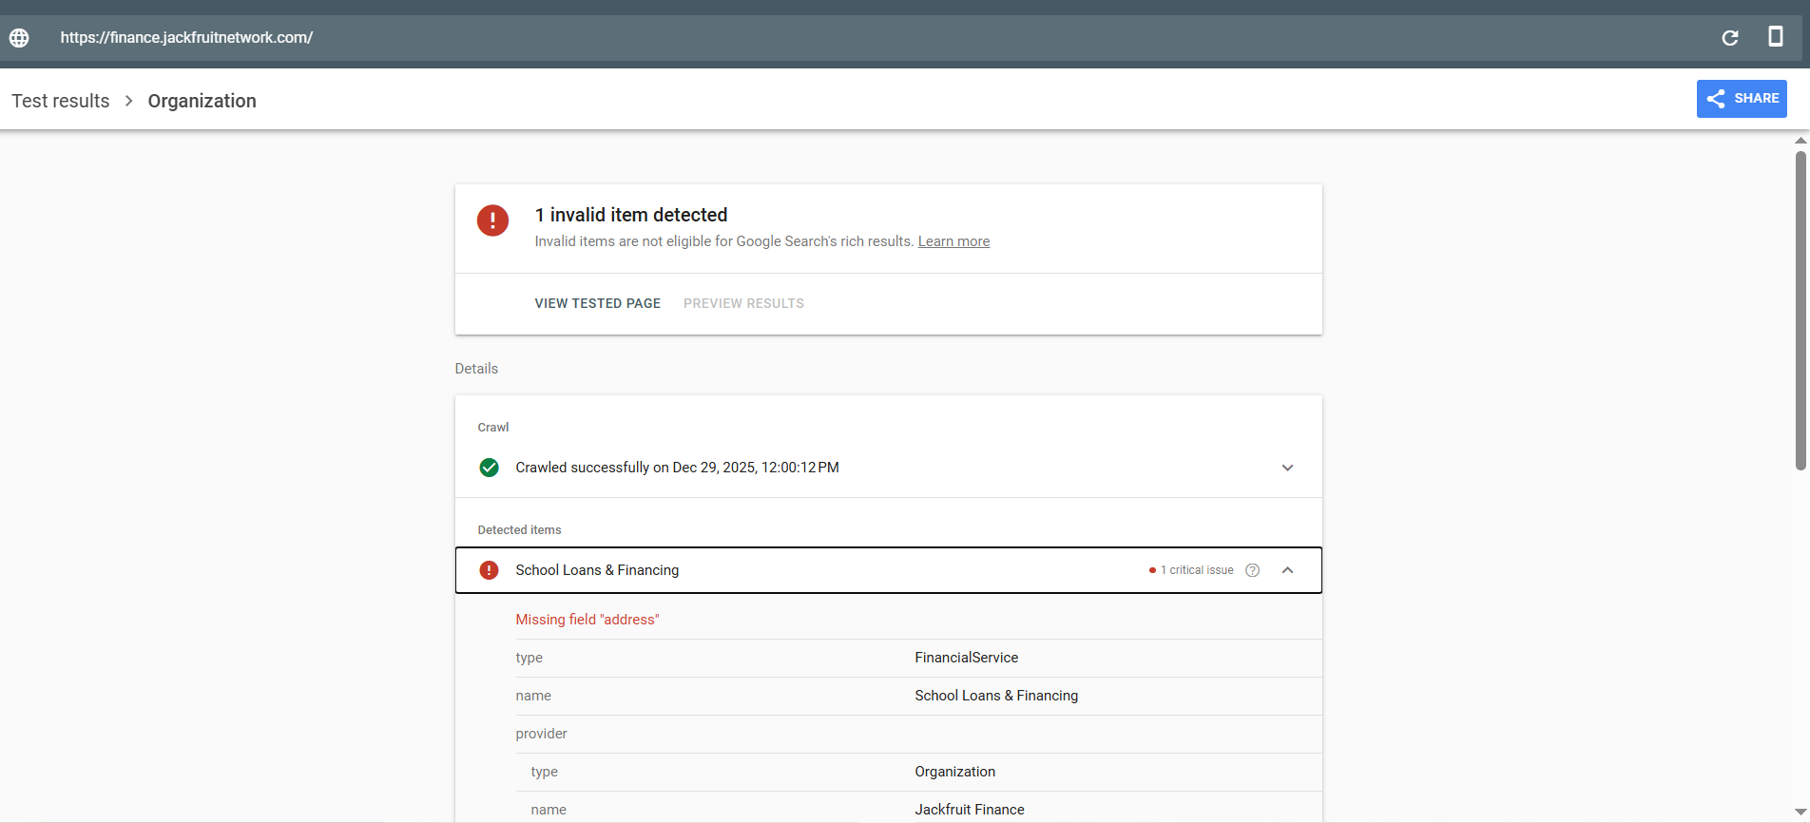
The Rich Results Test confirms that Jackfruit Finance has detectable schema markup, including LocalBusiness and Organization / FinancialService structured data. While the LocalBusiness schema is valid, the Organization/FinancialService schema is currently invalid due to a missing required address field, making it ineligible for Google rich results. This does not prevent indexation, but it limits eligibility for enhanced SERP features and weakens entity trust and E-E-A-T signals, which are critical for a financial services brand. Fixing the address issue and expanding schema coverage with Organization, FinancialService, WebSite, BreadcrumbList, and FAQPage schema would improve SERP visibility, credibility, and long-term organic performance.

Recommendations (Implementation Framework)

1. Fix the Critical Organization / FinancialService Schema Error (Highest Priority)
Action:
Add a complete PostalAddress to the existing Organization / FinancialService schema.
Why it matters:
Financial sites are held to a higher trust standard. A missing address weakens entity verification, E-E-A-T, and Google’s confidence in the business.
Required fields to add:
- streetAddress
- addressLocality
- addressCountry
- (Recommended) postalCode

2. Standardise Entity Definition (One Clear Primary Entity)
Action:
Ensure one authoritative Organization entity is used site-wide and referenced consistently.
Best practice:
- Use a unique @id (e.g. https://jackfruitnetwork.com/#organization)
- Reference the same @id across LocalBusiness, FinancialService, Website, and WebPage schemas
SEO value:
Prevents entity fragmentation and strengthens brand/entity recognition in Google’s Knowledge Graph.

3. Implement WebSite Schema with SearchAction
Action:
Add a WebSite schema including a SearchAction.
Why:
Helps Google understand the site structure and brand ownership, improving sitelink eligibility.
Impact:
Better branded SERP appearance and improved navigation signals.

4. Add FinancialService Schema on Relevant Pages
Action:
Explicitly mark service pages with FinancialService schema
Include:
- serviceType (e.g. School Loans, Asset Financing, Working Capital)
- areaServed (Kenya, Uganda, Africa where applicable)
- provider → reference the Organization @id
SEO impact:
Improves topical relevance for financial queries and strengthens service-level entity associations.

5. Implement FAQPage Schema (High CTR Opportunity)
Action:
Add FAQPage schema to pages answering common finance questions.
Examples:
- School loan eligibility
- Repayment terms
- Regions served
- Application process
Why:
Eligible for SERP FAQ expansions, improving click-through rate and visibility.

6. Add BreadcrumbList Schema
Action:
Implement BreadcrumbList schema across all indexable pages.
SEO benefit:
- Improves crawl clarity
- Enhances SERP presentation
- Supports internal linking signals

7. Strengthen Trust Signals with Authoritative Properties
Action:
Enhance Organization schema with:
- logo
- sameAs (LinkedIn, Facebook, X, Crunchbase if available)
- contactPoint (customer support, sales)
Why:
Critical for financial and YMYL sites — strengthens credibility, legitimacy, and E-E-A-T.

8. Avoid Over-Markup and Schema Duplication
Action:
Ensure:
- No duplicate Organization schema across templates
- Schema matches visible page content
- JSON-LD is preferred (clean and Google-recommended)
Risk mitigated:
Over-markup or conflicting schema can dilute trust rather than enhance it.

9. Validate and Monitor Continuously
Action:
- Validate using Google Rich Results Test
- Monitor Enhancements reports in Google Search Console
- Re-test after every major deployment
Why:
Schema errors silently reduce eligibility for rich results if left unchecked.
JackfruitNetwork.com has a solid schema foundation, but to compete in financial SERPs, it must eliminate validation errors, unify its entity definition, and expand schema coverage strategically. Done correctly, this will improve trust, SERP visibility, CTR, and long-term organic performance, especially for finance-related, high-intent queries.

